ICCP Service Request Process
ERCOT ICCP Team
EMMS Production Support
V1.0
Updated 5/10/2007

Purpose
A process needs to be defined to capture all changes for ICCP points being submitted by Market Participants (MP) for new NODAL and existing ZONAL ICCP changes.

Process Definition
The ICCP Service Request Process creates secure and historical central records of telemetry change requests to ensure accuracy and consistency in managing ICCP changes. Market Participants (MP) will submit ICCP changes using the ICCP Change Request Form to the ERCOT ICCP team through the Texas Market Link (TML). The ICCP team processes these changes as received and performs a series of checks with the MP to verify the accuracy of the changes (ICCP point additions/ deletions) before and after they are loaded into the system.

ICCP Change Request Form
The ICCP Change Request Form is a standard Excel form that a MP must use to submit any ICCP changes. The form has required information that both the ICCP Team and ERCOT Operations need to process the changes correctly. If any of the required information is missing, the Service Request can not be processed until the MP provides that information in the correct format using the approved form.

Provided below is an example of the ICCP Change Request Form:

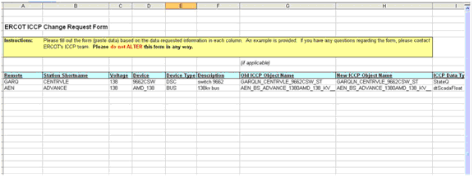

ICCP Standards
Market Participants must follow the ICCP standards outlined in the ICCP Handbook which can be found on ERCOT’s website at http://nodal.ercot.com/docs/pd/irt/odfr/icchb/ERCOT_ICCP_Communication_Handbook.doc.

ICCP Service Request Procedure
The following procedure outlines the new ICCP Service Request that Market Participants must follow to submit ICCP changes.

Note: The procedure outlined below will be rolled out 2Q 07 once ERCOT has had time to make function changes to Texas Market Link (TML) and confirm the process with all support teams. Effective 5/15, MPs are required to use the new ICCP Change Request Form and submit changes in the form as an email attachement to the ICCP team. Service Requests are submitted for EDS1 to EDS1@Ercot.com through TML.

To submit a ICCP change, a MP must follow these steps:

- A MP accesses the Texas Market Link (TML) through ERCOT.com and creates a Service Request (SR) by clicking on the Service Request link in the left-hand navigation.

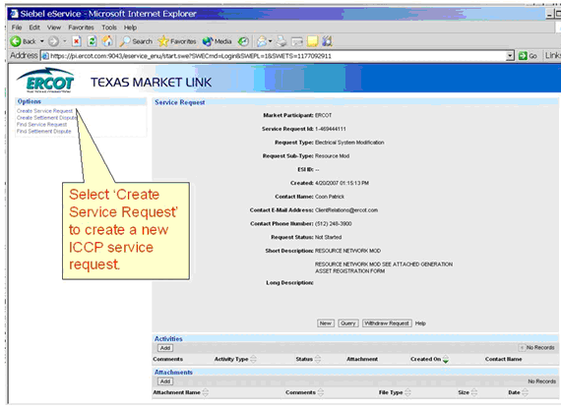

Note: The MP must be a designated as a Primary or Secondary Representative to submit a request.

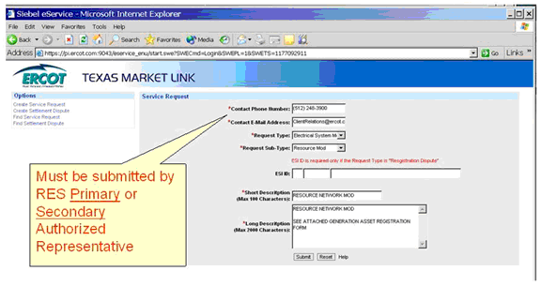

- A MP chooses the ICCP Service Request as the Request Type and ICCP Change Request as the Request Sub-type from the drop down lists in the form.

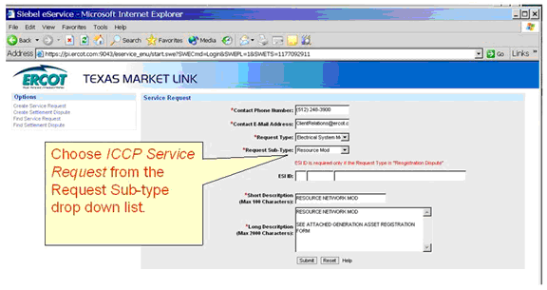

- A MP provides a summary of the requested changes in the Description section.

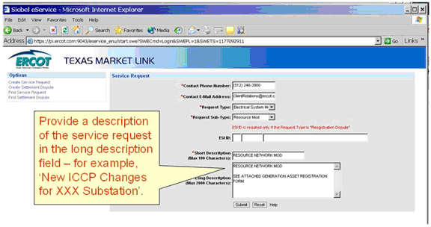
- A MP attaches a completed ICCP Change Request Form in the section labeled Attachments detailing all the ICCP changes that are being requested.

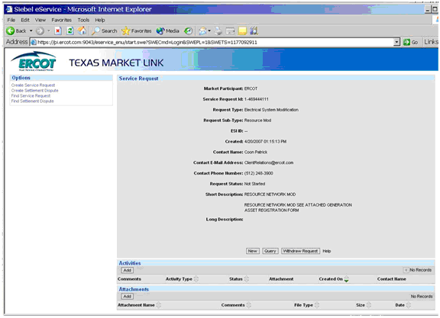

- A MP submits the Service Request by clicking the Submit button.

- The ICCP Team receives all Service Requests and processes each request individually.

- The Service Request is closed when the ICCP Team has processed the request and confirmed all changes with the MP.

- The MP requestor is notified by email that the SR has been processed and closed.

