Schedule Proposal for External Interfaces

The purpose of this is to set the basis for documenting the solution to the ‘market time’ issue for the external web services. There are currently the following rules for identification of ‘market intervals’:

- For hour based intervals, use 01:00-24:00.
- For sub-hour intervals, the interval is identified by HH:MM, where HH:MM represents the time at the END of the interval, e.g. the fifteen minute interval from 3:15 to 3:30 is identified by 03:30. Note that the last interval of the day is identified by 24:00.
- There needs to be a way to identify the repeated hour for CDT->CST changes. MMS will probably have a ‘repeated hour’ flag. For XML realizations, we need to consider use of an attribute, or better get just use a date time string with a time zone offset, e.g. -05:00.

During the discussion with market participants in the first face-to-face meeting of the API sub group regarding the proposed web services, the primary issues were that the use of Zulu time and second offsets for schedules (using CIM IrregularIntervalSchedules) were confusing and would make debugging difficult. The use of an absolute time string like 2008-01-01T00:00:00-06:00 would seem to be easier to debug, especially if time points in schedules are specified using absolute times instead of second offsets from a starting time. As opposed to the use of CIM IrregularIntervalSchedules, we can propose a replacement schedule structure, where we identify time points by an absolute time (most general and directly supports DST)

The following is a proposed structure for a TmSchedule, where values are provided at specific points in time using an absolute datetime (e.g. 2008-01-01T00:00:00-06:00):

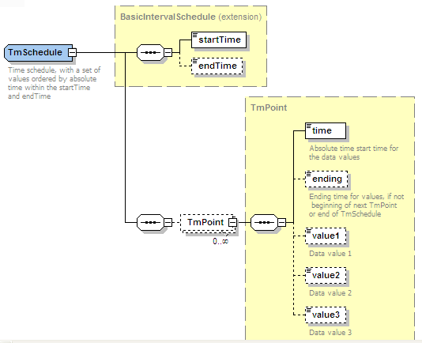

The following is a realization of an EnergySchedule using a ‘TmSchedule’. The startTime and endTime indicate the range of times for the schedule, typically covering a day.

<msg:EnergySchedule>
<msg:startTime>2007-10-17T00:00:00-05:00</msg:startTime>
<msg:endTime>2007-10-17T24:00:00-06:00</msg:endTime>
<msg:TmPoint>
<msg:time>2007-10-17T00:00:00-05:00</msg:time>
<msg:value1>120</msg:value1>
</msg:TmPoint>
<msg:TmPoint>
<msg:time>2007-10-17T10:00:00-06:00</msg:time>
<msg:value1>130</msg:value1>
</msg:TmPoint>
<msg:TmPoint>
<msg:time>2007-10-17T16:00:00-06:00</msg:time>
<msg:value1>115</msg:value1>
</msg:TmPoint>
</msg:EnergySchedule>

This example is graphically represented in the following diagram:

The following is a variation, where the optional ‘ending’ time is allowed for each TmPoint. This permits gaps in schedules. The following is a realization of an EnergySchedule using a ‘TmSchedule’, where a five hour gap is defined using the ‘ending’ tag.

<msg:EnergySchedule>
<msg:startTime>2007-10-17T00:00:00-05:00</msg:startTime>
<msg:endTime>2007-10-17T24:00:00-06:00</msg:endTime>
<msg:TmPoint>
<msg:time>2007-10-17T00:00:00-05:00</msg:time>
<msg:ending>2007-10-17T05:00:00-05:00</msg:ending>
<msg:value1>120</msg:value1>
</msg:TmPoint>
<msg:TmPoint>
<msg:time>2007-10-17T10:00:00-06:00</msg:time>
<msg:value1>130</msg:value1>
</msg:TmPoint>
<msg:TmPoint>
<msg:time>2007-10-17T16:00:00-06:00</msg:time>
<msg:value1>115</msg:value1>
</msg:TmPoint>
</msg:EnergySchedule>

This example is graphically represented in the following diagram, where there is a ‘gap’ from 5AM to 10AM:

