ERCOT OPERATIONS REPORT
ON THE
EECP EVENT
OF
DECEMBER 22, 2006

Executive Summary 3
Time Line and Description of Significant Events 4
Observations/Data Review...........................................................................................5
Lessons Learned.........................................................................................................11

Executive Summary

ERCOT implemented Step One of its Emergency Electric Curtailment Plan (EECP) on December 22, 2006. Factors that led to ERCOT implementing the EECP Step One:

At 02:53:46 ERCOT load was approximately 27,100 MW and frequency was 59.982 Hz when a fault occurred on Unit A main power transformer. Unit A was not generating at the time.

In response to this fault, Unit B, which is in close proximity electrically to Unit A, tripped offline due to operation of the transformer differential relay as reported by the plant operators at 02:53:50. Plant operators observed a transient voltage drop of 10kV on the 345kV bus. Unit B was carrying 130 MW at the time of the trip.

Approximately 16 sec after Unit B tripped, Unit C carrying 803 MW tripped at 02:54:06 due to loss of unit auxiliaries and Unit D began to run back.

At 02:54:07 168 MW of LaaR responded due to a frequency drop below 59.8 Hz.

At 02:54:52 Unit D tripped at a level of 561 MW also due to loss of unit auxiliaries. At this point, with the frequency reaching a low point of 59.681 Hz based on the ERCOT high-speed data recorder, 831 MW of LaaR responded to the unit trips. Frequency immediately recovered to 59.84 Hz. Unit E and Unit F ramped back an additional 170MW over the next several minutes.

At 02:59:11, a VDI was issued to trip all remaining LaaR with frequency hovering in the 59.92-59.95 Hz range.

EECP Step #1 was initiated at approximately 03:03:00 with Adjusted Responsive Reserve at 1751 MW. By 03:09:00 an additional 374 MW of LaaR responded and frequency recovered to 60 Hz (Frequency recovered to pre-disturbance level in 9 minutes). The total LaaR response in 10 minutes of the VDI and the automatic deployment was 1205 MW.

At 03:58:00 a VDI was issued to restore all LaaR and at 04:07:00 EECP Step #1 was cancelled.

This was a NERC Reportable Event due to the loss of greater than 1000MW of generation in the ERCOT Interconnection.

Time Line and Description of Significant Events

- 02:53:46 December 22, 2006 Unit A main power transformer tripped.

- 02:53:50 Unit B tripped with 130 MW.

- 02:54:06 Unit C tripped with 803 MW. Unit D began to run back.

- 02:54:07 168 MW LaaR responded due to under-frequency at 59.8 Hz.

- 02:54:52 Unit D tripped with 561 MW. Unit E and Unit F began to run back for a total of 170 MW. 663 MW of LaaR responded due to the unit trips.

- 02:59:11 Made hot line call (VDI) to QSE’s to deploy all LaaR bid in for responsive. (A total of 1205 MW of LaaR responded within 10 minutes of the VDI, including the automatic deployment)

- 03:03:00 Made hotline call to QSE’s and implemented step 1 EECP due to adjusted responsive reserve falling below 2300 MW. Adjusted responsive reserve fell to
1752 MW.

- 03:03:28 Frequency recovered to 60.004 Hz. (9 minutes and 42 seconds to recover to pre-disturbance level). 1045 MW of responsive reserve deployed.

- 03:19:00 SPP was notified that ERCOT is in EECP Step 1.

- 03:48:00 made hot line call for QSE’s to restore LaaR @ 3:58 due to all the responsive being recalled. Adjusted Responsive Reserve back over 2300 MW.

- 04:07:00 Terminated EECP Step 1 and issued Advisory Responsive Reserve for Adjusted Responsive Reserve below 3000MW. Adjusted Responsive Reserve was 2705 MW.
Subsequent Information Received

Unit A main power transformer (MPT) was energized to Unit A but switched open on the 345kV bus at the time the fault occurred. This transformer had a recent history of problems and diagnostics had been completed on the transformer.

Unit A and its MPT were synchronized to the ERCOT Power System at this time through a back feed into a 138kV bus in preparation for bringing the unit online two days later. That 138kV bus was connected by two autotransformers to a 345kV bus at the station. The transformer experienced a phase- to-phase to ground fault on the high side of the transformer. The fault cleared in 76 ms. During the fault, the plant 480 V service dropped to 213 V.

Unit C and Unit D both tripped due to reverse power relaying. The cause for the trip of Units C and D is suspected to be low voltage on the plant auxiliary system. In the case of both units, the event began with a loss of fuel leading to a turbine trip. Once the turbine trips, the generator is removed from service by reverse power relaying.

Further investigation is planned to determine if Unit A’s main power transformer fault of 76 ms was associated with Unit C’s & D’s loss of auxiliaries.

Observations/Data Review

02:50 – 3:00 GENERATION AND FREQUENCY

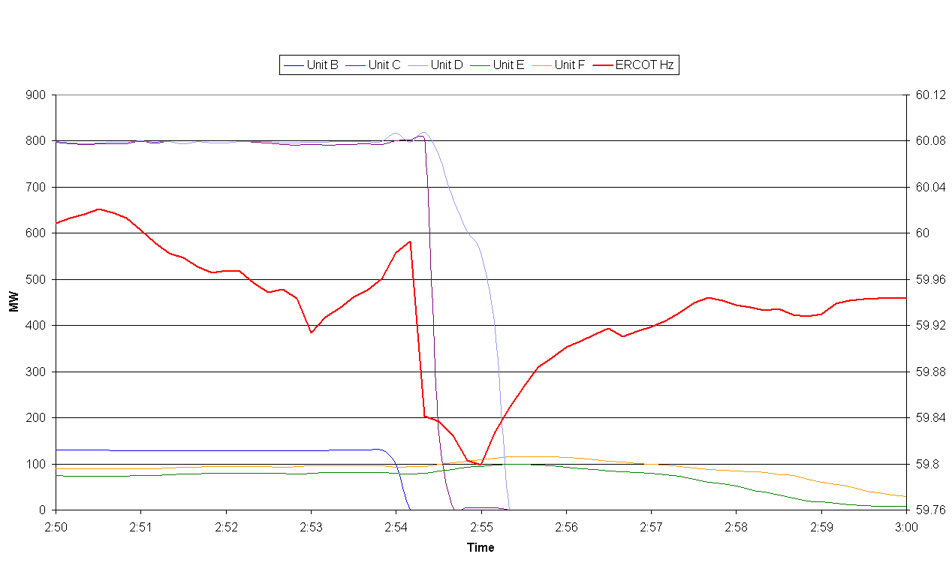

02:00 – 03:00 UNIT B 345kV VOLTAGE

Graph provided by Unit B Operator.

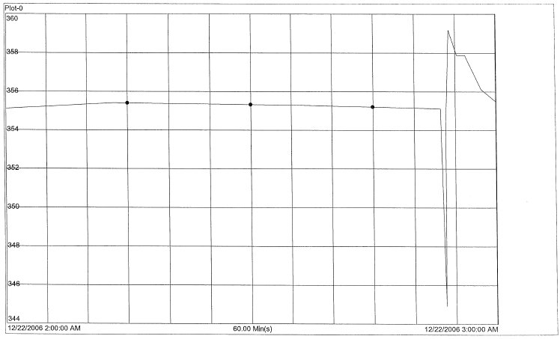

02:00 – 4:00 LOAD AND ADJUSTED RESPONSIVE RESERVE

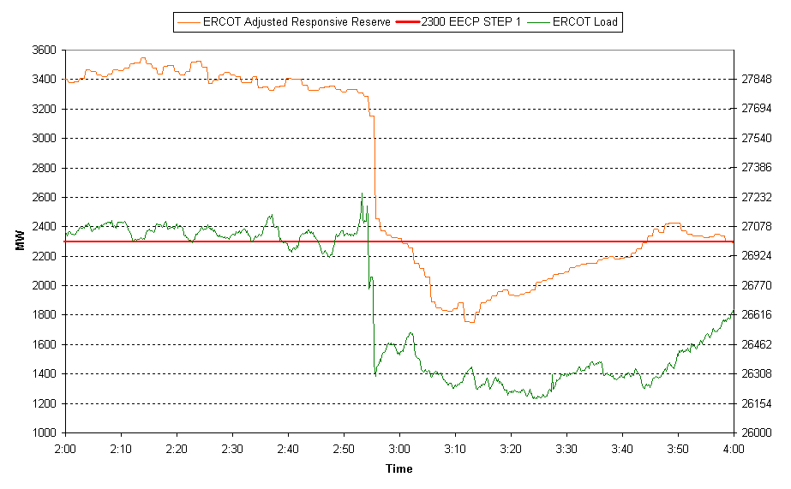

02:50 – 03:20 LaaR AND FREQUENCY

- 2:54:07 168 MW of LaaR deploys on under-frequency
- 2:54:55 663 MW of additional LaaR deploys on second unit trip
- 2:59:11 VDI issued to deploy all remaining LaaR
- A total of 1205 MW of LaaR are deployed within 10 minutes of VDI

02:30 – 03:30 FREQUENCY AND REGULATION

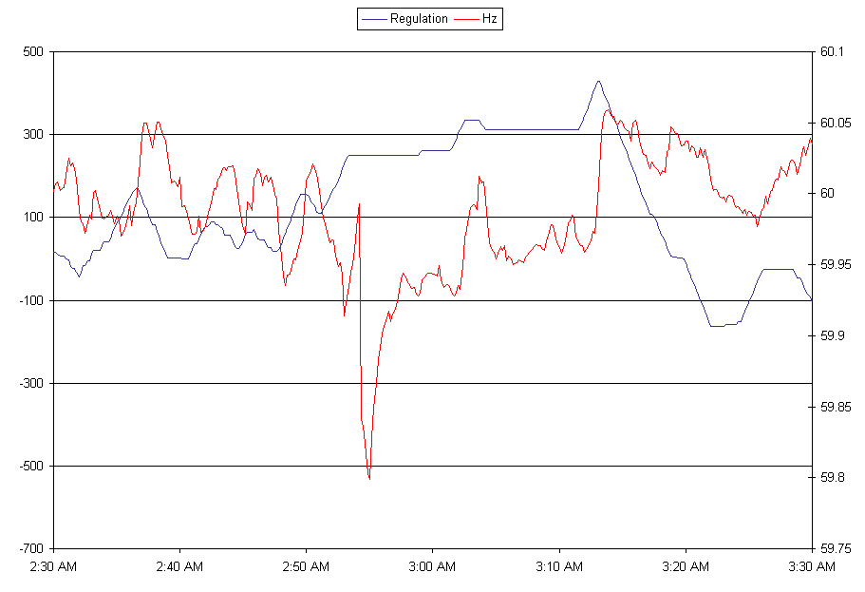
Lessons Learned

A total of 1205 MW of LaaR deployed within 10 minutes of the VDI, however, not all LaaR deployed when frequency dropped to 59.7 Hz.

Loss of greater than 1000 MW of generation is not a DCS reportable event however it is a NERC reportable event.

An initial report was filed with NERC a subsequent report with reasons why generators tripped will need to follow.

What are unit requirements for ride-through during voltage fault transients?

The investigation findings of this event will be reported by ERCOT Compliance.

ERCOT Operations recommends that the SPWG to investigate this issue.

