

ERCOT Independent Review

TXUED Anna – Collin – NW Carrollton 345 kV Line Upgrade Projects

February 6, 2007

ERCOT Regional Planning

ERCOT Independent Review

TXUED Anna – Collin – NW Carrollton 345 kV Line Upgrade Projects

Project Submitted
In October 2006, TXU Electric Delivery submitted a project to upgrade the Anna – Collin 345 kV line and the Collin – Northwest Carrollton 345 kV line. The 13.2 mile Anna – Collin 345 kV line was proposed to be reconductored from 2-795 kcmil ACSR conductor operating up to 120 degrees C to 2-959.6 kcmil ACSS/TW conductor operating up to 180 degrees C for 3200 Amp capacity. The 19.3 mile Collin – Northwest Carrollton 345 kV line will be upgraded to allow the conductor to operate at 120 degrees C instead of the present 90 degrees C by raising various lattice tower structures to achieve 2292 Amp capacity. The cost of the Anna – Collin segment as submitted is approximately $4 M and the cost of the Collin – Northwest Carrollton segment is approximately $3 M. The project area is shown in the figure below.

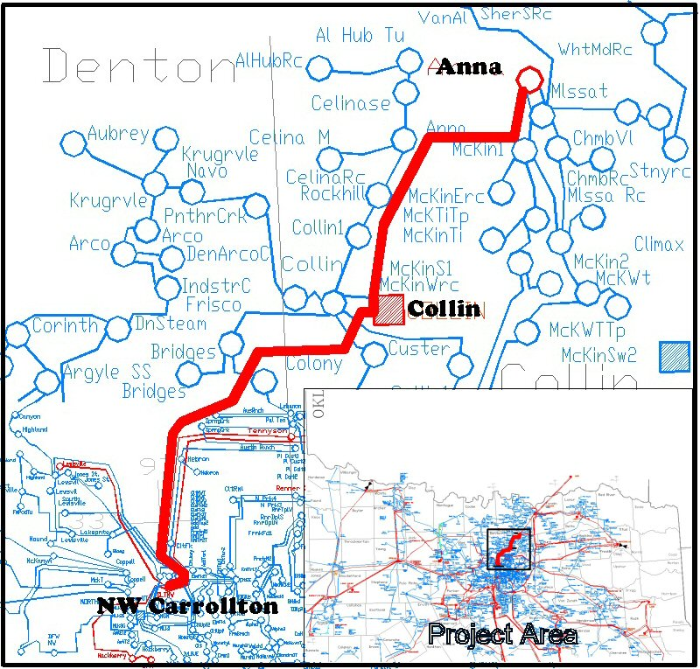

Project Scope
It should be noted that the upgrade of the Anna – Collin 345 kV line was determined to be necessary and economic during work on the 2006 ERCOT Five Year Plan study. The results of this study can be found in the 2006 Electric Reliability Council of Texas’ Report on Existing and Potential Electric System Constraints and Needs document available on the ERCOT website.

The need and economic viability of upgrading the Anna – Collin 345 kV line was confirmed during the course of this study. In 2007 and 2008, the upgrade of the Anna – Collin 345 kV line saved $2.6 million and $5 million in production costs respectively.

For this reason, the remainder of the study presented in this document will concentrate on the upgrade of the Collin – Northwest Carrollton 345 kV line.

Project Analysis

Base Cases
The SSWG summer peak cases, 07sum1updated11272006, ss08sum1eco12052006, ss09sum1eco12052006 and ss10sum1eco12052006 were used for 2007, 2008, 2009, and 2010 steady state AC analysis respectively. These cases were used to determine post-contingency AC flows on the Collin – Northwest Carrollton circuit and steady state AC per unit voltage at the Collin SS bus 2372. These values were used to modify the rating in the DC power flow to account for AC post-contingency conditions on the Collin – Northwest Carrollton 345 kV circuit as shown later in this document.

For DC economic analysis, the Five Year Plan cases, 7econ13, 8econ15, 9econ19, and 10econ12 were used. These cases all originate from the 2006 data set A and B cases last updated March 1, 2006 and were modified to exclude major transmission projects that had yet to be RPG approved and include reliability projects necessary to eliminate unserved energy and projects that proved to be economic during work on the 2006 Five Year Plan. Information on these cases is available on http://oldercot.ercot.com/tmaps/login.cfm under the link 2007 5-year Study. The results of this study are in the 2006 Electric Reliability Council of Texas’ Report on Existing and Potential Electric System Constraints and Needs document.

All base cases were modified as necessary to reflect the availability of Valley units 2 and 3 and the unavailability of Mountain Creek unit 2, which recently submitted a Notice of Suspension of Operations. The cases were also modified to reflect new transmission line parameters for the Anna to Collin 345 kV line after it is upgraded.

The 2010 case was also tested with the 858 MW Valley Unit #4 at the 138 kV Valley bus number 1691, as a sensitivity. Valley units 2 and 3 were removed from service with the addition of Valley unit #4. To resolve overloads on the Anna to Collin 345 kV and Valley to Payne 138 kV circuits that resulted, several projects identified in the Valley #4 full interconnect study (09INR0014) were added to the case. These additions consisted of the Valley to Payne 345 kV line, Payne 345 kV station, Payne 345/138 kV autotransformer, and upgrade of the 138 kV paths from Payne to Collin.

Alternative Description
Two alternatives were studied by TXUED in their submitted document; continuation of the SPS, and rebuilding the entire Anna – Collin – NW Carrollton circuit using double circuit construction that would cost more than $ 36 M. Neither of these alternatives was studied by ERCOT.

Reliability Analysis
The upgrade of the Collin – NW Carrollton 345 kV circuit was determined to be not reliability-driven, since a security constrained generation dispatch was available to keep the post-contingency loading under 100% of the emergency rating of 1072 MVA. Thus, an economic analysis of the cost of that dispatch, relative to the cost of the dispatch that could be used to serve load if the circuit was upgraded, was performed.

Economic Analysis
The economic analysis using a DC power flow did not initially show the Collin – NW Carrollton line to be an economic constraint using the full MVA rating of 1072 MVA. However the high post-contingency MVar flow shown in the AC steady state analysis and the post-contingency voltage drop at the Collin SS (2372) bus could not be accurately modeled in the DC power flow.

To compensate for these AC factors in the DC model, the Collin – NW Carrollton line was de-rated in the DC power flow so that the rating in the DC power flow reflected the real part of the ampere flow seen in the post-contingency AC power flow. The contingency used was the loss of the Farmersville to Royce 345 kV double circuit. This contingency causes the highest loading on this line.

The Monticello #2 B and Allen Switch 345/138 kV Autotransformer #1 Series Reactor SPSes were modeled in UPLAN as protective schemes in order to test the effectiveness of this SPS exit strategy for the Valley 345 kV SPS. Since this project is specifically to exit the Valley 345 kV SPS, all other SPSes were assumed to still be in service. Only these two SPSes were modeled because the lines protected by these SPSes were actually binding generation or causing congestion.

After applying the above UPLAN MW ratings to the 2007 – 2010 economic cases and modeling the two SPSes, the production cost savings in the 2007 – 2010 period for upgrading the Collin – NW Carrollton line after upgrading the Anna – Collin line were:

The production cost savings from the proposed project exceed the annual carrying cost of the project ($3 million * 16.8% carrying cost rate = $0.5 million) for 2007-2009. The production cost savings in 2010 due to the line upgrade increases dramatically to $5.7 million if the Valley #4 unit is present but zero without it due to other constraints.

Summary
The upgrade of the Collin – NW Carrollton line can not be recommended at this time. The production cost savings from the project support its cost in 2007-2009 but without the Valley #4 unit the 2010 production cost savings is zero. This line will be studied again during the 2007 Coal Plant Transmission study.

The Anna – Collin 345 kV line is economic and recommended. This project will pay for itself in two years.

Designated Providers of Transmission Facilities
In accordance with ERCOT’s Power System Planning Charter and Processes, ERCOT staff is to designate transmission providers for projects reviewed in the regional planning groups. These providers can agree to provide or delegate the new facilities or inform ERCOT they do not elect to provide them. For the project scope recommended in this report, TXU Electric Delivery is the designated provider for this project.

