EDS 1

Approach

Early Delivery Systems

Submitted By

EDS Project Team
Texas Nodal Project

February 2007

TABLE OF CONTENTS
EDS 1 OVERVIEW 3
Introduction 3
Transition Plan Tasks 3
EDS 1 Releases 3
Beta Testing 4
Description 4
Beta Testing Objectives 4
Beta Testing Organization Chart 4
Checklist Template Example 5
Release 1 6
Description 6
Release 1 Objectives 6
Release 1 Entry Criteria 7
Release 1 Exit Criteria 7
Release 2 8
Description 8
Release 2 Objectives 8
Release 2 System Design 8
Release 2 Entry Criteria 9
Release 2 Exit Criteria 9
EDS 1 High Level Timeline 10
Appendix 11
Beta Testing Tasks 11
Verification Steps for Beta Testing Stations 11

EDS 1 OVERVIEW

Introduction
Each Early Delivery System (EDS) release is a deployment of new applications, hardware, functions and processes to satisfy the objectives of the Transition Plan tasks as outlined in the ERCOT Nodal Transition Plan document.

This document summarizes the approach for EDS 1 and describes how each release of new EDS 1 testing environments will satisfy a set of related Transition Plan tasks.

Transition Plan Tasks
The related transition plan tasks for EDS 1 are listed below:
- 5.4.1 (1) - Install systems, build and verify graphic displays for all substations, verify actual telemetry from TSPs and QSEs
- 5.4.1 (2d) - Verify redundant communications (ERCOT, TSP and QSE)
- 5.4.1 (2e) - Verify telemetry meets performance requirements
- 5.4.1 (2f) - Verify alarm processing for changes in status
- 5.4.1 (2g) - Verify alarm processing for limit violations
- 5.4.1 (2k) - Verify telemetry meets Protocol 3.10.7.4 (failover, scan rates)

EDS 1 Releases
EDS 1 testing is organized into three distinct activities. Each activity corresponds to a Nodal EMS system software and hardware release. . The activities/releases are:
- Beta Testing - Perform Beta Testing Point-to-Point Verification process
- Release 1 - Configure and Verify ERCOT Alarm Processing
- Release 2 - Verify ICCP Communications, Performance and Failover for TSPs, QSEs and ERCOT and perform Point-to-Point Verification for all SCADA telemetry

Beta Testing

Description
This activity will test the point-to-point testing processes to determine if there are any systematic problems with telemetry with QSEs and TSPs. The Beta testing results will be used to identify potential issues and to plan and streamline the point-to-point verification activity that will occur in Release 2. The Beta Testing will include testing of 2 stations for each TSP and 2+ resources for each QSE.

Beta Testing Objectives
- To test the testing process planned for point-to-point verification of telemetry by ERCOT operators and TSP/QSE operators.
- To verify real-time values and status for selected TSP and QSE stations.
- To verify that the TSP and QSE substation topology diagrams match the ERCOT one line substation diagrams.
- To streamline the point to point testing process and reduce the time to complete by working closely with the operators who perform the test.
- To record and analyze systematic issues (quality codes, mapping, other) and to communicate back to TSPs, QSEs and ERCOT operations.
- To prepare for the point-to-point testing activity.

Beta Testing Organization Chart
The following organization chart illustrates the EDS 1 team structure and the interaction between EDS 1 team members and the TSPs/QSEs:

Checklist Template Example
The following diagram illustrates the point-to-point testing checklist template that will be filled out for each station during the Beta Testing:

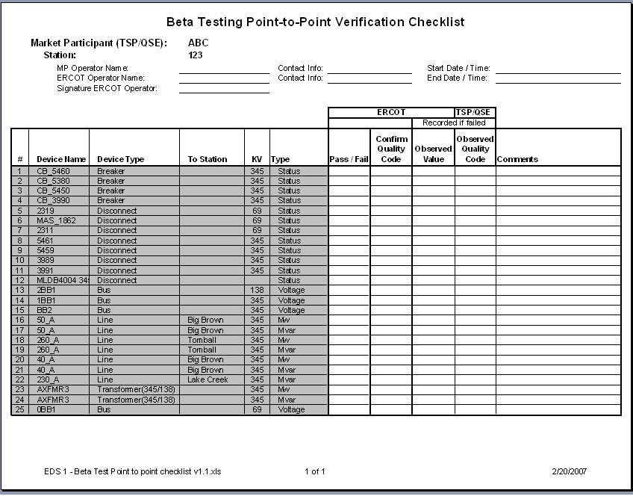

Release 1

Description
This activity will analyze and improve the existing ERCOT operator alarm configuration. The EDS 1 team will work with the ERCOT operators to identify the desired alarm processing configuration to categorize, organize and prioritize alarms. This activity addresses ERCOT Nodal Transition Plan Tasks 5.4.1 (2f) and (2g), and will be verified using selected TSPs and QSEs.

Release 1 Objectives
- To identify the desired alarm process configuration working with ERCOT operators
- To design an approach to categorize, organize and prioritize alarms
- To gain approval of the alarm configuration design by ERCOT Operations Management
- Configure the approved design using the Nodal EMS (COTS) System
- Verify the configuration with selected TSPs and QSEs, by having Operators randomly test selected breakers and switches and enter values that exceed selected limits to test message organization/categorization
- Implement Alarm Configuration on the Nodal EMS System

Release 1 System Design

Release 1 Entry Criteria
Before EDS 1 – Release 1 can begin; the following entry criteria (dependencies) must be met:
- The EMS Nodal System – version 2.3 COTS (commercial off the shelf):
  - Must have completed ITEST (integration test)
  - Must be installed in the EDS 1 environment

Release 1 Exit Criteria
For EDS 1 – Release 1 to complete; the following exit criteria must be met:
- The alarm configuration design is approved by ERCOT Operations Management
- The alarm configuration has been implemented on the EMS COTS Nodel System
- ERCOT Operators have verified the configuration and have signed-off

Release 2

Description
This release will include two main activities. It will verify ICCP communication links from TSPs and QSEs and insure proper ERCOT communication links and failover, and it will perform point-to-point verification between ERCOT and each TSP and QSE for all SCADA telemetry These activities address ERCOT Nodal Transition Plan Tasks 5.4.1 (1), (2d), (2e) and (2k).

Release 2 Objectives
- Verify ICCP performance for each TSP and QSE during failover configurations
- Verify ICCP and EMS failover performance at ERCOT
- Verify ERCOT’s substation topology diagrams match TSP’s one line diagrams
- Perform point-to-point testing by station for all TSPs and QSEs
  - Verify status by toggling each breaker and switch and verifying change in status and in quality code
  - Perform analog verification by cross-checking displayed values at ERCOT and at TSPs/QSEs for each telemetered analog point
  - Verify correct operation of telemetered quality codes by manually replacing selected analog points
- Identify issues and request TSPs and QSEs to submit change request to correct errors
- Place the SCADA database under a full change control process

Release 2 System Design

Release 2 Entry Criteria
Before EDS 1 – Release 2 can begin; the following entry criteria (dependencies) must be met:
- The EMS/ICCP Nodal System – version 2.3 COTS (commercial off the shelf):
  - Must have completed ITEST (integration test)
  - Must be installed in the EDS 1 environment

Release 2 Exit Criteria
For EDS 1 – Release 1 to complete; the following exit criteria must be met:
- Verification of all substation one lines for all TSPs and QSEs match ERCOT’s
- Verify displays of all Resources for QSEs
- Verify telemetry mapping for all SCADA points for TSPs and QSEs
- SCADA database under full change control process

EDS 1 High Level Timeline
The following diagram represents the EDS 1 release activities timeline for the Beta Testing, Release 1 and Release 2.

Appendix

Beta Testing Tasks
# | Description | Who
1 | Develop Beta Testing approach | EDS 1 Team
2 | Communicate and agree approach with TPTF | EDS 1 Team, TPTF
3 | Obtain contacts to schedule Beta Testing:  - For each TSP  - For each QSE | EDS 1 Team, TSP/QSE
4 | Create checklist for each station to be Beta Tested | EDS 1 Team
5 | Provide station checklists to TSP/QSE contacts | EDS 1 Team
6 | Confirm schedule and identify operators that will perform the verification | EDS 1 Team, ERCOT Operations, TSP/QSE Operators
7 | Perform the Beta Testing | ERCOT Operations, TSP/QSE Operators
8 | Record results and issues | ERCOT Operations, TSP/QSE Operators
9 | Analyze and resolve issues | EDS 1 Team
10 | Submit Service Requests to resolve issues if required | TSP/QSE
11 | Process Service Requests | ERCOT Operations

Verification Steps for Beta Testing Stations
The following steps describe the verification activity and instructions for completing the Beta Testing Point-to-Point Verification Checklist spreadsheet:

- Record Operator Names (ERCOT and TSP/QSE) on the spreadsheet
- Record Operator contact information on the spreadsheet
- Record Start Date / Time and End Date / Time on the spreadsheet
- The TSP/QSE operator emails a cut and paste of the Station topology diagram to the ERCOT operator.
- The ERCOT operator phones the TSP/QSE operator and walks thru the diagram to ensure that the station is drawn correctly. Modeling errors are identified and changes to the model will be submitted by the TSP/QSE to ERCOT via a Service Request.
- Once the one-line displays are reviewed, each operator will then walk thru the Beta Testing Point-to-Point Verification Checklist spreadsheet. This spreadsheet will be used to verify each of the Beta test station points. Each column in the spreadsheet is either provided with information or will need to be entered during the verification exercise. The following table describes each column in the verification checklist and instructions to complete:

Who | Column Name | Provided / Needed | Description
EDS 1 Team | # | Provided | Point #
EDS 1 Team | Device Name | Provided | Device Name
EDS 1 Team | Device Type | Provided | Line, Unit, Breaker, Disconnect
EDS 1 Team | To Station | Provided on Lines | Line from Station Name - To Station
EDS 1 Team | KV | Provided | 345 KV, 138 KV, 69 KV
EDS 1 Team | Type | Provided | Measurement Type (Status, MW, MVar)
ERCOT Operator | Pass / Fail | Needed | Verification Passed or Failed due to values/status being the same or different. The ERCOT operator only needs to document Failed values in the spreadsheet.
TSP/QSE Operator, ERCOT Operator | Toggle Status | Needed | TSP/QSE toggles the status, ERCOT confirms toggled status, ERCOT confirms quality code (should display ‘Replaced’), TSP/QSE returns the status to normal. ERCOT confirms status and quality code back to normal
TSP/QSE Operator | Confirm Value | Needed | TSP/QSE states value
ERCOT Operator | Confirm Value | Needed | ERCOT confirms value
Either ERCOT or TSP/QSE Operator | Comments | As needed | Comments should include any long delays when toggling between values and quality codes, reasons why a test failed, and if there are missing points from either ERCOT or TXU.

To complete the verification, the ERCOT operator who performed the test signs the spreadsheet and provides back to the EDS 1 Team.

