ERCOT OPERATIONS REPORT
ON THE
EECP EVENT
OF
FEBRUARY 24, 2007

Executive Summary 3
Time Line and Description of Significant Events 4
Observations/Data Review...........................................................................................5
Lessons Learned.........................................................................................................10

Executive Summary

ERCOT implemented Step One of its Emergency Electric Curtailment Plan (EECP) on February 24, 2007. Factors that led to ERCOT implementing the EECP Step One:

Morning load pickup continued to climb by 1000 MW/Hr, leveling off at 10:30 AM at approximately 30,200 MW. Starting at 9:00 AM wind generation started to drop by 600 MW/Hr.

At 10:20:00, ERCOT declared an Advisory for Adjusted Responsive Reserve (ARRS) below 3000 MW.

As ARRS and wind generation declined, ERCOT declared an Alert for ARRS below 2500 MW at 11:15:00.

At 11:43:00 ERCOT declared EECP. At this time wind generation had lost a total of 1550 MW from its morning peak generation. The aggregate SCE at this time was
-1369 MW.

As ARRS was recovering, an 1180 MW Unit (Unit A) tripped while loaded at 226 MW at 12:00:00. ARRS did not show a significant change, however aggregate SCE dropped to -1498 MW. The unit was coming offline for a scheduled shutdown. Responsive Reserve (RRS) Deployed 364 MW.

EECP was terminated at 12:15:00.

Time Line and Description of Significant Events

- 10:20:00 February 24, 2007 Advisory issued for Adjusted Responsive Reserve below 3000 MW.

- 11:15:00 Alert issued for Adjusted Responsive Reserve below 2500 MW. Wind generation dropped 500 MW since 9:15 AM.

- 11:20:00 OOME RMR unit(s) to the top for Alert issued.

- 11:43:00 EECP Step 1 declared. Hotline call to QSE’s instructing them to call back with all units that are available and their start times.

- 11:44:00 Notified SPP to maximize the DC Tie coming into ERCOT due to ERCOT declaring EECP Step 1.

- 11:45:00 ARRS rose above 2300 MW’s.

- 11:47:00 Notified SPP at this time ERCOT does not need any additional imports on the DC tie, but ERCOT is still in EECP 1.

- By 12:10:00 Several QSEs reported that they had executed ERCOT instructions and reported plants and the times the units are available to start.

- 12:15:00 EECP terminated. ARRS was at 2,816 MW.

Observations/Data Review

09:00 – 13:00 GENERATION AND ARRS

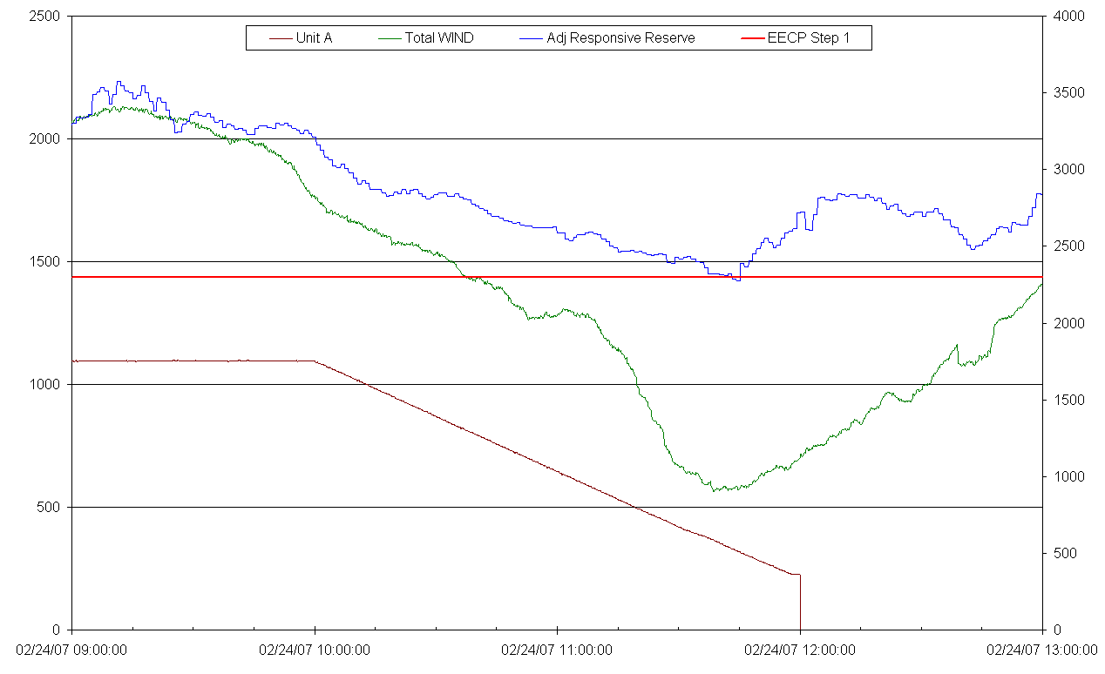

09:00 – 13:00 LOAD, RRS AVAILABLE, AND ARRS

09:00 – 13:00 ARRS AND TOTAL SCE

QSE total SCE dropped to -1498 MW at 12:00.

09:00 – 13:00 FREQUENCY AND REGULATION

09:00 – 13:00 UNIT A, TOTAL WIND, AND RRS DEPLOYED

Lessons Learned

Drop in total wind generation had a significant impact on Adjusted Responsive Reserve.

Replacement Reserve Services (RPRS) uses the planned output of wind.

There was no noticeable increase in available Adjusted Responsive Reserve as a result of the early Advisories and Alerts.

Need to find out why the wind units came off-line and how they did it.
- Lack of wind?
- Too much wind?
- Did they ramp down or trip off-line?

