ERCOT OPERATIONS REPORT
ON THE
EECP EVENT
OF
FEBRUARY 8, 2007

Executive Summary 3
Time Line and Description of Significant Events 4
Observations/Data Review...........................................................................................5
Lessons Learned.........................................................................................................13

Executive Summary

ERCOT implemented Step One of its Emergency Electric Curtailment Plan (EECP) on February 8, 2007. Factors that led to ERCOT implementing the EECP Step One:

At 9:15, ERCOT declared an Advisory for Adjusted Responsive Reserve (ARRS) below 3000 MW.

An earlier than predicted cold front arrived not long after the morning peak load. The load continued to grow resulting in a decline of ARRS.

As ARRS declined, ERCOT declared an Alert for ARRS below 2500 MW at 10:35.

At 11:20 ERCOT experienced low frequency due to a large schedule change which caused 253 MW of Responsive Reserve (RRS) to be deployed. The load also leveled off at 34,000 MW this exceeded the morning peak which was 33,440 MW at 7:15. In the Day-Ahead Market, generation procured by Replacement Reserve Service (RPRS) based on the Hour Ending 12 load forecast was short by 2272 MW from the real-time load due to early arrival of cold front. The Hour Ending 8 load forecast was 443 MW above actual load.

As ARRS was recovering from the schedule change, an 800 MW unit tripped while loaded at 375 MW at 12:01, ARRS dropped below 2300 MW. The unit was coming offline for a tube leak. RRS Deployed 453 MW.

EECP Step 1 was declared at 12:08.

Time Line and Description of Significant Events

- 9:15 February 8, 2007 Advisory issued for Adjusted Responsive Reserve below 3000 MW.

- 10:35 Alert issued for Adjusted Responsive Reserve below 2500 MW. A cold front expected to arrive at around 16:00, came earlier than predicted. Load continued to grow.

- 11:21 System deployed 254 MW of Responsive Reserve due to low frequency (59.92) due to large schedule change.

- 12:00 Unit A tripped with 375 MW as the plant was ramping down and coming offline for a tube leak.

- 12:01 Due to low frequency and unit trip system deployed 453 MW of Responsive Reserve.

- 12:01 Adjusted Responsive Reserve 2,231 MW, ERCOT Load 33,990 MW.

- 12:06 Adjusted Responsive Reserve 2,307 MW, ERCOT Load 34,100 MW.
(ARRS below 2300 MW duration was 5 minutes)

- 12:08 EECP Step 1 initiated.

- 12:10 SPP was notified to check the availability of assistance to ERCOT.

- By 12:22 Several QSEs reported that they had executed ERCOT instructions and reported plants and the times the units responded to the unit trip.

- 12:38 Emergency assistance over the East DC Tie was cancelled; schedule was set up but was never initiated.

- 12:38 EECP terminated.

- 13:00 Advisory and Alert remained in place.

Observations/Data Review

00:00 – 24:00 DAY AHEAD FORECAST (RPRS) AND REAL TIME LOAD (RTLOAD)

Values noted in the graph are at the time of 12:00 PM.

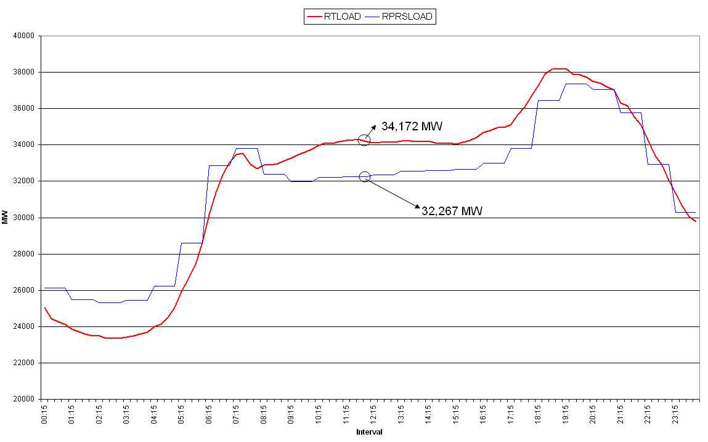
04:00 – 20:00 LOAD, RRS AVAILABLE, AND ARRS

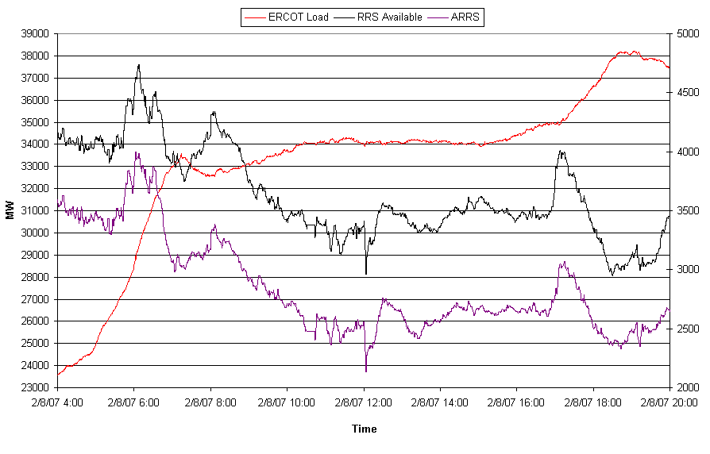
11:40 – 12:20 ARRS AND TOTAL SCE

QSE total SCE maintained approximately -250 MW for most of the morning except for the unit trip spike which dropped SCE to -971 MW.

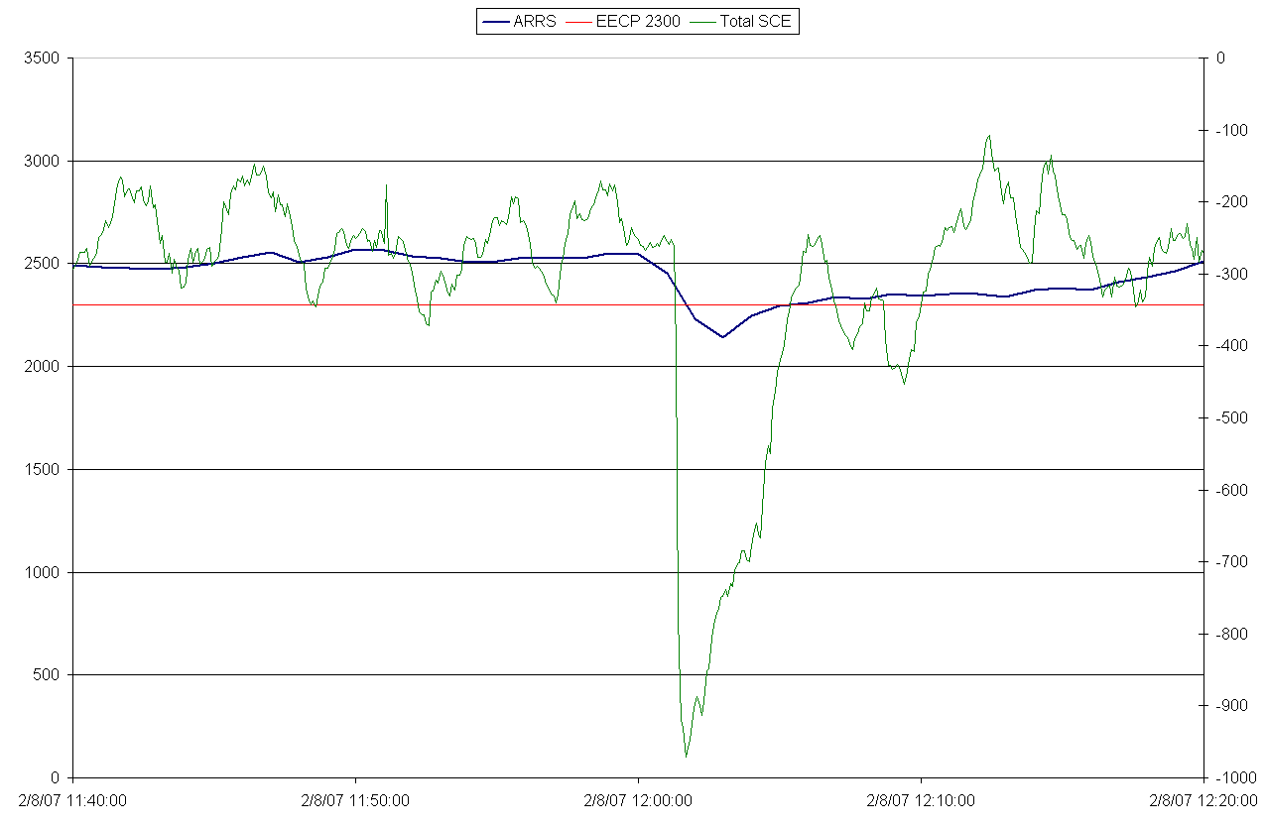
10:00 – 13:00 FREQUENCY AND REGULATION

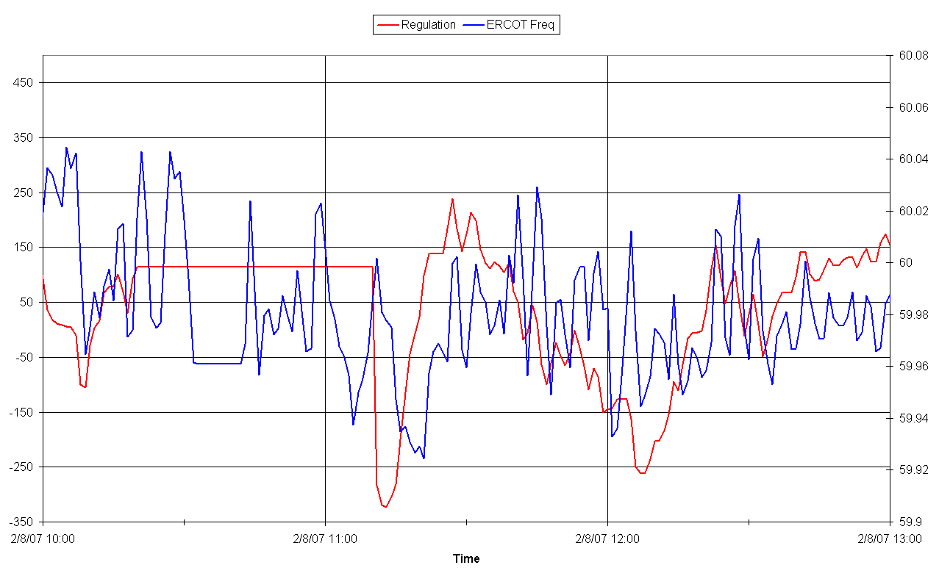

04:00 – 19:00 ARRS AND ERCOT LOAD

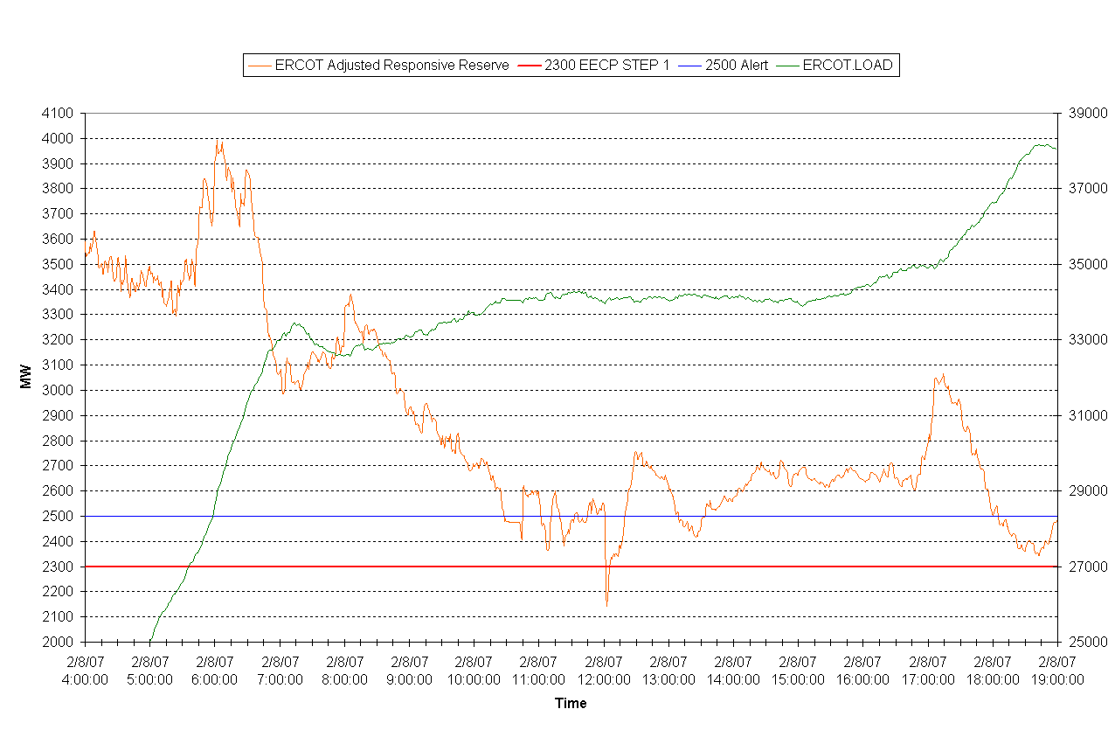
9:00 – 13:00 ARRS AND RRS DEPLOYED

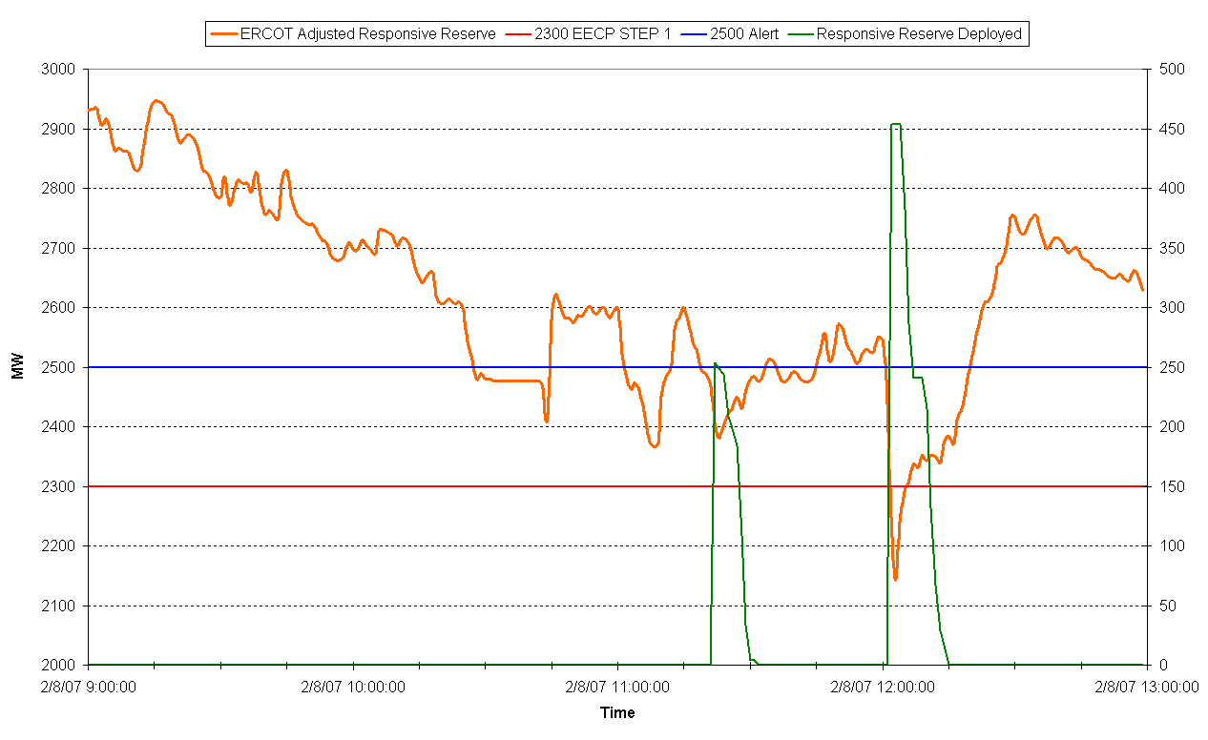

9:00 – 13:00 UNIT TRIP AND ARRS

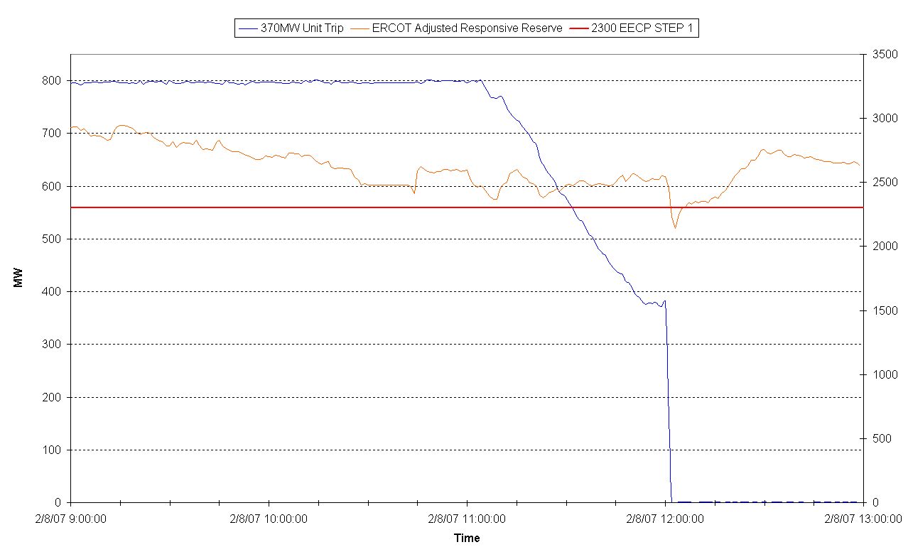
9:00 – 13:00 RRS DEPLOYMENT AND FREQUENCY
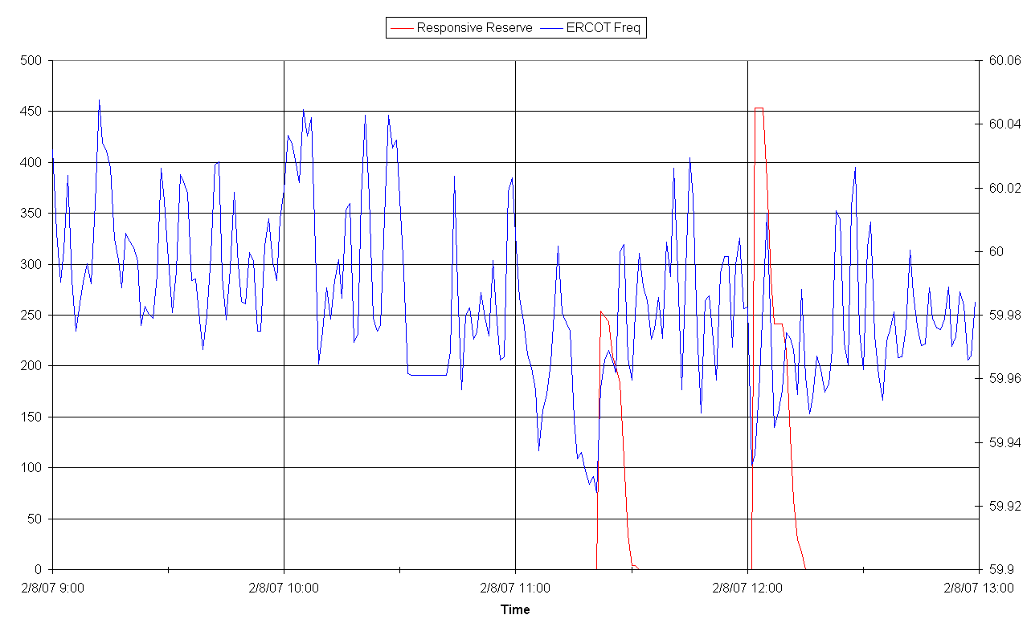

Lessons Learned

Missed load forecast after the morning load pick-up due to early arrival of cold front and a continued increase in load.

There was no noticeable increase in available Adjusted Responsive Reserve as a result of the early Advisories and Alerts.

