Revision Date: 02/17/06
Mote Study Case Setup

If you need assistance with passwords, logins, or problems with the Mote System, please call the ERCOT help desk at 512-248-6800.

Once you log into the MOTE system you will see the main Web FG screen. See figure 1

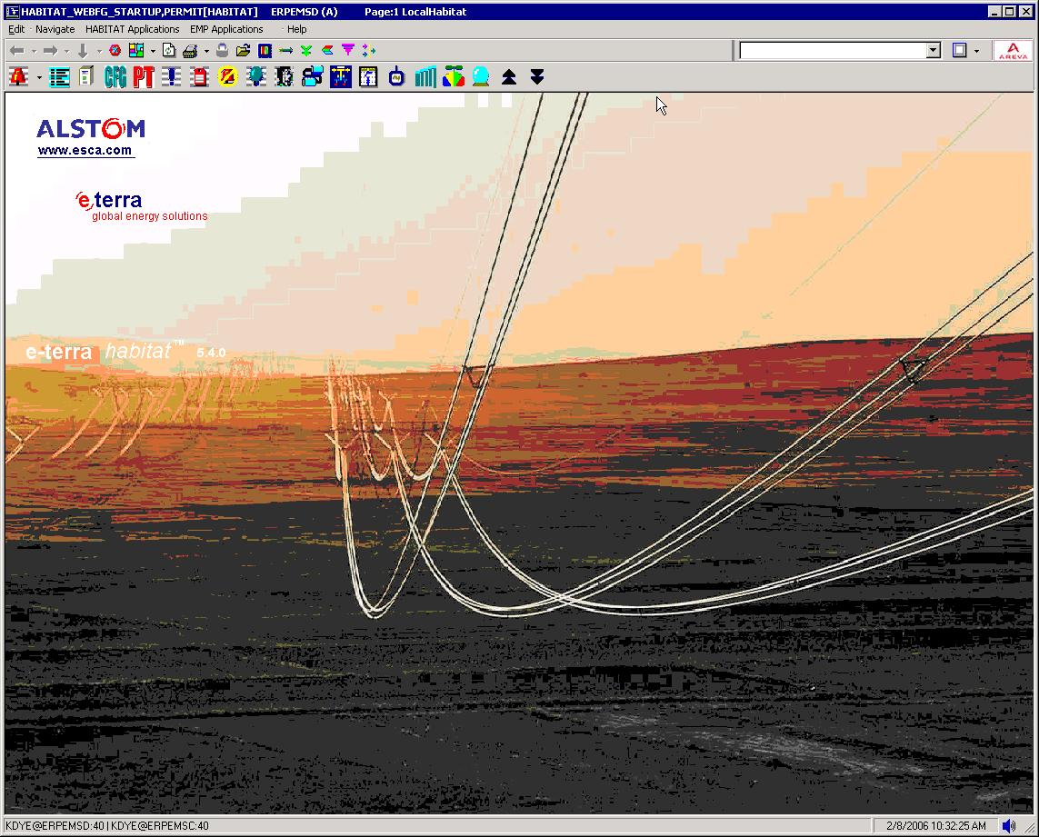
Figure 1 Main Web FG Screen

- Click on ‘EMP Applications’, ‘Network Study Applications’, then ‘Study Network Analysis’
Or click on the 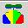 button. See Figure 2.

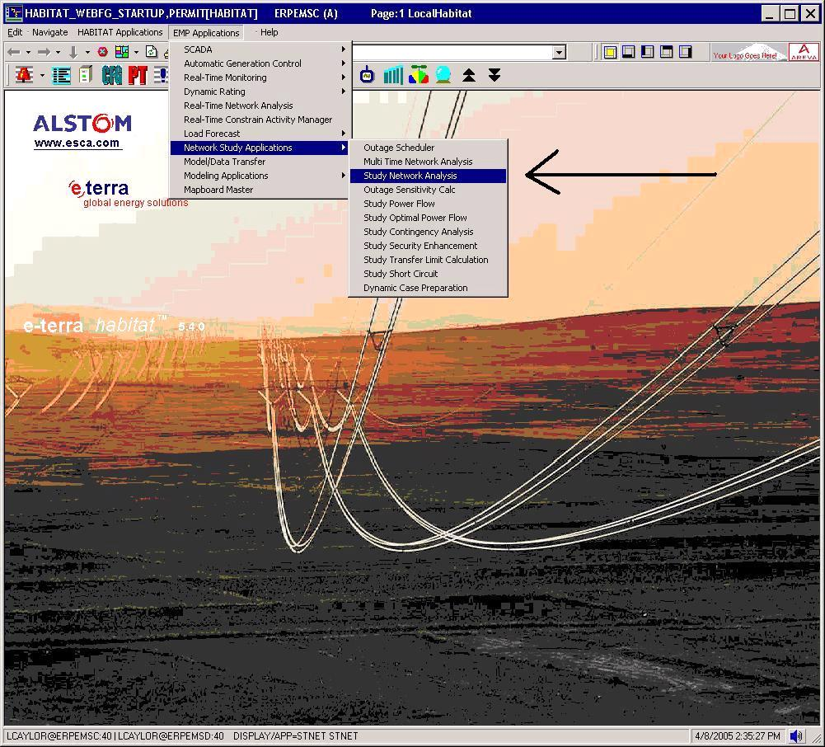
Figure 2

- The network study window will open. See Figure 3.

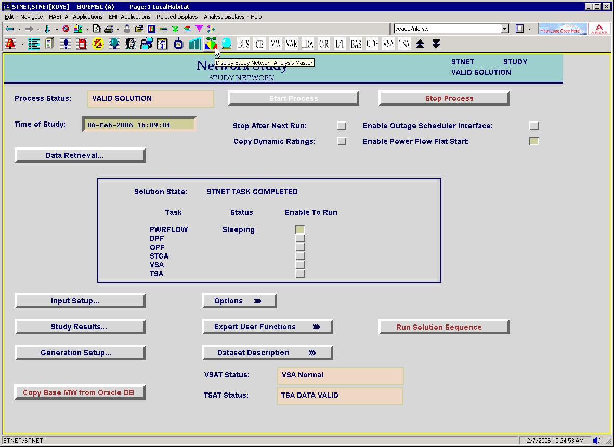
Figure 3 Main Network Study Window

- Find the ‘Stop Process’ button. Click it. Wait a few seconds for the process to stop. Then click the “Start Process’ button. See Figure 3.

NOTE: You will need to click the ‘STOP Process’ to Load any file into your Web FG.
After the file is loaded, you can then click the ‘Start Process’ button

- In the study network window, click ‘Data Retrieval’ followed by ‘Savecase Directory’. A new file directory window will open. Click ‘Update List’ in the upper left corner of the window. This will update the list of files. See Figure 4 and 5.

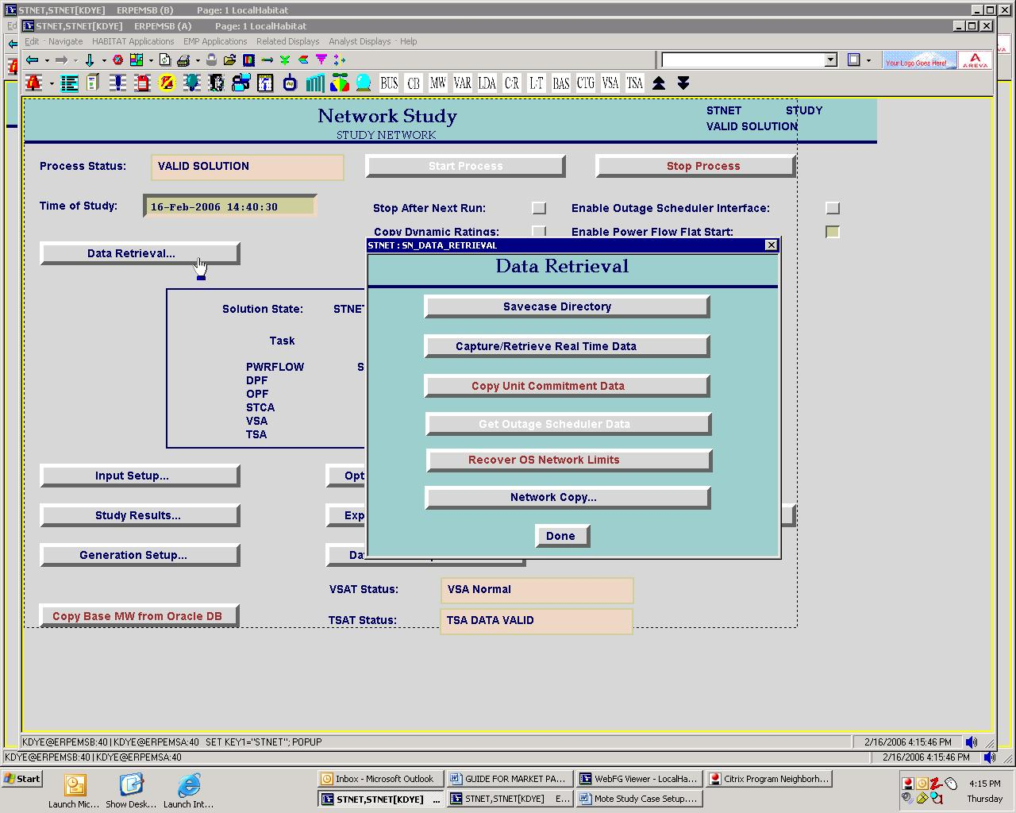
Figure 4 Data Retrieval Screen

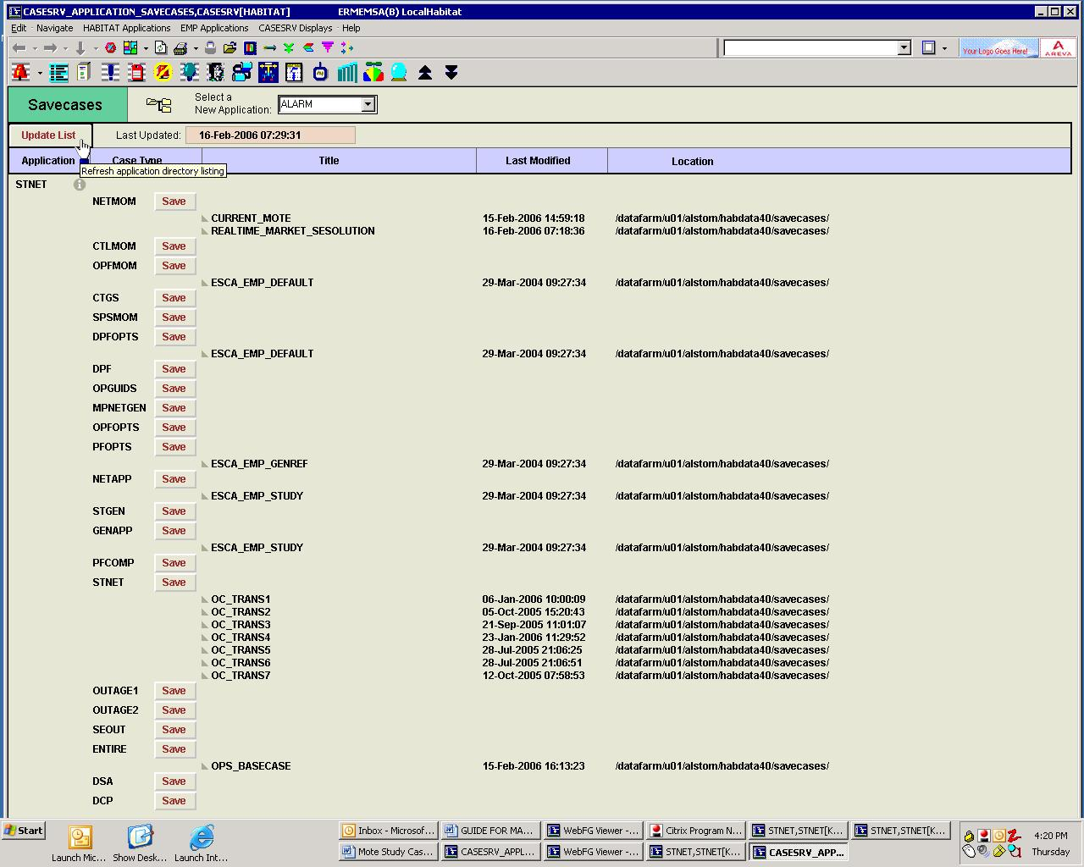
Figure 5 Saved Case Directory Screen

The file list shows several categories:
1. NETMOM.
Beside ‘Netmom’ you will see a file called ‘Current_Mote’ this is a solved daily file created by the Network Model Group of model changes. This file is updated daily after our daily archive.
2. STNET
Beside ‘STNET’ you will find seven files. These files are named ‘OC_TRANS1 thru 7’ and are cases created by the Outage coordinators.
3. Beside ‘ENTIRE’ you will see ‘OPS_BASECASE’. This file is a file used to reset your entire stnet case. This is used if you are using Web FG for the first time or it is used if you mess- up your stnet clone. It resets all you’re setting to default. See Figure 5.

- Click name of the file you wish to retrieve in you Web FG. Right mouse click and select ‘Retrieve’
This will load the current file into your Web FG. Wait for the file to load. See Figure 6.

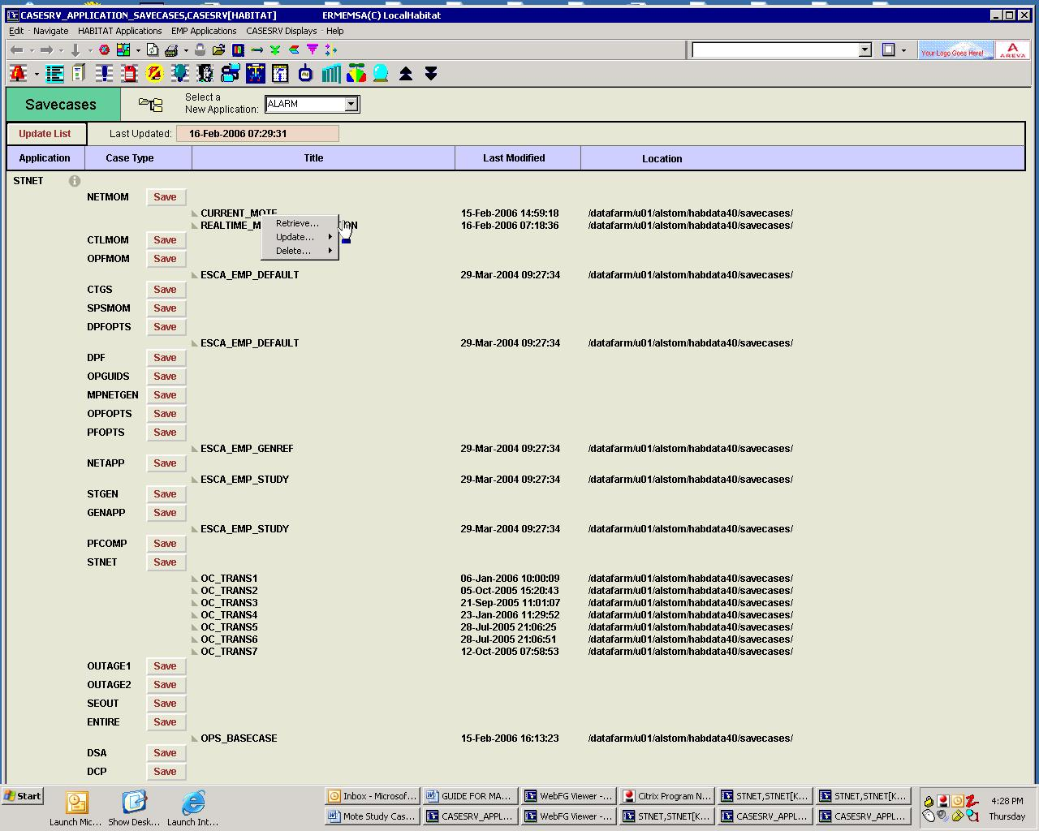
Figure 6 Web FG case update (Retrieve, Update, Delete) Please be careful not to delete any saved cases.

Note: You will need to restart the process on the Network Study page once the file is loaded.
See Step 5.

- Return to the study network window ‘EMP Applications’ ‘Network Study Applications’
‘Study Network Analysis’ (or F8 key) and click ‘Start Process’
Or Click the 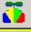 Button. See Figure 3.

- If you need to change any options for your stnet case Click on ‘Options’ which is found in the middle of the screen. The options page is used to select flat start, or change normal tap, change transformers to all ‘All Transf’.
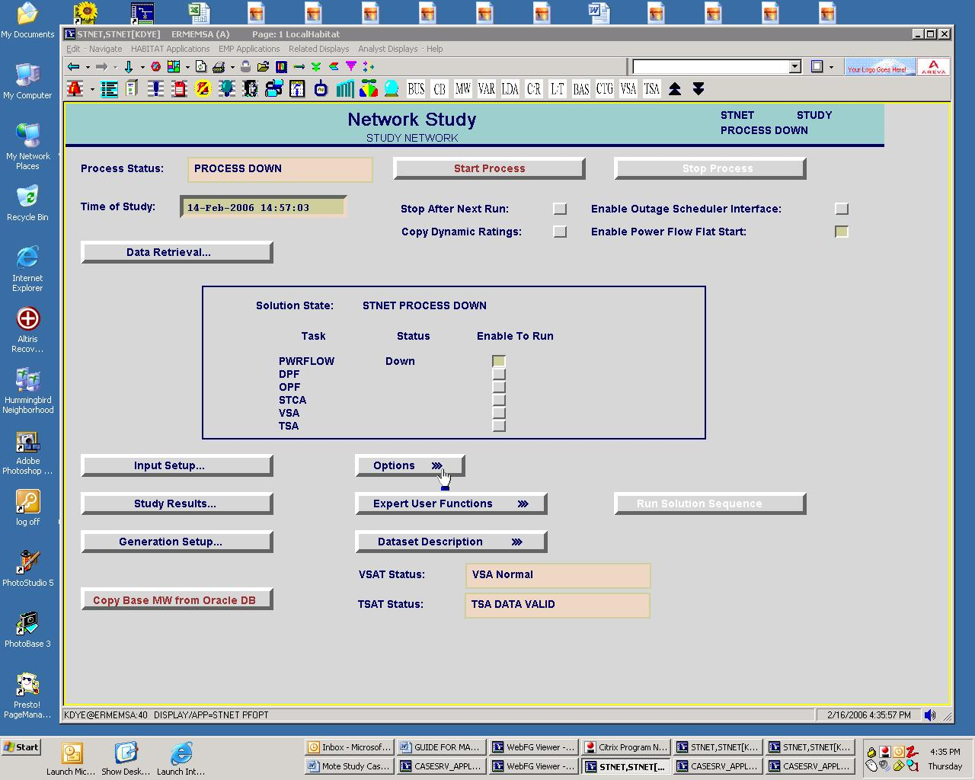
Figure 7 Options Button

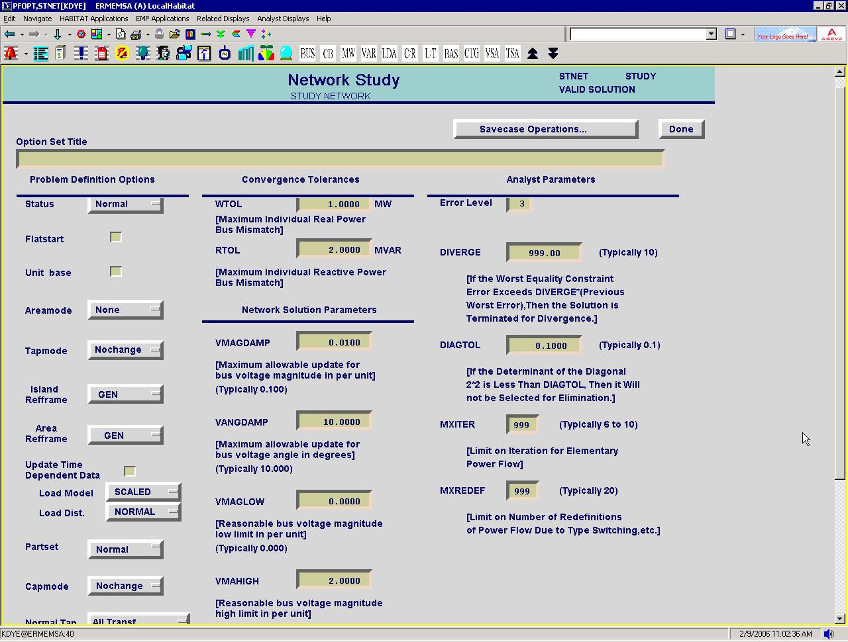
Figure 8 STNET Case Settings

Note:
1. ‘Flat Start’ Pushed in will set your stnet case to start from the beginning. Pushed out will run your stnet case from where it left off. Default is pushed in.
2. ‘Tap Mode’ is used to change your stnet case taps from “All’,’ nochange’ or’ none’. ‘All’: This turns regulation on for all LTCs that have schedules, regardless of current manual area control flags.
‘Nochange’: This leaves all AVR flags unchanged. This is the Default.
‘None’: This turns regulation off everywhere, regardless of current manual area control flags.

3. ‘Normal Tap’ this setting is used to set your avr on your stnet for transformers. Transformer avr can be set in three ways: All Transf, avr/Awr, and none.
The default setting should be “All Transf”.

See Figure 8 for a snapshot of default option settings.

Load area
Note: The Mote system does not have direct access to load forecast or production load
The only load values are what are provided in the case you import.

- From the study network window, select the ‘LDA’ button from the top of the screen.
- Make sure ‘Manual’ in the ERCOT Load Area is selected and then click the ‘Load Forecast Data’ button. The ‘use LF’ should be deselected. See Figure 9 -11.
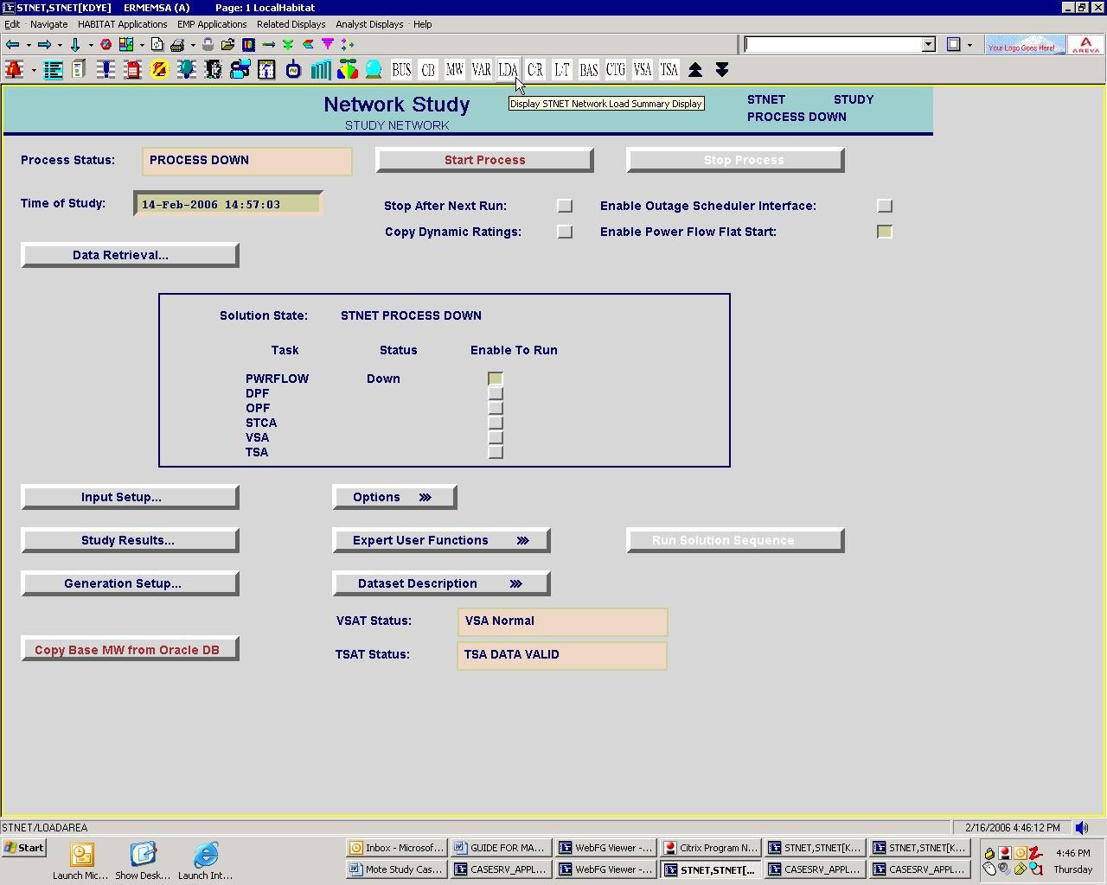
Figure 9 LDA /Load Area

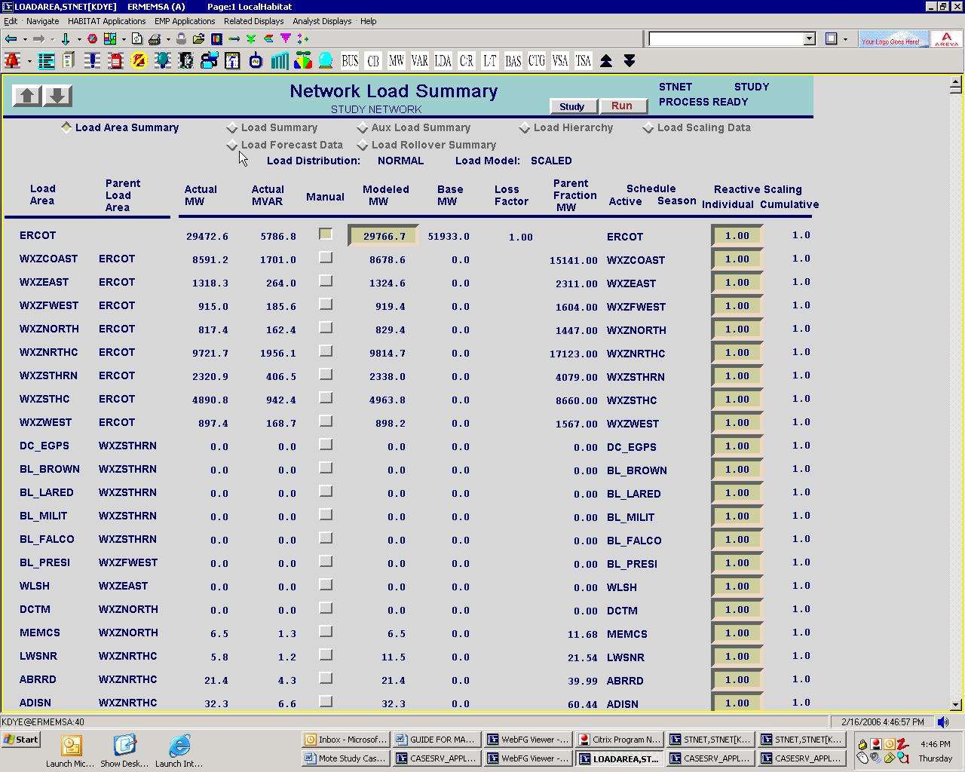
Figure 10 Load Area Summary

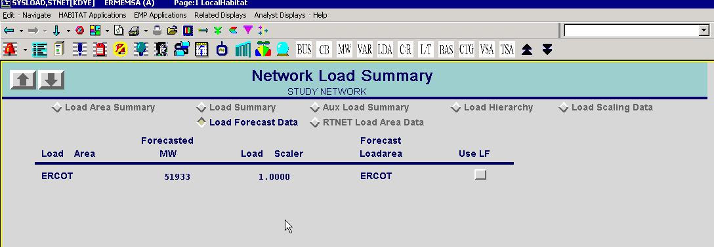
Figure 11 L/F Load Forecast Window
- Return to the network study window or click the button and click ‘Start Process’

- Click ‘Run Solution Sequence’

Note: This step may have to be repeated several times to achieve a valid solution.

