NDSWG REPORT TO ROS
December 7, 2006

The Network Data Support Working Group met in Taylor on November 14.

We spent lot of the time discussing the NMT project by ERCOT staff. The project is primarily focused on improving the accuracy of the state estimator. The group are contacting each transmission provider and working with them where they feel they need additional telemetry or where the telemetry does not appear correct.

The next operations/planning case comparison will be done in about two weeks using the Winter Peak Case. TSPs are to submit corrections to the SSWG case to bring it current.

NMMS Forum meeting was held on November 17 in Austin. Lots of good information was presented on CIM models and the user interfaces. There remains some concern as to whether all of the required functionality requested by the market participants will be available in the early releases.

A presentation was made on the CIM modeling by Margaret Goodrich.

Curtis stated he would begin sending Incident Reports to the PUCT and ERCOT Compliance for people that didn’t comply with the rules particularly in regards to energizing before all of the models were updated and the person had approval to energize. Apparently some TSPs have energized transmission facilities prior to contacting the Transmission Security desk and getting permission from ERCOT. One of the checks the Security Desk Operator performs is to verify the facility is in the operations model prior to it being released to be in service.

Concerns about the compliance issues caused a discussion about the Approval to Energize procedures.

Curtis said he had been having problems with IT getting new people set up to use the MOTE system but felt the problem had now been resolved.

We are considering three people for Vice Chairman and will take a vote by email in mid-December.

Next Meeting
The group did not want to have a December meeting therefore the next scheduled meeting will be in January.

Telemetry Standard
Subsequent to the meeting I found the document below (Texas Nodal EDS Market Trials Approach) that proposes to require the TSPs to certify under a PE seal, the accuracy and thus also the correct wiring for each of the analog points and status points telemetered to ERCOT all the way from the CTs, PTs and status contacts in the field to where it leaves the EMS as an ICCP value. This is even more stringent than is required for EPS metering since a PE seal is only required when appropriate documentation is not available as to the accuracy of a device. This will create a significant burden on TSPs if this documentation is required for each of the hundreds of thousands of points being provided to ERCOT across the ICCP links.

When we were developing the initial Telemetry Standards we were concerned that such a requirement would be put on TSPs and felt that it was impractical at that time which was one of the reasons specific accuracy requirement were not put into the Telemetry Standard.

The NDSWG has already opposed the requirements for a technician to verify the connections of every ICCP point as unnecessary and to require such checks only if the telemetered data is significantly different from the ERCOT State Estimator. Now there is a proposal that a PE verify the connections and initial device accuracy, the transducer accuracy as well as the appropriate multipliers within the SCADA system. This makes even less sense and I believe it will be opposed by the NDSWG also.


Texas Nodal
DRAFT EDS Market Trials Approach
Version 0.6

November 21, 2006
Revision History

Date | Version | Description | Author
10/10/06 | 0.1 | Initial Draft. | John Hall
10/30/06 | 0.2 | Revise document title to Market Trials Approach.  Refine document scope to include approach and transfer detailed testing data to the Market Trials Detailed Plan | John Hall
11/13/06 | 0.3 | Refined SCADA schematic and added overall market trials approach. | John Hall
11/15/06 | 0.4 | Restructured and updated the document based on a document review walkthrough. | John Hall, Ken Kasparian
11/20/06 | 0.5 | Comments from Jeyant Tamby and Raj Chudgar added. | John Hall, Ken Kasparian
11/21/06 | 0.6 | Updates based on feedback from Steve G and improved alignment with the Nodal Transition Plan. | Ken Kasparian

Document Sign-off

Package | Name | Signature | Date
Document Author | John Hall
ERCOT Integrated Readiness & Transition | Steve Grendel
Integration & Design Authority | Jeyant Tamby
EMS / MMS | Al Hirsch
Commercial Systems | Raj Chudgar
NMMS | Raj Chudgar
MIS | Pat Harris
MER | Trip Doggett
EDW | Sylvia Shiroyama
EIP | Daryl Shing
Infrastructure | David Forfia
ITP | Glen Wingerd
CRR | Shawna Jirasek
Director, Systems Operation | Kent Saathoff
Director, Commercial Operations | Betty Day
Director, Market Services | Richard Gruber

Table of Contents
1 Executive Summary 6
2 Market Trials Overview 8
2.1 Market Trials Requirements 8
2.2 Market Trials Phases 9
2.3 Testing Cycles and Market Participant Segmentation 9
2.4 Market Trials Testing Week 9
2.5 Market Trials Reporting 9
2.6 Market Trials Data 10
2.7 Market Trials Sandbox 10
2.8 Market Trials Documentation 10
2.9 Market Trials Planning Next Steps 10
3 EDS 1 – Data and Telemetry Market Trials 11
3.1 Objectives 11
3.2 System Functionality 12
3.3 Entrance Criteria 13
3.4 Exit Criteria 13
4 EDS 2 – State Estimator, Real-time Security Analysis Market Trials 14
4.1 Objectives 14
4.2 System Functionality 15
4.3 Entrance Criteria 15
4.4 Exit Criteria 15
5 EDS 3 – Real Time Market Trials 16
5.1 Objectives 16
5.2 System Functionality 16
5.3 Entrance Criteria 17
5.4 Exit Criteria 17
6 EDS 4 – Day-Ahead Market Trials 18
6.1 Objectives 18
6.2 System Functionality 19
6.3 Entrance Criteria 19
6.4 Exit Criteria 20
7 Summary 20
8 Appendices 21
8.1 Texas Nodal High-level Inputs & Outputs 21
8.2 Texas Nodal High-level Schedule 22
8.3 Market Trials High-level Timeline 23
8.4 Detailed Market Trials Plan (Illustrative Example) 24

Executive Summary
The objective of market trials is to confirm through a series of structure and unstructured tests that “stable and accurate operations of the SCADA, Network Security Analysis, Transmission Constraint Management, SCED, LFC, DAM, RUC, and real time settlement system can be declared” as outlined in the Nodal Transition Plan.

Nodal Program Work streams (packages) have been tasked with providing this functionality with the following documents defining the necessary detail. All design documentation and plans will be guided by these documents.

- Texas Nodal Protocols revised with all approved Nodal Protocol Revision Requests (NPRRs) approved by Nodal Program Change Control.
- ERCOT Nodal Transition Plan

The market trials plan has been compiled based on the Nodal Timeline, as shown in Figure 1 below. For ease of reference, each phase of the market trials is defined in the following categories:
- Objectives
- System functionality
- Entry criteria

Each phase of the market trials honors the ERCOT Nodal Transition Plan, except where noted, with appropriate references to the Nodal Protocols and also defines the SoSA operations (processes) to be tested in each phase.
This approach document defines the framework against which the Market Trials Detailed Plan will describe the phases in sufficient detail to execute the trials.
Many exhibits in the approach are sample formats which will be expanded in the detailed plan.

The following diagram illustrates the four phases of market trials. Following the illustration is more detail about each phase.

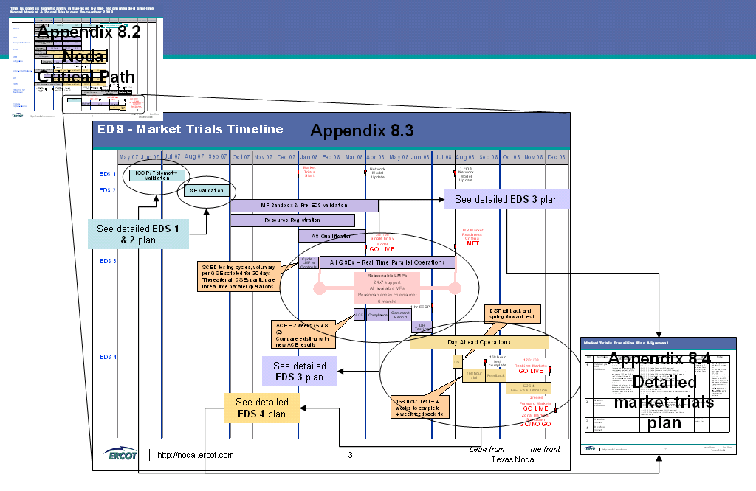
Figure 1 - Market Trials Plans align with the Nodal timeline

Market Trials Overview
This document provides a high level market trials approach. This approach will guide detailed planning of the Early Delivery System phases (EDS) for the Texas Nodal project and outlines the key objectives, functionality, and beginning entrance criteria for each phase of the market trials. The approach aligns with the Nodal schedule agreed by TPTF in September 2006. In this document, “Paragraph #” references refer to the ERCOT Nodal Transition Plan.

Note that these areas provide an overview of the approach and will be further detailed over time in the EDS Market Trials Detailed Test Plan and Market Trials Handbook.

Market Trials Requirements
The ERCOT Nodal Transition Plan, Reference Protocols (October 2006) and SoSA procedures will be used as guiding documents for market trials planning. These requirements will be tied to specific criteria and EDS phase tasks to ensure a traceable and comprehensive process. The detailed market trials planning documentation will document the specific requirements and traceability matrices. This table is an example of the plan.

EDS | Description | Transition Plan Requirement | Operations / SoSA | Market Trials tasks | MP Interventions | Notes
1 | Telemetry & ICCP Validation | 5.4.1(2)  ERCOT shall develop procedures for setup and data implementation requirements applicable to TSP’s and QSE’s. ERCOT  shall with the assistance of TSP’s and QSE’s:  (a) Verify that all data and  telemetry requirements  Specified in the nodal  Protocols Section  3.10, Network Operations  Modeling and Telemetry,  Have been met and that all  Data submittals are  complete and represent an  accurate model of the  ERCOT System; | EDS 1 - Assumption: only testing data coming in FROM the field  ICCP-related operations I can think of:  - S.UC1.OP1: Update Frequency (EMS operation)  - S.UC1.OP3: Update Generation Levels (EMS Operation)  - S.UC1.OP5: Update Responsiveness Information (EMS Operation) | All telemetry (SCADA/ICCP) points checked out (programmatically or manually).  Status Report at the end of this activity must indicate that all points have been tested and verified  Require Professional Engineers Seal from Entities to assure accuracy of data. Can be required from QSE’s/TSP’s due to issues of public safety and public interest  Alarm Functionality Validated | 12-31-06 – Preliminary MP Interface Specs  3-30-07 – Final Interface Specs | This is a joint ERCOT and Market Participant task.  Will require a EDS type functionality from TSP/QSE  QSE/TSP personnel can SIMULATE analog/digital changes on their EDS and ERCOT EDS will be able to accomplish point-to-point check out with ERCOT operators  Explore programmatic way to validate – this approach can be used later for periodic verification.
2 | Network model validation
3 | Real-time Operations
4 | Day ahead Operations

Market Trials Phases
The Market Trials will be implemented in four different phases with each phase testing critical functionality and progressively increasing in scope and complexity. The phases and high level focus areas are:

- EDS 1 – Data and Telemetry
- EDS 2 – State Estimator, Real Time Security Analysis
- EDS 3 – Real Time Market Operations
- EDS 4 – Day Ahead Market Operations

Based on a comprehensive release schedule, each successive EDS phase will provide additional operational capabilities to be tested, building up to the complete set of Texas Nodal systems and functionality.

Testing Cycles and Market Participant Segmentation
To help optimize the trials schedule and reduce resource constraints for both Market Participants and ERCOT, each of the EDS phases will be further broken down into test cycles. The cycles will be targeted to meet specific objectives that support the overall EDS phase.

Market Participant involvement may be segmented into different cycles to allow the team to focus on certain areas and benefit from both a smaller testing pool and common characteristics of the segments. Some example segments could be:

- Size | - Entity type/classification
- Type of EMS/GMS | - Readiness to connect with ERCOT

Each segment will be defined and communicated with each Market Participant and a list will be included in the Market Trials detailed plan.

Market Trials Testing Week
To provide strong communication and focus on testing activities, the Market Trials schedule will revolve around a standard weekly testing schedule. During any Trials week specific activities and communication points will be defined. This will include a minimum of two conference calls with participants to start off and closeout the week. Testing cycles will be defined that may include multiple cycles during a given week or a single cycle for the week cycle based functionality and complexity. Activities within the trials will be documented within the Market Trials Handbook and posted externally to avoid surprises and to ensure maximum value to both Market Participants and ERCOT.

Market Trials Reporting
During each of the EDS phases, a defined set of reporting criteria and system outputs will be posted to provide Market Participants with appropriate data. During the Market Trials planning phase, the specific reporting requirements, output data, and periodicity will be detailed in the EDS Market Trials Detailed Test Plan.

Market Trials Data
The Market Trials will utilize a combination of live ICCP data feeds and production quality simulated data feeds to support trial scenarios. When specific data feeds are not realistic for the specific trial scenarios (i.e. zonal RT telemetry, outages, operating date, operating load, etc.) the data will be simulated. Details of data elements, source and method of simulation will be defined within the Market Trials Detailed Plan.

Market Trials Sandbox
The market trials sandbox environment will provide a means for Market Participants to test communication with the Nodal ERCOT systems. This environment provides the interfaces for Market Participant testing of data submission prior to the start of EDS. This environment will be available ahead of the EDS implementation and is provided for Market Participant system testing. The details of specific interfaces, functionality, and timelines will be outlined in the EDS Market Trials Detailed Test Plan. Participation in the Sandbox may be required prior to Market Trials.

Market Trials Documentation
Market trials will be defined and managed using a suite of documents which build in detail on the overall EDS Strategy defined in the ERCOT Nodal Transition Plan. These documents are listed and defined below:

- EDS Market Trials Approach (This document) – Provides a high level market trials approach for each of the EDS phases.
- ERCOT Nodal Transition Plan – TPTF-created definition of the Nodal System components and transition considerations
- EDS Release Strategy – Definition of the EDS phases and release management process, entry and exit criteria for each release.
- EDS Market Trials Detailed Test Plan –Details the test plan for each of the EDS phases defining specific entry and exit criteria, system functionality, test environments, data management plans, staffing, detailed schedules, Market Participant requirements and trial cycles, test scripts and use cases. This is the most detailed document in the suite of EDS documents
- Market Trials Handbook - A document containing a compilation of relevant material from all of the above documents with the focus of providing detailed guidelines for Market Participants during market trials.

Market Trials Planning Next Steps
The ideas and concepts outlined in this approach document will be further detailed in the EDS Market Trials Detailed Plan. In order to ensure that ERCOT and Market Participant expectations remain in alignment while the implementation details continue to be documented, the team has requested setting up a working group to provide draft versions of the EDS Market Trials Detailed Test Plan sections for comment prior to completing a final draft for signoff. The target milestones for completion are outlined below, interim drafts will be sent on a periodic basis.

- EDS 1 to 4 Detailed Plan – Drafts for comment To be defined
- EDS 1 Detailed Plan – Final Signoff To be defined
- EDS 2 Detailed Plan – Final Signoff To be defined
- EDS 3 Detailed Plan – Final Signoff March 30, 2007
- EDS 3 Market Trials Handbook – Final Signoff June 29, 2007
- EDS 4 Detailed Plan – Final Signoff September 28, 2007
- EDS 4 Market Trials Handbook – Final Signoff December 31, 2007

EDS 1 – Data and Telemetry Market Trials

Objectives
The Data and Telemetry Market Trials phase will verify the following:

- data and telemetry requirements and data submittals are complete and represent an accurate model of the ERCOT System
- accuracy of all constraints on transmission elements
- TSP calculations on likely binding transmission constraints in the SCED
- redundant telemetry communications paths between ERCOT and QSE’s/TSP’s
- all telemetry meets update performance requirements and recovery capabilities
- alarm processors operate properly per requirements
- outage detection functionality (including scheduled vs. forced outages)
- real-time weather information acquisition requirements
- the ability to process stale telemetry at ERCOT, QSE’s and TSP’s

System Functionality
The following Texas Nodal systems and capabilities listed below will be utilized for the EDS 1 phase of Market Trials.

- Nodal Energy Management System (SCADA)
- ICCP Links

The table and the SCADA schematic below indicate testing points and data validation required by professional engineers’ seal.

Segment | Certification Requirement | Notes
A to H | To be certified by MPs by PE Seal | See NP Section 8
H to I | To be certified by TBD (3rd Party ?) | See NP Section 8
I to N | To be certified by ERCOT – PE Seal and by System Operators | See NP Section 8

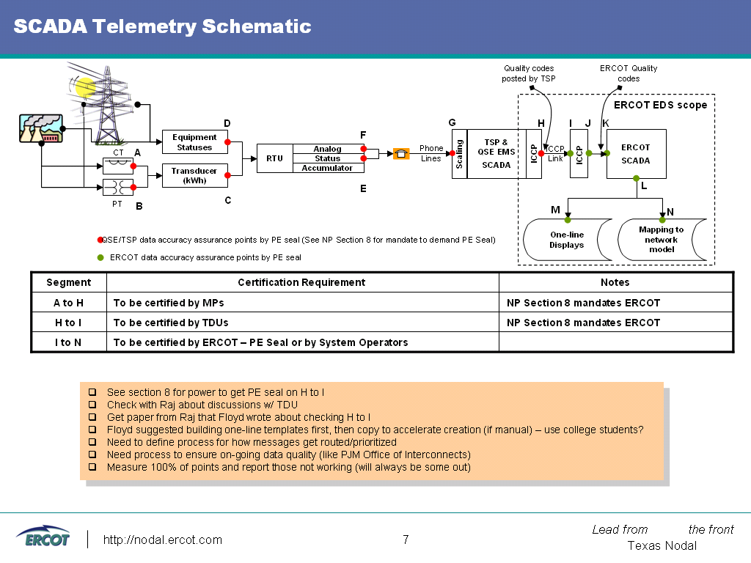
Figure 2 - ERCOT SCADA Schematic Data Flow Configuration

EDS 1 key issues:
- NMMS naming convention is different from current model and a mapping table will need to be created
- Provide Real Time data from QSE’s/TSP’s as described in the schematic above.

Market Participants will verify and validate the accuracy of their data and

Entrance Criteria
To begin the EDS 1 phase of Market Trials, a defined set of entrance criteria must be completed to ensure readiness. Specific criteria will need to be defined for both ERCOT and the Market Participants to help ensure that the test phase will be productive. During the market trials planning phase the team will be working with Market Participants to finalize a set of measurable criteria.

Below are some example areas that will be expanded and documented in the EDS Market Trials Detailed Test Plan and Market Trials Handbook.

Criteria | Measurement | Pass (Y/N)
ERCOT CRITERIA
EMS system stability | EMS ITEST complete based on exit criteria
SCADA interfaces tested
ICCP Link setup
Independent Readiness Critieria - TBD
MP CRITERIA
EDS1 required system development complete

Exit Criteria

Exit criteria for each EDS phase is defined to ensure that the deliverables from each phase are of the required quality and completeness to allow each successive phase, which builds on the previous phase, to proceed as planned.

Exit criteria will be defined together with Market Participants to finalize a set of measurable criteria.

EDS 2 – State Estimator, Real-time Security Analysis Market Trials

Objectives
To further validate telemetry by introducing the Nodal Network Model and Network Security Analysis the State Estimator and Real-time Security Analysis Market Trials phase will verify the following:

- State Estimator performance and availability requirements
- State Estimator utilizing live data acquisition processes and calculated data
- Continuous Telemetry of the Status of Breakers and Switches
- Network Security Analysis sequence
- Network Security Analysis results against real-time computations
- Transmission Constraint Management process

System Functionality
The following Texas Nodal systems and capabilities listed below will be utilized for the EDS 2 phase of Market Trials.

- EDS 1 Components - Nodal Energy Management System (SCADA)
- State Estimator
- Nodal Network Model
- Network Topology Builder
- Topology Consistency Analyzer
- Bus Load Forecast functions
- Network Security Analysis functionality
- Contingency Screening application

Entrance Criteria
To begin the EDS 2 phase of Market Trials, a defined set of entrance criteria must be completed to ensure readiness. Specific criteria will need to be defined for both ERCOT and the Market Participants to help ensure that the test phase will be productive. During the market trials planning phase the team will be working with Market Participants to finalize a set of measurable criteria.

Below are some example areas that will be expanded and documented in the EDS Market Trials Detailed Test Plan and Market Trials Handbook.

Criteria | Measurement | Pass (Y/N)
ERCOT CRITERIA
ICCP data input tested | 100% validation of telemetry data points H to I | (See Figure 2)
SCADA interfaces tested
ICCP Link setup
Network Model complete
MP CRITERIA
MP Network Model Transparency Tool (Viewer) & Registration and Qualification

Exit Criteria

Exit criteria for each EDS phase are defined to ensure that the deliverables from each phase are of the required quality and completeness to allow each successive phase, which builds on the previous phase, to proceed as planned.

Exit criteria will be defined together with Market Participants to finalize a set of measurable criteria.

EDS 3 – Real Time Market Trials

Objectives
The third phase of market trials will build on EDS 1 & 2 to demonstrate the Real-Time system integration with the EMS components of the system. The phase will verify the following:

- that QSE’s/TSP’s can successfully submit resource offer curves into SCED
- RT SCED functionality and market results
- the reasonableness of the LMPs calculated by SCED
- the RUC functionality and market results
- RT settlement statements including RUC commitments
- Supplemental Ancillary Services Market procedures
- Load Frequency Control functionality
- Area Control Error (ACE) accuracy

System Functionality
The following Texas Nodal systems and capabilities listed below will be utilized for the EDS 3 phase of Market Trials.

- NMMS (without Planning model) | - Nodal EMS (live feeds)
- Outage Scheduler | - SCED
- RUC | - SASM
- COP | - Emergency Operations
- Trades | - 3 Part Offers
- Schedules | - CMM
- MIS (RT components) | - Commercial operations (RT components)
- EDW (RT components) | - Integration (RT components)
- 8*5 Market Trials support in place | - LMPs calculated and deemed reasonable by ERCOT

Entrance Criteria
To begin the EDS 3 phase of Market Trials, a defined set of entrance criteria must be defined to ensure readiness. Specific criteria will need to be defined for both ERCOT and the Market Participants to help ensure that the test phase will be productive. During the market trials planning phase, the team will be working with Market Participants to finalize a set of measurable criteria.

Below are some example areas that will be expanded and documented in the EDS Market Trials Detailed Test Plan and Market Trials Handbook.

Criteria | Measurement | Pass (Y/N)
ERCOT CRITERIA
MMS system stability | MMS ITEST complete based on exit criteria
Commercial operations system stability | COMS ITEST complete based on exit criteria
MIS system stability | MIS ITEST complete based on exit criteria
EMS system stability | EDS 1, 2 complete based on exit criteria
MP CRITERIA
MP specific EDS 3 development completed

MP EDS 3 interfaces completed per ERCOT published requirements
Sandbox connectivity tested
MP ability to generate and submit offers via API or MIS Portal
Have signed up for a SCED cycle [Methodology to follow]
Registration | EDS 3 specific Asset Registration complete

Exit Criteria
Exit criteria for each EDS phase are defined to ensure that the deliverables from each phase are of the required quality and completeness to allow each successive phase, which builds on the previous phase, to proceed as planned.

Exit criteria will be defined together with Market Participants to finalize a set of measurable criteria.

EDS 4 – Day-Ahead Market Trials

Objectives
The fourth phase of market trials will continue to build on EDS 1, 2, and 3 to demonstrate the Day-Ahead market system integration with the overall Nodal systems. This phase will verify the following:

- that QSE’s/TSP’s can successfully create and submit DAM offers
- the operation of DAM to procure Ancillary Services
- DAM settlement statements using LMPs and MCPCs
- all Real Time components integrate with Day Ahead
- the overall system stability through a 168 hour test
- Settlement Statements for each operating day of the 168 hour test

System Functionality
The following Texas Nodal systems and capabilities listed below will be utilized for the EDS 4 phase of Market Trials.

- NMMS (full) | - Nodal EMS (live feeds)
- DAM (full) | - SCED (full)
- RUC | - COP
- CRR (full) | - SASM (full)
- Credit Monitoring & Management (full) | - Emergency Operations
- MIS (full) | - 3 Part Offers
- Trades | - Schedules
- Full back-end (x4) | - EDS (full)
- 8*5 support (24*7 for MP SAT) | - Commercial operations (full)
- Integration (full)

Entrance Criteria
To begin the EDS 4 phase of Market Trials, a defined set of entrance criteria must be defined to ensure readiness. Specific criteria will need to be defined for both ERCOT and the Market Participants to help ensure that the test phase will be productive. During the market trials planning phase, the team will be working with Market Participants to finalize a set of measurable criteria.

Below are some example areas that will be expanded and documented in the EDS Market Trials Detailed Test Plan and Market Trials Handbook.

Criteria | Measurement | Pass (Y/N)
ERCOT CRITERIA
NMMS Planning Model completed ITEST | Exit criteria to be defined
DAM system completed ITEST | Exit criteria to be defined
CRR DAM components completed ITEST | Exit criteria to be defined
CMM DAM components completed ITEST | Exit criteria to be defined
MP CRITERIA
MP specific EDS 4 development completed

MP EDS 4 interfaces completed per ERCOT published requirements
Connection to Sandbox, MP Network Model Transparency Tool (Viewer) & Registration and Qualification
MP ability to generate and submit DAM offers via API or MIS Portal

Exit Criteria
Exit criteria for each EDS phase are defined to ensure that the deliverables from each phase are of the required quality and completeness to allow each successive phase, which builds on the previous phase, to proceed as planned.

Exit criteria will be defined together with Market Participants to finalize a set of measurable criteria.

Summary

The Market Trials Approach defines how the market trials detailed plans will be developed by ERCOT together with the market Participants. This purposely ensures the definition of future TPTF checkpoints for reporting back on the products which will drive effective market trials. The overarching intent is that all products and any detailed plans will be developed by ERCOT with the market participants.

Appendices

Texas Nodal High-level Inputs & Outputs
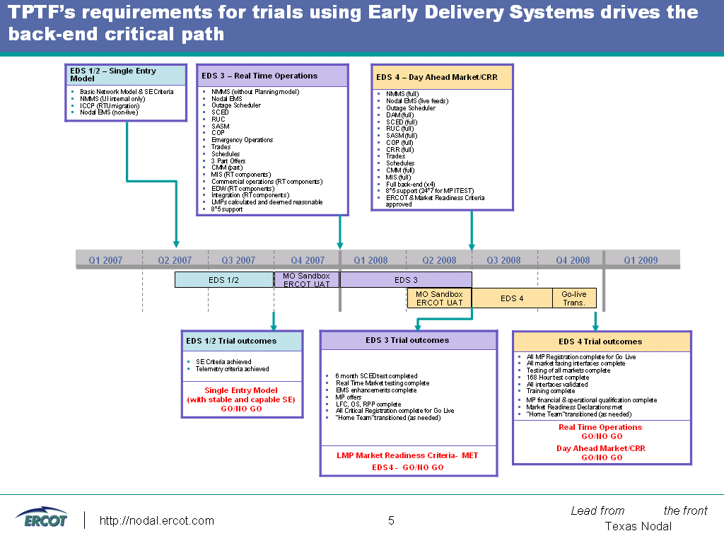

Texas Nodal High-level Schedule

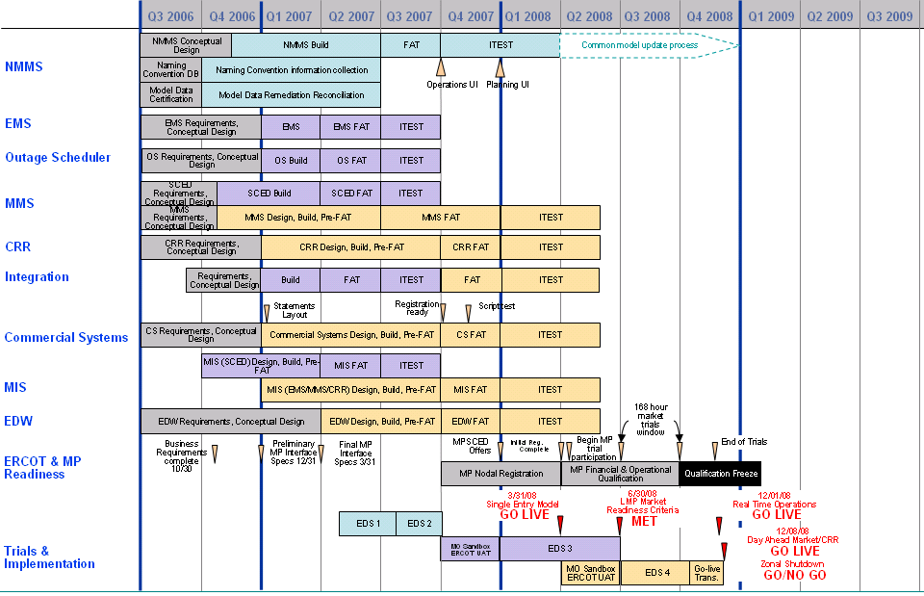
See Appendix 7.3 for detail

Market Trials High-level Timeline
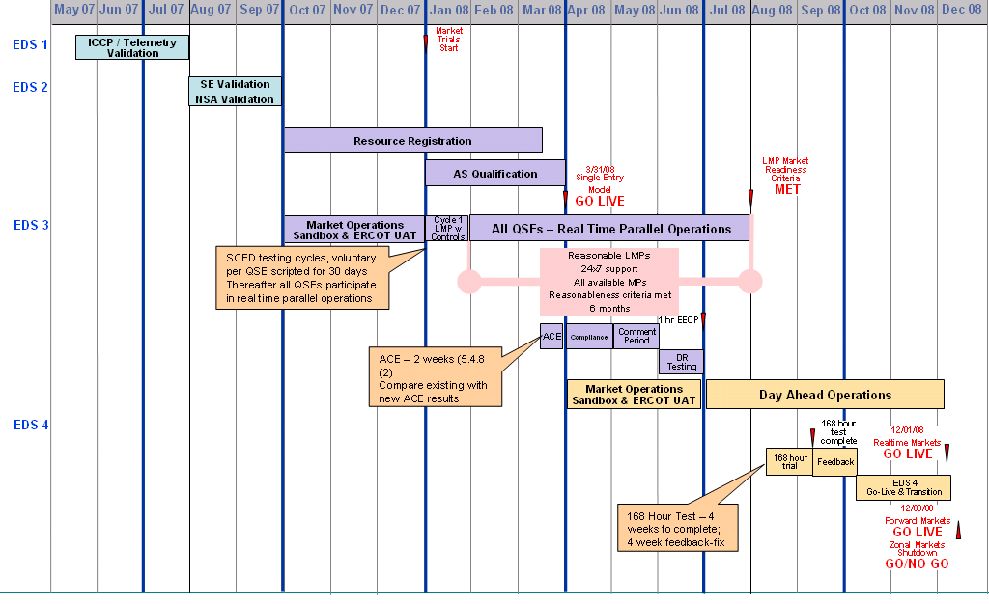

Detailed Market Trials Plan (Illustrative Example)
EDS | Description | Transition Plan Requirement | Operations / SoSA | Market Trials tasks | MP Interventions | Notes
1 | Telemetry & ICCP Validation | 5.4.1(2)  ERCOT shall develop procedures for setup and data implementation requirements applicable to TSP’s and QSE’s. ERCOT  shall with the assistance of TSP’s and QSE’s:  (a) Verify that all data and  telemetry requirements  Specified in the nodal  Protocols Section  3.10, Network Operations  Modeling and Telemetry,  Have been met and that all  Data submittals are  complete and represent an  accurate model of the  ERCOT System; | EDS 1 - Assumption: only testing data coming in FROM the field  ICCP-related operations I can think of:  - S.UC1.OP1: Update Frequency (EMS operation)  - S.UC1.OP3: Update Generation Levels (EMS Operation)  - S.UC1.OP5: Update Responsiveness Information (EMS Operation)  - S.UC1.OP6: Update QSE Provider Information (EMS Operation)  - S.UC1.OP7: Use Revised Data (EMS Operation)  - S.UC1.OP8: Use Telemetry Data (EMS Operation)  - S.UC2.OP1: Update RT Generation/Transmission Data (EMS  Operation)  - S.UC2.OP2: Update Transmission Ratings (EMS Operation)  ICCP information TO the field (external):  - S.UC2.OP4: Send Base Points  - M.UC12.OP1: Clear RT Market (I know Base Points are communicated to  QSE’s via ICCP, will need to check which other ones do) | - All telemetry (SCADA/ICCP) points checked out (programmatically or manually) 100 %  - Status Report at the end of this activity must indicate that 100 % of all points have been tested and verified  - Require Professional Engineers Seal from Entities to assure accuracy of data. Can be required from QSE’s/TSP’s due to issues of public safety and public interest  - Alarm Functionality Revalidated  - SCADA/ICCP enhancement to detect Forced Outage of equipment  - Real Time Weather Telemetry revalidated  - Dynamic Rating telemetry  - Validate all Transmission Element Limits and Constraints  - Check TSP’s calculation Transmission Element Ratings that are likely to be active in SCED  - Telemetry Criteria Developed (protocol 3.10.7.4)  - Define and implement business processes to repair errors. | - 12-31-06 – Preliminary MP Interface Specs  - 3-30-07 – Final Interface Specs | - This is a joint ERCOT and Market Participant task.  - Will require a EDS type functionality from TSP/QSE  - QSE/TSP personnel can SIMULATE analog/digital changes on their EDS and ERCOT EDS will be able to accomplish point-to-point check out with ERCOT operators  - Explore programmatic way to validate – this approach can be used later for periodic verification.
2 | Network Model Validation  SE Solution
3 | Real-time Operations
4 | Day ahead Operations

