

Nodal System of Systems:
Market Information Systems (I.)
Version 0.993

Revision History
Date | Version | Description | Author(s)
25-Sept-2006 | 0.90 | Draft – need to address highlights | Rachel Cheng
26-Sept-2006 | 0.91 | Added input re. highlights from Daryl/Gary  Revised WB/BB and specs | Rachel Cheng
27-Sept-2006 | 0.92 | After Shawn’s pre-review | Rachel Cheng
30-Sept-2006 | 0.93 | Layout and Black Box Updates | Daryl Shing
1-Oct-2006 | 0.98 | Final Layout Updates | Daryl Shing
2-Oct-2006 | 0.991 | Released to TPTF for review | Daryl Shing
1-Nov-2006 | 0.992 | Split up the use case. | Gary Macomber
2-Nov-2006 | 0.993 | Final Review | Daryl Shing

Table of Contents
System of Systems Architecture 4
I – Market Information Systems Use Case 10
I.UC1 – Access Nodal Applications and Information 11
I.UC1.BB – Access Nodal Applications and Information 11
I.UC1.OP1 – Present Allowed Activities 12
I.UC1.OP1.WB – Present Allowed Activities 13
I.UC2 – Retrieve Documents 14
I.UC2.BB – Retrieve Documents 15
C.COM.OP1 – Reference: Send Selected Document 15
I.UC2.OP1 – Send List of Documents 16
I.UC2.OP1.WB – Send List of Documents 17
I.UC3 – Revise Document Delivery Schedule 18
I.UC3.BB – Revise Document Delivery Schedule 19
I.UC3.OP1 – Update Delivery Schedule 19
I.UC3.OP1.WB – Update Delivery Schedule 20
I.UC4 – Search for Documents 21
I.UC4.BB – Search for Documents 22
C.COM.OP1 – Reference: Send Selected Document 22
I.UC4.OP1 – Perform Search 22
I.UC4.OP1.WB – Perform Search 23
I.UC5 – Construct Report or Extract 24
I.UC5.BB – Construct Report or Extract 25
C.COM.OP1 – Reference: Send Selected Document 25
I.UC5.OP1 – Perform Query 25
I.UC5.OP1.WB – Perform Query 26
I.UC5.OP2 – Present Status of Report/Extract 26
I.UC5.OP2.WB – Present Status of Report 27
I.UC6 – Customize “My Page” 28
I.UC6.BB – Customize “My Page” 28
I.UC6.OP1 – Customize “My Page” 29
I.UC6.OP1.WB – Customize “My Page” 29
I.UC7 – Launch Application 30
I.UC7.BB – Launch Application 31
Common Operations 32
I.COM.OP1 – Send Selected Document 32
I.COM.OP1.WB – Send Selected Document 33

System of Systems Architecture
The System of Systems Architecture (SoSA) is a technique for modeling a complex system that is itself comprised of complex systems. The value of this approach comes from its ability to look at customers of Nodal and how they expect to operate in a Nodal Market. We believe this approach will provide TPTF and ERCOT a holistic view of Nodal and the means to ensure that the requirements of the individual projects effectively integrate to meet the needs of the Nodal Market.
Document Structure
The Use Case Diagram at the start of the document identifies the Use Cases covered by this document. Each Use Case will have a Use Case Specification documenting the steps, and alternate steps, required to realize the Actors usage of Nodal. The interactions between the Actor and Nodal, found in the Use Case Specification, are documented in the Black Box Sequence Diagram. Each interaction that requires an action by Nodal will have an Operation Specification and supporting White Box Sequence Diagram.
So the logical progression of SoSA is as follows; a Use Case Specification, its Block Box Sequence Diagram, one or more Operation Specifications and their supporting White Box Sequence Diagram(s). This repeats for every Use Case in the Use Case Diagram.
Document Numbering
This document contains Enterprise Use Cases for the Market Information System. The Market Information System Use Cases are prefixed with I. (Market Information System Use Cases are always orange on diagrams and in this document) and are numbered I.UC1 through I.UC7.
Each Use Case has a Black Box Sequence Diagram identified by postfix of .BB, for example I.UC1.BB identifies the Black Box Sequence Diagram for Market Information Systems Use Case 1.
Each Operation identified in the Black Box Sequence Diagram is numbered OP1 through OPx and each numbered Operation has a corresponding White Box Sequence Diagram with postfix WB. For example the White Box Sequence Diagram for Operation 1 on Use Case 1 would be prefixed by I.UC1.OP1.WB.
Any Operations identified as common between Use Cases are referenced as common under the Black Box Sequence Diagram and located in a separate Common Operations Section at the end of the document.
How to Read the Use Case Diagram
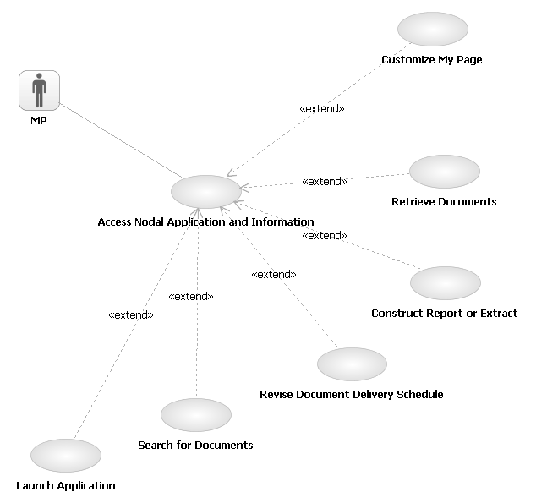
The Use Case Diagram shows the Actors relationships to the Use Cases. A Use Case at the Enterprise Level is a complete usage of Nodal that provides value to an Actor. Use Case names are structured <Verb> <Noun> to ensure the ‘use’ is captured in the name of the Use Case. The line between the Actor and the Use Case indicates which Actor ‘initiates’ the Use Case. You will only see Actors in the Use Case Diagram that operate outside of Nodal. For example, an ERCOT System Operator would not appear as an Actor at this level because they are inside of Nodal. They will appear as a user of the system at the System and/or Component Level.
You should read the above example as:
The Market Participant initiates Access Nodal Application and Information.
You will also notice that this base use cases is extended (<<extend>>) by six other uses cases. This represents that fact that the base usages are to get access to applications and information but there are six distinct types of applications and information accessed. We have separated these out to make the base use case easier to read and to represent that each of these types of access have unique requirements. In the previous version we used alternative flows in a single use cases to show these different types of access.
How to Read the Use Case Specification
The Use Case Specification outlines the steps, and alternate steps, required to meet the Use Cases objectives. Each step in the Main Success Scenario is numbered in sequence and contains very deliberate language follow a structure of <who> is requesting <what> from <whom>. (if the whom is absent it is assumed to be the System in this case Nodal).
Main Success Scenario
- MP presents credentials to access list of allowed activities.
- Nodal validates credentials and Nodal presents home page with allowed activities.
- MP requests a list of available information.
- Nodal returns list of available information based on MP’s credentials.
- MP submits request for information.
- Nodal returns information.
- Use case ends.

Alternative flows
1.a. Direct retrieval of information.
1. MP submits required credentials and requests for selected information.
2. Return to Main Flow, Step 6.

Behavior/functionality performed completely within Nodal is not reflected in these steps. At this point we are concentrating on interactions between the Actor and Nodal. Each of these interactions, or operations that Nodal supports, will be broken down into steps at the Operation Specification.
Alternative Flows are attached by using the number of the step to replace and appending an ‘a’ for the first Alternative Flow and a ‘b’ for the second etc. You should read the alternative as in the case of the <alterative description>, instead of doing step x, Nodal will do the following <alternate steps>. Using this approach you should read alternative ‘1.a’ in the example above as:
In the case of Direct retrieval of information, instead of doing MP presents credentials to access list of allowed activities’ Nodal will do 1. MP submits required cred…
The same pattern is followed for Alternate Flows to Alternate Flows. 1.a.2.a is an Alternate Flow to step 2 in Alternate Flow 1a.
How to Read the Black Box Sequence Diagram
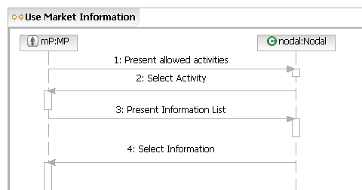
The Black Box Sequence Diagram takes the steps in the Use Case Specification and captures the requests from the Actor to Nodal, and from Nodal to the Actor. These are always in the form of a request, not the passing of information, and should be read in the direction of the arrow. In the example above request one and two should be read as:
1. The Market Participant requests Nodal to Present allowed Activities.
2. Nodal requests the Market Participant to Select an Activity.
This takes some “getting used to” but it is done for a very good reason. We are trying to identify the behaviors, called operations in SoSA that Nodal needs to be able to perform. Every time you see an arrow pointing to Nodal, this is an operation Nodal needs to support.
How to Read the Operation Specification
Operation for Market Participant Request: Present Allowed Activities

Main Flow
Actor Action | Nodal Action | Step | Subsystem Action | White Box Budgeted Requirements
MP presents credentials. | Nodal validates credentials and Nodal presents home page. | 1 | MP requests access to MIS.
MP presents credentials. | Nodal validates credentials and Nodal presents home page. | 2 | MIS requests user registration define activities the MP can perform.
MP presents credentials. | Nodal validates credentials and Nodal presents home page. | 3 | User Registration presents MIS with list of activities.
MP presents credentials. | Nodal validates credentials and Nodal presents home page. | 4 | MIS presents the MP with the list of activities.

The Operation Specification takes each of the arrowheads pointing to Nodal and details the interactions required between the systems within Nodal to perform the Operation.
You can see from the example above the first column in the Operation Specification shows the initial Actor Action from the Use Case Specification. The Nodal Action shows the action Nodal is performing until the next Actor Interaction. The Subsystem Actions are the interactions between systems inside Nodal required to meet the Actors Request. You would read the example above as:
The Market Participant presents credentials to Nodal.
Nodal validates the credentials by requesting access to the MIS System and asking the User Registration System to define a list of activities that the Market Participant can perform.
How to Read the White Box Sequence Diagram
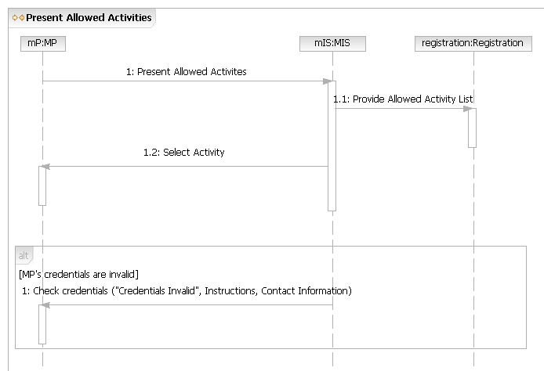
The White Box Sequence Diagram takes the interactions within Nodal identified in the Operation Specification and documents the flow in a Sequence Diagram. A box and a vertical line represent each of the Systems identified within Nodal, this is called a ‘lifeline’. You can see in the example above we have lifelines for MIS and the Registration System along with the original Actor. Like the Black Box Sequence Diagram, each line with associated arrow represents a request in the direction of the arrowhead. You would read the example above as
The Market Participant requests MIS to Present Allowed Activities.
MIS requests Registration to Provide Allowed Activities List.
MIS request the Market Participant to Select an Activity.
You will notice there is no request back from the Registration System to MIS. In cases like this when the return request would be simply meeting the request, we leave the return request out to simplify the diagram.
Functionality/Behavior within the Registration System or MIS System required to meet the request are not show at this level. We are concentrating on identifying the interactions between the Systems inside Nodal required to fulfill the Market Participants request. This detail will be exposed when we look inside the MIS or Registration Systems themselves. In the Nodal Program this is being performed by the individual Project Teams.
Another consideration as you read this document is that the White Box Requests provide requirements for each of the systems inside Nodal but the sequence of execution may change when the systems are implemented. For example, a system may request information each time a flow is executed but this may be done only once per day for efficiency reasons.
I – Market Information Systems Use Case
I.UC1 – Access Nodal Applications and Information
Brief Description
The “Access Nodal Applications and Information” use case starts with the MP submitting credentials for access to Nodal applications and information and ends with Nodal presenting the available options to the MP.
Preconditions
MP has the URL for MIS and an internet connection.
Post Conditions
Nodal applications and information based on role.
Main Success Scenario
1. MP requests access to Nodal applications and information.
2. Nodal validates credentials.
3. Nodal presents home page with allowed activities.
4. MP selects activity.
5. Use case ends.
Alternative flows
2.a. MP credentials to access information are invalid.
1. Nodal presents “credentials invalid” message.
2. Use case ends.
I.UC1.BB – Access Nodal Applications and Information
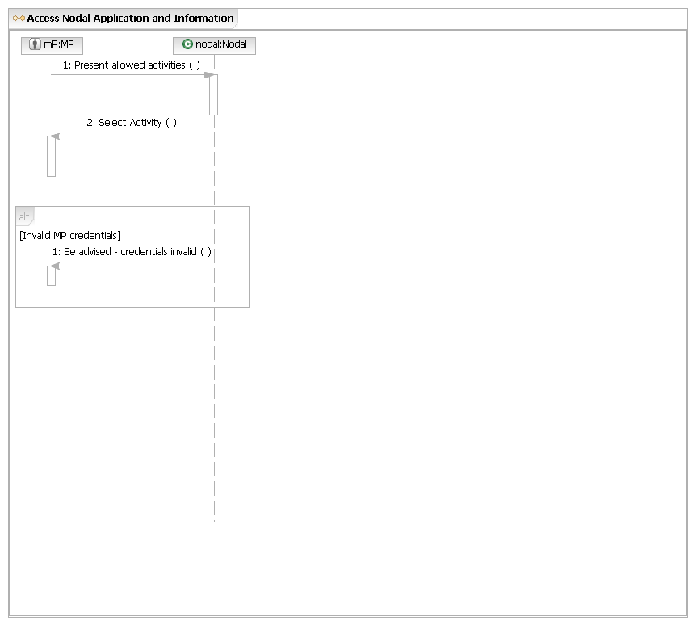
I.UC1.OP1 – Present Allowed Activities

Main Flow
Actor Action | Nodal Action | Step | Subsystem Action | White Box Budgeted Requirements
MP requests access to Nodal applications and information. | Nodal validates credentials.  Nodal presents home page with allowed activities. | 1 | MP requests access to applications and information from MIS.
MP requests access to Nodal applications and information. |  | 2 | MIS requests User Registration define activities the MP can perform.
MP requests access to Nodal applications and information. |  | 3 | User Registration presents MIS with list of activities.
MP requests access to Nodal applications and information. |  | 4 | MIS presents the MP with the list of activities.

[MP’s credentials are invalid]
 | Nodal presents “Credentials Invalid” message. | 1 | MIS presents “Credentials Invalid” message with instructions and contact information.

I.UC1.OP1.WB – Present Allowed Activities

I.UC2 – Retrieve Documents
Brief Description
The “Retrieve Documents” use case starts with the MP selecting the “Retrieve Documents” option from the available options and ends with Nodal presenting the selected document to the MP.
Preconditions
None.
Post Conditions
MP has successfully retrieved selected document.
Main Success Scenario
1. At Step 4 of the “Access Nodal Applications and Information” use case, if MP selects “Retrieve Document”, then:
2. Nodal presents a list of available document types based on MP’s credentials.
3. MP requests a list of documents of a specific type.
4. Nodal returns list of available documents of the specified type based on MP’s credentials.
5. MP submits request for a specific document.
6. Nodal returns specific document.
7. Use case ends
Alternative flows
2.a. List of available document types is unavailable.
1. Nodal presents “List Unavailable” message.
2. Use case ends.
4.a. No documents available.
1. Nodal presents “No Documents for this document type” message.
2. Use case ends.
6.a. Selected document is unavailable.
1. Nodal presents “Document Unavailable” message.
2. Use case ends.

I.UC2.BB – Retrieve Documents
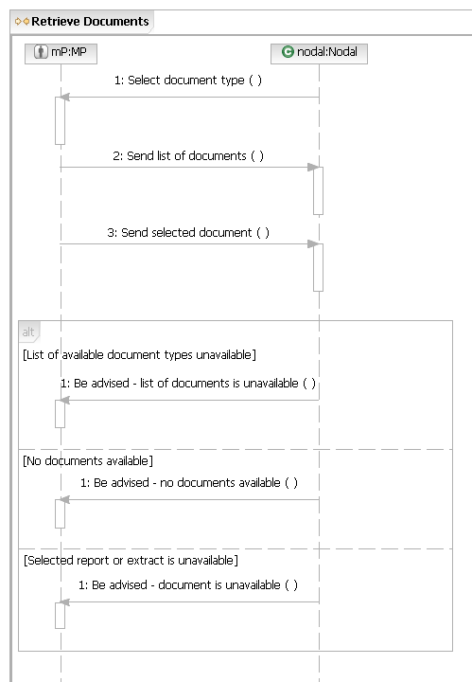
C.COM.OP1 – Reference: Send Selected Document
The Send Selected Document above uses the Common Operation Send Selected Document located at the end of this document.
I.UC2.OP1 – Send List of Documents

Main Flow
Actor Action | Nodal Action | Step | Subsystem Action | White Box Budgeted Requirements
 | Nodal presents a list of available document types based on credentials. | 1 | MIS requests EDW send list of available documents types.
 |  | 2 | EDW requests MIS post document type list.
 |  | 3 | MIS presents the list of available document types

[Document list unavailable]
 | Nodal presents “Information List Unavailable” message. | 1 | EDW requests MIS present “Document List Unavailable” message.
 | Nodal presents “Information List Unavailable” message. | 2 | MIS presents “Document List Unavailable” message.
I.UC2.OP1.WB – Send List of Documents
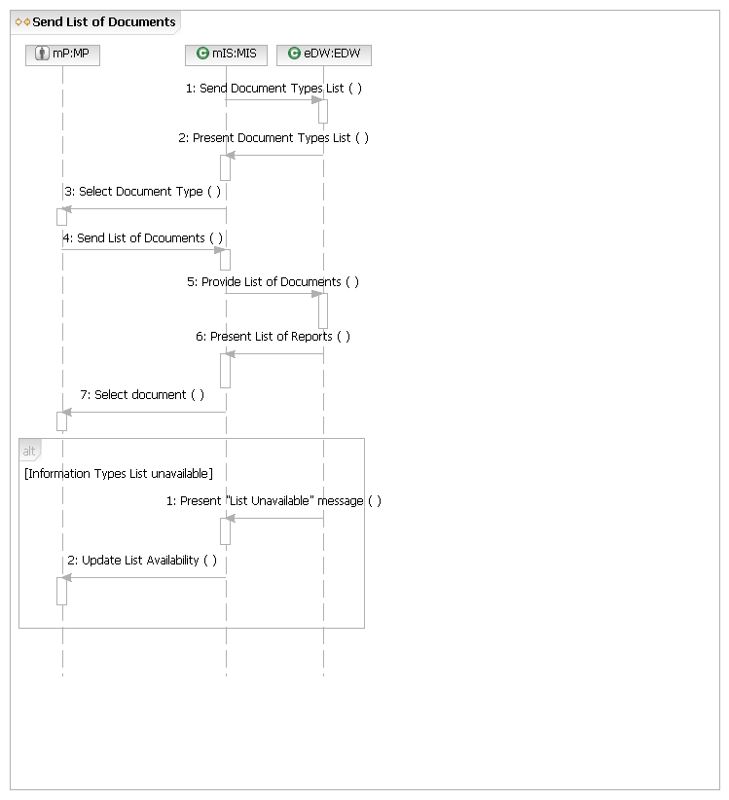

I.UC3 – Revise Document Delivery Schedule
Brief Description
The “Revise Document Delivery Schedule” use case starts with the MP selecting the “Revise Document Delivery Schedule” option from the available options and ends with Nodal presenting the revised document delivery schedule to the MP.
Preconditions
None.
Post Conditions
MP has successfully revised their document delivery schedule.
Main Success Scenario
1. At Step 4 of the “Access Nodal Applications and Information” use case, if MP selects “Revise Report and Extract Delivery Schedule” option, then:
2. Nodal presents delivery schedule options.
3. MP submits delivery schedule options.
4. Nodal requests MP review delivery schedules.
5. Use case ends.
Alternative flows
4.a. Delivery schedule invalid.
1. Nodal presents “Delivery Schedule not Valid” message on Schedule Delivery screen, indicates problem.
2. Return to Main Flow, Step 3.

I.UC3.BB – Revise Document Delivery Schedule
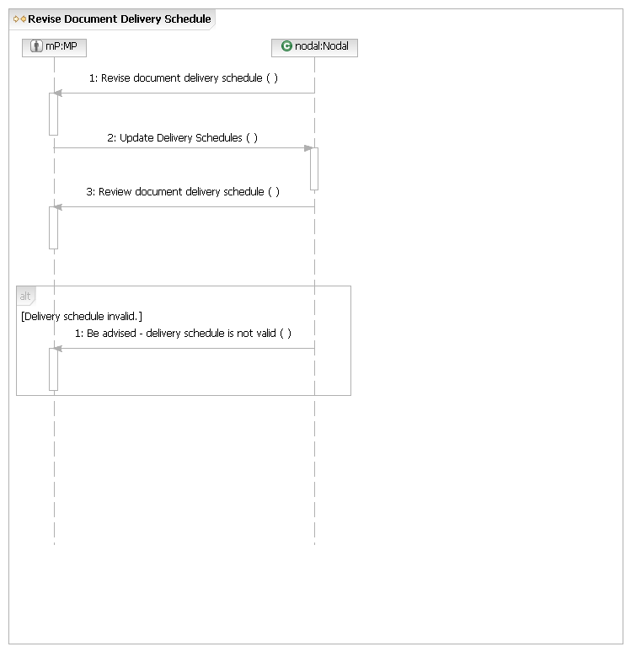
I.UC3.OP1 – Update Delivery Schedule

Main Flow
Actor Action | Nodal Action | Step | Subsystem Action | White Box Budgeted Requirements
MP submits delivery schedule options. | Nodal requests user review delivery schedules. | 1 | MP requests MIS update document delivery schedule.
MP submits delivery schedule options. | Nodal requests user review delivery schedules. | 2
MP submits delivery schedule options. | Nodal requests user review delivery schedules. | 3 | MIS requests MP review delivery schedules.

[Delivery schedule invalid]
 | Nodal presents “Delivery Schedule Not Valid” message. | 1 | MIS presents “Delivery Schedule not Valid” message on Schedule Delivery screen, indicates problem.
I.UC3.OP1.WB – Update Delivery Schedule
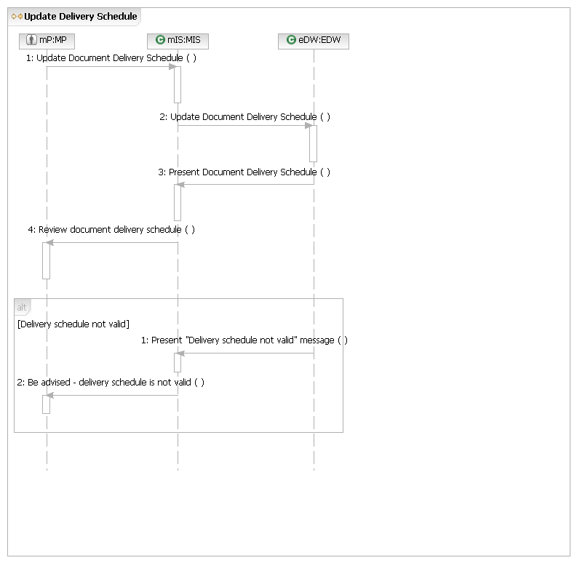

I.UC4 – Search for Documents
Brief Description
The “Search for Documents” use case starts with the MP selecting the “Search for Documents” option from the available options and ends with Nodal presenting the item selected from the search results to the MP.
Preconditions
None.
Post Conditions
MP has successfully found and retrieved the document.
Main Success Scenario
1. At Step 4 of the “Access Nodal Applications and Information” use case, if MP selects “Search for Documents” option, then:
2. MP sends search parameters.
3. Nodal presents search results.
4. MP selects item from search results
5. Nodal presents selected item.
6. Use case ends.
Alternative flows
3.a. Search parameters invalid.
1. Nodal presents “Search Parameters Invalid” message, includes guidance on valid search parameters.
2. Return to Main Success Scenario, Step 2.
I.UC4.BB – Search for Documents
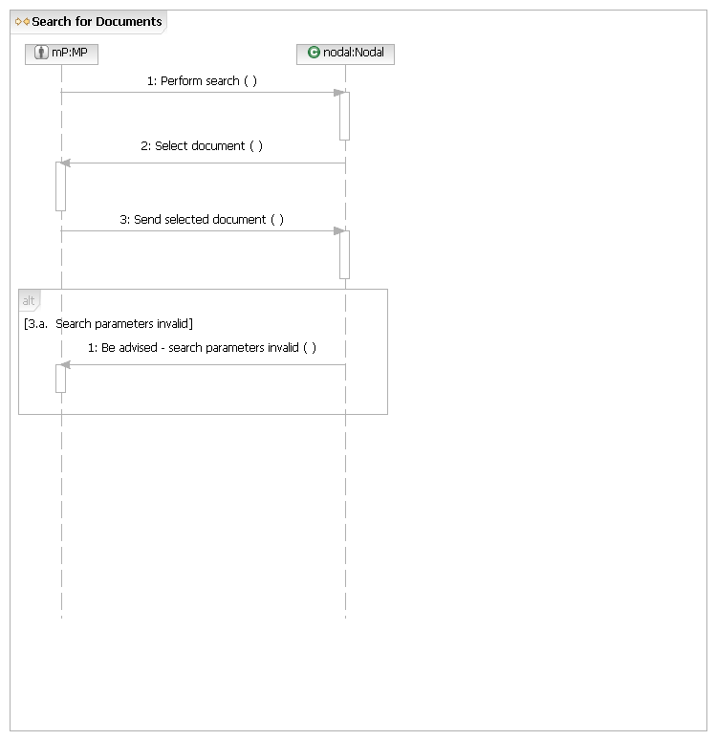
C.COM.OP1 – Reference: Send Selected Document
The Send Selected Document above uses the Common Operation Send Selected Document located at the end of this document.
I.UC4.OP1 – Perform Search

Main Flow
Actor Action | Nodal Action | Step | Subsystem Action | White Box Budgeted Requirements
MP sends search parameters. | Nodal presents search results. | 1 | MP requests MIS perform information search.
MP sends search parameters. | Nodal presents search results. | 2 | MIS presents search results to MP

[Search parameters invalid]
 | Nodal presents “Search Parameters Invalid” message | 1 | MIS presents “Search Parameters Invalid” message
I.UC4.OP1.WB – Perform Search
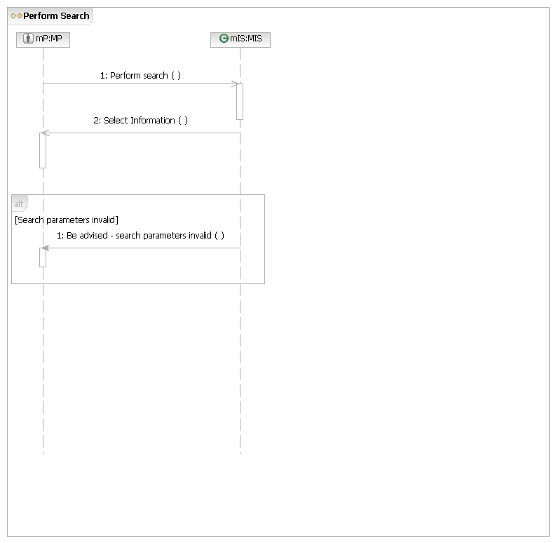

I.UC5 – Construct Report or Extract
Brief Description
The “Construct Report or Extract” use case starts with the MP selecting the “Construct Report or Extract” option from the available options and ends with Nodal presenting the resulting report or extract to the MP.
Preconditions
None.
Post Conditions
MP has successfully construct a report or extract and received the resulting report or extract.
Main Success Scenario
1. At Step 4 of the “Access Nodal Applications and Information” use case, if MP selects “Construct Report or Extract” option, then:
2. Nodal presents query function.
3. MP sends query parameters.
4. Nodal sends results to MP.
5. Use case ends.
Alternative flows
4.a. Query parameters invalid.
1. Nodal presents “Query Parameters” message on report or extract construction screen, indicates problem.
2. Return to Main Flow, Step 3.
4.b. Report or extract will take time to construct.
1. Nodal presents MP with estimated time for completion and URLs to check report status and retrieve report.
2. MP requests Nodal provide status of document.
3. MP requests Nodal send report or extract.
4. Use case ends.
4.b.3.a. Status information not available.
1. Nodal displays “Status Information Unavailable” message.
2. Use case ends.
4.b.4.a. Report or extract not created.
1. Nodal presents “Report or extract not created” with information about expected resolution.
2. Return to Alternate Flow 4.b., Step 2.

I.UC5.BB – Construct Report or Extract
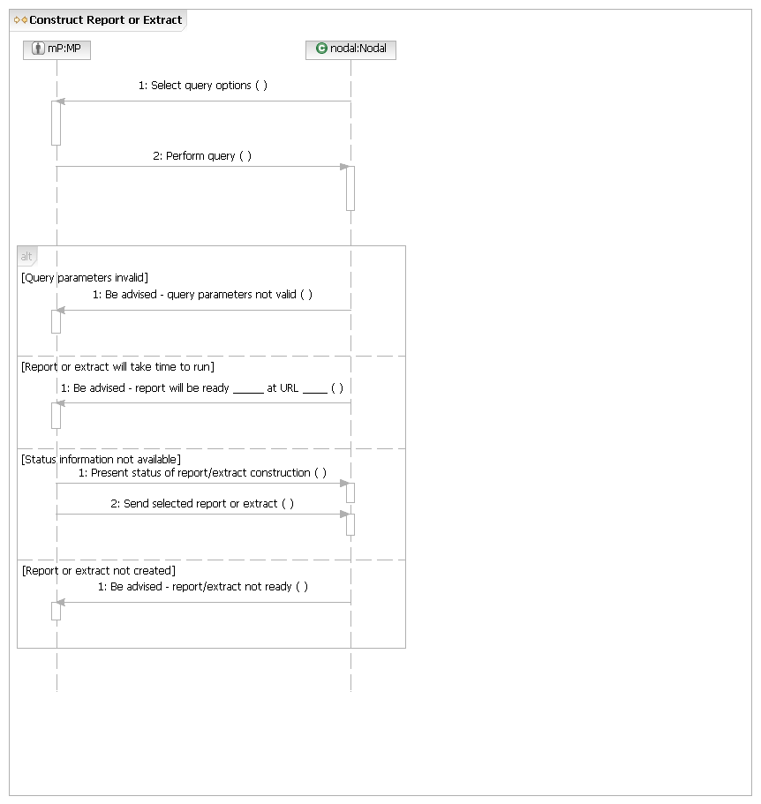
C.COM.OP1 – Reference: Send Selected Document
The Send Selected Report or Extract above uses the Common Operation Send Selected Document located at the end of this document.
I.UC5.OP1 – Perform Query

Main Flow
Actor Action | Nodal Action | Step | Subsystem Action | White Box Budgeted Requirements
MP sends query parameters. | Nodal sends results to MP | 1 | MP requests MIS perform query (sends query parameters).
MP sends query parameters. | Nodal sends results to MP | 2 | MIS requests EDW perform query.
MP sends query parameters. | Nodal sends results to MP | 3 | EDW request MIS present query results.
MP sends query parameters. | Nodal sends results to MP | 4 | MIS presents query results.

[Query parameters invalid]
 |  | 1 | EDW requests MIS present “Query parameters invalid” message.
 |  | 2 | MIS presents “Query parameters invalid” message.
I.UC5.OP1.WB – Perform Query
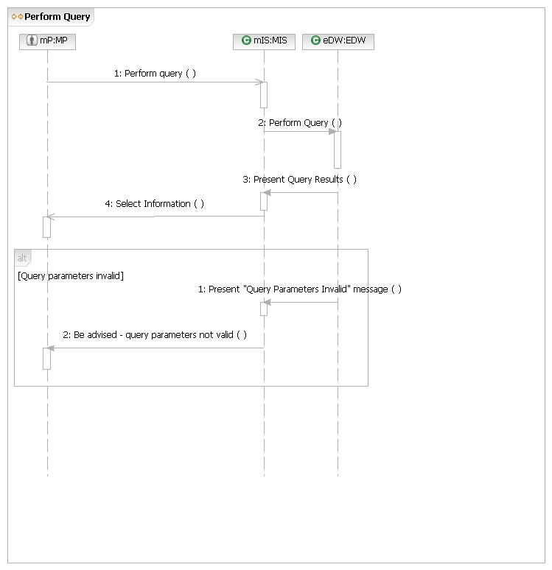
I.UC5.OP2 – Present Status of Report/Extract

Main Flow
Actor Action | Nodal Action | Step | Subsystem Action | White Box Budgeted Requirements
MP requests Nodal provide status of report or extract. |  | 1 | MP requests MIS provide status of report/extract.
MP requests Nodal provide status of report or extract. |  | 2 | MIS requests EDW provide status of report/extract.
MP requests Nodal provide status of report or extract. |  | 3 | EDW requests MIS present report/extract status.
MP requests Nodal provide status of report or extract. |  | 4 | MIS requests MP review report/extract status.

[Status information unavailable]
 |  | 1 | EDW requests MIS present “Status information unavailable” message.
 |  | 2 | MIS present “Status information unavailable” message.

I.UC5.OP2.WB – Present Status of Report
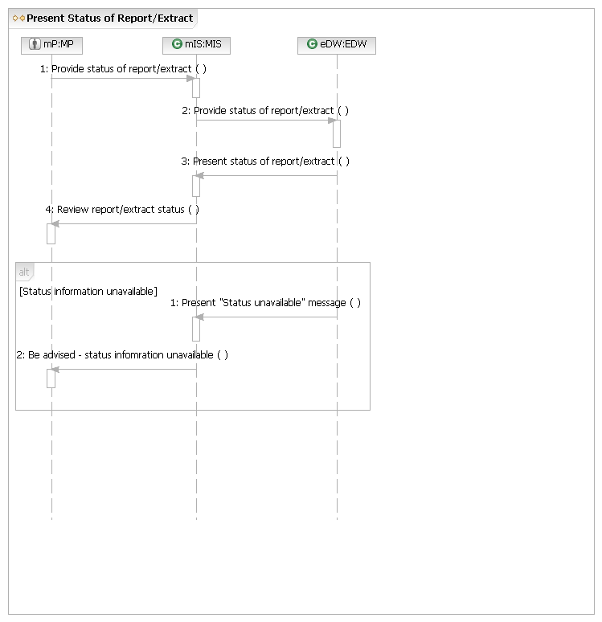
I.UC6 – Customize “My Page”
Brief Description
The “Customize My Page” use case starts with the MP selecting the “Customize My Page” option from the available options and ends with Nodal presenting the revised My Page screen to the MP.
Preconditions
MP user has permission to change “My Page” configuration.
Post Conditions
“My Page” has been reconfigured.
Main Success Scenario
1. At Step 4 of the “Access Nodal Applications and Information” use case, if MP selects “Customize My Page” option, then:
2. Nodal presents the “Customize My Page” screen.
3. MP submits revised “My Page”.
4. Nodal presents revised “My Page”.
5. Use case ends.
I.UC6.BB – Customize “My Page”
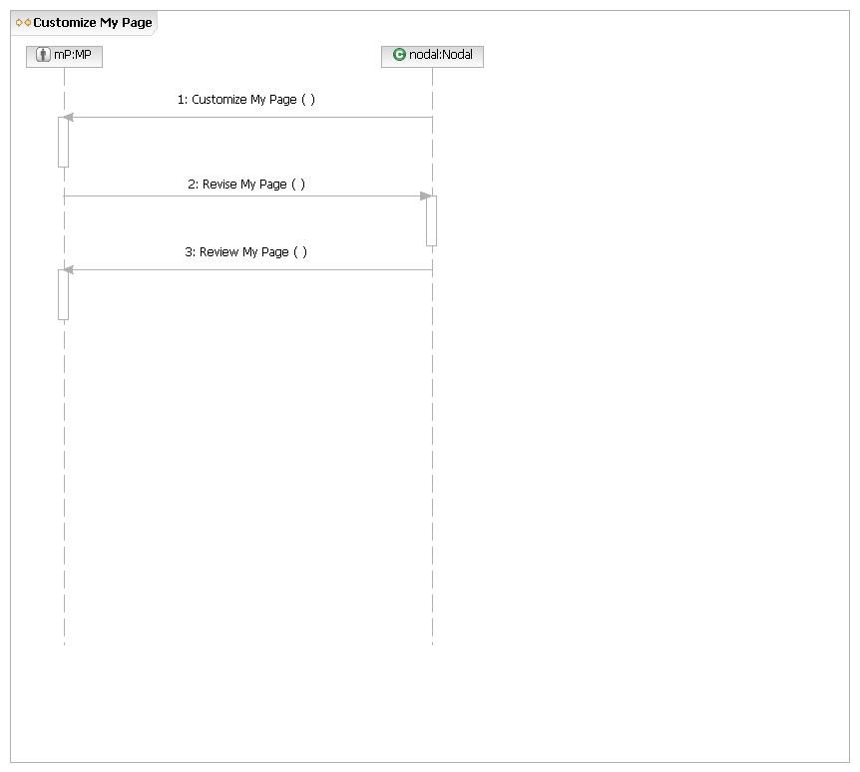
I.UC6.OP1 – Customize “My Page”

Main Flow
Actor Action | Nodal Action | Step | Subsystem Action | White Box Budgeted Requirements
MP submits revised “My Page”. | Nodal presents the “Customize My Page” screen.  Nodal presents revised “My Page”. | 1 | MIS presents the “Customize My Page” screen.
MP submits revised “My Page”. |  | 2 | MP submits revised “My Page” to MIS.
MP submits revised “My Page”. |  | 3 | MIS presents revised “My Page”.
I.UC6.OP1.WB – Customize “My Page”
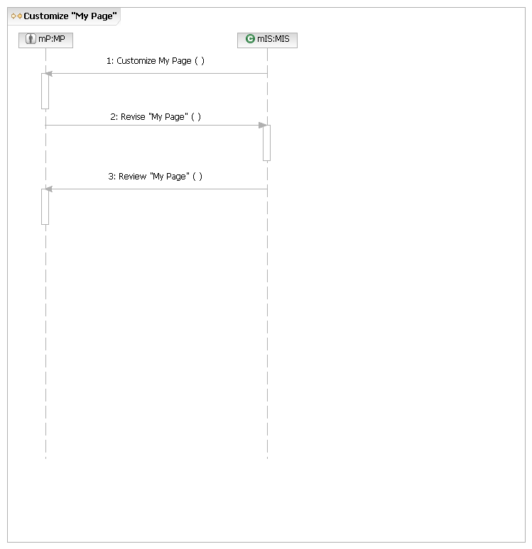

I.UC7 – Launch Application
Brief Description
The “Launch Application” use case starts with the MP selecting a specific application to launch from the available options and ends when the selected application launches. Examples of applications are User Account Administration, Market Operations (Scheduling), CRR, and Outage Scheduler.
Preconditions
None.
Post Conditions
MP has access to use of application.
Main Success Scenario
1. At Step 4 of the “Access Nodal Applications and Information” use case, if MP selects the link to launch a specific application option, then:
2. Nodal presents the selected application’s home page.
3. Use case ends.
Alternative flows
2.a. Selected application is unavailable for use.
1. Nodal presents “Application Unavailable” message.
2. Use case ends.
2.b. Selected application already launched.
1. Nodal presents a second instance of the application.
2. Use case ends.
I.UC7.BB – Launch Application
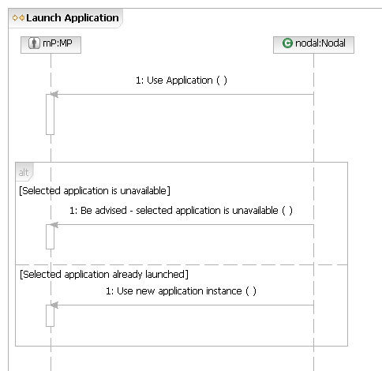
Common Operations
I.COM.OP1 – Send Selected Document

Main Flow
Actor Action | Nodal Action | Step | Subsystem Action | White Box Budgeted Requirements
MP requests Nodal send document. | Nodal sends Document. | 1 | MP requests MIS send document.
MP requests Nodal send document. | Nodal sends Document. | 2 | MIS requests EDW provide document.
MP requests Nodal send document. | Nodal sends Document. | 3 | EDW requests MIS send document.
MP requests Nodal send document. | Nodal sends Document. | 4 | MIS requests MP use document.

[Selected document unavailable]
 |  | 1 | EDW requests MIS present “Document Unavailable” message.
 |  | 2 | MIS presents “Document is Unavailable” message.
I.COM.OP1.WB – Send Selected Document
