

Nodal System of Systems:
System Operations (S.)
Version 0.992

Revision History
Date | Version | Description | Author(s)
16-Sept-2006 | 0.91 | TPTF Draft | Daryl Shing,  Gary Macomber
3-Oct-2006 | 0.93 | Incorporate comments for UC 3 and 4 | Rachel Cheng
4-Oct-2006 | 0.94 | Format Review | Daryl Shing
5-Oct-2006 | 0.991 | Released to TPTF for review | Daryl Shing
2-Nov-2006 | 0.992 | Released to TPTF for approval | Gary Macomber/Daryl Shing

Table of Contents
System of Systems Architecture 4
M - System Operations 9
S.UC1 – Ensure 60 Hz 10
S.UC1.BB – Ensure 60 Hz 15
S.UC1.OP1 – Update frequency 21
S.UC1.OP1.WB – Update frequency 21
S.UC1.OP2 – Execute Load Frequency Control 21
S.UC1.OP2.WB – Execute Load Frequency Control 27
S.UC1.OP3 – Update Generation Levels 31
S.UC1.OP3.WB – Update Generation Levels 31
S.UC1.OP4 – Update Responsiveness Information – Will Respond 32
S.UC1.OP4.WB – Update Responsiveness Information – Will Respond 32
S.UC1.OP5 – Update Responsiveness Information – Can’t Restore Reserve Obligation 32
S.UC1.OP5.WB – Update Responsiveness Information – Can’t Restore Reserve Obligation 33
S.UC1.OP6 – Update QSE Provider Information 33
S.UC1.OP6.WB – Update QSE Provider Information 34
S.UC1.OP7 – Use Revised Data 34
S.UC1.OP7.WB – Use Revised Data 34
S.UC1.OP8 – Use Telemetry Data 35
S.UC1.OP8.WB – Use Telemetry Data 35
S.UC2 – Ensure Grid Security 36
S.UC2.BB – Ensure Grid Security 39
S.UC2.OP1 – Use Transmission and Generation Data 40
S.UC2.OP1.WB – Use Transmission and Generation Data 40
S.UC2.OP2.WB – Update Transmission Element Ratings 41
S.UC2.OP3 – Implement Proposed Plan (RAP, Post Contingency) 42
S.UC2.OP3.WB – Implement Proposed Plan (RAP, Post Contingency) 42
S.UC2.OP4. – Send New Base Points 43
S.UC2.OP4.WB – Send New Base Points 43
S.UC3 – Plan System Operations 44
S.UC3.BB – Plan System Operations 45
S.UC3.OP1 – Update Information 46
S.UC3.OP1.WB – Update Information 46
S.UC3.OP2 – Analyze Solution 47
S.UC3.OP2.WB – Analyze Solution 48
S.UC4 – Plan the System (Long Term) 49
S.UC4.BB – Plan the System (Long Term) 52
S.UC4.OP1 – Update Annual Planning Model 56
S.UC4.OP1.WB – Update Annual Planning Model 56
S.UC4.OP2 – Post Approved Annual Planning Models 57
S.UC4.OP2.WB – Post Approved Annual Planning Models 57
S.UC4.OP3 – Endorse Project 58
S.UC4.OP3.WB – Endorse project 59
S.UC4.OP4 – Incorporate Comments 60
S.UC4.OP4.WB – Incorporate Comments 61
S.UC4.OP5 – Generate Project Status Report 62
S.UC4.OP5.WB – Generate Project Status Report 62
S.UC4.OP6 – Proceed with Project 63
S.UC4.OP6.WB – Proceed with Project 63
S.UC4.OP7 – Update Annual Planning Models with Seasonal Information 64
S.UC4.OP7.WB – Update Annual Planning Models with Seasonal Information 64
S.UC4.OP8 – Recommend Alternative Project 65
S.UC4.OP8.WB – Recommend Alternative Project 65
S.UC4.OP9 – Update Project Information 66
S.UC4.OP9.WB – Update Project Information 66
S.UC4.OP10 – Brief on Project 67
S.UC4.OP10.WB – Brief on Project 67
S.UC5 Request Nodal Approve a New or Relocated Facility 68
S.UC5.BB Request Nodal Approve a New or Relocated Facility 68
S.UC5.OP1 Incorporate NOMCR 69
S.UC5.OP1.WB Incorporate NOMCR 69
S.UC5.OP2 Use Generation Resource Parameters 69
S.UC5.OP2 Use Generation Resource Parameters 70
S.UC5.OP3 Approve Metering Design Proposal 70
S.UC5.OP3.WB Approve Metering Design Proposal 70
S.UC5.OP4 Coordinate on Testing 71
S.UC5.OP4.WB Coordinate on Testing 71
S.UC5.OP5 Use Verifiable Costs 71
S.UC5.OP5.WB Use Verifiable Cost Information 72
Common Operations 73

System of Systems Architecture
The System of Systems Architecture (SoSA) is a technique for modeling a complex system that is itself comprised of complex systems. The value of this approach comes from its ability to look at customers of Nodal and how they expect to operate in a Nodal Market. We believe this approach will provide TPTF and ERCOT a holistic view of Nodal and the means to ensure that the requirements of the individual projects effectively integrate to meet the needs of the Nodal Market.
Document Structure
The Use Case Diagram at the start of the document identifies the Use Cases covered by this document. Each Use Case will have a Use Case Specification documenting the steps, and alternate steps, required to realize the Actors usage of Nodal. The interactions between the Actor and Nodal, found in the Use Case Specification, are documented in the Black Box Sequence Diagram. Each interaction that requires an action by Nodal will have an Operation Specification and supporting White Box Sequence Diagram.
So the logical progression of SoSA is as follows; a Use Case Specification, its Block Box Sequence Diagram, one or more Operation Specifications and their supporting White Box Sequence Diagram(s). This repeats for every Use Case in the Use Case Diagram.
Document Numbering
This document contains the Enterprise Uses Cases for System Operations. All System Operations Use Cases are prefixed with S. (System Operations Use Cases are always purple on diagrams and in this document) and are numbered S.UC1 through S.UC5. Each use case has a Black Box Sequence Diagram identified by postfix of .BB, for example S.UC1.BB identifies the Black Box Sequence Diagram for System Operations Use Case 1. Each operation identified in the Black Box Sequence Diagram is numbered OP1 through OPx and each operation has a corresponding White Box Sequence Diagram WB. For example the White Box Sequence Diagram for Operation 1 on Use Case 1 would be prefixed by S.UC1.OP1.WB.
Any operations identified as common between Use Cases are referenced as common under the Black Box Sequence Diagram and located in a separate Common Operations Section at the end of the document.
How to Read the Use Case Diagram
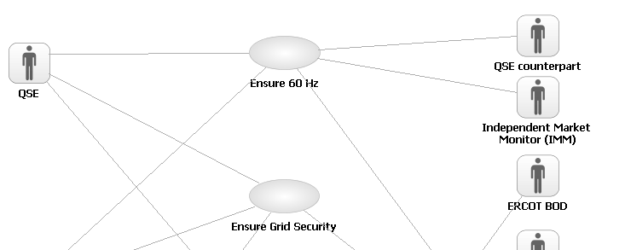
The Use Case Diagram shows the Actors relationships to the Use Cases. A Use Case at the Enterprise Level is a complete usage of Nodal that provides value to an Actor. Use Case names are structured <Verb> <Noun> to ensure the ‘use’ is captured in the name of the Use Case. The line between the Actor and the Use Case indicates which Actor ‘initiates’ the Use Case. You will only see Actors in the Use Case Diagram that operate outside of Nodal. For example, an ERCOT System Operator would not appear as an Actor at this level because they are inside of Nodal. They will appear as a user of the system at the System and/or Component Level.
You should read the above example as:
The QSE initiates Ensure 60 Hz.
The QSE initiates Ensure Grid Security.
How to Read the Use Case Specification
Main Success Scenario (6.5.7.6.2.1)
1. TSPs and Frequency Monitor send Nodal frequency data to Nodal.
2. At 4 second intervals Time requests Nodal execute Load Frequency Control.
3. Nodal analyzes grid frequency, generation levels, other generator telemetry and status of telemetry, finding it all valid; frequency is within a normal range (no emergency exists). Nodal calculates total load.
4. Nodal confirms actual Reserves meet obligation.
5. Nodal calculates the delta (additional +/-) energy requirement.
6. Nodal assigns the QSEs regulation deployment.
7. Nodal sends regulation deployments to QSEs, without new base points.
8. QSEs request Nodal update generation levels.
9. Nodal analyzes generation levels and concludes QSE is responding to past instructions.
10. Nodal publishes real time grid data for the Public.
11. Use case ends.
Alternate flows
…
3.a. Frequency source or reference is invalid.
1. Switch to alternative frequency source or reference.
2. Return to Main Success Scenario, Step 2.

The Use Case Specification outlines the steps, and alternate steps, required to meet the Use Cases objectives. Each step in the Main Success Scenario is numbered in sequence and contains very deliberate language follow a structure of <who> is requesting <what> from <whom>. (if the whom is absent it is assumed to be the System in this case Nodal).
Behavior/functionality performed completely within Nodal is not reflected in these steps. At this point we are concentrating on interactions between the Actor and Nodal. Each of these interactions, or operations that Nodal supports, will be broken down into steps at the Operation Specification.
Alternative Flows are attached by using the number of the step to replace and appending an ‘a’ for the first Alternative Flow and a ‘b’ for the second etc. You should read the alternative as in the case of the <alterative description>, instead of doing step x, Nodal will do the following <alternate steps>. Using this approach you should read alternative ‘3.a’ in the example above as:
In the case of Frequency source or reference is invalid, instead of doing Nodal analyzes grid frequency, generation levels… Nodal will do 1. Switch to alternative frequency…
The same pattern is followed for Alternate Flows to Alternate Flows. 1.a.2.a is an Alternate Flow to step 2 in Alternate Flow 1a.
How to Read the Black Box Sequence Diagram
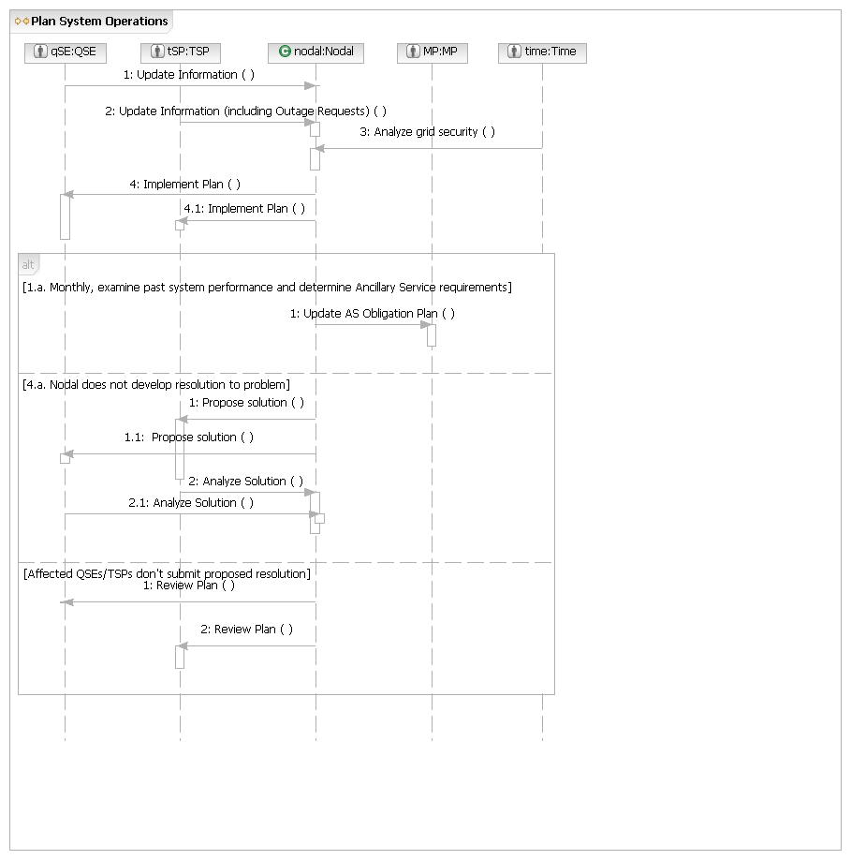
The Black Box Sequence Diagram takes the steps in the Use Case Specification and captures the requests from the Actor to Nodal, and from Nodal to the Actor. These are always in the form of a request, not the passing of information, and should be read in the direction of the arrow. In the example above request one, two and three should be read as:
1. The QSE requests Nodal to Update Information.
2. TSP requests the Nodal to Update Information.
3. Time requests the Nodal to Analyze Grid Security.
This takes some “getting used to” but it is done for a very good reason. We are trying to identify the behaviors, called operations in SoSA that Nodal needs to be able to perform. Every time you see an arrow pointing to Nodal, this is an operation Nodal needs to support.
How to Read the Operation Specification
Time, QSE or TSP Request: Analyze Solution

Main Flow
Actor Action | Nodal Action | Step | Subsystem Action | White Box Budgeted Requirements
Time, QSE, or TSPs request Nodal analyze solution to future security risks | Nodal analyzes solution to future security risks.  Nodal requests QSE and TSP implement solution. | 1 | QSE requests MMS or TSP requests OS analyze solution to future security risks.
 |  | 2 | MMS requests OS send outage information, NMMS send updated network model, and EMS send load forecasts.
 |  | 3 | EMS requests OS, NMMS, and MMS send processed information.
 |  | 4 | EMS performs analyses to determine future security risks.
 |  | 5 | MMS or OS requests QSE and TSP implement plan.

The Operation Specification takes each of the arrowheads pointing to Nodal and details the interactions required between the systems within Nodal to perform the Operation.
You can see from the example above the first column in the Operation Specification shows the initial Actor Action from the Use Case Specification. The Nodal Action shows the action Nodal is performing until the next Actor Interaction. The Subsystem Actions are the interactions between systems inside Nodal required to meet the Actors Request. You would read the example above as:
Time, QSE or TSP requests Nodal to analyze solution to future security risk.
Nodal analyzes solution to future security risk by QSE requests MMS or TSP requests OS analyze solution to future security risk. MMS requests OS send outage information, NMMS…
How to Read the White Box Sequence Diagram
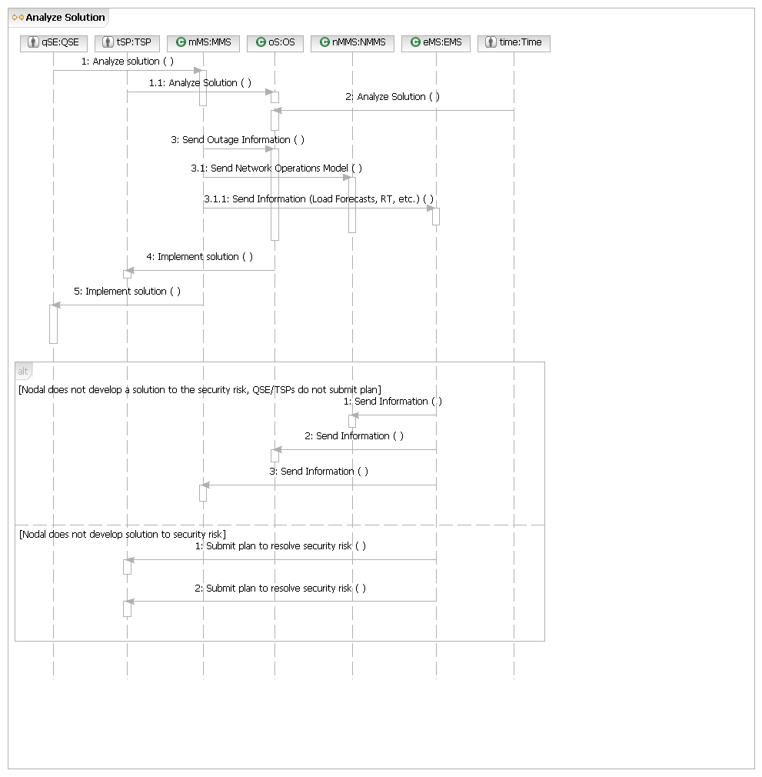
The White Box Sequence Diagram takes the interactions within Nodal identified in the Operation Specification and documents the flow in a Sequence Diagram. A box and a vertical line represent each of the Systems identified within Nodal, this is called a ‘lifeline’. You can see in the example above we have lifelines for MMS, OS, NMMS and EMS along with the original Actors. Like the Black Box Sequence Diagram, each line with associated arrow represents a request in the direction of the arrowhead. You would read the example above as
The QSE requests MMS to Analyze solution.
The TSP requests OS to Analyze Solution.
Time requests OS to Analyze Solution.
MMS requests OS to Send Outage Information.
You will notice there is no request back from the OS to MMS for request 3. In cases like this when the return request would be simply meeting the request, we leave the return request out to simplify the diagram.
Functionality/Behavior within the MMS, OS, EMS or NMMS required to meet the request are not shown at this level. We are concentrating on identifying the interactions between the Systems inside Nodal required to fulfill the Market Participants request. This detail will be exposed when we look inside the MMS, OS, EMS or NMMS systems themselves. In the Nodal Program this is being performed by the individual Project Teams.
Another consideration as you read this document is that the White Box Requests provide requirements for each of the systems inside Nodal but the sequence of execution may change when the systems are implemented. For example, a system may request information each time a flow is executed but this may be done only once per day for efficiency reasons.
M - System Operations
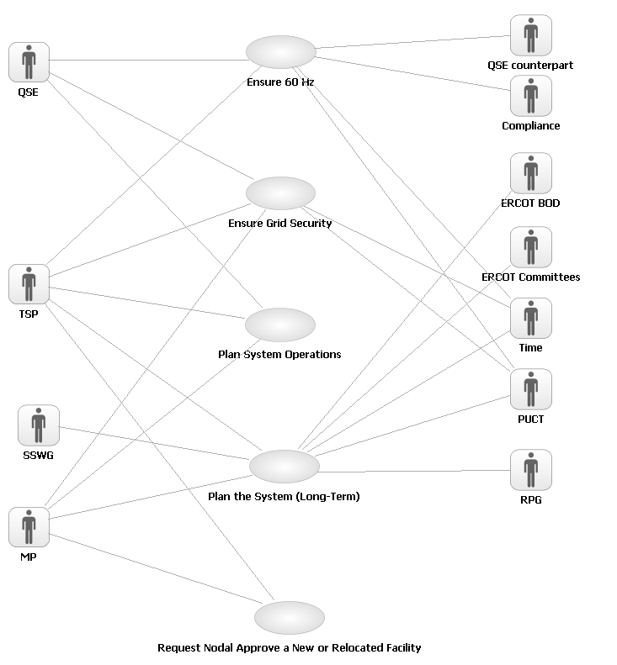
S.UC1 – Ensure 60 Hz
Brief description
Ensure 60 Hz Use Case covers the process of assessing and maintaining 60 HZ frequency on the grid.
Precondition
Transmission/generation interconnection functioning and system frequency is close to 60 Hz. LFC tuning parameters are properly established and LFC meeting performance criteria.
Post Condition
Generation is adjusted to maintain 60 Hz frequency.
Main Success Scenario (6.5.7.6.2.1)
1. TSPs, QSEs, and Frequency Monitor send Nodal frequency data to Nodal.
2. At 4 second intervals Time requests Nodal execute Load Frequency Control.
3. Nodal analyzes grid frequency, generation levels, other generator telemetry and status of telemetry, finding it all valid; frequency is within a normal range (no emergency exists). Nodal calculates total load.
4. Nodal confirms actual and future Reserves meet obligation.
5. Nodal calculates the delta (additional +/-) energy requirement.
6. Nodal assigns the QSEs regulation deployment.
7. Nodal sends regulation deployments to QSEs, without new base points.
8. QSEs request Nodal update generation levels.
9. Nodal analyzes generation levels and concludes QSE is responding to past instructions.
10. Nodal publishes real time grid data in the Public and Secure areas.
11. Use case ends.
Alternate flows
2.a. Nodal (EMS) fails.
1. Nodal initiates failover.
2. Nodal notifies QSE.
3. Use case ends.
2.a.2,a, Nodal (EMS) fails, failover longer than 1 minute.
1. Nodal requests QSEs manage in constant frequency until new data sent.
2. Use case ends.
3.a. Frequency source or reference is invalid.
1. Switch to alternative frequency source or reference.
2. Return to Main Success Scenario, Step 2.
3.b. Nodal finds generation telemetry MW status invalid or manually entered for less than 5 minutes.
1. Nodal notifies QSE that telemetry is invalid.
2. Nodal uses QSEs’ last value.
3. Return to Main Success Scenario, Step 4.
3.c. Generation telemetry MW status or manually entered for more than 5 minutes.
1. Nodal notifies QSE that telemetry is invalid.
2. Use last state estimator generation MW to calculate load.
3. Return to Main Success Scenario, Step 4.
3.d. Low Frequency – Nodal finds frequency below RRS deployment threshold (59.9).
1. Nodal calculates delta energy requirement.
2. Nodal deploys all regulation up to requirement.
3. Nodal determines if there is a delta requirement (amount beyond Regulation available)
3. Nodal deploys responsive reserve to meet delta requirement
4. Nodal sends new base points.
5. Use case ends.
3.e. Low Frequency – Frequency below 59.5 Hz (automatically; at 59.8 the operator may declare EECP).
1. Nodal notifies QSEs, TSPs, and PUCT we are entering EECP.
2. Nodal sends new base points
3. Follow EECP procedures.
4. Use case ends.
3.f. High frequency – Nodal finds frequency High above 60.1 Hz.
1. Nodal calculates available Reg-Down.
2. Nodal has enough Regulation Down to resolve frequency deviation, but insufficient ramp rate to resolve the deviation in a timely manner.
3. Nodal deploys available regulation down to QSEs.
4. Nodal calculates and issues new base points (SCED) to obtain additional ramp-rate and sends to QSEs.
5. Use case ends.
3.f.2.a. High frequency – Insufficient Reg Down. (6.5.7.6.1.9).
1. Nodal determines there is insufficient Reg Down to resolve high frequency.
2. Nodal deploys available Reg Down to QSE’s.
3. Nodal calculates there is sufficient down capacity to adjust base points and resolve problem.
4. Nodal calculates and issues new base points (SCED) and sends to QSEs.
5. Use case ends.
3.f.2.a.3.a High Frequency – Insufficient Reg-down, Insufficient capacity down.
1. Nodal determines there is insufficient capacity down using LSL’s to resolve high frequency.
2. Nodal deploys all available regulation down.
3. Nodal determines that there is sufficient “down” room if emergency low limits are implemented.
4. Nodal issues an Alert (Emergency) to QSE’s,TSPs, PUCT.
5. Nodal directs QSEs to implement Low Emergency Limits on all generators.
6. Nodal calculates and issues new generator base points (SCED) and sends to QSEs.
7. Use case ends.
3.f.2.a.3.a.3.a High Frequency – Emergency Low Limits are not adequate.
1. Nodal determines that it even using low emergency limits there is too much generation on line to restore 60 Hz.
2. Nodal declares Emergency status and notifies QSEs, TSPs, PUCT.
3. Nodal orders QSEs to take specific generators offline.
4. Use case ends.
3.g. Frequency Source – No alternate source available
1. All alternate frequency sources are invalid
2. Notify QSE to switch to constant frequency
3. Nodal declares Emergency status and notifies QSEs, TSPs, PUCT.
4. Use Case ends?
4.a Responsive Reserve available, provider doesn’t meet their obligation.
1. Nodal asks QSEs who are short of obligation if telemetered Responsive Reserves are correct
2. QSEs affirm telemetered Responsive Reserves are correct.
3. Nodal asks QSEs if they can restore reserves to its obligation
4. QSEs responds it can within a short time
5. Use case ends.
4.a.4a Responsive Reserve short- provider cannot meet obligation in future hours.
1. QSE informs Nodal that they can’t restore reserve obligation.
2. Nodal requests QSE arrange alternate QSE.
3. QSE notifies Nodal of alternate supplier.
4. Nodal issues future deployments to alternate QSE.
5. Use case ends.
4.a.4.a.3.a QSE doesn’t find alternate QSE. (6.5.9.3.3).
1. QSE notifies Nodal that they can’t find an alternate QSE.
2. Nodal procures replacement AS thru SASM Market for future hours.
3. Use case ends.
4.b. Physical Responsive Reserve available doesn’t meet total Nodal obligation.
1. Nodal asks QSEs who are short of their obligation if telemetered Responsive Reserves are correct.
2. QSEs affirms telemetered Responsive Reserves are correct.
3. Nodal determines physical reserves can not be quickly restored (SASM or bilateral trades are methods, but neither will quickly restore reserves).
4. Nodal notifies QSEs, TSPs, and PUCT we are entering EECP.
5. Follow EECP procedures.
6. Use case ends.
4.b.2.a. QSE informs Nodal that its evaluation of Responsive Reserves is incorrect.
1. QSE says shortage Responsive Reserves are incorrect, identifies error(s) in Responsive Reserves calculation and informs Nodal (QSE requests Nodal update information).
2. Nodal substitutes estimated amount from QSE and concludes with estimated amount that QSE Responsive Reserve does meet obligation.
3. Use case ends.
4.b.2.a.2.a. Inadequate Reserves even with estimated amounts.
1. Nodal concludes with estimated amount that actual Reserve does not meet obligation.
2. Nodal notifies QSEs, TSPs, and PUCT we are entering EECP.
3. Follow EECP procedures.
4. Use case ends.
7.a. High Frequency – Nodal determines insufficient Reg-Down available.
1. Nodal deploys available Reg Down to QSE’s.
2. Nodal calculates and issues new basepoints (SCED) to obtain additional reg-down and sends to QSEs.
3. Use case ends.
7.b. Low Frequency – Nodal determines insufficient (additional) Reg-Up available.
1. Nodal deploys available Reg up.
2. Nodal calculates RRS energy in excess of available Reg-Up needed.
3. Nodal determines additional RRS requirement is <500MW.
4. Nodal sends RRS deployment to QSEs.
5. Nodal calculates and issues new basepoints (SCED) and sends to QSEs.
6. Use case ends.
7.b.2.a. RRS needed is more than 500 MW (6.5.7.6.2.2)
1. Nodal determines Responsive Reserve requirement >500MW.
2. Nodal notifies QSEs, TSPs, and PUCT we are entering EECP.
3. Follow EECP procedures.
4. Use case ends.
7.c. Nodal sends new Base Points.
1. Nodal sends regulation deployments to QSEs.
2. Nodal sends new Base Points to QSEs.
3. Use case ends.
9.a. QSE not responsive to AS instructions.
1. Nodal determines QSE generation has not been responsive to instructions.
2. Nodal asks QSE if they will be responsive in the future.
3. QSE says they will respond and they do.
4. Use case ends.
9.a.3.a. QSE is repeatedly non-responsive.
1. Nodal determines QSE generation has repeatedly not been responsive to instructions even after assuring Nodal they would be responsive.
2. Nodal sends Incident Report to Compliance.
3. Use case ends.
9.a.3.b. QSE can’t respond (maintenance issue).
1. QSE informs Nodal that they can’t respond.
2. Nodal requests QSE arrange alternate QSE as supplier.
3. QSE notifies Nodal of alternate supplier.
4. Nodal issues future deployments to alternate QSE.
5. Use case ends.
9.a.3.b.3.a QSE does not find alternate QSE. (6.5.9.3.3).
1. QSE notifies Nodal that they can’t find an alternate QSE.
2. Nodal issues an Ancillary Service Alert to QSEs, TSPs, PUCT.
3. Nodal issues an order to provide regulation for the short term to another QSE even if no AS offers exist from that QSE for short term.
4. Nodal procures replacement AS thru SASM Market for future hours.
5. Use case ends.
9.a.3.b.3.a.2.a. No alternate QSE, no Ancillary Service alert issued.
1. Nodal determines insufficiency doesn’t justify an alert.
2. Nodal procures replacement AS thru SASM Market for future hours.
3. Use case ends.

S.UC1.BB – Ensure 60 Hz
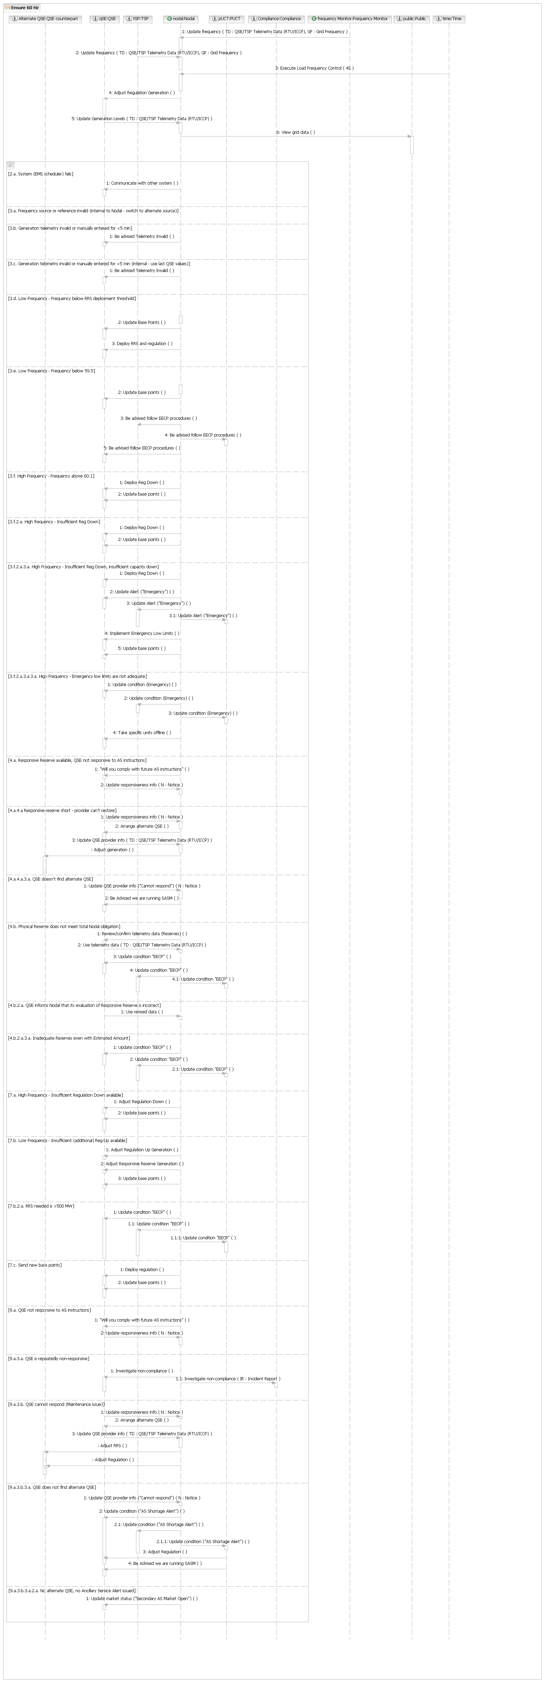

S.UC1.OP1 – Update frequency

Main Flow
Actor Action | Nodal Action | Step | Subsystem Action | White Box Budgeted Requirements
TSPs and Frequency Monitor send Nodal frequency data. |  | 1 | TSPs and Frequency Monitor request EMS update frequency data
S.UC1.OP1.WB – Update frequency
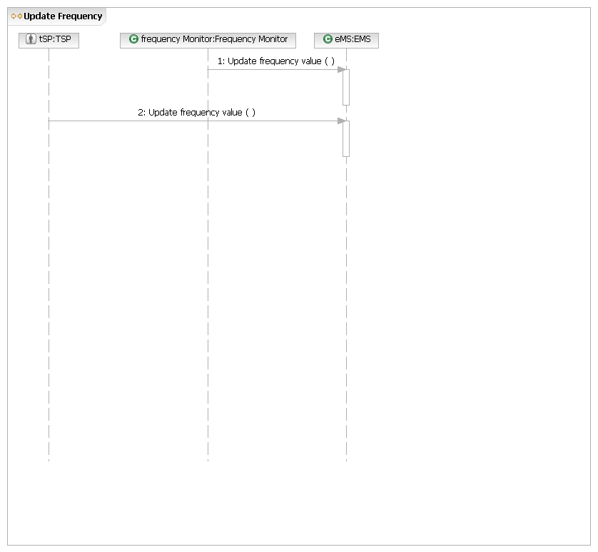
S.UC1.OP2 – Execute Load Frequency Control

Main Flow
Actor Action | Nodal Action | Step | Subsystem Action | White Box Budgeted Requirements
Time requests Nodal execute Load Frequency Control. |  | 1 | Time requests EMS execute Load Frequency Control. | 4 sec interval.

[Nodal Finds Frequency Source or reference is invalid]
Nodel finds frequency source or reference invalid: switches. | Nodal switches to alternative source. | 1 | EMS failure of data validation on frequency source, or frequency reference.
Nodel finds frequency source or reference invalid: switches. | Nodal switches to alternative source. | 2 | EMS switches to alternate source.

[Generation telemetry invalid or manually entered for <5 min, EMS uses last values from QSEs]
 |  | 1 | EMS notifies QSEs that telemetry is invalid.

[Generation telemetry invalid or manually entered for >5 min, EMS uses SE last value]
 |  | 1 | EMS notifies QSEs that telemetry is invalid.

[Low Frequency - Frequency below RRS deployment threshold]
 |  | 1 | EMS requests QSEs deploy RRS and Regulation.

[Low Frequency – Frequency below 59.5 Hz]
 | Nodal notifies QSEs, TSPs, and PUCT we are entering EECP Step 5. | 1 | EMS notifies QSEs, TSPs, and PUCT we are entering EECP Step 5.

[High Frequency – Nodal finds frequency above threshold (60.1 Hz)]
 | Nodal deploys regulation down  Nodal notifies QSEs to implement new base points. | 1 | EMS sends Regulation down deployment to QSEs.
 |  | 2 | EMS notifies QSEs to implement new base points.

[High Frequency – Frequency above threshold and insufficient Reg Down.]
 | Nodal deploys Reg Down. | 1 | EMS deploys available Reg down.
 | Nodal deploys Reg Down. | 2 | EMS requests MMS calculate new base points.
 | Nodal deploys Reg Down. | 3 | MMS passes new base points to EMS.
 | Nodal deploys Reg Down. | 4 | EMS transmits unit base points to QSEs.

[High Frequency – Insufficient Reg Down, insufficient capacity]
 | Nodal deploys all available Reg Down.  Nodal issues an Alert (hotline).  Nodal issues new generator set points using Low Emergency Limits | 1 | EMS deploys all available Reg Down.
 |  | 2 | EMS using Hot line directs all QSE’s that Nodal is implementing Low emergency limits.
 |  | 3 | EMS implements emergency conditions and LEL’s.
 |  | 4 | EMS passes LEL’s to MMS(SCED) and triggers new SCED calculation.
 |  | 5 | MMS passes new base points back to EMS.
 |  | 6 | EMS transmits new base points to QSE.

[High Frequency - Insufficient capacity down even using LEL]
 | Nodal deploys all available Reg Down.  Nodal issues an emergency alert.  Nodal directs generating units offline. | 1 | EMS deploys all available Reg Down.
 |  | 2 | EMS using Hot line issues an emergency alert, and notifies all QSE’s that Nodal has insufficient capacity down and is will direct units offline, Asks QSEs for volunteers.
 |  | 3 | EMS directs specific units offline.

[Responsive Reserve available – a provider does not meet obligation (but Nodal not overall short or insecure)]
 | Nodal asks “short” QSE if telemetered Responsive Reserves are correct. | 1 | EMS calls short QSE and asks if telemetered RRS showing they are short is correct.
 |  | 2 | QSE notifies EMS the telemetered RRS are correct.
 |  | 3 | EMS asks if they can restore to obligation soon.
 |  | 4 | QSE informs EMS they will restore reserves to meet obligation soon.

[Responsive Reserve available – a provider does not meet obligation & cannot restore – ID’s alternate supplier]
 | Nodal requests short QSE to arrange an alternate provider. | 1 | EMS requests that QSE arrange an alternate provider of its AS.
 | Nodal requests short QSE to arrange an alternate provider. | 2 | QSE provides an alternate supplier (Steps 2-4 reuses Operation 6 – Update QSE Provider Information).
 | Nodal requests short QSE to arrange an alternate provider. | 3 | EMS updates new supplier.
 | Nodal requests short QSE to arrange an alternate provider. | 4 | EMS redirects monitoring to new supplier.

[Physical Reserve does not meet total Nodal obligation]
 | Nodal asks short QSEs if they can restore their obligation within a short time period  Nodal notifies QSEs, TSPs and PUCT we are entering EECP | 1 | EMS calls QSE showing short and asks if telemetered RRS is correct
 |  | 2 | QSE responds telemetered values are correct
 |  | 3 | EMS determines we will not be able to restore total system RRS to its obligation in a short timeframe.
 |  | 4 | EMS notifies QSEs, TSPs, (hotline) and PUCT (email revised daily report) we are entering EECP

[Inadequate reserves even with estimated amount]
 | Nodal asks TSP, QSEs and PUCT follow EECP procedures. | 1 | EMS requests TSP, QSEs and PUCT follow EECP procedures.

[High Frequency – Insufficient Reg Down available]
 | Nodal deploys available Reg Down to QSE’s.  Nodal calculates and issues new basepoints (SCED) to obtain additional reg-down and sends to QSEs. | 1 | EMS requests QSEs adjust Reg Down.
 |  | 2 | EMS requests MMS calculate new base points.
 |  |  | MMS passes new base points to EMS.
 |  |  | EMS transmits unit base points to QSEs.

[Low Frequency – Insufficient (additional) regulation up available.]
 | Nodal Sends RRS and Reg Up deployments to QSEs.  Nodal calculates total demand and triggers calculation of economic base points.  Nodal dispatches unit base points to QSEs to recover Responsive Reserve. | 1 | EMS Calculates RRS required in excess of available REG and concludes it is less than 500 MW (No EECP required).  EMS calculates and sends RRS and Reg Up deployments to QSEs.
 |  | 2 | EMS requests MMS calculate new base points.
 |  | 3 | MMS passes new base points to EMS.
 |  | 4 | EMS transmits unit base points to QSEs.

[More than 500 MW of RRS required to recover frequency along with regulation up (6.5.7.6.2.2)
 | Nodal notifies QSEs, TSPs, and PUCT we are entering EECP. | 1 | EMS notifies QSEs, TSPs, (hotline) and PUCT (email revised daily report) we are entering EECP.

[Send new base points.]
 | Nodal sends regulation deployments to QSEs. | 1 | Nodal requests QSEs deploy available regulation down.
 | Nodal sends regulation deployments to QSEs. | 2 | MMS calculates new base points and passes back to EMS
 | Nodal sends regulation deployments to QSEs. | 3 | EMS passes new base points to QSE’s and resets Regulation and Responsive.

[QSE not responsive to AS instructions]
 | Nodal asks QSE if they will be responsive in the future. | 1 | EMS asks QSE if they will be responsive in the future.
 | Nodal asks QSE if they will be responsive in the future. | 2 | QSE requests EMS update QSE responsiveness information – will respond (reuses “Update Responsiveness Information – Will Respond).
 |  | 3 | EMS updates QSE responsiveness information – will respond.

[QSE is repeatedly non-responsive]
 | Nodal sends Incident Report to Compliance. | 1 | EMS sends Incident Report to Compliance.

S.UC1.OP2.WB – Execute Load Frequency Control
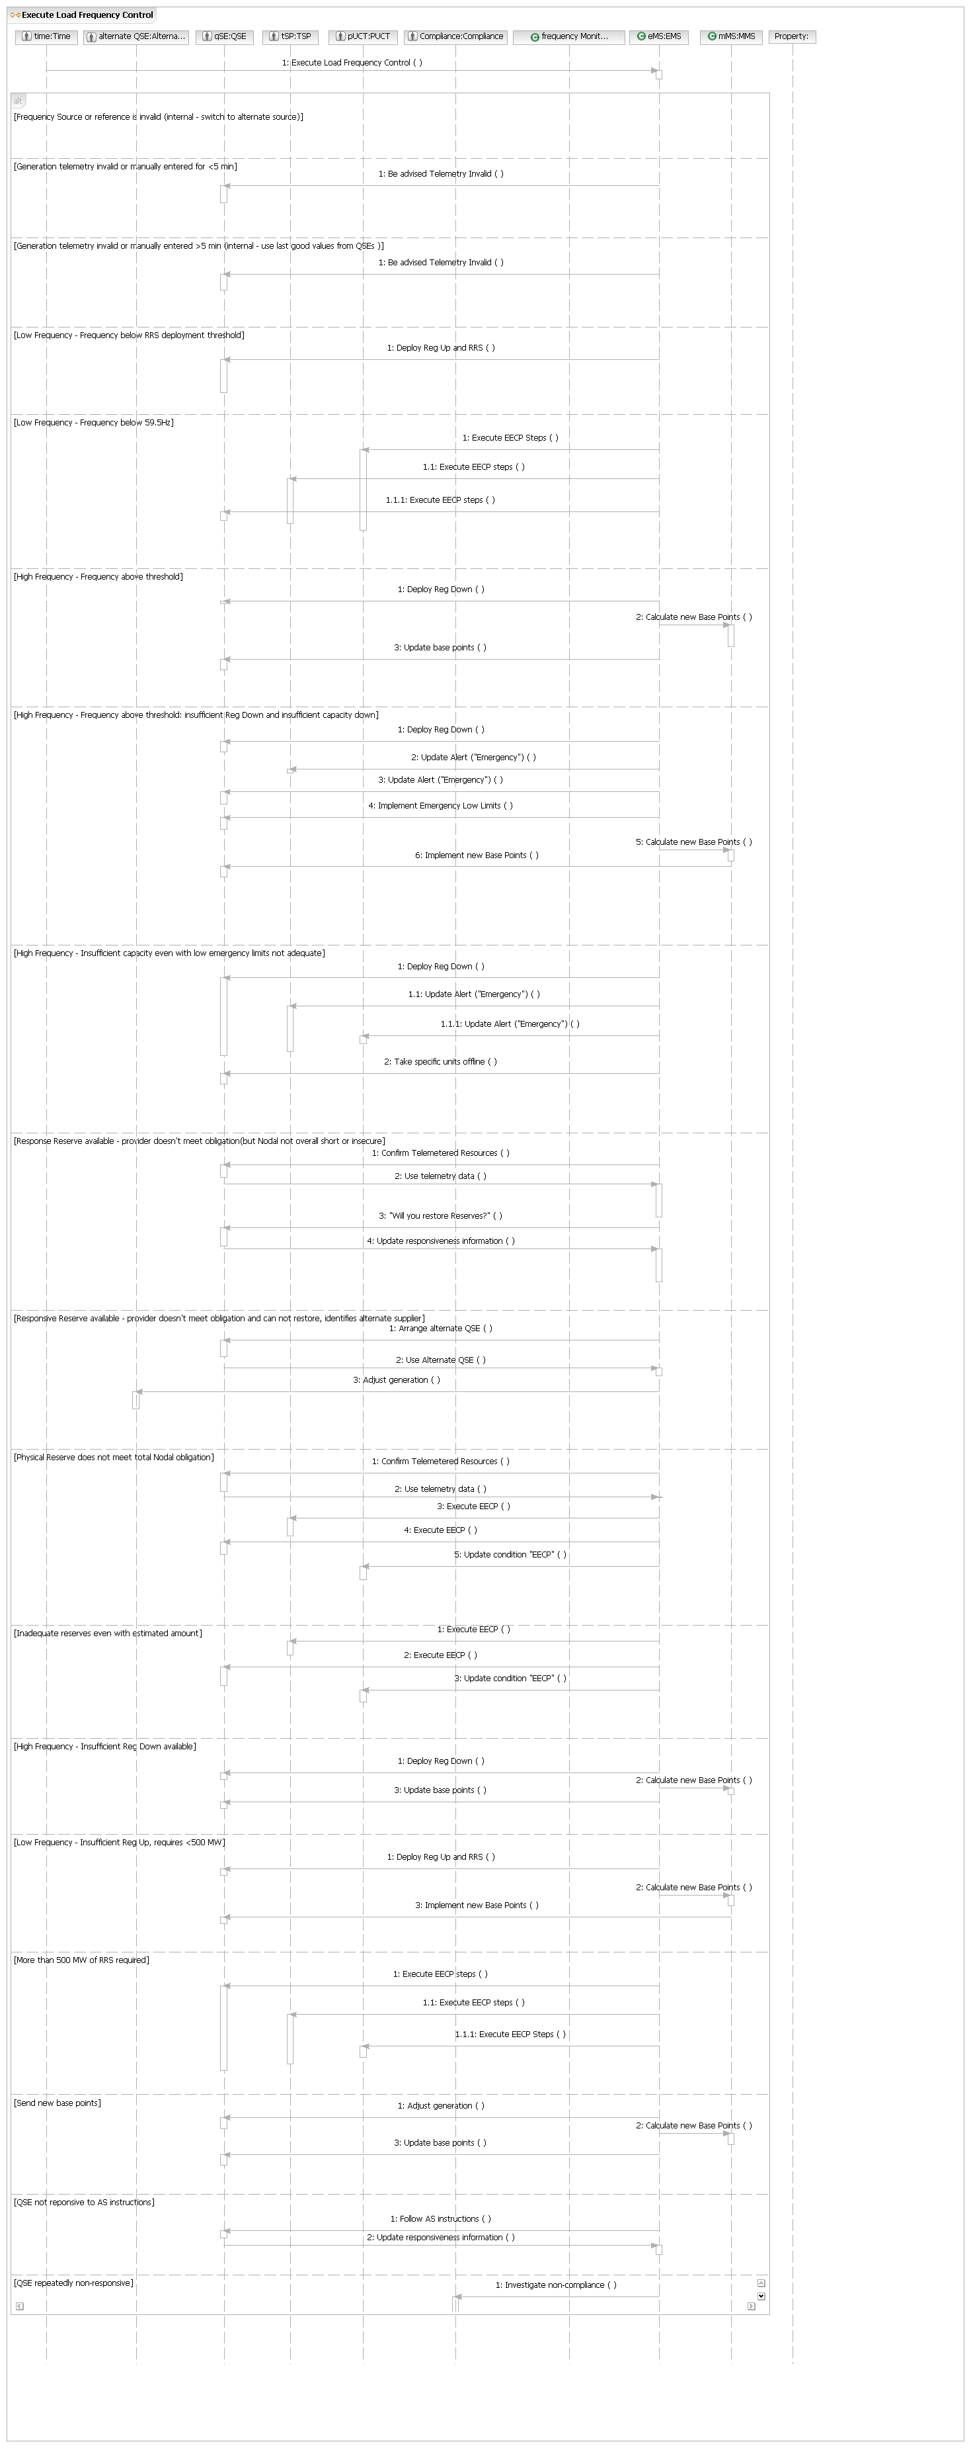

S.UC1.OP3 – Update Generation Levels

Main Flow
Actor Action | Nodal Action | Step | Subsystem Action | White Box Budgeted Requirements
QSEs request Nodal update generation levels. |  | 1 | QSEs request EMS update generation levels.
QSEs request Nodal update generation levels. |  | 2 | EMS validates resource status.
QSEs request Nodal update generation levels. |  | 3 | EMS updates QSE generation levels.

[Unit not in on line status (except hydros and quick start units)]
 |  | 1 | Set generation level to 0
S.UC1.OP3.WB – Update Generation Levels
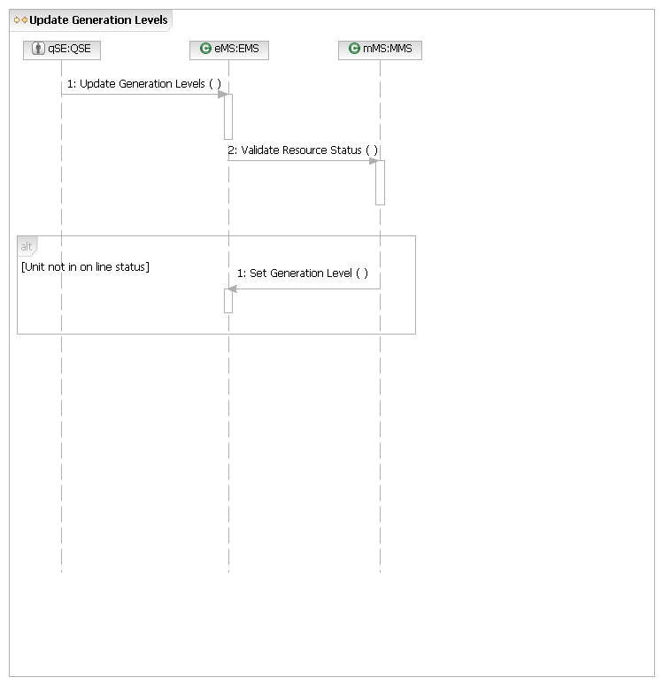
S.UC1.OP4 – Update Responsiveness Information – Will Respond

Main Flow
Actor Action | Nodal Action | Step | Subsystem Action | White Box Budgeted Requirements
QSE informs Nodal that will respond. |  | 1 | QSE requests EMS update QSE responsiveness information – will respond.
QSE informs Nodal that will respond. |  | 2 | EMS updates QSE responsiveness information – will respond.
S.UC1.OP4.WB – Update Responsiveness Information – Will Respond
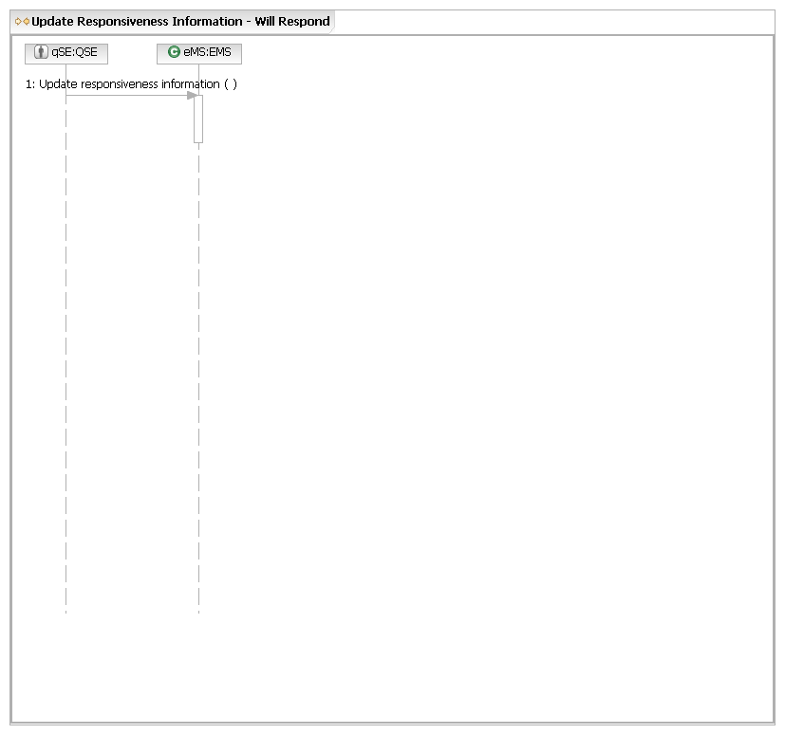
S.UC1.OP5 – Update Responsiveness Information – Can’t Restore Reserve Obligation

Main Flow
Actor Action | Nodal Action | Step | Subsystem Action | White Box Budgeted Requirements
QSE informs Nodal that it can’t restore reserve obligation. | Nodal procures replacement AS thru SASM for future hours. | 1 | QSE requests EMS update QSE responsiveness information – can’t restore reserve obligation.
QSE informs Nodal that it can’t restore reserve obligation. | Nodal procures replacement AS thru SASM for future hours. | 2 | EMS updates QSE responsiveness information – can’t restore reserve obligation.
QSE informs Nodal that it can’t restore reserve obligation. | Nodal procures replacement AS thru SASM for future hours. | 3 | EMS requests MMS open SASM.
QSE informs Nodal that it can’t restore reserve obligation. | Nodal procures replacement AS thru SASM for future hours. | 4 | MMS opens SASM.
QSE informs Nodal that it can’t restore reserve obligation. | Nodal procures replacement AS thru SASM for future hours. | 5 | MMS notifies QSEs of SASM awards.
S.UC1.OP5.WB – Update Responsiveness Information – Can’t Restore Reserve Obligation
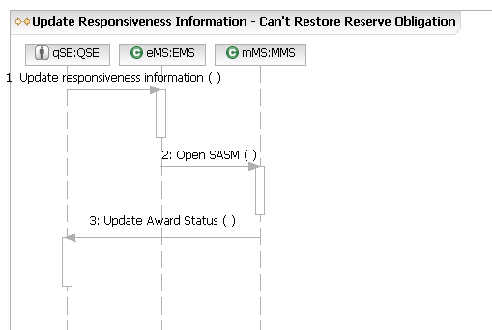
S.UC1.OP6 – Update QSE Provider Information

Main Flow
Actor Action | Nodal Action | Step | Subsystem Action | White Box Budgeted Requirements
QSE notifies Nodal that they found an alternate QSE. |  | 1 | QSE requests EMS update QSE provider information with alternate QSE.
QSE notifies Nodal that they found an alternate QSE. |  | 2 | EMS issues future Regulation deployments to other QSE.

[No alternate QSE found, no alert issued]
Nodal notifies QSEs that SASM will open.

S.UC1.OP6.WB – Update QSE Provider Information
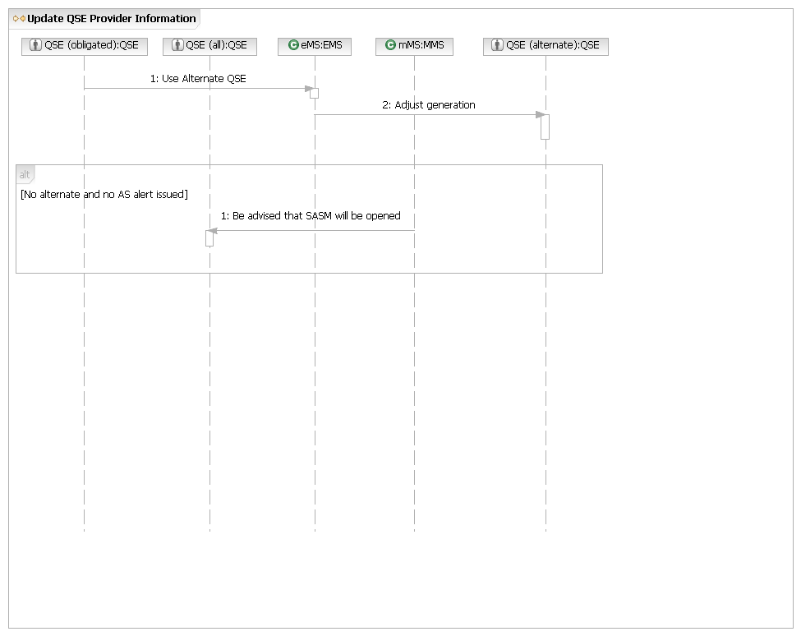
S.UC1.OP7 – Use Revised Data
QSE informs NODAL its data showing that the QSE is short of RRS is incorrect |  | 1 | QSE tells EMS via telephone that its information showing that the QSE is short of RRS is incorrect.
 |  | 2 | EMS consults with QSE on each telemetered value and determines source of disagreement.
 |  | 3 | EMS validates QSE information, and substitutes QSEs information on available RRS.
S.UC1.OP7.WB – Use Revised Data
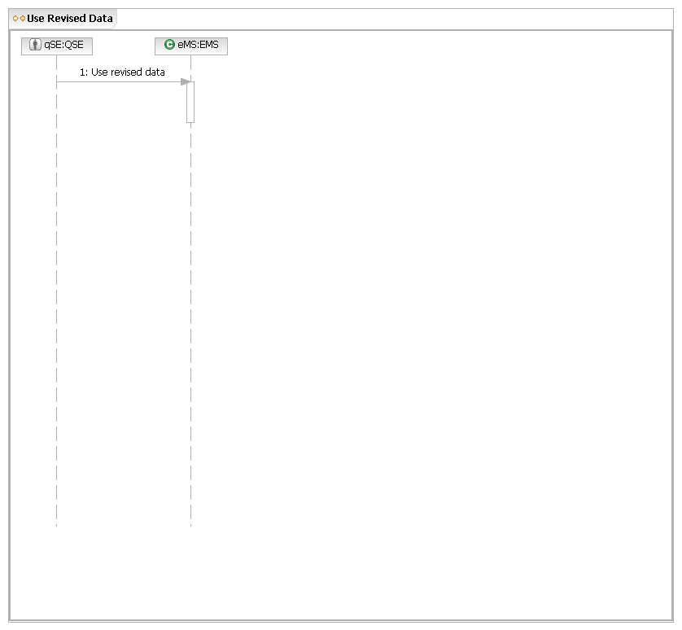
S.UC1.OP8 – Use Telemetry Data

Main Flow
Actor Action | Nodal Action | Step | Subsystem Action | White Box Budgeted Requirements
QSE requests Nodal use telemetry data. |  | 1 | QSE requests EMS use telemetry data.
QSE requests Nodal use telemetry data. |  | 2 | EMS uses telemetry.
S.UC1.OP8.WB – Use Telemetry Data
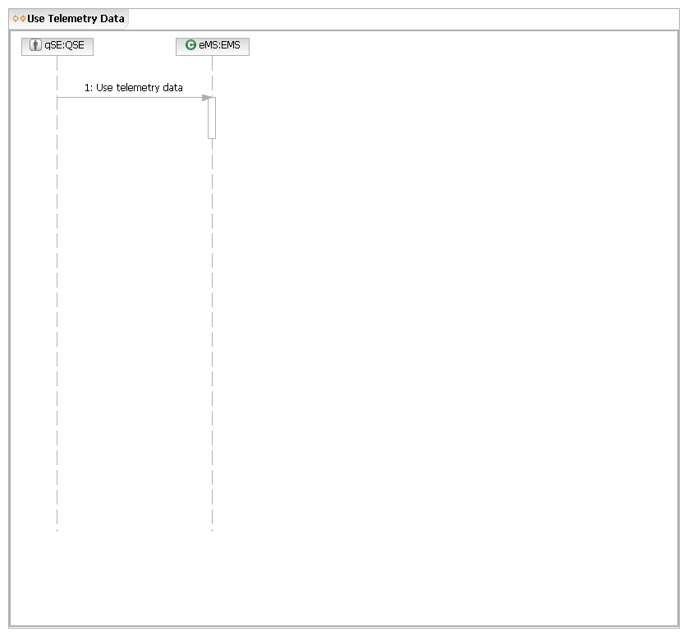
S.UC2 – Ensure Grid Security
Brief Description
Ensure Transmission Grid Security Use Case analyzes the current real time grid conditions, ands derives and implements solutions to transmission security risks.
Note: Post Contingency Transmission Security Risk (PCSTR) can be a post contingency transmission element overload, post contingency voltage violation, post contingency voltage collapse, or post contingency transient security violation.
Preconditions
- Transmission grid is in a steady-state condition.
- Load roughly in balance with generation.
- Communication to QSEs and TSPs operating normally.
- Current system models are valid.
- Nodal has generation offers.
- MMS is operational.
- EMS is operational
Post Condition
All grid N-1 security risks have been resolved or are being mitigated.
Main Success Scenario (6.5.7.1)
1. TSPs and QSEs send real time transmission and generation data to Nodal. (6.5.7.1.13)
2. Nodal determines no base case overloads or under voltage conditions exist.
3. Nodal determines no N-1 Post Contingency Transmission Security Risks (PCTSRs) exists.
4. Use case ends.
Alternate flows
2.a. Nodal cannot determine if base case overloads or under voltage conditions exist due to telemetry or state estimator failure.
1. Nodal requests TSPs report base case overloads or under voltage conditions.
2. TSPs report there are no base case overloads or under voltage conditions.
3. Return to Main Success Scenario, Step 3.
2.a.2.a. or 2.b. Nodal or TSP determines that there are base case overloads or under voltage conditions.
1. Nodal works with TSP to determine corrective actions to resolve base case overload or under voltage condition.
2. Nodal directs TSP or QSE to implement corrective actions.
3. Return to Main Success Scenario, Step 3.
3.a. Nodal cannot determine if any N-1 PCTSRs exist (1 or more N-1 study cases do not solve) because Nodal is unable to get real-time studies (NSA) or contingency study to solve for 30 minutes.
1. Nodal notifies TSPs, QSEs, and PUCT of Transmission Alert Condition.
2. Nodal asks TSPs to notify if there are any constraint violations or N-1 violations.
3. Nodal uses TSP advice and offline studies to identify constraints.
4. Nodal analyzes bids and determines minimum cost of generation dispatch solution to eliminate constraints.
5. Nodal sends new base points and prices to QSEs.
6. Nodal sends constraint analysis and prices to MPs.
7. Nodal fixes problem in NSA (security assessment process).
8. Nodal notifies TSPs, QSEs and PUCT of the end to Transmission Alert Condition.
9. Use case ends.
3.b. Nodal determines PCTSR exists and generation solution exists.
1. Nodal analyzes bids and determines minimum cost of generation dispatch solution to eliminate constraints.
2. Nodal sends new base points and prices to QSEs.
3. Nodal sends constraint analysis and prices to MPs.
4. Use case ends.
3.c. Nodal determines PCTSR exists and generation solution does not exist.
1. Nodal requests TSP confirm accuracy of transmission element ratings.
2. TSP confirms accuracy of transmission element ratings.
3. Nodal works with TSP to determine a known pre-contingency switching solution to the PCTSR exists.
4. Nodal directs switching actions to TSP.
5. Use case ends.
3.c.2.a. Nodal confirms transmission elements’ ratings are inaccurate.
1. TSP submits revised element rating to Nodal.
2. Nodal incorporates revised rating into grid model.
3. Return to Main Success Scenario, Step 3.
3.c.3.a. Nodal cannot determine known pre-contingency switching solution to the PCTSR, but solution without load shedding or element violation of 15 minute rating exists (create new RAP).
1. Nodal notifies TSPs, QSEs and PUCT of Transmission Alert Condition.
2. Nodal presents proposed Remedial Action Plan (RAP) to TSPs (that deal with the PCTSR which eliminates the risk of cascading outages and grid instability according to NERC Standards without load shedding or any post contingency transmission element loadings above the 15 minute rating).
3. TSP agrees to immediately implement plan (proposed RAP).
4. Nodal incorporates proposed RAP into contingency evaluation as a new Remedial Action Plan (RAP).
5. Nodal notifies TSPs, QSEs and PUCT of end to Transmission Alert Condition.
6. Use case ends.
3.c.3.a.2.a Nodal determines switching solution does not exist or TSP cannot immediately implement, solution requires a new Mitigation Plan).
1. Nodal determines a post contingency plan for dealing with [the scenario in step 1].
2. Nodal presents post contingency plan to TSP.
3. TSP agrees to immediately adopt post contingency plan.
4. Use case ends.
3.c.3.a.3.a. or 3.c.3.a.2.a.3.a. TSP cannot immediately implement plan.
1. Nodal notifies TSPs, QSEs and PUCT of Emergency Condition.
2. Nodal identifies pre-contingency load shed plan to mitigate PCTSR.
3. Nodal presents pre-contingency load shed plan to TSP.
4. TSP agrees with pre-contingency load shed plan.
5. Nodal delivers executive notification of impending pre-contingency load shed plan.
6. Nodal notifies PUCT of impending Load Shed action.
7. Nodal directs TSP to shed load in accordance with load shed action plan.
8. After the emergency is over, Nodal directs TSP to restore load.
9. Nodal notifies TSPs, QSEs, and PUCT of end of Emergency Condition.
10. Use case ends.
S.UC2.BB – Ensure Grid Security
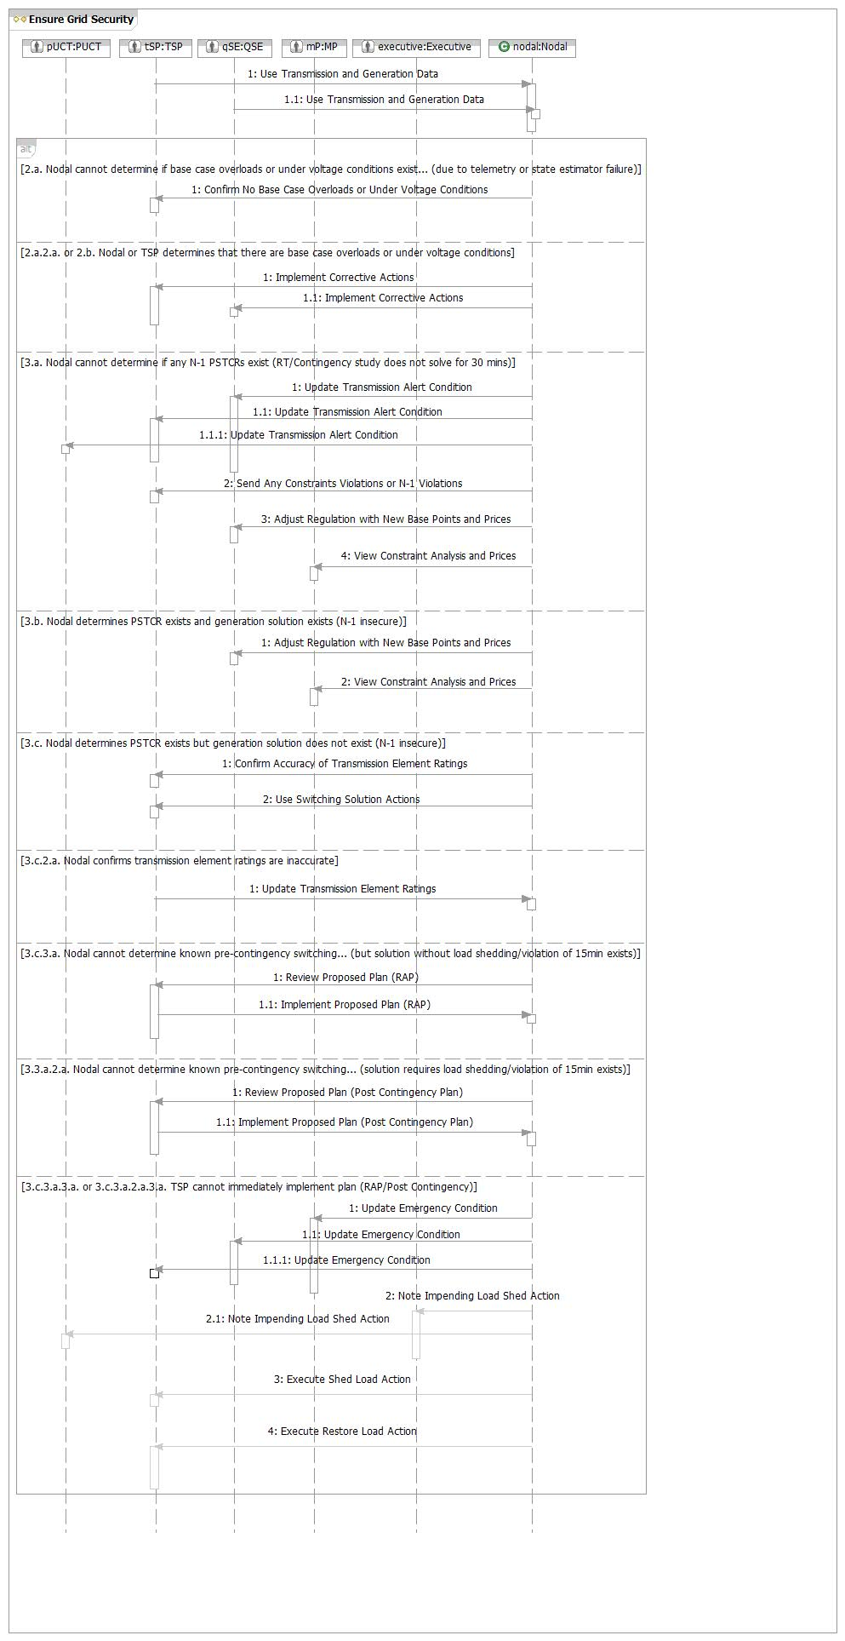
S.UC2.OP1 – Use Transmission and Generation Data

Main Flow
Actor Action | Nodal Action | Step | Subsystem Action | White Box Budgeted Requirements
TSPs and QSEs send transmission and generation data to Nodal. | Nodal uses transmission and generation data in studies. | 1 | TSPs and QSEs sends transmission and generation data to EMS.
 | Nodal uses transmission and generation data in studies. | 2 | EMS uses transmission and generation data in studies.
S.UC2.OP1.WB – Use Transmission and Generation Data
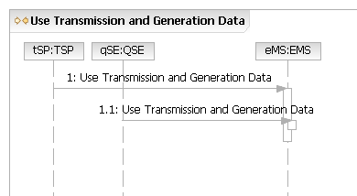
S.UC2.OP2 – Update Transmission Element Ratings

Main Flow
Actor Action | Nodal Action | Step | Subsystem Action | White Box Budgeted Requirements
TSP requests Nodal to update transmission element ratings. | Nodal updates transmission element ratings. | 1 | TSP requests NMMS update transmission element ratings.
TSP requests Nodal to update transmission element ratings. | Nodal updates transmission element ratings. | 2 | NMMS sends updated information to EMS.
TSP requests Nodal to update transmission element ratings. | Nodal updates transmission element ratings. | 3 | EMS requests MIS post updated information.
TSP requests Nodal to update transmission element ratings. | Nodal updates transmission element ratings. | 4 | MIS posts updated information to MPs.
S.UC2.OP2.WB – Update Transmission Element Ratings
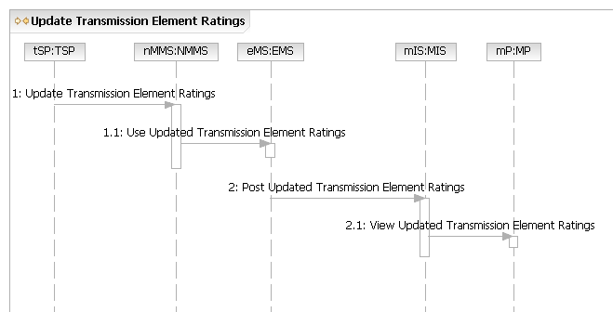
S.UC2.OP3 – Implement Proposed Plan (RAP, Post Contingency)

Main Flow
Actor Action | Nodal Action | Step | Subsystem Action | White Box Budgeted Requirements
TSP agrees to immediately implement proposed plan (RAP or Post Contingency). | Nodal implements proposed plan (RAP or Post Contingency). | 1 | TSP requests EMS to immediately implement proposed plan (RAP or Post Contingency).
 | Nodal implements proposed plan (RAP or Post Contingency). | 2 | EMS requests MIS to post plan (RAP).
 | Nodal implements proposed plan (RAP or Post Contingency). | 3 | MIS posts plan (RAP).
 | Nodal implements proposed plan (RAP or Post Contingency). | 4 | EMS notifies TSPs, QSEs and PUCT of updated Alert Condition (Emergency, Transmission Alert).
S.UC2.OP3.WB – Implement Proposed Plan (RAP, Post Contingency)
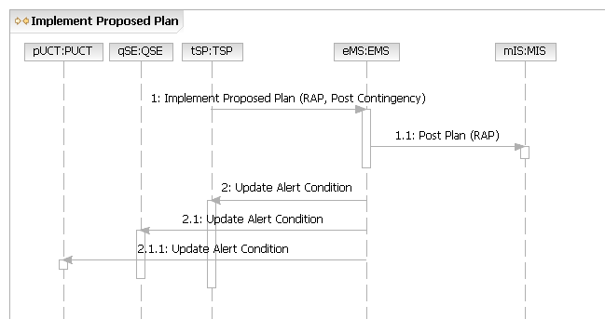

S.UC2.OP4. – Send New Base Points

Main Flow
Actor Action | Nodal Action | Step | Subsystem Action | White Box Budgeted Requirements
 | Nodal sends new base points and prices to QSEs. | 1 | EMS requests MMS compute new base points using constraint violations and shift factors.
 | Nodal sends new base points and prices to QSEs. | 2 | MMS requests EMS use new base points.
 | Nodal sends new base points and prices to QSEs. | 3 | EMS requests QSEs update base points.
S.UC2.OP4.WB – Send New Base Points
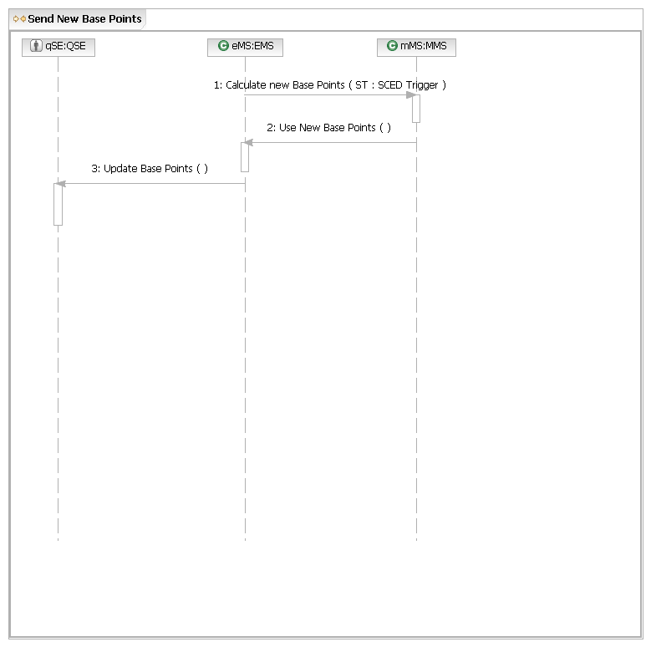

S.UC3 – Plan System Operations
Brief Description
Plan system operations use case: From valid long term system plan to daily operations plan. Covers outage scheduling, 8 day Look Ahead, DRUC, HRUC operational time periods.
Precondition
Transmission grid and generation models for future time periods or the schedules are available, load forecasts, outage schedules, and generation dispatch or schedules are available for future time.
Post Condition
Plans have been developed and agreed to resolve transmission security risks.
Main Success Scenario
1. QSEs and TSPs request Nodal to update static and dynamic grid information about future state of system. (Note: this includes TSPs requests to approve transmission outages)
2. Time requests Nodal analyze grid security.
3. Generate scenarios describing future state of system (Load Forecast, Network Model).
4. Nodal provides scenarios to TSPs.
5. Nodal analyzes scenarios of future states for base case and N-1 security.
6. Nodal develops resolution to problem.
7. Nodal orders implementation of secure plan, when required.
8. Use Case ends.
Alternative Flows
1.a. Monthly, examine past system performance and determine Ancillary Service requirements.
1. Gather information about past operations.
2. Project from history to develop future Ancillary Services requirements.
3. Use case ends.
4.a. Nodal does not develop resolution to problem.
1. Nodal notify affected QSE/TSPs of risk to future security.
2. Affected QSE/TSPs respond with proposed resolution to future security risks.
3. Return to Main Success Scenario, Step 6.
4.a.2.a. Affected QSE/TSPs don’t submit proposed resolution.
1. Nodal develops resolution with higher risk components (Mitigation Plans).
2. Return to Main Success Scenario, Step 5.
Assumptions/Explanations
Step 1 covers all inputs from long-term up until hour-ahead studies. Static and dynamic grid information related to NOMCRs, COP, Generation Outages, Transmission Outages, RAPs/SPSs, etc.
Steps 3 and 4 use information from steps 1 and 2, and (or) inputs from internal Nodal processes such as approved RAPs/SPSs, historic AS deployments, approved NOMCRs, generation registration, load forecasts, renewable power potential, load distribution, approved outages, and contingencies, weather forecasts, etc.
Step 3 includes scenarios such as: RAP/SPS reviews, all outage studies, generic limits calculation, power flow studies, AS deliverability studies.
Step 6 includes implementation plans related to outage coordination (ranging from 90, 45, 9, 5, 3 days to current day) such as: cancellation of outages, changes to generation distribution, changes to transmission switching, changes to move outage time and load service reconfiguration. Plan changes during Day-Ahead also include procuring and committing generating units, procuring all Ancillary Services, and deploying Non-Spin.
S.UC3.BB – Plan System Operations
S.UC3.OP1 – Update Information

Main Flow
Actor Action | Nodal Action | Step | Subsystem Action | White Box Budgeted Requirements
QSEs and TSPs request Nodal update static and dynamic grid information about future state of system. |  | 1 | QSEs request MMS update COP.
 |  | 2 | QSEs and TSPs request OS update outages.
 |  | 3 | QSEs and TSPs request NMMS update network model.
S.UC3.OP1.WB – Update Information
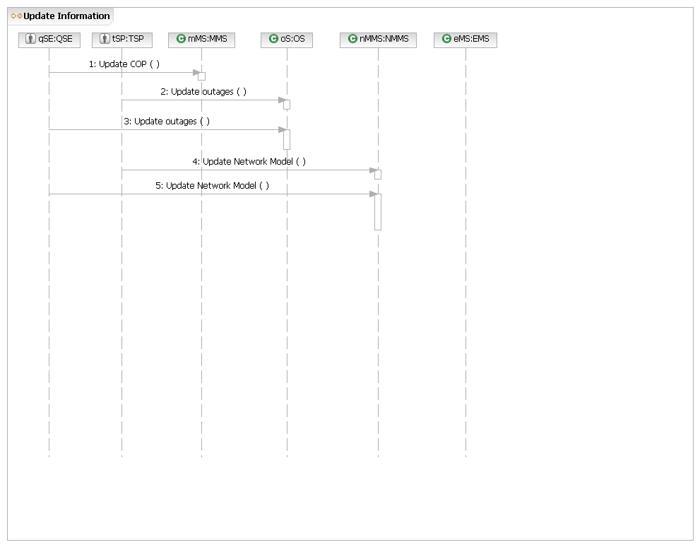
S.UC3.OP2 – Analyze Solution

Main Flow
Actor Action | Nodal Action | Step | Subsystem Action | White Box Budgeted Requirements
Time, QSE, or TSPs request Nodal analyze solution to future security risks | Nodal analyzes solution to future security risks.  Nodal requests QSE and TSP implement solution. | 1 | QSE requests MMS or TSP requests OS analyze solution to future security risks.
 |  | 2 | MMS requests OS send outage information, NMMS send updated network model, and EMS send load forecasts.
 |  | 3 | EMS requests OS, NMMS, and MMS send processed information.
 |  | 4 | EMS or MMS perform analyses to determine future security risks.
 |  | 5 | EMS determines what plans to implement and requests MMS or OS notify impacted QSEs and TSPs
 |  | 6 | MMS or OS requests QSE and TSP implement plan.

[Nodal doesn’t develop solution to problem]
MMS requests QSEs or OS requests TSPs submit plan to resolve security risk.

[Nodal doesn’t develop solution to problem, QSEs and TSPs don’t submit plan]
EMS requests NMMS, OS, and MMS send processed information.
S.UC3.OP2.WB – Analyze Solution
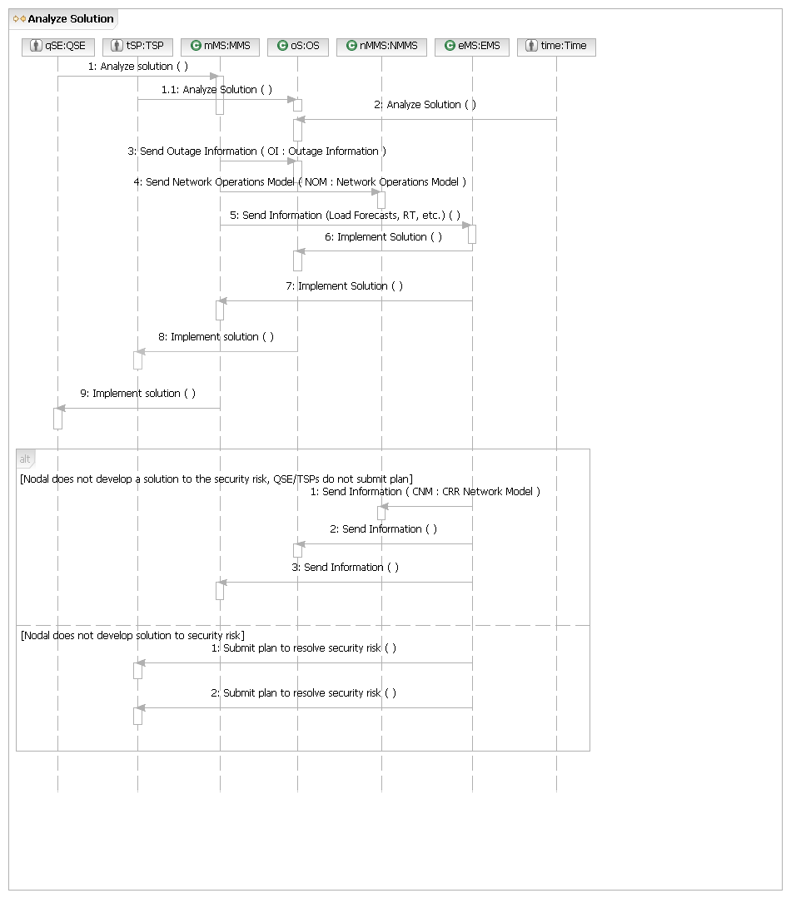
S.UC4 – Plan the System (Long Term)
Brief Description
Plan the System (Long Term) Use Case covers the process of developing the 5 year base cases through the approval of projects to resolve predicted transmission grid risks or improve economic operation.
Preconditions
None.
Post Condition
Produced a list of endorsed transmission projects in the Oct report to the PUCT, and a 5 year plan for grid security and economic operation.
Note: Planning Base Cases are up to 5 years ahead.
Main Success Scenario
1. Nodal sends out request to TSPs to update their information in the planning models.
2. TSPs send updates to Transmission Planning Models (PMCRs – Planning Model Change Request) and historical load (CDR – Capacity Demand and Reserve) and future load information to Nodal
3. Nodal generates 5 year load forecast using load information from the TSPs.
4. Nodal generates 5 years of Annual Planning Models for CRR and Planning.
5. Nodal sends the Annual Planning Models to the SSWG.
6. TSPs request Nodal approve annual planning models.
7. Nodal sends annual planning models to MPs.
8. TSPs, QSEs, Resource Entities, and Nodal use annual planning models to study future grid security and economic operation.
9. MPs (including TSPs) send proposed projects (as required by the Planning Charter) to maintain grid security or improve grid economics to Nodal.
10. Nodal sends projects proposed by both Nodal and TSPs to Regional Planning Group (RPG) and requests comments.
11. Nodal publishes the proposed projects.
12. Nodal notifies RPG of meeting to review proposed projects.
13. RPG sends comments to Nodal.
14. Nodal publishes comments to RPGs.
15. Nodal leads RPG review of projects.
16. At the appropriate time, Nodal generates Project status report.
17. Nodal sends Project status reports to ERCOT Committees and PUCT.
18. Nodal publishes comments on projects to MIS Secure Area and Operations and System Planning Data (Public– requires access permission).
19. Nodal recommends project and publishes to TSP, PUCT, and - Operations and System Planning Data (Public – requires access permission).
20. Nodal presents projects over threshold to ERCOT BOD.
21. ERCOT BOD endorses projects over threshold.
22. Nodal sends letter to TSP to proceed with ERCOT BOD or PUCT endorsed project.
23. Nodal sends out request for TSPs to update seasonal information and load information.
24. TSPs send seasonal and load information updates to Nodal.
25. Nodal generates detailed Seasonal Planning Models for coming year.
26. Nodal sends Next Year Seasonal Planning Models to the TSPs for approval.
27. TSPs approve Seasonal Planning Models.
28. Nodal sends October Report to PUCT.
29. Nodal sends SB 20 (Renewable Energy Status Update and Long Term Nodal Plan) required reports to PUCT.
30. Use case ends.
Alternative Flows
2.a. TSP does not send updates.
1. Nodal sends management escalation notification to TSP.
2. Nodal updates TSP performance metrics..
3. Return to Main Success Scenario, Step 2.
6.a. Resource Entity requests “Generation Interconnection Screening Study”.
1. Resource Entity requests “Generation Interconnection Screening Study”.
2. Nodal performs study and sends results to Generation entity.
3. Return to Main Success Scenario, Step 6.
6.a.3.a. Resource Entity proceeds with interconnection request.
1. Resource Entity notifies Nodal that they want to proceed with interconnection.
2. Nodal posts Screening Study results.
3. Nodal notifies TSP about Resource Entity’s plans for interconnect.
4. Nodal participates in meetings and discussion about interconnect between TSP and Resource Entity.
5. Nodal posts TSP study results to MPs.
6. Return to Main Success Scenario, Step 6.
8.a. TSP doesn’t approve Annual Planning Models.
1. TSP notifies Nodal that Annual Planning Models are incorrect.
2. TSP sends corrected information.
3. Return to Main Success Scenario, Step 4.
19.a. Nodal doesn’t recommend project.
1. Nodal sends notification to MP that project is not approved.
2. Nodal sends proposed alternative to MP.
3. MP accepts proposed alternative.
4. Return to Main Success Scenario, Step 10.
19.a.3.a MP rejects Nodal alternative, makes alternative proposal.
1. MP proposes another alternative.
2. Nodal accepts MP alternative.
3. Return to Main Success Scenario, Step 10.
19.a.3.b. MP rejects Nodal alternative, sends additional information
1. MP sends additional information to Nodal.
2. Nodal reconsiders previous recommendation and approves project.
3. Return to Main Success Scenario, Step 10.
19.a.3.b.2.a. MP rejects Nodal alternative, Nodal does not approve project after reviewing the additional information, MP escalates to ERCOT BOD
1. MP escalates discussion to ERCOT BOD.
2. ERCOT BOD requests information from Nodal and MP.
3. ERCOT BOD endorses project and sends decision to Nodal and MP.
4. Return to Main Success Scenario, Step10.
19.a.3.b.2.a.3.a. ERCOT BOD rejects project, MP rejects ERCOT BOD decision, MP escalates to PUCT.
1. MP escalates discussion to PUCT.
2. PUCT requests information from Nodal and MP.
3. PUCT sends decision to Nodal and MP.
4. Return to Main Success Scenario, Step 10.
20.a. Project is under threshold.
1. Nodal directs TSP to proceed with project.
2. Return to Main Success Scenario, Step 21.
21.a. ERCOT BOD refuses to endorse project.
1. Return to Alternative Flow 19.a., Step 1.
26.a. TSP does not send Seasonal Updates of Transmission Plans.
1. Nodal sends mgmt escalation notification to TSP
2. Nodal updates TSP performance metrics
2. Returns to Main Success Scenario, Step 24.
27.a. TSP doesn’t approve Seasonal Planning Models.
3. TSP notifies Nodal that the Seasonal Base Case is incorrect.
4. TSP sends corrected information.
5. Return to Main Success Scenario, Step 24.
S.UC4.BB – Plan the System (Long Term)
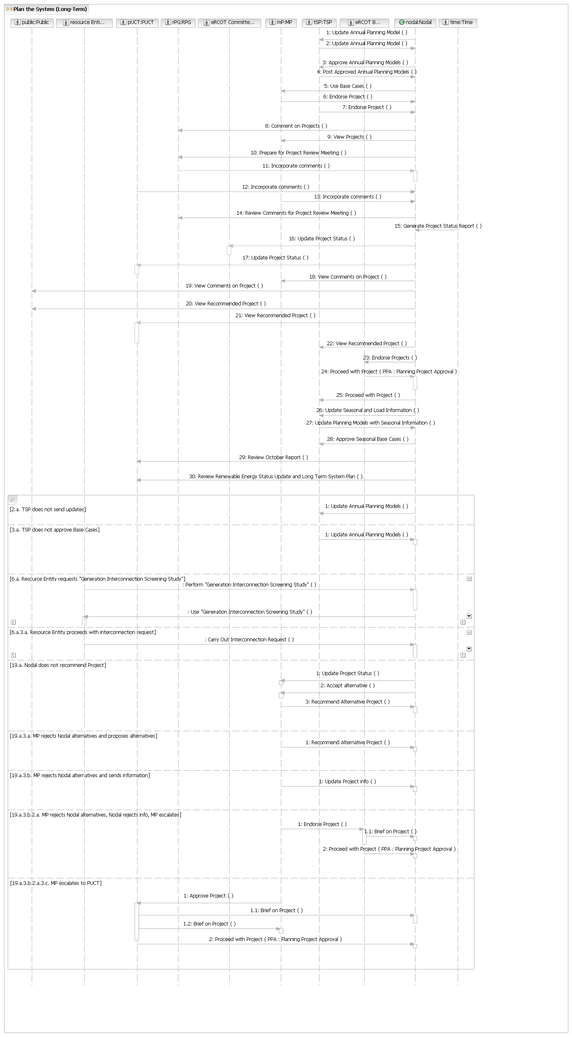

S.UC4.OP1 – Update Annual Planning Model

Main Flow
Actor Action | Nodal Action | Step | Subsystem Action | White Box Budgeted Requirements
MP requests Nodal Update Planning Model. | Nodal updates planning model. | 1 | TSP requests NMMS update Annual Planning Model.
MP requests Nodal Update Planning Model. | Nodal updates planning model. | 2 | NMMS requests MIS post Annual Planning Models for 5 years for TSP Review.
MP requests Nodal Update Planning Model. | Nodal updates planning model. | 3 | MIS posts post Annual Planning Models for 5 years (unapproved) for review in Secure Area for TSPs.
S.UC4.OP1.WB – Update Annual Planning Model
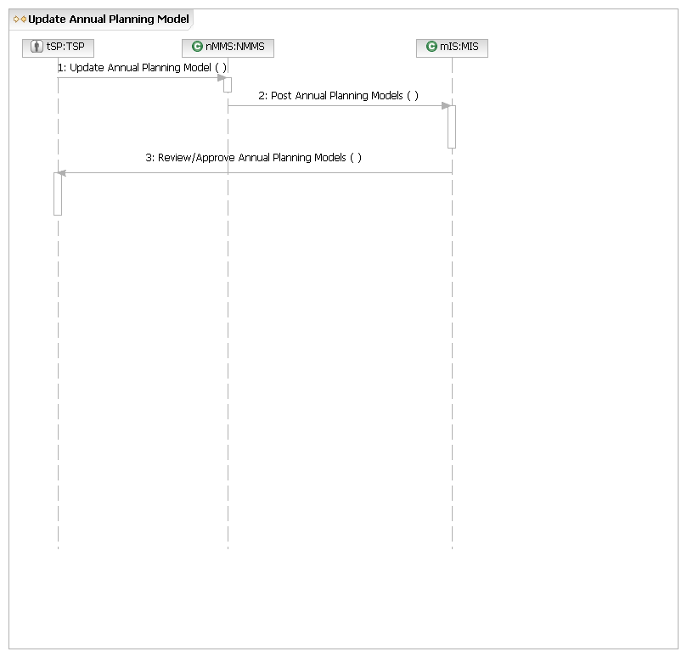`
S.UC4.OP2 – Post Approved Annual Planning Models

Main Flow
Actor Action | Nodal Action | Step | Subsystem Action | White Box Budgeted Requirements
TSP requests Nodal post approved Planning Models. | Nodal posts approved Models. | 1 | TSP requests NMMS post 5 year approved Planning Models.
TSP requests Nodal post approved Planning Models. | Nodal posts approved Models. | 2 | NMMS requests MIS post 5 year Planning Models to MIS .Secure (Approved)
TSP requests Nodal post approved Planning Models. | Nodal posts approved Models. | 3 | MIS posts 5 year Planning Models (approved) in MIS Secure for TSP Planning.
S.UC4.OP2.WB – Post Approved Annual Planning Models
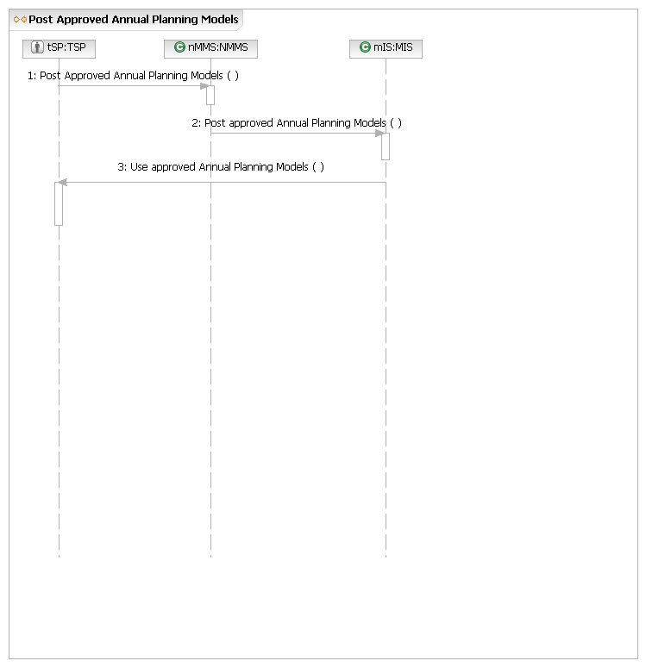
S.UC4.OP3 – Endorse Project

Main Flow
Actor Action | Nodal Action | Step | Subsystem Action | White Box Budgeted Requirements
Actor requests Nodal endorse project |  | 1 | MP requests Planning endorse Project.
Actor requests Nodal endorse project |  | 2 | NMMS sends network model and Contingency file to Planning.
Actor requests Nodal endorse project |  | 3 | Planning solves Power Flow and Contingency Analysis
Actor requests Nodal endorse project |  | 4 | Planning sends Power Flow case and Contingency Analysis to MIS.
Actor requests Nodal endorse project |  | 5 | MIS posts Power Flow case and Contingency Analysis in Secure Area (Unapproved Projects).
Actor requests Nodal endorse project |  | 6 | Planning requests comments from PUCT, RPG and MPs.
Actor requests Nodal endorse project |  | 7 | Planning requests MIS post RPG meeting.
Actor requests Nodal endorse project |  | 8 | MIS requests RPG attend meeting.
S.UC4.OP3.WB – Endorse project
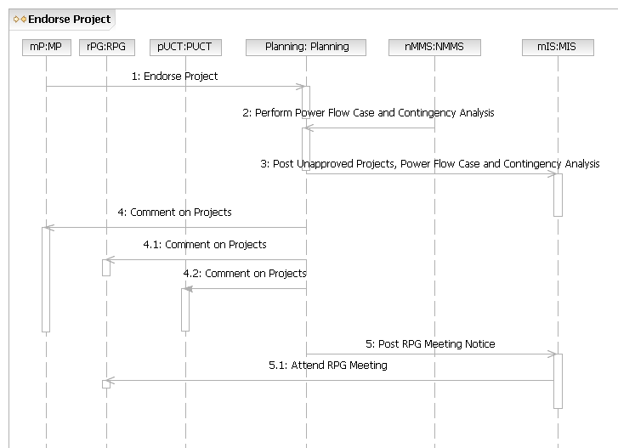
S.UC4.OP4 – Incorporate Comments

Main Flow
Actor Action | Nodal Action | Step | Subsystem Action | White Box Budgeted Requirements
RPG, PUCT, MP request Nodal incorporate comments. | Nodal publishes comments.  Nodal recommends project and publishes to TSP, PUCT, and public (T-Maps).  Nodal directs TSP to proceed with project. | 1 | RPG, PUCT, MP request Planning incorporate comments.
RPG, PUCT, MP request Nodal incorporate comments. |  | 2 | Planning sends comments to MIS.
RPG, PUCT, MP request Nodal incorporate comments. |  | 3 | MIS presents comments in Secure Area (T-Maps).
RPG, PUCT, MP request Nodal incorporate comments. |  | 4 | Planning requests recommendations on Projects from RPG meeting.
RPG, PUCT, MP request Nodal incorporate comments. |  | 5 | Planning sends project recommendations to MIS.
RPG, PUCT, MP request Nodal incorporate comments. |  | 6 | MIS presents recommendations in Secure Area (T-Maps).
RPG, PUCT, MP request Nodal incorporate comments. |  | 7 | Planning directs TSP to proceed with project.

[Project is over threshold]
 | Nodal presents over threshold projects to ERCOT BOD | 1 | Planning sends over threshold projects to ERCOT BOD for endorsement
S.UC4.OP4.WB – Incorporate Comments
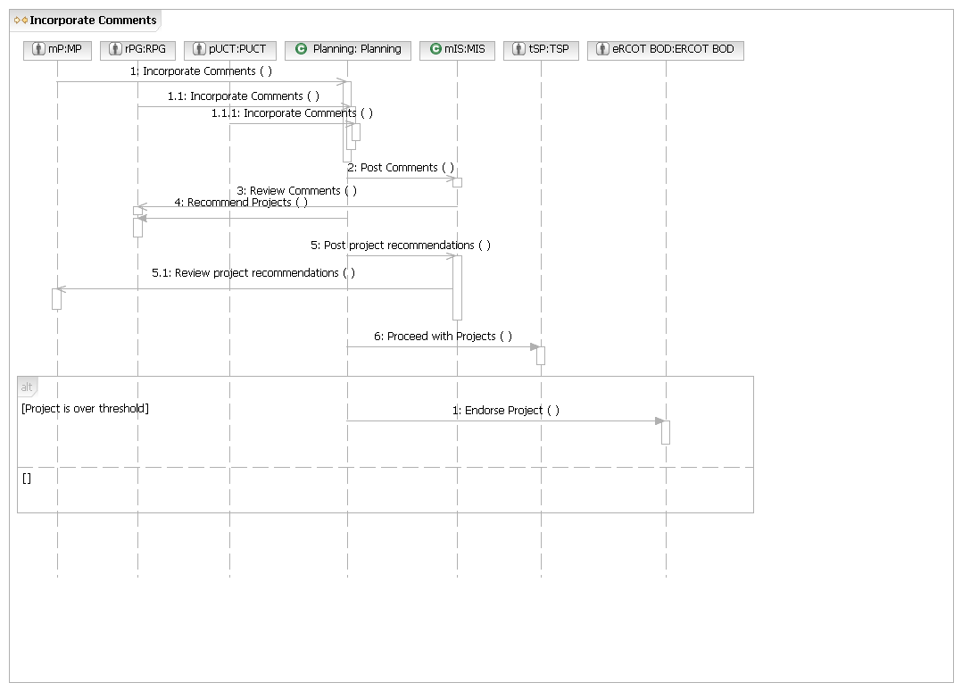
S.UC4.OP5 – Generate Project Status Report

Main Flow
Actor Action | Nodal Action | Step | Subsystem Action | White Box Budgeted Requirements
Time requests Nodal generate Project Status Report. | Nodal sends Project Status Reports to ERCOT Committees and PUCT. | 1 | Time requests Planning generate Project Status Report.
Time requests Nodal generate Project Status Report. |  | 2 | Planning presents the Project Status Report to ERCOT Committees for approval.
Time requests Nodal generate Project Status Report. |  | 3 | ERCOT Committees request Market Rules post approved Project Status Report.
Time requests Nodal generate Project Status Report. |  | 4 | Market Rules sends the Project Status report to MIS.
Time requests Nodal generate Project Status Report. |  | 5 | MIS publishes the Project Status Report in the Public area.
S.UC4.OP5.WB – Generate Project Status Report
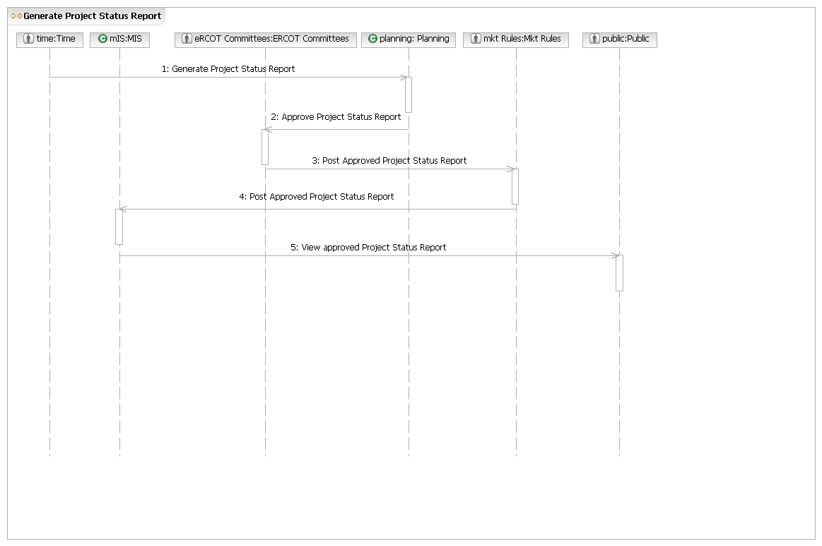
S.UC4.OP6 – Proceed with Project

Main Flow
Actor Action | Nodal Action | Step | Subsystem Action | White Box Budgeted Requirements
ERCOT BOD request Nodal proceed with project |  | 1 | ERCOT BOD request Planning proceed with project
ERCOT BOD request Nodal proceed with project |  | 2 | Planning requests TSPs proceed with project
S.UC4.OP6.WB – Proceed with Project
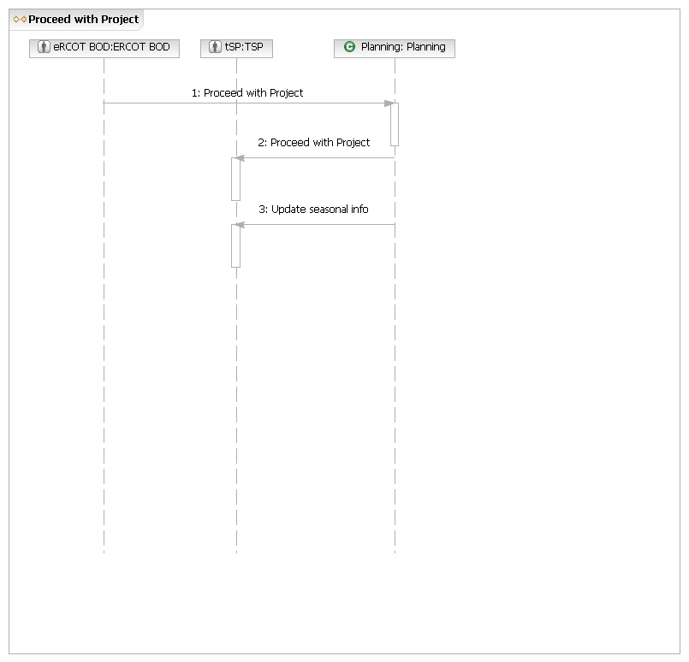
S.UC4.OP7 – Update Annual Planning Models with Seasonal Information

Main Flow
Actor Action | Nodal Action | Step | Subsystem Action | White Box Budgeted Requirements
TSPs request Nodal update Annual Planning Models with seasonal info. | Nodal generates detailed Seasonal Planning Models for coming year  Nodal sends Next Year Seasonal Base Case to the TSPs | 1 | TSPs request SSWG update Annual Planning Models with seasonal info.
 |  | 2 | SSWG generates detailed Seasonal On Peak/Off Peak Planning models for coming year.
 |  | 3 | SSWG requests Planning review Seasonal On Peak/Off Peak Planning Models.
 |  | 4 | Planning requests MIS post Seasonal Planning Models.
 |  | 5 | MIS posts Seasonal Planning Models in Secure Area.
 |  | 6 | MIS requests TSP review Seasonal On Peak/Off Peak Planning Models.
S.UC4.OP7.WB – Update Annual Planning Models with Seasonal Information
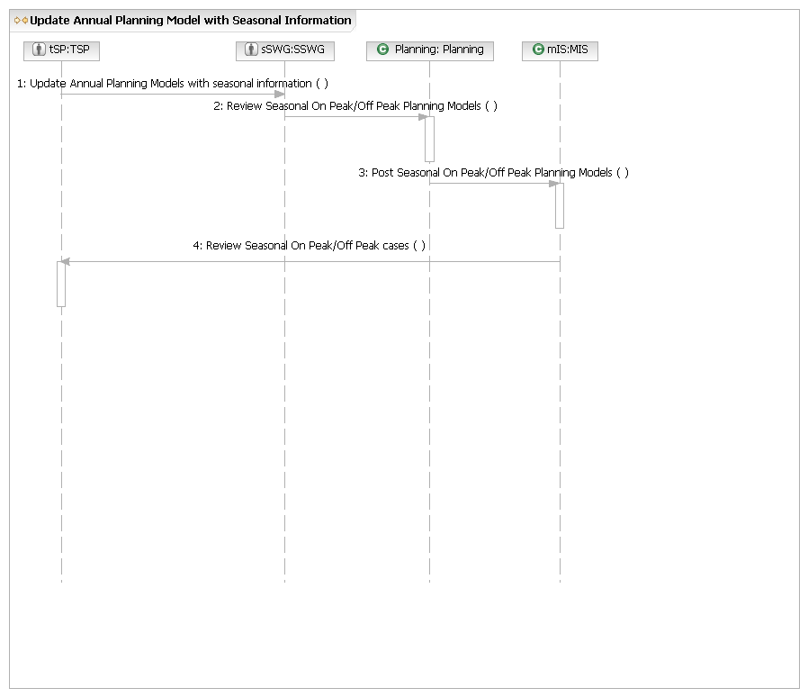
S.UC4.OP8 – Recommend Alternative Project

Main Flow
Actor Action | Nodal Action | Step | Subsystem Action | White Box Budgeted Requirements
MP requests Nodal recommend alternative project | Nodal accepts MP alternative | 1 | MP requests Planning recommend alternative project.
MP requests Nodal recommend alternative project | Nodal accepts MP alternative | 2 | Planning accepts MP alternative.
MP requests Nodal recommend alternative project | Nodal accepts MP alternative | 3 | MP requests Planning perform power flow case and contingency analysis.
S.UC4.OP8.WB – Recommend Alternative Project
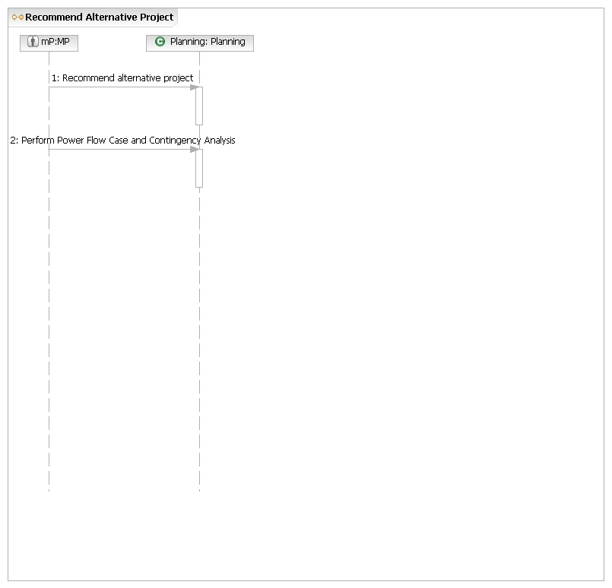
S.UC4.OP9 – Update Project Information

Main Flow
Actor Action | Nodal Action | Step | Subsystem Action | White Box Budgeted Requirements
MP requests Nodal update project info. |  | 1 | MP requests NMMS update project info.
MP requests Nodal update project info. |  | 2 | NMMS requests that Planning perform power flow case and contingency analysis.
S.UC4.OP9.WB – Update Project Information
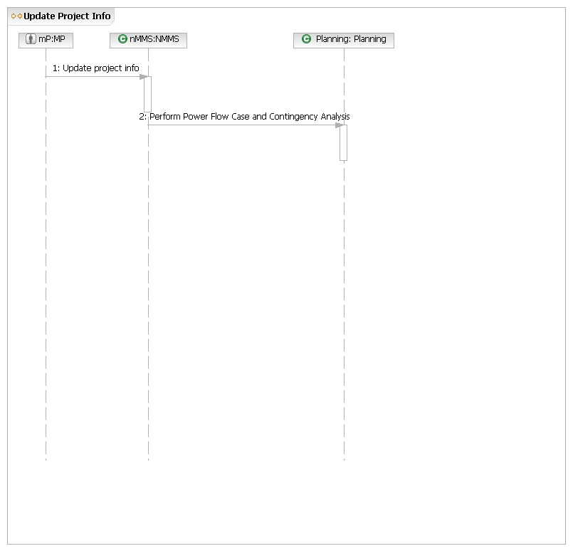
S.UC4.OP10 – Brief on Project

Main Flow
Actor Action | Nodal Action | Step | Subsystem Action | White Box Budgeted Requirements
ERCOT BOD or PUCT requests information from Nodal and MP |  | 1 | ERCOT BOD or PUCT requests information from Planning
ERCOT BOD or PUCT requests information from Nodal and MP |  | 2 | Planning request information from NMMS
ERCOT BOD or PUCT requests information from Nodal and MP |  | 3 | Planning presents information to ERCOT BOD or PUCT.
S.UC4.OP10.WB – Brief on Project
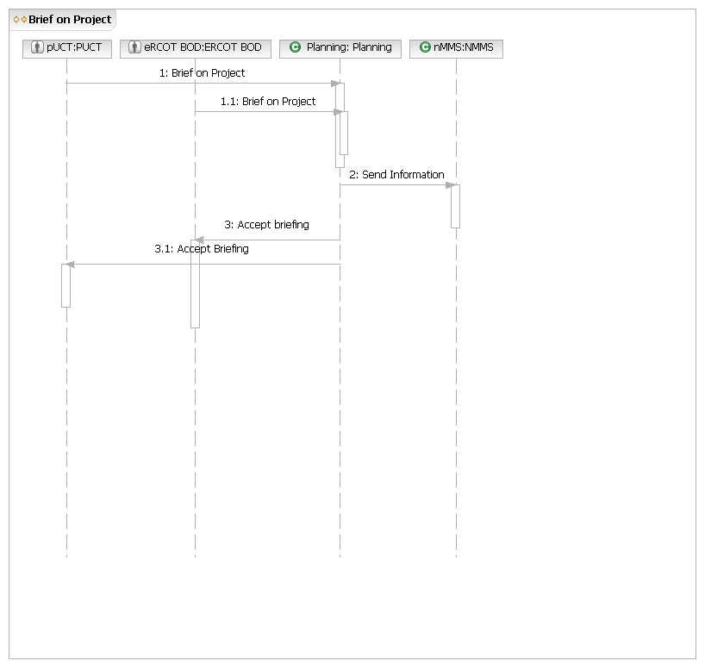
S.UC5 Request Nodal Approve a New or Relocated Facility
Brief Description
Request ERCOT Approval of New or Relocated Facilities Use Case covers the activities from the request to approve a new or relocated facility to the new or relocated facility going live and the planning/network models being updated to include it.
Precondition
None.
Post Condition
New or relocated facility added to the grid and models.
Main Success Scenario
1. Resource entity or TSP submits a Network Operations Model Change Request for the new or relocated facility.
2. Nodal publishes updated models.
3. Use case ends.
Alternate Flows
3.a. New or relocated generation facility.
1. QSE requests Nodal use generation resource parameters.
2. TSP requests Nodal approve metering design proposal.
3. QSE coordinates with ERCOT on testing.
4. QSE requests Nodal use verifiable costs.
5. Use case ends.
S.UC5.BB Request Nodal Approve a New or Relocated Facility
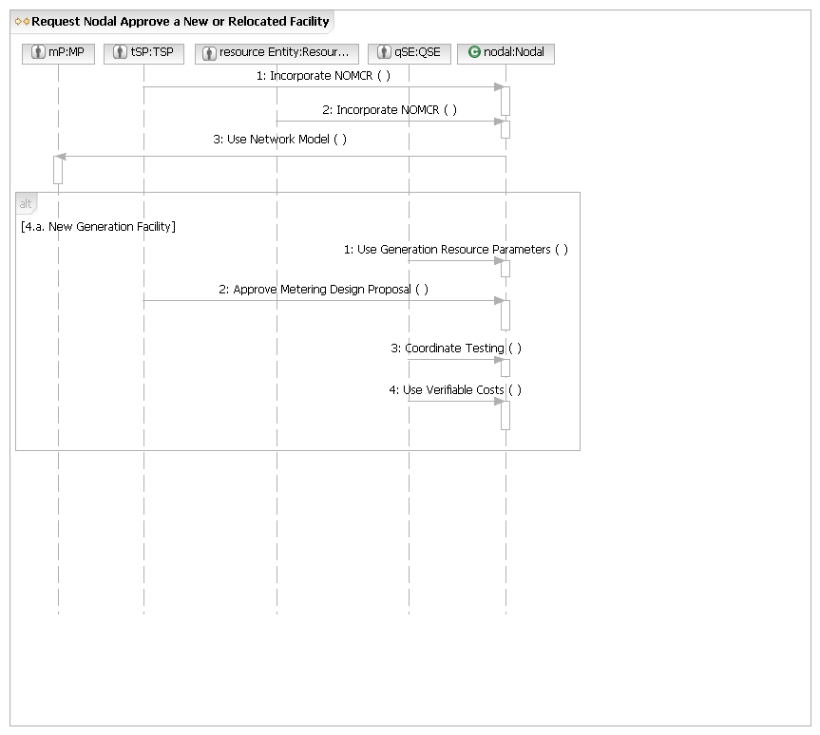
S.UC5.OP1 Incorporate NOMCR

Main Flow
Actor Action | Nodal Action | Step | Subsystem Action | White Box Budgeted Requirements
Resource entity or TSP submits a Network Operations Model Change Request for the new or relocated facility. | Nodal publishes updated models. | 1 | Resource entity or TSP submits a Network Operations Model Change Request for the new or relocated facility to NMMS.
 | Nodal publishes updated models. | 2 | NMMS publishes updated models for MMS, CRR, MIS (Secure).
S.UC5.OP1.WB Incorporate NOMCR
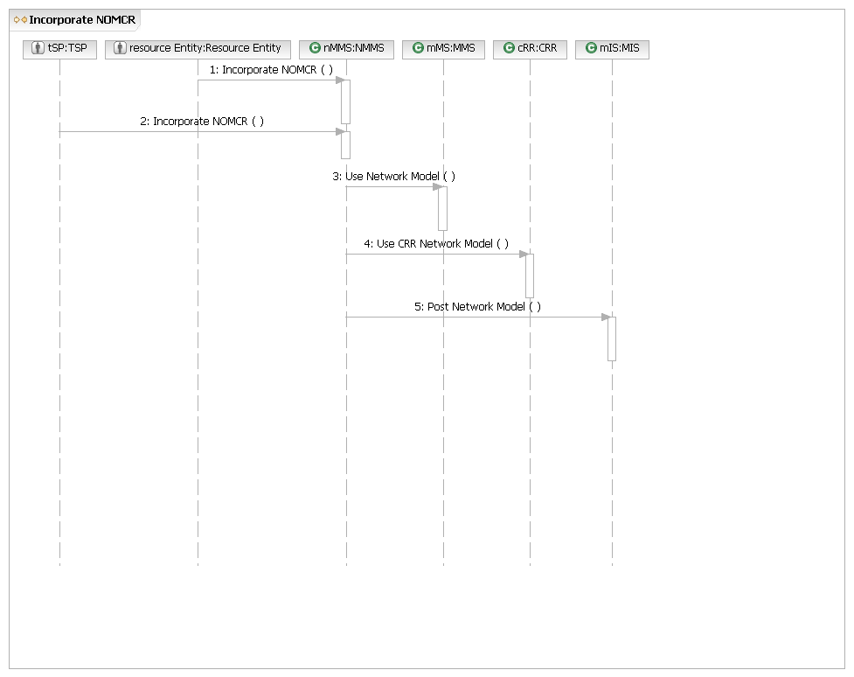
S.UC5.OP2 Use Generation Resource Parameters

Main Flow
Actor Action | Nodal Action | Step | Subsystem Action | White Box Budgeted Requirements
QSE requests Nodal use generation resource parameters. |  | 1 | QSE submits generation resource parameters to Registration.
QSE requests Nodal use generation resource parameters. |  | 2 | Registration requests MMS use resource parameters.
S.UC5.OP2 Use Generation Resource Parameters
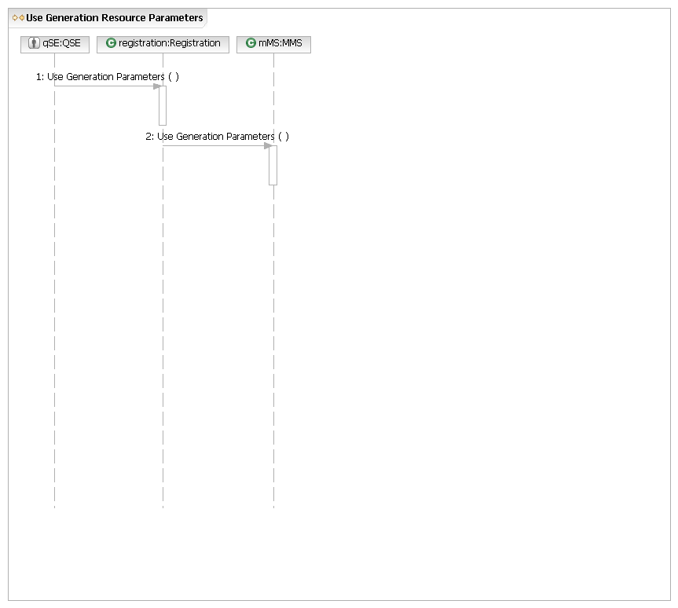
S.UC5.OP3 Approve Metering Design Proposal

Main Flow
Actor Action | Nodal Action | Step | Subsystem Action | White Box Budgeted Requirements
TSP requests Nodal approve metering design proposal. |  | 1 | TSP requests Metering approve Metering Design Proposal.
TSP requests Nodal approve metering design proposal. |  | 2 | Metering notifies TSP that plan is approved
S.UC5.OP3.WB Approve Metering Design Proposal
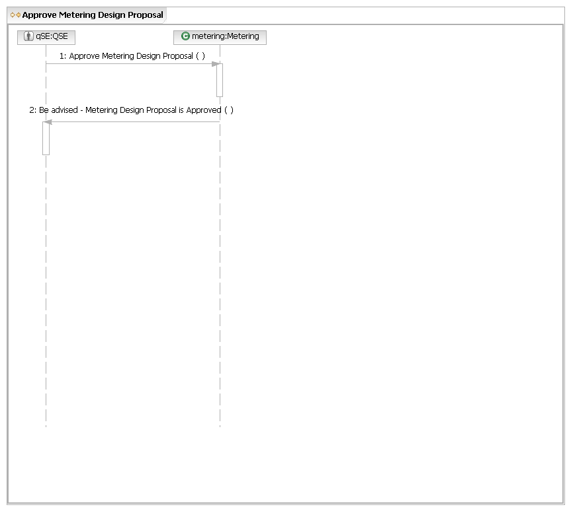
S.UC5.OP4 Coordinate on Testing

Main Flow
Actor Action | Nodal Action | Step | Subsystem Action | White Box Budgeted Requirements
QSE coordinates with ERCOT on testing. |  | 1 | QSE coordinates with Client Relations on testing
QSE coordinates with ERCOT on testing. |  | 2 | QSE coordinates with EMS on testing
S.UC5.OP4.WB Coordinate on Testing
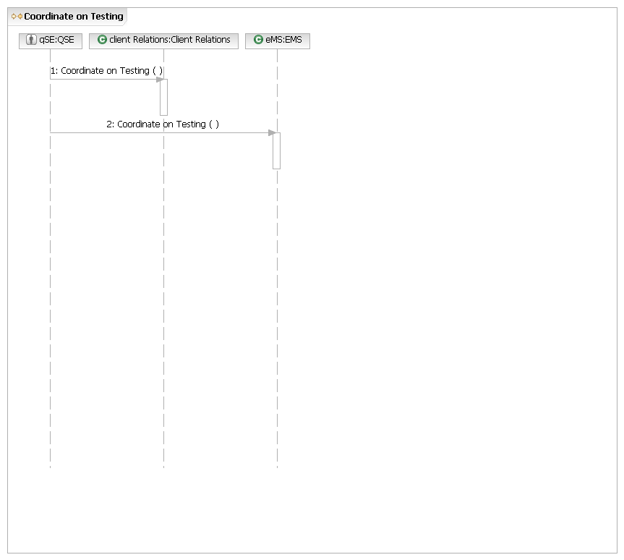
S.UC5.OP5 Use Verifiable Costs

Main Flow
Actor Action | Nodal Action | Step | Subsystem Action | White Box Budgeted Requirements
QSE requests Nodal use verifiable costs. |  | 1 | QSE requests Registration use verifiable.
QSE requests Nodal use verifiable costs. |  | 2 | Registration requests Commercial Systems and MMS approve verifiable costs..
QSE requests Nodal use verifiable costs. |  | 3 | Registration requests Commercial Systems and MMS use approved verifiable costs.
S.UC5.OP5.WB Use Verifiable Cost Information
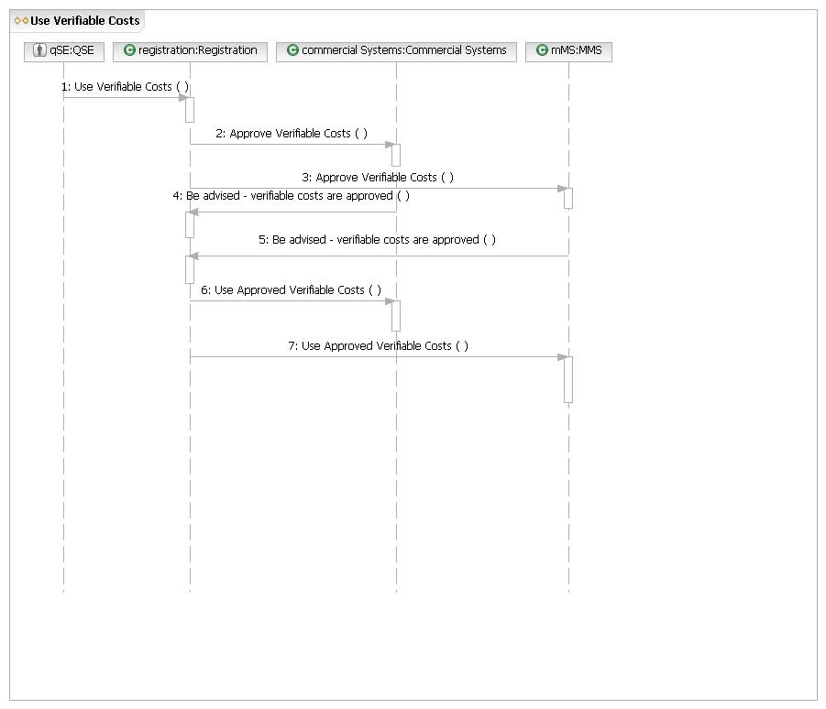
Common Operations
There are no common operations for this Use Case Area.

