Commercial Systems
Software Requirements Specification
v0.091

Revision History
Date | Version | Description | Author
10/20/06 | 0.09 | Verifiable Costs – Startup, Minimum-Energy and Energy | Keely Hilton
11/02/06 | 0.091 | Incorporated comments from TPTF | Keely Hilton

Table of Contents
1. Settlement Statements 4
1.1 Proposed System Scope 4
1.2 Document Conventions 4
1.3 Document Assumptions 4
2. Functional Requirements 5
2.1 Verifiable Startup Costs (VERISU) 5
2.2 Verifiable Minimum-Energy Costs (VERIME) 8
2.3 Verifiable Energy Costs 12
3. Supplementary Requirements 13
3.1 Performance Requirements 13
3.2 Legal and Regulatory requirements 13
3.3 System Security Requirements 13
3.4 Back up and Recovery Requirements 13
3.5 Availability and Redundancy Requirements 13
3.6 Maintainability Requirements 13
3.7 Daylight Savings Time shall be recognized in Nodal Market settlements. 13
4. Protocol Coverage 13

Software Requirements Specification

Settlement Statements

Proposed System Scope
ERCOT plans to implement a Nodal market in 2009. Section 4 and 5 of the Nodal Protocols describes the various requirements for the submittal and calculation of Verifiable Costs. The Nodal Protocols will guide this project.

This document defines the requirements for Verifiable Costs. The requirements in this document are based on the October 2006 versions of Nodal Protocol Sections 4 and 5

Document Conventions
- All text lifted from the Nodal Protocols is in italic font.
- All requirements are identified using FR1, FR2, etc.
- All dependencies are identified using D1, D2, etc.
- All assumptions are identified using A1, A2, etc.

Document Assumptions
A1) The process for determining verifiable costs will be developed by ERCOT, approved by the appropriate TAC subcommittee, and posted to the MIS Secure Area within one (1) Business Day after initial approval and after each approved change. (PR 5.6.1(4))

This document reflects protocol defined system requirements and does not imply any part of the process for determining verifiable costs.

A2) All of Nodal Protocols Section 5.6.1, Verifiable Costs, and Nodal Protocol Section 5.6.1.2(2), Verifiable Minimum-Energy Costs (for seasonal cost submittal), shall be addressed by ERCOT and the appropriate TAC subcommittee which includes items that are valid verifiable costs and timelines for submittal.

Functional Requirements

Verifiable Startup Costs (VERISU)
Verifiable Startup Costs are the Resource specific costs to startup and reach breaker close in dollars per start. Verifiable Startup Costs will be used by ERCOT to cap the Startup Offer component submitted in the Three-Part Supply Offer for the Resource and by ERCOT Settlements to use in place of an absent Three-Part Supply Offer.

For more information on how ERCOT will cap the minimum-energy component of the Three-Part Supply Offer, see the RUC Functional Specification Document.

Requirement ID | FR1
Source Mapping (Protocol/NERC/FERC and other binding documents Ref #) | PR 5.6.1.1, PR 5.6.1.1(a), PR5.6.1.1(b)
Traceability to Sub-Process Maps | CSWM.P03SettleBillTransfer
Description: Calculate the VERISU for each Operating Day and Start Type, by QSE, and Resource, for each Resource with a RUC-Commitment for the Operating Day and with approved Verifiable Startup Costs in the Settlement System, using the most current Verifiable inputs based on start and stop time.

VERISU_<Q>_<R>_<SP>_<ST> = [AFCRS_<Q>_<R>_<SP>_<ST> * ((GASPERSU_<Q>_<R>_<SP>_<ST> * FIP)
+ (OILPERSU_<Q>_<R>_<SP>_<ST> * FOP) + (SFPERSU_<Q>_<R>_<SP>_<ST> * SFP))] +VOMS_<Q>_<R>_<SP>_<ST>

Input Data
Variable | Unit | Definition | Source
AFCRS | MMBtu/Start | Actual Fuel Consumption Rate per Start – The actual fuel consumption rate per start type for the Resource and submitted to ERCOT through the Verifiable Costs process. | QSE
Interval Frequency: None

Additional Comments: The AFCRS shall be submitted by the QSE to ERCOT through the Verifiable Cost Process and reviewed by ERCOT. The approved value shall be imported into the settlement system. There shall be an AFCRS for each QSE/Resource combination for each type of start: Hot, Intermediate and Cold.
GASPERSU | Misc | Percent Gas – The percentage of fuel used by the resource to startup that will be gas, for each start type. | QSE
Interval Frequency: None

Additional Comments: The GASPERSU shall be submitted by the QSE to ERCOT through the Verifiable Cost Process and reviewed by ERCOT. The approved value shall be imported into the settlement system. There shall be a GASPERSU for each QSE/Resource combination for each type of start: Hot, Intermediate and Cold.
OILPERSU | Misc | Percent Oil – The percentage of fuel used by the resource to startup that will be oil, for each start type. | QSE
Interval Frequency: None

Additional Comments: The OILPERSU shall be submitted by the QSE to ERCOT through the Verifiable Cost Process and reviewed by ERCOT. The approved value shall be imported into the settlement system. There shall be a OILPERSU for each QSE/Resource combination for each type of start: Hot, Intermediate and Cold.
SFPERSU | Misc | Percent Solid Fuel – The percentage of fuel used by the resource to startup that will be solid fuel, for each start type. | QSE
Interval Frequency: None

Additional Comments: The SFPERSU shall be submitted by the QSE to ERCOT through the Verifiable Cost Process and reviewed by ERCOT. The approved value shall be imported into the settlement system. There shall be a SFPERSU for each QSE/Resource combination for each type of start: Hot, Intermediate and Cold.
VOMS | $/Start | Verifiable Operation and Maintenance Expenses per Start – The actual Operational and Maintenance expenses incurred for a start type for the Resource and submitted to ERCOT through the Verifiable Costs process. | QSE
Interval Frequency: None

Additional Comments: The VOMS shall be submitted by the QSE to ERCOT through the Verifiable Cost Process and reviewed by ERCOT. The approved value shall be imported into the settlement system. There shall be a VOMS for each QSE/Resource combination for each type of start: Hot, Intermediate and Cold.
FIP | $/MMBtu | Fuel Index Price – The midpoint price expressed in dollars per million British thermal units ($/MMBtu), published in the Platts Gas Daily, in the Daily Price Survey, under the heading “East-Houston-Katy, Houston Ship Channel” for the Operating Day. | Platts
Interval Frequency: 1 / Day

Additional Comments: None
FOP | $/MMBtu | Fuel Oil Price – The sum of five cents per gallon plus the average of the range shown in the Platts Oilgram Price Report for U.S. Gulf Coast, pipeline, for No. 2 oil, converted to dollars per million British thermal units ($/MMBtu) for the Operating Day. | Platts
Interval Frequency: 1 / Day

Additional Comments: None
SFP | $/MMBtu | Solid Fuel Price – Deemed fuel price for solid fuel fired units of $1.50/MMBtu. | Settlement System
Interval Frequency: None

Additional Comments: The SFP shall be a variable with Start and Stop Time.

Output Bill Determinants
Variable | Unit | Definition | Destination
VERISU | $/Start | Verifiable Startup Costs—The verifiable startup costs of a Resource for a start submitted by the QSE for the Resource, according to Section 5.6.1, Verifiable Costs and Section 5.6.1.1, Verifiable Startup Costs. | Settlement System
Interval Frequency: 1 / hour

Additional Comments: There will be a VERISU, for each QSE/Resource combination, for each type of start: Hot, Intermediate and Cold.

Dependencies
D1) MMS is dependent upon the availability of the input bill determinants resulting from the Verifiable Costs process, including:
- AFCRS
- VOMS
- GASPERSU
- OILPERSU
- SFPERSU

D2) Calculation of VERISU is dependent upon the availability of the input bill determinants.

D3) Calculation of VERISU must be complete prior to the calculation of the Startup Price (SUPR).

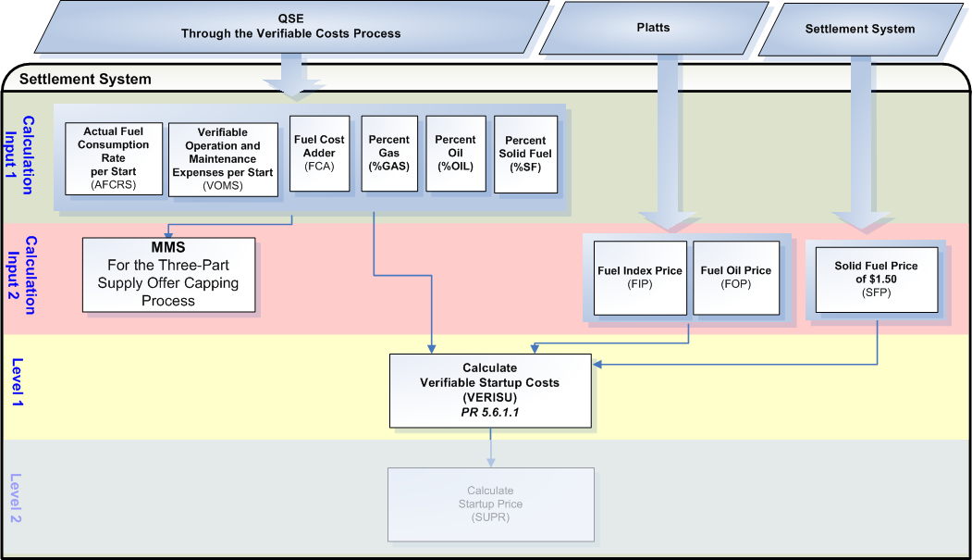

Assumptions
A1) “The appropriate TAC subcommittee” (WMS) will determine if Verifiable Startup and Minimum-Energy Costs may be submitted or approved independently of each other.

A2) “The appropriate TAC subcommittee” (WMS) will determine what is acceptable to be included in the Verifiable Startup Costs and will specify the documentation required and the process and timing for submittal, review and approval by ERCOT.

A3) Prior to the execution of the DAM, MMS will require the most current data for:
  - AFCRS_<Q>_<R>_<SP>_<ST>
  - GASPERSU_<Q>_<R>_<SP>_<ST>
  - OILPERSU_<Q>_<R>_<SP>_<ST>
  - SFPERSU_<Q>_<R>_<SP>_<ST>
  - VOMS_<Q>_<R>_<SP>_<ST>

A4) Settlements should settle based on the data used by MMS to commit the Resource, excluding the fuel prices.

A5) Settlements shall use the fuel prices, including FIP and FOP, for the Operating Day. The FIP and FOP for the Operating Day may not be available for the RUC Process that commits a Resource, therefore the FIP or FOP used in the optimization may not be the FIP or FOP used in Settlements.

Business Rules
Req. ID | Protocol(s) | Sub-Process Map | Description
FR2 | PR 5.6.1.1 | CSWM.  P03SettleBillTransfer | DRIVER: The VERISU calculation should only be attempted for QSE/Resource combinations based on two (2) drivers  - The QSE/Resource combination has a RUC_<Q>_<R>_<SP>_<RUC> in the settlement system for the Operating Day; and  - The QSE/ Resource combination has approved Verifiable Startup Costs existing in the settlement system for the Operating Day.
FR3 | PR 5.6.1.1 | CSWM.  P03SettleBillTransfer | No input or output bill determinants should be rounded or truncated.
FR4 | PR 12.3 (c) | CSWM.  P03SettleBillTransfer | All input and output bill determinants should be made available to the extracts process and should be classified in the settlement system as:  - AFCRS – private  - GASPERSU – private  - OILPERSU – private  - SFPERSU – private  - VOMS – private  - FIP – public  - FOP – public  - VERISU – private

Business Defined Errors
Req. ID | Protocol(s) | Sub-Process Map | Description
FR5 | PR 5.6.1.1 | CSWM.  P03SettleBillTransfer | While calculating VERISU, if RUC does not exist in the Settlement System for the Operating Day for the QSE/Resource combination, then the Settlement System should process as if no RUC-Commitment was issued and should not perform the calculation for the QSE/Resource combination
FR6 | PR 5.6.1.1 | CSWM.  P03SettleBillTransfer | While calculating VERISU, if approved Verifiable Startup Costs do not exist in the Settlement System for the Operating Day for the QSE/Resource combination, then the Settlement System should process as if no Verifiable Startup Costs have been approved by ERCOT and should not perform the calculation for the QSE/Resource combination

Specific Database Needs
Req. ID | Protocol(s) | Sub-Process Map | Description
FR7 | PR 5.6.1(1) | CSWM.  P03SettleBillTransfer | Resource specific input variables for the calculation of VERISU for each Resource and start type shall be stored and maintained in a centralized area with start and stop times, including:  - Actual Fuel Consumption Rate per Start (AFCRS)  - Unit-Specific Specific Verifiable Operation and Maintenance Expenses per Start (VOMS)  - Percent Gas per Start Type (GASPERSU)  - Percent Oil per Start Type (OILPERSU)  - Percent Solid Fuel per Start Type (SFPERSU)

Verifiable Minimum-Energy Costs (VERIME)
Verifiable Minimum-Energy Costs are the Resource specific costs to operate at the Resource’s Lowest Sustained Limit in dollars per MWh. Verifiable Minimum-Energy Costs will be used by ERCOT to cap the Minimum-Energy Offer component submitted in the Three-Part Supply Offer for the Resource and by ERCOT Settlements to use in place of an absent Three-Part Supply Offer.

For more information on how ERCOT will cap the minimum-energy component of the Three-Part Supply Offer, see the RUC Functional Specification Document.

Requirement ID | FR8
Source Mapping (Protocol/NERC/FERC and other binding documents Ref #) | PR 5.6.1.2(1a)  PR 5.6.1.2(1b)
Traceability to Sub-Process Maps | CSWM.P03SettleBillTransfer
Description: Calculate the VERIME for each Operating Day, Season and hour by QSE, and Resource, for each Resource with a RUC-Commitment for the Operating Day and with approved Verifiable Minimum-Energy Costs in the Settlement System, using the most current Verifiable inputs based on start and stop time.

VERIME_<Q>_<R>_<SP> = [(VFCLSL_<Q>_<R>_<SP>
* ((GASPERME_<Q>_<R>_<SP> * FIP) + (OILPERME_<Q>_<R>_<SP> * FOP) + (SFPERME_<Q>_<R>_<SP> * SFP))) / LSL_<Q>_<R>_<SP>] + VOMLSL_<Q>_<R>_<SP>

Input Bill Determinants
Variable | Unit | Definition | Source
VFCLSL | MMBtu/Hr | Verified Fuel Consumption at LSL – The energy required to sustain the Resource at LSL for the hour, submitted to ERCOT through the Verifiable Costs process. | QSE
Interval Frequency: None

Additional Comments: The VFCLSL shall be submitted by the QSE to ERCOT through the Verifiable Costs Process and reviewed by ERCOT. The approved value shall be imported into the settlement system. There shall be a VFCLSL for each QSE/Resource combination.
GASPERME | Misc | Percent Gas – The percentage of fuel used by the resource to operate at minimum-energy that will be gas. | QSE
Interval Frequency: None

Additional Comments: The GASPERME shall be submitted by the QSE to ERCOT through the Verifiable Costs Process and reviewed by ERCOT. The approved value shall be imported into the settlement system. There shall be a GASPERME for each QSE/Resource combination.
OILPERME | Misc | Percent Oil – The percentage of fuel used by the resource to operate at minimum-energy that will be oil. | QSE
Interval Frequency: None

Additional Comments: The OILPERME shall be submitted by the QSE to ERCOT through the Verifiable Costs Process and reviewed by ERCOT. The approved value shall be imported into the settlement system. There shall be a OILPERME for each QSE/Resource combination.
SFPERME | Misc | Percent Solid Fuel – The percentage of fuel used by the resource to operate at minimum-energy that will be solid fuel. | QSE
Interval Frequency: None

Additional Comments: The SFPERME shall be submitted by the QSE to ERCOT through the Verifiable Costs Process and reviewed by ERCOT. The approved value shall be imported into the settlement system. There shall be a SFPERME for each QSE/Resource combination.
VOMLSL | $/MWh | Variable Operation and Maintenance Expenses at LSL – The variable operational and maintenance expenses to operate at LSL for the Resource and submitted to ERCOT through the Verifiable Costs process. | QSE
Interval Frequency: None

Additional Comments: The VOMLSL shall be submitted by the QSE to ERCOT through the Verifiable Costs Process and reviewed by ERCOT. The approved value shall be imported into the settlement system. There shall be a VOMLSL for each QSE/Resource combination.
LSL | MW | Low Sustained Limit—The limit established by the QSE, continuously updated in Real-Time, that describes the minimum sustained energy production capability of the Resource for the hour that includes the Settlement Interval i. | MMS
Interval Frequency: 1 / Hour

Additional Comments: None
FIP | $/MMBtu | Fuel Index Price – The midpoint price expressed in dollars per million British thermal units ($/MMBtu), published in the Platts Gas Daily, in the Daily Price Survey, under the heading “East-Houston-Katy, Houston Ship Channel” for the Operating Day. | Platts
Interval Frequency: 1 / Day

Additional Comments: None
FOP | $/MMBtu | Fuel Oil Price – The sum of five cents per gallon plus the average of the range shown in the Platts Oilgram Price Report for U.S. Gulf Coast, pipeline, for No. 2 oil, converted to dollars per million British thermal units ($/MMBtu) for the Operating Day. | Platts
Interval Frequency: 1 / Day

Additional Comments: None
SFP | $/MMBtu | Solid Fuel Price – Deemed fuel price for solid fuel fired units of $1.50/MMBtu. | Settlement System
Interval Frequency: None

Additional Comments: The SFP shall be a variable with Start and Stop Time.

Output Bill Determinants
Variable | Unit | Definition | Destination
VERIME | $/MWh | Verifiable Minimum-Energy Costs—The verifiable minimum-energy costs of a Resource for a operating at LSL submitted by the QSE for the Resource, according to Section 5.6.1, Verifiable Costs and Section 5.6.1.2, Verifiable Minimum-energy Costs. | Settlement System
Interval Frequency: 1 / hour

Additional Comments: None

Dependencies
D1) MMS is dependent upon the availability of the input bill determinants resulting from the Verifiable Costs process, including:
- VFCLSL
- VOMLSL
- GASPERME
- OILPERME
- SFPERME

D2) Calculation of VERIME is dependent upon the availability of the input bill determinants.

D3) Calculation of VERIME must be complete prior to calculation of the Minimum-Energy Price (MEPR)

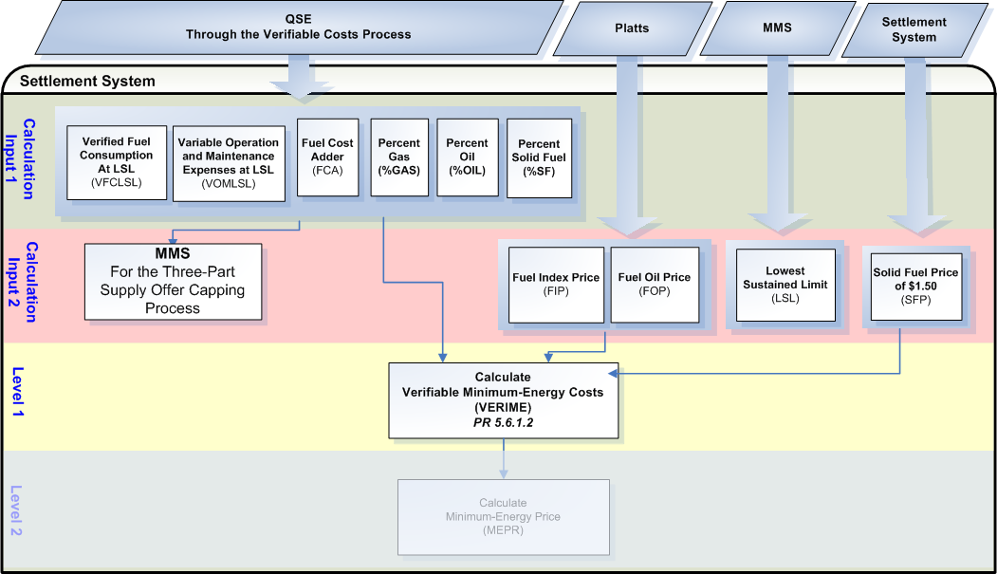

Assumptions
A1) “The appropriate TAC subcommittee” (WMS) will determine if Verifiable Startup and Minimum-Energy Costs may be submitted or approved independently of each other.

A2) “The appropriate TAC subcommittee” (WMS) will determine what is acceptable to be included in the Verifiable Minimum-Energy Costs and will specify the documentation required and the process and timing for submittal, review and approval by ERCOT.

A3) Prior to the execution of the DAM, MMS will require the most current data for:
  - VFCLSL_<Q>_<R>_<SP>
  - GASPERME_<Q>_<R>_<SP>
  - OILPERME_<Q>_<R>_<SP>
  - SFPERME_<Q>_<R>_<SP>
  - VOMLSL_<Q>_<R>_<SP>

A4) Settlements should settle based on the data used by MMS to commit the Resource, excluding the fuel prices.

A5) Settlements shall use the fuel prices, including FIP and FOP, for the Operating Day. The FIP and FOP for the Operating Day may not be available for the RUC Process that commits a Resource, therefore the FIP or FOP used in the optimization may not be the FIP or FOP used in Settlements.

A6) The fuel consumption at LSL (MMBtu/Hr) shall be the fuel consumption indicated in the input/output curve at the LSL designated point provided to ERCOT through the Verifiable Costs process.

Business Rules
Req. ID | Protocol(s) | Sub-Process Map | Description
FR9 | PR 5.6.1.2(1) | CSWM.  P03SettleBillTransfer | DRIVER: The VERIME calculation should only be attempted for QSE/Resource combinations based on two (2) drivers  - The QSE/Resource combination has a RUC_<Q>_<R>_<SP>_<RUC> in the settlement system for the Operating Day; and  - The QSE/ Resource combination has approved Verifiable Minimum-Energy Costs existing in the settlement system for the Operating Day.
FR10 | PR 5.6.1.2(1) | CSWM.  P03SettleBillTransfer | No input or output bill determinants should be rounded or truncated.
FR11 | PR 12.3 (c) | CSWM.  P03SettleBillTransfer | All input and output bill determinants should be made available to the extracts process and should be classified in the settlement system as:  - VFCLSL – private  - GASPERME – private  - OILPERME – private  - SFPERME – private  - VOMLSL – private  - FIP – public  - FOP – public  - VERIME – private

Business Defined Errors
Req. ID | Protocol(s) | Sub-Process Map | Description
FR12 | PR 5.6.1.1 | CSWM.  P03SettleBillTransfer | While calculating VERIME, if RUC does not exist in the Settlement System for the Operating Day for the QSE/Resource combination, then the Settlement System should process as if no RUC-Commitment was issued and should not perform the calculation for the QSE/Resource combination.
FR13 | PR 5.6.1.1 | CSWM.  P03SettleBillTransfer | While calculating VERIME, if approved Verifiable Minimum-Energy Costs do not exist in the Settlement System for the Operating Day for the QSE/Resource combination, then the Settlement System should process as if no Verifiable Minimum-Energy Costs have been approved by ERCOT and should not perform the calculation for the QSE/Resource combination.

Specific Database Needs
Req. ID | Protocol(s) | Sub-Process Map | Description
FR14 | PR 5.6.1(1) | CSWM.  P03SettleBillTransfer | Resource specific input variables for the calculation of VERIME for each Resource shall be stored and maintained in a centralized area by season with start and stop times, including:  - Verified Fuel Consumption at LSL (VFCLSL)  - Variable Operation and Maintenance Expenses (VOMLSL)  - Percent Gas to operate at Minimum-Energy (GASPERME)  - Percent Oil to operate at Minimum-Energy (OILPERME)  - Percent Solid Fuel to operate at Minimum-Energy (SFPERME)

Verifiable Energy Costs

Assumptions
A1) Settlements does not require Verifiable Energy Costs, including verifiable incremental heat rate and verifiable variable O&M energy cost per Section 4.4.9.4.1, Mitigated Offer Cap, for any of its calculations. Therefore, it is assumed that Verifiable Energy Cost information will not be stored by the Settlement system.

The submittal of the incremental heat rates to ERCOT shall be executed in a similar fashion as other verifiable costs. Only approved incremental heat rates will be used by MMS to cap the Energy offers.

Supplementary Requirements

Performance Requirements
Lodestar must be able to perform its full set of Nodal settlement calculations. Performance characteristics will be determined and detailed in the conceptual and detailed design.

Legal and Regulatory requirements
All Lodestar financial data must be saved in accordance with standard accounting principles as dictated by the ERCOT Texas Nodal Protocols.

System Security Requirements
Lodestar will only be accessed directly by internal ERCOT personnel either through thin client UI, Citrix environment, or thick client on employee desktops. Market Participants will be able to access their statements and invoices on ERCOT private web site. ERCOT private web site access will be controlled by digital certificate authentication in accordance with ERCOT security policies. Additional details will be provided in the Conceptual System Design.

Back up and Recovery Requirements
All Lodestar Nodal settlement data must be backed up on a daily basis and recoverable within 24 hours. Additional details will be provided in the Conceptual System Design.

Availability and Redundancy Requirements
Nodal Lodestar system must be available 7/24. Lodestar is considered a tier 1 system and critical to base ERCOT business processes. Additional details will be provided in the Conceptual System Design.

Maintainability Requirements
Lodestar Nodal system will be maintained by internal ERCOT personnel. Service Level Agreements and explicit support will be detailed in the detail design document.

Daylight Savings Time shall be recognized in Nodal Market settlements.
Spring Daylight Savings Time Operating Day:
- Hour Ending 0300 will be skipped, resulting in 23 hourly intervals for the day.
- The four fifteen minute intervals within Hour Ending 0300 will be skipped, resulting in 92 fifteen minute intervals for the day.
- The sixty one minute intervals within Hour Ending 0300 will be skipped, resulting in 1380 total one minute intervals.

Fall Daylight Savings Time Operating Day:
- Hour Ending 0200 will have two (2) sets of data, resulting in 25 hourly intervals for the day.
- The four fifteen minute intervals within Hour Ending 0200 will have two (2) sets of data, resulting in 100 fifteen minute intervals for the day.
- The sixty one minute intervals within Hour Ending 0200 will have two (2) sets of data, resulting in 1500 total one minute intervals.

Protocol Coverage

Protocol Sub-Section # (To the lowest level of granularity as possible) | Coverage by Requirements  (Full/Partial)
5.6.1(1) | Partial
5.6.1.1 | Partial
5.6.1.1 (a) | Partial
5.6.1.1 (b) | Partial
5.6.1.2 (1) | Partial
5.6.1.2 (1a) | Partial
5.6.1.2 (1b) | Partial
12.3 (c) | Partial

