

Nodal System of Systems:
Market Operations (M.)
Version 0.992
Revision History
Date | Version | Description | Author(s)
16-Sept-2006 | 0.9 | TPTF Draft | Daryl Shing,  Gary Macomber
24-Sept-2006 | 091 | Complete Use Cases | Daryl Shing
27-Sept-2006 | 0.94 | Updated with comments | Gary Macomber
2-Oct-2006 | 0.98 | Final Layout Updates | Daryl Shing
3-Oct-2006 | 0.981 | Updated w/ comments | Gary Macomber
4-Oct-2006 | 0.991 | Released to TPTF for review | Daryl Shing
31-Oct 2006 | 0.992 | Revised version for TPTF | Gary Macomber

Table of Contents
System of Systems Architecture 3
M – Market Operations 3
M.UC1 - Validate Self-Schedules, Self-Arranged AS or COP 3
M.UC1.BB - Validate Self-Schedules, Self-Arranged AS or COP 3
M.UC1.OP1 – Perform Validation on Self-Schedules, Self-Arranged AS or COP 3
M.UC1.OP1.WB – Perform Validation on Self-Schedules, Self-Arranged AS or COP 3
M.UC2 - Edit Self-Schedules, Self-Arranged AS or COP 3
M.UC2.BB – Edit Self-Schedules, Self –Arranged AS or COP 3
M.COM.OP1 – Reference: Provide Transaction Details 3
M.UC2.OP2 - Revise Self-Schedule, Self-Arranged AS or COP 3
M.UC2.OP2.WB - Revise Self-Schedule, Self-Arranged AS or COP 3
M.UC3 - Validate Trades 3
M.UC3.BB – Validate Trades 3
M.COM.OP1 – Reference: Provide Transaction Details 3
M.UC3.OP1 - Register Trade 3
M.UC3.OP1.WB - Register Trade 3
M.UC3.OP2 – Update Unconfirmed Trade 3
M.UC3.OP2.WB - Update Unconfirmed Trade 3
M.UC3.OP3 - Delete Unconfirmed Trade 3
M.UC3.OP3.WB - Delete Unconfirmed Trade 3
M.UC4 - Cancel / Reject Confirmed Trade 3
M.UC4.BB - Cancel / Reject Confirmed Trade 3
M.COM.OP1 – Reference: Provide Transaction Details 3
M.UC4.OP1 - Reject Trade 3
M.UC4.OP1.WB - Reject Trade 3
M.UC5 - Buy/Sell Services through Bids and Offers 3
M.UC5.BB - Buy/Sell Services through Bids and Offers 3
M.COM.OP2 – Reference: Register Offer or Bid 3
M.UC6 – Edit Bid or Offer 3
M.UC6.BB – Edit Bid or Offer 3
M.COM.OP1 – Reference: Provide Transaction Details 3
M.UC6.OP1 – Revise Bid/Offer 3
M.UC6.OP1.WB – Revise Bid/Offer 3
M.UC7 - Buy/Sell CRRs through Bilateral Trades 3
M.UC7.BB - Buy/Sell CRRs through Bilateral Trades 3
M.UC7.OP1 – Transfer CRR Ownership 3
M.UC7.OP1.WB - Transfer CRR Ownership 3
M.UC7.OP2 – Confirm CRR Ownership Transfer 3
M.UC7.OP2.WB – Confirm CRR Ownership Transfer 3
M.UC8 - CRR Account Holder Requests Pre-Assigned CRRs 3
M.UC8.BB - CRR Account Holder Requests Pre-Assigned CRRs 3
M.UC8.OP1 - Nominate PCRRs 3
M.UC8.OP1.WB - Nominate PCRRs 3
M.UC9 - Manage RMR Unit Availability 3
M.UC9.BB – Manage RMR Unit Availability 3
M.UC9.OP1 - Update RMR Unit Availability 3
M.UC9.OP1.WB - Update RMR Unit Availability 3
M.UC10 - Manage CRR Auction 3
M.UC10.BB - Manage CRR Auction 3
M.COM.OP2 – Reference: Register Offer or Bid 3
M.UC10.OP1 - Open CRR Auction 3
M.UC10.OP1.WB - Open CRR Auction 3
M.UC10.OP2 – Clear CRR Market 3
M.UC10.OP2.WB – Clear CRR Market 3
M.UC11 – Clear AS, CRR, and Energy in DAM 3
M.UC11.BB – Clear AS, CRR, and Energy in DAM 3
M.UC11.OP1 – Clear DAM 3
M.UC11.OP1.WB – Clear DAM 3
M.UC11.OP2 – Replace COP 3
M.UC11.OP2.WB – Replace COP 3
M.UC11.OP3 – Update AS Offer 3
M.UC11.OP3.WB – Update AS Offer 3
M.UC12 – Clear Energy in Real Time Market 3
M.UC12.BB – Clear Energy in Real Time Market 3
M.UC12.OP1 – Clear Real Time Market 3
M.UC12.OP1.WB – Clear Real Time Market 3
M.UC13 – Manage RUC Process 3
M.UC13.BB – Manage RUC Process 3
M.UC13.OP1 – Perform RUC Process 3
M.UC13.OP1.WB – Perform RUC Process 3
M.UC14 – Check Credit Exposure 3
M.UC14.BB – Check Credit Exposure 3
M.UC14.OP1 – Report Credit Exposure 3
M.UC14.OP1.WB – Report Credit Exposure 3
Common Operations 3
M.COM.OP1 – Provide Transaction Details 3
M.COM.OP1.WB – Provide Transaction Details 3
M.COM.OP2 - Register Offer or Bid 3
M.COM.OP2.WB - Register Bid or Offer 3

System of Systems Architecture
The System of Systems Architecture (SoSA) is a technique for modeling a complex system that is itself comprised of complex systems. The value of this approach comes from its ability to look at customers of Nodal and how they expect to operate in a Nodal Market. We believe this approach will provide TPTF and ERCOT a holistic view of Nodal and the means to ensure that the requirements of the individual projects effectively integrate to meet the needs of the Nodal Market.
Document Structure
The Use Case Diagram at the start of the document identifies the Use Cases covered by this document. Each Use Case will have a Use Case Specification documenting the steps, and alternate steps, required to realize the Actors usage of Nodal. The interactions between the Actor and Nodal, found in the Use Case Specification, are documented in the Black Box Sequence Diagram. Each interaction that requires an action by Nodal will have an Operation Specification and supporting White Box Sequence Diagram.
So the logical progression of SoSA is as follows; a Use Case Specification, its Block Box Sequence Diagram, one or more Operation Specifications and their supporting White Box Sequence Diagram(s). This repeats for every Use Case in the Use Case Diagram.
Document Numbering
This document contains the Enterprise Uses Cases for Market Operations. All Market Operations Use Cases are prefixed with M. (Market Operations Use Cases are always orange on diagrams and in this document) and are numbered M.UC1 through M.UC14. Each use case has a Black Box Sequence Diagram identified by postfix of .BB, for example M.UC1.BB identifies the Black Box Sequence Diagram for commercial systems Use Case 1. Each operation identified in the Black Box Sequence Diagram is numbered OP1 through OPx and each operation has a corresponding White Box Sequence Diagram WB. For example the White Box Sequence Diagram for Operation 1 on Use Case 1 would be prefixed by M.UC1.OP1.WB.
Any operations identified as common between Use Cases are referenced as common under the Black Box Sequence Diagram and located in a separate Common Operations Section at the end of the document.
How to Read the Use Case Diagram
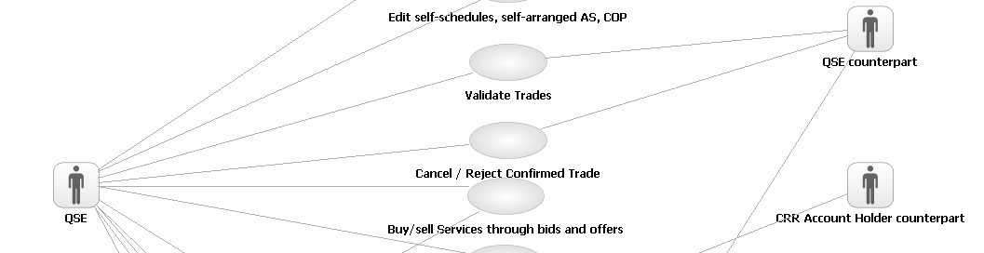
The Use Case Diagram shows the Actors relationships to the Use Cases. A Use Case at the Enterprise Level is a complete usage of Nodal that provides value to an Actor. Use Case names are structured <Verb> <Noun> to ensure the ‘use’ is captured in the name of the Use Case. The line between the Actor and the Use Case indicates which Actor ‘initiates’ the Use Case. You will only see Actors in the Use Case Diagram that operate outside of Nodal. For example, an ERCOT System Operator would not appear as an Actor at this level because they are inside of Nodal. They will appear as a user of the system at the System and/or Component Level.
You should read the above example as:
The QSE initiates Validate Trades.
The QSE initiates Buy/Sell Services through bids and offers.
How to Read the Use Case Specification
Main Success Scenario: (4.4.7.1)
1. QSE submits Self-Schedules, Self-Arranged AS or COP.
2. Nodal ensures that Self-Schedules, Self-Arranged AS or COP meets criteria.
3. Nodal notifies QSE that Self-Schedules, Self-Arranged AS or COP is valid.
4. Nodal displays updated market information.
5. Use Case ends.
Alternate flows
3.a. Nodal finds that Self-Schedules, Self-Arranged AS or COP does not meet criteria.
1. Nodal notifies QSE that it is not valid, displays the invalid Self-Schedules, Self-Arranged AS or COP with information about the error.
2. Use Case ends.
2. Return to Main Flow, Step 6.
The Use Case Specification outlines the steps, and alternate steps, required to meet the Use Cases objectives. Each step in the Main Success Scenario is numbered in sequence and contains very deliberate language follow a structure of <who> is requesting <what> from <whom>. (if the whom is absent it is assumed to be the System in this case Nodal).
Behavior/functionality performed completely within Nodal is not reflected in these steps. At this point we are concentrating on interactions between the Actor and Nodal. Each of these interactions, or operations that Nodal supports, will be broken down into steps at the Operation Specification.
Alternative Flows are attached by using the number of the step to replace and appending an ‘a’ for the first Alternative Flow and a ‘b’ for the second etc. You should read the alternative as in the case of the <alterative description>, instead of doing step x, Nodal will do the following <alternate steps>. Using this approach you should read alternative ‘3.a’ in the example above as:
In the case of Nodal finds that Self-Schedules, Self-Arranged AS or COP does not meet criteria, instead of doing Nodal notifies QSE that Self-Schedules, Self-Arranged AS or COP is valid Nodal will do 1. Nodal notifies QSE that it is not valid…
The same pattern is followed for Alternate Flows to Alternate Flows. 1.a.2.a is an Alternate Flow to step 2 in Alternate Flow 1a.
How to Read the Black Box Sequence Diagram
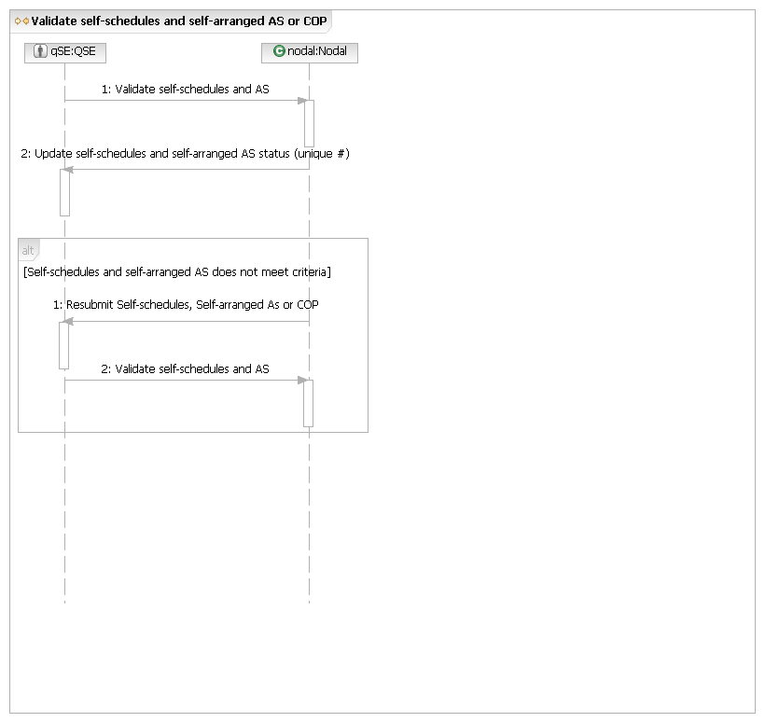
The Black Box Sequence Diagram takes the steps in the Use Case Specification and captures the requests from the Actor to Nodal, and from Nodal to the Actor. These are always in the form of a request, not the passing of information, and should be read in the direction of the arrow. In the example above request one and two should be read as:
1. The QSE requests Nodal to Validate self-schedules and AS.
2. Nodal requests the QSE to Update self-schedules and self-arranged AS status.
This takes some “getting used to” but it is done for a very good reason. We are trying to identify the behaviors, called operations in SoSA that Nodal needs to be able to perform. Every time you see an arrow pointing to Nodal, this is an operation Nodal needs to support.
How to Read the Operation Specification
The Operation Specification takes each of the arrowheads pointing to Nodal and details the interactions required between the systems within Nodal to perform the Operation.
Operation for QSE Request: Perform Validation on Self-Schedules, Self-Arranged AS or COP

Main Flow
Actor Action | Nodal Action | Step | Subsystem Action | White Box Budgeted Requirements
QSE request Nodal validate Self-Schedules, Self-Arranged AS or COP. | Nodal ensures that Self-Schedules, Self-Arranged AS or COP meets criteria.  Nodal notifies QSE that Self-Schedules, Self-Arranged AS or COP is valid.  Nodal displays updated market information | 1 | QSE request MMS validate Self-Schedules, Self-Arranged AS or COP.
 |  | 2 | MMS requests QSE information from Registration.
 |  | 3 | MMS requests Commercial Systems send load ratio share.
 |  | 4 | MMS notifies QSE that transaction is valid.
 |  | 5 | MMS requests MIS post to MIS Certified area.
 |  | 6 | MIS posts to Certified area.

You can see from the example above the first column in the Operation Specification shows the initial Actor Action from the Use Case Specification. The Nodal Action shows the action Nodal is performing until the next Actor Interaction. The Subsystem Actions are the interactions between systems inside Nodal required to meet the Actors Request. You would read the example above as:
The QSE requests Nodal to validate self-schedules, self-arranged AS or COP.
Nodal ensures that Self-Schedules, Self-Arranged AS or COP meets criteria by requesting MMS validate Self-Schedules, Self-Arranged AS or COP…
How to Read the White Box Sequence Diagram
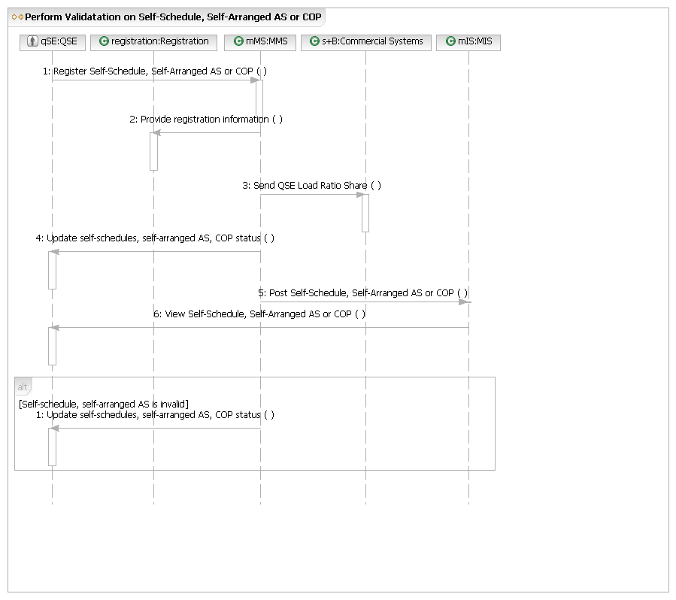
The White Box Sequence Diagram takes the interactions within Nodal identified in the Operation Specification and documents the flow in a Sequence Diagram. A box and a vertical line represent each of the Systems identified within Nodal, this is called a ‘lifeline’. You can see in the example above we have lifelines for MIS and the Registration System along with the original Actor. Like the Black Box Sequence Diagram, each line with associated arrow represents a request in the direction of the arrowhead. You would read the example above as
The QSE requests MMS to Register Self-Schedule, Self-Arranged AS or COP.
MMS requests Registration to Provide registration information.
MMS request Commercial Systems to Send QSE Load Ratio Share.
You will notice there is no request back from the Registration System to MMS. In cases like this when the return request would be simply meeting the request, we leave the return request out to simplify the diagram.
Functionality/Behavior within the Registration or MMS Systems required to meet the request are not show at this level. We are concentrating on identifying the interactions between the Systems inside Nodal required to fulfill the Market Participants request. This detail will be exposed when we look inside the MMS or Registration Systems themselves. In the Nodal Program this is being performed by the individual Project Teams.
Another consideration as you read this document is that the White Box Requests provide requirements for each of the systems inside Nodal but the sequence of execution may change when the systems are implemented. For example, a system may request information each time a flow is executed but this may be done only once per day for efficiency reasons.

M – Market Operations
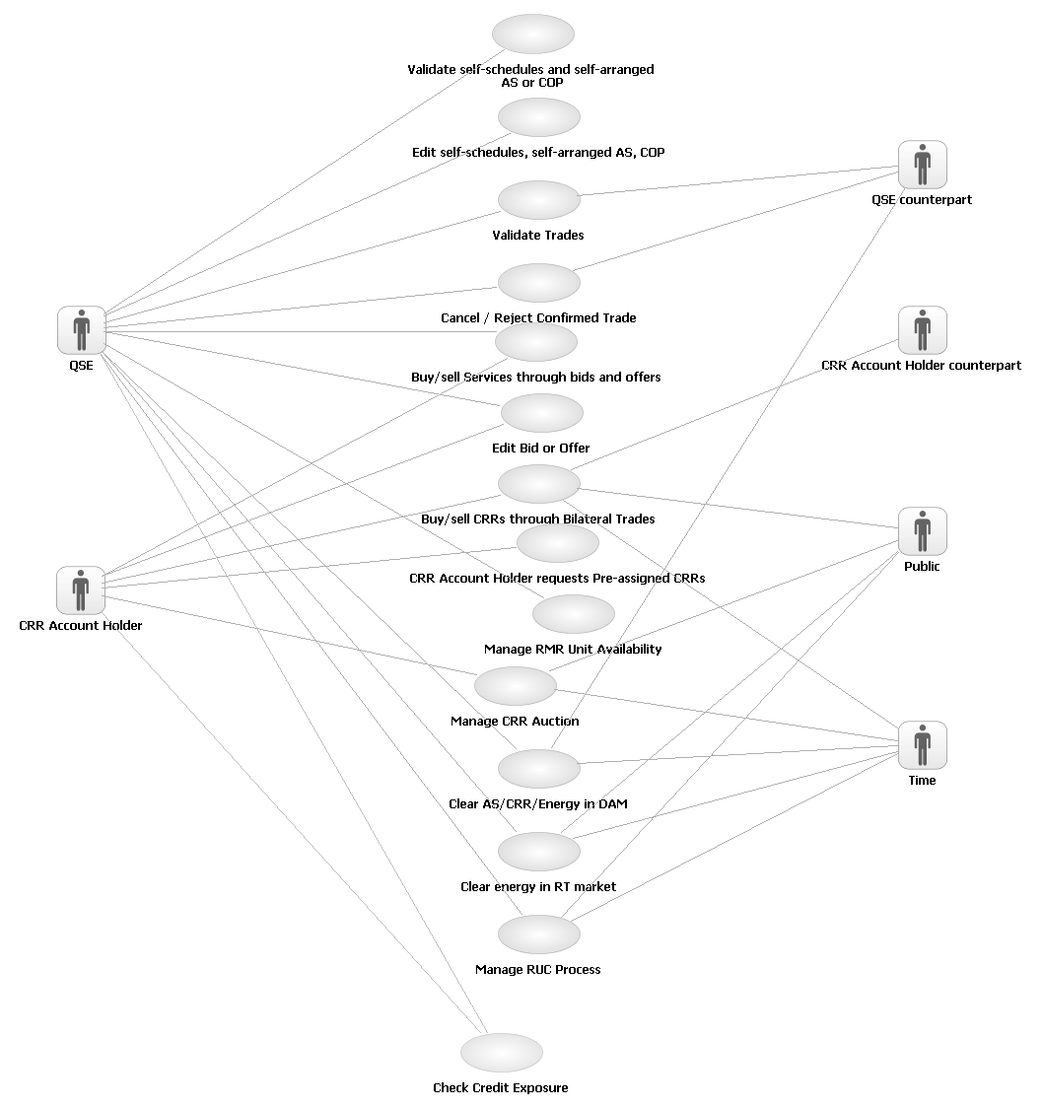
M.UC1 - Validate Self-Schedules, Self-Arranged AS or COP
Brief description
Validate Self-Schedules, Self-Arranged AS or COP Use Case covers the process from the QSE entering/submitting Self-Schedules, Self-Arranged AS or COP to Nodal.
Precondition
QSE has successfully launched the Market application.
Post Condition
Nodal sends validation message.
Main Success Scenario: (4.4.7.1)
1. QSE submits Self-Schedules, Self-Arranged AS or COP.
2. Nodal ensures that Self-Schedules, Self-Arranged AS or COP meets criteria.
3. Nodal notifies QSE that Self-Schedules, Self-Arranged AS or COP is valid.
4. Nodal displays updated market information.
5. Use Case ends.
Alternate flows
3.a. Nodal finds that Self-Schedules, Self-Arranged AS or COP does not meet criteria.
1. Nodal notifies QSE that it is not valid, displays the invalid Self-Schedules, Self-Arranged AS or COP with information about the error.
2. Use Case ends.
M.UC1.BB - Validate Self-Schedules, Self-Arranged AS or COP
M.UC1.OP1 – Perform Validation on Self-Schedules, Self-Arranged AS or COP

Main Flow
Actor Action | Nodal Action | Step | Subsystem Action | White Box Budgeted Requirements
QSE request Nodal validate Self-Schedules, Self-Arranged AS or COP. | Nodal ensures that Self-Schedules, Self-Arranged AS or COP meets criteria.  Nodal notifies QSE that Self-Schedules, Self-Arranged AS or COP is valid.  Nodal displays updated market information | 1 | QSE request MMS validate Self-Schedules, Self-Arranged AS or COP.
 |  | 2 | MMS requests QSE information from Registration.
 |  | 3 | MMS requests Commercial Systems send load ratio share.
 |  | 4 | MMS notifies QSE that transaction is valid.
 |  | 5 | MMS requests MIS post to MIS Certified area.
 |  | 6 | MIS posts to Certified area.

[Self-Schedule, Self-Arranged AS or COP is invalid]
MMS requests QSE update Self-Schedules, Self-Arranged AS or COP.
M.UC1.OP1.WB – Perform Validation on Self-Schedules, Self-Arranged AS or COP
M.UC2 - Edit Self-Schedules, Self-Arranged AS or COP
Brief description
QSE selects and modifies unconfirmed Self-Schedules, Self-Arranged AS or COP and submits to Nodal for validation.
Precondition
QSE has submitted at least 1 valid Self-Schedules, Self-Arranged AS or COP.
Post Condition
Edited Self-Schedules, Self-Arranged AS or COP are entered into Nodal.
Specification
1. QSE requests a Self-Schedules, Self-Arranged AS or COP details.
2. Nodal displays details for selected Self-Schedules, Self-Arranged AS or COP.
3. QSE edits (or deletes) details for selected Self-Schedules, Self-Arranged AS or COP, and submits the edited Self-Schedules, Self-Arranged AS or COP.
4. Nodal notifies QSE that Self-Schedules, Self-Arranged AS or COP was edited and is valid.
5. Use case ends.
Alternate flows
4.a. Nodal finds the Self-Schedules, Self-Arranged AS or COP is not valid.
1. Nodal notifies QSE that it is not valid, displays the invalid Self-Schedules, Self-Arranged AS or COP with information about the error.
2. Use case ends.
M.UC2.BB – Edit Self-Schedules, Self –Arranged AS or COP
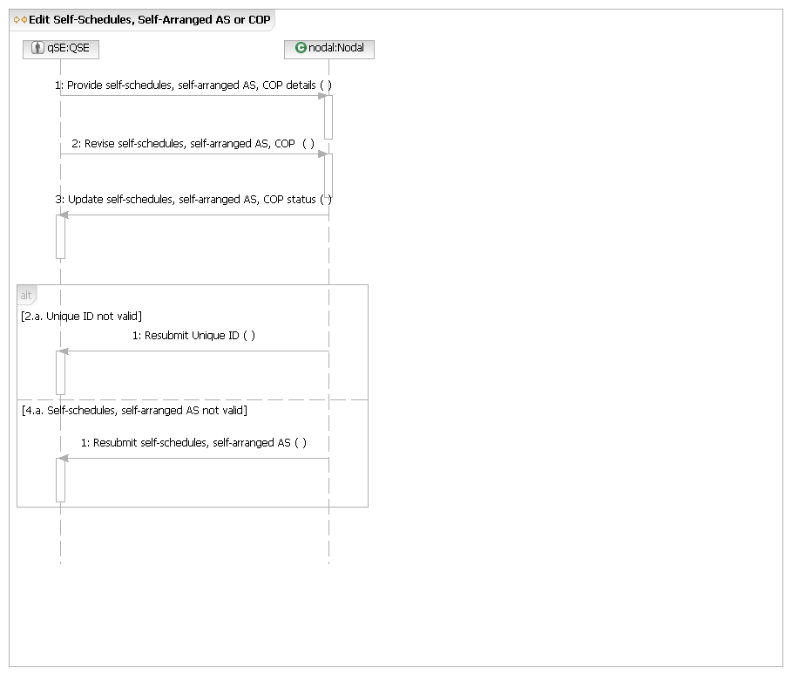
M.COM.OP1 – Reference: Provide Transaction Details
The Provide self-schedules, self-arranged AS, COP Details operation above uses the Common Operation Provide Transaction Details located at the end of this document.
M.UC2.OP2 - Revise Self-Schedule, Self-Arranged AS or COP

Main Flow:
Actor Action | Nodal Action | Step | Subsystem Action | White Box Budgeted Requirements
QSE request Nodal revise Self-Schedules, Self-Arranged AS or COP. | Nodal ensures that Self-Schedules, Self-Arranged AS or COP meets criteria.  Nodal notifies QSE that Self-Schedules, Self-Arranged AS or COP was edited and is valid. | 1 | QSE requests MMS revise Self-Schedules, Self-Arranged AS or COP.
 |  | 2 | MMS requests QSE information from Registration.
 |  | 3 | MMS requests Commercial Systems send load ratio share.
 |  | 4 | MMS notifies QSE that Self-Schedules, Self-Arranged AS or COP is valid and requests MIS post to MIS Certified area.
 |  | 5 | MIS posts to Certified area.

[4.a. Self-Schedule, Self-Arranged AS, or COP invalid]
 |  | 1 | MMS notifies QSE that Self-Schedule, Self-Arranged AS, or COP is invalid
M.UC2.OP2.WB - Revise Self-Schedule, Self-Arranged AS or COP
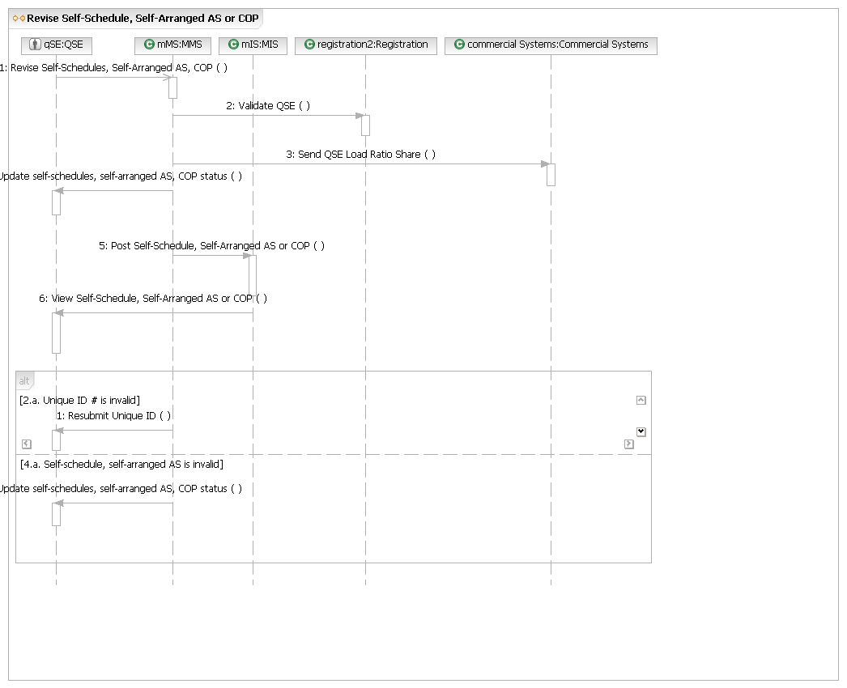
M.UC3 - Validate Trades
Brief description
QSE respectively enter/submit trades, which are the information for a QSE-to-QSE transaction that transfers financial responsibility for Capacity, Energy or AS between a buyer and seller, for Nodal to validate.
Precondition
QSE has successfully launched the energy, capacity, AS Market trading application.
Post Condition
QSE Counterpart has confirmed trade and the requisite systems have been updated.
Main Success Scenario
1. QSE submits trades (for buyer and seller QSE respectively).
2. Nodal checks that trade meets criteria (and assigns it a unique number).
3. Nodal notifies QSE that trade is received and is valid.
4. Nodal notifies the QSE Counterpart that a trade is pending confirmation.
5. Nodal displays the trade.
6. The QSE Counterpart confirms the trade.
7. Nodal sends an acknowledgement of confirmed/validated trade to both QSEs (for buyer and seller QSE respectively).
8. Use case ends.
Alternate flows
3.a. Nodal does not accept trade because it does not meet criteria.
1. Nodal notifies QSE that trade is invalid and why.
2. Use case ends.
6.a. The QSE Counterpart does not confirm the trade.
1. Nodal does not act on trade.
2. Use case ends.
6.b. QSE edits unconfirmed trade.
1. QSE selects unconfirmed trade to edit.
2. Nodal displays details for selected trade.
3. QSE edits details for selected trade, and submits the edited trade.
4. Return to Main Success Scenario, Step 2.
6.c. QSE deletes an unconfirmed trade.
1. QSE selects unconfirmed trade to delete.
2. Nodal displays details for selected trade.
3. QSE requests deletion of selected trade.
4. Nodal confirms deletion of selected trade.
5. Use case ends.

M.UC3.BB – Validate Trades
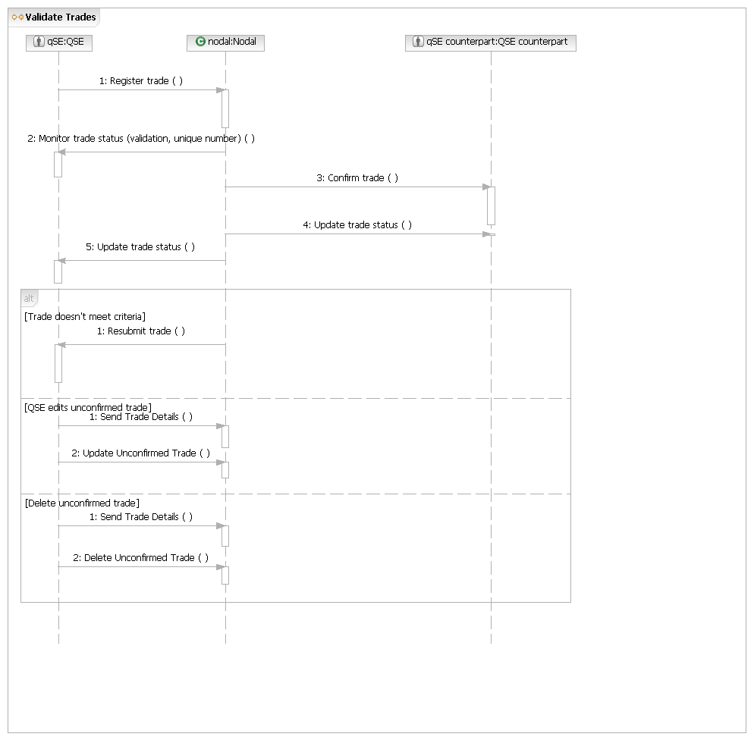
M.COM.OP1 – Reference: Provide Transaction Details
The Provide Trade Details operation above uses the Common Operation Provide Transaction Details located at the end of this document.
M.UC3.OP1 - Register Trade

Main Flow
Actor Action | Nodal Action | Step | Subsystem Action | White Box Budgeted Requirements
QSE requests Nodal register trade. | Nodal ensures that trade meets criteria (and assigns it a unique number).  Nodal notifies QSE that trade is received and is valid.  Nodal notifies the QSE Counterpart that a trade is pending confirmation.  Nodal displays the trade. | 1 | QSE requests Nodal register trade with MMS.
QSE requests Nodal register trade. |  | 2 | MMS gathers data from Registration.
QSE requests Nodal register trade. |  | 3 | MMS notifies QSE that trade is received, is valid, and provides unique identifier for the trade.
QSE requests Nodal register trade. |  | 4 | MMS notifies the QSE Counterpart that a trade is pending confirmation.
QSE requests Nodal register trade. |  | 5 | MMS requests MIS display the trade in the Certified Area.
QSE requests Nodal register trade. |  | 6 | MIS displays the trade in the Certified Area.
M.UC3.OP1.WB - Register Trade
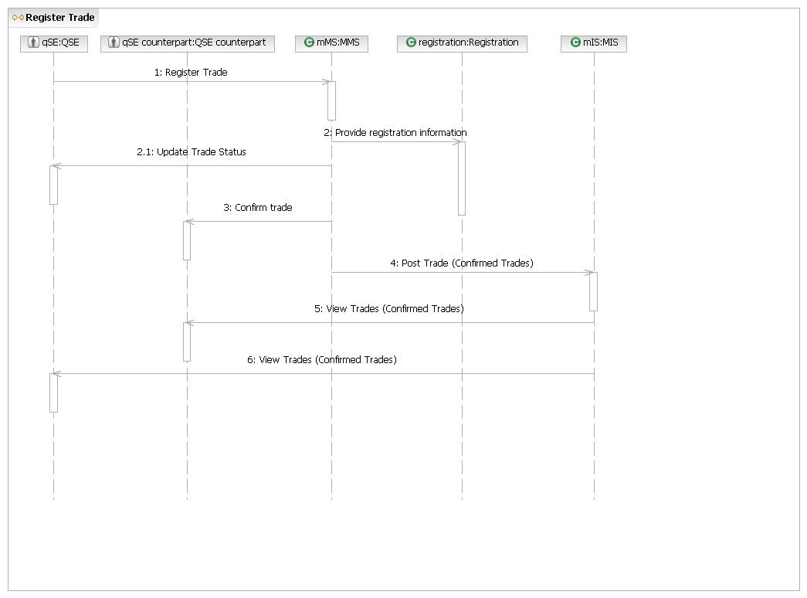
M.UC3.OP2 – Update Unconfirmed Trade

Main Flow
Actor Action | Nodal Action | Step | Subsystem Action | White Box Budgeted Requirements
QSE requests Nodal update trade. | Nodal ensures that trade meets criteria.  Nodal notifies QSE that trade is received and is valid.  Nodal notifies the QSE Counterpart that a trade is pending confirmation.  Nodal displays the trade | 1 | QSE requests MMS update trades.
QSE requests Nodal update trade. |  | 2 | MMS gathers data from Registration.
QSE requests Nodal update trade. |  | 3 | MMS notifies QSE that trade is received, and is valid.
QSE requests Nodal update trade. |  | 4 | MMS notifies the QSE Counterpart that a trade is pending confirm.
QSE requests Nodal update trade. |  | 5 | MMS requests MIS display the trade in the Certified Area.
QSE requests Nodal update trade. |  | 6 | MIS displays the trade in the Certified Area.
M.UC3.OP2.WB - Update Unconfirmed Trade
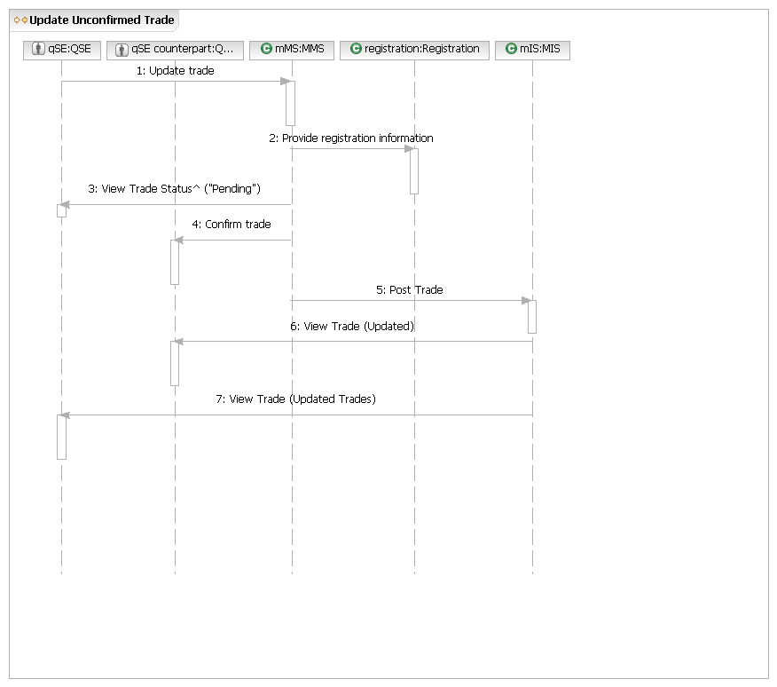
M.UC3.OP3 - Delete Unconfirmed Trade

Main Flow
Actor Action | Nodal Action | Step | Subsystem Action | White Box Budgeted Requirements
QSE requests a trade be deleted. | Nodal notifies QSE that delete trade request is received and is valid.  Nodal notifies the counter QSE that a trade is deleted. | 1 | QSE submits request to delete a trade to MMS (submits unique identifier and action requested).
QSE requests a trade be deleted. |  | 2 | MMS notifies QSE that request is received, is valid, and that the trade has been deleted.
QSE requests a trade be deleted. |  | 3 | MMS notifies the counter QSE that a trade is deleted.
M.UC3.OP3.WB - Delete Unconfirmed Trade
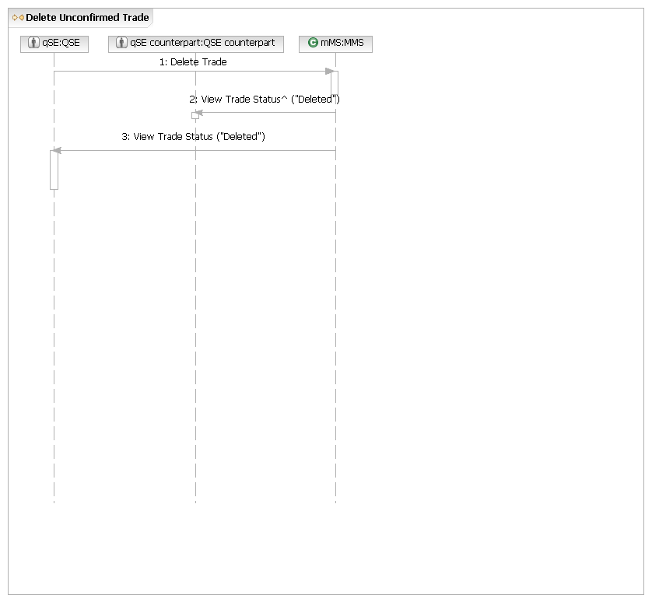
M.UC4 - Cancel / Reject Confirmed Trade
Brief description
QSE rejects confirmed trade.
Precondition
QSE has submitted at least one confirmed trade. QSE has the unique ID for the confirmed trade they want to cancel/reject.
Post Condition
Selected trade has been cancelled or rejected.
Specification
1. QSE submits unique ID for a confirmed trade to reject.
2. Nodal displays details for selected trade.
3. QSE rejects trade, and submits the rejected trade.
4. Nodal notifies QSE that trade was rejected.
5. Nodal notifies the counter QSE that this trade becomes unconfirmed.
6. Nodal display the unconfirmed trade
7. Use case ends.
Alternate flows
2.a. Unique ID is not valid for this QSE.
1. Nodal notifies QSE that unique ID is not valid.
2. Use case ends.
4.a. Trade cannot be rejected.
1. Nodal notifies QSE that trade cannot be rejected and provide details.
2. Use case ends.
M.UC4.BB - Cancel / Reject Confirmed Trade
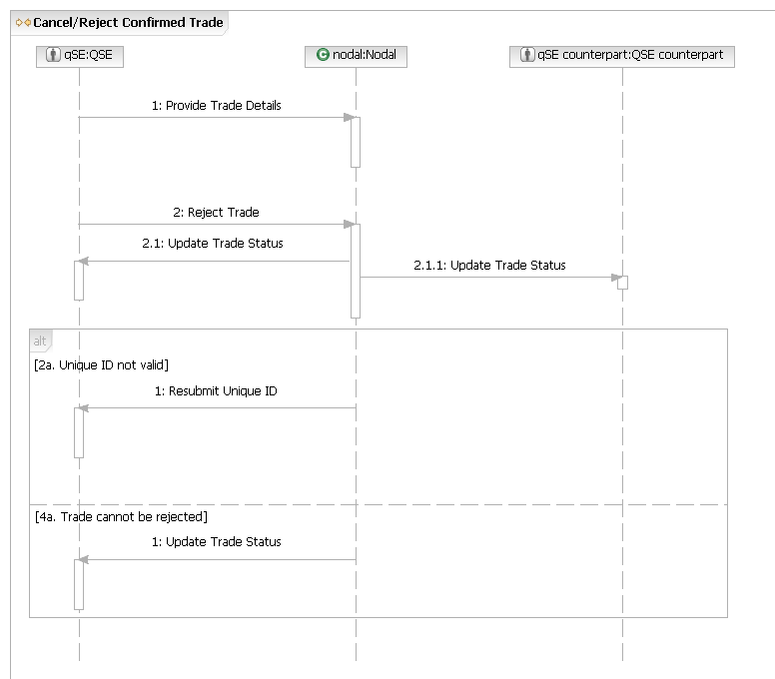
M.COM.OP1 – Reference: Provide Transaction Details
The Provide Trade Details operation above uses the Common Operation Provide Transaction Details located at the end of this document.
M.UC4.OP1 - Reject Trade

Main Flow:
Actor Action | Nodal Action | Step | Subsystem Action | White Box Budgeted Requirements
QSE requests Nodal reject a confirmed and submits the unique ID. | Nodal notifies QSE that trade was rejected.  Nodal notifies the QSE counterpart that this trade becomes unconfirmed.  Nodal display the unconfirmed trade. | 1 | QSE requests MMS reject a confirmed trade and submits the unique ID.
 |  | 2 | MMS notifies QSE that trade was rejected.
 |  | 3 | MMS notifies the QSE counterpart that this trade becomes unconfirmed.
 |  | 4 | MMS requests MIS post-unconfirmed trades in MIS Certified area.
 |  | 5 | MIS posts unconfirmed trades in Certified area.
M.UC4.OP1.WB - Reject Trade
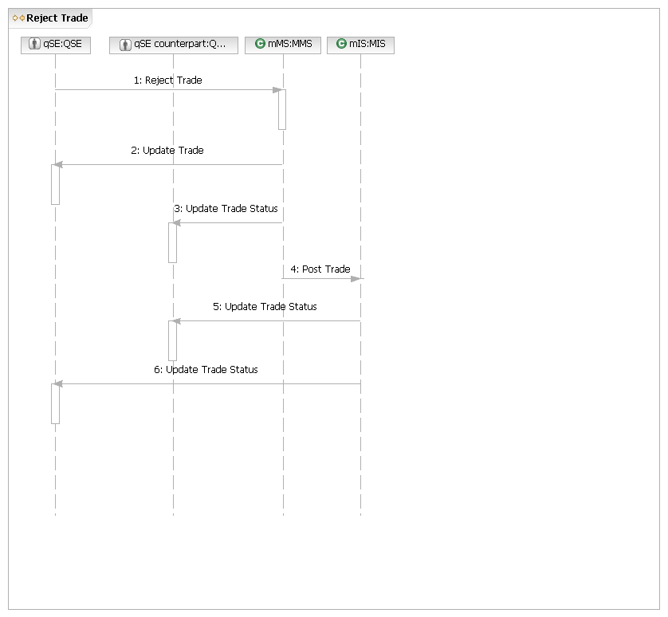
M.UC5 - Buy/Sell Services through Bids and Offers
Brief description
QSEs and CRR Account Holders submit bids/offers to Nodal and Nodal validates those bids/offers.
Precondition
QSE or CRR Account Holder has successfully launched the Market or CRR application.
Post Condition
Valid bid/offer has been accepted by Nodal.
Main Success Scenario (4.4.5.2, 4.4.9.5.2, 4.5.3, etc)
1. QSE or CRR Account Holder submits a bid or offer.
2. Nodal validates the bid or offer.
3. Nodal notifies QSE or CRR Account Holder that bids/offers are received and valid.
4. Use case ends.
Alternate flow
2.a. Nodal finds that bid or offer is not valid.
1. Nodal notifies QSE or CRR Account Holder that the bid or offer was not valid and provide details.
2. Use case ends.

M.UC5.BB - Buy/Sell Services through Bids and Offers
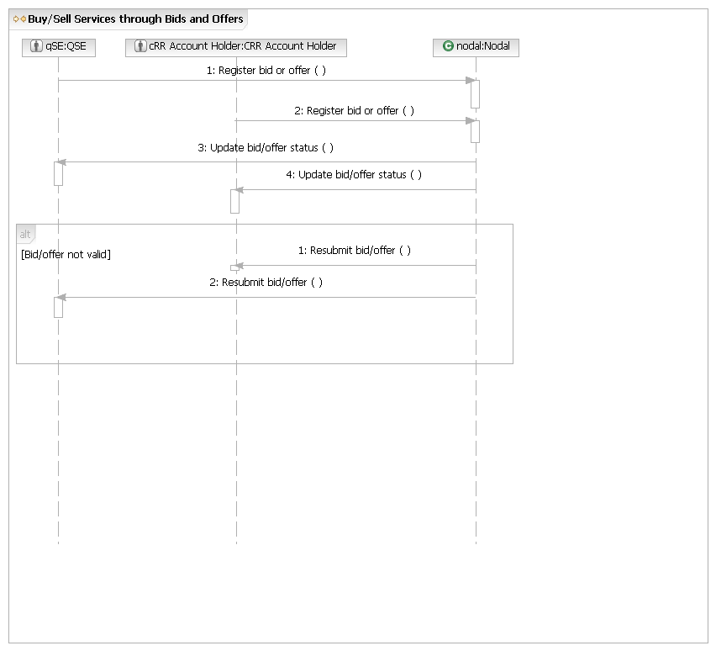
M.COM.OP2 – Reference: Register Offer or Bid
The Register bid/offer/request operation above uses the Common Operation Register Offer or Bid located at the end of this document.
M.UC6 – Edit Bid or Offer
Brief description
QSE or CRR Account Holder selects and modifies a bid/offer for ERCOT to validate.
Precondition
QSE or CRR Account Holder has submitted at least 1 valid bid/offer. QSE or CRR Account Holder has list of Unique IDs for bids and offers.
Post Condition
Edited bid/offer are entered into Nodal.
Main Success Scenario
1. QSE or CRR Account Holder submits unique ID for a bid/offer
2. Nodal displays details for selected bid/offer.
3. QSE or CRR Account Holder edits (or deletes) details for selected bid/offer, and submits the edited bid/offer.
4. Nodal ensures that bid/offer meets criteria.
5. Nodal notifies QSE or CRR Account Holder that bid/offer was edited and is valid.
6. Use case ends.
Alternate flows
2.a. Unique ID is not valid for this QSE or CRR Account Holder.
1. Nodal notifies QSE or CRR Account Holder that unique ID is not valid and provide details.
2. Use case ends.
5.a. Nodal finds that the bid/offer is not valid.
1. Nodal notifies QSE or CRR Account Holder that bid/offer is invalid.
2. Use case ends.
M.UC6.BB – Edit Bid or Offer
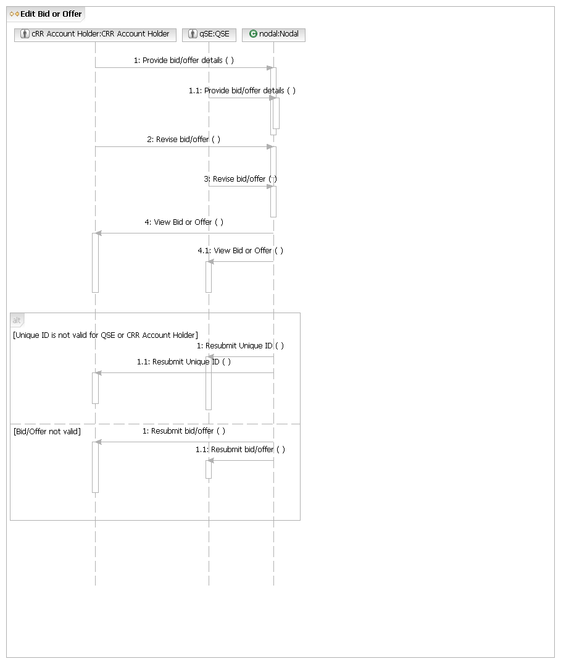
M.COM.OP1 – Reference: Provide Transaction Details
The Provide Bid/Offer Details operation above uses the Common Operation Provide Transaction Details located at the end of this document.
M.UC6.OP1 – Revise Bid/Offer

Main Flow
Actor Action | Nodal Action | Step | Subsystem Action | White Box Budgeted Requirements
QSE or CRR Account Holder request Nodal revise bid/offer. | Nodal ensures that bid/offer meets criteria.  Nodal notifies QSE or CRR Account Holder that bid/offer was edited and is valid. | 1 | QSE or CRR Account Holder requests MMS revise bid/offer.
QSE or CRR Account Holder request Nodal revise bid/offer. |  | 2 | MMS requests QSE or CRR Account Holder information from Registration.
QSE or CRR Account Holder request Nodal revise bid/offer. |  | 3 | MMS notifies QSE or CRR Account Holder (bid/offer is valid) and requests MIS post to MIS Certified area.
QSE or CRR Account Holder request Nodal revise bid/offer. |  | 4 | MIS posts to Certified area.

[Bid/Offer invalid]
 |  | 1 | MMS notifies QSE or CRR Account Holder that bid/offer is invalid
M.UC6.OP1.WB – Revise Bid/Offer
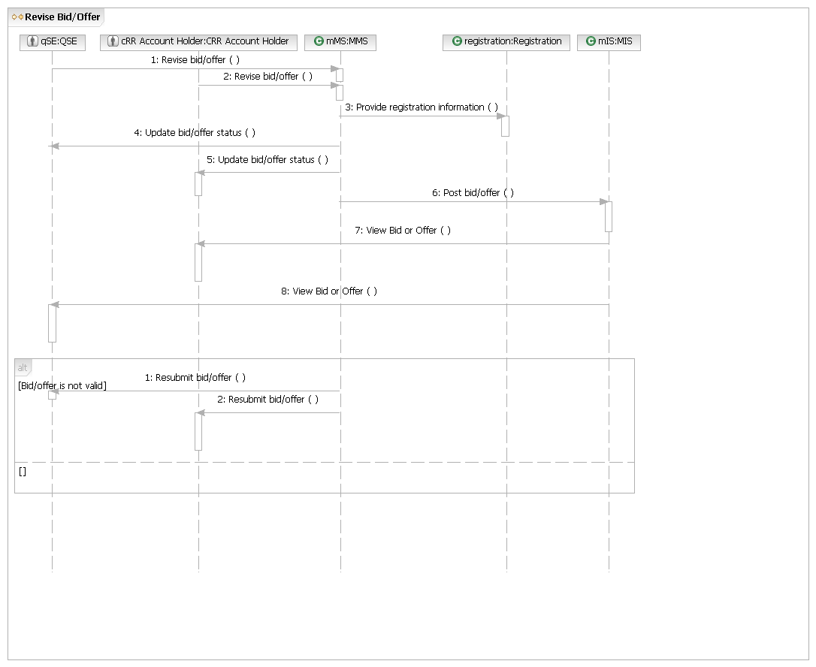
M.UC7 - Buy/Sell CRRs through Ownership Transfer
Brief description
Buy/sell CRRs through Bilateral trades covers the activities from the selling CRR Account Holder reporting the transaction to Nodal notifying the CRR Account Holders that the trade is completed.
Precondition
Selling CRR Account Holder has launched the application.
Post Condition
Trade is completed.
Main Success Scenario
1. Selling CRR Account Holder reports a proposed CRR ownership transfer.
2. Nodal notifies the selling CRR Account Holder the report is received and valid.
3. Nodal notifies the buying CRR Account Holder that an ownership transfer is pending acknowledgement.
4. Buying CRR Account Holder acknowledges the ownership transfer.
5. Nodal notifies both CRR Account Holders that the Bilateral trades is completed.
6. Use case ends.
Alternate flow
2.a. The transaction is not valid.
1. Nodal notifies the selling CRR Account Holder that the Bilateral trades is not valid.
2. Return to Main Success Scenario, Step 1.
4.a. The buying CRR Account Holder does not acknowledge the transaction.
1. Time requests Nodal expire pending transactions.
2. Nodal notifies Both the Selling and Buying CRR Account Holders that the ownership transfer was expired, not completed..
3. Use Case ends
4.b [Buying CRR Account Holder rejects trade]
1. Buying CRR Accountholder rejects the ownership transfer.
2. Nodal notifies the Selling CRR Account Holder that the ownership transfer is rejected.
3. Use case ends.
5.a. One or both of the CRR Account Holders do not meet credit requirement.
1. Nodal notifies CRR Account Holders that the credit requirement is not met and the transaction does not go through.
2. Use case ends.

M.UC7.BB - Buy/Sell CRRs through Ownership Transfer
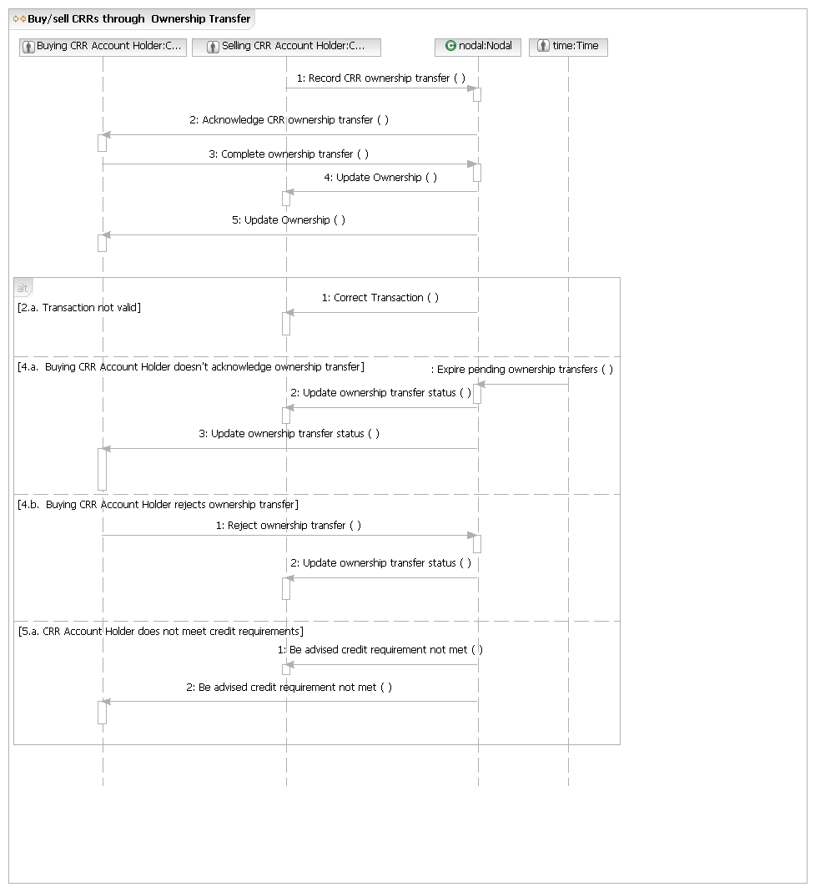

M.UC7.OP1 – Record CRR Ownership Transfer

Main Flow
Actor Action | Nodal Action | Step | Subsystem Action | White Box Budgeted Requirements
Selling CRR Account Holder requests Nodal transfer CRR ownership. |  | 1 | Selling CRR Account Holder requests CRR transfer ownership to CRR System.
 |  | 2 | CRR validates transfer with Registration and CRR ownership information.
 |  | 3 | CRR notifies the selling CRR Account Holder the report is received and valid.
 |  | 4 | CRR requests the buying CRR Account Holder confirm CRR ownership transfer.
M.UC7.OP1.WB - Record CRR Ownership Transfer
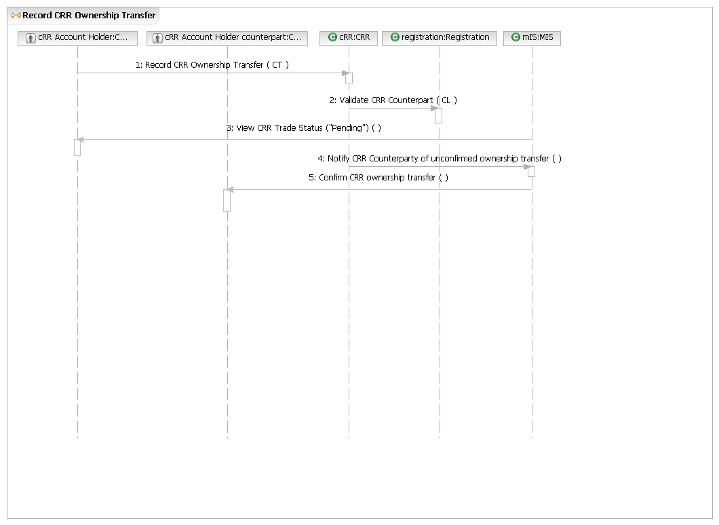
M.UC7.OP2 – Confirm CRR Ownership Transfer

Main Flow
Actor Action | Nodal Action | Step | Subsystem Action | White Box Budgeted Requirements
Buying CRR Account Holder confirms CRR Ownership Transfer. | Nodal checks the credit of both CRR Account Holders and find that both of them meet credit requirement.  Nodal notifies both CRR Account Holders that the transaction is completed. | 1 | Buying CRR Account Holder confirms CRR Ownership Transfer.
Buying CRR Account Holder confirms CRR Ownership Transfer. |  | 2 | CRR checks the credit of both CRR Account Holders with CM information and finds that both of them meet credit requirement.
Buying CRR Account Holder confirms CRR Ownership Transfer. |  | 3 | CRR requests MIS notify the CRR Account Holders that the transfer has been completed.
Buying CRR Account Holder confirms CRR Ownership Transfer. |  | 4 | MIS notifies the CRR Account Holders that the transfer has been completed.
Buying CRR Account Holder confirms CRR Ownership Transfer. |  | 5 | CRR requests CS and CM update CRR Account Holder information.
M.UC7.OP2.WB – Confirm CRR Ownership Transfer
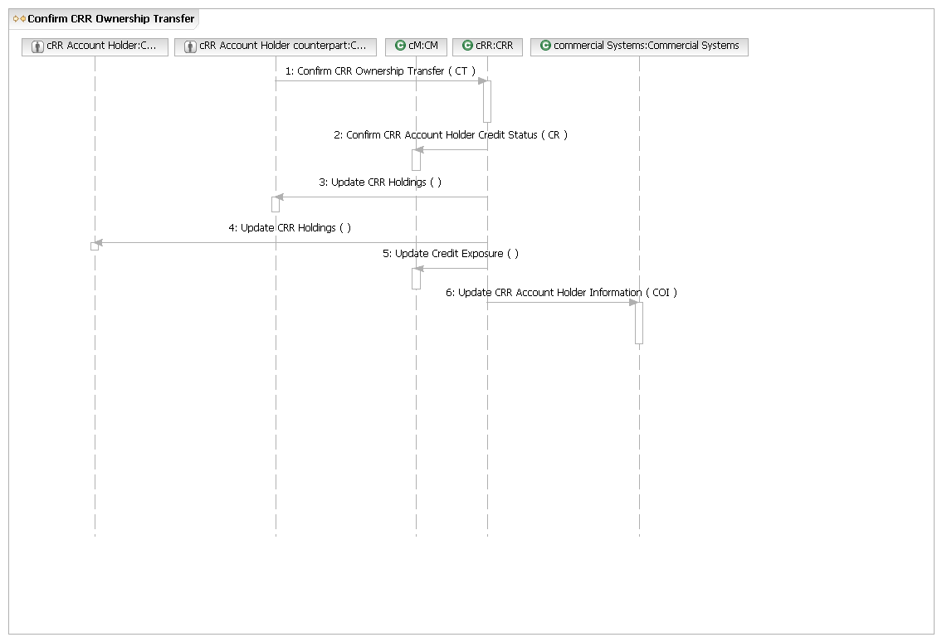
M.UC8 - CRR Account Holder Requests Pre-Assigned CRRs
Brief description
CRR Account Holders request pre-assigned CRRs and Nodal may (or may not) award them based on network capacity and CRR Account Holder entitlements.
Precondition
CRR Account Holder has launched CRR application.
Post Condition
Pre-assigned CRRs are distributed to the CRR Account Holder.
Main Success Scenario
- Time requests Nodal open PCRR Allocation.
- Nodal requests CRR Account Holders nominate PCRRs.
- CRR Account Holders request Nodal accept PCRR nomination.
- Time requests CRR clear PCRR allocation
- Nodal notifies CRR Account Holders of PCRR allocations .
- Use case ends.
Alternate flow
2.a. The PCRR nomination is not valid.
1. Nodal notifies CRR Account Holders that the PCRR nomination is not valid.
2. CRR Account Holder adjusts the PCRR nomination and resubmits the request.
3. Returns to Main Success Scenario, Step 2.
M.UC8.BB - Request Pre-Assigned CRRs
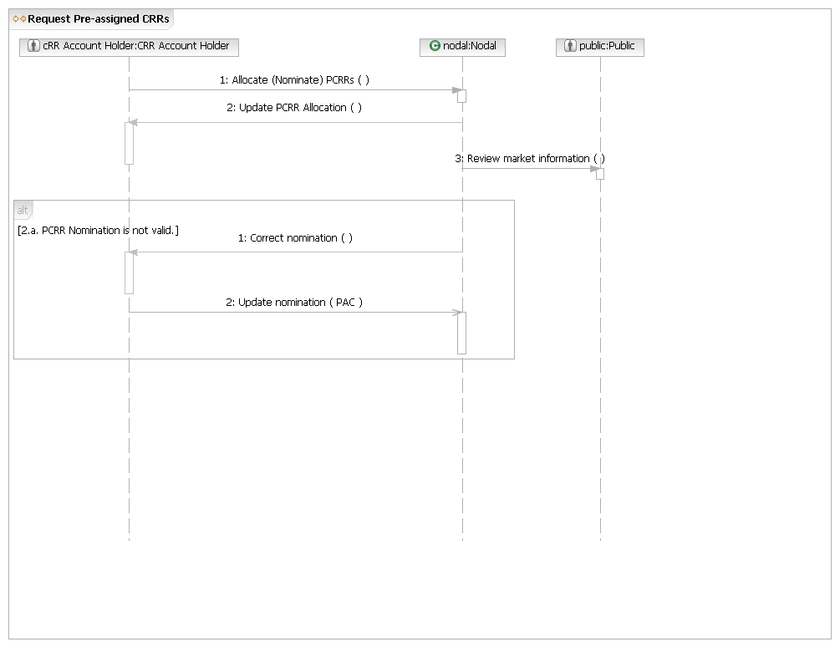
M.UC8.OP1 - Allocate PCRRs

Main Flow
Actor Action | Nodal Action | Step | Subsystem Action | White Box Budgeted Requirements
CRR Account Holder nominates Pre-assigned CRRs to System. | Nodal checks the PCRR nomination and finds it is valid.  Nodal notifies CRR Account Holders of PCRR allocations.  Nodal makes available updated market information. | 1 | CRR Account Holders request CRR System allocate Pre-assigned CRRs .
CRR Account Holder nominates Pre-assigned CRRs to System. |  | 2 | CRR validates nomination with Registration.
CRR Account Holder nominates Pre-assigned CRRs to System. |  | 3 | CRR requests CRR Network Model from NMMS.
CRR Account Holder nominates Pre-assigned CRRs to System. |  | 4 | NMMS requests EMS send Dynamic Ratings, Contingencies, Generic and non-thermal constraints
CRR Account Holder nominates Pre-assigned CRRs to System. |  | 5 | NMMS requests outage information from OS.
CRR Account Holder nominates Pre-assigned CRRs to System. |  | 6 | CRR notifies CRR Account Holders of PCRR allocation.
CRR Account Holder nominates Pre-assigned CRRs to System. |  | 7 | CRR requests MIS post allocations in MIS Certified area.
CRR Account Holder nominates Pre-assigned CRRs to System. |  | 8 | MIS posts allocations in Certified area.
[Nomination invalid]
 |  | 1 | CRR requests CRR Account Holder update nomination

M.UC8.OP1.WB - Allocate PCRRs
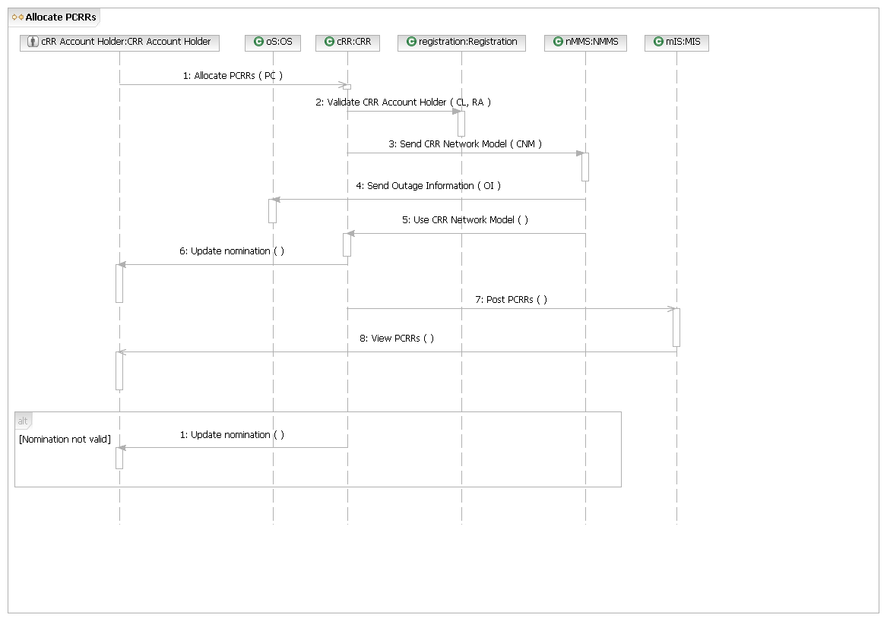
M.UC9 - Manage RMR Unit Availability
Brief description
RMR units indicate availability; ERCOT commits them as necessary and pays the unit accordingly.
Precondition
The units have existing RMR agreements and access to the Market application.
Post Condition
RMR unit awards have been distributed.
Main Success Scenario
1. QSE indicate availability of RMR units.
2. Nodal evaluates need and creates RMR offers.
3. Nodal clears DAM/RUC.
4. Nodal notifies QSE of commitment or deployments.
5. Nodal makes available updated market information.
6. Use case ends.
Alternate flows
None.
M.UC9.BB – Manage RMR Unit Availability
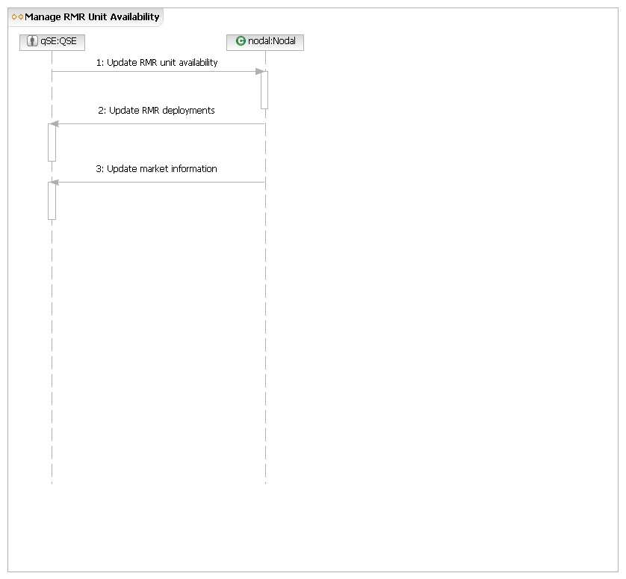
M.UC9.OP1 - Update RMR Unit Availability

Main Flow
Actor Action | Nodal Action | Step | Subsystem Action | White Box Budgeted Requirements
QSE indicate RMR unit availability. | Nodal evaluates need and creates RMR offer.  Nodal clears DAM or RUC.  Nodal notifies QSE of commitment or deployments. | 1 | QSE notify MMS of RMR unit availability.
QSE indicate RMR unit availability. |  | 2 | Gather information from OS, NMMS, and EMS to determine need for RMR.
QSE indicate RMR unit availability. |  | 3 | MMS creates offer for DAM/RUC for the available RMR units.
QSE indicate RMR unit availability. |  | 4 | MMS notifies QSE of commitments or deployments and requests MIS post to MIS Certified area.
QSE indicate RMR unit availability. |  | 5 | MIS posts to Certified area.
M.UC9.OP1.WB - Update RMR Unit Availability
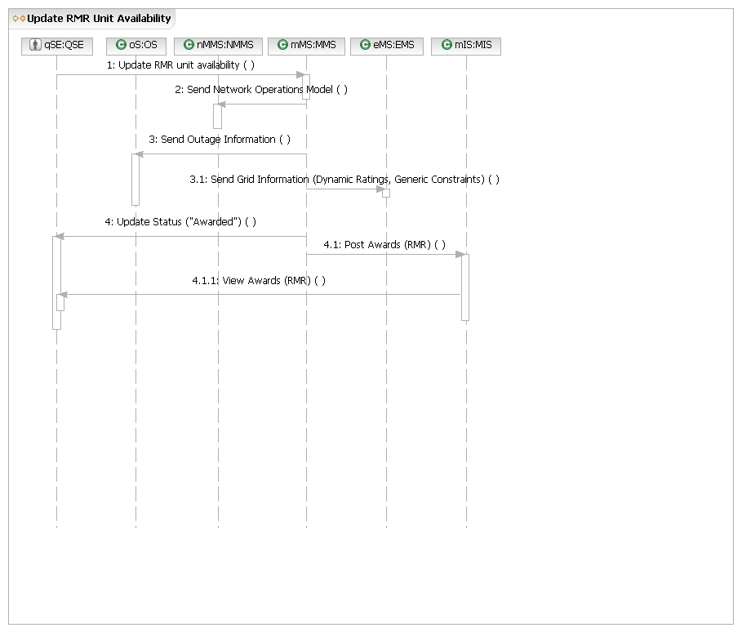
M.UC10 - Manage CRR Auction
Brief description
Manage the CRR Auction Use Case covers activities from the initiation of opening a CRR Auction to publishing the auction results.
Precondition
CRR application is running.
Post Condition
Auction results have been published.
Main Success Scenario
1. Time request Nodal open CRR Auction.
2. Nodal requests CRR Account Holders submit offers and bids.
3. CRR Account Holder submits offers or bids.
4. Time requests Nodal clear CRR auction.
5. Nodal notifies CRR Account Holder of awards.
6. Nodal makes available updated market information.
7. Use case ends.
Alternate Flows
3.a. CRR Account Holder updates credit limit for auction.
1. CRR Account Holder requests Nodal set specific credit limit for auction.
2. Nodal notifies CRR Account Holder of updated credit limit.
3. Return to Main Success Scenario, Step 3.
3.a.2.a. Request to update credit limit invalid.
1. Nodal notifies CRR Account Holder that requested update is invalid.
2. Return to Main Success Scenario, Step 3.
4.a. CRR offer or bid is not valid.
1. Nodal notifies CRR Account Holder that bid or offer is invalid.
2. Use case ends.
M.UC10.BB - Manage CRR Auction
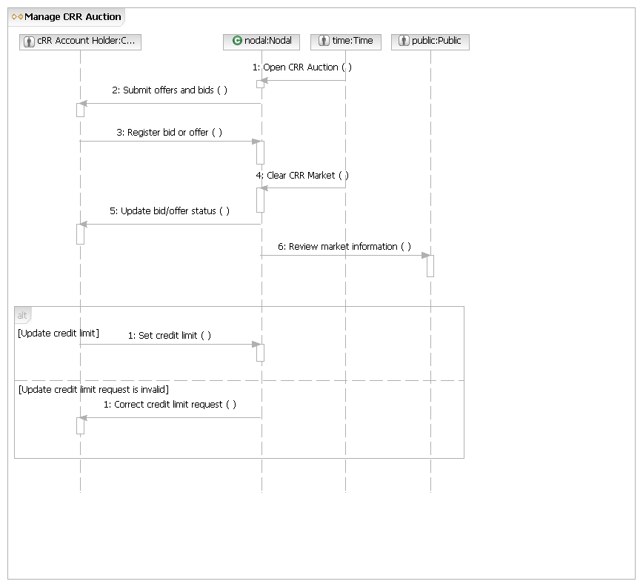
M.COM.OP2 – Reference: Register Offer or Bid
The Register bid and offer operation above uses the Common Operation Register Offer or Bid located at the end of this document.
M.UC10.OP1 - Open CRR Auction

Main Flow
Actor Action | Nodal Action | Step | Subsystem Action | White Box Budgeted Requirements
Time requests Nodal open CRR Auction. | Nodal requests CRR Account Holders submit offers and bids. | 1 | Time requests CRR open CRR Auction.
Time requests Nodal open CRR Auction. | Nodal requests CRR Account Holders submit offers and bids. | 2 | CRR requests NMMS send CRR Network Model.
Time requests Nodal open CRR Auction. | Nodal requests CRR Account Holders submit offers and bids. | 3 | NMMS requests EMS send Dynamic Ratings, Contingencies, Generic and non-thermal constraints
Time requests Nodal open CRR Auction. | Nodal requests CRR Account Holders submit offers and bids. |  | NMMS requests OS send outage information.
Time requests Nodal open CRR Auction. | Nodal requests CRR Account Holders submit offers and bids. |  | NMMS requests CRR use CRR Network Model.
Time requests Nodal open CRR Auction. | Nodal requests CRR Account Holders submit offers and bids. |  | CRR requests CRR Account Holders submit offers and bids.
M.UC10.OP1.WB - Open CRR Auction
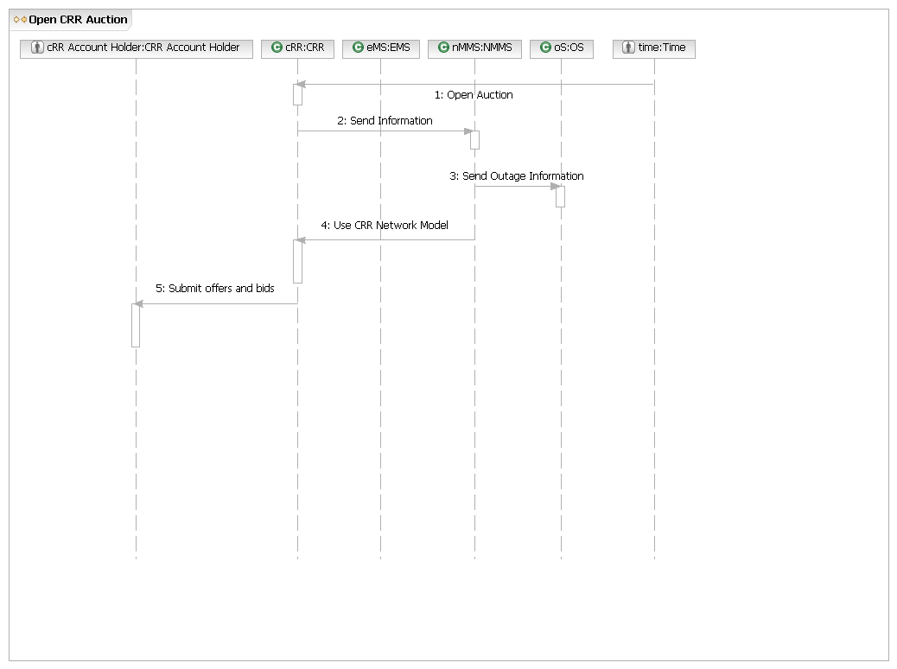
M.UC10.OP2 – Clear CRR Auction

Main Flow
Actor Action | Nodal Action | Step | Subsystem Action | White Box Budgeted Requirements
Time requests Nodal clear CRR Auction. | Nodal clears CRR auction market.  Nodal notifies QSE of awards.  Nodal makes available updated market information. | 1 | Time requests CRR clear CRR Auction.
Time requests Nodal clear CRR Auction. |  | 2 | NMMS requests OS send outage information.CRR requests CM check CRR Account Holder’s available credit.
Time requests Nodal clear CRR Auction. |  | 3 | CRR requests CM report CRR Account Holder’s available credit.CRR notifies CRR Account Holder of awards.
Time requests Nodal clear CRR Auction. |  | 4 | CRR notifies CRR Account Holder of awards.CRR requests MIS post auction awards in MIS Certified area.
Time requests Nodal clear CRR Auction. |  | 5 | CRR requests MIS post auction awards in MIS Certified area.MIS posts auction awards in MIS Certified area.
Time requests Nodal clear CRR Auction. |  | 6 | MIS posts auction awards in MIS Certified area.CRR requests CS, MMS, and CM update CRR Account Holder status.
Time requests Nodal clear CRR Auction. |  | 7 | CRR requests CS, MMS, and CM update CRR Account Holder status.
Time requests Nodal clear CRR Auction. |  | 8
M.UC10.OP2.WB – Clear CRR Auction

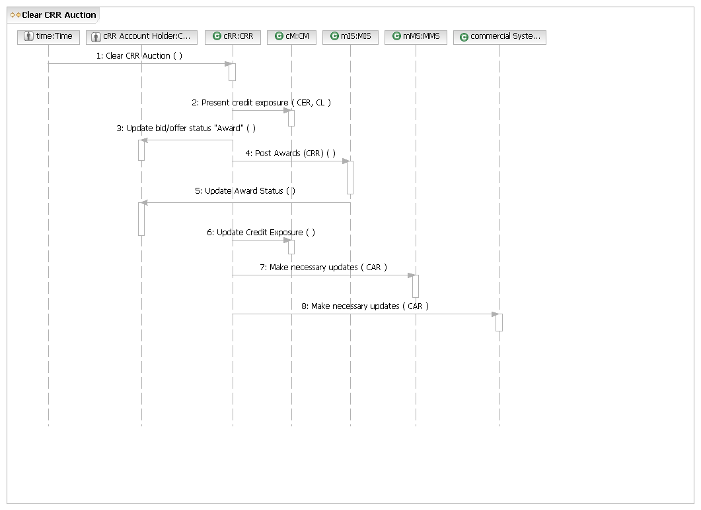
M.UC11 – Clear AS, CRR, and Energy in DAM
Brief description
Clear Energy/AS/CRR in the DAM Use Case covers the activities from the initiation of clearing through validation of the updated COP.
Precondition
QSEs have entered bids/offers in the DAM.
Post Condition
Updated, valid COP is entered in the Nodal system.
Main Success Scenario
1. Time requests Nodal clear DAM.
2. Nodal notifies QSE of awards.
3. Nodal makes available updated market information.
4. QSE updates COP.
5. Nodal checks the updated COP and finds QSEs provide enough AS.
6. Use Case ends.
Alternate flow
2.a. Nodal finds that there are not enough AS offers.
1. Nodal requests QSEs submit additional AS offers.
2. Nodal finds there are sufficient AS offers.
3. Return to Main Success Scenario, Step 2.
2.a.2.a. Nodal finds that there are not sufficient AS offers.
1. Nodal reduces the AS Plan quantities only for the purposes of the DAM by the amount of the insufficiency.
2. Return to Main Success Scenario, Step 2.
2.b. Nodal fails clearing DAM.
1. Nodal notifies QSEs that it is unable to execute DAM.
2. Use case ends.
5.a. QSEs do not provide enough AS in COP.
1. Nodal notifies QSEs of intent to procure additional AS (run SASM).
2. QSE resubmits (edit) AS offers.
3. Nodal clears SASM.
4. Return to Main Success Scenario, Step 2.

5.b. Additional AS is required.
1. Nodal notifies QSEs of intent to procure additional AS (run SASM).
2. QSE resubmits (edit) AS offers.
3. QSE submits additional Self-arranged AS.
4. Nodal clears SASM.
5. Return to Main Success Scenario, Step 2.

M.UC11.BB – Clear AS, CRR, and Energy in DAM

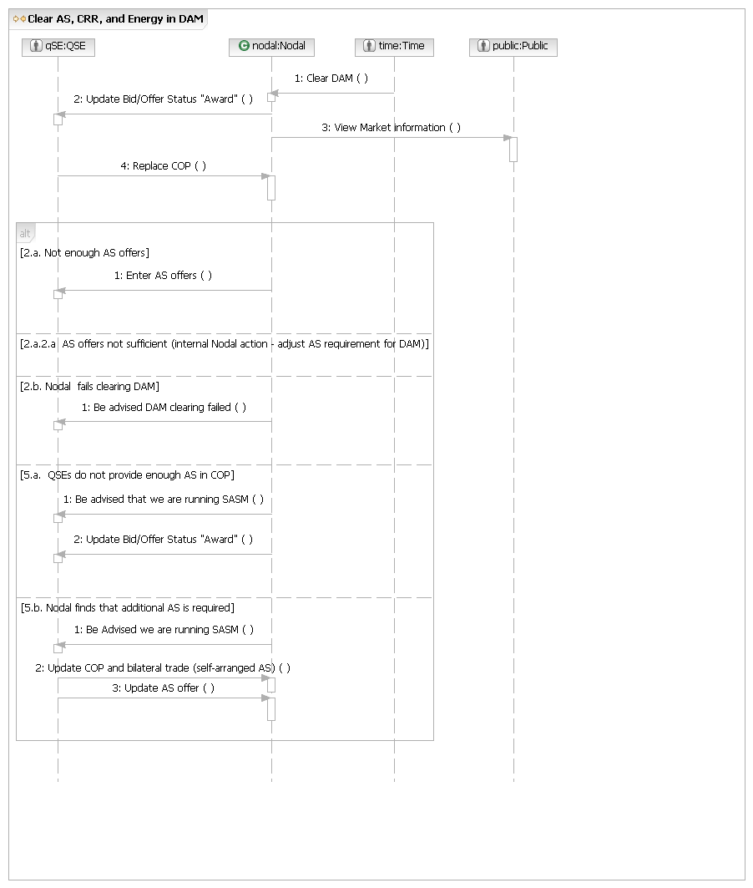

M.UC11.OP1 – Clear DAM

Main Flow
Actor Action | Nodal Action | Step | Subsystem Action | White Box Budgeted Requirements
Time requests Nodal clear DAM. | Nodal notifies QSE of awards.  Nodal makes available updated market information. | 1 | Time requests MMS clear DAM.
Time requests Nodal clear DAM. |  | 2 | MMS gathers information from CM (daily ownership), CRR, EMS, OS, and NMMS.
Time requests Nodal clear DAM. |  | 3 | MMS notifies QSE of awards.
Time requests Nodal clear DAM. |  | 4 | MMS requests MIS display awards in the Certified Area.
Time requests Nodal clear DAM. |  | 5 | MIS displays the awards in the Certified Area.
Time requests Nodal clear DAM. |  | 6 | MMS requests CM and CS update QSE information.

[Market doesn’t Clear]
 | Nodal notifies QSEs that it is unable to execute DAM. | 1 | MMS notifies QSEs that it is unable to execute DAM.

[QSEs not providing enough AS offers]
 | Nodal notifies QSEs to submit additional AS offers. | 1 | MMS notifies QSEs to submit additional AS offers.

[Additional AS needed]
 | Nodal notifies QSEs of intent to procure additional AS. | 1 | MMS notifies QSEs of intent to procure additional AS by running SASM.
M.UC11.OP1.WB – Clear DAM

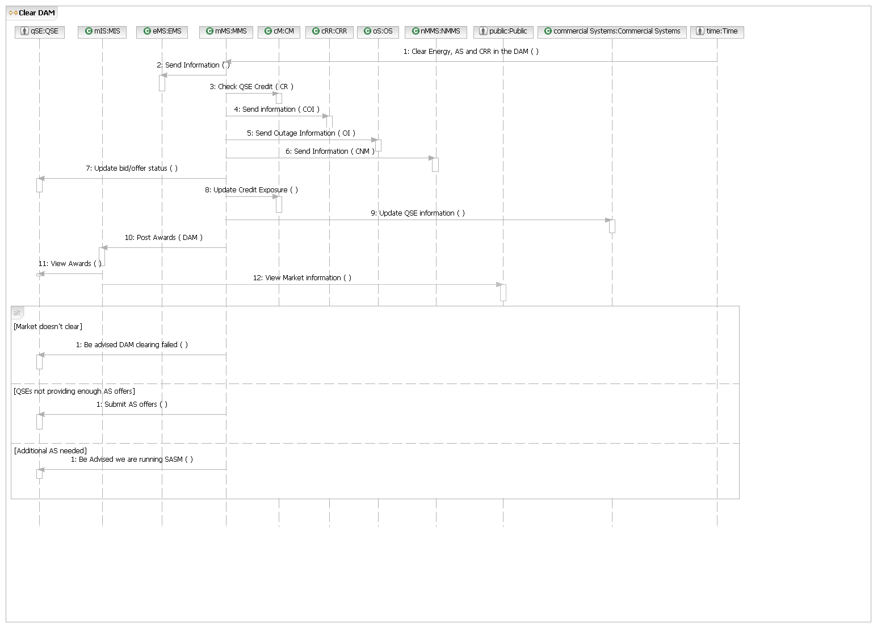
M.UC11.OP2 – Replace COP

Main Flow:
Actor Action | Nodal Action | Step | Subsystem Action | White Box Budgeted Requirements
QSE updates COP. | Nodal notifies QSE that COP is valid,  Nodal checks the updated COP and finds QSEs provide enough A/S. | 1 | QSE sends updated COP to MMS.
QSE updates COP. |  | 2 | MMS gathers information from Registration.
QSE updates COP. |  | 3 | MMS gathers information from OS, NMMS, and EMS to check the updated COP.
QSE updates COP. |  | 4 | MMS notifies QSE that COP is valid.

[COP is invalid]
MMS requests QSE update COP.

[COP doesn’t provide enough AS]
MMS notifies QSEs that SASM will open..
M.UC11.OP2.WB – Replace COP
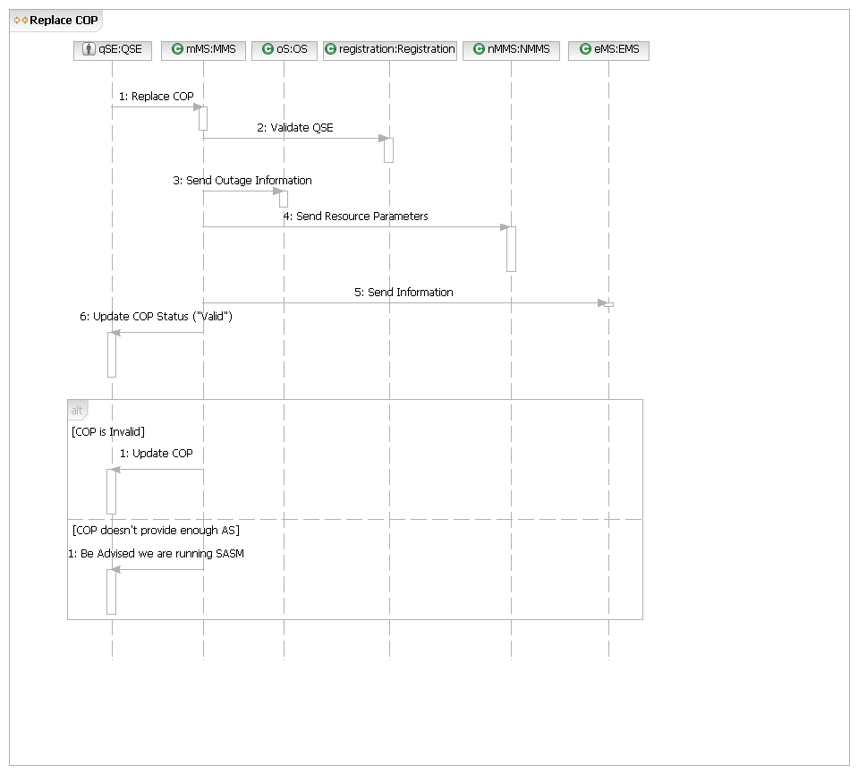
M.UC11.OP3 – Update AS Offer

Main Flow:
Actor Action | Nodal Action | Step | Subsystem Action | White Box Budgeted Requirements
QSE resubmits (edit) A/S offers. | Nodal notifies QSE that updated offer has been received. | 1 | QSE resubmits (edit) A/S offers to MMS.
QSE resubmits (edit) A/S offers. | Nodal notifies QSE that updated offer has been received. | 2 | MMS gathers data from Registration.
QSE resubmits (edit) A/S offers. | Nodal notifies QSE that updated offer has been received. | 3 | MMS notifies QSE of updated offer has been received.
QSE resubmits (edit) A/S offers. | Nodal notifies QSE that updated offer has been received. | 4 | MMS requests MIS post updated offer.
QSE resubmits (edit) A/S offers. | Nodal notifies QSE that updated offer has been received. | 5 | MIS posts updated offer
M.UC11.OP3.WB – Update AS Offer
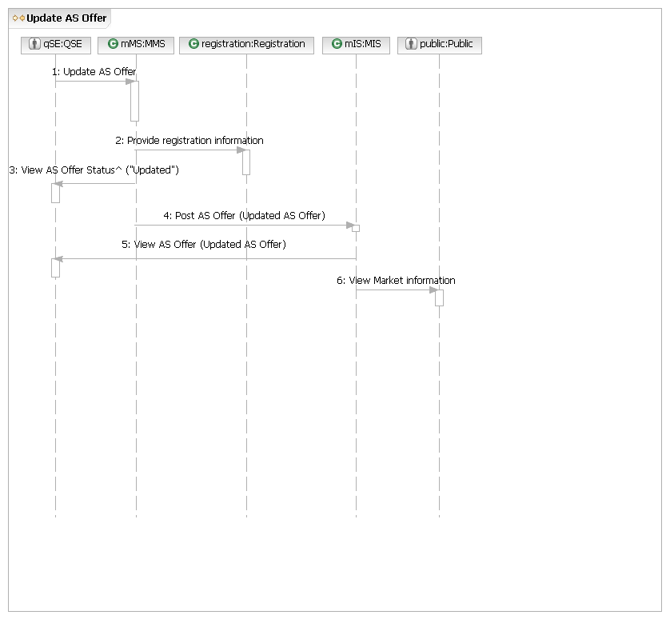

M.UC12 – Clear Energy in Real Time Market
Brief description
Clear Energy on the Real Time Market covers the process from time clearing starts to the publishing the results.
Precondition
Market application is up and running.
Post Condition
Market clearing results have been posted.
Main Success Scenario
1. Time or Power System event request Nodal clear Real Time market.
2. Nodal notifies QSE of awards.
3. Nodal makes available updated market information.
4. Use Case ends.
Alternate Flow
2.b. Nodal fails to clear Real Time Market.
1. Nodal notifies QSEs of the failure to clear Real Time Market.
2. Use case ends.
M.UC12.BB – Clear Energy in Real Time Market
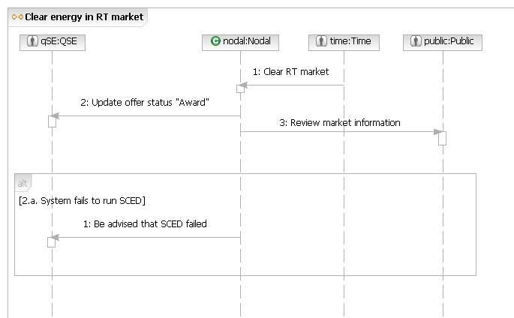

M.UC12.OP1 – Clear Real Time Market

Main Flow
Actor Action | Nodal Action | Step | Subsystem Action | White Box Budgeted Requirements
Time or Power System event request Nodal Clear Real Time Market. | Nodal notifies QSE of awards.  Nodal makes available updated market information. | 1 | Time or Power System event request MMS Clear Real Time Market.
 |  | 2 | MMS gathers information from CM, EMS.
 |  | 3 | MMS notifies QSE of awards.
 |  | 4 | MMS requests MIS post awards in MIS Certified area.
 |  | 5 | MIS posts awards in Certified area and updates market information.
 |  | 6 | MMS requests CM and CS update QSE information.
M.UC12.OP1.WB – Clear Real Time Market
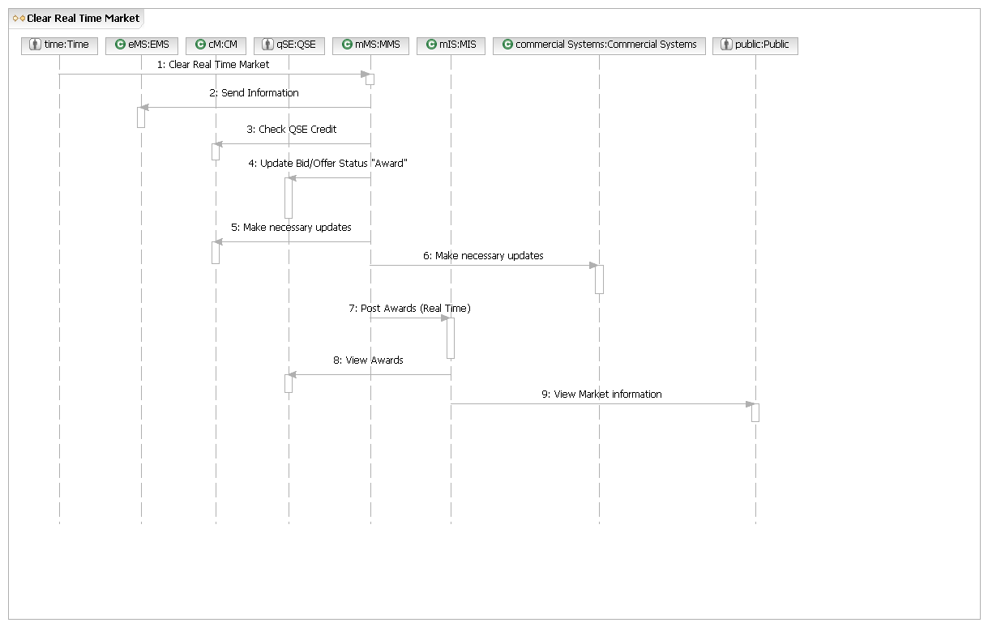
M.UC13 – Manage RUC Process
Brief description
Manage RUC Process Use Case covers the activities from the start of the RUC process to the presenting of the RUC results. The process covers Hourly, Daily, and 8 Day Look Ahead RUC.
Precondition
MMS is running.
Post Condition
RUC results are presented.
Main Success Scenario
1. Time requests Nodal run RUC process.
2. Nodal runs RUC process.
3. Nodal notifies QSE of awards.
4. Nodal makes available updated market information.
5. Use case ends.
Alternate Flows
3.a. RUC doesn’t converge.
1. Notify Market Participants that RUC failed.
2. Use case ends.
M.UC13.BB – Manage RUC Process
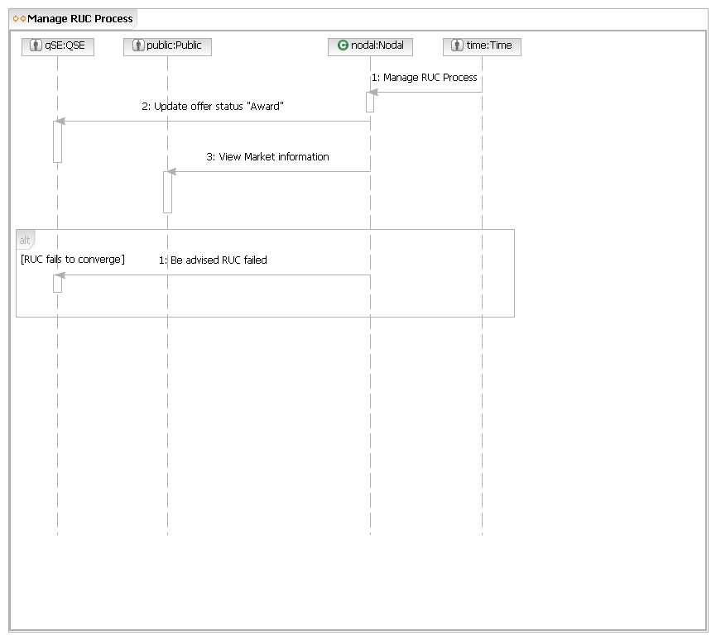
M.UC13.OP1 – Perform RUC Process

Main Flow
Actor Action | Black Box Step | Step | Subsystem Action | White Box Budgeted Requirements
Time requests Nodal run RUC process. | Nodal runs RUC process.  Nodal notifies QSE of awards.  Nodal makes available updated market information. | 1 | Time requests MMS run RUC process..
Time requests Nodal run RUC process. |  | 2 | MMS gathers information from CM, EMS, NMMS, and OS.
Time requests Nodal run RUC process. |  | 3 | MMS notifies QSEs of awards.
Time requests Nodal run RUC process. |  | 4 | MMS requests MIS posts award information.
Time requests Nodal run RUC process. |  | 5 | MIS posts award information.
Time requests Nodal run RUC process. |  | 6 | MMS requests CS and CM update QSE information.

[RUC fails to converge]
 |  | 1 | MMS notifies Market Participants that RUC failed
M.UC13.OP1.WB – Perform RUC Process
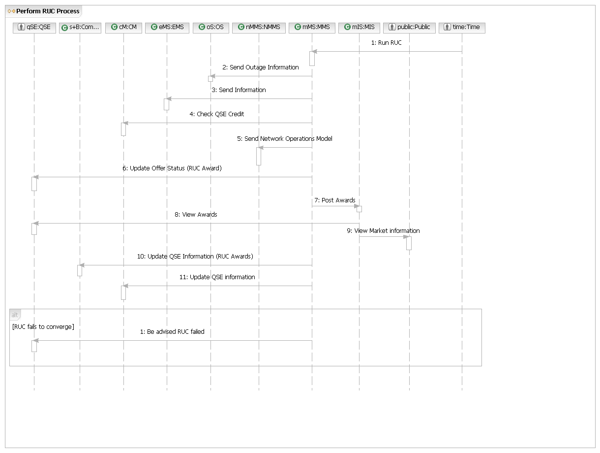
M.UC14 – Check Credit Exposure
Brief Description
Check Credit Exposure Use case covers MP actions from requesting current credit exposure to Nodal present that information to the MP
Preconditions
None.
Post Condition:
Nodal has presented MP with credit exposure information
Main Success Flow
1. MP requests current credit exposure
2. Nodal presents current credit exposure
3. Use case ends.
Alternative Flows
None.
M.UC14.BB – Check Credit Exposure
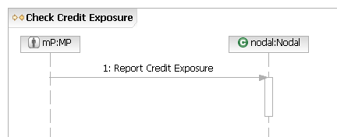
M.UC14.OP1 – Report Credit Exposure

Main Flow
Actor Action | Nodal Action | Step | Subsystem Action | White Box Budgeted Requirements
MP requests current credit exposure. | Nodal presents current credit exposure. | 1 | MP requests CM report credit exposure.
MP requests current credit exposure. | Nodal presents current credit exposure. | 2 | CM presents MP with credit exposure information.

[MP requests credit exposure report from system]
 |  | 1 | MP requests credit exposure report from MIS.
 |  | 2 | MIS presents credit exposure report to MP.

[MP requests credit exposure from MMS or CRR]
 |  | 1 | MP requests credit exposure report from MMS or CRR.
 |  | 2 | MMS or CR requests MP credit exposure from CM.
 |  | 3 | CM presents MMS or CRR with MP’s credit exposure.
 |  | 4 | MMS or CRR presents credit exposure to MP.
M.UC14.OP1.WB – Report Credit Exposure
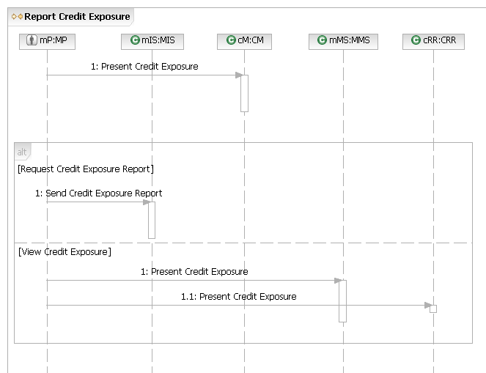
Common Operations
M.COM.OP1 – Provide Transaction Details

Main Flow
Actor Action | Nodal Action | Step | Subsystem Action | White Box Budgeted Requirements
MP submits unique ID for a transaction. | Nodal displays details for selected transaction. | 1 | MP submits unique ID for a transaction to MMS or CRR.
MP submits unique ID for a transaction. | Nodal displays details for selected transaction. | 2 | MMS or CRR displays details for selected transaction.

[Transaction ID # invalid]
 | Nodal requests unique ID # be corrected. |  | MMS or CRR request unique ID # be corrected.

M.COM.OP1.WB – Provide Transaction Details
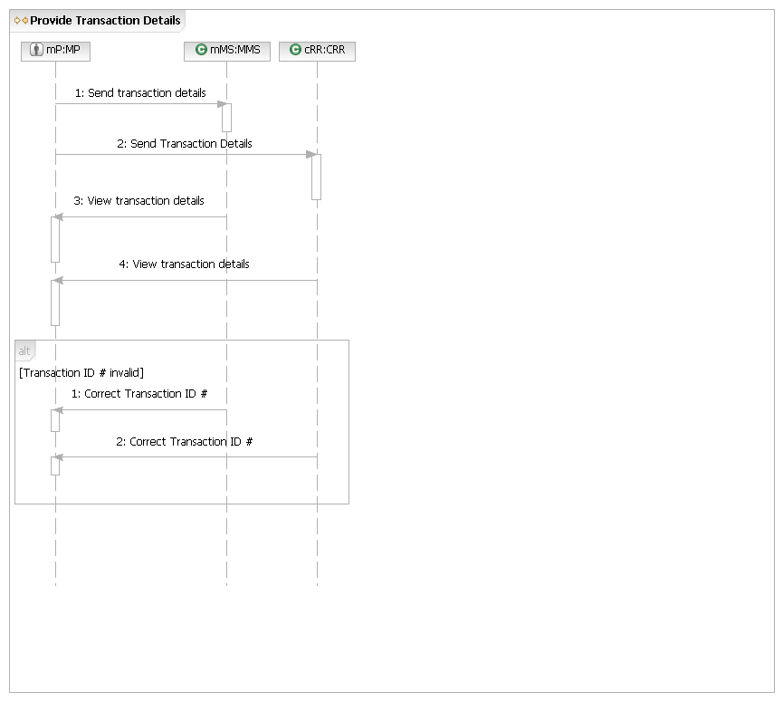
M.COM.OP2 - Register Offer or Bid

Main Flow:
Actor Action | Nodal Action | Step | Subsystem Action | White Box Budgeted Requirements
Actor requests the Nodal register a bid or | Nodal notifies QSE that bids/offers are received and validated | 1 | Actor requests the MMS or CRR register a bid or offer.
Actor requests the Nodal register a bid or |  | 2 | MMS or CRR checks with Registration to ensure the submitter is eligible to make the submission
Actor requests the Nodal register a bid or |  | 3 | MMS or CRR notify QSE that bid/offer/request is registered
Actor requests the Nodal register a bid or |  | 4 | MMS or CRR requests MIS post bids/offers in MIS Certified area
Actor requests the Nodal register a bid or |  |  | MIS posts bids/offers in Certified area

[Bid/offer invalid]
 | Nodal requests unique ID # be corrected. |  | MMS or CRR request unique ID # be corrected.
M.COM.OP2.WB - Register Bid or Offer
