Commercial Systems
Eligibility Process for Settlements
Requirements

Version 0.09

.
Revision History
Date | Version | Description | Author
10/02/2006 | 0.01 | Initial Draft | Mandy Bauld
10/04/2006 | 0.02 | Incorporated Revisions from IDA and Commercial Systems | Mandy Bauld
10/09/2006 | 0.03 | Clean-up Edits | Mandy Bauld
10/11/2006 | 0.04 | IDA comments, ties to examples, added Forced Outage rules | Mandy Bauld
10/13/2006 | 0.06 | Going back to “Startup Initiator” logic on DAM commitments (v 0.05 is reserved for the other version of the document that assumes DAM is always a startup initiator.) | Mandy Bauld
10/16/2006 | 0.07 | More changes after discussions with Kenneth and Keely (FO, RUC Designated Start Hour, associated examples) | Mandy Bauld
10/16/2006 | 0.09 | Version for TPTF review | Mandy Bauld

Table of Contents
1. Eligibility Process for Settlements 5
1.1 Proposed System Scope 5
1.2 Document Conventions 6
1.3 Document Assumptions 6
1.4 Definitions 6
2. Functional Requirements 8
2.1 Background 8
2.2 Proposed Changes to Nodal Protocols through an NPRR 9
2.3 Changes to Approved Commercial Systems Requirements 9
2.4 Eligibility Process 10
Determine Startup Initiator 12
Determine Startup Eligibility 20
Determine Start Type 25
Determine Energy Eligibility 29
Forced Outage Considerations 30
Input Bill Determinants 33
Intermediate Bill Determinants 34
Output Bill Determinants 34
Data Dependencies 35
Assumptions 37
Business Defined Errors 38
Specific Database Needs 38
3. Supplementary Requirements 39
3.1 Performance Requirements 39
3.2 Legal and Regulatory requirements 39
3.3 System Security Requirements 39
3.4 Back up and Recovery Requirements 39
3.5 Availability and Redundancy Requirements 39
3.6 Maintainability Requirements 39
3.7 Daylight Savings Time shall be recognized in Nodal Market settlements. 39
4. Protocol Coverage 40
5. Appendix – Example Eligibility Scenarios 41
Example 1 41
Example 2 42
Example 3 43
Example 4 44
Example 5 45
Example 6 46
Example 7 47
Example 8 48
Example 9 49
Example 10 50
Example 11 51
Example 12 52
Example 13 53
Example 14 54
Example 15 55
Example 16 56

Software Requirements Specification

Eligibility Process for Settlements

Proposed System Scope
ERCOT plans to implement a new Nodal market in 2009. Sections 2, 4, and 5 of the Nodal Protocols describe the eligibility requirements for the Day-Ahead Market (DAM) and Real-Time Operations (RT) settlements. The Nodal Protocols will guide this project.

The requirements in scope for this document are based upon the following:

- Nodal Protocols Section 2 (NPRR 013 approved by BOD on 09/19/2006)
- Nodal Protocols Section 4 (NPRR 006 approved by BOD on 07/18/2006)
- Nodal Protocols Section 5 (NPRR 003 approved by BOD on 09/19/2006)

This document defines the requirements for the Eligibility Process. The main function of the Eligibility Process is to determine eligibility for the Day-Ahead Make-Whole Payment (startup and energy), eligibility for the RUC Guarantee (startup), eligibility for the RMR Energy Payment (startup), and eligibility for RUC Decommitment Payment. The process also determines the type of start that occurred for a DAM commitment, RUC commitment, or RUC decommitment and determines QSE Clawback intervals for purposes of RUC settlement. The startup Eligibility Process should provide the following outputs to the settlements process:

Settlements for DAM Statement
- Day Ahead Make-Whole startup eligibility via the SUFLAG data element
- Day-Ahead Make-Whole energy eligibility via the DAMWENEFLAG data element
- Start Type via the STARTTYPE data element

Settlements for RTM Statement
- RUC startup eligibility via the SUFLAG data element
- RUC decommitment eligibility via the SUFLAG data element
- RMR Energy Payment eligibility via the SUFLAG data element
- Start Type via the STARTTYPE data element
- QSE Clawback Interval via the QCLAW data element

Document Conventions
- All text lifted from the Nodal Protocols is in italic font.
- All dependencies are identified using D1, D2, etc.
- All assumptions are identified using A1, A2, etc.
- The original source system is defined for each input bill determinant. It is important to note that the format defined for the input bill determinant is the format for which the data should exist in the Settlement System, after any interface functionality. The bill determinant may or may not exist in the original source system in the format defined for the bill determinant. A separate set of business requirements will address data transformations and interfacing between the original source system and the Settlement System.

Document Assumptions
- Any bill determinant calculation process that requires historical data will obtain this information via alternative means during the beginning of market open until the data is available.
- The bill determinant calculations are documented using the proposed recorder format. The following list defines the nomenclature used for the recorders (not all of these bill determinant recorder elements may apply to the charge types within this document):

<Q> = QSE
<CO> = CRR Owner
<R> = Resource
<SP> = Settlement Point
<BLTP> = Block Load Transfer Point
<SRSP> = Source Settlement Point
<SKSP> = Sink Settlement Point
<ST> = Start Type
<F> = Flowgate
<E> = Directional Network Element
<C> = Constraint Identifier
<M> = Market
<RUC> = RUC Process

Definitions
Protocol-defined terms (Section 2) relevant to the Eligibility Process requirements:
- Adjustment Period - For each Operating Hour, the time between 1800 in the Day-Ahead up to the start of the hour before that Operating Hour.

- DAM-Committed Interval - A Settlement Interval for which the Resource has been committed due to a Day-Ahead Market award.

- QSE Clawback Interval – Any QSE-Committed Interval that is part of a contiguous block that includes at least one RUC-Committed Hour unless it is:
(1) QSE-committed before the first RUC instruction for any RUC-Committed Hour in that contiguous block; or
(2) Part of a contiguous block of a QSE-Committed Intervals, at least one of which was committed by the QSE before the RUC instruction described in paragraph (1) above

- QSE-Committed Interval - A Settlement Interval for which the QSE for a Resource has committed the Resource without a RUC instruction to commit it

- RUC-Committed Hour - An Operating Hour for which a RUC has committed a Resource to be On-Line

Terms defined within this document, specifically for use within the Eligibility Process requirements:
- Earliest Issued Commitment –In a series of contiguous commitment periods (DAM, RUC, or QSE Self-Committed) the commitment that was issued at the earliest point in time. If multiple commitments within a set of contiguous commitments were issued at the same point in time, of those commitments, the Earliest Issued Commitment is the commitment that applies to the earliest block of Operating Hours.

- Eligibility Process – The process by which the Settlement System: determines eligibility for the Day-Ahead Make-Whole Payment (startup and energy compensation); determines eligibility for the RUC Guarantee (startup compensation); determines eligibility for the RUC Decommitment Payment; determines the type of start that occurred for a DAM commitment, RUC commitment, or RUC decommitment; and identifies QSE Clawback intervals for purposes of RUC settlement.

- QSE self-commitments – Intervals where the Resource’s COP indicates that the Resource is synchronized to the ERCOT system with a status other than “ONRUC” and there is no associated DAM commitment (i.e., the QSE chooses to run the Resource; it is not committed by DAM or RUC.)

- Startup Initiator – The commitment (DAM commitment, RUC commitment, RUC decommitment, or QSE self-commitment) that is deemed responsible for bringing the Resource online (synchronized to the ERCOT system), for purposes of Day-Ahead Market and Real-Time Operations settlements.

- Startup Flag (SUFLAG) –The hourly flag that indicates whether or not a Resource is eligible for startup compensation in a DAM commitment, RUC commitment, or RUC decommitment.

  - 0 = Resource is not eligible for startup compensation
  - 1 = Resource is eligible for startup in the DAM commitment
  - 2 = Resource is eligible for startup in the RUC commitment
  - 3 = Resource is eligible for startup in the RUC decommitment

- Start Type (STARTTYPE) – The hourly flag that indicates the type of start (hot, intermediate, or cold) that a Resource incurred with a startup.

  - 0 = No startup
  - 1 = Hot startup
  - 2 = Intermediate startup
  - 3 = Cold startup

- QSE Clawback Interval (QCLAW) - The 15-minute flag that indicates for the Resource whether or not the settlement interval is a QSE Clawback Interval.

  - 1 = QSE Clawback Interval
  - 0 = Not a QSE Clawback Interval

- Day-Ahead make Whole Energy Flag (DAMWENEFLAG) – The hourly flag that indicates Day-Ahead Make-Whole Payment energy eligibility for the Resource represented by the QSE, for the hour.

  - 0 = Resource is not eligible for energy costs in the Day-Ahead Make-Whole payment
  - 1 = Resource is eligible for energy costs in the Day-Ahead Make-Whole payment,

Functional Requirements

Background
The Eligibility Process is a supplementary settlement process that is essential to both the DAM and RTM settlements. The Eligibility Process determines the following:
    - Should the cost of the startup be assigned to a DAM commitment, a RUC commitment, or a RUC decommitment?
    - Did the Resource actually startup for the commitment?
    - If there was a startup, which type of startup occurred (hot, intermediate, or cold)?
    - Which intervals are QSE Clawback intervals, for use in the RUC make whole calculations?
    - Which intervals are eligible for energy compensation in the DAM make whole calculations?

The Eligibility Process considers all commitments (DAM, RUC, RUC decommitment, or QSE self-commitments) for a QSE, Resource, and Operating Day, as well as the Resource’s actual performance (breaker status) to make these determinations.

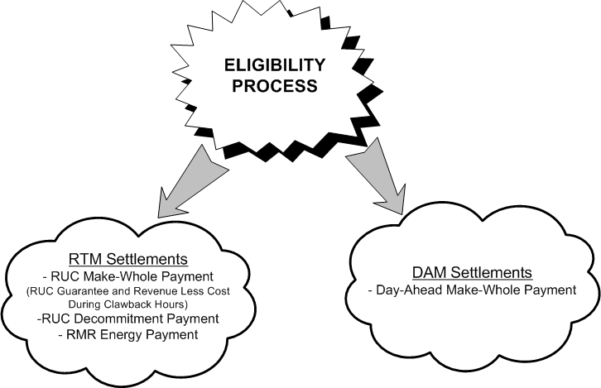

Example scenarios are included in the Appendix of this document. It is highly recommended that the reader review and understand the examples before working through the requirements, or consider the examples in parallel with the logic laid out by the requirements.

Proposed Changes to Nodal Protocols through an NPRR

1) Protocol section 4.6.2.3 should be revised to indicate eligibility criteria for energy compensation through the Day-Ahead Make-Whole Payment.
2) Protocol section 4.6.2.3 should be revised to indicate that startup eligibility criteria should consider QSE-commitments prior to the DAM (similar to RUC consideration of QSE-commitments).
3) Protocol section 5.6.3 (2) should include language to indicate that the QSE is required to submit a dispute in order to include the Resource’s verifiable actual costs in the Resource’s RUC Guarantee in the event that the that there is no breaker closure in an attempt to startup for a RUC commitment.
4) Protocol section 5.7.3 (2) should be modified to read “QSE-committed” instead of “QSE self-committed.”

Changes to Approved Commercial Systems Requirements
If these requirements are approved, modifications to other approved requirements are necessary.
- SUFLAG as documented within these requirements was documented as DAMWSUFFLAG in TNS.COMS.63C01.DAMAKEWHOLE.REQUIREMENTS.A
- SUFLAG as documented within these requirements was documented as RUCSUFLAG in TN.COMS.63C01.RUC.REQUIREMENTS.A.
- SUFLAG as documented within these requirements was documented as RMRSUFLAG in TN.COMS.63C01.RTRMR.REQUIREMENTS.A.

Eligibility Process

High-level process flow:
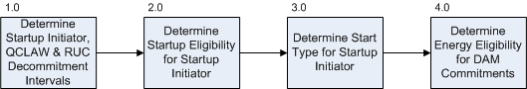

High-level data flow:
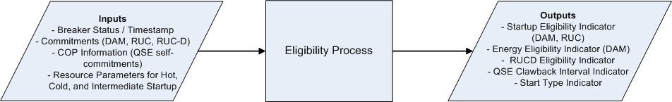

Requirement ID | FR 1
Source Mapping (Protocol/NERC/FERC and other binding documents Ref #) | PR 4.6.2.3, PR 5.6.2, PR 5.6.3, PR 5.7.3, PR 2 (QSE Clawback Interval Definition)
Traceability to Sub-Process Maps | CSWM.P03SettleBillTransfer
Description:
The Eligibility Process should run after the end of the Operating Day to ensure that all potential RUC processes have been executed for the Operating Day and that the breaker status data is available for all Operating Hours within that Operating Day.

Requirement ID | FR 2
Source Mapping (Protocol/NERC/FERC and other binding documents Ref #) | PR 4.6.2.3, PR 5.6.2, PR 5.6.3, PR 5.7.3, PR 2 (QSE Clawback Interval Definition)
Traceability to Sub-Process Maps | CSWM.P03SettleBillTransfer
Description:
The process should be run before any settlement process (i.e. before any DAM Settlement or DAM Resettlement, as well as before any RTM Initial Settlement, RTM Final Settlement, RTM True-Up Settlement, or RTM Resettlement.)

Requirement ID | FR 3
Source Mapping (Protocol/NERC/FERC and other binding documents Ref #) | PR 4.6.2.3, PR 5.6.2, PR 5.6.3, PR 5.7.3, PR 2 (QSE Clawback Interval Definition)
Traceability to Sub-Process Maps | CSWM.P03SettleBillTransfer
Description:
It is not anticipated that the results of the Eligibility Process should change between DAM and RTM settlement runs for the Operating Day. If the results are different it may be indication of a problem or a potential need for resettlement. Therefore, the system should identify any difference between the DAM and RTM eligibility results. The eligibility results for any RTM settlement run (Intial, Final, True-Up, or Resettlement) should be compared with the latest available DAM settlement data. If a DAM Resettlement occurs after an RTM settlement run, the results should be compare to those of the latest RTM settlement run. The system should log a WARN error message stating the QSE, Resource, Operating Hours, Operating Days, and data elements with inconsistent values.

Determine Startup Initiator
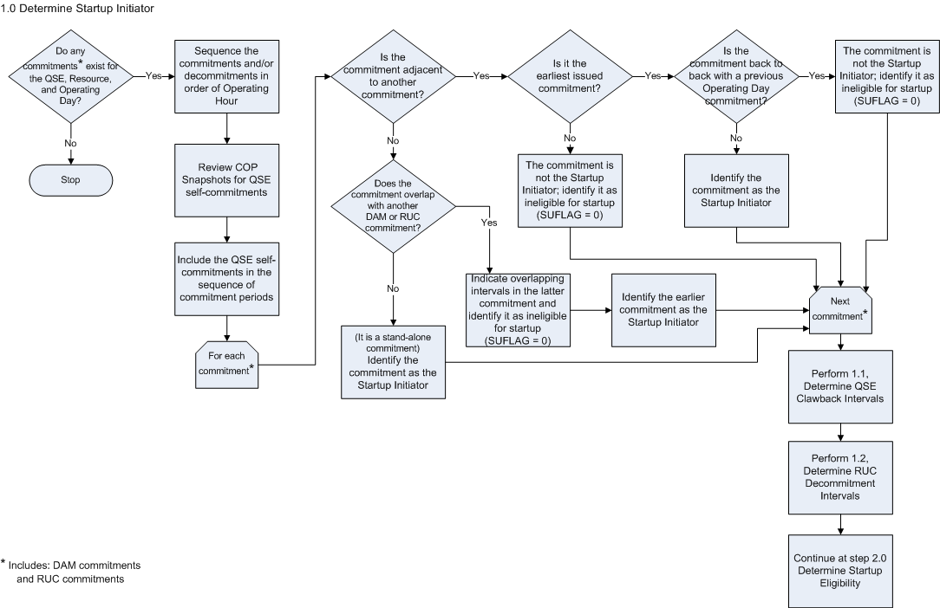

Requirement ID | FR 4
Source Mapping (Protocol/NERC/FERC and other binding documents Ref #) | PR 4.6.2.3 (1), PR 5.6.2 (1), PR 5.6.2 (2)
Traceability to Sub-Process Maps | CSWM.P03SettleBillTransfer
Description:
The driver for the Eligibility Process is the existence of a DAM commitment or a RUC commitment for a QSE, Resource, and Operating Day. Begin the Eligibility Process for any combination of QSE, Resource, and Operating Day with one of the listed commitments.
If one of the drivers exists, obtain and consider all commitment periods for that QSE, Resource, and Operating Day:
- DAM commitments (identified by DAMCOMMITFLAG) and the time at which the commitment was issued
- RUC commitments (identified by RUC) and the time at which the commitment was issued (i.e. the RUC process)
- QSE Self-Commitments (identified in a COP snapshot with a status of synchronized to ERCOT system, but not DAM-committed or RUC-committed) and the COP snapshot time.
Sequence all of the Resource’s DAM commitments and RUC commitments by Operating Hour.
Review the COP snapshots to identify any QSE self-commitments (the Resource shows as online without a related RUC or DAM commitment) and include any QSE self-commitments in the sequence of commitments for the QSE, Resource, and Operating Day.

Requirement ID | FR 5
Source Mapping (Protocol/NERC/FERC and other binding documents Ref #) | PR 4.6.2.3 (1), PR 5.6.2 (1), PR 5.6.2 (2)
Traceability to Sub-Process Maps | CSWM.P03SettleBillTransfer
Description:
Determine if there are any adjacent commitment periods within the Operating Day. For any set of contiguous (adjacent) commitment periods in the Operating Day, identify the Earliest Issued Commitment. The Earliest Issued Commitment should be identified as the Startup Initiator, with one exception. See the following requirement (FR 6) for details around the exception to this rule.
This check should be performed for all sets of adjacent commitment periods. It is possible to have more than one startup initiator for a given QSE, Resource, and Operating Day.

Requirement ID | FR 6
Source Mapping (Protocol/NERC/FERC and other binding documents Ref #) | PR 4.6.2.3 (1), PR 5.6.2 (1), PR 5.6.2 (2)
Traceability to Sub-Process Maps | CSWM.P03SettleBillTransfer
Description:
If the commitment begins at HE0100 and a previous Operating Day commitment exists and ends at HE2400 the current Operating Day commitment should not be identified as the Startup Initiator. This ensures that the Resource will not receive two startup payments (one in the previous Operating Day and one in the current Operating Day) for the same set of contiguous committed intervals. It is important to note that, unlike the situation when there is no crossover into a previous Operating Day, when a contiguous block includes commitments from the previous Operating Day the process will not consider the timing under which the previous Operating Day commitment was issued. (For examples, see Example 9, Example 11, and Example 12 in the Appendix.)

Requirement ID | FR 7
Source Mapping (Protocol/NERC/FERC and other binding documents Ref #) | PR 4.6.2.3 (1), PR 5.6.2 (1), PR 5.6.2 (2)
Traceability to Sub-Process Maps | CSWM.P03SettleBillTransfer
If more than one commitment within a contiguous block of commitments qualifies as the Earliest Issued Commitment based upon timestamp/snapshot (i.e. more than one commitment was issued by the same DAM or RUC process or captured in the same COP snapshot), and the Resource does not go offline between the commitments, identify the commitment representing the earliest block of Operating Hours as the Startup Initiator. (For example, see Example 16 in the Appendix.)

Requirement ID | FR 8
Source Mapping (Protocol/NERC/FERC and other binding documents Ref #) | PR 4.6.2.3 (1), PR 5.6.2 (1), PR 5.6.2 (2)
Traceability to Sub-Process Maps | CSWM.P03SettleBillTransfer
Description:
If there are any overlapping DAM or RUC commitments (i.e. multiple commitments all of which include at least one of the same Operating Hours), the process should not allow the overlapping intervals to be eligible for energy.
In this situation, the overlapping intervals should “belong” to the earlier issued commitment and therefore should be settled with the earlier issued commitment. To achieve this, the commitment flag data cut (DAMCOMMIT or RUC) associated with the latter issued commitment should be modified in the overlapping intervals. The overlapping intervals in the latter issued commitment should be changed from a value of one (1), which indicates that the commitment exists in the interval, to a value of two (2), which indicates that it is not a valid commitment in that interval and thus will prevent potential duplicate payment in those intervals. The RUC = 2 setting will communicate that an overlap situation occurred.
For example, the following commitments were issued to a Resource for the same Operating Hours HE0900 – HE 2000:
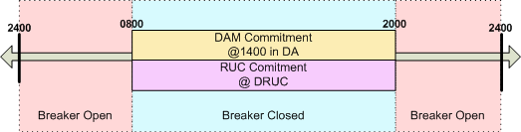

 |  | 0800 | 0900 | 1000 | 1100 | 1200 | 1300 | 1400 | 1500 | 1600 | 1700 | 1800 | 1900 | 2000 | 2100
DAMCOMMIT | … | 0 | 1 | 1 | 1 | 1 | 1 | 1 | 1 | 1 | 1 | 1 | 1 | 1 | 0 | …
RUC (original) | … | 0 | 1 | 1 | 1 | 1 | 1 | 1 | 1 | 1 | 1 | 1 | 1 | 1 | 0 | …
RUC (modified) | … | 0 | 2 | 2 | 2 | 2 | 2 | 2 | 2 | 2 | 2 | 2 | 2 | 2 | 0 | …

Modification of the RUC value serves to communicate the overlap event and to prevent the Resource from being overpaid for energy.
The overlapping interval logic included in this requirement specifically excludes any commitment period overlap that is the result of a RUC decommitment.
(For additional example, see Example 15 in the Appendix.)
(Note: it is anticipated that an overlap most likely has the potential to occur between DAM and DRUC commitments, in the situation that the QSE has not updated their COP for DAM awards prior to DRUC. While potentially unlikely, the rules for handling an overlap of commitments have been established and included in order to anticipate the Settlement System need to handle this scenario.)

Requirement ID | FR 9
Source Mapping (Protocol/NERC/FERC and other binding documents Ref #) | PR 4.6.2.3 (1), PR 5.6.2 (1), PR 5.6.2 (2)
Traceability to Sub-Process Maps | CSWM.P03SettleBillTransfer
Description:
Identify any stand-alone commitment period as the Startup Initiator. (For example, see Example 3 in the Appendix.)

Requirement ID | FR 10
Source Mapping (Protocol/NERC/FERC and other binding documents Ref #) | PR 4.6.2.3 (1), PR 5.6.2 (1), PR 5.6.2 (2)
Traceability to Sub-Process Maps | CSWM.P03SettleBillTransfer
Description:
For any commitment period not identified as a Startup Initiator, set the startup flag (SUFLAG) to zero (0) for the commitment period, to indicate no startup.

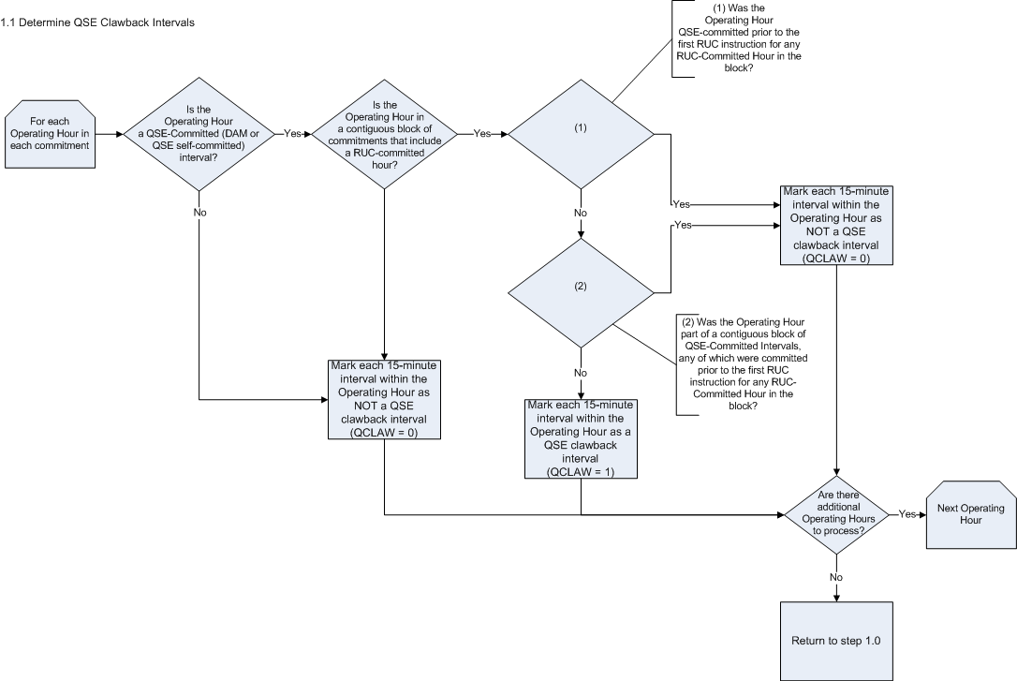

Requirement ID | FR 11
Source Mapping (Protocol/NERC/FERC and other binding documents Ref #) | Section 2 (Definition of QSE Clawback Interval)
Traceability to Sub-Process Maps | CSWM.P03SettleBillTransfer
Description:
For each Operating Hour in a commitment period, determine if the Operating Hour is a QSE clawback interval. Per the Protocol definition of a QSE Clawback Interval in Section 2:
Any QSE-Committed Interval that is part of a contiguous block that includes at least one RUC-Committed Hour unless it is:
(1) QSE-committed before the first RUC instruction for any RUC-Committed Hour in that contiguous block; or
(2) Part of a contiguous block of a QSE-Committed Intervals, at least one of which was committed by the QSE before the RUC instruction described in paragraph (1) above
If the Operating Hour is a QSE-committed interval:
- If the QSE-committed interval is connected to a RUC-committed interval, the QSE-committed interval in question was committed after the RUC instruction, and there are no other QSE-commitments connecting to the current QSE commitment,, set QCLAW = 1 in each 15-minute interval of the QSE-committed Operating Hour. (For example, see Example 7 in the Appendix.)
- If the QSE-committed interval is connected to a RUC committed interval, the QSE-committed interval in question was committed after the RUC instruction, there are other QSE commitments connected to the current QSE commitment, (including any portion of the contiguous block that exists in the previous Operating Day) none of which were committed prior to the RUC instruction, set QCLAW = 1 in each 15-minute interval of the QSE-committed Operating Hours. (For example, see Example 6 in the Appendix.)
- If the QSE-committed interval is connected to a RUC committed interval, the QSE-committed interval in question was committed after the RUC instruction, there are other QSE commitments connected to the current QSE commitment (including any portion of the contiguous block that exists in the previous Operating Day), at least one of which was committed before to the RUC instruction, set QCLAW = 0 in each 15-minute interval of the QSE-committed Operating Hours. (For example, see Example 5 in the Appendix.)
- If the QSE-committed interval is not connected to a RUC commitment, set QCLAW = 0 for each 15-minute interval in the QSE-committed Operating Hour.
- If the QSE-committed interval is not part of a contiguous block of any commitments (i.e. it is a stand-alone commitment) set QCLAW = 0 for each 15-minute interval in the QSE-committed Operating Hour. (For example, see Example 3 in the Appendix.)
- If the Operating Hour is not a QSE-committed interval set QCLAW = 0 for each 15-minute interval in the QSE-committed Operating Hour. (For example, see Example 3 in the Appendix.)
The bill determinant will be structured as follows: QCLAW_<Q>_<R>_<SP>

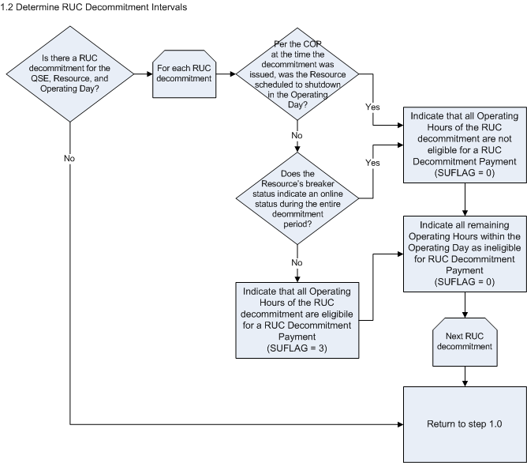
Requirement ID | FR 12
Source Mapping (Protocol/NERC/FERC and other binding documents Ref #) | PR 5.7.3 (2)
Traceability to Sub-Process Maps | CSWM.P03SettleBillTransfer
Description:
For a Resource with a RUC decommitment, identify the Operating Hours that are eligible for the RUC Decommitment Payment. The Startup Flag (SUFLAG) will be used to identify the eligible Operating Hours. If the SUFLAG = 3 for a given interval, that interval is eligible for startup payment through the RUC Decommitment Payment.
The Resource is eligible for a RUC Decommitment Payment under the following conditions identified in PR 5.7.3 (2):
If ERCOT decommits a QSE-committed Resource that is not scheduled to shutdown within the Operating Day, then ERCOT shall pay the affected QSE an amount as calculated below for the hours of decommitment. The hours used in the calculation are the hours beginning with the first decommitted hour until the later of:
(a) The hour ERCOT determines that the Resource may again be at LSL; and
(b) The end of the last hour of the Operating Day.
“The hour ERCOT determines that the Resource may again be at LSL” has been interpreted to mean the first Operating Hour after the end of the RUC decommitment. For instance, if the RUC decommitment was issued for HE1500 – HE1900, “The hour ERCOT determines that the Resource may again be at LSL” would be HE2000.
The Resource is not eligible for a RUC Decommitment Payment under the following condition in PR 5.7.3 (1):
If ERCOT decommits a QSE-committed Resource during the RUC process earlier than its scheduled shutdown within the Operating Day, then no compensation is due to the affected QSE from ERCOT.
Determine if the Resource was scheduled to shutdown within the Operating Day by using the Resource Status from the snapshot of the Resource’s COP at the time of the RUC Decommitment instruction. If any of the Operating Hours on or after the start of the RUC decommitment are not associated with an online status, the Resource was scheduled to shutdown within the Operating Day. In this situation, indicate that the RUC decommitment is ineligibile for the RUC Decommitment Payment be setting the SUFLAG = 0 for all Operating Hours within the decommitment. (For example, see Example 13 in the Appendix.)
If the Resource was not scheduled to shutdown within the Operating Day it is eligible for a RUC Decommitment Payment. Indicate that all Operating Hours within the RUC decommitment period are eligible for the RUC Decommitment Payment by setting the SUFLAG = 3. (For example, see Example 14 in the Appendix.)
If the Resource is eligible for the RUC Decommitment Payment but did not follow the RUC decommitment instruction (i.e. it did not actually incur a startup) it should not be eligible for a RUC decommitment startup. Therefore, if the breaker status for the Resource indicates that the Resource was online during the entire RUC decommitment, set the SUFLAG =0 for all Operating Hours of the RUC decommitment.
Set the SUFLAG = 0 for all Operating Hours not affected by a RUC decommitment.
The bill determinant will be structured as follows: SUFLAG_<Q>_<R>_<SP>

Determine Startup Eligibility

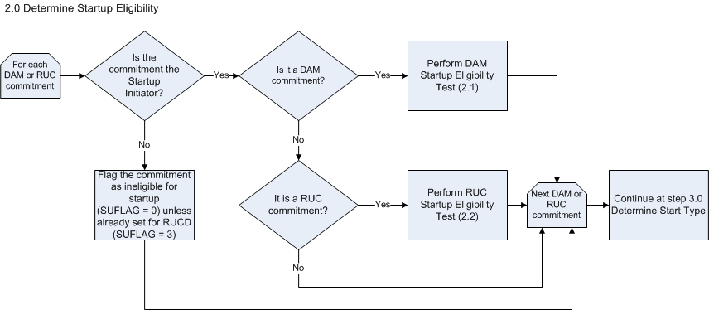

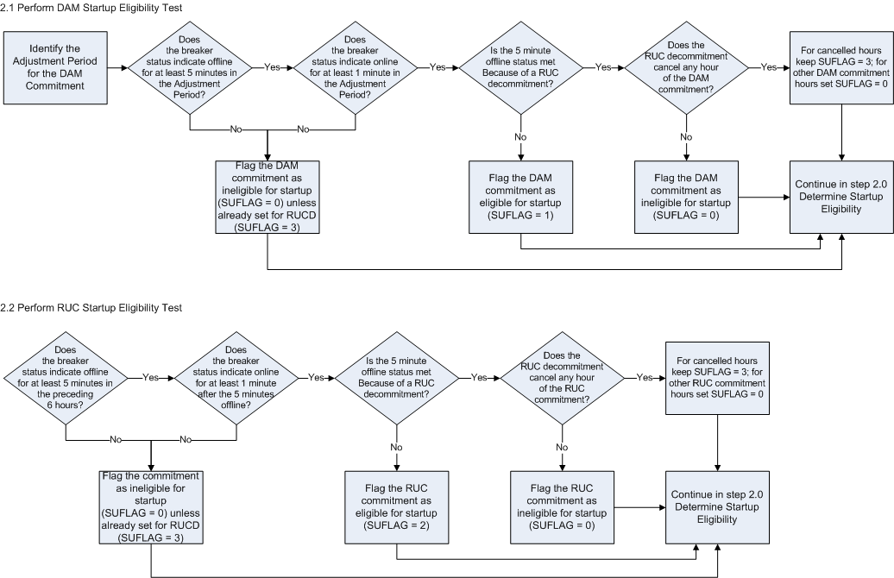

Requirement ID | FR 13
Source Mapping (Protocol/NERC/FERC and other binding documents Ref #) | PR 4.6.2.3 (1), PR 5.7.3 (2)
Traceability to Sub-Process Maps | CSWM.P03SettleBillTransfer
Description:
Protocol-defined DAM eligibility criteria:
4.6.2.3 Day-Ahead Make-Whole Settlements
(1) A QSE that has a Three-Part Supply Offer cleared in the DAM is eligible for a Day-Ahead Make-Whole Payment, if, for the Resource associated with the offer:
(a) The generator’s breakers were open for at least five minutes during the Adjustment Period for the beginning of the DAM commitment;
(b) The generator’s breakers were closed for at least one minute during the DAM commitment period; and
(c) The breaker open-close sequence for which the QSE is eligible for startup cost compensation received a Make-Whole Payment in the DAM or RUC for the previous Operating Day does not qualify in meeting the criteria in (a) and (b) above.
Consider the following suggested NPRR changes, as documented in section 2.2 of this requirements document:
1) Protocol section 4.6.2.3 should be revised to indicate eligibility criteria for startup compensation through the Day-Ahead Make-Whole Payment, and eligibility criteria for energy (minimum energy and incremental energy) compensation through the Day-Ahead Make-Whole Payment.
2) Protocol section 4.6.2.3 should be revised to indicate that startup eligibility criteria should prevent the intervals that make one DAM commitment eligible from also making a subsequent, non-contiguous DAM Commitment within the same Operating Day eligible for startup.
If the commitment period is identified as the Startup Initiator and is a DAM commitment determine if the commitment is eligible for startup compensation. (For example, see Example 2 in the Appendix.)
1. Determine the Adjustment Period for the DAM commitment:
The Adjustment Period, as defined by the Protocols, should begin at 1800 in the Day-Ahead and should end one hour prior to the start of the commitment period.
2. Evaluate Breaker Status:
If the Resource’s breaker status indicates that the Resource was offline (breaker status open) at least 5 minutes in the Adjustment Period and the breaker status indicates that the Resource was online (breaker status closed) at least 1 minute during the commitment period continue the process at step 3.
Otherwise, identify that the DAM commitment is ineligible for startup by setting the SUFLAG = 0 for all Operating Hours of the DAM commitment. If the flag was already set to indicate eligibility for a RUC decommitment (SUFLAG =3) in the DAM commitment period intervals, keep the SUFLAG = 3 rather than setting the flag to zero.
3. Check for multiple startups resulting from same set of intervals:
The same set of intervals cannot result in making more than one DAM commitment within an Operating Day eligible for startup. Therefore, if there are multiple, non-contiguous DAM commitments within an Operating Day and the offline intervals that make the earlier DAM commitment eligible would also make a subsequent DAM commitment eligible, flag the subsequent commitment as ineligible for startup by setting the SUFLAG = 0 in all hours of the DAM commitment. (For example, see Example 3 in the Appendix.)
4. Check for RUC decommitment startup:
If the startup was not due to a RUC decommitment (none of the Operating Hours between when the Resource was previously online and when the Resource came online for the DAM commitment are indicated as startup eligible with an SUFLAG = 3), then identify that the DAM commitment should be eligible for startup by setting the SUFLAG = 1 in the first Operating Hour of the DAM commitment. Set the SUFLAG = 0 in the remaining hours of the DAM commitment.
Otherwise, indicate that the DAM commitment is not eligible for startup. Set the SUFLAG = 0 in any of the DAM commitment intervals that are not already set to indicate eligibility for a RUC decommitment (SUFLAG = 3).
The bill determinant will be structured as follows: SUFLAG_<Q>_<R>_<SP>.

Requirement ID | FR 14
Source Mapping (Protocol/NERC/FERC and other binding documents Ref #) | PR 5.6.2 (1), PR 5.6.2 (2), PR 5.7.3 (2)
Traceability to Sub-Process Maps | CSWM.P03SettleBillTransfer
Description:
Protocol-defined DAM eligibility criteria:
5.6.2 RUC Startup Cost Eligibility
(1) For purposes of this Section 5.6.2, all contiguous RUC-Committed Hours are considered as one RUC instruction. For each Resource, only one Startup Cost is eligible per block of contiguous RUC-Committed Hours.
(2) For a Resource’s Startup Costs in the Operating Day, per RUC instruction, to be included in the calculation of the RUC Guarantee for that Operating Day, all the criteria below must be met:
(a) When the RUC instruction is given, the Resource must not be QSE-committed in the Settlement Interval immediately before the designated start hour or after the last hour of the RUC instruction;
(b) A later RUC instruction or QSE commitment must not connect the designated start hour or last hour of the RUC instruction to a block of QSE-Committed Intervals that was QSE-committed before the RUC instruction was given;
(c) The generation breakers must have been open for at least five minutes during the six hours preceding the first RUC-Committed Hour; and
(d) The generation breakers must have been closed for at least one minute during the RUC commitment period or after the determined five-minute open breaker in the six hours preceding the first RUC-Committed Hour.

If the commitment period is identified as the Startup Initiator and is a RUC commitment determine if the commitment is eligible for startup compensation. (For example, see Example 7 in the Appendix.)
1. Identify the RUC Designated Start Hour:
For purposes of determining eligibility, the start of the RUC commitment (i.e. the “RUC Designated Start Hour”) should be considered as the first RUC-committed hour in the contiguous block of commitments that includes the Startup Initiator RUC commitment. The 6 hour look-back period that is performed when evaluating breaker status should begin with the hour preceding this RUC Designated Start Hour.
2. Evaluate Breaker Status:
If the Resource’s breaker status indicates that the Resource was offline (breaker status open) at least 5 minutes in the 6 hours preceding the RUC Designated Start Hour and the breaker status indicates that the Resource was online (breaker status closed) at least 1 minute in any of the RUC commitments within the contiguous block of commitments, or after the 5 minutes that the breaker status was open but before the start of the contiguous block of commitments, continue the process at step 3.
Otherwise, identify that the RUC commitment is ineligible for startup by setting the SUFLAG = 0 for all Operating Hours of the RUC commitment. If the flag was already set to indicate eligibility for a RUC decommitment (SUFLAG =3) in the RUC commitment period intervals, keep the SUFLAG = 3 rather than setting the flag to zero.
3. Check for RUC decommitment startup:
If the startup was not due to a RUC decommitment (none of the Operating Hours between when the Resource was previously online and when the Resource came online for the RUC commitment are indicated as startup eligible with an SUFLAG = 3), then identify that the RUC commitment should be eligible for startup by setting the SUFLAG = 2 in the RUC Designated Start Hour. Set the SUFLAG = 0 in the remaining hours of the contiguous block of commitments.
Otherwise, indicate that the RUC commitment is ineligible for startup. Set the SUFLAG = 0 in any of the intervals within the contiguous block of commitments that are not already set to indicate eligibility for a RUC decommitment (i.e., SUFLAG = 3).
The bill determinant will be structured as follows: SUFLAG_<Q>_<R>_<SP>

Requirement ID | FR 15
Source Mapping (Protocol/NERC/FERC and other binding documents Ref #) | PR 4.6.2.3 (1), PR 5.6.2 (1), PR 5.6.2 (2), PR 5.7.3 (2)
Traceability to Sub-Process Maps | CSWM.P03SettleBillTransfer
Description:
For any intervals where SUFLAG is not already set to 0, 1, 2, or 3 (i.e., the interval is not included in a DAM commitment, RUC commitment, or RUC decommitment), set SUFLAG = 0.

Determine Start Type

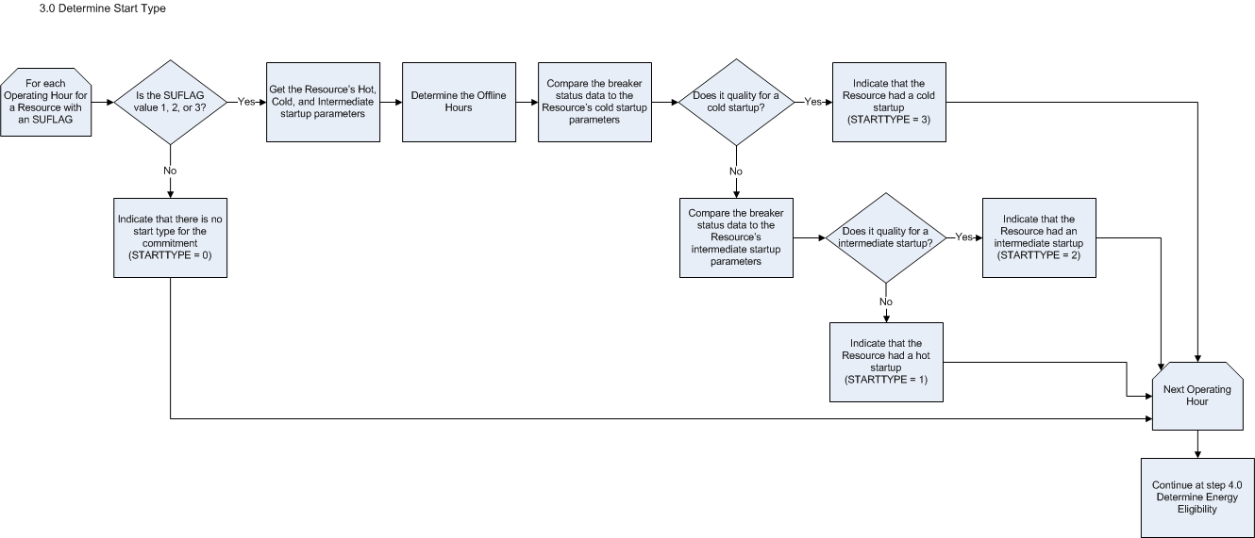
Requirement ID | FR 16
Source Mapping (Protocol/NERC/FERC and other binding documents Ref #) | PR 4.6.2.3.1 (3), PR 5.7.1.1 (2), 5.7.3, PR3.7.1.1 (2) f and g
Traceability to Sub-Process Maps | CSWM.P03SettleBillTransfer
Description:
Create a STARTTYPE data cut for every Resource with at least one DAM or RUC commitment or RUC decommitment identified as the Startup Initiator in a given Operating Day (i.e., SUFLAG = 1, 2, or 3.)
If the Resource is identified as the Startup Initiator, it is necessary to indicate the start type (hot, intermediate, or cold) incurred by the unit based on online / offline status as indicated by the breaker status data. The STARTTYPE is necessary in order to determine the appropriate Startup Price to use in the related settlement Charge Type calculation. Section 3 of the Protocols identifies the startup parameters that will be submitted by the QSE:

3.7.1.1 Generation Resource Parameters …
…
(2) Seasonal Resource Parameters must be submitted by a QSE and must include the following for each Generation Resource represented by the QSE:

(f) Hot-to-intermediate time – The time, in hours, after shutdown that a hot-temperature-state Resource takes to cool down to intermediate-temperature state; and
(g) Intermediate-to-cold time – The time, in hours, after shutdown that an intermediate-temperature-state Resource takes to cool down to cold-temperature state.

Requirement ID | FR 17
Source Mapping (Protocol/NERC/FERC and other binding documents Ref #) | PR 4.6.2.3.1 (3), PR 5.7.1.1 (2), PR 5.7.3
Traceability to Sub-Process Maps | CSWM.P03SettleBillTransfer
Description:
The STARTTYPE data cut should be created as an hourly data cut for a QSE, Resource, and Settlement Point. The bill determinant should be structured as follows: STARTTYPE_<Q>_<R>_<SP>.

Requirement ID | FR 18
Source Mapping (Protocol/NERC/FERC and other binding documents Ref #) | PR 4.6.2.3.1 (3), PR 5.7.1.1 (2), PR3.7.1.1 (2) f and g
Traceability to Sub-Process Maps | CSWM.P03SettleBillTransfer
Description:
For Operating Hours when a Resource has a DAM or RUC commitment identified as the Startup Initiator (SUFLAG = 1 or 2), the STARTTYPE data for the corresponding interval should contain a value of 1 (hot), 2 (intermediate), or 3 (cold).

Looking back from the Startup Initiator’s transition to breaker close (for RUC this is the RUC Designated Start Hour), find the most previous breaker close status to determine the “offline hours”:
If hours between breaker closures <= hot to intermediate hours, then STARTTYPE = 1
If hot to intermediate hours < hours between breaker closures <= (intermediate to cold) hours, then STARTTYPE = 2
If hours between breaker closures > (intermediate to cold) hours, then STARTTYPE = 3
Determining the offline hours may require breaker status data from previous Operating Days, but will not require breaker status for any Operating Hours further back than the number of hours specified by the defined intermediate to cold hours parameter.

Requirement ID | FR 19
Source Mapping (Protocol/NERC/FERC and other binding documents Ref #) | PR 5.7.3, PR3.7.1.1 (2) f and g
Traceability to Sub-Process Maps | CSWM.P03SettleBillTransfer
Description:
For Operating Hours when a Resource has a RUC decommitment identified as the Startup Initiator (SUFLAG = 3) the STARTTYPE data for the corresponding interval should contain a value of 1 (hot), 2 (intermediate), or 3 (cold). Unlike the STARTTYPE determination for DAM and RUC commitments, the STARTTYPE determination for RUC decommitments should determine the STARTTYPE based on when the Resource is back online after a RUC decommitment.

Looking forward from the start of the RUC decommitment transition to breaker open, find the next breaker close status to determine the “offline hours”:
If hours between breaker closures <= hot to intermediate hours, then STARTTYPE = 1
If hot to intermediate hours < hours between breaker closures <= (intermediate to cold) hours, then STARTTYPE = 2
If hours between breaker closures > (intermediate to cold) hours, then STARTTYPE = 3
Determining the offline hours may require breaker status data from subsequent Operating Days, but will not require breaker status for any future Operating Hours that are farther in the future than the number of hours specified by the defined intermediate to cold hours parameter.

Requirement ID | FR 20
Source Mapping (Protocol/NERC/FERC and other binding documents Ref #) | PR 4.6.2.3.1 (3), PR 5.7.1.1 (2), PR 5.7.3
Traceability to Sub-Process Maps | CSWM.P03SettleBillTransfer
Description:
For Operating Hours when the Resource is ineligible for startup (i.e., SUFLAG = 0), set the STARTTYPE value for the corresponding interval equal to 0.

Requirement ID | FR 21
Source Mapping (Protocol/NERC/FERC and other binding documents Ref #) | PR 4.6.2.3.1 (3), PR 5.7.1.1 (2), PR 5.7.3
Traceability to Sub-Process Maps | CSWM.P03SettleBillTransfer
Description:
If all of the Resource’s startup parameters contain a zero (0) value set the STARTTYPE = 3 and log a WARN-DEFAULT error message stating the QSE, Resource, Operating Day, and that the STARTTYPE value was defaulted to 3 due to zero-value startup parameters (i.e. default to a cold startup.)

Requirement ID | FR 22
Source Mapping (Protocol/NERC/FERC and other binding documents Ref #) | PR 4.6.2.3.1 (3), PR 5.7.1.1 (2), PR 5.7.3
Traceability to Sub-Process Maps | CSWM.P03SettleBillTransfer
Description:
If any of the Resource’s startup parameters are missing and are needed in order to make the appropriate startup evaluation, set the STARTTYPE = 3 and log a WARN-DEFAULT error message stating the QSE, Resource, Operating Day, and that the STARTTYPE value was defaulted to 3 due missing startup parameters (i.e. default to a cold startup.)

Determine Energy Eligibility

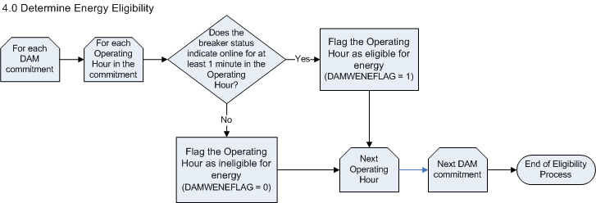
Requirement ID | FR 23
Source Mapping (Protocol/NERC/FERC and other binding documents Ref #) | PR 4.6.2.3 (NPRR needed)
Traceability to Sub-Process Maps | CSWM.P03SettleBillTransfer
Description:
The DAMWENEFLAG should only be created for Resources with at least one DAM commitment in an Operating Day. The bill determinant will be structured as follows: DAMWENEFLAG_<Q>_<R>_<SP>

Requirement ID | FR 24
Source Mapping (Protocol/NERC/FERC and other binding documents Ref #) | PR 4.6.2.3 (NPRR needed)
Traceability to Sub-Process Maps | CSWM.P03SettleBillTransfer
Description:

For each interval of every DAM commitment, identify whether or not the Operating Hour is eligible for energy payment in the Day-Ahead Make-Whole Payment.
If the Resource breaker status indicates online for at least one minute within a specific Operating Hour in the DAM commitment, indicate that the Operating Hour is eligible for energy payment by setting the DAMWENEFLAG = 1. (For example, see Example 1 in the Appendix.)
Set the DAMWENEFLAG = 0 for any Operating Hours within a DAM commitment where the Resource is not online. It is possible that not all Operating Hours within the DAM commitment will be eligible for an energy payment through the Day-Ahead Make-Whole Payment. (For example, see Example 1 in the Appendix.)

Requirement ID | FR 25
Source Mapping (Protocol/NERC/FERC and other binding documents Ref #) | PR 4.6.2.3 (NPRR needed)
Traceability to Sub-Process Maps | CSWM.P03SettleBillTransfer
Description:

Set the DAMWENEFLAG = 0 for any Operating Hour that is not part of a DAM commitment.

Forced Outage Considerations

The impact of a Forced Outage on startup eligibility is mentioned in the Protocols under the context of RUC commitments.
5.6.3 Forced Outage of a RUC-Committed Resource
(1) The calculation of a Make-Whole Payment for a RUC-committed Resource that is eligible to receive startup costs under Section 5.6.2, RUC Startup Cost Eligibility, and that experiences a Forced Outage after unit synchronization is governed by Section 5.6.2, RUC Startup Cost Eligibility.
(2) If a RUC-committed Resource, which Resource is eligible to include startup costs in its RUC Guarantee under Section 5.6.2, RUC Startup Cost Eligibility, without considering the criteria in subsection (d) of that Section 5.6.2, that experiences startup failure that creates a Forced Outage before breaker close, ERCOT shall include the Resource’s verifiable actual costs in the Resource’s RUC Guarantee, limited to the lesser of: …(proposed NPRR to clarify that this should be done through a manual process.)

Requirement ID | FR 26
Source Mapping (Protocol/NERC/FERC and other binding documents Ref #) | PR 5.6.3 (NPRR needed)
Traceability to Sub-Process Maps | CSWM.P03SettleBillTransfer
Description:

The system will not look for Forced Outage intervals. Any interval with an opened breaker status may or may not be associated to a Forced Outage; the Eligibility Process will not attempt to make a distinction. The system will simply execute the defined logic considering the available data inputs (breaker status data and commitment period data). The following points represent how a Forced Outage would flow through the Eligibility Process logic defined within this requirements document:
- The system will see a Resource that never reaches breaker close when attempting to come online for the Startup Initiator RUC commitment (5.6.3 (2)) as ineligible for startup in that commitment, due to a failure to meet the “one minute online” eligibility criteria. The QSE must submit a dispute in order to receive any compensation for the startup.

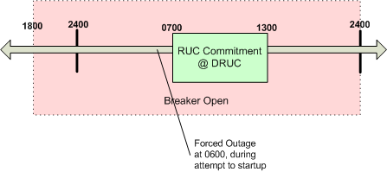
- The Eligibility Process only attempts to determine one startup per commitment period. Therefore, in the case where the Resource experiences a Forced Outage during a commitment but comes back online in the commitment, the system will not consider the commitment to be eligible for multiple startups.
In the following example, the system would not recognize multiple startups for this stand-alone Startup Initiator RUC Commitment. The system only considers one startup per commitment. It only looks for opened breaker status data within the 6 hours preceding the commitment to identify the first startup for the commitment.

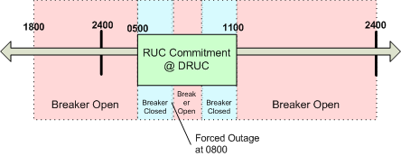

- An open breaker status that is the result of a Forced Outage may make a later Startup Initiator commitment eligible for startup by fulfilling the 5 minute breaker status close criteria. When the system evaluates the breaker status data for the later Startup Initiator against the eligibility criteria, it will not consider whether or not the open breaker status is due to a Forced Outage.
In the following example, the system would consider the existing breaker status data when evaluating eligibility for the Startup Initiator DAM commitment. Therefore, it would see that the breakers were open for at least 5 minutes during the Adjustment Period and would identify the DAM commitment as eligible for startup; it would not care that the breakers were open because of a Forced Outage.

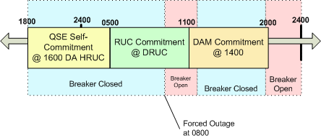

The Forced Outage impacts on the Eligibility Process may require the functionality of after-the-fact manual adjustments. This decision will be made after further analysis, during the design process.

Input Bill Determinants
Variable | Unit | Definition | Original Source
BREAKERSTATUS | Misc | Breaker Status per QSE and Resource - Indicates a change in breaker status and the point in time at which the Resource experienced a breaker status change that resulted in the Resource going offline or coming online. A value of one (1) indicates that the Resource came online at the specified time; a value of zero (0) indicates that the Resource went offline at the specified time. | EMS
Interval Frequency: To be determined in design (This can be handled as interval or non-interval data)

Additional Comments: The breaker status data from EMS should indicate the online/offline status of the Resource.

This data element will exist in the following format: BREAKERSTATUS_<Q>_<R>_<SP>

Hot to Intermediate Startup Parameter | Misc | Resource-specific parameter that represent the time, in hours, after shutdown that a hot-temperature state Resource takes to cool down to intermediate-temperature state . | NMMS
Interval Frequency: Non-interval, lookup data

Additional Comments: The Resource-specific startup parameters should be captured through the registration process.

Intermediate to Cold Startup Parameter | Misc | Resource-specific parameter that represent the time, in hours, after shutdown that an intermediate-temperature state Resource takes to cool down to cold-temperature state . | NMMS
Interval Frequency: Non-interval, lookup data

Additional Comments: The Resource-specific startup parameters should be captured through the registration process.

DAMCOMMITFLAG | Misc | DAM-Committed Resource Flag per QSE and Resource by hour ⎯ Flag that indicates if an hourly interval was DAM-Committed for a QSE and Resource for the hour. A value of one (1) indicates that the interval is DAM-committed; a value of zero (0) indicates that the interval is not DAM-committed. | MMS
Interval Frequency: 1 / hour

Additional Comments: The DAMCOMMITFLAG will indicate the intervals in which a Resource was DAM-committed based upon an awarded Three Part Supply Offer.

This data element will exist in the following format: DAMCOMMITFLAG_<Q>_<R>_<SP>

RUC | Misc | RUC—The RUC-Commitment, issued by a RUC process, indicating the hours in which the Resource was committed by that RUC process. A value of one (1) indicates that the interval is RUC-committed; a value of zero (0) indicates that the interval is not RUC-committed. | MMS
Interval Frequency: To be determined in design (This can be handled as interval or non-interval data)

Additional Comments: This data element will exist in the following format: RUC_<Q>_<R>_<SP>_<RUC>

RUCDECOMMIT | Misc | RUCDECOMMIT—The RUC-Decommitment, issued by a RUC process, indicating the hours in which the Resource was decommitted. A value of one (1) indicates that the interval is RUC-decommitted interval; a value of zero (0) indicates that the interval is not RUC-decommitted. | MMS
Interval Frequency: To be determined in design (This can be handled as interval or non-interval data)

Additional Comments: This data element will exist in the following format: RUCDECOMMIT_<Q>_<R>_<SP>_<RUC>

STATUSSNAP | Misc | Resource Status at Snapshot —The Resource Status for the Resource represented by the QSE, according to the COP snapshot at DAM, at DRUC, and at each HRUC process. | MMS
Interval Frequency: To be determined in design (This can be handled as interval or non-interval data)

Additional Comments: It is expected that through the design process and integration with MMS a numeric code will be associated with each COP Resource Status defined in PR 3.9.1.

A Resource should always have STATUSSNAP data for all Operating Hours in an Operating Day produced from a snapshot taken at DAM. A Resource should only get additional STATUSSNAP data for an Operating Hour if the Resource Status for that Operating Hour was modified in a snapshot taken before a later process (DRUC or HRUC).

This data element will exist in the following format: STATUSSNAP_<Q>_<R>_<SP>_<RUC>, DASTATUSSNAP_<Q>_<R>_<SP>.

Intermediate Bill Determinants
None

Output Bill Determinants
Variable | Unit | Definition | Destination
SUFLAG | Misc | Startup Flag per QSE and Resource by hour—The flag that indicates whether or not a Resource is eligible for startup compensation in a DAM commitment, RUC commitment, or RUC decommitment. The Startup Flag value is zero (0) if the Resource is not eligible for startup compensation, one (1) if the Resource is eligible for startup in a DAM commitment, (2) if the Resource is eligible for startup in a RUC commitment, or three (3) if the Resource is eligible for startup in a RUC decommitment. | Settlement System
Interval Frequency: 1 / hour

Additional Comments: Originally these were documented as separate startup flags (e.g., DAMWSUFLAG, RUCSUFLAG, RMRSUFLAG, and RUCDECOMMIT.) However, after further analysis it was decided that startup indication should be combined into one data element (SUFLAG) in order to streamline the process. Using one flag ensures that only one type of commitment can be eligible for startup compensation in any given interval.

The data element will exist in the following format: SUFLAG_<Q>_<R>_<SP>

DAMWENEFLAG | Misc | Day-Ahead Make-Whole Energy Eligibility Flag per QSE and Resource —The flag that indicates Day-Ahead Make-Whole Payment energy eligibility for the Resource represented by the QSE, for the hour. The value is set to zero (0) if the resource is not eligible or one (1) if the resource is eligible for energy costs in the Day-Ahead Make-Whole payment, for the hour. | Settlement System
Interval Frequency: 1 / hour

Additional Comments: Every hour within the commitment period should contain a value of zero or one for the flag, and each hour should be utilized by the Day-Ahead Market Guaranteed Cost calculation.

The data element will exist in the following format: DAMWENEFLAG_<Q>_<R>_<SP>

QCLAW | Misc | QSE Clawback Interval Flag—The flag that indicates for the Resource whether or not the settlement interval is a QSE Clawback interval. If the settlement interval is a QSE Clawback interval, its value is one (1); otherwise, zero (0). | Settlement System
Interval Frequency: 4 / Hour

Additional Comments: This determinant is not documented in the Nodal Protocols but is required to determine QSE Clawback intervals for a Resource. The 15-minute QCLAW data element is determined using hourly data; all 15-minute settlement intervals within an Operating Hour will have the same QCLAW value.

The data element will exist in the following format: QCLAW_<Q>_<R>_<SP>

STARTTYPE | Misc | Start Type Flag – The flag that indicates the type of start (hot intermediate or cold) that a Resource incurred for the Resource, represented by the QSE for each hour for the Operating Day. The possible values include: zero (0) for none, one (1) for hot, two (2) for intermediate and three (3) for cold. | Settlement System
Interval Frequency: 1 / hour

Additional Comments: This determinant is not documented in the Nodal Protocols but is required to indicate what type of start the Resource performed.

The data element will exist in the following format: STARTTYPE_<Q>_<R>_<SP>

Data Dependencies
D1) Calculation of the Day-Ahead Make-Whole Payment is dependent upon the completion of the Eligibility Process (SUFLAG, STARTTYPE, and DAMWENEFLAG.)
D2) Calculation of the RUC Guarantee calculation is dependent upon the completion of the Eligibility Process (SUFLAG and STARTTYPE.)
D3) Calculation of RUC Decommitment Payment is dependent upon the completion of the Eligibility Process (SUFLAG.)
D4) Calculation of the RUC Clawback Charge is dependent upon the completion of the Eligibility Process (QCLAW.)
D5) Calculation of the Revenue Less Cost During QSE Clawback Intervals is dependent upon the completion of the Eligibility Process (QCLAW.)
D6) Calculation of the RMR Energy Payment is dependent upon the completion of the Eligibility Process (SUFLAG and STARTTYPE.)

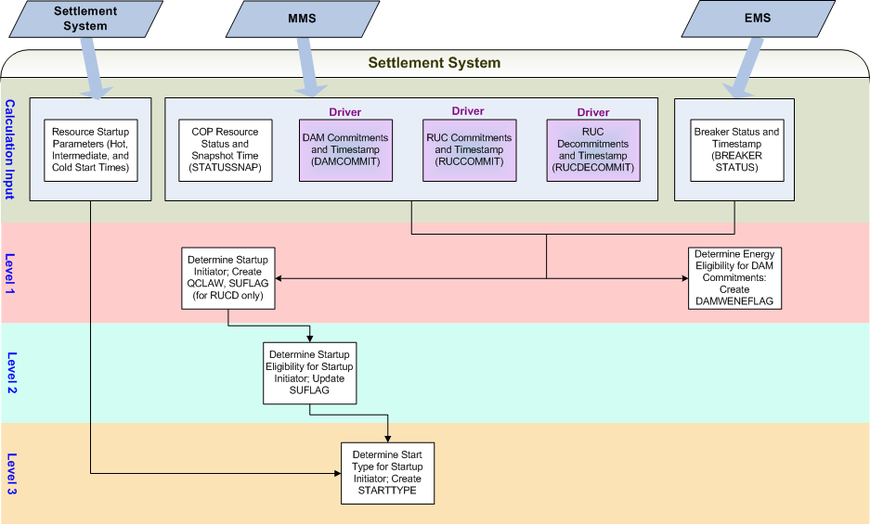
Figure 1.0: Eligibility Process Data Dependencies

Assumptions
A1) All commitment periods are measured in hourly increments (i.e. there are no partial hours.)

A2) The source system will correctly identify the Operating Hours included in each commitment period.
- DAM commitments are results from the DAM, based on cleared Three Part Supply Offers; the Operating Hour definition of a DAM commitment cannot change after the fact.
- A DAM commitment period cannot literally be extended or reduced. In other words, once the DAM commitment is created that same DAM commitment cannot be redefined to include additional Operating Hours or to remove Operating Hours.
- An existing RUC commitment cannot literally be extended. In other words, once the RUC commitment is created, that same RUC commitment cannot be redefined to include additional Operating Hours or to remove Operating Hours.

A3) The optimization engine may have selected the Resource based upon a pre-determined start type according to the COP, offer information, or other information available at that point in time. However, settlement will use actual data (breaker status) to determine the start type that actually occurred.
A4) Startup determination for RMR resources is not exempt from the set of startup criteria identified within this document for a given DAM or RUC commitment. Therefore, the SUFLAG as documented here is sufficient for the purposes of RMR settlement.
A5) Advisory RUC decommitments, as referred to in 5.5.3 (2), will not have an associated RUCDECOMMIT data element and therefore will not flow through into the Settlement System and result in financial settlement.
A6) Any verbal RUC commitments will be received by the Settlement System in the same manner as any programmatic RUC commitment. Therefore, the source system will capture verbal RUC commitments as well as programmatic RUC commitments. The verbal RUC commitment will have an associated data element to identify the commitment and the data element will flow through into the Settlement System. The data element created for the RUC commitment will be associated to the most previous existing RUC process.
A7) Any verbal RUC decommitment will be received by the Settlement System in the same manner as any programmatic RUC decommitment. Therefore, the source system will capture verbal RUC decommitments as well as programmatic RUC decommitments. The verbal RUC decommitment will have an associated data element to identify the decommitment and the data element will flow through into the Settlement System. The data element created for the RUC decommitment will be associated to the most previous existing RUC process.
A8) It is recognized that specific eligibility requirements may be necessary in order to support settlement for combined cycle units. The specific impacts of combined cycle units on the Eligibility Process cannot be determined until the details concerning how combined cycle units will be identified within ERCOT systems and committed are finalized and made available. This topic will be re-addressed within this document after the combined cycle unit details are finalized and made available.

Business Defined Errors
Req. ID | Protocol(s) | Sub-Process Map | Description
FR 27 | PR 4.6.2.3.1 (3) | CSWM.P03SettleBillTransfer | If a DAM commitment (DAMCOMMITFLAG) data cut exists for a QSE, Resource, Settlement Point, and Operating Day but an SUFLAG data cut was not created for the QSE, Resource, Settlement Point, and Operating Day the system should create a WARN error message identifying the QSE, Resource, Settlement Point, Operating Day, and Operating Hour and missing data element.
FR 28 | PR 5.7.1.1 | CSWM.P03SettleBillTransfer | If a RUC commitment (RUC) data cut exists for a QSE, Resource, Settlement Point, and Operating Day but an SUFLAG data cut was not created for the QSE, Resource, Settlement Point, and Operating Day the system should create a WARN error message identifying the QSE, Resource, Settlement Point, Operating Day, and Operating Hour and missing data element.
FR 29 | PR 5.7.3 | CSWM.P03SettleBillTransfer | If a RUC decommitment (RUCDECOMMIT) data cut exists for a QSE, Resource, Settlement Point, and Operating Day but an SUFLAG data cut was not created for the QSE, Resource, Settlement Point, and Operating Day the system should create a WARN error message identifying the QSE, Resource, Settlement Point, Operating Day, and Operating Hour and missing data element.
FR 30 | PR 4.6.2.3.1 (3) | CSWM.P03SettleBillTransfer | If an SUFLAG exists for a QSE, Resource, and Operating Day and indicates startup through DAM, RUC, or RUC decommitment, but there is no associated STARTTYPE data (i.e. the STARTTYPE bill determinant does not exist at all or the data exists but contains a zero value for the corresponding Operating Hour that identified a startup in the SUFLAG bill determinant), the system should create a WARN error message identifying the QSE, Resource, Settlement Point, Operating Day, and Operating Hour and should indicate that an a startup was identified without a corresponding a start type.
FR 31 | PR 4.6.2.3.1 (3) | CSWM.P03SettleBillTransfer | If a DAM commitment (DAMCOMMITFLAG) data cut exists for a QSE, Resource, Settlement Point, and Operating Day but an DAMWENEFLAG data cut was not created for the QSE, Resource, Settlement Point, and Operating Day the system should create a WARN error message identifying the QSE, Resource, Settlement Point, Operating Day, and Operating Hour and missing data element.

Specific Database Needs
None

Supplementary Requirements

Performance Requirements
Lodestar must be able to perform its full set of Nodal settlement calculations. Performance characteristics will be determined and detailed in the conceptual and detailed design.

Legal and Regulatory requirements
All Lodestar financial data must be saved in accordance with standard accounting principles as dictated by the ERCOT Texas Nodal Protocols.

System Security Requirements
Lodestar will only be accessed directly by internal ERCOT personnel either through thin client UI, Citrix environment, or thick client on employee desktops. Market Participants will be able to access their statements and invoices on ERCOT private web site. ERCOT private web site access will be controlled by digital certificate authentication in accordance with ERCOT security policies. Additional details will be provided in the Conceptual System Design.

Back up and Recovery Requirements
All Lodestar Nodal settlement data must be backed up on a daily basis and recoverable within 24 hours. Additional details will be provided in the Conceptual System Design.

Availability and Redundancy Requirements
Nodal Lodestar system must be available 7/24. Lodestar is considered a tier 1 system and critical to base ERCOT business processes. Additional details will be provided in the Conceptual System Design.

Maintainability Requirements
Lodestar Nodal system will be maintained by internal ERCOT personnel. Service Level Agreements and explicit support will be detailed in the detail design document.

Daylight Savings Time shall be recognized in Nodal Market settlements.
Spring Daylight Savings Time Operating Day:
- Hour Ending 0300 will be skipped, resulting in 23 hourly intervals for the day.
- The four fifteen minute intervals within Hour Ending 0300 will be skipped, resulting in 92 fifteen minute intervals for the day.
- The sixty one minute intervals within Hour Ending 0300 will be skipped, resulting in 1380 total one minute intervals.
Fall Daylight Savings Time Operating Day:
- Hour Ending 0200 will have two (2) sets of data, resulting in 25 hourly intervals for the day.
- The four fifteen minute intervals within Hour Ending 0200 will have two (2) sets of data, resulting in 100 fifteen minute intervals for the day.
- The sixty one minute intervals within Hour Ending 0200 will have two (2) sets of data, resulting in 1500 total one minute intervals.

Protocol Coverage

Since one protocol may translate into many requirements, Project Managers are required to identify the coverage extent (Full/Partial) of all relevant Nodal Protocols that are mentioned in this requirements document.

Protocol Sub-Section # (To the lowest level of granularity as possible) | Coverage by Requirements  (Full/Partial)
4.6.2.3 | Partial
5.6.2 | Partial
5.6.3 | Partial
5.7.1.4 | Partial
5.7.2 | Partial
5.7.3 | Partial

Appendix – Example Eligibility Scenarios

Example 1
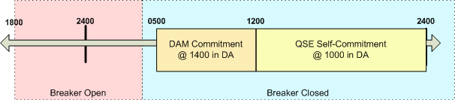

 | DAM Commitment (HE0600 – HE1200) | QSE Self-Commitment (HE1300 – HE2400) | All Other Intervals
Startup Initiator | No | Yes | No
QCLAW | N/A (No RUC commitments in the day, therefore N/A; do not create the data cut) | N/A (No RUC commitments in the day, therefore N/A; do not create the data cut) | N/A (No RUC commitments in the day, therefore N/A; do not create the data cut)
Startup Eligibility | SUFLAG = 0 (ineligible) for all hours in the commitment | SUFLAG = 0 (ineligible) for all hours in the commitment | SUFLAG = 0 (ineligible) for all other hours
Start Type | STARTTYPE = 0 (no start) for all hours in the commitment | STARTTYPE = 0 (no start) for all hours in the commitment | STARTTYPE = 0 (no start) for all other hours
Energy Eligibility | DAMWENEFLAG = 1 (eligible) for all hours in the commitment | DAMWENEFLAG = 0 (ineligible) for all hours in the commitment | DAMWENEFLAG = 0 (ineligible) for all other hours

Example 2
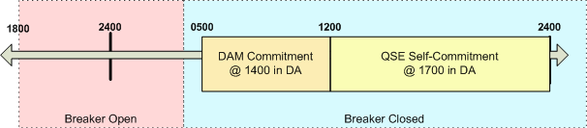

 | DAM Commitment (HE0600 – HE1200) | QSE Self-Commitment (HE1300 – HE2400) | All Other Intervals
Startup Initiator | Yes | No | No
QCLAW | N/A (No RUC commitments in the day, therefore N/A; do not create the data cut) | N/A (No RUC commitments in the day, therefore N/A; do not create the data cut) | N/A (No RUC commitments in the day, therefore N/A; do not create the data cut)
Startup Eligibility | SUFLAG = 1 (DAM eligible) for the first hour of the commitment period  SUFLAG = 0 (ineligible) for all other hours in the commitment | SUFLAG = 0 (ineligible) for all hours in the commitment | SUFLAG = 0 (ineligible) for all other hours
Start Type | STARTTYPE = 1, 2, or 3 for the first hour of the commitment period, based on Resource’s startup parameters  STARTTYPE = 0 (no start) for all other hours in the commitment | STARTTYPE = 0 (no start) for all hours in the commitment | STARTTYPE = 0 (no start) for all other hours
Energy Eligibility | DAMWENEFLAG = 1 (eligible) for all hours in the commitment | DAMWENEFLAG = 0 (ineligible) for all hours in the commitment | DAMWENEFLAG = 0 (ineligible) for all other hours

Example 3
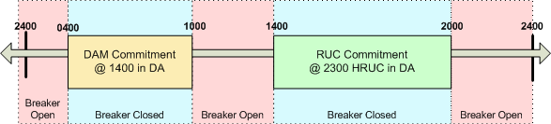

 | DAM Commitment (HE0500 – HE1000) | RUC Commitment (HE1500 – HE2000) | All Other Intervals
Startup Initiator | Yes | Yes | No
QCLAW | QCLAW = 0 for all intervals in the commitment | QCLAW = 0 for all intervals in the commitment | QCLAW = 0 for all other intervals
Startup Eligibility | SUFLAG = 1 (DAM eligible) for the first hour of the commitment period  SUFLAG = 0 (ineligible) for all other hours in the commitment | SUFLAG = 2 (RUC eligible) for all hours in the commitment | SUFLAG = 0 (ineligible) for all other hours
Start Type | STARTTYPE = 1, 2, or 3 for the first hour of the commitment period, based on Resource’s startup parameters  STARTTYPE = 0 (no start) for all other hours in the commitment | STARTTYPE = 1, 2, or 3 for the first hour of the commitment period, based on Resource’s startup parameters  STARTTYPE = 0 (no start) for all other hours in the commitment | STARTTYPE = 0 (no start) for all other hours
Energy Eligibility | DAMWENEFLAG = 1 (eligible) for all hours in the commitment | DAMWENEFLAG = 0 (ineligible) for all hours in the commitment | DAMWENEFLAG = 0 (ineligible) for all other hours

Example 4
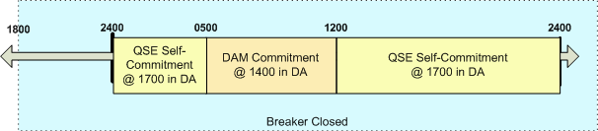

 | DAM Commitment  (HE0600 – HE1200) | QSE Self-Commitments  (HE0100 – HE0500 and HE1300 – HE2400)
Startup Initiator | Yes | No
QCLAW | N/A (No RUC commitments in the day, therefore N/A; do not create the data cut) | N/A (No RUC commitments in the day, therefore N/A; do not create the data cut)
Startup Eligibility | SUFLAG = 0 (ineligible) for all hours in the commitment | SUFLAG = 0 (ineligible) for all hours in the commitment
Start Type | STARTTYPE = 0 (no start) for all hours in the commitment | STARTTYPE = 0 (no start) for all hours in the commitment
Energy Eligibility | DAMWENEFLAG = 1 (eligible) for all hours in the commitment | DAMWENEFLAG = 0 (ineligible) for all hours in the commitment

Example 5
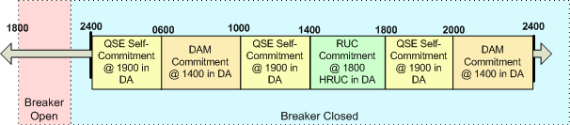
(Note, without the suggested NPRR modifications to the DAM eligibility criteria, this scenario would have paid two DAM startups.)
 | DAM Commitment (HE0700 – HE1000) | QSE Self-Commitments (HE0100 – 0600, HE1100 – HE1400, and HE1900 – HE2000) | RUC Commitment (HE1500 – HE1800) | DAM Commitment (HE2100 – HE2400)
Startup Initiator | Yes | No | No | No
QCLAW | QCLAW = 0 for all intervals in the commitment | QCLAW = 0 for all intervals in the commitment | QCLAW = 0 for all intervals in the commitment | QCLAW = 0 for all intervals in the commitment
Startup Eligibility | SUFLAG = 1 (DAM eligible) for the first hour of the commitment  SUFLAG = 0 (ineligible) for all other hours in the commitment | SUFLAG = 0 (ineligible)for all hours in the commitment | SUFLAG = 0 (ineligible) for all hours in the commitment | SUFLAG = 0 (ineligible) for all hours in the commitment
Start Type | STARTTYPE = 1, 2, or 3 for the first hour of the commitment period, based on Resource’s startup parameters  STARTTYPE = 0 (no start) for all other hours in the commitment | STARTTYPE = 0 (no start) for all hours in the commitment | STARTTYPE = 0 (no start) for all hours in the commitment | STARTTYPE = 0 (no start) for all hours in the commitment
Energy Eligibility | DAMWENEFLAG = 1 (eligible) for all hours in the DAM commitment period | DAMWENEFLAG = 0 (ineligible) for all hours in the commitment | DAMWENEFLAG = 0 (ineligible) for all hours in the commitment | DAMWENEFLAG = 1 (eligible) for all hours in the DAM commitment period

Example 6
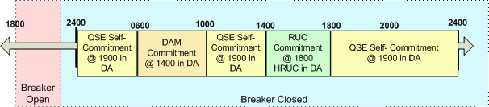

 | DAM Commitment (HE0700 – HE1000) | QSE Self-Commitment (HE0100 – 0600 and HE1100 – HE1400) | RUC Commitment (HE1500 – HE1800) | QSE Self-Commitment (HE1900 – HE2000)
Startup Initiator | Yes | No | No | No
QCLAW | QCLAW = 0 for all intervals in the commitment | QCLAW = 0 for all intervals in the commitment | QCLAW = 0 for all intervals in the commitment | QCLAW = 1 for all intervals in the commitment
Startup Eligibility | SUFLAG = 1 (DAM eligible) for the first hour of the commitment  SUFLAG = 0 (ineligible) for all other hours in the commitment | SUFLAG = 0 (ineligible) for all hours in the commitment | SUFLAG = 0 (ineligible) for all hours in the commitment | SUFLAG = 0 (ineligible) for all hours in the commitment
Start Type | STARTTYPE = 1, 2, or 3 for the first hour of the commitment period, based on Resource’s startup parameters  STARTTYPE = 0 (no start) for all other hours in the commitment | STARTTYPE = 0 (no start) for all hours in the commitment | STARTTYPE = 0 (no start) for all hours in the commitment | STARTTYPE = 0 (no start) for all hours in the commitment
Energy Eligibility | DAMWENEFLAG = 1 (eligible) for all hours in the DAM commitment period | DAMWENEFLAG = 0 (ineligible) for all hours in the commitment | DAMWENEFLAG = 0 (ineligible) for all hours in the commitment | DAMWENEFLAG = 0 (ineligible) for all hours in the commitment

Example 7
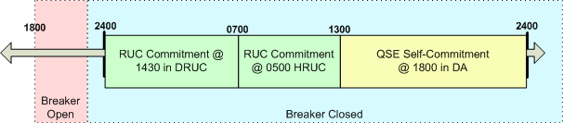

 | RUC Commitment (HE0100 – HE0700) | RUC Commitment (HE0800 – HE1300) | QSE Self-Commitment (HE1400 – HE2400)
Startup Initiator | Yes | No | No
QCLAW | QCLAW = 0 for all intervals in the commitment | QCLAW = 0 for all intervals in the commitment | QCLAW = 1 for all intervals in the commitment
Startup Eligibility | SUFLAG = 2 (RUC eligible) in the RUC Designated Start Hour (HE0100)  SUFLAG = 0 (ineligible) for all other hours in the commitment | SUFLAG = 0 (ineligible) for all hours in the commitment | SUFLAG = 0 (ineligible) for all hours in the commitment
Start Type | STARTTYPE = 1, 2, or 3 for the RUC Designated Start Hour, based on Resource’s startup parameters  STARTTYPE = 0 (no start) for all other hours in the commitment | STARTTYPE = 0 (no start) for all hours in the commitment | STARTTYPE = 0 (no start) for all hours in the commitment
Energy Eligibility | N/A (No DAM commitments in the day, therefore N/A; do not create the data cut) | N/A (No DAM commitments in the day, therefore N/A; do not create the data cut) | N/A (No DAM commitments in the day, therefore N/A; do not create the data cut)

Example 8
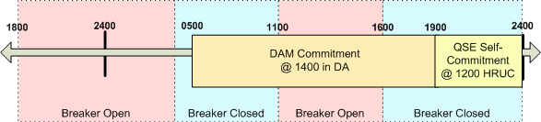

 | DAM Commitment |  |  | QSE Self-Commitment (HE2000 – HE2400) | All Other Intervals
 | (HE0500 – HE1100) | (HE1200 – HE1600) | (HE1700 – HE1900) | QSE Self-Commitment (HE2000 – HE2400) | All Other Intervals
Startup Initiator | Yes | No | No | No | No
QCLAW | N/A (No RUC commitments in the day, therefore N/A; do not create the data cut) | N/A (No RUC commitments in the day, therefore N/A; do not create the data cut) | N/A (No RUC commitments in the day, therefore N/A; do not create the data cut) | N/A (No RUC commitments in the day, therefore N/A; do not create the data cut) | N/A (No RUC commitments in the day, therefore N/A; do not create the data cut)
Startup Eligibility | SUFLAG = 1 (DAM eligible) for the first hour of the commitment  SUFLAG = 0 (ineligible) for all other hours in this portion of the commitment | SUFLAG = 0 (ineligible) for all hours in this portion of the commitment | SUFLAG = 0 (ineligible) for all hours in this portion of the commitment | SUFLAG = 0 (ineligible) for all other hours in the commitment | SUFLAG = 0 (ineligible) for all other hours
Start Type | STARTTYPE = 1, 2, or 3 for the first hour of the commitment period, based on Resource’s startup parameters  STARTTYPE = 0 (no start) for all other hours in the commitment | STARTTYPE = 0 (no start) for all hours in this portion of the commitment | STARTTYPE = 0 (no start) for all hours in this portion of the commitment | STARTTYPE = 0 (no start) for all hours in the commitment | STARTTYPE = 0 (no start) for all other hours
Energy Eligibility | DAMWENEFLAG = 1 (eligible) for all hours in this portion of the DAM commitment period | DAMWENEFLAG = 0 (ineligible) for all hours in this portion of the DAM commitment period | DAMWENEFLAG = 1 (eligible) for all hours in this portion of the DAM commitment period | DAMWENEFLAG = 0 (ineligible) for all hours in the commitment | DAMWENEFLAG = 0 (ineligible) for all other hours

Example 9
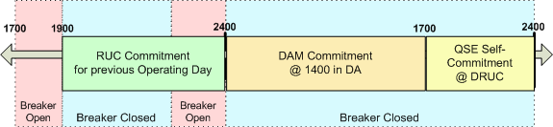

 | DAM Commitment (HE0100 – HE0900) | QSE Self-Commitment (HE1800 – HE2400)
Startup Initiator | No | No
QCLAW | N/A (No RUC commitments in the day, therefore N/A; do not create the data cut) | N/A (No RUC commitments in the day, therefore N/A; do not create the data cut)
Startup Eligibility | SUFLAG = 0 (ineligible) for all hours in the commitment | SUFLAG = 0 (ineligible) for all hours in the commitment
Start Type | STARTTYPE = 0 (no start) for all hours in the commitment | STARTTYPE = 0 (no start) for all hours in the commitment
Energy Eligibility | DAMWENEFLAG = 1 (eligible) for all hours in the DAM commitment period | DAMWENEFLAG = 0 (ineligible) for all hours in the commitment

Example 10
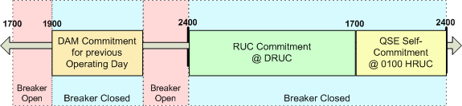

 | RUC Commitment (HE0100 – HE1700) | QSE Self-Commitment (HE1800 – HE2400)
Startup Initiator | Yes | No
QCLAW | QCLAW = 0 for all intervals in the commitment | QCLAW = 1 for all intervals in the commitment
Startup Eligibility | SUFLAG = 2 (RUC eligible) in the RUC Designated Start Hour (HE0100)  SUFLAG = 0 (ineligible) for all other hours in the commitment | SUFLAG = 0 (ineligible) for all hours in the commitment
Start Type | STARTTYPE = 1, 2, or 3 for the RUC Designated Start Hour, based on Resource’s startup parameters  STARTTYPE = 0 (no start) for all other hours in the commitment | STARTTYPE = 0 (no start) for all hours in the commitment
Energy Eligibility | N/A (No DAM commitments in the day, therefore N/A; do not create the data cut) | N/A (No DAM commitments in the day, therefore N/A; do not create the data cut)

Example 11

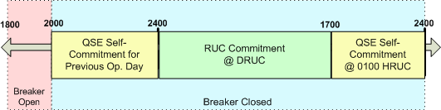
 | RUC Commitment (HE0100 – HE1700) | QSE Self-Commitment (HE1800 – HE2400)
Startup Initiator | No | No
QCLAW | QCLAW = 0 for all intervals in the commitment | QCLAW = 1 for all intervals in the commitment
Startup Eligibility | SUFLAG = 0 (ineligible) for all hours in the commitment | SUFLAG = 0 (ineligible) for all hours in the commitment
Start Type | STARTTYPE = 0 (no start) for all hours in the commitment | STARTTYPE = 0 (no start) for all hours in the commitment
Energy Eligibility | N/A (No DAM commitments in the day, therefore N/A; do not create the data cut) | N/A (No DAM commitments in the day, therefore N/A; do not create the data cut)

Example 12
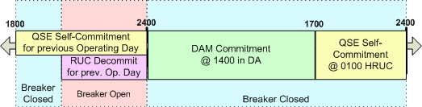

 | DAM Commitment (HE0100 – HE1700) | QSE Self-Commitment (HE1800 – HE2400)
Startup Initiator | No | No
QCLAW | N/A (No RUC commitments in the day, therefore N/A; do not create the data cut) | N/A (No RUC commitments in the day, therefore N/A; do not create the data cut)
Startup Eligibility | SUFLAG = 0 (ineligible) for all hours in the commitment | SUFLAG = 0 (ineligible) for all hours in the commitment
Start Type | STARTTYPE = 0 (no start) for all hours in the commitment | STARTTYPE = 0 (no start) for all hours in the commitment
Energy Eligibility | DAMWENEFLAG = 1 (eligible) for all hours in the DAM commitment period | DAMWENEFLAG = 0 (ineligible) for all hours in the commitment

Example 13
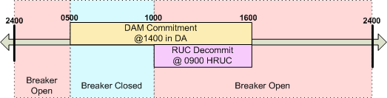

 | DAM Commitment |  | RUC Decommitment (HE1100 – HE1600) | All Other Intervals
 | (HE0600 – HE1000) | (HE1100 – HE1600) | RUC Decommitment (HE1100 – HE1600) | All Other Intervals
Startup Initiator | Yes |  | No | No
QCLAW | N/A (No RUC commitments in the day, therefore N/A; do not create the data cut) |  | N/A (No RUC commitments in the day, therefore N/A; do not create the data cut) | N/A (No RUC commitments in the day, therefore N/A; do not create the data cut)
Startup Eligibility | SUFLAG = 1 (DAM eligible) for the first hour of the commitment  SUFLAG = 0 (ineligible) for all other hours in the commitment |  | SUFLAG = 0 (ineligible) for all hours in the commitment | SUFLAG = 0 (ineligible) for all other hours
Start Type | STARTTYPE = 1, 2, or 3 for the first hour of the commitment period, based on Resource’s startup parameters  STARTTYPE = 0 (no start) for all other hours in the commitment |  | STARTTYPE = 0 (no start) for all hours in the commitment | STARTTYPE = 0 (no start) for all other hours
Energy Eligibility | DAMWENEFLAG = 1 (eligible) for all hours in the DAM commitment period | DAMWENEFLAG = 0 (ineligible) for all hours in the DAM commitment period | DAMWENEFLAG = 0 (ineligible) for all hours in the commitment | DAMWENEFLAG = 0 (ineligible) for all other hours

Example 14
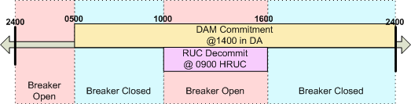

 | DAM Commitment |  |  | RUC Decommitment (HE1100 – HE1600) | All Other Intervals
 | (HE0600 – HE1000) | (HE1100 – HE1600) | (HE1700 – HE2400) | RUC Decommitment (HE1100 – HE1600) | All Other Intervals
Startup Initiator | Yes |  |  | Yes | No
QCLAW | N/A (No RUC commitments in the day, therefore N/A; do not create the data cut) |  |  | N/A (No RUC commitments in the day, therefore N/A; do not create the data cut) | N/A (No RUC commitments in the day, therefore N/A; do not create the data cut)
Startup Eligibility | SUFLAG = 1 (DAM eligible) for the first hour of the commitment  SUFLAG = 0 (ineligible) for all other hours in the commitment |  |  | SUFLAG = 3 (RUC decommitment eligible) for all hours of the decommitment | SUFLAG = 0 (ineligible) for all other hours
Start Type | STARTTYPE = 1, 2, or 3, for the first hour of the commitment period based on Resource’s startup parameters  STARTTYPE = 0 (no start) for all other hours in the commitment |  |  | STARTTYPE = 1, 2, or 3, for the last hour of the decommitment period, based on Resource’s startup parameters  STARTTYPE = 0 (no start) for all other hours in the decommitment | STARTTYPE = 0 (no start) for all other hours
Energy Eligibility | DAMWENEFLAG = 1 (eligible) for all hours in the DAM commitment period | DAMWENEFLAG = 0 (ineligible) for all hours in the DAM commitment period | DAMWENEFLAG = 1 (eligible) for all hours in the DAM commitment period | DAMWENEFLAG = 0 (ineligible) for all hours in the commitment | DAMWENEFLAG = 0 (ineligible) for all other hours

Example 15
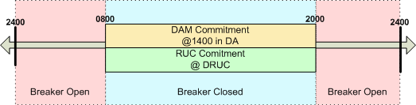
(Note, in this scenario the RUC data element would be modified to contain a value of 3 in each hour, HE 0900 – HE 2000, in order to prevent energy payment through both DAM and RUC.)

 | DAM Commitment (HE0900 – HE2000) | RUC Commitment (HE0900 – HE2000)
Startup Initiator | Yes | No
QCLAW | No | No
Startup Eligibility | SUFLAG = 1 (DAM eligible) for the first hour of the commitment  SUFLAG = 0 (ineligible) for all other hours in the commitment | SUFLAG values are set by DAM Commitment
Start Type | STARTTYPE = 1, 2, or 3, for the first hour of the commitment period based on Resource’s startup parameters  STARTTYPE = 0 (no start) for all other hours in the commitment | STARTTYPE values are set by DAM Commitment
Energy Eligibility | DAMWENEFLAG = 1 (eligible) for all hours in the DAM commitment period | DAMWENEFLAG values are set by DAM Commitment (the Resource is eligible for energy payment through the DAM commitment, not the RUC commitment.)

Example 16

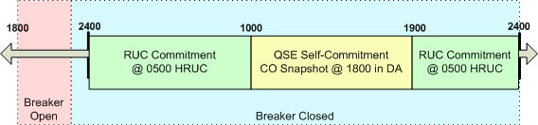

 | RUC Commitment (HE0100 – HE1000) | QSE Self-Commitment (HE1100 – HE1900) | RUC Commitment (HE2000 – HE2400)
Startup Initiator | No | No | No
QCLAW | QCLAW = 0 for all intervals in the commitment | QCLAW = 1 for all intervals in the commitment | QCLAW = 0 for all intervals in the commitment
Startup Eligibility | SUFLAG = 0 (ineligible) for all hours in the commitment | SUFLAG = 0 (ineligible) for all hours in the commitment | SUFLAG = 0 (ineligible) for all hours in the commitment
Start Type | STARTTYPE = 0 (no start) for all hours in the commitment | STARTTYPE = 0 (no start) for all hours in the commitment | STARTTYPE = 0 (no start) for all hours in the commitment
Energy Eligibility | N/A (No DAM commitments in the day, therefore N/A; do not create the data cut) | N/A (No DAM commitments in the day, therefore N/A; do not create the data cut) | N/A (No DAM commitments in the day, therefore N/A; do not create the data cut)

