Commercial Systems
Software Requirements Specification Requirements
v0.092

Revision History
Date | Version | Description | Author
09/20/06 | 0.09 | Settlement Invoices, including DAM, DAM Late Fee, RTM, RTM Late Fee Invoices, CRR Auction, CARD, CRR Balancing Account, RTM Uplift Invoices and Miscellaneous Invoices | Keely Hilton
10/06/06 | 0.091 | Incorporated comments from TPTF | Keely Hilton
10/17/06 | 0.092 | Incorporated COPS resolution to open issues. | Keely Hilton

Table of Contents
1. Invoices 4
1.1 Proposed System Scope 4
1.2 Document Conventions 4
1.3 Document Assumptions 4
2. Functional Requirements 4
2.1 DAM Invoices 4
2.2 RTM Invoices 7
2.3 DAM Late Fee Invoices 10
2.4 RTM Late Fee Invoices 13
2.5 CRR Auction Invoices 16
2.6 CRR Auction Revenue Distribution Invoices 20
2.7 CRR Balancing Account Invoices 23
2.8 RTM Uplift Invoices 26
2.9 Miscellaneous Settlement Invoices 28
3. Supplementary Requirements 28
3.1 Performance Requirements 28
3.2 Legal and Regulatory requirements 29
3.3 System Security Requirements 29
3.4 Back up and Recovery Requirements 29
3.5 Availability and Redundancy Requirements 29
3.6 Maintainability Requirements 29
4. Protocol Coverage 29

Software Requirements Specification

Invoices

Proposed System Scope
ERCOT plans to implement a new Nodal market in 2009. Section 9 of the Nodal Protocols describes the various requirements for Invoices. The Nodal Protocols will guide this project.

This document defines the requirements for Invoices. The requirements in scope for this document are:
- detailed in Nodal Protocols Section 9 (007NPRR as approved by BOD on 07/18/2006),

The following Invoices are included in the scope of this document:
- DAM Invoices (PR 9.3)
- RTM Invoices (PR 9.6)
- DAM Late Fee Invoices (PR 9.4.5)
- RTM Late Fee Invoices (PR 9.7.5)
- CRR Auction Invoices (PR 9.8)
- CRR Auction Revenue Distribution Invoices (PR 9.10)
- CRR Balancing Account Invoices (PR 9.12)
- RTM Uplift Invoices (PR 9.7.3)
- Miscellaneous Settlement Invoices

Document Conventions
- All text lifted from the Nodal Protocols is in italic font.
- All requirements resulting from COPS direction is in bold font.
- All requirements are identified using FR1, FR2, etc.
- All dependencies are identified using D1, D2, etc.
- All assumptions are identified using A1, A2, etc.

Document Assumptions
A1) The term “DAM” will be used to describe the Day-Ahead Market.

A2) The term “RTM” will be used to describe the Real-Time Market.

A3) The term “CRR” will be used to describe Congestion Revenue Rights.

A4) The term “Invoice Recipient” will be used to indicate the applicable Market Participant to which the Invoice is addressed. Applicable Market Participants are:
- QSE
- CRR Account Holder
- CRR Owner

A5) The term “RTM Invoice Cycle” is used to define the 7-day statement posting period by which RTM Invoices are based.

A6) The term “Late Fee Invoice Cycle” is used to define the calendar month for which daily late fees are calculated by which DAM and RTM Late Fee Invoices are based.

Functional Requirements

DAM Invoices
ERCOT shall produce, to applicable Invoice Recipients, a DAM Invoice for each DAM Statement and each DAM Resettlement Statement. DAM Invoices will reflect the total amount due for each Invoice Recipient for each Statement produced for the DAM.

Dependencies
D1) DAM Invoices are dependent on the availability of:
- DAM Statement or DAM Resettlement Statement for the same DAM
- Invoice Recipient account information.

D2) DAM Invoices must be created prior:
- to posting to Invoice Recipients
- the financial transfer process for that DAM Invoice

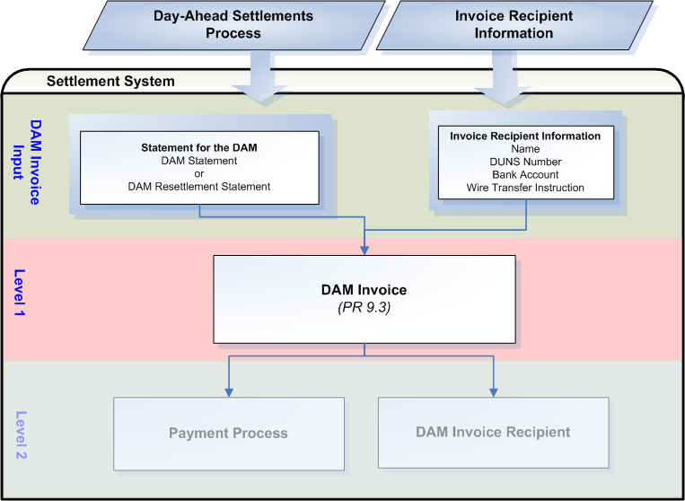

Assumptions
A1) ERCOT Registration will make available to the settlement system all Market Participant data required for the creation of DAM Invoices, such as:
- Market Participant Name
- Market Participant DUNS number
- Market Participant Bank Name
- Market Participant Bank Account Number
- Specific wire transfer instructions of the Invoice Recipient’s bank account, including Bank ABA Routing number.

A2) Accessibility of Invoices shall be consistent with the accessibility of statements. ERCOT suggests a protocol revision to add Invoice access to Nodal Protocol Section 9.1.3.

A3) The DAM Invoice shall include the Invoice Recipient’s name. ERCOT suggests a protocol revision to include Invoice Recipient’s name to the list of items required for DAM Invoices in Nodal Protocol Section 9.3(3).

A4) The DAM Invoice shall include ERCOT’s unique identifier for that Invoice Recipient. ERCOT suggests a protocol revision to include ERCOT’s unique identifier for the Invoice Recipient to the list of items required for DAM Invoices in Nodal Protocol Section 9.3(3).

A5) The Settlement Calendar data required by DAM Invoices pertinent to Invoice dates and due dates will be stored in a user-maintained centralized area.

See TN.COMS.63CO1.STATEMENT.REQUIREMENTS.A for more information on the Settlement Calendar.

A6) The DAM Invoice due date, with funds owed from the Invoice Recipient to ERCOT, shall be the 4th Bank Business Day after the DAM Invoice date. ERCOT suggests a protocol revision to change the DAM Invoice due date from the 4th Business Day to the 4th Bank Business Day after the DAM Invoice Date in Nodal Protocol Section 9.4.1(1), Invoice Recipient Payment to ERCOT for the DAM.

Business Rules
Req. ID | Protocol(s) | Sub-Process Map | Description
FR1 | PR 9.1.3  PR 9.3(1) | CSWM.  P03SettleBillTransfer | DAM Invoices must be made available to the Invoice Recipient via:  - Secured entry on the MIS Certified Area; and  - eXtensible Markup Language (XML) access to the MIS Certified Area  ( See Assumption A2)
FR2 | PR 9.1.4  PR 9.3(1) | CSWM.  P03SettleBillTransfer | The publication of each DAM Invoice can occur as late as 2400 on its issue date.
FR3 | PR 9.1.5 | CSWM.  P03SettleBillTransfer | DAM Invoice payment conventions must reflect:  - for an amount due from ERCOT to the Invoice Recipient, a negative amount  - for an amount due to ERCOT from the Invoice Recipient, a positive amount
FR4 | PR 9.3(1)  PR 9.3(2) | CSWM.  P03SettleBillTransfer | ERCOT shall create a DAM Invoice for each statement for the DAM, including both DAM Statements and DAM Resettlement Statements, by Invoice Recipient.
FR5 | PR 9.3(1) | CSWM.  P03SettleBillTransfer | ERCOT shall make each DAM Invoice, based on a DAM Statement, available on the date specified on the Settlement Calendar for that DAM Invoice for the applicable Invoice Recipient which shall be the 2nd Business Day after the Operating Day.
FR6 | PR 9.3(2) | CSWM.  P03SettleBillTransfer | ERCOT shall make each DAM Invoice, based on a DAM Resettlement Statement, available on the same Business Day as the day that the DAM Resettlement Statement is posted to the MIS Certified Area.
FR7 | PR 9.4.1(1) | CSWM.  P03SettleBillTransfer | The due date and time for each DAM Invoice with payments due to ERCOT from the Invoice Recipient is 1700 on the 4th Bank Business Day after DAM Invoice Date. If the 4th Bank Business Day is not a Business Day, then the DAM Invoice is due on the next day that is both a Business Day and Bank Business Day.
FR8 | PR 9.4.2(1) | CSWM.  P03SettleBillTransfer | The due date and time for each DAM Invoice with payments from ERCOT to the Invoice Recipient is 1700 on the day that follows the date when payments are due in to ERCOT from the Invoice Recipients, for that DAM Invoice. This day must be both a Business Day and a Bank Business Day.
FR9 | PR 9.3(3) | CSWM.  P03SettleBillTransfer | Each DAM Invoice must contain the Invoice Recipient’s name.  Invoice Recipient name = QSE or CRR Owner Name  (See Assumption A3)
FR10 | PR 9.3(3) | CSWM.  P03SettleBillTransfer | Each DAM Invoice must contain ERCOT’s unique identifier for that Invoice Recipient.  Invoice Recipient unique identifier = code associated with QSE or CRR Owner (DUNs Number)  (See Assumption A4)
FR11 | PR 9.3(3a) | CSWM.  P03SettleBillTransfer | Each DAM Invoice must contain the Net Amount Due or Payable – the aggregate summary of all charges owed by, or due to, an Invoice Recipient for the DAM.  NET AMT DUE/PAYABLE = DAM Statement or DAM Resettlement Statement Total
FR12 | PR 9.3(3b) | CSWM.  P03SettleBillTransfer | Each DAM Invoice must contain the time period covered for each line item.  Time Period = Operating Day
FR13 | PR 9.3(3c) | CSWM.  P03SettleBillTransfer | Each DAM Invoice must contain the date in which the DAM Invoice was issued.
FR14 | PR 9.3(3d) | CSWM.  P03SettleBillTransfer | Each DAM Invoice must contain the unique number generated by the ERCOT applications for payment tracking purposes.  DAM Invoice Number = numbering specific to DAM Invoices
FR15 | PR 9.3(3e) | CSWM.  P03SettleBillTransfer | Each DAM Invoice must contain an identification code used to reference the Settlement Statement invoiced.  Statement Identification Code = Statement Number
FR16 | PR 9.3(3f) | CSWM.  P03SettleBillTransfer | Each DAM Invoice must contain the date and time that DAM Invoice amounts must be paid or received.
FR17 | PR 9.3(3g) | CSWM.  P03SettleBillTransfer | Each DAM Invoice must contain payment remittance details, including:  - ERCOT bank account number  - ERCOT bank name  - Wire transfer instructions of the ERCOT account to which any amounts owed by the Invoice Recipient are to be paid, including Bank ABA Routing number.  - Wire transfer instructions of the Invoice Recipient’s account to which ERCOT may draw payments due, including Bank ABA Routing number.
FR18 | PR 9.3(3h) | CSWM.  P03SettleBillTransfer | Each DAM Invoice must contain the terms that would be applied if payments are received late.

Business Defined Errors
None

Specific Database Needs
Req. ID | Protocol(s) | Sub-Process Map | Description
FR19 | PR 9.3 | CSWM.  P03SettleBillTransfer | An approval control mechanism is required so that only approved DAM Invoices are sent to Invoice Recipients. The approval control mechanism must contain record of when and by whom invoices were approved.
FR20 | PR 9.3 | CSWM.  P03SettleBillTransfer | All required data must be populated and viewable for each DAM Invoice prior to approval.
FR21 | PR 9.3 | CSWM.  P03SettleBillTransfer | The due dates of DAM Invoices and dates ERCOT shall pay out to DAM Invoice Recipients shall be stored and maintained in a centralized area and configured in such a way that they can be easily updated by the Business Analyst.

RTM Invoices
ERCOT shall prepare RTM Invoices on a net basis for each RTM Invoice Cycle for each RTM Invoice Recipient. RTM Invoices are based on RTM Initial Statements, RTM Final Statements, RTM True-Up Statements, and RTM Resettlement Statements.

Dependencies
D1) RTM Invoices are dependent on the availability of:
- RTM Initial Statements posted within the Invoice Cycle
- RTM Final Statements posted within the Invoice Cycle
- RTM Trueup Statements posted within the Invoice Cycle
- RTM Resettlement Statements posted within the Invoice Cycle
- Invoice Recipient account information

D2) RTM Invoices must be created prior:
- to posting to Invoice Recipients
- the financial transfer process for that RTM Invoice

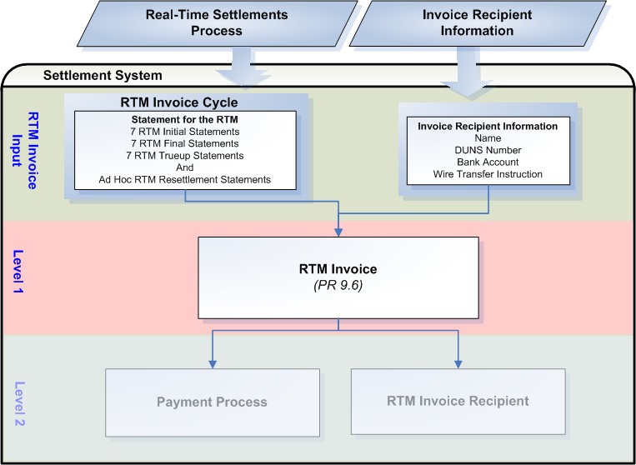

Assumptions
A1) ERCOT Registration will make available to the settlement system all Market Participant data required for the creation of RTM Invoices, such as:
- Market Participant Name
- Market Participant DUNS number
- Market Participant Bank Name
- Market Participant Bank Account Number
- Specific wire transfer instructions of the Invoice Recipient’s bank account, including Bank ABA Routing number.

A2) Accessibility of Invoices shall be consistent with the accessibility of statements. ERCOT suggests a protocol revision to add Invoice access to Nodal Protocol Section 9.1.3.

A3) The RTM Invoice shall include the Invoice Recipient’s name. ERCOT suggests a protocol revision to include Invoice Recipient’s name to the list of items required for RTM Invoices in Nodal Protocol Section 9.6(4).

A4) The RTM Invoice shall include ERCOT’s unique identifier for that Invoice Recipient. ERCOT suggests a protocol revision to include ERCOT’s unique identifier for the Invoice Recipient to the list of items required for RTM Invoices in Nodal Protocol Section 9.6(4).

A5) The Settlement Calendar data required by RTM Invoices pertinent to Invoice dates and due dates will be stored in a user-maintained centralized area.

See TN.COMS.63CO1.STATEMENT.REQUIREMENTS.A for more information on the Settlement Calendar.

Business Rules
Req. ID | Protocol(s) | Sub-Process Map | Description
FR22 | PR 9.1.3  PR 9.6(1)  PR 9.6(3) | CSWM.  P03SettleBillTransfer | RTM Invoices must be made available to the Invoice Recipient via:  - Secured entry on the MIS Certified Area; and  - eXtensible Markup Language (XML) access to the MIS Certified Area  ( See Assumption A2)
FR23 | PR 9.1.4 | CSWM.  P03SettleBillTransfer | The publication of each RTM Invoice can occur as late as 2400 on its issue date.
FR24 | PR 9.1.5 | CSWM.  P03SettleBillTransfer | RTM Invoice payment conventions must reflect:  - for an amount due from ERCOT to the Invoice Recipient, a negative amount  - for an amount due to ERCOT from the Invoice Recipient, a positive amount
FR25 | PR 9.6(1) | CSWM.  P03SettleBillTransfer | ERCOT shall create a RTM Invoice weekly on a net basis, by Invoice Recipient.
FR26 | PR 9.6(1)  PR 9.6(3) | CSWM.  P03SettleBillTransfer | ERCOT shall make each RTM Invoice available on the date specified on the Settlement Calendar for that RTM Invoice for the applicable Invoice Recipient which shall be on a Thursday. Should the Thursday not be a Business Day, the RTM Invoice will be available on the next day that is a Business Day.
FR27 | PR 9.7.1(1) | CSWM.  P03SettleBillTransfer | The due date and time for each RTM Invoice with payments due to ERCOT from the Invoice Recipient is 1700 on the 5th Bank Business Day after RTM Invoice Date. If the 5th Bank Business Day is not a Business Day, then the RTM Invoice is due on the next day that is both a Business Day and Bank Business Day.
FR28 | PR 9.7.2(1) | CSWM.  P03SettleBillTransfer | The due date and time for each RTM Invoice with payments from ERCOT to the Invoice Recipient is 1700 on the day that follows the date when payments are due in to ERCOT from the Invoice Recipients, for that RTM Invoice. This day must be both a Business Day and a Bank Business Day.
FR29 | PR 9.6(4)  PR 9.6(3)  PR 9.5.6(5) | CSWM.  P03SettleBillTransfer | RTM Invoice items must be grouped by Initial, Final, Resettlement, and True-Up categories, subtotaled, and must be sorted by Operating Day within each category for statements posted within the RTM Invoice Cycle.
FR30 | PR 9.6(4) | CSWM.  P03SettleBillTransfer | Each RTM Invoice must contain the Invoice Recipient’s name.  Invoice Recipient name = QSE or CRR Owner Name  ( See Assumption A3)
FR31 | PR 9.6(4) | CSWM.  P03SettleBillTransfer | Each RTM Invoice must contain ERCOT’s unique identifier for that Invoice Recipient.  Invoice Recipient unique identifier = code associated with QSE or CRR Owner (DUNs Number)  ( See Assumption A4)
FR32 | PR 9.6(4a) | CSWM.  P03SettleBillTransfer | Each RTM Invoice must contain the Net Amount Due or Payable – the aggregate summary of all charges owed by, or due to, an Invoice Recipient summarized by Operating Day.
FR33 | PR 9.6(4b) | CSWM.  P03SettleBillTransfer | Each RTM Invoice must contain the time period covered for each line item.  Time Period = Operating Day
FR34 | PR 9.6(4c) | CSWM.  P03SettleBillTransfer | Each RTM Invoice must contain the date in which the RTM Invoice was issued.
FR35 | PR 9.6(4d) | CSWM.  P03SettleBillTransfer | Each RTM Invoice must contain the unique number generated by the ERCOT applications for payment tracking purposes.  RTM Invoice Number = numbering specific to RTM Invoices
FR36 | PR 9.6(4e) | CSWM.  P03SettleBillTransfer | Each RTM Invoice must contain an identification code used to reference each Settlement Statement invoiced.  Statement Identification Code = Statement Number and Settlement Run number
FR37 | PR 9.6(4f) | CSWM.  P03SettleBillTransfer | Each RTM Invoice must contain the date and time that RTM Invoice amounts must be paid or received.
FR38 | PR 9.6(4g) | CSWM.  P03SettleBillTransfer | Each RTM Invoice must contain payment remittance details, including:  - ERCOT bank account number  - ERCOT bank name  - Wire transfer instructions of the ERCOT account to which any amounts owed by the Invoice Recipient are to be paid, including Bank ABA Routing number.  - Wire transfer instructions of the Invoice Recipient’s account to which ERCOT may draw payments due, including Bank ABA Routing number.
FR39 | PR 9.6(4h) | CSWM.  P03SettleBillTransfer | Each RTM Invoice must contain the terms that would be applied if payments are received late.

Business Defined Errors
None

Specific Database Needs
Req. ID | Protocol(s) | Sub-Process Map | Description
FR40 | PR 9.6 | CSWM.  P03SettleBillTransfer | An approval control mechanism is required so that only approved RTM Invoices are sent to Invoice Recipients. The approval control mechanism must contain record of when and by whom invoices were approved.
FR41 | PR 9.6 | CSWM.  P03SettleBillTransfer | All required data must be populated and viewable for each RTM Invoice prior to approval.
FR42 | PR 9.6 | CSWM.  P03SettleBillTransfer | The due dates of RTM Invoices and dates ERCOT shall pay out to RTM Invoice Recipients shall be stored and maintained in a centralized area and configured in such a way that they can be easily updated by the Business Analyst.
FR43 | PR 9.6 | CSWM.  P03SettleBillTransfer | Functionality is required to remove or add statements scheduled or not scheduled to be included in on the RTM Invoice.
FR43 | PR 22 Attachment H (11L) | CSWM.  P03SettleBillTransfer | In the situation of bankruptcy, ERCOT is required to treat pre-petition activity differently from post-petition activity per bankruptcy law. To accomplish this, ERCOT must track pre-petition activity separately from post petition activity. Pre-petition activity is all activity on operating days up to and including the date bankruptcy is filed. Post-petition activity is activity on all operating days after the date bankruptcy is filed. Functionality is required to allow the Invoice Generation System to create two separate RTM Invoices for the same RTM Billing Cycle and Invoice Recipient in this situation. One Invoice shall be for pre-petition Operating Day amounts and one Invoice shall be for post-petition Operating Day amounts, based on the date bankruptcy is filed.

DAM Late Fee Invoices
ERCOT shall produce a monthly DAM Late Fee Invoice on a net basis for each DAM Invoice Recipient with unpaid balances. Each Invoice Recipient who did not pay their DAM Invoice in full or who was not paid in full for their DAM Invoice, and for which late fees were calculated during the Late Fee Invoice Cycle, will receive a DAM Late Fee Invoice.

Dependencies
D1) DAM Late Fee Invoices are dependent on the availability of:
- Calculated Late Fees on unpaid DAM Invoices for the month in which the DAM Late Fee Invoice is generated
- Invoice Recipient account information.

D2) DAM Late Fee Invoices must be created prior:
- to posting to Invoice Recipients
- the financial transfer process for that DAM Late Fee Invoice

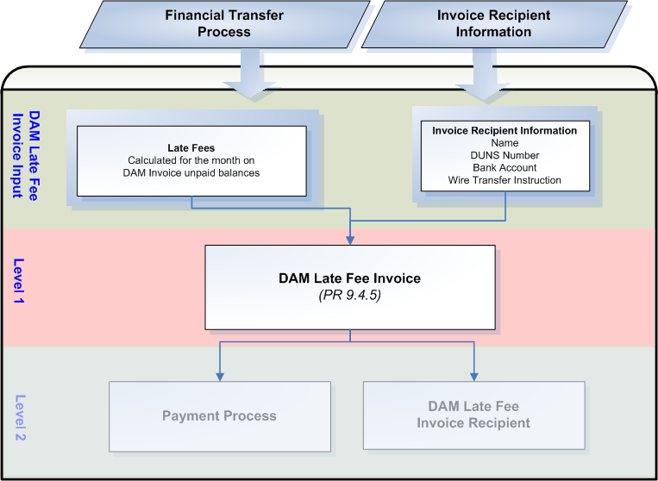

Assumptions
A1) All Market Participant data required for the creation of DAM Late Fee Invoices will be made available by ERCOT Registration, such as:
- Market Participant Name
- Market Participant DUNS number
- Market Participant Bank Name
- Market Participant Bank Account Number
- Specific wire transfer instructions of the Invoice Recipient’s bank account, including Bank ABA Routing number.

A2) Accessibility of Invoices shall be consistent with the accessibility of statements. ERCOT suggests a protocol revision to add Invoice access to Nodal Protocol Section 9.1.3.

A3) The DAM Late Fee Invoice shall include the Invoice Recipient’s name. ERCOT suggests a protocol revision to include Invoice Recipient’s name to the list of items required for DAM Late Fee Invoices in Nodal Protocol Section 9.4.5(9).

A4) The DAM Late Fee Invoice shall include ERCOT’s unique identifier for that Invoice Recipient. ERCOT suggests a protocol revision to include ERCOT’s unique identifier for the Invoice Recipient to the list of items required for DAM Late Fee Invoices in Nodal Protocol Section 9.4.5(9).

A5) If there are no DAM Late Fees calculated within the month, ERCOT shall not post zero value DAM Late Fee Invoices for that month. The Market shall be notified if this condition occurs.

A6) The Settlement Calendar data required by DAM Late Fee Invoices pertinent to Invoice dates and due dates will be stored in a user-maintained centralized area.

See TN.COMS.63CO1.STATEMENT.REQUIREMENTS.A for more information on the Settlement Calendar.

A7) The DAM Late Fee Invoice due date, with funds owed from the Invoice Recipient to ERCOT, shall be the 4th Bank Business Day after the DAM Late Fee Invoice date. ERCOT suggests a protocol revision to change the DAM Late Fee Invoice due date from the 4th Business Day to the 4th Bank Business Day after the DAM Late Fee Invoice Date in Nodal Protocol Section 9.4.5(5), Late Fees and Late Fee Invoice for the DAM.

Business Rules
Req. ID | Protocol(s) | Sub-Process Map | Description
FR44 | PR 9.1.3  PR 9.4.5(3) | CSWM.  P03SettleBillTransfer | DAM Late Fee Invoices must be made available to the Invoice Recipient via:  - Secured entry on the MIS Certified Area; and  - eXtensible Markup Language (XML) access to the MIS Certified Area  ( See Assumption A2)
FR45 | PR 9.1.4  PR 9.4.5(4) | CSWM.  P03SettleBillTransfer | The publication of each DAM Late Fee Invoice can occur as late as 2400 on its issue date.
FR46 | PR 9.1.5 | CSWM.  P03SettleBillTransfer | DAM Late Fee Invoice payment conventions must reflect:  - for an amount due from ERCOT to the Invoice Recipient, a negative amount  - for an amount due to ERCOT from the Invoice Recipient, a positive amount
FR47 | PR 9.4.5(3) | CSWM.  P03SettleBillTransfer | ERCOT shall create a DAM Late Fee Invoice for each DAM Invoice Recipient for which late fees have been calculated on an unpaid DAM Invoice balance during the Late Fee Invoice Cycle.
FR48 | PR 9.4.5(3)  PR 9.4.5(4) | CSWM.  P03SettleBillTransfer | ERCOT shall make each DAM Late Fee Invoice available on the date specified on the Settlement Calendar for that DAM Late Fee Invoice for the applicable Invoice Recipient which shall be the 10th calendar day after the end of the month, unless the 10th day is not a Business Day. If the 10th calendar day is not a Business Day, then ERCOT shall issue the DAM Late Fee Invoice on the next Business Day after 10th calendar day.
FR49 | PR 9.4.5(5) | CSWM.  P03SettleBillTransfer | The due date and time for each DAM Late Fee Invoice with payments due to ERCOT from the Invoice Recipient is 1700 on the 4th Bank Business Day after DAM Late Fee Invoice Date. If the 4th Bank Business Day is not a Business Day, then the DAM Late Fee Invoice is due on the next day that is both a Business Day and Bank Business Day.
FR50 | PR 9.4.5(7) | CSWM.  P03SettleBillTransfer | The due date and time for each DAM Late Fee Invoice with payments from ERCOT to the Invoice Recipient is 1700 on the day that follows the date when payments are due to ERCOT from the Invoice Recipients, for that DAM Late Fee Invoice. This day must be both a Business Day and a Bank Business Day.
FR51 | PR 9.4.5(9) | CSWM.  P03SettleBillTransfer | Each DAM Late Fee Invoice must contain the Invoice Recipient’s name.  Invoice Recipient name = QSE or CRR Owner Name  ( See Assumption A3)
FR52 | PR 9.4.5(9) | CSWM.  P03SettleBillTransfer | Each DAM Late Fee Invoice must contain ERCOT’s unique identifier for that Invoice Recipient.  Invoice Recipient unique identifier = code associated with QSE or CRR Owner (DUNs Number)  ( See Assumption A4)
FR53 | PR 9.4.5(9a) | CSWM.  P03SettleBillTransfer | Each DAM Late Fee Invoice must contain the Net Amount Due or Payable – the aggregate summary of all charges or credits owed or due by an Invoice Recipient.
FR54 | PR 9.4.5(9b) | CSWM.  P03SettleBillTransfer | DAM Late Fee Invoice line items must contain:  - Dates for which DAM Late Fees are calculated;  - DAM Late Fee amounts calculated for each day; and  - Unpaid DAM Invoice Numbers for which late fees are calculated.
FR55 | PR 9.4.5(9c) | CSWM.  P03SettleBillTransfer | Each DAM Late Fee Invoice must contain the date in which the DAM Late Fee Invoice was issued.
FR56 | PR 9.4.5(9d) | CSWM.  P03SettleBillTransfer | Each DAM Late Fee Invoice must contain the unique number generated by the ERCOT applications for payment tracking purposes.  DAM Late Fee Invoice Number = numbering specific to DAM Late Fee Invoices
FR57 | PR 9.4.5(9e) | CSWM.  P03SettleBillTransfer | Each DAM Late Fee Invoice must contain the date and time that DAM Late Fee Invoice amounts must be paid or received.
FR58 | PR 9.4.5(9f) | CSWM.  P03SettleBillTransfer | Each DAM Late Fee Invoice must contain payment remittance details, including:  - ERCOT bank account number  - ERCOT bank name  - Wire transfer instructions of the ERCOT account to which any amounts owed by the Invoice Recipient are to be paid, including Bank ABA Routing number.  - Wire transfer instructions of the Invoice Recipient’s account to which ERCOT may draw payments due, including Bank ABA Routing number.
FR59 | PR 9.4.5(9g) | CSWM.  P03SettleBillTransfer | Each DAM Late Fee Invoice must contain the terms that would be applied if payments are received late.  Overdue Terms = None

Business Defined Errors
Req. ID | Protocol(s) | Sub-Process Map | Description
FR60 | PR 9.4.5 | CSWM.  P03SettleBillTransfer | While generating DAM Late Fee Invoices, if there are no late fee charges or credits calculated for unpaid DAM Invoices in the Invoice Generating System for the month in which the DAM Late Fee Invoices are being generated, the system should not create DAM Late Fee Invoices for the month and provide an error message indicating “No DAM Late Fee Charges or Credits are available for processing DAM Late Fee Invoices for DAM Late Fee Invoice Cycle <MMDDYY>”. There should be no Late Fee Charges or Credits resulting from any unpaid DAM Invoices for any Invoice Recipient for the month for this condition to occur.

Specific Database Needs
Req. ID | Protocol(s) | Sub-Process Map | Description
FR61 | PR 9.4.5 | CSWM.  P03SettleBillTransfer | An approval control mechanism is required so that only approved DAM Late Fee Invoices are sent to Invoice Recipients. The approval control mechanism must contain record of when and by whom invoices were approved.
FR62 | PR 9.4.5 | CSWM.  P03SettleBillTransfer | All required data must be populated and viewable for each DAM Late Fee Invoice prior to approval.
FR63 | PR 9.4.5 | CSWM.  P03SettleBillTransfer | The due dates of DAM Late Fee Invoices and dates ERCOT shall pay out to DAM Late Fee Invoice Recipients shall be stored and maintained in a centralized area and configured in such a way that they can be easily updated by the Business Analyst.
FR64 | PR 9.4.5 | CSWM.  P03SettleBillTransfer | If ERCOT is instructed to reverse late fee charges, DAM Late Fee Invoices must be able to reflect the reversal of late fee charges and credits.

RTM Late Fee Invoices
ERCOT shall produce a monthly RTM Late Fee Invoice on a net basis for each RTM and RTM Uplift Invoice Recipient with unpaid balances. Each Invoice Recipient who did not pay their RTM or RTM Uplift Invoice in full or who was not paid in full for their RTM Invoice, and for which late fees were calculated during the Late Fee Invoice Cycle, will receive an RTM Late Fee Invoice.

Dependencies
D1) RTM Late Fee Invoices are dependent on the availability of:
- Calculated Late Fees on unpaid RTM Invoices for the month in which the RTM Late Fee Invoice is generated
- Calculated Late Fees on unpaid RTM Uplift Invoices for the month in which the RTM Late Fee Invoice is generated
- Invoice Recipient account information.

D2) RTM Late Fee Invoices must be created prior:
- to posting to Invoice Recipients
- the financial transfer process for that RTM Late Fee Invoice

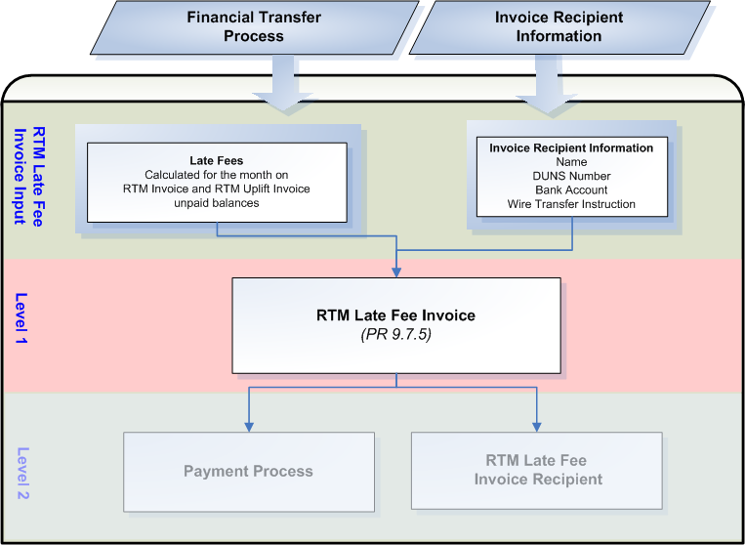

Assumptions
A1) All Market Participant data required for the creation of RTM Late Fee Invoices will be made available by ERCOT Registration, such as:
- Market Participant Name
- Market Participant DUNS number
- Market Participant Bank Name
- Market Participant Bank Account Number
- Specific wire transfer instructions of the Invoice Recipient’s bank account, including Bank ABA Routing number.

A2) Accessibility of Invoices shall be consistent with the accessibility of statements. ERCOT suggests a protocol revision to add Invoice access to Nodal Protocol Section 9.1.3.

A3) The RTM Late Fee Invoice shall include the Invoice Recipient’s name. ERCOT suggests a protocol revision to include Invoice Recipient’s name to the list of items required for RTM Late Fee Invoices in Nodal Protocol Section 9.7.5(9).

A4) The RTM Late Fee Invoice shall include ERCOT’s unique identifier for that Invoice Recipient. ERCOT suggests a protocol revision to include ERCOT’s unique identifier for the Invoice Recipient to the list of items required for RTM Late Fee Invoices in Nodal Protocol Section 9.7.5(9).

A5) If there are no RTM Late Fees calculated within the month, ERCOT shall not post zero value RTM Late Fee Invoices for that month. The Market shall be notified if this condition occurs.

A6) The Settlement Calendar data required by RTM Late Fee Invoices pertinent to Invoice dates and due dates will be stored in a user-maintained centralized area.

See TN.COMS.63CO1.STATEMENT.REQUIREMENTS.A for more information on the Settlement Calendar.

A7) The RTM Late Fee Invoice due date, with funds owed from the Invoice Recipient to ERCOT, shall be the 4th Bank Business Day after the RTM Late Fee Invoice date. ERCOT suggests a protocol revision to change the RTM Late Fee Invoice due date from the 4th Business Day to the 4th Bank Business Day after the RTM Late Fee Invoice Date in Nodal Protocol Section 9.7.5(5), Late Fees and Late Fee Invoice for the RTM.

Business Rules
Req. ID | Protocol(s) | Sub-Process Map | Description
FR65 | PR 9.1.3  PR 9.7.5(3) | CSWM.  P03SettleBillTransfer | RTM Late Fee Invoices must be made available to the Invoice Recipient via:  - Secured entry on the MIS Certified Area; and  - eXtensible Markup Language (XML) access to the MIS Certified Area  ( See Assumption A2)
FR66 | PR 9.1.4  PR 9.7.5(4) | CSWM.  P03SettleBillTransfer | The publication of each RTM Late Fee Invoice can occur as late as 2400 on its issue date.
FR67 | PR 9.1.5 | CSWM.  P03SettleBillTransfer | RTM Late Fee Invoice payment conventions must reflect:  - for an amount due from ERCOT to the Invoice Recipient, a negative amount  - for an amount due to ERCOT from the Invoice Recipient, a positive amount
FR68 | PR 9.7.5(3)  PR 9.7.3(g) | CSWM.  P03SettleBillTransfer | ERCOT shall create a RTM Late Fee Invoice for each RTM and RTM Uplift Invoice Recipient for which late fees have been calculated on an unpaid RTM or RTM Uplift Invoice balance during the Late Fee Invoice Cycle.
FR69 | PR 9.7.5(3)  PR 9.7.5(4) | CSWM.  P03SettleBillTransfer | ERCOT shall make each RTM Late Fee Invoice available on the date specified on the Settlement Calendar for that RTM Late Fee Invoice for the applicable Invoice Recipient which shall be the 10th calendar day after the end of the month, unless the 10th day is not a Business Day. If the 10th calendar day is not a Business Day, then ERCOT shall issue the RTM Late Fee Invoice on the next Business Day after 10th calendar day.
FR70 | PR 9.7.5(5) | CSWM.  P03SettleBillTransfer | The due date and time for each RTM Late Fee Invoice with payments due to ERCOT from the Invoice Recipient is 1700 on the 4th Bank Business Day after RTM Late Fee Invoice Date. If the 4th Bank Business Day is not a Business Day, then the RTM Late Fee Invoice is due on the next day that is both a Business Day and Bank Business Day.
FR71 | PR 9.7.5(7) | CSWM.  P03SettleBillTransfer | The due date and time for each RTM Late Fee Invoice with payments from ERCOT to the Invoice Recipient is 1700 on the day that follows the date when payments are due in to ERCOT from the Invoice Recipients, for that RTM Late Fee Invoice. This day must be both a Business Day and a Bank Business Day.
FR72 | PR 9.7.5(9) | CSWM.  P03SettleBillTransfer | Each RTM Late Fee Invoice must contain the Invoice Recipient’s name.  Invoice Recipient name = QSE or CRR Owner Name  ( See Assumption A3)
FR73 | PR 9.7.5(9) | CSWM.  P03SettleBillTransfer | Each RTM Late Fee Invoice must contain ERCOT’s unique identifier for that Invoice Recipient.  Invoice Recipient unique identifier = code associated with QSE or CRR Owner (DUNs Number)  ( See Assumption A4)
FR74 | PR 9.7.5(9a) | CSWM.  P03SettleBillTransfer | Each RTM Late Fee Invoice must contain the Net Amount Due or Payable – the aggregate summary of all charges or credits owed or due by an Invoice Recipient.
FR75 | PR 9.7.5(9b) | CSWM.  P03SettleBillTransfer | RTM Late Fee Invoice line items must contain:  - Dates for which RTM Late Fees are calculated;  - RTM Late Fee amounts calculated for each day; and  - Unpaid RTM or RTM Uplift Invoice Numbers for which late fees are calculated.
FR76 | PR 9.7.5(9c) | CSWM.  P03SettleBillTransfer | Each RTM Late Fee Invoice must contain the date in which the RTM Late Fee Invoice was issued.
FR77 | PR 9.7.5(9d) | CSWM.  P03SettleBillTransfer | Each RTM Late Fee Invoice must contain the unique number generated by the ERCOT applications for payment tracking purposes.  RTM Late Fee Invoice Number = numbering specific to RTM Late Fee Invoices
FR78 | PR 9.7.5(9e) | CSWM.  P03SettleBillTransfer | Each RTM Late Fee Invoice must contain the date and time that RTM Late Fee Invoice amounts must be paid or received.
FR79 | PR 9.7.5(9f) | CSWM.  P03SettleBillTransfer | Each RTM Late Fee Invoice must contain payment remittance details, including:  - ERCOT bank account number  - ERCOT bank name  - Wire transfer instructions of the ERCOT account to which any amounts owed by the Invoice Recipient are to be paid, including Bank ABA Routing number.  - Wire transfer instructions of the Invoice Recipient’s account to which ERCOT may draw payments due, including Bank ABA Routing number.
FR80 | PR 9.7.5(9g) | CSWM.  P03SettleBillTransfer | Each RTM Late Fee Invoice must contain the terms that would be applied if payments are received late.  Overdue Terms = None

Business Defined Errors
Req. ID | Protocol(s) | Sub-Process Map | Description
FR81 | PR 9.7.5 | CSWM.  P03SettleBillTransfer | While generating RTM Late Fee Invoices, if there are no late fee charges or credits calculated for unpaid RTM Invoices or RTM Uplift Invoices in the Invoice Generating System for the month in which the RTM Late Fee Invoices are being generated, the system should not create RTM Late Fee Invoices for the month and provide an error message indicating “No RTM Late Fee Charges or Credits are available for processing RTM Late Fee Invoices for RTM Late Fee Invoice Cycle <MMDDYY>”. There should be no Late Fee Charges or Credits resulting from any unpaid RTM or RTM Uplift Invoices for any Invoice Recipient for the month for this condition to occur.

Specific Database Needs
Req. ID | Protocol(s) | Sub-Process Map | Description
FR82 | PR 9.7.5 | CSWM.  P03SettleBillTransfer | An approval control mechanism is required so that only approved RTM Late Fee Invoices are sent to Invoice Recipients. The approval control mechanism must contain record of when and by whom invoices were approved.
FR83 | PR 9.7.5 | CSWM.  P03SettleBillTransfer | All required data must be populated and viewable for each RTM Late Fee Invoice prior to approval.
FR84 | PR 9.7.5 | CSWM.  P03SettleBillTransfer | The due dates of RTM Late Fee Invoices and dates ERCOT shall pay out to RTM Late Fee Invoice Recipients shall be stored and maintained in a centralized area and configured in such a way that they can be easily updated by the Business Analyst.
FR85 | PR 9.4.5 | CSWM.  P03SettleBillTransfer | If ERCOT is instructed to reverse late fee charges, RTM Late Fee Invoices must be able to reflect the reversal of late fee charges and credits.

CRR Auction Invoices
ERCOT shall prepare CRR Auction Invoices on net basis, for each CRR Account Holder, of CRRs bought and sold in each CRR Auction.

Dependencies
D1) CRR Auction Invoices are dependent on the availability of:
- Invoice Recipient account information.
- CRR Auction payment and charge results

D2) CRR Auction Invoices must be created prior:
- to posting to Invoice Recipients
- the financial transfer process for that CRR Auction Invoice

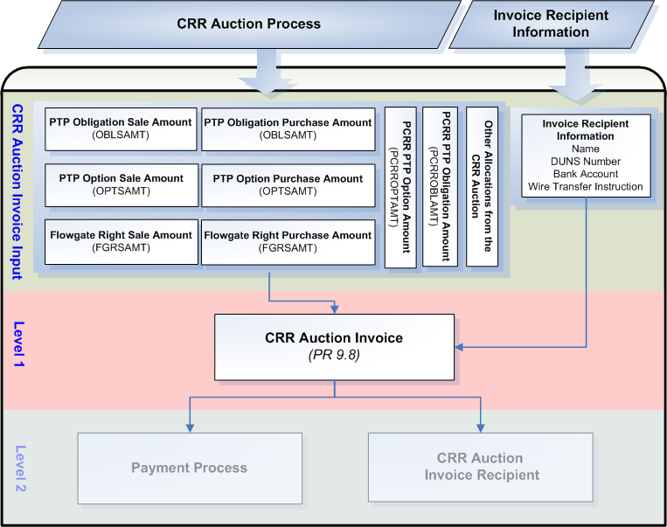

Assumptions
A1) All CRR Account Holder data required for the creation of CRR Auction Invoices will be made available by ERCOT Registration, such as:
- CRR Account Holder Name
- CRR Account Holder DUNS number
- CRR Account Holder Bank Name
- CRR Account Holder Bank Account Number
- Specific wire transfer instructions of the Invoice Recipient’s bank account, including Bank ABA Routing number.

A2) The CRR Auction Engine will perform all calculations pertaining to payments and charges resulting from a CRR Auction.

A3) Accessibility of Invoices shall be consistent with the accessibility of statements. ERCOT suggests a protocol revision to add Invoice access to Nodal Protocol Section 9.1.3.

A4) The CRR Auction Invoice shall include the Invoice Recipient’s name. ERCOT suggests a protocol revision to include Invoice Recipient’s name to the list of items required for CRR Auction Invoices in Nodal Protocol Section 9.8(4).

A5) The CRR Auction Invoice shall include ERCOT’s unique identifier for that Invoice Recipient. ERCOT suggests a protocol revision to include ERCOT’s unique identifier for the Invoice Recipient to the list of items required for CRR Auction Invoices in Nodal Protocol Section 9.8(4).

A6) The CRR Auction Invoice must indicate:
- Time period for which the products cover (months and time of use blocks)
- Total MWs of product
- Clearing price
- Product total (in dollars)

A7) Zero balance CRR Auction Invoices shall be prepared for CRR Account Holders in the event that they are allocated PCRRs and/or MCFRIs at no charge. In addition, if the CRR Auction Invoice results in a zero balance due to the netting of CRRs bought and sold in the auction an invoice will be issued.

Business Rules
Req. ID | Protocol(s) | Sub-Process Map | Description
FR86 | PR 9.1.3  PR 9.8(1)  PR 9.8(3) | CSWM.  P03SettleBillTransfer | CRR Auction Invoices must be made available to the Invoice Recipient via:  - Secured entry on the MIS Certified Area; and  - eXtensible Markup Language (XML) access to the MIS Certified Area  ( See Assumption A3)
FR87 | PR 9.1.4  PR 9.8(1) | CSWM.  P03SettleBillTransfer | The publication of each CRR Auction Invoice can occur as late as 2400 on its issue date.
FR88 | PR 9.1.5 | CSWM.  P03SettleBillTransfer | CRR Auction Invoice payment conventions must reflect:  - for an amount due from ERCOT to the Invoice Recipient, a negative amount  - for an amount due to ERCOT from the Invoice Recipient, a positive amount
FR89 | PR 9.8(1)  PR 9.8(3) | CSWM.  P03SettleBillTransfer | ERCOT shall create a CRR Auction Invoice on a net basis for each CRR Account Holder with CRRs sold or purchased in the CRR Auction for which this CRR Auction Invoice is created.
FR90 | PR 9.8(1) | CSWM.  P03SettleBillTransfer | ERCOT shall make each CRR Auction Invoice available on the date specified on the Settlement Calendar for that CRR Auction Invoice for the applicable Invoice Recipient which shall be the 1st Business Day following the completion a CRR Auction.
FR91 | PR 9.8(3)  PR 9.8(3a)  PR 9.8(3b)  PR 9.8(3c)  PR 7.5.6.1(1)  PR 7.5.6.1(2)  PR 7.5.6.1(3)  PR 7.5.6.2(1)  PR 7.5.6.2(2)  PR 7.5.6.2(3)  PR 7.5.6.3(1)  PR 7.5.6.3(2) | CSWM.  P03SettleBillTransfer | Each CRR Auction Invoice must reflect CRR Auction charges, payments and allocations, which include:  - Payment of an Awarded CRR Auction Offer;  - PTP Obligation Sale Amount  - PTP Option Sale Amount  - Flowgate Right (FGR) Sale Amount  - Charge of an Awarded CRR Auction Bid;  - PTP Obligation Purchase Amount  - PTP Option Purchase Amount  - Flowgate Right (FGR) Purchase Amount  - Charge of PCRRs Pertaining to a CRR Auction  - PCRR PTP Obligation Amount  - PCRR PTP Option Amount  - Other allocations from the CRR Auction  See the CRR System Requirements Specification for further information on the CRR Auction Process.
FR92 | PR 9.9.1(1) | CSWM.  P03SettleBillTransfer | The due date and time for each CRR Auction Invoice with payments due to ERCOT from the Invoice Recipient is 1700 on the 3rd Bank Business Day after the CRR Auction Invoice date. If the 3rd Bank Business Day is not a Business Day, then the CRR Auction Invoice is due on the next day that is both a Business Day and Bank Business Day.
FR93 | PR 9.9.2(1) | CSWM.  P03SettleBillTransfer | The due date and time for each CRR Auction Invoice with payments from ERCOT to the Invoice Recipient is 1700 on the day that follows the date when payments are due in to ERCOT from the Invoice Recipients, for that CRR Auction Invoice. This day must be both a Business Day and a Bank Business Day.
FR94 | PR 9.8(4) | CSWM.  P03SettleBillTransfer | Each CRR Auction Invoice must contain the Invoice Recipient’s name.  Invoice Recipient name = CRR Account Holder Name  ( See Assumption A4)
FR95 | PR 9.8(4) | CSWM.  P03SettleBillTransfer | Each CRR Auction Invoice must contain ERCOT’s unique identifier for that Invoice Recipient.  Invoice Recipient unique identifier = code associated with CRR Account Holder (DUNs Number)  ( See Assumption A5)
FR96 | PR 9.8(4a) | CSWM.  P03SettleBillTransfer | Each CRR Auction Invoice must contain the Net Amount Due or Payable – the aggregate summary of all charges owed by, or due to, an Invoice Recipient summarized by CRR Auction.
FR97 | PR 9.8(4b) | CSWM.  P03SettleBillTransfer | Each CRR Auction Invoice must contain the time period.  Time Period = CRR Auction for which the Invoice is generated
FR98 | PR 9.8(4c) | CSWM.  P03SettleBillTransfer | Each CRR Auction Invoice must contain the date in which the CRR Auction Invoice was issued.
FR99 | PR 9.8(4d) | CSWM.  P03SettleBillTransfer | Each CRR Auction Invoice must contain the unique number generated by the ERCOT applications for payment tracking purposes.  CRR Auction Invoice Number = numbering specific to CRR Auction Invoices
FR100 | PR 9.8(4e) | CSWM.  P03SettleBillTransfer | Each CRR Auction Invoice must contain a description of each product awarded in, sold in, or allocated before the CRR Auction, including:  - Time period for which the products cover (months and time of use blocks)  - Total MWs of product  - Clearing price  - Product total (in dollars)  ( See Assumption A6)
FR101 | PR 9.8(4f) | CSWM.  P03SettleBillTransfer | Each CRR Auction Invoice must contain the date and time that CRR Auction Invoice amounts must be paid or received.
FR102 | PR 9.8(4g) | CSWM.  P03SettleBillTransfer | Each CRR Auction Invoice must contain payment remittance details, including:  - ERCOT bank account number  - ERCOT bank name  - Wire transfer instructions of the ERCOT account to which any amounts owed by the Invoice Recipient are to be paid, including Bank ABA Routing number.  - Wire transfer instructions of the Invoice Recipient’s account to which ERCOT may draw payments due, including Bank ABA Routing number.

Business Defined Errors
Req. ID | Protocol(s) | Sub-Process Map | Description
FR103 | PR 9.8 | CSWM.  P03SettleBillTransfer | While generating CRR Auction Invoices, if no CRR Auction payments, charges or allocations exist in the Invoice Generating System for the CRR Auction in which the CRR Auction Invoices are being generated, the system should not create CRR Auction Invoices and provide an error message indicating, “No CRR Auction results for CRR Auction <> are available for processing CRR Auction Invoices”. There should be no CRR Auction charges, payments or allocations for any CRR Account Holder for this condition to occur.

Specific Database Needs
Req. ID | Protocol(s) | Sub-Process Map | Description
FR104 | PR 9.8 | CSWM.  P03SettleBillTransfer | An approval control mechanism is required so that only approved CRR Auction Invoices are sent to Invoice Recipients. The approval control mechanism must contain record of when and by whom invoices were approved.
FR105 | PR 9.8 | CSWM.  P03SettleBillTransfer | All required data must be populated and viewable for each CRR Auction Invoice prior to approval.
FR106 | PR 9.8 | CSWM.  P03SettleBillTransfer | The due dates of CRR Auction Invoices and dates ERCOT shall pay out to CRR Auction Invoice Recipients shall be stored and maintained in a centralized area and configured in such a way that they can be easily updated by the Business Analyst.

CRR Auction Revenue Distribution Invoices
ERCOT shall prepare Invoices for distribution of CRR Auction Revenues (CARD Invoices) on a monthly basis. CARD Invoices will be issued after the RTM Initial Settlement Statement has been posted for the last Operating Day of the month and again after the RTM Final Settlement Statement has been issued for the last Operating Day of the month.

Dependencies
D1) CARD Invoices are dependent on the availability of:
- Invoice Recipient account information.
- Settlement calculation results of Charge Types that produce data required by Nodal Protocol Section 9.10(5) of the Nodal Protocols to be included on the monthly CARD Invoice.

D2) CARD Invoices must be created prior:
- to posting to Invoice Recipients
- the financial transfer process for that CARD Invoice

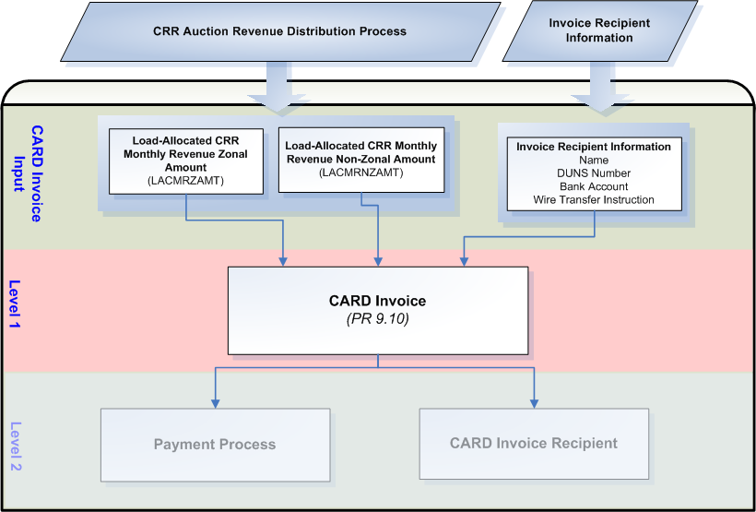

Assumptions
A1) All QSE data required for the creation of CARD Invoices will be made available by ERCOT Registration, such as:
- QSE Name
- QSE DUNS number
- QSE Bank Name
- QSE Bank Account Number
- Specific wire transfer instructions of the Invoice Recipient’s bank account, including Bank ABA Routing number.

A2) Accessibility of Invoices shall be consistent with the accessibility of statements. ERCOT suggests a protocol revision to add Invoice access to Nodal Protocol Section 9.1.3.

A3) The CARD Invoice shall include the Invoice Recipient’s name. ERCOT suggests a protocol revision to include Invoice Recipient’s name to the list of items required for CARD Invoices in Nodal Protocol Section 9.10(6).

A4) The CARD Invoice shall include ERCOT’s unique identifier for that Invoice Recipient. ERCOT suggests a protocol revision to include ERCOT’s unique identifier for the Invoice Recipient to the list of items required for CARD Invoices in Nodal Protocol Section 9.10(6).

Business Rules
Req. ID | Protocol(s) | Sub-Process Map | Description
FR107 | PR 9.1.3  PR 9.10(3)  PR 9.10(5) | CSWM.  P03SettleBillTransfer | CARD Invoices must be made available to the Invoice Recipient via:  - Secured entry on the MIS Certified Area; and  - eXtensible Markup Language (XML) access to the MIS Certified Area  ( See Assumption A2)
FR108 | PR 9.1.4  PR 9.10(1)  PR 9.10(2) | CSWM.  P03SettleBillTransfer | The publication of each CARD Invoice can occur as late as 2400 on its issue date.
FR109 | PR 9.1.5 | CSWM.  P03SettleBillTransfer | CARD Invoice payment conventions must reflect:  - for an amount due from ERCOT to the Invoice Recipient, a negative amount  - for an amount due to ERCOT from the Invoice Recipient, a positive amount
FR110 | PR 9.10(1) | CSWM.  P03SettleBillTransfer | ERCOT shall create CARD Invoices on a monthly basis for each applicable QSE.
FR111 | PR 9.10(2) | CSWM.  P03SettleBillTransfer | ERCOT shall true up the distribution of monthly CRR Auction Revenues by creating additional CARD Invoices for each month previously issued on a monthly basis for each applicable QSE.
FR112 | PR 9.10(1) | CSWM.  P03SettleBillTransfer | ERCOT shall make the 1st iteration of CARD Invoices for a month available on the date specified on the Settlement Calendar for that CARD Invoice for the applicable Invoice Recipient, which shall be monthly on the 1st Business Day following the RTM Initial Settlement posting of the last day of the month.
FR113 | PR 9.10(2) | CSWM.  P03SettleBillTransfer | ERCOT shall make the 2nd iteration of CARD Invoices for a month available on the date specified on the Settlement Calendar for that CARD Invoice for the applicable Invoice Recipient, which shall be monthly on the 1st Business Day following the RTM Final Settlement posting of the last day of the month.
FR114 | PR 9.10(2) | CSWM.  P03SettleBillTransfer | The 2nd iteration (trued up) CARD Invoice for a month will reflect differences to financial records generated on the 1st iteration of CARD Invoices for the same given month.
FR115 | PR 9.10(5)  PR 9.10(5a)  PR 9.10(5b)  PR 7.5.7(5)  PR 7.5.7(6) | CSWM.  P03SettleBillTransfer | Each CARD Invoice must reflect applicable charges and payments which include:  - For CRR Auction Revenue produced from CRRs, including PCRRs, cleared and paid for in each CRR Auction of the month that source and sink from the same 2003 ERCOT CM Zone;  - Load-Allocated CRR Monthly Revenue Zonal Amount  - For CRR Auction Revenue produced from CRRs cleared and paid for in each CRR Auction of the month that do not source and sink from the same 2003 ERCOT CM Zone;  - Load-Allocated CRR Monthly Revenue Non-Zonal Amount
FR116 | PR 9.11.1(1) | CSWM.  P03SettleBillTransfer | The due date and time for each CARD Invoice with payments due to ERCOT from Invoice Recipients is 1700 on the 5th Bank Business Day that is also a Business Day after the CARD Invoice date. If the 5th Bank Business Day is not a Business Day, then payments are due the next Bank Business Day that is also a Business Day.
FR117 | PR 9.11.2(1) | CSWM.  P03SettleBillTransfer | The due date and time for each CARD Invoice with payments from ERCOT to the Invoice Recipient is 1700 on the day that follows the date when payments are due to ERCOT from the Invoice Recipients, for that CARD Invoice. This day must be both a Business Day and a Bank Business Day.
FR118 | PR 9.10(6) | CSWM.  P03SettleBillTransfer | Each CARD Invoice must contain the Invoice Recipient’s name.  Invoice Recipient name = QSE Name  ( See Assumption A3)
FR119 | PR 9.10(6) | CSWM.  P03SettleBillTransfer | Each CARD Invoice must contain ERCOT’s unique identifier for that Invoice Recipient.  Invoice Recipient unique identifier = code associated with QSE (DUNs Number)  ( See Assumption A4)
FR120 | PR 9.10(6a) | CSWM.  P03SettleBillTransfer | Each CARD Invoice must contain the Net Amount Due/Payable – the aggregate summary of charges owed or due by the Invoice Recipient summarized by each CRR Auction Revenue month.
FR121 | PR 9.10(6b) | CSWM.  P03SettleBillTransfer | Each CARD Invoice must contain the time period.  Time Period = the CRR Auction Revenue month for which the Invoice is generated, including which data (Initial or Final) was used to generate the Invoice.
FR122 | PR 9.10(6c) | CSWM.  P03SettleBillTransfer | Each CARD Invoice must contain the date in which the CARD Invoice was issued.
FR123 | PR 9.10(6d) | CSWM.  P03SettleBillTransfer | Each CARD Invoice must contain the unique number generated by the ERCOT applications for payment tracking purposes.  CARD Invoice Number = numbering specific to CARD Invoices
FR124 | PR 9.10(6e) | CSWM.  P03SettleBillTransfer | Each CARD Invoice must contain the date and time that CARD Invoice amounts are to be paid or received.
FR125 | PR 9.10(6f) | CSWM.  P03SettleBillTransfer | Each CARD Invoice must contain payment remittance details, including:  - ERCOT bank account number  - ERCOT bank name  - Wire transfer instructions of the ERCOT account to which any amounts owed by the Invoice Recipient are to be paid, including Bank ABA Routing number.  - Wire transfer instructions of the Invoice Recipient’s account to which ERCOT may draw payments due, including Bank ABA Routing number.

Business Defined Errors
None

Specific Database Needs
Req. ID | Protocol(s) | Sub-Process Map | Description
FR126 | PR 9.10 | CSWM.  P03SettleBillTransfer | An approval control mechanism is required so that only approved CARD Invoices are sent to Invoice Recipients. The approval control mechanism must contain record of when and by whom invoices were approved.
FR127 | PR 9.10 | CSWM.  P03SettleBillTransfer | All required data must be populated and viewable for each CARD Invoice prior to approval.
FR128 | PR 9.10 | CSWM.  P03SettleBillTransfer | The due dates of CARD Invoices and dates ERCOT shall pay out to CARD Invoice Recipients shall be stored and maintained in a centralized area and configured in such a way that they can be easily updated by the Business Analyst.

CRR Balancing Account Invoices
ERCOT shall prepare Settlement Invoices for the CRR Balancing Account on a monthly basis. CRR Balancing Account Invoices will be prepared for:
- CRR Owners who received a shortfall charge for any Operating Hour in a month; and (if appropriate)
- QSEs with non-zero load in the month

Dependencies
D1) CRR Balancing Account Invoices are dependent on the availability of:
- Invoice Recipient account information.
- Settlement calculation results of Charge Types that produce data required by Nodal Protocol Section 9.12(4) of the Nodal Protocols to be included on the monthly CRR Balancing Account Invoice.

D2) CRR Balancing Account Invoices must be created prior:
- to posting to Invoice Recipients
- the financial transfer process for that CRR Balancing Account Invoice

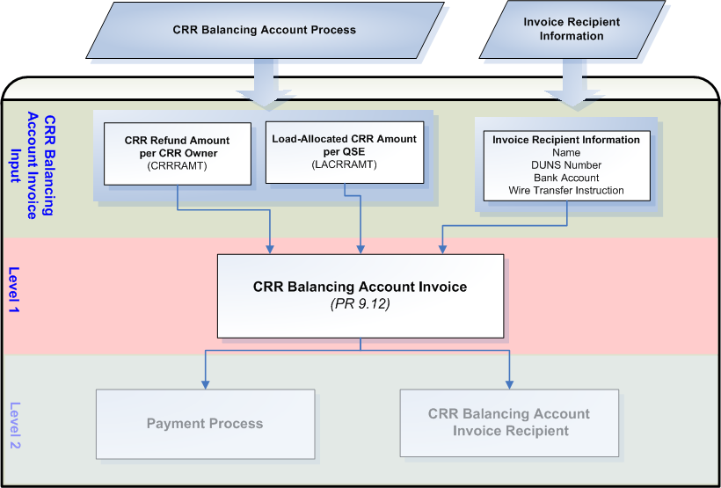

Assumptions
A1) All QSE and CRR Owner data required for the creation of CRR Balancing Account Invoices will be made available by ERCOT Registration, such as:
- QSE Name
- QSE DUNS number
- QSE Bank Name
- QSE Bank Account Number
- CRR Owner Name
- CRR Owner DUNS number
- CRR Owner Bank Name
- CRR Owner Bank Account Number
- Specific wire transfer instructions of the Invoice Recipient’s bank account, including Bank ABA Routing number.

A2) Accessibility of Invoices shall be consistent with the accessibility of statements. ERCOT suggests a protocol revision to add Invoice access to Nodal Protocol Section 9.1.3.

A3) The CRR Balancing Account Invoice shall include the Invoice Recipient’s name. ERCOT suggests a protocol revision to include Invoice Recipient’s name to the list of items required for CRR Balancing Account Invoices in Nodal Protocol Section 9.12(5).

A4) The CRR Balancing Account Invoice shall include ERCOT’s unique identifier for that Invoice Recipient. ERCOT suggests a protocol revision to include ERCOT’s unique identifier for the Invoice Recipient to the list of items required for CRR Balancing Account Invoices in Nodal Protocol Section 9.12(5).

A5) The CRR Balancing Account Invoice shall be paid by 1700 on its due date. ERCOT suggests a protocol revision to include time when CRR Balancing Account Invoices shall be paid to the Invoice Recipient in Nodal Protocol Section 9.13(1).

A6) In the event that subsequent settlement runs for an Operating Day for the DAM and RTM produce changes that affect the monthly balancing account, the monthly CRR Balancing Account Invoice shall be trued up. ERCOT suggests a protocol revision to Nodal Protocol Section 9, Settlements and Billing, to include a trueup of CRR Balancing Account Invoices, the process in which ERCOT shall receive payments for CRR Balancing Account Invoices, and a process by which ERCOT shall distribute funds in the event payment is not received in full. Business requirements in this document do not reflect this assumption.

Business Rules
Req. ID | Protocol(s) | Sub-Process Map | Description
FR129 | PR 9.1.3  PR 9.12(2)  PR 9.12(4) | CSWM.  P03SettleBillTransfer | CRR Balancing Account Invoices must be made available to the Invoice Recipient via:  - Secured entry on the MIS Certified Area; and  - eXtensible Markup Language (XML) access to the MIS Certified Area  ( See Assumption A2)
FR130 | PR 9.1.4  PR 9.12(1) | CSWM.  P03SettleBillTransfer | The publication of each CRR Balancing Account Invoice can occur as late as 2400 on its issue date.
FR131 | PR 9.1.5 | CSWM.  P03SettleBillTransfer | CRR Balancing Account Invoice payment conventions must reflect:  - for an amount due from ERCOT to the Invoice Recipient, a negative amount
FR132 | PR 9.12(1)  PR 9.12(2) | CSWM.  P03SettleBillTransfer | ERCOT shall create CRR Balancing Account Invoices on a monthly basis for each applicable CRR Account Holder or QSE.
FR133 | PR 9.12(1) | CSWM.  P03SettleBillTransfer | ERCOT shall make each CRR Balancing Account Invoice available on the date specified on the Settlement Calendar for that CRR Balancing Account Invoice for the applicable Invoice Recipient, which shall be monthly on the 1st Bank Business Day that is also a Business Day following the RTM Initial Settlement posting of the last day of the month.
FR134 | PR 9.12(4)  PR 9.12(4a)  PR 9.12(4b)  PR 7.9.3.4  PR 7.9.3.4(2) | CSWM.  P03SettleBillTransfer | Each CRR Balancing Account Invoice must reflect applicable payments which include:  - Monthly Refunds to Short-Paid CRR Owners;  - CRR Refund Amount  - CRR Balancing Account Closure;  - Load-Allocated CRR Amount
FR135 | PR 9.13(1) | CSWM.  P03SettleBillTransfer | The due date and time for each CRR Balancing Account Invoice with payments due from ERCOT to Invoice Recipient is 1700 on the 1st Bank Business Day that is also a Business Day following the due date of the RTM Invoice that includes the RTM Initial Settlement Statement for the last day of the month.  ( See Assumption A5)
FR136 | PR 9.12(5) | CSWM.  P03SettleBillTransfer | Each CRR Balancing Account Invoice must contain the Invoice Recipient’s name.  Invoice Recipient name = QSE or CRR Owner Name  ( See Assumption A3)
FR137 | PR 9.12(5) | CSWM.  P03SettleBillTransfer | Each CRR Balancing Account Invoice must contain ERCOT’s unique identifier for that Invoice Recipient.  Invoice Recipient unique identifier = code associated with QSE or CRR Owner (DUNs Number)  ( See Assumption A4)
FR138 | PR 9.12(5a) | CSWM.  P03SettleBillTransfer | Each CRR Balancing Account Invoice must contain the Net Amount Payable to – the aggregate summary of all payments due to an Invoice Recipient summarized by month.
FR139 | PR 9.12(5b) | CSWM.  P03SettleBillTransfer | Each CRR Balancing Account Invoice must contain the time period.  Time Period = Month for which the Invoice is generated
FR140 | PR 9.12(5c) | CSWM.  P03SettleBillTransfer | Each CRR Balancing Account Invoice must contain the date in which the CRR Balancing Account Invoice was issued.
FR141 | PR 9.12(5d) | CSWM.  P03SettleBillTransfer | Each CRR Balancing Account Invoice must contain the unique number generated by the ERCOT applications for payment tracking purposes.  CRR Balancing Account Invoice Number = numbering specific to CRR Balancing Account Invoices
FR142 | PR 9.12(5e) | CSWM.  P03SettleBillTransfer | Each CRR Balancing Account Invoice must contain the date and time that CRR Balancing Account Invoice amounts must be received by the Invoice Recipient.

Business Defined Errors
Req. ID | Protocol(s) | Sub-Process Map | Description
FR143 | PR 9.12 | CSWM.  P03SettleBillTransfer | While generating CRR Balancing Account Invoices, if no monthly refunds or load-allocations for the CRR Balancing Account exist in the Invoice Generating System for the month in which the CRR Balancing Account Invoices are being generated, the system should not create CRR Balancing Account Invoices and provide an error message indicating, “No CRR Balancing Account Refunds or Load-Allocations for the month of <Month> are available for processing CRR Balancing Account Invoices”. There should be no CRR Refund Amounts or Load-Allocated CRR Amounts for any CRR Account Holder or QSE for this condition to occur.

Specific Database Needs
Req. ID | Protocol(s) | Sub-Process Map | Description
FR144 | PR 9.12 | CSWM.  P03SettleBillTransfer | An approval control mechanism is required so that only approved CRR Balancing Account Invoices are sent to Invoice Recipients. The approval control mechanism must contain record of when and by whom invoices were approved.
FR145 | PR 9.12 | CSWM.  P03SettleBillTransfer | All required data must be populated and viewable for each CRR Balancing Account Invoice prior to approval.
FR146 | PR 9.12 | CSWM.  P03SettleBillTransfer | The dates ERCOT shall pay out to CRR Balancing Account Invoice Recipients shall be stored and maintained in a centralized area and configured in such a way that they can be easily updated by the Business Analyst.

RTM Uplift Invoices
ERCOT shall prepare RTM Uplift Invoices to collect from QSEs representing LSEs a debt owed to ERCOT by an entity who has not paid their RTM or RTM Uplift Invoice in full and meets the criteria set forth in Nodal Protocol Section 9.7.3, Partial Payments by Invoice Recipients for the RTM.

Dependencies
D1) RTM Uplift Invoices are dependent on:
- Invoice Recipient account information.
- Time period for which an RTM or RTM Uplift Invoice has been unpaid
- Payment Plan status of the short-paying RTM or RTM Uplift Invoice Recipient
- Availability of LRS

D2) RTM Uplift Invoices must be created prior:
- to posting to Invoice Recipients
- the financial transfer process for that RTM Uplift Invoice

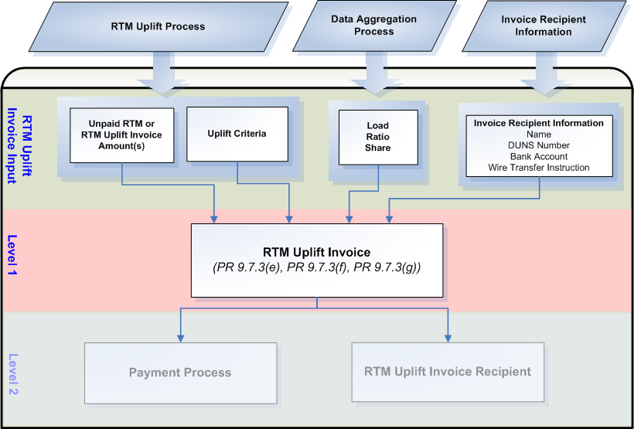

Assumptions
A1) Nodal protocols do not describe the RTM Uplift Invoice in detail. ERCOT will design the RTM Uplift Invoice similar to the RTM Invoice, described in Nodal Protocol Section 9.6, for consistency. ERCOT suggests a protocol revision to include specific information required by the Market for RTM Uplift Invoices in Nodal Protocol Section 9.

A2) All QSE data required for the creation of RTM Uplift Invoices will be made available by ERCOT Registration, such as:
- QSE Name
- QSE DUNS number
- QSE Bank Name
- QSE Bank Account Number
- Specific wire transfer instructions of the Invoice Recipient’s bank account, including Bank ABA Routing number.

A3) Accessibility of Invoices shall be consistent with the accessibility of statements. ERCOT suggests a protocol revision to add Invoice access to Nodal Protocol Section 9.1.3.

Business Rules
Req. ID | Protocol(s) | Sub-Process Map | Description
FR147 | PR 9.1.3 | CSWM.  P03SettleBillTransfer | RTM Uplift Invoices must be made available to the Invoice Recipient via:  - Secured entry on the MIS Certified Area; and  - eXtensible Markup Language (XML) access to the MIS Certified Area  ( See Assumption A3)
FR148 | PR 9.1.4 | CSWM.  P03SettleBillTransfer | The publication of each RTM Uplift Invoice can occur as late as 2400 on its issue date.
FR149 | PR 9.1.5 | CSWM.  P03SettleBillTransfer | RTM Uplift Invoice payment conventions must reflect:  - for an amount due to ERCOT from the Invoice Recipient, a positive amount
FR150 | PR 9.7.3(e) | CSWM.  P03SettleBillTransfer | ERCOT shall create RTM Uplift Invoices for each QSE on a monthly Load Ratio Share basis of the month 3 months prior to the date in which the RTM Uplift is issued when the conditions set forth in Nodal Protocol Section 9.7.3 are met which include:  - 180 days following the short-pay of a RTM or RTM Uplift Invoice if sufficient funds continue to be unavailable for ERCOT to pay all amounts in full to short-paid Entities for that RTM Invoice  - The short-paying Entity is not in compliance with a payment plan designed to enable ERCOT to pay all RTM or RTM Uplift Invoice amounts in full to short-paid Entities
FR151 | PR 9.7.3(e) | CSWM.  P03SettleBillTransfer | The total amount that is eligible to be uplifted is the total unpaid amount of the RTM or RTM Uplift Invoice less the total payments expected from a payment plan.
FR152 | PR 9.7.3(f)  PR 9.7.3(g) | CSWM.  P03SettleBillTransfer | Any uplifted short-paid amount that is greater than $2,500,000.00 must be scheduled so that an amount no greater than $2,500,000.00 is charged on each set of RTM Uplift Invoices until the total short-paid amount is uplifted. Subsequent sets of RTM Uplift Invoices must be issued at least 30 days apart from each other.
FR153 | PR 9.7.3(e) | CSWM.  P03SettleBillTransfer | The RTM Uplift Invoice generation system must allow the user to generate the RTM Uplift Invoice ad hoc (not scheduled).
FR154 | PR 9.7.1(1) | CSWM.  P03SettleBillTransfer | The RTM Uplift Invoice must be issued on a Business Day.
FR155 | PR 9.7.1(1)  PR 9.7.3(g) | CSWM.  P03SettleBillTransfer | The due date and time for each RTM Uplift Invoice with payments due to ERCOT from the Invoice Recipient is 1700 on the 5th Bank Business Day after RTM Uplift Invoice Date. If the 5th Bank Business Day is not a Business Day, then the RTM Uplift Invoice is due on the next day that is both a Business Day and Bank Business Day.
FR156 |  | CSWM.  P03SettleBillTransfer | Each RTM Uplift Invoice must contain the Invoice Recipient’s name.  Invoice Recipient name = QSE Name
FR157 |  | CSWM.  P03SettleBillTransfer | Each RTM Uplift Invoice must contain ERCOT’s unique identifier for that Invoice Recipient.  Invoice Recipient unique identifier = code associated with QSE (DUNs Number)
FR158 | PR 9.6(4a) | CSWM.  P03SettleBillTransfer | Each RTM Uplift Invoice must contain the Net Amount Payable to – the aggregate summary of all charges due to ERCOT summarized by RTM Uplift Invoice occurrence.  ( See Assumption A1)
FR159 | PR 9.6(4c) | CSWM.  P03SettleBillTransfer | Each RTM Uplift Invoice must contain the date in which the RTM Uplift Invoice was issued.  ( See Assumption A1)
FR160 | PR 9.6(4d) | CSWM.  P03SettleBillTransfer | Each RTM Uplift Invoice must contain the unique number generated by the ERCOT applications for payment tracking purposes.  RTM Uplift Invoice Number = numbering specific to CRR RTM Uplift Invoices  ( See Assumption A1)
FR161 | PR 9.7.3(e) | CSWM.  P03SettleBillTransfer | Each RTM Uplift Invoice must reference the Short-Pay(s).
FR162 | PR 9.6(4f) | CSWM.  P03SettleBillTransfer | Each RTM Uplift Invoice must contain the date and time that RTM Uplift Invoice amounts must be received by the ERCOT from the Invoice Recipient.  ( See Assumption A1)
FR163 | PR 9.6(4g) | CSWM.  P03SettleBillTransfer | Each RTM Uplift Invoice must contain payment remittance details, including:  - ERCOT bank account number  - ERCOT bank name  - Wire transfer instructions of the ERCOT account to which any amounts owed by the Invoice Recipient are to be paid, including Bank ABA Routing number.  - Wire transfer instructions of the Invoice Recipient’s account to which ERCOT may draw payments due, including Bank ABA Routing number.  ( See Assumption A1)
FR164 | PR 9.6(4h) | CSWM.  P03SettleBillTransfer | Each RTM Uplift Invoice must contain the terms that would be applied if payments are received late.  ( See Assumption A1)

Business Defined Errors
None

Specific Database Needs
Req. ID | Protocol(s) | Sub-Process Map | Description
FR165 | PR 9.7.3 | CSWM.  P03SettleBillTransfer | An approval control mechanism is required so that only approved RTM Uplift Invoices are sent to Invoice Recipients. The approval control mechanism must contain record of when and by whom invoices were approved.
FR166 | PR 9.7.3 | CSWM.  P03SettleBillTransfer | All required data must be populated and viewable for each RTM Uplift Invoice prior to approval.
FR167 | PR 9.7.3 | CSWM.  P03SettleBillTransfer | The due dates of RTM Uplift Invoices shall be stored and maintained in a centralized area and configured in such a way that they can be easily updated by the Business Analyst.

Miscellaneous Settlement Invoices
Req. ID | Protocol(s) | Sub-Process Map | Description
FR168 |  | CSWM.  P03SettleBillTransfer | ERCOT requires the functionality to generate and post Invoices due to circumstances not detailed in the Nodal Protocols, such as ADR settlement. These Invoices must be created in, or importable to, the payment tracking system. Miscellaneous Invoices must have user defined fields that will be described in detail during the design phase.

Supplementary Requirements

Performance Requirements
Lodestar must be able to perform its full set of programmatic Nodal settlement requirements. Performance characteristics will be determined and detailed in the conceptual and detailed design.

Legal and Regulatory requirements
All Lodestar financial data must be saved in accordance with standard accounting principles as dictated by the ERCOT Texas Nodal Protocols.

System Security Requirements
Lodestar will only be accessed directly by internal ERCOT personnel either through thin client UI, Citrix environment, or thick client on employee desktops. Market Participants will be able to access their statements and invoices on ERCOT private web site. ERCOT private web site access will be controlled by digital certificate authentication in accordance with ERCOT security policies. Additional details will be provided in the Conceptual System Design.

Back up and Recovery Requirements
All Lodestar Nodal settlement data must be backed up on a daily basis and recoverable within 24 hours. Additional details will be provided in the Conceptual System Design.

Availability and Redundancy Requirements
Nodal Lodestar system must be available 7/24. Lodestar is considered a tier 1 system and critical to base ERCOT business processes. Additional details will be provided in the Conceptual System Design.

Maintainability Requirements
Lodestar Nodal system will be maintained by internal ERCOT personnel. Service Level Agreements and explicit support will be detailed in the detail design document.

Protocol Coverage

Protocol Sub-Section # (To the lowest level of granularity as possible) | Coverage by Requirements  (Full/Partial)
7.5.6.1(1) | Partial
7.5.6.1(2) | Partial
7.5.6.1(3) | Partial
7.5.6.2(1) | Partial
7.5.6.2(2) | Partial
7.5.6.2(3) | Partial
7.5.6.3(1) | Partial
7.5.6.3(2) | Partial
7.5.7(5) | Partial
7.5.7(6) | Partial
7.9.3.4 | Partial
7.9.3.4(2) | Partial
9.1.3 | Partial
9.1.4 | Partial
9.1.5 | Partial
9.3(1) | Partial
9.3(2) | Partial
9.3(3) | Partial
9.3(3a) | Partial
9.3(3b) | Partial
9.3(3c) | Partial
9.3(3d) | Partial
9.3(3e) | Partial
9.3(3f) | Partial
9.3(3g) | Partial
9.3(3h) | Partial
9.4.1(1) | Partial
9.4.2(1) | Partial
9.4.5 | Partial
9.4.5(3) | Partial
9.4.5(4) | Partial
9.4.5(5) | Partial
9.4.5(7) | Partial
9.4.5(9) | Partial
9.4.5(9a) | Partial
9.4.5(9b) | Partial
9.4.5(9c) | Partial
9.4.5(9d) | Partial
9.4.5(9e) | Partial
9.4.5(9f) | Partial
9.4.5(9g) | Partial
9.5.6(5) | Partial
9.6(1) | Partial
9.6(3) | Partial
9.6(4) | Partial
9.6(4a) | Partial
9.6(4b) | Partial
9.6(4c) | Partial
9.6(4d) | Partial
9.6(4e) | Partial
9.6(4f) | Partial
9.6(4g) | Partial
9.6(4h) | Partial
9.7.1(1) | Partial
9.7.2(1) | Partial
9.7.3(e) | Partial
9.7.3(f) | Partial
9.7.3(g) | Partial
9.7.5 | Partial
9.7.5(3) | Partial
9.7.5(4) | Partial
9.7.5(5) | Partial
9.7.5(7) | Partial
9.7.5(9) | Partial
9.7.5(9a) | Partial
9.7.5(9b) | Partial
9.7.5(9c) | Partial
9.7.5(9d) | Partial
9.7.5(9e) | Partial
9.7.5(9f) | Partial
9.7.5(9g) | Partial
9.8 | Partial
9.8(1) | Partial
9.8(3) | Partial
9.8(3a) | Partial
9.8(3b) | Partial
9.8(3c) | Partial
9.8(4) | Partial
9.8(4a) | Partial
9.8(4b) | Partial
9.8(4c) | Partial
9.8(4d) | Partial
9.8(4e) | Partial
9.8(4f) | Partial
9.8(4g) | Partial
9.9.1(1) | Partial
9.9.2(1) | Partial
9.10(1) | Partial
9.10(2) | Partial
9.10(3) | Partial
9.10(5) | Partial
9.10(5a) | Partial
9.10(5b) | Partial
9.10(6) | Partial
9.10(6a) | Partial
9.10(6b) | Partial
9.10(6c) | Partial
9.10(6d) | Partial
9.10(6e) | Partial
9.10(6f) | Partial
9.11.1(1) | Partial
9.11.1(2) | Partial
9.12 | Partial
9.12(1) | Partial
9.12(2) | Partial
9.12(4) | Partial
9.12(4a) | Partial
9.12(4b) | Partial
9.12(5) | Partial
9.12(5a) | Partial
9.12(5b) | Partial
9.12(5c) | Partial
9.12(5e) | Partial
9.12(5e) | Partial
9.13(1) | Partial
22 Attachment H (11L) | Partial

