Commercial Systems

Congestion Revenue Rights Balancing Account Requirements

v0.091

Revision History
Date | Version | Description | Author
08/15/06 | 0.01 | Start Initial Draft | Sharon Wang
09/18/06 | 0.02 | Incorporated IDA Feedback | Sharon Wang
09/21/06 | 0.03 | Incorporated Internal Review Feedback | Sharon Wang
09/21/06 | 0.09 | Ready for TPTF Review Process | Sharon Wang
10/06/06 | 0.091 | Incorporated TPTF Comments | Sharon Wang

Table of Contents
1. Congestion Revenue Rights Balancing Account 3
1.1 Proposed System Scope 3
1.2 Document Conventions 3
1.3 Document Assumptions 3
2. Functional Requirements 3
2.1 Credit to CRR Balancing Account (CRRBACR) 3
Input Bill Determinants 3
Intermediate Bill Determinants 3
Output Bill Determinants 3
Data Dependencies 3
Assumptions 3
Business Rules 3
Business Defined Errors 3
Specific Database Needs 3
2.2 Day-Ahead Shortfall Charges to CRR Owners (DACRRSAMT) 3
Input Bill Determinants 3
Intermediate Bill Determinants 3
Output Bill Determinants 3
Data Dependencies 3
Assumptions 3
Business Rules 3
Business Defined Errors 3
Specific Database Needs 3
2.3 Real-Time Shortfall Charges to CRR Owners (RTCRRSAMT) 3
Input Bill Determinants 3
Intermediate Bill Determinants 3
Output Bill Determinants 3
Data Dependencies 3
Assumptions 3
Business Rules 3
Business Defined Errors 3
Specific Database Needs 3
2.4 Monthly Refund to Short-Paid CRR Owners (CRRRAMT) 3
Input Bill Determinants 3
Intermediate Bill Determinants 3
Output Bill Determinants 3
Data Dependencies 3
Assumptions 3
Business Rules 3
Business Defined Errors 3
Specific Database Needs 3
2.5 CRR Balancing Account Closure (LACRRAMT) 3
Input Bill Determinants 3
Output Bill Determinants 3
Data Dependencies 3
Assumptions 3
Business Rules 3
Business Defined Errors 3
Specific Database Needs 3
3. Supplementary Requirements 3
3.1 Performance Requirements 3
3.2 Legal and Regulatory requirements 3
3.3 System Security Requirements 3
3.4 Back up and Recovery Requirements 3
3.5 Availability and Redundancy Requirements 3
3.6 Maintainability Requirements 3
3.7 Daylight Savings Time shall be recognized in Nodal Market settlements. 3
4. Protocol Coverage 3

Software Requirements Specification

Congestion Revenue Rights Balancing Account

Proposed System Scope

ERCOT plans to implement a new Nodal market in 2009. Sections 7, 9 and 12 of the Nodal Protocols describe the various Charge Types, Settlement Statement, and Market Information System requirements for the Congestion Revenue Rights (CRR) Balancing Account. The Nodal Protocols will guide this project. The requirements in this document were based on information detailed in Nodal Protocols Section 7 (005NPRR-05_BOD_Action_Report_071806), and Nodal Protocols Section 9 (007NPRR-05_BOD_Action_Report_ 071806).

The document defines the requirements for Settlements of Congestion Revenue Rights Balancing Account. Specifically, it comprises the requirements for the following CRR Charge Type Settlements that will be on the DAM Settlement Statement and RTM Settlement Statement respectively:
- Day-Ahead CRR Shortfall Charges Amount (DACRRSAMT)
-- PR 7.9.3.3; PR 9.2.3 (t)
- Real-Time CRR Shortfall Charges Amount (RTCRRSAMT)
-- PR 7.9.3.3; PR 9.5.3 (vv)

The document also defines the requirements for Settlements of Congestion Revenue Rights Balancing Account calculations that are reflected separately in monthly invoices:
- Monthly Refund to Short-Paid CRR Owners (CRRRAMT)
-- PR 7.9.3.4; PR 9.12
- CRR Balancing Account Closure (LACRRAMT)
-- PR 7.9.3.5; PR 9.12

Lastly, the following calculation is also addressed by these requirements:
- Credit to CRR Balancing Account (CRRBACR)
-- PR 7.9.3.2

To Be Sub-Process for Settlements and Billing
For illustrative purposes, Figures 1 to Figure 8 are provided to describe calculation dependencies in this document.
Figure 1 illustrates the proposed scope of CRR Settlements. It comprises Day-Ahead CRR Settlements, Real-Time CRR Settlements, CRR Balancing Account, and CRR Auctions Settlements, within which CRR Balancing Account is addressed by this document, and other components are addressed by separate sets of Requirements.
A dependency diagram is provided to depict the dependencies between calculation inputs, intermediate variables, and outputs for each section of Functional Requirements.
These figures should be considered in conjunction with the textual requirements. If a contradiction exists between an illustrative figure and its associated textual requirements, the textual requirements should override the figure.

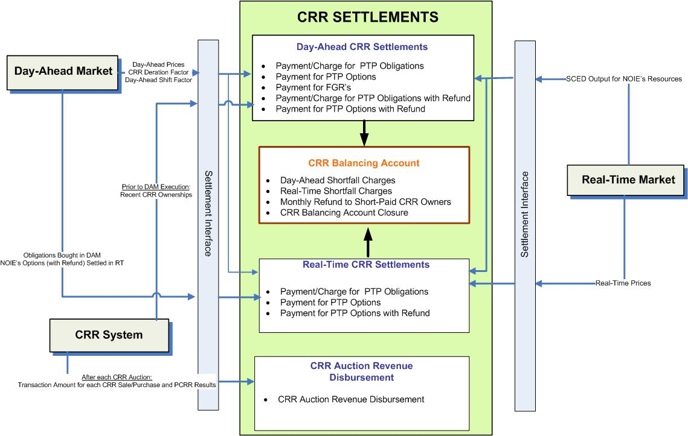

- Proposed Scope of CRR Settlements

Document Conventions
- All text directly lifted from the Nodal Protocols is in italic font.
- All requirements are identified using R1, R2, etc.
- All dependencies are identified using D1, D2, etc.
- All assumptions are identified using A1, A2, etc.
- Settlement Recorders in this document adhere to the following naming convention:
BILLDETERMINANT_<Q>_<CO>_<R>_<SP>_<SRSP>_<SKSP>_<F>_<E>_<C>

Where:
<Q> = QSE
<CO> = CRR Owner
<R> = Resource
<SP> = Settlement Point
<SRSP> = Source Settlement Point
<SKSP> = Sink Settlement Point
<F> = Flowgate
<E> = Directional Network Element
<C> = Constraint Identifier

- Footnotes in this document are denoted by a * sign.
- Each Section Title will include the Charge Type/Bill Determinant description and the associated Bill Determinant in parenthesis.
- It is assumed that Input Bill Determinants described in this requirement has a compatible data format with Settlement System.
- The color scheme used in calculation dependency diagrams is defined in Figure 2 and Figure 3.
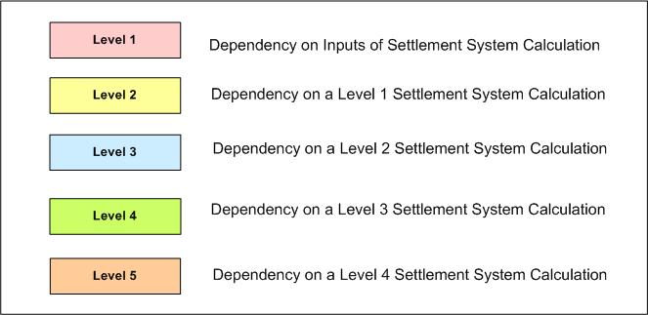

- Color Definition for Levels of Dependency Diagram used in CRR Balancing Account Requirements

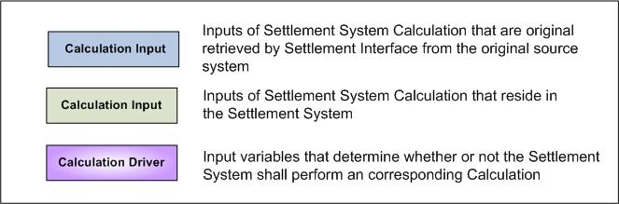

- Color Definition for Inputs of Dependency Diagram used in CRR Balancing Account Requirements

Document Assumptions

- A separate requirement document will address the Settlement Interface with original sources such as MMS and CRR System. Specifically, this Settlement Interface Requirement will focus on when, what, and how input data should be retrieved from the original source, how to evaluate input data validity and completeness, and how to handle input data missing or other types of errors, to perform CRR Settlements Calculations described in this document.
- The DAM is executed completely and correctly. Therefore, the applicable amount of allocated PCRRs and CRRs acquired in CRR auctions and bilateral trades are settled in the DAM as detailed in TN.COMS63C01.DAMCRR.REQUIREMENTS.A. In the event that the DAM is not executed, the settlements calculations detailed in this requirements document will not be applicable.
- For any Charge Types that require historical data for the calculation, this information is obtained via alternative means for during the beginning of market open until the data is available.

Functional Requirements

Credit to CRR Balancing Account (CRRBACR)

If the Day-Ahead Congestion Rent is greater than the total payment to all CRR Owners for the CRRs settled in the DAM for any Operating Hour, a credit is put into the CRR balancing Account for that Operating Hour.

Requirement ID
Source Mapping (Protocol/NERC/FERC and other binding documents Ref #) | PR 7.9.3.2
Traceability to Sub-Process Maps | CSWM.P03SettleBillTransfer
Description

Calculate Day-Ahead CRR Credit Total for each Operating Hour of the Operating Day:

DACRRCRTOT = DAOBLCRTOT + DAOBLRCRTOT + DAOPTAMTTOT
+ DAOPTRAMTTOT + DAFGRAMTTOT

Requirement ID
Source Mapping (Protocol/NERC/FERC and other binding documents Ref #) | PR 7.9.3.2
Traceability to Sub-Process Maps | CSWM.P03SettleBillTransfer
Description

Calculate Day-Ahead CRR Charge Total for each Operating Hour of the Operating Day:

DACRRCHTOT = DAOBLCHTOT + DAOBLRCHTOT

Requirement ID
Source Mapping (Protocol/NERC/FERC and other binding documents Ref #) | PR 7.9.3.2
Traceability to Sub-Process Maps | CSWM.P03SettleBillTransfer
Description

Calculate CRR Balancing Account Credit for each Operating Hour of the Operating Day:

CRRBACR = Max (0, (DACONGRENT + DACRRCRTOT + DACRRCHTOT))

Input Bill Determinants
Variable | Unit | Definition | Original Source
DAOBLCRTOT | $ | Day-Ahead Obligation Credit Total—The total payment of all PTP Obligations settled in the DAM, for the hour. | Settlement System
Interval Frequency: 1/hour

Comments:
- Calculation of DAOBLCRTOT is addressed by TN.COMS.63C01.DAMCRR.REQUIREMENTS.A
DAOBLRCRTOT | $ | Day-Ahead Obligation with Refund Credit Total—The total payment of all PTP Obligations with Refund settled in the DAM, for the hour. | Settlement System
Interval Frequency: 1/hour

Comments:
- Calculation of DAOBLRCRTOT is addressed by TN.COMS.63C01.DAMCRR.REQUIREMENTS.A
DAOBLCHTOT | $ | Day-Ahead Obligation Charge Total—The total charge of all PTP Obligations settled in the DAM, for the hour. | Settlement System
Interval Frequency: 1/hour

Comments:
- Calculation of DAOBLCHTOT is addressed by TN.COMS.63C01.DAMCRR.REQUIREMENTS.A
DAOBLRCHTOT | $ | Day-Ahead Obligation with Refund Charge Total—The total charge of all PTP Obligations with Refund settled in the DAM, for the hour. | Settlement System
Interval Frequency: 1/hour

Comments:
- Calculation of DAOBLRCHTOT is addressed by TN.COMS.63C01.DAMCRR.REQUIREMENTS.A
DAOPTAMTTOT | $ | Day-Ahead Option Amount Total—The total payment of all PTP Options settled in the DAM, for the hour. | Settlement System
Interval Frequency: 1/hour

Comments:
- Calculation of DAOPTAMTTOT is addressed by TN.COMS.63C01.DAMCRR.REQUIREMENTS.A
DAOPTRAMTTOT | $ | Day-Ahead Option with Refund Amount Total—The total payment of all PTP Options with Refund settled in the DAM, for the hour. | Settlement System
Interval Frequency: 1/hour

Comments:
- Calculation of DAOPTRAMTTOT is addressed by TN.COMS.63C01.DAMCRR.REQUIREMENTS.A
DAFGRAMTTOT | $ | Day-Ahead FGR Amount Total—The total payment of all FGRs settled in the DAM, for the hour. | Settlement System
Interval Frequency: 1/hour

Comments:
- Calculation of DAFGRAMTTOT is addressed by TN.COMS.63C01.DAMCRR.REQUIREMENTS.A
DACONGRENT | $ | Day-Ahead Congestion Rent—The Congestion Rent collected in the DAM for the hour. See 7.9.3.1. | Settlement System
Interval Frequency: 1/hour

Comments:
- Calculation of DACONGRENT is addressed by TN.COMS.63C01.DAMENERGY.REQUIREMENTS.A

Intermediate Bill Determinants
Variable | Unit | Definition | Original Source
DACRRCRTOT | $ | Day-Ahead CRR Credit Total—The total payment to all CRR Owners of all CRRs settled in the DAM for the hour. | Settlement System
Interval Frequency: 1/hour

Comments:
- The value of DACRRCRTOT shall always be no greater than zero (0).
DACRRCHTOT | $ | Day-Ahead CRR Charge Total—The total charge to all CRR Owners of all CRRs settled in the DAM for the hour. | Settlement System
Interval Frequency: 1/hour

Comments:
- The value of DACRRCHTOT shall always be no less than zero (0).

Output Bill Determinants
Variable | Unit | Definition | Original Source
CRRBACR | $ | CRR Balancing Account Credit—The credit to the CRR Balancing Account for the hour. | Settlement System
Interval Frequency: 1/hour

Comments:
- CRRBACR will be used to calculate Monthly Refunds to Short-Paid CRR Owners, and CRR Balancing Account Closure.

- The value of CRRBACR shall be no less than Zero (0).

Data Dependencies
D1) Calculation of CRRBACR is dependent upon the availability of input bill determinants.
D2) Calculation of CRRBACR is dependent upon completion of the following calculations:
- Payments/Charges for PTP Obligations Settled in DAM defined by TN.COMS.63C01.DAMCRR.REQUIREMENTS.A
- Payments for PTP Options Settled in DAM defined by TN.COMS.63C01.DAMCRR.REQUIREMENTS.A
- Payments for FGRs Settled in DAM defined by TN.COMS.63C01.DAMCRR.REQUIREMENTS.A
- Payment/Charges for PTP Obligations with Refund Settled in DAM defined by TN.COMS.63C01.DAMCRR.REQUIREMENTS.A
- Payments for PTP Options with Refund Settled in DAM defined by TN.COMS.63C01.DAMCRR.REQUIREMENTS.A
- Day-Ahead Congestion Rent defined by TN.COMS.63C01.DAMENERGY.REQUIREMENTS.A

D3) The following charge types are dependent upon the calculation of CRRBACR: Monthly Refunds to Short-Paid CRR Owners [CRR Refund Amount] (CRRRAMT), and CRR Balancing Account Closure [Load-Allocated CRR Amount] (LACRRAMT).

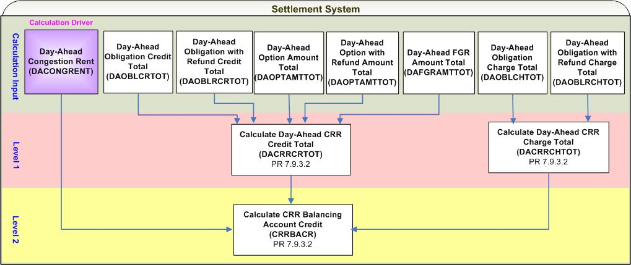
- Calculation Dependencies of CRR Balancing Account Credit (CRRBACR)

Assumptions
None

Business Rules
Req. ID | Protocol(s) | Sub-Process Map | Description
 | PR 7.9.3.2 | CSWM. P03SettleBill Transfer | None of the input, intermediate and output bill determinants should be rounded or truncated.
 | PR 12.3 (C) | CSWM. P03SettleBill Transfer | The following data shall be available for public data extracts, including:  - DACRRCRTOT  - DACRRCHTOT  - DAOBLCRTOT  - DAOBLCHTOT  - DAOBLRCRTOT  - DAOBLRCHTOT  - DAOPTAMTTOT  - DAOPTRAMTTOT  - DAFGRAMTTOT  - DACONGRENT
 | PR 7.9.3.2 | CSWM. P03SettleBill Transfer | DRIVER: The CRRBACR calculation shall be attempted for an Operating Day for which Day-Ahead Congestion Rent (DACONGRENT) cut exists.

Business Defined Errors
Req. ID | Protocol(s) | Sub-Process Map | Description
 | PR 7.9.3.2 | CSWM. P03SettleBill Transfer | If the Settlement System calculation needs DACONGRENT that is not available or equals zero (0), the Settlement System should log a “CRITICAL” error message and stop any down stream calculations including CRRBACR. The error message should capture the data element, including the Operating Day.
 | PR 7.9.3.2 | CSWM. P03SettleBill Transfer | If the Settlement System calculation needs DAOBLCRTOT that is not available, the Settlement System should log an error message set it to default value ---zero (0), and stop any down stream calculations including CRRBACR. The error message should capture the data element, including the Operating Day. An investigation shall be followed.
 | PR 7.9.3.2 | CSWM. P03SettleBill Transfer | If the Settlement System calculation needs DAOBLRCRTOT that is not available, the Settlement System should log an error message set it to default value ---zero (0), and stop any down stream calculations including CRRBACR. The error message should capture the data element, including the Operating Day. An investigation shall be followed.
 | PR 7.9.3.2 | CSWM. P03SettleBill Transfer | If the Settlement System calculation needs DAOPTAMTTOT that is not available, the Settlement System should log an error message set it to default value ---zero (0), and stop any down stream calculations including CRRBACR. The error message should capture the data element, including the Operating Day. An investigation shall be followed.
 | PR 7.9.3.2 | CSWM. P03SettleBill Transfer | If the Settlement System calculation needs DAOPTRAMTTOT that is not available, the Settlement System should log an error message set it to default value ---zero (0), and stop any down stream calculations including CRRBACR. The error message should capture the data element, including the Operating Day. An investigation shall be followed.
 | PR 7.9.3.2 | CSWM. P03SettleBill Transfer | If the Settlement System calculation needs DAFGRAMTTOT that is not available, the Settlement System should log an error message set it to default value ---zero (0), and stop any down stream calculations including CRRBACR. The error message should capture the data element, including the Operating Day. An investigation shall be followed.
 | PR 7.9.3.2 | CSWM. P03SettleBill Transfer | If the Settlement System calculation needs DAOBLCHTOT that is not available, the Settlement System should log an error message set it to default value ---zero (0), and stop any down stream calculations including CRRBACR. The error message should capture the data element, including the Operating Day. An investigation shall be followed.
 | PR 7.9.3.2 | CSWM. P03SettleBill Transfer | If the Settlement System calculation needs DAOBLRCHTOT that is not available, the Settlement System should log an error message set it to default value ---zero (0), and stop any down stream calculations including CRRBACR. The error message should capture the data element, including the Operating Day. An investigation shall be followed.

Specific Database Needs
None

Day-Ahead Shortfall Charges to CRR Owners (DACRRSAMT)

For each Operating Hour, if the Day-Ahead Congestion Rent is less than the total payment to all CRR Owners for the CRRs settled in the DAM, a charge will be made to each CRR Owner for any of its CRRs settled in the DAM or Real-Time that have positive settlement prices, except for CRRs bought in the DAM.

Requirement ID
Source Mapping (Protocol/NERC/FERC and other binding documents Ref #) | PR 7.9.3.3 (2)
Traceability to Sub-Process Maps | CSWM.P03SettleBillTransfer
Description

Calculate Day-Ahead CRR Shortfall Amount Total for each Operating Hour of the Operating Day:

DACRRSAMTTOT = (-1) * Min (0, DACONGRENT + DACRRCRTOT + DACRRCHTOT)

Requirement ID
Source Mapping (Protocol/NERC/FERC and other binding documents Ref #) | PR 7.9.3.3 (2)
Traceability to Sub-Process Maps | CSWM.P03SettleBillTransfer
Description

Calculate CRR Credit Ratio Share Day-Ahead per CRR Owner for each Operating Hour of the Operating Day:

CRRCRRSDA_<CO> = (DAOBLCROTOT_<CO> + DAOBLRCROTOT_<CO>
+ DAOPTAMTOTOT_<CO> + DAOPTRAMTOTOT_<CO>
+ DAFGRAMTOTOT_<CO>)
/ (DACRRCRTOT + RTOPTAMTTOT + RTOPTRAMTTOT)

Requirement ID
Source Mapping (Protocol/NERC/FERC and other binding documents Ref #) | PR 7.9.3.3 (2)
Traceability to Sub-Process Maps | CSWM.P03SettleBillTransfer
Description

Calculate Day-Ahead CRR Shortfall Amount per CRR Owner for each Operating Hour of the Operating Day:

DACRRSAMT_<CO> = DACRRSAMTTOT * CRRCRRSDA_<CO>

Input Bill Determinants
Variable |  | Unit |  | Definition | Original Source
DAOBLCROTOT |  | $ |  | Day-Ahead Obligation Credit Owner Total per owner—The total payment to CRR Owner of PTP Obligations settled in the DAM, for the hour. | Settlement System
Interval Frequency: 1/hour

Comments:
- Calculation of DAOBLCROTOT is addressed by TN.COMS.63C01.DAMCRR.REQUIREMENTS.A
DAOBLRCROTOT |  | $ |  | Day-Ahead Obligation with Refund Credit Owner Total per owner—The total payment to CRR Owner of PTP Obligations with Refund settled in the DAM, for the hour. | Settlement System
Interval Frequency: 1/hour

Comments:
- Calculation of DAOBLRCROTOT is addressed by TN.COMS.63C01.DAMCRR.REQUIREMENTS.A
DAOPTAMTOTOT |  | $ |  | Day-Ahead Option Amount Owner Total per owner—The total payment to CRR Owner of PTP Options settled in the DAM, for the hour. | Settlement System
Interval Frequency: 1/hour

Comments:
- Calculation of DAOPTAMTOTOT is addressed by TN.COMS.63C01.DAMCRR.REQUIREMENTS.A
DAOPTRAMTOTOT |  | $ |  | Day-Ahead Option with Refund Amount Owner Total per owner—The total payment to CRR Owner of PTP Options with Refund settled in the DAM, for the hour. | Settlement System
Interval Frequency: 1/hour

Comments:
- Calculation of DAOPTRAMTOTOT is addressed by TN.COMS.63C01.DAMCRR.REQUIREMENTS.A
DAFGRAMTOTOT |  | $ |  | Day-Ahead FGR Amount Owner Total per owner—The total payment to CRR Owner of FGRs settled in the DAM, for the hour. | Settlement System
Interval Frequency: 1/hour

Comments:
- Calculation of DAFGRAMTOTOT is addressed by TN.COMS.63C01.DAMCRR.REQUIREMENTS.A
RTOPTAMTTOT |  | $ |  | Real-Time Option Amount Total—The total of payments to all CRR Owners of all PTP Options settled in Real-Time for the hour. | Settlement System
Interval Frequency: 1/hour

Comments:
- Calculation of RTOPTAMTTOT is addressed by TN.COMS.63C01.RTCRR.REQUIREMENTS.A
RTOPTRAMTTOT |  | $ |  | Real-Time Option with Refund Amount Total—The total of payments to all CRR Owners of all PTP Options with Refund settled in Real-Time for the hour. | Settlement System
Interval Frequency: 1/hour

Comments:
- Calculation of DAOPTRAMTTOT is addressed by TN.COMS.63C01.DAMCRR.REQUIREMENTS.A
DACONGRENT | $ |  | Day-Ahead Congestion Rent—The Congestion Rent collected in the DAM for the hour. See 7.9.3.1. |  | Settlement System
Interval Frequency: 1/hour

Comments:
- Calculation of DACONGRENT is addressed by TN.COMS.63C01.DAMENERGY.REQUIREMENTS.A
DACRRCRTOT | $ |  | Day-Ahead CRR Credit Total—The total payment to all CRR Owners of all CRRs settled in the DAM for the hour. |  | Settlement System
Interval Frequency: 1/hour

Comments:
- Calculation of DACRRCRTOT is addressed by the section of Credit to CRR Balancing Account.
DACRRCHTOT | $ |  | Day-Ahead CRR Charge Total—The total charge to all CRR Owners of all CRRs settled in the DAM for the hour. |  | Settlement System
Interval Frequency: 1/hour

Comments:
- Calculation of DACRRCHTOT is addressed by the section of Credit to CRR Balancing Account.

Intermediate Bill Determinants
Variable | Unit | Definition | Original Source
CRRCRRSDA | none | CRR Credit Ratio Share Day-Ahead per owner—The ratio of the total payments to CRR Owner of its CRRs settled in the DAM to the total payments to all CRR Owners of all CRRS, for the hour. | Settlement System
Interval Frequency: 1/hour

Comments:
- The value of CRRCRRSDA shall be a number ranging from zero (0) to one (1).
DACRRSAMTTOT | $ | Day-Ahead CRR Shortfall Amount Total—The shortfall charge to all CRR Owners for their CRRs settled in the DAM, due to deration, for the hour. | Settlement System
Interval Frequency: 1/hour

Comments:
- DACRRSAMTTOT is not documented in the Protocols but is necessary.
- the value of DACRRSAMT is no less than zero (0)

Output Bill Determinants
Variable | Unit | Definition | Original Source
DACRRSAMT | $ | Day-Ahead CRR Shortfall Amount per owner—The shortfall charge to CRR Owner for its CRRs settled in the DAM, due to deration, for the hour. | Settlement System
Interval Frequency: 1/hour

Comments:
- The value of DACRRSAMT is no less than zero (0)
DACRRSBILLAMT | $ | Day-Ahead CRR Shortfall Bill Amount per owner— The Delta of The Shortfall Charge to CRR Owner for its CRRs settled in the DAM between the current and the previous settlement run -- per CRR Owner, for the day. | Settlement System
Interval Frequency: 1/Day

Comments:
- This bill determinant is not specifically documented in the Nodal Protocols but is required as a result of Section 9 Statements and Invoices Protocol requirements.

Data Dependencies
D1) Calculation of DACRRSAMT is dependent upon the availability of input bill determinants.
D2) Calculation of DACRRSAMT is dependent upon completion of the following calculations:
- Payments/Charges for PTP Obligations Settled in DAM defined by TN.COMS.63C01.DAMCRR.REQUIREMENTS.A
- Payments for PTP Options Settled in DAM defined by
- TN.COMS.63C01.DAMCRR.REQUIREMENTS.A
- Payments for FGRs Settled in DAM defined by TN.COMS.63C01.DAMCRR.REQUIREMENTS.A
- Payment/Charges for PTP Obligations with Refund Settled in DAM defined by TN.COMS.63C01.DAMCRR.REQUIREMENTS.A
- Payments for PTP Options with Refund Settled in DAM defined by TN.COMS.63C01.DAMCRR.REQUIREMENTS.A
- Payments for NOIE’s PTP Options Settled in Real-Time defined by TN.COMS.63C01.RTCRR.REQUIREMENTS.A
- Payments for NOIE’s PTP Options with Refund Settled in Real-Time defined by TN.COMS.63C01.RTCRR.REQUIREMENTS.A
- Day-Ahead Congestion Rent defined by TN.COMS.63C01.DAMENERGY.REQUIREMENTS.A

D3) The following charge type is dependent upon the calculation of DACRRSAMT: CRR Refund Amount (CRRRAMT).

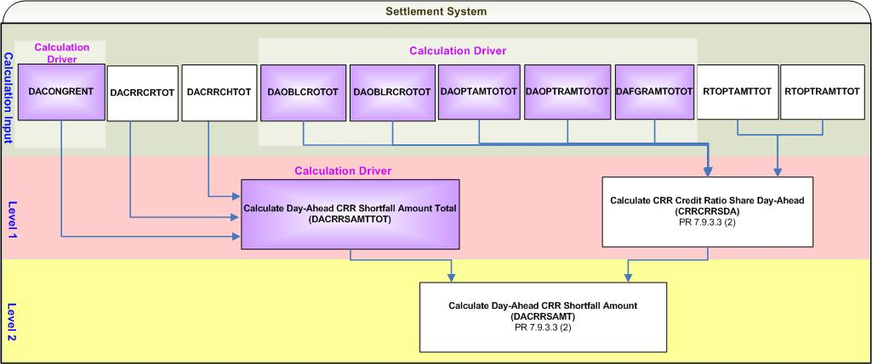

- Calculation Dependencies of Day-Ahead CRR Shortfall Amount (DACRRSAMT)

Assumptions
None

Business Rules
Req. ID | Protocol(s) | Sub-Process Map | Description
 | PR 9.2.3 (t) | CSWM. P03SettleBill Transfer | DACRRSAMT shall be reflected on the DAM Statement.
 | PR 7.9.3.3 (2) | CSWM. P03SettleBill Transfer | None of the input and intermediate bill determinants should be rounded or truncated.
 | PR 7.9.3.3 (2) | CSWM. P03SettleBill Transfer | The following output bill determinant should be rounded or truncated to two (2) decimals, including:  - DACRRSAMT
 | PR 12.3 (C) | CSWM. P03SettleBill Transfer | The following data shall be available for public data extracts, including:  - DACONGRENT  - DACRRCRTOT  - DACRRCHTOT  - RTOPTAMTTOT  - RTOPTRAMTTOT
 | PR 12.3 (C) | CSWM. P03SettleBill Transfer | The following data shall be available for private data extracts, including:  - DAOBLCROTOT  - DAOBLRCROTOT  - DAOPTAMTOTOT  - DAOPTRAMTOTOT  - DAFGRAMTOTOT  - CRRCRRSDA  - DACRRSAMT  - DACRRBILLAMT
 | PR 7.9.3.3 (2) | CSWM. P03SettleBill Transfer | DRIVER:  NOTE: The calculation driver for this section is defined at the sub-calculation level and therefore requires a certain calculation sequence. Specifically: the Settlement System first calculates DACRRSAMTTOT, then calculates CRRCRRSDA, and lastly calculates DACRRSAMT.  - DACRRSAMTTOT calculation shall be attempted for an Operating Day for which the DACONGRENT cut exists.  - For an Operating Day for which DACRRSAMTTOT is calculated non-zero for at least one Operating Hour, the Settlement System shall attempt CRRCRRSDA and DACRRSAMT calculations for a CRR Owner for an Operating Day for which at least one of the following data cuts exists:  - DAOBLCROTOT  - DAOBLRCROTOT  - DAOPTAMTOTOT  - DAOPTRAMTOTOT  - DAFGRAMTOTOT

Business Defined Errors
Req. ID | Protocol(s) | Sub-Process Map | Description
 | PR 7.9.3.3 (2) | CSWM. P03SettleBill Transfer | If the Settlement System calculation needs DACONGRENT that is not available or equals zero (0), the Settlement System should log a “CRITICAL” error message and stop the calculation of DACRRSAMT. The error message should capture the data element, including the Operating Day.
 | PR 7.9.3.3 (2) | CSWM. P03SettleBill Transfer | If the Settlement System calculation needs DACRRCRTOT that equals zero (0), the Settlement System should log a “CRITICAL” error message and stop the calculation of DACRRSAMT. The error message should capture the data element, including the Operating Day.
 | PR 7.9.3.3 (2) | CSWM. P03SettleBill Transfer | If the Settlement System calculation needs DAOBLCROTOT that is not available, the Settlement System should set DAOBLCROTOT to be zero (0). No error message is necessary.
 | PR 7.9.3.3 (2) | CSWM. P03SettleBill Transfer | If the Settlement System calculation needs DAOBLRCROTOT that is not available, the Settlement System should set DAOBLRCROTOT to be zero (0). No error message is necessary.
 | PR 7.9.3.3 (2) | CSWM. P03SettleBill Transfer | If the Settlement System calculation needs DAOPTAMTOTOT that is not available, the Settlement System should set DAOPTAMTOTOT to be zero (0). No error message is necessary.
 | PR 7.9.3.3 (2) | CSWM. P03SettleBill Transfer | If the Settlement System calculation needs DAOPTRAMTOTOT that is not available, the Settlement System should set DAOPTRAMTOTOT to be zero (0). No error message is necessary.
 | PR 7.9.3.3 (2) | CSWM. P03SettleBill Transfer | If the Settlement System calculation needs DAFGRAMTOTOT that is not available, the Settlement System should set DAFGRAMTOTOT to be zero (0). No error message is necessary.
 | PR 7.9.3.3 (2) | CSWM. P03SettleBill Transfer | If the Settlement System calculation needs RTOPTAMTTOT that is not available, the Settlement System should set RTOPTAMTTOT to be zero (0). No error message is necessary. An investigation shall be followed.
 | PR 7.9.3.3 (2) | CSWM. P03SettleBill Transfer | If the Settlement System calculation needs RTOPTRAMTTOT that is not available, the Settlement System should set RTOPTRAMTTOT to be zero (0). No error message is necessary. An investigation shall be followed.
 | PR 7.9.3.3 (2) | CSWM. P03SettleBill Transfer | If the sum of DACRRCRTOT, RTOPTAMTTOT, and RTOPTRAMTTOT equals Zero (0), the Settlement System should set CRRCRRSDA to be zero (0). No error message is necessary.

Specific Database Needs
None

Real-Time Shortfall Charges to CRR Owners (RTCRRSAMT)

For each Operating Hour, if the Day-Ahead Congestion Rent is less than the total payment to all CRR Owners for the CRRs settled in the DAM, a charge will be made to each CRR Owner for any of its CRRs settled in the DAM or Real-Time that have positive settlement prices, except for CRRs bought in the DAM.

Requirement ID
Source Mapping (Protocol/NERC/FERC and other binding documents Ref #) | PR 7.9.3.3 (3)
Traceability to Sub-Process Maps | CSWM.P03SettleBillTransfer
Description

Calculate CRR Credit Ratio Share Real-Time per CRR Owner for each Operating Hour of the Operating Day:

CRRCRRSRT_<CO> = (RTOPTAMTOTOT_<CO> + RTOPTRAMTOTOT_<CO>)
/ (DACRRCRTOT + RTOPTAMTTOT + RTOPTRAMTTOT)

Requirement ID
Source Mapping (Protocol/NERC/FERC and other binding documents Ref #) | PR 7.9.3.3 (3)
Traceability to Sub-Process Maps | CSWM.P03SettleBillTransfer
Description

Calculate Real-Time CRR Shortfall Amount per CRR Owner for each Operating Hour of the Operating Day:

RTCRRSAMT_<CO> = DACRRSAMTTOT * CRRCRRSRT_<CO>

Input Bill Determinants
Variable |  | Unit |  | Definition | Original Source
RTOPTAMTTOT |  | $ |  | Real-Time Option Amount Total—The total of payments to all CRR Owners of all PTP Options settled in Real-Time for the hour. | Settlement System
Interval Frequency: 1/hour

Comments:
- Calculation of RTOPTAMTTOT is addressed by TN.COMS.63C01.RTCRR.REQUIREMENTS.A
RTOPTRAMTTOT |  | $ |  | Real-Time Option with Refund Amount Total—The total of payments to all CRR Owners of all PTP Options with Refund settled in Real-Time for the hour. | Settlement System
Interval Frequency: 1/hour

Comments:
- Calculation of DAOPTRAMTTOT is addressed by TN.COMS.63C01.DAMCRR.REQUIREMENTS.A
DACRRCRTOT | $ |  | Day-Ahead CRR Credit Total—The total payment to all CRR Owners of all CRRs settled in the DAM for the hour. |  | Settlement System
Interval Frequency: 1/hour

Comments:
- Calculation of DACRRCRTOT is addressed by the section of Credit to CRR Balancing Account.
RTOPTAMTOTOT | $ |  | Real-Time Option Amount Owner Total per owner—The total payment to CRR Owner of all its PTP Options settled in Real-Time for the hour. See Section 7.9.2.2, Payments for PTP Options Settled in Real-Time. |  | Settlement System
Interval Frequency: 1/hour

Comments:
- Calculation of RTOPTAMTOTOT is addressed by TN.COMS.63C01.RTCRR.REQUIREMENTS.A
RTOPTRAMTOTOT | $ |  | Real-Time Option with Refund Amount Owner Total per owner—The total payment to CRR Owner of all its PTP Options with Refund settled in Real-Time for the hour. See Section 7.9.2.3, Payments for NOIE PTP Options with Refund Settled in Real-Time. |  | Settlement System
Interval Frequency: 1/hour

Comments:
- Calculation of RTOPTRAMTOTOT is addressed by TN.COMS.63C01.RTCRR.REQUIREMENTS.A
DACRRSAMTTOT | $ |  | Day-Ahead CRR Shortfall Amount Total—The shortfall charge to all CRR Owners for their CRRs settled in the DAM, due to deration, for the hour. |  | Settlement System
Interval Frequency: 1/hour

Comments:
- Calculation of DACRRSAMTTOT is addressed by the section of Day-Ahead Shortfall Charges to CRR Owners.
- DACRRSAMTTOT is not documented in the Protocols but is necessary.

Intermediate Bill Determinants
Variable | Unit | Definition | Original Source
CRRCRRSRT | none | CRR Credit Ratio Share Real-Time per owner—The ratio of the total payments to CRR Owner of its CRRs settled in Real-Time to the total payments to all CRR Owners of all CRRS, for the hour. | Settlement System
Interval Frequency: 1/hour

Comments:
- The value of CRRCRRSRT shall be a number ranging from zero (0) to one (1).

Output Bill Determinants
Variable | Unit | Definition | Original Source
RTCRRSAMT | $ | Real-Time CRR Shortfall Amount per owner—The shortfall charge to CRR Owner for its CRRs settled in Real-Time, due to deration, for the hour. | Settlement System
Interval Frequency: 1/hour

Comments:
- The value of RTCRRSAMT is no less than zero (0)
RTCRRSBILLAMT | $ | Real-Time CRR Shortfall Bill Amount per owner—The Delta of Shortfall Charge to CRR Owner between the current and the previous settlement run -- per CRR Owner, for the day. | Settlement System
Interval Frequency: 1/hour

Comments:
- This bill determinant is not specifically documented in the Nodal Protocols but is required as a result of Section 9 Statements and Invoices Protocol requirements.

Data Dependencies
D1) Calculation of RTCRRSAMT is dependent upon the availability of input bill determinants.
D2) Calculation of RTCRRSAMT is dependent upon completion of the following calculations:
- Payments/Charges for PTP Obligations Settled in DAM defined by TN.COMS.63C01.DAMCRR.REQUIREMENTS.A
- Payments for PTP Options Settled in DAM defined by TN.COMS.63C01.DAMCRR.REQUIREMENTS.A
- Payments for FGRs Settled in DAM defined by TN.COMS.63C01.DAMCRR.REQUIREMENTS.A
- Payment/Charges for PTP Obligations with Refund Settled in DAM defined by TN.COMS.63C01.DAMCRR.REQUIREMENTS.A
- Payments for PTP Options with Refund Settled in DAM defined by TN.COMS.63C01.DAMCRR.REQUIREMENTS.A
- Payments for NOIE’s PTP Options Settled in Real-Time defined by TN.COMS.63C01.RTCRR.REQUIREMENTS.A
- Payments for NOIE’s PTP Options with Refund Settled in Real-Time defined by TN.COMS.63C01.RTCRR.REQUIREMENTS.A
- Day-Ahead Congestion Rent defined by TN.COMS.63C01.DAMENERGY.REQUIREMENTS.A

D3) The following charge type is dependent upon the calculation of RTCRRSAMT: CRR Refund Amount (CRRRAMT).

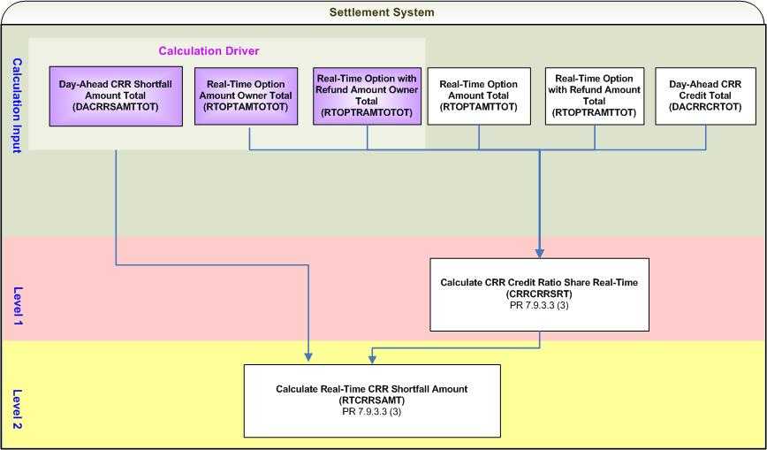
- Calculation Dependencies of Real-Time CRR Shortfall Amount (RTCRRSAMT)

Assumptions
None

Business Rules
Req. ID | Protocol(s) | Sub-Process Map | Description
 | PR 9.5.3 (vv) | CSWM. P03SettleBill Transfer | RTCRRSAMT shall be reflected on the RTM Statement.
 | PR 7.9.3.3 (3) | CSWM. P03SettleBill Transfer | None of the input and intermediate bill determinants should be rounded or truncated.
 | PR 7.9.3.3 (3) | CSWM. P03SettleBill Transfer | The following output bill determinant should be rounded or truncated to two (2) decimals, including:  - RTCRRSAMT
 | PR 12.3 (C) | CSWM. P03SettleBill Transfer | The following data shall be available for public data extracts, including:  - DACONGRENT  - DACRRCRTOT  - DACRRCHTOT  - RTOPTAMTTOT  - RTOPTRAMTTOT
 | PR 12.3 (C) | CSWM. P03SettleBill Transfer | The following data shall be available for private data extracts, including:  - RTOPTAMTOTOT  - RTOPTRAMTOTOT  - CRRCRRSRT  - RTCRRSAMT  - ERCRRSBILLAMT
 | PR 7.9.3.3 (3) | CSWM. P03SettleBill Transfer | DRIVER: The RTCRRSAMT calculation shall be attempted for a CRR Owner for an Operating Day for which both conditions described below are met:  - DACRRSAMTTOT is non-zero for at least one Operating Hour.  - At least one of the following data cuts exists for the CRR Owner:  - RTOPTAMTOTOT  - RTOPTRAMTOTOT

Business Defined Errors
Req. ID | Protocol(s) | Sub-Process Map | Description
 | PR 7.9.3.3 (3) | CSWM. P03SettleBill Transfer | If the Settlement System calculation needs RTOPTAMTOTOT that is not available, the Settlement System should set RTOPTAMTOTOT to be zero (0). No error message is necessary.
 | PR 7.9.3.3 (3) | CSWM. P03SettleBill Transfer | If the Settlement System calculation needs RTOPTRAMTOTOT that is not available, the Settlement System should set RTOPTRAMTOTOT to be zero (0). No error message is necessary.
 | PR 7.9.3.3 (3) | CSWM. P03SettleBill Transfer | If the sum of DACRRCRTOT, RTOPTAMTTOT, and RTOPTRAMTTOT equals Zero (0), the Settlement System should set CRRCRRSRT to be zero (0). No error message is necessary.

Specific Database Needs
None

Monthly Refund to Short-Paid CRR Owners (CRRRAMT)

On a monthly basis, a refund may be paid to the CRR Owners that have a shortfall charge for any Operating Hour in a month.

Requirement ID
Source Mapping (Protocol/NERC/FERC and other binding documents Ref #) | PR 7.9.3.4
Traceability to Sub-Process Maps | CSWM.P03SettleBillTransfer
Description

Calculate CRR Balancing Account Credit Total for each Operating Month:

CRRBACRTOT = $\sum_{h}{{\text{CRRBACR}}_{h}}$

Where: h represents each Operating Hour residing in the calculated Operating Month.

Requirement ID
Source Mapping (Protocol/NERC/FERC and other binding documents Ref #) | PR 7.9.3.4
Traceability to Sub-Process Maps | CSWM.P03SettleBillTransfer
Description

Calculate CRR Shortfall Amount Owner Total per CRR Owner for each Operating Month:

CRRSAMTOTOT_<CO> = $\underset{h}{Σ}$((DACRRSAMT_<CO>)_{h} + (RTCRRSAMT_<CO>)_{h})

Where: h represents each Operating Hour residing in the calculated Operating Month.

Requirement ID
Source Mapping (Protocol/NERC/FERC and other binding documents Ref #) | PR 7.9.3.4
Traceability to Sub-Process Maps | CSWM.P03SettleBillTransfer
Description

Calculate CRR Shortfall Amount Total for each Operating Month:

CRRSAMTTOT = $\underset{\text{co}}{Σ}$CRRSAMTOTOT_<CO>

Requirement ID
Source Mapping (Protocol/NERC/FERC and other binding documents Ref #) | PR 7.9.3.4
Traceability to Sub-Process Maps | CSWM.P03SettleBillTransfer
Description

Calculate CRR Shortfall Amount Ratio Share per owner for each Operating Month:

IF (CRRSAMTTOT = 0)
THEN:
CRRSAMTRS_<CO> = 0

Otherwise:
CRRSAMTRS_<CO> = CRRSAMTOTOT_<CO> / CRRSAMTTOT

Requirement ID
Source Mapping (Protocol/NERC/FERC and other binding documents Ref #) | PR 7.9.3.4
Traceability to Sub-Process Maps | CSWM.P03SettleBillTransfer
Description

Calculate CRR Refund Amount per owner for each Operating Month:

CRRRAMT_<CO> = (-1) * Min (CRRBACRTOT, CRRSAMTTOT) * CRRSAMTRS_<CO>

Requirement ID
Source Mapping (Protocol/NERC/FERC and other binding documents Ref #) | PR 7.9.3.5
Traceability to Sub-Process Maps | CSWM.P03SettleBillTransfer
Description

Calculate CRR Refund Amount Total for each Operating Month:

CRRRAMTTOT = $\underset{\text{co}}{Σ}$CRRRAMT_<CO>

Input Bill Determinants
Variable | Unit | Definition | Original Source
CRRBACR | $ | CRR Balancing Account Credit per hour—The credit to the CRR Balancing Account for the hour. | Settlement System
Interval Frequency: 1/hour

Comments:
- Calculation of CRRBACR is addressed by the section of Credit to CRR Balancing Account in this document.
DACRRSAMT | $ | Day-Ahead CRR Shortfall Amount per owner per hour—The shortfall charge to CRR Owner for its CRRs settled in the DAM for the hour. | Settlement System
Interval Frequency: 1/hour

Comments:
- Calculation of DACRRSAMT is addressed by the section of Day-Ahead Shortfall Charges to CRR Owners in this document
RTCRRSAMT | $ | Real-Time CRR Shortfall Amount per owner per hour—The shortfall charge to CRR Owner for its CRRs settled in Real-Time for the hour. | Settlement System
Interval Frequency: 1/hour

Comments:
- Calculation of RTCRRSAMT is addressed by the section of Real-Time Shortfall Charges to CRR Owners in this document.

Intermediate Bill Determinants
Variable | Unit | Definition | Original Source
CRRSAMTOTOT | $ | CRR Shortfall Amount Owner Total per owner—The total of shortfall charges to CRR Owner for all Operating Hours in the month. | Settlement System
Interval Frequency: 1/month

Comments: None
CRRSAMTRS | none | CRR Shortfall Amount Ratio Share per owner—The ratio of the CRR Owner’s total shortfall-charge to the total of all the CRR Owners’ shortfall charges, for the month. | Settlement System
Interval Frequency: 1/month

Comments:
- The value of CRRSAMTRS is a value ranging from Zero (0) to One (1).
CRRSAMTTOT | $ | CRR Shortfall Amount Total—The total of shortfall charges to all CRR Owners for all Operating Hours in the month. | Settlement System
Interval Frequency: 1/month

Comments: None
CRRBACRTOT | $ | CRR Balancing Account Credit Total—The total of credits accumulated in the CRR Balancing Account for all Operating Hours in the month. | Settlement System
Interval Frequency: 1/month

Comments: None

Output Bill Determinants
Variable | Unit | Definition | Original Source
CRRRAMT | $ | CRR Refund Amount per owner—The refund to the short-paid CRR Owner for the month. | Settlement System
Interval Frequency: 1/month

Comments: None
CRRRAMTTOT | $ | CRR Refund Amount Total—The total refund to all the previously short-paid CRR Owners at the end of the month. | Settlement System
Interval Frequency: 1/month

Comments: None

Data Dependencies
D1) Calculation of CRRRAMT is dependent upon the availability of input bill determinants.
D2) Calculation of CRRRAMT is dependent upon completion of the following calculations:
- Credit to CRR Balancing Account (CRRBACR)
- Day-Ahead Shortfall Charges to CRR Owners (DACRRSAMT)
- Real-Time Shortfall Charges to CRR Owners (RTCRRSAMT)

D3) The following charge type is dependent upon the calculation of CRRRAMTTOT: CRR Balancing Account Closure (LACRRAMT).

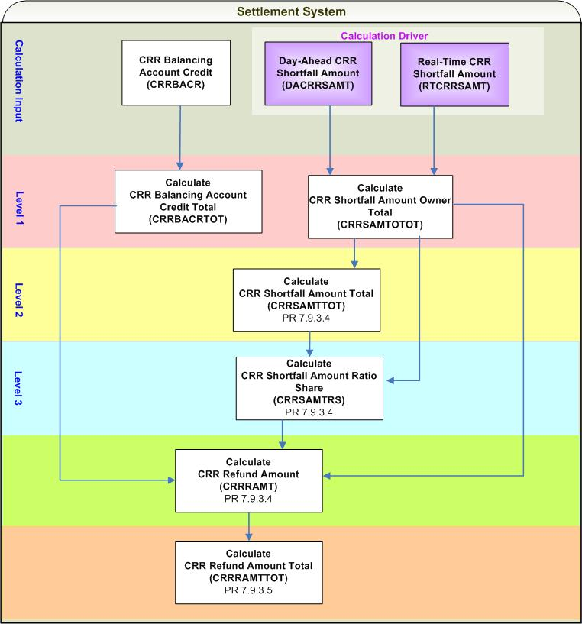
- Calculation Dependencies of CRR Refund Amount (CRRRAMT)

Assumptions

A1) The CRR Balancing Account Credit is not short paid. [An NPRR is suggested to clarify that before payments are made out on the DAM Invoice, the CRR Balancing Account Credit shall be paid in full].

NOTE: ERCOT will also suggest a protocol revision to Nodal Protocol Section 7 and 9, Settlements and Billing, to include a true up of CRR Balancing Account Invoices, the process in which ERCOT shall recalculate the following CRR Balancing Account charge types in the event that subsequent settlement runs for an Operating Day for the DAM and RTM produce changes that affect the monthly balancing account:
- Monthly Refund to Short-Paid CRR Owners (CRRRAMT)
- CRR Balancing Account Closure (LACRRAMT)

Business Rules
Req. ID | Protocol(s) | Sub-Process Map | Description
 | PR 9.12 4(a) | CSWM. P03SettleBill Transfer | CRRRAMT shall be reflected on the monthly CRR Balancing Account invoices.
 | PR 7.9.3.4 | CSWM. P03SettleBill Transfer | None of the input and intermediate bill determinants should be rounded or truncated.
 | PR 7.9.3.4 | CSWM. P03SettleBill Transfer | The following output bill determinant should be rounded or truncated to two (2) decimals, including:  - CRRRAMT
 | PR 12.3 (C) | CSWM. P03SettleBill Transfer | The following data shall be available for public data extracts, including:  - CRRBACR  - CRRSAMTTOT  - CRRBACRTOT  - CRRRAMTTOT
 | PR 12.3 (C) | CSWM. P03SettleBill Transfer | The following data shall be available for private data extracts, including:  - DACRRSAMT  - RTCRRSAMT  - CRRSAMTOTOT  - CRRSAMTRS  - CRRRAMT
 | PR 7.9.3.4 | CSWM. P03SettleBill Transfer | DRIVER: The CRRRAMT calculation shall be attempted for a CRR Owner for an Operating Month within which at least one of the following data cuts is positive for at least one Operating Hour:  - DACRRSAMT  - RTCRRSAMT

Business Defined Errors
Req. ID | Protocol(s) | Sub-Process Map | Description
 | PR 7.9.3.4 | CSWM. P03SettleBill Transfer | If the Settlement System calculation needs DACRRSAMT that is not available, the Settlement System should set DACRRSAMT to be zero (0). No error message is necessary.
 | PR 7.9.3.4 | CSWM. P03SettleBill Transfer | If the Settlement System calculation needs RTCRRSAMT that is not available, the Settlement System should set RTCRRSAMT to be zero (0). No error message is necessary.
 | PR 7.9.3.4 | CSWM. P03SettleBill Transfer | If the Settlement System calculation needs CRRBACR that is not available, the Settlement System should set CRRBACR to be zero (0). No error message is necessary.

Specific Database Needs
None

CRR Balancing Account Closure (LACRRAMT)

At the end of each month, the surplus in the CRR Balancing Account, if any, is paid to the QSEs representing LSEs based on a monthly Load Ratio Share. The monthly Load Ratio Share is the 15-minute Load Ratio Share calculated for the peak-load Settlement Interval during the month.

Requirement ID
Source Mapping (Protocol/NERC/FERC and other binding documents Ref #) | PR 7.9.3.5
Traceability to Sub-Process Maps | CSWM.P03SettleBillTransfer
Description

Calculate Load Allocated CRR Amount per QSE for each Operating Month:

LACRRAMT_<Q> = (-1) * (CRRBACRTOT + CRRRAMTTOT) * MLRS_<Q>

Input Bill Determinants
Variable | Unit | Definition | Original Source
CRRBACRTOT | $ | CRR Balancing Account Credit Total—The total credit accumulated in the CRR Balancing Account during the month. See its calculation in Section 7.9.3.4, Monthly Refunds to Short-Paid CRR Owners. | Settlement System
Interval Frequency: 1/month

Comments:
- Calculation of CRRBACRTOT is addressed by the section of Monthly Refund to Short Paid CRR Owners.
CRRRAMTTOT | $ | CRR Refund Amount Total—The total refund to all the previously short-paid CRR Owners at the end of the month. | Settlement System
Interval Frequency: 1/month

Comments:
- Calculation of CRRRAMTTOT is addressed by the section of Monthly Refund to Short Paid CRR Owners.
MLRS | none | Monthly Load Ratio Share per QSE—The Load Ratio Share calculated for QSE for the 15-minute monthly peak-load Settlement Interval. See Section 6.6.2.2, QSE Load Ratio Share for a 15-Minute Settlement Interval, for the calculation of LRS for a 15-minute Settlement Interval. | Data Aggregation Process
Interval Frequency: 1/month

Comments:
- The calculation of MLRS will be performed in the Data Aggregation Process prior to the Settlement System process.

Output Bill Determinants
Variable | Unit | Definition | Original Source
LACRRAMT | $ | Load-Allocated CRR Amount per QSE—The allocated surplus in the CRR Balancing Account at the end of the month to QSE, based on Load Ratio Share for the month. | Settlement System
Interval Frequency: 1/month

Comments: None

Data Dependencies
D1) Calculation of LACRRAMT is dependent upon the availability of input bill determinants.
D2) Calculation of LACRRAMT is dependent upon completion of Monthly Refund to Short Paid CRR Owners (CRRRAMT).
D3) None of the charge types is dependent upon the calculation of LACRRAMT.

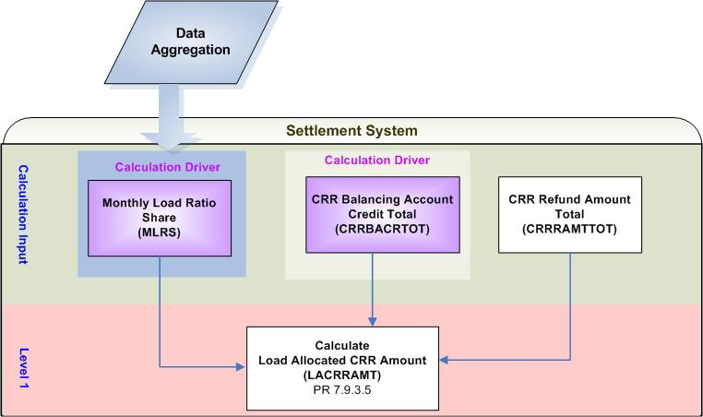
- Calculation Dependencies of Load Allocated CRR Amount (LACRRAMT)

Assumptions
A1) The CRR Balancing Account Credit is not short paid. [An NPRR is suggested to clarify that before payments are made out on the DAM Invoice, the CRR Balancing Account Credit shall be paid in full].

NOTE: ERCOT will also suggest a protocol revision to Nodal Protocol Section 7 and 9, Settlements and Billing, to include a true up of CRR Balancing Account Invoices, the process in which ERCOT shall recalculate the following CRR Balancing Account charge types in the event that subsequent settlement runs for an Operating Day for the DAM and RTM produce changes that affect the monthly balancing account:
- Monthly Refund to Short-Paid CRR Owners (CRRRAMT)
- CRR Balancing Account Closure (LACRRAMT)

Business Rules
Req. ID | Protocol(s) | Sub-Process Map | Description
 | PR 9.12 4 (b) | CSWM. P03SettleBill Transfer | LACRRAMT shall be reflected on monthly CRR Balancing Account invoices.
 | PR 7.9.3.5 | CSWM. P03SettleBill Transfer | None of the input and intermediate bill determinants should be rounded or truncated.
 | PR 7.9.3.5 | CSWM. P03SettleBill Transfer | The following output bill determinant should be rounded or truncated to two (2) decimals, including:  - LACRRAMT
 | PR 12.3 (C) | CSWM. P03SettleBill Transfer | The following data shall be available for public data extracts, including:  - CRRBACRTOT  - CRRRAMTTOT
 | PR 12.3 (C) | CSWM. P03SettleBill Transfer | The following data shall be available for private data extracts, including:  - MLRS  - LACRRAMT
 | PR 7.9.3.5 | CSWM. P03SettleBill Transfer | DRIVER: The LACRRAMT calculation shall be attempted for a QSE for an Operating Month for which both conditions described below are met:  - CRRBACRTOT is greater than zero (0).  - The QSE’s MLRS is greater than zero (0).

Business Defined Errors
Req. ID | Protocol(s) | Sub-Process Map | Description
 | PR 7.9.3.5 | CSWM. P03SettleBill Transfer | If the Settlement System calculation needs CRRRAMTTOT that is not available, the Settlement System should set CRRRAMTTOT to be zero (0). No error message is necessary.

Specific Database Needs
None

Supplementary Requirements

Performance Requirements
Lodestar must be able to perform its full set of Nodal settlement calculations. Performance characteristics will be determined and detailed in the conceptual and detailed design.

Legal and Regulatory requirements
All Lodestar financial data must be saved in accordance with standard accounting principles as dictated by the ERCOT Texas Nodal Protocols.

System Security Requirements
Lodestar will only be accessed directly by internal ERCOT personnel either through thin client UI, Citrix environment, or thick client on employee desktops. Market Participants will be able to access their statements and invoices on ERCOT private web site. ERCOT private web site access will be controlled by digital certificate authentication in accordance with ERCOT security policies.

Back up and Recovery Requirements
All Lodestar Nodal settlement data must be backed up on a daily basis and recoverable within 24 hours.

Availability and Redundancy Requirements
Nodal Lodestar system must be available 7/24. Lodestar is considered a tier 1 system and critical to base ERCOT business processes

Maintainability Requirements
Lodestar Nodal system will be maintained by internal ERCOT personnel. SLAs and explicit support will be detailed in the detail design document.

Daylight Savings Time shall be recognized in Nodal Market settlements.
- Spring Daylight Savings Time Operating Day:
    - Hour Ending 0300 will be skipped, resulting in 23 hourly intervals for the day.
    - The four fifteen minute intervals within Hour Ending 0300 will be skipped, resulting in 92 fifteen minute intervals for the day.
    - The sixty one minute intervals within Hour Ending 0300 will be skipped, resulting in 1380 total one minute intervals.
  - Fall Daylight Savings Time Operating Day:
    - Hour Ending 0200 will have two sets of data, resulting in 25 hourly intervals for the day.
    - The four fifteen minute intervals within Hour Ending 0200 will have two sets of data, resulting in 100 fifteen minute intervals for the day.
    - The sixty one minute intervals within Hour Ending 0200 will have two sets of data, resulting in 1500 total one minute intervals.

Protocol Coverage

Protocol Sub-Section | Description | Coverage by Requirements  (Full/Partial)
PR 7.9.2.3 | Payments for PTP Options with Refund Settled in Real-Time | Partial
PR 7.9.3.3 | Shortfall Charges to CRR Owners | Partial
PR 7.9.3.4 | Monthly Refunds to Short-Paid CRR Owners | Partial
PR 7.9.3.5 | CRR Balancing Account Closure | Partial

