Commercial Systems

Real-Time Congestion Revenue Rights Settlements Requirements

v0.091

Revision History
Date | Version | Description | Author
09/18/06 | 0.01 | Completed Internal Review Process  Incorporated IDA Feedback. | Sharon Wang
09/18/06 | 0.09 | TPTF Review Process | Sharon Wang
10/06/06 | 0.091 | Incorporated TPTF Comments | Sharon Wang

Table of Contents
1. Real-Time Congestion Revenue Rights Settlements 3
1.1 Proposed System Scope 3
1.2 Document Conventions 3
1.3 Document Assumptions 3
2. Functional Requirements 3
2.1 Calculation of Real-Time Obligation Price (RTOBLPR) 3
Input Bill Determinants 3
Output Bill Determinants 3
Data Dependencies 3
Assumptions 3
Business Rules 3
Business Defined Errors 3
Specific Database Needs 3
2.2 Calculation of Real-Time Option Price (RTOPTPR) 3
Input Bill Determinants 3
Output Bill Determinants 3
Data Dependencies 3
Assumptions 3
Business Rules 3
Business Defined Errors 3
Specific Database Needs 3
2.3 Calculation of Real-Time Option Informational Price (RTOPTPRINFO) 3
Input Bill Determinants 3
Output Bill Determinants 3
Data Dependencies 3
Assumptions 3
Business Rules 3
Business Defined Errors 3
Specific Database Needs 3
2.4 Calculation of Real-Time Option Hedge Value Price (RTOPTHVPR) 3
Input Bill Determinants 3
Output Bill Determinants 3
Data Dependencies 3
Assumptions 3
Business Rules 3
Business Defined Errors 3
Specific Database Needs 3
2.5 Payments and Charges for Real-Time Obligations Settled in Real-Time (RTOBLAMT) 3
Input Bill Determinants 3
Output Bill Determinants 3
Data Dependencies 3
Assumptions 3
Business Rules 3
Business Defined Errors 3
2.6 Payments for NOIE’s PTP Options Settled in Real-Time (RTOPTAMT) 3
Input Bill Determinants 3
Intermediate Bill Determinants 3
Output Bill Determinants 3
Data Dependencies 3
Assumptions 3
Business Rules 3
Business Defined Errors 3
Specific Database Needs 3
2.7 Payments for NOIE’s PTP Options with Refund Settled in Real-Time (RTOPTRAMT) 3
Input Bill Determinants 3
Intermediate Bill Determinants 3
Output Bill Determinants 3
Data Dependencies 3
Assumptions 3
Business Rules 3
Business Defined Errors 3
Specific Database Needs 3
3. Supplementary Requirements 3
3.1 Performance Requirements 3
3.2 Legal and Regulatory requirements 3
3.3 System Security Requirements 3
3.4 Back up and Recovery Requirements 3
3.5 Availability and Redundancy Requirements 3
3.6 Maintainability Requirements 3
3.7 Daylight Savings Time shall be recognized in Nodal Market settlements. 3
4. Protocol Coverage 3

Software Requirements Specification

Real-Time Congestion Revenue Rights Settlements

Proposed System Scope

ERCOT plans to implement a new Nodal market in 2009. Sections 7, 9 and 12 of the Nodal Protocols describe the various Charge Types, Settlement Statement, and Market Information System requirements for the Real-Time (RT) Congestion Revenue Rights (CRR). The Nodal Protocols will guide this project. The requirements in this document were based on information detailed in Nodal Protocols Section 7 (005NPRR-05_BOD_Action_Report_071806), Nodal Protocols Section 9 (007NPRR-07_BOD_Action_Report_071806).

The document defines the requirements for Congestion Revenue Rights Settlements in the Real-Time Market (RTM). Specifically, it comprises the requirements for the following CRR Charge Type Settlements:
- Payments and Charges for PTP (Point To Point) Obligations Settled in Real-Time (RTOBLAMT)
--- PR 7.9.2.1; PR 9.5.3 (nn)
- Payments for PTP Options Settled in Real-Time (RTOPTAMT)
--- PR 7.9.2.2; PR 9.5.3 (oo)
- Payments for PTP Options with Refunds Settled in Real-Time (RTOPTRAMT)
--- PR 7.9.2.3; PR 9.5.3 (pp)

The following calculations are defined as global calculations in CRR Real-Time Settlements:
- Calculation of Real-Time Obligation Price (RTOBLPR)
- Calculation of Real-Time Option Price (RTOPTPR)
- Calculation of Real-Time Option Hedge Value Price (RTOPTHVPR)

The following calculation is defined in the document for MIS posting:
- Real-Time Option Informational Price (RTOPTPRINFO)

The calculation detailed in Section 7.9.3.3, Shortfall Charges to CRR Owners, Item 3 (shortfall Charges to CRR Owners in Real-Time) will be on the RTM Statement but will be covered in the “TN.COMS.63C01.CRRBA.REQUIREMENTS.A” document. The purpose of the “TN.COMS.63C01.CRRBA.REQUIREMENTS.A” document is to addresses the balancing account.

To Be Sub-Process for Settlements and Billing
For illustrative purposes, Figures 1 to Figure 11 are provided to describe calculation dependencies in this document.
Figure 1 illustrates the proposed scope of CRR Settlements. It comprises Day-Ahead CRR Settlements, Real-Time CRR Settlements, CRR Balancing Account, and CRR Auctions Settlements, within which Real-Time CRR Settlements are addressed by this document, and other components are addressed by separate sets of Requirements.
Figure 2 illustrates the high-level calculation dependencies in the CRR Real-Time Settlement system -- between global calculations and charge type calculations.
A dependency diagram is provided to depict the dependencies between calculation inputs, intermediate variables, and outputs for each section of Functional Requirements.
These figures should be considered in conjunction with the textual requirements. If a contradiction exists between an illustrative figure and its associated textual requirements, the textual requirements should override the figure.

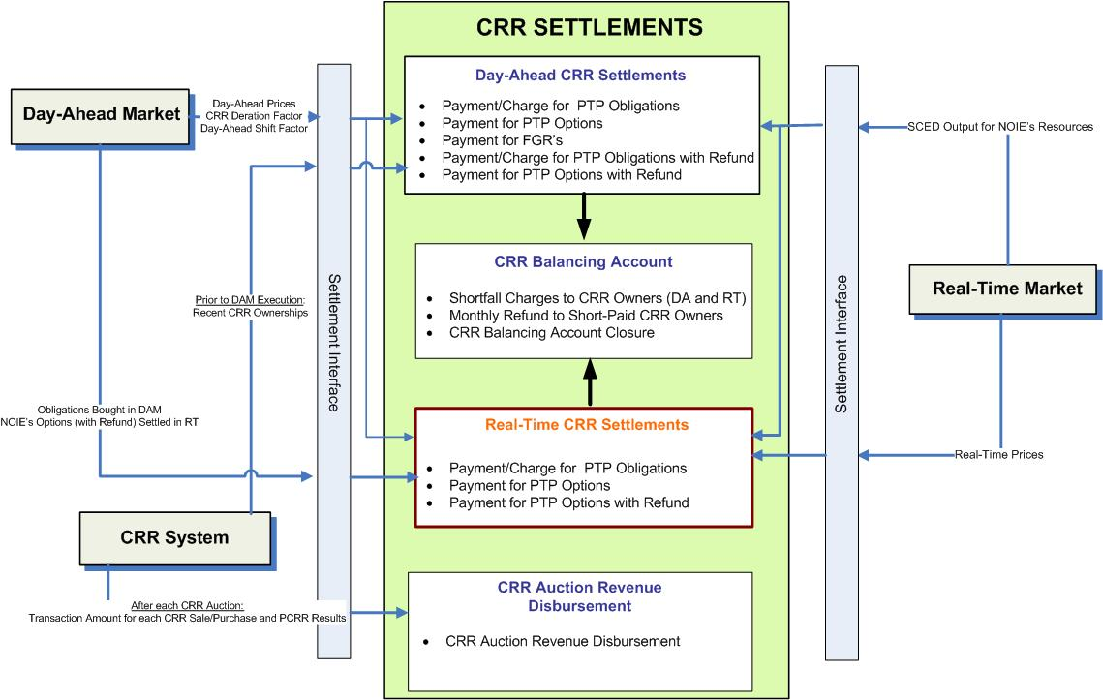

- Proposed Scope of CRR Settlements

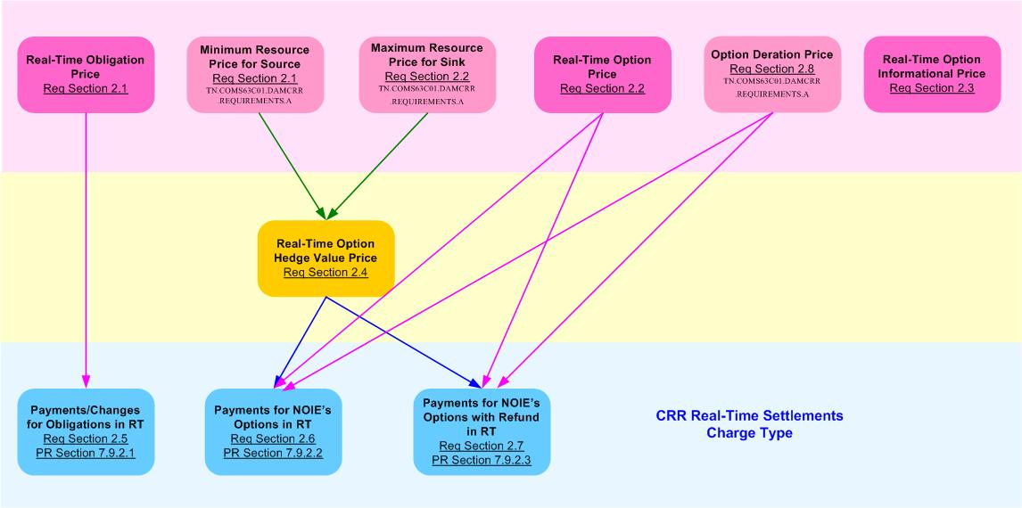

- High-Level Dependency Diagram between Global Calculations and Charge Type Calculations defined in Real-Time CRR Settlement Requirements

Document Conventions
- All text directly lifted from the Nodal Protocols is in italic font.
- All requirements are identified using R1, R2, etc.
- All dependencies are identified using D1, D2, etc.
- All assumptions are identified using A1, A2, etc.
- Settlement Recorders in this document adhere to the following naming convention:
BILLDETERMINANT_<Q>_<CO>_<R>_<SP>_<SRSP>_<SKSP>_<F>_<E>_<C>

Where:
<Q> = QSE
<CO> = CRR Owner
<R> = Resource
<SP> = Settlement Point
<SRSP> = Source Settlement Point
<SKSP> = Sink Settlement Point
<F> = Flowgate
<E> = Directional Network Element
<C> = Constraint Identifier

- Footnotes in this document are denoted by a * sign.
- Each Section Title will include the Charge Type/Bill Determinant description and the associated Bill Determinant in parenthesis.
- It is assumed that Input Bill Determinants described in this requirement have a compatible data format with the Settlement System.
- The color scheme used in calculation dependency diagrams is defined in Figure 3 and Figure 4.
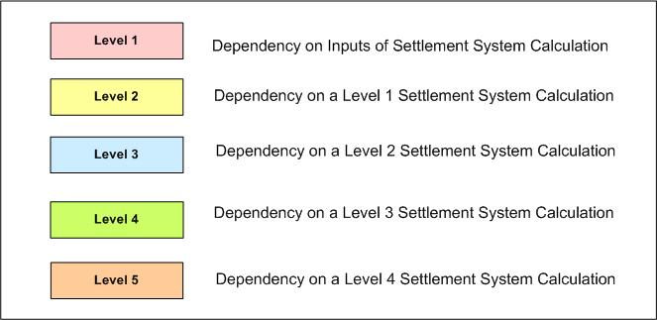

- Color Definition for Levels of Dependency Diagram used in Real-Time CRR Settlement Requirements

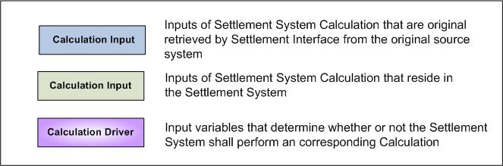

- Color Definition for Inputs of Dependency Diagram used in Real-Time CRR Settlement Requirements

Document Assumptions

- A separate requirement document will address the Settlement Interface with original sources such as MMS and CRR System. Specifically, this Settlement Interface Requirement will focus on when, what, and how input data should be retrieved from the original source, how to evaluate input data validity and completeness, and how to handle input data missing or other types of errors, to perform CRR Settlements Calculations described in this document.
- The DAM is executed completely and correctly. Therefore, the applicable amount of allocated PCRRs and CRRs acquired in CRR auctions and bilateral trades are settled in the DAM as detailed in TN.COMS63C01.DAMCRR.REQUIREMENTS.A.
- For any Charge Types that require historical data for the calculation, this information is obtained via alternative means for during the beginning of market open until the data is available.

Functional Requirements

Calculation of Real-Time Obligation Price (RTOBLPR)

ERCOT shall pay or charge the QSE of each PTP Obligation acquired in the DAM the difference in Real-Time Settlement Point Prices between the sink Settlement Point and the source Settlement Point. The value of Real-Time Obligation Price (RTOBLPR) could be negative, zero, or positive.

Real-Time Obligation Price (RTOBLPR) is utilized in the calculation of Real-Time Obligation Amount (RTOBLAMT).

Requirement ID
Source Mapping (Protocol/NERC/FERC and other binding documents Ref #) | PR 7.9.2.1 (1)
Traceability to Sub-Process Maps | CSWM.P03SettleBillTransfer
Description

Calculate Real-Time Obligation Price per Source and Sink pair for each Operating Hour of the Operating Day:

RTOBLPR_<SRSP>_<SKSP> = $\sum_{i=1}^{4}{}$(RTSPP_<SKSP> – RTSPP_<SRSP>)_{i} / 4

Where: i represents a 15-minute Settlement Interval within the Operating Hour.

Input Bill Determinants
Variable | Unit | Definition | Original Source
RTSPP | $/MWh | Real-Time Settlement Point Price at source (sink) per interval—The Real-Time Settlement Point Price at the source (sink) for the 15-minute Settlement Interval. | MMS RTM
Interval Frequency: 4/hour

Comments:
- RTSPP is calculated and certified by MMS RTM package.
RTOBL | MW | Real-Time Obligation per QSE per pair of source and sink—The number of QSE’s PTP Obligations for the sink and source pair settled in Real-Time for the hour. | MMS DAM
Interval Frequency: 1/ hour

Comments:
- RTOBL represents PTP Obligations bought in DAM.

- The Owner of RTOBL shall be a qualified QSE that is also a CRR Account Holder.

Output Bill Determinants
Variable | Unit | Definition | Destination
RTOBLPR | $/MW per hour | Real-Time Obligation Price—The Real-Time price of the PTP Obligation, for the hour. | Settlement System
Interval Frequency: 1/ hour

Additional Comments:
- The value of RTOBLPR could be negative, zero, or positive.

Data Dependencies
D1) Calculation of RTOBLPR is dependent upon the availability of the input bill determinants.
D3) The following charge type is dependent upon the calculation of RTOBLPR: Real-Time Obligation Amount (RTOBLAMT).

- Calculation Dependencies of Real-Time Obligation Price (RTOBLPR)

Assumptions
Assumptions of upstream systems:
A1) Calculation and certification of Real-Time Settlement Point Prices is performed outside of the Settlement System. Therefore RTSPP is assumed to be valid for use in the Settlement System.
A2) Price corrections of RTSPP are completed in the original source system (MMS RTM) prior to RTM settlements.
A3) Determination of whether or not a PTP Obligation bid is awarded is made in the original source (MMS DAM). Therefore, RTOBL is assumed to be valid for use in the Settlement System.
Assumptions of Settlement Interface:
A4) If RTSPP is adjusted in the original system (MMS RTM), the Settlement Interface with the original source system (MMS) will retrieve the adjusted RTSPP prior to DAM settlements.

Business Rules
Req. ID | Protocol(s) | Sub-Process Map | Description
 | PR 7.9.2.1 | CSWM. P03SettleBill Transfer | None of the input bill determinants should be rounded or truncated.
 | PR 7.9.2.1 | CSWM. P03SettleBill Transfer | The following output bill determinant should be rounded or truncated to two (2) decimals, including:  - RTOBLPR
 | PR 12.3 (C) | CSWM. P03SettleBill Transfer | The following data shall be available for private data extracts, including:  - RTOBLPR
 | PR 12.3 (C) | CSWM. P03SettleBill Transfer | The following data shall be available for public data extracts, including:  - RTSPP
 | PR 7.9.2.1 | CSWM. P03SettleBill Transfer | DRIVER: The RTOBLPR calculation shall be attempted for a source and sink Settlement Point pair for which Real-Time Obligation (RTOBL) exists with positive value for at least one Operating Hour of the Operating Day.

Business Defined Errors
Req. ID | Protocol(s) | Sub-Process Map | Description
 | PR 7.9.2.1 | CSWM. P03SettleBill Transfer | If a RTSPP data cut is not available for a Settlement Point and Operating Day for which RTOBL data cut exists, the system should log a “CRITICAL” error message and stop any downstream CRR calculations that depend on RTSPP. The error message should capture the missing data element, including the Settlement Point, and the Operating Day.

Specific Database Needs
None

Calculation of Real-Time Option Price (RTOPTPR)

ERCOT shall pay the NOIE that owns a PTP Option and PTP Options with Refund that were declared before DAM execution by the NOIE to be settled in Real-Time and not cleared in the DAM. Under this scenario, Real-Time Option Price (RTOPTPR) shall be calculated as the positive difference in Real-Time Settlement Point Prices between the sink and the source. The value of RTOPT PR could never be negative.

The Calculation of Real-Time Option Price (RTOPTPR) is defined as a global calculation because it is a common component utilized in multiple calculations in RT CRR Settlements. Specifically, RTOPTPR is used by the calculation of: Real-Time Option Target Payment (RTOPTTP), and Real-Time Option with Refund Target Payment (RTOPTRTP).

Requirement ID
Source Mapping (Protocol/NERC/FERC and other binding documents Ref #) | PR 7.9.2.2 (3), PR 7.9.2.3 (3)
Traceability to Sub-Process Maps | CSWM.P03SettleBillTransfer
Description

Calculate Real-Time Option Price per Source and Sink pair for each Operating Hour of the Operating Day:

RTOPTPR_<SRSP>_<SKSP> = $\sum_{i=1}^{4}{}$Max( 0, RTSPP_<SKSP> – RTSPP_<SRSP> )_{i} /4

Where: i represents a 15-minute Settlement Interval within the Operating Hour.

Input Bill Determinants
Variable | Unit | Definition | Original Source
RTSPP | $/MWh | Real-Time Settlement Point Price at source (sink) per interval—The Real-Time Settlement Point Price at the source (sink) for the 15-minute Settlement Interval. | MMS RTM
Interval Frequency: 4/hour

Comments:
- RTSPP is calculated and certified by MMS RTM package.
RTOPT | MW | Real-Time Option per CRR Owner per pair of source and sink—The number of NOIE CRR Owner’s PTP Options with the source and sink pair settled in Real-Time for the hour. | MMS DAM
Interval Frequency: 1/ hour

Comments:
- RTOPT is the amount of PTP Options that are declared before DAM execution by NOIE CRR Owners to be settled in Real-Time and not cleared in the DAM.
RTOPTR | MW | Real-Time Option with Refund per pair of source and sink—The number of the NOIE CRR Owner’s PTP Options with Refund with the source and sink pair, settled in Real-Time, for the hour. | MMS DAM
Interval Frequency: 1/ hour

Comments:
- RTOPTR is the amount of PTP Options with Refund that are declared before DAM execution by NOIE CRR Owners to be settled in Real-Time and not cleared in the DAM.

Output Bill Determinants
Variable | Unit | Definition | Destination
RTOPTPR | $/MW per hour | Real-Time Option Price per source and sink pair —The Real-Time price of a PTP Option with the source and sink pair for the hour. | Settlement System
Interval Frequency: 1/ hour

Additional Comments:
- The value of RTOPTPR could be equal to, or greater than zero (0).

Data Dependencies
D1) Calculation of RTOPTPR is dependent upon the availability of the input bill determinants.
D3) The following charge types are dependent upon the calculation of RTOPTPR: Real-Time Option Amount (RTOPTAMT) and Real-Time Option with Refund Amount (RTOPTRAMT)

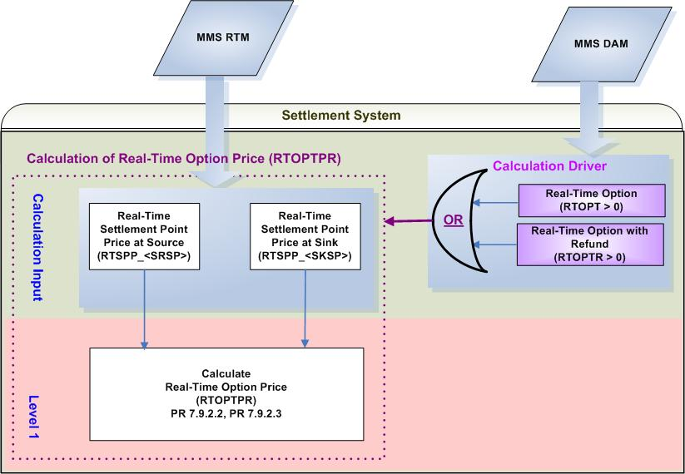
- Calculation Dependencies of Real-Time Option Price (RTOPTPR)

Assumptions
Assumptions of upstream systems:
A1) Calculation and certification of Real-Time Settlement Point Prices is performed outside of the Settlement System. Therefore RTSPP is assumed to be valid for use in the Settlement System.
A2) Price corrections of RTSPP are completed in the original source system (MMS RTM) prior to RTM settlements.
A3) Determination of whether or not PTP Options and PTP Options with Refund owned by NOIE are eligible for Real-Time Settlements is made in the original source system (MMS DAM). Therefore, RTOPT and RTOPTR are assumed to be valid for use in the Settlement System.
Assumptions of Settlement Interface:
A4) If RTSPP is adjusted in the original system (MMS RTM), the Settlement Interface with the original
source system (MMS) will retrieve the adjusted RTSPP prior to DAM settlements.

Business Rules
Req. ID | Protocol(s) | Sub-Process Map | Description
 | PR 7.9.3.3;  PR 9.2.3 (t) | CSWM. P03SettleBill Transfer | The calculation of RTOPTPR shall be completed along with other Day-Ahead Settlement Charge Types.
 | PR 7.9.2.2; PR 7.9.2.3 | CSWM. P03SettleBill Transfer | None of the input bill determinants should be rounded or truncated.
 | PR 7.9.2.2; PR 7.9.2.3 | CSWM. P03SettleBill Transfer | The following output bill determinant should be rounded or truncated to two (2) decimals, including:  - RTOPTPR
 | PR 12.3 (C) | CSWM. P03SettleBill Transfer | The following data shall be available for private data extracts, including:  - RTOPTPR
 | PR 12.3 (C) | CSWM. P03SettleBill Transfer | The following data shall be available for public data extracts, including:  - RTSPP
 | PR 7.9.2.2; PR 7.9.2.3 | CSWM. P03SettleBill Transfer | DRIVER: The RTOPTPR calculation shall be attempted for a source and sink Settlement Point pair only when each condition as described below is met:  - At least one of the following data cuts exists and is positive for at least one Operating Hour of the Operating Day:  - Real-Time Option (RTOPT)  - Real-Time Option with Refund (RTOPTR)

Business Defined Errors
Req. ID | Protocol(s) | Sub-Process Map | Description
 | PR 7.9.2.2, PR 7.9.2.3 | CSWM. P03SettleBill Transfer | If any calculated RTOPTPR is negative, the Settlement System should consider it as a WARN--DEFAULT error, and set RTOPTPR as a default value of zero (0) and an error message should be logged. The error message should capture the source and sink Settlement Point, the Operating Hour, and Operating Day, for which RTOPTPR is calculated as negative.
 | PR 7.9.2.2; PR 7.9.2.3 | CSWM. P03SettleBill Transfer | If a RTSPP data cut is not available for a Settlement Point and Operating Day for which either RTOPT or RTOPTR data cut exists, the system should log a “CRITICAL” error message and stop any downstream CRR calculations that depend on RTSPP. The error message should capture the missing data element, including the Settlement Point, and the Operating Day.

Specific Database Needs
None

Calculation of Real-Time Option Informational Price (RTOPTPRINFO)

For informational purposes, the Real-Time Option Informational Price (RTOPTPRINFO) shall be calculated and posted on the MIS Public Area. In accordance to the current Nodal Protocols, the Real-Time Option Informational Price is not used to settle any of the CRR products.

Requirement ID
Source Mapping (Protocol/NERC/FERC and other binding documents Ref #) | PR 7.9.2.2 (5)
Traceability to Sub-Process Maps | Will be completed by August 31, 2006
Description

Calculate Informational Real-Time Option Price to be posted in MIS Public Area per Source and Sink pair for each Operating Hour of the Operating Day:

RTOPTPRINFO_<SRSP>_<SKSP> = $\sum_{y}{}$[$\underset{c}{Σ}$(RTSP_<C>)_{y} * Max (0, RTWASF_<SRSP>_<C>
- RTWASF_<SKSP>_<C>)_{y}*TLMP_{y} / $\sum_{y}{}$TLMP_{y} ]
Where: y represents a Security Constrained Economic Dispatch (SCED) interval within the Operating Hour.

Input Bill Determinants
Variable | Unit | Definition | Original Source
RTSP | $/MW per hour | Real-Time per constrain per SCED interval—The Real-Time Shadow Price of the constraint for the hour in the SCED interval. | MMS RTM
Interval Frequency: 1/ hour

Additional Comments:
- RTSP is calculated by MMS RTM Package.
RTWASF | None | Real-Time Weighted Average Shift Factor at source (sink) per constraint—The Real-Time Shift Factor for the source (sink) Settlement Point and the directional network element for constraint, in the hour. | MMS RTM / EMS
Interval Frequency: 1/ hour

Additional Comments: None
RTOPT | MW | Real-Time Option per CRR Owner per pair of source and sink—The number of NOIE CRR Owner’s PTP Options with the source and sink pair settled in Real-Time for the hour. | MMS DAM
Interval Frequency: 1/ hour

Comments:
- RTOPT is the amount of PTP Options that are declared before DAM execution by NOIE CRR Owners to be settled in Real-Time and not cleared in the DAM.
RTOPTR | MW | Real-Time Option with Refund per pair of source and sink—The number of the NOIE CRR Owner’s PTP Options with Refund with the source and sink pair, settled in Real-Time, for the hour. | MMS DAM
Interval Frequency: 1/ hour

Comments:
- RTOPTR is the amount of PTP Options with Refund that are declared before DAM execution by NOIE CRR Owners to be settled in Real-Time and not cleared in the DAM.
TLMP | Second | Duration of SCED interval per interval—The duration of the portion of the SCED interval y within the hour. | MMS RTM
Interval Frequency: 1/SCED Interval

Comments: None

Output Bill Determinants
Variable | Unit |  | Definition |  | Destination
RTOPTPRINFO |  | $/MW per hour |  | Real-Time Option Informational Price per pair of source and sink—The Informational RTM price of the PTP Options with the source Settlement Point and the sink Settlement Point, for the hour. | MIS Public Posting Area
Interval Frequency: 1/hour

Additional Comments:
- RTOPTPRINFO shall be posted on the MIS Public Area for informational purposes.
- The value of RTOPTPRINFO shall always be equal to, or greater than zero(0).
- The word “Informational” shall be added into the definition to distinguish it from the definition of RTOPTPR.

Data Dependencies
D1) Calculation of RTOPTPRINFO is dependent upon the availability of input bill determinants.
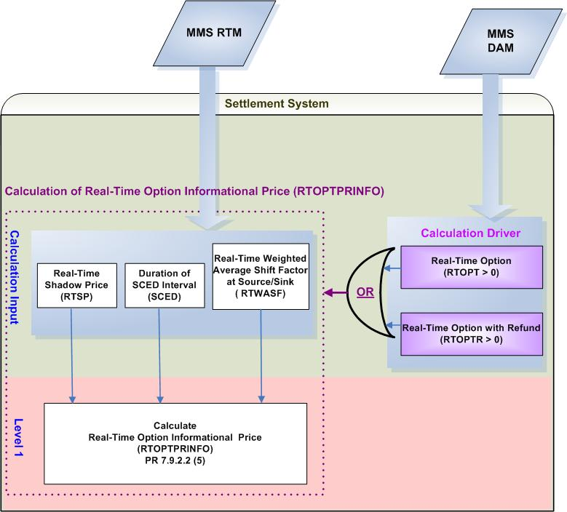
- Calculation Dependencies of Real-Time Option Informational Price (RTOPTPRINFO)

Assumptions
Assumptions of upstream systems:
A1) Calculation of Real-Time Shadow Prices (RTSP) is performed in the original system (MMS RTM).
A2) Price corrections of DASP are completed in the original source system (MMS) prior to the calculation of RTOPTPRINFO.
A3) Determination of whether or not PTP Options and PTP Options with Refund owned by NOIE are eligible for Real-Time Settlements is made in the original source system (MMS DAM).
A4) Calculation of Real-Time Weighted Average Shift Factors (RTWASF) for Resource Nodes, Hubs and Load Zones will be completed in the original source system (MMS RTM / EMS).
A5) It is currently under discussion where the RTOPTPRINFO calculation should occur.

Business Rules
Req. ID | Protocol(s) | Sub-Process Map | Description
 | PR 7.9.2.2 (5) | CSWM. P03SettleBill Transfer | None of the input bill determinants should be rounded or truncated.
 | PR 7.9.2.2 (5) | CSWM. P03SettleBill Transfer | The following output bill determinant should be rounded or truncated to two (2) decimals, including:  - RTOPTPRINFO
 | PR 7.9.2.2 (5) | CSWM. P03SettleBill Transfer | Real-Time Option Informational Price (RTOPTPRINFO) shall be posted in MIS Public Area.
 | PR 7.9.2.2 (5) | CSWM. P03SettleBill Transfer | DRIVER: The RTOPTPRINFO calculation shall only be attempted for a source and sink Settlement Point pair for which at least either one of the following data cuts exists and is positive for at least one Operating Hour of the Operating Day:  - Real-Time Option (RTOPT)  - Real-Time Option with Refund (RTOPTR)

Business Defined Errors
Req. ID | Protocol(s) | Sub-Process Map | Description
 | PR 7.9.2.2 (5) | CSWM. P03SettleBill Transfer | If the System that performs the RTOPTPRINFO calculation needs RTWASF that is not available for a source or a sink Settlement Point pair to a Constraint, the System should set DAWASF to be Zero (0). No error message is necessary.
 | PR 7.9.2.2 (5) | CSWM. P03SettleBill Transfer | If RTOPTPRINFO is calculated to be negative, the System that performs the RTOPTPRINFO calculation should consider it as a WARN--DEFAULT error, and set RTOPTPRINFO as a default value – zero (0) and an error message should be logged. The error message should capture the source and sink Settlement Point, the Operating Hour, and Operating Day, for which RTOPTPRINFO is calculated as negative.

Specific Database Needs
None

Calculation of Real-Time Option Hedge Value Price (RTOPTHVPR)

For PTP Options that its source or sink is a Resource Node, the PTP Option payment may be reduced due to directional network elements that are oversold in previous CRR auctions. Under this scenario, Real-Time Option Hedge Value Price (RTOPTHVPR) is calculated.

The Calculation of Real-Time Option Hedge Value Price (RTOPTHVPR) is defined as a global calculation because it is a common component utilized in multiple calculations in RT CRR Settlements. Specifically, RTOPTHVPR is used by the calculation of: Real-Time Option Hedge Value (RTOPTHV), and Real-Time Option with Refund Hedge Value (RTOPTRHV).

Requirement ID
Source Mapping (Protocol/NERC/FERC and other binding documents Ref #) | PR 7.9.2.2 (3); PR 7.9.2.3 (3)
Traceability to Sub-Process Maps | CSWM.P03SettleBillTransfer
Description

Calculate Real-Time PTP Option Hedge Value Price per Source and Sink pair for each Operating Hour of the Operating Day:

1. IF the SRSP is a Load Zone or Hub AND SKSP is a Resource Node, THEN:
$${\text{RTOPTHVPR}}_{}\text{SRSP}>_{}\text{SKSP}\text{>=}{\sum_{i=1}^{4}{\text{Max}(0,{\text{MAXRESPR}}_{}\text{SKSP}>−{\text{RTSPP}}_{}\text{SRSP}>)_{i}}}/4$$

2. IF SRSP is a Resource Node AND SKSP is a Load Zone or Hub, THEN:
$${\text{RTOPTHVPR}}_{}\text{SRSP}>_{}\text{SKSP}\text{>=}{\sum_{i=1}^{4}{{\text{Max}(0,{\text{RTSPP}}_{}\text{SKSP}>−{\text{MINRESPR}}_{}\text{SRSP}>)}_{i}}}/4$$

3. IF SRSP Is a Resource Node AND SKSP is also a Resource Node, THEN:
RTOPTHVPR_<SRSP>_<SKSP> = Max (0, MAXRESPR_<SKSP> – MINRESPR_<SRSP>)

Input Bill Determinants
Variable | Unit | Definition | Original Source
RTSPP | $/MWh | Real-Time Settlement Point Price at source (sink) per interval—The Real-Time Settlement Point Price at the source (sink) for the 15-minute Settlement Interval. | MMS RTM
Interval Frequency: 4/hour

Comments:
- RTSPP is calculated and certified by MMS RTM package.
MINRESPR | $/MWh | Minimum Resource Price for source—The lowest Minimum Resource Price for the types of Resources located at the source Settlement Point for the Operating Hour. | Settlement System
Interval Frequency: 1/ hour

Additional Comments:
- The availability of MINRESPR is dependent on the global calculation of Minimum Resource Price (MINRESPR) defined in Section 2.1of TN.COMS63C01.DAMCRR.REQUIREMENTS.A.
MAXRESPR | $/MWh | Maximum Resource Price for sink—The highest Maximum Resource Price for the types of Resources located at the sink Settlement Point for the Operating Hour. | Settlement System
Interval Frequency: 1/ hour

Additional Comments:
- The availability of MAXRESPR is dependent on the global calculation of Maximum Resource Price (MAXRESPR) defined in Section 2.2 of TN.COMS63C01.DAMCRR.REQUIREMENTS.A.
An NPRR will be suggested to clarify the above definitions in Protocols for TPTF to approve and vote.
RTOPT | MW | Real-Time Option per CRR Owner per pair of source and sink—The number of NOIE CRR Owner’s PTP Options with the source and sink pair settled in Real-Time for the hour. | MMS DAM
Interval Frequency: 1/ hour

Comments:
- RTOPT is the amount of PTP Options that are declared before DAM execution by NOIE CRR Owners to be settled in Real-Time and not cleared in the DAM.
RTOPTR | MW | Real-Time Option with Refund per pair of source and sink—The number of the NOIE CRR Owner’s PTP Options with Refund with the source and sink pair, settled in Real-Time, for the hour. | MMS DAM
Interval Frequency: 1/ hour

Comments:
- RTOPTR is the amount of PTP Options with Refund that are declared before DAM execution by NOIE CRR Owners to be settled in Real-Time and not cleared in the DAM.

Output Bill Determinants
Variable | Unit | Definition | Destination
RTOPTHVPR | $/MWh | Real-Time Option Hedge Value Price per pair of source and sink—The Real-Time hedge price of a PTP Option with the pair of source and sink, for the hour. | Settlement System
Interval Frequency: 1/ hour

Additional Comments:
- The value of RTOPTHVPR shall always be equal to, or greater than zero (0).

Data Dependencies
D1) Calculation of RTOPTHVPR is dependent upon the availability of the input bill determinants.
D2) Calculation of RTOPTHVPR is dependent upon the completion of global calculations: MINRESPR and MAXRESPR defined in Section 2.1 and Section 2.2 of TN.COMS63C01.DAMCRR.REQUIREMENTS.A.
D3) Calculation of RTOPTHVPR is dependent upon the availability of the most up-to-date network topology information for the mapping of a Settlement Point to Settlement Point type (Resource Node, Load Zone, or Hub).
D4) The following charge types are dependent upon the calculation of RTOPTHVPR: Real-Time Option Amount (RTOPTAMT), and Real-Time Option with Refund Amount (RTOPTRAMT).

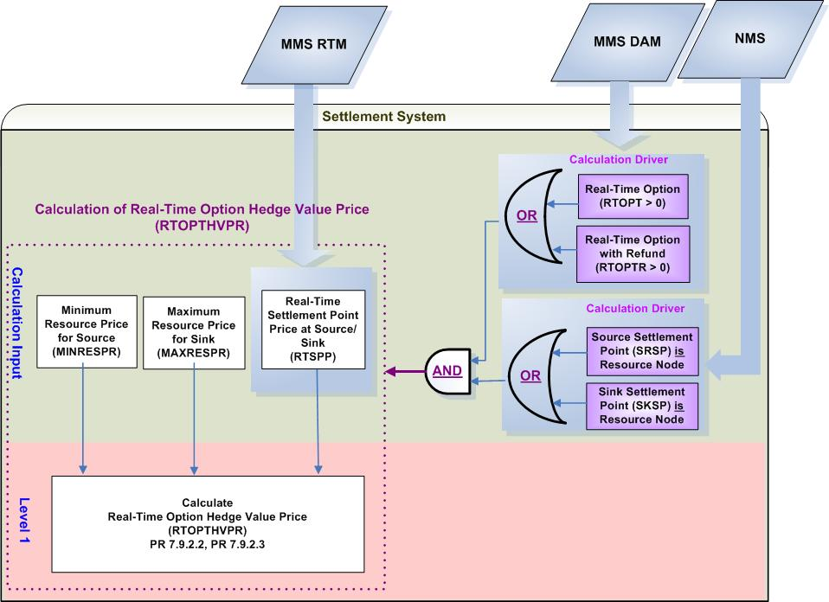

- Calculation Dependencies of Real-Time Obligation hedge Value Price (RTOBLHVPR)

Assumptions
Assumptions of upstream systems:
A1) Calculation and certification of Real-Time Settlement Point Prices is performed outside of the Settlement System. Therefore RTSPP is assumed to be valid for use in the Settlement System.
A2) Price corrections of RTSPP are completed in the original source system (MMS RTM) prior to RTM settlements.
A3) Determination of whether or not PTP Options and PTP Options with Refund owned by NOIE are eligible for Real-Time Settlements is made in the original source system (MMS DAM). Therefore, RTOPT and RTOPTR are assumed to be valid for use in the Settlement System.
Assumptions of Settlement Interface:
A4) If RTSPP is adjusted in the original system (MMS RTM), the Settlement Interface with the original source system (MMS) will retrieve the adjusted RTSPP prior to DAM settlements.

Business Rules
Req. ID | Protocol(s) | Sub-Process Map | Description
 | PR 7.9.3.3;  PR 9.2.3 (t) | CSWM. P03SettleBill Transfer | The calculation of RTOPTHVPR shall be completed along with other Day-Ahead Settlement Charge Types.
 | PR 7.9.2.2; PR 7.9.2.3 | CSWM. P03SettleBill Transfer | None of the input bill determinants should be rounded or truncated.
 | PR 7.9.2.2; PR 7.9.2.3 | CSWM. P03SettleBill Transfer | The following output bill determinant should be rounded or truncated to two (2) decimals, including:  - RTOPTHVPR
 | PR 12.3 (C) | CSWM. P03SettleBill Transfer | The following data shall be available for private data extracts, including:  - MINRESPR  - MAXRESPR  - RTOPT  - RTOPTR  - RTOPTHVPR
 | PR 12.3 (C) | CSWM. P03SettleBill Transfer | The following data shall be available for public data extracts, including:  - RTSPP
 | PR 7.9.2.2; PR 7.9.2.3 | CSWM. P03SettleBill Transfer | DRIVER: The RTOPTHVPR calculation shall be attempted for a source and sink Settlement Point pair only when each condition as described below is met:  - Either the source Settlement Point or the sink Settlement Point is a Resource Node  - At least one of the following data cuts exists and is positive for at least One Operating hour of the Operating Day:  - Real-Time Option (RTOPT)  - Real-Time Option with Refund (RTOPTR)

Business Defined Errors
Req. ID | Protocol(s) | Sub-Process Map | Description
 | PR 7.9.2.2; PR 7.9.2.3 | CSWM. P03SettleBill Transfer | If any calculated RTOPTHVPR is negative, the Settlement System should consider it as a WARN--DEFAULT error, and set RTOPTHVPR as a default value of zero (0) and an error message should be logged. The error message should capture the source and sink Settlement Point, the Operating Hour, and Operating Day, for which RTOPTHVPR is calculated as negative.
 | PR 7.9.2.2; PR 7.9.2.3 | CSWM. P03SettleBill Transfer | If a RTSPP data cut is not available for a Settlement Point and Operating Day for which either RTOPT or RTOPTR data cut exists, the system should log a “CRITICAL” error message and stop any downstream CRR calculations that depend on RTSPP. The error message should capture the missing data element, including the Settlement Point, and the Operating Day.

Specific Database Needs
None

Payments and Charges for Real-Time Obligations Settled in Real-Time (RTOBLAMT)

ERCOT shall pay or charge the QSE of each PTP Obligation acquired in the DAM the difference in Real-Time Settlement Point Prices between the sink Settlement Point and the source Settlement Point. The payment or charge to each QSE for a given Operating Hour of its cleared PTP obligations with each pair of source and sink Settlement Points is calculated as follows:

Requirement ID
Source Mapping (Protocol/NERC/FERC and other binding documents Ref #) | PR 7.9.2.1 (1)
Traceability to Sub-Process Maps | CSWM.P03SettleBillTransfer
Description

Calculate Real-Time Obligation Amount per QSE per Source and Sink pair for each Operating Hour of the Operating Day:

RTOBLAMT_<Q>_<SRSP>_<SKSP> = (-1) * RTOBLPR_<SRSP>_<SKSP>
* RTOBL_<Q>_<SRSP>_<SKSP>

Requirement ID
Source Mapping (Protocol/NERC/FERC and other binding documents Ref #) | PR 7.9.2.1 (2)
Traceability to Sub-Process Maps | CSWM.P03SettleBillTransfer
Description

Calculate Real-Time Obligation Amount QSE Total per QSE for each Operating Hour of the Operating Day

RTOBLAMTQSETOT_<Q> = $\underset{\text{SRSP}}{Σ}$$\underset{\text{SKSP}}{Σ}$ (RTOBLAMT_<Q>_<SRSP>_<SKSP)

Requirement ID
Source Mapping (Protocol/NERC/FERC and other binding documents Ref #) | PR 6.6.10 (2)
Traceability to Sub-Process Maps | CSWM.P03SettleBillTransfer
Description

Calculate Real-Time Obligation Amount Total for each Operating Hour of the Operating Day

RTOBLAMTTOT_<Q> = $\underset{Q}{Σ}$ (RTOBLAMTQSETOT_<Q>)

NPRR required: Modify the RTOBLAMTQSETOT formula and the associated variable description to reflect the settlement for RTOBLAMT is actually performed by QSE, instead of by CRR Owner. [This is addressed by the NPRR for CRR Settlements without DAM]

Input Bill Determinants
Variable | Unit | Definition |  | Original Source
RTOBL | MW | Real-Time Obligation per QSE per pair of source and sink—The number of QSE’s PTP Obligations for the sink and source pair settled in Real-Time for the hour. |  | MMS DAM
Interval Frequency: 1/ hour

Comments:
- RTOBL represents PTP Obligations bought in DAM.

- The Owner of RTOBL shall be a qualified QSE that is also a CRR Account Holder.
RTOBLPR | $/MW per hour |  | Real-Time Obligation Price—The Real-Time price of the PTP Obligation, for the hour. | Settlement System
Interval Frequency: 1/ hour

Additional Comments:
- The value of RTOBLPR could be negative, zero, or positive.

Output Bill Determinants
Variable | Unit |  | Definition | Destination
RTOBLAMT | $ |  | Real-Time Obligation Amount per QSE per pair of source and sink—The payment or charge to QSE q for the PTP Obligations with the source and sink pair settled in Real-Time, for the hour. | Settlement System
Interval Frequency: 1/ hour

Additional Comments:
- The value of RTOBLAMT could be negative, zero, or positive.
RTOBLAMTQSETOT | $ |  | Real-Time Obligation Amount QSE Total per QSE—The net total payment or charge to QSE of all its PTP Obligations settled in Real-Time, for the hour. | Settlement System
Interval Frequency: 1/ hour

Additional Comments:
- The value of RTOBLAMTQSETOT could be negative, zero, or positive.
RTOBLAMTTOT |  | $ | Real-Time Obligation Amount Total—The sum of all payments and charges for PTP Obligations settled in Real-Time, for the hour that includes the 15-minute Settlement Interval. | Settlement System
Interval Frequency: 1/ hour

Additional Comments:
- RTOBLAMTTOT is used by the calculation of LARTRNAMT which is addressed by TN.COMS.63C01.RTENERGY.REQUIREMENTS.
RTOBLBILLAMTQSETOT |  | $ | Real-Time Obligation QSE Bill Amount per QSE— The Delta of Real-Time Option Amount QSE Total between the current and the previous settlement run -- per QSE, for the day. | Settlement System
Interval Frequency: 1/day

Additional Comments:
- This bill determinant is not specifically documented in the Nodal Protocols but is required as a result of Section 9 Statements and Invoices Protocol requirements.

Data Dependencies
D1) Calculation of RTOBLAMT is dependent upon the availability of the input bill determinants.
D2) Calculation of RTOBLAMT is dependent upon the completion of global calculation RTOBLPR.
D3) Calculation of Real-Time Revenue Neutrality Allocation (LARTRNAMT) is dependent upon the calculation of RTOBLAMTTOT.

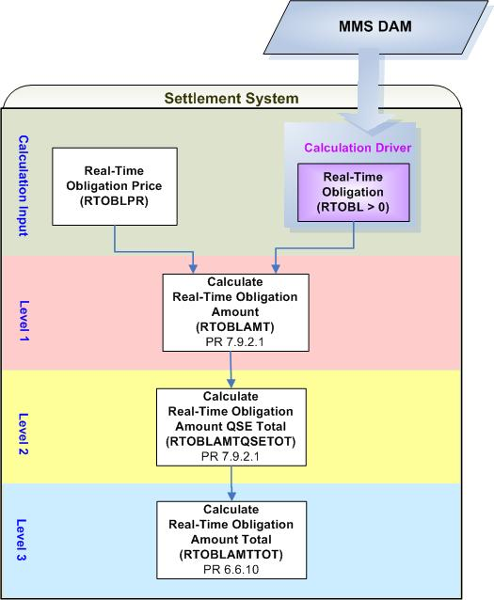
- Calculation Dependencies of Real-Time Obligation Amount (RTOBLAMT)

Assumptions
Assumptions of upstream systems:
A1) Determination of whether or not a PTP Obligation bid is awarded is made in the original source (MMS DAM). Therefore, RTOBL is assumed to be valid for use in the Settlement System.

Business Rules
Req. ID | Protocol(s) | Sub-Process Map | Description
 | PR 7.9.2.1 | CSWM. P03SettleBill Transfer | None of the input and intermediate bill determinants should be truncated or rounded in the Settlement System.
 | PR 7.9.2.1 | CSWM. P03SettleBill Transfer | Output bill determinates should be rounded to (2) decimals, including:  - RTOBLAMT
 | 12.3 (c) | CSWM. P03SettleBill Transfer | The following data shall be available for private data extract, including:  - RTOBL  - RTOBLPR  - RTOBLAMT  - RTOBLAMTQSETOT
 | 12.3 (c) | CSWM. P03SettleBill Transfer | The following data shall be available for public data extract, including:  - RTOBLAMTTOT
 | PR 7.9.2.1 | CSWM. P03SettleBill Transfer | DRIVER: the calculation of Payments/Charges for PTP Obligations Settled in RT (RTOBLAMT) shall be only attempted for the source and sink pair for which a RTOBL exists with a positive value for at least one Operating Hour of the Operating Day.

Business Defined Errors
None

Payments for NOIE’s PTP Options Settled in Real-Time (RTOPTAMT)

Settlement of NOIE’s PTP Options in Real-Time is described as follows:

- Except as specified in paragraph (2) below, ERCOT shall pay the NOIE that owns a PTP Option that was declared before DAM execution by the NOIE to be settled in Real-Time and not cleared in the DAM, the positive difference in Real-Time Settlement Point Prices between the sink and the source.
- For PTP Options that source or sink at a Resource Node, the PTP Option payment may be reduced due to transmission elements that are oversold in previous CRR auctions.

Requirement ID
Source Mapping (Protocol/NERC/FERC and other binding documents Ref #) | PR 7.9.2.2 (3)
Traceability to Sub-Process Maps | CSWM.P03SettleBillTransfer
Description

Calculate Real-Time Option Target Payment per CRR Owner per Source and Sink pair for each Operating Hour of the Operating Day:

RTOPTTP_<CO>_<SRSP>_<SKSP> =
RTOPTPR_<SRSP>_<SKSP> * RTOPT_<CO>_<SRSP>_<SKSP>

Requirement ID
Source Mapping (Protocol/NERC/FERC and other binding documents Ref #) | PR 7.9.2.2 (3)
Traceability to Sub-Process Maps | CSWM.P03SettleBillTransfer
Description

Calculate Real-Time Option Amount per CRR Owner per Source and Sink pair for each Operating Hour of the Operating Day:

IF (BOTH SRSP AND SKSP are Load Zones or Hubs)
THEN:
RTOPTAMT_<CO>_<SRSP>_<SKSP> = (-1) * RTOPTTP_<CO>_<SRSP>_<SKSP>

ELSE IF (EITHER SRSP OR SKSP is a Resource Node)
THEN:
RTOPTAMT_<CO>_<SRSP>_<SKSP> =
(-1) * Max {(RTOPTTP_<CO>_<SRSP>_<SKSP> – RTOPTDA_<CO>_<SRSP>_<SKSP>), Min (RTOPTTP_<CO>_<SRSP>_<SKSP>, RTOPTHV_<CO>_<SRSP>_<SKSP>)}

Requirement ID
Source Mapping (Protocol/NERC/FERC and other binding documents Ref #) | PR 7.9.2.2 (3)
Traceability to Sub-Process Maps | CSWM.P03SettleBillTransfer
Description

Calculate Real-Time Option Derated Amount per CRR Owner per Source and Sink pair for each Operating Hour of the Operating Day:

RTOPTDA_<CO>_<SRSP>_<SKSP> =
OPTDRPR_<SRSP>_<SKSP> * RTOPT_<CO>_<SRSP>_<SKSP>

Requirement ID
Source Mapping (Protocol/NERC/FERC and other binding documents Ref #) | PR 7.9.2.2 (3)
Traceability to Sub-Process Maps | CSWM.P03SettleBillTransfer
Description

Calculate Real-Time PTP Option Hedge Value per CRR Owner per Source and Sink pair for each Operating Hour of the Operating Day:

RTOPTHV_<CO>_<SRSP>_<SKSP> =
RTOPTHVPR_<SRSP>_<SKSP> * RTOPT_<CO>_<SRSP>_<SKSP>

Requirement ID
Source Mapping (Protocol/NERC/FERC and other binding documents Ref #) | PR 7.9.2.2 (4)
Traceability to Sub-Process Maps | CSWM.P03SettleBillTransfer
Description

Calculate Real-Time PTP Option Amount Owner Total per CRR Owner for each Operating Hour of the Operating Day:

RTOPTAMTOTOT_<CO> = $\underset{\text{SRSP}}{Σ}$$\underset{\text{SKSP}}{Σ}$RTOPTAMT_<CO>_<SRSP>_<SKSP>

Requirement ID
Source Mapping (Protocol/NERC/FERC and other binding documents Ref #) | PR 7.9.3.3 (2)  PR 6.6.10
Traceability to Sub-Process Maps | CSWM.P03SettleBillTransfer
Description

Calculate Real-Time Option Amount Total for each Operating Hour of the Operating Day:

RTOPTAMTTOT = $\underset{\text{co}}{Σ}$RTOPTAMTOTOT_<CO>

Input Bill Determinants
Variable | Unit | Definition |  | Original Source
RTOPT | MW | Real-Time Option per CRR Owner per pair of source and sink—The number of NOIE CRR Owner’s PTP Options with the source and sink pair settled in Real-Time for the hour. |  | MMS DAM
Interval Frequency: 1/ hour

Comments:
- RTOPT is the amount of PTP Options that are declared before DAM execution by NOIE CRR Owners to be settled in Real-Time and not cleared in the DAM.
RTOPTPR | $/MW per hour |  | Real-Time Option Price per source and sink pair —The Real-Time price of a PTP Option with the source and sink pair for the hour. | Settlement System
Interval Frequency: 1/ hour

Additional Comments:
- The value of RTOPTPR could be equal to or greater than zero (0).
OPTDRPR | $/MW per hour | Option Deration Price per source and sink pair—The deration price of a PTP Option with the source and the sink, for the hour. |  | Settlement System
Interval Frequency: 1/ hour

Additional Comments:
- The value of OPTDRPR shall always be equal to or greater than zero (0).
- The availability of OPTDRPR is dependent on the global calculation of Option Deration Price (OPTDRPR) defined in TN.COMS63C01.DAMCRR.REQUIREMENTS.A.
RTOPTHVPR | $/MWh |  | Real-Time Option Hedge Value Price per pair of source and sink—The Real-Time hedge price of a PTP Option with the pair of source and sink, for the hour. | Settlement System
Interval Frequency: 1/ hour

Additional Comments:
- The value of RTOPTHVPR shall always be equal to or greater than zero (0).
Note: an NPRR will be submitted to correct RTOPTHVPR definition for TPTF to vote and approve.

Intermediate Bill Determinants
Variable | Unit | Definition | Destination
RTOPTTP | $ | Real-Time Option Target Payment per CRR Owner per source and sink pair—The target payment for CRR Owner’s PTP Options with the source and sink pair settled in Real-Time, for the hour. | Settlement System
Interval Frequency: 1/ hour

Additional Comments:
- The value of RTOPTTP shall always be equal to or greater than zero (0).
RTOPTHV | $ | Real-Time Option Hedge Value per CRR Owner per source and sink pair—The hedge value of CRR Owner’s PTP Options with the source and sink pair settled in Real-Time, for the hour. | Settlement System
Interval Frequency: 1/ hour

Additional Comments:
- The value of RTOPTHV shall always be equal to or greater than zero (0).
RTOPTDA | $ | Real-Time Option Derated Amount per CRR Owner per source and sink pair—The derated amount of CRR Owner’s PTP Options with the source and sink pair settled in Real-Time, for the hour. | Settlement System
Interval Frequency: 1/ hour

Additional Comments:
- The value of RTOPTDA shall always be equal to or greater than zero (0).

Output Bill Determinants
Variable | Unit |  | Definition | Destination
RTOPTAMT | $ |  | Real-Time Option Amount per CRR Owner per source and sink pair —The payment to NOIE CRR Owner of PTP Options with the source and sink pair settled in Real-Time, for the hour. | Settlement System
Interval Frequency: 1/hour

Additional Comments:
- RTOPTAMT shall always be equal to or less than zero (0).
RTOPTAMTOTOT | $ |  | Real-Time Option Amount Owner Total per CRR Owner—The total payment to NOIE CRR Owner for all its PTP Options settled in Real-Time, for the hour. | Settlement System
Interval Frequency: 1/hour

Additional Comments:
- RTOPTAMTOTOT shall always be equal to or less than zero (0).
RTOPTAMTTOT | $ |  | Real-Time Option Amount Total—The total of payments to all CRR Owners of all PTP Options settled in Real-Time for the hour. | Settlement System
Interval Frequency: 1/hour

Additional Comments:
- RTOPTAMTTOT will be used by CRR Balancing Account Credit (CRRBACR) calculation and Day-Time CRR Shortfall Amount (DACRRSAMT) calculation.
RTOPTBILLAMTOTOT |  | $ | Real-Time Option Owner Bill Amount per CRR Owner— The Delta of Real-Time Option Amount Owner Total between the current and the previous settlement run -- per CRR Owner, for the day. | Settlement System
Interval Frequency: 1/day

Additional Comments:
- This bill determinant is not specifically documented in the Nodal Protocols but is required as a result of Section 9 Statements and Invoices Protocol requirements.

Data Dependencies
D1) Calculation of RTOPTAMT is dependent upon the availability of the input determinants.
D2) Calculation of RTOPTAMT is dependent upon the completion of global calculations: OPTDRPR defined in Section 2.8 of TN.COMS63C01.DAMCRR.REQUIREMENTS.A, RTOPTPR, and RTOPTHVPR.
D3) Calculation of Day-Ahead CRR Shortfall Amount (DACRRSAMT) defined in TN.COMS.63C01.CRRBA.REQUIREMENTS.A is dependent upon the calculation of DAOPTAMTTOT.
D4) Calculation of Real-Time Revenue Neutrality Allocation (LARTRNAMT) defined in TN.COMS.63C01.RTENERGY.REQUIREMENTS.A is dependent upon the calculation of DAOPTAMTTOT.

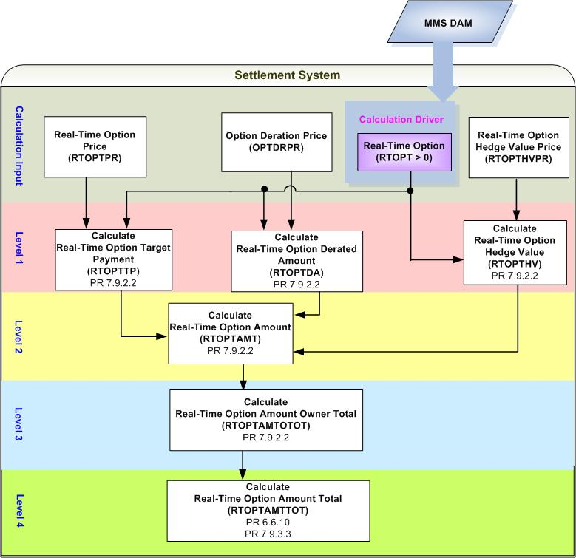
- Calculation Dependencies of Real-Time Option Amount (RTOPTAMT)

Assumptions
Assumptions of upstream systems:
A1) Determination of whether or not PTP Options and PTP Options with Refund owned by NOIE are eligible for Real-Time Settlements is made in the original source (MMS DAM). Therefore, RTOPT and RTOPTR are assumed to be valid for use in the Settlement System.

Business Rules
Req. ID | Protocol(s) | Sub-Process Map | Description
 | PR 7.9.3.3;  PR 9.2.3 (t) | CSWM. P03SettleBill Transfer | The calculation of RTOPTAMT shall be completed along with other Day-Ahead Settlement Charge Types.
 | PR 7.9.2.2 | CSWM. P03SettleBill Transfer | None of the input and intermediate bill determinants should be truncated or rounded in the Settlement System.
 | PR 7.9.2.2 | CSWM. P03SettleBill Transfer | Output bill determinates should be rounded to (2) decimals, including:  - RTOPTAMT
 | 12.3 (c) | CSWM. P03SettleBill Transfer | The following data shall be available for private data extract, including:  - RTOPT  - RTOPTPR  - OPTDAPR  - RTOPTHVPR  - RTOPTTP  - RTOPTHV  - RTOPTDA  - RTOPTAMT  - RTOPTAMTOTOT  - RTOPTBILLAMTOTOT
 | 12.3 | CSWM. P03SettleBill Transfer | The following data shall be available for public data extract, including:  - RTOPTAMTTOT
 | PR 7.9.2.2 | CSWM. P03SettleBill Transfer | DRIVER: the calculation of Payments for NOIE’s PTP Options Settled in Real-Time (RTOPTAMT) shall be only attempted for the source and sink pair for which a RTOPT exists with a positive value for at least one Operating Hour of the Operating Day.

Business Defined Errors
Req. ID | Protocol(s) | Sub-Process Map | Description
 | PR 7.9.2.2 | CSWM. P03SettleBill Transfer | If the calculation of RTOPTDA needs OPTDRPR that is not available for the source and sink Settlement Point pair, the Settlement System should set RTOPTDA to be zero (0). No error message is necessary.
 | PR 7.9.2.2 | CSWM. P03SettleBill Transfer | If the calculation of RTOPTHV needs RTOPTHVPR that is not available for the source and sink Settlement Point pair, the Settlement System should set RTOPTHV to be zero (0) and an error message should be logged. The error message should capture the source and sink Settlement Point, the Operating Hour, and Operating Day, for which RTOPTHVPR is missing.
 | PR 7.9.2.2 | CSWM. P03SettleBill Transfer | If RTOPTAMT is calculated to be positive, the Settlement System should consider it as a WARN--DEFAULT error, and set RTOPTAMT as a default value of zero (0) and an error message should be logged. The error message should capture the source and sink Settlement Point, the Operating Hour, and Operating Day, for which RTOPTAMT is calculated as negative.

Specific Database Needs
None

Payments for NOIE’s PTP Options with Refund Settled in Real-Time (RTOPTRAMT)

Settlement of NOIE’s PTP Options with Refund in Real-Time is described as follows:

- Except as specified in paragraph (2) below, ERCOT shall pay the NOIE that owns a PTP Option with Refund that was allocated to that NOIE as a PCRR and that was, declared before DAM execution by the NOIE to be settled in Real-Time but not cleared in the DAM, for MW quantity up to the pro-rata actual usage based on the positive difference in Real-Time Settlement Point Prices between the sink and source.
- The payment of PTP Options with Refund may be further reduced due to transmission elements that are oversold in previous CRR auctions.

Requirement ID
Source Mapping (Protocol/NERC/FERC and other binding documents Ref #) | PR 7.9.2.3 (3)
Traceability to Sub-Process Maps | CSWM.P03SettleBillTransfer
Description

Calculate Real-Time Option with Refund Amount per CRR Owner per Source and Sink pair for each Operating Hour of the Operating Day:

RTOPTRAMT_<CO>_<SRSP>_<SKSP> = (-1) * Max ((RTOPTRTP_<CO>_<SRSP>_<SKSP>
– RTOPTRDA_<CO>_<SRSP>_<SKSP>), Min (RTOPTRTP_<CO>_<SRSP>_<SKSP>, RTOPTRHV_<CO>_<SRSP>_<SKSP>)

Requirement ID
Source Mapping (Protocol/NERC/FERC and other binding documents Ref #) | PR 7.9.2.3 (3)
Traceability to Sub-Process Maps | CSWM.P03SettleBillTransfer
Description

Calculate Real-Time Option with Refund Target Payment per CRR Owner per Source and Sink pair for each Operating Hour of the Operating Day:

RTOPTRTP_<CO>_<SRSP>_<SKSP> = RTOPTPR_<SRSP>_<SKSP>
* Min (RTOPTR_<CO>_<SRSP>_<SKSP>
, (OPTRACT_<CO>_<SRSP>_<SKSP> * RTOPTR_<CO>_<SRSP>_<SKSP>
/ (DAOPTR_<CO>_<SRSP>_<SKSP> + RTOPTR_<CO>_<SRSP>_<SKSP>)))
NPRR Suggested:
As the prices for PTP Option and PTP Option with Refund are actually equivalent, it would be good to use the same variable (bill determinant) name.

Requirement ID
Source Mapping (Protocol/NERC/FERC and other binding documents Ref #) | PR 7.9.2.3 (3)
Traceability to Sub-Process Maps | CSWM.P03SettleBillTransfer
Description

Calculate Real-Time Option with Refund Derated Amount per CRR Owner per Source and Sink pair for each Operating Hour of the Operating Day:

RTOPTRDA_<CO>_<SRSP>_<SKSP> = OPTDRPR_<SRSP>_<SKSP>
* Min (RTOPTR_<CO>_<SRSP>_<SKSP>
, (OPTRACT_<CO>_<SRSP>_<SKSP> * RTOPTR_<CO>_<SRSP>_<SKSP>
/ (DAOPTR_<CO>_<SRSP>_<SKSP> + RTOPTR_<CO>_<SRSP>_<SKSP>)))

Requirement ID
Source Mapping (Protocol/NERC/FERC and other binding documents Ref #) | PR 7.9.2.3 (3)
Traceability to Sub-Process Maps | CSWM.P03SettleBillTransfer
Description

Calculate Real-Time Option with Refund Hedge Value per CRR Owner per Source and Sink pair for each Operating Hour of the Operating Day:

RTOPTRHV_<CO>_<SRSP>_<SKSP> = RTOPTHVPR_<SRSP>_<SKSP>
* Min (RTOPTR_<CO>_<SRSP>_<SKSP>
, (OPTRACT_<CO>_<SRSP>_<SKSP> * RTOPTR_<CO>_<SRSP>_<SKSP>
/ (DAOPTR_<CO>_<SRSP>_<SKSP> + RTOPTR_<CO>_<SRSP>_<SKSP>)))

Requirement ID
Source Mapping (Protocol/NERC/FERC and other binding documents Ref #) | PR 7.9.2.3(4)
Traceability to Sub-Process Maps | CSWM.P03SettleBillTransfer
Description

Calculate Real-Time Option with Refund Amount Owner Total per NOIE CRR Owner for each Operating Hour of the Operating Day:

RTOPTRAMTOTOT_<CO> = $\underset{\text{SRSP}}{Σ}$$\underset{\text{SKSP}}{Σ}$RTOPTRAMT_<CO>_<SRSP>_<SKSP>

Requirement ID
Source Mapping (Protocol/NERC/FERC and other binding documents Ref #) | PR 7.9.3.3 (2)  PR 6.6.10
Traceability to Sub-Process Maps | CSWM.P03SettleBillTransfer
Description

Calculate Real-Time Option with Refund Amount Total for each Operating Hour of the Operating Day:

RTOPTRAMTTOT = $\underset{\text{co}}{Σ}$RTOPTRAMTOTOT_<CO>

Input Bill Determinants
Variable |  |  | Unit |  |  |  |  |  | Definition |  |  |  | Original Source
RTOPTR | MW |  |  |  |  | Real-Time Option with Refund per pair of source and sink—The number of the NOIE CRR Owner’s PTP Options with Refund with the source and sink pair, settled in Real-Time, for the hour. |  |  |  |  |  |  | MMS DAM
Interval Frequency: 1/ hour

Comments:
- RTOPTR is the amount of PTP Options with Refund that are declared before DAM execution by NOIE CRR Owners to be settled in Real-Time and not cleared in the DAM.
RTOPTPR | $/MW  per hour |  |  |  |  | Real-Time Option Price per source and sink pair —The Real-Time price of a PTP Option with the source and sink pair for the hour. |  |  |  |  |  |  | Settlement System
Interval Frequency: 1/ hour

Additional Comments:
- The value of RTOPTPR could be equal to, or greater than zero (0).
OPTRACT |  | MW |  |  |  |  | Option with Refund Actual usage per CRR Owner per pair of source and sink—CRR Owner’s actual usage for the PTP Options with Refund with the pair of source and sink, for the hour. |  |  |  |  |  |  | TBD
Interval Frequency: 1/hour

Additional Comments:
- It’s currently under discussion as to where the calculation of OPTRACT occurs.
OPTDRPR |  |  |  |  | $/MW  per hour |  |  | Option Deration Price per source and sink pair—The deration price of a PTP Option with the source and the sink, for the hour. |  |  | Settlement System
Interval Frequency: 1/hour

Additional Comments:
- The value of OPTDRPR shall always be equal to, or greater than zero (0).
- The availability of OPTDRPR is dependent on the global calculation of Option Deration Price (OPTDRPR) defined in Section 2.8 of TN.COMS63C01.DAMCRR.REQUIREMENTS.A.
RTOPTHVPR |  |  |  |  | $/MWh |  |  | Real-Time Option Hedge Value Price per pair of source and sink—The Real-Time hedge price of a PTP Option with the pair of source and sink, for the hour. |  |  | Settlement System
Interval Frequency: 1/hour
Additional Comments:
- The value of RTOPTHVPR shall always be equal to, or greater than zero (0).
DAOPTR |  |  |  | MW |  |  |  |  |  | Day-Ahead Option with Refund per CRR Owner per pair of source and sink⎯The number of CRR Owner’s PTP Options with Refund with the pair of source and sink, settled in DAM, for the hour. |  | CRR System & MMS DAM
Interval Frequency: 1/ hour

Additional Comments:
- DAOPTR is a result of PCRR Allocation. The owner of DAOPTR shall be a designated NOIE.

- DAOPTR equals the difference between (a) and (b):
(a) The amount of PTP Options with Refund acquired through PCRR Allocations by NOIEs.
(b) The amount of PTP Options with Refund that is declared before DAM execution by NOIEs to be settled in Real-Time and not cleared in the DAM.

- DAOPTR shall always be equal to or greater than zero (0).

Intermediate Bill Determinants
Variable | Unit | Definition | Destination
RTOPTRTP | $ | Real-Time Option with Refund Target Payment per CRR Owner per source and sink pair—The target payment for CRR Owner’s PTP Options with Refund, with the source and sink pair, settled in Real-Time, for the hour. | Settlement System
Interval Frequency: 1/ hour

Additional Comments:
- The value of RTOPTRTP shall always be greater than or equal to zero (0).
RTOPTRHV | $ | Real-Time Option with Refund Hedge Value per CRR Owner per source and sink pair—The hedge value of CRR Owner’s PTP Options with Refund, with the source and sink pair, settled in Real-Time, for the hour. | Settlement System
Interval Frequency: 1/ hour

Additional Comments:
- The value of RTOPTHV shall always be greater than or equal to zero (0).
RTOPTRDA | $ | Real-Time Option with Refund Derated Amount per CRR Owner per source and sink pair—The derated amount of CRR Owner’s PTP Options with Refund, with the pair of source and the sink, settled in the Real-Time, for the hour. | Settlement System
Interval Frequency: 1/hour

Additional Comments:
- The value of RTOPTRDA always be greater than or equal to zero (0).

Output Bill Determinants
Variable | Unit |  | Definition | Destination
RTOPTRAMT | $ |  | Real-Time Option with Refund Amount per CRR Owner per pair of source and sink—The payment to CRR Owner of the PTP Options with Refund with the source and sink pair, settled in Real-Time, for the hour. | Settlement System
Interval Frequency: 1/hour

Additional Comments:
- The value of RTOPTAMT always be less than or equal to zero (0).
RTOPTRAMTOTOT | $ |  | Real-Time Option with Refund Amount Owner Total per CRR Owner—The total payment to NOIE CRR Owner for all its PTP Options with Refund settled in Real-Time, for the hour. | Settlement System
Interval Frequency: 1/hour

Additional Comments:
- The value of RTOPTRAMTOTOT always be less than or equal to zero (0).
RTOPTRAMTTOT | $ |  | Real-Time Option with Refund Amount Total—The total of payments to all CRR Owners of all PTP Options with Refund settled in Real-Time for the hour. | Settlement System
Interval Frequency: 1/hour

Additional Comments:
- RTOPTRAMTTOT will be used by CRR Balancing Account Credit (CRRBACR) Calculation.
- RTOPTRAMTTOT will be used by Real-Time Revenue Neutrality Allocation (LARTRNAMT) Calculation.
RTOPTRBILLAMTOTOT |  | $ | Real-Time Option with Refund Bill Amount per CRR Owner ⎯ The Delta of Real-Time Option with Refund Amount Owner Total between the current and the previous settlement run -- per CRR Owner, for the day. | Settlement System
Interval Frequency: 1/hour

Additional Comments:
- This bill determinant is not specifically documented in the Nodal Protocols but is required as a result of Section 9 Statements and Invoices Protocol requirements.

Data Dependencies
D1) Calculation of RTOPTRAMT is dependent upon the availability of the input determinants.
D2) Calculation of RTOPTRAMT is dependent upon the completion of global calculations: OPTDRPR defined in Section 2.8 of TN.COMS63C01.DAMCRR.REQUIREMENTS.A, RTOPTPR, and RTOPTHVPR.
D3) Calculation of Day-Ahead CRR Shortfall Amount (DACRRSAMT) defined in TN.COMS.63C01.CRRBA.REQUIREMENTS.A is dependent upon the calculation of DAOPTRAMTTOT.
D4) Calculation of Real-Time Revenue Neutrality Allocation (LARTRNAMT) defined in TN.COMS.63C01.RTENERGY.REQUIREMENTS.A is dependent upon the calculation of DAOPTRAMTTOT.
- Calculation Dependencies of Real-Time Option with Refund Amount (RTOPTRAMT)

Assumptions
Assumptions of upstream systems:
A1) Determination of whether or not PTP Options with Refund owned by NOIE are eligible for Real-Time Settlements is made in the original source (MMS DAM).

Assumptions of Settlement Interface:
A2) Calculation of Option with Refund Actual Usage (OPTRACT) as described by the formula below will be addressed by a separate set of Requirements:

OPTRACT _{o, (j, k)} = $\underset{y}{Σ}$($\underset{r}{Σ}$(OPTROF _{o, r, (j, k)} * RESACT _{r, (j, k), y}) * TLMP _{y}) / ($\underset{y}{Σ}$TLMP_{y}) * OPTRF _{o, (j, k)}

Where:
RESACT is the output of Resource r associated with the PTP options with Refund with the source and sink pair, for the SCED interval y;
OBLRF is the factor showing the percentage usage of Resource r for CRR Owner o’s PTP Options with Refund with the source and sink pair; Its value is 1, if only one CRR Owner has acquired PCRRs under the refund provision using Resource r;
TLMP is the duration of the portion of the SCED interval y within the hour;
o is a CRR Owner;
y is a SCED interval in the hour;
r is a Resource;
j is a source Settlement Point;
k is a sink Settlement Point.

A3) Calculation of Resource Actual (RESACT) as described by the formula below will be addressed by a separate set of Requirements:

If (OS _{r, y} exists)
RESACT _{r, (j, k), y} = OS _{r, y}
Otherwise
If (EBP _{r, y} exists)
RESACT _{r, (j, k), y} = EBP _{r, y}
Otherwise
RESACT _{r, (j, k), y} = BP _{r, y}

Where:
RESACT is the output of Resource r associated with the PTP options with Refund with the source and sink pair, for the SCED interval y;
BP is the Base Point of Resource for the SCED interval y;
EBP is the Emergency Base Point of Resource for the SCED interval y;
OS is the Output Schedule for Resource for the ACED interval y;
y is a SCED interval in the hour;
r is a Resource;
j is a source Settlement Point;
k is a sink Settlement Point;

Business Rules
Req. ID | Protocol(s) | Sub-Process Map | Description
 | PR 7.9.3.3;  PR 9.2.3 (t) | CSWM. P03SettleBill Transfer | The calculation of RTOPTAMT shall be completed along with other Day-Ahead Settlement Charge Types.
 | PR 7.9.2.3 | CSWM. P03SettleBill Transfer | Due to the fact that SCED information is involved to calculate Obligation with Refund Actual Usage (OPTRACT), the calculation of RTOPTRAMT requires that SCED data, including the amount of time for which each SCED run LMP value was effective, from Real-Time Market be available.
 | PR 7.9.2.3 | CSWM. P03SettleBill Transfer | None of the input and intermediate bill determinants should be truncated or rounded in the Settlement System.
 | PR 7.9.2.3 | CSWM. P03SettleBill Transfer | Output bill determinates should be rounded to (2) decimals, including:  - RTOPTRAMT
 | PR12.3 (c) | CSWM. P03SettleBill Transfer | The following data shall be available for private data extract, including:  - DAOPTR  - RTOPTR  - OPTRACT  - OPTDRPR  - RTOPTHVPR  - RTOPTPR  - RTOPTRTP  - RTOPTRHV  - RTOPTRDA  - RTOPTRAMT  - RTOPTRAMTOTOT  - RTOPTRBILLAMTOTOT
 | PR12.3 | CSWM. P03SettleBill Transfer | The following data shall be available for public data extract, including:  - RTOPTRAMTTOT
 | PR 7.9.2.3 | CSWM. P03SettleBill Transfer | DRIVER: the calculation of RTOPTRAMT shall be only attempted for the source and sink pair for which a RTOPTR exists with a positive value for at least one Operating Hour of the Operating Day.

Business Defined Errors

Req. ID | Protocol(s) | Sub-Process Map | Description
 | PR 7.9.2.3 | CSWM. P03SettleBill Transfer | If the calculation of RTOPTRDA needs OPTDRPR that is not available for the source and sink Settlement Point pair, the Settlement System should set RTOPTRDA to be zero (0). No error message is necessary.
 | PR 7.9.2.3 | CSWM. P03SettleBill Transfer | If the calculation of RTOPTRHV needs RTOPTHVPR that is not available for the source and sink Settlement Point pair, the Settlement System should set RTOPTRHV to be zero (0) and an error message should be logged. The error message should capture the source and sink Settlement Point, the Operating Hour, and Operating Day, for which RTOPTHVPR is missing.
 | PR 7.9.2.3 | CSWM. P03SettleBill Transfer | If RTOPTRAMT is calculated to be positive, the Settlement System should consider it as a WARN--DEFAULT error, and set RTOPTRAMT as a default value of zero (0) and an error message should be logged. The error message should capture the source and sink Settlement Point, the Operating Hour, and Operating Day, for which RTOPTRAMT is calculated as negative.

Specific Database Needs
None

Supplementary Requirements

Performance Requirements
Lodestar must be able to perform its full set of Nodal settlement calculations. Performance characteristics will be determined and detailed in the conceptual and detailed design.

Legal and Regulatory requirements
All Lodestar financial data must be saved in accordance with standard accounting principles as dictated by the ERCOT Texas Nodal Protocols.

System Security Requirements
Lodestar will only be accessed directly by internal ERCOT personnel either through thin client UI, Citrix environment, or thick client on employee desktops. Market Participants will be able to access their statements and invoices on ERCOT private web site. ERCOT private web site access will be controlled by digital certificate authentication in accordance with ERCOT security policies.

Back up and Recovery Requirements
All Lodestar Nodal settlement data must be backed up on a daily basis and recoverable within 24 hours.

Availability and Redundancy Requirements
Nodal Lodestar system must be available 7/24. Lodestar is considered a tier 1 system and critical to base ERCOT business processes.

Maintainability Requirements
Lodestar Nodal system will be maintained by internal ERCOT personnel. SLAs and explicit support will be detailed in the detail design document.

Daylight Savings Time shall be recognized in Nodal Market settlements
- Spring Daylight Savings Time Operating Day:
    - Hour Ending 0300 will be skipped, resulting in 23 hourly intervals for the day.
    - The four fifteen minute intervals within Hour Ending 0300 will be skipped, resulting in 92 fifteen minute intervals for the day.
    - The sixty one minute intervals within Hour Ending 0300 will be skipped, resulting in 1380 total one minute intervals.
  - Fall Daylight Savings Time Operating Day:
    - Hour Ending 0200 will have two sets of data, resulting in 25 hourly intervals for the day.
    - The four fifteen minute intervals within Hour Ending 0200 will have two sets of data, resulting in 100 fifteen minute intervals for the day.
    - The sixty one minute intervals within Hour Ending 0200 will have two sets of data, resulting in 1500 total one minute intervals.

Protocol Coverage

Protocol Sub-Section | Description | Coverage by Requirements  (Full/Partial)
PR 6.6.10 | Real-Time Revenue Neutrality Allocation | Partial
PR 7.9.2.1 | Payments and Charges for PTP Obligations Settled in Real-Time | Partial
PR 7.9.2.2 | Payments for PTP Options Settled in Real-Time | Partial
PR 7.9.2.3 | Payments for PTP Options with Refund Settled in Real-Time | Partial
PR 7.9.3.3 | Shortfall Charges to CRR Owners | Partial

