Commercial Systems
Software Requirements Specification Requirements
v0.09

Revision History
Date | Version | Description | Author
10/06/2006 | 0.09 | Payment Processes for DAM Invoices, DAM Late Fee Invoices, RTM Invoices, RTM Uplift Invoices, RTM Late Fee Invoices, CRR Auction Invoices, CARD Invoices, CRR Balancing Account Invoices, and Miscellaneous Invoices  Late Fees for the DAM and Late Fees for the RTM | Keely Hilton

Table of Contents
1. Invoices 5
1.1 Proposed System Scope 5
1.2 Document Conventions 5
1.3 Document Assumptions 5
2. Functional Requirements 5
2.1 Payment Process for DAM Invoices 5
2.2 Payment Process for RTM Invoices 9
2.3 Payment Process for DAM Late Fee Invoices 12
2.4 Payment Process for RTM Late Fee Invoices 14
2.5 Payment Process for RTM Uplift Invoices 16
2.6 Payment Process for CRR Auction Invoices 19
2.7 Payment Process for CARD Invoices 21
2.8 Payment Process for CRR Balancing Account Invoices 23
2.9 Payment Process for Miscellaneous Invoices 25
2.10 Late Fees for the DAM 25
2.11 Late Fees for the RTM 28
3. Supplementary Requirements 32
3.1 Performance Requirements 32
3.2 Legal and Regulatory requirements 32
3.3 System Security Requirements 33
3.4 Back up and Recovery Requirements 33
3.5 Availability and Redundancy Requirements 33
3.6 Maintainability Requirements 33
4. Protocol Coverage 33

Software Requirements Specification

Invoices

Proposed System Scope
ERCOT plans to implement a Nodal market in 2009. Section 9 of the Nodal Protocols describes the various requirements for Financial Transfer and the calculation of Late Fees. The Nodal Protocols will guide this project.

This document defines the requirements for Financial Transfer and the calculation of Late Fees. The requirements in scope for this document are:
- detailed in Nodal Protocols Section 9 (007NPRR as approved by BOD on 07/18/2006),

The following processes are included in the scope of this document:
- Payment process for DAM Invoices (PR 9.4, PR 9.4.1, PR 9.4.2, PR 9.4.3)
- Payment process for RTM Invoices (PR 9.7, PR 9.7.1, PR 9.7.2, PR 9.7.3)
- Payment process for DAM Late Fee Invoices (PR 9.4.5)
- Payment process for RTM Late Fee Invoices (PR 9.7.5)
- Payment process for RTM Uplift Invoices (PR 9.7.3)
- Payment process for CRR Auction Invoices (PR 9.9, PR 9.9.1, PR 9.9.2)
- Payment Process for CARD Invoices (PR 9.11, PR 9.11.1, PR 9.11.2, PR 9.11.3)
- Payment Process for CRR Balancing Account Invoices (PR 9.13)
- Miscellaneous Invoices
- Late Fees for the DAM (PR 9.4.5)
- Late Fees for the RTM (PR 9.7.5)

Document Conventions
- All text lifted from the Nodal Protocols is in italic font.
- All requirements are identified using FR1, FR2, etc.
- All dependencies are identified using D1, D2, etc.
- All assumptions are identified using A1, A2, etc.

Document Assumptions
A1) The term “DAM” will be used to describe the Day-Ahead Market.

A2) The term “RTM” will be used to describe the Real-Time Market.

A3) The term “CRR” will be used to describe Congestion Revenue Rights.

A4) The term “Invoice Recipient” will be used to indicate the applicable Market Participant to which the Invoice is addressed. Applicable Market Participants are:
- QSE
- CRR Account Holder
- CRR Owner

Functional Requirements

Payment Process for DAM Invoices
The financial transfer process for DAM Invoices is a 2-day, 2-step process, namely the receipt of payments from DAM Invoice Recipients to ERCOT and the calculation and remittance of payments from ERCOT to DAM Invoice Recipients.

Dependencies
D1) Payments from DAM Invoice Recipients to ERCOT are dependent on:
- Availability of DAM Invoices
- Dates and times when payments are due to ERCOT from DAM Invoice Recipients
- Business Days
- Bank Business Days

D2) Payments from ERCOT to DAM Invoice Recipients are dependent upon:
- Availability of DAM Invoices
- Payments from DAM Invoice Recipients to ERCOT
- Dates and times when payments are due to DAM Invoice Recipients from ERCOT
- Business Days
- Bank Business Days

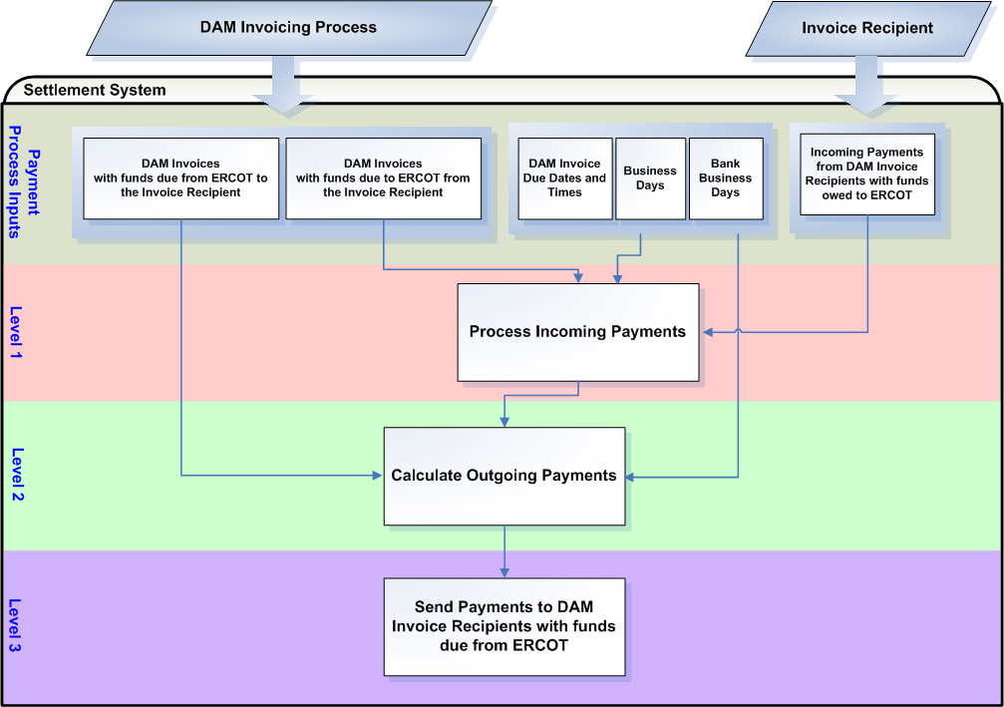

Assumptions
A1) ERCOT suggests a protocol revision to Nodal Protocol Section 9.4.1(1) and 9.4.2(1), Invoice Recipient Payment to ERCOT for the DAM, to make Bank Business Day / Business Day language consistent throughout all of Nodal Protocols Section 9, Settlement and Billing.

A2) ERCOT shall deduct payments for RMR Services and amounts calculated for the CRR Balancing Account from the amount collected for DAM Invoices prior to sending payments to DAM Invoice Recipients who are owed money. This will insure RMR Service Providers full payment in Real-Time and Short-Paid CRR Owners payments at months end. ERCOT suggests a protocol revision to include these provisions in Nodal Protocol Section 9.4.3(d), Partial Payments by Invoice Recipients for the DAM.

Business Rules
Req. ID | Protocol(s) | Sub-Process Map | Description
FR1 | PR 9.4 | CSWM.  P03SettleBillTransfer | Payments for DAM Invoices must be made in a 2-day, 2-step process.
FR2 | PR 9.4 | CSWM.  P03SettleBillTransfer | Payments for DAM Invoices are due on the applicable payment due date, whether or not there is any Settlement and billing dispute regarding the amount of the payment.
FR3 | A1  PR 9.4  PR 9.4.1(1) | CSWM.  P03SettleBillTransfer | The date and time when payments are due to ERCOT from DAM Invoice Recipients is day 1 of the DAM Invoice Payment Process and is 1700 on the 4th Bank Business Day after the DAM Invoice date. If the 4th Bank Business Day is not a Business Day, then the date and time when payments are due to ERCOT from DAM Invoice Recipients is 1700 on the next Bank Business Day after the 4th Bank Business Day that is also a Business Day.
FR4 | PR 9.4.1(2)  PR 9.4.1(2a)  PR 9.4.1(2b) | CSWM.  P03SettleBillTransfer | All DAM Invoices due, with funds owed by an Invoice Recipient, must be paid to ERCOT in U.S. Dollars by either of the following:  - On or before the payment due date if the payment is made by Electronic Funds Transfer (EFT) in immediately available or good funds (i.e., not subject to reversal); or  - On or before two Bank Business Days before the payment due date if the payment is made by Automated Clearing House (ACH) funds.
FR5 | A1  PR 9.4.2(1)  PR 9.4.2(2) | CSWM.  P03SettleBillTransfer | The date and time when payments must be paid by ERCOT to DAM Invoice Recipients is day 2 of the DAM Invoice Payment Process and is 1700 on the next day after the date when payments are due to ERCOT from Invoice Recipients for that DAM Invoice that is both a Bank Business Day and a Business Day.
FR6 | A2  PR 9.4.3(d) | CSWM.  P03SettleBillTransfer | For payments due to DAM Invoice Recipients, ERCOT shall first deduct any applicable DAM administrative fees as specified in Section 9.10, Administrative Fees, payments for RMR Services and amounts calculated for the CRR Balancing Account from the amount received or collected, and pay all DAM Invoice Recipients on a pro rata basis of monies owed to each Invoice Recipient, to the extent necessary to clear ERCOT’s accounts on the payment due date to achieve revenue neutrality for ERCOT.
FR7 | PR 9.4.2(1) | CSWM.  P03SettleBillTransfer | ERCOT shall exercise its right to withhold payments for DAM Invoices under Section 16, Registration and Qualification of Market Participants.  See the Credit Monitoring Management Requirements document for further information on the Credit Monitoring Process.
FR8 | PR 9.4.2(2) | CSWM.  P03SettleBillTransfer | ERCOT shall give irrevocable instructions to the ERCOT financial institution to remit, to each DAM Invoice Recipient for same day value, the amounts determined to be available for payment to DAM Invoice Recipients who are owed funds.
FR9 | PR 9.4.3  PR 9.4.3(a)  PR 9.4.3(b)  PR 9.4.3(c) | CSWM.  P03SettleBillTransfer | If at least one Invoice Recipient owing funds does not pay its DAM Invoice in full (short-pays), then ERCOT shall  - make every reasonable attempt to collect payment from each short-paying Invoice Recipient before any payments owed by ERCOT for that DAM is due to be paid to applicable Invoice Recipient(s);  - draw on any available security pledged to ERCOT by each short-paying Invoice Recipient that did not pay the DAM Invoice in full; and  - offset or recoup any amounts owed, or to be owed, by ERCOT to a short-paying Invoice Recipient against amounts not paid by that Invoice Recipient, and ERCOT shall apply the amount offset or recouped to cover payment shortages by that Invoice Recipient.
FR10 | PR 9.4.3(f) | CSWM.  P03SettleBillTransfer | When ERCOT is able to collect past due funds owed by a short-paying Invoice Recipient, ERCOT shall allocate the collected funds to the earliest DAM Invoice for which that Invoice Recipient remains a short-payer. ERCOT shall use its best efforts to distribute collected past due funds on a pro rata basis of monies owed on the next Business Day that is also a Bank Business Day after receipt of the monies, when sufficient funds for the relevant DAM are available.

Business Defined Errors
Req. ID | Protocol(s) | Sub-Process Map | Description
FR11 | PR 9.4 | CSWM.  P03SettleBillTransfer | While importing payments from Invoice Recipients to ERCOT into the Financial Transfer system, if any problems occur during import of payments, no records shall be updated. An error report is required to clearly indicate why the import failed. The error report should indicate all Invoice Recipients, payment amounts and payment numbers that failed.
FR12 | PR 9.4 | CSWM.  P03SettleBillTransfer | While importing payments from Invoice Recipients to ERCOT into the Financial Transfer system, if the import of payments conflicts with a currently executing process in the Settlement and Billing system, an error message is required indicating the conflicting process. The payment import process should not be allowed to execute. The XML batch payment file should be held in storage for future import. The user should have the option of storage or abort.
FR13 | PR 9.4 | CSWM.  P03SettleBillTransfer | While calculating payments to Invoice Recipients from ERCOT, if any problems occur, no records shall be updated. An error report is required to clearly indicate why the process failed.

Specific Database Needs
Req. ID | Protocol(s) | Sub-Process Map | Description
FR14 | PR 9.4 | CSWM.  P03SettleBillTransfer | An application is required that can interact with the Financial Transfer system and have the ability to create an XML batch payment file for import into the Financial Transfer system based on one or more payments received by ERCOT regardless of Invoice Type or due date to be applied to particular invoice ids based on actual invoice data stored in the Financial Transfer system.  The application should allow the Business Analyst a choice of immediate import or future import. If future import is chosen, the Business Analyst should have the ability to input additional payments as they are received to the same XML batch payment file.  Fields necessary for Business Analyst query should be invoice date, invoice due date, Invoice Recipient duns number, invoice id, invoice amount and invoice balance.  Fields necessary for Business Analyst edit should be payment amount received and payment date received. The application should allow adds and updates.  The application should not allow a payment greater than the amount due.  The application should indicate when a payment entered for import is less than the amount due. If the payment is less than the amount due, the Business Analyst is required to approve the amount.  The application will access the Financial Transfer system to retrieve invoice and payment data.
FR15 | PR 9.4 | CSWM.  P03SettleBillTransfer | In order to satisfy Credit Monitoring requirements, Market Participant accounts must be fully updated within 30 minutes of payment import into the Financial Transfer system.
FR16 | PR 9.4 | CSWM.  P03SettleBillTransfer | The Business Analyst should have the ability to execute all payment receipt processes.
FR17 | PR 9.4 | CSWM.  P03SettleBillTransfer | A pre-posting report is required, for Business Analyst review, of payments included in the XML batch payment file. Amounts that do not match the amount due should be indicated.
FR18 | PR 9.4 | CSWM.  P03SettleBillTransfer | A post-posting report is required to verify that the payments imported into the Financial Transfer system updated accounts correctly. The report should show outstanding balances for verification.
FR19 | PR 9.4 | CSWM.  P03SettleBillTransfer | An approval control mechanism is required for auditing purposes. The approval control mechanism must record and store who approved the “batch of incremental” payments imported into the Settlement and Billing System since the last approval. It shall also record when this approval was made. This approval control record must be present before the job to calculate refunds can be executed. The approval control mechanism must also record and store who approved the calculated refunds and when this approval was made. This approval control record must be present before the job to wire the funds can be executed.
FR20 | PR 9.4 | CSWM.  P03SettleBillTransfer | The application of payments from ERCOT to Invoice Recipients for billing cycles that are past due shall be applied whenever late payments are received by ERCOT.
FR21 | PR 9.4 | CSWM.  P03SettleBillTransfer | A mechanism is required to back out records and updates produced by the import of payments to ERCOT from Invoice Recipients into the Financial Transfer system. The back out mechanism must have the functionality to back a single payment, multiple payments, or all payments for a particular Batch Payment XML file for amounts owed to ERCOT from Invoice Recipients.
FR22 | PR 9.4 | CSWM.  P03SettleBillTransfer | The Business Analyst should have the ability to execute all outgoing payment processes.
FR23 | PR 9.4 | CSWM.  P03SettleBillTransfer | A post-calculation report is required to verify that the calculation of payments to Invoice Recipients updated accounts correctly. The report should show outstanding balances for verification.
FR24 | PR 9.4 | CSWM.  P03SettleBillTransfer | A mechanism is required to back out records and updates produced by the application of payments from ERCOT to Invoice Recipients. The back out mechanism must have the functionality to back a the application of payments from ERCOT to Invoice Recipients for a single billing cycle, multiple billing cycles, or all billing cycles for a particular payment calculation process.

Payment Process for RTM Invoices
The financial transfer process for RTM Invoices is a 2-day, 2-step process, namely the receipt of payments from RTM Invoice Recipients to ERCOT and the calculation and remittance of payments from ERCOT to RTM Invoice Recipients.

Dependencies
D1) Payments from RTM Invoice Recipients to ERCOT are dependent on:
- Availability of RTM Invoices
- Dates and times when payments are due to ERCOT from RTM Invoice Recipients
- Business Days
- Bank Business Days

D2) Payments from ERCOT to RTM Invoice Recipients are dependent upon:
- Availability of RTM Invoices
- Payments from RTM Invoice Recipients to ERCOT
- Dates and times when payments are due to RTM Invoice Recipients from ERCOT
- Business Days
- Bank Business Days

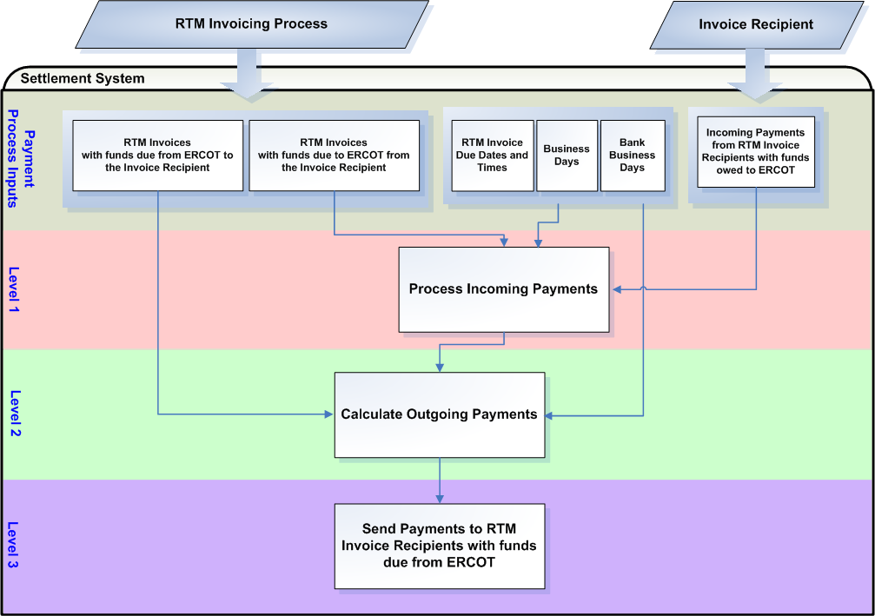

Assumptions
A1) Payments for RTM Invoices are due on the applicable payment due date, whether or not there is any Settlement and billing dispute regarding the amount of the payment. ERCOT suggests a protocol revision to include this provision in Nodal Protocol Section 9.7, Payment Process for the RTM.

A2) ERCOT suggests a protocol revision to Nodal Protocol Section 9.7.1(1) and 9.7.2(1), Invoice Recipient Payment to ERCOT for the RTM, to make Bank Business Day / Business Day language consistent throughout all of Nodal Protocols Section 9, Settlement and Billing.

Business Rules
Req. ID | Protocol(s) | Sub-Process Map | Description
FR25 | PR 9.7 | CSWM.  P03SettleBillTransfer | Payments for RTM Invoices must be made in a 2-day, 2-step process.
FR26 | A1 (PR 9.7) | CSWM.  P03SettleBillTransfer | Payments for RTM Invoices are due on the applicable payment due date, whether or not there is any Settlement and billing dispute regarding the amount of the payment.
FR27 | A2  PR 9.7  PR 9.7.1(1) | CSWM.  P03SettleBillTransfer | The date and time when payments are due to ERCOT from RTM Invoice Recipients is day 1 of the RTM Invoice Payment Process and is 1700 on the 5th Bank Business Day after the RTM Invoice date. If the 5th Bank Business Day is not a Business Day, then the date and time when payments are due to ERCOT from RTM Invoice Recipients is 1700 on the next Bank Business Day after the 5th Bank Business Day that is also a Business Day.
FR28 | PR 9.7.1(2)  PR 9.7.1(2a)  PR 9.7.1(2b) | CSWM.  P03SettleBillTransfer | All RTM Invoices due, with funds owed by an Invoice Recipient, must be paid to ERCOT in U.S. Dollars by either of the following:  - On or before the payment due date if the payment is made by Electronic Funds Transfer (EFT) in immediately available or good funds (i.e., not subject to reversal); or  - On or before two Bank Business Days before the payment due date if the payment is made by Automated Clearing House (ACH) funds.
FR29 | A2  PR 9.7.2(1)  PR 9.7.2(2) | CSWM.  P03SettleBillTransfer | The date and time when payments must be paid by ERCOT to RTM Invoice Recipients is day 2 of the RTM Invoice Payment Process and is 1700 on the next day after the date when payments are due to ERCOT from Invoice Recipients for that RTM Invoice that is both a Bank Business Day and a Business Day.
FR30 | PR 9.7.3(d) | CSWM.  P03SettleBillTransfer | For payments due to RTM Invoice Recipients, ERCOT shall first deduct any applicable RTM administrative fees as specified in Section 9.10, Administrative Fees and payments for RMR Services from the amount received or collected and pay all RTM Invoice Recipients on a pro rata basis of monies owed to each Invoice Recipient except for monies owed for RMR Services, to the extent necessary to clear ERCOT’s accounts on the payment due date to achieve revenue neutrality for ERCOT.
FR31 | PR 9.7.2(1) | CSWM.  P03SettleBillTransfer | ERCOT shall exercise its right to withhold payments for RTM Invoices under Section 16, Registration and Qualification of Market Participants.  See the Credit Monitoring Management Requirements document for further information on the Credit Monitoring Process.
FR32 | PR 9.7.2(2) | CSWM.  P03SettleBillTransfer | ERCOT shall give irrevocable instructions to the ERCOT financial institution to remit, to each RTM Invoice Recipient for same day value, the amounts determined to be available for payment to RTM Invoice Recipients who are owed funds.
FR33 | PR 9.7.3  PR 9.7.3(a)  PR 9.7.3(b)  PR 9.7.3(c) | CSWM.  P03SettleBillTransfer | If at least one Invoice Recipient owing funds does not pay its RTM Invoice in full (short-pays), then ERCOT shall  - make every reasonable attempt to collect payment from each short-paying Invoice Recipient before any payments owed by ERCOT for that RTM is due to be paid to applicable Invoice Recipient(s);  - draw on any available security pledged to ERCOT by each short-paying Invoice Recipient that did not pay the RTM Invoice in full; and  - offset or recoup any amounts owed, or to be owed, by ERCOT to a short-paying Invoice Recipient against amounts not paid by that Invoice Recipient, and ERCOT shall apply the amount offset or recouped to cover payment shortages by that Invoice Recipient.
FR34 | PR 9.7.3(i) | CSWM.  P03SettleBillTransfer | When ERCOT is able to collect past due funds owed by a short-paying RTM Invoice Recipient, ERCOT shall allocate the collected funds to the earliest RTM Invoice for which that Invoice Recipient remains a short-payer. ERCOT shall use its best efforts to distribute collected past due funds on a pro rata basis of monies owed on the next Business Day that is also a Bank Business Day after receipt of the monies, when sufficient funds for the relevant RTM are available.

Business Defined Errors
See FR11, FR12 and FR13.

Specific Database Needs
See FR14, FR15, FR16, FR17, FR18, FR19, FR20, FR21, FR22, FR23, and FR24.

Payment Process for DAM Late Fee Invoices
The financial transfer process for DAM Late Fee Invoices is a 2-day, 2-step process, namely the receipt of payments from DAM Late Fee Invoice Recipients to ERCOT and the calculation and remittance of payments from ERCOT to DAM Late Fee Invoice Recipients.

Dependencies
D1) Payments from DAM Late Fee Invoice Recipients to ERCOT are dependent on:
- Availability of DAM Late Fee Invoices
- Dates and times when payments are due to ERCOT from DAM Late Fee Invoice Recipients
- Business Days
- Bank Business Days

D2) Payments from ERCOT to DAM Late Fee Invoice Recipients are dependent upon:
- Availability of DAM Late Fee Invoices
- Payments from DAM Late Fee Invoice Recipients to ERCOT
- Dates and times when payments are due to DAM Late Fee Invoice Recipients from ERCOT
- Business Days
- Bank Business Days

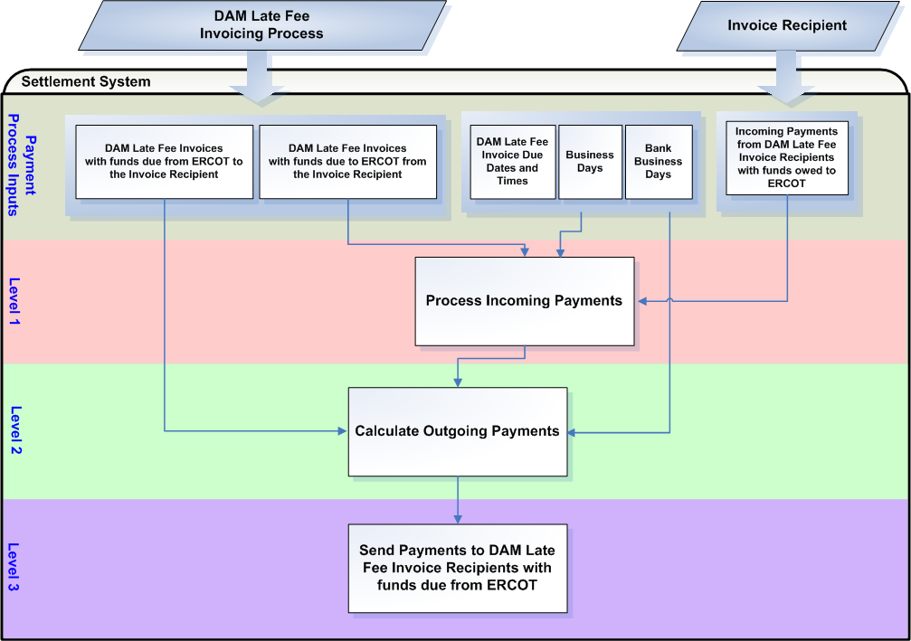

Assumptions
A1) Payments for DAM Late Fee Invoices are due on the applicable payment due date, whether or not there is any Settlement and billing dispute regarding the amount of the payment. ERCOT suggests a protocol revision to include this provision in Nodal Protocol Section 9.4.5, Late Fees and Late Fee Invoices for the DAM.

A2) ERCOT suggests a protocol revision to Nodal Protocol Section 9.4.5(5) and 9.4.5(7), Late Fees and Late Fee Invoices for the DAM, to make Bank Business Day / Business Day language consistent throughout all of Nodal Protocols Section 9, Settlement and Billing.

Business Rules
Req. ID | Protocol(s) | Sub-Process Map | Description
FR35 | PR 9.4.5(5)  PR 9.4.5(7) | CSWM.  P03SettleBillTransfer | Payments for DAM Late Fee Invoices must be made in a 2-day, 2-step process.
FR36 | A1 (PR 9.4.5) | CSWM.  P03SettleBillTransfer | Payments for DAM Late Fee Invoices are due on the applicable payment due date, whether or not there is any Settlement and billing dispute regarding the amount of the payment.
FR37 | A2  PR 9.4.5(5) | CSWM.  P03SettleBillTransfer | The date and time when payments are due to ERCOT from DAM Late Fee Invoice Recipients is day 1 of the DAM Late Fee Invoice Payment Process and is 1700 on the 4th Bank Business Day after the DAM Late Fee Invoice date. If the 4th Bank Business Day is not a Business Day, then the date and time when payments are due to ERCOT from DAM Late Fee Invoice Recipients is 1700 on the next Bank Business Day after the 4th Bank Business Day that is also a Business Day.
FR38 | PR 9.4.5(6)  PR 9.4.5(6a)  PR 9.4.5(6b) | CSWM.  P03SettleBillTransfer | All DAM Late Fee Invoices due, with funds owed by an Invoice Recipient, must be paid to ERCOT in U.S. Dollars by either of the following:  - On or before the payment due date if the payment is made by Electronic Funds Transfer (EFT) in immediately available or good funds (i.e., not subject to reversal); or  - On or before two Bank Business Days before the payment due date if the payment is made by Automated Clearing House (ACH) funds.
FR39 | A2  PR 9.4.5(7) | CSWM.  P03SettleBillTransfer | The date and time when payments must be paid by ERCOT to DAM Late Fee Invoice Recipients is day 2 of the DAM Late Fee Invoice Payment Process and is 1700 on the next day after the date when payments are due to ERCOT from Invoice Recipients for that DAM Late Fee Invoice that is both a Bank Business Day and a Business Day.
FR40 | PR 9.4.5(8) | CSWM.  P03SettleBillTransfer | For payments due to DAM Late Fee Invoice Recipients, ERCOT shall pay all DAM Late Fee Invoice Recipients on a pro rata basis of monies owed to each Invoice Recipient, to the extent necessary to clear ERCOT’s accounts on the payment due date to achieve revenue neutrality for ERCOT.
FR41 | PR 9.4.5(7) | CSWM.  P03SettleBillTransfer | ERCOT shall exercise its right to withhold payments for DAM Late Fee Invoices under Section 16, Registration and Qualification of Market Participants.  See the Credit Monitoring Management Requirements document for further information on the Credit Monitoring Process.
FR42 | PR 9.4.5(8) | CSWM.  P03SettleBillTransfer | ERCOT shall give irrevocable instructions to the ERCOT financial institution to remit, to each DAM Late Fee Invoice Recipient for same day value, the amounts determined to be available for payment to DAM Late Fee Invoice Recipients.

Business Defined Errors
See FR11, FR12 and FR13.

Specific Database Needs
See FR14, FR15, FR16, FR17, FR18, FR19, FR20, FR21, FR22, FR23, and FR24.

Payment Process for RTM Late Fee Invoices
The financial transfer process for RTM Late Fee Invoices is a 2-day, 2-step process, namely the receipt of payments from RTM Late Fee Invoice Recipients to ERCOT and the calculation and remittance of payments from ERCOT to RTM Late Fee Invoice Recipients.

Dependencies
D1) Payments from RTM Late Fee Invoice Recipients to ERCOT are dependent on:
- Availability of RTM Late Fee Invoices
- Dates and times when payments are due to ERCOT from RTM Late Fee Invoice Recipients
- Business Days
- Bank Business Days

D2) Payments from ERCOT to RTM Late Fee Invoice Recipients are dependent upon:
- Availability of RTM Late Fee Invoices
- Payments from RTM Late Fee Invoice Recipients to ERCOT
- Dates and times when payments are due to RTM Late Fee Invoice Recipients from ERCOT
- Business Days
- Bank Business Days

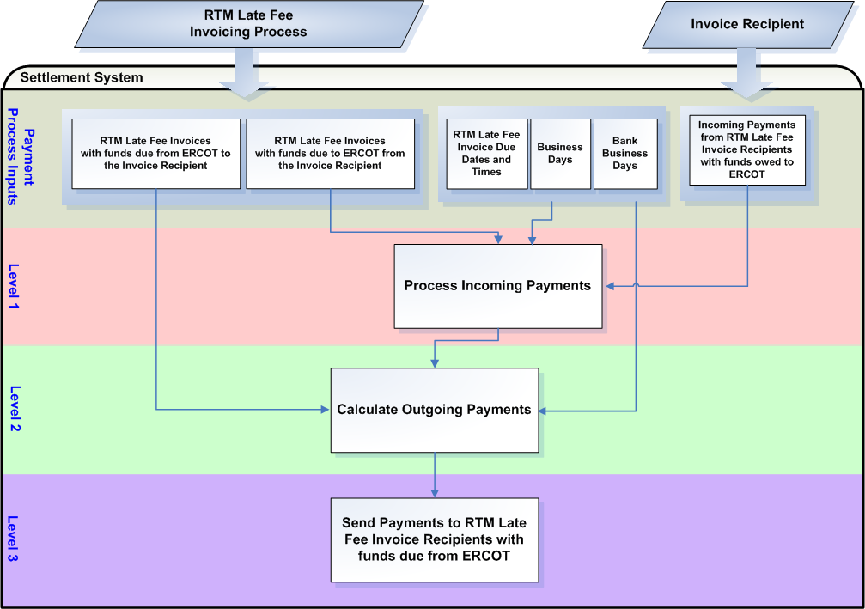

Assumptions
A1) Payments for RTM Late Fee Invoices are due on the applicable payment due date, whether or not there is any Settlement and billing dispute regarding the amount of the payment. ERCOT suggests a protocol revision to include this provision in Nodal Protocol Section 9.7.5, Late Fees and Late Fee Invoices for the RTM.

A2) ERCOT suggests a protocol revision to Nodal Protocol Section 9.7.5(5) and 9.7.5(7), Late Fees and Late Fee Invoices for the RTM, to make Bank Business Day / Business Day language consistent throughout all of Nodal Protocols Section 9, Settlement and Billing.

Business Rules
Req. ID | Protocol(s) | Sub-Process Map | Description
FR43 | PR 9.7.5(5)  PR 9.7.5(7) | CSWM.  P03SettleBillTransfer | Payments for RTM Late Fee Invoices must be made in a 2-day, 2-step process.
FR44 | A1 (PR 9.7.5) | CSWM.  P03SettleBillTransfer | Payments for RTM Late Fee Invoices are due on the applicable payment due date, whether or not there is any Settlement and billing dispute regarding the amount of the payment.
FR45 | A2  PR 9.7.5(5) | CSWM.  P03SettleBillTransfer | The date and time when payments are due to ERCOT from RTM Late Fee Invoice Recipients is day 1 of the RTM Late Fee Invoice Payment Process and is 1700 on the 4th Bank Business Day after the RTM Late Fee Invoice date. If the 4th Bank Business Day is not a Business Day, then the date and time when payments are due to ERCOT from RTM Late Fee Invoice Recipients is 1700 on the next Bank Business Day after the 4th Bank Business Day that is also a Business Day.
FR46 | PR 9.7.5(6)  PR 9.7.5(6a)  PR 9.7.5(6b) | CSWM.  P03SettleBillTransfer | All RTM Late Fee Invoices due, with funds owed by an Invoice Recipient, must be paid to ERCOT in U.S. Dollars by either of the following:  - On or before the payment due date if the payment is made by Electronic Funds Transfer (EFT) in immediately available or good funds (i.e., not subject to reversal); or  - On or before two Bank Business Days before the payment due date if the payment is made by Automated Clearing House (ACH) funds.
FR47 | A2  PR 9.7.5(7) | CSWM.  P03SettleBillTransfer | The date and time when payments must be paid by ERCOT to RTM Late Fee Invoice Recipients is day 2 of the RTM Late Fee Invoice Payment Process and is 1700 on the next day after the date when payments are due to ERCOT from Invoice Recipients for that RTM Late Fee Invoice that is both a Bank Business Day and a Business Day.
FR48 | PR 9.7.5(8) | CSWM.  P03SettleBillTransfer | For payments due to RTM Late Fee Invoice Recipients, ERCOT shall pay all RTM Late Fee Invoice Recipients on a pro rata basis of monies owed to each Invoice Recipient, to the extent necessary to clear ERCOT’s accounts on the payment due date to achieve revenue neutrality for ERCOT.
FR49 | PR 9.7.5(7) | CSWM.  P03SettleBillTransfer | ERCOT shall exercise its right to withhold payments for RTM Late Fee Invoices under Section 16, Registration and Qualification of Market Participants.  See the Credit Monitoring Management Requirements document for further information on the Credit Monitoring Process.
FR50 | PR 9.7.5(8) | CSWM.  P03SettleBillTransfer | ERCOT shall give irrevocable instructions to the ERCOT financial institution to remit, to each RTM Late Fee Invoice Recipient for same day value, the amounts determined to be available for payment to RTM Late Fee Invoice Recipients.

Business Defined Errors
See FR11, FR12 and FR13.

Specific Database Needs
See FR14, FR15, FR16, FR17, FR18, FR19, FR20, FR21, FR22, FR23, and FR24.

Payment Process for RTM Uplift Invoices
The financial transfer process for RTM Uplift Invoices is a 2-day, 2-step process, namely the receipt of payments from RTM Uplift Invoice Recipients to ERCOT and the calculation and remittance of payments from ERCOT to RTM Invoice Recipients who were not paid in full for the RTM Billing Cycle which was uplifted.

Dependencies
D1) Payments from RTM Uplift Invoice Recipients to ERCOT are dependent on:
- Availability of RTM Uplift Invoices
- Dates and times when payments are due to ERCOT from RTM Uplift Invoice Recipients
- Business Days
- Bank Business Days

D2) Payments from ERCOT to short-paid RTM Invoice Recipients are dependent upon:
- Availability of RTM Uplift Invoices
- Presence of unpaid RTM Invoices for the RTM Billing Cycle which was uplifted.
- Payments from RTM Uplift Invoice Recipients to ERCOT
- Business Days
- Bank Business Days

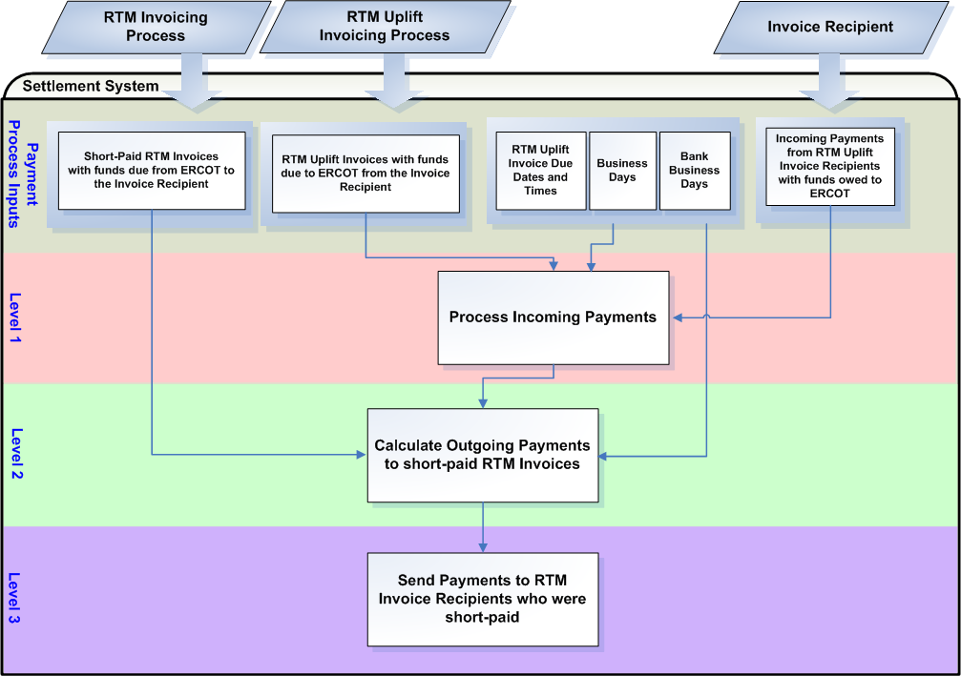

Assumptions
A1) Payments for RTM Uplift Invoices are due on the applicable payment due date, whether or not there is any Settlement and billing dispute regarding the amount of the payment. ERCOT suggests a protocol revision to include this provision in Nodal Protocol Section 9.7.3, Partial Payments by Invoice Recipients for the RTM.

A2) The date and time when payments are due to ERCOT from RTM Uplift Invoice Recipients is day 1 of the RTM Uplift Invoice Payment Process and will be 1700 on the 5th Bank Business Day after the RTM Uplift Invoice date. If the 5th Bank Business Day is not a Business Day, then the date and time when payments are due to ERCOT from RTM Uplift Invoice Recipients is 1700 on the next Bank Business Day after the 5th Bank Business Day that is also a Business Day.

The date and time when payments must be paid by ERCOT to short-paid RTM Invoice Recipients is day 2 of the RTM Uplift Invoice Payment Process and is 1700 on the next day after the date when payments are due to ERCOT from Invoice Recipients for that RTM Uplift Invoice that is both a Bank Business Day and a Business Day.

This assumption is based on current ERCOT business processes. ERCOT suggests a Protocol Revision to include this language for RTM Uplift Invoices in Section 9.7.3, Partial Payments by Invoice Recipients for the RTM.

A3) All RTM Uplift Invoices due, with funds owed by an Invoice Recipient, must be paid to ERCOT in U.S. Dollars by either of the following:
- On or before the payment due date if the payment is made by Electronic Funds Transfer (EFT) in immediately available or good funds (i.e., not subject to reversal); or
- On or before two Bank Business Days before the payment due date if the payment is made by Automated Clearing House (ACH) funds.

ERCOT suggests a Protocol Revision to include this language for RTM Uplift Invoices in Section 9.7.3, Partial Payments by Invoice Recipients for the RTM.

Business Rules
Req. ID | Protocol(s) | Sub-Process Map | Description
FR51 | PR 9.7.3(i) | CSWM.  P03SettleBillTransfer | Payments for RTM Uplift Invoices must be made in a 2-day, 2-step process.
FR52 | A1 (PR 9.7.3) | CSWM.  P03SettleBillTransfer | Payments for RTM Uplift Invoices are due on the applicable payment due date, whether or not there is any Settlement and billing dispute regarding the amount of the payment.
FR53 | A2 (PR 9.7.3) | CSWM.  P03SettleBillTransfer | The date and time when payments are due to ERCOT from RTM Uplift Invoice Recipients is day 1 of the RTM Uplift Invoice Payment Process and will be 1700 on the 5th Bank Business Day after the RTM Uplift Invoice date. If the 5th Bank Business Day is not a Business Day, then the date and time when payments are due to ERCOT from RTM Uplift Invoice Recipients is 1700 on the next Bank Business Day after the 5th Bank Business Day that is also a Business Day.
FR54 | A3 (PR 9.7.3) | CSWM.  P03SettleBillTransfer | All RTM Uplift Invoices due, with funds owed by an Invoice Recipient, must be paid to ERCOT in U.S. Dollars by either of the following:  - On or before the payment due date if the payment is made by Electronic Funds Transfer (EFT) in immediately available or good funds (i.e., not subject to reversal); or  - On or before two Bank Business Days before the payment due date if the payment is made by Automated Clearing House (ACH) funds.
FR55 | A2  PR 9.7.3(e)  PR 9.7.3(i) | CSWM.  P03SettleBillTransfer | The date and time when payments must be paid by ERCOT to short-paid RTM Invoice Recipients is day 2 of the RTM Uplift Invoice Payment Process and is 1700 on the next day after the date when payments are due to ERCOT from Invoice Recipients for that RTM Uplift Invoice that is both a Bank Business Day and a Business Day.
FR56 | PR 9.7.3(e)  PR 9.7.3(i) | CSWM.  P03SettleBillTransfer | For payments due to short-paid RTM Invoice Recipients, ERCOT shall pay all RTM Invoice Recipients, from monies received from RTM Uplift Invoice Recipients, on a pro rata basis of monies owed to each Invoice Recipient, to the extent necessary to clear ERCOT’s accounts on the payment due date to achieve revenue neutrality for ERCOT. ERCOT shall begin applying funds to the earliest uplifted RTM Invoice cycle.
FR57 | PR 9.7.3(g)  PR 9.7.3  PR 9.7.3(a)  PR 9.7.3(b)  PR 9.7.3(c) | CSWM.  P03SettleBillTransfer | If at least one Invoice Recipient owing funds does not pay its RTM Uplift Invoice in full (short-pays), then ERCOT shall  - make every reasonable attempt to collect payment from each short-paying Invoice Recipient before any payments owed by ERCOT for that RTM Uplift is due to be paid to applicable Invoice Recipient(s);  - draw on any available security pledged to ERCOT by each short-paying Invoice Recipient that did not pay the RTM Uplift Invoice in full; and  - offset or recoup any amounts owed, or to be owed, by ERCOT to a short-paying Invoice Recipient against amounts not paid by that Invoice Recipient, and ERCOT shall apply the amount offset or recouped to cover payment shortages by that Invoice Recipient.

Business Defined Errors
See FR11, FR12 and FR13.

Specific Database Needs
See FR14, FR15, FR16, FR17, FR18, FR19, FR20, FR21, FR22, FR23, and FR24.
Req. ID | Protocol(s) | Sub-Process Map | Description
FR58 | PR 9.7.3(e) | CSWM.  P03SettleBillTransfer | Payments calculated for short-paid RTM Invoice Recipients, which are derived from payments received from RTM Uplift Invoices, must be recorded as paid by uplift.
FR59 | PR 9.7.3(e) | CSWM.  P03SettleBillTransfer | The original short-paying RTM Invoice recipient must be closed out and recorded as paid by uplift as the past-due amount is fulfilled by uplift. A record tying each uplift event to a short-paying RTM Invoice Recipient amount must be stored in the Settlement and Billing system.

Payment Process for CRR Auction Invoices
The financial transfer process for CRR Auction Invoices is a 2-day, 2-step process, namely the receipt of payments from CRR Auction Invoice Recipients to ERCOT and the remittance of payments from ERCOT to CRR Auction Invoice Recipients.

Dependencies
D1) Payments from CRR Auction Invoice Recipients to ERCOT are dependent on:
- Availability of CRR Auction Invoices
- Dates and times when payments are due to ERCOT from CRR Auction Invoice Recipients
- Business Days
- Bank Business Days

D2) Payments from ERCOT to CRR Auction Invoice Recipients are dependent upon:
- Availability of CRR Auction Invoices
- Payments from CRR Auction Invoice Recipients to ERCOT
- Business Days
- Bank Business Days

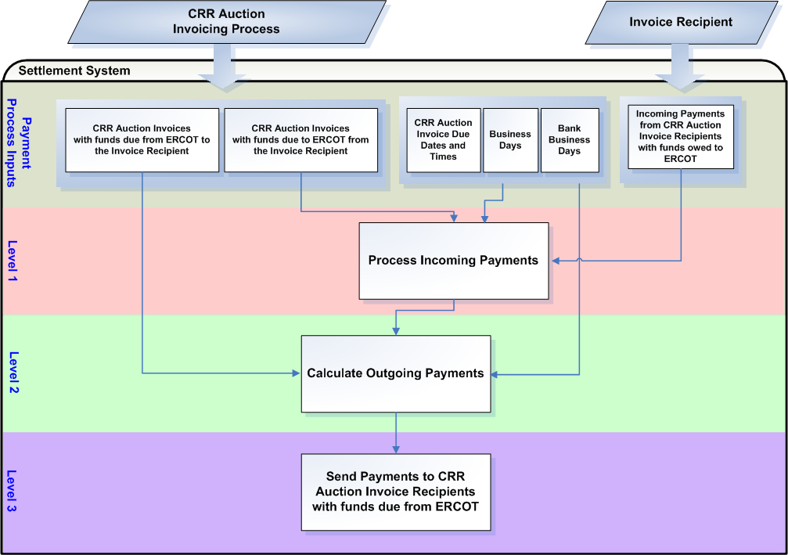

Assumptions
A1) Payments for CRR Auction Invoices are due on the applicable payment due date, whether or not there is any Settlement and billing dispute regarding the amount of the payment. ERCOT suggests a protocol revision to include this provision in Nodal Protocol Section 9.9, Payment Process for CRR Auction Award Invoices.

A2) ERCOT suggests a protocol revision to Nodal Protocol Section 9.9.1(1) and 9.9.2(1), Invoice Recipient Payment to ERCOT for the CRR Auction, to make Bank Business Day / Business Day language consistent throughout all of Nodal Protocols Section 9, Settlement and Billing.

Business Rules
Req. ID | Protocol(s) | Sub-Process Map | Description
FR60 | PR 9.9 | CSWM.  P03SettleBillTransfer | Payments for CRR Auction Invoices must be made in a 2-day, 2-step process.
FR61 | A1 (PR 9.9) | CSWM.  P03SettleBillTransfer | Payments for CRR Auction Invoices are due on the applicable payment due date, whether or not there is any Settlement and billing dispute regarding the amount of the payment.
FR62 | A2 (PR 9.9.1(1)) | CSWM.  P03SettleBillTransfer | The date and time when payments are due to ERCOT from CRR Auction Invoice Recipients is day 1 of the CRR Auction Invoice Payment Process and will be 1700 on the 3rd Bank Business Day after the CRR Auction Invoice date. If the 3rd Bank Business Day is not a Business Day, then the date and time when payments are due to ERCOT from CRR Auction Invoice Recipients is 1700 on the next Bank Business Day after the 3rd Bank Business Day that is also a Business Day.
FR63 | PR 9.9.1(2)  PR 9.9.1(2a)  PR 9.9.1(2b) | CSWM.  P03SettleBillTransfer | All CRR Auction Invoices due, with funds owed by an Invoice Recipient, must be paid to ERCOT in U.S. Dollars by either of the following:  - On or before the payment due date if the payment is made by Electronic Funds Transfer (EFT) in immediately available or good funds (i.e., not subject to reversal); or  - On or before two Bank Business Days before the payment due date if the payment is made by Automated Clearing House (ACH) funds.
FR64 | A2  PR 9.9.2(1) | CSWM.  P03SettleBillTransfer | The date and time when payments must be paid by ERCOT to CRR Auction Invoice Recipients is day 2 of the CRR Auction Invoice Payment Process and is 1700 on the next day after the date when payments are due to ERCOT from Invoice Recipients for that CRR Auction Invoice that is both a Bank Business Day and a Business Day.
FR65 | PR 9.9.1(3) | CSWM.  P03SettleBillTransfer | ERCOT does not accept partial payments for CRR Auction Invoices. All CRR Auction Invoices must be paid in full on the CRR Auction Invoice due date. The following rules apply when no payment is received or partial payments are received for a CRR Auction Invoice:  - CRR Bids awarded and PCRRs allocated to the CRR Auction Invoice Recipient will be forfeited; and  - CRR Offers awarded to the CRR Auction Invoice Recipient will be honored.
FR66 | PR 9.9.2(1) | CSWM.  P03SettleBillTransfer | ERCOT shall exercise its right to withhold payments for RTM Invoices under Section 16, Registration and Qualification of Market Participants.  See the Credit Monitoring Management Requirements document for further information on the Credit Monitoring Process.
FR67 | PR 9.9.2(2) | CSWM.  P03SettleBillTransfer | ERCOT shall give irrevocable instructions to the ERCOT financial institution to remit, to each CRR Auction Invoice Recipient for same day value, the amounts owed to each CRR Auction Invoice Recipient.

Business Defined Errors
See FR11, FR12 and FR13.

Specific Database Needs
See FR14, FR15, FR16, FR17, FR18, FR19, FR20, FR21, FR22, FR23, and FR24.
Req. ID | Protocol(s) | Sub-Process Map | Description
FR68 | PR 9.4 | CSWM.  P03SettleBillTransfer | The Financial Transfer system must have the functionality to split CRR Auction Invoices into credit (CRR offers awarded) and debit (CRR bids awarded) invoices for those CRR Auction Invoice Recipients who do not pay their invoice in full so that payments can be calculated for CRR offers awarded that are netted on the same CRR Auction Invoice as forfeited CRR bids awarded.
FR69 | PR 9.4 | CSWM.  P03SettleBillTransfer | A notification report is required to inform the CRR group of payments received from CRR Auction Invoices as they are approved. The report must indicate:  - CRR Invoice Recipient name  - Invoice Recipients unique identifier  - CRR Invoice number  - Payment Status (Paid or Not Paid)

Payment Process for CARD Invoices
The financial transfer process for CARD Invoices is a 2-day, 2-step process, namely the receipt of payments from CARD Invoice Recipients to ERCOT and the remittance of payments from ERCOT to CARD Invoice Recipients.

Dependencies
D1) Payments from CARD Invoice Recipients to ERCOT are dependent on:
- Availability of CARD Invoices
- Dates and times when payments are due to ERCOT from CARD Invoice Recipients
- Business Days
- Bank Business Days

D2) Payments from ERCOT to CARD Invoice Recipients are dependent upon:
- Availability of CARD Invoices
- CRR Auction Revenue
- Payments from CARD Invoice Recipients to ERCOT
- Business Days
- Bank Business Days

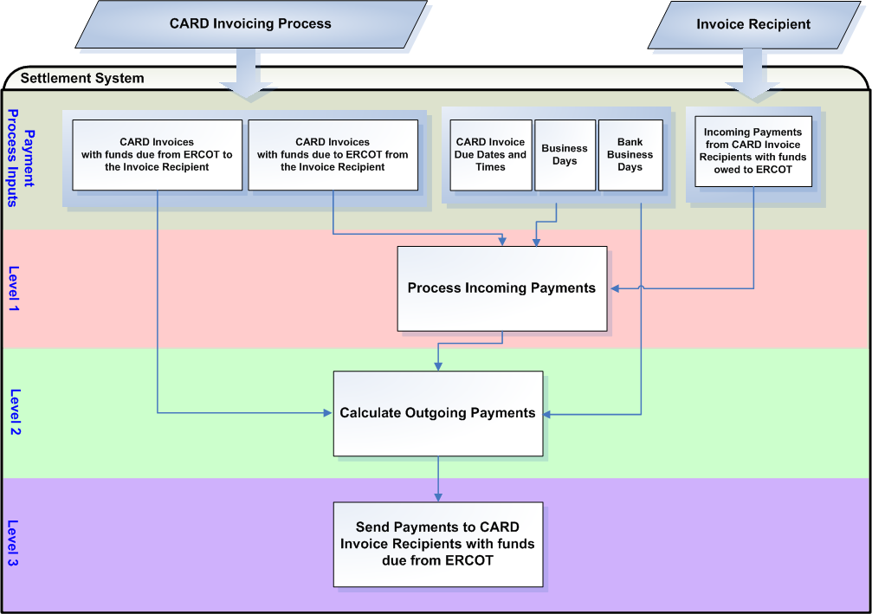

Assumptions
A1) Payments for CARD Invoices are due on the applicable payment due date, whether or not there is any Settlement and billing dispute regarding the amount of the payment. ERCOT suggests a protocol revision to include this provision in Nodal Protocol Section 9.11, Payment Process for CRR Auction Award Invoices.

A2) ERCOT suggests a protocol revision to Nodal Protocol Section 9.11.1(1) and 9.11.2(1), Invoice Recipient Payment to ERCOT for the CRR Auction Revenue Distribution, to make Bank Business Day / Business Day language consistent throughout all of Nodal Protocols Section 9, Settlement and Billing.

Business Rules
Req. ID | Protocol(s) | Sub-Process Map | Description
FR70 | PR 9.11 | CSWM.  P03SettleBillTransfer | Payments for CRR Auction Invoices must be made in a 2-day, 2-step process.
FR71 | A1 (PR 9.11) | CSWM.  P03SettleBillTransfer | Payments for CRR Auction Invoices are due on the applicable payment due date, whether or not there is any Settlement and billing dispute regarding the amount of the payment.
FR72 | A2 (PR 9.11.1(1)) | CSWM.  P03SettleBillTransfer | The date and time when payments are due to ERCOT from CARD Invoice Recipients is day 1 of the CARD Invoice Payment Process and will be 1700 on the 5th Bank Business Day after the CARD Invoice date. If the 5th Bank Business Day is not a Business Day, then the date and time when payments are due to ERCOT from CARD Invoice Recipients is 1700 on the next Bank Business Day after the 5th Bank Business Day that is also a Business Day.
FR73 | PR 9.11.1(2)  PR 9.11.1(2a)  PR 9.11.1(2b) | CSWM.  P03SettleBillTransfer | All CARD Invoices due, with funds owed by an Invoice Recipient, must be paid to ERCOT in U.S. Dollars by either of the following:  - On or before the payment due date if the payment is made by Electronic Funds Transfer (EFT) in immediately available or good funds (i.e., not subject to reversal); or  - On or before two Bank Business Days before the payment due date if the payment is made by Automated Clearing House (ACH) funds.
FR74 | A2  PR 9.11.2(1) | CSWM.  P03SettleBillTransfer | The date and time when payments must be paid by ERCOT to CARD Invoice Recipients is day 2 of the CARD Invoice Payment Process and is 1700 on the next day after the date when payments are due to ERCOT from Invoice Recipients for that CARD Invoice that is both a Bank Business Day and a Business Day.
FR75 | PR 9.11.3(d) | CSWM.  P03SettleBillTransfer | For payments due to CARD Invoice Recipients, ERCOT shall pay all CARD Invoice Recipients on a pro rata basis of monies owed to each Invoice Recipient, to the extent necessary to clear ERCOT’s accounts on the payment due date to achieve revenue neutrality for ERCOT.
FR76 | PR 9.11.3  PR 9.11.3(a)  PR 9.11.3(b)  PR 9.11.3(c) | CSWM.  P03SettleBillTransfer | If at least one Invoice Recipient owing funds does not pay its CARD Invoice in full (short-pays), then ERCOT shall  - make every reasonable attempt to collect payment from each short-paying Invoice Recipient before any payments owed by ERCOT for that month’s distribution of CRR Auction Revenue is due to be paid to applicable Invoice Recipient(s);  - draw on any available security pledged to ERCOT by each short-paying Invoice Recipient that did not pay the CARD Invoice in full; and  - offset or recoup any amounts owed, or to be owed, by ERCOT to a short-paying Invoice Recipient against amounts not paid by that Invoice Recipient, and ERCOT shall apply the amount offset or recouped to cover payment shortages by that Invoice Recipient.
FR77 | PR 9.11.2(1) | CSWM.  P03SettleBillTransfer | ERCOT shall exercise its right to withhold payments for RTM Invoices under Section 16, Registration and Qualification of Market Participants.  See the Credit Monitoring Management Requirements document for further information on the Credit Monitoring Process.
FR78 | PR 9.11.2(2) | CSWM.  P03SettleBillTransfer | ERCOT shall give irrevocable instructions to the ERCOT financial institution to remit, to each RTM Late Fee Invoice Recipient for same day value, the amounts owed to each CRR Auction Invoice Recipient.

Business Defined Errors
See FR11, FR12 and FR13.

Specific Database Needs
See FR14, FR15, FR16, FR17, FR18, FR19, FR20, FR21, FR22, FR23, and FR24.

Payment Process for CRR Balancing Account Invoices
The financial transfer process for CRR Balancing Account Invoices is the process by which ERCOT distributes revenue from the CRR Balancing Account to short-paid CRR Owners and QSEs based on LRS.

Dependencies
D2) Payments from ERCOT to CRR Balancing Account Invoice Recipients are dependent upon:
- Availability of CRR Balancing Account Invoices
- Dates and times when payments are due from ERCOT to CRR Balancing Account Invoice Recipients
- Business Days
- Bank Business Days

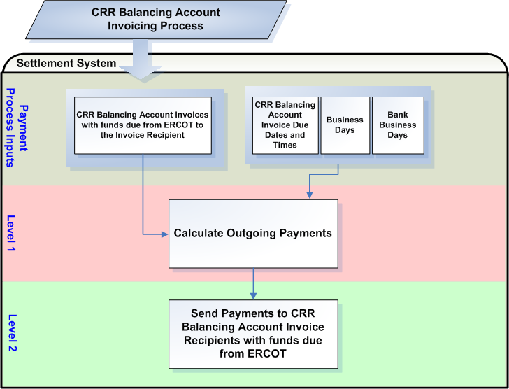

Assumptions
None

Business Rules
Req. ID | Protocol(s) | Sub-Process Map | Description
FR79 | PR 9.13 | CSWM.  P03SettleBillTransfer | Payments for CRR Auction Invoices must be made in a 1-day, 1-step process.
FR80 | PR 9.13(1) | CSWM.  P03SettleBillTransfer | The date and time when payments must be paid by ERCOT to CRR Balancing Account Invoice Recipients is 1700 on the 1st day that is both a Bank Business Day and Business Day after the date of the RTM Invoice that includes the RTM Initial Settlement for the last day of the month.
FR81 | PR 9.13(1) | CSWM.  P03SettleBillTransfer | ERCOT shall exercise its right to withhold payments for RTM Invoices under Section 16, Registration and Qualification of Market Participants.  See the Credit Monitoring Management Requirements document for further information on the Credit Monitoring Process.
FR82 | PR 9.13(2) | CSWM.  P03SettleBillTransfer | ERCOT shall give irrevocable instructions to the ERCOT financial institution to remit, to each RTM Late Fee Invoice Recipient for same day value, the amounts owed to each CRR Auction Invoice Recipient.

Business Defined Errors
See FR13.

Specific Database Needs
See FR19, FR22, FR23, and FR24.

Payment Process for Miscellaneous Invoices

Business Rules
Req. ID | Protocol(s) | Sub-Process Map | Description
FR83 |  | CSWM.  P03SettleBillTransfer | ERCOT requires the functionality to receive payments from and send payments to Miscellaneous Invoice Recipients.

Late Fees for the DAM
Daily Late Fees will be calculated for all DAM Invoice Recipients with unpaid balances. If the DAM Invoice Recipient did not pay its DAM Invoice in full, the DAM Invoice Recipient will receive late fee charges. If the DAM Invoice Recipient is not paid in full for its DAM Invoice, the DAM Invoice Recipient will receive late fee credits.

Requirement ID | FR84
Source Mapping (Protocol/NERC/FERC and other binding documents Ref #) | PR 9.4.5(1)
Traceability to Sub-Process Maps | CSWM.P03SettleBillTransfer
Description: Calculate DAM Late Fee Charges for each DAM Invoice Recipient who did not pay its DAM Invoice in full. This calculation shall only be performed on unpaid DAM Invoice amounts with money owed to ERCOT (charge invoices).

DAM Late Fee Charge = DAM Unpaid Charge Balance *
((Prime Rate + 2%) / Total number days in the year for which DAM Late Fees are calculated)

Note: The total number of days in the year for which DAM Late Fees are calculated should be 365 unless it is a leap year. In a leap year the number should be 366.

Requirement ID | FR85
Source Mapping (Protocol/NERC/FERC and other binding documents Ref #) | PR 9.4.5(2)
Traceability to Sub-Process Maps | CSWM.P03SettleBillTransfer
Description: Calculate DAM Late Fee Credits for each DAM Invoice Recipient who was not paid in full for its DAM Invoice. This calculation shall only be performed on unpaid DAM Invoice amounts with money owed to the Invoice Recipient (credit invoices). DAM Late Fee Credits should be calculated separately for each DAM Unpaid Charge Balance so that each DAM Late Fee Credit may be tracked back to the DAM Late Fee Charge it resulted from.

DAM Late Fee Credit = (-1) * DAM Late Fee Charge * DAM Late Fee Credit Ratio Share

Where,
DAM Late Fee Credit Ratio Share = DAM Unpaid Credit Balance / DAM Unpaid Charge Balance

Input Data
Variable | Unit | Definition | Original Source
DAM Unpaid Charge Balance | $/Invoice/DAM Billing Cycle | DAM Unpaid Charge Balance —The DAM Invoice unpaid amount, with funds owed from the Invoice Recipient to ERCOT that was not paid in full on its due date. | Settlement System
Additional Comments:

Prime Rate | Misc | Prime Rate —The Wall Street Journal Prime Interest Rate effective for the calendar day in which Late Fees are calculated. | Wall Street Journal
Additional Comments: The Wall Street Journal Prime Rate will be a manually input into the Settlement System.

DAM Unpaid Credit Balance | $/Invoice/DAM Billing Cycle | DAM Unpaid Credit Balance —The DAM Invoice unpaid amount, with funds owed from ERCOT to the Invoice Recipient that was not paid in full on its due date. | Settlement System
Additional Comments:

Intermediate Calculation
Variable | Unit | Definition | Destination
DAM Late Fee Credit Ratio Share | Misc | DAM Late Fee Credit Ratio Share —The ratio of a DAM Invoice Recipient’s unpaid credit balance to the short-paying DAM Invoice Recipient’s unpaid charge balance for which late fees are calculated. | Settlement System
Additional Comments:

Output Data
Variable | Unit | Definition | Destination
DAM Late Fee Charge | $/day/Unpaid Balance | DAM Late Fee Charge —The late fee charge to the short-paying DAM Invoice Recipient for unpaid DAM Invoice amounts, for the calendar day. | Settlement System
Additional Comments:

DAM Late Fee Credit | $/day/Unpaid Balance | DAM Late Fee Credit —The late fee credit to the DAM Invoice Recipient who was not paid in full for unpaid DAM Invoice amounts, for the calendar day. | Settlement System
Additional Comments:

Dependencies
D1) DAM Late Fee Charges are dependent on:
- Financial Transfer process for DAM Invoices
- Annual Prime Rate
- 2% Factor

D2) DAM Late Fee Credits are dependent on:
- Financial Transfer process for DAM Invoices
- DAM Late Fee Charges
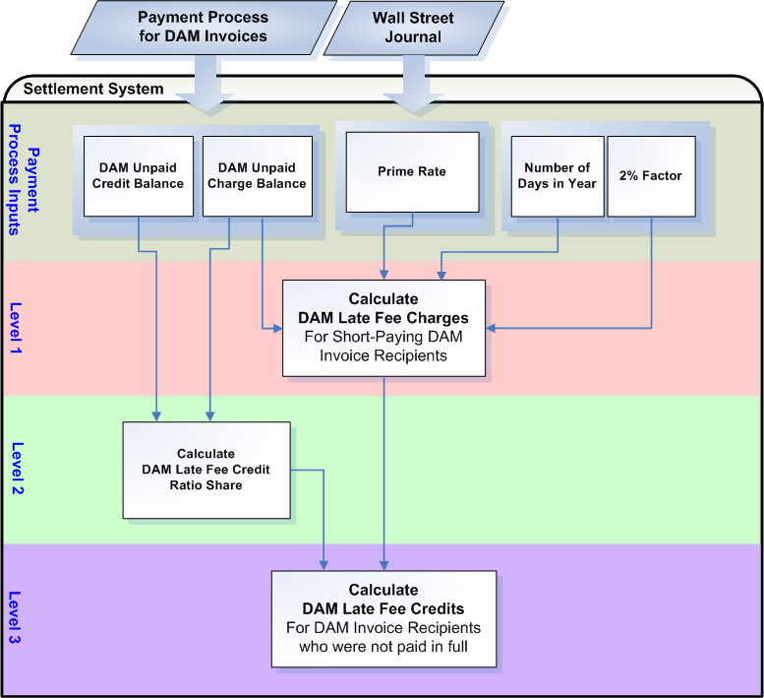

Assumptions
A1) The Zonal Protocol ERCOT Fee Schedule effective for October 1, 2006 is acceptable to use for Nodal reference.

A2) ERCOT should build in the functionality to reverse DAM Late Fees so that if directed, ERCOT may reverse and track the reversal in an automated process for DAM Late Fee recipients. The reversal of DAM Late Fees shall be posted on a DAM Late Fee Invoice.

A3 ERCOT shall make available to DAM Late Fee recipients the data necessary for shadow settlement.

Business Rules
Req. ID | Protocol(s) | Sub-Process Map | Description
FR86 | PR 9.4.5 | CSWM.  P03SettleBillTransfer | DRIVER: DAM Late Fees should only be attempted for a calendar day if the Settlement System reflects unpaid DAM Invoice Amounts past their due dates.
FR87 | PR 9.4.5(1)  ERCOT Fee Schedule | CSWM.  P03SettleBillTransfer | DAM Late Fee Charges shall be calculated based on Late Fee Terms specified in the ERCOT Fee Schedule for the time period from, and including, the relevant payment due date to the date on which the payment, including any related transaction costs incurred by ERCOT, is received by ERCOT.  Late Fee Terms = Wall Street Journal prime interest rate plus two (2) percent – assessed for failure to make timely payment under the Protocols.
FR88 | PR 9.4.5(2) | CSWM.  P03SettleBillTransfer | ERCOT shall calculate DAM Late Fee Credits for the DAM Invoice Recipients that were underpaid, due to a short-pay, on a pro rata basis of monies owed to each DAM Invoice Recipient, less ERCOT’s transaction costs.
FR89 | PR 9.4.5 | CSWM.  P03SettleBillTransfer | No input data or intermediate calculations shall be rounded or truncated.
FR90 | PR 9.4.5 | CSWM.  P03SettleBillTransfer | All output data should be rounded to two (2) decimal places.
FR91 | A2 | CSWM.  P03SettleBillTransfer | DAM Late Fees shall be calculated so that DAM Late Fee Credits resulting from a single DAM Late Fee Charge may be tracked back to the single DAM Late Fee Charge and are reversible. The settlement system should have the functionality to reverse DAM Late Fees.
FR92 | A3 | CSWM.  P03SettleBillTransfer | Data used to calculate DAM Late Fees should be made available to the DAM Late Fee recipient for shadow settlement.

Business Defined Errors
Req. ID | Protocol(s) | Sub-Process Map | Description
FR93 | PR 9.4.5 | CSWM.  P03SettleBillTransfer | While calculating DAM Late Fees, if there are no unpaid DAM Invoice amounts existing in the Settlement System for any DAM Invoice cycle, the system should not calculate DAM Late Fees for that calendar day and provide an error message indicating “No unpaid DAM Invoice amounts are available for processing DAM Late Fees for the date of <MMDDYY>”.

Specific Database Needs
Req. ID | Protocol(s) | Sub-Process Map | Description
FR94 | PR 9.4.5 | CSWM.  P03SettleBillTransfer | The Settlement System should have the functionality to not calculate Late Fees (either DAM, RTM or both) for a specific Invoice Recipient, Invoice Type or specific Invoice number based on an exception stored in a centralized area with start and stop times and configured in such a way that it can be easily updated by the Business Analyst.
FR95 | PR 9.4.5 | CSWM.  P03SettleBillTransfer | The Prime Rate shall be stored in a centralized area with start and stop times and configured in such a way that it can be easily updated by the Business Analyst.
FR96 | PR 9.4.5 | CSWM.  P03SettleBillTransfer | The factor of 2% shall be stored in a centralized area with start and stop times and configured in such a way that it can be easily updated by the Business Analyst.

Late Fees for the RTM
Daily Late Fees will be calculated for all RTM Invoice and RTM Uplift Invoice Recipients with unpaid balances. If the RTM Invoice or RTM Uplift Invoice Recipient did not pay its RTM Invoice or RTM Uplift Invoice in full, a late fee charge will be calculated. If the RTM Invoice Recipient is not paid in full for its RTM Invoice, a late fee credit will be calculated.

Requirement ID | FR97
Source Mapping (Protocol/NERC/FERC and other binding documents Ref #) | PR 9.7.5(1)
Traceability to Sub-Process Maps | CSWM.P03SettleBillTransfer
Description: Calculate RTM Late Fee Charges for each RTM Invoice and RTM Uplift Invoice Recipient who did not pay its Invoice in full. This calculation shall only be performed on unpaid RTM Invoice and RTM Uplift Invoice amounts with money owed to ERCOT (charge invoices).

RTM Late Fee Charge = RTM Unpaid Charge Balance *
((Prime Rate + 2%) / Total number days in the year for which RTM Late Fees are calculated)

Note: The total number of days in the year for which RTM Late Fees are calculated should be 365 unless it is a leap year. In a leap year the number should be 366.

Note: The RTM Unpaid Charge Balance refers to an unpaid balance from an RTM Invoice or RTM Uplift Invoice.

Requirement ID | FR98
Source Mapping (Protocol/NERC/FERC and other binding documents Ref #) | PR 9.7.5(2)
Traceability to Sub-Process Maps | CSWM.P03SettleBillTransfer
Description: Calculate RTM Late Fee Credits for each RTM Invoice Recipient who was not paid in full for its RTM Invoice. This calculation shall only be performed on unpaid RTM Invoice amounts with money owed to the Invoice Recipient (credit invoices). RTM Late Fee Credits should be calculated separately for each RTM Unpaid Charge Balance so that each RTM Late Fee Credit may be tracked back to the RTM Late Fee Charge it resulted from.

RTM Late Fee Credit = (-1) * RTM Late Fee Charge * RTM Late Fee Credit Ratio Share

Where,
RTM Late Fee Credit Ratio Share = RTM Unpaid Credit Balance / RTM Unpaid Charge Balance

Note:
RTM Late Fee Charges calculated for unpaid RTM Invoice amounts will result in RTM Late Fee Credits for RTM Invoice Recipients.

RTM Late Fee Charges calculated for unpaid RTM Uplift Invoice amounts will also result in RTM Late Fee Credits for RTM Invoice Recipients.

Input Data
Variable | Unit | Definition | Original Source
RTM Unpaid Charge Balance | $/Invoice/RTM or RTM Uplift Billing Cycle | RTM Unpaid Charge Balance —The RTM Invoice or RTM Uplift Invoice unpaid amount, with funds owed from the Invoice Recipient to ERCOT that was not paid in full on its due date. | Settlement System
Additional Comments:

Prime Rate | Misc | Prime Rate —The Wall Street Journal Prime Interest Rate effective for the calendar day in which Late Fees are calculated. | Wall Street Journal
Additional Comments: The Wall Street Journal Prime Rate will be a manually input into the Settlement System.

RTM Unpaid Credit Balance | $/Invoice/RTM Billing Cycle | RTM Unpaid Credit Balance —The RTM Invoice unpaid amount, with funds owed from ERCOT to the Invoice Recipient that was not paid in full on its due date. | Settlement System
Additional Comments:

Intermediate Calculation
Variable | Unit | Definition | Destination
RTM Late Fee Credit Ratio Share | Misc | RTM Late Fee Credit Ratio Share —The ratio of a RTM Invoice Recipient’s unpaid credit balance to the short-paying RTM Invoice or RTM Uplift Invoice Recipient’s unpaid charge balance for which late fees are calculated. | Settlement System
Additional Comments:

Output Data
Variable | Unit | Definition | Destination
RTM Late Fee Charge | $/day/Unpaid Balance | RTM Late Fee Charge —The late fee charge to the short-paying RTM Invoice or RTM Uplift Invoice Recipient for unpaid RTM Invoice or RTM Uplift Invoice amounts, for the calendar day. | Settlement System
Additional Comments:

RTM Late Fee Credit | $/day/Unpaid Balance | RTM Late Fee Credit —The late fee credit to the RTM Invoice Recipient who was not paid in full for unpaid RTM Invoice amounts, for the calendar day. | Settlement System
Additional Comments:

Dependencies
D1) RTM Late Fee Charges are dependent on:
- Financial Transfer process for RTM Invoices and RTM Uplift Invoices
- Annual Prime Rate
- 2% Factor

D2) RTM Late Fee Credits are dependent on:
- Financial Transfer process for RTM Invoices and RTM Uplift Invoices
- RTM Late Fee Charges
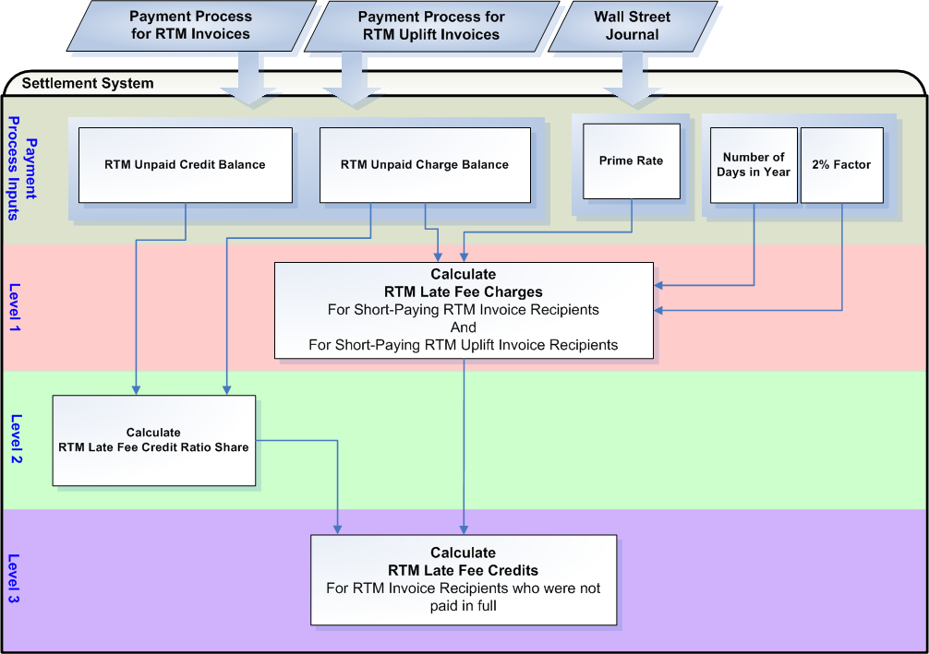

Assumptions
A1) The Zonal Protocol ERCOT Fee Schedule effective for October 1, 2006 is acceptable to use for Nodal reference.

A2) ERCOT should build in the functionality to reverse RTM Late Fees so that if directed, ERCOT may reverse and track the reversal in an automated process for RTM Late Fee recipients. The reversal of RTM Late Fees shall be posted on an RTM Late Fee Invoice.

A3 ERCOT shall make available to RTM Late Fee Recipients the data necessary for shadow settlement.

Business Rules
Req. ID | Protocol(s) | Sub-Process Map | Description
FR99 | PR 9.7.5 | CSWM.  P03SettleBillTransfer | DRIVER: RTM Late Fees should only be attempted for a calendar day if the Settlement System reflects unpaid RTM Invoice or RTM Uplift Invoice Amounts past their due dates.
FR100 | PR 9.7.5(1)  ERCOT Fee Schedule | CSWM.  P03SettleBillTransfer | RTM Late Fee Charges shall be calculated based on Late Fee Terms specified in the ERCOT Fee Schedule for the time period from, and including, the relevant payment due date to the date on which the payment, including any related transaction costs incurred by ERCOT, is received by ERCOT.  Late Fee Terms = Wall Street Journal prime interest rate plus two (2) percent – assessed for failure to make timely payment under the Protocols.
FR101 | PR 9.7.5(2) | CSWM.  P03SettleBillTransfer | ERCOT shall calculate RTM Late Fee Credits for the RTM Invoice Recipients that were underpaid, due to a short-pay, on a pro rata basis of monies owed to each RTM Invoice Recipient, less ERCOT’s transaction costs.  RTM Late Fee Charges for RTM Uplift Invoice amounts will result in RTM Late Fee Credits for RTM Invoice Recipients who were not paid in full for the RTM Invoice cycle that was uplifted.
FR102 | PR 9.7.5 | CSWM.  P03SettleBillTransfer | No input data or intermediate calculations shall be rounded or truncated.
FR103 | PR 9.7.5 | CSWM.  P03SettleBillTransfer | All output data should be rounded to two (2) decimal places.
FR104 | A2 | CSWM.  P03SettleBillTransfer | RTM Late Fees shall be calculated so that RTM Late Fee Credits resulting from a single RTM Late Fee Charge may be tracked back to the single RTM Late Fee Charge and are reversible. The Settlement system should have the functionality to reverse RTM Late Fees.
FR105 | A3 | CSWM.  P03SettleBillTransfer | Data used to calculate RTM Late Fees should be made available to the RTM Late Fee recipient for shadow settlement.

Business Defined Errors
Req. ID | Protocol(s) | Sub-Process Map | Description
FR106 | PR 9.7.5 | CSWM.  P03SettleBillTransfer | While calculating RTM Late Fees, if there are no unpaid RTM Invoice or RTM Uplift Invoice amounts existing in the Settlement System for any RTM Invoice or RTM Uplift Invoice cycle, the system should not calculate RTM Late Fees for that calendar day and provide an error message indicating “No unpaid RTM or RTM Uplift Invoice amounts are available for processing RTM Late Fees for the date of <MMDDYY>”.

Specific Database Needs
Req. ID | Protocol(s) | Sub-Process Map | Description
FR107 | PR 9.7.5 | CSWM.  P03SettleBillTransfer | The Settlement System should have the functionality to not calculate Late Fees (either DAM, RTM or both) for a specific Invoice Recipient, Invoice Type or specific Invoice number based on an exception stored in a centralized area with start and stop times and configured in such a way that it can be easily updated by the Business Analyst.
FR108 | PR 9.7.5 | CSWM.  P03SettleBillTransfer | The Prime Rate shall be stored in a centralized area with start and stop times and configured in such a way that it can be easily updated by the Business Analyst.
FR109 | PR 9.7.5 | CSWM.  P03SettleBillTransfer | The factor of 2% shall be stored in a centralized area with start and stop times and configured in such a way that it can be easily updated by the Business Analyst.

Supplementary Requirements

Performance Requirements
Lodestar must be able to perform its full set of programmatic Nodal settlement requirements. Performance characteristics will be determined and detailed in the conceptual and detailed design.

Legal and Regulatory requirements
All Lodestar financial data must be saved in accordance with standard accounting principles as dictated by the ERCOT Texas Nodal Protocols.

System Security Requirements
Lodestar will only be accessed directly by internal ERCOT personnel either through thin client UI, Citrix environment, or thick client on employee desktops. Market Participants will be able to access their statements and invoices on ERCOT private web site. ERCOT private web site access will be controlled by digital certificate authentication in accordance with ERCOT security policies. Additional details will be provided in the Conceptual System Design.

Back up and Recovery Requirements
All Lodestar Nodal settlement data must be backed up on a daily basis and recoverable within 24 hours. Additional details will be provided in the Conceptual System Design.

Availability and Redundancy Requirements
Nodal Lodestar system must be available 7/24. Lodestar is considered a tier 1 system and critical to base ERCOT business processes. Additional details will be provided in the Conceptual System Design.

Maintainability Requirements
Lodestar Nodal system will be maintained by internal ERCOT personnel. Service Level Agreements and explicit support will be detailed in the detail design document.

Protocol Coverage

Protocol Sub-Section # (To the lowest level of granularity as possible) | Coverage by Requirements  (Full/Partial)
9.4 | Partial
9.4.1(1) | Partial
9.4.1(2) | Partial
9.4.1(2a) | Partial
9.4.1(2b) | Partial
9.4.2(1) | Partial
9.4.2(2) | Partial
9.4.3 | Partial
9.4.3(a) | Partial
9.4.3(b) | Partial
9.4.3(c) | Partial
9.4.3(d) | Partial
9.4.3(f) | Partial
9.4.5 | Partial
9.4.5(1) | Partial
9.4.5(2) | Partial
9.4.5(5) | Partial
9.4.5(6) | Partial
9.4.5(6a) | Partial
9.4.5(6b) | Partial
9.4.5(7) | Partial
9.4.5(8) | Partial
9.7 | Partial
9.7.1(1) | Partial
9.7.1(2) | Partial
9.7.1(2a) | Partial
9.7.1(2b) | Partial
9.7.2(1) | Partial
9.7.2(2) | Partial
9.7.3 | Partial
9.7.3(a) | Partial
9.7.3(b) | Partial
9.7.3(c) | Partial
9.7.3(d) | Partial
9.7.3(e) | Partial
9.7.3(g) | Partial
9.7.3(i) | Partial
9.7.5 | Partial
9.7.5(1) | Partial
9.7.5(2) | Partial
9.7.5(5) | Partial
9.7.5(6) | Partial
9.7.5(6a) | Partial
9.7.5(6b) | Partial
9.7.5(7) | Partial
9.7.5(8) | Partial
9.9 | Partial
9.9.1(1) | Partial
9.9.1(2) | Partial
9.9.1(2a) | Partial
9.9.1(2b) | Partial
9.9.1(3) | Partial
9.9.2(1) | Partial
9.9.2(2) | Partial
9.11 | Partial
9.11.1(1) | Partial
9.11.1(2) | Partial
9.11.1(2a) | Partial
9.11.1(2b) | Partial
9.11.2(1) | Partial
9.11.2(2) | Partial
9.11.3 | Partial
9.11.3(a) | Partial
9.11.3(b) | Partial
9.11.3(c) | Partial
9.11.3(d) | Partial
9.13 | Partial
9.13(1) | Partial
9.13(2) | Partial

