Commercial Systems
Day-Ahead Market Congestion Revenue Rights Settlements Requirements

v0.091

Revision History
Date | Version | Description | Author
07/12/06 | 0.01 | Initial draft to Internal Discussions | Sharon Wang
09/12/06 | 0.09 | TPTF Review Process | Sharon Wang
09/27/06 | 0.091 | TPTF Comments | Sharon Wang

Table of Contents
1. Day-Ahead Market Congestion Revenue Rights Settlements 3
1.1 Proposed System Scope 3
1.2 Document Conventions 3
1.3 Document Assumptions 3
2. Functional Requirements 3
2.1 Calculation of Minimum Resource Price for Source Settlement Point (MINRESPR) 3
Input Bill Determinants 3
Intermediate Bill Determinants 3
Output Bill Determinants 3
Data Dependencies 3
Assumptions 3
Business Rules 3
Business Defined Errors 3
Specific Database Needs 3
2.2 Calculation of Maximum Resource Price for Sink Settlement Point (MAXRESPR) 3
Input Bill Determinants 3
Intermediate Bill Determinants 3
Output Bill Determinants 3
Data Dependencies 3
Assumptions 3
Business Rules 3
Business Defined Errors 3
Specific Database Needs 3
2.3 Calculation of Day-Ahead Obligation Price (DAOBLPR) 3
Data Dependencies 3
Assumptions 3
Business Rules 3
Business Defined Errors 3
Specific Database Needs 3
2.4 Calculation of Obligation Deration Price (OBLDRPR) 3
Input Bill Determinants 3
Output Bill Determinants 3
Data Dependencies 3
Assumptions 3
Business Rules 3
Business Defined Errors 3
Specific Database Needs 3
2.5 Calculation of Day-Ahead Obligation Hedge Value Price (DAOBLHVPR) 3
Input Bill Determinants 3
Output Bill Determinants 3
Data Dependencies 3
Assumptions 3
Business Rules 3
Business Defined Errors 3
Specific Database Needs 3
2.6 Calculation of Day-Ahead Option Price (DAOPTPR) 3
Input Bill Determinants 3
Output Bill Determinants 3
Data Dependencies 3
Assumptions 3
Business Rules 3
Business Defined Errors 3
Specific Database Needs 3
2.7 Calculation of Day-Ahead Option Informational Price (DAOPTPRINFO) 3
Input Bill Determinants 3
Output Bill Determinants 3
Data Dependencies 3
Assumptions 3
Business Rules 3
Business Defined Errors 3
Specific Database Needs 3
2.8 Calculation of Option Deration Price (OPTDRPR) 3
Input Bill Determinants 3
Output Bill Determinants 3
Data Dependencies 3
Assumptions 3
Business Rules 3
Business Defined Errors 3
Specific Database Needs 3
2.9 Calculation of Day-Ahead Option Hedge Value Price (DAOPTHVPR) 3
Input Bill Determinants 3
Output Bill Determinants 3
Data Dependencies 3
Assumptions 3
Business Rules 3
Business Defined Errors 3
Specific Database Needs 3
2.10 Payments and Charges for PTP Obligations Settled in DAM (DAOBLAMT) 3
Input Bill Determinants 3
Intermediate Bill Determinants 3
Output Bill Determinants 3
Data Dependencies 3
Assumptions 3
Business Rules 3
Business Defined Errors 3
Specific DDatabase Needs 3
2.11 Payments for PTP Options Settled in DAM (DAOPTAMT) 3
Input Bill Determinants 3
Intermediate Bill Determinants 3
Output Bill Determinants 3
Data Dependencies 3
Assumptions 3
Business Rules 3
Business Defined Errors 3
Specific Database Needs 3
2.12 Payments for FGR Settled in DAM (DAFGRAMT) 3
Input Bill Determinants 3
Intermediate Bill Determinants 3
Output Bill Determinants 3
Data Dependencies 3
Business Rules 3
Business Defined Errors 3
Specific Database Needs 3
2.13 Payments and Charges for PTP Obligations with Refund Settled in DAM (DAOBLRAMT) 3
Input Bill Determinants 3
Intermediate Bill Determinants 3
Output Bill Determinants 3
Data Dependencies 3
Business Rules 3
Business Defined Errors 3
Specific Database Needs 3
2.14 Payments for PTP Options with Refund Settled in DAM (DAOPTRAMT) 3
Input Bill Determinants 3
Intermediate Bill Determinants 3
Output Bill Determinants 3
Data Dependencies 3
Assumptions 3
Business Rules 3
Business Defined Errors 3
Specific Database Needs 3
3. Supplementary Requirements 3
3.1 Performance Requirements 3
3.2 Legal and Regulatory requirements 3
3.3 System Security Requirements 3
3.4 Back up and Recovery Requirements 3
3.5 Availability and Redundancy Requirements 3
3.6 Maintainability Requirements 3
3.7 Daylight Savings Time shall be recognized in Nodal Market settlements. 3
4. Protocol Coverage 3

Software Requirements Specification

Day-Ahead Market Congestion Revenue Rights Settlements

Proposed System Scope

ERCOT plans to implement a new Nodal market in 2009. Sections 7, 9 and 12 of the Nodal Protocols describe the various Charge Types, Settlement Statement, and Market Information System (MIS) requirements for the Day-Ahead Market (DAM) Congestion Revenue Rights (CRR). The Nodal Protocols will guide this project. The requirements in this document were based on information detailed in Nodal Protocols Section 7 (005NPRR-05_BOD_Action_Report_071806), Nodal Protocols Section 9 (007NPRR-05_BOD_Action_Report_071806) and NPRR (xxxx) [approved by TPTF and scheduled to be at the 9-21-06 PRS meeting] aimed to synchronize PRR640.

The document defines the requirements for Congestion Revenue Rights Settlements in Day-Ahead Market. Specifically, it comprises the requirements for the following CRR Charge Type Settlements:
- Payments and Charges for PTP Obligations Settled in DAM (DAOBLAMT)
--- (PR 7.9.1.1; PR 9.2.3 (o)
- Payments for PTP Options Settled in DAM (DAOPTAMT)
--- (PR 7.9.1.2; PR 9.2.3 (p)
- Payments for FGRs Settled in DAM (DAFGRAMT)
--- (PR 7.9.1.4; PR 9.2.3 (q)
- Payments and Charges for PTP Obligations with Refund Settled in DAM (DAOBLRAMT)
--- (PR 7.9.1.5; PR 9.2.3 (r)
- Payments for PTP Options with Refunds Settled in DAM (DAOPTRAMT)
--- (PR 7.9.1.6; PR 9.2.3 (s)

The following calculations are defined as global calculations for CRR Day-Ahead Settlements:
- Calculation of Minimum Resource Price for Source Settlement Point (MINRESPR)
--- (PR 7.9.1.1; PR7.9.1.2; PR7.9.1.4; PR7.9.1.5; PR7.9.1.6; PR7.9.2.2; PR7.9.2.3)
- Calculation of Maximum Resource Price for Sink Settlement Point (MAXRESPR)
--- (PR 7.9.1.1; PR7.9.1.2; PR7.9.1.5; PR7.9.2.2)
- Calculation of Day-Ahead Obligation Price (DAOBLPR)
--- (PR 7.9.1.1; PR 4.6.3)
- Calculation of Obligation Deration Price (OBLDRPR)
--- (PR 7.9.1.1 (3); PR 7.9.1.5 (3))
- Calculation of Day-Ahead Obligation Hedge Value Price (DAOBLHVPR)
--- (PR 7.9.1.1; PR 7.9.1.5)
- Calculation of Day-Ahead Option Price (DAOPTPR)
--- (PR 7.9.1.2; PR 7.9.1.6)
- Calculation of Option Deration Price (OPTDRPR)
--- (PR 7.9.1.2; PR 7.9.1.6; PR 7.9.2.2; PR 7.9.2.3)
- Calculation of Day-Ahead Option Hedge Value Price (DAOPTHVPR)
--- (PR 7.9.1.2; PR 7.9.1.6; PR 7.9.2.2; PR 7.9.2.3)

The following calculation is defined in the document for MIS posting:
- Day-Ahead Option Informational Price (DAOPTPRINFO)
--- (PR 7.9.1.2 (5))

The calculation detailed in Section 7.9.3.3, Shortfall Charges to CRR Owners, Item 2 will be on the DAM Statement but will be covered in the “TN.COMS.63C01.CRRBA.REQUIREMENTS.A” document. The purpose of the “TN.COMS.63C01.CRRBA.REQUIREMENTS.A” document is to address the balancing account.

To Be Sub-Process for Settlements and Billing
For illustrative purposes, Figures 1 to Figure 18 are provided to describe calculation dependencies in this document.
Figure 1 illustrates the proposed scope of CRR Settlements. It comprises Day-Ahead CRR Settlements, Real-Time CRR Settlements, CRR Balancing Account, and CRR Auction Disbursement Settlements, within which Day-Ahead CRR Settlements are addressed by this document, and other components are addressed by separate sets of Requirements.
Figure 2 illustrates the high-level calculation dependencies in CRR Day-Ahead Settlement system -- between global calculations and charge type calculations.
A dependency diagram is provided to depict the dependencies between calculation inputs, intermediate variables, and outputs for each section of Functional Requirements.
These figures should be considered in conjunction with the textual requirements. If a contradiction exists between an illustrative figure and its associated textual requirements, the textual requirements should override the figure.
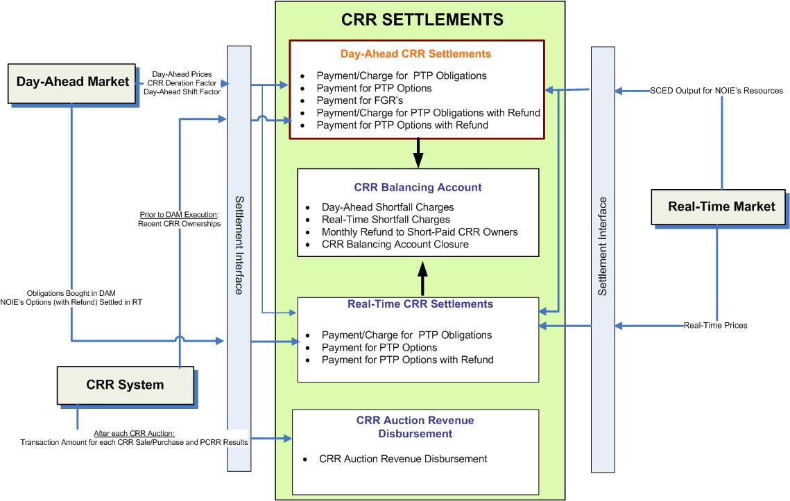
- Proposed Scope of CRR Settlements

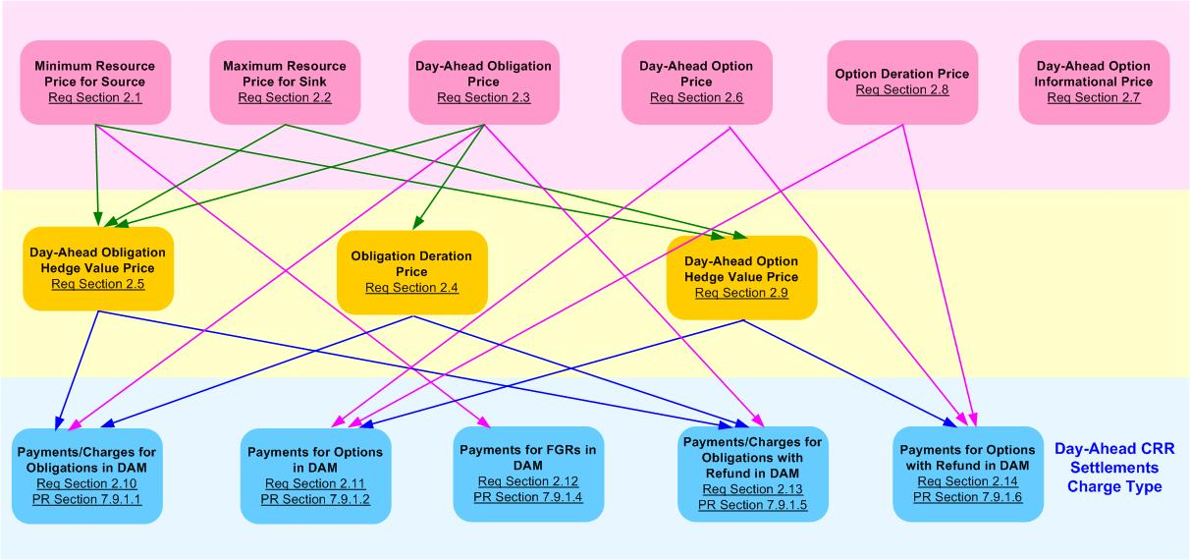
- High-Level Dependency Diagram between Global Calculations and Charge Type Calculations defined in Day-Ahead CRR Settlement Requirements

Document Conventions
- All text directly lifted from the Nodal Protocols is in italic font.
- All requirements are identified using R1, R2, etc.
- All dependencies are identified using D1, D2, etc.
- All assumptions are identified using A1, A2, etc.
- Settlement Recorders in this document adhere to the following naming convention:
BILLDETERMINANT_<Q>_<CO>_<R>_<SP>_<SRSP>_<SKSP>_<F>_<E>_<C>

Where:
<Q> = QSE
<CO> = CRR Owner
<R> = Resource
<SP> = Settlement Point
<SRSP> = Source Settlement Point
<SKSP> = Sink Settlement Point
<F> = Flowgate
<E> = Directional Network Element
<C> = Constraint Identifier

- Footnotes in this document are denoted by a * sign.
- Each Section Title will include the Charge Type/Bill Determinant description and the associated Bill Determinant in parenthesis.
- Input Bill Determinants described in this requirement have a compatible data format with Settlement System.
- The color scheme used in calculation dependency diagrams is defined in Figure 3 and Figure 4.

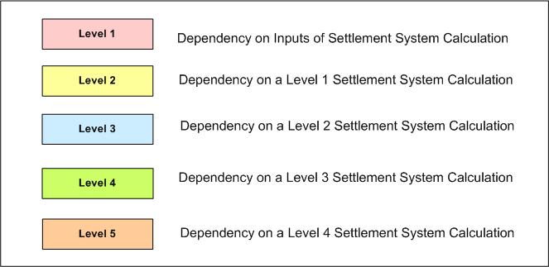

- Color Definition for Levels of Dependency Diagram used in Day-Ahead CRR Settlement Requirements

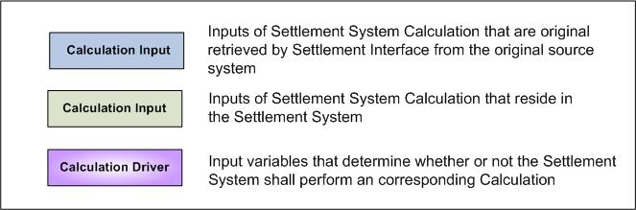

- Color Definition for Inputs of Dependency Diagram used in Day-Ahead CRR Settlement Requirements

Document Assumptions

- A separate requirement document will address the Settlement Interface with original sources such as MMS and CRR System. Specifically, this Settlement Interface Requirement will focus on when, what, and how input data should be retrieved from the original source, how to evaluate input data validity and completeness, and how to handle input data missing or other types of errors, to perform CRR Settlements Calculations described in this document.
- The DAM is executed completely and correctly and therefore there will be legitimate DAM Settlement Point Prices to perform the CRR Settlements described in this document.
- For any Charge Types that require historical data for the calculation, this information is obtained via alternative means for during the beginning of market open until the data is available.

Functional Requirements

Calculation of Minimum Resource Price for Source Settlement Point (MINRESPR)

Minimum Price for Source is the lowest Minimum Resource Price for the types of Resources located at the source Settlement Point. (PR 7.9.1.1; PR7.9.1.2; PR7.9.1.4; PR7.9.1.5; PR7.9.1.6; PR7.9.2.2; PR7.9.2.3)

The Calculation of Minimum Resource Price for Source Settlement Point (MINRESPR) is defined as a global calculation because it is a common component utilized by multiple calculations in CRR Settlements. Specifically, MINRESPR is used by the calculation of: Day-Ahead Obligation Hedge Value Price (DAOBLHVPR), Day-Ahead Option Hedge Value Price (DAOPTHVPR), Day-Ahead FGR Hedge Value Price for MCFRI (DAFGRHVPR_<MCFRI>), and Real-Time Option Hedge Value Price (RTOPTHVPR).

Requirement ID
Source Mapping (Protocol/NERC/FERC and other binding documents Ref #) | PR 7.9.1.3(2)  NPRR associated with Synch of Zonal PRR 640 (Section J -- “Input for Payments for “RMR Units” in “Standard Form Reliability Must-Run Agreement”)
Traceability to Sub-Process Maps | CSWM.P03SettleBillTransfer
Description

Calculate Minimum Resource Price (MINRESRPR) per Generation Resource (R) located at the source Settlement Point for each Operating Hour of the Operating Day:

- IF a Generation Resource is a RMR unit,
THEN:
MINRESRPR equals the sum of Fuel Index Price (FIP) and RMR Contract Estimated Fuel Adder (RMRCEFA), multiplied by RMR Contract Heat Rate at the LSL level (RMRCHRLSL);
MINRESRPR_<R>_<SRSP> = (FIP + RMRCEFA_<R>_<SRSP>)
* RMRCHRLSL_<R>_<SRSP>

Note: Estimated Fuel Adder and Heat Rate at LSL are specified values by RMR Contract.

- IF a Generation Resource is not a RMR unit, and belongs to: Nuclear, Hydro, Wind, and Renewable generating units,
THEN:
MINRESRPR equals a Minimum Resource Price (MINRESPRVALUE) specified by Protocols;
MINRESRPR_<R>_<SRSP> = MINRESPRVALUE_<R>_<SRSP>

Resource Type | Minimum Resource Price  (MINRESPRVALUE)
Nuclear | -$20.00 /MWh
Hydro | -$20.00 /MWh
Coal and Lignite | $0 /MWh
Wind | -$35 /MWh
Other Renewable | -$10/MWh

NOTE: An NPRR probably necessary: to use “Other Renewable B” instead of “Other Renewable”

- IF a Generation Resource is not a RMR Unit, and belongs to: a Combined Cycle greater than 90 MW, Combined Cycle less than or equal to 90 MW , Gas – Steam Supercritical Boiler , Gas Steam Reheat Boiler, Gas Steam Non-reheat or boiler without air-preheater, Simple Cycle greater than 90 MW, Simple Cycle less than or equal to 90 MW, and Diesel generating units,
THEN:
MINRESRPR equals the product of FIP and a Protocol-specified Heat Rate;
MINRESRPR_<R>_<SRSP> = FIP*MINRESHR_<R>_<SRSP>

Resource Type | Minimum Resource Price Heat Rate  (MINRESHR)
Combined Cycle greater than 90 MW | 5 MMBtu/MWh
Combined Cycle less than or equal to 90 MW | 6 MMBtu/MWh
Gas – Steam Supercritical Boiler | 6.5 MMBtu/MWh
Gas Steam Reheat Boiler | 7.5 MMBtu/MWh
Gas Steam Non-reheat or boiler without air-preheater | 10.5 MMBtu/MWh
Simple Cycle greater than 90 MW | 10 MMBtu/MWh
Simple Cycle less than or equal to 90 MW | 11 MMBtu/MWh
Diesel | 12 MMBtu/MWh

NOTE: An NPRR probably necessary: Per TXU’s comment that it is not strictly appropriate to apply FIP to the Diesel Resource Type hat rate as shown in the following table. For the Diesel resource type FOP is used in Protocol 4.4.9.2.3(2). On the other hand Protocol 4.4.9.3.3 (1) applies FIP as is done here and in the governing protocol section. TXU suggests that consistency is required and suggests that the correct application is the FOP in all f these sites for the Diesel Resource Type.

Requirement ID
Source Mapping (Protocol/NERC/FERC and other binding documents Ref #) | PR 7.9.1.1; PR7.9.1.2; PR7.9.1.4; PR7.9.1.5; PR7.9.1.6; PR7.9.2.2; PR7.9.2.3
Traceability to Sub-Process Maps | CSWM.P03SettleBillTransfer
Description

Calculate Minimum Resource Price per source Settlement Point for each Operating Hour of the Operating Day:*
$${\text{MINRESPR}}_{}\text{SRSP}\text{>=}\underset{R=r_{1}}{\overset{r_{n}}{\text{MIN}}}$$
Where:
R represents each Generation Resource (r₁, r₂…$r_{n}$) located at the source Settlement Point.

Input Bill Determinants
Variable |  |  | Unit |  | Definition |  | Original Source
MINRESPRVALUE |  |  | $/MWh |  | Minimum Resource Price for Resource Type– a specified Minimum Resource Price for certain Resource Types specified by Nodal Protocols. |  | Settlement System
Interval Frequency: Constant, specified by Nodal Protocols

Comments:
- The values for the MINRESPRVALUE shall be kept in a user maintained centralized area in the database with start and stop times. This should provide the flexibility to change as necessary.
MINRESHR |  |  | MMBtu/MWh |  | Minimum Resource Price Heat Rate – a specified Heat Rate to calculate Minimum Resource Price for certain Resource Types specified by Nodal Protocols. |  | Settlement System
Interval Frequency: Constant, specified by Nodal Protocols

Comments:
- The values for the MINRESHR shall be kept in a user maintained centralized area in the database with start and stop times. This should provide the flexibility to change as necessary.
FIP |  |  | $/MMBtu |  | Fuel Index Price - The midpoint price expressed in dollars per million British thermal units ($/MMBtu), published in Gas Daily, in the Daily Price Survey, under the heading “East-Houston-Katy, Houston Ship Channel.” For Saturdays, Sundays, holidays, and other days for which Gas Daily does not publish the described midpoint price, the FIP is the described midpoint price that is next published by Gas Daily. In the event that the described midpoint price is not published for more than two days, the previous day’s published described midpoint price will be used for the FIP in the initial settlement and the next day’s published described midpoint price will be used for the FIP in subsequent settlement statements. |  | Platts
Interval Frequency: 1/ day

Additional Comments: None
RMRCEFA |  |  | $/MMBtu |  | RMR Contract Estimated Fuel Adder |  | Settlement System
Interval Frequency: Constant, upon the approval of RMR contract data

Additional Comments:
- RMRCEFA is a value specified in the approved RMR Contract.
RMRCHRLSL |  |  | MMBtu/MWh |  | RMR Contract Heat Rate at LSL Level |  | Settlement System
Interval Frequency: Constant, upon the approval of RMR contract data

Additional Comments:
- RMRCHRLSL is a value specified in the approved RMR Contact.
DAOPT |  |  | MW |  | Day-Ahead Option per CRR Owner per source and sink pair—The number of CRR Owner’s PTP Options with the source and sink pair settled in the DAM for the hour. |  | CRR System  & MMS DAM
Interval Frequency: 1/ hour

Additional Comments:
- DAOPT equals the difference between (a) and (b):
(a) The amount of PTP Options acquired through PCRR Allocations, CRR Auctions, and CRR Bilateral Trades, prior to DAM execution
(b) The amount of PTP Options that are declared before DAM execution by NOIEs to be settled in Real-Time and not cleared in the DAM.

- DAOPT shall always be equal to or greater than zero (0).

- Calculation of DAOPT occurs in the Settlement Interface prior to the DAM Settlements process.
DAOPTR |  | MW |  | Day-Ahead Option with Refund per CRR Owner per pair of source and sink⎯The number of CRR Owner’s PTP Options with Refund with the pair of source and sink, settled in DAM, for the hour. |  | CRR System &  MMS DAM
Interval Frequency: 1/ hour

Additional Comments:
- DAOPTR is a result of PCRR Allocation. The owner of DAOPTR shall be a designated NOIE.

- DAOPTR equals the difference between (a) and (b):
(a) The amount of PTP Options with Refund acquired through PCRR Allocations by NOIEs.
(b) The amount of PTP Options with Refund that is declared before DAM execution by NOIEs to be settled in Real-Time and not cleared in the DAM.

- DAOPTR shall always be equal to or greater than zero (0).
RTOPT |  | MW |  | Real-Time Option per CRR Owner per pair of source and sink—The number of NOIE CRR Owner’s PTP Options with the pair of source and sink, settled in Real-Time, for the hour. |  | MMS DAM
Interval Frequency: 1/ hour

Additional Comments:
- RTOPT is the amount of PTP Options that are declared before DAM execution by NOIE CRR Owners to be settled in Real-Time and not cleared in the DAM.

- Reference to TN.COMS.63C01.RTCRR.REQUIREMENTS.A

- RTOPT shall always be greater than or equal to zero (0).
RTOPTR |  | MW |  | Real-Time Option with Refund per pair of source and sink—The number of the NOIE CRR Owner’s PTP Options with Refund with the pair of source and the sink, settled in Real-Time, for the hour. |  | MMS DAM
Interval Frequency: 1/ hour

Additional Comments:
- RTOPTR is the amount of PTP Options with Refund that are declared before DAM execution by NOIE CRR Owners to be settled in Real-Time and not cleared in the DAM.

- Reference to TN.COMS.63C01.RTCRR.REQUIREMENTS.A

- RTOPTR shall always be greater than or equal to zero (0).
DAFGR | MW |  |  | Day-Ahead FGR per CRR Owner per flowgate⎯The CRR Owner’s total number of FGRs determined by the principle element of flowgate settled in the DAM for the hour. |  | CRR System
Interval Frequency: 1/ hour

Additional Comments:
- DAFGR is retrieved from the original system and shall consider FGRs acquired through PCRR Allocations, CRR Auctions, and CRR Bilateral Trades, prior to DAM execution.

- DAFGR shall always be greater than or equal to zero (0).
DAOBL |  | MW |  | Day-Ahead Obligation per CRR Owner per source and sink pair—The number of CRR Owner’s PTP Obligations with the pair of source and sink settled in the DAM for the hour. |  | CRR System
Interval Frequency: 1/ hour

Additional Comments:
- DAOBL is retrieved from the original system and shall consider PTP Obligations acquired through PCRR Allocations, CRR Auctions, and CRR Bilateral Trades, prior to DAM execution.

- DAOBL shall always be greater than or equal to zero (0).
DAOBLR |  | MW |  | Day-Ahead Obligation with Refund per CRR Owner per pair of source and sink⎯ The number of CRR Owner’s PTP Obligations with Refund with the source and sink pair settled in DAM for the hour. |  | CRR System
Interval Frequency: 1/ hour

Additional Comments:
- DAOBLR is a result of PCRR Allocation. The owner of DAOBLR should be a designated NOIE.

- DAOBLR shall always be greater than or equal to zero (0).

Intermediate Bill Determinants
Variable | Unit | Definition | Original Source
MINRESRPR | $/MWh | Minimum Resource Price for Resource – The Minimum Resource Price for the Resources locating at the source Settlement Point. | Settlement System
Interval Frequency: 1/ hour

Additional Comments:
- This Intermediate Bill Determinant is not in the protocols but is necessary.

Output Bill Determinants
Variable | Unit | Definition | Original Source
MINRESPR | $/MWh | Minimum Resource Price for source Settlement Point—The lowest Minimum Resource Price for the types of the Resources located at the source Settlement Point. | Settlement System
Interval Frequency: 1/hour

Additional Comments:
- This Intermediate Bill Determinant is not in the protocols but is necessary.

- The corresponding calculation is described in FR2.
NPRR Required: Remove “the types of” from the Protocol Definition because a Type of Resource could have many different Minimum Resource Prices. For instances, Minimum Resource Price for RMR resources could be different depending on the contract data.

Data Dependencies
D1) Calculation of MINRESPR is dependent upon the availability of input bill determinants.
D2) Calculation of MINRESPR is dependent upon the availability of network topology information for the mapping of each Resource, to Settlement Point, to Settlement Point Type (Resource Node, Load Zone, or Hub).
D3) Calculation of MINRESPR is dependent upon the availability of Resource information for the mapping of each Generation Resource to Resource Type at a particular Settlement Point.
D4) The following Charge Types are dependent upon the calculation of MINRESPR:
- Day-Ahead Obligation Amount (DAOBLAMT)
- Day-Ahead Option Amount (DAOPTAMT)
- Day-Ahead FGR Amount (DAFGRAMT)
- Day-Ahead Obligation with Refund Amount (DAOBLRAMT)
- Day-Ahead Option with Refund Amount (DAOPTRAMT)
- Real-Time Option Amount (RTOPTAMT)
- Real-Time Option with Refund Amount (RTOPTRAMT)

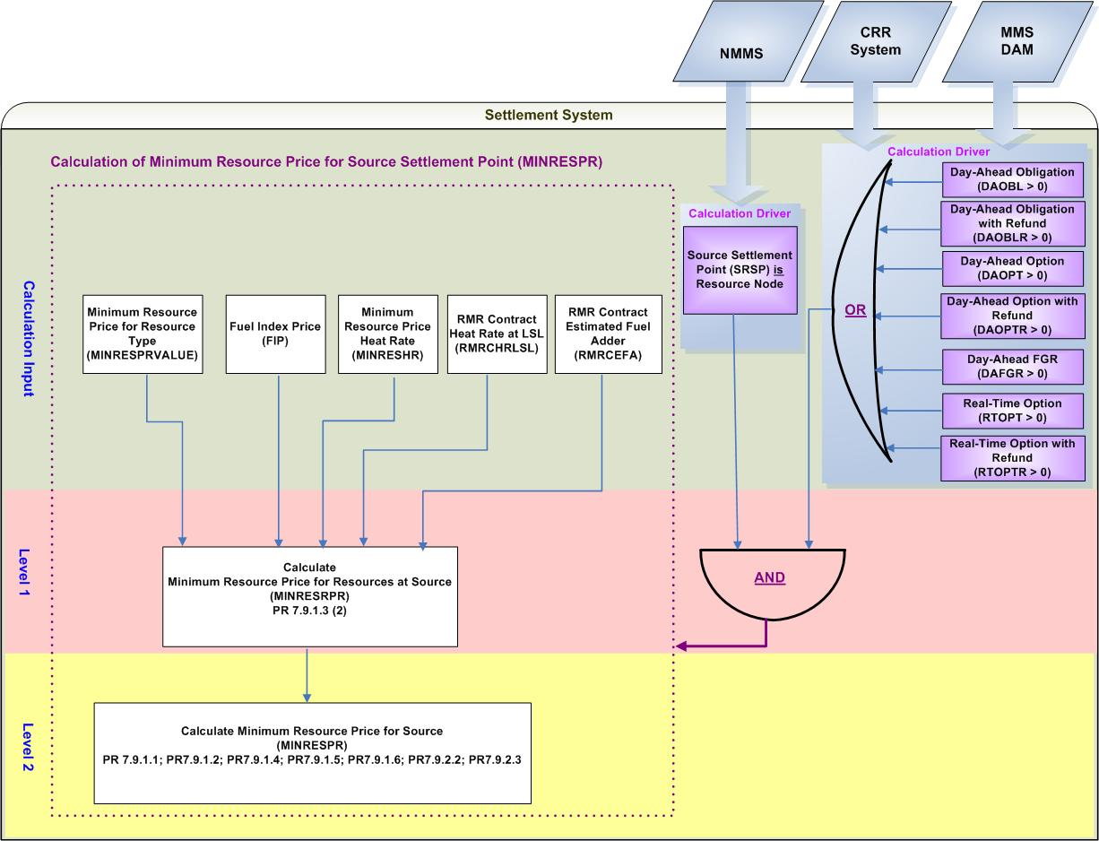
- Calculation Dependencies of Minimum Resource Price for source Settlement Point (MINRESPR)

Assumptions
A1) The Settlement System will receive daily updates from NMMS on the changes to the mapping of “resource to source Settlement Points” and shall use the relationships that were in place prior to the execution of the DAM.
A2) RMR Contracts in the Nodal Market will be in accordance with PRR 640 (Update Provisions for Capacity and Energy Payments for RMR Service and Add a New Standard Form Agreement for Synchronous Service) that is currently in NPRR synchronization process. It is also assumed that the ERCOT Board approved RMR Contract data containing RMR Resource Heat Rate and RMR Resource Estimated Price Adder will be available in the Settlement System, prior to DAM Settlements.

Business Rules
Req. ID | Protocol(s) | Sub-Process Map | Description
 | PR 7.9.1.3 | CSWM. P03SettleBill Transfer | None of the Input Bill Determinants should be truncated or rounded in the Settlement System, including:  - MINRESPRVALUE  - MINRESHR  - FIP  - RMRCEFA  - RMRCHRLSL
 | PR 7.9.1.3 | CSWM. P03SettleBill Transfer | None of the input and intermediate bill determinants should be truncated or rounded in the Settlement System, including:  - MINRESRPR
 | PR 7.9.1.1; PR7.9.1.2;  PR 7.9.1.3;  PR7.9.1.4; PR7.9.1.5; PR7.9.1.6; PR7.9.2.2; PR7.9.2.3 | CSWM. P03SettleBill Transfer | Output bill determinates should be rounded to (2) decimals, including:  - MINRESPR
 | 12.3 (c) | CSWM. P03SettleBill Transfer | The following data shall be available for private data extract, including:  - RMRCEFA  - RMRCHRLSL  - MINRESRPR  - MINRESPR
 | 12.3 | CSWM. P03SettleBill Transfer | The following data shall be available for public data extract, including:  - FIP
 | PR 7.9.1.1; PR7.9.1.2;  PR 7.9.1.3;  PR7.9.1.4; PR7.9.1.5; PR7.9.1.6; PR7.9.2.2; PR7.9.2.3 | CSWM. P03SettleBill Transfer | DRIVER: The MINRESPR calculation shall be attempted for a source Settlement Point only when both conditions as described below are met for at least one Operating Hour of the Operating Day:  - the source Settlement Point is a Resource Node  - At least one of the following data cuts exists and is positive:  - Day-Ahead Obligation (DAOBL)  - Day-Ahead Obligation with Refund (DAOBLR)  - Day-Ahead Option (DAOPT)  - Day-Ahead Option with Refund (DAOPTR)  - Day-Ahead FGR (DAFGR)  - Real-Time Option (RTOPT)  - Real-Time Option with Refund (RTOPTR)

Business Defined Errors
Req. ID | Protocol(s) | Sub-Process Map | Description
 | PR 7.9.1.1; PR7.9.1.2;  PR 7.9.1.3;  PR7.9.1.4; PR7.9.1.5; PR7.9.1.6; PR7.9.2.2; PR7.9.2.3 | CSWM. P03SettleBill Transfer | If the calculation of MINRESRPR can not be performed due to missing of MINRESPRVALUE, the Settlement System should consider it as a WARN--DEFAULT error, and set MINRESPR as a default value – Negative Thirty Five (-35) $/MWh. This default value is selected as the lowest of all MINRESPRVALUE for all types of Resources specified by Protocols.  Once this error is logged, Settlements shall investigate to find the root cause and shall take any possible actions to rectify any settlement results that may have been affected.
 | PR 7.9.1.1; PR7.9.1.2;  PR 7.9.1.3;  PR7.9.1.4; PR7.9.1.5; PR7.9.1.6; PR7.9.2.2; PR7.9.2.3 | CSWM. P03SettleBill Transfer | If the calculation of MINRESRPR can not be performed due to missing of MINRESHR, the Settlement System should consider it as a WARN--DEFAULT error, and set MINRESPR as a default value – Negative Thirty Five (-35) $/MWh. This default value is selected as the lowest of all MINRESPRVALUE for all types of Resources specified by Protocols.  Once this error is logged, Settlements shall investigate to find the root cause and shall take any possible actions to rectify any settlement results that may have been affected.
 | PR 7.9.1.1; PR7.9.1.2;  PR 7.9.1.3;  PR7.9.1.4; PR7.9.1.5; PR7.9.1.6; PR7.9.2.2; PR7.9.2.3 | CSWM. P03SettleBill Transfer | If the calculation of MINRESRPR can not be performed due to missing of FIP for the Operating Day , the Settlement System should consider it as a WARN--DEFAULT error, and use the most recent FIP available.  Once this error is logged, Settlements shall investigate to find the root cause and shall take any possible actions to rectify any settlement results that may have been affected.
 | PR 7.9.1.1; PR7.9.1.2;  PR 7.9.1.3;  PR7.9.1.4; PR7.9.1.5; PR7.9.1.6; PR7.9.2.2; PR7.9.2.3 | CSWM. P03SettleBill Transfer | If the calculation of MINRESRPR can not be performed due to missing RMRCEFA, the Settlement System should consider it as a WARN--DEFAULT error, and set MINRESPR as a default value – Negative Thirty Five (-35) $/MWh. This default value is selected as the lowest of all MINRESPRVALUE for all types of Resources specified by Protocols.  Once this error is logged, Settlements shall investigate to find the root cause and shall take any possible actions to rectify any settlement results that may have been affected.
 | PR 7.9.1.1; PR7.9.1.2;  PR 7.9.1.3;  PR7.9.1.4; PR7.9.1.5; PR7.9.1.6; PR7.9.2.2; PR7.9.2.3 | CSWM. P03SettleBill Transfer | If the calculation of MINRESRPR can not be performed due to missing RMRCHRLSL, the Settlement System should consider it as a WARN--DEFAULT error, and set MINRESPR as a default value – Negative Thirty Five (-35) $/MWh. This default value is selected as the lowest of all MINRESPRVALUE for all types of Resources specified by Protocols.  Once this error is logged, Settlements shall investigate to find the root cause and shall take any possible actions to rectify any settlement results that may have been affected.
 | PR 7.9.1.1; PR7.9.1.2;  PR 7.9.1.3;  PR7.9.1.4; PR7.9.1.5; PR7.9.1.6; PR7.9.2.2; PR7.9.2.3 | CSWM. P03SettleBill Transfer | If the calculation of MINRESRPR can not be performed because a Resource can not be mapped to Resource Type, the Settlement System should consider it as a WARN--DEFAULT error, and set MINRESPR as a default value – Negative Thirty Five (-35) $/MWh. This default value is selected as the lowest of all MINRESPRVALUE for all types of Resources specified by Protocols.  Once this error is logged, Settlements shall investigate to find the root cause and shall take any possible actions to rectify any settlement results that may have been affected.
 | PR 7.9.1.1; PR7.9.1.2;  PR 7.9.1.3;  PR7.9.1.4; PR7.9.1.5; PR7.9.1.6; PR7.9.2.2; PR7.9.2.3 | CSWM. P03SettleBill Transfer | If a source Settlement Point (SRSP) which is a resource node but doesn’t have any resources (R) located at the Settlement Point, the system should consider it as a WARN--DEFAULT error and set MINRESPR as a default value – Negative Thirty Five (-35) $/MWh. This default value is selected as the lowest of all MINRESPRVALUE for all types of Resources specified by Protocols.  An error message should be logged and capture the Operating Hour, Operating Day, and the source Settlement Point at which no Resource locates. An Investigation of the root cause shall be followed.

Specific Database Needs
Req. ID | Protocol(s) | Sub-Process Map | Description
 | PR 7.9.1.1; PR7.9.1.2;  PR 7.9.1.3;  PR7.9.1.4; PR7.9.1.5; PR7.9.1.6; PR7.9.2.2; PR7.9.2.3 | CSWM. P03SettleBill Transfer | MINRESPRVALUE and MINRESHR shall be user maintained in a centralized area with start and stop times. This should provide the flexibility to change as necessary.
 | PR 7.9.1.1; PR7.9.1.2;  PR 7.9.1.3;  PR7.9.1.4; PR7.9.1.5; PR7.9.1.6; PR7.9.2.2; PR7.9.2.3 | CSWM. P03SettleBill Transfer | The Settlement System shall store the mapping of each Resource to a Resource Type for use in the calculation of MINRESRPR with start and stop times.
 | PR 7.9.1.1; PR7.9.1.2;  PR 7.9.1.3;  PR7.9.1.4; PR7.9.1.5; PR7.9.1.6; PR7.9.2.2; PR7.9.2.3 | CSWM. P03SettleBill Transfer | The Settlement System shall store the mapping of each Settlement Point to a Settlement Point Type (Resource Node, Load Zone, Hub), according to the most updated topology information, for use in the calculation of MINRESRPR with start and stop times.
 | PR 7.9.1.1; PR7.9.1.2;  PR 7.9.1.3;  PR7.9.1.4; PR7.9.1.5; PR7.9.1.6; PR7.9.2.2; PR7.9.2.3 | CSWM. P03SettleBill Transfer | The Settlement System shall store RMR Contract Data for RMR Resources for use in the calculation of MINRESRPR with start and stop times.

Calculation of Maximum Resource Price for Sink Settlement Point (MAXRESPR)

Maximum Price for Sink is the highest Maximum Resource Price for the types of Resources located at the sink Settlement Point. (PR 7.9.1.1; PR7.9.1.2; PR7.9.1.5; PR7.9.2.2)

The Calculation of Maximum Resource Price for Sink Settlement Point (MAXRESPR) is defined as a global calculation because it is a common component utilized by multiple calculations in CRR Settlements. Specifically, MAXRESPR is used by the calculation of: Day-Ahead Obligation Hedge Value Price (DAOBLHVPR), Day-Ahead Option Hedge Value Price (DAOPTHVPR), and Real-Time Option Hedge Value Price (RTOPTHVPR).

Requirement ID
Source Mapping (Protocol/NERC/FERC and other binding documents Ref #) | PR 7.9.1.3(3)  NPRR associated with Synch of Zonal PRR 640 (Section J -- “Input for Payments for “RMR Units” in “Standard Form Reliability Must-Run Agreement”)
Traceability to Sub-Process Maps | CSWM.P03SettleBillTransfer
Description

Calculate Maximum Resource Price (MAXRESRPR) per Generation Resource (R) locating at the sink Settlement Point per sink Settlement Point (SKSP) for each Operating Hour of the Operating Day:

- IF a Generation Resource is a RMR unit,
THEN:
MAXRESRPR equals the sum of Fuel Index Price (FIP) and RMR Contract Estimated Fuel Adder (RMRCEFA), multiplied by RMR Contract Heat Rate at the HSL level (RMRCHRHSL);
MAXRESRPR_<R>_<SKSP> = (FIP + RMRCEFA_<R>_<SKSP>)
* RMRCHRHSL_<R>_<SKSP>
Note: Estimated Fuel Adder and Heat Rate at HSL are specified values by a RMR Contract.

- IF a Generation Resource is not a RMR unit, and belongs to: Nuclear, Hydro, Wind, and Renewable generating units,
THEN:
MAXRESRPR equals a Minimum Resource Price (MAXRESPRVALUE) specified by Protocols;
MAXRESRPR_<R>_<SKSP> = MAXRESPRVALUE_<R>_<SKSP>

Resource Type | Maximum Resource Price  (MAXRESPRVALUE)
Nuclear | $15.00 /MWh
Hydro | $10.00 /MWh
Coal and Lignite | $18 /MWh
Wind | $0 /MWh
Other Renewable | $0/MWh

NOTE: An NPRR probably necessary: to use “Other Renewable B” instead of “Other Renewable”

- IF a Generation Resource is not a RMR Unit, and belongs to: a Combined Cycle greater than 90 MW, Combined Cycle less than or equal to 90 MW , Gas – Steam Supercritical Boiler , Gas Steam Reheat Boiler, Gas Steam Non-reheat or boiler without air-preheater, Simple Cycle greater than 90 MW, Simple Cycle less than or equal to 90 MW, and Diesel generating units,
THEN:
MAXRESRPR equals the product of FIP and a Protocol-specified Heat Rate;
MAXRESRPR_<R>_<SKSP> = FIP*MAXRESHR_<R>_<SKSP>

Resource Type | Minimum Resource Price Heat Rate  (MAXRESHR)
Combined Cycle greater than 90 MW | 9 MMBtu/MWh
Combined Cycle less than or equal to 90 MW | 10 MMBtu/MWh
Gas – Steam Supercritical Boiler | 10.5 MMBtu/MWh
Gas Steam Reheat Boiler | 11.5 MMBtu/MWh
Gas Steam Non-reheat or boiler without air-preheater | 14.5 MMBtu/MWh
Simple Cycle greater than 90 MW | 14 MMBtu/MWh
Simple Cycle less than or equal to 90 MW | 15 MMBtu/MWh
Diesel | 16 MMBtu/MWh

NOTE: An NPRR probably necessary: Per TXU’s comment that it is not strictly appropriate to apply FIP to the Diesel Resource Type hat rate as shown in the following table. For the Diesel resource type FOP is used in Protocol 4.4.9.2.3(2). On the other hand Protocol 4.4.9.3.3 (1) applies FIP as is done here and in the governing protocol section. TXU suggests that consistency is required and suggests that the correct application is the FOP in all f these sites for the Diesel Resource Type.

Requirement ID
Source Mapping (Protocol/NERC/FERC and other binding documents Ref #) | PR 7.9.1.1; PR7.9.1.2; PR7.9.1.5; PR7.9.2.2
Traceability to Sub-Process Maps | CSWM.P03SettleBillTransfer
Description

Calculate Maximum Price per sink Settlement Point for each Operating Hour of the Operating Day*:
$$\text{MAXRESPR_}<\text{SKSP}\text{>=}\underset{R=r_{1}}{\overset{r_{n}}{\text{Max}}}$$
Where:
R represents each Generation Resource (r₁, r₂…$r_{n}$) located at the sink Settlement Point.
An NPRR will be submitted to add the “MINRESPR” formula into the Protocols.

Input Bill Determinants
Variable |  | Unit |  | Definition |  | Original Source
MAXRESPRVALUE |  | $/MWh |  | Maximum Resource Price for Resource Type– a specified Maximum Resource Price for certain Resource Types specified by Nodal Protocols. |  | Settlement System
Interval Frequency: Constant, specified by Nodal Protocols

Comments:
- The values for the MAXRESPRVALUE shall be kept in a user maintained centralized area in the database with start and stop times. This should provide the flexibility to change as necessary.
MAXRESHR |  | MMBtu/MWh |  | Maximum Resource Price Heat Rate – a specified Heat Rate to calculate Maximum Resource Price for certain Resource Types specified by Nodal Protocols. |  | Settlement System
Interval Frequency: Constant, specified by Nodal Protocols

Comments:
- The values for the MAXRESHR shall be kept in a user maintained centralized area in the database with start and stop times. This should provide the flexibility to change as necessary.
FIP |  | $/MMBtu |  | Fuel Index Price - The midpoint price expressed in dollars per million British thermal units ($/MMBtu), published in Gas Daily, in the Daily Price Survey, under the heading “East-Houston-Katy, Houston Ship Channel.” For Saturdays, Sundays, holidays, and other days for which Gas Daily does not publish the described midpoint price, the FIP is the described midpoint price that is next published by Gas Daily. In the event that the described midpoint price is not published for more than two days, the previous day’s published described midpoint price will be used for the FIP in the initial settlement and the next day’s published described midpoint price will be used for the FIP in subsequent settlement statements. |  | Platts
Interval Frequency: 1/ day

Additional Comments: None
RMRCEFA |  | $/MMBtu |  | RMR Contract Estimated Fuel Adder |  | Settlement System
Interval Frequency: Constant, upon the approval of RMR Contract data

Additional Comments:
- RMRCEFA is a value specified in RMR Contract.
RMRCHRHSL |  | MMBtu/MWh |  | RMR Contract Heat Rate at HSL Level |  | Settlement System
Interval Frequency: Constant, upon the approval of RMR Contract data

Additional Comments:
- RMRCHRLSL is a value specified in RMR Contact.
DAOPT |  | MW |  | Day-Ahead Option per CRR Owner per source and sink pair—The number of CRR Owner’s PTP Options with the source and sink pair settled in the DAM for the hour. |  | CRR System &  MMS DAM
Interval Frequency: 1/ hour

Additional Comments:
- DAOPT equals the difference between (a) and (b):
(a) The amount of PTP Options acquired through PCRR Allocations, CRR Auctions, and CRR Bilateral Trades, prior to DAM execution
(b) The amount of PTP Options that are declared before DAM execution by NOIEs to be settled in Real-Time and not cleared in the DAM.

- DAOPT shall always be equal to or greater than zero (0).

- Calculation of DAOPT occurs in the Settlement Interface prior to the DAM Settlements process.
RTOPT | MW |  | Real-Time Option per CRR Owner per pair of source and sink—The number of NOIE CRR Owner’s PTP Options with the pair of source and sink, settled in Real-Time, for the hour. |  | MMS DAM
Interval Frequency: 1/ hour

Additional Comments:
- RTOPT is the amount of PTP Options that are declared before DAM execution by NOIE CRR Owners to be settled in Real-Time and not cleared in the DAM.

- RTOPT shall be greater than or equal to zero (0).

- Reference to TN.COMS.63C01.RTCRR.REQUIREMENTS.A
DAOBL | MW |  | Day-Ahead Obligation per CRR Owner per source and sink pair—The number of CRR Owner’s PTP Obligations with the pair of source and sink settled in the DAM for the hour. |  | CRR System
Interval Frequency: 1/ hour

Additional Comments:
- DAOBL is retrieved from the original system and shall consider PTP Obligations acquired through PCRR Allocations, CRR Auctions, and CRR Bilateral Trades, prior to DAM execution.

- DAOBL shall be greater than or equal to zero (0).
DAOBLR | MW |  | Day-Ahead Obligation with Refund per CRR Owner per pair of source and sink⎯ The number of CRR Owner’s PTP Obligations with Refund with the source and sink pair settled in DAM for the hour. |  | CRR System
Interval Frequency: 1/ hour

Additional Comments:
- DAOBLR is a result of PCRR Allocation. The owner of DAOBLR should be a designated NOIE.

- DAOBLR shall be greater than or equal to zero (0).

Intermediate Bill Determinants
Variable | Unit | Definition | Original Source
MAXRESRPR | $/MWh | Maximum Resource Price for the Resource – The Maximum Resource Price for the Resources locating at the sink Settlement Point. | Settlement System
Interval Frequency: 1/ hour

Additional Comments: None

Output Bill Determinants
Variable | Unit | Definition | Original Source
MAXRESPR | $/MWh | Maximum Resource Price for sink—The highest Maximum Resource Price for the types of Resources located at the sink Settlement Point. | Settlement System
Interval Frequency: 1/hour

Additional Comments:
- This Intermediate Bill Determinant is not in the protocols but is necessary.
NPRR required: Remove “the types of” from the Protocol Definition because a Type of Resource could have different Maximum Resource Prices. For instances, Maximum Resource Price for RMR resources could be different depending on the contract data.

Data Dependencies
D1) Calculation of MAXRESPR is dependent upon the availability of input bill determinants.
D2) Calculation of MAXRESPR is dependent upon the availability of network topology information for the mapping of a Resource, to a Settlement Point, to Settlement Point Type (Resource Node, Load Zone, or Hub).
D3) Calculation of MAXRESPR is dependent upon the availability of Resource information for the mapping of a Generation Resource to Resource Type.
D4) The following Charge Types are dependent upon the calculation of MAXRESPR:
- Day-Ahead Obligation Amount (DAOBLAMT)
- Day-Ahead Option Amount (DAOPTAMT)
- Day-Ahead Obligation with Refund Amount (DAOBLRAMT)
- Real-Time Option Amount (RTOPTAMT)
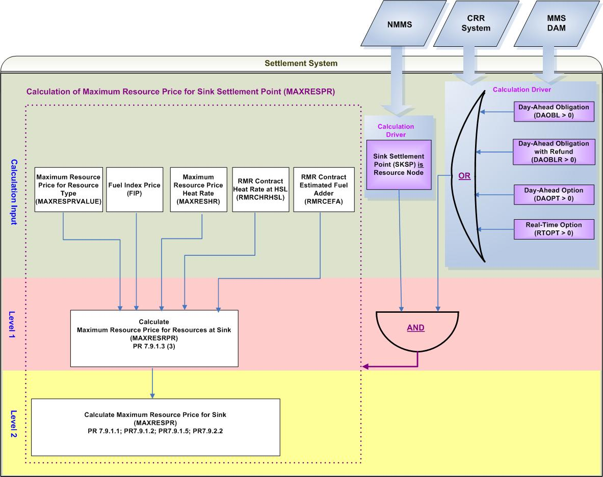
- Calculation Dependencies of Maximum Resource Price for sink Settlement Point (MAXRESPR)

Assumptions
A1) The Settlement System will receive daily updates from NMMS on the changes to the mapping of “resource to source Settlement Points” and shall use the relationships that were in place prior to the execution of the DAM.
A2) RMR Contracts in future Nodal Market will be in accordance with PR 640 that is currently in NPRR synchronization process- Update Provisions for Capacity and Energy Payments for RMR Service and Add a New Standard Form Agreement for Synchronous Service. It is also assumed that the ERCOT Board approved RMR Contract data containing RMR Resource Heat Rate and RMR Resource Estimated Price Adder are available in the Settlement System, prior to DAM Settlements.

Business Rules
Req. ID | Protocol(s) | Sub-Process Map | Description
 | PR 7.9.1.3 | CSWM. P03SettleBill Transfer | None of the Input Bill Determinants should be truncated or rounded in the Settlement System, including:  - MAXRESPRVALUE  - MAXRESHR  - FIP  - RMRCEFA  - RMRCHRHSL
 | PR 7.9.1.3 | CSWM. P03SettleBill Transfer | None of the input and intermediate bill determinants should be truncated or rounded in the Settlement System, including:  - MAXRESRPR
 | PR 7.9.1.1; PR7.9.1.2;  PR7.9.1.3;  PR7.9.1.5; PR7.9.2.2 | CSWM. P03SettleBill Transfer | Output bill determinates should be rounded to two (2) decimals, including:  - MAXRESPR
 | 12.3 (c) | CSWM. P03SettleBill Transfer | The following data shall be available for private data extract, including:  - RMRCEFA  - RMRCHRLSL  - MAXRESRPR
 | 12.3 | CSWM. P03SettleBill Transfer | The following data shall be available for public data extract, including:  - FIP  - MAXRESPR
 | PR 7.9.1.1; PR7.9.1.2;  PR7.9.1.3;  PR7.9.1.5; PR7.9.2.2 | CSWM. P03SettleBill Transfer | DRIVER: The MAXRESPR calculation shall be attempted for a sink Settlement Point only when both conditions as described below are met for at least one Operating Hour of the Operating Day:  - the sink Settlement Point is a Resource Node  - At least one of the following data cuts exists and is positive:  - Day-Ahead Obligation (DAOBL)  - Day-Ahead Obligation with Refund (DAOBLR)  - Day-Ahead Option (DAOPT)  - Real-Time Option (RTOPT)

Business Defined Errors
Req. ID | Protocol(s) | Sub-Process Map | Description
 | PR 7.9.1.1; PR7.9.1.2;  PR7.9.1.3;  PR7.9.1.5; PR7.9.2.2 | CSWM. P03SettleBill Transfer | If the calculation of MAXRESRPR can not be performed due to missing of MAXRESPRVALUE, the Settlement System should consider it as a WARN--DEFAULT error, and set MAXRESPR as a default value – Eighteen (18) $/MWh. This default value is selected as the highest of all MAXRESPRVALUE for all types of Resources specified by Protocols.  Once this error is logged, Settlements shall investigate to find the root cause and shall take any possible actions to rectify any settlement results that may have been affected.
 | PR 7.9.1.1; PR7.9.1.2;  PR7.9.1.3;  PR7.9.1.5; PR7.9.2.2 | CSWM. P03SettleBill Transfer | If the calculation of MAXRESRPR can not be performed due to missing of MAXRESHR, the Settlement System should consider it as a WARN--DEFAULT error, and set MAXRESPR as a default value – Eighteen (18) $/MWh. This default value is selected as the highest of all MAXRESPRVALUE for all types of Resources specified by Protocols.  Once this error is logged, Settlements shall investigate to find the root cause and shall take any possible actions to rectify any settlement results that may have been affected.
 | PR 7.9.1.1; PR7.9.1.2;  PR7.9.1.3;  PR7.9.1.5; PR7.9.2.2 | CSWM. P03SettleBill Transfer | If the calculation of MAXRESRPR can not be performed due to missing of FIP for the Operating Day, the Settlement System should consider it as a WARN--DEFAULT error, and use the most recent FIP available.  Once this error is logged, Settlements shall investigate to find the root cause and shall take any possible actions to rectify any settlement results that may have been affected.
 | PR 7.9.1.1; PR7.9.1.2;  PR7.9.1.3;  PR7.9.1.5; PR7.9.2.2 | CSWM. P03SettleBill Transfer | If the calculation of MAXRESRPR can not be performed due to missing of RMRCEFA, the Settlement System should consider it as a WARN--DEFAULT error, and set MAXRESPR as a default value – Eighteen (18) $/MWh. This default value is selected as the highest of all MAXRESPRVALUE for all types of Resources specified by Protocols.  Once this error is logged, Settlements shall investigate to find the root cause and shall take any possible actions to rectify any settlement results that may have been affected.
 | PR 7.9.1.1; PR7.9.1.2;  PR7.9.1.3;  PR7.9.1.5; PR7.9.2.2 | CSWM. P03SettleBill Transfer | If the calculation of MAXRESRPR can not be performed due to missing of RMRCHRHSL, the Settlement System should consider it as a WARN--DEFAULT error, and set MAXRESPR as a default value – Eighteen (18) $/MWh. This default value is selected as the highest of all MAXRESPRVALUE for all types of Resources specified by Protocols.  Once this error is logged, Settlements shall investigate to find the root cause and shall take any possible actions to rectify any settlement results that may have been affected.
 | PR 7.9.1.1; PR7.9.1.2;  PR7.9.1.3;  PR7.9.1.5; PR7.9.2.2 | CSWM. P03SettleBill Transfer | If the calculation of MAXRESRPR can not be performed because a Resource can not be mapped to Resource Type, the Settlement System should consider it as a WARN--DEFAULT error, and set MAXRESPR as a default value – Eighteen (18) $/MWh. This default value is selected as the highest of all MAXRESPRVALUE for all types of Resources specified by Protocols.  Once this error is logged, Settlements shall investigate to find the root cause and shall take any possible actions to rectify any settlement results that may have been affected.
 | PR 7.9.1.1; PR7.9.1.2;  PR7.9.1.3;  PR7.9.1.5; PR7.9.2.2 | CSWM. P03SettleBill Transfer | If a sink Settlement Point (SKSP) which is a resource node but doesn’t have any resources (R) located at the Settlement Point, the Settlement System should consider it as a WARN--DEFAULT error, and set MAXRESPR as a default value – Eighteen (18) $/MWh. This default value is selected as the highest of all MAXRESPRVALUE for all types of Resources specified by Protocols so as to eliminate or at least reduce financial impacts, if any, to the market participants.  An error message should be logged. The error message should capture the Operating Hour, Operating Day, and the source Settlement Point at which no Resource locates. An Investigation of the root cause shall be followed.

Specific Database Needs
Req. ID | Protocol(s) | Sub-Process Map | Description
 | PR 7.9.1.1; PR7.9.1.2;  PR7.9.1.3;  PR7.9.1.5; PR7.9.2.2 | CSWM. P03SettleBill Transfer | The Settlement System shall accommodate changes in the calculation of MAXRESPR resulted from changes in MAXRESPRVALUE and MAXRESHR. Also, The Settlement MAXRESPRVALUE and MAXRESHR shall be user maintained in a centralized area with start and stop times. This should provide the flexibility to change as necessary.
 | PR 7.9.1.1; PR7.9.1.2;  PR7.9.1.3;  PR7.9.1.5; PR7.9.2.2 | CSWM. P03SettleBill Transfer | The Settlement System shall store the mapping of each Resource to a Resource Type for use in the calculation of MINRESRPR with start and stop times.
 | PR 7.9.1.1; PR7.9.1.2;  PR 7.9.1.3;  PR7.9.1.4; PR7.9.1.5; PR7.9.1.6; PR7.9.2.2; PR7.9.2.3 | CSWM. P03SettleBill Transfer | The Settlement System shall store the mapping of Settlement Point to a Settlement Point Type (Resource Node, Load Zone, Hub), according to the most updated topology information, for use in the calculation of MAXRESRPR with start and stop times.
 | PR 7.9.1.1; PR7.9.1.2;  PR7.9.1.3;  PR7.9.1.5; PR7.9.2.2 | CSWM. P03SettleBill Transfer | The Settlement System shall store RMR Contract Data for RMR Resources for use in the calculation of MAXRESRPR with start and stop times.

Calculation of Day-Ahead Obligation Price (DAOBLPR)

Day-Ahead Obligation Price (DAOBLPR) is calculated based on the difference between the Day-Ahead Settlement Point Prices at the sink Settlement Point and at the source Settlement Point. The value of Day-Ahead Obligation Price (DAOBLPR) could be negative, zero, or positive.

The Calculation of Day-Ahead Obligation Price (DAOBLPR) is defined as a global calculation because it is a common component utilized by multiple calculations in CRR Settlements and other Day-Ahead Settlements. Specifically, DAOBLPR is used in the calculation of: Day-Ahead Obligation Target Payment (DAOBLTP), Day-Ahead Obligation with Refund Target Payment (DAOBLRTP), and Day-Ahead Real-Time Obligation Amount (DARTOBLAMT) that is described in Day-Ahead Market Energy Requirements.

This calculation is also defined in Section 2.4 of TN.COMS.63C01.DAMENERGY.REQUIREMENTS.A.

Requirement ID | TN.COMS.63C01.DAMENERGY.REQUIREMENTS.A
Source Mapping (Protocol/NERC/FERC and other binding documents Ref #) | PR 7.9.1.1, PR 4.6.3
Traceability to Sub-Process Maps | CSWM.P03SettleBillTransfer
Description

Calculate Day-Ahead Obligation Price per Source and Sink pair for each Operating Hour of the Operating Day:
DAOBLPR_<SRSP>_<SKSP> = DASPP_<SKSP> – DASPP_<SRSP>

Data Dependencies
D1) Calculation of DAOBLPR is dependent upon the availability of input bill determinants.
D2) The following charge types are dependent upon the calculation of DAOBLPR: Day-Ahead Obligation Amount (DAOBLAMT), Day-Ahead Obligation with Refund Amount (DAOBLRAMT), and Day-Ahead Real-Time Obligation Amount (DARTOBLAMT).
D3) DAOBLPR will be used as a Calculation Driver for the following global calculations in DA CRR Settlements: Obligation Deration Price (OBLDRPR), and Day-Ahead Obligation Hedge Value Price (DAOBLHVPR).

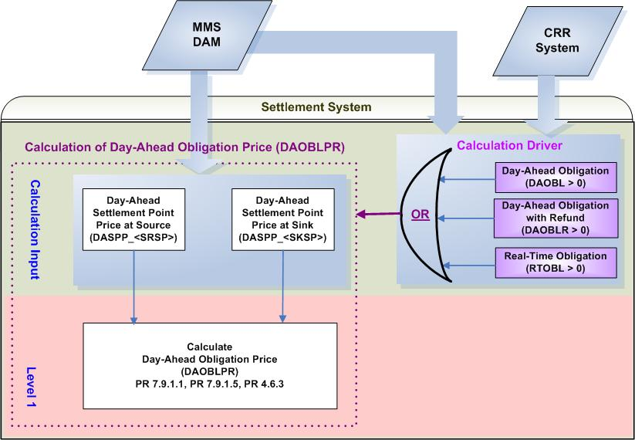
- Calculation Dependencies of Day-Ahead Obligation Price (DAOBLPR)

Assumptions
Assumptions of upstream systems:
A1) Calculation and certification of Day-Ahead Settlement Point Prices are performed outside of the Settlement System. Therefore DASPP is assumed to be valid for use of the Settlement System.
A2) Price corrections of DASPP are completed in the original source system (MMS) prior to DAM settlements.
A3) Tracking the ownership of CRRs is completed in the original source system which is the CRR System. Therefore, DAOBL is assumed to represent the final values resulting from PCRR Allocations, CRR Auctions and CRR Bilateral Trades reported to the ERCOT CRR system prior to DAM execution. DAOBLR is assumed to represent the final values resulting from PCRR Allocations as PTP Obligations with Refund (which can only be acquired by NOIEs through PCRR Allocations).
Assumptions of Settlement Interface:
A4) If DASPP is adjusted in the original system (MMS), the Settlement Interface with the original source system (MMS) will retrieve the adjusted DASPP prior to DAM settlements.

Business Rules
Reference to TN.COMS.63C01.DAMENERGY.REQUIREMENTS.A

Business Defined Errors
Reference to TN.COMS.63C01.DAMENERGY.REQUIREMENTS.A

Specific Database Needs
Reference to TN.COMS.63C01.DAMENERGY.REQUIREMENTS.A

Calculation of Obligation Deration Price (OBLDRPR)

For PTP Obligation that has a positive value and either its source or its sink is a Resource Node, the PTP Obligation payment may be reduced due to directional network elements that are oversold in previous CRR auctions. Under this scenario, Obligation Deration Price (OBLDRPR) is calculated.

The Calculation of Obligation Deration Price (OBLDRPR) is defined as a global calculation because it is a common component utilized by multiple calculations in CRR Settlements. Specifically, OBLDRPR is used by the calculation of: Day-Ahead Obligation Derated Amount (DAOBLDR), and Day-Ahead Obligation with Refund Derated Amount (DAOBLRDR).

Requirement ID
Source Mapping (Protocol/NERC/FERC and other binding documents Ref #) | PR 7.9.1.1 (3), PR 7.9.1.5 (3)
Traceability to Sub-Process Maps | CSWM.P03SettleBillTransfer
Description

Calculate Obligation Deration Price per Source and Sink pair for each Operating Hour of the Operating Day :

OBLDRPR_<SRSP>_<SKSP> = $\underset{c}{Σ}${Max (0, DAWASF_<SRSP>_<C> – DAWASF_<SKSP>_<C>)
* DASP_<C> * DRF_<C>}

Input Bill Determinants
Variable | Unit | Definition |  | Original Source
DASP | $/MW per hour | Day-Ahead Shadow Price per constraint—The DAM Shadow Price of the constraint for the hour. |  | MMS DAM
Interval Frequency: 1/ hour

Additional Comments:
- None
DAWASF | None | Day-Ahead Weighted Average Shift Factor at source (sink) per constraint—The Day-Ahead Shift Factor for the source (sink) Settlement Point and the directional network element for constraint, in the hour. |  | MMS DAM
Interval Frequency: 1/ hour

Additional Comments: None
DRF | None | Deration Factor per constraint—The deration factor of the constraint for the hour, equal to the MW amount by which the constraint is oversold divided by the total MW amount of the positive impacts on the constraint of all CRRs existing prior to DAM execution. |  | MMS DAM
Interval Frequency: 1/ hour

Additional Comments: None
DAOBL | MW | Day-Ahead Obligation per CRR Owner per source and sink pair—The number of CRR Owner’s PTP Obligations with the pair of source and sink settled in the DAM for the hour. |  | CRR System
Interval Frequency: 1/ hour

Additional Comments:
- DAOBL is retrieved from the original system and shall consider PTP Obligations acquired through PCRR Allocations, CRR Auctions, and CRR Bilateral Trades, prior to DAM execution.

- DAOBL shall be greater than or equal to zero (0).
DAOBLR | MW | Day-Ahead Obligation with Refund per CRR Owner per pair of source and sink⎯ The number of CRR Owner’s PTP Obligations with Refund with the source and sink pair settled in DAM for the hour. |  | CRR System
Interval Frequency: 1/ hour

Additional Comments:
- DAOBLR is a result of PCRR Allocation. The owner of DAOBLR shall be a designated NOIE.

- DAOBLR shall be greater than or equal to zero (0).
DAOBLPR | $/MW per hour |  | Day-Ahead Obligation Price per source and sink pair—The DAM price of a PTP Obligation with the pair of source and sink, for the hour. | Settlement System
Interval Frequency: 1/ hour

Additional Comments:
- The value of DAOBLPR could be negative, zero, or positive.
- The availability of DAOBLPR is dependent on the global calculation of Day-Ahead Obligation Price (DAOBLPR) documented in TN.COMS.63C01.DAMENERGY.REQUIREMENTS.A.

Output Bill Determinants
Variable | Unit | Definition | Destination
OBLDRPR | $/MW per hour | Obligation Deration Price per source and sink pair—The deration price of a PTP Obligation with the pair of source and sink, for the hour. | Settlement System
Interval Frequency: 1/ hour

Additional Comments:
- The value of OBLDRPR shall always be no less than zero (0).

Data Dependencies
D1) Calculation of OBLDRPR is dependent upon the availability of input bill determinants.
D2) Calculation of OBLDRPR is dependent upon the availability of network topology information for the mapping of a Settlement Point to Settlement Point Type (Resource Node, Load Zone, or Hub).
D3) Calculation of OBLDRPR is dependent upon the completion of global calculation: DAOBLPR.
D3) The following charge types are dependent upon the calculation of OBLDRPR:
- Day-Ahead Obligation Amount (DAOBLAMT);
- Day-Ahead Obligation with Refund Amount (DAOBLRAMT).

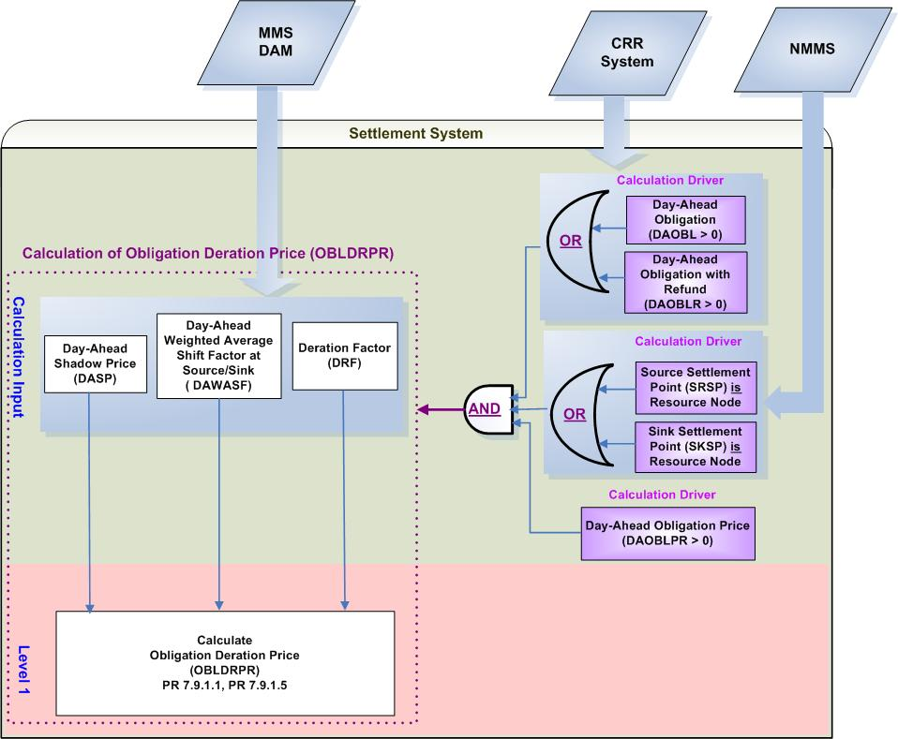
- Calculation Dependencies of Obligation Deration Price (OBLDRPR)

Assumptions
Assumptions of upstream systems:
A1) Calculation of Day-Ahead Shadow Prices (DASP) is performed outside of the Settlement System. Therefore DASP are assumed to be correct and certified for use of the Settlement System.
A2) Price corrections of DASP are completed in the original source system (MMS) prior to DAM settlements.
A3) Tracking the ownership of CRRs is completed in the original source system which is the CRR System. Therefore, DAOBL is assumed to represent the final values resulting from PCRR Allocations, CRR Auctions and CRR Bilateral Trades reported to the ERCOT CRR system prior to DAM execution. DAOBLR is assumed to represent the final values resulting from PCRR Allocations as PTP Obligations with Refund (which can only be acquired by NOIEs through PCRR Allocations).
A4) Calculation of Day-Ahead Weighted Average Shift Factors (DAWASF) for Resource Nodes, Hubs and Load Zones will be completed in the original source system (MMS). Therefore the Settlement System shall not have to derive this value from granular data such as distribution factors and the shift factors of each electrical bus residing in that Hub or Load Zone.
Assumptions of Settlement Interface:
A5) If DASP is adjusted in the original system (MMS); the Settlement Interface with the original source system (MMS) will retrieve not only the adjusted DASP but the affected DAWASF and DRF prior to DAM settlements.
A6) If DASP has a non zero value for a Constraint for at least one Operating Hour of an Operating Day, the Settlement Interface with original source (MMS) will retrieve that DASP for the Constraint for the entire Operating Day. The Settlement Interface will set DASP to be a default value Zero (0) for any Operating Hours of that Operating Day wherein DASP doesn’t exist for that Constraint.
A7) If DRF has a non zero value for a Constraint for at least one Operating Hour of an Operating Day, the Settlement Interface with original source (MMS) will retrieve that DRF for the Constraint for the entire Operating Day. The Settlement Interface will set DRF to be a default value Zero (0) for any Operating Hours of that Operating Day wherein DRF doesn’t exist for that Constraint.

Business Rules
Req. ID | Protocol(s) | Sub-Process Map | Description
 | PR 7.9.1.1; PR 7.9.1.5 | CSWM. P03SettleBill Transfer | None of the input bill determinants should be rounded or truncated.
 | PR 7.9.1.1; PR 7.9.1.5 | CSWM. P03SettleBill Transfer | The following output bill determinant should be rounded or truncated to two (2) decimals, including:  - OBLDRPR
 | PR 12.3 (C) | CSWM. P03SettleBill Transfer | The following data shall be available for private data extracts, including:  - RTOBL  - DAOBL  - DAOBLR  - DAWASF  - OBLDRPR  - DASP
 | PR 12.3 (C) | CSWM. P03SettleBill Transfer | The following data shall be available for public data extracts, including:  - None
 | PR 7.9.1.1; PR 7.9.1.5 | CSWM. P03SettleBill Transfer | DRIVER: The OBLDRPR calculation shall be attempted for a source and sink Settlement Point pair only when each condition as described below is met for at least one Operating Hour of the Operating Day:  - DAOBLPR is positive  - At least the source Settlement Point or the sink Settlement Point is a Resource Node  - At least one of the following data cuts exists and is positive:  - Day-Ahead Obligation (DAOBL)  - Day-Ahead Obligation with Refund (DAOBLR)

Business Defined Errors
Req. ID | Protocol(s) | Sub-Process Map | Description
 | PR 7.9.1.1; PR 7.9.1.5 | CSWM. P03SettleBill Transfer | If the Settlement System calculation needs a DAWASF that is not available for a source or a sink Settlement Point pair to a Constraint, the Settlement System should set DAWASF to be Zero (0). No error message is necessary.
 | PR 7.9.1.1; PR 7.9.1.5 | CSWM. P03SettleBill Transfer | If OBLDRPR is calculated to be negative, the Settlement System should consider it as a WARN--DEFAULT error, and set OBLDRPR as a default value – Zero (0) and an error message should be logged. The error message should capture the source and sink Settlement Point, the Operating Hour, and Operating Day, for which OBLDRPR is calculated as negative.

Specific Database Needs
None

Calculation of Day-Ahead Obligation Hedge Value Price (DAOBLHVPR)

For PTP Obligation that has a positive value and its source or sink is a Resource Node, the PTP Obligation payment may be reduced due to directional network elements that are oversold in previous CRR auctions. Under this scenario, Day-Ahead Obligation Hedge Price (DAOBLHVPR) is calculated.

The Calculation of Day-Ahead Obligation Hedge Price (DAOBLHVPR) is calculated is defined as a global calculation because it is a common component utilized by multiple calculations in CRR Settlements. Specifically, DAOBLHVPR is used by the calculation of: Day-Ahead Obligation Hedge Value (DAOBLHV), and Day-Ahead Obligation with Refund Hedge Value (DAOBLRHV).

Requirement ID
Source Mapping (Protocol/NERC/FERC and other binding documents Ref #) | PR 7.9.1.1, PR 7.9.1.5
Traceability to Sub-Process Maps | CSWM.P03SettleBillTransfer
Description

Calculate Day-Ahead Obligation Hedge Value Price per Source and Sink pair for each Operating Hour of the Operating Day:

- IF SRSP is a Load Zone or Hub and SKSP is a Resource Node THEN:
DAOBLHVPR_<SRSP>_<SKSP> = Max (0, MAXRESPR_<SKSP> – DASPP_<SRSP>)

- IF SRSP is a Resource Node and SKSP is a Load Zone or Hub THEN:
DAOBLHVPR_<SRSP>_<SKSP> = Max (0, DASPP_<SKSP> – MINRESPR_<SRSP>)

- IF both SRSP and SKSP are Resource Nodes THEN
DAOBLHVPR_<SRSP>_<SKSP> = Max (0, MAXRESPR_<SKSP> – MINRESPR_<SRSP>)

Input Bill Determinants
Variable | Unit | Definition |  | Original Source
DASPP | $/MWh | Day-Ahead Settlement Point Price at source (sink) —The DAM Settlement Point Price at the source (sink) Settlement Point, for the hour. |  | MMS DAM
Interval Frequency: 1/ hour

Additional Comments: DASPP is calculated and certified by MMS DAM Package.
MINRESPR | $/MWh | Minimum Resource Price for source—The lowest Minimum Resource Price for the Resources located at the source Settlement Point. |  | Settlement System
Interval Frequency: 1/hour

Additional Comments:
- The availability of MINRESPR is dependent on the global calculation of Minimum Resource Price (MINRESPR).
MAXRESPR | $/MWh | Maximum Resource Price for sink—The highest Maximum Resource Price for the Resources located at the sink Settlement Point. |  | Settlement System
Interval Frequency: 1/hour

Additional Comments:
- The availability of MAXRESPR is dependent on the global calculation of Maximum Resource Price (MAXRESPR).
DAOBL | MW | Day-Ahead Obligation per CRR Owner per source and sink pair—The number of CRR Owner’s PTP Obligations with the pair of source and sink settled in the DAM for the hour. |  | CRR System
Interval Frequency: 1/ hour

Additional Comments:
- DAOBL is retrieved from the original system and shall consider PTP Obligations acquired through PCRR Allocations, CRR Auctions, and CRR Bilateral Trades, prior to DAM execution.

- DAOBL shall be greater than or equal to zero (0).
DAOBLR | MW | Day-Ahead Obligation with Refund per CRR Owner per pair of source and sink⎯ The number of CRR Owner’s PTP Obligations with Refund with the source and sink pair settled in DAM for the hour. |  | CRR System
Interval Frequency: 1/ hour

Additional Comments:
- DAOBLR is a result of PCRR Allocation. The owner of DAOBLR should be a designated NOIE.

- DAOBLR shall be greater than or equal to zero (0).
DAOBLPR | $/MW per hour |  | Day-Ahead Obligation Price per source and sink pair—The DAM price of a PTP Obligation with the pair of source and sink, for the hour. | Settlement System
Interval Frequency: 1/ hour

Additional Comments:
- The value of DAOBLPR could be negative, zero, or positive.

- The availability of DAOBLPR is dependent on the global calculation of Day-Ahead Obligation Price (DAOBLPR).

Output Bill Determinants
Variable | Unit | Definition | Destination
DAOBLHVPR | $/MWh | Day-Ahead Obligation Hedge Value Price per source and sink pair—The Day-Ahead hedge price of a PTP Obligation with the pair of source and sink, for the hour. | Settlement System
Interval Frequency: 1/hour

Additional Comments:
- The value of DAOBLHVPR shall always be no less than zero (0).

Data Dependencies
D1) Calculation of DAOBLHVPR is dependent upon the availability of input bill determinants.
D2) Calculation of DAOBLHVPR is dependent upon the availability of most up-to-date network topology information for the mapping of a Settlement Point to Settlement Point Type (Resource Node, Load Zone, or Hub).
D3) Calculation of DAOBLHVPR is dependent upon the completion of global calculations: MINRESPR, MAXRESPR, and DAOBLPR.
D4) The following charge types are dependent upon the calculation of DAOBLHVPR:
- Day-Ahead Obligation Amount (DAOBLAMT)
- Day-Ahead Obligation with Refund Amount (DAOBLRAMT)

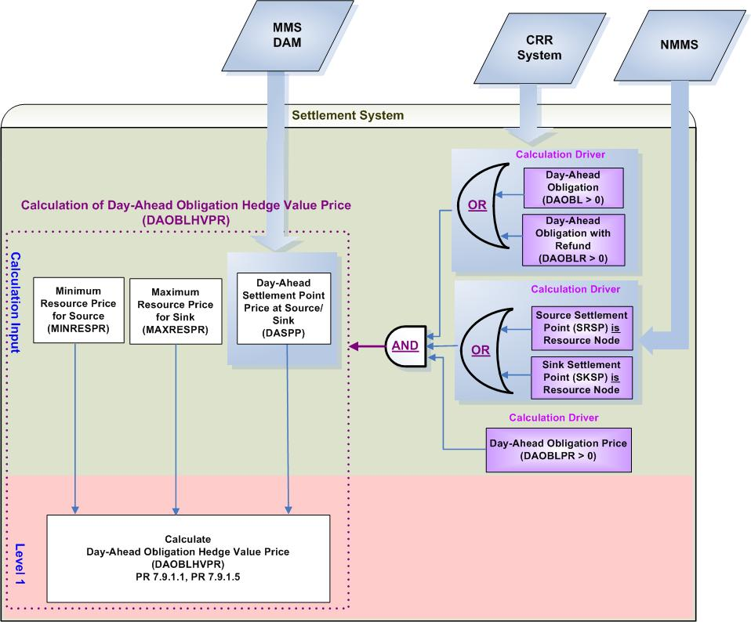
- Calculation Dependencies of Day-Ahead Obligation Hedge Value Price (DAOBLHVPR)

Assumptions
Assumptions of upstream systems:
A1) Calculation and certification of Day-Ahead Settlement Point Prices is performed outside of the Settlement System. Therefore DASPP is assumed to be valid for use of the Settlement System.
A2) Price corrections of DASPP are completed in the original source system (MMS) prior to DAM settlements.
A3) Tracking the ownership of CRRs is completed in the original source system which is the CRR System. Therefore, DAOBL is assumed to represent the final values resulting from PCRR Allocations, CRR Auctions and CRR Bilateral Trades reported to the ERCOT CRR system prior to DAM execution. DAOBLR is assumed to represent the final values resulting from PCRR Allocations as PTP Obligations with Refund (which can only be acquired by NOIEs through PCRR Allocations).
A4) PTP Obligation with Refund could only be either a Resource Node to a Load Zone/Hub, or a Load Zone/Hub to a Resource Node.
Assumptions of Settlement Interface:
A5) If DASPP is adjusted in the original system (MMS), the Settlement Interface with the original source system (MMS) will retrieve the adjusted DASPP prior to DAM settlements.

Business Rules
Req. ID | Protocol(s) | Sub-Process Map | Description
 | PR 7.9.1.1;  PR 7.9.1.5 | CSWM. P03SettleBill Transfer | None of the input bill determinants should be rounded or truncated.
 | PR 7.9.1.1;  PR 7.9.1.5 | CSWM. P03SettleBill Transfer | The following output bill determinant should be rounded or truncated to two (2) decimals, including:  - DAOBLHVPR
 | PR 12.3 (C) | CSWM. P03SettleBill Transfer | The following data shall be available for private data extracts, including:  - DAOBL  - DAOBLR  - DAOBLHVPR
 | PR 12.3 (C) | CSWM. P03SettleBill Transfer | The following data shall be available for public data extracts, including:  - DASPP  - MINRESPR  - MAXREPR
 | PR 7.9.1.1;  PR 7.9.1.5 | CSWM. P03SettleBill Transfer | DRIVER: The DAOBLHVPR calculation shall be attempted for a source and sink Settlement Point pair only when each condition as described below is met for at least one Operating Hour of the Operating Day:  - DAOBLPR is positive  - At least the source Settlement Point (SRSP) or the sink Settlement Point (SKSP) is a Resource Node  - At least one of the following data cuts exists and is positive:  - Day-Ahead Obligation (DAOBL)  - Day-Ahead Obligation with Refund (DAOBLR)

Business Defined Errors
Req. ID | Protocol(s) | Sub-Process Map | Description
 | PR 7.9.1.1;  PR 7.9.1.5 | CSWM. P03SettleBill Transfer | If DAOBLHVPR is calculated to be negative, the Settlement System should consider it as a WARN--DEFAULT error, and set DAOBLHVPR as a default value – Zero (0) and an error message should be logged. The error message should capture the source and sink Settlement Point, the Operating Hour, and Operating Day, for which DAOBLHVPR is calculated as negative.
 | PR 7.9.1.1;  PR 7.9.1.5 | CSWM. P03SettleBill Transfer | If a DASPP data cut is not available for a Settlement Point and Operating Day for which either DAOBL or DAOBLR data cut exists, the system should log a “CRITICAL” error message and stop any downstream CRR calculations that depend on DASPP. The error message should capture the missing data element, including the Settlement Point, and the Operating Day.

Specific Database Needs
None

Calculation of Day-Ahead Option Price (DAOPTPR)

Day-Ahead Option Price (DAOPTPR) is calculated based on the positive difference between the Day-Ahead Settlement Point Prices at the sink Settlement Point and at the source Settlement Point. The value of Day-Ahead Option Price could never be negative.

The Calculation of Day-Ahead Obligation Price (DAOPTPR) is defined as a global calculation because it is a common component utilized by multiple calculations in CRR Settlements. Specifically, DAOPTPR is used by the calculation of: Day-Ahead Option Target Payment (DAOPTTP), and Day-Ahead Option with Refund Target Payment (DAOPTRTP).

Requirement ID
Source Mapping (Protocol/NERC/FERC and other binding documents Ref #) | PR 7.9.1.2, PR 7.9.1.6
Traceability to Sub-Process Maps | CSWM.P03SettleBillTransfer
Description

Calculate Day-Ahead Option Price per Source and Sink pair for each Operating Hour of the Operating Day:

DAOPTPR_<SRSP>_<SKSP> = Max (0, DASPP_<SKSP> – DASPP_<SRSP>)

NPRR required on PR 7.9.1.2 to remove “CRR Owner” from DAOPTPR’s subscripts.

Input Bill Determinants
Variable | Unit | Definition | Original Source
DASPP | $/MWh | Day-Ahead Settlement Point Price at source (sink) —The DAM Settlement Point Price at the source (sink) Settlement Point, for the hour. | MMS DAM
Interval Frequency: 1/ hour

Additional Comments:
- DASPP is calculated and certified by MMS DAM Package.
DAOPT | MW | Day-Ahead Option per CRR Owner per source and sink pair—The number of CRR Owner’s PTP Options with the source and sink pair settled in the DAM for the hour. | CRR System &  MMS DAM
Interval Frequency: 1/ hour

Additional Comments:
- DAOPT equals the difference between (a) and (b):
(a) The amount of PTP Options acquired through PCRR Allocations, CRR Auctions, and CRR Bilateral Trades, prior to DAM execution
(b) The amount of PTP Options that are declared before DAM execution by NOIEs to be settled in Real-Time and not cleared in the DAM.

- DAOPT shall always be equal to or greater than zero (0).

- Calculation of DAOPT occurs in the Settlement Interface prior to the DAM Settlements process.
DAOPTR | MW | Day-Ahead Option with Refund per CRR Owner per pair of source and sink⎯The number of CRR Owner’s PTP Options with Refund with the pair of source and sink, settled in DAM, for the hour. | CRR System &  MMS DAM
Interval Frequency: 1/ hour

Additional Comments:
- DAOPTR is a result of PCRR Allocation. The owner of DAOPTR shall be a designated NOIE.

- DAOPTR equals the difference between (a) and (b):
(a) The amount of PTP Options with Refund acquired through PCRR Allocations by NOIEs.
(b) The amount of PTP Options with Refund that is declared before DAM execution by NOIEs to be settled in Real-Time and not cleared in the DAM.

- DAOPTR shall always be equal to or greater than zero (0).

Output Bill Determinants
Variable | Unit | Definition | Destination
DAOPTPR | $/MW per hour | Day-Ahead Option Price per source and sink pair—The DAM price of a PTP Option with the source and the sink, for the hour. | Settlement System
Interval Frequency: 1/ hour

Additional Comments:
- The value of DAOPTPR shall always be no less than zero (0).

Data Dependencies
D1) Calculation of DAOPTPR is dependent upon the availability of input bill determinants.
D2) The following charge types are dependent upon the calculation of DAOPTPR:
- Day-Ahead Option Amount (DAOPTAMT)
- Day-Ahead Option with Refund Amount (DAOPTRAMT)

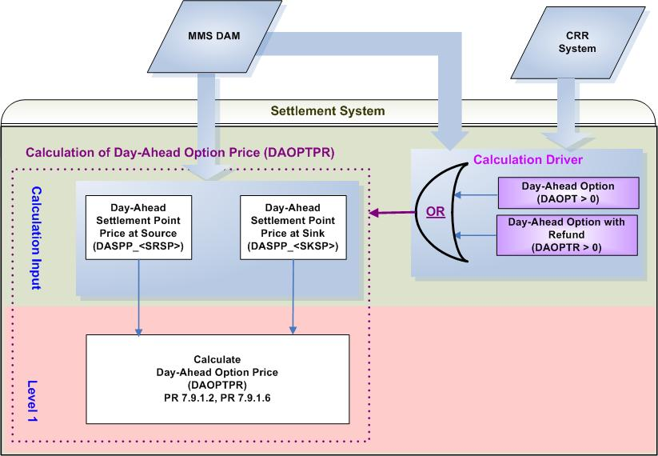
- Calculation Dependencies of Day-Ahead Option Price (DAOPTPR)

Assumptions
Assumptions of upstream systems:
A1) Calculation and certification of Day-Ahead Settlement Point Prices is performed outside of the Settlement System. Therefore DASPP is assumed to be valid for use of the Settlement System.
A2) Price corrections of DASPP are completed in the original source system (MMS DAM) prior to DAM settlements.
A3) Tracking the ownerships of CRRs is completed in the original source (which is CRR System). Determination of whether or not PTP Options and PTP Options with Refund owned by NOIE are eligible for Real-Time Settlements is made during the execution of the DAM by the original source (MMS DAM). The information from the CRR System and the MMS DAM will be used jointly to calculate the amount of CRRs to be settled in Day-Ahead.

Assumptions of Settlement Interface:-
A4) If DASPP is adjusted in the original system (MMS DAM), the Settlement Interface with the original source system (MMS) will retrieve the adjusted DASPP prior to DAM settlements.

Business Rules
Req. ID | Protocol(s) | Sub-Process Map | Description
 | PR 7.9.1.2;  PR 7.9.1.6 | CSWM. P03SettleBill Transfer | None of the input bill determinants should be rounded or truncated.
 | PR 7.9.1.2;  PR 7.9.1.6 | CSWM. P03SettleBill Transfer | The following output bill determinant should be rounded or truncated to two (2) decimals, including:  - DAOPTPR
 | PR 12.3 (C) | CSWM. P03SettleBill Transfer | The following data shall be available for private data extracts, including:  - DAOPT  - DAOPTR  - DAOPTPR
 | PR 12.3 (C) | CSWM. P03SettleBill Transfer | The following data shall be available for public data extracts, including:  - DASPP
 | PR 7.9.1.2;  PR 7.9.1.6 | CSWM. P03SettleBill Transfer | DRIVER: The DAOPTPR calculation shall only be attempted for a source and sink Settlement Point pair for which at least the following data cut exists and is positive for the Operating Day:  - Day-Ahead Option (DAOPT)  - Day-Ahead Option with Refund (DAOPTR)

Business Defined Errors
Req. ID | Protocol(s) | Sub-Process Map | Description
 | PR 7.9.1.2;  PR 7.9.1.6 | CSWM. P03SettleBill Transfer | If a DASPP data cut is not available for a Settlement Point and Operating Day for which either DAOPT or DAOPTR data cut exists, the system should log a “CRITICAL” error message and stop any downstream CRR calculations that depend on DASPP. The error message should capture the missing data element, including the Settlement Point, and the Operating Day.
 | PR 7.9.1.2;  PR 7.9.1.6 | CSWM. P03SettleBill Transfer | If DAOPTPR is calculated to be negative, the Settlement System should consider it as a WARN--DEFAULT error, and set DAOPTPR as a default value – Zero (0) and an error message should be logged. The error message should capture the source and sink Settlement Point, the Operating Hour, and Operating Day, for which DAOPTPR is calculated as negative.

Specific Database Needs
None

Calculation of Day-Ahead Option Informational Price (DAOPTPRINFO)

For informational purposes, Day-Ahead Option Informational Price (DAOPTPRINFO) shall be calculated and posted on the MIS Public Area. In accordance to the current Nodal Protocols, Day-Ahead Option Informational Price will not be used to settle any of CRR products.

Requirement ID
Source Mapping (Protocol/NERC/FERC and other binding documents Ref #) | PR 7.9.1.2 (5)
Traceability to Sub-Process Maps | CSWM.P03SettleBillTransfer
Description

Calculate Informational Day-Ahead Option Price to be posted in MIS Public Area per Source and Sink pair for each Operating Hour of the Operating Day:

DAOPTPRINFO_<SRSP>_<SKSP> = $\underset{c}{Σ}${DASP_<C> * Max [0, (DAWASF_<SRSP>_<C>
– DAWASF_<SKSP>_<C>)]}

Input Bill Determinants
Variable | Unit | Definition | Original Source
DASP | $/MW per hour | Day-Ahead Shadow Price per constraint—The DAM Shadow Price of the constraint for the hour. | MMS DAM
Interval Frequency: 1/ hour

Additional Comments:
- DASP is calculated by MMS DAM Package.
DAWASF | None | Day-Ahead Weighted Average Shift Factor at source (sink) per constraint—The Day-Ahead Shift Factor for the source (sink) Settlement Point and the directional network element for constraint, in the hour. | MMS DAM
Interval Frequency: 1/ hour

Additional Comments: None
DAOPT | MW | Day-Ahead Option per CRR Owner per source and sink pair—The number of CRR Owner’s PTP Options with the source and sink pair settled in the DAM for the hour. | CRR System &  MMS DAM
Interval Frequency: 1/ hour

Additional Comments:
- DAOPT equals the difference between (a) and (b):
(a) The amount of PTP Options acquired through PCRR Allocations, CRR Auctions, and CRR Bilateral Trades, prior to DAM execution
(b) The amount of PTP Options that are declared before DAM execution by NOIEs to be settled in Real-Time and not cleared in the DAM.

- DAOPT shall always be equal to or greater than zero (0).

- Calculation of DAOPT occurs in the Settlement Interface prior to the DAM Settlements process.
DAOPTR | MW | Day-Ahead Option with Refund per CRR Owner per pair of source and sink⎯The number of CRR Owner’s PTP Options with Refund with the pair of source and sink, settled in DAM, for the hour. | CRR System &  MMS DAM
Interval Frequency: 1/ hour

Additional Comments:

- DAOPTR is a result of PCRR Allocation. The owner of DAOPTR shall be a designated NOIE.

- DAOPTR equals the difference between (a) and (b):
(a) The amount of PTP Options with Refund acquired through PCRR Allocations by NOIEs.
(b) The amount of PTP Options with Refund that is declared before DAM execution by NOIEs to be settled in Real-Time and not cleared in the DAM.

- DAOPTR shall always be equal to or greater than zero (0).

Output Bill Determinants
Variable | Unit |  | Definition |  | Destination
DAOPTPRINFO |  | $/MW per hour |  | Informational Day-Ahead Option Price per pair of source and sink—The Informational DAM price of the PTP Options with the source Settlement Point and the sink Settlement Point, for the hour. | MIS Public Posting Area
Interval Frequency: 1/hour

Additional Comments:
- DAOPTPRINFO shall be posted on the MIS Public Area for informational purposes.
- The value of DAOPTPRINFO shall always be equal to, or greater than zero(0).
- NPRR required: the word “Informational” shall be added into the definition to distinguish it from the definition of DAOPTPR.

Data Dependencies
D1) Calculation of DAOPTPRINFO is dependent upon the availability of input bill determinants.

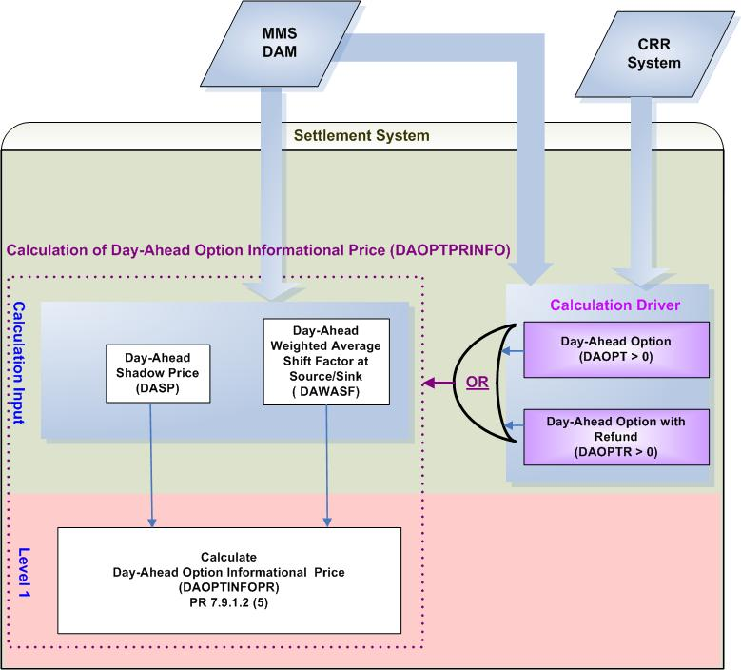
- Calculation Dependencies of Day-Ahead Option Informational Price (DAOPTPRINFO)

Assumptions
Assumptions of upstream systems:
A1) Calculation of Day-Ahead Shadow Prices (DASP) is performed outside of the Settlement System. Therefore DASP are assumed to be correct and certified for use of the Settlement System.
A2) Price corrections of DASP are completed in the original source system (MMS) prior to DAM settlements.
A3) Tracking the ownerships of CRRs is completed in the original source (which is CRR System). Determination of whether or not PTP Options and PTP Options with Refund owned by NOIE are eligible for Real-Time Settlements is made during the execution of the DAM by the original source (MMS DAM). The information from the CRR System and the MMS DAM will be used jointly to calculate the amount of CRRs to be settled in Day-Ahead.
A4) Calculation of Day-Ahead Weighted Average Shift Factors (DAWASF) for Resource Nodes, Hubs and Load Zones will be completed in the original source system (MMS). Therefore the Settlement System shall not have to derive this value from granular data such as distribution factors and the shift factors of each electrical bus residing in that Resource Node, Hub or Load Zone.

Assumptions of Settlement Interface:
A5) If DASP is adjusted in the original system (MMS); the Settlement Interface with the original source system (MMS) will retrieve not only the adjusted DASP but the affected DAWASF prior to DAM settlements.
A6) If DASP has a non zero value for a Constraint for at least one Operating Hour of an Operating Day, the Settlement Interface with original source (MMS) will retrieve that DASP for the Constraint for the entire Operating Day. The Settlement Interface will set DASP to be a default value Zero (0) for any Operating Hours of that Operating Day wherein DASP doesn’t exist for that Constraint.

Business Rules
Req. ID | Protocol(s) | Sub-Process Map | Description
 | PR 7.9.1.2 (5) | CSWM. P03SettleBill Transfer | None of the input bill determinants should be rounded or truncated.
 | PR 7.9.1.2 (5) | CSWM. P03SettleBill Transfer | The following output bill determinant should be rounded or truncated to two (2) decimals, including:  - DAOPTPRINFO
 | PR 7.9.1.2 (5) | CSWM. P03SettleBill Transfer | Informational Day-Ahead Option Price (DAOPTPRINFO) shall be posted in MIS Public Area.
 | PR 7.9.1.2 (5) | CSWM. P03SettleBill Transfer | DRIVER: The DAOPTPRINFO calculation shall only be attempted for a source and sink Settlement Point pair for which at least either one of the following data cuts exists and is positive for at least one Operating Hour of the Operating Day:  - Day-Ahead Option (DAOPT)  - Day-Ahead Option with Refund (DAOPTR)

Business Defined Errors
Req. ID | Protocol(s) | Sub-Process Map | Description
 | PR 7.9.1.2 (5) | CSWM. P03SettleBill Transfer | If the Settlement System calculation needs DAWASF that is not available for a source or a sink Settlement Point pair to a Constraint, the Settlement System should set DAWASF to be Zero (0). No error message is necessary.
 | PR 7.9.1.2 (5) | CSWM. P03SettleBill Transfer | If DAOPTPRINFO is calculated to be negative, the Settlement System should consider it as a WARN--DEFAULT error, and set DAOPTPRINFO as a default value – Zero (0) and an error message should be logged. The error message should capture the source and sink Settlement Point, the Operating Hour, and Operating Day, for which DAOPTPRINFO is calculated as negative.

Specific Database Needs
None

Calculation of Option Deration Price (OPTDRPR)

For PTP Options that its source or sink is a Resource Node, the PTP Option payment may be reduced due to directional network elements that are oversold in previous CRR auctions. Under this scenario, Option Deration Price (OPTDRPR) is calculated.

The Calculation of Option Deration Price (OPTDRPR) is defined as a global calculation because it is a common component utilized by multiple calculations in CRR Settlements. Specifically, OPTDRPR is used by the calculation of: Day-Ahead Option Derated Amount (DAOPTDR), and Day-Ahead Option with Refund Derated Amount (DAOPTRDR).

Requirement ID
Source Mapping (Protocol/NERC/FERC and other binding documents Ref #) | PR 7.9.1.2, PR 7.9.1.6  PR 7.9.2.2, PR 7.9.2.3
Traceability to Sub-Process Maps | CSWM.P03SettleBillTransfer
Description

Calculate Option Deration Price per Source and Sink pair for each Operating Hour of the Operating Day:

OPTDRPR_<SRSP>_<SKSP> = $\underset{c}{Σ}${Max (0, DAWASF_<SRSP>_<C> – DAWASF_<SKSP>_<C>)
* DASP_<C> * DRF_<C>}

Input Bill Determinants
Variable | Unit | Definition | Original Source
DASP | $/MW per hour | Day-Ahead Shadow Price per constraint—The DAM Shadow Price of the constraint for the hour. | MMS DAM
Interval Frequency: 1/ hour

Additional Comments:
- DASP is calculated by MMS DAM Package.
DAWASF | None | Day-Ahead Weighted Average Shift Factor at source (sink) per constraint—The Day-Ahead Shift Factor for the source (sink) Settlement Point and the directional network element for constraint, in the hour. | MMS DAM
Interval Frequency: 1/ hour

Additional Comments: None
DAOPT | MW | Day-Ahead Option per CRR Owner per source and sink pair—The number of CRR Owner’s PTP Options with the source and sink pair settled in the DAM for the hour. | CRR System &  MMS DAM
Interval Frequency: 1/ hour

Additional Comments:
- DAOPT equals the difference between (a) and (b):
(a) The amount of PTP Options acquired through PCRR Allocations, CRR Auctions, and CRR Bilateral Trades, prior to DAM execution
(b) The amount of PTP Options that are declared before DAM execution by NOIEs to be settled in Real-Time and not cleared in the DAM.

- DAOPT shall always be equal to or greater than zero (0).
DAOPTR | MW | Day-Ahead Option with Refund per CRR Owner per pair of source and sink⎯The number of CRR Owner’s PTP Options with Refund with the pair of source and sink, settled in DAM, for the hour. | CRR System &  MMS DAM
Interval Frequency: 1/ hour

Additional Comments:

- DAOPTR is a result of PCRR Allocation. The owner of DAOPTR shall be a designated NOIE.

- DAOPTR equals the difference between (a) and (b):
(a) The amount of PTP Options with Refund acquired through PCRR Allocations by NOIEs.
(b) The amount of PTP Options with Refund that is declared before DAM execution by NOIEs to be settled in Real-Time and not cleared in the DAM.

- DAOPTR shall always be equal to or greater than zero (0).
DRF | None | Deration Factor per constraint—The deration factor of the constraint for the hour, equal to the MW amount by which the constraint is oversold divided by the total MW amount of the positive impacts on the constraint of all CRRs existing prior to DAM execution. | MMS DAM
Interval Frequency: 1/ hour

Additional Comments: None

Output Bill Determinants
Variable | Unit | Definition | Destination
OPTDRPR | $/MW per hour | Option Deration Price per source and sink pair—The deration price of a PTP Option with the source and the sink, for the hour. | Settlement System
Interval Frequency: 1/ hour

Additional Comments:
- The value of OPTDRPR shall always be no less than zero (0).

Data Dependencies
D1) Calculation of OPTDRPR is dependent upon the availability of input bill determinants.
D2) Calculation of OPTDRPR is dependent upon the availability of network topology information for the mapping of a Settlement Point to Settlement Point Type (Resource Node, Load Zone, or Hub).
D3) The following charge types are dependent upon the calculation of OPTDRPR:
- Day-Ahead Option Amount (DAOPTAMT)
- Day-Ahead Option with Refund Amount (DAOPTRAMT)

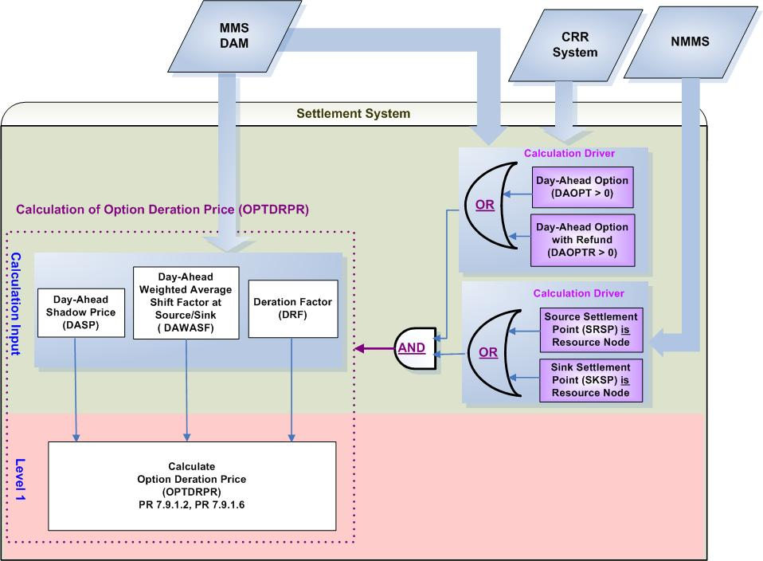
- Calculation Dependencies of Option Deration Price (OPTDRPR)

Assumptions
Assumptions of upstream systems:
A1) Calculation of Day-Ahead Shadow Prices (DASP) is performed outside of the Settlement System. Therefore DASP are assumed to be correct and certified for use of the Settlement System.
A2) Price corrections of DASP are completed in the original source system (MMS) prior to DAM settlements.
A3) Tracking the ownerships of CRRs is completed in the original source (which is CRR System). Determination of whether or not PTP Options and PTP Options with Refund owned by NOIE are eligible for Real-Time Settlements is made during the execution of the DAM by the original source (MMS DAM). The information from the CRR System and the MMS DAM will be used jointly to calculate the amount of CRRs to be settled in Day-Ahead.
A4) Calculation of Day-Ahead Weighted Average Shift Factors (DAWASF) for Resource Nodes, Hubs and Load Zones will be completed in the original source system (MMS). Therefore the Settlement System shall not have to derive this value from granular data such as distribution factors and the shift factors of each electrical bus residing in that Resource Node, Hub or Load Zone.

Assumptions of Settlement Interface:
A5) If DASP is adjusted in the original system (MMS); the Settlement Interface with the original source system (MMS) will retrieve not only the adjusted DASP but the affected DAWASF and DRF prior to DAM settlements.
A6) If DASP has a non zero value for a Constraint for at least one Operating Hour of an Operating Day, the Settlement Interface with original source (MMS) will retrieve that DASP for the Constraint for the entire Operating Day. The Settlement Interface will set DASP to be a default value Zero (0) for any Operating Hours of that Operating Day wherein DASP doesn’t exist for that Constraint.
A7) If DRF has a non zero value for a Constraint for at least one Operating Hour of an Operating Day, the Settlement Interface with original source (MMS) will retrieve that DRF for the Constraint for the entire Operating Day. The Settlement Interface will set DRF to be a default value Zero (0) for any Operating Hours of that Operating Day wherein DRF doesn’t exist for that Constraint.

Business Rules
Req. ID | Protocol(s) | Sub-Process Map | Description
 | PR 7.9.1.2; PR 7.9.1.6;  PR 7.9.2.2; PR 7.9.2.3 | CSWM. P03SettleBill Transfer | None of the input bill determinants should be rounded or truncated.
 | PR 7.9.1.2; PR 7.9.1.6;  PR 7.9.2.2; PR 7.9.2.3 | CSWM. P03SettleBill Transfer | The following output bill determinant should be rounded or truncated to two (2) decimals, including:  - OPTDRPR
 | PR 12.3 (C) | CSWM. P03SettleBill Transfer | The following data shall be available for private data extracts, including:  - DAOPT  - DAOPTR  - OPTDRPR  - DASP  - DASASF  - DFR
 | PR 12.3 (C) | CSWM. P03SettleBill Transfer | The following data shall be available for public data extracts, including:  - None
 | PR 7.9.1.2; PR 7.9.1.6;  PR 7.9.2.2; PR 7.9.2.3 | CSWM. P03SettleBill Transfer | DRIVER: The OPTDRPR calculation shall be attempted for a source and sink Settlement Point pair only when each condition as described below is met for at least one Operating Hour of the Operating Day:  - At least the source Settlement Point or the sink Settlement Point is a Resource Node  - At least one of the following data cuts exists and is positive:  - Day-Ahead Option (DAOPT)  - Day-Ahead Option with Refund (DAOPTR)

Business Defined Errors
Req. ID | Protocol(s) | Sub-Process Map | Description
 | PR 7.9.1.2; PR 7.9.1.6;  PR 7.9.2.2; PR 7.9.2.3 | CSWM. P03SettleBill Transfer | If the Settlement System calculation needs DAWASF that is not available for a source or a sink Settlement Point pair to a Constraint, the Settlement System should set DAWASF to be Zero (0). No error message is necessary.
 | PR 7.9.1.2; PR 7.9.1.6;  PR 7.9.2.2; PR 7.9.2.3 | CSWM. P03SettleBill Transfer | If OPTDRPR is calculated to be negative, the Settlement System should consider it as a WARN--DEFAULT error, and set OPTDRPR to a default value – Zero (0) and an error message should be logged. The error message should capture the source and sink Settlement Point, the Operating Hour, and Operating Day, for which OPTDRPR is calculated as negative.

Specific Database Needs
None

Calculation of Day-Ahead Option Hedge Value Price (DAOPTHVPR)

For PTP Options that source or sink at a Resource Node, the PTP Option payment may be reduced due to transmission elements that are oversold in previous CRR auctions. Under this scenario, Day-Ahead Option Hedge Value Price (DAOPTHVPR) is calculated.

The Calculation of Day-Ahead Option Hedge Value Price (DAOPTHVPR) is defined as a global calculation because it is a common component utilized by multiple calculations in CRR Settlements. Specifically, DAOPTHVPR is used by the calculation of: Day-Ahead Option Hedge Value (DAOPTHV), and Day-Ahead Option with Refund Hedge Value (DAOPTRHV).

Requirement ID
Source Mapping (Protocol/NERC/FERC and other binding documents Ref #) | PR 7.9.1.2, PR 7.9.1.6  PR 7.9.2.2, PR 7.9.2.3
Traceability to Sub-Process Maps | CSWM.P03SettleBillTransfer
Description

Calculate Day-Ahead PTP Option Hedge Value Price per Source and Sink pair for each Operating Hour of the Operating Day:

1. IF the SRSP is a Load Zone or Hub AND SKSP is a Resource Node, THEN:
DAOPTHVPR_<SRSP>_<SKSP> = Max (0, MAXRESPR_<SKSP> – DASPP_<SRSP>)

2. IF SRSP is a Resource Node AND SKSP is a Load Zone or Hub, THEN:
DAOPTHVPR_<SRSP>_<SKSP> = Max (0, DASPP_<SKSP> – MINRESPR_<SRSP>)

3. IF SRSP Is a Resource Node AND SKSP is also a Resource Node, THEN:
DAOPTHVPR_<SRSP>_<SKSP> = Max (0, MAXRESPR_<SKSP> – MINRESPR_<SRSP>)

Input Bill Determinants
Variable | Unit | Definition | Original Source
DASPP | $/MWh | Day-Ahead Settlement Point Price at source (sink) —The DAM Settlement Point Price at the source (sink) Settlement Point, for the hour. | MMS DAM
Interval Frequency: 1/ hour

Additional Comments:
- DASPP is calculated and certified by MMS DAM Package.
MINRESPR | $/MWh | Minimum Resource Price for source—The lowest Minimum Resource Price for Resources located at the source Settlement Point. | Settlement System
Interval Frequency: 1/hour

Additional Comments:
- The availability of MINRESPR is dependent on the global calculation of Minimum Resource Price (MINRESPR).
MAXRESPR | $/MWh | Maximum Resource Price for sink—The highest Maximum Resource Price for Resources located at the sink Settlement Point. | Settlement System
Interval Frequency: 1/ hour

Additional Comments:
- The availability of MAXRESPR is dependent on the global calculation of Maximum Resource Price (MAXRESPR).
DAOPT | MW | Day-Ahead Option per CRR Owner per source and sink pair—The number of CRR Owner’s PTP Options with the source and sink pair settled in the DAM for the hour. | CRR System &  MMS DAM
Interval Frequency: 1/ hour

Additional Comments:
- DAOPT equals the difference between (a) and (b):
(a) The amount of PTP Options acquired through PCRR Allocations, CRR Auctions, and CRR Bilateral Trades, prior to DAM execution
(b) The amount of PTP Options that are declared before DAM execution by NOIEs to be settled in Real-Time and not cleared in the DAM.

- DAOPT shall always be equal to or greater than zero (0).

- Calculation of DAOPT occurs in the Settlement Interface prior to the DAM Settlements process.
DAOPTR | MW | Day-Ahead Option with Refund per CRR Owner per pair of source and sink⎯The number of CRR Owner’s PTP Options with Refund with the pair of source and sink, settled in DAM, for the hour. | CRR System &  MMS DAM
Interval Frequency: 1/ hour

Additional Comments:

- DAOPTR is a result of PCRR Allocation. The owner of DAOPTR shall be a designated NOIE.

- DAOPTR equals the difference between (a) and (b):
(a) The amount of PTP Options with Refund acquired through PCRR Allocations by NOIEs.
(b) The amount of PTP Options with Refund that is declared before DAM execution by NOIEs to be settled in Real-Time and not cleared in the DAM.

- DAOPTR shall always be equal to or greater than zero (0).

Output Bill Determinants
Variable | Unit | Definition | Destination
DAOPTHVPR | $/MWh | Day-Ahead Option Hedge Value Price per pair of source and sink—The Day-Ahead hedge price of a PTP Option with the pair of source and sink, for the hour. | Settlement System
Interval Frequency: 1/hour

Additional Comments:
- The value of DAOPTHVPR shall always be no less than zero (0).

Data Dependencies
D1) Calculation of DAOPTHVPR is dependent upon the availability of input bill determinants.
D2) Calculation of DAOPTHVPR is dependent upon the availability of the most up-to-date network topology information for the mapping of a Settlement Point to Settlement Point Type (Resource Node, Load Zone, or Hub).
D3) Calculation of DAOPTHVPR is dependent upon the completion of global calculations: MINRESPR and MAXRESPR.
D4) The following charge types are dependent upon the calculation of DAOPTHVPR:
- Day-Ahead Option Amount (DAOPTAMT)
- Day-Ahead Option with Refund Amount (DAOPTRAMT)

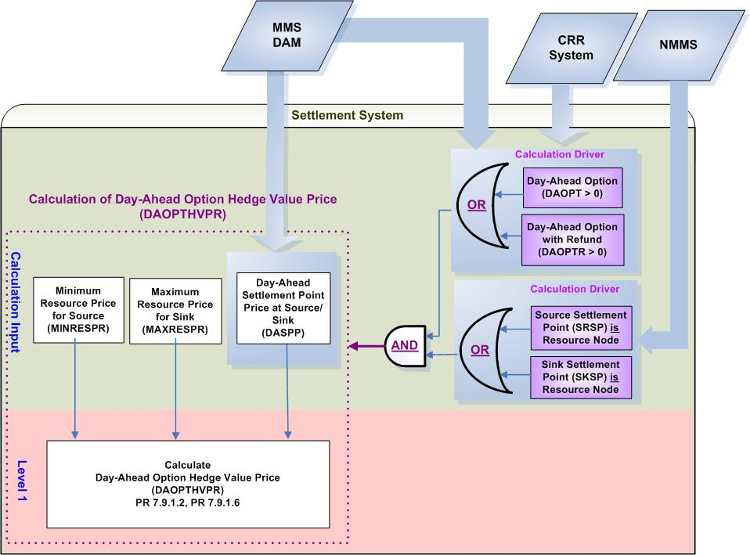
- Calculation Dependencies of Day-Ahead Option Hedge Value Price (DAOPTHVPR)

Assumptions
Assumptions of upstream systems:
A1) Calculation and certification of Day-Ahead Settlement Point Prices is performed outside of the Settlement System. Therefore DASPP is assumed to be valid for use of the Settlement System.
A2) Price corrections of DASPP are completed in the original source system (MMS DAM) prior to DAM settlements.
A3) Tracking the ownerships of CRRs is completed in the original source (which is CRR System). Determination of whether or not PTP Options and PTP Options with Refund owned by NOIE are eligible for Real-Time Settlements is made during the execution of the DAM by the original source (MMS DAM). The information from the CRR System and the MMS DAM will be used jointly to calculate the amount of CRRs to be settled in Day-Ahead.
A4) PTP Option with Refund could only be a Resource Node to a Load Zone/Hub.
Assumptions of Settlement Interface:
A4) If DASPP is adjusted in the original system (MMS DAM), the Settlement Interface with the original source system (MMS) will retrieve the adjusted DASPP prior to DAM settlements.

Business Rules
Req. ID | Protocol(s) | Sub-Process Map | Description
 | PR 7.9.1.2; PR 7.9.1.6;  PR 7.9.2.2;  PR 7.9.2.3 | CSWM. P03SettleBill Transfer | None of the input bill determinants should be rounded or truncated.
 | PR 7.9.1.2; PR 7.9.1.6;  PR 7.9.2.2;  PR 7.9.2.3 | CSWM. P03SettleBill Transfer | The following output bill determinant should be rounded or truncated to two (2) decimals, including:  - DAOPTHVPR
 | PR 12.3 (C) | CSWM. P03SettleBill Transfer | The following data shall be available for private data extracts, including:  - MINRESPR  - MAXRESPR  - DAOPT  - DAOPTR  - DAOPTHVPR
 | PR 12.3 (C) | CSWM. P03SettleBill Transfer | The following data shall be available for public data extracts, including:  - DASPP
 | PR 7.9.1.2; PR 7.9.1.6;  PR 7.9.2.2;  PR 7.9.2.3 | CSWM. P03SettleBill Transfer | DRIVER: The DAOPTHVPR calculation shall be attempted for a source and sink Settlement Point pair only when each condition as described below is met for at least one Operating Hour of the Operating Day:  - At least the source Settlement Point or the sink Settlement Point is a Resource Node  - At least one of the following data cuts exists and is positive:  - Day-Ahead Option (DAOPT)  - Day-Ahead Option with Refund (DAOPTR)

Business Defined Errors
Req. ID | Protocol(s) | Sub-Process Map | Description
 | PR 7.9.1.2; PR 7.9.1.6;  PR 7.9.2.2;  PR 7.9.2.3 | CSWM. P03SettleBill Transfer | If any calculated DAOPTHVPR is negative, the Settlement System should consider it as a WARN--DEFAULT error, and set DAOPTHVPR to a default value – Zero (0) and an error message should be logged. The error message should capture the source and sink Settlement Point, the Operating Hour, and Operating Day, for which DAOPTHVPR is calculated as negative.
 | PR 7.9.1.2; PR 7.9.1.6;  PR 7.9.2.2;  PR 7.9.2.3 | CSWM. P03SettleBill Transfer | If a DASPP data cut is not available for a Settlement Point and Operating Day for which either DAOPT or DAOPTR data cut exists, the system should log a “CRITICAL” error message and stop any downstream CRR calculations that depend on DASPP. The error message should capture the missing data element, including the Settlement Point, and the Operating Day.

Specific Database Needs
None

Payments and Charges for PTP Obligations Settled in DAM (DAOBLAMT)

A PTP Obligation is a type of CRR that entitles the holder to be charged or to receive compensation and is evaluated in each CRR Auction and DAM as the positive and negative power flows on all directional network elements created by the injection and withdrawal at the specified source and sink points of the quantity represented by the CRR bid or offer (MW).

Settlement of PTP Obligations in DAM is described as follows: (PR 7.9.1.1(3), PR 7.9.1.1.(4), PR 7.9.3.3)

- Except as specified otherwise in paragraph (2) below, ERCOT shall pay or charge the owner of each PTP Obligation based on the difference in the Day-Ahead Settlement Point Price between the sink Settlement Point and the source Settlement Point.
- For PTP Obligation that has a positive value and source or sink at a Resource Node, the PTP Obligation payment may be reduced due to directional network elements that are oversold in previous CRR auctions.

Requirement ID
Source Mapping (Protocol/NERC/FERC and other binding documents Ref #) | PR 7.9.1.1 (3)
Traceability to Sub-Process Maps | CSWM.P03SettleBillTransfer
Description

Calculate Day-Ahead Obligation Target Payment per CRR Owner per Source and Sink pair for each Operating Hour of the Operating Day:

DAOBLTP_<CO>_<SRSP>_<SKSP> = DAOBLPR_<SRSP>_<SKSP> * DAOBL_<CO>_<SRSP>_<SKSP>

Requirement ID
Source Mapping (Protocol/NERC/FERC and other binding documents Ref #) | PR 7.9.1.1(3)
Traceability to Sub-Process Maps | CSWM.P03SettleBillTransfer
Description

Calculate Day-Ahead Obligation Amount per CRR Owner per Source and Sink pair for each Operating Hour of the Operating Day:

IF (DAOBLPR_<SRSP>_<SKSP> is Non-Positive ( ≤ 0 ) OR
Both SRSP and SKSP locate at a Load Zone or Hub)
THEN:
DAOBLAMT_<CO>_<SRSP>_<SKSP> = (-1) * DAOBLTP_<CO>_<SRSP>_<SKSP>

ELSE IF (DAOBLPR_<SRSP>_<SKSP> is Positive (>0) AND
Either SRSP or SKSP is a Resource Node)
THEN:
DAOBLAMT_<CO>_<SRSP>_<SKSP> =
(-1) * Max {(DAOBLTP_<CO>_<SRSP>_<SKSP> – DAOBLDA_<CO>_<SRSP>_<SKSP>),
Min (DAOBLTP_<CO>_<SRSP>_<SKSP>, DAOBLHV_<CO>_<SRSP>_<SKSP>)}

Requirement ID
Source Mapping (Protocol/NERC/FERC and other binding documents Ref #) | PR 7.9.1.1(3)
Traceability to Sub-Process Maps | CSWM.P03SettleBillTransfer
Description

Calculate Day-Ahead Obligation Derated Amount per CRR Owner per Source and Sink pair for each Operating Hour of the Operating Day:

DAOBLDA_<CO>_<SRSP>_<SKSP> = OBLDRPR_<SRSP>_<SKSP>
* DAOBL_<CO>_<SRSP>_<SKSP>

Requirement ID
Source Mapping (Protocol/NERC/FERC and other binding documents Ref #) | PR 7.9.1.1(4)
Traceability to Sub-Process Maps | CSWM.P03SettleBillTransfer
Description

Calculate Day-Ahead Obligation Hedge Value per CRR Owner per Source and Sink pair for each Operating Hour of the Operating Day:

DAOBLHV_<CO>_<SRSP>_<SKSP> = DAOBLHVPR_<SRSP>_<SKSP>
* DAOBL_<CO>_<SRSP>_<SKSP>

Requirement ID
Source Mapping (Protocol/NERC/FERC and other binding documents Ref #) | PR 7.9.1.1(4)
Traceability to Sub-Process Maps | CSWM.P03SettleBillTransfer
Description

Calculate Day-Ahead Obligation Credit Owner Total per CRR Owner for each Operating Hour of the Operating Day:

DAOBLCROTOT_<CO> = $\underset{\text{SRSP}}{Σ}$$\underset{\text{SKSP}}{Σ}$Min (0, DAOBLAMT_<CO>_<SRSP>_<SKSP>)

Requirement ID
Source Mapping (Protocol/NERC/FERC and other binding documents Ref #) | PR 7.9.1.1(4)
Traceability to Sub-Process Maps | CSWM.P03SettleBillTransfer
Description

Calculate Day-Ahead Obligation Charge Owner Total per CRR Owner for each Operating Hour of the Operating Day

DAOBLCHOTOT_<CO> = $\underset{\text{SRSP}}{Σ}$$\underset{\text{SKSP}}{Σ}$Max (0, DAOBLAMT_<CO>_<SRSP>_<SKSP>)

Requirement ID
Source Mapping (Protocol/NERC/FERC and other binding documents Ref #) | PR 7.9.1.1 (4)
Traceability to Sub-Process Maps | CSWM.P03SettleBillTransfer
Description

Calculate Day-Ahead Obligation Amount Owner Total per CRR Owner for each Operating Hour of the Operating Day:

DAOBLAMTOTOT_<CO> = DAOBLCROTOT_<CO> + DAOBLCHOTOT_<CO>

Requirement ID
Source Mapping (Protocol/NERC/FERC and other binding documents Ref #) | PR 7.9.3.2
Traceability to Sub-Process Maps | CSWM.P03SettleBillTransfer
Description

Calculate Day-Ahead Obligation Credit Total for each Operating Hour of the Operating Day:

DAOBLCRTOT = $\underset{\text{co}}{Σ}$DAOBLCROTOT_<CO>

Requirement ID
Source Mapping (Protocol/NERC/FERC and other binding documents Ref #) | PR 7.9.3.2
Traceability to Sub-Process Maps | CSWM.P03SettleBillTransfer
Description

Calculate Day-Ahead Obligation Charge Total for each Operating Hour of the Operating Day::

DAOBLCHTOT = $\underset{\text{co}}{Σ}$DAOBLCHOTOT_<CO>

Input Bill Determinants
Variable | Unit | Definition |  | Original Source
DAOBL | MW | Day-Ahead Obligation per CRR Owner per source and sink pair—The number of CRR Owner’s PTP Obligations with the pair of source and sink settled in the DAM for the hour. |  | CRR System
Interval Frequency: 1/ hour

Additional Comments:
- DAOBL is retrieved from the original system and shall consider PTP Obligations acquired through PCRR Allocations, CRR Auctions, and CRR Bilateral Trades, prior to DAM execution.

- DAOBL shall be greater than or equal to zero (0).
DAOBLPR | $/MW per hour |  | Day-Ahead Obligation Price per source and sink pair—The DAM price of a PTP Obligation with the pair of source and sink, for the hour. | Settlement System
Interval Frequency: 1/ hour

Additional Comments:
- The value of DAOBLPR could be negative, zero, or positive.

- The availability of DAOBLPR is dependent on the global calculation of Day-Ahead Obligation Price (DAOBLPR)
OBLDRPR | $/MW per hour |  | Obligation Deration Price per source and sink pair—The deration price of a PTP Obligation with the pair of source and sink, for the hour. | Settlement System
Interval Frequency: 1/ hour

Additional Comments:
- The value of OBLDRPR shall always be no less than zero (0).

- The availability of OBLDRPR is dependent on the global calculation of Obligation Deration Price (OBLDRPR).
DAOBLHVPR | $/MWh |  | Day-Ahead Obligation Hedge Value Price per source and sink pair—The Day-Ahead hedge price of a PTP Obligation with the pair of source and sink, for the hour. | Settlement System
Interval Frequency: 1/hour

Additional Comments:
- The value of DAOBLHVPR shall always be no less than zero (0).

- The availability of DAOBLHVPR is dependent on the global calculation of Day-Ahead Obligation Hedge Value Price (DAOBLHVPR).

Intermediate Bill Determinants
Variable | Unit | Definition | Destination
DAOBLTP | $ | Day-Ahead Obligation Target Payment per CRR Owner per source and sink pair—The target payment for CRR Owner’s PTP Obligations with the pair of source and the sink settled in the DAM, for the hour. | Settlement System
Interval Frequency: 1/ hour

Additional Comments:
- The value of DAOBLTP could be negative, zero, or positive.
DAOBLHV | $ | Day-Ahead Obligation Hedge Value per CRR Owner per source and sink pair—The hedge value of CRR Owner’s PTP Obligations with the pair of source and the sink settled in the DAM, for the hour. | Settlement System
Interval Frequency: 1/ hour

Additional Comments:
- The value of DAOBLHV shall always be no less than zero (0).
DAOBLDA | $ | Day-Ahead Obligation Derated Amount per CRR Owner per source and sink pair—The derated amount of CRR Owner’s PTP Obligations with the pair of source and sink settled in the DAM, for the hour. | Settlement System
Interval Frequency: 1/ hour

Additional Comments:
- The value of DAOBLDA shall always be no less than zero (0).

Output Bill Determinants
Variable | Unit | Definition | Destination
DAOBLAMT | $ | Day-Ahead Obligation Amount per CRR Owner per source and sink pair—The payment or charge to CRR Owner for the PTP Obligations with the pair of source and the sink settled in the DAM, for the hour. | Settlement System
Interval Frequency: 1/hour

Additional Comments:
- The value of DAOBLAMT could be negative, zero, or positive.
DAOBLCROTOT | $ | Day-Ahead Obligation Credit Owner Total per CRR Owner—The total payment to CRR Owner for its PTP Obligations settled in the DAM, for the hour. | Settlement System
Interval Frequency: 1/hour

Additional Comments:
- The value of DAOBLCROTOT shall always be less than, or equal to, zero (0).

- DAOBLCROTOT will be used by the calculation of Day-Ahead CRR Shortfall Amount (DACRRSAMT).
DAOBLCHOTOT | $ | Day-Ahead Obligation Charge Owner Total per CRR Owner—The total charge to CRR Owner for its PTP Obligations settled in the DAM, for the hour. | Settlement System
Interval Frequency: 1/hour

Additional Comments:
- The value of DAOBLCHOTOT shall always be no less than zero (0).
DAOBLAMTOTOT | $ | Day-Ahead Obligation Amount Owner Total per CRR Owner—The net total payment or charge to CRR Owner for all its PTP Obligations settled in the DAM, for the hour. | Settlement System
Interval Frequency: 1/hour

Additional Comments: None
DAOBLCRTOT | $ | Day-Ahead Obligation Credit Total — The total payment of all PTP Obligations settled in DAM, for the hour. | Settlement System
Interval Frequency: 1/hour

Additional Comments:
- DAOBLCRTOT will be used by CRR Balancing Account Credit (CRRBACR) calculation and Day-Ahead CRR Shortfall Amount (DACRRSAMT) calculation.
DAOBLCHTOT | $ | Day-Ahead Obligation Charge Total — The total charge of all PTP Obligations settled in DAM, for the hour. | Settlement System
Interval Frequency: 1/hour

Additional Comments:
- DAOBLCHTOT will be used by the calculation of CRR Balancing Account (CRRBACR).
DAOBLBILLAMTOTOT | $ | Day-Ahead Obligation Owner Bill Amount per CRR Owner— The Delta of Day-Ahead Obligation Amount Owner Total between the current and the previous settlement run -- per CRR Owner, for the day. | Settlement System
Interval Frequency: 1/day

Additional Comments:
- This bill determinant is not specifically documented in the Nodal Protocols but is required as a result of Section 9 Statements and Invoices Protocol requirements.

Data Dependencies
D1) Calculation of DAOBLAMT is dependent upon the availability of the input determinants.
D2) Calculation of DAOBLAMT is dependent upon the completion of global calculations: DAOBLPR, OBLDRPR, and DAOBLHVPR.
D3) Calculation of CRR Balancing Account Credit (CRRBACR) is dependent upon the calculation of DAOBLCRTOT and DAOBLCHTOT.
D4) Calculation of Day-Ahead CRR Shortfall Amount (DACRRSAMT) is dependent upon the calculation of DAOBLCROTOT, and DAOBLCRTOT.

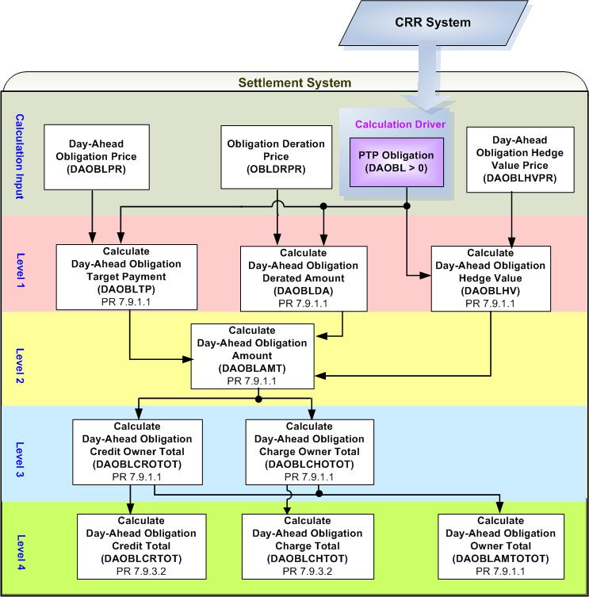
- Calculation Dependencies of PTP Obligations Settled in Day-Ahead Market (DAOBLAMT)

Assumptions
Assumptions of upstream systems:
A1) Tracking Ownership of CRRs is completed in the original source (CRR System). Therefore, DAOBL is assumed to represent appropriate values resulted from PCRR Allocations, CRR Auctions and CRR Bilateral Trades reported to ERCOT CRR system prior to DAM execution.

Business Rules
Req. ID | Protocol(s) | Sub-Process Map | Description
 | 9.2.3(o) | CSWM. P03SettleBill Transfer | DAOBLAMT is one of DAM settlement “Charge Types”. Therefore the calculation of DAOBLAMT and any calculations that DAOBLAMT is dependent upon shall be performed within DAM Settlements process
 | PR 7.9.1.1 | CSWM. P03SettleBill Transfer | None of the input and intermediate bill determinants should be truncated or rounded in the Settlement System.
 | PR 7.9.1.1 | CSWM. P03SettleBill Transfer | Output bill determinates should be rounded to (2) decimals, including:  - DAOBLAMT  - DAOBLCROTOT  - DAOBLCHOTOT  - DAOBLAMTOTOT  - DAOBLCRTOT  - DAOBLCHTOT
 | 12.3 (c) | CSWM. P03SettleBill Transfer | The following data shall be available for private data extract, including:  - DAOBL  - DAOBLPR  - OBLDRPR  - DAOBLHVPR  - DAOBLTP  - DAOBLHV  - DAOBLDA  - DAOBLAMT  - DAOBLCROTOT  - DAOBLCHOTOT  - DAOBLAMTOTOT
 | 12.3 | CSWM. P03SettleBill Transfer | The following data shall be available for public data extract, including:  - DAOBLCRTOT  - DAOBLCHTOT
 | PR 7.9.1.1 | CSWM. P03SettleBill Transfer | DRIVER: the calculation of Payments/Charges for PTP Obligations Settled in DAM (DAOBLAMT) shall be only attempted for the source and sink pair for which a DAOBL exists with a positive value for at least one Operating Hour of the Operating Day.

Business Defined Errors
Req. ID | Protocol(s) | Sub-Process Map | Description
 | PR 7.9.1.1 | CSWM. P03SettleBill Transfer | If the calculation of DAOBLDA needs OBLDRPR that is not available for the source and sink Settlement Point pair, the Settlement System should set DAOBLDA to be Zero (0). No error message is necessary.
 | PR 7.9.1.1 | CSWM. P03SettleBill Transfer | If the calculation of DAOBLHV needs DAOBLHVPR that is not available for the source and sink Settlement Point pair, the Settlement System should set DAOBLHV to be Zero (0) and an error message should be logged. The error message should capture the source and sink Settlement Point, the Operating Hour, and Operating Day, for which DAOBLHVPR is missing.

Specific DDatabase Needs
None

Payments for PTP Options Settled in DAM (DAOPTAMT)

A PTP Option is a type of CRR that entitles the holder to receive compensation and is evaluated in each CRR Auction and DAM as the positive power flows on all directional network elements created by the injection and withdrawal at the specified source and sink points in the quantity represented by the CRR bid or offer (MW), excluding all negative flows on all directional network elements.

Settlement of PTP Options in DAM is described as follows: (PR 7.9.1.2)

- Except as specified otherwise in paragraph (2) below, ERCOT shall pay the owner of a PTP Option the difference in the Day-Ahead Settlement Point Price between the sink Settlement Point and the source Settlement Point, if positive.
- For PTP Options that source or sink at a Resource Node, the PTP Option payment may be reduced due to transmission elements that are oversold in previous CRR auctions.

Requirement ID
Source Mapping (Protocol/NERC/FERC and other binding documents Ref #) | PR 7.9.1.2 (3)
Traceability to Sub-Process Maps | CSWM.P03SettleBillTransfer
Description

Calculate Day-Ahead Option Target Payment per CRR Owner per Source and Sink pair for each Operating Hour of the Operating Day:

DAOPTTP_<CO>_<SRSP>_<SKSP> =
DAOPTPR_<SRSP>_<SKSP> * DAOPT_<CO>_<SRSP>_<SKSP>

Requirement ID
Source Mapping (Protocol/NERC/FERC and other binding documents Ref #) | PR 7.9.1.2 (3)
Traceability to Sub-Process Maps | CSWM.P03SettleBillTransfer
Description

Calculate Day-Ahead Option Amount per CRR Owner per Source and Sink pair for each Operating Hour of the Operating Day:

IF (BOTH SRSP AND SKSP locate at a Load Zone or Hub)
THEN:
DAOPTAMT_<CO>_<SRSP>_<SKSP> = (-1) * DAOPTTP_<CO>_<SRSP>_<SKSP>

ELSE IF (EITHER SRSP OR SKSP is a Resource Node)
THEN:
DAOPTAMT_<CO>_<SRSP>_<SKSP> =
(-1) * Max {(DAOPTTP_<CO>_<SRSP>_<SKSP> – DAOPTDA_<CO>_<SRSP>_<SKSP>), Min (DAOPTTP_<CO>_<SRSP>_<SKSP>, DAOPTHV_<CO>_<SRSP>_<SKSP>)}

Requirement ID
Source Mapping (Protocol/NERC/FERC and other binding documents Ref #) | PR 7.9.1.2 (3)
Traceability to Sub-Process Maps | CSWM.P03SettleBillTransfer
Description

Calculate Day-Ahead Option Derated Amount per CRR Owner per Source and Sink pair for each Operating Hour of the Operating Day:

DAOPTDA_<CO>_<SRSP>_<SKSP> =
OPTDRPR_<SRSP>_<SKSP> * DAOPT_<CO>_<SRSP>_<SKSP>

Requirement ID
Source Mapping (Protocol/NERC/FERC and other binding documents Ref #) | PR 7.9.1.2 (3)
Traceability to Sub-Process Maps | CSWM.P03SettleBillTransfer
Description

Calculate Day-Ahead PTP Option Hedge Value per CRR Owner per Source and Sink pair for each Operating Hour of the Operating Day:

DAOPTHV_<CO>_<SRSP>_<SKSP> =
DAOPTHVPR_<SRSP>_<SKSP> * DAOPT_<CO>_<SRSP>_<SKSP>

Requirement ID
Source Mapping (Protocol/NERC/FERC and other binding documents Ref #) | PR 7.9.1.2 (4)
Traceability to Sub-Process Maps | CSWM.P03SettleBillTransfer
Description

Calculate Day-Ahead PTP Option Amount Owner Total per CRR Owner for each Operating Hour of the Operating Day:

DAOPTAMTOTOT_<CO> = $\underset{\text{SRSP}}{Σ}$$\underset{\text{SKSP}}{Σ}$DAOPTAMT_<CO>_<SRSP>_<SKSP>

Requirement ID
Source Mapping (Protocol/NERC/FERC and other binding documents Ref #) | PR 7.9.3.2
Traceability to Sub-Process Maps | CSWM.P03SettleBillTransfer
Description

Calculate Day-Ahead Option Amount Total, summed over all owners of CRR Options, for each Operating Hour of the Operating Day:

DAOPTAMTTOT = $\underset{\text{co}}{Σ}$DAOPTAMTOTOT_<CO>

Input Bill Determinants
Variable |  | Unit | Definition |  | Original Source
DAOPT |  | MW | Day-Ahead Option per CRR Owner per source and sink pair—The number of CRR Owner’s PTP Options with the source and sink pair settled in the DAM for the hour. |  | CRR System &  MMS DAM
Interval Frequency: 1/ hour

Additional Comments:
- DAOPT equals the difference between (a) and (b):
(a) The amount of PTP Options acquired through PCRR Allocations, CRR Auctions, and CRR Bilateral Trades, prior to DAM execution
(b) The amount of PTP Options that are declared before DAM execution by NOIE to be settled in Real-Time and not cleared in the DAM.

- DAOPT shall always be equal to or greater than zero (0).

- Calculation of DAOPT occurs in the Settlement Interface.
DAOPTPR | $/MW per hour |  |  | Day-Ahead Option Price per source and sink pair—The DAM price of a PTP Option with the source and the sink, for the hour. | Settlement System
Interval Frequency: 1/ hour

Additional Comments:
- The value of DAOPTPR shall always be no less than zero (0).

- The availability of DAOPTPR is dependent upon the global calculation of Day-Ahead Option Price (DAOPTPR).
OPTDRPR | $/MW per hour |  |  | Option Deration Price per source and sink pair—The deration price of a PTP Option with the source and the sink, for the hour. | Settlement System
Interval Frequency: 1/ hour

Additional Comments:
- The value of OPTDRPR shall always be no less than zero (0).

- The availability of OPTDRPR is dependent upon the global calculation of Option Deration Price (OPTDRPR).
DAOPTHVPR | $/MWh |  |  | Day-Ahead Option Hedge Value Price per source and sink pair—The Day-Ahead hedge price of a PTP Option with the source and the sink, for the hour. | Settlement System
Interval Frequency: 1/hour

Additional Comments:
- The value of DAOPTHVPR shall always be no less than zero (0).

- The availability of DAOPTHVPR is dependent upon the global calculation of Day-Ahead Option Hedge Value Price (DAOPTHVPR).

Intermediate Bill Determinants
Variable | Unit | Definition | Destination
DAOPTTP | $ | Day-Ahead Option Target Payment per CRR Owner per source and sink pair—The target payment for CRR Owner’s PTP Options with the source and the sink settled in the DAM, for the hour. | Settlement System
Interval Frequency: 1/ hour

Additional Comments:
- The value of DAOPTTP shall always be no less than zero (0).
DAOPTHV | $ | Day-Ahead Option Hedge Value per CRR Owner per source and sink pair—The hedge value of CRR Owner’s PTP Options with the source and the sink settled in the DAM, for the hour. | Settlement System
Interval Frequency: 1/ hour

Additional Comments:
- The value of DAOPTHV shall always be no less than zero (0).
DAOPTDA | $ | Day-Ahead Option Derated Amount per CRR Owner per source and sink pair—The derated amount of CRR Owners PTP Options with the source and the sink settled in the DAM, for the hour. | Settlement System
Interval Frequency: 1/ hour

Additional Comments:
- The value of DAOPTDA shall always be no less than zero (0).

Output Bill Determinants
Variable | Unit |  | Definition | Destination
DAOPTAMT | $ |  | Day-Ahead Option Amount per CRR Owner per source and sink pair—The payment or charge to CRR Owner for the PTP Options with the source and the sink settled in the DAM, for the hour. | Settlement System
Interval Frequency: 1/hour

Additional Comments:
- DAOPTAMT shall always be no greater than zero (0).
DAOPTAMTOTOT | $ |  | Day-Ahead Option Amount Owner Total per CRR Owner—The net total payment or charge to CRR Owner for all its PTP Options settled in the DAM, for the hour. | Settlement System
Interval Frequency: 1/hour

Additional Comments:
- DAOPTAMTOTOT will be used by the calculation of Day-Ahead CRR Shortfall Amount (DACRRSAMT).
DAOPTAMTTOT | $ |  | Day-Ahead Option Amount Total—The total payment of all PTP Options settled in the DAM, for the hour. | Settlement System
Interval Frequency: 1/hour

Additional Comments:
- DAOPTAMTTOT will be used in the CRR Balancing Account Credit (CRRBACR) calculation and Day-Ahead CRR Shortfall Amount (DACRRSAMT) calculation.
DAOPTBILLAMTOTOT |  | $ | Day-Ahead Option Owner Bill Amount per CRR Owner— The Delta of Day-Ahead Option Amount Owner Total between the current and the previous settlement run -- per CRR Owner, for the day. | Settlement System
Interval Frequency: 1/day

Additional Comments:
- This bill determinant is not specifically documented in the Nodal Protocols but is required as a result of Section 9 Statements and Invoices Protocol requirements.

Data Dependencies
D1) Calculation of DAOPTAMT is dependent upon the availability of the input determinants.
D2) Calculation of DAOPTAMT is dependent upon the availability of global calculations: DAOPTPR, OPTDRPR, and DAOPTHVPR.
D3) Calculation of CRR Balancing Account Credit (CRRBACR) is dependent upon the calculation of DAOPTAMTTOT.
D4) Calculation of Day-Ahead CRR Shortfall Amount (DACRRSAMT) is dependent upon the calculation of DAOPTAMTOTOT and DAOPTAMTTOT.

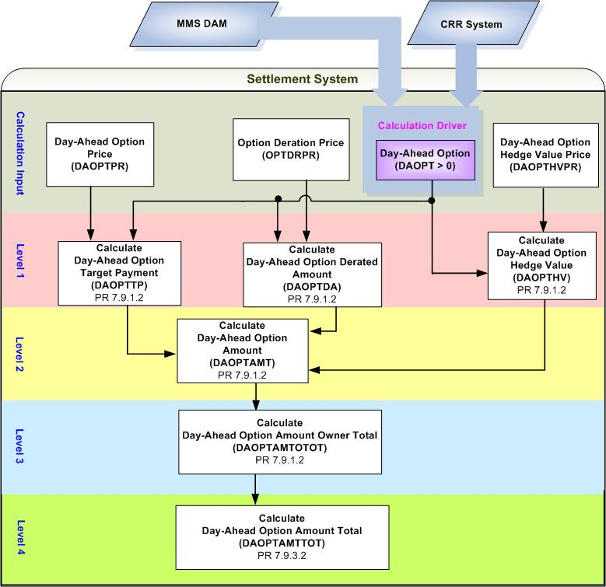
- Dependencies of PTP Options Settled in Day-Ahead Market (DAOPTAMT)

Assumptions
Assumptions of upstream systems:
A1) Determination of whether or not PTP Options owned by NOIE are eligible for Real-Time Settlements is made by the original source (MMS DAM).

Business Rules
Req. ID | Protocol(s) | Sub-Process Map | Description
 | 9.2.3(p) | CSWM. P03SettleBill Transfer | DAOPTAMT is one of DAM settlement “Charge Types”. Therefore the calculation of DAOPTAMT and any calculations that DAOPTAMT is dependent upon shall be performed within DAM Settlements process.
 | PR 7.9.1.2 | CSWM. P03SettleBill Transfer | None of the input and intermediate bill determinants should be truncated or rounded in the Settlement System.
 | PR 7.9.1.2 | CSWM. P03SettleBill Transfer | Output bill determinates should be rounded to (2) decimals, including:  - DAOPTAMT  - DAOPTAMTOTOT  - DAOPTAMTTOT
 | 12.3 (c) | CSWM. P03SettleBill Transfer | The following data shall be available for private data extract, including:  - DAOPT  - DAOPTPR  - OPTDAPR  - DAOPTHVPR  - DAOPTTP  - DAOPTHV  - DAOPTDA  - DAOPTAMT  - DAOPTAMTOTOT
 | 12.3 | CSWM. P03SettleBill Transfer | The following data shall be available for public data extract, including:  - DAOPTAMTTOT
 | PR 7.9.1.2 | CSWM. P03SettleBill Transfer | DRIVER: the calculation of Payments for PTP Options Settled in DAM (DAOPTAMT) shall be only attempted for the source and sink pair for which a DAOPT exists with a positive value for at least one Operating Hour of the Operating Day.

Business Defined Errors
Req. ID | Protocol(s) | Sub-Process Map | Description
 | PR 7.9.1.2 | CSWM. P03SettleBill Transfer | If the calculation of DAOPTDA needs OPTDRPR that is not available for the source and sink Settlement Point pair, the Settlement System should set DAOPTDA to be Zero (0). No error message is necessary.
 | PR 7.9.1.2 | CSWM. P03SettleBill Transfer | If the calculation of DAOPTHV needs DAOPTHVPR that is not available for the source and sink Settlement Point pair, the Settlement System should set DAOPTHV to be Zero (0) and an error message should be logged. The error message should capture the source and sink Settlement Point, the Operating Hour, and Operating Day, for which DAOPTHVPR is missing.
 | PR 7.9.1.2 | CSWM. P03SettleBill Transfer | If DAOPTAMT is calculated to be positive, the Settlement System should consider it as a WARN--DEFAULT error, and set DAOPTAMT as a default value – Zero (0) and an error message should be logged. The error message should capture the source and sink Settlement Point, the Operating Hour, and Operating Day, for which DAOPTAMT is calculated as negative.

Specific Database Needs
None

Payments for FGR Settled in DAM (DAFGRAMT)

A Flowgate Right is a type of CRR that entitles the holder to receive compensation and is evaluated in each CRR Auction and DAM as the positive power flows represented by the quantity of the CRR bid or offer (MW) on a flowgate (i.e., predefined directional network element or a predefined bundle of directional network elements).

Settlement of FGR in DAM is described as follows: (PR 7.9.1.4)

If an FGR is competitive, i.e., all directional network elements associated with the FGR are Competitive Constraints, ERCOT shall pay the owner of the FGR an amount equal to the sum of the Shadow Price of the hour for each directional network element associated with the FGR for each contingency (including the null contingency or base case) normalized to the impact of the principal network element of the FGR (the normal rating of which is used to determine the total MW amount for the flowgate).

If an FGR is non-competitive, i.e., one or more directional network elements associated with the FGR are Non-Competitive Constraints, the FGR payment may be reduced due to transmission elements that are oversold in previous CRR auctions.

The payment for MCFRI, when it is not designated as a Competitive Constraint, is specified by Protocols 7.9.1.4 (3); the payment for any other FGR, when it is non-competitive, will be specified upon introduction of the FGR.

Requirement ID
Source Mapping (Protocol/NERC/FERC and other binding documents Ref #) | PR 7.9.1.4 (1)
Traceability to Sub-Process Maps | CSWM.P03SettleBillTransfer
Description

If all directional network elements associated with the FGR are Competitive Constraints, i.e. No DRF exists for any constraints to one or more network elements associated with FGR for the Operating Day ,the payment to each CRR Owner for its FGRs determined by the principle network element of each flowgate for a given hour is calculated as follows:

- Calculate Day-Ahead FGR Price per Flowgate for each Operating Hour of the Operating Day:
DAFGRPR_<F> = $\sum_{E∈F}{}$ ( INF_<F>_<E> * $\sum_{C}{}$DASP_<E>_<C>)

- Calculate Day-Ahead FGR Amount per CRR Owner per Flowgate for each Operating Hour of the Operating Day:
DAFGRAMT_<CO>_<F> = (-1) * DAFGRTP_<CO>_<F>

- Calculate Day-Ahead FGR Target Payment per CRR Owner per Flowgate for each Operating Hour of the Operating Day:
DAFGRTP_<CO>_<F> = DAFGRPR_<F> * DAFGR_<CO>_<F>

Requirement ID
Source Mapping (Protocol/NERC/FERC and other binding documents Ref #) | PR 7.9.1.4 (2)
Traceability to Sub-Process Maps | CSWM.P03SettleBillTransfer
Description

If one or more directional network elements associated with the FGR are Non-Competitive Constraints, the FGR payment may be reduced. The payment for other FGR when it is non-competitive will be specified by Protocols upon introduction of the FGR, with the exception of MCFRI.

Requirement ID
Source Mapping (Protocol/NERC/FERC and other binding documents Ref #) | PR 7.9.1.4 (3)
Traceability to Sub-Process Maps | CSWM.P03SettleBillTransfer
Description

If one or more directional network elements associated with MCFRI are Non-Competitive, i.e. DRF exists with a positive value for at least one constraint to one or more network elements associated with MCFRI for at least one Hour of the Operating Day , the payment to each CRR Owner for its MCFRI for a given hour, when MCFRI is NOT designated as a Competitive Constraint, is calculated as follows:

- Calculate Day-Ahead FGR Price for MCFRI for each Operating Hour of the Operating Day:
DAFGRPR_<MCFRI> = $\sum_{E∈\text{MCFRI}}{}$(INF_<MCFRI>_<E> * $\underset{C}{Σ}$DASP_<E>_<C>)

- Calculate Day-Ahead FGR Target Payment per CRR Owner for MCFRI for each Operating Hour of the Operating Day:
DAFGRTP_<CO>_<MCFRI> = DAFGRPR_<MCFRI> * DAFGR_<CO>_<MCFRI>

- Calculate Day-Ahead FGR Deration Price for MCFRI for each Operating Hour of the Operating Day:
FGRDRPR_<MCFRI> = $\sum_{E∈\text{MCFRI}}{}$ (INF_<MCFRI>_<E> * $\underset{C}{Σ}$(DASP_<E>_<C> * DRF_<E>_<C>))

- Calculate Day-Ahead FGR Derated Amount per CRR Owner for MCFRI for each Operating Hour of the Operating Day:
DAFGRDA_<CO>_<MCFRI> = FGRDRPR_<MCFRI> * DAFGR_<CO>_<MCFRI>

- Calculate Day-Ahead FGR Hedge Value Price for MCFRI for each Operating Hour of the Operating Day:
DAFGRHVPR_<MCFRI> = Max {0, [DAWALBEP – MINRESPR_<SRSP>_<MCFRI>
–$\sum_{E∉\text{MCFRI}}{}$$\underset{C}{Σ}$ (DASP_<E>_<C> * (DASFMCWGRS_<E>_<C>
– DAWASFLB_<E>_<C>))]
/ (DASFMCWGRS_<MCFRI PRINCIPLE ELEMENT>_<BASE CASE>
– DAWASFLB_<MCFRI PRINCIPLE ELEMENT>_<BASE CASE>)}

- Calculate Day-Ahead FGR Hedge Value per CRR Owner for MCFRI for each Operating Hour of the Operating Day:
DAFGRHV_<CO>_<MCFRI> = DAFGRHVPR_<MCFRI> * DAFGR_<CO>_<MCFRI>

- Calculate Day-Ahead FGR Amount per CRR Owner for MCFRI for each Operating Hour of the Operating Day:
DAFGRAMT_<CO>_<MCFRI> = (-1) * Max {(DAFGRTP_<CO>_<MCFRI>
– DAFGRDA_<CO>_<MCFRI>), Min (DAFGRTP_<CO>_<MCFRI>, DAFGRHV_<CO>_<MCFRI>)}

An NPRR will be submitted to add “subscripts” for “MINRESPR”.
An NPRR will be submitted to correct the “DAFGRAMT” formula. ( “DAFRGHV” needs to be “DAFGRHV” and “DAFRGDA” needs to be “DAFGRDA”)

Requirement ID
Source Mapping (Protocol/NERC/FERC and other binding documents Ref #) | PR 7.9.1.4(4)
Traceability to Sub-Process Maps | CSWM.P03SettleBillTransfer
Description

Calculate Day-Ahead FGR Amount Owner Total per CRR Owner for each Operating Hour of the Operating Day:
DAFGRAMTOTOT_<CO> = $\underset{F}{Σ}$DAFGRAMT_<CO>_<F>

Requirement ID
Source Mapping (Protocol/NERC/FERC and other binding documents Ref #) | PR 7.9.3.2
Traceability to Sub-Process Maps | CSWM.P03SettleBillTransfer
Description

Calculate Day-Ahead FGR Amount Total for each Operating Hour of the Operating Day:
DAFGRAMTTOT = $\underset{\text{CO}}{Σ}$DAFGRAMTOTOT_<CO>

Input Bill Determinants
Variable | Unit |  |  |  | Definition | Original Source
DAFGR | MW |  |  |  | Day-Ahead FGR per CRR Owner per flowgate⎯The CRR Owner’s total number of FGRs determined by the principle element of flowgate settled in the DAM for the hour. | CRR System
Interval Frequency: 1/ hour

Additional Comments:
- DAFGR is retrieved from the original system and shall consider FGRs acquired through PCRR Allocations, CRR Auctions, and CRR Bilateral Trades, prior to DAM execution.

- DAFGR shall be greater than or equal to zero (0).
INF | None |  |  |  | Impact Normalization Factor per element per flowgate⎯The parameter that reflects the normalized impact on the directional network element relative to the impact on the principal network element of flowgate. | CRR System OR NMMS
Interval Frequency: 1/ hour

Additional Comments: None
DASP | $/MW per hour |  |  |  | Day-Ahead Shadow Price per element per constraint⎯The DAM Shadow Price on the directional network element, for the constraint, for the hour. | MMS DAM
Interval Frequency: 1/ hour

Additional Comments:
- DASP is calculated in DAM Market Operations Package.
DAWASFLB | None |  |  |  | Day-Ahead Weighted Average Shift Factor of Load Buses per element per constraint—The Day-Ahead weighted average Shift Factor for all load buses on the directional network element, for the constraint, in the hour. | MMS DAM
Interval Frequency: 1/ hour

Additional Comments: None
DASFMCWGRS |  |  | none |  | Day-Ahead Shift Factor of McCamey WGRs per element per constraint—The Day-Ahead McCamey Area WGR maximum rated output weighted Shift Factor on the directional network element, for the constraint, in the hour. | MMS DAM
Interval Frequency: 1/ hour

Additional Comments: None
DAWALBEP |  |  | $/MWh |  | Day-Ahead Weighted Average Load Bus Energy Price—The weighted average DAM energy price of all load buses for the hour. | MMS DAM
Interval Frequency: 1/ hour

Additional Comments: None
MINRESPR |  |  | $/MWh |  | Minimum Resource Price—The lowest Minimum Resource Price for the types of Resources located at the source of MCFRI. |  | Settlement System
Interval Frequency: 1/hour

Additional Comments:
- The availability of MINRESPR is dependent on the calculation of Minimum Resource Price for source Settlement Point.
DRF |  | None |  | Deration Factor per constraint—The deration factor of the constraint for the hour, equal to the MW amount by which the constraint is oversold divided by the total MW amount of the positive impacts on the constraint of all CRRs existing prior to DAM execution. |  |  |  | MMS DAM
Interval Frequency: 1/ hour

Additional Comments: None

Intermediate Bill Determinants
Variable | Unit | Definition | Destination
DAFGRPR | $/MW per hour | Day-Ahead FGR Price per flowgate⎯The DAM price of the flowgate for the hour. | Settlement System
Interval Frequency: 1/ hour

Additional Comments:
- The value of DAFGRPR shall always be no less than zero (0).
FGRDRPR | $/MW per hour | FGR Deration Price per flowgate—The deration price of the flowgate for the hour. | Settlement System
Interval Frequency: 1/hour

Additional Comments:
- The value of FGRDRPR shall always be no less than zero (0).
DAFGRHVPR | $/MWh | Day-Ahead FGR Hedge Value Price per flowgate—The Day-Ahead hedge price of the flowgate, for the hour. | Settlement System
Interval Frequency: 1/hour

Additional Comments:
- The value of FGRHVPR shall always be no less than zero (0).
DAFGRHV | $ | Day-Ahead FGR Hedge Value per CRR Owner per flowgate—The hedge value of CRR Owner’s flowgate settled in the DAM, for the hour. | Settlement System
Interval Frequency: 1/hour

Additional Comments:
- The value of DAFGRHV shall always be no less than zero (0).
DAFGRDA | $ | Day-Ahead FGR Derated Amount per CRR Owner per flowgate—The derated amount of CRR Owner’s flowgate settled in the DAM, for the hour. | Settlement System
Interval Frequency: 1/hour

Additional Comments:
- The value of DAFGRDA shall always be no less than zero (0).
DAFGRTP | $ | Day-Ahead FGR Target Payment per CRR Owner per flowgate—The target payment for CRR Owner’s flowgate settled in the DAM, for the hour. | Settlement System
Interval Frequency: 1/ hour

Additional Comments:
- The value of DAFGRTP shall always be no less than zero (0).

Output Bill Determinants
Variable | Unit | Definition | Destination
DAFGRAMT | $ | Day-Ahead FGR Amount per CRR Owner per flowgate—The payment to CRR Owner o of the FGRs associated with the flowgate settled in DAM, for the hour. | Settlement System
Interval Frequency: 1/hour

Additional Comments:
- The value of DAFGRAMT shall always be no greater than zero (0).
DAFGRAMTOTOT | $ | Day-Ahead FGR Amount Owner Total per CRR Owner—The total payment to CRR Owner of all its FGRs settled in the DAM, for the hour. | Settlement System
Interval Frequency: 1/hour

Additional Comments:
- DAFGRAMTOTOT will be used by CRR Shortfall Amount (DACRRSAMT) calculation.
DAFGRAMTTOT | $ | Day-Ahead FGR Amount Total—The total payment of all FGRs settled in the DAM, for the hour. | Settlement System
Interval Frequency:

Additional Comments:
- DAFGRAMTTOT will be used by CRR Balancing Account Credit (CRRBACR) calculation and Day-Ahead CRR Shortfall Amount (DACRRSAMT) calculation.
DAFGRBILLAMTOTOT | $ | Day-Ahead FGR Owner BILL Amount per CRR Owner— The Delta of Day-Ahead FGR Amount Owner Total between the current and the previous settlement run -- per CRR Owner, for the day | Settlement System
Interval Frequency: 1/day

Additional Comments:
- This bill determinant is not specifically documented in the Nodal Protocols but is required as a result of Section 9 Statements and Invoices Protocol requirements.

Data Dependencies
D1) Calculation of DAFGRAMT is dependent upon the availability of the input determinants.
D2) Calculation of DAFGRAMT is dependent upon the availability of global calculation: MINRESPR.
D3) Calculation of CRR Balancing Account Credit (CRRBACR) is dependent upon the calculation of DAFGRAMTTOT.
D4) Calculation of Day-Ahead CRR Shortfall Amount (DACRRSAMT) is dependent upon the calculation of DAFGRAMTOTOT, and DAFGRAMTTOT.

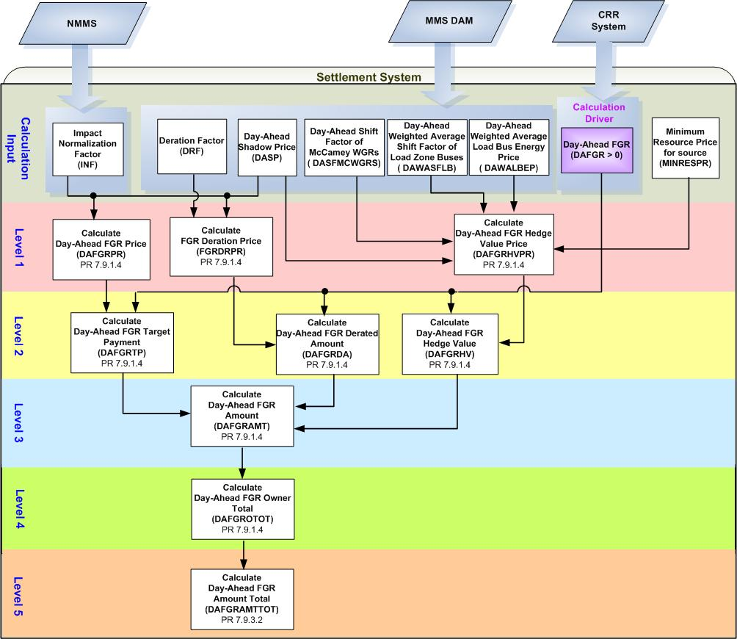
- Dependencies of FGRs Settled in Day-Ahead Market (DAFGRAMT)
Assumptions
Assumptions of upstream systems:
A1) Calculation of Shadow Prices (DASP) is performed outside of the Settlement System. Therefore DASP is assumed to be valid for use of the Settlement System.
A2) Price corrections of DASP are completed in the original source system (MMS) prior to DAM settlements.
A3) Tracking ownership of CRRs is completed in the original source (CRR System). Therefore, DAFGR is assumed to represent appropriate values resulted from PCRR Allocations, CRR Auctions and CRR Bilateral Trades reported to ERCOT CRR system prior to DAM execution.

Assumptions of Settlement Interface:
A4) If DASP is adjusted in the original system (MMS); the Settlement Interface with the original source system (MMS) will update not only the adjusted DASP but the affected INF and DRF prior to DAM settlements.
A5) If DASP has a non zero value for a Constraint for at least one Operating Hour of an Operating Day, the Settlement Interface with original source (MMS) will retrieve that DASP for the Constraint for the entire Operating Day. The Settlement Interface will set DASP to be a default value Zero (0) for any Operating Hours of that Operating Day wherein DASP doesn’t exist for that Constraint.
A6) If DRF has a non zero value for a Constraint for at least one Operating Hour of an Operating Day, the Settlement Interface with original source (MMS) will retrieve that DRF for the Constraint for the entire Operating Day. The Settlement Interface will set DRF to be a default value Zero (0) for any Operating Hours of that Operating Day wherein DRF doesn’t exist for that Constraint.

Other Assumptions:
A7) McCamey Area WGR is the designated source of MCFRI unless specified otherwise by TPTF.
A8) Settlement methodology of payment for a new FGR when it’s not a competitive constraint will be specified upon the FGR introduction.

Business Rules
Req. ID | Protocol(s) | Sub-Process Map | Description
 | PR9.2.3(q) | CSWM. P03SettleBill Transfer | DAFGRAMT is one of DAM settlement “Charge Types”. Therefore the calculation of DAFGRAMT and any calculations that DAFGRAMT is dependent upon should be performed within DAM Settlements process.
 | PR 7.9.1.4 | CSWM. P03SettleBill Transfer | None of the input and intermediate bill determinants should be truncated or rounded in the Settlement System.
 | PR 7.9.1.4 | CSWM. P03SettleBill Transfer | Output bill determinates should be rounded to (2) decimals, including:  - DAFGRAMT  - DAFGRAMTOTOT  - DAFGRAMTTOT
 | PR12.3 (c) | CSWM. P03SettleBill Transfer | The following data shall be available for private data extract, including:  - DAFGR  - INF  - DRF  - DASFMCWGRS  - DAWASFLB  - DAWALBEP  - DAFGRPR  - FGRDRPR  - DAFGRHVPR  - DAFGRTP  - DAFGRHV  - DAFGRDA  - DAFGRAMT  - DAFGRAMTOTOT
 | PR12.3 | CSWM. P03SettleBill Transfer | The following data shall be available for public data extract, including:  - DAFGRAMTTOT
 | PR 7.9.1.4 | CSWM. P03SettleBill Transfer | DRIVER: the calculation of DAFGRAMT shall only be attempted for a FGR for which DAFGR exists with a positive value, for at least one Operating Hour of the Operating Day.

Business Defined Errors
Req. ID | Protocol(s) | Sub-Process Map | Description
 | PR 7.9.1.4 | CSWM. P03SettleBill Transfer | If DAFGRAMT is calculated to be positive, the Settlement System should consider it as a WARN--DEFAULT error, and set DAFGRAMT to a default value – Zero (0) and an error message should be logged. The error message should capture the source and sink Settlement Point, the Operating Hour, and Operating Day, for which DAFGRAMT is calculated as negative.

Specific Database Needs
Req. ID | Protocol(s) | Sub-Process Map | Description
 | PR7.9.1.4 (2) | CSWM. P03SettleBill Transfer | The Settlement System shall incorporate settlements of a newly introduced FGR for its non-competitive condition.

Payments and Charges for PTP Obligations with Refund Settled in DAM (DAOBLRAMT)

Settlement of PTP Obligations with Refund in DAM is described as follows: (PR7.9.1.5)

- Except as specified otherwise in paragraph (2) below, ERCOT shall pay the owner of a PTP Obligation with Refund the difference in the Day-Ahead Settlement Point Prices between the sink Settlement Point and the source Settlement Point, subject to a charge for refund, when the price difference is positive.

- The payment of PTP Obligations with Refund may be further reduced due to transmission elements that are oversold in previous CRR auctions.

Requirement ID
Source Mapping (Protocol/NERC/FERC and other binding documents Ref #) | PR 7.9.1.5
Traceability to Sub-Process Maps | CSWM.P03SettleBillTransfer
Description

Calculate Day-Ahead Obligation with Refund Amount per CRR Owner per Source and Sink pair for each Operating Hour of the Operating Day:

IF ( The Price of PTP Obligation is Non-Positive (DAOBLPR_<SRSP>_<SKSP> ≤ 0) )
THEN:
DAOBLRAMT_<CO>_<SRSP>_<SKSP> = (-1) * DAOBLRTP_<CO>_<SRSP>_<SKSP>

ELSE IF (The Price of PTP Obligation is Positive (DAOBLPR_<SRSP>_<SKSP> > 0) )
THEN:
DAOBLRAMT_<CO>_<SRSP>_<SKSP> = (-1) * Max (DAOBLRTP_<CO>_<SRSP>_<SKSP>
- DAOBLRDA_<CO>_<SRSP>_<SKSP>, Min (DAOBLRTP_<CO>_<SRSP>_<SKSP>, DAOBLRHV_<CO>_<SRSP>_<SKSP>))

Note: An NPRR will be submitted to add subscripts in the protocol formula for “DAOBLRDA”, “DAOBLRTP” and “DAOBLRHV” for TPTP to vote and approve.

Requirement ID
Source Mapping (Protocol/NERC/FERC and other binding documents Ref #) | PR 7.9.1.5 (3)
Traceability to Sub-Process Maps | CSWM.P03SettleBillTransfer
Description

Calculate Day-Ahead Obligation with Refund Target Payment per CRR Owner per Source and Sink pair for each Operating Hour of the Operating Day:

DAOBLRTP_<CO>_<SRSP>_<SKSP> = DAOBLPR_<SRSP>_<SKSP>
* Min (DAOBLR_<CO>_<SRSP>_<SKSP>, OBLRACT_<CO>_<SRSP>_<SKSP>)

NPRR Suggested:
As the prices for PTP Obligation and PTP Obligation with Refund are actually equivalent, it would be good to use the same variable (bill determinant) name.

Requirement ID
Source Mapping (Protocol/NERC/FERC and other binding documents Ref #) | PR 7.9.1.5 (3)
Traceability to Sub-Process Maps | CSWM.P03SettleBillTransfer
Description

Calculate Day-Ahead Obligation with Refund Derated Amount per CRR Owner per Source and Sink pair for each Operating Hour of the Operating Day:

DAOBLRDA_<CO>_<SRSP>_<SKSP> = OBLDRPR_<SRSP>_<SKSP>
* Min (DAOBLR_<CO>_<SRSP>_<SKSP>, OBLRACT_<CO>_<SRSP>_<SKSP>)

Requirement ID
Source Mapping (Protocol/NERC/FERC and other binding documents Ref #) | PR 7.9.1.5 (3)
Traceability to Sub-Process Maps | CSWM.P03SettleBillTransfer
Description

Calculate Day-Ahead Obligation with Refund Hedge Value per CRR Owner per Source and Sink pair for each Operating Hour of the Operating Day:

DAOBLRHV_<CO>_<SRSP>_<SKSP> = DAOBLHVPR_<SRSP>_<SKSP>
* Min (DAOBLR_<CO>_<SRSP>_<SKSP>, OBLRACT_<CO>_<SRSP>_<SKSP>)

Requirement ID
Source Mapping (Protocol/NERC/FERC and other binding documents Ref #) | PR 7.9.1.5(4)
Traceability to Sub-Process Maps | CSWM.P03SettleBillTransfer
Description

Calculate Day-Ahead Obligation with Refund Credit Owner Total per CRR Owner for Each Operating Hour of the Operating Day:

DAOBLRCROTOT_<CO> = $\underset{\text{SRSP}}{Σ}$$\underset{\text{SKSP}}{Σ}$Min (0, DAOBLRAMT_<CO>_<SRSP>_<SKSP>)

Requirement ID
Source Mapping (Protocol/NERC/FERC and other binding documents Ref #) | PR 7.9.1.5(4)
Traceability to Sub-Process Maps | CSWM.P03SettleBillTransfer
Description

Calculate Day-Ahead Obligation with Refund Charge Owner Total per CRR Owner for Each Operating Hour of the Operating Day:

DAOBLRCHOTOT_<CO> = $\underset{\text{SRSP}}{Σ}$$\underset{\text{SKSP}}{Σ}$Max (0, DAOBLRAMT_<CO>_<SRSP>_<SKSP>)

Requirement ID
Source Mapping (Protocol/NERC/FERC and other binding documents Ref #) | PR 7.9.1.5(4)
Traceability to Sub-Process Maps | CSWM.P03SettleBillTransfer
Description

Calculate Day-Ahead Obligation with Refund Amount Owner Total per CRR Owner for Each Operating Hour of the Operating Day:

DAOBLRAMTOTOT_<CO> = DAOBLRCROTOT_<CO> + DAOBLRCHOTOT_<CO>

Requirement ID
Source Mapping (Protocol/NERC/FERC and other binding documents Ref #) | PR 7.9.3.2
Traceability to Sub-Process Maps | CSWM.P03SettleBillTransfer
Description

Calculate Day-Ahead Obligation with Refund Credit Total for Each Operating Hour of the Operating Day:

DAOBLRCRTOT = $\underset{\text{co}}{Σ}$DAOBLRCROTOT_<CO>

Requirement ID
Source Mapping (Protocol/NERC/FERC and other binding documents Ref #) | PR 7.9.3.2
Traceability to Sub-Process Maps | CSWM.P03SettleBillTransfer
Description

Calculate Day-Ahead Obligation with Refund Charge Total for Each Operating Hour of the Operating Day:

DAOBLRCHTOT = $\underset{\text{co}}{Σ}$DAOBLRCHOTOT_<CO>

Input Bill Determinants
Variable |  | Unit |  |  |  |  |  | Definition |  | Original Source
DAOBLR |  | MW |  |  |  |  |  | Day-Ahead Obligation with Refund per CRR Owner per pair of source and sink⎯ The number of CRR Owner’s PTP Obligations with Refund with the source and sink pair settled in DAM for the hour. |  | CRR System
Interval Frequency: 1/ hour

Additional Comments:
- DAOBLR is a result of PCRR Allocation. The owner of DAOBLR should be a NOIE.

- DAOBLR shall be greater than or equal to zero (0).
OBLRACT | MW |  |  |  |  |  | Obligation with Refund Actual usage per CRR Owner per pair of source and sink—CRR Owner’s actual usage for the PTP Obligations with Refund with the source and sink pair, for the hour. |  | TBD
Interval Frequency:

Additional Comments: None
DAOBLPR |  |  | $/MW per hour |  | Day-Ahead Obligation Price per source and sink pair—The DAM price of a PTP Obligation with the pair of source and sink, for the hour. |  |  |  |  | Settlement System
Interval Frequency: 1/ hour

Additional Comments:
- The value of DAOBLPR could be negative, zero, or positive.

- The availability of DAOBLPR is dependent on the global calculation of Day-Ahead Obligation Price (DAOBLPR)
OBLDRPR |  |  |  | $/MW per hour |  | Obligation Deration Price per source and sink pair—The deration price of a PTP Obligation with the source and sink pair, for the hour. |  |  |  |  | Settlement System
Interval Frequency: 1/hour

Additional Comments:
- The value of OBLDRPR shall always be no less than zero (0).

- The availability of OBLDRPR is dependent on the global calculation of Obligation Deration Price (OBLDRPR).
DAOBLHVPR |  |  |  | $/MWh |  | Day-Ahead Obligation Hedge Value Price per source and sink pair—The Day-Ahead hedge price of a PTP Obligation with the source and sink pair, for the hour. |  |  |  |  | Settlement System
Interval Frequency: 1/hour

Additional Comments:
- The value of DAOBLHVPR shall always be no less than zero (0).

- The availability of DAOBLHVPR is dependent on the global calculation of Day-Ahead Obligation Hedge Value Price (DAOBLHVPR).

Intermediate Bill Determinants
Variable | Unit | Definition | Destination
DAOBLRTP | $ | Day-Ahead Obligation with Refund Target Payment per CRR Owner per source and sink pair—The target payment for CRR Owner’s PTP Obligations with Refund, with the source and the sink pair, settled in the DAM, for the hour. | Settlement System
Interval Frequency: 1/ hour

Additional Comments:
- The value of DAOBLRTP could be negative, zero, or positive.
DAOBLRHV | $ | Day-Ahead Obligation with Refund Hedge Value per CRR Owner per source and sink pair—The hedge value of CRR Owner’s PTP Obligations with Refund, with the source and sink pair, settled in the DAM, for the hour. | Settlement System
Interval Frequency: 1/ hour

Additional Comments:
- The value of DAOBLHV shall always be no less than zero (0).
DAOBLRDA | $ | Day-Ahead Obligation with Refund Derated Amount per CRR Owner per source and sink pair—The derated amount of CRR Owner’s PTP Obligations with Refund, with the source and the sink pair, settled in the DAM, for the hour. |  | Settlement System
Interval Frequency: 1/hour

Additional Comments:
- The value of DAOBLRDA shall always be no less than zero (0).

Output Bill Determinants
Variable | Unit |  | Definition | Destination
DAOBLRAMT | $ |  | Day-Ahead Obligation with Refund Amount per CRR Owner per pair of source and sink⎯The payment to CRR Owner for the PTP Obligation with Refund with the source and sink pair, settled in the DAM, for the hour. | Settlement System
Interval Frequency: 1/hour

Additional Comments:
- The value of DAOBLRAMT could be negative, zero, or positive.
DAOBLRCROTOT | $ |  | Day-Ahead Obligation with Refund Credit Owner Total per CRR Owner—The total payment to CRR Owner for its PTP Obligations with Refund settled in the DAM, for the hour. | Settlement System
Interval Frequency: 1/hour

Additional Comments:
- DAOBLRCROTOT will be used by Day-Ahead CRR Shortfall Amount (DACRRSAMT) Calculation.
- The value of DAOBLRCROTOT shall always be no greater than zero (0).
DAOBLRCHOTOT | $ |  | Day-Ahead Obligation with Refund Charge Owner Total per CRR Owner—The total charge to CRR Owner for its PTP Obligations with Refund settled in the DAM, for the hour. | Settlement System
Interval Frequency: 1/hour

Additional Comments:
- The value of DAOBLRCHOTOT shall always be no less than zero (0).
DAOBLRAMTOTOT | $ |  | Day-Ahead Obligation with Refund Amount Owner Total per CRR Owner—The net total payment or charge to CRR Owner for all its PTP Obligations with Refund settled in the DAM, for the hour. | Settlement System
Interval Frequency: 1/hour

Additional Comments: None
DAOBLRCRTOT | $ |  | Day-Ahead Obligation with Refund Credit Total—The total payment of all PTP Obligations with Refund settled in the DAM, for the hour. | Settlement System
Interval Frequency: 1/hour

Additional Comments:
- DAOBLRCRTOT will be used by CRR Balancing Account Credit (CRRBACR) Calculation.
DAOBLRCHTOT | $ |  | Day-Ahead Obligation with Refund Charge Total—The total charge of all PTP Obligations with Refund settled in the DAM, for the hour. | Settlement System
Interval Frequency: 1/hour

Additional Comments:
- DAOBLRCHTOT will be used by CRR Balancing Account Credit (CRRBACR) Calculation.
DAOBLRBILLAMTOTOT |  | $ | Day-Ahead Obligation with Refund Owner Bill Amount per CRR Owner ⎯ The Delta of Day-Ahead Obligation with Refund Amount Owner Total between the current and the previous settlement run -- per CRR Owner, for the day. | Settlement System
Interval Frequency: 1/hour

Additional Comments:
- This bill determinant is not specifically documented in the Nodal Protocols but is required as a result of Section 9 Statements and Invoices Protocol requirements.

Data Dependencies
D1) Calculation of DAOBLRAMT is dependent upon the availability of the input determinants.
D2) Calculation of DAOBLRAMT is dependent upon the availability of global calculations: DAOBLPR, OBLDRPR, and DAOBLHVPR.
D3) Calculation of CRR Balancing Account Credit (CRRBACR) is dependent upon the calculation of DAOBLRCHTOT and DAOBLRCRTOT.
D4) Calculation of Day-Ahead CRR Shortfall Amount (DACRRSAMT) is dependent upon the calculation of DAOBLRCROTOT.

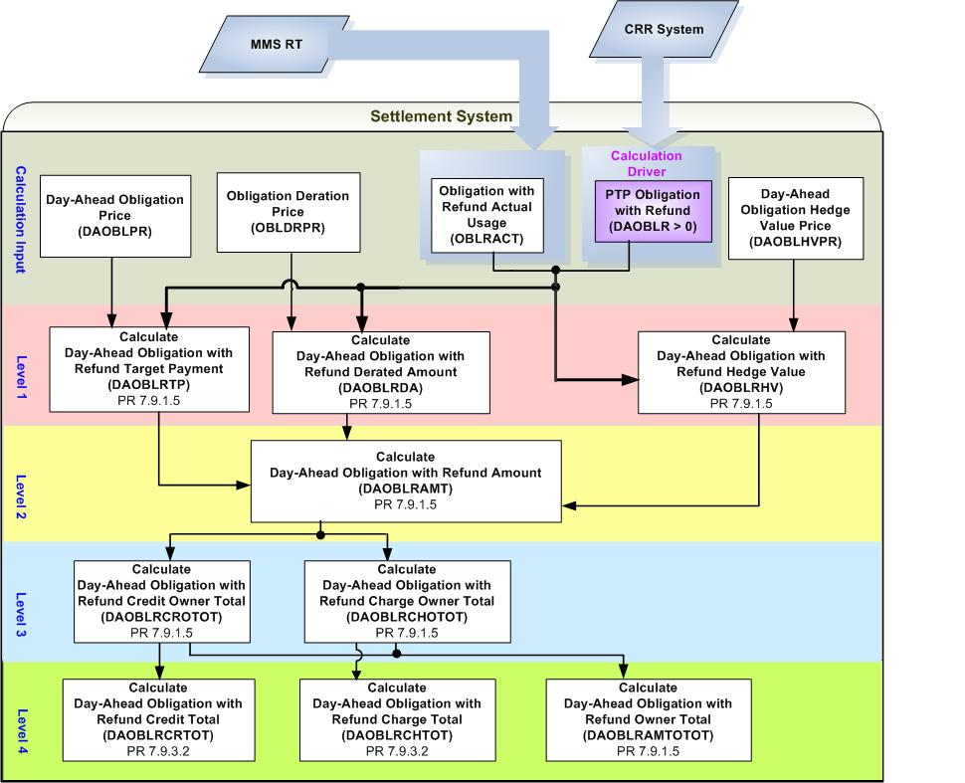

- Dependencies of PTP Obligations with Refund Settled in Day-Ahead Market (DAOBLRAMT)

Assumptions of upstream systems:
A1) Tracking ownership of CRRs is completed in the original source (CRR System). Therefore, DAOBLR is assumed to represent appropriate values resulted from PCRR Allocations as PTP Obligations with Refund can be acquired by NOIE only through PCRR Allocations.
Other Assumptions:
A2) Calculation of Obligation with Refund Actual Usage (OBLRACT) as described in the formula below will be addressed by a separate set of Requirements:

OBLRACT _{o, (j, k)} = $\underset{y}{Σ}$($\underset{r}{Σ}$(OBLROF _{o, r, (j, k)} * RESACT _{r, (j, k), y}) * TLMP _{y}) / ($\underset{y}{Σ}$TLMP _{y}) * OBLRF _{o, (j, k)}

Where:
RESACT is the output of Resource r associated with the PTP options with Refund with the source and sink pair, for the SCED interval y;
OBLRF is the factor showing the percentage usage of Resource r for CRR Owner o’s PTP Options with Refund with the source and sink pair; Its value is 1, if only one CRR Owner has acquired PCRRs under the refund provision using Resource r;
TLMP is the duration of the portion of the SCED interval y within the hour;
o is a CRR Owner;
y is a SCED interval in the hour;
r is a Resource;
j is a source Settlement Point;
k is a sink Settlement Point.

A3) Calculation of Resource Actual (RESACT) as described in the formula below will be addressed by a separate set of Requirements:

If (OS _{r, y} exists)
RESACT _{r, (j, k), y} = OS _{r, y}
Otherwise
If (EBP _{r, y} exists)
RESACT _{r, (j, k), y} = EBP _{r, y}
Otherwise
RESACT _{r, (j, k), y} = BP _{r, y}

Where:
RESACT is the output of Resource r associated with the PTP options with Refund with the source and sink pair, for the SCED interval y;
BP is the Base Point of Resource for the SCED interval y;
EBP is the Emergency Base Point of Resource for the SCED interval y;
OS is the Output Schedule for Resource for the ACED interval y;
y is a SCED interval in the hour;
r is a Resource;
j is a source Settlement Point;
k is a sink Settlement Point;

Business Rules
Req. ID | Protocol(s) | Sub-Process Map | Description
 | PR9.2.3(r) | CSWM. P03SettleBill Transfer | DAOBLRAMT is one of DAM settlement “Charge Types”. Therefore the calculation of DAOBLRAMT and any calculations that DAOBLRAMT is dependent upon shall be performed within DAM Settlements process.
 | PR 7.9.1.5 | CSWM. P03SettleBill Transfer | Due to the fact that SCED information is involved in the calculation of Obligation with Refund Actual Usage (OBLRACT), the calculation of DAOBLRAMT requires that SCED data from Real-Time Market be available.
 | PR 7.9.1.5 | CSWM. P03SettleBill Transfer | None of the input and intermediate bill determinants should be truncated or rounded in the Settlement System.
 | PR 7.9.1.5 | CSWM. P03SettleBill Transfer | Output bill determinates should be rounded to (2) decimals, including:  - DAOBLRAMT  - DAOBLRCROTOT  - DAOBLRCHOTOT  - DAOBLRAMTOTOT  - DAOBLRCRTOT  - DAOBLRCHTOT
 | PR12.3 (c) | CSWM. P03SettleBill Transfer | The following data shall be available for private data extract, including:  - DAOBLR  - OBLRACT  - DAOBLRPR  - OBLDRPR  - DAOBLHVPR  - DAOBLRPR  - DAOBLRTP  - DAOBLRHV  - DAOBLRDA  - DAOBLRAMT  - DAOBLRBILLAMTOTOT  - DAOBLRCROTOT  - DAOBLRCHOTOT  - DAOBLRAMTOTOT
 | PR12.3 | CSWM. P03SettleBill Transfer | The following data shall be available for public data extract, including:  - DAOBLRCRTOT  - DAOBLRCHTOT
 | PR 7.9.1.5 | CSWM. P03SettleBill Transfer | DRIVER: the calculation of DAOBLRAMT shall be only attempted for the source and sink pair for which a DAOBLR exists with a positive value for at least one Operating Hour of the Operating Day.

Business Defined Errors
Specific Da
 | PR 7.9.1.5 | CSWM. P03SettleBill Transfer | If the calculation of DAOBLRDA needs OBLDRPR that is not available for the source and sink Settlement Point pair, the Settlement System should set DAOBLRDA to be Zero (0). No error message is necessary.
 | PR 7.9.1.5 | CSWM. P03SettleBill Transfer | If the calculation of DAOBLRHV needs DAOBLHVPR that is not available for the source and sink Settlement Point pair, the Settlement System should set DAOBLRHV to be Zero (0) and an error message should be logged. The error message should capture the source and sink Settlement Point, the Operating Hour, and Operating Day, for which DAOBLHVPR is missing.

Specific Database Needs
None

Payments for PTP Options with Refund Settled in DAM (DAOPTRAMT)

Settlement of PTP Options with Refund in DAM is described as follows: (PR7.9.1.6)

(1) Except as specified otherwise in paragraph (2) below, ERCOT shall pay the owner of a PTP Option with Refund the difference in the DAM Settlement Point Prices between the sink Settlement Point and the source Settlement Point, if positive, subject to a charge for refund, as described in the item (1) (c) (i) of Section 7.4.2, PCRR Allocation Terms and Conditions.

(2) The payment of PTP Options with Refund may be further reduced due to transmission elements that are oversold in previous CRR auctions.

(3) The payment to each CRR Owner for a given Operating Hour of its PTP Options with Refund with each pair of source and sink Settlement Points settled in the DAM is calculated as follows:

Requirement ID
Source Mapping (Protocol/NERC/FERC and other binding documents Ref #) | PR 7.9.1.6(3)
Traceability to Sub-Process Maps | CSWM.P03SettleBillTransfer
Description

Calculate Day-Ahead Option with Refund Amount per CRR Owner per Source and Sink pair for each Operating Hour of the Operating Day:

DAOPTRAMT_<CO>_<SRSP>_<SKSP> = (-1) * Max ((DAOPTRTP_<CO>_<SRSP>_<SKSP>
– DAOPTRDA_<CO>_<SRSP>_<SKSP>), Min (DAOPTRTP_<CO>_<SRSP>_<SKSP>, DAOPTRHV_<CO>_<SRSP>_<SKSP>)

Requirement ID
Source Mapping (Protocol/NERC/FERC and other binding documents Ref #) | PR 7.9.1.6(3)
Traceability to Sub-Process Maps | CSWM.P03SettleBillTransfer
Description

Calculate Day-Ahead Option with Refund Target Payment per CRR Owner per Source and Sink pair for each Operating Hour of the Operating Day:

DAOPTRTP_<CO>_<SRSP>_<SKSP> = DAOPTPR_<SRSP>_<SKSP>
* Min (DAOPTR_<CO>_<SRSP>_<SKSP>
, OPTRACT_<CO>_<SRSP>_<SKSP> * DAOPTR_<CO>_<SRSP>_<SKSP>
/ (DAOPTR_<CO>_<SRSP>_<SKSP> + RTOPTR_<CO>_<SRSP>_<SKSP>))

NPRR Suggested: As the prices for PTP Obligation and PTP Obligation with Refund are actually equivalent, it would be good to use the same variable (bill determinant) name.

Requirement ID
Source Mapping (Protocol/NERC/FERC and other binding documents Ref #) | PR 7.9.1.6(3)
Traceability to Sub-Process Maps | CSWM.P03SettleBillTransfer
Description

Calculate Day-Ahead Option with Refund Derated Amount per CRR Owner per Source and Sink pair for each Operating Hour of the Operating Day:

DAOPTRDA_<CO>_<SRSP>_<SKSP> = OPTDRPR_<SRSP>_<SKSP>
* Min (DAOPTR_<CO>_<SRSP>_<SKSP>
, OPTRACT_<CO>_<SRSP>_<SKSP> * DAOPTR_<CO>_<SRSP>_<SKSP>
/ (DAOPTR_<CO>_<SRSP>_<SKSP> + RTOPTR_<CO>_<SRSP>_<SKSP>))

Requirement ID
Source Mapping (Protocol/NERC/FERC and other binding documents Ref #) | PR 7.9.1.6(3)
Traceability to Sub-Process Maps | CSWM.P03SettleBillTransfer
Description

Calculate Day-Ahead Option with Refund Hedge Value per CRR Owner per Source and Sink pair for each Operating Hour of the Operating Day:

DAOPTRHV_<CO>_<SRSP>_<SKSP> = DAOPTHVPR_<SRSP>_<SKSP>
* Min (DAOPTR_<CO>_<SRSP>_<SKSP>
, OPTRACT_<CO>_<SRSP>_<SKSP> * DAOPTR_<CO>_<SRSP>_<SKSP>
/ (DAOPTR_<CO>_<SRSP>_<SKSP> + RTOPTR_<CO>_<SRSP>_<SKSP>))

Requirement ID
Source Mapping (Protocol/NERC/FERC and other binding documents Ref #) | PR 7.9.1.6(4)
Traceability to Sub-Process Maps | CSWM.P03SettleBillTransfer
Description

Calculate Day-Ahead Option with Refund Amount Owner Total per NOIE CRR Owner for each Operating Hour of the Operating Day:

DAOPTRAMTOTOT_<CO> = $\underset{\text{SRSP}}{Σ}$$\underset{\text{SKSP}}{Σ}$DAOPTRAMT_<CO>_<SRSP>_<SKSP>

Requirement ID
Source Mapping (Protocol/NERC/FERC and other binding documents Ref #) | PR 7.9.3.2
Traceability to Sub-Process Maps | CSWM.P03SettleBillTransfer
Description

Calculate Day-Ahead Option with Refund Amount Total for each Operating Hour of the Operating Day:

DAOPTRAMTTOT = $\underset{\text{co}}{Σ}$DAOPTRAMTOTOT_<CO>

Input Bill Determinants
Variable | Unit |  |  |  |  |  | Definition |  | Original Source
DAOPTR | MW |  |  |  |  |  | Day-Ahead Option with Refund per CRR Owner per pair of source and sink⎯The number of CRR Owner’s PTP Options with Refund with the pair of source and sink, settled in DAM, for the hour. |  | CRR System & MMS DAM
Interval Frequency: 1/ hour

Additional Comments:
- DAOPTR is a result of PCRR Allocation. The owner of DAOPTR shall be a designated NOIE.

- DAOPTR equals the difference between (a) and (b):
(a) The amount of PTP Options with Refund acquired through PCRR Allocations by NOIEs.
(b) The amount of PTP Options with Refund that is declared before DAM execution by NOIEs to be settled in Real-Time and not cleared in the DAM.

- DAOPTR shall always be equal to or greater than zero (0).
OPTRACT |  |  |  | MW |  |  | Option with Refund Actual usage per CRR Owner per pair of source and sink—CRR Owner’s actual usage for the PTP Options with Refund with the pair of source and sink, for the hour. |  |  | TBD
Interval Frequency: 1/hour

Additional Comments: None
DAOPTPR |  |  | $/MW per hour |  |  | Day-Ahead Option Price per pair of source and sink⎯The DAM price of the PTP Option with the pair of source and sink, for the hour. |  |  | Settlement System
Interval Frequency: 1/hour

Additional Comments:
- The value of DAOPTPR shall always be no less than zero (0).

- The availability of DAOPTPR is dependent on the global calculation of Day-Ahead Option Price (DAOPTPR).
OPTDRPR |  |  | $/MW per hour |  |  | Option Deration Price per source and sink pair—The deration price of a PTP Option with the source and the sink, for the hour. |  |  | Settlement System
Interval Frequency: 1/hour

Additional Comments:
- The value of OPTDRPR shall always be no less than zero (0).

- The availability of Option Deration Price is dependent on the global calculation of Option Deration Price(OPTDRPR).
DAOPTHVPR |  |  | $/MWh |  |  | Day-Ahead Option Hedge Value Price per pair of source and sink—The Day-Ahead hedge price of a PTP Option with the pair of source and sink, for the hour. |  |  | Settlement System
Interval Frequency: 1/hour

Additional Comments:
- The value of DAOPTHVPR shall always be no less than zero (0).

- The availability of DAOPTHVPR is dependent on the global calculation of Day-Ahead Option Hedge Value Price (DAOPTHVPR).
RTOPTR |  | MW |  |  | Real-Time Option with Refund per pair of source and sink—The number of the NOIE CRR Owner’s PTP Options with Refund with the source and sink pair, settled in Real-Time, for the hour. |  |  | MMS DAM
Interval Frequency: 1/Hour

Comments:
- RTOPTR is the amount of PTP Options with Refund that are declared before DAM execution by NOIE CRR Owners to be settled in Real-Time and not cleared in the DAM.

- Reference to TN.COMS.63C01.RTCRR.REQUIREMENTS.A

Intermediate Bill Determinants
Variable | Unit | Definition | Destination
DAOPTRTP | $ | Day-Ahead Option with Refund Target Payment per CRR Owner per source and sink pair—The target payment for CRR Owner’s PTP Options with Refund, with the pair of source and sink, settled in the DAM, for the hour. | Settlement System
Interval Frequency: 1/ hour

Additional Comments:
- The value of DAOPTRTP shall always be no less than zero (0).
DAOPTRHV | $ | Day-Ahead Option with Refund Hedge Value per CRR Owner per source and sink pair—The hedge value of CRR Owner’s PTP Options with Refund, with the pair of source and the sink, settled in the DAM, for the hour. | Settlement System
Interval Frequency: 1/ hour

Additional Comments:
- The value of DAOPTHV shall always be no less than zero (0).
DAOPTRDA | $ | Day-Ahead Option with Refund Derated Amount per CRR Owner per source and sink pair—The derated amount of CRR Owner’s PTP Options with Refund, with the pair of source and the sink, settled in the DAM, for the hour. | Settlement System
Interval Frequency: 1/hour

Additional Comments:
- The value of DAOPTDA always be no less than zero (0).

Output Bill Determinants
Variable | Unit |  | Definition | Destination
DAOPTRAMT | $ |  | Day-Ahead Option with Refund Amount per CRR Owner per pair of source and sink⎯The payment to CRR Owner for its PTP Options with Refund with the pair of source and the sink, settled in the DAM, for the hour. | Settlement System
Interval Frequency: 1/hour

Additional Comments:
- The value of DAOPTAMT shall be no greater than zero (0).
DAOPTRAMTOTOT | $ |  | Day-Ahead Option with Refund Amount Owner Total per CRR Owner—The total payment to NOIE CRR Owner for all its PTP Options with Refund settled in the DAM, for the hour. | Settlement System
Interval Frequency: 1/hour

Additional Comments:
- DAOPTRAMTOTOT will be used by Day-Ahead CRR Shortfall Amount (DACRRSAMT) Calculation.
DAOPTRAMTTOT | $ |  | Day-Ahead Option with Refund Amount Total—The total payment of all PTP Options with Refund settled in the DAM, for the hour. | Settlement System
Interval Frequency: 1/hour

Additional Comments:
- DAOPTRAMTTOT will be used by CRR Balancing Account Credit (CRRBACR) Calculation.
DAOPTRBILLAMTOTOT |  | $ | Day-Ahead Option with Refund Bill Amount per CRR Owner ⎯ The Delta of Day-Ahead Option with Refund Amount Owner Total between the current and the previous settlement run -- per CRR Owner, for the day. | Settlement System
Interval Frequency: 1/hour

Additional Comments:
- This bill determinant is not specifically documented in the Nodal Protocols but is required as a result of Section 9 Statements and Invoices Protocol requirements.

Data Dependencies
D1) Calculation of DAOPTRAMT is dependent upon the availability of the input determinants.
D2) Calculation of DAOPTAMT is dependent upon the availability of global calculations: DAOPTPR, OPTDRPR, and DAOPTHVPR.
D3) Calculation of CRR Balancing Account Credit (CRRBACR) is dependent upon the calculation of DAOPTRAMTTOT.
D4) Calculation of Day-Ahead CRR Shortfall Amount (DACRRSAMT) is dependent upon the calculation of DAOPTRAMTOTOT.

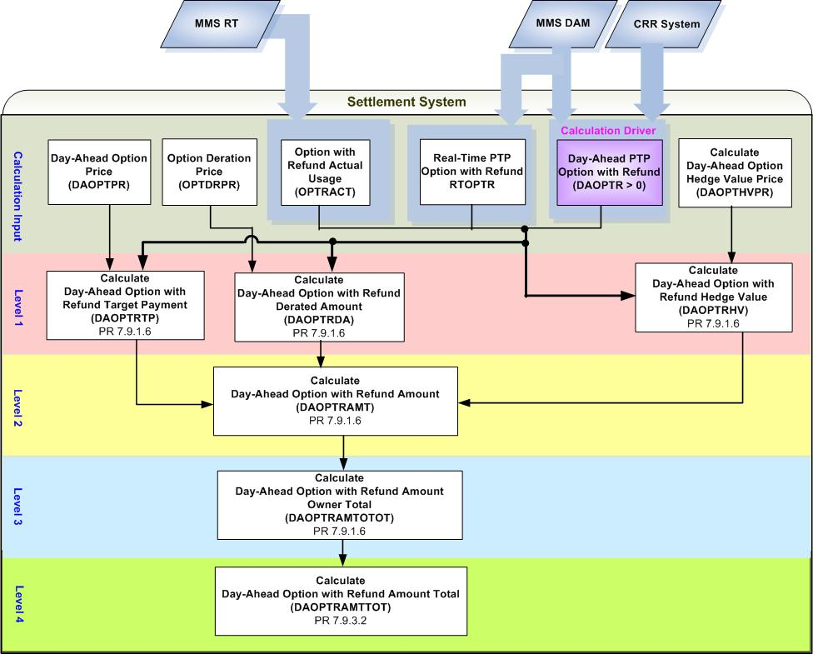
- Dependencies of PTP Options with Refund Settled in Day-Ahead Market (DAOPTRAMT)

Assumptions
Assumptions of upstream systems:
A1) Determination of whether or not PTP Options with Refund owned by NOIE are eligible for Real-Time Settlements is made by the original source (MMS DAM).

Other Assumptions:
A2) Calculation of Option with Refund Actual Usage (OPTRACT) as described in the formula below will be addressed by a separate set of Requirements:

OPTRACT _{o, (j, k)} = $\underset{y}{Σ}$($\underset{r}{Σ}$(OPTROF _{o, r, (j, k)} * RESACT _{r, (j, k), y}) * TLMP _{y}) / ($\underset{y}{Σ}$TLMP_{y}) * OPTRF _{o, (j, k)}

Where:
RESACT is the output of Resource r associated with the PTP options with Refund with the source and sink pair, for the SCED interval y;
OPTRF is the factor showing the percentage usage of Resource r for CRR Owner o’s PTP Options with Refund with the source and sink pair; Its value is 1, if only one CRR Owner has acquired PCRRs under the refund provision using Resource r;
TLMP is the duration of the portion of the SCED interval y within the hour;
o is a CRR Owner;
y is a SCED interval in the hour;
r is a Resource;
j is a source Settlement Point;
k is a sink Settlement Point.

A3) Calculation of Resource Actual (RESACT) as described in the formula below will be addressed by a separate set of Requirements:

If (OS _{r, y} exists)
RESACT _{r, (j, k), y} = OS _{r, y}
Otherwise
If (EBP _{r, y} exists)
RESACT _{r, (j, k), y} = EBP _{r, y}
Otherwise
RESACT _{r, (j, k), y} = BP _{r, y}

Where:
RESACT is the output of Resource r associated with the PTP options with Refund with the source and sink pair, for the SCED interval y;
BP is the Base Point of Resource for the SCED interval y;
EBP is the Emergency Base Point of Resource for the SCED interval y;
OS is the Output Schedule for Resource for the ACED interval y;
y is a SCED interval in the hour;
r is a Resource;
j is a source Settlement Point;
k is a sink Settlement Point;

Business Rules
Req. ID | Protocol(s) | Sub-Process Map | Description
 | PR9.2.3(s) | CSWM. P03SettleBill Transfer | DAOPTRAMT is one of DAM settlement “Charge Types”. Therefore the calculation of DAOPTRAMT and any calculations that DAOPTRAMT is dependent on shall be performed within DAM Settlements process.
 | PR 7.9.1.6 | CSWM. P03SettleBill Transfer | Due to the fact that SCED information is involved in the calculation of Option with Refund Actual Usage (OPTRACT), the calculation of DAOPTRAMT requires that SCED data from Real-Time Market be available.
 | PR 7.9.1.6 | CSWM. P03SettleBill Transfer | None of the input and intermediate bill determinants should be truncated or rounded in the Settlement System.
 | PR 7.9.1.6 | CSWM. P03SettleBill Transfer | Output bill determinates should be rounded to (2) decimals, including:  - DAOPTRAMT  - DAOPTRAMTOTOT  - DAOPTRAMTTOT
 | PR12.3 (c) | CSWM. P03SettleBill Transfer | The following data shall be available for private data extract, including:  - DAOPTR  - OPTRACT  - DAOPTRPR  - OPTDRPR  - DAOPTHVPR  - DAOPTRPR  - DAOPTRTP  - DAOPTRHV  - DAOPTRDA  - DAOPTRAMT  - DAOPTRAMTOTOT  - DAOPTRBILLAMTOTOT
 | PR12.3 | CSWM. P03SettleBill Transfer | The following data shall be available for public data extract, including:  - DAOPTRAMTTOT
 | PR 7.9.1.6 | CSWM. P03SettleBill Transfer | DRIVER: the calculation of DAOPTRAMT shall be only attempted for the source and sink pair for which a DAOPTR exists with a positive value for at least one Operating Hour of the Operating Day.

Business Defined Errors

Req. ID | Protocol(s) | Sub-Process Map | Description
 | PR 7.9.1.6 | CSWM. P03SettleBill Transfer | If the calculation of DAOPTRDA needs OPTDRPR that is not available for the source and sink Settlement Point pair, the Settlement System should set DAOPTRDA to be Zero (0). No error message is necessary.
 | PR 7.9.1.6 | CSWM. P03SettleBill Transfer | If the calculation of DAOPTRHV needs DAOPTHVPR that is not available for the source and sink Settlement Point pair, the Settlement System should set DAOPTRHV to be Zero (0) and an error message should be logged. The error message should capture the source and sink Settlement Point, the Operating Hour, and Operating Day, for which DAOPTHVPR is missing.
 | PR 7.9.1.6 | CSWM. P03SettleBill Transfer | If DAOPTRAMT is calculated to be positive, the Settlement System should consider it as a WARN--DEFAULT error, and set DAOPTRAMT as a default value – Zero (0) and an error message should be logged. The error message should capture the source and sink Settlement Point, the Operating Hour, and Operating Day, for which DAOPTRAMT is calculated as negative.

Specific Database Needs
None

Supplementary Requirements

Performance Requirements
Lodestar must be able to perform its full set of Nodal settlement calculations. Performance characteristics will be determined and detailed in the conceptual and detailed design.

Legal and Regulatory requirements
All Lodestar financial data must be saved in accordance with standard accounting principles as dictated by the ERCOT Texas Nodal Protocols.

System Security Requirements
Lodestar will only be accessed directly by internal ERCOT personnel either through thin client UI, Citrix environment, or thick client on employee desktops. Market Participants will be able to access their statements and invoices on ERCOT private web site. ERCOT private web site access will be controlled by digital certificate authentication in accordance with ERCOT security policies.

Back up and Recovery Requirements
All Lodestar Nodal settlement data must be backed up on a daily basis and recoverable within 24 hours.

Availability and Redundancy Requirements
Nodal Lodestar system must be available 7/24. Lodestar is considered a tier 1 system and critical to base ERCOT business processes

Maintainability Requirements
Lodestar Nodal system will be maintained by internal ERCOT personnel. SLAs and explicit support will be detailed in the detail design document.

Daylight Savings Time shall be recognized in Nodal Market settlements.
- Spring Daylight Savings Time Operating Day:
    - Hour Ending 0300 will be skipped, resulting in 23 hourly intervals for the day.
    - The four fifteen minute intervals within Hour Ending 0300 will be skipped, resulting in 92 fifteen minute intervals for the day.
    - The sixty one minute intervals within Hour Ending 0300 will be skipped, resulting in 1380 total one minute intervals.
  - Fall Daylight Savings Time Operating Day:
    - Hour Ending 0200 will be repeated, resulting in 25 hourly intervals for the day.
    - The four fifteen minute intervals within Hour Ending 0200 will be repeated, resulting in 100 fifteen minute intervals for the day.
    - The sixty one minute intervals within Hour Ending 0200 will have two sets of data, resulting in 1500 total one minute intervals.

Protocol Coverage

Protocol Sub-Section | Description | Coverage by Requirements  (Full/Partial)
PR 7.9.1.1 | Payments and Charges for PTP Obligations Settled in DAM | Partial
PR 7.9.1.2 | Payments for PTP Options Settled in DAM | Partial
PR 7.9.1.3 | Minimum and Maximum Resource Prices | Partial
PR 7.9.1.4 | Payments for FGRs Settled in DAM | Partial
PR 7.9.1.5 | Payments and Charges for PTP Obligations with Refund Settled in DAM | Partial
PR 7.9.1.6 | Payments for PTP Options with Refund Settled in DAM | Partial
PR 7.9.3.3 | Shortfall Charges to CRR Owners | Partial

* Formula to calculate Minimum Resource Price for source Settlement Point is not explicitly documented by Nodal Protocols.
* Formula to calculate Maximum Resource Price for sink Settlement Point is not explicitly documented by Nodal Protocols.

