Commercial Systems

Congestion Revenue Rights Auction Revenue Disbursement Requirements

v0.09

Revision History
Date | Version | Description | Author
09/14/06 | 0.01 | Started Initial Draft | Sharon Wang
09/15/06 | 0.02 | Incorporated IDA Feedback | Sharon Wang
09/21/06 | 0.03 | Incorporated Internal Review Feedback | Sharon Wang
09/21/06 | 0.09 | TPTF Review Process | Sharon Wang

Table of Contents
1. Congestion Revenue Rights Auction Revenue Disbursement 3
1.1 Proposed System Scope 3
1.2 Document Conventions 3
1.3 Document Assumptions 3
2. Functional Requirements 3
2.1 CRR Auction Revenues (CRRZREV; CRRNZREV; PCRRAREV; PCRRNZREV) 3
Input Bill Determinants 3
Output Bill Determinants 3
Data Dependencies 3
Assumptions 3
Business Rules 3
Business Defined Errors 3
Specific Database Needs 3
2.2 CRR Auction Revenue Disbursement (LACMRZAMT, LACMRNZAMT) 3
Input Bill Determinants 3
Output Bill Determinants 3
Data Dependencies 3
Assumptions 3
Business Rules 3
Business Defined Errors 3
Specific Database Needs 3
3. Supplementary Requirements 3
3.1 Performance Requirements 3
3.2 Legal and Regulatory requirements 3
3.3 System Security Requirements 3
3.4 Back up and Recovery Requirements 3
3.5 Availability and Redundancy Requirements 3
3.6 Maintainability Requirements 3
3.7 Daylight Savings Time shall be recognized in Nodal Market settlements. 3
4. Protocol Coverage 3

Software Requirements Specification

Congestion Revenue Rights Auction Revenue Disbursement

Proposed System Scope

ERCOT plans to implement a new Nodal market in 2009. Sections 7, 9 and 12 of the Nodal Protocols describe the various Charge Types, Settlement Statement, and Market Information System requirements for the Congestion Revenue Rights (CRR) Auction Revenue Disbursement. The Nodal Protocols will guide this project. The requirements in this document were based on information detailed in Nodal Protocols Section 7 (005NPRR-05_BOD_Action_Report_071806), and Nodal Protocols Section 9 (007NPRR-05_BOD_Action_ Report_ 071806).

The document defines the requirements for calculating the Congestion Revenue Rights Auction Revenue Disbursement. Specifically, it comprises the requirements for the following two payments (or charges) that shall be both shall on one monthly invoice:
- Load-Allocated CRR Monthly Revenue Zonal Amount (LACMRZAMT)
-- PR 7.5.7 (1) (5); PR 9.10 5 (b)
- Load-Allocated CRR Monthly Revenue Non-Zonal Amount (LACMRNZAMT)
-- PR 7.5.7 (1) (6); PR 9.10 5 (b)

The following calculations are also addressed by these requirements:
- CRR Auction Revenues:
-- PR 7.5.6.4; PR 9.10 5 (a)
  - CRR Zonal Revenue (CRRZREV)
  - CRR non-Zonal Revenue (CRRNZREV)
  - PCRR Zonal Revenue (PCRRZREV)
  - PCRR non-Zonal Revenue (PCRRNZREV)

To Be Sub-Process for Settlements and Billing
For illustrative purposes, Figures 1 to Figure 5 are provided to describe calculation dependencies in this document.
Figure 1 illustrates the proposed scope of CRR Settlements. It comprises Day-Ahead CRR Settlements, Real-Time CRR Settlements, CRR Balancing Account, and CRR Auctions Settlements, within which CRR Auction Revenue Disbursement is addressed by this document, and other components are addressed by separate sets of Requirements.
A dependency diagram is provided to depict the dependencies between calculation inputs, intermediate variables, and outputs for each section of Functional Requirements.
These figures should be considered in conjunction with the textual requirements. If a contradiction exists between an illustrative figure and its associated textual requirements, the textual requirements should override the figure.

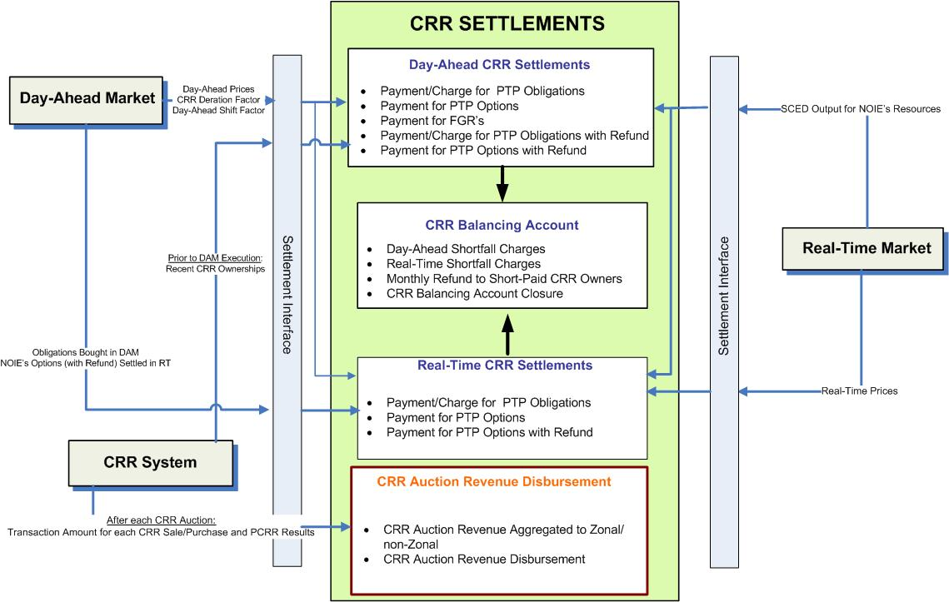

- Proposed Scope of CRR Settlements

Document Conventions
- All text directly lifted from the Nodal Protocols is in italic font.
- All requirements are identified using R1, R2, etc.
- All dependencies are identified using D1, D2, etc.
- All assumptions are identified using A1, A2, etc.
- Settlement Recorders in this document adhere to the following naming convention:
BILLDETERMINANT_<Q>_<CO>_<CH>_<Z>_<R>_<SP>_<SRSP>_<SKSP>_<F>_<E>_<C>_<A>

Where:
<Q> = QSE
<CO> = CRR Owner
<CH> = CRR Account Holder
<Z> = Zone
<R> = Resource
<SP> = Settlement Point
<SRSP> = Source Settlement Point
<SKSP> = Sink Settlement Point
<F> = Flowgate
<E> = Directional Network Element
<C> = Constraint Identifier
<A> = CRR Auction

- Footnotes in this document are denoted by a * sign.
- Each Section Title will include the Charge Type/Bill Determinant description and the associated Bill Determinant in parenthesis.
- It is assumed that Input Bill Determinants described in this requirement has a compatible data format with Settlement System.
- The color scheme used in calculation dependency diagrams is defined in Figure 3 and Figure 4.
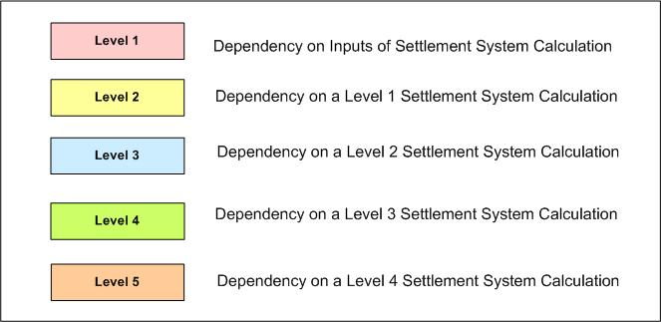

- Color Definition for Levels of Dependency Diagram used in CRR Auction Revenue Disbursement Requirements

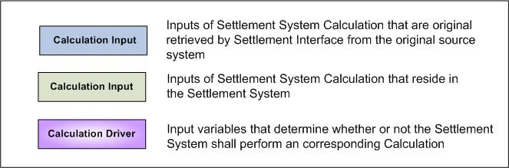

- Color Definition for Inputs of Dependency Diagram used in CRR Auction Revenue Disbursement Requirements

Document Assumptions

- A separate requirement document will address the Settlement Interface with original sources such as MMS and CRR System. Specifically, this Settlement Interface Requirement will focus on when, what, and how input data should be retrieved from the original source, how to evaluate input data validity and completeness, and how to handle input data missing or other types of errors, to perform CRR Settlements Calculations described in this document.
- For any Charge Types that require historical data for the calculation, this information is obtained via alternative means for during the beginning of market open until the data is available.

Functional Requirements

CRR Auction Revenues (CRRZREV; CRRNZREV; PCRRAREV; PCRRNZREV)

Requirement ID
Source Mapping (Protocol/NERC/FERC and other binding documents Ref #) | PR 7.5.6.4 (1)
Traceability to Sub-Process Maps | CSWM.P03SettleBillTransfer
Description

Calculate CRR Zonal Revenue per 2003 ERCOT Congestion Management Zone (CMZ) per CRR Auction for PTP Obligations and PTP Options for which source and sink are located within the same 2003 ERCOT CMZ and FGR’s Located in the 2003 ERCOT CMZ, cleared in each CRR Auction:

CRRZREV_<Z>_<A> =
$\sum_{h}{}$($\sum_{\text{CH}}{\begin{matrix} \\ \sum_{\text{SKSP}}{\begin{matrix} \\ \sum_{\text{SRSP}}{}\end{matrix}}\end{matrix}}$OBLSAMT_<CH>_<Z>_<SKSP>_<SRSP>_<A>
+ $\sum_{\text{CH}}{\begin{matrix} \\ \sum_{\text{SKSP}}{\begin{matrix} \\ \sum_{\text{SRSP}}{}\end{matrix}}\end{matrix}}$OPTSAMT_<CH>_<Z>_<SKSP>_<SRSP>_<A>
+ $\sum_{\text{CH}}{\begin{matrix} \\ \sum_{F}{}\end{matrix}}$FGRSAMT_<CH>_<Z>_<F>_<A>
+ $\sum_{\text{CH}}{\begin{matrix} \\ \sum_{\text{SKSP}}{\begin{matrix} \\ \sum_{\text{SRSP}}{}\end{matrix}}\end{matrix}}$OBLPAMT_<CH>_<Z>_<SKSP>_<SRSP>_<A>
+ $\sum_{\text{CH}}{\begin{matrix} \\ \sum_{\text{SKSP}}{\begin{matrix} \\ \sum_{\text{SRSP}}{}\end{matrix}}\end{matrix}}$OPTPAMT_<CH>_<Z>_<SKSP>_<SRSP>_<A>
+ $\sum_{\text{CH}}{\begin{matrix} \\ \sum_{F}{}\end{matrix}}$FGRPAMT_<CH>_<Z>_<F>_<A> )

Where:
h represents each hour in the auctioned month;
OBLSAMT, OBLPAMT, OPTPAMT, and FGRPAMT represent the transaction dollar amount for which invoices have been paid in full by the applicable CRR Account Holders.

Clarification necessary on an FGR that has multiple elements (because the elements may not all reside in the same CMZ).

Requirement ID
Source Mapping (Protocol/NERC/FERC and other binding documents Ref #) | PR 7.5.6.4 (2)
Traceability to Sub-Process Maps | CSWM.P03SettleBillTransfer
Description

Calculate CRR non-Zonal Revenue per CRR Auction for PTP Obligations and PTP Options for which source and sink are located in multiple 2003 ERCOT CMZ’s and FGR across 2003 ERCOT CMZ’s, cleared in each CRR Auction:

CRRNZREV_<A> =
$\sum_{h}{}$($\sum_{\text{CH}}{\begin{matrix} \\ \sum_{\text{SKSP}}{\begin{matrix} \\ \sum_{\text{SRSP}}{}\end{matrix}}\end{matrix}}$OBLSAMT_<CH>_<SKSP>_<SRSP>_<A>
+ $\sum_{\text{CH}}{\begin{matrix} \\ \sum_{\text{SKSP}}{\begin{matrix} \\ \sum_{\text{SRSP}}{}\end{matrix}}\end{matrix}}$OPTSAMT_<CH>_<SKSP>_<SRSP>_<A>
+ $\sum_{\text{CH}}{\begin{matrix} \\ \sum_{F}{}\end{matrix}}$FGRSAMT_<CH>_<F>_<A>
+ $\sum_{\text{CH}}{\begin{matrix} \\ \sum_{\text{SKSP}}{\begin{matrix} \\ \sum_{\text{SRSP}}{}\end{matrix}}\end{matrix}}$OBLPAMT_<CH>_<SKSP>_<SRSP>_<A>
+ $\sum_{\text{CH}}{\begin{matrix} \\ \sum_{\text{SKSP}}{\begin{matrix} \\ \sum_{\text{SRSP}}{}\end{matrix}}\end{matrix}}$OPTPAMT_<CH>_<SKSP>_<SRSP>_<A>
+ $\sum_{\text{CH}}{\begin{matrix} \\ \sum_{F}{}\end{matrix}}$FGRPAMT_<CH>_<F>_<A> )

Where:
h represents each hour in the auctioned month;
OBLSAMT, OBLPAMT, OPTPAMT, and FGRPAMT represent the transaction dollar amount for which invoices have been paid in full by the applicable CRR Account Holders.

Requirement ID
Source Mapping (Protocol/NERC/FERC and other binding documents Ref #) | PR 7.5.6.4 (3)
Traceability to Sub-Process Maps | CSWM.P03SettleBillTransfer
Description

Calculate PCRR Zonal Revenue per 2003 ERCOT CMZ per CRR Auction for PCRR PTP Obligations and PCRR PTP Options for which source and sink are located in the same 2003 ERCOT CMZ, pertaining to each CRR Auction:

PCRRZREV _<Z>_<A> =
$\sum_{h}{}$($\sum_{\text{CH}}{\begin{matrix} \\ \sum_{\text{SKSP}}{\begin{matrix} \\ \sum_{\text{SRSP}}{}\end{matrix}}\end{matrix}}$ $\sum_{\text{tech}}{}$PCRROBLAMT _<CH>_<Z>_<SKSP>_<SRSP>_<A>
+ $\sum_{\text{CH}}{\begin{matrix} \\ \sum_{\text{SKSP}}{\begin{matrix} \\ \sum_{\text{SRSP}}{}\end{matrix}}\end{matrix}}$$\sum_{\text{tech}}{}$ PCRROPTAMT _<CH>_<Z>_<SKSP>_<SRSP>_<A> )

Where:
h represents each hour in the auctioned month;
tech represents a Resource Technology;
PCRROBLAMT and PCRROPTAMT represent the transaction dollar amount for which invoices have been paid in full by the applicable CRR Account Holders.

Requirement ID
Source Mapping (Protocol/NERC/FERC and other binding documents Ref #) | PR 7.5.6.4 (4)
Traceability to Sub-Process Maps | CSWM.P03SettleBillTransfer
Description

Calculate PCRR Zonal Revenue per 2003 ERCOT CMZ per CRR Auction for PCRR PTP Obligations and PCRR PTP Options for which source and sink are located in multiple 2003 ERCOT CMZ’s, pertaining to each CRR Auction:

PCRRNZREV_<A> =
$\sum_{h}{}$($\sum_{\text{CH}}{\begin{matrix} \\ \sum_{\text{SKSP}}{\begin{matrix} \\ \sum_{\text{SRSP}}{}\end{matrix}}\end{matrix}}$ $\sum_{\text{tech}}{}$PCRROBLAMT _<CH>_<SKSP>_<SRSP>_<A>
+ $\sum_{\text{CH}}{\begin{matrix} \\ \sum_{\text{SKSP}}{\begin{matrix} \\ \sum_{\text{SRSP}}{}\end{matrix}}\end{matrix}}$$\sum_{\text{tech}}{}$ PCRROPTAMT _<CH>_<SKSP>_<SRSP>_<A> )

Where:
h represents each hour in the auctioned month,
tech represents a Resource Technology;
PCRROBLAMT and PCRROPTAMT represent the transaction dollar amount for which invoices have been paid in full by the applicable CRR Account Holders.

Input Bill Determinants
Variable | Unit | Definition | Original Source
OBLSAMT | $ | PTP Obligation Sale Amount per CRR Account Holder per source and sink pair per CRR Auction—The payment calculated for CRR Account Holder of the MW quantity that represents the total PTP Obligation offers awarded in CRR Auction with the pair of source and the sink, for the hour. | CRR System
Interval Frequency: 1 / Hour

Comments: None
OPTSAMT | $ | PTP Option Sale Amount per CRR Account Holder per source and sink pair per CRR Auction—The payment calculated for CRR Account Holder of the MW quantity that represents the total PTP Option bids awarded in CRR Auction with the pair of source and sink, for the hour. | CRR System
Interval Frequency: 1 / Hour

Comments: None
FGRSAMT | $ | Flowgate Right Sale Amount per CRR Account Holder per flowgate per CRR Auction—The payment calculated for CRR Account Holder of the MW quantity that represents the total FGR offers awarded in CRR Auction a associated with FGR, for the hour. | CRR System
Interval Frequency: 1 / Hour

Comments: None
OBLPAMT | $ | PTP Obligation Purchase Amount per CRR Account Holder per source and sink pair per CRR Auction—The charge calculated for CRR Account Holder of the MW quantity that represents the total PTP Obligation offers awarded in CRR Auction with the pair of source and sink, for the hour. | CRR System
Interval Frequency: 1 / Hour

Comments: None
OPTPAMT | $ | PTP Option Purchase Amount per CRR Account Holder per source and sink pair per CRR Auction—The charge calculated for CRR Account Holder of the MW quantity that represents the total PTP Option bids awarded in CRR Auction with the pair of source and sink, for the hour. | CRR System
Interval Frequency: 1 / Hour

Comments: None
FGRPAMT | $ | Flowgate Right Purchase Amount per CRR Account Holder per flowgate per CRR Auction—The charge calculated for CRR Account Holder of the MW quantity that represents the total FGR offers awarded in CRR Auction associated with FGR, for the hour. | CRR System
Interval Frequency: 1 / Hour

Comments: None
PCRROBLAMT | $ | PCRR PTP Obligation Amount per CRR Account Holder per source and sink pair per zone per CRR Auction per resource technology per hour—The charge calculated for CRR Account Holder of the MW quantity that represents its total PTP Obligations pertaining to CRR Auction with the pair of source and sink, based on Resources of the technology, for the hour. | CRR System
Interval Frequency: 1 / Hour

Comments: None
PCRROPTAMT | $ | PCRR PTP Option Amount per CRR Account Holder per source and sink pair per zone per CRR Auction per resource technology per hour—The charge calculated for CRR Account Holder of the MW quantity that represents its total PTP Options pertaining to CRR Auction with the pair of source and sink, based on Resources of the technology, for the hour. | CRR System
Interval Frequency: 1 / Hour

Comments: None

Output Bill Determinants
Variable | Unit | Definition | Original Source
CRRZREV | $ | CRR Zonal Revenue per zone per CRR Auction—The revenue resulted from the CRRs that source and sink in one CMZ, cleared through CRR Auction Offers and CRR Auction Bids in CRR Auction, for the month. | Settlement System
Interval Frequency: 1 / Month

Comments: None
CRRNZREV | $ | CRR Non-Zonal Revenue—The revenue resulted from the CRRs that source and sink in different CMZs, cleared through CRR Auction Offers and CRR Auction Bids in CRR Auction, for the month. | Settlement System
Interval Frequency: 1 / Month

Comments: None
PCRRZREV | $ | PCRR Zonal Revenue per zone per CRR Auction—The revenue resulted from the PCRRs that source and sink in CMZ, pertaining to CRR Auction, for the month. | Settlement System
Interval Frequency: 1 / Month

Comments: None
PCRRNZREV | $ | PCRR Non-Zonal Revenue per CRR Auction—The revenue resulted from the PCRRs that source and sink in different CMZs, pertaining to CRR Auction, for the month. | Settlement System
Interval Frequency: 1 / Month

Comments: None

Data Dependencies
D1) Calculations of CRRZREV, CRRNZREV, PCRRZREV, and PCRRNZREV are dependent upon the availability of input bill determinants.
D2) The following charge types are dependent upon the calculation of CRRZREV and PCRRZREV: Load-Allocated CRR Monthly Revenue Zonal Amount (LACMRZAMT).
D2) The following charge types are dependent upon the calculation of CRRNZREV and PCRRNZREV: Load-Allocated CRR Monthly Revenue non-Zonal Amount (LACMRNZAMT).

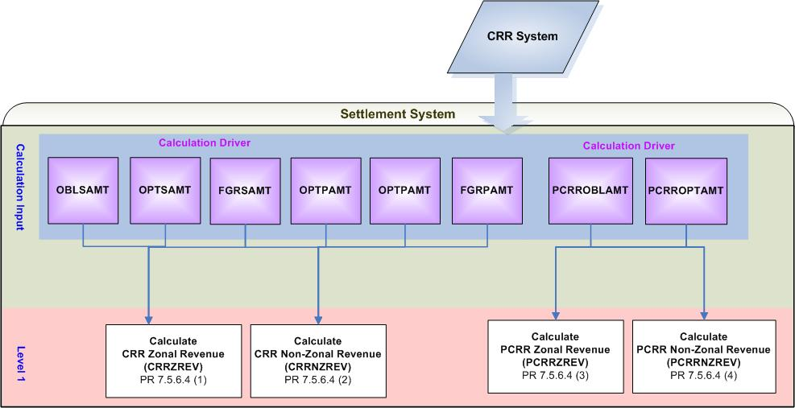
- Calculation Dependencies of CRR Auction Revenue

Assumptions
A1) Calculation of transaction dollar amount (applicable price multiplied by applicable quantity) is performed in the original system (CRR System) for each transaction for each CRR Auction. Therefore, OBLSAMT, OBLPAMT, OPTPAMT, FGRPAMT, PCRROBLAMT, and PCRROPTAMT shall represent the valid data for use in the Settlement System.
A2) The Settlement System shall have the appropriate information from the original system (CRR System) to the mapping of “OBLSAMT, OBLPAMT, OPTPAMT, FGRPAMT, PCRROBLAMT, and PCRROPTAMT” to 2003 ERCOT CMZs.

Business Rules
Req. ID | Protocol(s) | Sub-Process Map | Description
 | PR 7.5.6.4 | CSWM. P03SettleBill Transfer | None of the input, intermediate, and output bill determinants should be rounded or truncated.
 | PR 12.3 (C)  PR 7.5.6.4 | CSWM. P03SettleBill Transfer | The following data shall be available for public data extracts, including:  - CRRZREV  - CRRNZREV  - PCRRZREV  - PCRRNZREV
 | PR 12.3 (C)  PR 7.5.6.4 | CSWM. P03SettleBill Transfer | The following data shall be available for private data extracts, including:  - OBLSAMT  - OPTSAMT  - FGRSAMT  - OBLPAMT  - OPTPAMT  - FGRPAMT  - PCRROBLAMT  - PCRROPTAMT
 | PR 7.5.6.4 | CSWM. P03SettleBill Transfer | DRIVER:  - Calculations of CRRZREV and CRRNZREV shall be attempted for a CRR Auction for which at least one of the following data cuts exists and is paid in full for the CRR Auction:  - OBLSAMT  - OPTSAMT  - FGRSAMT  - OBLPAMT  - OPTPAMT  - FGRPAMT  - Calculations of PCRRZREV and PCRRNZREV shall be attempted for a CRR Auction for which at least one of the following data cuts exists and is paid in full for the CRR Auction:  - PCRROBLAMT  - PCRROPTAMT

Business Defined Errors
Req. ID | Protocol(s) | Sub-Process Map | Description
 | PR 7.5.6.4 | CSWM. P03SettleBill Transfer | If the Settlement System calculation needs OBLSAMT that is not available for a CRR Auction, the Settlement System should set OBLSAMT to be zero (0). No error message is necessary.
 | PR 7.5.6.4 | CSWM. P03SettleBill Transfer | If the Settlement System calculation needs OPTSAMT that is not available for a CRR Auction, the Settlement System should set OPTSAMT to be zero (0). No error message is necessary.
 | PR 7.5.6.4 | CSWM. P03SettleBill Transfer | If the Settlement System calculation needs FGRSAMT that is not available for a CRR Auction, the Settlement System should set FGRSAMT to be zero (0). No error message is necessary.
 | PR 7.5.6.4 | CSWM. P03SettleBill Transfer | If the Settlement System calculation needs OBLPAMT that is not available for a CRR Auction, the Settlement System should set OBLPAMT to be zero (0). No error message is necessary.
 | PR 7.5.6.4 | CSWM. P03SettleBill Transfer | If the Settlement System calculation needs OPTPAMT that is not available for a CRR Auction, the Settlement System should set OPTPAMT to be zero (0). No error message is necessary.
 | PR 7.5.6.4 | CSWM. P03SettleBill Transfer | If the Settlement System calculation needs FGRPAMT that is not available for a CRR Auction, the Settlement System should set FGRPAMT to be zero (0). No error message is necessary.
 | PR 7.5.6.4 | CSWM. P03SettleBill Transfer | If the Settlement System calculation needs PCRROBLAMT that is not available for a CRR Auction, the Settlement System should set PCRROBLAMT to be zero (0). No error message is necessary.
 | PR 7.5.6.4 | CSWM. P03SettleBill Transfer | If the Settlement System calculation needs PCRROPTAMT that is not available for a CRR Auction, the Settlement System should set PCRROPTAMT to be zero (0). No error message is necessary.

Specific Database Needs
Req. ID | Protocol(s) | Sub-Process Map | Description
 | PR 7.5.6.4 | CSWM. P03SettleBill Transfer | The Settlement System shall store the mapping of each source Settlement Point, sink Settlement Point, and FGR to a 2003 ERCOT CMZ for use in the calculation of CRR Auction Revenue.

CRR Auction Revenue Disbursement (LACMRZAMT, LACMRNZAMT)

ERCOT shall determine, for each month, the CRR Monthly Revenues (CMR). The CMR is the sum of:
(a) Monthly CRR revenue for that month; and
(b) PCRR revenues.

The disbursement of CMR based is described as follows:

Requirement ID
Source Mapping (Protocol/NERC/FERC and other binding documents Ref #) | PR 7.5.7
Traceability to Sub-Process Maps | CSWM.P03SettleBillTransfer
Description

For the first three years after the TNT Market Implementation Date, ERCOT shall credit the net CRR Auction revenue (including PCRR revenue) produced from CRRs cleared in each CRR Auction that source from a Settlement Point located within a 2003 ERCOT Congestion Management Zone (CMZ) and sink at a Settlement Point located within the same 2003 ERCOT CMZ to QSEs in the 2003 ERCOT CMZ on a zonal Load Ratio Share basis. All other net CRR Auction revenues must be allocated to QSEs on an ERCOT-wide Load Ratio Share basis. For these allocation purposes, any NOIE Load Zone is considered to be located entirely within the 2003 ERCOT CMZ that represented the largest Load for that NOIE or group of NOIEs in 2003. Before the end of the three-year period described above, the ERCOT Board shall consider whether to extend the policy or ratify some other alternative.

Requirement ID
Source Mapping (Protocol/NERC/FERC and other binding documents Ref #) | PR 7.5.7
Traceability to Sub-Process Maps | CSWM.P03SettleBillTransfer
Description

For Initial distribution of CRR Monthly Revenues, revenues shall be paid to each QSE based on that QSE’s Load Ratio Share in the interval coincident with the ERCOT-wide peak 15-minute Settlement Interval for the month.
ERCOT shall true up the distribution of CRR Monthly Revenues based on that QSE’s Load Ratio Share in the interval coincident with the ERCOT-wide peak 15-minute Settlement Interval for the month.

Requirement ID
Source Mapping (Protocol/NERC/FERC and other binding documents Ref #) | PR 7.5.7
Traceability to Sub-Process Maps | CSWM.P03SettleBillTransfer
Description

The net CRR Auction Revenue produced from CRRs cleared and paid for in each CRR Auction that source from a Settlement Point within a 2003 ERCOT CMZ and sink at a Settlement Point located within the same 2003 ERCOT CMZ shall be distributed on a zonal Load Ratio Share basis.

Calculate Load-Allocated CRR Monthly Revenue Zonal Amount per Zone per QSE for each Operating Month:

LACMRZAMT_<Q>_<Z> = (-1) * $\underset{A}{Σ}$(CRRZREV_<Z>_<A> + PCRRZREV_<Z>_<A>)
* MLRSZ_<Q>_<Z>

Requirement ID
Source Mapping (Protocol/NERC/FERC and other binding documents Ref #) | PR 7.5.7
Traceability to Sub-Process Maps | CSWM.P03SettleBillTransfer
Description

The net CRR Auction Revenue produced from CRRs cleared and paid for in each CRR Auction that do not source from a Settlement Point within a 2003 ERCOT CMZ and sink at a Settlement Point located within the same 2003 ERCOT CMZ shall be distributed on an ERCOT-wide LRS basis.

Calculate Load-Allocated CRR Monthly Revenue Non-Zonal Amount per QSE for each Operating Month:

LACMRNZAMT_<Q> = (-1) * $\underset{A}{Σ}$(CRRNZREV_<A> + PCRRNZREV_<A>) * MLRS_<Q>

Input Bill Determinants
Variable | Unit | Definition | Original Source
CRRZREV | $ | CRR Zonal Revenue per zone per CRR Auction—The revenue resulted from the CRRs that source and sink in CMZ, cleared through CRR Auction Offers and CRR Auction Bids in CRR Auction, for the month. | Settlement System
Interval Frequency: 1 / Month

Comments: None
PCRRZREV | $ | PCRR Zonal Revenue per zone per CRR Auction—The revenue resulted from the PCRRs that source and sink in CMZ, pertaining to CRR Auction, for the month. | Settlement System
Interval Frequency: 1 / Month

Comments: None
CRRNZREV | $ | CRR Zonal Revenue per CRR Auction—The revenue resulted from the CRRs that source and sink in different CMZs, cleared through CRR Auction Offers and CRR Auction Bids in CRR Auction, for the month. | Settlement System
Interval Frequency: 1 / Month

Comments: None
PCRRNZREV | $ | PCRR Zonal Revenue per CRR Auction—The revenue resulted from the PCRRs that source and sink in different CMZs, pertaining to CRR Auction, for the month. | Settlement System
Interval Frequency: 1 / Month

Comments: None
MLRSZ | none | Monthly Load Ratio Share Zonal per QSE per zone—The LRS of QSE for its Load in CMZ, for the peak-Load 15-minute Settlement Interval in the month. | Data Aggregation
Interval Frequency: 1 / Month

Comments: None
MLRS | none | Monthly Load Ratio Share per QSE—The LRS calculated for QSE for the peak-Load 15-minute Settlement Interval in the month. See Section 6.6.2.2, QSE Load Ratio Share for a 15-Minute Settlement Interval. | Data Aggregation
Interval Frequency: 1 / Month

Comments: None

Output Bill Determinants
Variable | Unit | Definition | Original Source
LACMRZAMT | $ | Load-Allocated CRR Monthly Revenue Zonal Amount per zone per QSE—The payment to QSE of the revenues resulted from the CRRs that source and sink in CMZ, for the month. | Settlement System
Interval Frequency: 1 / Month

Comments: None
LACMRNZAMT | $ | Load-Allocated CRR Monthly Revenue Non-Zonal Amount per QSE—The payment to QSE of the revenues resulted from the CRRs that source and sink in different CMZs, for the month. | Settlement System
Interval Frequency: 1 / Month

Comments: None
LACMRZBILLAMT | $ | Load-Allocated CRR Monthly Revenue Zonal Bill Amount per zone per QSE—The delta of Load Allocated CRR Monthly Revenue Zonal Amount between current and the previous settlement run -- per QSE, for the month. | Settlement System
Interval Frequency: 1 / Month

Comments: This bill determinant is not specifically documented in the Nodal Protocols but is required as a result of Section 9 Statements and Invoices Protocol requirements.
LACMRNZBILLAMT | $ | Load-Allocated CRR Monthly Revenue Non-Zonal Bill Amount per QSE— The delta of Load Allocated CRR Monthly Revenue Non-Zonal Amount between current and the previous settlement run -- per QSE, for the month. | Settlement System
Interval Frequency: 1 / Month

Comments: This bill determinant is not specifically documented in the Nodal Protocols but is required as a result of Section 9 Statements and Invoices Protocol requirements.

Data Dependencies
D1) Calculations of LACMRZAMT and LACMRNZAMT are dependent upon the availability of input bill determinants.
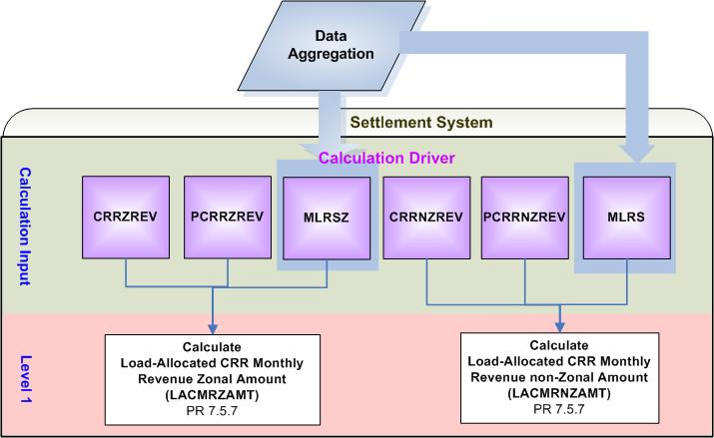
- Calculation Dependencies of CRR Auction Revenue Disbursement

Assumptions
A1) Calculations of MLRSZ and MLRS are performed in the Data Aggregation process according to ERCOT 2003 CMZs for the first three years after TNT Implementation Date. After three years, if ERCOT Board approves an alternative methodology to calculate MLRSZ and MLRS, the Data Aggregation process shall incorporate any applicable changes as necessary. Therefore, MLRSZ and MLRS shall represent the valid data for use in the Settlement System process.

Business Rules
Req. ID | Protocol(s) | Sub-Process Map | Description
 | PR 9.10 5 (b) | CSWM. P03SettleBill Transfer | LACMRZAMT and/or LACMRNZAMT shall be reflected on CRR Auction Revenue Disbursement Invoices.
 | PR 7.5.7 | CSWM. P03SettleBill Transfer | None of the input and intermediate bill determinants should be rounded or truncated.
 | PR 7.5.7 | CSWM. P03SettleBill Transfer | The following output bill determinant should be rounded or truncated to two (2) decimals, including:  - LACMRZAMT  - LACMRNZAMT
 | PR 12.3 (C)  PR 7.5.7 | CSWM. P03SettleBill Transfer | The following data shall be available for private data extracts, including:  - LACMRZAMT  - LACMRNZAMT  - MLRSZ  - MLRS
 | PR 12.3 (C)  PR 7.5.7 | CSWM. P03SettleBill Transfer | The following data shall be available for public data extracts, including:  - CRRZREV  - CRRNZREV  - PCRRZREV  - PCRRNZREV
 | PR 7.5.7 | CSWM. P03SettleBill Transfer | DRIVER:  - The calculation of LACMRZAMT shall be attempted for a QSE for an Operating Month for which both conditions described below are met:  - MLRSZ is greater than zero (0)  - At least one of the following data cuts exists:  - CRRZREV  - PCRRZREV  - The calculation of LACMRNZAMT shall be attempted for a QSE for an Operating Month for which both conditions described below are met:  - MLRS is greater than zero (0)  - At least one of the following data cuts exists:  - CRRNZREV  - PCRRNZREV

Business Defined Errors
Req. ID | Protocol(s) | Sub-Process Map | Description
 | PR 7.5.7 | CSWM. P03SettleBill Transfer | If the Settlement System calculation needs CRRZREV that is not available for a CRR Auction, the Settlement System should set CRRZREV to be zero (0). No error message is necessary.
 | PR 7.5.7 | CSWM. P03SettleBill Transfer | If the Settlement System calculation needs CRRNZREV that is not available for a CRR Auction, the Settlement System should set CRRNZREV to be zero (0). No error message is necessary.
 | PR 7.5.7 | CSWM. P03SettleBill Transfer | If the Settlement System calculation needs PCRRZREV that is not available for a CRR Auction, the Settlement System should set PCRRZREV to be zero (0). No error message is necessary.
 | PR 7.5.7 | CSWM. P03SettleBill Transfer | If the Settlement System calculation needs PCRRNZREV that is not available for a CRR Auction, the Settlement System should set PCRRNZREV to be zero (0). No error message is necessary.

Specific Database Needs
None

Supplementary Requirements

Performance Requirements
Lodestar must be able to perform its full set of Nodal settlement calculations. Performance characteristics will be determined and detailed in the conceptual and detailed design.

Legal and Regulatory requirements
All Lodestar financial data must be saved in accordance with standard accounting principles as dictated by the ERCOT Texas Nodal Protocols.

System Security Requirements
Lodestar will only be accessed directly by internal ERCOT personnel either through thin client UI, Citrix environment, or thick client on employee desktops. Market Participants will be able to access their statements and invoices on ERCOT private web site. ERCOT private web site access will be controlled by digital certificate authentication in accordance with ERCOT security policies.

Back up and Recovery Requirements
All Lodestar Nodal settlement data must be backed up on a daily basis and recoverable within 24 hours.

Availability and Redundancy Requirements
Nodal Lodestar system must be available 7/24. Lodestar is considered a tier 1 system and critical to base ERCOT business processes

Maintainability Requirements
Lodestar Nodal system will be maintained by internal ERCOT personnel. SLAs and explicit support will be detailed in the detail design document.

Daylight Savings Time shall be recognized in Nodal Market settlements.
Spring Daylight Savings Time Operating Day:
Hour Ending 0300 will be skipped, resulting in 23 hourly intervals for the day.
The four fifteen minute intervals within Hour Ending 0300 will be skipped, resulting in 92 fifteen minute intervals for the day.
The sixty one minute intervals within Hour Ending 0300 will be skipped, resulting in 1380 total one minute intervals.
Fall Daylight Savings Time Operating Day:
Hour Ending 0200 will have two sets of data, resulting in 25 hourly intervals for the day.
The four fifteen minute intervals within Hour Ending 0200 will have two sets of data, resulting in 100 fifteen minute intervals for the day.
The sixty one minute intervals within Hour Ending 0200 will have two sets of data, resulting in 1500 total one minute intervals.

Protocol Coverage

Protocol Sub-Section | Description | Coverage by Requirements  (Full/Partial)
PR 7.5.6.4 | CRR Auction Revenues | Partial
PR 7.5.7 | Method for distributing CRR Auction Revenues | Partial

