NPRR Number | 003 | NPRR Title | Section 5, Zonal PRR Synchronization and ERCOT Staff Clarifications
Date |  | 9/7/06
Submitter’s Information
Name |  | DeAnn Walker
E-mail Address |  | deann.walker@CenterPointEnergy.com
Company |  | CenterPoint Energy
Company Address |  | 1005 Congress Ave. Suite 650  Austin, Tx 78701
Phone Number |  | 512-397-3032
Fax Number |  | 512-397-3050

ERCOT/Market Segment Impacts and Benefits
Instructions: To allow for comprehensive PRR consideration, please fill out each block below completely, even if your response is “none,” “not known,” or “not applicable.” Wherever possible, please include reasons, explanations, and cost/benefit analyses pertaining to the PRR.

Assumptions | 1
 |  | Impact Area | Monetary Impact
Market Cost | 1
 |  | Impact Area | Monetary Impact
Market Benefit | 1
Additional Qualitative Information | 1 | Inclusion of these revisions provides for a Nodal market design that more completely reflects the intentions of the ERCOT stakeholders.
Other | 1

Comments

On July 11, 2006, the Technical Advisory Committee (TAC) remanded this NPRR to the Reliability and Operations Subcommittee (ROS) to be reviewed for consistency with the Operating Guides. On August 14, 2006, ROS proposed new language for consistency with the Operating Guides. On August 25, TPTF submitted comments changing the proposed language submitted by ROS.

CenterPoint Energy continues to have concerns that the NPRR as proposed by TPTF is not consistent with the Operating Guides. CenterPoint Energy does not believe that it is appropriate to alter the Operating Guides through the TPTF process. Therefore, CenterPoint Energy recommends that Section 5.5.1 of the NPRR simply reference the Operating Guide. This solution will also alleviate the need for the Nodal Protocols to be amended whenever the Operating Guides are amended.

More specifically, CenterPoint Energy believes that the version submitted by TPTF is open for interpretation. TPTF’s proposal appears to follow the Operating Guides by stating that ERCOT shall exclude double circuit transmission contingencies for resource deployment decisions except for high consequence or high probability conditions as those terms are used in the Operating Guides. However, the Operating Guides are clear that there is no exclusion of double circuit contingencies for unit commitment decisions. Unit commitment decisions can be defined as either another term for resource deployment decisions or, alternatively, a subset of resource deployment decisions. CenterPoint Energy’s proposed modification requires ERCOT to make resource commitment decisions for management of congestion consistent with the Operating Guides. This change will remove the ambiguities that have been at issue with the changes proposed by TPTF.

Revised Proposed Nodal Protocol Language

5.5.1 Security Sequence
(1) The figure below highlights the key computational modules and processes that are used in the Security Sequence:
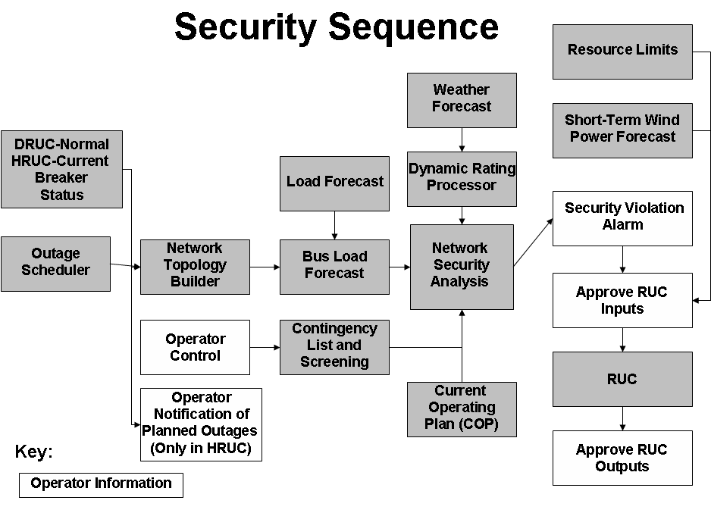
(2) The Security Sequence uses a subset of the computational modules used by the Real-Time Sequence. A more detailed explanation of those computational modules can be found in Section 6.5.7.1, Real-Time Sequence. The main distinction between the two models concerns inputs. The inputs into the Security Sequence are based on a snapshot of projected hourly system conditions and constraints.
(3) The Security Sequence uses the status of all transmission breakers and switches(current status for HRUC and normal status for DRUC), updated for approved Planned Outages for equipment out of service and returned to service for building a representation of the ERCOT Transmission Grid for each hour of the RUC Study Period. The Network Topology Processor constructs a network model for each hour that must be used by the Bus Load Forecast to estimate the hourly load for each transmission bus.
(4) The weather forecast obtained by ERCOT must be provided to the Dynamic Rating Processor to create weather-adjusted MVA limits for each hour of the RUC Study Period for all transmission lines and transformers that have Dynamic Ratings.
(5) ERCOT shall analyze base configuration, select n-1 contingencies and select n-2 contingencies under the Operating Guides. The Operating Guides must also specify the criteria by which ERCOT may remove contingencies from the list. ERCOT shall post to the MIS Secure Area the standard contingency list, including identification of changes from previous versions before being used in the Security Sequence. ERCOT shall evaluate the need for Resource-specific deployments during Real-Time operations for management of congestion consistent with the Operating Guides.

(6) ERCOT shall also post to the MIS Secure Area any contingencies temporarily removed from the standard contingency list by ERCOT immediately after successful execution of the Security Sequence. ERCOT shall include the reason for removal of any contingency as soon as practicable but not later than one hour after removal.
(7) As part of the Network Security Analysis, for each hour of the RUC Study Period, ERCOT shall analyze all selected contingencies and perform the following:
(a) Perform full AC analysis of all contingencies;
(b) Monitor element and bus voltage limit violations; and
(c) Monitor transmission line and transformer security violations; and
(8) As part of the Network Security Analysis, if there is an approved Remedial Action Plan (RAP) available, it must be used before considering a Resource commitment.
(9) ERCOT shall review all security violations prior to RUC execution.
(10) ERCOT shall model all approved Special Protection Systems (SPSs) and RAPs in the contingency analysis. The computational modules must enable ERCOT to analyze contingencies, including the effects of all approved automatically deployed SPSs.
(11) ERCOT may deselect certain contingencies known to cause errors or that otherwise result in inconclusive study output in the RUC. On continued de-selection of contingencies, ERCOT shall prepare an analysis to determine the cause of the error. ERCOT may use information from the DAM processes as decision support during the Hour-Ahead processes. ERCOT shall post to the MIS Secure Area any contingencies deselected by ERCOT and must include the reason for removal as soon as practicable, but not later than one hour after deselection.

