NPRR Number | 003 | NPRR Title | Section 5, Zonal PRR Synchronization and ERCOT Staff Clarifications
Date |  | August 14, 2006
Submitter’s Information
Name |  | Paul Rocha on behalf of the ROS
E-mail Address |  | Paul.rocha@centerpointenergy.com
Company |  | CenterPoint Energy
Company Address |  | 1111 Louisiana
Phone Number |  | 713-207-2768
Fax Number

Comment Form Instructions:

Comments are to be submitted electronically to RevisionRequest@ercot.com and are due by close of business of the comment due date. Please follow this file naming convention:
###PRR <Company Name> Comments <date>.doc.

ERCOT/Market Segment Impacts and Benefits
Instructions: To allow for comprehensive PRR consideration, please fill out each block below completely, even if your response is “none,” “not known,” or “not applicable.” Wherever possible, please include reasons, explanations, and cost/benefit analyses pertaining to the PRR.

Assumptions | 1
 |  | Impact Area | Monetary Impact
Market Cost | 1
 |  | Impact Area | Monetary Impact
Market Benefit | 1
Additional Qualitative Information | 1 | Inclusion of these revisions provides for a Nodal market design that more completely reflects the intentions of the ERCOT stakeholders.
Other | 1

Comments

Per the discussion at the July 6th TAC meeting, ROS is making the following changes to the PRS recommendation report. The intent of the changes is to make the NPRR language consistent with Section 4.3 of the current ERCOT Operating Guides. For ease of discussion, the only section attached as a redline to the PRS report is 5.5.1, Security Sequence.

On 8/10/06, ROS voted unanimously to approve the comments as revised by ROS. All Market Segments were present for the vote.

Revised Proposed Nodal Protocol Language

5.5.1 Security Sequence
(1) The figure below highlights the key computational modules and processes that are used in the Security Sequence:
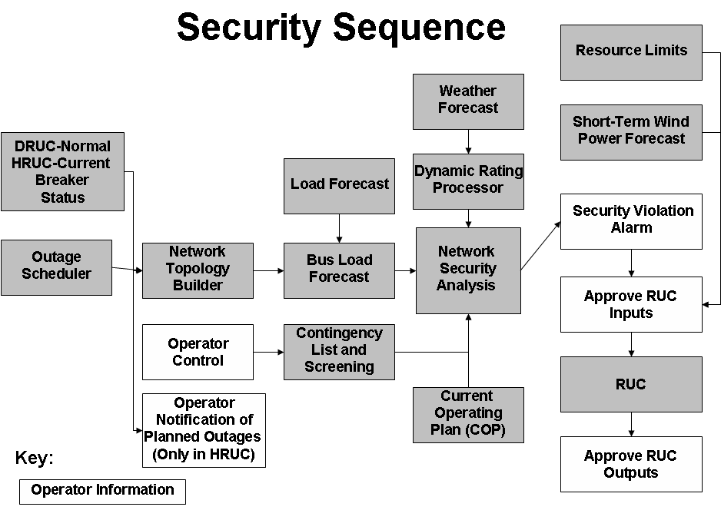
(2) The Security Sequence uses a subset of the computational modules used by the Real-Time Sequence. A more detailed explanation of those computational modules can be found in Section 6.5.7.1, Real-Time Sequence. The main distinction between the two models concerns inputs. The inputs into the Security Sequence are based on a snapshot of projected hourly system conditions and constraints.
(3) The Security Sequence uses the status of all transmission breakers and switches(current status for HRUC and normal status for DRUC), updated for approved Planned Outages for equipment out of service and returned to service for building a representation of the ERCOT Transmission Grid for each hour of the RUC Study Period. The Network Topology Processor constructs a network model for each hour that must be used by the Bus Load Forecast to estimate the hourly load for each transmission bus.
(4) The weather forecast obtained by ERCOT must be provided to the Dynamic Rating Processor to create weather-adjusted MVA limits for each hour of the RUC Study Period for all transmission lines and transformers that have Dynamic Ratings.

(5) ERCOT Operators are responsible for operating the ERCOT Transmission systems within first contingency transfer limits so that there is no overload of any significant transmission element whose loss could jeopardize the reliability of the ERCOT System. Whenever the ERCOT System is not engaged in emergency operation, it will be operated in such a manner that the occurrence of a single contingency will not cause any of the following:
(a) Uncontrolled breakup of the transmission system,
(b) Loading of Transmission Facilities above defined emergency ratings which can not be eliminated in time to prevent damage or failure following the loss through execution of specific, predefined operating procedures,
(c) Transmission voltage levels outside system design limits which can not be corrected through execution of specific, predefined operating procedures before voltage instability or collapse occurs, or
(d) Customer outages, except for high set interruptible and radially served loads.

(6) “Single contingency” criteria are specified as follows:
(a) A credible single contingency is defined as the Forced Outage of two generating units as defined in Section 5.1.4 of the Operating Guides , Transmission Reliability Testing, item (2), in the ERCOT System within a short period of time, or the Forced Outage of any single transmission element (such as a circuit or transformer).
(b) The Forced Outage of a double-circuit transmission line (DCKT) in excess of 0.5 miles in length will always be considered a credible single contingency for all security constrained unit commitment decisions. The Forced Outage of a double-circuit transmission line (DCKT) will only be considered a credible single contingency for energy deployment decisions for any of the following operating conditions characterized by high DCKT Outage probability or consequence:
(i) High Outage Probability for a double-circuit transmission line means severe weather conditions are forecasted by ERCOT in the vicinity of the line, weather conditions indicate a high risk of insulator flashover, individual circuits that are part of the line have experienced repeated Forced Outages within the preceding 48 hours possibly indicating unresolved problems, or a high risk of a line outage due to fire in progress near the transmission right-of-way.
(ii) High Outage Consequence for a double-circuit transmission line means another transmission outage has occurred, which significantly increases the impact of an additional outage to the double-circuit transmission line, studies affirmatively indicate the line’s outage would result in cascading outages or voltage collapse, or studies affirmatively indicate an outage of the double-circuit transmission line poses a significant risk of uncontrolled outages because it would result in equipment overloads, which cannot be eliminated through execution of specific, predefined operating procedures in time to prevent equipment damage or failure
(7) ERCOT shall post to the MIS Secure Area the standard contingency list, including identification of changes from previous versions before being used in the Security Sequence.
(8) ERCOT shall also post to the MIS Secure Area any contingencies temporarily removed from the standard contingency list by ERCOT immediately after successful execution of the Security Sequence. ERCOT shall include the reason for removal of any contingency as soon as practicable but not later than one hour after removal.
(9) As part of the Network Security Analysis, for each hour of the RUC Study Period, ERCOT shall analyze all selected contingencies and perform the following:
(a) Perform full AC analysis of all contingencies;
(b) Monitor element and bus voltage limit violations; and
(c) Monitor transmission line and transformer security violations; and
(10) As part of the Network Security Analysis, if there is an approved Remedial Action Plan (RAP) available, it must be used before considering a Resource commitment.
(11) ERCOT shall review all security violations prior to RUC execution.
(12) ERCOT shall model all approved Special Protection Systems (SPSs) and RAPs in the contingency analysis. The computational modules must enable ERCOT to analyze contingencies, including the effects of all approved automatically deployed SPSs.
(13) ERCOT may deselect certain contingencies known to cause errors or that otherwise result in inconclusive study output in the RUC. On continued de-selection of contingencies, ERCOT shall prepare an analysis to determine the cause of the error. ERCOT may use information from the DAM processes as decision support during the Hour-Ahead processes. ERCOT shall post to the MIS Secure Area any contingencies deselected by ERCOT and must include the reason for removal as soon as practicable, but not later than one hour after deselection.

