Commercial Systems
Software Requirements SpecificationReliability Unit Commitment Settlements Requirements
v0.09

Revision History
Date | Version | Description | Author
08/08/06 | 0.09 | Initial Draft to TPTF | Keely Hilton

Table of Contents
1. Reliability Unit Commitment Settlement 5
1.1 Proposed System Scope 5
1.2 Document Conventions 6
1.3 Document Assumptions 6
2. Functional Requirements 6
2.1 Startup Price (SUPR) 6
2.2 Minimum-Energy Price (MEPR) 11
2.3 RUC Guarantee (RUCG) 15
2.4 RUC Minimum-Energy Revenue (RUCMEREV) 19
2.5 Revenue Less Costs Above LSL During RUC-Committed Hours (RUCEXRR) 22
2.6 Revenue Less Costs During QSE Clawback Intervals (RUCEXRQC) 26
2.7 RUC Make-Whole Payment (RUCMWAMT) 31
2.8 RUC Clawback Charge (RUCCBAMT) 36
2.9 RUC Decommitment Payment (RUCDCAMT) 42
2.10 RUC Capacity-Short Charge (RUCCSAMT) 47
2.11 RUC Make-Whole Uplift Charge (LARUCAMT) 67
2.12 RUC Clawback Payment (LARUCCBAMT) 70
2.13 RUC Decommitment Charge (LARUCDCAMT) 72
3. Supplementary Requirements 75
3.1 Performance Requirements 75
3.2 Legal and Regulatory requirements 75
3.3 System Security Requirements 75
3.4 Back up and Recovery Requirements 75
3.5 Availability and Redundancy Requirements 75
3.6 Maintainability Requirements 75
3.7 Daylight Savings Time shall be recognized in Nodal Market settlements. 75
4. Protocol Coverage 76

Software Requirements Specification

Reliability Unit Commitment Settlement

Proposed System Scope
ERCOT plans to implement a new Nodal market in 2009. Sections 4, 5, 6 and 9 of the Nodal Protocols describe the various Charge Type requirements and Settlement Statement requirements for the settlement of Reliability Unit Commitment (RUC). The Nodal Protocols will guide this project.

This document defines the requirements for Reliability Unit Commitment (RUC) settlements. The requirements in scope for this document include calculation of RUC settlement Charge Types that are

- detailed in Nodal Protocols Section 4 (006NPRR as approved by BOD on 07/18/2006),
- detailed in Nodal Protocols Section 5 (003NPRR as approved by PRS on 06/22/2006),
- detailed in Nodal Protocols Section 6 (009NPRR as approved by PRS on 07/20/2006), and
- listed as a component of the RTM Settlement Statement in Nodal Protocols Section 9 (007NPRR as approved by BOD on 07/18/2006)

The following Settlement Charge Types are considered RUC settlement and are included in the scope of this document:

- RUC Make-Whole Payment (PR 5.7.1)
- RUC Clawback Charge (PR 5.7.2)
- RUC Decommitment Payment (PR 5.7.3)
- RUC Capacity-Short Charge (PR 5.7.4.1)
- RUC Make-Whole Uplift Charge (PR 5.7.4.2)
- RUC Clawback Payment (PR 5.7.5)
- RUC Decommitment Charge (PR 5.7.6)

The RUC settlement global bill determinants are also included in scope for this document. Global bill determinants are bill determinants that are used by multiple charge types. The RUC settlement global bill determinants include:

- Startup Price (SUPR) (PR 5.7.1.1, PR 5.7.3)
- Minimum-Energy Price (MEPR) (PR 5.7.1.1, PR 5.7.1.4, PR 5.7.3)
- RUC Guarantee (RUCG) (PR 5.7.1.1)
- RUC Minimum-Energy Revenue (RUCMEREV) (PR 5.7.1.2)
- Revenue Less Cost Above LSL During RUC-Committed Hours (RUCEXRR) (PR 5.7.1.3)
- Revenue Less Cost During QSE Clawback Intervals (RUCEXRQC) (PR 5.7.1.4)

Document Conventions
- All text lifted from the Nodal Protocols is in italic font.
- All requirements are identified using FR1, FR2, etc.
- All dependencies are identified using D1, D2, etc.
- All assumptions are identified using A1, A2, etc.
- The “Original Source” column of the Input, Intermediate, and Output Bill Determinates tables (refer to Section 2, Functional Requirements) delineate the initial source of market and/or operational information required to construct each variable. The data transformation process exists within the interface between the Settlement System and Market / Operational Systems. A separate and distinct set of Business Requirements will address all data interfacing between the original source system and the Settlement System.

Document Assumptions
A1) Startup Eligibility, including determination of QSE Clawback intervals, is documented in a separate set of requirements. See TN.COMS.63C01.STARTUPELIGIBILITY.REQUIREMENTS.A for further information.

A2) Verifiable Costs, including startup and minimum-energy, is documented in a separate set of requirements. See TN.COMS.63C01.VERIFIABLECOSTS.REQUIREMENTS.A for further information.

A3) All Settlement Point Prices will be calculated outside of the Settlement System and therefore the SPP calculations are not detailed within this document.

A4) The Settlement System should not store zero value data cuts for a charge type, unless the zero data cut is a result of a calculation or a requirement specifies that the cut be saved.

A5) Any charge type that requires historical data will obtain this information via alternative means during the beginning of market open until the data is available.

A6) The charge type calculations are documented using the proposed recorder format for the bill determinants. The following list defines the nomenclature used for the recorders (not all of these bill determinant recorder elements may apply to the charge types within this document):

<Q> = QSE
<CO> = CRR Owner
<R> = Resource
<SP> = Settlement Point
<SRSP> = Source Settlement Point
<SKSP> = Sink Settlement Point
<ST> = Start Type
<F> = Flowgate
<E> = Directional Network Element
<C> = Constraint Identifier
<M> = Market
<RUC> = RUC Process

Functional Requirements

Startup Price (SUPR)
The SUPR is the validated Three-Part Supply Offer component for startup for a Resource, unless a validated Three-Part Supply Offer has not been submitted.

If a validated Three-Part Supply Offer component for startup has not been submitted for a Resource for the RUC, then the SUPR is the ERCOT-approved verifiable startup cost for that Resource.

If ERCOT has not approved verifiable startup costs, then the SUPR is the Resource Category Generic Startup Cap for that Resource.

Requirement ID | FR1
Source Mapping (Protocol/NERC/FERC and other binding documents Ref #) | PR 5.7.1.1  PR 5.7.3
Traceability to Sub-Process Maps | Will be completed August 31, 2006
Description: Calculate the SUPR by QSE and Resource, for each Start Type, for each Resource with a RUC commitment (RUCHR) within the Operating Day.

If, SUO for the Resource exists in the settlement system for the Operating Day,
SUPR_<Q>_<R>_<SP>_<ST> = SUO_<Q>_<R>_<SP>_<ST>
Else,
If VERISU for the Resource is available in the settlement system for the Operating Day,
SUPR_<Q>_<R>_<SP>_<ST> = VERISU_<Q>_<R>_<SP>_<ST>
Else,
SUPR_<Q>_<R>_<SP>_<ST> = RCGSC (resource category for the Resource)
End

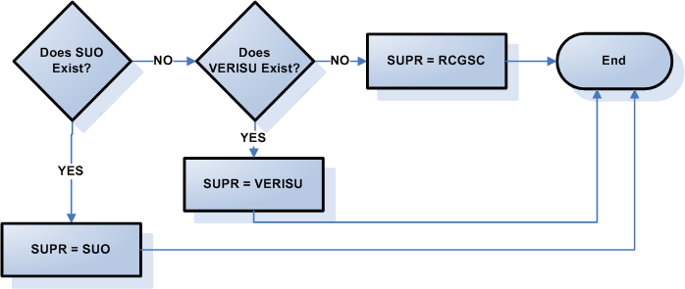

Requirement ID | FR2
Source Mapping (Protocol/NERC/FERC and other binding documents Ref #) | PR 4.4.9.2.3(1)
Traceability to Sub-Process Maps | Will be completed August 31, 2006
Description: For each Resource Category the Resource Category Startup Cap (RCGSC), by applicable Resource, is determined by the following O&M costs:

Resource Category | RCGSC Calculation
Nuclear | $7,200
Coal and Lignite | $7,200
Hydro | $7,200
Renewable | $7,200
Combined Cycle > 90 MW with 5+ hours offline | $6,810
Combined Cycle > 90 MW with less than 5 hours offline | $5,310
Combined Cycle <= 90 MW with 5+ hours offline | $6,810
Combined Cycle <= 90 MW with less than 5 hours offline | $5,310
Gas Steam Supercritical Boiler | $4,800
Gas Steam Reheat Boiler | $3,000
Gas Steam Non-Reheat or Boiler without air-preheater | $2,310
Simple Cycle > 90 MW | $5,000
Simple Cycle <= 90 MW | $2,300
Diesel | $1
RMR Resource | (Not Applicable)RMR Resource will be one of the above categories.

Input Bill Determinants
Variable | Unit | Definition | Original Source
RUCHR | Misc | RUC Hour—The total number of RUC-Committed Hours, for the Resource for the Operating Day. | MMS
Interval Frequency: 1 / hour

Additional Comments: None
SUO | $/Start | Startup Offer per QSE per Resource per Settlement Point—The Startup Offer included in the Three-Part Supply Offer associated with Resource r at Resource Node p represented by QSE q, representing an offer for all costs incurred by the Resource in starting up and reaching breaker close. | MMS
Interval Frequency: 1 / hour

Additional Comments: The settlement system will receive an offer, from each QSE/Resource combination that submitted a Three-Part Supply Offer, for each type of start: Hot, Intermediate and Cold.

The SUO value used in this calculation is the value that is valid at the end of the adjustment period for each hour.
VERISU | $/Start | Verifiable Startup Costs—The verifiable startup costs of a Resource for a start submitted by the QSE for the Resource, according to Section 5.6.1, Verifiable Costs and Section 5.6.1.1, Verifiable Startup Costs, for the Operating Day. | Settlement System – Calculation for Verifiable Costs calculated previously
Interval Frequency: 1 / hour

Additional Comments: There will be a VERISU, for each QSE/Resource combination with a RUC-Commitment, for each type of start: Hot, Intermediate and Cold.

The VERISU bill determinant will be an output from the Verifiable Costs process and will only be created for Resources with ERCOT approved Verifiable Costs.

See TN.COMS.63C01.VERIFIABLECOSTS.REQUIREMENTS.A for further information on the VERISU bill determinant.
RCGSC | $/Start | Resource Category Generic Startup Cost—The Resource Category Generic Startup Cost for the category of the Resource, according to Section 4.4.8.2.3, Startup Offer and Minimum-Energy Offer Generic Caps, for the Operating Day. | Settlement System
Interval Frequency: 1 / day

Additional Comments: None

Output Bill Determinants
Variable | Unit | Definition | Destination
SUPR | $/Start | Startup Price per start—The settlement price for the start. | Settlement System
Interval Frequency: 1 / hour

Additional Comments: There should be a SUPR, for each QSE/Resource combination with a RUC-Commitment, for each type of start: Hot, Intermediate and Cold.

Data Dependencies
D1) Calculation of the SUPR is dependent upon the availability of the input bill determinants.

D2) Calculation of SUPR must be complete prior to the calculation of the RUC Guarantee (RUCG) and the RUC Decommitment Payment (RUCDCAMT).

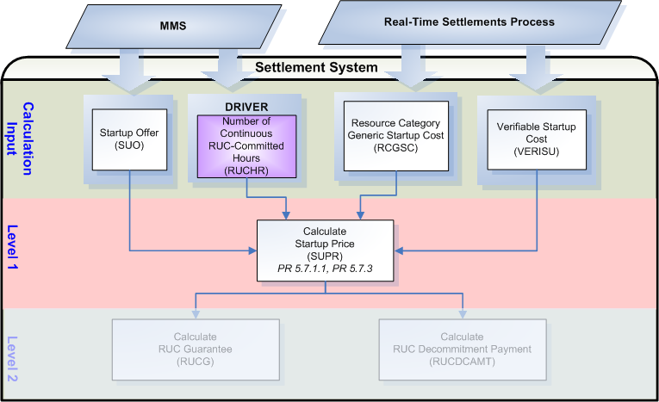

Assumptions
A1) Validation of all components of the Three-Part Supply Offer will occur within the original source system.

A2) Startup Offer (SUO) data will exist for each Resource with a valid Three-Part Supply Offer, for each type of startup (Hot, Intermediate, and Cold.) A hot Startup Offer will be indicated by a 1 in the <ST> startup type indicator; an intermediate Startup Offer will be indicated by a 2 in the <ST> startup type indicator, and a cold Startup Offer will be indicated by a 3 in the <ST> startup type indicator.

A3) Protocol 4.4.9.2.1 (1), Startup and Minimum-Energy Offer Criteria, does not include criteria for specifying the first and last hour of the Offer as does Protocol 4.4.9.3.1 (1), Energy Offer Curve Criteria. It is assumed that a QSE can submit multiple Startup and Minimum-Energy Offers that are valid for different sets of Operating Hours and that the first and last hour of the Offer specified for the Energy Offer Curve also applies to any associated Startup and Minimum-Energy Offer in a Three-Part Supply Offer. If this assumption is valid, it may be prudent to change Protocol 4.4.9.2.1 (1) of the Protocols to be more specific and include an additional criterion for the first and last hour of the Offer.

A4) Settlements requires instruction on how to settle Combined Cycle resources based on Combined Cycle configurations. More information is needed. Until more information available, when no offer is submitted and no verifiable exists, the generic value for Combined Cycle Resources will be determined using the existing table in Section 4.4.9.2.3 (1) for calculation of Startup Price (SUPR).

Business Rules
Req. ID | Protocol(s) | Sub-Process Map | Description
FR3 | PR 5.7.1.1  PR 5.7.3 | Will be completed August 31, 2006 | DRIVER: The SUPR calculation should only be attempted for QSE/Resource combinations with a RUCHR_<Q>_<R> in the settlement system for the Operating Day.
FR4 | PR 5.7.1.1  PR 5.7.3 | Will be completed August 31, 2006 | No input or output bill determinants should be rounded or truncated.
FR5 | PR 12.3 (c) | Will be completed August 31, 2006 | All input and output bill determinants should be made available to the extracts process and should be classified in the settlement system as:  - RUCHR – private  - SUO – private  - VERISU – private  - RCGSC - public  - SUPR – private

Business Defined Errors
Req. ID | Protocol(s) | Sub-Process Map | Description
FR6 | PR 5.7.1.1  PR 5.7.3 | Will be completed August 31, 2006 | While calculating SUPR, if RUCHR does not exist in the Settlement System for the Operating Day for the QSE/Resource combination, then the Settlement System should process as if no RUC-Commitment was issued and should not perform the calculation for the QSE/Resource combination
FR7 | PR 5.7.1.1  PR 5.7.3 | Will be completed August 31, 2006 | While calculating SUPR, if SUO does not exist in the Settlement System for the Operating Day for the QSE/Resource combination, then the Settlement System should default to the QSE/Resource VERISU.
FR8 | PR 5.7.1.1  PR 5.7.3 | Will be completed August 31, 2006 | While calculating SUPR, if VERISU does not exist in the Settlement System for the Operating Day for the QSE/Resource combination, then the Settlement System should default to the appropriate RCGSC for the Resource and provide a WARN-DEFAULT error message indicating the failure as “VERISU for QSE <Q> and Resource <R> was not available for calculation of SUPR.”
FR9 | PR 5.7.1.1  PR 5.7.3 | Will be completed August 31, 2006 | While calculating SUPR, if the factor of RCGSC does not exist in the Settlement System for the Resource Category, then the Settlement System should default to zero and should provide a WARN-DEFAULT error message indicating the failure as “RCGSC for Resource Category <Resource Category> was not available for calculation of SUPR.”

Specific Database Needs
Req. ID | Protocol(s) | Sub-Process Map | Description
FR10 | PR 5.7.1.1  PR 5.7.3 | Will be completed August 31, 2006 | The Settlement System needs to be able to map, and store the mapping of, each Resource to a Resource Category (RCGSC) for use in the calculation SUPR. Each value for RCGSC should be a variable and stored with a start and stop time.

Minimum-Energy Price (MEPR)
The MEPR is the validated Three-Part Supply Offer component for minimum-energy for a Resource, unless a validated Three-Part Supply Offer has not been submitted.

If a validated Three-Part Supply Offer component for minimum-energy has not been submitted for a Resource for the RUC, then the MEPR is the ERCOT-approved verifiable minimum-energy cost for that Resource.

If ERCOT has not approved verifiable minimum-energy costs, then the MEPR is the Resource Category Generic Minimum-Energy Cap for that Resource.

Requirement ID | FR11
Source Mapping (Protocol/NERC/FERC and other binding documents Ref #) | PR 5.7.1.1  PR 5.7.1.4  PR 5.7.3
Traceability to Sub-Process Maps | Will be completed August 31, 2006
Description: Calculate the MEPR by QSE and Resource, for each Resource with a RUC commitment (RUCHR) within the Operating Day.

If, MEO for the Resource exists in the settlement system for the Operating Day,
MEPR_<Q>_<R>_<SP> = MEO_<Q>_<R>_<SP>
Else,
If VERIME for the Resource is available in the settlement system for the Operating Day,
MEPR_<Q>_<R>_<SP> = VERIME_<Q>_<R>_<SP>
Else,
MEPR_<Q>_<R>_<SP> = RCGMEC (resource category for the Resource)
End
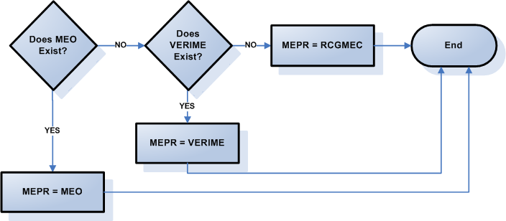

Requirement ID | FR12
Source Mapping (Protocol/NERC/FERC and other binding documents Ref #) | PR 4.4.9.2.3(2)PR 4.4.9.2.3(3)
Traceability to Sub-Process Maps | Will be completed August 31, 2006
Description: The Resource Category Minimum-Energy Generic Cap (RCGMEC), by applicable Resource, is the cost per MWh of energy for a Resource in producing energy up to and including the Resource’s LSL after breaker close according to the following:

Resource Category | RCGMEC Calculation
Hydro | $10.00/MWh
Coal and Lignite | $18.00/MWh
Combined Cycle > 90 MW | 10.0 MMBtu/MWh * ((%FOP * FOP) + (%FIP * FIP)), as specified in the Minimum-Energy Offer;
Combined Cycle <= 90 MW | 10.0 MMBtu/MWh * ((%FOP * FOP) + (%FIP * FIP)), as specified in the Minimum-Energy Offer;
Gas Steam Supercritical Boiler | 16.5 MMBtu/MWh * ((%FOP * FOP) + (%FIP * FIP)), as specified in the Minimum-Energy Offer;
Gas Steam Reheat Boiler | 17.0 MMBtu/MWh * ((%FOP * FOP) + (%FIP * FIP)), as specified in the Minimum-Energy Offer;
Gas Steam Non-Reheat or Boiler without air-preheater | 19.0 MMBtu/MWh * ((%FOP * FOP) + (%FIP * FIP)), as specified in the Minimum-Energy Offer;
Simple Cycle > 90 MW | 15.0 MMBtu/MWh * ((%FOP * FOP) + (%FIP * FIP)), as specified in the Minimum-Energy Offer;
Simple Cycle <= 90 MW | 15.0 MMBtu/MWh * ((%FOP * FOP) + (%FIP * FIP)), as specified in the Minimum-Energy Offer;
Diesel | 16.0 MMBtu/MWh * FOP
RMR Resource | RMR contract estimated fuel cost using it’s contract I/O curve at it’s LSL * FIP
Nuclear | $0
Renewable | $0

Settlements will only use the cap if no offer is submitted therefore Settlements shall use 100% of the minimum of FIP or FOP.

Input Bill Determinants
Variable | Unit | Definition | Original Source
RUCHR | Misc | RUC Hour—The total number of RUC-Committed Hours, for the Resource for the Operating Day. | MMS
Interval Frequency: 1 / hour

Additional Comments: None
MEO | $/MWh | Minimum-Energy Offer per QSE per Resource per Settlement Point—The Minimum-Energy Offer included in the Three-Part Supply Offer associated with Resource r at Resource Node p represented by QSE q, for the hour h that includes the settlement interval i.. | MMS
Interval Frequency: 1 / hour

Additional Comments: The MEO value used in this calculation is the value that is valid at the end of the adjustment period for each hour.
VERIME | $/MWh | Verifiable Minimum-Energy Costs—The verifiable minimum-energy costs of a Resource for a operating at LSL submitted by the QSE for the Resource, according to Section 5.6.1, Verifiable Costs and Section 5.6.1.2, Verifiable Minimum-energy Costs, for the Operating Day. | Settlement System – Calculation for Verifiable Costs calculated previously
Interval Frequency: 1 / hour

Additional Comments: The VERIME bill determinant will be an output from the Verifiable Costs process and will only be created for Resources with ERCOT approved Verifiable Costs.

See TN.COMS.63C01.VERIFIABLECOSTS.REQUIREMENTS.A for further information on the VERIME bill determinant.
RCGMEC | $/MWh | Resource Category Generic Minimum-Energy Cost—The Resource Category Generic Minimum Energy Cost cap for the category of the Resource, according to Section 4.4.8.2.3, Startup Offer and Minimum-Energy Offer Generic Caps, for the Operating Day. | Settlement System
Interval Frequency: 1 / day

Additional Comments: None

Output Bill Determinants
Variable | Unit | Definition | Destination
MEPR | $/MWh | Minimum-Energy Price—The settlement price for minimum energy for the 15-minute Settlement Interval. | Settlement System
Interval Frequency: 1 / hour

Additional Comments: None

Data Dependencies
D1) Calculation of the MEPR is dependent upon the availability of the input bill determinants.

D2) The MEPR calculation must be complete prior to the calculation of the RUC Guarantee (RUCG), Energy Revenue Less Cost During QSE Clawback Intervals (RUCEXRQC) and the Payment When ERCOT Decommits a QSE-Committed Resource (RUCDCAMT).

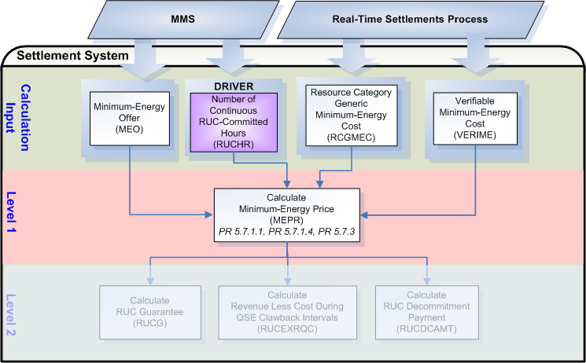

Assumptions
A1) Validation of all components of the Three-Part Supply Offer will occur within the original source system.

A2) Protocol 4.4.9.2.1 (1), Startup and Minimum-Energy Offer Criteria, does not include criteria for specifying the first and last hour of the Offer as does Protocol 4.4.9.3.1 (1), Energy Offer Curve Criteria. It is assumed that a QSE can submit multiple Startup and Minimum-Energy Offers that are valid for different sets of Operating Hours and that the first and last hour of the Offer specified for the Energy Offer Curve also applies to any associated Startup and Minimum-Energy Offer in a Three-Part Supply Offer. If this assumption is valid, it may be prudent to change Protocol 4.4.9.2.1 (1) of the Protocols to be more specific and include an additional criterion for the first and last hour of the Offer.

A3) Settlements requires instruction on how to settle Combined Cycle resources based on Combined Cycle configurations. More information is needed. Until more information available, when no offer is submitted and no verifiable exists, the generic value for Combined Cycle Resources will be determined using the existing table in Section 4.4.9.2.3 (2) for calculation of Minimum-Energy Price (MEPR).

.Business Rules
Req. ID | Protocol(s) | Sub-Process Map | Description
FR13 | PR 5.7.1.1  PR 5.7.1.4  PR 5.7.3 | Will be completed August 31, 2006 | DRIVER: The MEPR calculation should only be attempted for QSE/Resource combinations with a RUCHR_<Q>_<R> in the settlement system for the Operating Day.
FR14 | PR 5.7.1.1  PR 5.7.1.4  PR 5.7.3 | Will be completed August 31, 2006 | No input or output bill determinants should be rounded or truncated.
FR15 | PR 12.3 (c) | Will be completed August 31, 2006 | All input and output bill determinants should be made available to the extracts process and should be classified in the settlement system as:  - RUCHR – private  - MEO – private  - VERIME – private  - RCGMEC - public  - MEPR – private

Business Defined Errors
Req. ID | Protocol(s) | Sub-Process Map | Description
FR16 | PR 5.7.1.1  PR 5.7.1.4  PR 5.7.3 | Will be completed August 31, 2006 | While calculating MEPR, if RUCHR does not exist in the Settlement System for the Operating Day for the QSE/Resource combination, then the Settlement System should process as if no RUC-Commitment was issued and should not perform the calculation for the QSE/Resource combination
FR17 | PR 5.7.1.1  PR 5.7.1.4  PR 5.7.3 | Will be completed August 31, 2006 | While calculating MEPR, if MEO does not exist in the Settlement System for the Operating Day for the QSE/Resource combination, then the Settlement System should default to the QSE/Resource VERIME.
FR18 | PR 5.7.1.1  PR 5.7.1.4  PR 5.7.3 | Will be completed August 31, 2006 | While calculating MEPR, if VERIME does not exist in the Settlement System for the Operating Day for the QSE/Resource combination, then the Settlement System should default to the appropriate RCGMEC for the Resource and provide a WARN-DEFAULT error message indicating the failure as “VERIME for QSE <Q> and Resource <R> was not available for calculation of MEPR.”
FR19 | PR 5.7.1.1  PR 5.7.1.4  PR 5.7.3 | Will be completed August 31, 2006 | While calculating MEPR, if the factor of RCGMEC does not exist in the Settlement System for the Resource Category, then the Settlement System should default to zero and should provide a WARN-DEFAULT error message indicating the failure as “RCGMEC for Resource Category <Resource Category> was not available for calculation of MEPR.”

Specific Database Needs
Req. ID | Protocol(s) | Sub-Process Map | Description
FR20 | PR 5.7.1.1  PR 5.7.1.4  PR 5.7.3 | Will be completed August 31, 2006 | The Settlement System needs to be able to map, and store the mapping of, each Resource to a Resource Category (RCGMEC) for use in the calculation MEPR. Each value for RCGMEC should be a variable and stored with a start and stop time.

RUC Guarantee (RUCG)
The RUC Guarantee (RUCG) represents the Resource’s eligible daily cost to provide the service expected due to the Resource’s RUC Commitments for the Operating Day, including startup and minimum-energy. The RUCG is a daily value that is the result of the entire Operating Day’s RUC-Commitments.

Requirement ID | FR21
Source Mapping (Protocol/NERC/FERC and other binding documents Ref #) | PR 5.7.1.1
Traceability to Sub-Process Maps | Will be completed August 31, 2006
Description: Calculate the RUCG by QSE and Resource, for each Resource with a RUC commitment within the Operating Day.

RUCG_<Q>_<R>_<SP> = $\underset{s}{Σ}$(SUPR_<Q>_<R>_<SP>_<ST> * RUCSUFLAG_<Q>_<R>_<SP>) +
$\underset{i}{Σ}$(MEPR_<Q>_<R>_<SP> * Min ((LSL_<Q>_<R>_<SP> * (¼)), RTMG_<Q>_<R>_<SP>)
Note: Startup portion of the RUCG calculation
For each contiguous RUC-Commitment;
If startup is eligible (RUCSUFLAG = 1in hour one on the contiguous RUC Commitment), determine the type of start (hot, intermediate, cold) based on the STARTTYPE bill determinant.

STARTTYPES:
Not Eligible = 0
Hot = 1
Intermediate = 2
Cold = 3

If STARTTYPE = 0 for a contiguous RUC Commitment, then use zero (0) in place of SUPR when calculating RUCG.

Multiply the SUPR for the type of start indicated on the STARTTYPE bill determinant and the RUCSUFLAG (which will be one (1)). Then sum all eligible starts for the Operating Day.

There can be more than one (1) contiguous RUC-Commitment within an Operating Day therefore it is possible to have more than one (1) eligible startup for an Operating Day. For each Resource, only one Startup Cost is eligible per block of contiguous RUC-Committed Hours. PR 5.6.2 (2)

Input Bill Determinants
Variable | Unit | Definition | Source
RUCHR | Misc | RUC Hour—The total number of RUC-Committed Hours, for the Resource for the Operating Day. | MMS
Interval Frequency: 1 / hour

Additional Comments: None
SUPR | $/Start | Startup Price per start—The settlement price for the start s. | Settlement System – Calculation for Startup Price calculated previously
Interval Frequency: 1 / hour

Additional Comments: There should be a SUPR, for each QSE/Resource combination with a RUC-Commitment, for each type of start: Hot, Intermediate and Cold.
RUCSUFLAG | Misc | RUC Startup Flag—The flag that indicates whether or not the start s is eligible for RUC Make-Whole Payment. Its value is one if eligible; otherwise, zero. See Section 5.6.2, RUC Startup Cost Eligibility and Section 5.6.3, Forced Outage of a RUC-Committed Resource, for more information on startup eligibility. | Settlement System – Calculation for Startup Eligibility calculated previously
Interval Frequency: 1 / hour

Additional Comments: The RUCSUFLAG bill determinant will be an output from the startup eligibility process and will only be created for Resources with RUC commitments.

See TN.COMS.63C01.STARTUPELIGIBILITY.REQUIREMENTS.A for further information on the RUCSUFLAG bill determinant.
STARTTYPE | Misc | Start Type Flag – The flag that indicates the type of start (hot intermediate or cold) that a Resource incurred for Resource r, represented by QSE q for each hour for the Operating Day. The value is one (1) for hot, two (2) for intermediate, three (3) for cold and zero (0) for not eligible. | Settlement System – Calculation for Startup Eligibility calculated previously
Interval Frequency: 1 / hour

Additional Comments: This determinant is not documented in the Nodal Protocols but is required to calculate an accurate startup payment for a Resource.

The STARTTYPE bill determinant will be an output from the startup eligibility process and will only be created for Resources with DAM or RUC commitments.

See TN.COMS.63C01.STARTUPELIGIBILITY.REQUIREMENTS.A for further information on the STARTTYPE bill determinant.
MEPR | $/MWh | Minimum-Energy Price—The settlement price for minimum energy for the Settlement Interval i. | Settlement System – Calculation for Minimum-Energy Price calculated previously
Interval Frequency: 1 / hour

Additional Comments: None
RTMG | MWh | Real-Time Metered Generation—The Resource’s metered generation for the Settlement Interval i. | Settlement System through the Data Aggregation Process
Interval Frequency: 4 / hour

Additional Comments: None
LSL | MW | Low Sustained Limit—The limit established by the QSE, continuously updated in Real-Time, that describes the minimum sustained energy production capability of the Resource for the hour that includes the Settlement Interval i. | MMS
Interval Frequency: 1 / hour

Additional Comments: None

Output Bill Determinants
Variable | Unit | Definition | Destination
RUCG | $ | RUC Guarantee—The sum of the Resource’s Startup Costs and Minimum-Energy Costs during all RUC-Committed Hours, for the Operating Day. | ERCOT Settlement System
Interval Frequency: 1 / day

Additional Comments: None

Data Dependencies
D1) Calculation of the RUC Guarantee (RUCG) is dependent on:
- availability of the input bill determinants
- successful completion of the Data Aggregation Process
- successful calculation of SUPR
- successful calculation of MEPR
- successful calculation of RUCSUFLAG
- successful calculation of STARTTYPE

D2) The RUCG calculation must be complete prior to the calculation of the RUC Make-Whole Payment (RUCMWAMT) and the RUC Clawback Charge (RUCCBAMT).

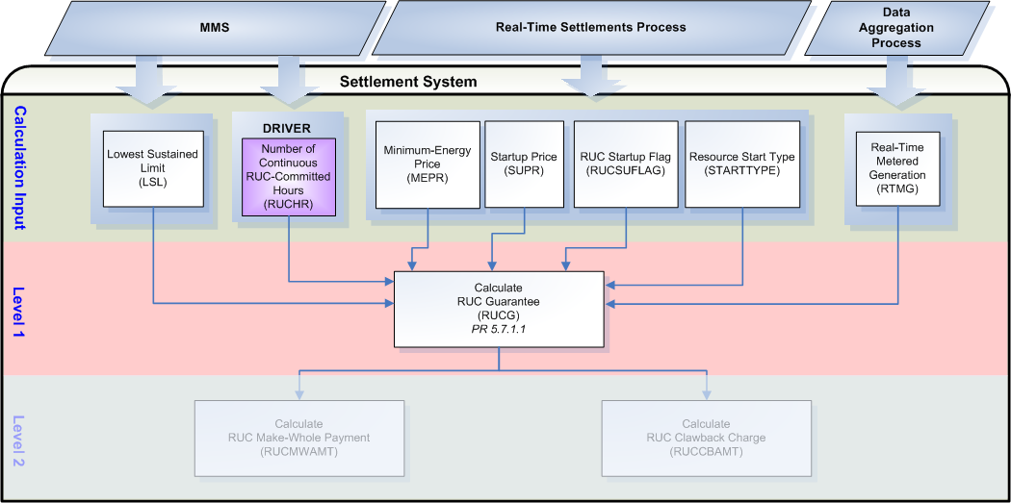

Assumptions
None

Business Rules
Req. ID | Protocol(s) | Sub-Process Map | Description
FR22 | PR 5.7.1.1 | Will be completed August 31, 2006 | DRIVER: The RUCG calculation should only be attempted for QSE/Resource combinations with a RUCHR_<Q>_<R> in the settlement system for the Operating Day.
FR23 | PR 5.7.1.1 | Will be completed August 31, 2006 | No input or output bill determinants should be rounded or truncated.
FR24 | PR 12.3 (c) | Will be completed August 31, 2006 | All input and output bill determinants should be made available to the extracts process and should be classified in the settlement system as:  - RUCHR – private  - SUPR – private  - MEPR – private  - RUCSUFLAG – private  - STARTTYPE – private  - RTMG – private  - LSL – private  - RUCG – private

Business Defined Errors
Req. ID | Protocol(s) | Sub-Process Map | Description
FR25 | PR 5.7.1.1 | Will be completed August 31, 2006 | While calculating RUCG, if RUCHR does not exist in the Settlement System for the Operating Day for the QSE/Resource combination, then the Settlement System should process as if no RUC-Commitment was issued and should not perform the calculation for the QSE/Resource combination
FR26 | PR 5.7.1.1 | Will be completed August 31, 2006 | While calculating RUCG, if SUPR does not exist in the Settlement System for the Operating Day for the QSE/Resource combination, then the Settlement System should default to zero for all intervals of the Operating Day and should provide a WARN-DEFAULT error message indicating the failure as “SUPR for QSE <Q> and Resource <R> was not available for calculation of RUCG.”
FR27 | PR 5.7.1.1 | Will be completed August 31, 2006 | While calculating RUCG, if MEPR does not exist in the Settlement System for the Operating Day for the QSE/Resource combination, then the Settlement System should default to zero for all intervals of the Operating Day and should provide a WARN-DEFAULT error message indicating the failure as “MEPR for QSE <Q> and Resource <R> was not available for calculation of RUCG.”
FR28 | PR 5.7.1.1 | Will be completed August 31, 2006 | While calculating RUCG, if RUCSUFLAG does not exist in the Settlement System for the Operating Day for the QSE/Resource combination, then the Settlement System should default to zero for all intervals of the Operating Day and should provide a WARN-DEFAULT error message indicating the failure as “RUCSUFLAG for QSE <Q> and Resource <R> was not available for calculation of RUCG.”
FR29 | PR 5.7.1.1 | Will be completed August 31, 2006 | While calculating RUCG, if STARTTYPE does not exist in the Settlement System for the Operating Day for the QSE/Resource combination, then the Settlement System should default to zero for all intervals of the Operating Day and should provide a WARN-DEFAULT error message indicating the failure as “STARTTYPE for QSE <Q> and Resource <R> was not available for calculation of RUCG.”
FR30 | PR 5.7.1.1 | Will be completed August 31, 2006 | While calculating RUCG, if RTMG does not exist in the Settlement System for the Operating Day for the QSE/Resource combination, then the Settlement System should default to zero for all intervals of the Operating Day and should provide a WARN-DEFAULT error message indicating the failure as “RTMG for QSE <Q> and Resource <R> was not available for calculation of RUCG.”
FR31 | PR 5.7.1.1 | Will be completed August 31, 2006 | While calculating RUCG, if LSL does not exist in the Settlement System for the Operating Day for the QSE/Resource combination, then the Settlement System should default to zero for all intervals of the Operating Day and should provide a WARN-DEFAULT error message indicating the failure as “LSL for QSE <Q> and Resource <R> was not available for calculation of RUCG.”

Specific Database Needs
None

RUC Minimum-Energy Revenue (RUCMEREV)
The RUC Minimum-Energy Revenue (RUCMEREV) represents the revenue, earned in Real-Time, for the Resource’s generation up to LSL during all RUC-Committed Hours of the Operating Day.

Requirement ID | FR32
Source Mapping (Protocol/NERC/FERC and other binding documents Ref #) | PR 5.7.1.2
Traceability to Sub-Process Maps | Will be completed August 31, 2006
Description: Calculate the RUCMEREV by QSE and Resource, for each 15-minute Settlement Interval within each RUC-Committed hour of the Operating Day.

RUCMEREV_<Q>_<R>_<SP> = $\underset{i}{Σ}$(RTSPP_<SP> * Min (RTMG_<Q>_<R>_<SP>, (LSL_<Q>_<R>_<SP> * (¼))))

Input Bill Determinants
Variable | Unit | Definition | Source
RUCHR | Misc | RUC Hour—The total number of RUC-Committed Hours, for the Resource for the Operating Day. | MMS
Interval Frequency: 1 / hour

Additional Comments: None
RTSPP | $/MWh | Real-Time Settlement Point Price—The Real-Time Settlement Point Price at the Settlement Point for the Settlement Interval i. | MMS
Interval Frequency: 4 / hour

Additional Comments: None
RTMG | MWh | Real-Time Metered Generation—The Resource’s metered generation for the Settlement Interval i. | Settlement System through the Data Aggregation Process
Interval Frequency: 4 / hour

Additional Comments: None
LSL | MW | Low Sustained Limit—The limit established by the QSE, continuously updated in Real-Time, that describes the minimum sustained energy production capability of the Resource for the hour that includes the Settlement Interval i. | MMS
Interval Frequency: 1 / hour

Additional Comments: None

Output Bill Determinants
Variable | Unit | Definition | Destination
RUCMEREV | $ | RUC Minimum-Energy Revenue—The sum of the energy revenues for the Resource’s generation up to LSL during all RUC-Committed Hours, for the Operating Day. | Settlement System
Interval Frequency: 1 / day

Additional Comments: None

Data Dependencies
D1) Calculation of the RUCMEREV is dependent on:
- availability of the input bill determinants
- successful completion of the Data Aggregation Process

D2) The RUCMEREV calculation must be complete prior to the calculation of the RUC Make-Whole Payment (RUCMWAMT) and the RUC Clawback Charge (RUCCBAMT).

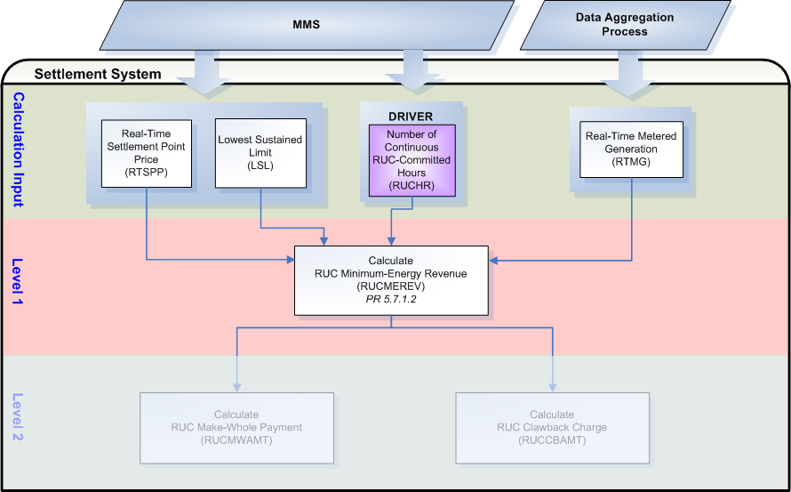

Assumptions
None

Business Rules
Req. ID | Protocol(s) | Sub-Process Map | Description
FR33 | PR 5.7.1.2 | Will be completed August 31, 2006 | DRIVER: The RUCMEREV calculation should only be attempted for QSE/Resource combinations with a RUC-Commitment (RUCHR_<Q>_<R>) in the settlement system for the Operating Day.
FR34 | PR 5.7.1.2 | Will be completed August 31, 2006 | No input or output bill determinants should be rounded or truncated.
FR35 | PR 12.3 (c) | Will be completed August 31, 2006 | All input and output bill determinants should be made available to the extracts process and should be classified in the settlement system as:  - RUCHR – private  - RTSPP – public  - RTMG – private  - LSL – private  - RUCMEREV – private

Business Defined Errors
Req. ID | Protocol(s) | Sub-Process Map | Description
FR36 | PR 5.7.1.2 | Will be completed August 31, 2006 | While calculating RUCMEREV, if RUCHR does not exist in the Settlement System for the Operating Day for the QSE/Resource combination, then the Settlement System should process as if no RUC-Commitment was issued and should not perform the calculation for the QSE/Resource combination
FR37 | PR 5.7.1.2 | Will be completed August 31, 2006 | While calculating RUCMEREV, if RTMG does not exist in the Settlement System for the Operating Day for the QSE/Resource combination, then the Settlement System should default to zero for all intervals of the Operating Day and should provide a WARN-DEFAULT error message indicating the failure as “RTMG for QSE <Q> and Resource <R> was not available for calculation of RUCMEREV.”
FR38 | PR 5.7.1.2 | Will be completed August 31, 2006 | While calculating RUCMEREV, if LSL does not exist in the Settlement System for the Operating Day for the QSE/Resource combination, then the Settlement System should default to zero for all intervals of the Operating Day and should provide a WARN-DEFAULT error message indicating the failure as “LSL for QSE <Q> and Resource <R> was not available for calculation of RUCMEREV.”
FR39 | PR 5.7.1.2 | Will be completed August 31, 2006 | While calculating RUCMEREV, if RTSPP does not exist in the Settlement System for the Operating Day for the Settlement Point, then the Settlement System should default to zero for all intervals of the Operating Day and should provide a WARN-DEFAULT error message indicating the failure as “RTSPP for Settlement Point <SP> was not available for calculation of RUCMEREV.”

Specific Database Needs
None

Revenue Less Costs Above LSL During RUC-Committed Hours (RUCEXRR)
The Revenue Less Cost Above LSL During RUC-Committed Hours (RUCEXRR) represents the total revenue for the Resource operating above its LSL less the cost during all RUC-Committed Hours of the Operating Day.

Requirement ID | FR40
Source Mapping (Protocol/NERC/FERC and other binding documents Ref #) | PR 5.7.1.3
Traceability to Sub-Process Maps | Will be completed August 31, 2006
Description: Calculate the RUCEXRR by QSE and Resource, for each 15-minute Settlement Interval within each RUC-Committed hour of the Operating Day.

RUCEXRR_<Q>_<R>_<SP> = Max {0, $\underset{i}{Σ}$[RTSPP_<SP> * Max (0, RTMG_<Q>_<R>_<SP> – (LSL_<Q>_<R>_<SP> * (¼)))
+ (-1) * (VSSVARAMT_<Q>_<R>_<SP> + VSSEAMT_<Q>_<R>_<SP>)
+ (-1) * EMREAMT_<Q>_<R>_<SP>
– RTAIEC_<Q>_<R>_<SP> * Max (0, RTMG_<Q>_<R>_<SP> – (LSL_<Q>_<R>_<SP> * (¼)))]}

Input Bill Determinants
Variable | Unit | Definition | Source
RUCHR | Misc | RUC Hour—The total number of RUC-Committed Hours, for the Resource for the Operating Day. | MMS
Interval Frequency: 1 / hour

Additional Comments: None
RTSPP | $/MWh | Real-Time Settlement Point Price—The Real-Time Settlement Point Price at the Settlement Point for the Settlement Interval i. | MMS
Interval Frequency: 4 / hour

Additional Comments: None
RTAIEC | $/MWh | Real-Time Average Incremental Energy Cost⎯The average incremental energy cost, calculated using the Energy Offer Curve capped by the Energy Offer Curve Cap, for the Resource’s generation above the LSL for the Settlement Interval i. See Section 4.6.5, Calculation of “Average Incremental Energy Cost” (AIEC). | Settlement System – Calculation for Real Time Average Incremental Energy Curve calculated previously
Interval Frequency: 4 / hour

Additional Comments: See TN.COMS.63C01.AIEC.REQUIREMENTS.A for further information on the RTAIEC bill determinant.
RTMG | MWh | Real-Time Metered Generation—The Resource’s metered generation for the Settlement Interval i. | Settlement System through the Data Aggregation Process
Interval Frequency: 4 / hour

Additional Comments: None
LSL | MW | Low Sustained Limit—The limit established by the QSE, continuously updated in Real-Time, that describes the minimum sustained energy production capability of the Resource for the hour that includes the Settlement Interval i. | MMS
Interval Frequency: 1 / hour

Additional Comments: None
VSSVARAMT | $ | Voltage Support Service var Amount by interval—The payment to the QSE for the VSS provided by Generation Resource for the 15-minute Settlement Interval i. See Section 6.6.7.1, Voltage Support Service Payments. | Settlement System – Calculation for Voltage Support Service VAR Payment calculated previously
Interval Frequency: 4 / hour

Additional Comments: See TN.COMS.63C01.RTVOLTAGE.REQUIREMENTS.A for further information on the VSSVARAMT bill determinant.
VSSEAMT | $ | Voltage Support Service Energy Amount by interval—The lost opportunity payment to the QSE for ERCOT-directed VSS from the Generation Resource for the 15-minute Settlement Interval i. See Section 6.6.7.1, Voltage Support Service Payments. | Settlement System – Calculation for Voltage Support Service Energy Payment calculated previously
Interval Frequency: 4 / hour

Additional Comments: See TN.COMS.63C01.RTVOLTAGE.REQUIREMENTS.A for further information on the VSSEAMT bill determinant.
EMREAMT | $ | Emergency Energy Amount by interval—The payment to the QSE as additional compensation for the additional energy produced by the Generation Resource in Real-Time during the Emergency Condition, for the 15-minute Settlement Interval i. See Section 6.6.9.1, Payment for Emergency Power Increase directed by ERCOT. | Settlement System – Calculation for Emergency Power Increase Payment calculated previously
Interval Frequency: 4 / hour

Additional Comments: See TN.COMS.63C01.RTEMEROPS.REQUIREMENTS.A for further information on the EMREAMT bill determinant.

Output Bill Determinants
Variable | Unit | Definition | Destination
RUCEXRR | $ | Energy Revenue Less Cost Above LSL During RUC-Committed Hours—The sum of the total energy revenue for the Resource’s generation above the LSL less the cost of the generation during all RUC-Committed Hours, for the Operating Day. | Settlement System
Interval Frequency: 1 / day

Additional Comments: None

Data Dependencies
D1) Calculation of the RUCEXRR is dependent on:
- availability of the input bill determinants
- successful completion of the Data Aggregation Process
- successful calculation of RTAIEC
- successful calculation of VSSVARAMT
- successful calculation of VSSEAMT
- successful calculation of EMREAMT

D2) The RUCEXRR calculation must be complete prior to the calculation of the RUC Make-Whole Payment (RUCMWAMT) and the RUC Clawback Charge (RUCCBAMT).

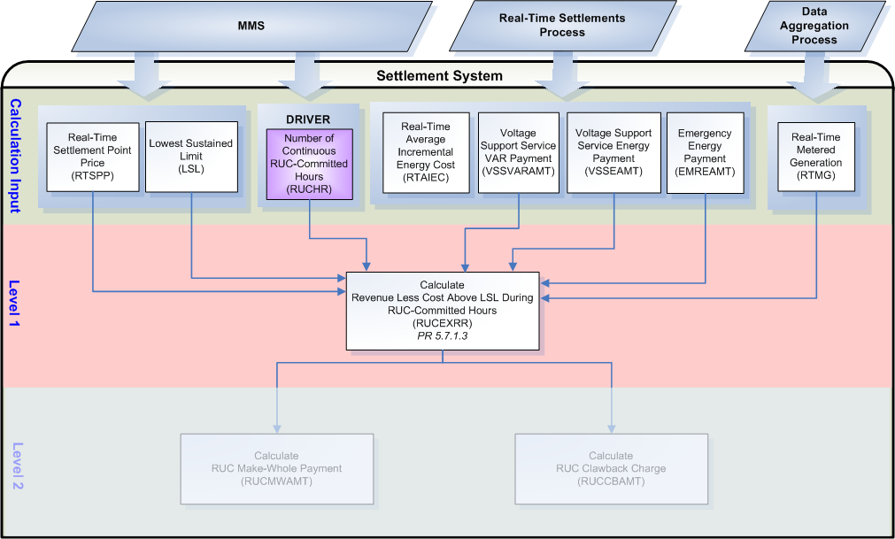

Assumptions
None

Business Rules
Req. ID | Protocol(s) | Sub-Process Map | Description
FR41 | PR 5.7.1.3 | Will be completed August 31, 2006 | DRIVER: The RUCEXRR calculation should only be attempted for QSE/Resource combinations with a RUC-Commitment (RUCHR_<Q>_<R>) in the settlement system for the Operating Day.
FR42 | PR 5.7.1.3 | Will be completed August 31, 2006 | No input or output bill determinants should be rounded or truncated.
FR43 | PR 12.3 (c) | Will be completed August 31, 2006 | All input and output bill determinants should be made available to the extracts process and should be classified in the settlement system as:  - RUCHR – private  - RTSPP – public  - RTAIEC - private  - RTMG – private  - LSL – private  - VSSVARAMT – private  - VSSEAMT – private  - EMREAMT – private  - RUCEXRR – private

Business Defined Errors
Req. ID | Protocol(s) | Sub-Process Map | Description
FR44 | PR 5.7.1.3 | Will be completed August 31, 2006 | While calculating RUCEXRR, if RUCHR does not exist in the Settlement System for the Operating Day for the QSE/Resource combination, then the Settlement System should process as if no RUC-Commitment was issued and should not perform the calculation for the QSE/Resource combination
FR45 | PR 5.7.1.3 | Will be completed August 31, 2006 | While calculating RUCEXRR, if RTMG does not exist in the Settlement System for the Operating Day for the QSE/Resource combination, then the Settlement System should default to zero for all intervals of the Operating Day and should provide a WARN-DEFAULT error message indicating the failure as “RTMG for QSE <Q> and Resource <R> was not available for calculation of RUCEXRR.”
FR46 | PR 5.7.1.3 | Will be completed August 31, 2006 | While calculating RUCEXRR, if LSL does not exist in the Settlement System for the Operating Day for the QSE/Resource combination, then the Settlement System should default to zero for all intervals of the Operating Day and should provide a WARN-DEFAULT error message indicating the failure as “LSL for QSE <Q> and Resource <R> was not available for calculation of RUCEXRR.”
FR47 | PR 5.7.1.3 | Will be completed August 31, 2006 | While calculating RUCEXRR, if RTAIEC does not exist in the Settlement System for the Operating Day for the QSE/Resource combination, then the Settlement System should default to zero for all intervals of the Operating Day and should provide a WARN-DEFAULT error message indicating the failure as “RTAIEC for QSE <Q> and Resource <R> was not available for calculation of RUCEXRR.”
FR48 | PR 5.7.1.3 | Will be completed August 31, 2006 | While calculating RUCEXRR, if VSSVARAMT does not exist in the Settlement System for the Operating Day for the QSE/Resource combination, then the Settlement System should default to zero for all intervals of the Operating Day.
FR49 | PR 5.7.1.3 | Will be completed August 31, 2006 | While calculating RUCEXRR, if VSSEAMT does not exist in the Settlement System for the Operating Day for the QSE/Resource combination, then the Settlement System should default to zero for all intervals of the Operating Day.
FR50 | PR 5.7.1.3 | Will be completed August 31, 2006 | While calculating RUCEXRR, if EMREAMT does not exist in the Settlement System for the Operating Day for the QSE/Resource combination, then the Settlement System should default to zero for all intervals of the Operating Day.
FR51 | PR 5.7.1.3 | Will be completed August 31, 2006 | While calculating RUCEXRR, if RTSPP does not exist in the Settlement System for the Operating Day for the Settlement Point, then the Settlement System should default to zero for all intervals of the Operating Day and should provide a WARN-DEFAULT error message indicating the failure as “RTSPP for Settlement Point <SP> was not available for calculation of RUCEXRR.”

Specific Database Needs
None

Revenue Less Costs During QSE Clawback Intervals (RUCEXRQC)
The Revenue Less Cost During QSE Clawback Intervals (RUCEXRQC) represents the total revenue for the Resource less the cost during all QSE Clawback Intervals of the Operating Day.

A QSE Clawback Interval is: Any QSE-Committed Interval that is part of a contiguous block that includes at least one RUC-Committed Hour unless it is:
(1) QSE-committed before the first RUC instruction for any RUC-Committed Hour in that contiguous block; or
(2) Part of a contiguous block of a QSE-Committed Intervals, at least one of which was committed by the QSE before the RUC instruction described in paragraph (1) above. PR 2.1

A QSE-Committed Interval is: A Settlement Interval for which the QSE for a Resource has committed the Resource without a RUC instruction to commit it. PR 2.1

QSE Clawback Intervals will be determined the startup eligibility process.
See TN.COMS.63C01.STARTUPELIGIBILITY.REQUIREMENTS.A for further information.

Requirement ID | FR52
Source Mapping (Protocol/NERC/FERC and other binding documents Ref #) | PR 5.7.1.4
Traceability to Sub-Process Maps | Will be completed August 31, 2006
Description: Calculate the RUCEXRQC by QSE and Resource, for each 15-minute Settlement Interval determined to be a QSE Clawback interval (QCLAW_<Q>_<R>_<SP> = 1) of the Operating Day.

RUCEXRQC_<Q>_<R>_<SP> = Max {0, $\underset{i}{Σ}$[(RTSPP_<SP> * RTMG_<Q>_<R>_<SP>)
+ (-1) * (VSSVARAMT_<Q>_<R>_<SP> + VSSEAMT_<Q>_<R>_<SP>)
+ (-1) * EMREAMT_<Q>_<R>_<SP>
– [MEPR_<Q>_<R>_<SP> * Min (RTMG_<Q>_<R>_<SP>, (LSL_<Q>_<R>_<SP> * (¼)))]
– [RTAIEC_<Q>_<R>_<SP> * Max (0, RTMG_<Q>_<R>_<SP> – (LSL_<Q>_<R>_<SP> * (¼)))]]}

Input Bill Determinants
Variable | Unit | Definition | Source
RUCHR | Misc | RUC Hour—The total number of RUC-Committed Hours, for the Resource for the Operating Day. | MMS
Interval Frequency: 1 / hour

Additional Comments: None
QCLAW | Misc | QSE Clawback Interval Flag—The flag that indicates, for the resource, whether or not the settlement interval is a QSE Clawback interval. If the settlement interval is a QSE Clawback interval, its value is one; otherwise, zero. | Settlement System – Calculation for Startup Eligibility calculated previously
Interval Frequency: 4 / hour

Additional Comments: This determinant is not documented in the Nodal Protocols but is required to determine QSE Clawback intervals for a Resource.

The QCLAW bill determinant will be an output from the startup eligibility process and will only be created for Resources with RUC commitments.

See TN.COMS.63C01.STARTUPELIGIBILITY.REQUIREMENTS.A for further information on the QCLAW bill determinant.
RTSPP | $/MWh | Real-Time Settlement Point Price—The Real-Time Settlement Point Price at the Settlement Point for the Settlement Interval i. | MMS
Interval Frequency: 4 / hour

Additional Comments: None
RTAIEC | $/MWh | Real-Time Average Incremental Energy Cost⎯The average incremental energy cost, calculated using the Energy Offer Curve capped by the Energy Offer Curve Cap, for the Resource’s generation above the LSL for the Settlement Interval i. See Section 4.6.5, Calculation of “Average Incremental Energy Cost” (AIEC). | ERCOT Settlement System – RTAIEC calculated previously
Interval Frequency: 4 / hour

Additional Comments: See TN.COMS.63C01.AIEC.REQUIREMENTS.A for further information on the RTAIEC bill determinant.
MEPR | $/MWh | Minimum-Energy Price—The settlement price for minimum energy for the Settlement Interval i. | ERCOT Settlement System – Calculation for Minimum-Energy Price calculated previously
Interval Frequency: 1 / hour

Additional Comments: None
RTMG | MWh | Real-Time Metered Generation—The Resource’s metered generation for the Settlement Interval i. | ERCOT Settlement System through the Data Aggregation Process
Interval Frequency: 4 / hour

Additional Comments: None
LSL | MW | Low Sustained Limit—The limit established by the QSE, continuously updated in Real-Time, that describes the minimum sustained energy production capability of the Resource for the hour that includes the Settlement Interval i. | MMS
Interval Frequency: 1 / hour

Additional Comments: None
VSSVARAMT | $ | Voltage Support Service var Amount by interval—The payment to the QSE for the VSS provided by Generation Resource for the 15-minute Settlement Interval i. See Section 6.6.7.1, Voltage Support Service Payments. |  | ERCOT Settlement System – Calculation for Voltage Support Service Payments calculated previously
Interval Frequency: 4 / hour

Additional Comments: See TN.COMS.63C01.RTVOLTAGE.REQUIREMENTS.A for further information on the VSSVARAMT bill determinant.
VSSEAMT | $ | Voltage Support Service Energy Amount by interval—The lost opportunity payment to the QSE for ERCOT-directed VSS from the Generation Resource for the 15-minute Settlement Interval i. See Section 6.6.7.1, Voltage Support Service Payments. |  | ERCOT Settlement System – Calculation for Voltage Support Service Payments calculated previously
Interval Frequency: 4 / hour

Additional Comments: See TN.COMS.63C01.RTVOLTAGE.REQUIREMENTS.A for further information on the VSSEAMT bill determinant.
EMREAMT | $ | Emergency Energy Amount by interval—The payment to the QSE as additional compensation for the additional energy produced by the Generation Resource in Real-Time during the Emergency Condition, for the 15-minute Settlement Interval i. See Section 6.6.9.1, Payment for Emergency Power Increase directed by ERCOT. |  | ERCOT Settlement System – Calculation for Emergency Power Payment calculated previously
Interval Frequency: 4 / hour

Additional Comments: See TN.COMS.63C01.RTEMEROPS.REQUIREMENTS.A for further information on the EMREAMT bill determinant.

Output Bill Determinants
Variable | Unit | Definition | Destination
RUCEXRQC | $ | Revenue Less Cost During QSE-Clawback Intervals—The sum of the total energy revenue for the Resource’s generation less the cost of the generation during all QSE-Clawback Intervals for the Operating Day. | Settlement System
Interval Frequency: 1 / day

Additional Comments: None

Data Dependencies
D1) Calculation of the RUCEXRQC is dependent on:
- availability of the input bill determinants
- successful completion of the Data Aggregation Process
- successful calculation of QCLAW
- successful calculation of RTAIEC
- successful calculation of MEPR
- successful calculation of VSSVARAMT
- successful calculation of VSSEAMT
- successful calculation of EMREAMT

D2) The RUCEXRQC calculation must be complete prior to the calculation of the RUC Make-Whole Payment (RUCMWAMT) and the RUC Clawback Charge (RUCCBAMT).

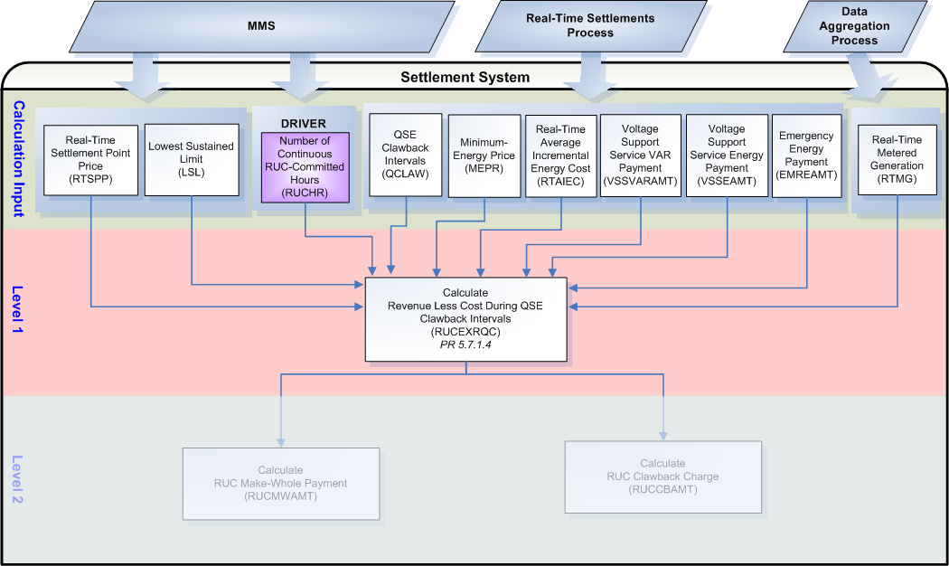

Assumptions
None

Business Rules
Req. ID | Protocol(s) | Sub-Process Map | Description
FR53 | PR 5.7.1.4 | Will be completed August 31, 2006 | DRIVER: The RUCEXRQC calculation should only be attempted for QSE/Resource combinations with a RUC-Commitment (RUCHR_<Q>_<R>) in the settlement system for the Operating Day.
FR54 | PR 5.7.1.4 | Will be completed August 31, 2006 | No input or output bill determinants should be rounded or truncated.
FR55 | PR 12.3 (c) | Will be completed August 31, 2006 | All input and output bill determinants should be made available to the extracts process and should be classified in the settlement system as:  - RUCHR – private  - QCLAW – private  - RTSPP – public  - RTAIEC – private  - MEPR – private  - RTMG – private  - LSL – private  - VSSVARAMT – private  - VSSEAMT – private  - EMREAMT – private  - RUCEXRQC – private

Business Defined Errors
Req. ID | Protocol(s) | Sub-Process Map | Description
FR56 | PR 5.7.1.4 | Will be completed August 31, 2006 | While calculating RUCEXRQC, if RUCHR does not exist in the Settlement System for the Operating Day for the QSE/Resource combination, then the Settlement System should process as if no RUC-Commitment was issued and should not perform the calculation for the QSE/Resource combination
FR57 | PR 5.7.1.4 | Will be completed August 31, 2006 | While calculating RUCEXRQC, if QCLAW does not exist in the Settlement System for the Operating Day for the QSE/Resource combination, then the Settlement System should default to zero for all intervals of the Operating Day and should provide a WARN-DEFAULT error message indicating the failure as “QCLAW for QSE <Q> and Resource <R> was not available for calculation of RUCEXRQC.”
FR58 | PR 5.7.1.4 | Will be completed August 31, 2006 | While calculating RUCEXRQC, if RTMG does not exist in the Settlement System for the Operating Day for the QSE/Resource combination, then the Settlement System should default to zero for all intervals of the Operating Day and should provide a WARN-DEFAULT error message indicating the failure as “RTMG for QSE <Q> and Resource <R> was not available for calculation of RUCEXRQC.”
FR59 | PR 5.7.1.4 | Will be completed August 31, 2006 | While calculating RUCEXRQC, if LSL does not exist in the Settlement System for the Operating Day for the QSE/Resource combination, then the Settlement System should default to zero for all intervals of the Operating Day and should provide a WARN-DEFAULT error message indicating the failure as “LSL for QSE <Q> and Resource <R> was not available for calculation of RUCEXRQC.”
FR60 | PR 5.7.1.4 | Will be completed August 31, 2006 | While calculating RUCEXRQC, if MEPR does not exist in the Settlement System for the Operating Day for the QSE/Resource combination, then the Settlement System should default to zero for all intervals of the Operating Day and should provide a WARN-DEFAULT error message indicating the failure as “MEPR for QSE <Q> and Resource <R> was not available for calculation of RUCEXRQC.”
FR61 | PR 5.7.1.4 | Will be completed August 31, 2006 | While calculating RUCEXRQC, if RTAIEC does not exist in the Settlement System for the Operating Day for the QSE/Resource combination, then the Settlement System should default to zero for all intervals of the Operating Day and should provide a WARN-DEFAULT error message indicating the failure as “RTAIEC for QSE <Q> and Resource <R> was not available for calculation of RUCEXRQC.”
FR62 | PR 5.7.1.4 | Will be completed August 31, 2006 | While calculating RUCEXRQC, if VSSVARAMT does not exist in the Settlement System for the Operating Day for the QSE/Resource combination, then the Settlement System should default to zero for all intervals of the Operating Day.
FR63 | PR 5.7.1.4 | Will be completed August 31, 2006 | While calculating RUCEXRQC, if VSSEAMT does not exist in the Settlement System for the Operating Day for the QSE/Resource combination, then the Settlement System should default to zero for all intervals of the Operating Day.
FR64 | PR 5.7.1.4 | Will be completed August 31, 2006 | While calculating RUCEXRQC, if EMREAMT does not exist in the Settlement System for the Operating Day for the QSE/Resource combination, then the Settlement System should default to zero for all intervals of the Operating Day.
FR65 | PR 5.7.1.4 | Will be completed August 31, 2006 | While calculating RUCEXRQC, if RTSPP does not exist in the Settlement System for the Operating Day for the Settlement Point, then the Settlement System should default to zero for all intervals of the Operating Day and should provide a WARN-DEFAULT error message indicating the failure as “RTSPP for Settlement Point <SP> was not available for calculation of RUCEXRQC.”

Specific Database Needs
None

RUC Make-Whole Payment (RUCMWAMT)
ERCOT shall pay each QSE, whose Resource is selected by RUC, the dollar amount required to make the Resource whole (RUCG) after taking in to account all revenues (RUCMEREV, RUCEXRR, RUCEXRQC) earned by the Resource for the Operating Day. The RUC Make-Whole Payment is a calculation of daily values spread evenly across all RUC-Committed hours of the Operating Day.

If the revenues (RUCMEREV, RUCEXRR, RUCEXRQC) earned by the Resource for the Operating Day is greater than the dollar amount required to make the Resource whole (RUCG) then no RUC Make-Whole Payment is due to the QSE for the Resource.

Requirement ID | FR66
Source Mapping (Protocol/NERC/FERC and other binding documents Ref #) | PR 5.7.1
Traceability to Sub-Process Maps | Will be completed August 31, 2006
Description: Calculate the RUCMWAMT by QSE and Resource, with a RUC Commitment, for each hour of the Operating Day.

RUCMWAMT_<Q>_<R>_<SP> = (-1) * MAX(0, RUCG_<Q>_<R>_<SP> - RUCMEREV_<Q>_<R>_<SP> -RUCEXRR_<Q>_<R>_<SP> - RUCEXRQC_<Q>_<R>_<SP>) / $\underset{h}{Σ}$RUCHR_<Q>_<R>_<SP>
The RUCMWAMT will be calculated for each Operating Day by QSE, Resource and divided evenly across all RUC-Committed hours while indicating which hours were RUC-Committed and by which individual RUC Process. Each hour that is RUC-Committed and the RUC Process that committed it will be identified within the bill determinant RUCHR_<Q>_<R> and the RUCMWAMT may use this bill determinant to retrieve RUC Process data for the appropriate RUC Process.

Requirement ID | FR67
Source Mapping (Protocol/NERC/FERC and other binding documents Ref #) | PR 5.7.4.1
Traceability to Sub-Process Maps | Will be completed August 31, 2006
Description: Calculate the RUCMWAMTRUCTOT by RUC Process, for each hour of the Operating Day.

RUCMWAMTRUCTOT_<RUC> = $\underset{q}{Σ}$$\underset{r}{Σ}$$\underset{\text{sp}}{Σ}$RUCMWAMT_<Q>_<R>_<SP>
The RUCMWAMT should indicate, by hour, which RUC Process initiated the hour for payment. Each RUCMWAMTTUCTOT must sum all QSE/Resource combinations that were RUC-Committed in the same hour by the same RUC Process, for each hour of the Operating Day. There is a possibility of having many RUCMWAMTRUCTOTs per Operating Day, depending on the number of RUC Processes that committed Resources.

Requirement ID | FR68
Source Mapping (Protocol/NERC/FERC and other binding documents Ref #) | PR 5.7.4.2
Traceability to Sub-Process Maps | Will be completed August 31, 2006
Description: Calculate the RUCMWAMTTOT for each hour of the Operating Day.

RUCMWAMTTOT = $\underset{\text{ruc}}{Σ}$RUCMWAMTRUCTOT_<RUC>

Input Bill Determinants
Variable | Unit | Definition | Original Source
RUCHR | Misc | RUC Hour—The total number of RUC-Committed Hours, for the Resource for the Operating Day. | MMS
Interval Frequency: 1 / hour

Additional Comments: The RUCMWAMT must use the daily sum of all RUCHR bill determinant hours for the calculation but must also use the individual hourly RUC Process indicators to populate, for each RUCMWAMT payment hour, the appropriate RUC Process.
RUCG | $ | RUC Guarantee—The sum of the Resource’s Startup Costs and Minimum-Energy Costs during all RUC-Committed Hours, for the Operating Day. | Settlement System – Global Calculation for RUCG calculated previously
Interval Frequency: 1 / day

Additional Comments: None
RUCMEREV | $ | RUC Minimum-Energy Revenue—The sum of the energy revenues for the Resource’s generation up to LSL during all RUC-Committed Hours, for the Operating Day. | Settlement System – Global Calculation for RUCMEREV calculated previously
Interval Frequency: 1 / day

Additional Comments: None
RUCEXRR | $ | Energy Revenue Less Cost Above LSL During RUC-Committed Hours—The sum of the total energy revenue for the Resource’s generation above the LSL less the cost of the generation during all RUC-Committed Hours, for the Operating Day. | Settlement System - Global Calculation for RUCEXRR calculated previously
Interval Frequency: 1 / day

Additional Comments: None
RUCEXRQC | $ | Energy Revenue Less Cost During QSE-Clawback Intervals—The sum of the total energy revenue for the Resource’s generation less the cost of the generation during all QSE-Clawback Intervals for the Operating Day. | Settlement System - Global Calculation for RUCEXRQC calculated previously
Interval Frequency: 1 / day

Additional Comments: None

Output Bill Determinants
Variable | Unit |  | Definition | Destination
RUCMWAMT | $ |  | RUC Make-Whole Payment—The RUC Make-Whole Payment to the QSE for a Resource, for each RUC-Committed Hour of the Operating Day. | Settlement System
Interval Frequency: 1 / hour

Additional Comments: None
RUCMWBILLAMT | $ | RUC Make-Whole Payment Bill Amount ⎯ The difference between two consecutive daily summed settlement runs of RUCMWAMT for the QSE, for an Operating Day. |  | Settlement System
Interval Frequency: 1 / day

Additional Comments: This bill determinant is not specifically documented in the Nodal Protocols but is required as a result of Section 9 Statements and Invoices Protocol requirements. The BILLAMT methodology is currently under consideration with the Commercial Operations Subcommittee (COPS.)

RUCMWAMTQSETOT | $ | RUC Make-Whole Payment Amount QSE Total ⎯ The QSE total for RUC Make-Whole payments for the hour. |  | Settlement System
Interval Frequency: 1 / hour

Additional Comments: This bill determinant is not specifically documented in the Nodal Protocols but is required as a result of Section 9 Statements and Invoices Protocol requirements. Settlement Statement methodology is currently under consideration with the Commercial Operations Subcommittee (COPS.)

RUCMWAMTRUCTOT | $ |  | RUC Make-Whole Amount Total per RUC Process—The sum of RUC Make-Whole Payments for a particular RUC process, including amounts for RMR Units, for the hour that includes the 15-minute Settlement Interval. | Settlement System
Interval Frequency: 1 / hour

Additional Comments: This is the total sum of all RUC Make-Whole payments (RUCMWAMT) for a particular RUC process and is used in the RUC Capacity-Short Charge (RUCCSAMT) and RUC Make-Whole Uplift Charge (LARUCAMT). This could be either the DRUC or any individual HRUC.

For example, if in the Day-Ahead RUC, a unit is asked to be on-line for hour 12 and through this calculation is paid $1,000 for that hour but later another unit, in an Hour-Ahead RUC, is asked to be on-line for hour 12 and is paid $2,000 for that hour then we need to differentiate between the first RUC instance of hour 12 for $1,000 and the second RUC instance of hour 12 for $2,000. The RUCMWAMT data cut will need an indicator for each hour so that the calculation for RUCMWAMTRUCTOT can tell the difference between RUCs. This data cut, RUCMWAMTRUCTOT, will need to indicate the RUC process it represents.
RUCMWAMTTOT | $ |  | RUC Make-Whole Amount Total—The sum of RUC Make-Whole Payments for all QSEs and RUC processes, including amounts for RMR Units, for the hour that includes the 15-minute Settlement Interval. | Settlement System
Interval Frequency: 1 / hour

Additional Comments:

Data Dependencies
D1) Calculation of the RUCMWAMT is dependent on:
- availability of the input bill determinants
- successful calculation of RUCG
- successful calculation of RUCMEREV
- successful calculation of RUCEXRR
- successful calculation of RUCEXRQC

D2) Calculation of the RUCMWAMTRUCTOT is dependent on the successful calculation of RUCMWAMT.

D3) Calculation of the RUCMWAMTTOT is dependent on the successful calculation of RUCMWAMTRUCTOT.

D4) The RUCMWAMTRUCTOT calculation must be complete prior to the calculation of the RUC Capacity-Short Charge (RUCCSAMT).

D5) The RUCMWAMTTOT calculation must be complete prior to the calculation of the RUC Make-Whole Uplift Charge (LARUCAMT).

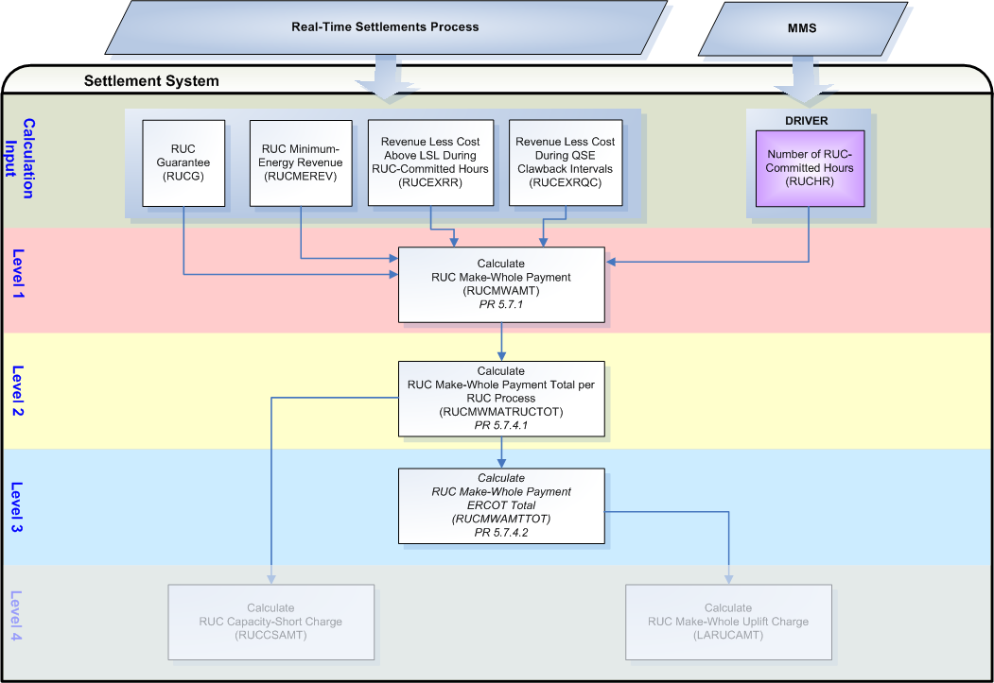

Assumptions
A1) The RUCHR bill determinant will be created within the interface between MMS and the Settlement System and will be populated with a value of one (1) for all RUC-Committed hours and a value of zero (0) for all other hours. Each non-zero populated hour will indicate which RUC Process committed the hour for the Resource.

Business Rules
Req. ID | Protocol(s) | Sub-Process Map | Description
FR69 | PR 5.7.1 | Will be completed August 31, 2006 | DRIVER: The RUCMWAMT calculation should only be attempted for QSE/Resource combinations with a RUCHR_<Q>_<R> in the settlement system for the Operating Day.
FR70 | PR 5.7.4.1 | Will be completed August 31, 2006 | The RUCMWAMT bill determinant must indicate which individual RUC Process committed each RUC-Committed hour so that the RUCMWAMTRUCTOT bill determinant will calculate correctly.
FR71 | PR 5.7.4.1 | Will be completed August 31, 2006 | DRIVER: For each RUC Process, the RUCMWAMTRUCTOT calculation should only be attempted for if there is at least one (1) RUCMWAMT_<Q>_<R> indicating that particular RUC process in the settlement system for the Operating Day.
FR72 | PR 5.7.4.1 | Will be completed August 31, 2006 | The RUCMWAMTRUCTOT bill determinant must be identified with a RUC Process identifier.
FR73 | PR 5.7.4.2 | Will be completed August 31, 2006 | DRIVER: The RUCMWAMTTOT calculation should always be calculated for every Operating Day.
FR74 | PR 5.7.1 | Will be completed August 31, 2006 | No input bill determinants should be rounded or truncated.
FR75 | PR 9.5.3 | Will be completed August 31, 2006 | All output bill determinants should be rounded to two (2) decimal places.
FR76 | PR 12.3 (c) | Will be completed August 31, 2006 | All input and output bill determinants should be made available to the extracts process and should be classified in the settlement system as:  - RUCHR – private  - RUCG – private  - RUCMEREV – private  - RUCEXRR – private  - RUCEXRQC – private  - RUCMWAMT – private  - RUCMWBILLAMT – private  - RUCMWAMTQSETOT – private  - RUCMWAMTRUCTOT – public  - RUCMWAMTTOT – public

Business Defined Errors
Req. ID | Protocol(s) | Sub-Process Map | Description
FR77 | PR 5.7.1 | Will be completed August 31, 2006 | While calculating RUCMWAMT, if RUCHR does not exist in the Settlement System for the Operating Day for the QSE/Resource combination, then the Settlement System should process as if no RUC-Commitment was issued and should not perform the calculation for the QSE/Resource combination.
FR78 | PR 5.7.1 | Will be completed August 31, 2006 | While calculating RUCMWAMT, if RUCG does not exist in the Settlement System for the Operating Day for the QSE/Resource combination, then the Settlement System should default to zero for all intervals of the Operating Day and should provide a WARN-DEFAULT error message indicating the failure as “RUCG for QSE <Q> and Resource <R> was not available for calculation of RUCMWAMT.”
FR79 | PR 5.7.1 | Will be completed August 31, 2006 | While calculating RUCMWAMT, if RUCMEREV does not exist in the Settlement System for the Operating Day for the QSE/Resource combination, then the Settlement System should default to zero for all intervals of the Operating Day and should provide a WARN-DEFAULT error message indicating the failure as “RUCMEREV for QSE <Q> and Resource <R> was not available for calculation of RUCMWAMT.”
FR80 | PR 5.7.1 | Will be completed August 31, 2006 | While calculating RUCMWAMT, if RUCEXRR does not exist in the Settlement System for the Operating Day for the QSE/Resource combination, then the Settlement System should default to zero for all intervals of the Operating Day and should provide a WARN-DEFAULT error message indicating the failure as “RUCEXRR for QSE/Resource <?> was not available for calculation of RUCMWAMT.”
FR81 | PR 5.7.1 | Will be completed August 31, 2006 | While calculating RUCMWAMT, if RUCEXRQC does not exist in the Settlement System for the Operating Day for the QSE/Resource combination, then the Settlement System should default to zero for all intervals of the Operating Day and should provide a WARN-DEFAULT error message indicating the failure as “RUCEXRQC for QSE <Q> and Resource <R> was not available for calculation of RUCMWAMT.”
FR82 | PR 5.7.4.1 | Will be completed August 31, 2006 | While calculating RUCMWAMTRUCTOT and for each RUC Process, if RUCMWAMT does not exist in the Settlement System for the Operating Day for the RUC Process, then the Settlement System should process as if there were no RUC Make-Whole Payments for that RUC Process and do not perform the calculation.
FR83 | PR 5.7.4.2 | Will be completed August 31, 2006 | While calculating RUCMWAMTTOT, if there are no RUCMWAMTRUCTOT in the Settlement System for the Operating Day, then the Settlement System should process as of there were no RUC Make-Whole Payments for the Operating Day for any RUC Process and create a RUCMWAMTTOT data cut with zeros for all hours of the Operating Day. There should be no RUCMWAMTRUCTOT data cuts for any RUC Process for the entire Operating Day for this condition to occur.

Specific Database Needs
Req. ID | Protocol(s) | Sub-Process Map | Description
FR84 | PR 5.7.1 | Will be completed August 31, 2006 | The settlement system must be able to visibly identify and track individual RUC Processes, by hour, within or for the bill determinant of RUCMWAMT.
FR85 | PR 5.7.4.1 | Will be completed August 31, 2006 | The settlement system must be able to visibly identify and track individual RUC Processes within or for the bill determinant of RUCMWAMTRUCTOT.

RUC Clawback Charge (RUCCBAMT)
ERCOT shall charge each QSE, whose Resource is selected by RUC, the dollar amount earned through revenues (RUCMEREV, RUCEXRR, RUCEXRQC) that is greater than the amount required to make the Resource whole (RUCG) for the Operating Day. The amount charged to the QSE for the Resource will depend on whether the QSE submitted a valid Three-Part Supply Offer for the Resource.

If a valid Three-Part Supply Offer was submitted into the DAM:
- For RUC-Committed Hours the Clawback percentage is 50% (Factor = 0.5) unless EECP is in effect, then the Clawback percentage is 0% (Factor = 0.0)
- For QSE-Clawback Intervals the Clawback percentage is 0% (Factor = 0.0)

If a valid Three-Part Supply Offer was not submitted into the DAM:
  - For RUC-Committed Hours the Clawback percentage is 100% (Factor = 1.0) unless EECP is in effect, then the Clawback percentage is 50% (Factor = 0.5)
  - For QSE-Clawback Intervals the Clawback percentage is 50% (Factor = 0.5)

If the revenues (RUCMEREV, RUCEXRR, RUCEXRQC) earned by the Resource for the Operating Day is less than the dollar amount required to make the Resource whole (RUCG) then no charge is made the QSE for the Resource. If a Resource that received a RUC Commitment, was not made whole by revenue earned and gets a RUC Make-Whole Payment it should not get a RUC Clawback Charge. If a Resource that received a RUC Commitment does not get a RUC Make-Whole Payment, it is eligible for a RUC Clawback Charge.

The RUC Clawback Charge is a calculation of daily values divided evenly across all RUC-Committed hours of the Operating Day.

Requirement ID | FR86
Source Mapping (Protocol/NERC/FERC and other binding documents Ref #) | PR 5.7.2
Traceability to Sub-Process Maps | Will be completed August 31, 2006
Description: Calculate RUC Clawback factors by QSE and Resource, with a RUC Commitment, for each Operating Day.

If QSE submits a valid Three-Part Supply Offer into the DAM (3PSOFLAG = 1) for the Resource,
Then, RUCCBFR_<Q>_<R>_<SP> = 0.5 for the Operating Day
If EECP is in effect for any hour of the Operating Day (EECP = 1):
RUCCBFR_<Q>_<R>_<SP> = 0.0 for the Operating Day

RUCCBFC_<Q>_<R>_<SP> = 0.0 for the Operating Day

Otherwise, RUCCBFR_<Q>_<R>_<SP> = 1.0 for the Operating Day
If EECP is in effect for any hour of the Operating Day (EECP = 1):
RUCCBFR_<Q>_<R>_<SP> = 0.5 for the Operating Day

RUCCBFC_<Q>_<R>_<SP> = for each hour of the Operating Day

Requirement ID | FR87
Source Mapping (Protocol/NERC/FERC and other binding documents Ref #) | PR 5.7.2
Traceability to Sub-Process Maps | Will be completed August 31, 2006
Description: Calculate the RUCCBAMT by QSE and Resource, with a RUC Commitment, for each hour of the Operating Day.

If (RUCMEREV_<Q>_<R>_<SP> + RUCEXRR_<Q>_<R>_<SP> - RUCG_<Q>_<R>_<SP>) > 0,

Then, RUCCBAMT_<Q>_<R>_<SP> = [(RUCMEREV_<Q>_<R>_<SP> + RUCEXRR_<Q>_<R>_<SP> - RUCG_<Q>_<R>_<SP>) * RUCCBFR_<Q>_<R>_<SP> + RUCEXRQC_<Q>_<R>_<SP> * RUCCBFC_<Q>_<R_<SP>] / $\underset{h}{Σ}$RUCHR_<Q>_<R>_<SP>

Otherwise, RUCCBAMT_<Q>_<R>_<SP> = [Max (0, RUCMEREV_<Q>_<R>_<SP> + RUCEXRR_<Q>_<R>_<SP> + RUCEXRQC_<Q>_<R>_<SP> - RUCG_<Q>_<R>_<SP>) * RUCCBFC_<Q>_<R>_<SP>] / $\underset{h}{Σ}$RUCHR_<Q>_<R>_<SP>

Requirement ID | FR88
Source Mapping (Protocol/NERC/FERC and other binding documents Ref #) | PR 5.7.5
Traceability to Sub-Process Maps | Will be completed August 31, 2006
Description: Calculate the RUCCBAMTTOT for each hour of the Operating Day.

RUCCBAMTTOT = $\underset{q}{Σ}$$\underset{r}{Σ}$$\underset{\text{sp}}{Σ}$RUCCBAMT_<Q>_<R>_<SP>

Input Bill Determinants
Variable | Unit | Definition | Original Source
RUCHR | Misc | RUC Hour—The total number of RUC-Committed Hours, for the Resource for the Operating Day. | MMS
Interval Frequency: 1 / hour

Additional Comments: The RUCCBAMT must use the daily sum of all RUCHR bill determinant hours for the calculation but will not need the individual hourly RUC Process indicators.
EECP | Misc | Emergency Electric Curtailment Plan Flag—The flag that indicates, for each hour of the Operating Day, when an Emergency Electric Curtailment Plan is in effect. The value will be one (1) if EECP is in effect for any portion of the hour and zero (0) if EECP is not in effect for any portion of the hour. | MMS
Interval Frequency: 1 / hour

Additional Comments: This determinant is not documented in the Nodal Protocols but is required to determine RUC Clawback factors for the calculation of RUCCBAMT.
3PSOFLAG | Misc | Valid Three-Part Supply Offer Flag—The flag that indicates, for each Operating Day, when valid Three-Part Supply Offer has been submitted for consideration in the DAM. The value will be one (1) if a Three-Part Supply Offer is submitted for consideration in the DAM and zero (0) otherwise. | MMS
Interval Frequency: 1 / day

Additional Comments: This determinant is not documented in the Nodal Protocols but is required to determine RUC Clawback factors for the calculation of RUCCBAMT.
RUCG | $ | RUC Guarantee—The sum of the Resource’s Startup Costs and Minimum-Energy Costs during all RUC-Committed Hours, for the Operating Day. | Settlement System – Global Calculation for RUCG calculated previously
Interval Frequency: 1 / day

Additional Comments: None
RUCMEREV | $ | RUC Minimum-Energy Revenue—The sum of the energy revenues for the Resource’s generation up to LSL during all RUC-Committed Hours, for the Operating Day. | Settlement System – Global Calculation for RUCMEREV calculated previously
Interval Frequency: 1 / day

Additional Comments: None
RUCEXRR | $ | Energy Revenue Less Cost Above LSL During RUC-Committed Hours—The sum of the total energy revenue for the Resource’s generation above the LSL less the cost of the generation during all RUC-Committed Hours, for the Operating Day. | Settlement System - Global Calculation for RUCEXRR calculated previously
Interval Frequency: 1 / day

Additional Comments: None
RUCEXRQC | $ | Energy Revenue Less Cost During QSE-Clawback Intervals—The sum of the total energy revenue for the Resource’s generation less the cost of the generation during all QSE-Clawback Intervals for the Operating Day. | Settlement System - Global Calculation for RUCEXRQC calculated previously
Interval Frequency: 1 / day

Additional Comments: None

Intermediate Bill Determinants
Variable | Unit | Definition | Destination
RUCCBFR | Misc | RUC Claw-Back Factor for RUC-Committed Hours—The Resource’s Claw-Back Factor for RUC-Committed Hours, which is 50% if a Three-Part Supply Offer was submitted and 100% otherwise. During EECP conditions the Resource’s clawback factor for RUC-Committed Hours is 0% if a Three-Part Supply Offer was submitted and 50% otherwise. | Settlement System
Interval Frequency: 1 / day

Additional Comments: None
RUCCBFC | Misc | RUC Claw-Back Factor for QSE Clawback intervals— The Resource’s clawback factor for QSE Clawback Intervals, which is 0% if a Three-Part Supply Offer was submitted and 50% otherwise. | Settlement System
Interval Frequency: 1 / day

Additional Comments: None

Output Bill Determinants
Variable | Unit | Definition | Destination
RUCCBAMT | $ | RUC Clawback Charge––The RUC Clawback Charge to a QSE for a Resource as described in Section 5.7.2, RUC Clawback Charge, for each RUC-Committed Hour of the Operating Day for that Resource. | Settlement System
Interval Frequency: 1 / hour

Additional Comments: None
RUCCBBILLAMT | $ | RUC Clawback Charge Bill Amount ⎯ The difference between two consecutive daily summed settlement runs of RUCCBAMT for the QSE, for an Operating Day. | Settlement System
Interval Frequency: 1 / day

Additional Comments: This bill determinant is not specifically documented in the Nodal Protocols but is required as a result of Section 9 Statements and Invoices Protocol requirements. The BILLAMT methodology is currently under consideration with the Commercial Operations Subcommittee (COPS.)

RUCCBAMTQSETOT | $ | RUC Clawback Charge Amount QSE Total ⎯ The QSE total for RUC Clawback Charges for the hour. | Settlement System
Interval Frequency: 1 / hour

Additional Comments: This bill determinant is not specifically documented in the Nodal Protocols but is required as a result of Section 9 Statements and Invoices Protocol requirements. Settlement Statement methodology is currently under consideration with the Commercial Operations Subcommittee (COPS.)

RUCCBAMTTOT | $ | RUC Clawback Amount Total—The sum of RUC Clawback Charges for all QSEs, including amounts for RMR Units, for the hour that includes the 15-minute Settlement Interval. | Settlement System
Interval Frequency: 1 / hour

Additional Comments: None

Data Dependencies
D1) Calculation of the RUCCBFR and RUCCBFC are dependent on:
  - availability of the input bill determinants
  - availability of factor value data (within settlement system)

D2) Calculation of the RUCCBAMT is dependent on:
  - availability of the input bill determinants
  - successful calculation of RUCG
  - successful calculation of RUCMEREV
  - successful calculation of RUCEXRR
  - successful calculation of RUCEXRQC
  - successful calculation of RUCCBFR
  - successful calculation of RUCCBFC

D3) Calculation of the RUCCBAMTTOT is dependent on the successful calculation of RUCCBAMT.

D4) The RUCCBAMTTOT calculation must be complete prior to the calculation of the RUC Clawback Payment (LARUCCBAMT).

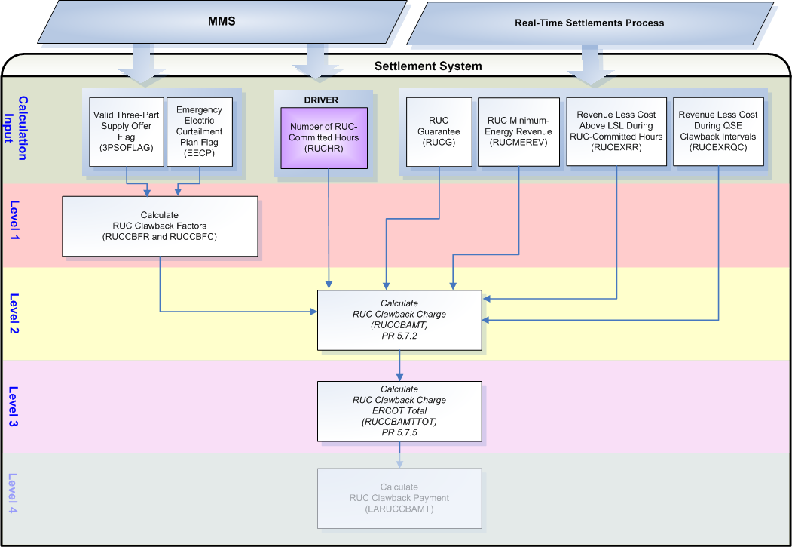

Assumptions
A1) The valid Three-Part Supply Offer submitted for considerationin the DAM for the Operating Day will be used to determine Clawback factors.

A2) If EECP is in effect for any hour within the Operating Day, the Clawback factor for RUC hours (RUCCBFR) will default to the appropriate value for EECP for the entire Operating Day.

Business Rules
Req. ID | Protocol(s) | Sub-Process Map | Description
FR89 | PR 5.7.2 | Will be completed August 31, 2006 | DRIVER: The RUCCBAMT calculation should only be attempted for QSE/Resource combinations with a RUCHR_<Q>_<R> in the settlement system for the Operating Day.
FR90 | PR 5.7.5 | Will be completed August 31, 2006 | DRIVER: The RUCCBAMTTOT calculation should always be calculated for every Operating Day.
FR91 | PR 5.7.2 | Will be completed August 31, 2006 | The Clawback factor value choices for RUC-Committed Hours of 0.5 for offer submitted and 1.0 for offer not submitted, used to calculate each QSE/Resource RUCCBFR are required to be stored with start and stop times.
FR92 | PR 5.7.2 | Will be completed August 31, 2006 | The Clawback factor value choices for RUC-Committed Hours when EECP is in effect of 0.0 for offer submitted and 0.5 for offer not submitted, used to calculate each QSE/Resource RUCCBFR are required to be stored with start and stop times.
FR93 | PR 5.7.2 | Will be completed August 31, 2006 | The Clawback factor value choices for QSE Clawback Intervals of 0.0 for offer submitted and 0.5 for offer not submitted, used to calculate each QSE/Resource RUCCBFC are required to be stored with start and stop times.
FR94 | PR 5.7.2 | Will be completed August 31, 2006 | No input or intermediate bill determinants should not be rounded or truncated.
FR95 | PR 9.5.3 | Will be completed August 31, 2006 | All output bill determinants should be rounded to two (2) decimal places.
FR96 | PR 12.3 (c) | Will be completed August 31, 2006 | All input and output bill determinants should be made available to the extracts process and should be classified in the settlement system as:  - RUCHR – private  - 3PSOFLAG – private  - EECP – public  - RUCCBFR – private  - RUCCBFC – private  - RUCG – private  - RUCMEREV – private  - RUCEXRR – private  - RUCEXRQC – private  - RUCCBAMT – private  - RUCCBBILLAMT – private  - RUCCBAMTQSETOT – private  - RUCCBAMTTOT – public

Business Defined Errors
Req. ID | Protocol(s) | Sub-Process Map | Description
FR97 | PR 5.7.2 | Will be completed August 31, 2006 | While calculating RUC Clawback Factors (RUCCBFR and RUCCBFC), if RUCHR does not exist in the Settlement System for the Operating Day for the QSE/Resource combination, then the Settlement System should process as if no RUC-Commitment was issued and should not perform the calculation for the QSE/Resource combination.
FR98 | PR 5.7.2 | Will be completed August 31, 2006 | While calculating RUC Clawback Factors (RUCCBFR and RUCCBFC), if 3PSOFLAG does not exist in the Settlement System for the Operating Day, then the Settlement System should process as if no valid Three-Part Supply Offer was submitted by the QSE for the Operating Day and calculate based on non-submitted status only.
FR99 | PR 5.7.2 | Will be completed August 31, 2006 | While calculating RUC Clawback Factors (RUCCBFR and RUCCBFC), if EECP does not exist in the Settlement System for the Operating Day, then the Settlement System should process as if no Emergency Electric Curtailment Plan in was effect for the Operating Day and calculate based on 3-Part Offer submitted status only.
FR100 | PR 5.7.2 | Will be completed August 31, 2006 | While calculating RUCCBAMT, if RUCHR does not exist in the Settlement System for the Operating Day for the QSE/Resource combination, then the Settlement System should process as if no RUC-Commitment was issued and should not perform the calculation for the QSE/Resource combination.
FR101 | PR 5.7.2 | Will be completed August 31, 2006 | While calculating RUCCBAMT, if RUCG does not exist in the Settlement System for the Operating Day for the QSE/Resource combination, then the Settlement System should default to zero for all intervals of the Operating Day and should provide a WARN-DEFAULT error message indicating the failure as “RUCG for QSE <Q> and Resource <R> was not available for calculation of RUCCBAMT.”
FR102 | PR 5.7.2 | Will be completed August 31, 2006 | While calculating RUCCBAMT, if RUCMEREV does not exist in the Settlement System for the Operating Day for the QSE/Resource combination, then the Settlement System should default to zero for all intervals of the Operating Day and should provide a WARN-DEFAULT error message indicating the failure as “RUCMEREV for QSE <Q> and Resource <R> was not available for calculation of RUCCBAMT.”
FR103 | PR 5.7.2 | Will be completed August 31, 2006 | While calculating RUCCBAMT, if RUCEXRR does not exist in the Settlement System for the Operating Day for the QSE/Resource combination, then the Settlement System should default to zero for all intervals of the Operating Day and should provide a WARN-DEFAULT error message indicating the failure as “RUCEXRR for QSE <Q> and Resource <R> was not available for calculation of RUCCBAMT.”
FR104 | PR 5.7.2 | Will be completed August 31, 2006 | While calculating RUCCBAMT, if RUCEXRQC does not exist in the Settlement System for the Operating Day for the QSE/Resource combination, then the Settlement System should default to zero for all intervals of the Operating Day and should provide a WARN-DEFAULT error message indicating the failure as “RUCEXRQC for QSE <Q> and Resource <R> was not available for calculation of RUCCBAMT.”
FR105 | PR 5.7.5 | Will be completed August 31, 2006 | While calculating RUCCBAMTTOT, if there is no RUCCBAMT in the Settlement System for the Operating Day, then the Settlement System should process as if there were no RUC Clawback Charges for the Operating Day and create a RUCCBAMTTOT data cut with zeros for all hours of the Operating Day. There should be no RUCCBAMT data cuts for the entire Operating Day for this condition to occur.

Specific Database Needs
None

RUC Decommitment Payment (RUCDCAMT)
If ERCOT decommits a QSE self-committed Resource that is not scheduled to shutdown within the Operating Day, then ERCOT shall pay the affected QSE an amount as calculated below for the hours of decommitment. The hours used in the calculation are the hours beginning with the first decommitted hour until the later of:
(a) The hour ERCOT determines that the Resource may again be at LSL; and
(b) The end of the last hour of the Operating Day. PR 5.7.3 (2)

If ERCOT decommits a QSE-committed Resource during the RUC process earlier than its scheduled shutdown within the Operating Day, then no compensation is due to the affected QSE from ERCOT. PR 5.7.3 (1)

The RUC Decommitment Payment is calculated using per start, hourly and 15-minute data divided evenly across all RUC-Decommitted hours of the Operating Day.

Requirement ID | FR106
Source Mapping (Protocol/NERC/FERC and other binding documents Ref #) | PR 5.7.3
Traceability to Sub-Process Maps | Will be completed August 31, 2006
Description: Calculate the RUCDCAMT by QSE and Resource, with a RUC De-Commitment, for each hour of the Operating Day.

RUCDCAMT_<Q>_<R>_<SP> = (-1) * Max (0, (SUPR_<Q>_<R>_<SP>_<ST> - $\underset{i}{Σ}$(Max (0, MEPR_<Q>_<R>_<SP> - RTSPP_<SP>) * (LSL_<Q>_<R>_<SP> * (¼))))) / $\underset{h}{Σ}$NCDCHR_<Q>_<R>_<SP>

The Startup Price included in the RUC Decommitment Payment can be hot, intermediate or cold and is determined by the length of the Decommitment and the parameters of the Resource. This will be determined in the startup eligibility process. See TN.COMS.63C01.STARTUPELIGIBILITY.REQUIREMENTS.A for further information.

Requirement ID | FR107
Source Mapping (Protocol/NERC/FERC and other binding documents Ref #) | PR 5.7.6
Traceability to Sub-Process Maps | Will be completed August 31, 2006
Description: Calculate the RUCDCAMTTOT for each hour of the Operating Day.

RUCDCAMTTOT = $\underset{q}{Σ}$$\underset{r}{Σ}$RUCDCAMT_<Q>_<R>

Input Bill Determinants
Variable | Unit | Definition | Original Source
NCDCHR | Misc | Number of Continuous De-committed Hours— The number of continuous decommitment hours within an Operating Day. | MMS
Interval Frequency: 1 / hour

Additional Comments: The RUCDCAMT must use the daily sum of all NCDCHR bill determinant hours for the calculation.
SUPR | $/Start | Startup Price per start—The settlement price for the start s. | ERCOT Settlement System – Calculation for Startup Price calculated previously
Interval Frequency: 1 / hour

Additional Comments: There should be a SUPR, for each QSE/Resource combination with a RUC-Commitment, for each type of start: Hot, Intermediate and Cold.
MEPR | $/MWh | Minimum-Energy Price—The settlement price for minimum energy for the Settlement Interval i. | ERCOT Settlement System – Calculation for Minimum-Energy Price calculated previously
Interval Frequency: 1 / hour

Additional Comments: None
LSL | MW | Low Sustained Limit—The limit established by the QSE, continuously updated in Real-Time, that describes the minimum sustained energy production capability of the Resource for the hour that includes the Settlement Interval i. | MMS
Interval Frequency: 1 / hour

Additional Comments: None
RTSPP | $/MWh | Real-Time Settlement Point Price—The Real-Time Settlement Point Price at the Settlement Point for the Settlement Interval i. | MMS
Interval Frequency: 4 / hour

Additional Comments: None

Output Bill Determinants
Variable | Unit | Definition | Destination
RUCDCAMT | $ | RUC De-commitment Payment Amount—The payment to the QSE for the Resource that was de-committed by ERCOT but that was not scheduled to shut down in the Operating Day, for each decommited hour of the Operating Day. | Settlement System
Interval Frequency: 1 / hour

Additional Comments: None
RUCDCBILLAMT | $ | RUC De-commitment Payment Bill Amount ⎯ The difference between two consecutive daily summed settlement runs of RUCDCAMT for the QSE, for an Operating Day. | Settlement System
Interval Frequency: 1 / day

Additional Comments: This bill determinant is not specifically documented in the Nodal Protocols but is required as a result of Section 9 Statements and Invoices Protocol requirements. The BILLAMT methodology is currently under consideration with the Commercial Operations Subcommittee (COPS.)

RUCDCAMTQSETOT | $ | RUC De-commitment Payment Amount QSE Total ⎯ The QSE total for RUC De-commitment payments for the hour. | Settlement System
Interval Frequency: 1 / hour

Additional Comments: This bill determinant is not specifically documented in the Nodal Protocols but is required as a result of Section 9 Statements and Invoices Protocol requirements. Settlement Statement methodology is currently under consideration with the Commercial Operations Subcommittee (COPS.)

RUCDCAMTTOT | $ | RUC Decommitment Payment Total—The sum of RUC Decommitment Payments to all QSEs, including amounts for RMR Units, for the hour that includes the 15-minute Settlement Interval. | Settlement System
Interval Frequency: 1 / hour

Additional Comments: None

Data Dependencies
D1) Calculation of the RUCDCAMT is dependent on:
- availability of the input bill determinants
- successful calculation of SUPR
- successful calculation of MEPR

D2) Calculation of the RUCDCAMTTOT is dependent on the successful calculation of RUCDCAMT.

D3) The RUCDCAMTTOT calculation must be complete prior to the calculation of the RUC Decommitment Charge (LARUCDCAMT).

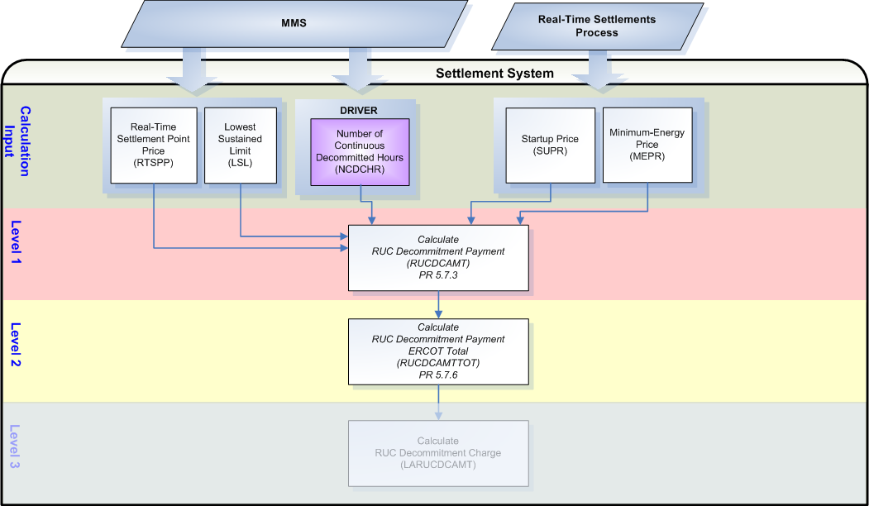

Assumptions
A1) The NCDCHR bill determinant will be created within the interface between MMS and the Settlement System and will be populated with a value of one (1) for all RUC Decommitted hours and a value of zero (0) for all other hours.

Business Rules
Req. ID | Protocol(s) | Sub-Process Map | Description
FR108 | PR 5.7.3 | Will be completed August 31, 2006 | DRIVER: The RUCDCAMT calculation should only be attempted for QSE/Resource combinations with a NCDCHR_<Q>_<R> in the settlement system for the Operating Day.
FR109 | PR 5.7.6 | Will be completed August 31, 2006 | DRIVER: The RUCDCAMTTOT calculation should always be calculated for each Operating Day.
FR110 | PR 5.7.3 | Will be completed August 31, 2006 | No input bill determinants should not be rounded or truncated.
FR111 | PR 9.5.3 | Will be completed August 31, 2006 | All output bill determinants should be rounded to two (2) decimal places.
FR112 | PR 12.3 (c) | Will be completed August 31, 2006 | All input and output bill determinants should be made available to the extracts process and should be classified in the settlement system as:  - NCDCHR – private  - SUPR – private  - MEPR – private  - RTSPP – public  - LSL – private  - RUCDCAMT – private  - RUCDCBILLAMT – private  - RUCDCAMTQSETOT – private  - RUCDCAMTOT – public

Business Defined Errors
Req. ID | Protocol(s) | Sub-Process Map | Description
FR113 | PR 5.7.3 | Will be completed August 31, 2006 | While calculating RUCDCAMT, if NCDCHR does not exist in the Settlement System for the Operating Day for the QSE/Resource combination, then the Settlement System should process as if no RUC Decommitment was issued and should not perform the calculation for the QSE/Resource combination.
FR114 | PR 5.7.3 | Will be completed August 31, 2006 | While calculating RUCDCAMT, if SUPR does not exist in the Settlement System for the Operating Day for the QSE/Resource combination, then the Settlement System should default to zero for all intervals of the Operating Day and should provide a WARN-DEFAULT error message indicating the failure as “SUPR for QSE <Q> and Resource <R> was not available for calculation of RUCDCAMT.”
FR115 | PR 5.7.3 | Will be completed August 31, 2006 | While calculating RUCDCAMT, if MEPR does not exist in the Settlement System for the Operating Day for the QSE/Resource combination, then the Settlement System should default to zero for all intervals of the Operating Day and should provide a WARN-DEFAULT error message indicating the failure as “MEPR for QSE <Q> and Resource <R> was not available for calculation of RUCDCAMT.”
FR116 | PR 5.7.3 | Will be completed August 31, 2006 | While calculating RUCDCAMT, if LSL does not exist in the Settlement System for the Operating Day for the QSE/Resource combination, then the Settlement System should default to zero for all intervals of the Operating Day and should provide a WARN-DEFAULT error message indicating the failure as “LSL for QSE <Q> and Resource <R> was not available for calculation of RUCDCAMT.”
FR117 | PR 5.7.3 | Will be completed August 31, 2006 | While calculating RUCDCAMT, if RTSPP does not exist in the Settlement System for the Operating Day for the Settlement Point, then the Settlement System should default to zero for all intervals of the Operating Day and should provide a WARN-DEFAULT error message indicating the failure as “RTSPP for Settlement Point <SP> was not available for calculation of RUCDCAMT.”
FR118 | PR 5.7.6 | Will be completed August 31, 2006 | While calculating RUCDCAMTTOT, if there is no RUCDCAMT in the Settlement System for the Operating Day, then the Settlement System should process as if there were no RUC Decommitment Payments for the Operating Day and create a RUCDCAMTTOT data cut with zeros for all hours of the Operating Day. There should be no RUCDCAMT data cuts for the entire Operating Day for this condition to occur.

Specific Database Needs
None

RUC Capacity-Short Charge (RUCCSAMT)
For the RUC Capacity-Short Charge (RUCCSAMT):
ERCOT shall charge each QSE an amount, subject to a cap, if they are found to be short in capacity. This calculation will be performed for each QSE for each RUC Process in which a RUCMWAMTTUCTOT exists for the Operating Day.

The dollar amount charged to each QSE, due to capacity shortfalls for a particular RUC Process, is the QSE’s shortfall ratio share (RUCSFRS) multiplied by the total Make-Whole Payments to all QSEs for that RUC Process (RUCMWAMTRUCTOT), subject to a cap. The cap is two (2) multiplied by the total RUC Make-Whole Payments for all QSEs (RUCMWAMTRUCTOT) multiplied by that QSE’s capacity shortfall for that RUC process (RUCSF), divided by the total capacity of all RUC-Committed Resources for the RUC process.

The RUC Capacity-Short Charge is calculated by QSE for each RUC Process for each 15-minute settlement interval.

For the RUC Shortfall (RUCSF) and RUC Shortfall Ratio Share (RUCSFRS):
ERCOT shall calculate for each QSE, a RUC Shortfall MW amount and a RUC Shortfall Ratio Share using a comparison of two separate sets of data, one showing each QSEs capacity when the RUC Process was executed compared to their Real-Time Adjusted Metered Load and one showing each QSEs capacity at the end of the adjustment period compared to their Real-Time Adjusted Metered Load.

The RUC Shortfall and RUC Shortfall Ratio Share will reflect a capacity credit for any capacity they are found short and charged for the same interval of the same Operating Day for previous RUC Processes (See RUCCAPCREDIT below).

The RUC Shortfall and RUC Shortfall Ratio Share are calculated by QSE for each RUC Process for each 15-minute settlement interval.

For the RUC Capacity Credit (RUCCAPCREDIT):
A QSE that is charged for a capacity shortfall in one RUC process gets a capacity credit equal to the minimum of the QSE’s RUC shortfall (MW) or the total RUC capacity purchased multiplied by the QSE’s shortfall ratio share. The capacity credit is to be used in future RUC processes for the same 15-minute Settlement Interval. (PR 5.7.4.1.2)

ERCOT shall calculate for each QSE a capacity credit to account for any capacity shortfall that has been assigned to them in the same interval in the same Operating Day, in a previous RUC Process. This will be calculated after the RUC Shortfall, RUC Shortfall Ratio Share and RUC Capacity-Short Charge calculations for each RUC Process of the Operating Day, to be used in future RUC Shortfall amounts (RUCSF) for the same Operating Day. The QSE must have been previously charged for a shortfall for the capacity shortfall to be included in the RUC Capacity Credit.

The RUC Capacity Credit is calculated by QSE for each RUC Process for each 15-minute settlement interval.

Requirement ID | FR119
Source Mapping (Protocol/NERC/FERC and other binding documents Ref #) | PR 5.7.4.1.1
Traceability to Sub-Process Maps | Will be completed August 31, 2006
Description: Calculate the RUCCAPADJ and RUCSFADJ by QSE and RUC Process, for each 15-minute settlement interval of the Operating Day.
RUCSFADJ_<Q>_<RUC> = Max (0, (($\underset{\text{sp}}{Σ}$RTAML_<Q>_<SP>) *4) – RUCCAPADJ_<Q>))
Where,
RUCCAPADJ_<Q> = $\underset{r}{Σ}$HASLADJ_<Q>_<R>_<SP> + (RUCCPADJ_<Q> – RUCCSADJ_<Q>)
+ ($\underset{\text{sp}}{Σ}$DAEP_<Q>_<SP> – $\underset{\text{sp}}{Σ}$DAES_<Q>_<SP>)
+ ($\underset{\text{sp}}{Σ}$RTQQEPADJ_<Q>_<SP> – $\underset{\text{sp}}{Σ}$RTQQESADJ_<Q>_<SP>)
If the HASLSNAP for a Resource exists in the Settlement System for the current RUC Process and the Resource experiences a forced outage (FOFLAG_<Q>_<R>_<SP>) within the two hours before the start of the Settlement Interval, then the HASLSNAP must be used in place of the HASLADJ for the Resource for the RUC Process.

This calculation must be calculated for each RUC Process due to the HASLADJ adjustments for RUC Decommits and forced outages which will correspond to the RUC Process. RTAML, HASLADJ, RUCCPADJ, RUCCSADJ, DAEP, DAES, RTQQEPADJ and RTQQESADJ will be actual values.

Requirement ID | FR120
Source Mapping (Protocol/NERC/FERC and other binding documents Ref #) | PR 5.7.4.1.1
Traceability to Sub-Process Maps | Will be completed August 31, 2006
Description: Calculate the RUCCAPSNAP and RUCSFSNAP by QSE and RUC Process, for each 15-minute settlement interval of the Operating Day.

RUCSFSNAP_<Q>_<RUC> = Max (0, (($\underset{\text{sp}}{Σ}$RTAML_<Q>_<SP>) *4) – RUCCAPSNAP_<Q>_<RUC>))
Where,
RUCCAPSNAP_<Q>_<RUC> = $\underset{r}{Σ}$HASLSNAP_<Q>_<R>_<SP>_<RUC>
+ (RUCCPSNAP_<Q>_<RUC> – RUCCSSNAP_<Q>_<RUC>)
+ ($\underset{\text{sp}}{Σ}$DAEP_<Q>_<SP> – $\underset{\text{sp}}{Σ}$DAES_<Q>_<SP>)
+ ($\underset{\text{sp}}{Σ}$RTQQEPSNAP_<Q>_<SP>_<RUC> – $\underset{\text{sp}}{Σ}$RTQQESSNAP_<Q>_<SP>_<RUC>)

This calculation must be calculated for each RUC Process with the snapshot data corresponding to the RUC Process. RTAML, DAEP and DAES will be actual values, not snapshot values.

Requirement ID | FR121
Source Mapping (Protocol/NERC/FERC and other binding documents Ref #) | PR 5.7.4.1.1
Traceability to Sub-Process Maps | Will be completed August 31, 2006
Description: Calculate the RUCSF by QSE and RUC Process, for each 15-minute settlement interval of the Operating Day.

RUCSF_<Q>_<RUC> = Max (0, Max (RUCSFSNAP_<Q>_<RUC>, RUCSFADJ_<Q>)
– $\underset{z \text{is} \text{prior} \text{to} \text{ruc}}{Σ}$RUCCAPCREDIT_<Q>_{z})
This calculation must be calculated for each RUC Process. The RUCCAPCREDIT used for the QSE must be the sum of all “applicable” RUCCAPCREDITs, for that QSE, from all previous RUC Processes calculated for the Operating Day. “Applicable” means that the previous shortfall calculated for the QSE and used in a previous calculation of RUCCAPCREDIT must have resulted in a RUC Capacity-Short Charge for the QSE.

Requirement ID | FR122
Source Mapping (Protocol/NERC/FERC and other binding documents Ref #) | PR 5.7.4.1.1
Traceability to Sub-Process Maps | Will be completed August 31, 2006
Description: Calculate the RUCSFRS by QSE and RUC Process, for each 15-minute settlement interval of the Operating Day.

RUCSFRS_<Q>_<RUC> = RUCSF_<Q>_<RUC> / RUCSFTOT_<RUC>

Where:
RUCSFTOT_<RUC> = $\underset{q}{Σ}$RUCSF_<Q>_<RUC>
This calculation must be calculated for each RUC Process.

Requirement ID | FR123
Source Mapping (Protocol/NERC/FERC and other binding documents Ref #) | PR 5.7.4.1
Traceability to Sub-Process Maps | Will be completed August 31, 2006
Description: Calculate the RUCCSAMT by QSE and RUC Process, for each 15-minute settlement interval of the Operating Day.

RUCCSAMT_<Q>_<RUC> = (-1) * Max [(RUCSFRS_<Q>_<RUC> * RUCMWAMTRUCTOT_<RUC>),
(2 * RUCSF_<Q>_<RUC> * RUCMWAMTRUCTOT_<RUC> / RUCCAPTOT_<RUC>)] / 4
Where:
RUCCAPTOT_<RUC> = $\underset{q}{Σ}$$\underset{r}{Σ}$HSL_<Q>_>R>_<SP>_<RUC>
This calculation must be calculated for each RUC Process.

Requirement ID | FR124
Source Mapping (Protocol/NERC/FERC and other binding documents Ref #) | PR 5.7.4.2
Traceability to Sub-Process Maps | Will be completed August 31, 2006
Description: Calculate the RUCCSAMTTOT by RUC Process, for each 15-minute settlement interval of the Operating Day.

RUCCSAMTTOT = $\underset{q}{Σ}$$\underset{\text{ruc}}{Σ}$RUCCBAMT_<Q>_<RUC>
This calculation may be calculated one (1) time. It is not calculated for each RUC Process but is the sum of all RUC Processes for the Operating Day.

Requirement ID | FR125
Source Mapping (Protocol/NERC/FERC and other binding documents Ref #) | PR 5.7.4.1.2
Traceability to Sub-Process Maps | Will be completed August 31, 2006
Description: Calculate the RUCCAPCREDIT by QSE and RUC Process, for each 15-minute settlement interval of the Operating Day.

RUCCAPCREDIT_<Q>_<RUC> = Min [RUCSF_<Q>_<RUC>, (RUCCAPTOT_<RUC>* RUCSFRS_<Q>_<RUC>)]

This calculation must be calculated for each RUC Process. The value calculated will be used in the RUCSF calculation of all future RUC Processes for the Operating Day if the shortfall of that RUC Process resulted in a RUC Capacity-Short Charge for the QSE.

Input Bill Determinants
Variable | Unit | Definition | Original Source
RTAML | MWh | Real-Time Adjusted Metered Load—The QSE q’s Adjusted Metered Load at the Settlement Point p for the 15-minute Settlement Interval. | ERCOT Settlement System through the Data Aggregation Process
Interval Frequency: 4 / hour

Additional Comments: None
FOFLAG | Misc | Forced Outage Flag— A flag to indicate the time when a resource experiences a forced outage. | MMS
Interval Frequency: TBD

Additional Comments: This determinant is not documented in the Nodal Protocols but is required to determine when a forced outage has occurred so that the QSE’s HASLADJ can be adjusted to the value included in the HASLSNAP, per PR 5.7.4.1.1 (9) definition for HASLADJ.
HSL | MW | High Sustained Limit— A High Sustainable Limit of a Generation Resource as defined in Section 2, Definitions, for the hour that includes the Settlement Interval i. | MMS
Interval Frequency: 1 / hour

Additional Comments: None
DAEP | MW | Day-Ahead Energy Purchase—The QSE q’s energy purchased in the DAM at the Settlement Point p for the hour that includes the 15-minute Settlement Interval. | MMS
Interval Frequency: 1 / hour

Additional Comments: None
DAES | MW | Day-Ahead Energy Sale—The QSE q’s energy sold in the DAM at the Settlement Point p for the hour that includes the 15-minute Settlement Interval. | MMS
Interval Frequency: 1 / hour

Additional Comments: None
HASLSNAP | MW | High Ancillary Services Limit at Snapshot—The High Ancillary Services Limit of the Resource r represented by the QSE q, according to the COP and Trades Snapshot for the RUC process for the hour that includes the 15-minute Settlement Interval. | MMS
Interval Frequency: 1 / hour

Additional Comments: None
RUCCPSNAP | MW | RUC Capacity Purchase at Snapshot—The QSE q’s Capacity purchase, according to the COP and Trades Snapshot for the RUC process for the hour that includes the 15-minute Settlement Interval. | MMS
Interval Frequency: 1 / hour

Additional Comments: None
RUCCSSNAP | MW | RUC Capacity Sale at Snapshot—The QSE q’s capacity sale, according to the COP and Trades Snapshot for the RUC process for the hour that includes the 15-minute Settlement Interval. | MMS
Interval Frequency: 1 / hour

Additional Comments: None
RTQQEPSNAP | MW | QSE-to-QSE Energy Purchase by QSE by point—The QSE q’s Energy Trades in which the QSE is the buyer at the delivery Settlement Point p for the 15-minute Settlement Interval, in the COP and Trades Snapshot. | MMS
Interval Frequency: 4 / hour

Additional Comments: None
RTQQESSNAP | MW | QSE-to-QSE Energy Sale by QSE by point—The QSE q’s Energy Trades in which the QSE is the seller at the delivery Settlement Point p for the 15-minute Settlement Interval, in the COP and Trades Snapshot. | MMS
Interval Frequency: 4 / hour

Additional Comments: None
HASLADJ | MW | High Ancillary Services Limit at Adjustment Period—The High Ancillary Services Limit of the Resource r represented by the QSE q, according to the adjustment period snapshot, for the hour that includes the 15-minute Settlement Interval. If the HASL for a Resource was credited to the QSE during the RUC Snapshot but the Resource experiences a Forced Outage within two hours before the start of the Settlement Interval, then the HASL for that Resource is also credited to the QSE in the HASLADJ. | MMS
Interval Frequency: 1 / hour

Additional Comments: None
RUCCPADJ | MW | RUC Capacity Purchase at Adjustment Period—The QSE q’s capacity purchase, according to the Adjustment Period COP and Trades Snapshot for the hour that includes the 15-minute Settlement Interval. | MMS
Interval Frequency: 1 / hour

Additional Comments: None
RUCCSADJ | MW | RUC Capacity Sale at Adjustment Period—The QSE q’s capacity sale, according to the Adjustment Period COP and Trades Snapshot for the hour that includes the 15-minute Settlement Interval. | MMS
Interval Frequency: 1 / hour

Additional Comments: None
RTQQEPADJ | MW | QSE-to-QSE Energy Purchase by QSE by point—The QSE q’s Energy Trades in which the QSE is the buyer at the delivery Settlement Point p for the 15-minute Settlement Interval, in the last COP and Trades Snapshot at the end of the Adjustment Period for that Settlement Interval. | MMS
Interval Frequency: 4 / hour

Additional Comments: None
RTQQESADJ | MW | QSE-to-QSE Energy Sale by QSE by point—The QSE q’s Energy Trades in which the QSE is the seller at the delivery Settlement Point p for the 15-minute Settlement Interval, in the last COP and Trades Snapshot at the end of the Adjustment Period for that Settlement Interval. | MMS
Interval Frequency: 4 / hour

Additional Comments: None
RUCCAPCREDIT | MW | RUC Capacity Credit by QSE—The capacity credit resulting from capacity paid through the RUC Capacity-Short Charge for the 15-minute Settlement Interval. | ERCOT Settlement System – Calculation for RUC Capacity Credit calculated previously from prior RUC Processes
Interval Frequency: 4 / hour

Additional Comments: The RUCCAPCREDIT that is calculated using data from a particular RUC Process will not be used in the RUCSF calculation for that particular RUC Process. This RUCCAPCREDIT will be used in the RUCSF calculation of future RUC Processes for the Operating Day.
RUCMWAMTRUCTOT | $ | RUC Make-Whole Amount Total per RUC Process—The sum of RUC Make-Whole Payments for a particular RUC process, including amounts for RMR Units, for the hour that includes the 15-minute Settlement Interval. | ERCOT Settlement System – Calculation for RUC Make-Whole Amount per RUC Process Total calculated previously for each RUC Process
Interval Frequency: 4 / hour

Additional Comments: None

Intermediate Bill Determinants – Level 1 (See Data Dependencies)
Variable | Unit | Definition | Destination
RUCCAPSNAP | MW | RUC Capacity Snapshot at time of RUC—The amount of the QSE’s calculated capacity in the COP and Trades Snapshot for a 15-minute Settlement Interval. | Settlement System
Interval Frequency: 4 / hour

Additional Comments: None
RUCCAPADJ | MW | RUC Capacity Snapshot during Adjustment Period—The amount of the QSE’s calculated capacity in the RUC according to the COP and Trades Snapshot at the end of the Adjustment Period for a 15-minute Settlement Interval.. | Settlement System
Interval Frequency: 4 / hour

Additional Comments: None
RUCCAPTOT | MW | RUC Capacity Total—The sum of the HSLs of all RUC-committed Resources for a particular RUC process, for the hour that includes the 15-minute Settlement Interval. | Settlement System
Interval Frequency: 4 / hour

Additional Comments: None

Intermediate Bill Determinants – Level 2 (See Data Dependencies)
Variable | Unit | Definition | Destination
RUCSFSNAP | MW | RUC Shortfall at Snapshot—The QSE q’s capacity shortfall according to the snapshot for the RUC process for the 15-minute Settlement Interval. | Settlement System
Interval Frequency: 4 / hour

Additional Comments: None
RUCSFADJ | MW | RUC Shortfall at Adjustment Period—The QSE q’s adjustment period capacity shortfall for the 15-minute Settlement Interval. | Settlement System
Interval Frequency: 4 / hour

Additional Comments: None

Intermediate Bill Determinants – Level 3 (See Data Dependencies)
Variable | Unit | Definition | Destination
RUCSF | MW | RUC Shortfall—The QSE’s capacity shortfall for a particular RUC process for the 15-minute Settlement Interval. See formula in Section 5.7.4.1.1, Capacity Shortfall Ratio Share. | Settlement System
Interval Frequency: 4 / hour

Additional Comments: None

Intermediate Bill Determinants – Level 4 (See Data Dependencies)
Variable | Unit | Definition | Destination
RUCSFTOT | MW | RUC Shortfall Total—The sum of all QSEs’ capacity shortfalls, for a RUC process, for a 15-minute Settlement Interval. | Settlement System
Interval Frequency: 4 / hour

Additional Comments: None

Intermediate Bill Determinants – Level 5 (See Data Dependencies)
Variable | Unit | Definition | Destination
RUCSFRS | Misc | RUC Shortfall Ratio Share—The ratio of the QSE’s capacity shortfall to the sum of all QSEs’ capacity shortfalls for a particular RUC process, for the 15-minute Settlement Interval. See Section 5.7.4.1.1, Capacity Shortfall Ratio Share. | Settlement System
Interval Frequency: 4 / hour

Additional Comments: None

Output Bill Determinants
Variable | Unit | Definition | Destination
RUCCAPCREDIT | MW | RUC Capacity Credit by QSE—The capacity credit resulting from capacity paid through the RUC Capacity-Short Charge for the 15-minute Settlement Interval. | Settlement System – awaiting the calculation of RUCSF for future RUC Processes for the Operating Day.
Interval Frequency: 4 / hour

Additional Comments: The RUCCAPCREDIT that is calculated using data from a particular RUC Process will not be used in the RUCSF calculation for that particular RUC Process. This RUCCAPCREDIT will be used in the RUCSF calculation of future RUC Processes for the Operating Day.
RUCCSAMT | $ | RUC Capacity-Short Amount—The charge to a QSE, due to capacity shortfall for a particular RUC process, for the 15-minute Settlement Interval. | Settlement System
Interval Frequency: 4 / hour

Additional Comments: None
RUCCSBILLAMT | $ | RUC Capacity-Short Charge Bill Amount ⎯ The difference between two consecutive daily summed settlement runs of RUCCSAMT for the QSE, for an Operating Day. | Settlement System
Interval Frequency: 1 / day

Additional Comments: This bill determinant is not specifically documented in the Nodal Protocols but is required as a result of Section 9 Statements and Invoices Protocol requirements. The BILLAMT methodology is currently under consideration with the Commercial Operations Subcommittee (COPS.)

RUCCSAMTQSETOT | $ | RUC Capacity-Short Charge Amount QSE Total ⎯ The QSE total for RUC Capacity-Short Charges for the 15-minute settlement interval. |  | Settlement System
Interval Frequency: 4 / hour

Additional Comments: This bill determinant is not specifically documented in the Nodal Protocols but is required as a result of Section 9 Statements and Invoices Protocol requirements. Settlement Statement methodology is currently under consideration with the Commercial Operations Subcommittee (COPS.)

RUCCSAMTTOT | $ | RUC Capacity-Short Amount Total—The sum of RUC Capacity-Short Charges for all QSEs and RUC processes for the 15-minute Settlement Interval. | Settlement System
Interval Frequency: 4 / hour

Additional Comments: None

Data Dependencies
RUC Capacity-Short Calculations
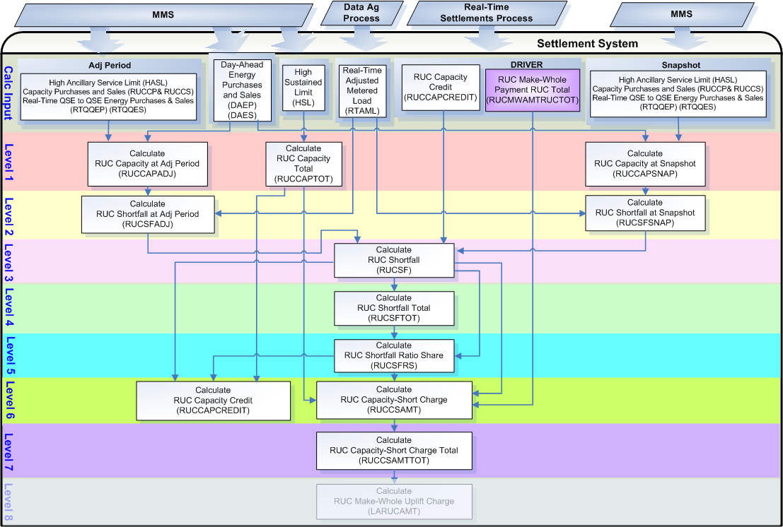
Level 1 Calculation Dependencies:
D1) Calculation of the RUC Capacity at Snapshot (RUCCAPSNAP) is dependent on:
- availability of the input bill determinants (successful import from MMS)

D2) Calculation of the RUC Capacity at Adjustment Period (RUCCAPADJ) is dependent on:
- availability of the input bill determinants (successful import from MMS)

D3) Calculation of the RUC Capacity Total (RUCCAPTOT) is dependent on:
- availability of the input bill determinants (successful import from MMS)

D4) The RUC Capacity at Snapshot (RUCCAPSNAP) calculation must be complete prior to the calculation of the RUC Shortfall at Snapshot (RUCSFSNAP).

D5) The RUC Capacity at Adjustment Period (RUCCAPADJ) calculation must be complete prior to the calculation of the RUC Shortfall at Adjustment Period (RUCSFADJ).

D6) The RUC Capacity Total (RUCCAPTOT) calculation must be complete prior to the calculation:
- RUC Capacity-Short Charge (RUCCSAMT)
- RUC Capacity Credit (RUCCAPCREDIT)

Level 1 Calculations
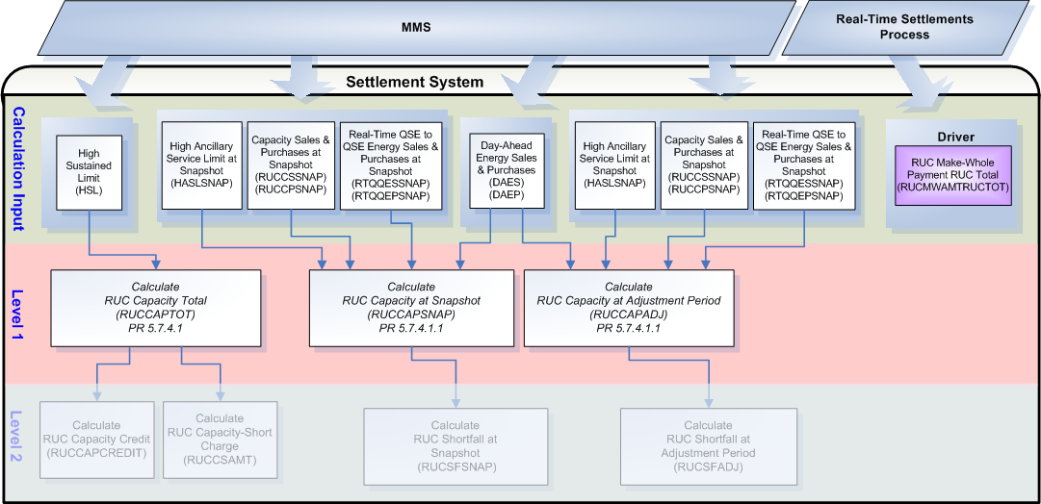
Level 2 Calculation Dependencies:
D7) Calculation of the RUC Shortfall at Snapshot (RUCSFSNAP) is dependent on:
- successful completion of Data Ag process
- successful calculation of RUC Capacity at Snapshot (RUCCAPSNAP)

D8) Calculation of the RUC Shortfall at Adjustment Period (RUCSFADJ) is dependent on:
- successful completion of Data Ag process
- successful calculation of RUC Capacity at Adjustment Period (RUCCAPADJ)

D9) The RUC Shortfall at Snapshot (RUCSFSNAP) calculation must be complete prior to the calculation of the RUC Shortfall (RUCSF).

D10) The RUC Shortfall at Adjustment Period (RUCSFADJ) calculation must be complete prior to the calculation of the RUC Shortfall (RUCSF).

Level 2 Calculations
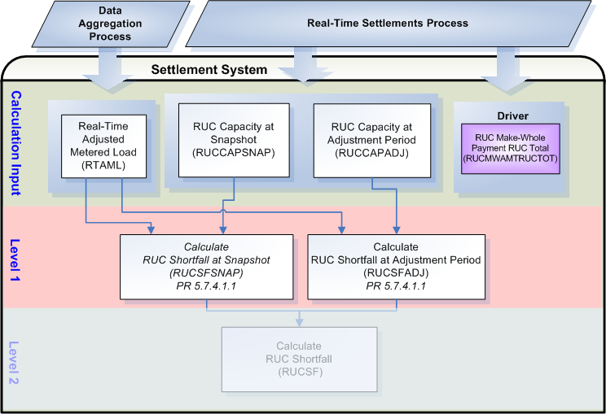
Level 3 Calculation Dependencies:
D11) Calculation of the RUC Shortfall (RUCSF) is dependent on:
- successful calculation of RUC Capacity Credit (RUCCAPCREDIT) from previous RUC Processes
- successful calculation of RUC Shortfall at Snapshot (RUCSFSNAP)
- successful calculation of RUC Shortfall at Adjustment Period (RUCSFADJ)

D12) The RUC Shortfall (RUCSF) calculation must be complete prior to the calculation:
- RUC Capacity Credit for the Current RUC Process (RUCCAPCREDIT)
- RUC Shortfall Total (RUCSFTOT)
- RUC Shortfall Ratio Share (RUCSFRS)
- RUC Capacity-Short Charge (RUCCSAMT)

Level 3 Calculations
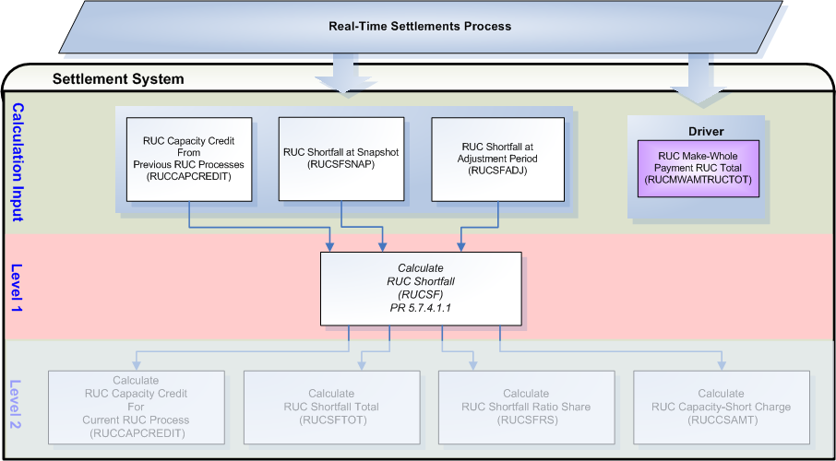
Level 4 Calculation Dependencies:
D13) Calculation of the RUC Shortfall Total RUCSFTOT is dependent on:
- successful calculation of RUC Shortfall (RUCSF)

D14) The RUC Shortfall Total (RUCSFTOT) calculation must be complete prior to the calculation of the RUC Shortfall Ratio Share (RUCSFRS).

Level 4 Calculations
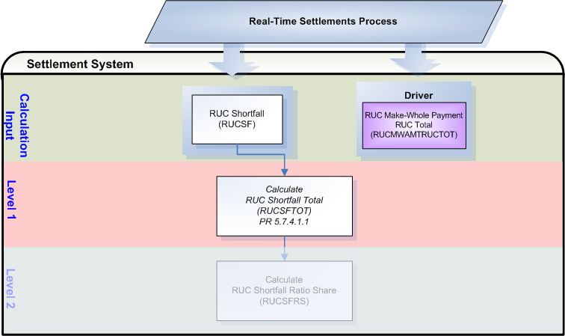
Level 5 Calculation Dependencies:
D15) Calculation of the RUC Shortfall Ratio Share (RUCSFRS) is dependent on:
- successful calculation of RUC Shortfall (RUCSF)
- successful calculation of RUC Shortfall Total (RUCSFTOT)

D16) The RUC Shortfall Ratio Share (RUCSFRS) calculation must be complete prior to the calculation:
- RUC Capacity Credit for the Current RUC Process (RUCCAPCREDIT)
- RUC Capacity-Short Charge (RUCCSAMT)

Level 5 Calculations
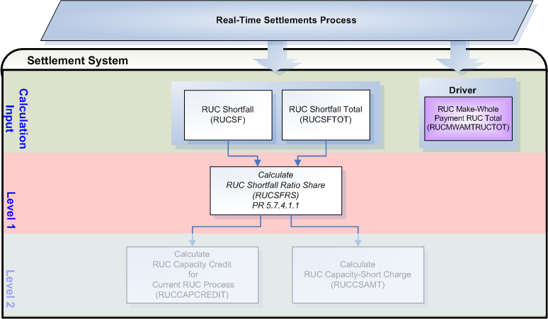
Level 6 and 7 Calculation Dependencies:
D17) Calculation of the RUC Capacity-Short Charge (RUCCSAMT) is dependent on:
- successful calculation of Shortfall Ratio Share (RUCSFRS)
- successful calculation of RUC Shortfall (RUCSF)
- successful calculation of RUC Capacity Total (RUCCAPTOT)
- successful calculation of RUC Make-Whole Payment RUC Total (RUCMWAMTRUCTOT)

D18) Calculation of the RUC Capacity-Short Charge Total (RUCCSAMTTOT) is dependent on:
- successful calculation of RUC Capacity-Short Charge (RUCSAMT)

D19) Calculation of the RUC Capacity Credit (RUCCAPCREDIT) is dependent on:
- successful calculation of RUC Shortfall (RUCSF)
- successful calculation of Shortfall Ratio Share (RUCSFRS)
- successful calculation of RUC Capacity Total (RUCCAPTOT)

D20) The RUC Capacity-Short Charge (RUCCSAMT) calculation must be complete prior to the calculation of RUC Capacity-Short Charge Total (RUCCSAMTTOT).

D21) The RUC Capacity-Short Charge Total (RUCCSAMTTOT) calculation must be complete prior to the calculation of the RUC Make-Whole Uplift Charge (LARUCAMT).

D22) The RUCCAPCREDIT calculation for the current RUC Process must be complete prior to the calculation of the RUC Shortfall (RUCSF) for the next RUC Process.

Level 6 and 7 Calculations
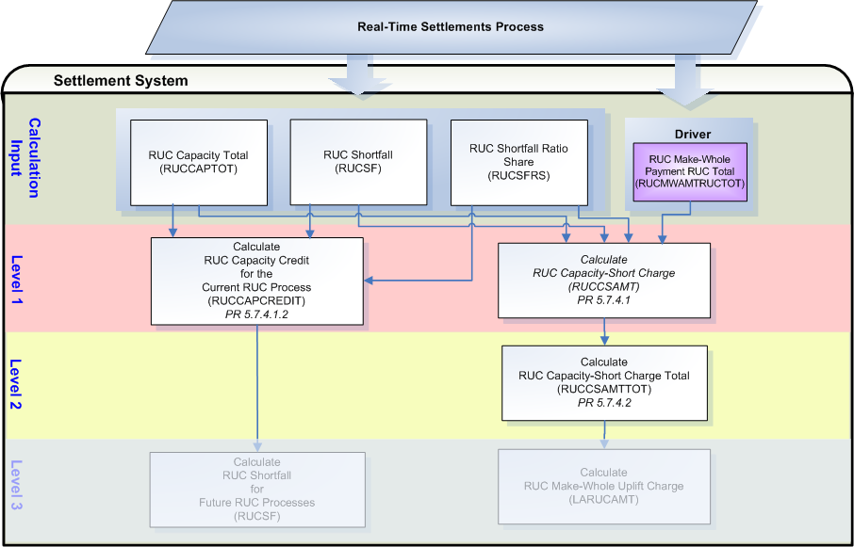

Assumptions
A1) The interface from MMS to the Settlement System will adjust the HASLSNAP and HASLADJ for each WGR to the value represented in the COP and Trades Snapshot prior to the Day-Ahead RUC which should be equal to the WGRs WGRPP. (PR 4.2.2(7))

PR 4.2.2(7) will satisfy:
- PR 5.7.4.1.1(1) which states: In calculating the amount short for each QSE, the QSE must be given a capacity credit for its WGRs based on the WGRPP of the Resource by setting the HASLSNAP and HASLADJ variables used below equal to the WGRPP, and

- PR 5.7.4 (2) which states: To determine whether a QSE is capacity-short, the WGR Production Potential, as described in Section 4.2.2, Wind-Powered Generation Resource Production Potential, for a WGR used in the corresponding RUC is considered the available capacity of the WGR when determining responsibility for the corresponding RUC charges, regardless of the Real-Time output of the WGR.

A2) The interface from MMS to the Settlement System will adjust the HASLSNAP and HASLADJ for non-wind Resources that were given notice of decommitment within the two hours before the Operating Hour as a result of the RUC process by setting the HASLSNAP and HASLADJ variable equal to the HASLSNAP value for the Resource immediately before the decommitment instruction was given. (PR 5.7.4.1.1(2))

Business Rules
Req. ID | Protocol(s) | Sub-Process Map | Description
FR126 | PR 5.7.4.1  PR 5.7.4.1.1  PR 5.7.4.1.2 | Will be completed August 31, 2006 | DRIVER: For each RUC Process, all calculations included in the RUC Capacity-Short Charge (RUCCSAMT), except for the RUCCSAMTTOT, should only be attempted when a RUCMWAMTRUCTOT_<RUC> exists in the settlement system for the Operating Day for that RUC Process.
FR127 | PR 5.7.4.2 | Will be completed August 31, 2006 | DRIVER: The RUCCSAMTTOT calculation should always be calculated for each Operating Day.
FR128 | PR 5.7.4.2 | Will be completed August 31, 2006 | DRIVER: A second DRIVER for the calculation of RUCCAPCREDIT is, if no RUCCSAMT exists for the QSE for the current RUC Process, do not perform the calculation for the current RUC Process.
FR129 | PR 5.7.4.1  PR 5.7.4.1.1  PR 5.7.4.1.2 | Will be completed August 31, 2006 | No input bill determinants should be rounded or truncated.
FR130 | PR 9.5.3 | Will be completed August 31, 2006 | No intermediate bill determinants should be rounded or truncated.
FR131 | PR 9.5.3 | Will be completed August 31, 2006 | Output bill determinants that should be rounded to two (2) decimal places are:  - RUCCSAMT  - RUCCSAMTTOT  Output bill determinants that should not be rounded or truncated are:  - RUCCAPCREDIT
FR132 | PR 12.3 (c) | Will be completed August 31, 2006 | All input and output bill determinants should be made available to the extracts process and should be classified in the settlement system as:  - RTAML – private  - FOFLAG – private  - HSL – private  - DAEP – private  - DAES – private  - HASLSNAP – private  - RUCCPSNAP – private  - RUCCSSNAP – private  - RTQQEPSNAP – private  - RTQQESSNAP – private  - HASLADJ – private  - RUCCPADJ – private  - RUCCSADJ – private  - RTQQEPADJ – private  - RTQQESADJ – private  - RUCCAPCREDIT – private  - RUCMWAMTRUCTOT – public  - RUCCAPSNAP – private  - RUCCAPADJ – private  - RUCCAPTOT – public  - RUCSFSNAP – private  - RUCSSFADJ – private  - RUCSF – private  - RUCSFTOT – public  - RUCSFRS – private  - RUCCSAMT – private  - RUCCSBILLAMT – private  - RUCCSAMTQSETOT – private  - RUCCSAMTTOT – public

Business Defined Errors
Req. ID | Protocol(s) | Sub-Process Map | Description
FR133 | PR 5.7.4.1  PR 5.7.4.1.1  PR 5.7.4.1.2 | Will be completed August 31, 2006 | While calculating RUCCAPSNAP, RUCCAPADJ, RUCSFSNAP, RUCSFADJ, RUCSF, RUCSFTOT, RUCSFRS, RUCCAPTOT RUCCAPCREDIT and RUCCSAMT, if RUCMWAMTRUCTOT does not exist in the Settlement System for the Operating Day for the RUC Process, then the Settlement System should process as if there were no RUC Make-Whole Payments for the RUC Process and should not perform the calculation for the RUC Process.
FR134 | PR 5.7.4.1.2 | Will be completed August 31, 2006 | While calculating RUCCAPCREDIT, if RUCMWAMTRUCTOT exists in the Settlement System for the Operating Day for the RUC Process but RUCCSAMT does not exist in the Settlement System for the Operating Day for the RUC Process, then the Settlement System should process as if there were no RUC Capacity-Short Charges for the RUC Process and should not perform the calculation for the RUC Process.
FR135 | PR 5.7.4.1.1 | Will be completed August 31, 2006 | While calculating RUCCAPADJ, if no HASLADJ exists in the Settlement System for the Operating Day for the QSE, then the Settlement System should default to zero for all intervals of the Operating Day.
FR136 | PR 5.7.4.1.1 | Will be completed August 31, 2006 | While calculating RUCCAPADJ, if no RUCCPADJ exists in the Settlement System for the Operating Day for the QSE, then the Settlement System should default to zero for all intervals of the Operating Day.
FR137 | PR 5.7.4.1.1 | Will be completed August 31, 2006 | While calculating RUCCAPADJ, if no RUCCSADJ exists in the Settlement System for the Operating Day for the QSE, then the Settlement System should default to zero for all intervals of the Operating Day.
FR138 | PR 5.7.4.1.1 | Will be completed August 31, 2006 | While calculating RUCCAPADJ, if no DAEP exists in the Settlement System for the Operating Day for the QSE, then the Settlement System should default to zero for all intervals of the Operating Day.
FR139 | PR 5.7.4.1.1 | Will be completed August 31, 2006 | While calculating RUCCAPADJ, if no DAES exists in the Settlement System for the Operating Day for the QSE, then the Settlement System should default to zero for all intervals of the Operating Day.
FR140 | PR 5.7.4.1.1 | Will be completed August 31, 2006 | While calculating RUCCAPADJ, if no RTQQEPADJ exists in the Settlement System for the Operating Day for the QSE, then the Settlement System should default to zero for all intervals of the Operating Day.
FR141 | PR 5.7.4.1.1 | Will be completed August 31, 2006 | While calculating RUCCAPADJ, if no RTQQESADJ exists in the Settlement System for the Operating Day for the QSE, then the Settlement System should default to zero for all intervals of the Operating Day.
FR142 | PR 5.7.4.1.1 | Will be completed August 31, 2006 | While calculating RUCCAPSNAP, if no HASLSNAP exists in the Settlement System for the Operating Day, for the RUC Process and for the QSE, then the Settlement System should default to zero for all intervals of the Operating Day.
FR143 | PR 5.7.4.1.1 | Will be completed August 31, 2006 | While calculating RUCCAPSNAP, if no RUCCPSNAP exists in the Settlement System for the Operating Day, for the RUC Process and for the QSE, then the Settlement System should default to zero for all intervals of the Operating Day.
FR144 | PR 5.7.4.1.1 | Will be completed August 31, 2006 | While calculating RUCCAPSNAP, if no RUCCSSNAP exists in the Settlement System for the Operating Day, for the RUC Process and for the QSE, then the Settlement System should default to zero for all intervals of the Operating Day.
FR145 | PR 5.7.4.1.1 | Will be completed August 31, 2006 | While calculating RUCCAPSNAP, if no DAEP exists in the Settlement System for the Operating Day, for the RUC Process and for the QSE, then the Settlement System should default to zero for all intervals of the Operating Day.
FR146 | PR 5.7.4.1.1 | Will be completed August 31, 2006 | While calculating RUCCAPSNAP, if no DAES exists in the Settlement System for the Operating Day, for the RUC Process and for the QSE, then the Settlement System should default to zero for all intervals of the Operating Day.
FR147 | PR 5.7.4.1.1 | Will be completed August 31, 2006 | While calculating RUCCAPSNAP, if no RTQQEPSNAP exists in the Settlement System for the Operating Day, for the RUC Process and for the QSE, then the Settlement System should default to zero for all intervals of the Operating Day.
FR148 | PR 5.7.4.1.1 | Will be completed August 31, 2006 | While calculating RUCCAPSNAP, if no RTQQESSNAP exists in the Settlement System for the Operating Day, for the RUC Process and for the QSE, then the Settlement System should default to zero for all intervals of the Operating Day.
FR149 | PR 5.7.4.1.1 | Will be completed August 31, 2006 | While calculating RUCSFADJ, if RTAML does not exist in the Settlement System for the Operating Day for the QSE, then the Settlement System should default to zero for all intervals of the Operating Day and should provide a WARN-DEFAULT error message indicating the failure as “While calculating RUCSFADJ for RUC Process <RUC>, RTAML for QSE <Q> was not available for calculation.”
FR150 | PR 5.7.4.1.1 | Will be completed August 31, 2006 | While calculating RUCSFADJ, if RUCCAPADJ does not exist in the Settlement System for the Operating Day for the QSE, then the Settlement System should default to zero for all intervals of the Operating Day and should provide a WARN-DEFAULT error message indicating the failure as “While calculating RUCSFADJ for RUC Process <RUC>, RUCCAPADJ for QSE <Q> was not available for calculation.”
FR151 | PR 5.7.4.1.1 | Will be completed August 31, 2006 | While calculating RUCSFSNAP, if RTAML does not exist in the Settlement System for the Operating Day for the QSE, then the Settlement System should default to zero for all intervals of the Operating Day and should provide a WARN-DEFAULT error message indicating the failure as “While calculating RUCSFSNAP for RUC Process <RUC>, RTAML for QSE <Q> was not available for calculation.”
FR152 | PR 5.7.4.1.1 | Will be completed August 31, 2006 | While calculating RUCSFSNAP, if RUCCAPSNAP does not exist in the Settlement System for the Operating Day for the QSE, then the Settlement System should default to zero for all intervals of the Operating Day and should provide a WARN-DEFAULT error message indicating the failure as “While calculating RUCSFSNAP for RUC Process <RUC>, RUCCAPSNAP for QSE <Q> was not available for calculation.”
FR153 | PR 5.7.4.1.1 | Will be completed August 31, 2006 | While calculating RUCSF, if RUCSFSNAP does not exist in the Settlement System for the Operating Day, for the RUC Process and for the QSE, then the Settlement System should default to zero for all intervals of the Operating Day and should provide a WARN-DEFAULT error message indicating the failure as “While calculating RUCSF for RUC Process <RUC>, RUCSFSNAP for QSE <Q> was not available for calculation.”
FR154 | PR 5.7.4.1.1 | Will be completed August 31, 2006 | While calculating RUCSF, if RUCSFADJ does not exist in the Settlement System for the Operating Day for the QSE, then the Settlement System should default to zero for all intervals of the Operating Day and should provide a WARN-DEFAULT error message indicating the failure as “While calculating RUCSF for RUC Process <RUC>, RUCSFADJ for QSE <Q> was not available for calculation.”
FR155 | PR 5.7.4.1.1 | Will be completed August 31, 2006 | While calculating RUCSF, if there are no RUCCAPCREDIT in the Settlement System for the Operating Day, for the QSE and for prior RUC Processes than the RUC Process being calculated, then the Settlement System should default to zero for all intervals of the Operating Day. There should be no RUCCAPCREDIT data cuts for the QSE for any previous RUC Processes for the Operating Day for this condition to occur.
FR156 | PR 5.7.4.1.1 | Will be completed August 31, 2006 | While calculating RUCSFTOT, if there are no RUCSF in the Settlement System for the Operating Day for the RUC Process, then the Settlement System should default to zero for all intervals of the Operating Day and should provide a WARN-DEFAULT error message indicating the failure as “While calculating RUCSFTOT for RUC Process <RUC>, no RUCSF were available for calculation.” There should be no RUCSF data cuts for the Operating Day for the RUC Process for this condition to occur.
FR157 | PR 5.7.4.1.1 | Will be completed August 31, 2006 | While calculating RUCSFRS, if RUCSF does not exist in the Settlement System for the Operating Day, for the RUC Process and for the QSE, then the Settlement System should default to zero for all intervals of the Operating Day and should provide a WARN-DEFAULT error message indicating the failure as “While calculating RUCSFRS for RUC Process <RUC>, RUCSF for QSE <?> was not available for calculation.”
FR158 | PR 5.7.4.1.1 | Will be completed August 31, 2006 | While calculating RUCSFRS, if RUCSFTOT does not exist in the Settlement System for the Operating Day, then the Settlement System should default to zero for all intervals of the Operating Day and should provide a WARN-DEFAULT error message indicating the failure as “While calculating RUCSFRS for RUC Process <RUC>, RUCSFTOT was not available for calculation.”
FR159 | PR 5.7.4.1 | Will be completed August 31, 2006 | While calculating RUCCAPTOT, if there are no HSL in the Settlement System for the Operating Day for the RUC Process, then the Settlement System should default to zero for all intervals of the Operating Day and should provide a WARN-DEFAULT error message indicating the failure as “While calculating RUCCAPTOT for RUC Process <RUC>, no HSL were available for calculation.” There should be no HSL data cuts for the Operating Day for the RUC Process for this condition to occur.
FR160 | PR 5.7.4.1 | Will be completed August 31, 2006 | While calculating RUCCSAMT, if RUCSFRS does not exist in the Settlement System for the Operating Day, for the RUC Process and for the QSE, then the Settlement System should default to zero for all intervals of the Operating Day and should provide a WARN-DEFAULT error message indicating the failure as “While calculating RUCCSAMT for RUC Process <RUC>, RUCSFRS for QSE <?> was not available for calculation.”
FR161 | PR 5.7.4.1 | Will be completed August 31, 2006 | While calculating RUCCSAMT, if RUCSF does not exist in the Settlement System for the Operating Day, for the RUC Process and for the QSE, then the Settlement System should default to zero for all intervals of the Operating Day and should provide a WARN-DEFAULT error message indicating the failure as “While calculating RUCCSAMT for RUC Process <RUC>, RUCSF for QSE <?> was not available for calculation.”
FR162 | PR 5.7.4.1 | Will be completed August 31, 2006 | While calculating RUCCSAMT, if RUCCAPTOT does not exist in the Settlement System for the Operating Day for the RUC Process, then the Settlement System should default to zero for all intervals of the Operating Day and should provide a WARN-DEFAULT error message indicating the failure as “While calculating RUCCSAMT for RUC Process <RUC>, RUCCAPTOT was not available for calculation.”
FR163 | PR 5.7.4.2 | Will be completed August 31, 2006 | While calculating RUCCSAMTTOT, if there is no RUCCSAMT in the Settlement System for the Operating Day, then the Settlement System should process as if there were no RUC Capacity-Short Charges for the Operating Day and create a RUCCSAMTTOT data cut with zeros for all hours of the Operating Day. There should be no RUCCSAMT data cuts for the entire Operating Day for this condition to occur.
FR164 | PR 5.7.4.1.2 | Will be completed August 31, 2006 | While calculating RUCCAPCREDIT for the current RUC Process, if RUCSF does not exist in the Settlement System for the Operating Day, for the RUC Process and for the QSE, then the Settlement System should default to zero for all intervals of the Operating Day and should provide a WARN-DEFAULT error message indicating the failure as “While calculating RUCCAPCREDIT for RUC Process <RUC>, RUCSF for QSE <?> was not available for calculation.”
FR165 | PR 5.7.4.1.2 | Will be completed August 31, 2006 | While calculating RUCCAPCREDIT for the current RUC Process, if RUCSFRS does not exist in the Settlement System for the Operating Day, for the RUC Process and for the QSE, then the Settlement System should default to zero for all intervals of the Operating Day and should provide a WARN-DEFAULT error message indicating the failure as “While calculating RUCCAPCREDIT for RUC Process <RUC>, RUCSFRS for QSE <?> was not available for calculation.”
FR166 | PR 5.7.4.1.2 | Will be completed August 31, 2006 | While calculating RUCCAPCREDIT for the current RUC Process, if RUCCAPTOT does not exist in the Settlement System for the Operating Day for the RUC Process, then the Settlement System should default to zero for all intervals of the Operating Day and should provide a WARN-DEFAULT error message indicating the failure as “While calculating RUCCAPCREDIT for RUC Process <RUC>, RUCCAPTOT was not available for calculation.”

Specific Database Needs
Req. ID | Protocol(s) | Sub-Process Map | Description
FR167 | PR 5.7.4.1  PR 5.7.4.1.1  PR 5.7.4.1.2 | Will be completed August 31, 2006 | - The settlement system must be able to visibly identify and track individual RUC Processes within or for various bill determinants used in the calculations of RUCCSAMT.

RUC Make-Whole Uplift Charge (LARUCAMT)
If the revenues from the RUC Capacity-Short Charge are not enough to cover all RUC Make-Whole Payments for a 15-minute Settlement Interval, then the difference will be uplifted to all QSEs on a Load Ratio Share basis, as a RUC Make-Whole Uplift Charge.

Requirement ID | FR168
Source Mapping (Protocol/NERC/FERC and other binding documents Ref #) | PR 5.7.4.2
Traceability to Sub-Process Maps | Will be completed August 31, 2006
Description: Calculate the LARUCAMT by QSE for each 15-minute settlement interval of the Operating Day.

LARUCAMT_<Q> = (-1) * (RUCMWAMTTOT / 4 + RUCCSAMTTOT) * LRS_<Q>

Input Bill Determinants
Variable | Unit | Definition | Original Source
LRS | Misc | Load Ratio Share—The ratio of Adjusted Metered Load to the total ERCOT Adjusted Metered Load for the 15-minute Settlement Interval. See Section 6.6.2.2, QSE Load Ratio Share for a 15-Minute Settlement Interval. | ERCOT Settlement System – Calculation for 15-minute Load Ratio Share calculated previously
Interval Frequency: 4 / hour

Additional Comments: See TN.COMS.63C01.RTENERGY.REQUIREMENTS.A for further information on the LRS bill determinant.
RUCMWAMTTOT | $ | RUC Make-Whole Amount Total—The sum of RUC Make-Whole Payments for all QSEs and RUC processes, including amounts for RMR Units, for the hour that includes the 15-minute Settlement Interval. | ERCOT Settlement System – Calculation for RUC Make-Whole Amount Total calculated previously
Interval Frequency: 1 / hour

Additional Comments: None
RUCCSAMTTOT | $ | RUC Capacity-Short Amount Total—The sum of RUC Capacity-Short Charges for all QSEs and RUC processes for the 15-minute Settlement Interval. | ERCOT Settlement System – Calculation for RUC Capacity-Short Amount Total calculated previously
Interval Frequency: 4 / hour

Additional Comments: None

Output Bill Determinants
Variable | Unit | Definition | Destination
LARUCAMT | $ | RUC Make-Whole Uplift Charge—The amount owed from the QSE based on Load Ratio Share, for the 15-minute Settlement Interval. | Settlement System
Interval Frequency: 4 / hour

Additional Comments: None
LARUCBILLAMT | $ | RUC Make-Whole Uplift Charge Bill Amount ⎯ The difference between two consecutive daily summed settlement runs of LARUCAMT for the QSE, for an Operating Day. | Settlement System
Interval Frequency: 1 / day

Additional Comments: This bill determinant is not specifically documented in the Nodal Protocols but is required as a result of Section 9 Statements and Invoices Protocol requirements. The BILLAMT methodology is currently under consideration with the Commercial Operations Subcommittee (COPS.)

LARUCAMTQSETOT | $ | RUC Make-Whole Uplift Charge Amount QSE Total ⎯ The QSE total for RUC Make-Whole Uplift Charges for the 15-minute settlement interval. | Settlement System
Interval Frequency: 4 / hour

Additional Comments: This bill determinant is not specifically documented in the Nodal Protocols but is required as a result of Section 9 Statements and Invoices Protocol requirements. Settlement Statement methodology is currently under consideration with the Commercial Operations Subcommittee (COPS.)

Data Dependencies
D1) Calculation of the RUC Make-Whole Uplift Charge (LARUCAMT) is dependent on:
- successful calculation of 15-minute Load Ratio Share (LRS)
- successful calculation of RUC Make-Whole Amount Total (RUCMWAMTTOT)
- successful calculation of RUC Capacity-Short Amount Total (RUCCSAMTTOT)

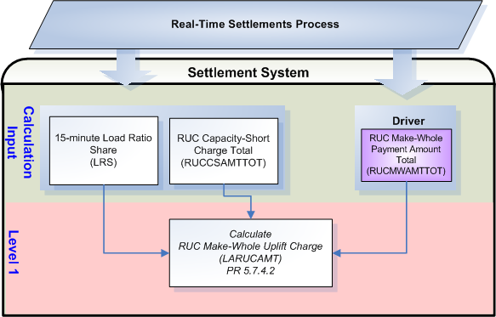

Assumptions
None

Business Rules
Req. ID | Protocol(s) | Sub-Process Map | Description
FR169 | PR 5.7.4.2 | Will be completed August 31, 2006 | DRIVER: The LARUCAMT calculation should only be attempted for the Operating Day when there is a RUCMWAMTTOT with at least one (1) non-zero interval in the settlement system for the Operating Day.
FR170 | PR 5.7.4.2 | Will be completed August 31, 2006 | No input bill determinants should not be rounded or truncated.
FR171 | PR 9.5.3 | Will be completed August 31, 2006 | All output bill determinants should be rounded to two (2) decimal places.
FR172 | PR 12.3 (c) | Will be completed August 31, 2006 | All input and output bill determinants should be made available to the extracts process and should be classified in the settlement system as:  - RUCMWAMTTOT – public  - LRS – private  - RUCCSAMTTOT – public  - LARUCAMT – private  - LARUCBILLAMT – private  - LARUCAMTQSETOT – private

Business Defined Errors
Req. ID | Protocol(s) | Sub-Process Map | Description
FR173 | PR 5.7.4.2 | Will be completed August 31, 2006 | While calculating LARUCAMT, if RUCMWAMTTOT does not exist in the Settlement System for the Operating Day, then the Settlement System should default to zero for all intervals of the Operating Day and should provide a WARN-DEFAULT error message indicating the failure as “RUCMWAMTTOT for Operating Day <mmddyy> was not available for calculation of LARUCAMT.”
FR174 | PR 5.7.4.2 | Will be completed August 31, 2006 | While calculating LARUCAMT, if LRS does not exist in the Settlement System for the Operating Day for the QSE, then the Settlement System should default to zero for all intervals of the Operating Day and should provide a WARN-DEFAULT error message indicating the failure as “LRS for QSE <Q> was not available for calculation of LARUCAMT.”
FR175 | PR 5.7.4.2 | Will be completed August 31, 2006 | While calculating LARUCAMT, if RUCCSAMTTOT does not exist in the Settlement System for the Operating Day, then the Settlement System should default to zero for all intervals of the Operating Day and should provide a WARN-DEFAULT error message indicating the failure as “RUCCSAMTTOT for Operating Day <mmddyy> was not available for calculation of LARUCAMT.”

Specific Database Needs
None

RUC Clawback Payment (LARUCCBAMT)
ERCOT shall pay the revenues from all RUC Clawback Charges in a 15-minute Settlement Interval to all QSEs, on a Load Ratio Share basis, as the RUC Clawback Payment. (PR 5.7.5)

Requirement ID | FR176
Source Mapping (Protocol/NERC/FERC and other binding documents Ref #) | PR 5.7.5
Traceability to Sub-Process Maps | Will be completed August 31, 2006
Description: Calculate the LARUCCBAMT by QSE for each 15-minute settlement interval of the Operating Day.

LARUCCBAMT_<Q> = (-1) * [(RUCCBAMTTOT / 4) * LRS_<Q>]

Input Bill Determinants
Variable | Unit | Definition | Original Source
LRS | Misc | Load Ratio Share—The ratio of Adjusted Metered Load to the total ERCOT Adjusted Metered Load for the 15-minute Settlement Interval. See Section 6.6.2.2, QSE Load Ratio Share for a 15-Minute Settlement Interval. | ERCOT Settlement System – Calculation for 15-minute Load Ratio Share calculated previously
Interval Frequency: 4 / hour

Additional Comments: See TN.COMS.63C01.RTENERGY.REQUIREMENTS.A for further information on the LRS bill determinant.
RUCCBAMTTOT | $ | RUC Clawback Amount Total—The sum of RUC Clawback Charges for all QSEs, including amounts for RMR Units, for the hour that includes the 15-minute Settlement Interval. | ERCOT Settlement System – Calculation for RUC Clawback Amount Total calculated previously
Interval Frequency: 1 / hour

Additional Comments: None

Output Bill Determinants
Variable | Unit | Definition | Destination
LARUCCBAMT | $ | RUC Clawback Payment—The RUC Make-Whole Clawback Payment to a QSE to uplift RUC Make-Whole Clawback Charges received, for a 15-minute Settlement Interval. | Settlement System
Interval Frequency: 4 / hour

Additional Comments: None
LARUCCBBILLAMT | $ | RUC Clawback Payment Bill Amount ⎯ The difference between two consecutive daily summed settlement runs of LARUCCBAMT for the QSE, for an Operating Day. | Settlement System
Interval Frequency: 1 / day

Additional Comments: This bill determinant is not specifically documented in the Nodal Protocols but is required as a result of Section 9 Statements and Invoices Protocol requirements. The BILLAMT methodology is currently under consideration with the Commercial Operations Subcommittee (COPS.)

LARUCCBAMTQSETOT | $ | RUC Clawback Payment Amount QSE Total ⎯ The QSE total for RUC Clawback Payments for the 15-minute settlement interval. | Settlement System
Interval Frequency: 4 / hour

Additional Comments: This bill determinant is not specifically documented in the Nodal Protocols but is required as a result of Section 9 Statements and Invoices Protocol requirements. Settlement Statement methodology is currently under consideration with the Commercial Operations Subcommittee (COPS.)

Data Dependencies
D1) Calculation of the RUC Clawback Payment (LARUCCBAMT) is dependent on:
- successful calculation of 15-minute Load Ratio Share (LRS)
- successful calculation of RUC Clawback Amount Total (RUCCBAMTTOT)

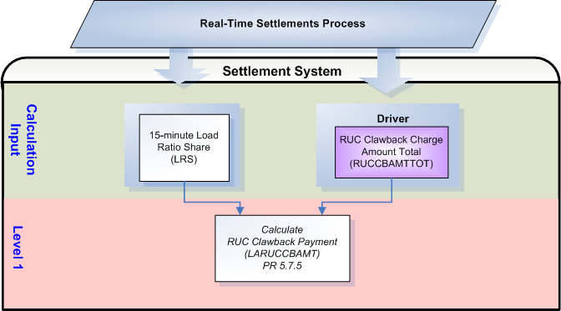

Assumptions
None

Business Rules
Req. ID | Protocol(s) | Sub-Process Map | Description
FR177 | PR 5.7.5 | Will be completed August 31, 2006 | DRIVER: The LARUCCBAMT calculation should only be attempted for the Operating Day when there is a RUCCBAMTTOT with at least one (1) non-zero interval in the settlement system for the Operating Day.
FR178 | PR 5.7.5 | Will be completed August 31, 2006 | No input bill determinants should not be rounded or truncated.
FR179 | PR 9.5.3 | Will be completed August 31, 2006 | All output bill determinants should be rounded to two (2) decimal places.
FR180 | PR 12.3 (c) | Will be completed August 31, 2006 | All input and output bill determinants should be made available to the extracts process and should be classified in the settlement system as:  - RUCCBAMTTOT – public  - LRS – private  - LARUCCBAMT – private  - LARUCCBBILLAMT – private  - LARUCCBAMTQSETOT – private

Business Defined Errors
Req. ID | Protocol(s) | Sub-Process Map | Description
FR181 | PR 5.7.5 | Will be completed August 31, 2006 | While calculating LARUCCBAMT, if RUCCBAMTTOT does not exist in the Settlement System for the Operating Day, then the Settlement System should default to zero for all intervals of the Operating Day and should provide a WARN-DEFAULT error message indicating the failure as “RUCCBAMTTOT for Operating Day <mmddyy> was not available for calculation of LARUCCBAMT.”
FR182 | PR 5.7.5 | Will be completed August 31, 2006 | While calculating LARUCCBAMT, if LRS does not exist in the Settlement System for the Operating Day for the QSE, then the Settlement System should default to zero for all intervals of the Operating Day and should provide a WARN-DEFAULT error message indicating the failure as “LRS for QSE <Q> was not available for calculation of LARUCCBAMT.”

Specific Database Needs
None

RUC Decommitment Charge (LARUCDCAMT)
ERCOT shall charge each QSE a RUC Decommitment Charge, on a Load Ratio Share basis, all revenues paid as a result of RUC Decommitment Payments. (PR 5.7.6)

Requirement ID | FR183
Source Mapping (Protocol/NERC/FERC and other binding documents Ref #) | PR 5.7.6
Traceability to Sub-Process Maps | Will be completed August 31, 2006
Description: Calculate the LARUCDCAMT by QSE for each 15-minute settlement interval of the Operating Day.

LARUCDCAMT_<Q> = (-1) * [(RUCDCAMTTOT / 4) * LRS_<Q>]

Input Bill Determinants
Variable | Unit | Definition | Original Source
LRS | Misc | Load Ratio Share—The ratio of Adjusted Metered Load to the total ERCOT Adjusted Metered Load for the 15-minute Settlement Interval. See Section 6.6.2.2, QSE Load Ratio Share for a 15-Minute Settlement Interval. | ERCOT Settlement System – Calculation for 15-minute Load Ratio Share calculated previously
Interval Frequency: 4 / hour

Additional Comments: See TN.COMS.63C01.RTENERGY.REQUIREMENTS.A for further information on the LRS bill determinant.
RUCDCAMTTOT | $ | RUC Decommitment Payment Total—The sum of RUC Decommitment Payments to all QSEs for the hour that includes the 15-minute Settlement Interval. | ERCOT Settlement System – Calculation for RUC Decommitment Payment Total calculated previously
Interval Frequency: 1 / hour

Additional Comments: None

Output Bill Determinants
Variable | Unit | Definition | Destination
LARUCDCAMT | $ | RUC Decommitment Charge—The RUC Decommitment Charge to a QSE, for a 15-minute Settlement Interval. | Settlement System
Interval Frequency: 4 / hour

Additional Comments: None
LARUCCBBILLAMT | $ | RUC Clawback Payment Bill Amount ⎯ The difference between two consecutive daily summed settlement runs of LARUCCBAMT for the QSE, for an Operating Day. | Settlement System
Interval Frequency: 1 / day

Additional Comments: This bill determinant is not specifically documented in the Nodal Protocols but is required as a result of Section 9 Statements and Invoices Protocol requirements. The BILLAMT methodology is currently under consideration with the Commercial Operations Subcommittee (COPS.)

LARUCDCAMTQSETOT | $ | RUC Decommitment Charge Amount QSE Total ⎯ The QSE total for RUC Decommitment Charges for the 15-minute settlement interval. | Settlement System
Interval Frequency: 4 / hour

Additional Comments: This bill determinant is not specifically documented in the Nodal Protocols but is required as a result of Section 9 Statements and Invoices Protocol requirements. Settlement Statement methodology is currently under consideration with the Commercial Operations Subcommittee (COPS.)

Data Dependencies
D1) Calculation of the RUC Decommitment Charge (LARUCDCAMT) is dependent on:
- successful calculation of 15-minute Load Ratio Share (LRS)
- successful calculation of RUC Decommitment Payment Total (RUCDCAMTTOT)

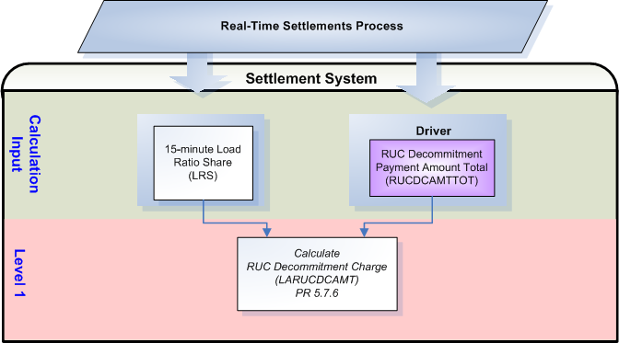

Assumptions
None

Business Rules
Req. ID | Protocol(s) | Sub-Process Map | Description
FR184 | PR 5.7.6 | Will be completed August 31, 2006 | DRIVER: The LARUCDCAMT calculation should only be attempted for the Operating Day when there is a RUCDCAMTTOT with at least one (1) non-zero interval in the settlement system for the Operating Day.
FR185 | PR 5.7.6 | Will be completed August 31, 2006 | No input bill determinants should not be rounded or truncated.
FR186 | PR 9.5.3 | Will be completed August 31, 2006 | All output bill determinants should be rounded to two (2) decimal places.
FR187 | PR 12.3 (c) | Will be completed August 31, 2006 | All input and output bill determinants should be made available to the extracts process and should be classified in the settlement system as:  - RUCDCAMTTOT – public  - LRS – private  - LARUCDCAMT – private  - LARUCDCBILLAMT – private  - LARUCDCAMTQSETOT – private

Business Defined Errors
Req. ID | Protocol(s) | Sub-Process Map | Description
FR188 | PR 5.7.6 | Will be completed August 31, 2006 | While calculating LARUCDCAMT, if RUCDCAMTTOT does not exist in the Settlement System for the Operating Day, then the Settlement System should default to zero for all intervals of the Operating Day and should provide a WARN-DEFAULT error message indicating the failure as “RUCDCAMTTOT for Operating Day <mmddyy> was not available for calculation of LARUCDCAMT.”
FR189 | PR 5.7.6 | Will be completed August 31, 2006 | While calculating LARUCDCAMT, if LRS does not exist in the Settlement System for the Operating Day for the QSE, then the Settlement System should default to zero for all intervals of the Operating Day and should provide a WARN-DEFAULT error message indicating the failure as “LRS for QSE <Q> was not available for calculation of LARUCDCAMT.”

Specific Database Needs
None

Supplementary Requirements

Performance Requirements
Lodestar must be able to perform its full set of Nodal settlement calculations. Performance characteristics will be determined and detailed in the conceptual and detailed design.

Legal and Regulatory requirements
All Lodestar financial data must be saved in accordance with standard accounting principles as dictated by the ERCOT Texas Nodal Protocols.

System Security Requirements
Lodestar will only be accessed directly by internal ERCOT personnel either through thin client UI, Citrix environment, or thick client on employee desktops. Market Participants will be able to access their statements and invoices on ERCOT private web site. ERCOT private web site access will be controlled by digital certificate authentication in accordance with ERCOT security policies. Additional details will be provided in the Conceptual System Design.

Back up and Recovery Requirements
All Lodestar Nodal settlement data must be backed up on a daily basis and recoverable within 24 hours. Additional details will be provided in the Conceptual System Design.

Availability and Redundancy Requirements
Nodal Lodestar system must be available 7/24. Lodestar is considered a tier 1 system and critical to base ERCOT business processes. Additional details will be provided in the Conceptual System Design.

Maintainability Requirements
Lodestar Nodal system will be maintained by internal ERCOT personnel. Service Level Agreements and explicit support will be detailed in the detail design document.

Daylight Savings Time shall be recognized in Nodal Market settlements.
Spring Daylight Savings Time Operating Day:
- Hour Ending 0300 will be skipped, resulting in 23 hourly intervals for the day.
- The four fifteen minute intervals within Hour Ending 0300 will be skipped, resulting in 92 fifteen minute intervals for the day.
- The sixty one minute intervals within Hour Ending 0300 will be skipped, resulting in 1380 total one minute intervals.

Fall Daylight Savings Time Operating Day:
- Hour Ending 0200 will have two (2) sets of data, resulting in 25 hourly intervals for the day.
- The four fifteen minute intervals within Hour Ending 0200 will have two (2) sets of data, resulting in 100 fifteen minute intervals for the day.
- The sixty one minute intervals within Hour Ending 0200 will have two (2) sets of data, resulting in 1500 total one minute intervals.

Protocol Coverage

Protocol Sub-Section # (To the lowest level of granularity as possible) | Coverage by Requirements  (Full/Partial)
4.4.9.2.3 (1) | Partial
4.4.9.2.3 (2) | Partial
4.4.9.2.3 (3) | Partial
5.7.1 | Partial
5.7.1.1 | Partial
5.7.1.2 | Partial
5.7.1.3 | Partial
5.7.1.4 | Partial
5.7.2 | Partial
5.7.3 | Partial
5.7.4.1 | Partial
5.7.4.1.1 | Partial
5.7.4.1.2 | Partial
5.7.4.2 | Partial
5.7.5 | Partial
5.7.6 | Partial
9.5.3 | Partial
12.3 (c) | Partial

