ERCOT Independent Review

CenterPoint (CNP) Dynamic Reactive Project

July 14, 2006

Project Submitted
In March 2006, CenterPoint Energy submitted a project to address the need for additional dynamic reactive support in the Houston area. This project seeks to install two dynamic VAR devices at two locations, Bellaire and Crosby, with both devices planned to be in-service prior to peak of 2008.

Several dynamic reactive technologies of equal rating at each site are being considered by CNP, including:

- Synchronous Condenser (70 MVA each)
- Distribution Static Compensator (DSTATCOM), (35-70 MVA each)
- Static Synchronous Compensator (STATCOM), (85 – 160 MVA each)
- Static VAR Compensator (SVC), (120 – 200 MVA each)
- Thyristor-Switched Capacitors (TSC), (140 – 260 MVA each)

The project is currently being readied for bid so the exact cost, size, and technology will be determined when a bidder is selected. The estimated cost range of this project is $20.0 - $25.0 M for the dynamic reactive devices and all associated substation construction necessary to install the devices. The project will not require new transmission line additions or upgrades in new or expanded Right-of-Ways.

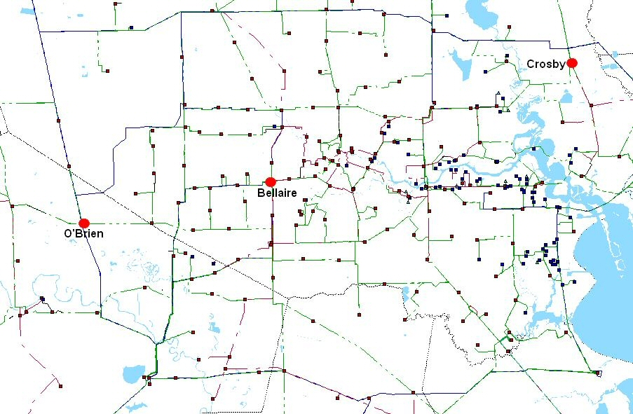
Figure 1: Sites Considered and Chosen (Highlighted) for Dynamic Reactive Device Placement

Project Justification
The CNP dynamic reactive project proposal prompted the review of various ERCOT planning and operating criteria for severe contingencies with complex transient system responses. ERCOT system planning staff agrees with the criteria and performance recommended by CenterPoint to mitigate reactive resource deficiencies during outages as being reasonable for the Houston region. Specific considerations for the justification of the CNP dynamic reactive project include:

1. Operation Guide 3.1.4.6, Protective Relaying Requirement:

”Generator terminal voltage deviations exceed five percent (5%) but are within ten percent (10%) of the rated design voltage and persist for less than 10.0 seconds”

2. Load Shedding Limit: one of CNP’s stated objectives is to limit the amount of load shedding to less than 1250 MW following a NERC Category D contingency, matching the size of ERCOT’s largest generating unit, which it was assumed that ERCOT’s responsive reserves should be able to handle. ERCOT concurs with the CNP’s load shedding limit as necessary to avoid possible over-frequency tripping of generation, avoid potential loss of significant local demand in Houston, and to mitigate the risk for a cascading regional blackout.

3. Load and Generation Outlook for the Houston Area: static reactive resources (capacitor banks) have been added to the Houston region based on Power vs. Voltage (PV) analysis and satisfying the PV margins specified in the ERCOT planning criteria. However, given the amount of dynamic reactive capability that has been lost due to generator retirements and the increasing import requirements to serve existing demand and the growth in Houston, it is advisable that a portion of that capability be replaced with dynamic reactive resources. Figure 2 depicts the decrease in the generation resources, with dynamic voltage support, available to meet the growing needs of the eight Houston-area counties. Starting in 2005 demand exceeded the local generation resources available in this area. By 2007, demand will exceed local generation by 2,000 MW and by 2009, this gap will be close to 3,000 MW. The difference in load vs. generation will be made-up by incremental imports in the transmission grid and must be supported by both static and dynamic reactive resources in the Houston area.

Figure 2: Generation vs Load in the Houston Area 2003 to 2011

The ROS Dynamic Working Group is presently working on defining performance requirements for severe (NERC Category D) contingencies for incorporation in the ERCOT planning criteria. In the meantime, the ROS Dynamic Working Group supports the need for the CNP dynamic reactive project.

Study Summary
ERCOT performed an independent review of the CNP dynamic reactive project using TSAT software. In this review, the need for the dynamic reactive devices was verified. The dynamic reactive devices are necessary due to the recent retirement of units within the Houston area and loss of their dynamic capability. Figure 2 shows the steep decline in generation within the Houston area from 2004 to 2005 due to these retirements. The MW totals in this chart include mothballed generation from P.H. Robinson and Cedar Bayou 3.

ERCOT’s review showed that if the Houston area retired/mothballed units were available, the dynamic devices were not needed, but without the dynamic devices and without the Houston area retired/mothballed units, the terminal voltages at several generating unit buses did not recover to 0.9 p.u. or above within the required 10 seconds.

A detailed discussion of this analysis can be found in the Appendix 1.

Multiple Facility Forced Outages
Since part of the justification for the CNP dynamic reactive project is based on a NERC Category D outage, ERCOT surveyed transmission operators in the ERCOT region in April and May 2006 to get an idea of how often extreme events occur within ERCOT. The transmission operators were asked for a historic list of “extreme events resulting in two or more (multiple) components removed or cascading out service, otherwise known as NERC Category D”. A summary of the results of this survey where only five transmission operators responded is shown in Figure 3.

2000 to present
Average Events/Yr | Average Ckts/Event | Mean Time Between Events in Days
19.71 | 3.89 | 16.67
Figure 3: ERCOT Survey on Multiple Element Outages

Figure 3 shows that on average, every 16 to 17 days, there is a multiple facility outage where 3 to 4 circuits are outaged with between 19 and 20 events per year. This data shows that multiple transmission element outage events do occur!

MAAC undertook a similar survey of its facilities 230 kV and above and its results are shown in Figure 4. MAAC’s average events per year of 18.4 shown in the bottom right of the slide compares favorably to ERCOT’s average events per year of 19.71.

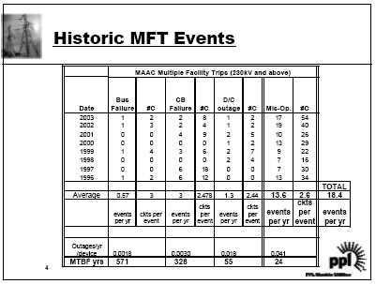
Figure 4: PPL Electric Utilities Multiple Facility Forced Outages

Summary
ERCOT supports the need for dynamic reactive devices in the CenterPoint system. Studies confirmed that generators in the area can not meet the requirements of Op. Guide 3.1.4.6 without the Houston area retired/mothballed units and without the dynamic reactive devices.

An outage as extreme as the NERC Category D outage used in the study, a 3 phase fault with a breaker failure at a 345 kV bus followed by tripping a large generating unit along with a 345 kV circuit, is a credible contingency as shown by Figures 3 and 4.

ERCOT also concurs with the CNP’s load shedding limit of 1,250 MW as a maximum local area load shedding amount in order to avoid significant risks of cascading outages. Finally, ERCOT encourages CNP to install dynamic reactive resources in its transmission system to replace dynamic reactive capability supplied by generators that has been lost due to generator retirements and the increasing import requirements to serve existing demand and the growth in Houston.

Designated Providers of Transmission Facilities
In accordance with ERCOT’s Power System Planning Charter and Processes, ERCOT staff is to designate transmission providers for projects reviewed in the regional planning groups. These providers can agree to provide or delegate the new facilities or inform ERCOT they do not elect to provide them. For the project scope recommended in this report, CenterPoint Energy is the sole provider of transmission facilities for this project.



Appendix 1
REVIEW OF CENTERPOINT’S
HOUSTON AREA DYNAMIC REACTIVE PROJECT
2007 SUMMER PEAK NETWORK CONDITIONS

ERCOT System Planning Transmission Services

Austin  7620 Metro Center Drive  Austin, Texas 78744  Tel: (512) 225-7000  Fax: (512) 225-7020 | www.ercot.com | Transmission Services - Taylor  2705 West Lake Drive  Taylor, Texas 76574  Tel: (512) 248-3000  Fax: (512) 248-6560

TABLE OF CONTENTS

DISCLAIMER 9
EXECUTIVE SUMMARY 10
NERC Category D Contingency Results 10
INTRODUCTION 12
VOLTAGE COLLAPSE STUDIES 12
STUDY DEVELOPMENT AND PROCESS 13
STUDY RESULTS 15

DISCLAIMER
The Electric Reliability Council of Texas (ERCOT) System Planning Transmission Services staff prepared this document. It is an engineering review report of a project proposed by CenterPoint on the ERCOT transmission system. Transmission system planning is a continuous process. Conclusions reached in this report can change with the addition (or elimination) of plans for new generation, transmission facilities, equipment, or loads.
ERCOT AND ITS CONTRIBUTING MEMBER COMPANIES DISCLAIM ANY WARRANTY, EXPRESSED OR IMPLIED, INCLUDING ANY WARRANTY OF MERCHANTABILITY OR FITNESS FOR ANY PARTICULAR PURPOSE WHATSOEVER WITH RESPECT TO THE INFORMATION BEING PROVIDED IN THIS REPORT.
The use of this information in any manner constitutes an agreement to hold harmless and indemnify ERCOT, its Member Companies, employees, and/or representatives from all claims of any damages. In no event shall ERCOT, its Member Companies, employees, and/or representatives be liable for actual, indirect, special or consequential damages in connection with the use of this data. Users are advised to verify the accuracy of this information with the original source of the data.
This is an interim report to ERCOT. It should not be disclosed to other parties outside ERCOT without the approval of its author(s).

AUTHORS
This report was prepared by José Conto, Sr. Consultant and John Schmall, Sr. Consultant.

GLOSSARY
CSC Commercially Significant Constraint (CSC zones group buses into larger regional areas)
NERC North America Electric Reliability Council
WECC Western Electricity Coordinating Council
PV Power versus Voltage relationship
TSAT Transient Security Assessment Tool, v.5.0 (Powertech’s software to perform transient stability studies)
VSAT Voltage Security Assessment Tool, v.5.1 (Powertech’s software to perform PV studies)

EXECUTIVE SUMMARY
ERCOT system planning staff agrees with the criteria and performance recommended by CenterPoint to mitigate reactive resource deficiencies during outages as being reasonable for the Houston region. Significant amounts of static reactive resources (capacitor banks) have recently been added to the Houston region based on PV analysis and satisfying the PV margins specified in the ERCOT planning criteria. However, given the amount of dynamic reactive capability that has been lost due to generator retirements and the increasing import requirements to serve existing demand and the growth in Houston, it is advisable that a portion of that capability be replaced with dynamic reactive resources. The installation of additional dynamic reactive resources, as shown in the study, shall compensate the unbalance of reactive power during severe outages and maintain reliable service to load.
NERC Category B and C Contingency Results
This study identifies the most severe contingencies with respect to the Houston CSC zone PV margin for the ERCOT 2007 summer on-peak base case. PV simulations were performed both with and without 2x35 MVAR DVARS devices included in the system model and it was found that for both scenarios, all contingencies studied satisfy ERCOT reliability criteria with PV margins greater than 5% for NERC category B contingencies and PV margins greater than 2.5% for NERC category C contingencies. The 2x35 MVAR DVARS dynamic reactive devices added approximately 0.6% to Houston zone PV margins.
ERCOT-to-Houston power transfer scenarios were studied. The Houston CSC zonal load was increased and load reduced in the remaining ERCOT CSC zones. Self-serve loads in Houston were not scaled.
Result tables reporting the most severe contingencies with respect to PV margin are included in the attached Appendices.

NERC Category D Contingency Results
The CenterPoint proposal is based on adding sufficient dynamic reactive support to satisfy the following voltage recovery performance objectives:
For a three-phase fault with cleared breaker failure relaying (NERC Category D),
- Transmission system voltages must recover so that no generator terminal voltage remains below 90% of rated voltage for more than 10 seconds.
- No more than 1250 MW of load should be lost due to the operation of under-voltage load shedding schemes.
The disturbance studied by CenterPoint involved a three-phase fault cleared with breaker failure relaying by disconnecting a generator and a 345 kV line with an 8-cycle total fault clearing time.
ERCOT’s simulation of the 2007 summer op-peak case showed the same results as those listed in the reports provided by Centerpoint for the NERC Category D contingency test. The 2007 data set (basecase file, contingency files, load data, models data) was also examined and found to follow accepted industry practices (system load at peak conditions, contingencies selection, voltage recovery level, etc.) for this type of voltage recovery studies. A summary of these runs are presented in Appendix C.
Transient Voltage Dip Considerations
An alternative method to assess dynamic voltage performance is the application of Transient Voltage Dip (TVD) criteria. At ERCOT, the Dynamics Working Group (DWG) of the Reliability and Operations Subcommittee (ROS) is investigating the utilization of a criteria similar to one used by WECC. However, acceptable dynamic voltage recovery performance may vary depending on the local network characteristics and it may not be appropriate to apply a single criterion for all buses in the system. Therefore, ERCOT system planning staff recommends the application of region-specific voltage recovery criteria. Regions would have to be defined for this purpose and it may be possible to identify a set of critical buses within each region that would have to satisfy the voltage recovery criteria. Generator buses, HVDC buses, dynamic reactive device buses, large industrial load buses, 345 kV buses, etc. may be included in this set. Region definitions and the selected set of critical buses would need to be reviewed periodically and updated as necessary due to changes in the network. Additional information about the ERCOT TVD criteria is discussd in “ERCOTtvd_sep0903a.pdf”

INTRODUCTION
CenterPoint Energy is seeking ERCOT review of their proposed project to provide additional dynamic reactive support to the Houston area. A summary of their project (“Houston Area Dynamic Reactive Project”), a project study document prepared by Powertech (“Dynamic Voltage Recovery Analysis for Houston Area”) and a summary of CenterPoint studies (“Summary of the Dynamic VAR Study for the 2007 CNP System”) were provided by CenterPoint to all ERCOT stakeholders. Any one of several types of dynamic reactive devices considered could be utilized to meet CenterPoint’s chosen performance objectives.
The project justification is based on satisfying voltage recovery criteria that has not been previously applied at ERCOT. To provide an assessment of the project impact under existing ERCOT voltage stability criteria, this review included a PV analysis for expected 2007 summer on-peak conditions including proposed transmission system upgrades expected to be completed. PV simulations were performed both with and without the dynamic reactive device. The dynamic reactive device selected for this analysis was the DVARS (also referred as DSATCOM) since it would add the least amount of continuous reactive capability to the system among the dynamic reactive device options considered (total of 70 MVAR added: 35 MVAR at Bellaire and 35 MVAR at Crosby). Other device options with higher continuous reactive capability would be expected to provide a greater increase in PV margin.
A description of the CNP voltage recovery criteria based on NERC category D contingency test is fully described in the document “CNP Voltage Recovery Final Report.doc.” ERCOT system planning staff did verify the results found for the DVARS device. A summary of these runs are presented in Appendix C.

VOLTAGE COLLAPSE STUDIES
Traditionally, the limiting criterion of power transfer between regions has been the thermal capability of transmission elements. Recently, the unbalance of reactive resources has led a re-evaluation of the limiting criteria during power transfers between regions. While increasing power transfers under contingency, bus voltage depression at the power-receiving region could lead to a voltage collapse ending in a blackout due to lack of dynamic reactive resources. PV studies provide power transfer limits and lists of critical contingencies ranked in severity for each export-import scenario.
In a typical PV study, power transfer between two study zones is increased and at each step, contingencies are independently applied, followed by a load flow solution. The transfer level and associated contingency is flagged as a voltage collapse scenario for those scenarios where the load flow does not converge. The process is repeated for higher power transfer level until the base case voltage collapses under no contingency, or the source zone reaches its maximum specified exporting generation capacity.
Voltage violations and branch overloads are monitored, and while they do impose operational limitation of the study network, they may not affect the voltage collapse point. Additional investigation may be required when voltages below 0.80 p.u. are found, because such under-voltage levels could trigger the stalling of motor loads, leading to a fast voltage collapse scenario.
Voltage collapse is reached when the load flow fails to converge within the specified error tolerance and number of iterations. Mathematically a non-convergent solution is a set of equations with no numerical solution, a singularity. Be aware that non-convergence could be the result of numerical instability due to cumulative error. For purpose of this study, a non-convergence scenario is identified as a voltage collapse outcome.

STUDY DEVELOPMENT AND PROCESS
PV simulations were performed on the 2007 summer on-peak ERCOT base case with Powertech’s VSAT program. Analysis included the application of contingencies both with and without 2x35 MVAR DVARS reactive devices as proposed by CenterPoint. For purpose of the PV simulation, the dynamic reactive device was modeled as a synchronous condenser.
This report identifies the most severe contingencies that limit the transfer of power into the Houston CSC zone and identifies the impact of the proposed project. Additionally, violations of voltage stability criteria (PV margin less than 5% for NERC category B contingencies and PV margin less than 2.5% for NERC category C contingencies) are identified.
In the PV study, incremental power transfers from all the other selected CSC zones to the Houston CSC zone are simulated and at each step, contingencies are executed, followed by a load flow solution. For those situations where the load flow does not converge, the scenario is identified as voltage collapse. Bus voltages are checked for under-voltage violation. The process is repeated for higher power transfer level until the base case voltage collapses under no contingency, or the source zone reached its specified exporting capacity.

Power Transfer Paths
Power transfer into the Houston zone was accomplished by scaling up Houston load while scaling down load in selected external zones. Self-serve loads in Houston were not scaled. A summary of power transfer modeling is as follows:
Sink Zone (ID) | Initial Sink Zone Load (MW) | Source Zones (ID)
Houston (3) | 17986.6 | North (2), South (3), Northeast (5)

Contingency sets
For each power transfer path, contingencies were screened to identify the most severe contingencies in each of the following sets:
NERC Category B Contingencies
Single Generator | Contingency set includes the largest generator at each site within the Houston zone.
Single Line | Contingency set includes all 138 kV and 345 kV lines within the Houston zone.
NERC Category C Contingencies
Single Event Multi-Line | Contingency set includes the outage of multiple 138 kV and 345 kV lines within the Houston zone that are susceptible to a single failure (e.g. common supporting structures).
Single Generator + Single Line | Contingency set includes the simultaneous outage of a single generator and selected (most severe with respect to PV margin) single lines.
Single Generator + Single Event Multi-Line | Contingency set includes the simultaneous outage of a single generator and selected (most severe with respect to PV margin) lines susceptible to a single failure.

Monitoring Elements
All transmission buses (138kV and above) in the Houston zone were monitored for under voltage violations. A bus voltage is flagged when its value is below 0.80 per unit.

Load Flow Solution parameters
The solution settings were such that:
- Area control set to off – ERCOT operates as a single control area, single swing bus.
- Transformer taps are allowed to move in pre-contingency and post-contingency.
- Switchable shunts are allowed to switch.
- Generation limits enforced.

Load Models
All loads were represented with a constant MVA model.

Study Limitations
This study is subject to the following issues that will limit its conclusions:
- Pre-existing conditions: Pre-existing conditions were not resolved prior to running this study. The base case may contain overloads, voltage violations and n-1 violations.
- Generation dispatch uncertainty: The base case is dispatched for minimum overloads on the ERCOT CSC interfaces, but there is no guarantee that such generation dispatch is the most severe to the region under study. Voltage collapse events may not be discovered when generation output are modeled with more reactive production and/or reserves than it would actually occur.
- Under-voltage violations: Depending on the composition in load types, low bus voltages could indicate the starting point for motor load stalling leading to fast voltage collapse. Such conditions can be studied with full time-domain simulations, not in the scope of this study.

STUDY RESULTS
Result tables reporting the most severe contingencies with respect to PV margin are included in the attached Appendices as follows:
Appendix A | ERCOT-to-Houston Transfer – PV Limits for NERC Category B Contingencies  Table A1: PV Results with the 2X35 MVAR DVARS  Table A2: PV Results without dynamic reactive device
Appendix B | ERCOT-to-Houston Transfer – PV Limits for NERC Category C Contingencies  Table B1: PV Results with the 2X35 MVAR DVARS  Table B2: PV Results without dynamic reactive device

PV margins are evaluated as follows:
$$\text{PV margin \%}=\frac{[Δ\text{MW of Zonal Load}]}{[\text{Original Zonal Load}]}x\text{100}\text{\%}$$
ERCOT reliability criteria requires a PV margin greater than 5% for NERC category B contingencies and a PV margin greater than 2.5% for NERC category C contingencies. All contingencies studied satisfy these criteria. The PV margin exceeds 11.2% for all NERC category B contingencies and 7.3% for all NERC category C contingencies with the 2x35 MVAR DVARS project included in the model. The PV margin exceeds 10.6% for all NERC category B contingencies and 6.7% for all NERC category C contingencies without a dynamic reactive device added to the system model. The 2x35 MVAR DVARS dynamic reactive devices added approximately 0.6% to Houston zone PV margins.
Table A1: PV Results with the 2x35 MVAR DVARS in Houston
PV Margin (%) | ΔLimit (MW) | Limit (Houston MW) | Contingency ID | Contingency Name
11.2 | 2000 | 19986.6 | SB 3
11.2 | 2000 | 19986.6 | SG 10
11.7 | 2100 | 20086.6 | SB 2
11.7 | 2100 | 20086.6 | SB 160
11.7 | 2100 | 20086.6 | SG 28
12.3 | 2200 | 20186.6 | SB 1
12.3 | 2200 | 20186.6 | SB 134
12.3 | 2200 | 20186.6 | SB 164
12.3 | 2200 | 20186.6 | SB 188
12.3 | 2200 | 20186.6 | SG 18
12.9 | 2300 | 20286.6 | SB 498
13.4 | 2400 | 20386.6 | SB 377
13.4 | 2400 | 20386.6 | SG 7
13.4 | 2400 | 20386.6 | SG 11
13.4 | 2400 | 20386.6 | SG 22
13.4 | 2400 | 20386.6 | SG 25
13.4 | 2400 | 20386.6 | SG 26
13.4 | 2400 | 20386.6 | SG 30
13.4 | 2400 | 20386.6 | SG 31
13.4 | 2400 | 20386.6 | SG 32
13.4 | 2400 | 20386.6 | SG 33
13.4 | 2400 | 20386.6 | SG 34
* all other studied contingencies result in PV margin greater than 13.4%
Table A2: PV Results without Dynamic Reactive Device in Houston
PV Margin (%) | ΔLimit (MW) | Limit (Houston MW) | Contingency ID | Contingency Name
10.6 | 1900 | 19886.6 | SG 10
11.2 | 2000 | 19986.6 | SB 3
11.7 | 2100 | 20086.6 | SB 1
11.7 | 2100 | 20086.6 | SB 2
11.7 | 2100 | 20086.6 | SB 160
11.7 | 2100 | 20086.6 | SB 188
11.7 | 2100 | 20086.6 | SG 18
11.7 | 2100 | 20086.6 | SG 28
12.3 | 2200 | 20186.6 | SB 134
12.3 | 2200 | 20186.6 | SB 164
12.3 | 2200 | 20186.6 | SB 498
12.9 | 2300 | 20286.6 | SG 22
12.9 | 2300 | 20286.6 | SG 30
12.9 | 2300 | 20286.6 | SG 31
13.4 | 2400 | 20386.6 | SB 377
13.4 | 2400 | 20386.6 | SG 7
13.4 | 2400 | 20386.6 | SG 11
13.4 | 2400 | 20386.6 | SG 25
13.4 | 2400 | 20386.6 | SG 26
13.4 | 2400 | 20386.6 | SG 29
13.4 | 2400 | 20386.6 | SG 32
13.4 | 2400 | 20386.6 | SG 33
13.4 | 2400 | 20386.6 | SG 34
* all other studied contingencies result in PV margin greater than 13.4%

Table B1: PV Results with the 2x35 MVAR DVARS in Houston
PV Margin (%) | ΔLimit (MW) | Limit (Houston MW) | Contingency ID | Contingency Name
7.3 | 1300 | 19286.6 | MG 66
7.8 | 1400 | 19386.6 | BG 34
7.8 | 1400 | 19386.6 | MG 98
7.8 | 1400 | 19386.6 | MG 114
7.8 | 1400 | 19386.6 | MG 290
8.4 | 1500 | 19486.6 | MG 2
8.4 | 1500 | 19486.6 | MG 50
8.4 | 1500 | 19486.6 | MG 130
8.9 | 1600 | 19586.6 | BG 18
8.9 | 1600 | 19586.6 | BG 66
8.9 | 1600 | 19586.6 | BG 98
8.9 | 1600 | 19586.6 | MG 18
8.9 | 1600 | 19586.6 | MG 34
8.9 | 1600 | 19586.6 | MG 68
Table B1: PV Results with the 2x35 MVAR DVARS in Houston (continued)
PV Margin (%) | ΔLimit (MW) | Limit (Houston MW) | Contingency ID | Contingency Name
8.9 | 1600 | 19586.6 | MG 72
8.9 | 1600 | 19586.6 | MG 82
8.9 | 1600 | 19586.6 | MG 578
8.9 | 1600 | 19586.6 | MG 658
9.5 | 1700 | 19686.6 | BG 2
9.5 | 1700 | 19686.6 | BG 36
9.5 | 1700 | 19686.6 | BG 40
9.5 | 1700 | 19686.6 | MG 75
9.5 | 1700 | 19686.6 | MG 100
9.5 | 1700 | 19686.6 | MG 104
9.5 | 1700 | 19686.6 | MG 116
9.5 | 1700 | 19686.6 | MG 120
9.5 | 1700 | 19686.6 | MG 136

Table B1: PV Results with the 2x35 MVAR DVARS in Houston (continued)
PV Margin (%) | ΔLimit (MW) | Limit (Houston MW) | Contingency ID | Contingency Name
9.5 | 1700 | 19686.6 | MG 292
9.5 | 1700 | 19686.6 | MG 296
9.5 | 1700 | 19686.6 | MG 322
9.5 | 1700 | 19686.6 | MG 594
* all other studied contingencies result in PV margin greater than 9.5%
Table B2: PV Results without Dynamic Reactive Device in Houston
PV Margin (%) | ΔLimit (MW) | Limit (Houston MW) | Contingency ID | Contingency Name
6.7 | 1200 | 19186.6 | MG 58
7.3 | 1300 | 19286.6 | BG 30
7.3 | 1300 | 19286.6 | MG 86
7.3 | 1300 | 19286.6 | MG 100
7.3 | 1300 | 19286.6 | MG 310
7.8 | 1400 | 19386.6 | MG 114
8.4 | 1500 | 19486.6 | BG 16
8.4 | 1500 | 19486.6 | BG 58
8.4 | 1500 | 19486.6 | MG 2
8.4 | 1500 | 19486.6 | MG 44
8.4 | 1500 | 19486.6 | MG 60
8.4 | 1500 | 19486.6 | MG 64
8.4 | 1500 | 19486.6 | MG 940
8.9 | 1600 | 19586.6 | BG 2
Table B2: PV Results without Dynamic Reactive Device in Houston (continued)
PV Margin (%) | ΔLimit (MW) | Limit (Houston MW) | Contingency ID | Contingency Name
8.9 | 1600 | 19586.6 | BG 32
8.9 | 1600 | 19586.6 | BG 36
8.9 | 1600 | 19586.6 | BG 86
8.9 | 1600 | 19586.6 | MG 16
8.9 | 1600 | 19586.6 | MG 30
8.9 | 1600 | 19586.6 | MG 72
8.9 | 1600 | 19586.6 | MG 88
8.9 | 1600 | 19586.6 | MG 92
8.9 | 1600 | 19586.6 | MG 102
8.9 | 1600 | 19586.6 | MG 106
8.9 | 1600 | 19586.6 | MG 316
8.9 | 1600 | 19586.6 | MG 856
8.9 | 1600 | 19586.6 | MG 870

Table B2: PV Results without Dynamic Reactive Device in Houston (continued)
PV Margin (%) | ΔLimit (MW) | Limit (Houston MW) | Contingency ID | Contingency Name
9.5 | 1700 | 19686.6 | BG 44
9.5 | 1700 | 19686.6 | MG 8
9.5 | 1700 | 19686.6 | MG 67
9.5 | 1700 | 19686.6 | MG 116
9.5 | 1700 | 19686.6 | MG 120
9.5 | 1700 | 19686.6 | MG 312
9.5 | 1700 | 19686.6 | MG 338
9.5 | 1700 | 19686.6 | MG 814
9.5 | 1700 | 19686.6 | MG 1500
* all other studied contingencies result in PV margin greater than 9.5%
DVARS Option run test
Base case: ERCOT 2007 summer on-peak with additional 1,500 Mvar of static capacitor added to the 2005 base case, the STP-Hillje-W.A. Parishg project included, and the decommissioned units removed from case.
Dynamic data: ERCOT 2006 dynamic model data set, Over Excitation Limiter (OEL) models revised, dynamic load models, and Under Voltage Load Shedding (UVLS) relay data from Centerpoint (CNP).
Contingency (Nerc category D ): A 3 phase fault with a breaker failure at a 345 kV bus followed by tripping a large generating unit along with a 345 kV circuit after an 8 cycle delay.
Performance criteria (as proposed by CNP): a) All the CNP area generator voltages must recover to .90 p.u. voltage within 10 seconds (based on ERCOT Operating Guide Section 3.1.4.6); b) The amount of load shed triggered by the CNP Under Voltage Load Shedding (UVLS) system should be lower than 1250 MW.
Simulation result: Plot of voltage output of all generators in the Houston Area
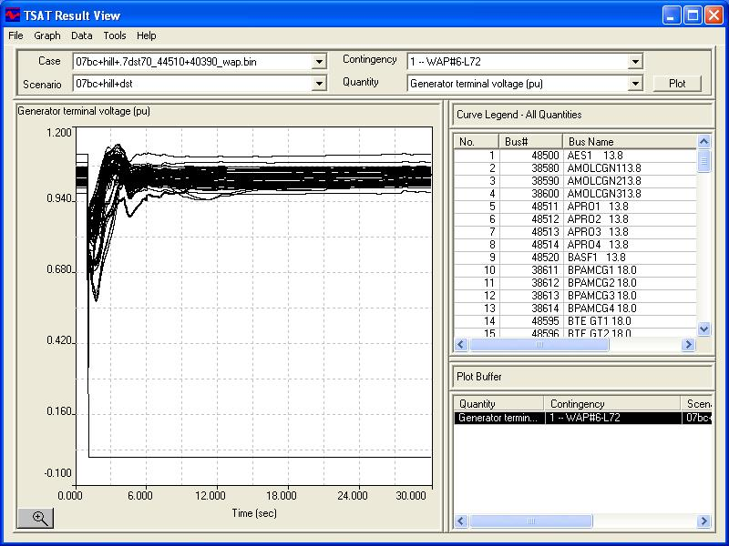
Comments: All generators terminal voltages recover to acceptable levels after the voltage dip due to the NERC Category D contingency test.
Scenario with Retired/Mothballed units in the base case
Retired/Mothballed units were included in the first run and then taken out again in the second run, without adding any dynamic device to the case. These runs show the dynamic vars contribution of the retired/mothballed units to the Houston Network and how the decommissioned units results in voltage collapse for the test of the NERC category D contingency.
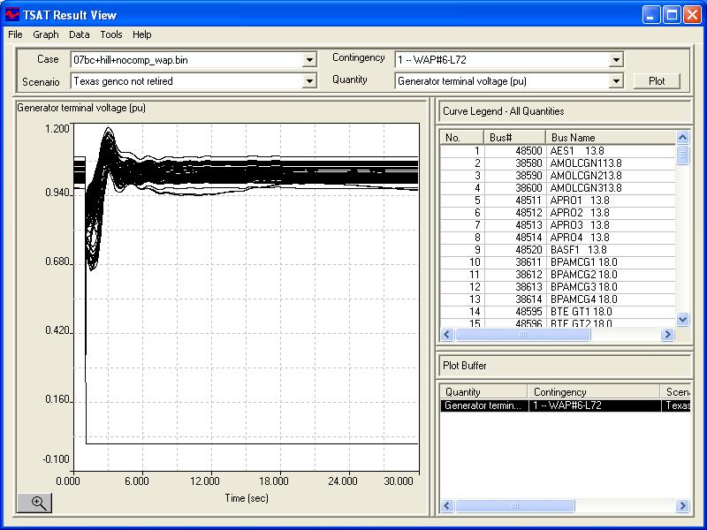
Simulation 1: Plot of voltage output of all generators in the Houston Area, with retired/mothballed units in.
All generators with terminal voltage levels higher than 0.9 p.u.

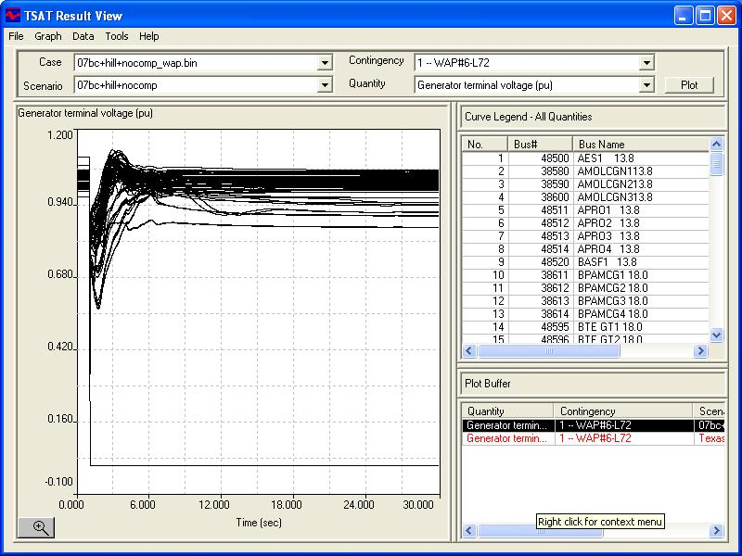
Simulation 2: Plot of voltage output of all generators in the Houston Area, with retired/mothballed units out.
There are generators with terminal voltage levels lower than 0.9 p.u.

