Changes to the Connectivity Profile on the Retail Testing Website

First I want to clarify the naming conventions used on the website. It has been decided by the market that what was formally known as the Technical Connectivity Worksheet and the Testing Signoff Worksheet would go by different names. The Technical Connectivity Worksheet is now known as the Connectivity Profile. The Connectivity Profile contains information necessary to connect to a Market Participants system and the format of the edi that the Market Participant uses. Connectivity information is published for Market Participants that can log onto the Retail Testing Website (etod.ercot.com). The Testing Signoff Worksheet is now known as the Testing Worksheet. This worksheet contains contact information and functionality/territories that a Market Participant is testing in a certain flight test. The Testing Worksheet is only visible to ERCOT and the Market Participant that created it.

The changes that were made and being explained here were changes to the connectivity profile.

The main change to the Connectivity Profile (CP) applicable to TDTWG concerns is the addition of production NAESB information. The CP formally contained information regarding certification environments only. Before the addition of production information to the CP this information had to be sent either in a separate manually created CP or via email etc.

The CP can be viewed from the Retail Testing Website (etod.ercot.com). The purpose of this website is mainly for testing not for production. The main reason for adding production environment information to a testing website was to make setting up connectivity after Market Participant certification easier. After the initial set up of production connectivity, Market Participants are not expected to revisit the Retail Testing Website every time they make a change in their production environment. However, if a Market Participant participates in another flight test at a later date they are expected to update both testing and production system information for that flight.

Changes implemented in may 2006.

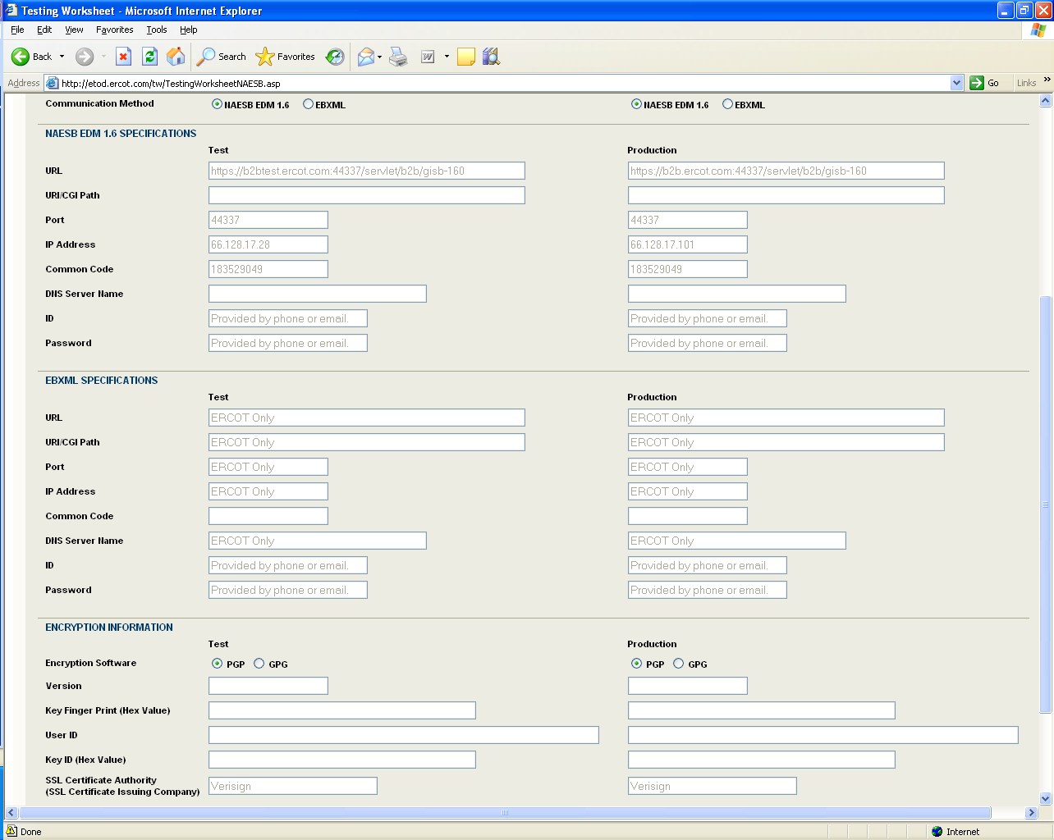

Another change made to the CP was the addition of a comments field in the NAESB section so a Market Participant can put in additional information. I believe this change was made because of a request from TDTWG.

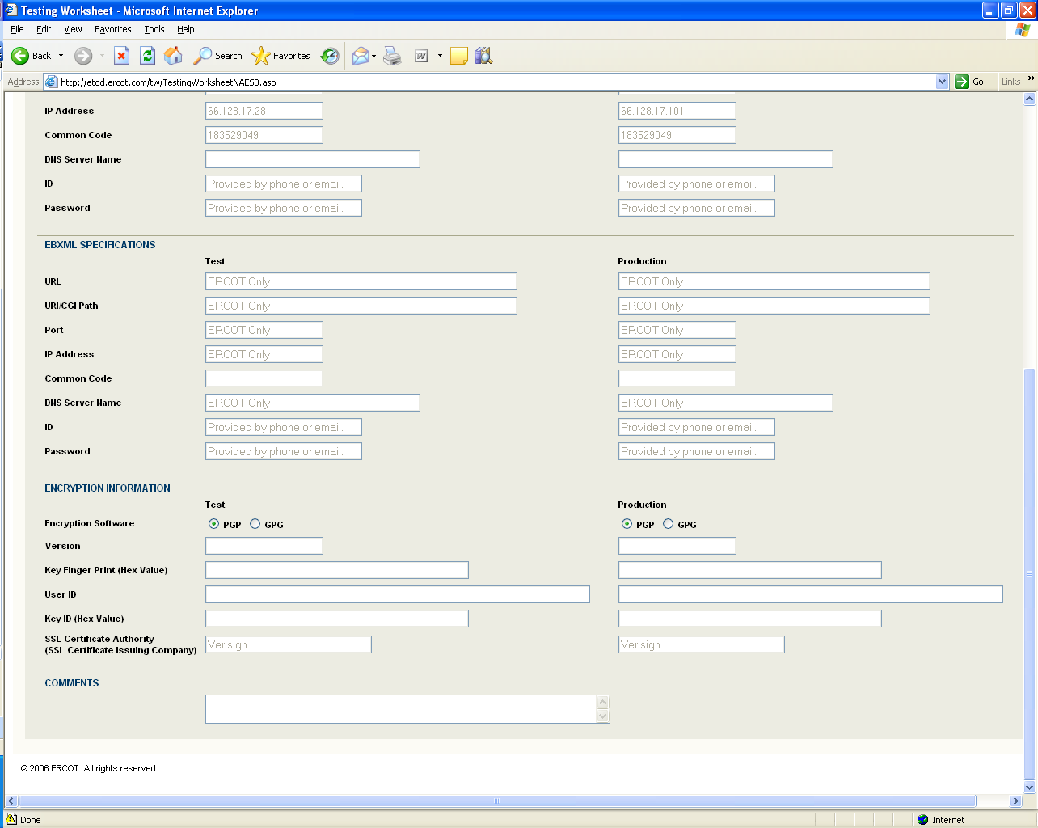

Because of these changes when a Market Participant downloads another Market Participant’s Connectivity Profile it will contain information necessary to do both certification testing and production connectivity testing.

