2007 South to Houston CSC Analysis

Transfer Analysis
At the June 28, 2006 Congestion Management WG meeting, ERCOT Transmission Services was tasked with performing a transfer analysis so that CMWG can determine if the STP-Dow 345-kV double circuit is the appropriate South-Houston CSC.

Transfer analysis was performed using the MUST software tool. The Steady State WG 2006 Data Set B, 2007 summer peak case updated June 2 was selected as the base case. This case has the future Hilje switch station and associated 345-kV line improvements in service. The base case generation dispatch was left unchanged except that the swing bus was moved from WA Parish to Monticello 3. The nuclear and coal units were excluded from being able to move in the transfer. Table 1 shows the top five most limiting element/ contingency pairs for generation transfers from the South zone to the Houston zone.

Transfer Limit (MW above base case) | Limiting Element | Contingency
632 | Waller-Prairie View 138-kV line | Jewett-Tomball/ Tomball-King-Kuykendahl 345-kV double circuit
897 | Waller-Prairie View 138-kV line | Jewett-Tomball/ King-Kuykendahl 345-kV double circuit
907 | Waller-Prairie View 138-kV line | Jewett-Tomball/ Roans Prairie-King 345-kV double circuit
1129 | Braunig-Highland 138-kV line | OW Sommers-Beck/ Kirby 138-kV double circuit
1253 | Braunig-Highland 138-kV line | Kirby-OW Sommers/ Beck 138-kV double circuit
Table 1: South-Houston transfer limits using the SSWG 2007 summer case

Note that none of the 345-kV lines from South to Houston showed up within the first 25 most limiting elements/ contingencies which represent a transfer of about 2200 MW above the base case dispatch.

The Hilje project was then backed out of the case and the analysis rerun. Table 2 shows the top five most limiting element and contingency pairs from this analysis.

Transfer Limit (MW above base case) | Limiting Element | Contingency
60 | Waller-Prairie View 138-kV line | Jewett-Tomball/ Tomball-King-Kuykendahl 345-kV double circuit
239 | Waller-Prairie View 138-kV line | Jewett-Tomball/ King-Kuykendahl 345-kV double circuit
298 | Waller-Prairie View 138-kV line | Jewett-TH Wharton/Tomball 345-kV double circuit
451 | STP-WA Parish 345-kV line | STP-Dow 345-kV double circuit
713 | Prairie View-Seaway 138-kV line | Jewett-Tomball/ Tomball-King-Kuykendahl 345-kV double circuit
Table 2: South-Houston transfer limits using the SSWG 2007 summer case with Hilje removed

TCR Calculation
TCR calculation analysis was performed in order to determine the potential difference in available TCRs for the above 2007 summer peak cases with and without the Hilje project. It should be noted that the 2006 CSC and CRE list was used for this analysis. Table 3 summarizes the results of this analysis.

Case | OC0 Limit (MVA) | Limiting Element | Contingency
Hilje removed | 1289.7 | Waller-Prairie View 138-kV line | STP-Dow 345-kV double circuit
Hilje in service | 1705.8 | STP-Hilje 345-kV line, circuit 1 | STP-Dow 345-kV double circuit
Table 3: OC0 Limits for 2007 Summer Peak Case with and without the Hilje project

Cluster Analysis
As a hypothetical exercise, cluster analysis was performed on the SSWG 2007 summer peak base case (Elm Creek and Hilje in service) with the South to Houston CSC removed. The following pictures illustrate this exercise clustered into 4, 5, and 6 zones.

4 Zones
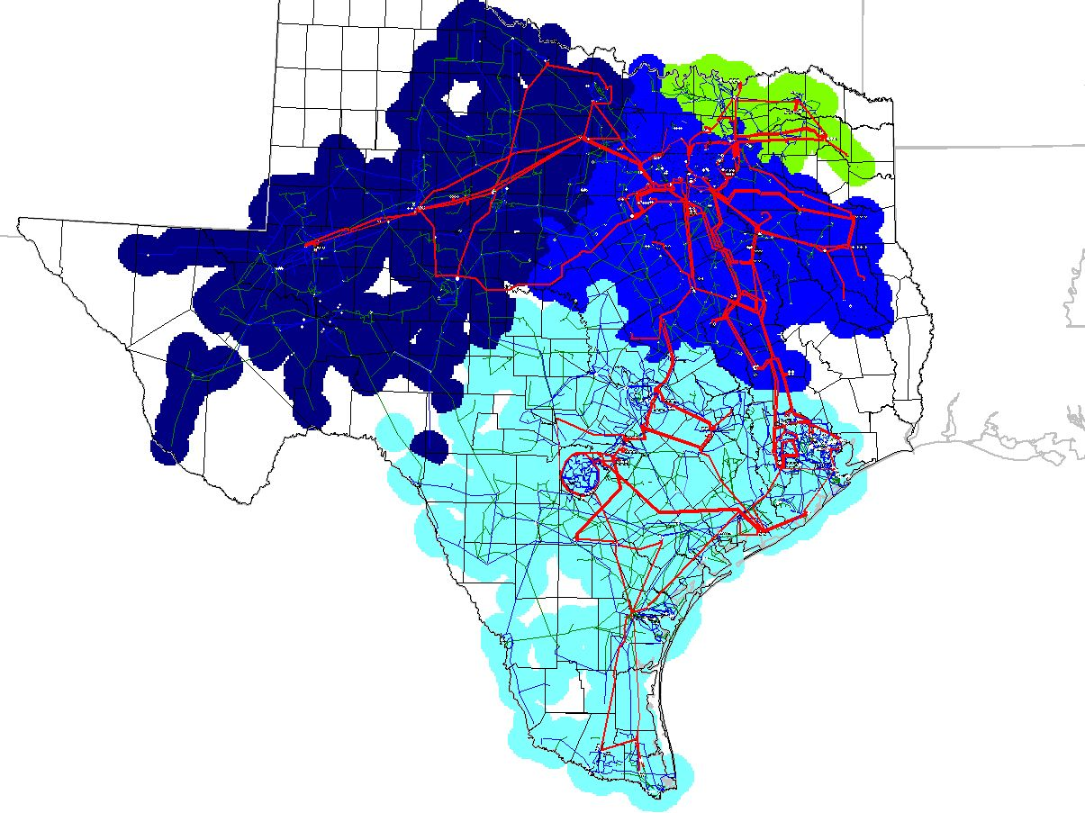
Notes:
- The Houston zone goes away instead of the Northeast zone disappearing as in all of the previous 4 zone clusters.
- There are two North-South CSCs.
5 Zones
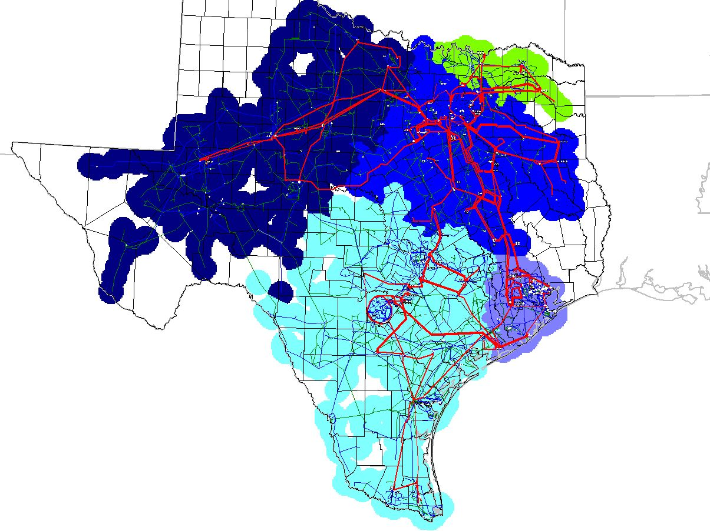
Notes:
- STP moves into the Houston zone.

6 Zones
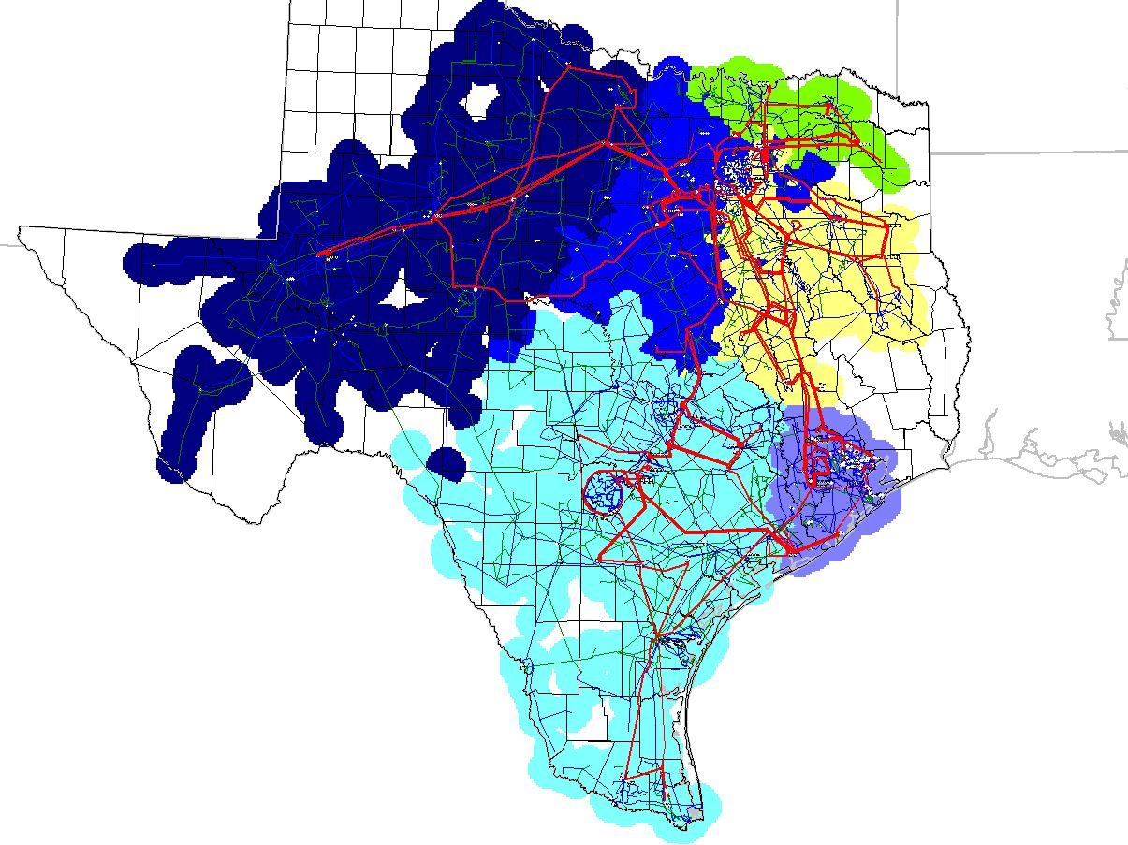
Notes:
- STP moves into the Houston zone.
- As in the other 6 zone analyses, the North zone splits.

