2007 CSC Analysis for CMWG
26 June, 2006

Bus comparisons performed using 5 zones.

The following buses change zones with Elm Creek:
Buses that change zones with Elm Creek | Bus Name | CM Zone with Elm Creek | CM Zone without Elm Creek
632 | JOHNSNSW | West | North
636 | JOHNSON | West | North
1710 | GAIN N | North | Northeast
6401 | MENPHTP2 | North | South
6402 | MENRDPH2 | North | South

The following buses are located in different zones in 2007 compared to 2006:
Buses that change zones in 2007 | Bus Name | 2006 CM Zone | 2007 CM Zone with Elm Creek and Hilje | 2007 CM Zone with Elm Creek but without Hilje
123 | JARREL | South | North | North
632 | JOHNSNSW | North | West | West
636 | JOHNSON | North | West | West
655 | CUSTER | Northeast | North | North
681 | FRISCO | Northeast | North | North
704 | MTNSPRGS | Northeast | North | North
1548 | MONTAG M | North | West | West
1552 | WIZRDPOD | West | North | North
1710 | GAIN N | Northeast | Northeast | North
1723 | LIBERTY | Northeast | North | North
1824 | NEYLAND | Northeast | Northeast | North
2364 | COLLIN 1 | Northeast | North | North
2365 | COLLIN 2 | Northeast | North | North
2370 | COLLIN | Northeast | North | North
2371 | COLL1 G | Northeast | North | North
2533 | ALLEN N1 | Northeast | North | North
2548 | ALLEN N2 | Northeast | North | North
3630 | COPPERCV | North | South | South
5556 | VNVLKSW9 | South | Houston | South
5558 | VNVLK 9 | South | Houston | South
5560 | BACT 9 | South | Houston | South
5564 | SARGNT 9 | South | Houston | Houston
5566 | FRNCP 9 | South | Houston | Houston
5568 | FRKCMP8 | South | Houston | Houston
6401 | MENPHTP2 | South | South | North
6402 | MENRDPH2 | South | South | North
6874 | MCK121RC | Northeast | North | North
6909 | ALNN RC | Northeast | North | North
7061 | COPPCV13 | North | South | South
7062 | KEMPNE13 | North | South | South
7064 | LAMPAS13 | North | South | South
7066 | ADAMSV13 | North | South | South
7068 | EVANT 13 | North | South | South
7074 | SANSAS06 | North | South | South
7075 | TERRY 06 | North | South | South
7076 | RICHSP06 | North | South | South
7078 | SANSAB06 | North | South | South
7080 | LOMETA06 | North | South | South
7082 | LAMPAS06 | North | South | South
7664 | SUNNYS06 | South | Houston | Houston
7666 | PRAIVI06 | South | Houston | Houston
7668 | PRAIVI13 | South | Houston | Houston
7670 | SEAWAY13 | South | Houston | Houston
8260 | ESCOND | West | South | South
43011 | NEWGLF 8 | South | Houston | Houston
43012 | NEWGLF 8 | South | Houston | Houston
43190 | S_LANE 8 | South | Houston | Houston
43570 | WHARTN 8 | South | Houston | Houston
44130 | CANEY_ | South | Houston | Houston

Scenario 13: Hilje & Elm Creek in service; 4 zones.

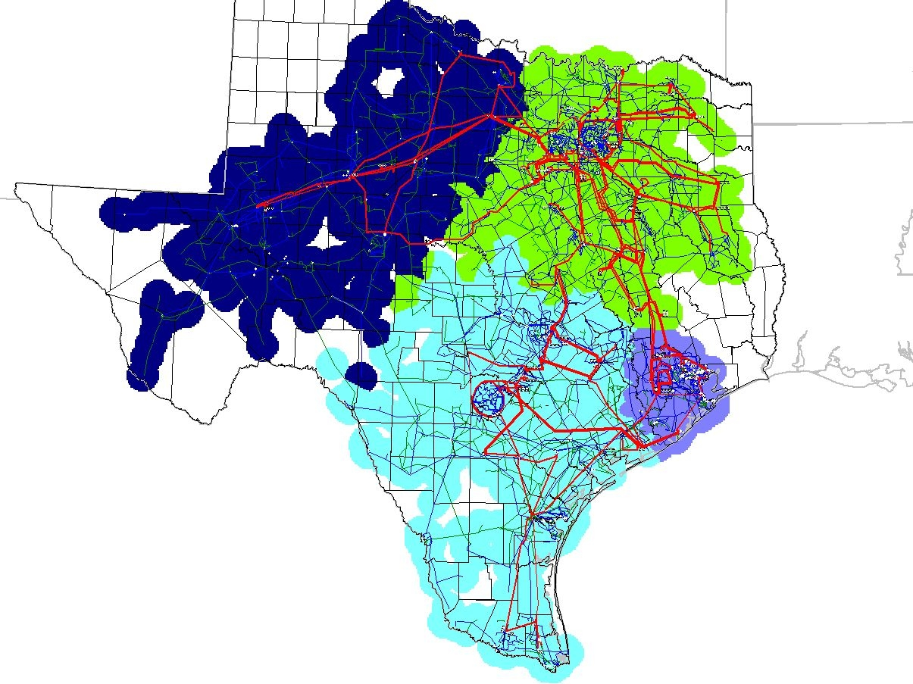

Scenario 14: Hilje & Elm Creek in service; 5 zones.

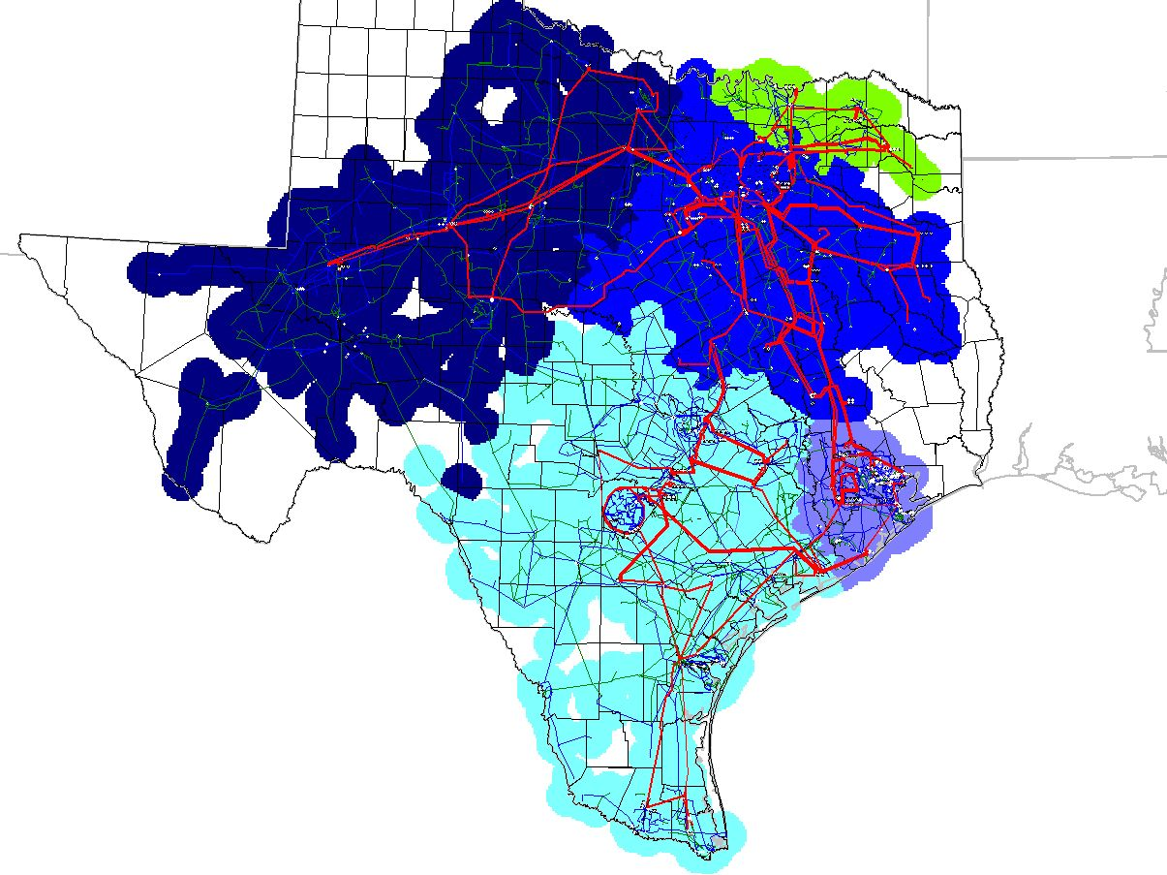

Scenario 15: Hilje & Elm Creek in service; 6 zones.

