Projects going in service during 2007 that may have an impact on CSCs:
- Hillje 345-kV switch station and STP-Hillje-WA Parish 345-kV lines
- Decker-Techridge 138-kV line reconductor
- Copperas Cove-Ding Dong 138-kV line

2007 CSC Analysis

Scenario | Description
1 | Current 6 CSCs, Case with Elm Creek and without Hillje; 4 zones.
2 | Current 6 CSCs, Case with Elm Creek and without Hillje; 5 zones.
3 | Current 6 CSCs, Case with Elm Creek and without Hillje; 6 zones.
4 | Current 6 CSCs, Case without Elm Creek and with Hillje; 4 zones.
5 | Current 6 CSCs, Case without Elm Creek and with Hillje; 5 zones.
6 | Current 6 CSCs, Case without Elm Creek and with Hillje; 6 zones.
7 | Current 6 CSCs, Case without Elm Creek and without Hillje; 4 zones.
8 | Current 6 CSCs, Case without Elm Creek and without Hillje; 5 zones.
9 | Current 6 CSCs, Case without Elm Creek and without Hillje; 6 zones.
10 | 7 CSCs - six existing plus SAPS-Menard with Hillje and Elm Creek in service; 4 zones
11 | 7 CSCs - six existing plus SAPS-Menard with Hillje and Elm Creek in service; 5 zones
12 | 7 CSCs - six existing plus SAPS-Menard with Hillje and Elm Creek in service; 6 zones

Scenario 1: Current 6 CSCs, Case with Elm Creek and without Hillje; 4 zones.

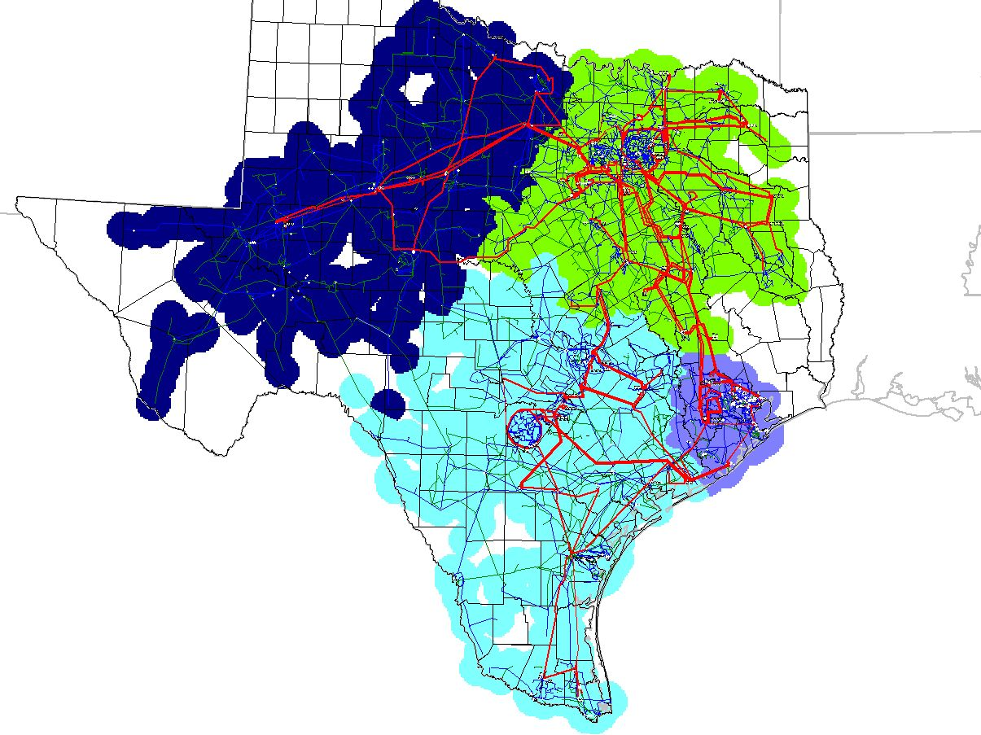

Scenario 2: Current 6 CSCs, Case with Elm Creek and without Hillje; 5 zones.

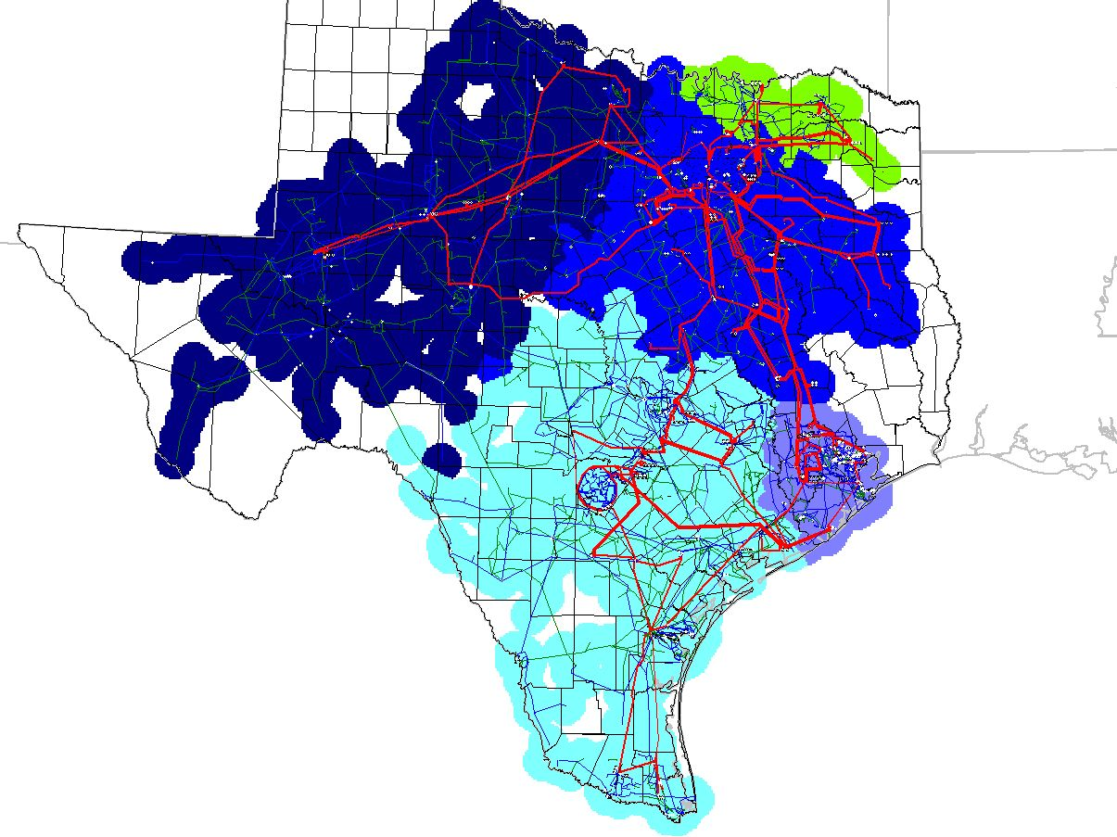

Scenario 3: Current 6 CSCs, Case with Elm Creek and without Hillje; 6 zones.

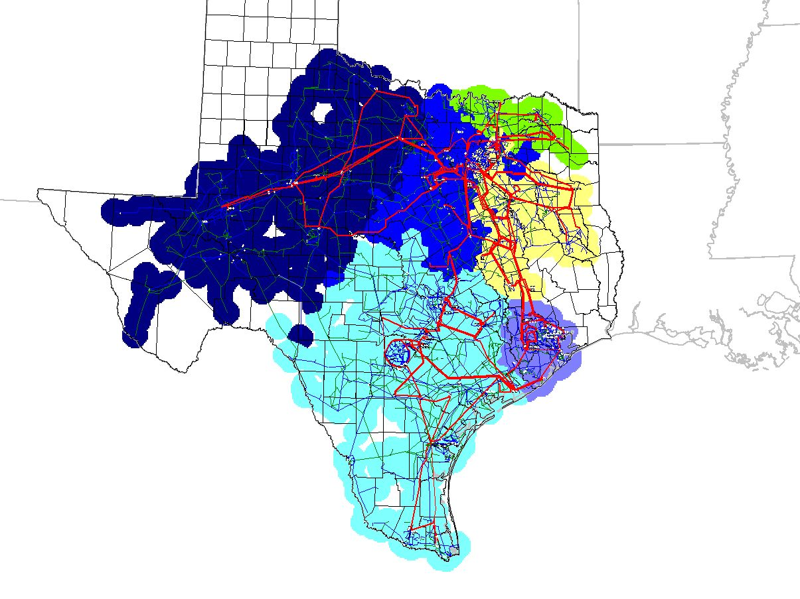

Scenario 4: Current 6 CSCs, Case without Elm Creek and with Hillje; 4 zones.

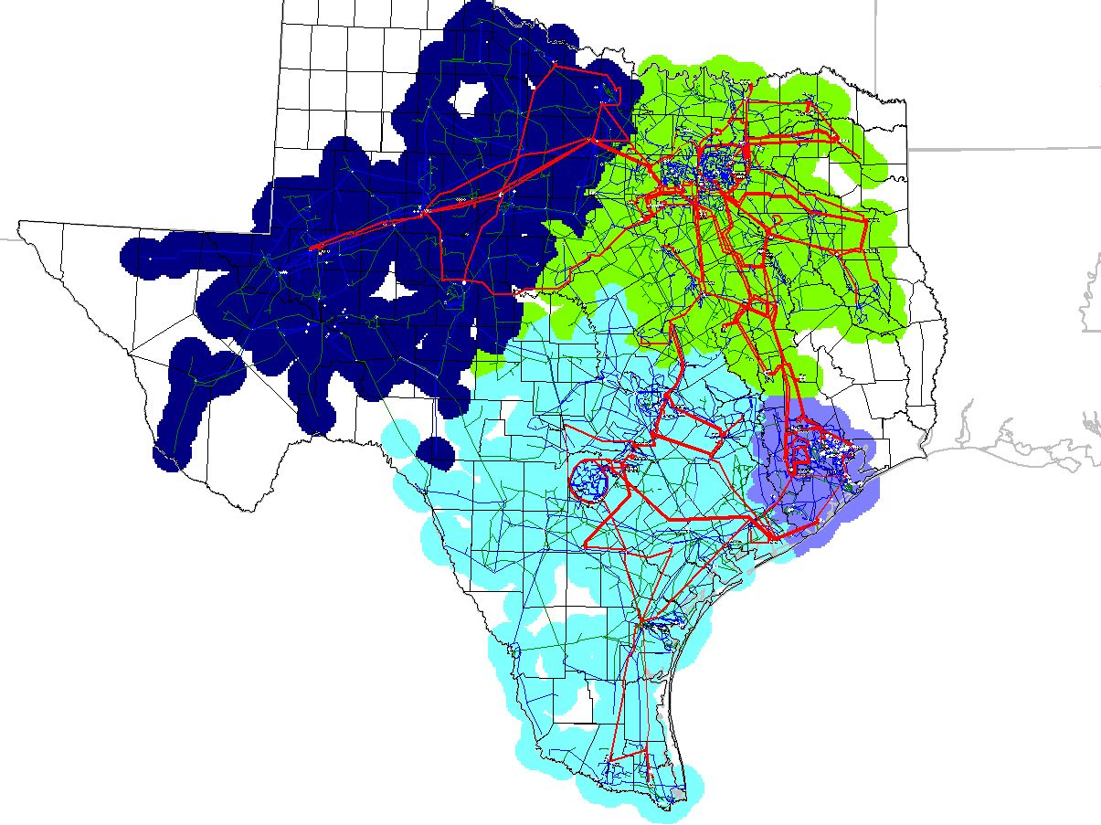

Scenario 5: Current 6 CSCs, Case without Elm Creek and with Hillje; 5 zones.

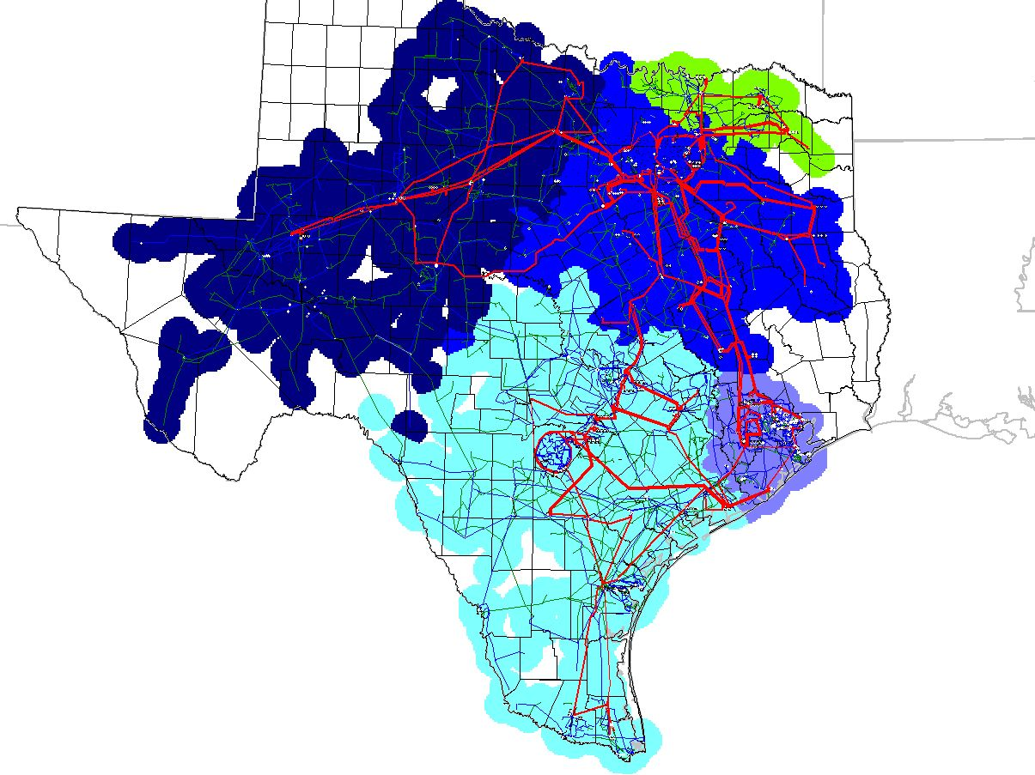

Scenario 6: Current 6 CSCs, Case without Elm Creek and with Hillje; 6 zones.

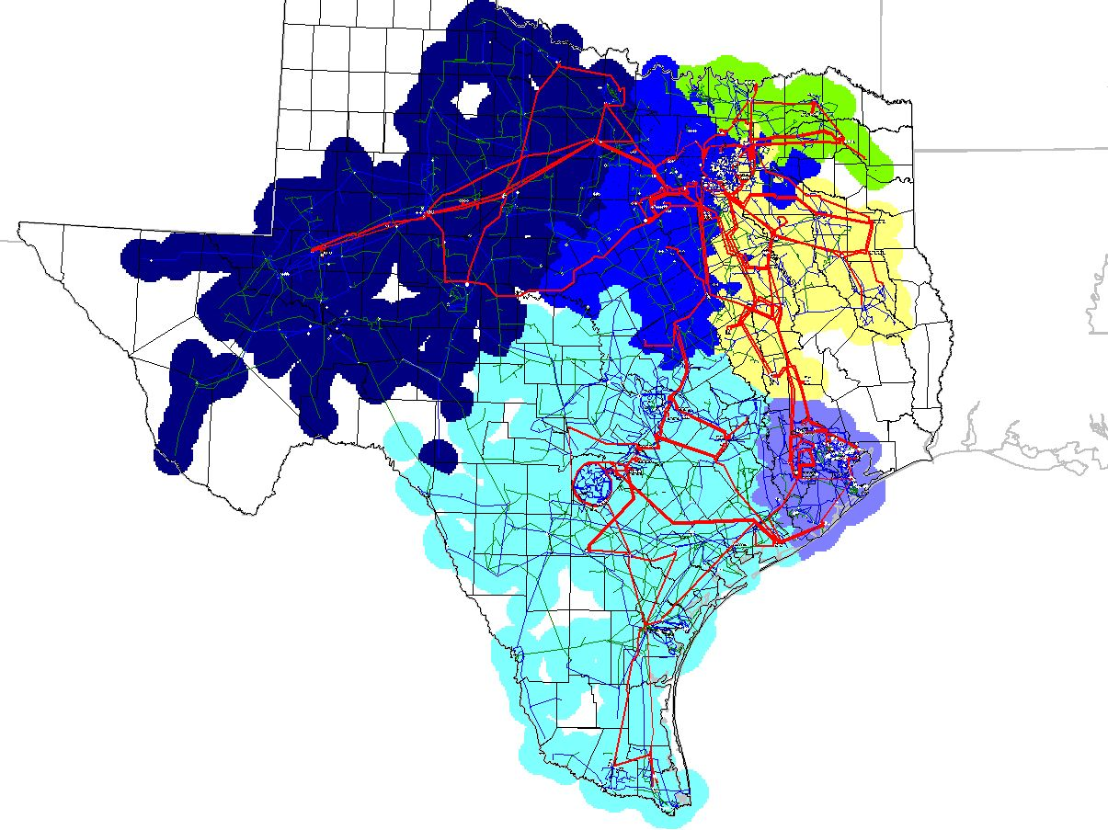

Scenario 7: Current 6 CSCs, Case without Elm Creek and without Hillje; 4 zones.

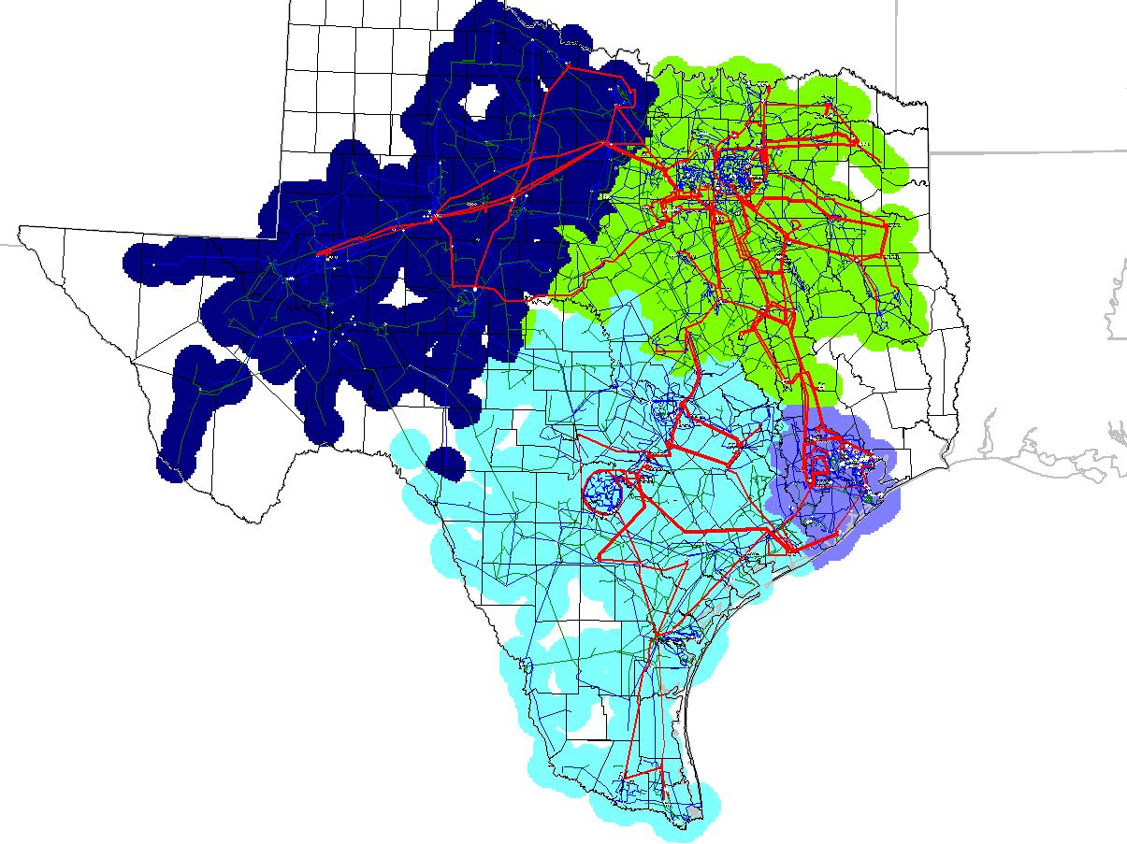

Scenario 8: Current 6 CSCs, Case without Elm Creek and without Hillje; 5 zones.
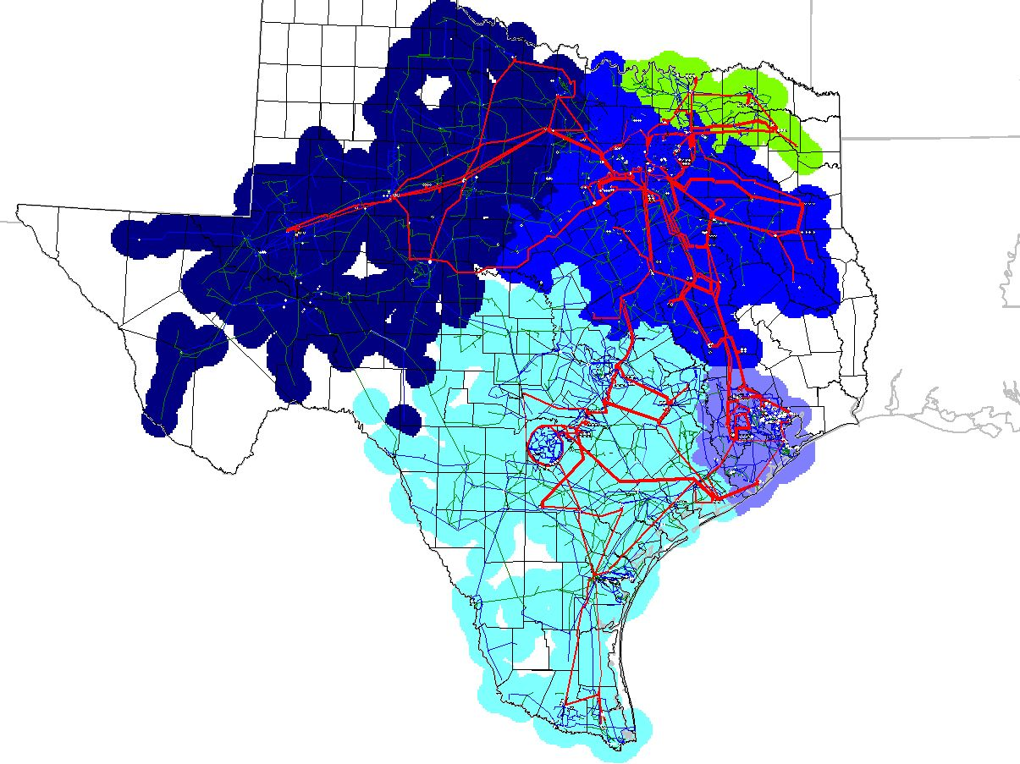

Scenario 9: Current 6 CSCs, Case without Elm Creek and without Hillje; 6 zones.

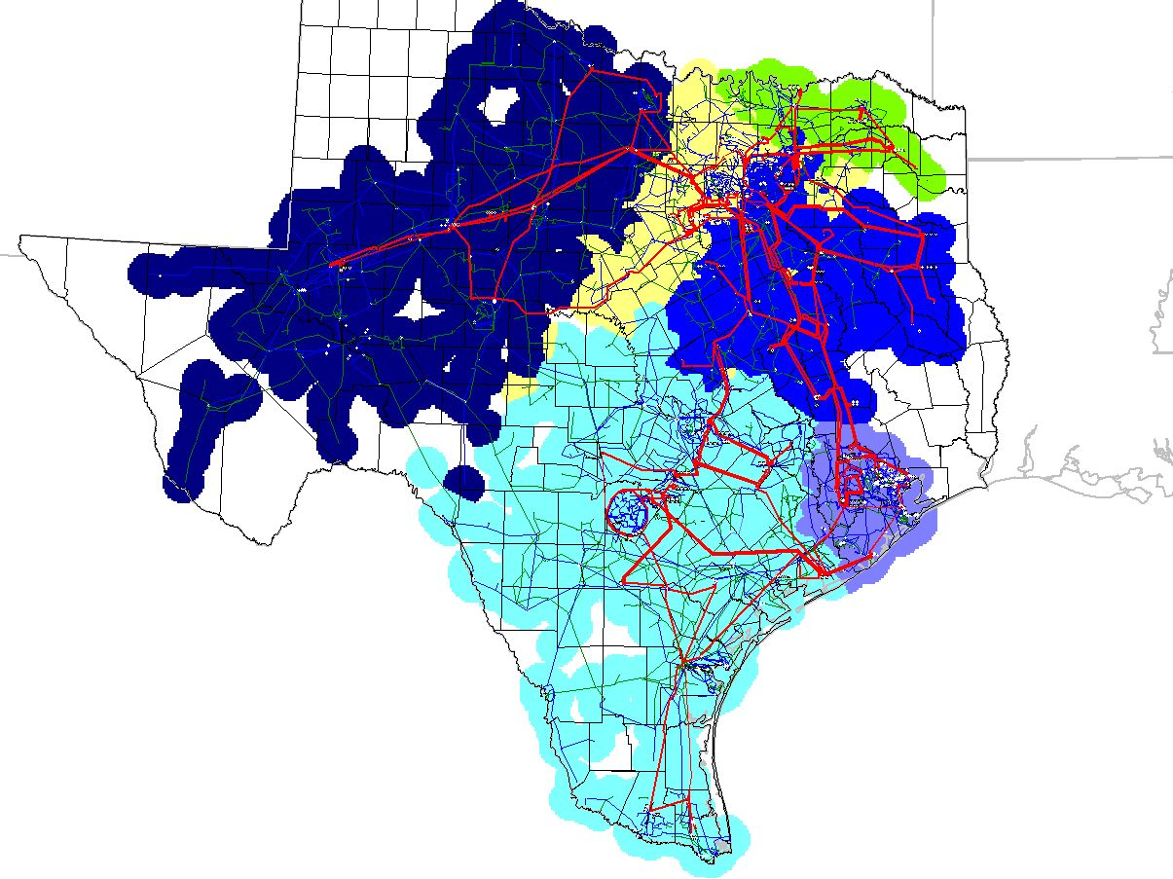

Scenario 10: 7 CSCs - six existing plus SAPS-Menard with Hillje and Elm Creek projects in service; 4 zones

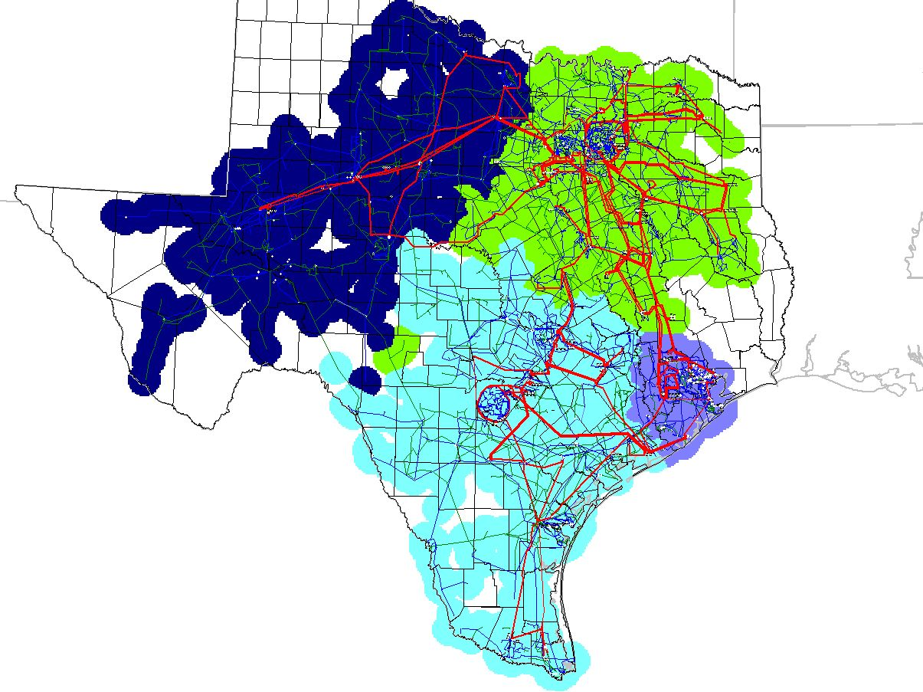

Scenario 11: 7 CSCs - six existing plus SAPS-Menard with Hillje and Elm Creek projects in service; 5 zones

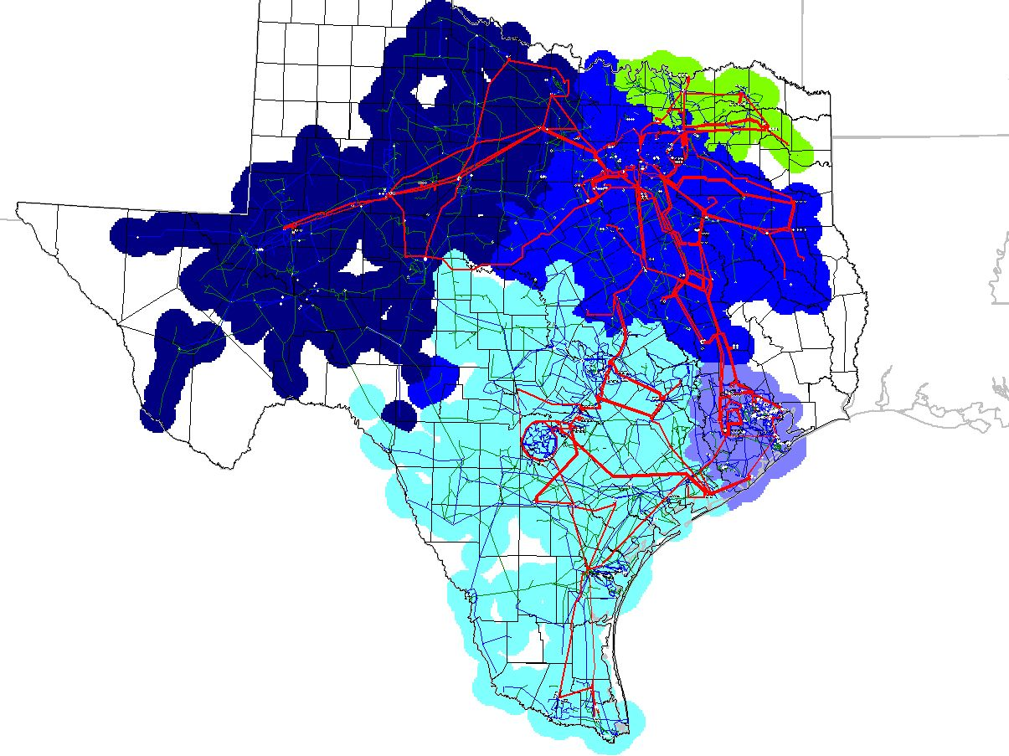

Scenario 12: 7 CSCs - six existing plus SAPS-Menard with Hillje and Elm Creek projects in service; 6 zones

