

Electric Reliability Council of Texas

Retail Market Transaction Processing
Service Availability

ERCOT

Summary:

A description of the retail transaction processing service availability targets of ERCOT.

EFFECTIVE: 6/1/2006

Contents

Introduction 3
Service Scope Definition 3
Retail Transaction Processing Service Availability 3
Performance Metrics 3
Service Availability Renegotiations and Change Control Process 3
Service Availability Reporting Process 3
Annual Review Process 3

Introduction

This document describes the service availability targets and operating hours for retail transaction processing services provided by ERCOT for the Texas competitive retail electric market.

These availability targets intend to build upon the requirements outlined in ERCOT Protocols Section 15 and provide additional guidance to Competitive Retailers and Transmission/Distribution Service Providers (TDSPs) regarding retail transaction processing service availability.

In the event of a conflict between this document and the ERCOT Protocols or PUCT Substantive Rules, the Protocols or PUC Substantive Rules take precedence over this document.

Service Scope Definition

“Retail Market Transaction Processing Services” is the end-to-end availability of successful retail transaction flow between ERCOT and Market Participants and includes the following components:

- NAESB Proxy Servers
- NAESB
- TCH
- Electronic Data Interchange (EDI) - Paperfree
- Enterprise Application Integration (EAI)
- Customer Registration Database - Siebel
- ERCOT maintained infrastructure supporting retail service availability

Excluded from the service availability calculation are the following systems that communicate with, but are not a primary component of, retail market transaction processing services:

- Enterprise Data Warehouse (EDW)
- Settlements & Billing Services (Lodestar)
- Web Services (e.g. TML, RMC, FasTrak, ERCOT.com)

Retail Transaction Processing Service Availability

Service Availability:

ERCOT targets retail transaction processing services to be available at least 99.25% of the time outside of scheduled maintenance and release outages. ERCOT reserves the following times as maintenance and release outage windows:

Maintenance Windows:

- 1st, 3rd, and 4th Sunday of each month – 8:00am until 8:00pm (12 hours)

Release Window:

- 2nd weekend of each month – 12:00pm Saturday until 12:00am Monday (36 hours)

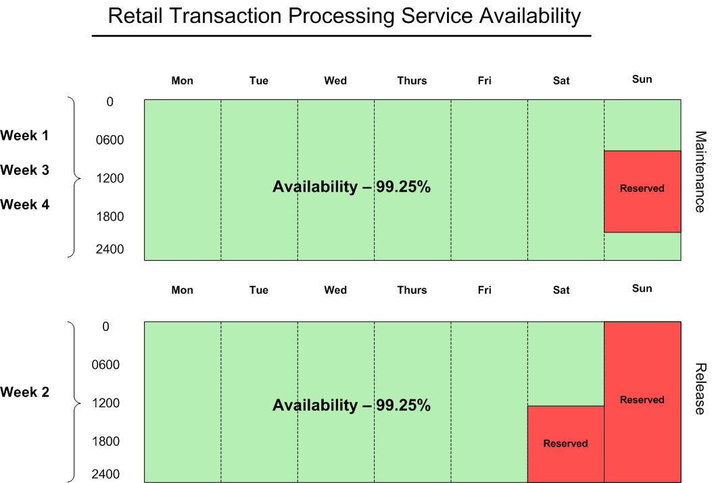

Availability Breakdown (Non-Leap Year):

Gross minutes per year = 525,600

Reserved maintenance outage minutes per year = 25,920

Reserved release outage minutes per year = 25,920

525,600 – 51,840 = 473,760 net availability minutes per year

99.25% availability = 3,553.2 unplanned outage minutes per year, or 59.22 hours (if all available maintenance and release windows are used)

Availability Breakdown (Leap Year):

Gross minutes per year = 527,040

Reserved maintenance outage minutes per year = 25,920

Reserved release outage minutes per year = 25,920

527,040 – 51,840 = 475,200 net availability minutes per year

99.25% availability = 3,564 unplanned outage minutes per year, or 59.4 hours (if all available maintenance and release windows are used)

Exceptions:

Outages excluded from the availability metric which do not count as unplanned outage time include any market-wide releases requiring Market Participants and ERCOT to coordinate system outages for major upgrades, such as TX Set implementations. ERCOT will continue to coordinate such market-wide releases and set outage expectations unique to each release.

Retail Market System Outage Notifications:

The maintenance windows during the 1st, 3rd and 4th weekends of each month and the release window reserved on the 2nd weekend of each month are the times ERCOT reserves to perform system maintenance and implement releases.

ERCOT will continue to notify Market Participants when it intends to utilize the maintenance and release outage windows to perform system maintenance or implement changes. This planned outage time will not count as unplanned outage time in the service availability metric.

Performance Metrics

Retail transaction processing service availability will be measured as a percentage of minutes that the service is available compared to the total number of minutes, excluding used maintenance and release outage window time.

The calculation for service availability first calculates the net availability minutes for the month by subtracting the used maintenance and release outage window minutes from the total minutes in the month, and then subtracts unplanned outage minutes from the net availability minutes. This number is then divided by the whole net availability minutes and multiplied by 100 to calculate the service availability percentage.

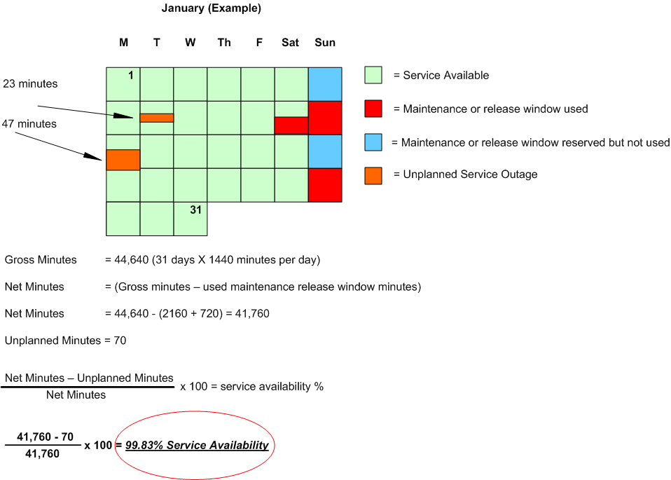

Definitions:

- Gross minutes = total minutes in a month
- Net minutes = gross minutes minus planned outage minutes
- Planned outage minutes = minutes used by ERCOT during the maintenance and release windows
- Unplanned outage minutes = minutes retail transaction processing services were not available that are outside of the planned use of the maintenance and release windows
- Exception outage minutes = minutes outside of the maintenance and release outage windows that have been granted exception from the availability metric (TX Set, etc.)
- Service availability percent = the percent of time that retail transaction processing services were available, not including planned outage minutes

Service Availability Renegotiations and Change Control Process

Renegotiations of these retail transaction processing service availability targets can be initiated by either Market Participants or ERCOT management by making a request to the Retail Market Subcommittee.

Version control in the form of document version numbering will be maintained in this document as a means of providing a change control process.

Service Availability Reporting Process

Retail transaction processing service availability will be tracked and reported to the Retail Market Subcommittee monthly in the form of monthly and year-to-date availability metrics. Service availability will also be presented to the ERCOT Board of Directors from time to time by ERCOT’s Chief Information Officer.

Annual Review Process

ERCOT is committed to providing reliable transaction processing services to Competitive Retailers in Texas. ERCOT intends that the service availability targets described in this document align with Market Participant requirements to the extent operationally feasible. To maintain alignment between the requirements of the Competitive Retailer and retail transaction processing service availability delivered by ERCOT, service availability performance and the availability targets defined in this document will be reviewed at least annually in a workshop during the first quarter of each year.

Version 1.0 – March 23rd, 2006
Version 1.1 – March 28th 2006
Version 1.2 – June 1st, 2006
Version 1.3 – June 15th, 2006

