PROFILE CHANGE REQUEST

Or

Correcting the Misallocation of

Electricity to

Texas Oil and Gas Properties

February, 2003

Presented by

^{LP} 



I. INTRODUCTION

ERCOT Protocols (Sec. 18.2.9) and the Load Profiling Guides (Sec. 12.3) provide a mechanism for market participants to request load profile changes. This request is submitted by:
Pioneer Natural Resources USA, Inc.
Energy Data Source LP
Priority Power Management LLC

The following entities have provided support in the creation of this request:
Texas Commercial Energy LLC
Devon Energy
Apache Corporation
Statex Petroleum
Citation Oil and Gas
Aghorn Operating
Southwest Royalties
Fasken Oil
Schlumberger Resources
Energen
Cambrian Management
Henry Petroleum
Kinder Morgan

The request seeks to cure a substantial inaccuracy in existing load profiles assigned to oil and gas properties. Based on information obtained from the Texas Railroad Commission (attached as RRCSummary.xls), there are an estimated 220,000 active electric accounts for oil and gas properties in Texas with an estimated 180,000 of these in ERCOT. These properties are overwhelmingly free from the peaking tendency of most accounts due to:
Time of day
Day of week
Season of year
Other climatic variables

Seasonal Variation

The aggregate actual usage from January through December of 2002 for approximately 10,000 properties managed by the entities listed above is shown below:

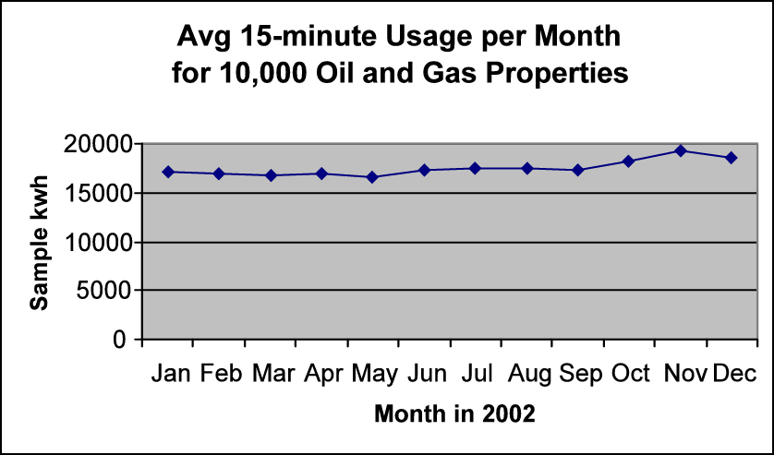

Highlights (below) of an analysis on the aggregate data reveal no seasonal variation, as evidenced by the virtual sameness of the load factors each month:

 | Interval | Interval | Load
 | Max kw | Avg kwh | Factor
Jan | 17731.6 | 17178.77 | 96.88%
Feb | 17777.01 | 16995.49 | 95.60%
Mar | 17649.81 | 16844.71 | 95.44%
Apr | 17730.09 | 16945.71 | 95.58%
May | 17542.89 | 16600.42 | 94.63%
Jun | 18435.68 | 17250.21 | 93.57%
Jul | 18284.12 | 17507.2 | 95.75%
Aug | 18688.47 | 17396.35 | 93.09%
Sep | 18285.63 | 17279.14 | 94.50%
Oct | 19754.5 | 18286.01 | 92.57%
Nov | 20095.88 | 19226.05 | 95.67%
Dec | 19921.49 | 18635.5 | 93.54%
Annual Avg. |  |  | 94.73%

Daily Variation

These same properties over the same period carry a load factor of 95%.
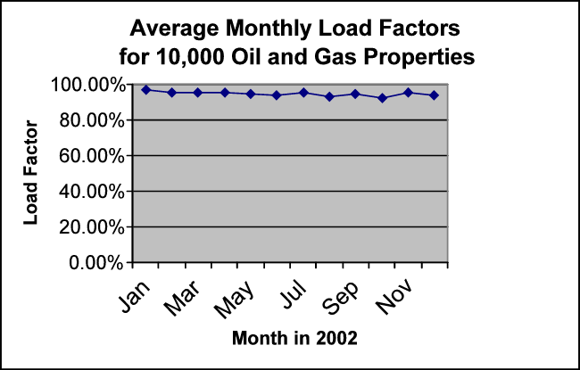

The average daily profile for the sampled oil and gas properties is shown below (see RequestedSample.xls, Graphs tab):
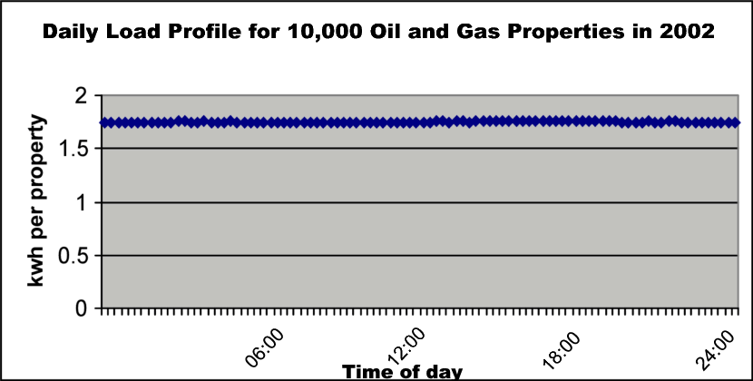

As can be plainly seen, oil and gas properties can only be characterized as having overwhelmingly flat usage.

Yet, as will be demonstrated, the profile assigned to many oil and gas properties significantly deviates from the actual usage shown above. This request urges ERCOT to consider revising load profile assignments for oil and gas properties for the general good of the market and in accordance with ERCOT protocols, with the Load Profiling Guides, and for the following specific reasons:
  - Increases the overall accuracy of the settlement process.
  - Eliminates the unfair penalty assessed to oil and gas producers for peak energy that is, in fact, consumed during off-peak hours.
  - Allows REP’s to reward greater off-peak usage patterns with appropriate pricing.

II. OVERVIEW OF THE INACCURACY

Oil and Gas Data Sample

This request includes interval data from thirteen companies covering approximately 10,000 oil and gas properties from January through December of 2002. The complete set of data is attached in electronic form as RequestedSample.xls. The data was not edited or selected with a profile in mind and, hence, represents a sizable random sampling of oil and gas load. The requestors note the extraordinarily consistent nature of this data and contend that this data is highly representative of the entire population of oil and gas properties in ERCOT. Moreover, because of the consistent flatness exhibited by oil and gas properties of all different sizes, requestors suggest that stratum indicators, weighting factors and other weighting methods are unnecessary when analyzing the oil and gas data sample. See also Section III.4. Homogeneity, below.

According to information obtained from Texas Railroad Commission databases, two-thirds of all oil production in Texas in 2002 came from RRC Districts 8 and 8A. These districts roughly coincide with ERCOT’s FWEST weather zone. (See attached RRCSummary.xls, Maps tab.) The preponderance of the load included in the oil and gas sample comes from meters in this same region.

Data was obtained exclusively from TDSP-owned interval data recorders (IDRs). In most instances, each IDR covered multiple properties, because the cost of an IDR on a single well is usually prohibitive. Indeed, this is one of the main reasons for this profile change request.

As a final note, requestors submit a random sampling of load profile assignments for 631 oil and gas accounts from a participating REP as ProfileAssignmentSample.xls. This data suggests a dispersion of profile assignments as follows:

BUSHI: 21.7% of accounts
BUSMED: 52.1% of accounts
BUSLO: 12.8% of accounts
BUSNODEM: 13.2% of accounts

Existing Profiles Sample

The sample profile data used in these comparisons is attached in electronic form as ProfileSample.xls. This data was obtained from the backcasted load profiles on the ERCOT website for August 2001 through July 2002. This data was then averaged and normalized to create an annual average day for comparison to oil and gas load data. Data for the FWEST weather zone only was used because of the preponderance of oil and gas load in that zone. Requestors are confident that an analysis across more weather zones would yield similar comparisons to the requested oil and gas profile.

Comparison of Oil and Gas Load to Standard Profiles
When the sample oil and gas load data is compared to the standard profiles for BUSLOLF, BUSMEDLF, and BUSNODEM the difference is striking. Clearly, these force-fit profiles are in no way representative of actual oil and gas load. By contrast, the BUSHILF profile bears considerable likeness to the requested oil and gas profile.

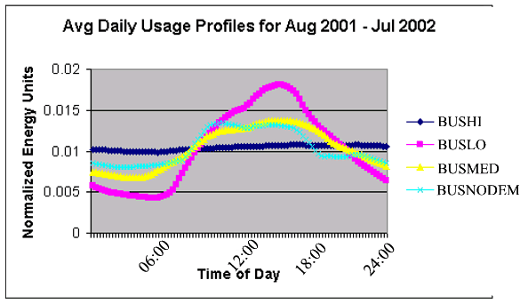
VS.

The requestors feel that this clear and sizable inaccuracy is justification enough for changes to existing load profile assignments.
III. REQUIREMENTS OF ERCOT PROTOCOLS AND LOAD PROFILE GUIDES

Section 12.6 of the Load Profiling Guides states that all requests for a profile change shall include the following:
  - Unambiguous Group Identification
  - Difference from Current Profiles
  - Size
  - Homogeneity

Requestors suggest:

    - Unambiguous Group Identification
The group in question could be defined as follows: All accounts held by entities with official Texas Railroad Commission Operator Number designations that use electricity within the ERCOT system and are exempt from Texas Sales Tax. This would effectively confine the profile change to accounts for oil and gas properties involved in production, gathering, transportation, storage and processing—exactly the properties that exhibit a consistent usage profile.
The requestors suggest two possible methods of identification within ERCOT systems. The first mirrors the identification method recently approved by the Profiling Working Group (PWG) for Direct Load Control (DLC) customers. Essentially, REP’s would communicate to ERCOT the ESI ID’s to be settled with the changed profile. Indeed, several REP’s have suggested their willingness to undertake this effort on behalf of affected customers. Requestors also note that identification of oil and gas properties is significantly less cumbersome, more objectively verifiable, and more unambiguous than identification of DLC customers:
        - Oil and gas properties are a fairly static population. Once an oil and gas property is identified with the proper settlement profile, it is highly unlikely that it will ever change. By contrast, the DLC customer population carries significant variability as customers enter and exit the DLC programs offered.
        - Once identified, an oil and gas property will carry the same settlement profile regardless of REP association. By contrast, every time a DLC customer leaves an REP, its settlement profile will change.
        - Assuring validity of DLC profile designations requires cooperation of the REP and/or onsite inspections of customer premises. Assuring validity of oil and gas profile designations can be aided by information from the Texas Railroad Commission.

The second possible method of identifying oil and gas properties involves data currently in the systems of ERCOT and/or its participating entities, particularly the records of TDSPs and/or REPs. While TDSPs’ records are deteriorating because of a requirement that they exclude customer contact information, records associated with SIC Code 1311 should still be available from many TDSPs that will identify most of the oil and gas properties affected by the requested change. Cross-referencing this data with Texas Railroad Commission records could also help identify the affected set of accounts.

    - Difference from Current Profiles
The profile change for oil and gas properties is requested primarily because it will significantly improve the accuracy of settlement. Considerable summary data in support of this contention is presented in the Introduction to this request, and all detailed data is included in the attachments to this request. Requestors see no point in re-presenting that data here.
Requestors do believe several further points are worth noting:
- The purpose of this request is to improve the accuracy of settlement. Requestors have submitted data covering approximately 10,000 oil and gas properties and have provided evidence (see Size, below) that the entire population of oil and gas properties actively consuming electricity in ERCOT numbers approximately 180,000. Requestors believe that the amount and quality of data presented, covering approximately 5.56% of oil and gas properties, compares favorably to the load sample data used in the initial establishment of profile segments in the March 27, 2000 report titled Load Profiling Methodology.
In particular, as outlined in the table below, sample sizes representing a much smaller segment of the affected population were used to establish comparable commercial profiles at market open.
Utility & Rate Class | Population | Sample | Percentage
Total Comparable Class | 638,172 | 1,511 | 0.24%
TXU Gen Service Secondary | 326,115 | 410 | 0.13%
Reliant Misc. Gen. Svcs. | 191,565 | 732 | 0.38%
TNMP Gen Service | 12,214 | 140 | 1.15%
AEP-WTU Comm. Service TCM | 32,008 | 115 | 0.36%
AEP-CPL General Service | 76,270 | 114 | 0.15%
Requested Oil and Gas Segment | 180,000 | 10,000 | 5.56%

- Requestors site several statistical comparisons between the existing BUSNODEM, BUSHILF, BUSLOLF and BUSMEDLF profiles and the profile suggested by the oil and gas data set. (See data in attached ProfileSample.xls and RequestedSample.xls)
- Average Load Factor. Requestors note that the average annual load factor (see LPG, Appendix C for formula) for the requested oil and gas profile is significantly greater than the load factors for all but the BUSHILF profile.
Profile | Load Factor
BUSLOLF | 39.40%
BUSMEDLF | 68.28%
BUSNODEM | 56.14%
BUSHILF | 91.01%
Requested Oil & Gas Profile | 94.73%

- On-peak/Off-peak Ratio. Requestors also computed the ratio of on-peak to off-peak usage based on the profile sample in ProfileSample.xls and compared it to the on-peak/off-peak ratio for the requested oil and gas profile data. On-peak and off-peak were defined in accordance with the wholesale markets wherein on-peak extends Monday through Friday from 7 a.m. to 10 p.m. while off-peak covers all other times. Results are summarized below:
Profile | Ratio
BUSLOLF | 3.15
BUSMEDLF | 2.35
BUSNODEM | 2.31
BUSHILF | 1.75
Requested Oil & Gas Profile | 1.67

Clearly, all but the BUSHILF profile inaccurately allocate significant usage by oil and gas properties to on-peak periods, thereby imposing a significant and unfair financial burden on oil and gas producers.

- Requestors do note the similarity between 1) the essentially flat profile of the data submitted for oil and gas properties and 2) the BUSHILF_FWEST profile. Indeed, requestors acknowledge the possible wisdom of settling oil and gas properties based on the BUSHILF_FWEST profile. In so doing, requestors reiterate that oil and gas load is essentially unaffected by temperature or climatic factors. Hence, weather zone differences should not apply to oil and gas properties.

    - Size
Based on information obtained from the Texas Railroad Commission, the population of electric accounts covering active oil and gas properties in ERCOT is considered to be approximately 180,000. This is a sizable population that compares favorably with established settlement profiles. For example, there are fewer than 10,000 accounts assigned the IDRREQ profile. While no accounts are yet assigned to the nascent DLC profile, estimates of 5,000 accounts over the next 2-3 years have been suggested by REPs active in DLC. Moreover, the total size of the residential population currently equipped for DLC (all in the CenterPoint service territory) is stated by Comverge as around 70,000. Finally, when one considers the 66 existing profiles (including DLC) and an estimated 6 million accounts in ERCOT, the resultant mean average is only 90,909 accounts per profile. This also compares favorably to the estimated 180,000 oil and gas properties for which a profile change is sought.
Requestors also submit that the average wellhead uses approximately 5000 kwh per month, based on analyses of RequestedSample.xls and a survey of experts on oil and gas electricity usage. Hence, the total load of all oil and gas wellheads is approximately 900,000 MWh per month.
Hence, requestors are confident that both the size of the population and the magnitude of the total load affected by the requested oil and gas profile are sufficient to warrant this request.
    - Homogeneity

Assessments of homogeneity for the requested oil and gas profile are straightforward. Because of the demonstrated flatness of the profile, requestors feel that a detailed analysis of variance and standard deviation would convey little value. Moreover, because requestors have been denied access to detailed load sampling data used in the creation of the existing profiles, comparisons between the requested profile and the existing profiles cannot be offered. Nevertheless, requestors believe they have provided the necessary detail in RequestedSample.xls for reviewers of this request to make such assessments should they choose to do so. Requestors do submit the following further evidence of homogeneity among oil and gas properties:
- For each account in the attached oil and gas sample the standard deviation over all intervals as a percentage of the mean average daily load is 0.4% or less in every case. (See RequestedSample.xls, Interval Data tab, row 35048.)
- Requestors also submit the attached report on electric profiling for Canadian oil and gas properties entitled “Impact of Load Settlement on Oilfield Electric Energy Consumers” (see attached SPPA Oilfield Load Profile Discussion Paper.pdf)*. This report covers 92 oilfield loads on 2 Canadian utilities and notes, “For small oilfield loads, ATCO Electric Limited . . . and Utilicorp Networks Canada . . . have developed rate class load profiles that are flat (nearly the same energy consumption every hour). For large oilfield loads that have interval meters a review of actual year-to-date data shows that their load profiles are also flat.” The report includes two charts which are reproduced below as further testimony to the homogeneous flatness of oil and gas load. (Note: Rate 4400/4500 on Utilicorp is the oil profile.)

*Courtesy of Optimum Energy Management, Inc. 400, 1100 - 8th Ave. S. W. Calgary, Alberta T2P 3T9 Canada.
Requestors do note that the flatness of aggregate oil and gas load is attributable to one main factor: The overwhelming preponderance of automatic timing devices running 24/7/365 turning pumps on and off at regular intervals on oil and gas properties. Indeed, this is a general tenet of reservoir management: Production is maximized by consistent intervals of pumping followed by periods of rest, with the interval lengths generally lasting from 15 minutes to 4 hours. Hence, the resultant electric load from a single oil and gas property is highly consistent, repeatable, and unaffected by time of day, season of year, or other climatic variables.

Requestors acknowledge that electric accounts for oil and gas properties, while often covering many wellheads, sometimes record usage for only a few wellheads or even a single wellhead. Usage by a single wellhead exhibits, in effect, a square-wave profile over the course of a day as a single timer cycles on and off. Usage by a small number of wellheads tends to exhibit a sinusoidal profile over the course of a day, with variability about the mean usage value approaching zero as more wellheads are added. And that is the key because, based on the reality of multi-month contracts, monthly billing cycles, and the de facto real-time aggregation of tens of thousands of oil and gas loads by only a few dozen retail providers at most, the peaks and valleys of individual wellhead timers cancel each other out in the electric power distribution systems. This should be reflected in the actual marketplace. Requestors are confident that they have demonstrated this and so submit this Profile Change Request: The most accurate settlement profile for oil and gas accounts in the ERCOT market is an essentially flat one.

- CONCLUSION

This request presents the case that all oil and gas properties should be settled using an essentially flat profile similar to the BUSHILF_FWEST profile. The market will be served by so doing:
- The overall accuracy of settlement will be improved.
- The unfair penalty assessed to oil and gas accountholders that forces them to pay peak prices for off-peak usage will be eliminated.
- The profile will allow REP’s to reward greater off-peak usage patterns with appropriate pricing in a competitive marketplace.

The request has detailed the considerable differences between the BUSLOLF, BUSMEDLF, and BUSNODEM profiles and actual oil and gas load shapes. The overwhelming consistency of oil and gas usage demonstrated herein, with virtually no discernible variability due to season, time-of-day, or any other factors, is the most compelling reason to implement the request.

All other factors identified in the Load Profiling Guide and ERCOT Protocols also support approval of the request including:
  - The large size of the segment affected.
  - Its highly homogenous nature.
  - The simplicity of unambiguously identifying its members, particularly relative to that methodology already approved for Direct Load Control.

Therefore, the requestors respectfully submit this Profile Change Request and look forward to cooperating in its prompt consideration by ERCOT.

As sited in the Profile Data Evaluation Report downloaded January 2003 from http://www.ercot.com/Participants/loadprofiling.htm.

