

Electric Reliability Council of Texas

Retail Market Transaction Processing
Service Availability

ERCOT

Summary:

A description of the retail transaction processing service availability targets of ERCOT.

Contents

Introduction 3
Document Location 3
Service Scope Definition 3
Retail Transaction Processing Service Availability 4
Retail Transaction Processing Outage vs. Degradation 6
Performance Metrics 6
Service Availability Renegotiations 6
Service Availability Reporting Process 7
Annual Review Process 7

Introduction

This document is a description of the service availability targets and operating hours for retail transaction processing services provided by ERCOT for the Texas competitive retail electric market.

These availability targets are intended to build upon the requirements as outlined in ERCOT Protocol Section 15 and provide additional guidance to competitive retailers and transmission/distribution service providers regarding retail transaction processing service availability. In all cases the ERCOT Protocols will be the ultimate authority.

Document Location

This document will be posted to and maintained in the market services section of the ERCOT.com website. It is not the intent of this document to request or initiate changes to the ERCOT Retail Market Guide or ERCOT Protocols.

Service Scope Definition

“Retail Market Transaction Processing Services” is the end-to-end availability of successful retail transaction flow between ERCOT and retail market participants and includes the following components:

- NAESB Proxy Servers
- NAESB
- TCH
- Electronic Data Interchange (EDI) - Paperfree
- Enterprise Application Integration (EAI)
- Customer Registration Database - Siebel
- ERCOT maintained infrastructure that supports retail service availability

Excluded from the service availability calculation are the following systems that communicate with, but are not a primary component of, retail market transaction processing services:

- Enterprise Data Warehouse (EDW)
- Settlements & Billing Services (Lodestar)
- Web Services (TML, RMC, FasTrak, ERCOT.com, etc…)

Retail Transaction Processing Service Availability

Service Availability:

ERCOT targets retail transaction processing services to be available at least 99.25% of the time outside of scheduled maintenance and release outage windows. ERCOT reserves the following times as maintenance and release windows:

Maintenance Windows:

- 1st, 3rd, and 4th Sunday of each month – 8:00am until 8:00pm (12 hours)

Release Window:

- 2nd weekend of each month – 12:00pm Saturday until 12:00am Monday (36 hours)

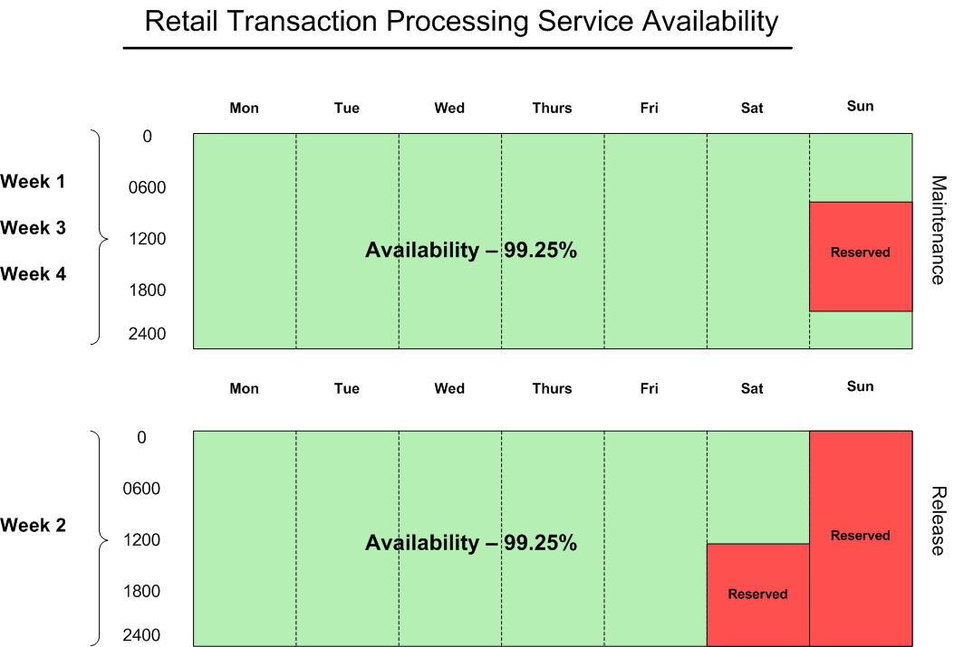

Availability Breakdown (Non-Leap Year):

Gross minutes per year = 525,600

Reserved maintenance outage minutes per year = 25,920

Reserved release outage minutes per year = 25,920

525,600 – 51,840 = 473,760 net availability minutes per year

99.25% availability = 3,553.2 unplanned outage minutes per year, or 59.22 hours

Availability Breakdown (Leap Year):

Gross minutes per year = 527,040

Reserved maintenance outage minutes per year = 25,920

Reserved release outage minutes per year = 25,920

527,040 – 51,840 = 475,200 net availability minutes per year

99.25% availability = 3,564 unplanned outage minutes per year, or 59.4 hours

Exceptions:

Outages that are excluded from the availability metric and do not count as unplanned outage time include any market wide releases that require market participants and ERCOT to coordinate system outages for major upgrades, such as TX Set implementations. ERCOT will continue to coordinate such market wide releases and set outage expectations unique to each release.

Retail Market System Outage Notifications:

The maintenance windows during the 1st, 3rd and 4th weekends of each month and the release window reserved on the 2nd weekend of each month are the times that ERCOT reserves to perform system maintenance and implement releases.

ERCOT will continue to notify market participants when it intends to utilize the maintenance and release outage windows to perform system maintenance or implement changes. This planned outage time will not count as unplanned outage time in the service availability metric.

Retail Transaction Processing Outage vs. Degradation

A degradation of transaction processing time will not automatically qualify as an unplanned outage.

Performance Metrics

Retail transaction processing service availability will be measured as a percentage of minutes that the service is available compared to the total amount of minutes excluding maintenance outage window time.

Definitions:

- Gross minutes = total minutes in a month
- Net minutes = gross minutes minus planned outage minutes
- Planned outage minutes = minutes used by ERCOT during the release and maintenance windows on a monthly basis
- Unplanned outage minutes = minutes that retail transaction processing services were not available that are outside of the release and maintenance windows
- Exception outage minutes = minutes outside of the maintenance and release outage windows that have been granted exception from the availability metric (TX Set, etc…)
- Service availability % = % of time that retail transaction processing services were available not including planned outage minutes

For example:



Service Availability Renegotiations

These retail transaction processing service availability targets can be renegotiated at the request of the Retail Market Subcommittee or ERCOT management if considered necessary due to retail market changes or ERCOT changes.

Service Availability Reporting Process

Retail transaction processing service availability will be tracked and reported to the Retail Market Subcommittee monthly in the form of monthly and year to date availability metrics. Service availability will also be presented to the ERCOT Board of Directors from time to time by ERCOT’s Chief Information Officer.

Annual Review Process

ERCOT is committed to providing reliable transaction processing services to the competitive retail provider market in Texas. It is intended that the service availability targets described in this document align with market requirements to the extent operationally feasible. To maintain alignment between the requirements of the competitive retail provider market and retail transaction processing service availability delivered by ERCOT, service availability performance and the availability targets defined in this document will be reviewed at least annually in a workshop setting during the first quarter of each year.

Version 1.0 – March 23rd, 2006

