The purpose of this document is to store the Diagrams (Appendices) referenced in the NMMS Requirements document so that the NMMS Requirements document’s file size is smaller.
PR50142 NMMS Network Model Management System Requirements Appendix
Document Revisions
Version | Date | Contributors | Comments
1.2a | 2/20/06 |  | Original draft of this document
1.3 | 3/1/06 |  | Updated references based on TPTF comments. No changes made to the diagrams.

®
TABLE OF CONTENTS

1 REQUIREMENTS FOR AN ENHANCED MODEL UPDATE PROCESS 3
1.1 Data Submittal Process 4
1.2 Project Build and Test Process 5
1.3 Model Database 7
1.4 Update Network Operations Model Process 8
1.5 Update Network Model Applicable to Day Ahead Build Process 9
1.6 Internal Data Editor and Comparison Tool 10
1.7 Application Software Data Process 11
1.8 Timeline Database Process 12
1.9 Study Case Builder Process 14
1.10 CRR Auction Case Builder Process 15
1.11 Planning Case Builder Process 16
1.12 Posting and Notification Capabilities 17

TABLE OF APPENDICES

Appendix 1: Conceptual Overview of Model Database and General Models Generation Process 3
Appendix 2: Data Submittal Process 4
Appendix 3: Project Build and Test Process 5
Appendix 4: Transition from Planning Project to Operations Project 6
Appendix 5: Model Database 7
Appendix 6: Update Network Operations Model Process 8
Appendix 7: Update Network Model Applicable to Day Ahead Build Process 9
Appendix 8: Internal Data Editor and Comparison Tool 10
Appendix 9: Application Software Data Process 11
Appendix 10: Timeline Database Process 12
Appendix 11: Posted Timeline Database 13
Appendix 12: Study Case Builder Process 14
Appendix 13: CRR Auction Case Builder Process 15
Appendix 14: Planning Case Builder Process 16
Appendix 15: Posting and Notification Capabilities 17

REQUIREMENTS FOR AN ENHANCED MODEL UPDATE PROCESS

Appendix 1: Conceptual Overview of Model Database and General Models Generation Process

Data Submittal Process

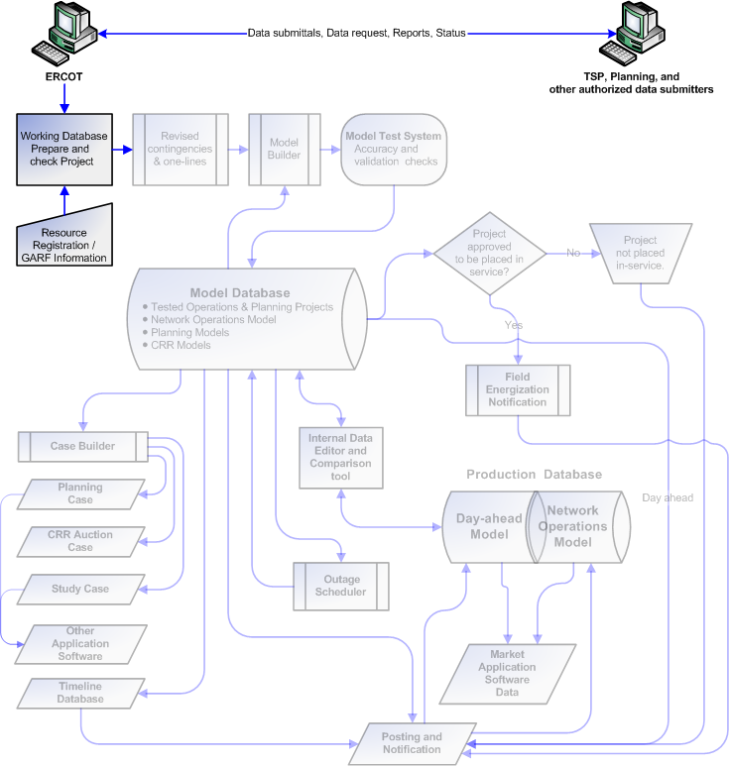
Appendix 2: Data Submittal Process

Project Build and Test Process

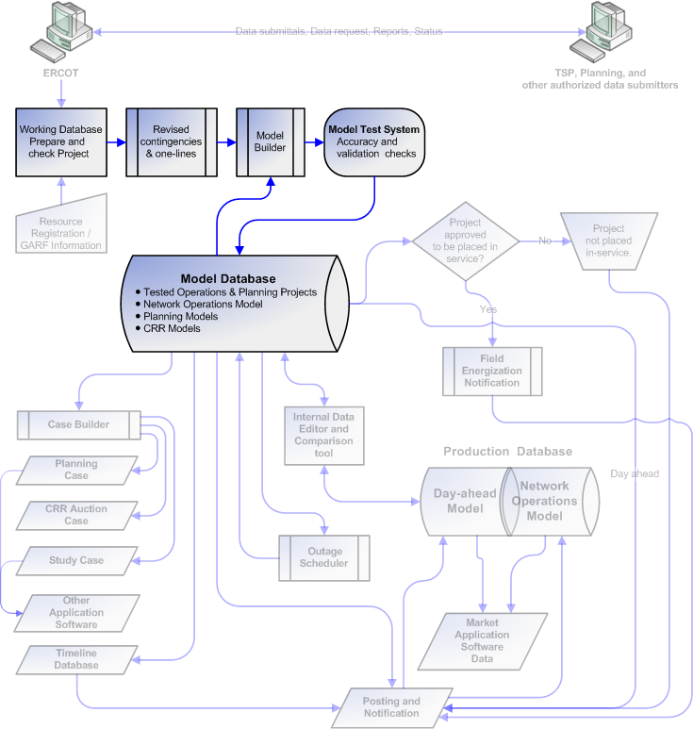
Appendix 3: Project Build and Test Process

Appendix 4: Transition from Planning Project to Operations Project

Model Database

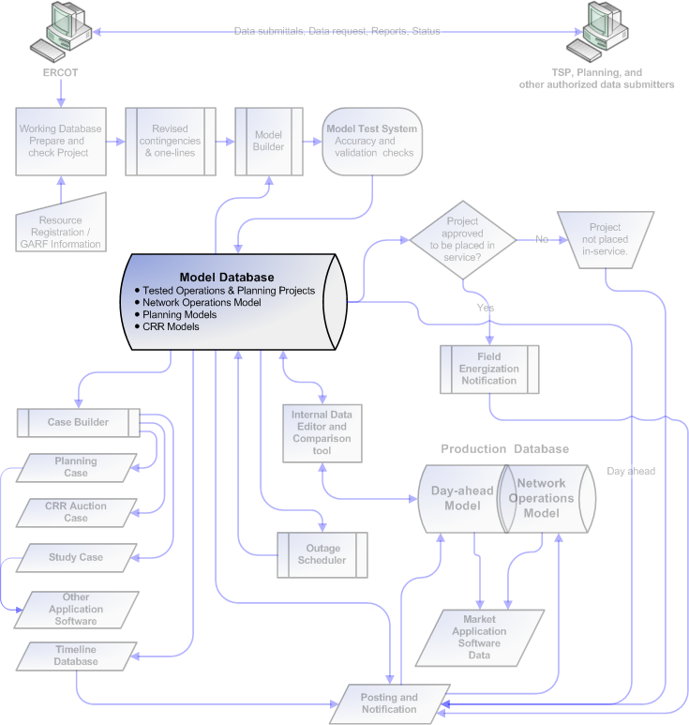
Appendix 5: Model Database

Update Network Operations Model Process

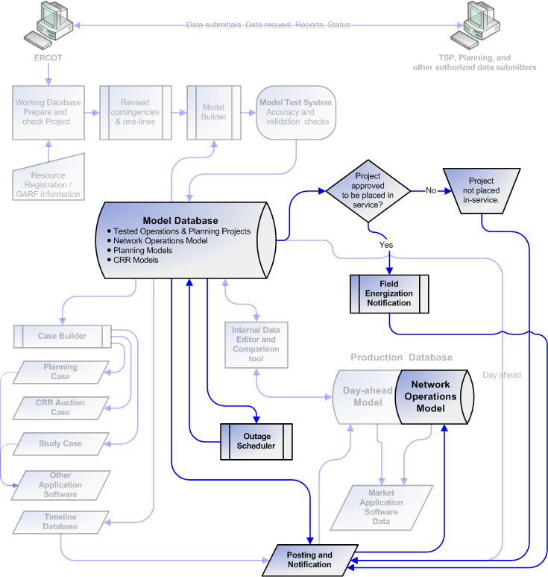
Appendix 6: Update Network Operations Model Process

Update Network Model Applicable to Day Ahead Build Process

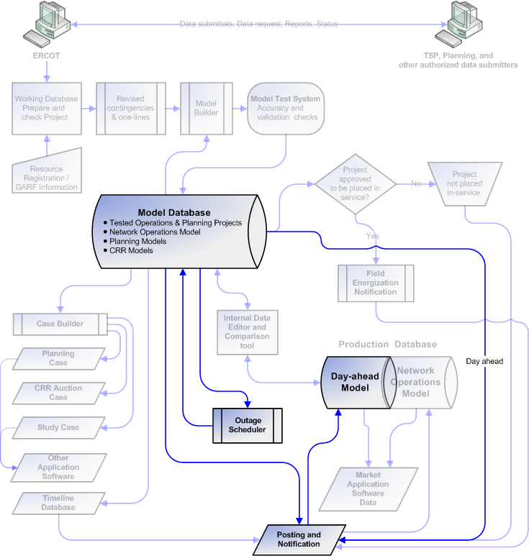
Appendix 7: Update Network Model Applicable to Day Ahead Build Process

Internal Data Editor and Comparison Tool

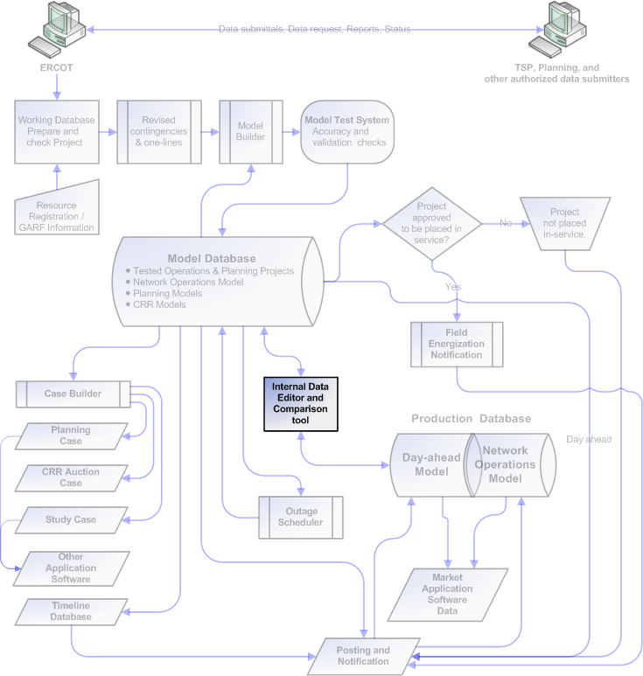
Appendix 8: Internal Data Editor and Comparison Tool

Application Software Data Process

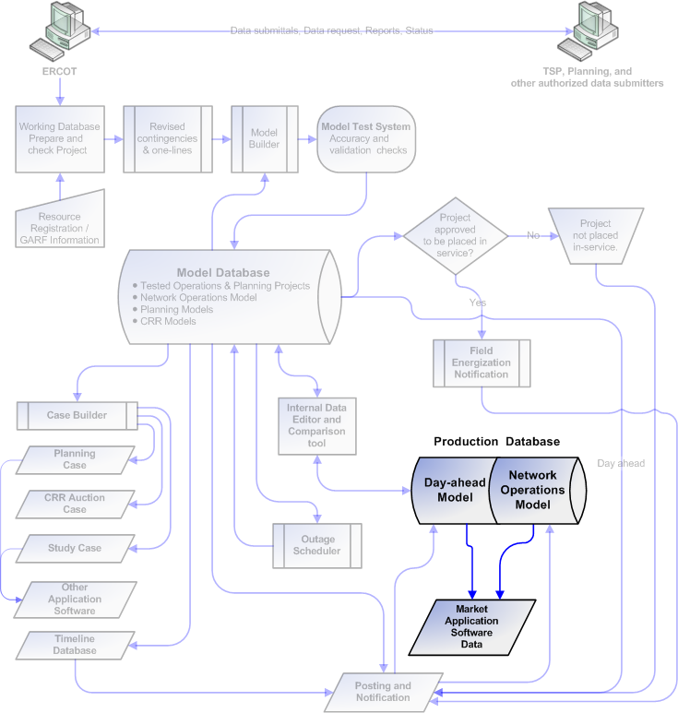
Appendix 9: Application Software Data Process

Timeline Database Process

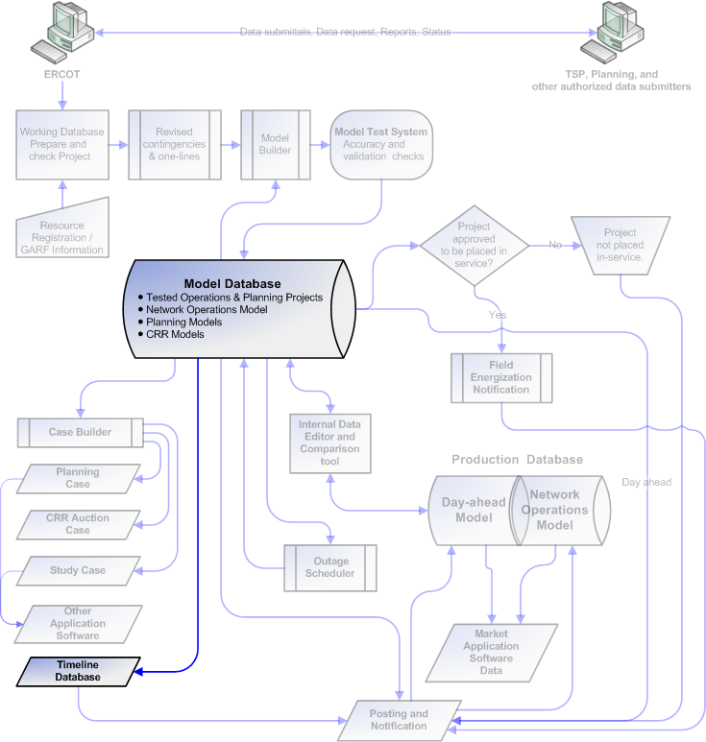
Appendix 10: Timeline Database Process
Appendix 11: Posted Timeline Database

Study Case Builder Process

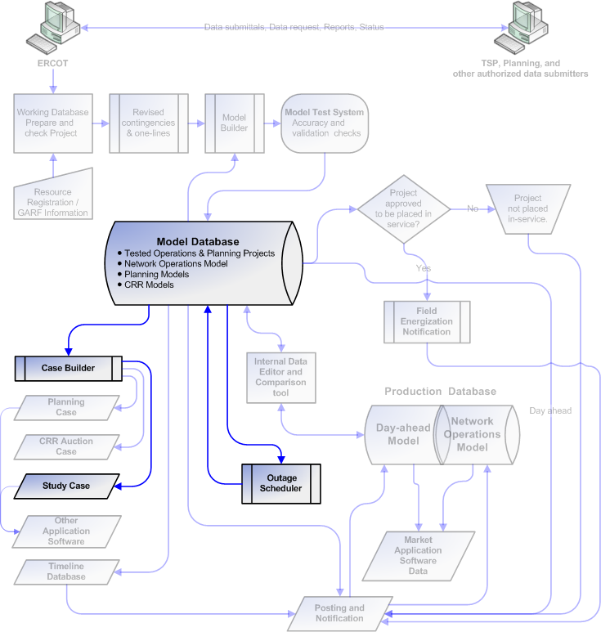
Appendix 12: Study Case Builder Process

CRR Auction Case Builder Process

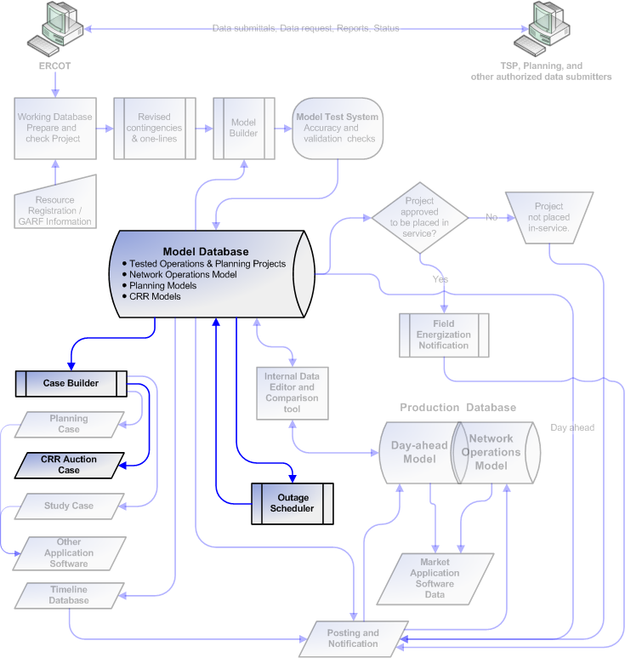
Appendix 13: CRR Auction Case Builder Process

Planning Case Builder Process

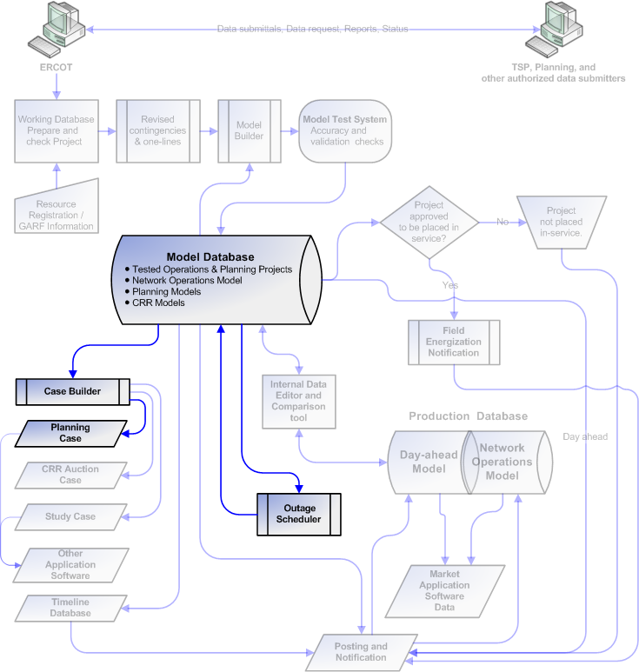
Appendix 14: Planning Case Builder Process

Posting and Notification Capabilities

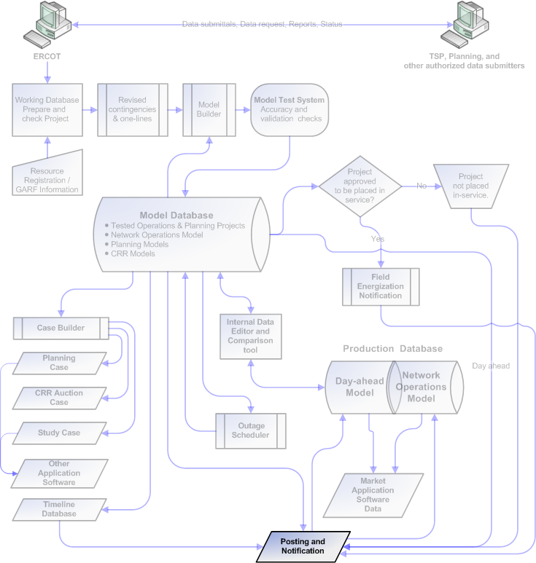
Appendix 15: Posting and Notification Capabilities

