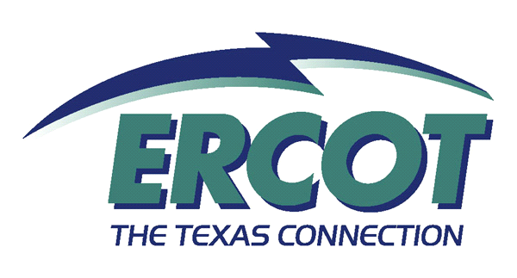

Texas Nodal Market (TNM 100)

Introduction:
This two day course is open for all ERCOT employees, Market Participants, and interested parties. It provides an introduction to the core Nodal concepts (LMP, Prince Transparency) and how they will be implemented in Texas (Day Ahead, Real-Time, Reliability Unit Commitment (RUC), and Congestion Revenue Rights (CRR). It assumes familiarity with the Texas market as it exists today.

Objectives:
After completing this course, you will be able to:
- Describe the primary differences between a zonal and nodal market
- Describe how the nodal market will be implemented in Texas
- Demonstrate the ability to calculate a simple LMP
- Define the Day Ahead Market, Real Time Operations, Reliability Unit Commitment, and Congestion Revenue Rights and their role in the Texas Nodal Market

Competencies Required:
None.

Prerequisites:
None. Note: Class assumes familiarity with the existing Texas Market.

Related Curriculum:
TBD

Nodal Requirements:

Intended Audiences | Knowledge Requirement | Readiness Assessment Method
ERCOT Employees | Mandatory | Quiz at end of class
Market Participants | Mandatory | Quiz at end of class

Offerings:

Delivery Options | Class Size Limitations
Instructor-led | 50

