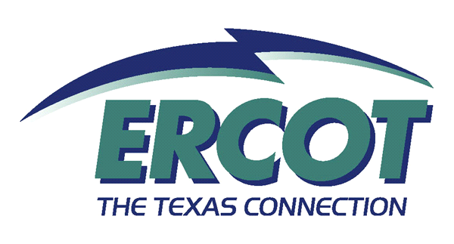

Nodal Modeling (NM 100)

Introduction:
This two day course is open for all ERCOT employees, Market Participants, and interested parties. It provides an introduction to the four Nodal models (Annual Planning, Congestion Revenue Rights, Network Operations Model, Operator Training Simulator), and their purpose in the Texas Nodal Market. It assumes basic knowledge of modeling, model function, outage scheduling, and Locational Marginal Pricing.

Objectives:
After completing this course, you will be able to:

- Describe the purpose of the Models in the Nodal Market:
- Annual Planning
- Congestion Revenue Rights Network
- Network Operations Model
- Operator Training Simulator
- Describe the roles of Market Participant
- Describe management of the Model data streams (submittals, update, timeline)
- Describe the inputs and outputs of the Models
- Distinguish a case versus a model
- Define the applications that will use the Models (i.e., Outage Scheduler, State Estimator, Contingency Analysis, Voltage Studies, RMR Studies, Black Start Studies, etc.)
- Describe the relationships between the Models (i.e., naming convention)
- Describe how the Models will impact the Nodal Market (consequences when models are not updated correctly)
- Define the elements of the Models (lines, breakers, substations, generators, electrical bus)

Competencies Required:
None.

Prerequisites:
TNM 100

Related Curriculum:
TBD

Nodal Requirements:

Intended Audiences | Knowledge Requirement | Readiness Assessment Method
ERCOT Employees | Mandatory | Quiz at end of class
Market Participants | Mandatory | Quiz at end of class

Offerings:

Delivery Options | Class Size Limitations
Instructor-led | 50

