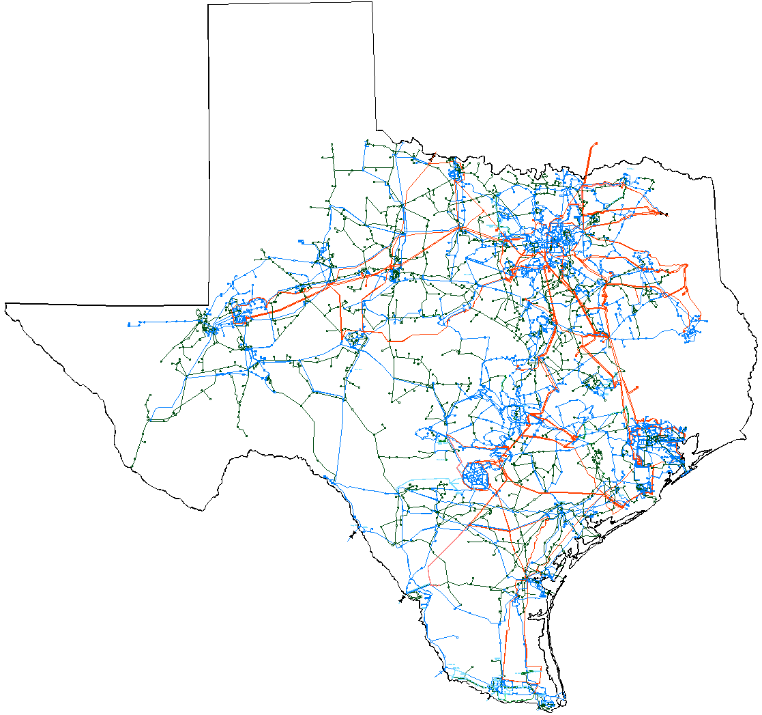

System Planning Division
February 2006 Report
To
Technical Advisory Committee
Reliability and Operations Subcommittee
Status of active generation interconnection requests Additional detailed generation interconnection information and impact studies is contained in the “Generation Project Interconnection Information” data folder posted in the “Operations and System Planning” data area on the internet. See links at end of this document for address.
GENERATION INTERCONNECTION PUBLIC PROJECTS
INR # | SiteName | Status | County | Region | Fuel | In Service Date | MW into Grid | Notes
04INR0020 | WKN Wind 1 Snyder | Interconnect Agreement | Scurry | West | Wind | Dec-05 | 60 | Redoing the stability study.
06INR0008 | Big Spring Carbon Plant | Interconnect Agreement | Howard | West | Waste heat | Apr-06 | 12
06INR0017 | Limestone Upgrade | Interconnect Agreement | Limestone | North | Coal | May-06 | 110
05INR0017 | Post Wind Farm 1 | Interconnect Agreement | Borden | West | Wind | Jun-06 | 84
05INR0018 | Horse Hollow 2 | Interconnect Agreement | Taylor | West | Wind | Jun-06 | 127 | Second of two phases
06INR0016 | Dow 9 | Interconnect Agreement | Brazoria | South | Gas | Oct-06 | 0
05INR0011 | Forest Creek | Interconnect Agreement | Sterling | West | Wind | Dec-06 | 215
04INR0011 | Mesquite Wind Farm 1 | Interconnect Agreement | Shackelford | West | Wind | Dec-06 | 200
04INR0015 | Buffalo Gap 2 | Interconnect Agreement | Taylor | West | Wind | Mar-07 | 120 | Second of two phases
03INR0034 | Silver Star Project | Interconnect Agreement | Erath | West | Wind | Mar-07 | 60
05INR0015 | Gulf Wind | Public Letter | Kenedy | South | Wind | Sep-07 | 1,200 | In four phases, 300 MW in 2007, 2008,2009,2010
01INR0028 | Orion Delaware Mountain Wind Farm | Interconnect Agreement | Culberson | West | Wind | Dec-07 | 175
06INR0006 | Cobisa-Greenville | Public Letter | Hunt | North | Gas | May-08 | 1,750
09INR0006 | Oak Grove | Public Letter | Robertson | North | Coal | Mar-09 | 1,660
09INR0001 | Sandy Creek | Public Letter | McLennan | North | Coal | Jul-09 | 800
09INR0002 | J K Spruce 2 | Interconnect Agreement | Bexar | South | Coal | Aug-09 | 750
10INR0002 | Hugo Plant | Public Letter | Choctaw, OK | North | Coal | Dec-10 | 500
11INR0001 | Twin Oaks 3 | Public Letter | Robertson | North | Coal | Jun-11 | 630
 |  |  |  |  | Totals |  | 8,994
PROJECTS INTO COMMERCIAL OPERATION IN JANUARY
INR | Site Name | County | Region | Fuel | In Service | MW for Grid
01INR0036 | Sweetwater Wind 3 | Nolan | West | Wind | Dec-05 | 136
05INR0010 | Jack County Generation Facility | Jack | North | Gas | Jan-06 | 620

ACTIVE GENERATION INTERCONNECTION REQUESTS BEING PROCESSED
Currently tracking 66 active generation interconnection or change requests
 |  | North | South | West | Total
Security Screening Study |  | 1 | 1 | 13 | 15
SSS Completed |  | 1 | 3 | 3 | 7
Full Interconnect Study |  | 8 | 6 | 19 | 33
FIS Completed |  | 0 | 0 | 0 | 0
Interconnect Agreement Completed (Includes public letters) |  | 7 | 3 | 8 | 18
Capacity for Grid, MW |  | 6,105 | 5,217 | 7,381 | 18,703
Wind MW (under development) |  | 180 | 2,130 | 6,627 | 8,937

Fuel | Public | Non-Public | Total
Coal | 4,450 | 209 | 4,659
Natural gas | 1,750 | 2,920 | 4,670
Other | 12 | 425 | 437
Wind | 2,241 | 6,696 | 8,937
Total | 8,453 | 10,250 | 18,703

Generation Currently Under RMR Contract in ERCOT (as of 01/31/06)
Unit | Capacity (Net) | RMR Contract Status | Contract Date | Current Anticipated Exit Date | Change Since Last Report
BM Davis 1 | 335 | Under Contract | 1/1/06-12/31/06 | 3Q 2006 | Contracted for Davis #1 unit in 2006.
JL Bates 1 & 2 |  |  |  |  | No contract for 2006
La Palma 5, 6, &7 | 222 | Under Contract | 1/1/06-12/31/06 | 1Q 2006 | contract for Unit 4 not renewed for 2006 but renewed for Units 5,6, and 7.
Laredo 1, 2, & 3 | 172 | Under Contract | 1/1/06-12/31/06 | 3Q 2010 | Contract renewed for 2006.
Atkins 3, 4, 5, 6 |  |  |  | 3Q 2006 | Will pursue RMR for Units 4, 5, and/or 6 starting in June 2006.
Total MW Under RMR Contract as of January 1, 2006: | 729

Studies underway or planned within System Planning Division
- Initiated Regional Planning Review of AEPTCC/MEC Western Region project submitted on January 10th, 2006. Project affects the Uvalde area and is estimated to cost over $156 million. Stakeholder review period ended on February 9th, 2006.
- Work continues on initial phase of the ERCOT and Entergy-TX Integration study
- Preliminary results of the Pre-Nodal Study requested by PUCT Chairman Hudson were reviewed at a combined RPG meeting on 1/19. No long-lead-time projects (in addition to those which have already received ERCOT recommendations) were identified as needed as a result of the study. 34 short-term projects were identified as potentially needed for reliability and to reduce congestion across ERCOT. Additional analysis to resolve stakeholder issues and develop timing for projects continues. Preliminary results were shared with the PUCT, but no formal filing will be made. Final project recommendations will not be made until the additional analysis is complete.
- In preparation for the 5-year study (the follow-up to the pre-nodal study work), a comparison of future SSWG cases is underway. The goal is to catalog what is added to the cases each year and compare that with what is presented to the RPG and what is represented in TPIT. A scope document for the 5-yr study is under development.
- An RPG meeting was held on 1/20 to discuss the framework for the Long-Term System Study mandated by SB20 and to gather input on potential Competitive Renewable Energy Zones. Have subsequently met with several wind developers, PUCT staff and other stakeholders to discuss identification of potential CREZs.
- The RFP for development of wind profiles needed for the SB 20 studies is being finalized
- Consultant has begun work on updated LOLP study
- TPIT February case updates
  - Updates have been received from all transmission owners
  - Data is being complied and checked
  - Expected release date is March 1
- Provided support to NMMS project scope and requirements
- Prepared Transmission mileage report for compliance
- Provided input to the development and clarification to the Nodal Protocol review team
- Net Dependable Capability Testing Data - ERCOT staff efforts are ongoing to determine the fidelity of and best practices in planning for the generator data that is sent to ERCOT compliance. Plan to coordinate update of compliance data for upcoming base cases with the filing requirements
- Supporting TAC ROS Dynamics WG started the dynamic case flat start for base case 2006 summer on-peak
- Transmission Services staff to developed and provided updated LaaR dynamic data/models
- Load stability modeling project - Phase II (EPRI Solutions) is underway
- EPRI Scope of Work document complete and contract complete
- ROS and TAC endorsed/supports this effort. ROS encouraged transmission owners to get involved in the project.
- TXU willing to “host” load monitoring locations in support of ERCOT’s participation in the project.
- Utility Wind Integration Group (UWIG) wind farm stability modeling effort – underway supporting user group efforts. ERCOT proposed development of wind models for TSAT in addition to PSSe and other simulation tools.

Studies completed by System Planning Division
- Seasonal Transmission Loss Factor calculation and posting completed
- March 2006 TCR calculation/determination completed
- Developing the Long-Term forecast
  - Completed updating historical load, weather and economic data to include the last four months of 2005 (September through December).
  - Completed testing of the forecasting models using updated historical data from January 1, 2002 through December 31, 2005.
- Completed a final pass on the fine-tuning and estimation of the coefficients in the weather zone forecasting model equations that will be used to produce the 2006 long-term hourly weather zone forecasts.

Upcoming Events
- NERC 2006 Summer Assessment preparation (due March 13)
- DOE/NERC 2006 EIA-411 (due April 1)
- FERC 714 Report (due June 1)
- NERC PC meeting March 15-16
- NERC OC TS meeting Feb 16-17
- NERC PC TIS MMWG meeting April
- NERC PC RIS meeting March 16-17
- Syncrophasor demonstration scheduled for February 21 in Austin
- Operator training seminar ( March and April)
- Seimens/PTI User group meetings April 24-25
- Various TPTF meetings, sub-meetings, and working group meetings.

Other Ongoing Work
- Enhance dynamic data models. Mitsubishi wind machine models are being requested.
- Enhance fidelity of contingency files and testing. Cascade contingency program developed by staff.
- Enhance fidelity of planning base cases to better match real-time operating environment
- Enhance generation data gathering efforts and model improvements
- Load modeling improvements and improvements to base case modeling
- Technical support to diverse ERCOT groups in power system dynamics issues
- Update all maps (for 2006) on secured area of website including bus numbers

Other Issues
- Significant number of new generation interconnection requests are being received and processed. Screening study response back to requestors will take 45 to 90 days. Others are going forward to full interconnection studies with transmission owners.

Reminders to TDSPs/TOs
- Annual Load Data Requests (ALDRs) are due to ERCOT March 1 from TDSP’s.
- Submit and maintain up to date outage scheduler submissions

