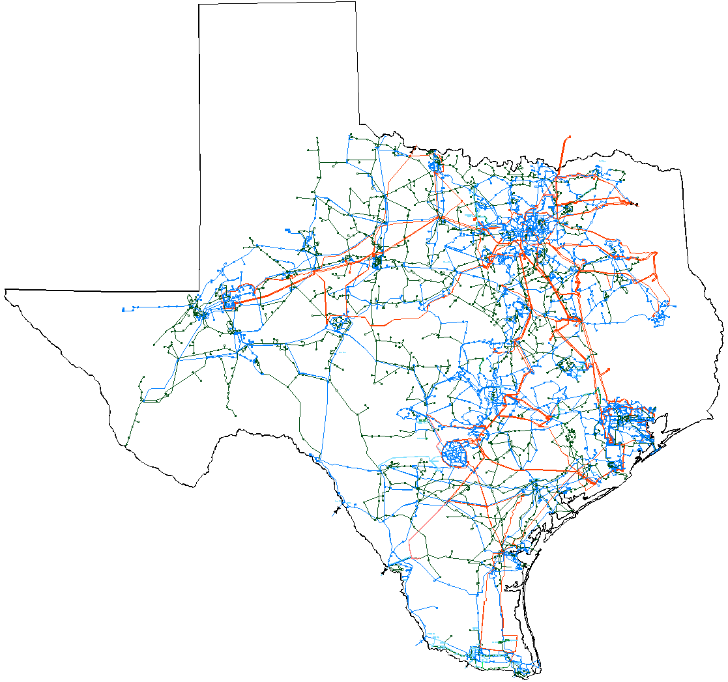

System Planning Division
January 2006 Report
To
Technical Advisory Committee
Reliability and Operations Subcommittee

Status of active generation interconnection requests Additional detailed generation interconnection information and impact studies is contained in the “Generation Project Interconnection Information” data folder posted in the “Operations and System Planning” data area on the internet. See links at end of this document for address.
GENERATION INTERCONNECTION PUBLIC PROJECTS
INR # | SiteName | Status | County | Region | Fuel | In Service Date | MW into Grid | Notes
04INR0020 | WKN Wind 1 Snyder | Interconnect Agreement | Scurry | West | Wind | Dec-05 | 60
01INR0036 | Sweetwater Wind 3 | Interconnect Agreement | Nolan | West | Wind | Dec-05 | 136
05INR0010 | Jack County Generation Facility | Interconnect Agreement | Jack | North | Gas | Jan-06 | 620 | testing 6/1/05, commercial 12/1/05
06INR0008 | Big Spring Carbon Plant | Interconnect Agreement | Howard | West | Waste heat | Apr-06 | 12
06INR0017 | Limestone Upgrade | Interconnect Agreement | Limestone | North | Coal | May-06 | 110
05INR0017 | Post Wind Farm 1 | Interconnect Agreement | Borden | West | Wind | Jun-06 | 84
05INR0018 | Horse Hollow 2 | Interconnect Agreement | Taylor | West | Wind | Jun-06 | 127 | Second of two phases
06INR0016 | Dow 9 | Interconnect Agreement | Brazoria | South | Gas | Oct-06 | 0
04INR0011 | Mesquite Wind Farm 1 | Interconnect Agreement | Shackelford | West | Wind | Dec-06 | 200
04INR0015 | Buffalo Gap 2 | Interconnect Agreement | Taylor | West | Wind | Mar-07 | 120 | Second of two phases
03INR0034 | Silver Star Project | Interconnect Agreement | Erath | West | Wind | Mar-07 | 60
05INR0015 | Gulf Wind | Public Letter | Kenedy | South | Wind | Sep-07 | 1,200 | In four phases, 300 MW in 2007, 2008,2009,2010
01INR0028 | Orion Delaware Mountain Wind Farm | Interconnect Agreement | Culberson | West | Wind | Dec-07 | 175
06INR0006 | Cobisa-Greenville | Public Letter | Hunt | North | Gas | May-08 | 1,750
09INR0006 | Oak Grove | Public Letter | Robertson | North | Coal | Mar-09 | 1,660
09INR0001 | Sandy Creek | Public Letter | McLennan | North | Coal | Jul-09 | 800
09INR0002 | J K Spruce 2 | Interconnect Agreement | Bexar | South | Coal | Aug-09 | 750
10INR0002 | Hugo Plant | Public Letter | Choctaw, OK | North | Coal | Dec-10 | 500
11INR0001 | Twin Oaks 3 | Public Letter | Robertson | North | Coal | Jun-11 | 630
 |  |  |  |  | Totals |  | 8,994
PROJECTS INTO OPERATION
INR | Site Name | County | Region | Fuel | In Service | MW for Grid

ACTIVE GENERATION INTERCONNECTION REQUESTS BEING PROCESSED
 |  | North | South | West | Total
Security Screening Study |  | 2 | 2 | 5 | 9
SSS Completed |  | 0 | 1 | 2 | 3
Full Interconnect Study |  | 7 | 6 | 17 | 30
FIS Completed |  | 0 | 0 | 0 | 0
Interconnect Agreement Completed (Includes public letters) |  | 8 | 3 | 9 | 19
Capacity for Grid, MW |  | 6,395 | 5,200 | 4,920 | 16,515
Wind MW (under development) |  | 180 | 2,130 | 3,733 | 6,043

Generation Currently Under RMR Contract in ERCOT (as of 12/31/05)
Unit | Capacity (Net) | RMR Contract Status | Contract Date | Current Anticipated Exit Date | Change Since Last Report
BM Davis 1 | 335 | Under Contract | 1/1/06-12/31/06 | 3Q 2006  under review | Contracted for Davis #1 unit in 2006.
JL Bates 1 & 2 |  |  |  |  | No contract for 2006
La Palma 5, 6, &7 | 222 | Under Contract | 1/1/06-12/31/06 | 1Q 2006  under review | contract for Unit 4 not renewed for 2006 but renewed for Units 5,6, and 7.
Laredo 1, 2, & 3 | 172 | Under Contract | 1/1/06-12/31/06 | 3Q 2010  under review | Contract renewed for 2006.
Atkins 3, 4, 5, 6 |  |  |  |  | Will pursue RMR for Units 4, 5, and/or 6 starting in June 2006.
Total MW Under RMR Contract as of January 1, 2006: | 729

Studies underway or planned within System Planning Division
- Pre-Nodal Transmission Improvements study is nearing completion. Some preliminary results were posted on January 4 and more will be posted this week. RPG meeting on this topic scheduled for January 19.
- Long-Term Transmission Study and analysis related to the determination of competitive renewable energy zones will kickoff with an RPG meeting on January 20.
- ROS Dynamics WG started the dynamic case flat start for base case 2006 summer on-peak. Transmission Services staff will provide support for this effort.
- Transmission Services staff to provide updated LaaR data/models by February 15, 2006
- Load stability modeling project - Phase II (EPRI Solutions) is starting.
- Scope of Work document received from EPRI.
- ROS and TAC endorsed/supports this effort. ROS encouraged transmission owners to get involved in the project.
- TXU ED has indicated they are willing to “host” load monitoring locations in support of ERCOT’s participation in the project.
- Review of Parkway SPS is ongoing
- Transient Voltage Recovery “How-To” procedural manual is under development. It will contain practical steps to perform contingency analysis, QV, PV and Voltage recovery studies using simulation software. Current manual under review.
- Utility Wind Integration Group (UWIG) wind farm stability modeling effort – underway supporting user group efforts. ERCOT proposed development of wind models for PTL TSAT in addition to PTI PSSe and other simulation tools.
- Net Dependable Capability Testing Data - ERCOT staff efforts are ongoing to determine the fidelity of and best practices in planning for the generator data that is sent to ERCOT compliance
- Examination of how to incorporate biennial unit reactive test data into the Steady State WG base cases for more accurate modeling
- Seasonal Transmission Loss Factor work was performed again after an error in the cases was found and is expected to be complete by the January 28th deadline
- LOLP Study contract has been finalized and work will begin shortly.
- Transmission Congestion Rights (TCR) March 2006 determination underway
- Development/Review/Determination of Nodal Procedures/Interpretations as related to CRR auction/model determination underway
- Seasonal Transmission Loss Factor work continues and is expected to be complete by the January 28th deadline
- Transmission Project Information Tracking (TPIT) February updates work is underway and expected to be completed and posted March 1
- Determined CSC zones for new substations and inform Data Aggregation for the settlement process
- Long-Term demand forecasting
  - Completed tasks:
    - Finished re-vamping preliminary model equations used in the weather zone forecast.
    - Developed a preliminary system-level weather normalization model.
  - On-going basis:
    - Updating historical load, weather and economic data.
    - Re-forecasting using updated historical data.
    - Providing monthly updates to weekly peak year ahead demand forecast by ERCOT total and congestion zone http://www.ercot.com/gridinfo/load/demand_forecast/
- SSWG manual review
- Support of NERC activities including development of blackout recommendations and standards development
- Other ongoing work
- Enhance dynamic data models
- Enhance fidelity of contingency files and testing
- Enhance fidelity of planning base cases to better match real-time operating environment
- Enhance generation data gathering efforts and model improvements
- Load modeling improvements and improvements to base case modeling
- Technical support to diverse ERCOT groups in power system dynamics issues

Studies completed by System Planning Division
- Completed and implemented reorganization of division
- Parker Maxwell Creek Project (TXU ED) North Region Planning Group review and approval
- ROS Dynamics WG selected the August 19, 2004 Forney plant trip event for simulation (in response to NERC recommendations to simulate an actual event to test dynamic models). Transmission Services staff completed assignments related to the study. Final report submitted to ROS by DWG.
- ROS Dynamics WG review and updated the DWG Procedural Manual. Transmission Services staff actively participated in the review process. Final manual submitted to ROS by DWG for approval.
- Voltage stability review of the Houston region, 2007 summer on-peak, with and without the Hillje 345 kV lines in service. Report submitted to PUCT as part of certification process

Upcoming Events
- January 19 - Combined RPG meeting on Pre-Nodal Study and other topics
- January 20 – Combined RPG meeting on Long-Term Transmission Plan and Renewable Zone studies related to SB 20 requirements
- Network Model Management System (NMMS) project development with ERCOT operations
- ROS Dynamics WG meeting planned for February
- NERC OC Transmission Subcommittee Meeting February 16 & 17

Other Issues
- In 2005 generation interconnection activity; processed 47 security screening study requests (~10,000 MW) and 19 full interconnection study requests (~5,500 MW)
- Supporting ERCOT Compliance with requests related to “modeling self-certification” as necessary

Reminders to TDSPs/TOs
- Please keep Outage Scheduler up to date and current, this information is needed to determine TCR amounts each month, currently working on March with April starting in several weeks

Future issues
- Upcoming Nodal Market may dramatically change the way planning and operations models are created, modified and used

Internet Links
- ERCOT Home Page
  - http://www.ercot.com
- Information Requests:
  - http://www.ercot.com/about/contact/index.html
- ERCOT Email Lists. To join Regional Planning Group email exploder list:
  - http://lists.ercot.com/cgi-bin/majordomo
- Operations and System Planning Data area
  - http://oldercot.ercot.com/tmaps/ListMaps.cfm
  - Major data folders of interest in this area
    - Power System Planning Charter & Processes
    - October 1 Report to PUCT Annual
    - CSC CM Zone 2005 Data Files
    - Capacity, Demand, and Reserve Reports
      - Report on generation capacity, projected demand and reserves
    - Contingency Information – planning
    - Demand and Energy Reports (D&E) Monthly Actuals
      - Monthly actual demand and energy report
    - EIA-411 DOE Regional Electricity Supply and Demand Projections
    - Generation Project Interconnection Information
      - Public new and existing generation projects in ERCOT since 1996
    - Maps of ERCOT Transmission System
    - Operations Engineering Procedures
    - Operations Model Data
      - System Operations Base Case updated often
    - Regional Planning Group NORTH
    - Regional Planning Group SOUTH
    - Regional Planning Group WEST
    - Reliability Must-Run (RMR) Studies
    - Special Protection Schemes (SPS) Information
    - Steady State Base Case Info & Old Data
    - Steady State Power Flow Base Cases 2005 Data Set A (2005 eight seasonal cases)
    - Steady State Power Flow Base Cases 2005 Data Set B (2006-2010 cases)
    - System Protection Short Circuit Data
    - TNT Cost Benefit Study Data
    - Transmission Project & Information Tracking (TPIT)
    - Voltage Security Study of ERCOT System
    - Wind Stability Modeling ERCOT Project

