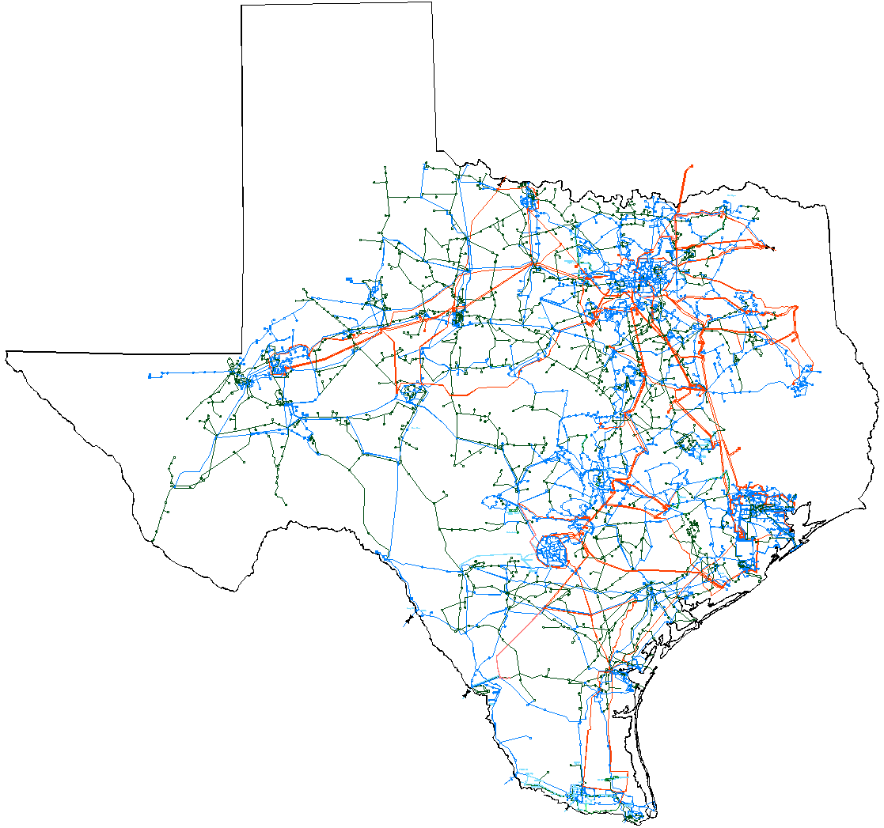

System Planning Division
November 2005 Report
To
Technical Advisory Committee
Reliability and Operations Subcommittee

Status of active generation interconnection requests Additional detailed generation interconnection information and impact studies is contained in the “Generation Project Interconnection Information” data folder posted in the “Operations and System Planning” data area on the internet. See links at end of this document for address.
GENERATION INTERCONNECTION PUBLIC PROJECTS
INR # | SiteName | Status | County | Region | Fuel | In Service Date | MW into Grid | Notes
04INR0020 | WKN Wind 1 Snyder | Interconnect Agreement | Scurry | West | Wind | Dec-05 | 60
01INR0036 | Sweetwater Wind 3 | Interconnect Agreement | Nolan | West | Wind | Dec-05 | 136
05INR0010 | Jack County Generation Facility | Interconnect Agreement | Jack | North | Gas | Jan-06 | 620 | testing 6/1/05, commercial 12/1/05
06INR0008 | Big Spring Carbon Plant | Interconnect Agreement | Howard | West | Waste heat | Apr-06 | 12
06INR0017 | Limestone Upgrade | Interconnect Agreement | Limestone | North | Coal | May-06 | 110
05INR0017 | Post Wind Farm 1 | Interconnect Agreement | Borden | West | Wind | Jun-06 | 84
05INR0018 | Horse Hollow 2 | Interconnect Agreement | Taylor | West | Wind | Jun-06 | 127 | Second of two phases
06INR0016 | Dow 9 | Interconnect Agreement | Brazoria | South | Gas | Oct-06 | 0
04INR0011 | Mesquite Wind Farm 1 | Interconnect Agreement | Shackelford | West | Wind | Dec-06 | 200
04INR0015 | Buffalo Gap 2 | Interconnect Agreement | Taylor | West | Wind | Mar-07 | 120 | Second of two phases
03INR0034 | Silver Star Project | Interconnect Agreement | Erath | West | Wind | Mar-07 | 60
05INR0015 | Gulf Wind | Public Letter | Kenedy | South | Wind | Sep-07 | 1,200 | In four phases, 300 MW in 2007, 2008,2009,2010
01INR0028 | Orion Delaware Mountain Wind Farm | Interconnect Agreement | Culberson | West | Wind | Dec-07 | 175
06INR0006 | Cobisa-Greenville | Public Letter | Hunt | North | Gas | May-08 | 1,750
09INR0006 | Oak Grove | Public Letter | Robertson | North | Coal | Mar-09 | 1,660
09INR0001 | Sandy Creek | Public Letter | McLennan | North | Coal | Jul-09 | 800
09INR0002 | J K Spruce 2 | Interconnect Agreement | Bexar | South | Coal | Aug-09 | 750
10INR0002 | Hugo Plant | Public Letter | Choctaw, OK | North | Coal | Dec-10 | 500
11INR0001 | Twin Oaks 3 | Public Letter | Robertson | North | Coal | Jun-11 | 630
 |  |  |  |  | Totals |  | 8,994
PROJECTS INTO OPERATION
INR | Site Name | County | Region | Fuel | In Service | MW for Grid
04INR0015 | Buffalo Gap 1 | Taylor | West | Wind | Sep-05 | 120

ACTIVE GENERATION INTERCONNECTION REQUESTS BEING PROCESSED
 |  | North | South | West | Total
Security Screening Study |  | 2 | 2 | 5 | 9
SSS Completed |  | 0 | 1 | 2 | 3
Full Interconnect Study |  | 7 | 6 | 17 | 30
FIS Completed |  | 0 | 0 | 0 | 0
Interconnect Agreement Completed (Includes public letters) |  | 8 | 3 | 9 | 19
Capacity for Grid, MW |  | 6,395 | 5,200 | 4,920 | 16,515
Wind MW (under development) |  | 180 | 2,130 | 3,733 | 6,043

Generation Currently Under RMR Contract in ERCOT (as of 11/30/05)
Unit | Capacity (Net) | RMR Contract Status | Contract Date | Current Anticipated Exit Date | Change Since Last Report
BM Davis 2 | 356 | Under Contract | 1/1/05-12/31/05 | 3Q 2006  under review | Will continue to pursue RMR for 1 Davis unit in 2006.
JL Bates 1 & 2 | 183 | Under Contract | 1/1/05-12/31/05 | 12/31/05 | Will not pursue RMR in 2006.
La Palma 4, 5, 6, &7 | 249 | Under Contract | 1/1/05-12/31/05 | 1Q 2006  under review | Will exit Unit 4 on 12/31/05. Will pursue RMR for Units 5,6, and 7 in 2006.
Laredo 1, 2, & 3 | 172 | Under Contract | 1/1/05-12/31/05 | 3Q 2010  under review | Will pursue RMR for 2006.
Atkins 3, 4, 5, 6 |  |  |  |  | Will pursue RMR for Units 4, 5, and/or 6 starting in June 2006.
Total MW Under RMR Contract as of December 1, 2005: | 960

Studies underway or planned within System Planning Division
- ERCOT/SPP joint study of interconnection feasibility – ERCOT/SPP joint study of interconnection feasibility: analysis of economic benefits from transactions over DC-ties is ongoing
- Pre-Nodal Transmission Improvements study is underway. Continuing to investigate congested elements and potential solutions
- Load stability modeling project - Phase II (EPRI Solutions) is starting
  - ROS and TAC endorsed/supports this effort. ROS encouraged transmission owners to get involved in the project
  - TXU should be able to “host” load monitoring locations in support of ERCOT’s participation in the project
- Transient Voltage Recovery “How-To” procedural manual is under development. It will contain practical steps to perform contingency analysis, QV, PV and Voltage recovery studies using simulation software. Current status is 80% complete
- Utility Wind Interest Group (UWIG) wind farm stability modeling effort – underway supporting user group efforts
- Net Dependable Capability Testing Data - ERCOT staff efforts are ongoing to determine the fidelity of and best practices in planning for the generator data that is sent to ERCOT compliance
- Examination of how to incorporate biennial unit reactive test data into the Steady State WG base cases for more accurate modeling
- Seasonal Transmission Loss Factor work continues and is expected to be complete by the January 28th deadline
- The Spare Autotransformer/Congestion Analysis study is substantially complete and will be posted in December
- LOLP Study bids have been received in response to RFP with study to be completed by January 2006
- February 2006 Transmission Congestion Rights determination underway
- Reviewing Sharyland DC Tie interconnection to determine constraints and maximum ERCOT import capability
- Seasonal Transmission Loss Factor work continues and is expected to be complete by the January 28th deadline
- Division is providing personnel to support operational Blackstart testing of units
- Development of 2006 division and department Goals and Objectives
- SSWG manual review

Studies completed by System Planning Division
- Bryan College Station transmission project RPG review completed. ERCOT staff will be presenting the Kurten Switch project to the ERCOT Board of Directors in January, 2006, for endorsement. TAC voted to support the project at their Dec 1 meeting.
- Steady State WG base cases with TPIT updates completed and posted http://oldercot.ercot.com/tmaps/ListMaps.cfm
- Steady State WG 2006 Data Set B future year base cases for the years 2007 to 2011 were posted on November 14 at http://oldercot.ercot.com/tmaps/ListMaps.cfm
- SPS approval procedure revisions
  - ERCOT staff has streamlined the process so that minor SPS additions and modifications can be reviewed in expedited manner
  - OGRR 172 recommendations are being incorporated into the SPS approval procedure
- ROS Dynamics WG selected the August 19, 2004 Forney plant trip event for simulation (in response to NERC recommendations to simulate an actual event to test dynamic models). System Planning staff completed assignments related to the study and will provide support for development of the final report
- ERCOT staff met with Centerpoint Energy personnel on how to incorporate biennial unit reactive test data in the Steady State WG base cases. Recommendation were presented to the Steady State WG in November
- Voltage stability review of the Houston region, 2007 summer on-peak, with and without the Hillje 345 kV lines in service was completed by ERCOT staff
- Annual 2006 Transmission Congestion Rights determination completed
  - Posted: https://tcr.ercot.com/TCRDocuments
  - Posted: http://oldercot.ercot.com/tmaps/ListMaps.cfm
- January 2006 Transmission Congestion Rights determination completed
  - Posted: https://tcr.ercot.com/TCRDocuments
  - Posted: http://oldercot.ercot.com/tmaps/ListMaps.cfm
- Atkins RMR determination is to keep Atkins units 4, 5, and/or 6

Upcoming Events
- OGRTF Special Meeting to discuss OGRR-174
  - December 6, 2005, ERCOT Met Center Room 206-A, 9:30 to 4:00
- The winter branch data comparison between the Steady State WG base cases and the Network Model will be conducted in mid-December
- Network Modeling Management System (NMMS) project development with ERCOT operations

Other Issues
- A preliminary version of the Transmission Adequacy and Reliability Assessment (TARA) software has been received from PowerGEM. This software now has an Excel interface making it relatively easy to utilize. The TARA application identifies bottlenecks in a transmission system, generators that affect bottlenecks and load that affects bottlenecks
- The new ERCOT website organization is good but has not been extended to the “Operations and System Planning” data area. A phase II project has been started to address this area. The internet address has changed http://oldercot.ercot.com/tmaps/ListMaps.cfm

Reminders to TDSPs/TOs
- Please keep your outage scheduler information up to date
- TDSPs are requested to update ERCOT staff and the regional planning groups as they complete interesting and/or challenging transmission projects. Operations model updates (service requests) should be promptly submitted as they are completed and placed in-service

Future issues
- The upcoming Nodal Market will dramatically change the way planning and operations models are created and modified. The NMMS project will incorporate the requirements in the Nodal Protocols filed with the PUCT along with the tools required to support the business processes for the operations, planning and CRR modeling needs.

Internet Links
- ERCOT Home Page
  - http://www.ercot.com
- Information Requests. For general communications and queries, the public can submit a request for information at:
  - http://www.ercot.com/AboutERCOT/InformationRequest.cfm
- Generation Interconnection or Change Request Procedure
  - http://www.ercot.com/mkt_part_apps/market_participant_application_f.htm
- ERCOT Email Lists. To join Regional Planning Group email exploder list:
  - http://lists.ercot.com/cgi-bin/majordomo
- Operations and System Planning Data area
  - http://oldercot.ercot.com/tmaps/ListMaps.cfm
  - Major data folders of interest in this area
    - Power System Planning Charter & Processes
    - October 1 Report to PUCT Annual
    - CSC CM Zone 2005 Data Files
    - Capacity, Demand, and Reserve Reports
      - Report on generation capacity, projected demand and reserves
    - Contingency Information – planning
    - Demand and Energy Reports (D&E) Monthly Actuals
      - Monthly actual demand and energy report
    - EIA-411 DOE Regional Electricity Supply and Demand Projections
    - Generation Project Interconnection Information
      - Public new and existing generation projects in ERCOT since 1996
    - Maps of ERCOT Transmission System
    - Operations Engineering Procedures
    - Operations Model Data
      - System Operations Base Case updated often
    - Regional Planning Group NORTH
    - Regional Planning Group SOUTH
    - Regional Planning Group WEST
    - Reliability Must-Run (RMR) Studies
    - Special Protection Schemes (SPS) Information
    - Steady State Base Case Info & Old Data
    - Steady State Power Flow Base Cases 2005 Data Set A (2005 eight seasonal cases)
    - Steady State Power Flow Base Cases 2005 Data Set B (2006-2010 cases)
    - System Protection Short Circuit Data
    - TNT Cost Benefit Study Data
    - Transmission Project & Information Tracking (TPIT)
    - Voltage Security Study of ERCOT System
    - Wind Stability Modeling ERCOT Project

