DRAFT MODULE ABSTRACT
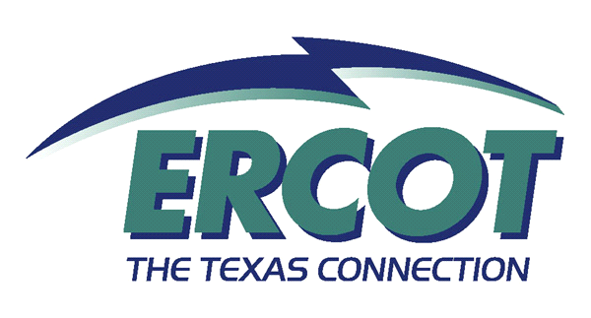
ERCOT System Operations:
Transmission & Generation Planning (OPS 202)

Introduction:
A one-day course to provide an overview of transmission & generation planning processes and issues for the ERCOT Region. The course is designed to increase knowledge of the planning processes, including planning criteria and reliability in transmission planning. Major project stakeholder input, official communications, transmission project review and proposed new and additional generation are also addressed as major considerations in transmission and generation planning.

Objectives:

Competencies Required:

Prerequisites:
None.

Nodal Requirements:

Intended Audiences | Knowledge Requirement | Readiness Assessment Method
Qualified Scheduling Entites (QSE) | Mandatory
Transmission and Distribution Service Companies (TDSP) | Mandatory
Power Generation Companies (PGC) | Highly Recommended
Load Serving Entities (LSE) | Recommended

Offerings:

Dates | Class Size | Delivery Methods | Time | Locations | Course Materials

