All significant changes have been excerpted here from the complete SSWG Procedural Manual to facilitate review. Minor changes, such as renumbering paragraphs, have not been included in this document. The appropriate section and paragraph headings are indicted for orientation.

ERCOT STEADY STATE WORKING GROUP

PROCEDURAL MANUAL

November, 2005

ERCOT STEADY-STATE WORKING GROUP’S SCOPE

- Develop and maintain load-flow base cases for the five future years following the upcoming year. The cases, collectively known as Data Set B, are produced by the SSWG by approximately November 15th on an annual basis. These future cases consist of five summer on-peak cases, and one minimum case. Data Set B will contain economically dispatched generation (ECO) and congestion constrained dispatch (CSC), as determined by the SSWG.

SECTION 1.0 – Data Requirements

1.4 GENERATOR DATA

1.4 GENERATOR DATA

    - Acquisition of Generator Data

Only net real and reactive generator outputs and ratings should be modeled in load-flow cases. Net generation is equal to the gross generation minus station auxiliaries and other internal power requirements. All non-self-serve generation connected at 60kV and above with at least 10 MW aggregated at the point of interconnect must be explicitly modeled. A generator explicitly modeled must include generator step-up transformer and actual no-load tap position. Generation of less than 10 MW is still required to be modeled, but not explicitly.

Unit reactive limits (leading and lagging) should be determined from the most recent generator reactive unit test. Unit reactive limits (leading and lagging) are tested at least once every two years (ERCOT Protocols, Section 6.10.3.5 and ERCOT Operating Guides, Section 6.2.3). Each generator establishes unit reactive limits (leading and lagging) by supplying a Corrected Unit Reactive Limit (CURL) curve to ERCOT. To be an acceptable test the unit must be operating at or above 95% of its net dependable megawatt capability and the measured reactive capability must be equal to or greater than 90% of the established CURL. The minimum acceptable test duration is 15 minutes. If the test meets all of these requirements the unit reactive limits established on the CURL are approved. If the test does not meet these requirements, ERCOT can request another test or a modified CURL. Note that the CURL MVAr values are gross values at the generator terminals.
Generator reactive limits should be modeled by one value for Qmax and one value for Qmin, as described below:

Qmax

Qmax is the maximum net lagging MVAr observed at the low side of the generator step up transformer when the unit is operating at its maximum net dependable MW capability. Qmax is calculated from the lagging CURL value by subtracting any auxiliary MVAr loads and any Load Host MVAr (Self Serve) load served from the low side of the generator step up transformer.

Example:

Lagging CURL value is 85 MVAr
Lagging test value is 80 MVAr
Auxiliary Load is 5 MVAr

Qmax is 85 – 5 = 80 MVAr (Use the CURL value here if the test value is equal to or greater than 90% of the CURL. Use the test value here if the test value is less than 90% of the CURL.)

Qmin

Qmin is the maximum leading MVAr observed at the low side of the generator step up transformer when the unit is operating at its maximum net dependable MW capability. Qmin is calculated from the leading CURL value by adding any auxiliary MVAr loads and any Load Host MVAr (Self Serve) load served from the low side of the generator step up transformer.

Example:

Leading CURL value is -55 MVAr
Auxiliary Load is 5 MVAr

Qmin is -55 – 5 = -60 MVAr

    - Generation Dispatch Methodology

In order to simulate the future market, the following methodology for generation dispatch has been adopted for building the Data Set A and Data Set B load flow cases.

Existing and planned units owned by the Non-Opt-In Entities (NOIE) are dispatched according to the NOIE's planning departments; unless a NOIE requests that their units are to be dispatched according to the order that is described below. Unless contracts are known for the full output of a unit, all remaining MWs of NOIE units will be put into the ERCOT dispatch in their respective order.

Private network generation is also dispatched independently. It is believed that cogeneration and self-serve units will have a better financial incentive to run than other plants. These plants are turned on at full output unless actual data is available, in which case they are dispatched to an average of their historical output. DC Ties are modeled as load levels or at generation levels based on historical data. Likewise, wind plants are modeled at generation levels based on historical data.

Units that are solely for black start purposes are to be modeled in the base cases, however, these units should not be dispatched. Black start units are designated with a unit ID that begins with the letter ‘B’ which can be followed by an alphanumeric character (for example, ‘B1’, ‘B2’, etc.).

All other units are dispatched by performing a system simulation using the UPLAN software package. The UPLAN simulation will dispatch units in order to minimize production costs taking into account unit start-up times and cost and heat rates while adhering to the following guidelines for each set of cases:

Data set A cases are dispatched to eliminate base case rate A overloads and maintain CSC and CRE loading below their thresholds. The model simulates the system for the two weeks leading up to the peak hour for each season.

Data set B CSC constrained cases are dispatched to maintain CSC and CRE loading below their thresholds. The model simulates the system for the two weeks leading up to the peak hour for each summer peak case.

Data set B economically constrained cases are dispatched in the most economical way for a given load level with no consideration for overloads. The model simulates the system load for the two weeks leading up to the peak hour for each summer peak case and the two weeks leading up to the minimum load hour for the minimum case.

In all cases spinning reserve is maintained according to ERCOT guides. Mothballed units are treated as described in Appendix F. The dispatch may be modified for data set A cases if necessary to maintain voltages at acceptable levels.

If a future unit is not on the ERCOT generation web site, it will not be put in the case unless an agreement has been reached between the TSP and the generating entity to do so. Future units that are expected to be constructed must either have signed an SGIA or have provided an agreement to reimburse the TSP for expenses incurred toward constructing facilities for their generation if the generation project fails to go forward.

SSWG shall be able to review and modify the generation dispatch based on historical information.

Extraordinary Dispatch Conditions

ERCOT powerflow cases typically model load at individual TSP peaks instead of at the ERCOT system peak. Additionally, some of the generation reserve modeled in the cases is actually made up from LaaR (Load Acting as a Resource) in system operations. Since LaaR is not modeled in powerflow cases it must be made up from generation resources. For these, and other reasons such as how mothballed generation is counted, the load and generation modeled in powerflow cases usually does not match the load and generation resources estimated in the ERCOT CDR.

These differences can result in future cases without sufficient dispatchable generation resources to match load. When such a condition is encountered in future cases, ERCOT may increase generation resources by taking the indicated action, or adding generation, in the following order:

- DC ties dispatched to increase transfers into ERCOT to the full capacity of the DC ties.
- Mothballed units that have not announced their return to service.
- Ignore spinning reserve.
- Increase NOIE generation.
- Add publicly announced plants without interconnect agreements.
- Blackstart Units
- Add generation resources at the sites of retired units.

1.6 TRANSFORMER DATA

      - Transformer Circuit Identifier
Circuit identifiers are limited to two alphanumeric characters. Actual transformer identifiers may be used for circuit identifiers for transformers, however, typically, circuit identifiers are used to indicate which transformer is being defined when more than one transformer is modeled between two common buses. Where practical, TO’s should identify auto-transformers with the letter A as the first character of the ID field. Generator Step-Up transformers should be identified with the letter G. Phase-shifting transformers should be identified with the letter P.

1.7 STATIC REACTIVE DEVICES

      - Bus Shunt
A shunt capacitor or reactor connected to the high side or low side of a substation transformer in a substation should be represented in the ERCOT load-flow case as a switched shunt device to accurately simulate operating conditions. Care should be exercised when specifying the size of cap banks. Be sure that the rated size of the bank is for 1.0 per unit voltage. A fixed bus shunt should be modeled as a fixed switched shunt for easy identification in the ERCOT load-flow cases. Care should be taken to ensure that distribution level capacitors are not modeled in such a way as to be counted twice.

1.8 DYNAMIC CONTOL DEVICES

There is a multiplicity of FACTS(Flexible ac Transmission System) devices currently available comprising shunt devices, such as Static Compensator (STATCOM), series devices such as the Static Synchronous Series Compensator (SSSC), combined devices such as the Unified Power Flow Controller (UPFC) and the Interline Power Flow Controllers (IPFC). These devices are being studied and installed for their fast and accurate control of the transmission system voltages, currents, impedance and power flow. They are intended to improve power system performance without the need for generator rescheduling or topology changes. These devices are available because of the fast development of power electronic devices specifically gate-turn-off semiconductors.

    - Basic Model

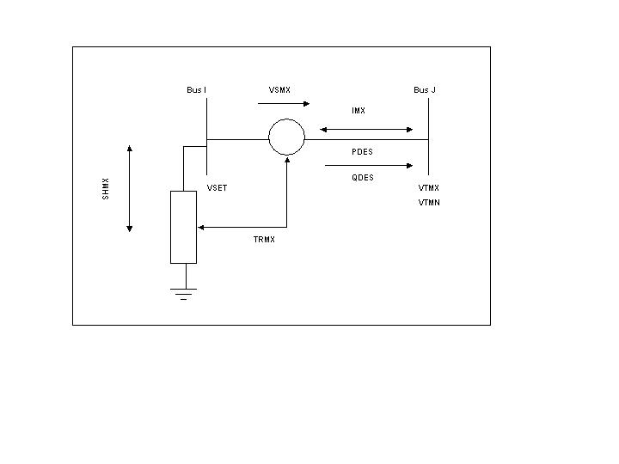
Figure 4. Basics FACTS Control Device Model
Each FACTS device data record shall have the following information:

N | FACTS control device number
I | Sending end bus number
J | Terminal end bus number (0 for a STATCOM)
MODE | Control mode
PDES | Desired real power flow arriving at the terminal end bus in MW (default 0.0)
QDES | Desired reactive power flow arriving at the terminal end bus in Mvar (default 0.0)
VSET | Voltage setpoint at the sending end bus in pu (default 1.0)
SHMX | Maximum shunt current at sending end bus in MVA at unity voltage (default 9999.)
TRMX | Maximum bridge real power transfer in MW (default 9999.)
VTMN | Minimum voltage at the terminal end bus in pu (default 0.9)
VTMX | Maximum voltage at the terminal end bus in pu (default 1.1)
VSMX | Maximum series voltage in pu (default 2.0)
IMX | Maximum series current in MVA at unity voltage (default 0.0)
LINX | Reactance of dummy series element used in certain solution states in pu (default 0.05)

The FACTS model figure has a series element that is connected between two buses and a shunt element that is connected between the sending end bus and ground. The shunt element at the sending end bus is used to hold the sending end bus voltage magnitude to VSET subject to the sending end shunt current limit SHMX. This is handled in power flow solutions in a manner similar to that of locally controlling synchronous condensers and continuous switched shunts. One or both of these elements may be used depending upon the type of device.

A unified power flow controller (UPFC) has both the series and shunt elements active, and allows for the exchange of active power between the two elements. (i.e. TRMX is positive)

A static series synchronous condenser (SSSC) is modeled by setting both the maximum shunt current limit (SHMX) and the maximum bridge active power transfer limit (TRMX) to zero. (i.e. the shunt element is disabled).

A static synchronous condenser (STATCON) or static compensator (STATCOM) is modeled by a FACTS device for which the terminal end bus is specified as zero. (i.e. the series element is disabled).

An Interline Power Flow Controller (IPFC) is modeled by using two consecutively numbered series FACTS devices. By setting the control mode, one device will be assigned, as the IPFC master device while the other becomes the slave device. Both devices have a series element but no shunt element. Conditions at the master device define the active power exchange between the devices.
    - Power Flow Handling of FACTS Devices

For an in-service FACTS device to be modeled during power flow solutions, it must satisfy the following conditions:

1. The sending end bus must be either a type 1 or type 2 bus.

2. The sending end bus must not be connected by a zero impedance line to a type 3 bus.

3. If it is specified, the terminal end bus must be a type 1 bus with exactly one in-service AC branch connected to it; this branch must not be a zero impedance line and it must not be in parallel with the FACTS device.

4. If it is specified, the terminal end bus must not have a switched shunt connected to it.

5. If it is specified, the terminal end bus must not be a converter bus of a DC line.

6. A bus, which is specified as the terminal end bus of an in-service FACTS device, may have no other in-service FACTS device connected to it. However, multiple FACTS device sending ends on the same bus are permitted.

7. A bus, which is specified as the terminal end bus of an in-service FACTS device, may not have its voltage controlled by any remote generating plant, switched shunt, or VSC DC line converter.

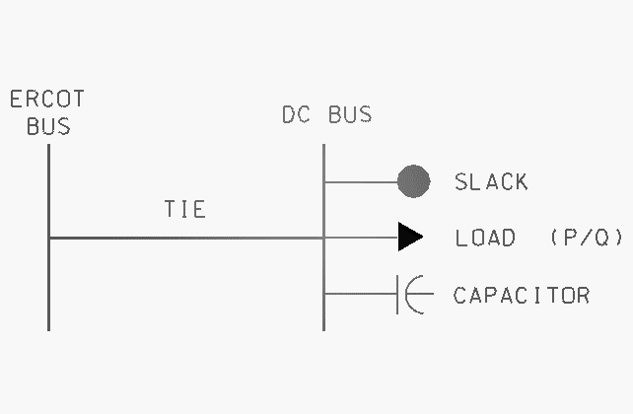
1.9 HVDC DEVICES

HVDC Devices allow a specified real power flow to be imposed on the DC link. For base case operation, this should be set to the desired interchange across the DC tie. Capacitors, filter banks and reactors should be modeled explicitly and switched in or out of service based on normal DC tie operation. The HVDC model itself normally calculates reactive power consumption.

HVDC ties with external interconnections may be modeled by the use of either the Two Terminal DC Transmission Line Data or Voltage Source Converter DC Line Data.

    - Two Terminal DC Transmission Line Data

Conventional HVDC ties should be modeled using Two Terminal DC Transmission Line Data. The Two Terminal DC Transmission Line Data model represents the HVDC terminal equipment, including any converter transformers, thyristers, and the DC link. The model will calculate voltages, converter transformer taps, losses, and VAr requirements, based upon the power transfer over the HVDC facility, and the terminal AC bus voltages.

    - Basic Two-Terminal HVDC Model
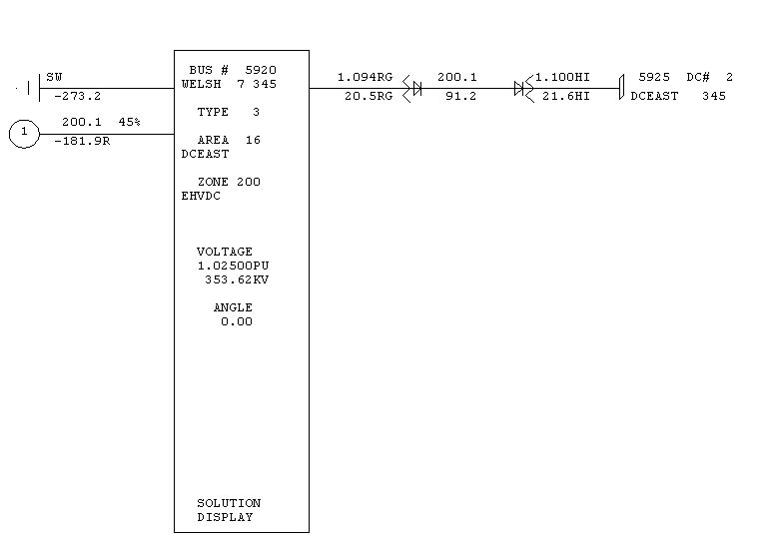
Figure 5. Basic Two-Terminal HVDC Model

A type 3 swing bus must be modeled on the bus external to ERCOT. Filters and capacitors, and reactors on the AC terminals should be explicitly modeled, and set to minimize the VAr interchange to the AC system.

1.9.3 Relevant parameter values for Two-Terminal HVDC Model

I | The DC line number.
MDC | Control mode: 0 for blocked, 1 for power, 2 for current.
RDC | DC line resistence, entered in ohms.
SETVL | Current (amps) or power (MW) demand. The sign of SETVL indicates desired power at the rectifier when positive, and desired power at the inverter when negative.
VSCHD | Scheduled DC voltage in kV
METER | Metered end code of either ‘R’ (for rectifier) or ‘I’ (for inverter).
IPR | Rectifier converter bus number
EBASR | Rectifier primary base AC voltage in kV.
TAPR | Rectifier tap setting
IPI | Inverter converter bus number
EBASI | Inverter primary base AC voltage in kV.
TAPI | Inverter tap setting

Notes:
- The DC line number, I, must be unique, and should be assigned by the ERCOT SSWG, such that new DC lines do not overlay existing DC lines in the ERCOT cases.
- SETVL may be varied to dispatch the amount of flow over the DC.
- To reverse the flow over the DC, it is necessary to reverse the Rectifier converter bus number, IPR, and the Inverter converter bus number, IPI.

1.9.4 Voltage Source Converter (VSC) DC Line Data

Voltage Source Converter DC line data can be used to model DC ties that use the voltage source converter technology, for PSS/e Rev. 30 and above.

1.9.4 VSC DC Line Basic Model
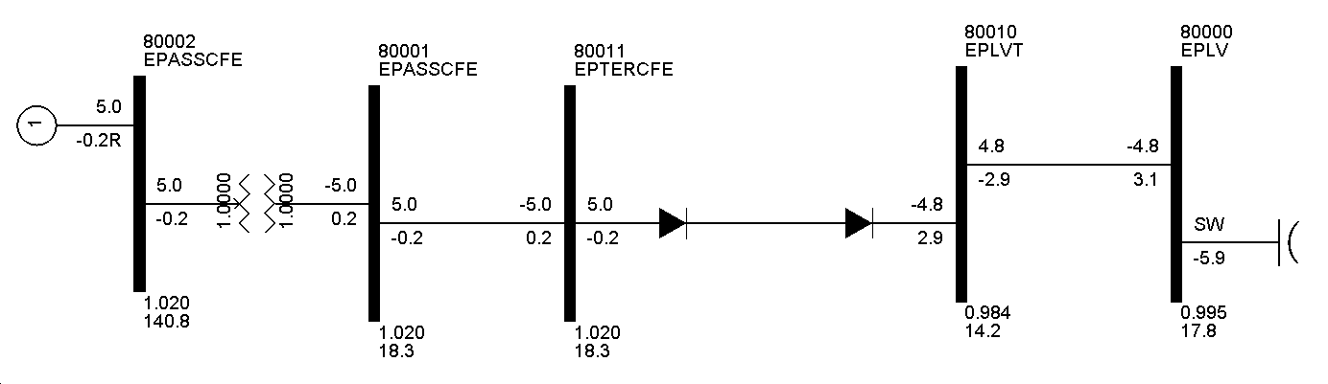
Figure 6. Basic VSC DC Line Model

1.9.5 Relevant parameter values for VSC DC Line Data

NAME | VSC Lines are designated by a NAME, rather than a number
MDC | Control mode: 0 for out-of-service, 1 for in-service.
RDC | DC line resistance, entered in ohms.
IBUS | Converter bus number
TYPE | Type code: 0 for converter out-of-service, 1 for DC voltage control, 2 for MW control.
MODE | Converter AC control mode 1 for AC voltage control, 2 for fixed AC power factor.
DCSET | If Type=1, the scheduled DC voltage; if Type=2, the power demand, with the sign indicating direction of flow.
ACSET | For Mode=1, the regulated AC voltage setpoint; for Mode=2, the power factor setpoint.
SMAX | Converter MVA rating
IMAX | Converter AC current rating

Notes:
- The VSC Name, must be unique, and should be assigned by the ERCOT SSWG, to prevent overlaying existing VSC DC lines in the ERCOT cases.
- DCSET may be varied to dispatch the amount of flow over the VSC DC, with the sign indicating the direction of flow. (It is not necessary with VSC DC line data to reverse the rectifier and inverter bus numbers).
- A type 3 swing bus must be modeled on a bus in the system external to ERCOT.
- Filters and capacitors, and reactors on the AC terminals should be explicitly modeled, and set to minimize the VAr interchange to the AC system.

SECTION 2.0 – Load-Flow Procedures and Schedules

2.1 DATA SET A CONSIDERATIONS

2.2 DATA SET B CONSIDERATIONS

    - Data Set B Dispatching
Data Set B will contain economically dispatched generation (ECO) and congestion constrained dispatch (CSC), as determined by the SSWG.

SECTION 3.0 – Other SSWG Activities
3.1 TRANSMISSION LOSS FACTOR CALCULATIONS
Transmission Loss Factors

The process with approximate timelines for creating the loss factors is below.

- Send out a request to SSWG for any case updates, changes to NOIE bus ranges, and latest self serve data. (2 weeks)
- Verify self serve data with the ERCOT planning staff that performs the congestion management functions (CSC &TCR). The CSC process tries to verify with ERCOT operations where the self serve is located.
- Update base cases. (1 week)
- Update the transmission loss factor spreadsheet. (1/4 day)
- Perform the calculations. (1 day)
- Fill in the yellow shaded squares on the loss factor spreadsheet. (1/4 day)
- Create the DIFF spreadsheet between this year and last year. (1/4 day)
- Send to SSWG for review and approval. (1 week)
- Send to ERCOT settlements (Settlement Metering Manager) to be put into the ERCOT settlement system and post at https://portal.ercot.com/ercotPublicWeb/MarketInformation/Transmission.htm. (1/4 day)

3.2 VOLTAGE CONTROL AND REACTIVE PLANNING
(To be determined)

APPENDICES
Appendix C

TSP Impedance and Line Ratings Assumptions

Comparison of ERCOT TDSP’s Ampacity Assumptions

 | Center Point | TNP | CPS | LCRA | Austin Energy | STEC | TXUED | BPUB | AEP | TMPA | Garland | Denton | Rayburn Country
Wind Velocity (feet per second) | 3 | 2 | 2.05 | 2 | 2 | 2.05 | 2 | 2 | 2 | 2.05 | 2.00
Wind Angle (degrees to conductor) | 30 | 90 |  | 90 |  | 90 | 90 | 90 |  |  | 90
Emissivity | 0.5 | 0.5 | 0.5 | 0.5 | 0.5 | 0.4 | 0.5 | 0.5 |  |  | 0.5
Solar Absorbtion | 0.5 | 0.5 | 0.5 | 0.5 | 0.5 | 0.4 | 0.5 | 0.5 |  |  | 0.5
Ambient Temp Summer ( °c ) | 36 | 25 | 25 | 40.55 | 40 | 40.55 | 40 | 25 | 40 | 25 | 40 |  | 43
Normal Conductor Temp Summer ( °c ) | 75/90 | 75 x 90% | 75 | 93.33 | 100 x 90% | 75 x 90% | 90 | 75 x 90% | 85 | 75 x 90% | 90 |  | 75
Emergency Conductor Temp Summer(°c) | 90 | 75 | 75 |  | 100 | 75 | 90 X 110% | 75 | 100 |  | 75 | 50 | 95
Ambient Temp Winter ( °c ) |  |  |  |  |  |  |  |  | 20 |  |  |  | -7
Normal Conductor Temp Winter ( °c ) |  |  |  |  |  |  |  |  | 85 |  |  |  | 38
Emergency Conductor Temp Winter (°c) |  |  |  |  |  |  |  |  | 100 |  |  |  | 49
The planning ratings are calculated in accordance with the methodology contained in IEEE Standard 738.
Each TDSP has their own set of design parameters and assumptions.

CenterPoint Energy

CenterPoint Energy uses the Line Constants (LC) module of the Computer Aided Protection Engineering (CAPE) which is developed and supported by Electrocon International Incorporated. The LC software calculates the line constant parameters for overhead transmission lines. LC calculates the total self-series positive and zero sequence impedance and self-shunt positive and zero sequence admittance of the main circuit in a given right-of-way section. LC also calculates the total mutual zero sequence series impedance and shunt admittance between the main circuit and all other circuits in the given right-of-way section.

LC does not calculate impedance for underground cables. Instead per-mile impedance data provided by the manufacturer is entered in parameter codes. LC multiplies this per-mile impedance with the actual mileage of the circuit to calculate total impedance for the underground cable.

Data used (conductor catalog, tower design, soil resistivity, parameter codes, right-of-way data, tower string data, line data and line section data) in LC calculation is stored in a database called TLIP.gdb. Calculated parameters are also stored in a TLIP database.

Line Constants
Assumptions used in the calculations are:
- Earth resistivity = 10 ohm-meters.
- Frequency = 60 Hz.
- Conductor characteristic data from T&D Reference Book, Aluminum Electrical Conductor Handbook Third Edition 1989 from the Aluminum Association and Southwire Conductor Reference Handbook, 1994.
- Conductor temperatures used for calculating impedance: 25ºC.
- Ground wires are included in zero sequence impedance calculations.
- Actual tower and pole configurations are used in calculations.
- Actual length of line is used.
- Sag characteristics are based upon the type of structure being studied.

Transformer Constants
Transformer impedance is calculated when possible using data from the manufacturer’s test reports and industry accepted formulas to convert the manufacturer's test results data to resistance and reactance values on the required per-unit base. If it is not available, CenterPoint Energy will use typical data from similar transformers in the system

Assumptions used in the calculations are:
- Frequency = 60 Hz.
- Temperatures vary depending upon the vendor test data.

Conductor Ratings
Conductor ampere ratings are calculated by the IEEE method detailed in ANSI/IEEE Standard 738-93 with the following input parameters:
Latitude = 28° N
Wind Velocity = 2 feet per second
Wind Angle = 90° to conductor
Emissivity Coefficient = 0.7
Solar Absorption Coefficient = 0.9
Line Elevation = 500 feet AMSL
Line Orientation = North – South
Time of Day = 2 P.M.
Atmospheric Condition = Industrial
Air Temperature = 36° C

The normal rating is the maximum current carrying capacity of an element for continuous operation without causing any loss of life. For overhead transmission conductor this capacity is the ampacity of the conductor at 75ºC unless the conductor has enough clearance for operating continuously at 90ºC The normal rating for switches, breakers, transformers, current transformers, wave traps etc. is the maximum nameplate rating.

The emergency rating is the maximum current carrying capacity of an element for a 2 hour duration with acceptable loss of life. For overhead transmission conductor it is the ampacity of the conductor at 90ºC unless the conductor has been surveyed and cleared for operating at a higher temperature for a short duration. For underground transmission conductor the emergency rating is the maximum allowable ampacity for 300 hours of emergency operation. For substation facilities such as switches and wave traps, the emergency rating is 110% of the normal rating. For breakers, the emergency rating is the same as the normal rating.
The emergency rating of the conductor is the conductor thermal rating.

Line Ratings
The maximum overall rating of a transmission line is the current carrying capability of the most limiting element in series between the breakers at its two end points. Unless otherwise limited by equipment ratings installed in the transmission line circuit such as breakers, current transformers, switches, disconnects, wave traps, jumpers, the normal and emergency rating of a transmission line is the conductor normal and emergency ratings. Where such equipment has a manufacturer's nameplate continuous current rating less than the conductor normal and/or emergency rating, then that equipment’s continuous rating shall be used for the normal and/or emergency rating of the transmission line.

Transformer Ratings
The normal rating of a transformer is the manufacturer’s highest continuous FA or FOA rating at 65°C rise. The emergency rating is the maximum loading for a 2-hour duration.

Texas-New Mexico Power Company

Conductor Ratings
Conductor thermal ratings for existing transmission lines are calculated by the IEEE method detailed in ANSI/IEEE Standard 738 with the following input parameters:

Latitude = 30° N
Wind Velocity = 2 feet per second
Wind Angle = 90° to conductor
Emissivity Coefficient = 0.5
Solar Absorption Coefficient = 0.5
Line Elevation = 600 feet AMSL
Line Orientation = East – West
Time of Day = 2 P.M.
Atmospheric Condition = Clear
Air Temperature = 25° C
Conductor Temperature = 75° C

New transmission lines will be designed using the above parameters to calculate load capacity, except that Ambient Temperature will be 38C, and Conductor Temperature will be 100C. In cases where ACSS conductor is installed, Ambient Temperature of 38C and Conductor Temperature of 200C will be used.

The 2-hour rating of the conductor of an existing line is the conductor thermal rating based on a conductor temperature of 75°C unless it has been determined that the conductor can operate at a higher temperature and maintain adequate clearance. No allowance is made for design or operational thermal limits such as conductor sag or for circuit elements other than the transmission line conductor.

Line Ratings
Unless otherwise limited by equipment ratings installed in the transmission line circuit such as breakers, current transformers, switches, disconnects, wave traps, jumpers, the rating of a transmission line is the conductor rating. Where such equipment has a manufacturer's continuous current rating less than the conductor rating, then that equipment continuous rating shall be used for the rating of the transmission line.

Transformer Ratings
The continuous rating of a transformer is the manufacturer’s highest continuous FA rating at 55°C rise.
The 2-hour rating of a transformer is the manufacturer’s highest continuous FA rating at 65°C rise.

Line Constants
Line impedance constants are calculated in a TNMP developed Transmission Line Impedance Calculation spreadsheet using formulas detailed in the Electrical Transmission and Distribution Reference Book by Westinghouse (T&D Reference Book). Factors used in the calculations are:
- Conductor characteristic data from T&D Reference Book, Electrical Conductor Handbook, or manufacturer's data sheets
- Tower or pole and conductor configuration information
- Actual length of line with no allowance for sag
- Earth resistivity = 100 ohm-meters
- Frequency = 60 Hz
- Ground wires are included in zero sequence impedance calculations

Transformer Constants
Transformer impedance is calculated using data from the manufacturer’s test reports and industry accepted formulas to convert the manufacturer's test results data to resistance and reactance values on the required per-unit base.

CPS Energy

Line constants
CPS Energy currently uses the CAPE Line Constants Program for calculating Line Impedance. Previously, CPS Energy used both the ASPEN and Bowen & Green line constant programs. For calculating line constants, CPS Energy models each right-of-way in great detail. This includes modelling the correct tower models, tower spacing, circuit mileage, conductor type, conductor seperation, and conductor sag. The line constants program then calculates positive, negative, and zero sequence and mutual line constants.

Assumptions used to make calculations:
Earth resistivity is 100 ohm-meters.
Frequency is 60 Hz.
The conductor names follow the convention, 1272AA (AWG or
kcmil size, and stranding class), as described in the Aluminum Association
Electrical Conductor Handbook Third Edition 1989.
Conductor temperature used for calculating impedance: 50ºC.
Typical conductor data: resistance, reactance, size of conductor, used in the calculations.
Data comes from Aluminum Association Electrical Conductor Handbook Third Edition 1989 or Electrical T&D Reference Book Westinghouse Electric Corporation Fourth Edition Copyright 1964.
Ground wires are included using diameter, resistance, and reactance in ohms/mile.
Actual tower configurations are used.
Actual line lengths are used.
Conductor sag is included in the calculation using typical data.

Transformer constants:
Impedance is calculated.
In order to calculate transformer impedance, test report results are ratioed to required parameters.
Assumptions used to make calculations:
Transformer test reports.
Earth resistivity is 100 ohm-meters.
Frequency is 60 Hz.
Temperature used for calculating impedance: 85ºC.
Typical transformer data: resistance, reactance used in the calculations.
Data comes from transformer test reports

Thermal Line Ratings Calculation:

Ratings are calculated with a programthat uses IEEE Standard 738 for Calculation of Bare Overhead Conductor. Conductor characteristics are taken from the Aluminum Association Electrical Conductor Handbook.
Loading levels are tolerated until 100% of rating. Begin taking action at 90% of rating.
Assumptions used to make calculations:
Normal & emergency line ratings are calculated using 25º ambient temperature, 75 ºconductor temperature.

1.4 MPH wind.
Solar emissivity of 0.5.
Solar absorption = 0.5.
Wind direction S-N or E-W, choice in program.
Elevation is 600 ft above sea level.
Latitude is 30º.

The level of wave trap loading is selected specifically for line rated higher than conductor.
Current transformers are loaded to CT rating multiplied by thermal rating factor.
Switches are loaded to manufacturer's rating.
If these rates are lower than conductor rating, they are the emergency rating for that circuit.

Transformers Ratings Calculation:
Normal transformer ratings are calculated by using the manufacturer’s highest rating either 55ºC or 65 º C, highest FA or FOA rating.
Basis for rating for transformers is transformer test reports.
What temperature is your emergency and normal used for these ratings?
The emergency and normal temperature used for these ratings is the highest transformer test report rating temperature.
These loading levels are tolerated until reaching 100%, then take immediate action, prepare for action at 90%
Assumptions used in making normal and emergency calculation are completely from manufacturer's test reports

Emergency transformer ratings are the same as the normal ratings.
This rating is the only rating used for studies concerning transformers.

City of Garland

Line Constants:
IEEE Transactions on Power Apparatus and System Textbook
Earth resistivity is 100 ohms-meter
Frequency is 60 Hz
Sag--tests were done assuming no sag, and assuming a reasonable sag value, equal in all phases and in the ground wires
Manufacturers data: resistance and reactance per phase per mile
Actual length of lines
Actual tower configurations
Ground wires were assumed to be segmented
Line Ratings Methodology:The maximum overall rating of a transmission line is the current capability of the most element in series between its two end points. Unless otherwise limited by equipment ratings installed in the transmission line circuit such as breakers, switches, disconnects, wave traps, jumpers, current transformers, etc. The normal and emergency ratings of a transmission line are the conductor normal and emergency ratings.
The transmission line ratings are calculated from a program that uses the IEEE Standard for Calculation of Bare Overhead Conductor. Conductor characteristics are taken from the Aluminum Association Electrical Conductor Handbook. Loading levels are tolerated until 100% of rating. Begin taking action at 90% of rating. Assumptions used to make normal and emergency calculations:
Ambient temperature: 40ºC
Conductor temperature: 90ºC
Wind speed: 2 feet per second
Emissivity coefficient: 0.5
Solar absorption coefficient: 0.5
Line orientation: North-South
Line elevation above sea level: 600 feet
Line latitude: 32º north
Atmospheric condition: clear
Time of day: 2 PM

Typical conductor information
No. | Capacity Rating at Voltage | Type | Stranding
1 | 218MW @ 138kV | 795 ACSR | 26/7
2 | 110MW @ 69kV | 795 ACSR | 26/7
3 | 77MW @ 69kV | 477 ACSR | 26/7
4 | 60MW @ 69kV | 336 ACSR | 26/7
5 | 87MW @ 69kV | 556 ACSR | 26/7
6 | 174MW @ 138kV | 556 ACSR | 26/7
7 | 314MW @ 138kV | 556 ACSS | 26/7
8 | 110MW @ 69kV | 954 ACSR | 54/7
9 | 40MW @ 69kV | 1/0 ACSR | 6/1
10 | 58MW @ 138kV | 1/0 ACSR | 6/1
11 | 157MW @ 69kV | 556 SSAC | 26/7

Transformer Constants:
Use manufacturer actual nameplate data.

American Electric Power Service Corporation (AEPSC)

Line Constants Calculation

AEPSC uses actual transformer test data in calculating the transformer’s impedance. When actual test data is not available, engineering assumptions and nameplate data are employed to determine the impedance that will be used in modeling the transformers in AEPSC/ERCOT load-flow cases.

American Electric Power Service Corporation (AEPSC)) uses a Transmission Line Constants program (TLC) that was developed by Electric Power Research Institute (EPRI) in 1981 that computes electrical transmission parameters. Inputs to the program are collected from manufacturer’s test reports and data collected from the field and used conjunction with industry accepted methods to calculate the modeling data required in the AEPSC/ERCOT load-flow cases.

Input Data / Assumptions
- Nominal Operating Voltages 69kV and above
- Structure geometry, tower height, including shield wire
- Conductor length – breaker to breaker
- Conductor characteristics geometric mean radius, conductor radius, resistance, reactance, etc.
- Frequency 60 Hz
- Earth resistivity – Depending on soil type ranges from 1 – 50 ohms-meter
- Data is obtained from the manufacture or; the Electrical Transmission and Distribution Reference Book, prepared by Westinghouse Electric Corporation or; EPRI’s Transmission Line Reference Book, 345 kV and Above/ Second Edition

The EPRI program and input data are used to calculate various impedances at 50º C including: Resistance, Reactance, Charging; Sequence Series Impedances; Shunt Admittance; and Mutual Impedances.

American Electric Power Service Corporation Facility Ratings Calculations

In determining the thermal facility ratings of 69 kV and above, AEPSC incorporates Good Utility Practice with actual field data to ensure that the transmission system is in compliance with the ERCOT Reliability Criteria, AEPSC Transmission Planning Reliability Criteria, and North American Reliability Council (NERC).

- Transmission Lines
- Existing transmission lines were designed to meet operating standards that were in effect at the time the line was built. The National Electric Safety Code (NESC) specified acceptable ground clearances are maintained while allowing for loss of conductor tensile strength. AEP will use thermal ratings that are consistent with the NESC design being practiced at the time the line was built.
- Lines are rated in accordance with the AEP’s System Planning Guidelines. The normal and emergency thermal rating for generic pre 1977 lines is based on an operating temperature of 85º C. The normal rating for generic post 1977 lines is based on a normal operating temperature of 85º C and an emergency operating temperature of 95º C. Lines with documented sag information have an emergency rating based on the maximum operating temperatures a normal rating based on an operating temperature of 95º C.
- Other assumptions used in calculating the ratings of AEP transmission lines include:
Wind Speed | 2 MPH (2.93 fps)
Wind angle to line | 60 degrees
Emissivity | 0.8
Absorptivity | 0.8
Summer Ambient Temperature | 40º C
Winter Ambient Temperature | 20º C

- AEP’s transmission lines can operate at the emergency ratings for 1000 hours over the life of the conductor before the loss of strength will cause unacceptable sag conditions. In accordance with this procedure manual, The Emergency Rating represents a 2 hour rating. Operations must take action to reduce the flows below the conductors normal ratings within 2 hours for each occurrence.

- Disconnect Switches - Normal and emergency rating shall be 100% of nameplate rating.

- Wave Traps - Emergency rating shall be 110% of nameplate rating.

- Current Transformers - Normal rating shall be 100% of nameplate rating adjusted for the continuous thermal current rating factor. The Emergency Rating shall be 110% of the Normal rating.

- Circuit Breakers - Normal and emergency rating shall be 100% of nameplate rating.

- Auto-transformers
The normal rating for auto-transformers shall be its top nameplate rating, including the effects of forced cooling equipment if it is available. The emergency rating for auto-transformers shall be 110% of its top nameplate rating for the first two hours of emergency and 100% thereafter.

Alternatively, transformer normal and emergency ratings may be calculated from test data, configuration and past history.

- The circuit thermal capabilities should be reduced to the ratings of the “Most Limiting Series Element” (MLSE) as described in the NERC Planning Standards. This includes but is not limited to substation terminal equipment; disconnect switches, wave traps, current transformers, and circuit breakers.

AEPSC uses the above describe assumptions, standards, and good utility practice in determining and applying the facility ratings described in section 1.5.1.4.1 Ratings Definitions for modeling criteria.

Appendix E

Transmission Project and Information Tracking (TPIT)

The TPIT spreadsheet was created to help convey information on future transmission projects to all ERCOT market stakeholders. The main goals of TPIT are below.

Increase Openness of Information
Increase Transparency
Improve Project Tracking
Able to Sort/Search Information
Improve Consistency of Basecases
Better Work Organization
Increase accuracy and project knowledge

TPIT is posted on the controlled access website http://www.ercot.com/tmaps/Login.cfm under the link - Transmission Project & Information Tracking (TPIT)

A sample of the spreadsheet is attached.

Appendix F

Treatment of Mothballed Units in Planning

The treatment described in this paper was developed by a joint workgroup of the Wholesale Market Subcommittee (WMS) and the Reliability and Operations Subcommittee (ROS) at the direction of the Technical Advisory Committee (TAC).

Reserve Margin
The ERCOT-wide reserve margin for assessing generation adequacy will continue to be calculated as recommended by the Generation Adequacy Task Force and approved by TAC in early 2003. However, for the purpose of determining how mothballed units will be treated in the powerflow cases, an alternative reserve margin calculation will be performed. In this alternative calculation, the capacity of mothballed units that have given sufficiently firm indication that they will return to service by a specified year will be included in the reserve calculation for that year and thereafter. However, the capacity of all mothballed units that have not given such indication will not be included in the calculation for any year. From this alternative reserve margin calculation, the year in which the ERCOT reserve margin drops below the target of 12.5% will be determined and will trigger the inclusion of the remaining mothballed units in the powerflow cases.

Powerflow Base Cases
In the first year that has a reserve margin less than 12.5%, based on the alternative reserve margin calculation described above, the mothballed units that have not committed to a specific un-mothballing date will be made available to meet the load requirement that is not able to be met by operational and planned generating units and imports (as included in the Capacity section of the CDR)in the powerflow base cases. However, in order to minimize the effect on transmission plans of the decision to use mothballed units to meet the load requirement, the generation that is needed from mothballed units as a group will be allocated over all the mothballed units on a capacity ratio share basis. If this technique results in some of the mothballed units being dispatched at a level below their minimum load, an economic ranking will be used to remove the least economic units from consideration for that particular case so that the allocation of the load requirement among the remaining mothballed units will result in all of those units being loaded above their minimum loads.
For example, assume that, in some future year, ERCOT has a projected peak demand of 80,000MW and installed capacity of 82,000MW with 3000MW of that installed capacity being units that are mothballed and have not indicated they will return. For this simple example, assume that the mothballed capacity is 20 generating units of equal 150MW size. Ignoring losses, the powerflow case would need to include 1000MW of the 3000MW mothballed capacity in order to match the load. Thus, each of the 20 mothballed units would be set to an output of 50MW in the powerflow case (assuming their minimum load is less than 50MW).

Alternative Dispatch Studies
While this treatment of mothballed units attempts to generally minimize the effect of the assumption that mothballed units will be used to meet the load requirement in the powerflow cases (rather than assumed new generation), the planning process should also consider alternative generation dispatches in instances where this treatment of mothballed units could have a direct effect on transmission plans. Specifically, in instances where having a mothballed unit available would alleviate the need for a transmission project that would be required to meet reliability criteria if the mothballed unit were not to return, the transmission project should not be deferred based on the assumption that the mothballed unit will return to service.

Interconnection Studies
The interconnection screening study should include a “what if” to show the required upgrades if any mothballed units that are electrically-near the new generation interconnection were to return to service. However, if a nearby mothballed unit has not committed to return to service by the date the interconnection study is accomplished, OR if the intended return date is beyond the expected in-service date of the interconnecting unit, then only the upgrades that are necessary to integrate the new unit into the system without the output of the mothballed unit will be recommended. If the mothballed unit does return to service, the market’s congestion management system would be used to ration the transmission capacity between the two units. Any additional upgrades that would be required to allow both the new unit and the mothballed unit to run simultaneously would be considered through the economic planning process once the mothballed unit commits to return.

If the auxiliary MVAr load is not supplied, it can be estimated from the auxiliary MW load by assuming a power factor. CenterPoint Energy reviewed test data for its units from the fall of 2005. By comparing generating unit net MVAr to the system (high side of GSU), gross MVAr at the generator terminals, and estimated generator step up transformer MVAr losses under test conditions, an estimated auxiliary load power factor of 0.87 was determined.

