

Bryan-College Station Security Report

ERCOT System Planning
October 2005
Austin  7620 Metro Center Drive  Austin, Texas 78744  Tel: (512) 225-7000  Fax: (512) 225-7020 | www.ercot.com | Transmission Services - Taylor  2705 West Lake Drive  Taylor, Texas 76574  Tel: (512) 248-6501  Fax: (512) 248-6560

TABLE OF CONTENTS
DISCLAIMER 1
EXECUTIVE SUMMARY 2
HISTORY 4
SHORT TERM STUDY 6
LONG TERM STUDY 9
LONG TERM CONCLUSION 16

DISCLAIMER
The Electric Reliability Council of Texas (ERCOT) System Planning Transmission Services staff prepared this document. Transmission system planning is a continuous process. Conclusions reached in this report can change with the addition (or elimination) of plans for new generation, transmission facilities, equipment, or loads.
ERCOT AND ITS CONTRIBUTING MEMBER COMPANIES DISCLAIM ANY WARRANTY, EXPRESSED OR IMPLIED, INCLUDING ANY WARRANTY OF MERCHANTABILITY OR FITNESS FOR ANY PARTICULAR PURPOSE WHATSOEVER WITH RESPECT TO THE INFORMATION BEING PROVIDED IN THIS REPORT.
The use of this information in any manner constitutes an agreement to hold harmless and indemnify ERCOT, its Member Companies, employees, and/or representatives from all claims of any damages. In no event shall ERCOT, its Member Companies, employees, and/or representatives be liable for actual, indirect, special or consequential damages in connection with the use of this data. Users are advised to verify the accuracy of this information with the original source of the data.
EXECUTIVE SUMMARY
The current transmission system supporting the Bryan and College Station area is not sufficient to meet the reliability needs of the area even if all of the generation in the area is available. Brazos Electric Cooperative (BEC), Bryan Texas Utilities (BTU), Texas Municipal Power Agency (TMPA), and the City of College Station Utilities (CSU) have each proposed various transmission upgrades to address this deficiency. A set of projects has been developed from the proposals and is included in this report. This set is adequate to meet the short term system needs of the area through 2008.
In addition to this set of projects designed to meet the short-term needs of the area, ten additional transmission upgrade options were proposed to meet the long term needs in the Bryan and College Station area. These options were evaluated and the preferred transmission upgrade option is proposed in this report.
Figure 1 shows the existing transmission system for Bryan, College Station, and the surrounding area.
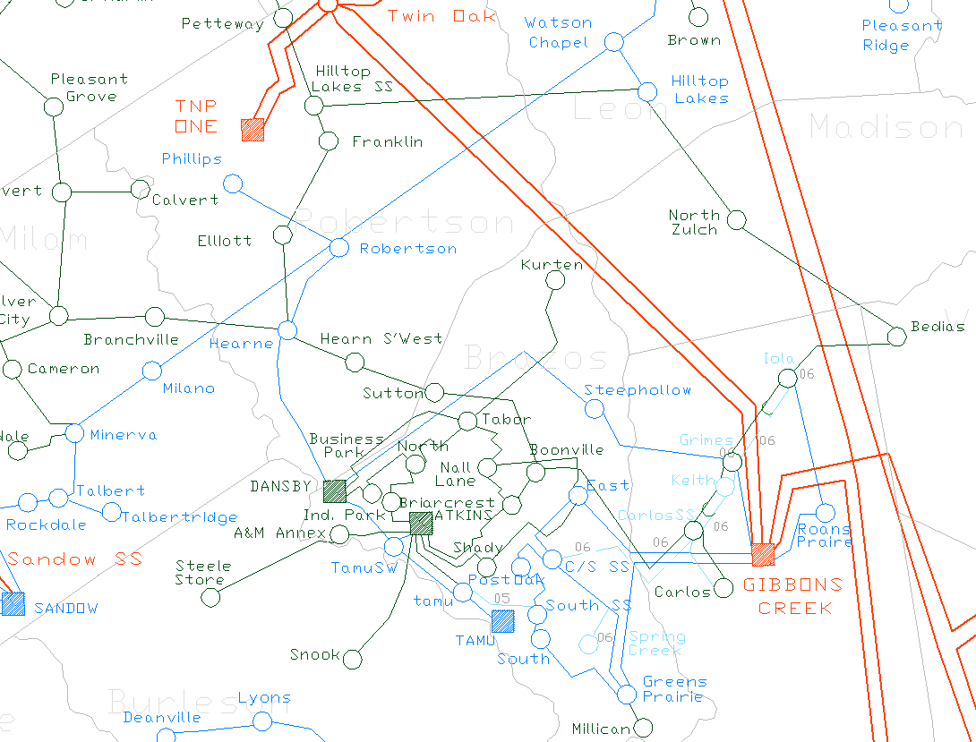
Figure 1: Bryan and College Station area Transmission System
This proposed transmission upgrade project includes the construction of a 345-kV switching station, Kurten Switch, in one of the Gibbons Creek to Twin Oak circuits. This switch station will include a 600-MVA 345/138-kV autotransformer with a double circuit 138-kV line to be constructed from Kurten Switch through Kurten substation into Tabor substation, tying into the Dansby-Steephollow 138-kV line where they intersect as shown in Figure 2. This project should be completed by summer 2009 at a net cost of approximately $16,620,000 (in 2005 dollars). Figure 2 depicts the transmission system in northeast Brazos County after these upgrades have been completed.
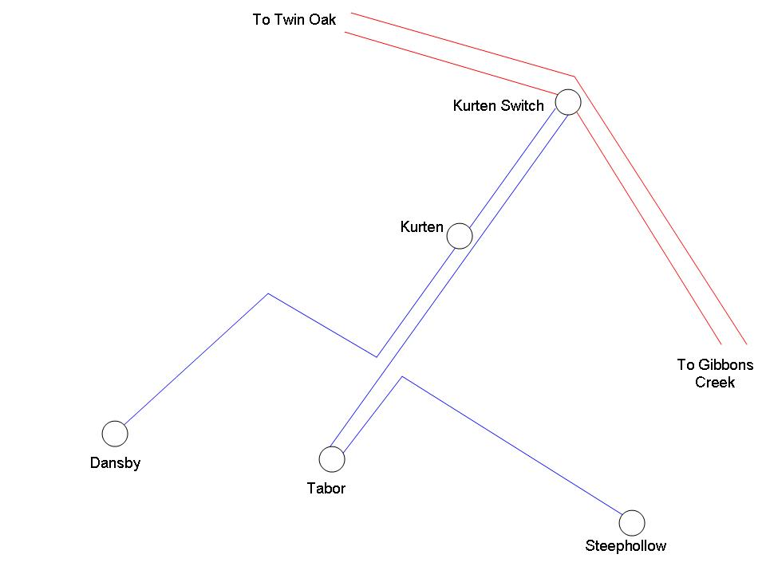
Figure 2: Northeast Brazos County Transmission System with Upgrades
HISTORY
On April 15, 2003 at about 11:30 AM, the majority of Brazos County, including the cities of College Station and Bryan, along with parts of Grimes and Burleson Counties, experienced a voltage collapse that resulted in loss of power to approximately 68,000 ERCOT customers and 212 MW of load. The event was initiated by the switching of the 345-kV breakers at Roan’s Prairie for a planned outage. Multiple protective relay component failures at Gibbons Creek resulted in the loss of both the 138-kV and 345-kV North and South buses at that station. This left both of the Gibbons Creek 345/138-kV autotransformers and all three 138-kV lines feeding the Bryan and College Station area from Gibbons Creek without power. The 171-MVA 138-kV Hearne-Dansby line remained as the sole transmission line supporting the area. The only other available source of power in the area, Dansby generation, eventually tripped as a result of the bus outages at Gibbons Creek. Power was restored to the area at approximately 3:30 PM.
The incident on April 15 is considered beyond ERCOT and NERC planning criteria due to the fact that it was caused by a double bus outage. This is an extremely rare occurrence. However, the outage illustrated that the Bryan and College Station area had weak connections to the rest of the ERCOT system and that ERCOT category B contingencies could result in thermal overloads and/or voltage collapse.
In August 2003, Brazos Electric Cooperative (BEC) submitted the Gibbons Creek to College Station Switch 138-kV project to the North Regional Planning Group (NRPG). This project, in part, relieves conditions that contributed to the April 15 voltage collapse by supplying an additional 138-kV source into the College Station area, albeit from Gibbons Creek. On February 6, 2004 ERCOT issued an independent review in support of the project. The following paragraph is an excerpt from the BEC submittal describing the project. Figure 3 illustrates the changes proposed by the project.
This project consists of converting 24 miles of 69 kV transmission line to 138 kV operation, rebuilding 3 miles of 138 kV line, constructing a 138 kV switching station and constructing approximately 2 miles of new 138 kV line. The conversion includes all transmission lines and substations from Carlos to Carlos S.S. and from Iola to Keith to Carlos S.S. from the north. Approximately 7 miles of the Carlos S.S. to Booneville 69 kV line will be converted to 138 kV operation using 1433 MCM ACSSTW to a point north of the city of College Station. 3 miles of the existing Gibbons Creeks to Steephollow 138 kV transmission line will be rebuilt with bundled 1590 MCM ACSR. A new 138 kV switching station will be constructed at the intersection of Brazos Electric’s existing 69 kV line, the Gibbons Creek to Steephollow 138 kV line and the Gibbons Creek to Twin Oak 345 kV line. A new 2 mile double circuit 138 kV line from College Station Switch substation to the endpoint of the 69 kV conversion will also be constructed using 1433 MCM ACSSTW. Brazos Electric’s remaining 69 kV transmission line to Booneville substation will be temporarily de-energized while other studies are performed to determine the best location to complete the 138 kV conversion. The existing 69kV tie with Bryan Texas Utilities (BTU) at Booneville will provide loop service for Brazos Electric’s 69 kV system back to the Hearne area. The items comprising this project and their estimated costs are shown in Exhibit GC.1. The estimated cost of the project is $16,212,200.
Figure 3: Gibbons Creek to College Station Switch 138-kV Project Upgrades
The regional planning group discussion resulted in a few changes to the scope of the project. The proposed double circuit out of College Station Switch was modified to a single circuit and the use of the remainder of the 69-kV line between Booneville and Carlos Switch was left for further study. Overall, the ERCOT North Regional Review did not result in any negative comments towards the project.
In October of 2003, Brazos submitted a second report to the original project entitled “Gibbons Creek to College Station Switch 138-kV Addendum.” This addendum was a result of discussions between Regional Planning Group members. The original project with the proposed changes found in the addendum is illustrated in Figure 4. The addendum included the following changes to the original project:
The original project calls for a 138 kV switching station, Keith Switch [also known as Grimes Switch], to be constructed in Brazos Electric’s existing 69 kV line from Keith to Iola at the intersection of the Gibbons Creek to Twin Oak 345 kV and Gibbons Creek to Steephollow 138 kV lines. Brazos has been in contact with TMPA about the ‘spare’ or reserve 400 MVA, 345/138 kV autotransformer that is located at Gibbons Creek. This auto is currently located at Gibbons Creek in the event one of the other 300 MVA autos is lost to contingency or becomes overloaded. Brazos has determined that the project would be improved if this auto were moved to Keith Switch thus creating a new 345 kV tie in the Gibbons Creek to Twin Oak 345 kV line. This would eliminate the need to reconductor the existing 138 kV line from Gibbons Creek to Keith Switch, at least for the foreseeable future. The items comprising this project with the addendum and the estimated costs are shown in Exhibit GCA.1. The estimated cost of the project has been revised to $17,303,650, approximately $1.1 million more than the previous estimate.
Figure 4: Gibbons Creek to College Station Switch 138-kV Project Addendum
Several comments were sent in by North Regional Planning Group members, including negative comments submitted by Bryan Texas Utilities (BTU). In May 2004, BTU completed a study of the area with proposed transmission upgrade alternatives to be constructed instead of the BEC project addendum. BEC, BTU, and the NRPG were not able to come to an agreement on how to proceed. In July 2004, ERCOT initiated an independent study to determine what would be the best short and long term solution(s) for the area.

SHORT TERM STUDY
The first task of the ERCOT study was to determine the transmission needs for the Bryan and College Station area for the next one to four years. Evaluation of the existing system showed that several contingencies resulted in low voltage conditions (below 0.90 pu) and thermal overloads. Additionally, the loss of the Gibbons Creek to East and Gibbons Creek to Greens Prairie double circuit 138-kV line would cause a voltage collapse during peak load conditions.
P-V analysis revealed that in 2005 the loss of the Gibbons Creek to East and Gibbons Creek to Greens Prairie double circuit 138-kV line would result in voltage collapse when the load in Bryan and College Station was above 318.4 MW if Dansby, Atkins, and Texas A&M generation were offline. This is 34.1% below the projected peak demand of 483.4 MW in the area. Based on the 2004 East Weather Zone load duration curve, load will be at or above 65.9% of peak for 20% of the time, or approximately 1,752 hours per year. Figure 5 shows the 2004 East Weather Zone load duration curve.
The P-V analysis was run again with local generation turned on and dispatched according to the SSWG 2005 summer peak base case. Dansby plant output was set at 136.3 MW, Atkins plant output was set at 45.75 MW, and Texas A&M self-serve plant output was set at 28 MW. Under this scenario the loss of the Gibbons Creek to East and Gibbons Creek to Greens Prairie double circuit 138-kV line resulted in voltage collapse when the load in Bryan and College Station was above 518.4 MW. This is 7.2% above the projected peak demand of the area and just within the NERC planning criteria of maintaining voltage security at a 2.5% margin over the projected peak. Figure 6 shows the Bryan and College Station load level at which the voltage will collapse under contingency.
Figure 5: 2004 East Weather Zone Load Duration Curve
Figure 6: Bryan and College Station 2005 Voltage Collapse Load Level
BEC, BTU, Texas Municipal Power Agency (TMPA), and the City of College Station Utilities (CSU) have each proposed various transmission upgrades to correct the above post-contingency problems. Each of the below projects were assumed to be necessary:

BEC Upgrades
Rebuild Watson Chapel to Jewett 138-kV line (Winter 2006 completion)
Complete 69-kV to 138-kV conversion from Hilltop Lakes to Iola (Winter 2006 completion)
Gibbons Creek to College Station Switch 138-kV project (Summer 2006 completion)
BTU Upgrades
Construct 138-kV line from Bryan South Switch to Texas A&M (Summer 2005 completion)
Install 54-MVAR switched shunt at Atkins (Summer 2005 completion)
Install 27-MVAR switched shunt at Nall (Winter 2006 completion)
Install 54-MVAR switched shunt at East (Winter 2006 completion)
Rebuild Dansby-Atkins 138-kV line to have a Rate B of 255 MVA (Summer 2007 completion)
Construct 138-kV bus at Tabor with 138/69-kV autotransformer (Summer 2007 completion)
Reconfigure Atkins to Jones (new substation) to Snook to Steel Store to A&M Annex to Dansby 138-kV line (Summer 2008 completion)
TMPA Upgrades
Place third autotransformer at Gibbons Creek permanently in service (Summer 2005 completion)
Upgrade Gibbons Creek to Keith Switch 138-kV line to have a Rate B of 717-MVA (Summer 2006 completion)
Install circuit breakers to isolate the Gibbons Creek autotransformers (Winter 2007 completion)
CSU Upgrades
Install 54-MVAR switched shunt at Greens Prairie (Summer 2005 completion)
Upgrade College Station Switch to Post Oak 138-kV line to have a Rate B of 386 MVA (Summer 2006 completion)
Upgrade Post Oak to Southwood 138-kV line to have a Rate B of 386-MVA (Summer 2007 completion)
Upgrade Southwood to Bryan South Switch bus tie to have a Rate B of 386-MVA (Summer 2007 completion)
Construct Spring Creek substation in 2006, Northgate substation in 2008, and Wellborn substation in 2010
The 2006 summer peak case containing the projects planned to be complete by summer 2006 was used to run P-V analysis for the area. In this case, with no local generation on, the loss of the Gibbons Creek to East and Gibbons Creek to Greens Prairie double circuit 138-kV line resulted in voltage collapse when the load in Bryan and College Station was above 745 MW. This is 47.5% above the projected peak of 505 MW. Figure 7 shows the Bryan and College Station load level at which the voltage will collapse under contingency in 2006.
When all of the above planned upgrades (through 2008) were applied it was found that the post-contingency voltage depression problems had been corrected and that no contingency caused a voltage collapse at summer peak. In short, these upgrades provide adequate transmission support for the area in the near term. However, in the Steady State Working Group 2005 Data Set B 2010 summer peak case there were numerous post-contingency thermal overloads. For this reason, a long-term study for the area was initiated.
Figure 7: Bryan and College Station 2006 Voltage Collapse Load Level

LONG TERM STUDY
The Steady State Working Group 2005 Data Set B 2010 summer peak base case created in December 2004 was used to study the long term requirements for the Bryan and College Station area. The aforementioned upgrades by BEC, BTU, TMPA, and CSU were applied to the case. Three separate generation dispatch scenarios were studied. Rate B was used for all analysis.
In the first generation scenario studied, all generation in the area was available and on-line.
For the second generation scenario studied, only the Dansby 2 generation was on-line (at its maximum output of 49MW). Texas A&M generation was not modeled as being available since ERCOT does not have dispatch control over this generation and Atkins was modeled as unavailable due to the potential that it might retire or be mothballed Dansby 1 was offline because it is the largest unit in the area and represents the worse-case situation under the planning criteria.
A third dispatch studied (dispatch scenario 3) was used to study the affect of having no generation available in the Bryan and College Station area during summer peak. Generation at the Hays plant was increased to make up for the loss of generation in the case.
P-V analysis was performed for the worst case dispatch scenario 3. It was found that the voltage collapsed for the loss of the Gibbons Creek to East and Gibbons Creek to Greens Prairie double circuit 138-kV line, but not until the Bryan and College Station area load was above 798.6 MW with no local generation on. This is a margin of 34.4 % over the 2010 peak load of 594.4 MW and is well within the planning criteria standard for voltage stability. Figure 8 shows the Bryan and College Station load level at which the voltage will collapse under contingency in 2010. Thus, thermal overloads are the only criteria violations of concern in this time frame.
Figure 8: Bryan and College Station 2010 Voltage Collapse Load Level
AC contingency analysis was conducted for all three generation dispatch scenarios. For the first dispatch scenario there were no post-contingency thermal overloads in the Bryan and College Station area.
Appendices A and B summarize the area post-contingency overloads for the 2010 case for dispatch scenarios 2 and 3. Per the ERCOT planning criteria, only the overloads that exist with dispatch scenario 2 must be solved. If an overload exists with scenario 3 generation dispatch, but not with scenario 2, this indicates the overload can be resolved with generation redispatch.
Ten different transmission upgrade alternatives were considered by ERCOT in order to find a solution to the overloads listed in Appendix A (dispatch scenario 2). The premise of each alternative project analyzed was to create a stronger connection between the Bryan and College Station area and ERCOT that solved the transmission overload problems in the most economical way. The conceptual ideas of these ten projects are as follows:
Option 1
Construct an approximately 100-mile 345-kV line from TNP One to Salem. Install two 345/138-kV autotransformers in the Bryan and College Station area – one at Dansby and one further south, possibly at Snook.
This option was the most significant studied since it involves approximately 100 miles of new 345-kV right of way (ROW). Looking at past history of similar 345-kV projects, it can be concluded that this project would cost well over $100 million and may not be completed until after 2010. Initial studies indicated that building this line with two autotransformers in the Bryan and College Station area would not solve all of the post-contingency overloads in Appendices A and B, including the overload of the Gibbons Creek autotransformers under contingency. Because of this and since initial economic analysis indicated very little possible production cost savings this option was not considered further.
Option 2
Construct an approximately 50-mile radial 345-kV line from Sandow to Dansby. Install one 345/138-kV autotransformer at Dansby.
This option also represents a significant project in terms of new ROW, cost, and construction time. Initial studies indicate that this line did very little to prevent post-contingency overloads in the Bryan and College Station area. This option was not considered further.
Option 3
Replace the three 345/138-kV autotransformers at Gibbons Creek with three new autotransformers with ratings of 600 MVA each. Additionally, reconductor the Gibbons Creek to Greens Prairie 138-kV line to have a Rate B of 386 MVA.
When the above upgrades were added to the case they induced other overloads. Because of this the following transmission upgrades were necessary:
- Rebuild Greens Prairie to Bryan South to Bryan South Switch 138-kV line to have a Rate B of 422 MVA
- Reconductor Gibbons Creek to East 138-kV line to have a Rate B of 386 MVA
- Complete the Booneville to College Station Switch 138-kV upgrade
- Convert Booneville to Tabor to 138-kV operation
- Move the 69-kV line from Sutton to terminate at Tabor
With these upgrades all post-contingency overloads in Appendices A and B were relieved.
Option 4
Construct a 345-kV bus at Keith Switch with a 600-MVA autotransformer. Additionally, reconductor the Gibbons Creek to Greens Prairie 138-kV line to have a Rate B of 386 MVA.
When the above upgrades were added to the case they induced other overloads. Because of this the following transmission upgrades were necessary:
- Rebuild Greens Prairie to Bryan South to Bryan South Switch 138-kV line to have a Rate B of 422 MVA
- Reconductor Gibbons Creek to East 138-kV line to have a Rate B of 386 MVA
- Complete the Booneville to College Station Switch 138-kV upgrade
- Convert Booneville to Tabor to 138-kV operation
- Move the 69-kV line from Sutton to terminate at Tabor
With these upgrades all post-contingency overloads in Appendices A and B were relieved.
Option 5
Construct a new 345-kV switch station approximately 8 miles north and west of Gibbons Creek on the Gibbons Creek to Twin Oak double circuit 345-kV lines. Install an autotransformer with a Rate B of at least 600 MVA at this switch station and construct a new, approximately 11-mile 138-kV line from this switch station to Steephollow substation. This new 138-kV line should have a Rate B of 422 MVA.
This option had approximately the same affect that installing an autotransformer at Keith Switch Station had in terms of relieving post-contingency overloads. Since this option would be significantly more expensive due to the new ROW, line, and switch station it was not considered further.
Option 6
Create a 138-kV bus at TNP One and install a 600-MVA 345/138-kV autotransformer. Construct a new, approximately 4-mile 138-kV line from TNP One to Phillips substation. Rebuild the Phillips to Robertson 138-kV line to have a Rate B of 422 MVA.
This option alone did not completely relieve all of the overloads in Appendices A and B. Because of this the following transmission upgrades were necessary:
- Reconductor Gibbons Creek to Greens Prairie 138-kV line to have a Rate B of 386 MVA
- Rebuild Robertson to Hearne 138-kV line to have a Rate B of 422 MVA
- Complete the Booneville to College Station Switch 138-kV upgrade
- Convert Booneville to Tabor to 138-kV operation
- Complete the Hearne to Tabor 138-kV upgrade
With these upgrades all post-contingency overloads in Appendices A and B were relieved.
Option 7
Create a 345-kV bus at Greens Prairie and build a new, approximately 13-mile 345-kV line from Gibbons Creek to Greens Prairie. Install an autotransformer with a Rate B of at least 600 MVA at Greens Prairie.
When the above upgrade was added to the case it induced other overloads which would require a significant amount of lines to be rebuilt. This option was not considered further.
Option 8
Create a 345-kV bus at Dansby and loop one of the existing 345-kV lines from Gibbons Creek to Twin Oak into Dansby. This would consist of constructing approximately 20 miles of new double circuit 345-kV line on new ROW and the installation of a 600-MVA 345/138-kV autotransformer at Dansby.
Additionally, the following upgrades were applied:
- Complete the Booneville to College Station Switch 138-kV upgrade
- Convert Booneville to Tabor to 138-kV operation
- Move the 69-kV line from Sutton to terminate at Tabor
With these upgrades all post-contingency overloads in Appendices A and B were relieved.
Option 9
Install a 100-MW DC tie between ERCOT and SERC at College Station Switch or purchase the SERC line currently owned by Entergy which runs from near College Station Switch to the Tenaska Frontier power plant.
This option did not solve all of the overloads in Appendices A and B. Since it would require additional upgrades and because either the DC tie or purchasing the SERC line would involve complexities on various levels, this option was not considered further.
Option 10
Construct a 345-kV switching station, Kurten Switch, with a 600-MVA 345/138-kV autotransformer in one of the Gibbons Creek to Twin Oak circuits. Construct a double circuit 138-kV line from Kurten Switch through Kurten into Tabor. Additionally, the Dansby to Steephollow 138-kV line would be broken so that the portion to Steephollow would tie into Tabor and the portion to Dansby would tie into Kurten. Figure 9 shows the Kurten area configuration for Option 10.
The following upgrades were also applied:
- Complete the Booneville to College Station Switch 138-kV upgrade
- Convert Booneville to Tabor to 138-kV operation
- Move the 69-kV line from Sutton to terminate at Tabor
With these upgrades all post-contingency overloads in Appendices A and B were relieved.
In addition, the upgrades mitigate the need for BTU’s planned transmission upgrades in the Kurten area. This includes alleviating the need to extend the 69-kV line from Kurten to a new substation and looping this substation back to Tabor.
Figure 9: Option 10 Configuration
As stated above, Options 1, 2, 5, 7, and 9 were not considered feasible and will not be further referenced in this report.
In addition to evaluating Options 3, 4, 6, 8, and 10 for post-contingency thermal overloads, each option was examined for steady state post-contingency bus voltage violations of less than 0.90 per unit (pu). The 2010 case with no local generation was used for this analysis. Appendices G-K show all of the post-contingency bus voltages 0.95 pu or less, excluding offline generator buses. None of the options had post-contingency bus voltages less than 0.94 pu and Options 6, 8, and 10 did not have any below 0.95 pu. Because of this, Options 3, 4, 6, 8, and 10 were considered satisfactory for steady state voltage support.
Economic Analysis of Long Term Options
BEC and TMPA provided estimates for the material and construction costs. BEC and TMPA created these estimates independently for all options in order to ensure fair and accurate results. Table 1 shows the capital cost estimates for Options 3, 4, 6, 8 and 10. All cost estimates are in terms of 2005 dollars.
Transmission Upgrade | Cost Estimate
Option 3 | $23,690,000
Option 4 | $19,410,000
Option 6 | $27,688,400
Option 8 | $32,300,000
Option 10 | $16,620,000
Table 1: Transmission Upgrade Cost Estimates
Appendix C shows the cost estimate details for Table 1. Note that the total cost for Option 10 has the cost of the mitigated Kurten area upgrades subtracted. The list of these mitigated costs is also in Appendix C.
In order to analyze the long term ability of each option to meet future transmission needs a study was conducted to investigate transmission elements in the area that are post-contingency loaded at 90% or greater with these options installed. Again, the 2010 case was used to examine this condition.
Appendices D-F show the elements post-contingency loaded at 90% or greater with dispatch scenario 2 in the Bryan and College Station area for Options 6, 8, and 10. There were no elements loaded 90% or greater with dispatch scenario 2 for Options 3 and 4. Appendices G-K show the elements post-contingency loaded at 90% or greater with no local generation running.
Table 2 shows the number of post-contingency elements loaded 90% or greater for each of the options in the 2010 case with no local generation.
Transmission Upgrade | Elements 90% Loaded | Description of Elements 90 % Loaded
Option 3 | 0 separate contingencies resulted in 90% loading of 0 elements* | None
Option 4 | 0 separate contingencies resulted in 90% loading of 0 elements* | None
Option 6 | 5 separate contingencies resulted in 90% loading of 5 different elements* | ~4.7 miles of 138-kV line,  3 345/138-kV autotransformers
Option 8 | 3 separate contingencies resulted in 90% loading of 1 different element* | ~12.9 miles of 138-kV line
Option 10 | 8 separate contingencies resulted in 90% loading of 3 different elements* | ~17.6 miles of 138-kV line
*Note: Bus ties were not included in the count
Table 2: Summary of Number of Post-Contingency Elements Loaded 90% or Higher in 2010
To further study the long term ability of each option to meet future transmission needs all loads in Brazos County were scaled 34% in the 2010 summer peak study case. This represents a rough simulation for ten years of load growth, assuming an aggressive 3% load growth per year at each load. Each option was analyzed at this load level to determine the additional number of overloaded elements that would potentially need to be upgraded between 2010 and 2020. The generation dispatch scenario used assumed no local generation would be running. Appendices L-P show the results of this analysis and Table 3 summarizes these results.
Transmission Upgrade | Overloads | Description of Overloaded Elements
Option 3 | 10 separate contingencies resulted in overloads of 9 different elements* | ~73.6 miles of 138-kV line
Option 4 | 8 separate contingencies resulted in overloads of 7 different elements* | ~54.4 miles of 138-kV line  3 345/138-kV autotransformers
Option 6 | 8 separate contingencies resulted in overloads of 6 different elements* | ~19.2 miles of 138-kV line  3 345/138-kV autotransformers
Option 8 | 13 separate contingencies resulted in overloads of 4 different elements* | ~21.6 miles of 138-kV line  2 345/138-kV autotransformers
Option 10 | 20 separate contingencies resulted in overloads of 6 different elements* | ~17.6 miles of 138-kV line  3 345/138-kV autotransformers
*Note: Bus ties were not included in the count
Table 3: Summary of Number of Post-Contingency Overloads with 2010 Load Scaled 34%
Examining the results of Tables 2 and 3 shows that both Options 3 and 4 have no elements that are loaded 90% or greater in 2010. However, as load grows in the area, many lines would be overloaded and have to be rebuilt by 2020 due to the concentration of power injection in a small area near Gibbons Creek. With Options 4, 6, 8, and 10, the autotransformers at Gibbons Creek would have to be replaced between 2010 and 2020.
Additional economic analysis was conducted in an effort to compare production cost savings between the five options. The results of this analysis showed no discernable production cost differences between the five options. These results are consistent with the results of the contingency analysis which showed that each option solved all of the post-contingency overloads in the area, thereby eliminating local congestion.
Timeline Analysis
Finally, an analysis of the time to implement each of the options was conducted. All of the transmission line upgrades associated with Options 3 and 4 involve reconductoring or rebuilding lines with virtually no need for new ROW. The total length of lines being reconductored in Options 3 and 4 is approximately 27.4 miles and the length of lines being rebuilt is approximately 4.7 miles. Additionally, Option 4 involves adding a 345-kV bus at Keith Switch. It was determined that both Options 3 and 4 could be implemented by summer 2009.
Option 6 includes adding 138-kV bus work at TNP One along with approximately 4 miles of new ROW 138-kV line construction, the reconductoring of approximately 12.9 miles of 138-kV line, and rebuilding approximately 19.2 miles of line. This Option could be implemented by summer 2009.
Option 8 presents the most significant time to implement due to the approximately 20 miles of new ROW for double circuit 345-kV line construction. Additionally, it would require 345-kV bus work be added at Dansby. The probable implementation date of Option 8 is summer 2010.
Option 10 would require 14 miles of new 138-kV double circuit line be constructed; approximately 6.5 miles of that on new ROW with the remainder on expanded ROW. Additionally, significant substation work would be required at Kurten. Option 10 could be implemented by summer 2009.
Figure 10: Upgrade Implementation Timeline for Options 3, 4 6, 8 and 10

LONG TERM CONCLUSION
Ten transmission upgrade options were evaluated to solve the long term needs of the area’s system if Atkins generation is not available. After initial analysis the list was pared down to five possible upgrades: Options 3, 4, 6, 8, and 10.
When assessing the viability of each of the options for the system conditions in 2010, Options 3, 4, 6, 8, and 10 equally solved the reliability needs of the area. None offered additional production cost savings over the others. Evaluating the potential for each option to serve the needs of the area beyond 2010 shows that Option 10 requires the fewest potential upgrades between 2010 and 2020.
Options 3 and 4 would prove to be the most difficult to obtain construction outages because they both involve reconductoring the Gibbons Creek to East and Gibbons Creek to Greens Prairie 138-kV lines. A significant portion of this work would require taking this double circuit out of service for extended times. Without another strong source into the area this would require operating in an insecure state even if all local generation were running. Taking this outage may not be possible even at low load levels.
Option 10, at a net cost of $16,620,000, is the least expensive option and was chosen as the preferred long-term solution. Additionally, none of the other options could be implemented sooner than Option 10 which could be in place by summer 2009.
In the short term (2005-2008), it is critical that each of the planned upgrades that BEC, BTU, TMPA, and CSU have scheduled be implemented in a timely manner including TMPA’s installation of breakers to isolate the Gibbons Creek autotransformers.

Proposed Long Term transmission solution:
- Construct a 345-kV substation, Kurten Switch, in one circuit of the Twin Oak-Gibbons Creek 345-kV double circuit lines with a 345/138-kV 600-MVA autotransformer
- Construct a double circuit 138-kV line from Kurten Switch through Kurten into Tabor; break the Dansby to Steephollow 138-kV line so that the portion to Steephollow ties into Tabor and the portion to Dansby ties into Kurten
- Complete the Booneville to College Station Switch 138-kV upgrade
- Convert Booneville to Tabor to 138-kV operation
- Move the 69-kV line from Sutton to terminate at Tabor
APPENDIX A
2010 summer peak post-contingency overloads with Dansby unit 1 offline and Dansby unit 2 set at 49 MW (dispatch scenario 2)

APPENDIX B
2010 summer peak post-contingency overloads with all local generation off (dispatch scenario 3)

APPENDIX C
Transmission upgrade cost estimates for options 3, 4, 6, 8, and 10:
APPENDIX D
2010 summer peak case with Option 6 applied and with dispatch scenario 2; transmission elements post-contingency loaded to 90% or greater
APPENDIX E
2010 summer peak case with Option 8 applied and with dispatch scenario 2; transmission elements post-contingency loaded to 90% or greater
APPENDIX F
2010 summer peak case with Option 10 applied and with dispatch scenario 2; transmission elements post-contingency loaded to 90% or greater
APPENDIX G
2010 summer peak case with Option 3 applied and with no local generation; transmission elements post-contingency loaded to 90% or greater

2010 summer peak case with Option 3 applied and with no local generation; buses with post-contingency voltage 0.95 or lower
APPENDIX H
2010 summer peak case with Option 4 applied and with no local generation; transmission elements post-contingency loaded to 90% or greater
None

2010 summer peak case with Option 4 applied and with no local generation; buses with post-contingency voltage 0.95 or lower
APPENDIX I
2010 summer peak case with Option 6 applied and with no local generation; transmission elements post-contingency loaded to 90% or greater
Note: Further analysis using PSS/E revealed the Gibbons Creek autotransformers are loaded at 98% of their 300-MVA capacity under contingency. The violations in the above report are due to calculation approximations in MUST AC Contingency Analysis.

2010 summer peak case with Option 6 applied and with no local generation; buses with post-contingency voltage 0.95 or lower
None
APPENDIX J
2010 summer peak case with Option 8 applied and with no local generation; transmission elements post-contingency loaded to 90% or greater

2010 summer peak case with Option 8 applied and with no local generation; buses with post-contingency voltage 0.95 or lower:
None
APPENDIX K
2010 summer peak case with Option 10 applied and with no local generation; transmission elements post-contingency loaded to 90% or greater

2010 summer peak case with Option 10 applied and with no local generation; buses with post-contingency voltage 0.95 or lower:
None
APPENDIX L
2010 summer peak case with Brazos County load scaled 34%, Option 3 applied and no local generation; transmission elements post-contingency loaded to 100% or greater
APPENDIX M
2010 summer peak case with Brazos County load scaled 34%, Option 4 applied and no local generation; transmission elements post-contingency loaded to 100% or greater
APPENDIX N
2010 summer peak case with Brazos County load scaled 34%, Option 6 applied and no local generation; transmission elements post-contingency loaded to 100% or greater
APPENDIX O
2010 summer peak case with Brazos County load scaled 34%, Option 8 applied and no local generation; transmission elements post-contingency loaded to 100% or greater
APPENDIX P
2010 summer peak case with Brazos County load scaled 34%, Option 10 applied and no local generation; transmission elements post-contingency loaded to 100% or greater

BTU has subsequently announced plans to mothball the Atkins units in June 2006.

