SCR Number | 736SCR
SCR Title | TML – ESIID TXN Portal Flag
Other Document Reference/Source
Requested Resolution | Data Flag to indicate Portal generated ESIID registration transactions displayed under TML Market Activities>Query ESIID Transactions>Find Transactions function.
System Change Description | Append a data Flag of “P” to the Transaction Type number to indicate when a displayed transaction was generated and transmitted through the Texas Market Link portal by Market Participants, rather than being generated by Market Participant’s system and transmitted in the Market via GISB.
Reason for Revision | When one looks at ESIID transactions on the Portal using the "Find Transactions" function under the Market Activities tab, one can drill down to see all of the 814 & 867 transactions recorded in ERCOT's system for a particular ESIID. However, not all transactions recorded at ERCOT were received via GISB. Some of the transactions may have been submitted by a MP through the Portal. ERCOT may also have issued transactions to a MP without sending them via GISB.  In investigating the transaction lifecycles of an ESIID, it is important for MP to understand when transactions were generated in the Portal. Otherwise, an MP might think they had lost some inbound transaction, when no transaction actually flowed or the MP might be concerned about how a transaction was received at ERCOT when it did not generate and transmit a registration transaction through its Market Interface System(s).

Timeline
Date Posted | 7/8/04
See the Master List on ERCOT website for current timelines.

Sponsor
Name | Jesse Reyes
E-mail Address | jreyes1@txu.com
Company | TXU Portfolio Management
Company Address | 1717 Main St., Ste. 19-367 Dallas, TX 75201
Phone Number | (214) 875-9601
Fax Number

Business Case for Proposed System Change
[Please provide sufficient detail]

Issue: This ESIID switch (814-01) was initiated through the Portal. The 814-03 and 814-04 were transmitted via GISB. The 814-05 was posted on the TML and not sent via GISB. The 814-06 was sent to losing CR via GISB. The 814-07 was sent via GISB. There is nothing on the displayed transactions to indicate that some of these transactions were generated in the TML Portal.

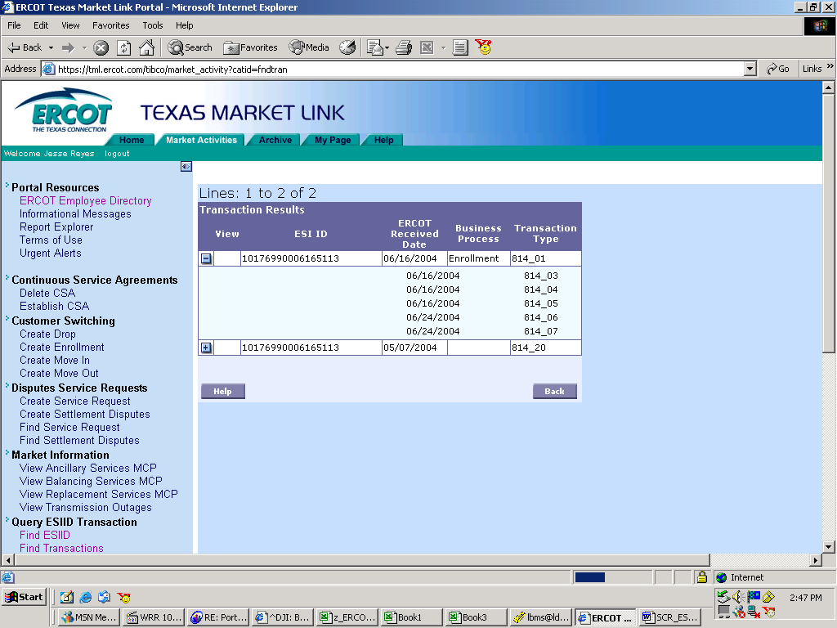

Resolution: Append a data Flag of “P” to the Transaction Type number to indicate when a displayed transaction was generated and transmitted through the Texas Market Link portal by Market Participants, rather than being generated by Market Participant’s system and transmitted in the Market via GISB.

