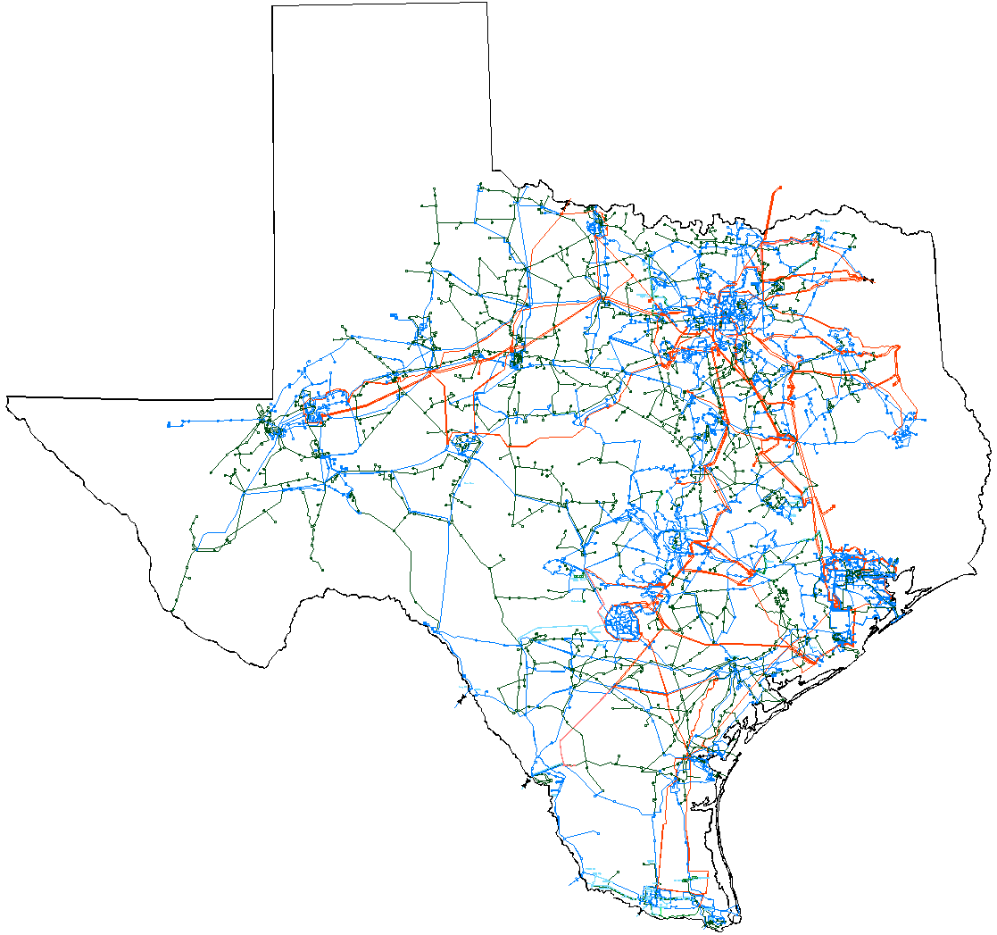

August 2005 Report
To
Technical Advisory Committee
Reliability and Operations Subcommittee

Prepared by ERCOT Transmission Services
Transmission Project Summaries
Additional detailed project information is contained in the August 1 Transmission Project Information Tracking workbook posted in the “Operations and System Planning” data area on the internet. See links at end of this document for address.
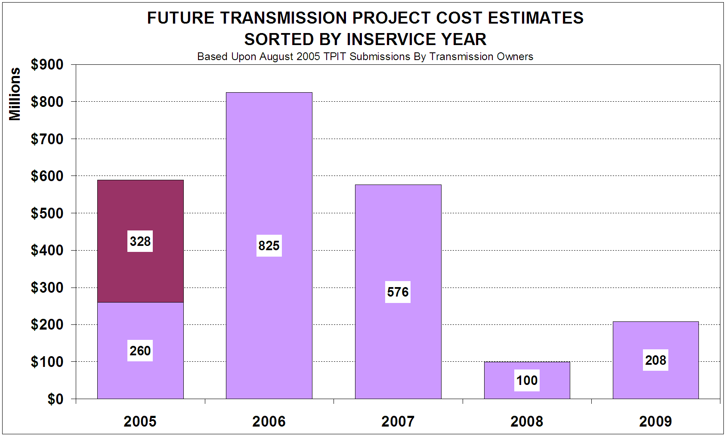
Completed Projects

Future Projects

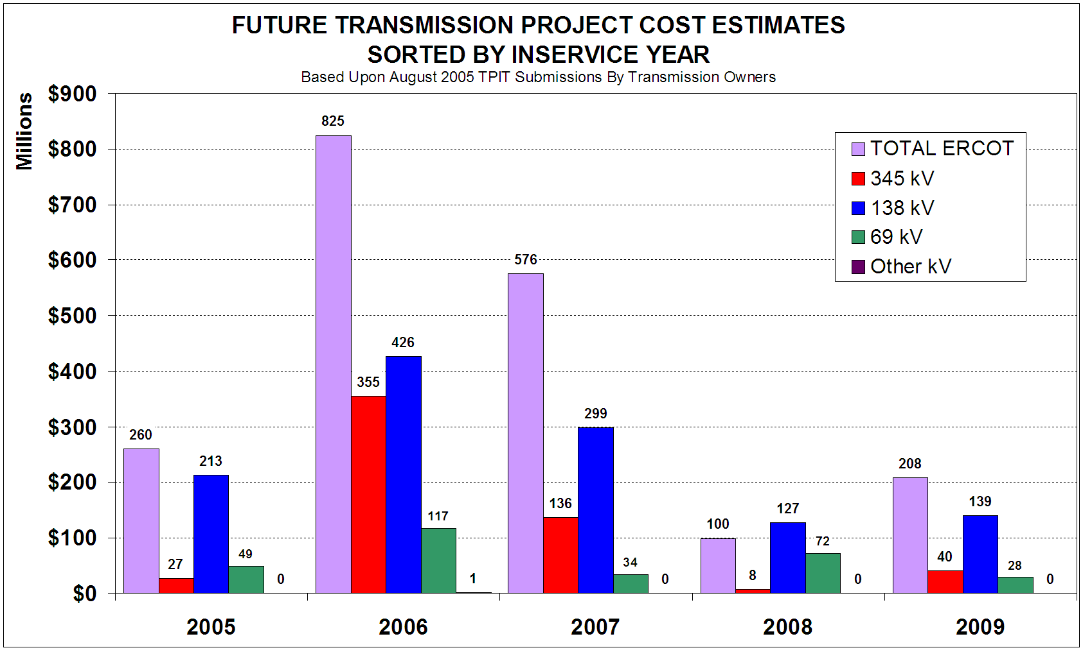

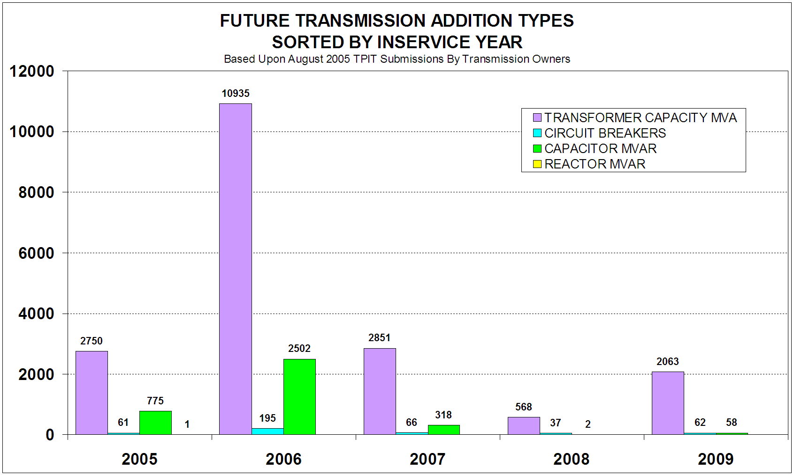

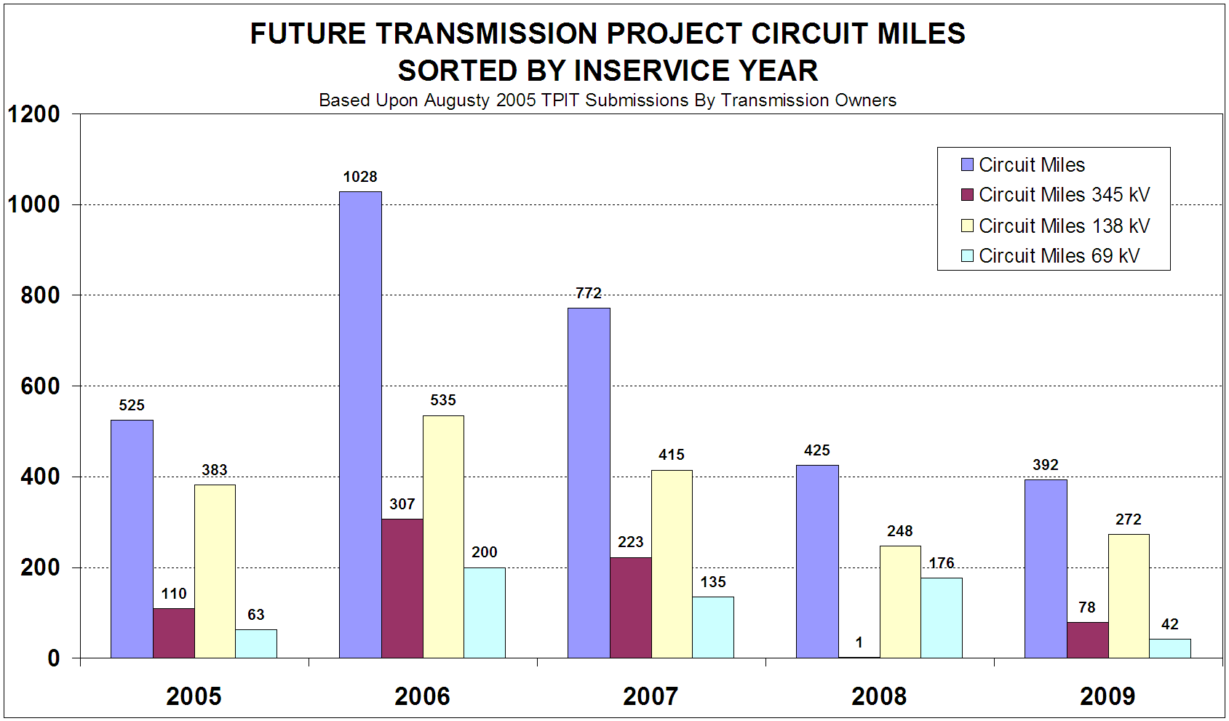

Major transmission projects recently completed
Additional detailed project information is contained in the August 1 Transmission Project Information Tracking workbook posted in the “Operations and System Planning” data area on the internet. See links at end of this document for address.

Project Title | Project Description | Transmission Owner | In-Service Date | kV | Location County
Kendall 345/138 kV autotransformer # 2 | Install a second 345/138 kV autotransformer at the Kendall substation | LCRA | Aug-05 | 345 | KENDALL
EXXON - Bertron, S R Plant ckt.03 | Raised conductors to increase thermal ratings. | CNP | Jul-05 | 138 | HARRIS
Parkway Tap - Glenwood ckt.95 | Raised conductors to increase thermal ratings | CNP | Jul-05 | 138 | HARRIS
Greens Bayou - Parkway Tap ckt.95 | Raised conductors to increase thermal ratings | CNP | Jul-05 | 138 | HARRIS
Killeen Switch 138 kV capacitors | Install 138 kV capacitors | TXU ED | Jul-05 | 138 | BELL
Sun 138 kV capacitors | Install 138 kV capacitors | TXU ED | Jul-05 | 138 | SCURRY
Waco E system reactive capacitors | Install 138 kV capacitors | TXU ED | Jul-05 | 138 | MCLENNAN
Westfield | Installed new 138kV 80 MVAR capacitor bank on 138kV ckt.66 to Treaschwig. | CNP | Jul-05 | 138 | HARRIS
Central Austin : Build 69 kV Substation | Establish a new substation with (2) 30MVA transformers between Fiesta and Koenig Lane substations. New 69-kV transmission lines will be established. | Austin Energy | Jul-05 | 69 | TRAVIS
Alamito Creek, add 7.2 MVAR capacitor | Add 259 MVAR of static and 75 MVAR of dynamic reactive support throughout the McCamey area | AEP/TNC | Jul-05 | 69 | PRESIDIO
White Oak North | Increased reactive capability to 120MVAR | CNP | Jul-05 | 138 | HARRIS
Construct Booster 138KV Substation | Serve substation by looping into ckt.02 Velasco - Seaway | CNP | Jul-05 | 138 | BRAZORIA
Burleson Auto Relocation and Circuit 831 conversion | Relocate the existing 220MVA Burleson autotransformer to replace the failed Seaholm autotransformer and convert the 69kV Circuit 831 back to 138kV Circuit 1015. | Austin Energy | Jul-05 | 138 | TRAVIS
Jack County Plant to Cottondale Sw | Construct 3 138kv circuits from Jack County plant to vicinity of Cottondale Sw. | Brazos | Jul-05 | 138 | JACK
Reno to Cottondale Switch | Rebuild existing Reno to Cottondale Sw. 69kv line with 138kv const. | Brazos | Jul-05 | 138 | WISE
Southwest Research (SWRI) loop 138 kV line | Build new 138 kV line to SWRI substation | CPS | Jul-05 | 138 | BEXAR
Northwest Reliability Project, Phase 1 | Converted Kluge to a breaker substation. Looped Kluge into ckt.81 Klein - Pinehurst and ckt.21 Cameron - Addicks. Upgraded limiting equipment at Cameron and Kluge. Installed new 80 MVAR capacitor bank @ Kluge and 14.4 MVAR capacitor banks @Gertie and Cyfair. | CNP | Jun-05 | 138 | HARRIS
Allen Switch system reactive capacitors | Install 138 kV capacitors | TXU ED | Jun-05 | 138 | COLLIN
Crosby | Installed new 138kV 100 MVAR capacitor bank on 138kV ckt.66 to Atascocita. | CNP | Jun-05 | 138 | HARRIS
Cedar Bayou 345/138 kV autotransformer | Added fourth 345/138 kV, 800MVA autotransformer (A1) @Cedar Bayou and reconnected third auto (A3) to the west bus, parallel to 2A & 2B | CNP | Jun-05 | 345 | HARRIS
Flewellen - Obrien ckt.73 | Bundled 138kV Flewellen - Obrien ckt.73 and upgraded limiting equipment @Obrien and Flewellen substations to increase thermal ratings. | CNP | Jun-05 | 138 | FORT BEND
Liggett - Euless 138 kV line | Upgrade underground sections of 138 kV line | TXU ED | Jun-05 | 138 | DALLAS
Construct Goodyear 138KV Substation | Looped into Deepwater - Magnolia Park ckt.70 | CNP | Jun-05 | 138 | HARRIS
Plano Tennyson system reactive capacitors | Install 138 kV capacitors | TXU ED | Jun-05 | 138 | COLLIN
Carrollton East system reactive capacitors | Install 138 kV capacitors | TXU ED | Jun-05 | 138 | DALLAS
Iron Bridge 138/69 kV autotransformer | Install 138/69 kV autotransformer | TXU ED | Jun-05 | 138 | HUNT
Greens Bayou | Installed new 138kV 120 MVAR capacitor bank on 138kV ckt.70 to Lydell. | CNP | Jun-05 | 138 | HARRIS
Price Rd 138-kV Substation | Convert Price Rd Substation from 69-kV to 138-kV | BPUB | Jun-05 | 138 | CAMERON
Lake Creek second 345/138 kV autotransformer | Install a 600 MVA 345/138 kV autotransformer | TXU ED | Jun-05 | 345 | MCLENNAN
Deepwater - South Houston ckt.13 | Upgrade limiting equipment at South Houston to increase thermal ratings. | CNP | Jun-05 | 69 | HARRIS
Deepwater - South Houston ckt.13 | Upgraded limiting equipment at South Houston to increase thermal ratings. | CNP | Jun-05 | 69 | HARRIS
Ft. Lancaster to Friend Ranch, build 138 kV line | Addition of a Fort Lancaster to Friend Ranch 2x795 ACSR 138 kV line and double circuit capable structures | LCRA/AEP | Jun-05 | 138
Fair Oaks Ranch 138 kV Substation loop | Install new 138kV substation loop into existing Boerne (LCRA) to Fair Oaks (LCRA) line. | CPS | Jun-05 | 138 | KENDALL
Cedar Bayou - Baytown ckt.88 | Raised conductors and partially reconductored ckt.88 Cedar Bayou - Baytown, and upgraded limiting equipment @Cedar Bayou to increase thermal ratings. | CNP | Jun-05 | 138 | HARRIS
Kendall-Miller Creek | Increase the line-to-ground clearance on the 40.4-mile Kendall(7152)-Miller Creek(7479) 138-kV transmission line as necessary to upgrade the circuit from its existing design rating of 82-MVA to its full conductor rating of 128-MVA. | LCRA | Jun-05 | 138 | KENDALL
Price Rd - Filter Plant 138-kV Circuit | Upgrade existing 69-kV circuit to 138-kV | BPUB | Jun-05 | 138 | CAMERON
Filter Plant - Airport 138-kV Circuit | Upgrade existing 69-kV circuit to 138-kV | BPUB | Jun-05 | 138 | CAMERON
Price Rd - FM 802 138-kV Circuit | Upgrade existing 69-kV circuit to 138-kV | BPUB | Jun-05 | 138 | CAMERON
FM 802 - Midtown 138-kV Circuit | Upgrade existing 69-kV circuit to 138-kV | BPUB | Jun-05 | 138 | CAMERON
Midtown - Military Hwy 138-kV Circuit | Upgrade existing 69-kV circuit to 138-kV | BPUB | Jun-05 | 138 | CAMERON
Loma Alta - Price Rd 138-kV Circuit | Upgrade existing 69-kV circuit to 138-kV | BPUB | Jun-05 | 138 | CAMERON
Fair Oaks Ranch 138 kV Substation | Install new 138kV substation, loop into existing Boerne (LCRA) to Fair Oaks (LCRA) line. | CPS | Jun-05 | 138 | KENDALL
Braunig to Kennedy 138 kV Reconductor (Braunig - Elmendorf Section) | Rebuild 138 kV line from Braunig to Elmendorf to Eagle Creek to Floresville to Stockdale to Kennedy. | CPS | Jun-05 | 138 | BEXAR
Frontera to N McAllen, tap Palmhurst sub at 138 kV | Convert Moore Field and Palmhurst substations from 69 kV to 138 kV and connect to North Edinburg to Bates 138 kV line | AEP/TCC | Jun-05 | 138 | HIDALGO
Benbrook - Mistletoe 138 kV line | Upgrade 138 kV line | TXU ED | May-05 | 138 | TARRANT
Santa Anna to Bangs, rebuild 69 kV circuit | Convert Santa Anna to Brownwood 69 kV line to 138 kV with 795 MCM ACSR conductor | AEP/TNC | May-05 | 69 | COLEMAN
Santa Anna, add 138 kV SS | Convert Santa Anna to Brownwood 69 kV line to 138 kV with 795 MCM ACSR conductor | AEP/TNC | May-05 | 138 | COLEMAN
Brittmoore | Increased reactive capability to 127.2MVAR | CNP | May-05 | 138 | HARRIS
Fondren - H.O. Clarke ckt.25 | Verified conductors clearance to increase thermal ratings | CNP | May-05 | 138 | HARRIS
Bayou - Orion ckt.79 | Verified conductors clearance to increase thermal ratings | CNP | May-05 | 138 | HARRIS
Enprod - Mont Belvieu ckt.86 | Verified conductors clearance to increase thermal ratings | CNP | May-05 | 138 | CHAMBERS
Hacher - Enprod ckt.86 | Verified conductors clearance to increase thermal ratings | CNP | May-05 | 138 | CHAMBERS
Barhill - Hacher ckt.86 | Verified conductors clearance to increase thermal ratings | CNP | May-05 | 138 | CHAMBERS
Crosby - Barhill ckt.86 | Verified conductors clearance to increase thermal ratings | CNP | May-05 | 138 | HARRIS
Humble | Increased reactive capability to 14.4MVAR | CNP | May-05 | 138 | HARRIS
Jeanetta | Increased reactive capability to 127.2MVAR | CNP | May-05 | 138 | HARRIS
North Belt | Increased reactive capability to 120MVAR | CNP | May-05 | 138 | HARRIS
T.H.Wharton West | Increased reactive capability to 120MVAR | CNP | May-05 | 138 | HARRIS
T.H.Wharton East | Increased reactive capability to 120MVAR | CNP | May-05 | 138 | HARRIS
Obrien | Increased reactive capability to 120MVAR | CNP | May-05 | 138 | FORT BEND
Watermill - Cedar Hill (2nd) 345 kV circuit | Install Watermill - Cedar Hill (2nd) 345 kV circuit | TXU ED | May-05 | 345 | DALLAS
Deepwater - Simson ckt.23 | Raised conductors to increase thermal ratings. | CNP | May-05 | 69 | HARRIS
Deepwater - South Channel ckt.16 | Raised conductors and upgraded limiting equipment at Deepwater to increase thermal ratings. | CNP | May-05 | 69 | HARRIS
Liggett system reactive capacitors | Install 138 kV capacitors | TXU ED | May-05 | 138 | DALLAS
South Mission, upgrade two 68 kV distributioin banks | Convert Bates to South Mission to South McAllen 69 kV line to 138 kV with 1590 ACSS reconnected to Frontera, and convert South McAllen and South Mission to 138 kV | AEP/TCC | May-05 | 138 | HIDALGO
Handley 138/69 kV autotransformer | Install a 150 MVA 138/69 kV autotransformer | TXU ED | May-05 | 138 | TARRANT
Airport 138-kV Substation | Relocate one 138/69-kV 60 MVA autotransformer from Loma Alta | BPUB | May-05 | 138 | CAMERON
Filter Plant 138-kV Substation | Convert Filter Plant Substation from 69-kV to 138-kV | BPUB | May-05 | 138 | CAMERON
Military Hwy 138-kV Substation | Facilitate the substation for a new 138-kV Circuit | BPUB | May-05 | 138 | CAMERON
Midtown 138-kV Substation | Convert Substation from 69-kV to 138-kV | BPUB | May-05 | 138 | CAMERON
FM 802 138-kV Substation | Convert Substation from 69-kV to 138-kV | BPUB | May-05 | 138 | CAMERON
Rockwall - E Richardson 138 kV line | Rebuild Rockwall - E Richardson 138 kV line | TXU ED | May-05 | 138 | ROCKWALL
White Point, add 2 series 10 Ohm reactors on Nueces Bay 138 kV lines | Install series reactors on both Nueces Bay to Whitepoint 138 kV circuits | AEP/TCC | May-05 | 138 | NUECES
Loma Alta 138-kV Substation | Facilitate the substation for a new 138-kV Circuit | BPUB | May-05 | 138 | CAMERON
Tomball | Increased reactive capability to 93.3MVAR | CNP | May-05 | 138 | HARRIS
Collin - Renner 138 kV line | Rebuild Collin - Renner 138 kV line for DCKT operation | TXU ED | May-05 | 138 | COLLIN
Morrison 138 kV breakers | Install two 138 kV bus tie breakers | TXU ED | May-05 | 138 | DALLAS
P.H. Robinson - Heights ckt.1 | Verified tie line from P.H. Robinson to TNMP tie point conductors clearance and upgraded limiting equipment at P.H. Robinson to increase thermal ratings. | CNP, TNMP | May-05 | 138 | GALVESTON
P.H. Robinson - ISP ckt.1 | Reconductored tie line from P.H. Robinson to TNMP tie point and upgraded limiting equipment at P.H. Robinson to increase thermal ratings. | CNP, TNMP | May-05 | 138 | GALVESTON
Cedar Hill Switch system reactive capacitors | Install 138 kV capacitors | TXU ED | May-05 | 138 | DALLAS
Rockport to Fulton #2, rebuild 69 kV Line | Rebuild Rockport to Fulton #2 69 kV line from 4/0 to 795 ACSR | LCRA/AEP | May-05 | 69 | ARANSAS
Texas City, PH Robinson-ISP-Greenbelt 138kV Line Reconductor | Reconductor 2-636 ACSR line running from PH Robinson to ISP to Greenbelt to 2-636 ACSS conductor | TNMP | May-05 | 138 | GALVESTON
Bates to Frontera, reconductor 138 kV line | Reconductor Bates to Frontera 138 kV line from 1272 ACSR to 1272 ACSS | AEP/TCC | May-05 | 138 | HIDALGO
P.H. Robinson - ISP -Greensbelt ckt.1 | Reconductored 2-636 ACSR tie line running from CNP tie point to ISP to Greenbelt to 2-636 ACSS conductor | CNP, TNMP | May-05 | 138 | GALVESTON
Martin Lake 345 kV breakers | Install two 345 kV bus tie breakers | TXU ED | May-05 | 345 | RUSK
Anna 345/138 kV autotransformer | Install a (2nd) 345/138 kV autotransformer (600 MVA) at Anna | TXU ED | May-05 | 345 | COLLIN
South Cross, add 3.6 MVAR cap | Add 259 MVAR of static and 75 MVAR of dynamic reactive support throughout the McCamey area | AEP/TNC | May-05 | 69 | CROCKET
Disconnected Choate 138KV Substation from CenterPoint Energy's system. | Disconnected customer owned Choate substation from CNP's ckt.79 Bayou - Orion and reconnected it to Bayou. | CNP | May-05 | 138 | HARRIS
North McCamey, add 2x28.8 MVAR caps | Add 259 MVAR of static and 75 MVAR of dynamic reactive support throughout the McCamey area | AEP/TNC | May-05 | 138 | UPTON
South Abilene, add 2-28.8 MVAR cap | Add 6-28.8 MVAR 138 kV capacitor banks in Abilene area | AEP/TNC | May-05 | 138 | TAYLOR
LCP - Pleasanton 138kV Reroute | Reroute part of the existing LCP-Pleasanton 138kV line | CPS | May-05 | 138 | BEXAR
East Munday, add 28.8 MVAR cap | Add 6-28.8 MVAR 138 kV capacitor banks in Abilene area | AEP/TNC | May-05 | 138 | CALLAHAN
Toyota 138 kV Substation | Install new 138 kV substation, loop into existing Braunig to Howard line. | CPS | May-05 | 138 | BEXAR
Santa Anna to Bangs, build 138 kV line | Convert Santa Anna to Brownwood 69 kV line to 138 kV with 795 MCM ACSR conductor | ? | May-05 | 138 | COLEMAN
Paris Switch - Brookston 138 kV line | Upgrade 138 kV line | TXU ED | Apr-05 | 138 | LAMAR
Copperas Cove and Clear Creek 138 kV capacitors | Install two 138 kV capacitor banks | TXU ED | Apr-05 | 138 | CORYELL
Monticello 345 kV breaker | Install one 345 kV bus tie breaker | TXU ED | Apr-05 | 345 | TITUS
T.H. Wharton - Gears ckt.95 | Verified conductors clearance to increase thermal ratings and upgrade in-series equipment at T.H. Wharton. | CNP | Apr-05 | 138 | HARRIS
MVEC Pharr to North Pharr, reconductor 138 kV line | Reconductor 138 kV MVEC Pharr to Hall Acres line from 336 to 795 ACSS conductor | AEP/TCC | Apr-05 | 138 | HIDALGO
McColl Road to North McAllen, reconductor/upgrade double circuit 138 kV Line | Reconductor North Edinburg to North McAllen 138/69 kV double circuit line with 795 ACSS conductor | AEP/TCC | Apr-05 | 138 | HIDALGO
Bentsen to South McAllen | Convert Bates to South Mission to South McAllen 69 kV line to 138 kV with 1590 ACSS conductor reconnected to Frontera, and conversion South McAllen and South Mission to 138 kV. Upgrade 69 kV line to 138 kV | SU | Apr-05 | 138 | HIDALGO
South Mission to Bentsen | Convert Bates to South Mission to South McAllen 69 kV line to 138 kV with 1590 ACSS conductor reconnected to Frontera, and conversion South McAllen and South Mission to 138 kV. Upgrade 69 kV line to 138 kV | SU | Apr-05 | 138 | HIDALGO
Baytown - EXXON ckt.66 | Raised conductors to increase thermal ratings | CNP | Apr-05 | 138 | HARRIS
Disconnect Cooper 69kV Substation from the system | Disconnected substation and deenergized ckt.19 H.O. Clarke - Cooper | CNP | Apr-05 | 69 | HARRIS
Comfort-Cico | Upgrade all terminal equipment on the Comfort(7155)-Cico(7151) 138kV transmission line to upgrade rating of line to 220MVA. | LCRA | Apr-05 | 138 | KENDALL
Eagle Mountain 345 kV breakers | Install two 345 kV breakers | TXU ED | Apr-05 | 345 | TARRANT
North Pharr, add 138 kV SS with temporary 138/69 kV auto | Convert Pharr to Weslaco SS to Harlingen SS 69 kV line to 138 kV from 4/0 to 795 ACSS and convert North Pharr to switching station | AEP/TCC | Apr-05 | 138 | HIDALGO
Toyota 138 kV Substation loop | Install new 138 kV substation loop into existing Braunig to Howard line. | CPS | Apr-05 | 138 | BEXAR
Relocate Tidal Generating Unit #2 | Relocated Gas Turbine Generating Unit #2 from Tidal to DIABOX. | CNP | Apr-05 | 138 | HARRIS
Construct Trinity Bay 138KV Substation | Looped substation into ckt.03 Cedar - Baytown | CNP | Apr-05 | 138 | CHAMBERS
Greens Bayou 138/69 kV autotransformer | Upgraded Autotransformer (A5) position to increase thermal ratings | CNP | Apr-05 | 138 | HARRIS
Santa Rosa Distribution, upgrade 2 transformers & distribution equipment | Convert Pharr to Weslaco SS to Harlingen SS 69 kV line to 138 kV from 4/0 to 795 ACSS and convert North Pharr to switching station | AEP/TCC | Apr-05 | 138 | HIDALGO
Veterans - Gears ckt.67 | Verified conductors clearance to increase thermal ratings. | CNP | Apr-05 | 138 | HARRIS

Status of future major transmission projects (345 kV)
Additional detailed project information is contained in the August 1 Transmission Project Information Tracking workbook posted in the “Operations and System Planning” data area on the internet. See links at end of this document for address.

Project Title | Project Description | Transmission Owner | Projected In-Service Date | kV | Location County
Watermill - W. Levee (2nd) 345 kV circuit | Install Watermill - W. Levee (2nd) 345 kV circuit | TXU ED | Oct-05 | 345 | DALLAS
Zorn Auto | Replace the 600MVA Zorn Auto 2 with a 478MVA auto (7045-7180) | LCRA | Oct-05 | 345 | GUADALUPE
Bellaire 345/138kV autotransformer | Upgrade Autotransformer (A1) position to increase thermal ratings | CNP | Nov-05 | 345 | HARRIS
Bellaire 345/138kV autotransformer | Upgrade Autotransformer (A4) position to increase thermal ratings | CNP | Nov-05 | 345 | HARRIS
T.H.Wharton - Jewett ckt.1 | Upgrade tie lines from TH Wharton to TXU tie point to increase thermal ratings to 1450 MVA by raising conductors and upgrading limiting equipment at TH Wharton | CNP | Dec-05 | 345 | HARRIS
Laredo BTB Station, Rebuild and convert line to CFE to 230 kV. | Construct 150 MW CFE asynchronous interconnection and 138 kV switching station. | AEP/TCC | Mar-06 | 230 | WEBB
Rio Hondo, add 345/138 kV auto | Rebuild La Palma to Rio Hondo 138 kV with 2-795 ACSS, double circuit capable and add 345/138 kV autotransformer at Rio Hondo | AEP/TCC | Apr-06 | 345 | CAMERON
Rio Hondo, add 345/138 kV auto | Rebuild La Palma to Rio Hondo 138 kV with 2-795 ACSS, double circuit capable and add 345/138 kV autotransformer at Rio Hondo | AEP/TCC | Apr-06 | 345 | CAMERON
Temple Pecan Creek Switching Station | Establish Temple Pecan Creek Switching station and install a 600 MVA 345/138 kV autotransformer. | TXU ED | May-06 | 345 | BELL
Venus - Sherry 345 kV line | Construct Venus - Sherry 345 kV line | TXU ED | May-06 | 345 | ELLIS
W. Levee - Norwood 345 kV line | Construct W. Levee - Norwood 345 kV line | TXU ED | May-06 | 345 | DALLAS
Venus - Liggett 345 kV line | Construct Venus - Liggett 345 kV line | TXU ED | May-06 | 345 | ELLIS
Venus - Johnson Switch 345 kV line | Upgrade existing 345 kV line | TXU ED | May-06 | 345 | ELLIS
Valley 345/138 kV autotransformer | Replace existing 450 MVA 345/138 kV autotransformer with a 600 MVA autotransformer | TXU ED | May-06 | 345 | FANNIN
Jewett - TH Wharton 345 kV line upgrade | Upgrade tie lines from Jewett to TXU Electric Delivery tie point to increase thermal ratings to 1450 MVA or above. | TXU ED | May-06 | 345 | LEON
Jewett - Tomball 345 kV line upgrade | Upgrade tie lines from Jewett to TXU Electric Delivery tie point to increase thermal ratings to 1450 MVA or above. | TXU ED | May-06 | 345 | LEON
Ben Davis Sub: Add 345 terminal and install a 2nd 345-138 autotransformer | Expand 345 ring bus and add a 2nd 345-138 kV autotransformer | TMPA | May-06 | 345 | DALLAS
Nelson Sharpe, add 345/138 kV autotransformer | Construct Nelson Sharpe 345/138 kV substation in the Lon Hill to Rio Hondo 345 kV line and add a phase-shifting transformer at Nelson Sharpe in Davis 138 kV line | AEP/TCC | May-06 | 345 | KLEBERG
Greens Bayou 345/138 kV autotransformer. | Replace 400MVA Autotransformer (A1) at Greens Bayou with 800MVA and swap autotransformer (A1) and (A2) 138kV leads. | CNP | Jun-06 | 345 | HARRIS
Addicks 345/138 kV autotransformer. | Add second 600MVA Autotransformer (A2) at Addicks. | CNP | Jun-06 | 345 | HARRIS
Kendall-CPS Cagnon 345-kV line | Construct a 345 kV bundled 1590 ACSR line (approximately 45 miles) between Kendall (7046) and Cagnon (5056) | LCRA / CPS | Jun-06 | 345 | BEXAR
Clear Springs | Add a new 345/138 kV 478 MVA auto-transformer at the Clear Springs substation(7050). The existing 345 kV bus at the Clear Springs will be converted from a ring bus configuration to a double-bus double-breaker configuration. Upgrade the 7.2-mile Clear Springs(7680)-Geronimo(7604)-Seguin(7228) 138 kV transmission line (T-264) from 336 ACSR to Bundled 795 ACSR double circuit capable. Upgrade the 7.2-mile Clear Springs(7680)-Freiheit(7462)-Hortontown(7175)-Comal(7176) 138 kV transmission line (T-264, T-394, and T-119) from 336 ACSR to Bundled 795 ACSR double circuit capable. | LCRA | Jun-06 | 345 | GUADALUPE
Bellaire 345/138 kV autotransformer. | Add 800MVA autotransformer (A2) at Bellaire, swap ckt.05 to Jeanetta and ckt.09 to Brays at Bellaire and upgrade fault duty rating of Bellaire North 138kV bus to at least 63kA. | CNP | Jun-06 | 345 | HARRIS
Tomball two 345/138 kV autotransformers. | Replace two 600MVA Autotransformers (A1) and (A2) at Tomball with two 800MVA autos. | CNP | Jun-06 | 345 | HARRIS
Skyline - Replace 345kV Autotransformer #2 & #4 | Replace the two 480 MVA autotransformers(#2 & #4) with one 600 MVA autotransformer. | CPS | Jul-06 | 345 | BEXAR
Elm Creek Substation | Install new 345 kV switching station at the intersection of the existing 345kV lines from STP-Skyline, STP-Hill Country, and both lines from Marion to San Miguel. | CPS | Oct-06 | 345 | GUADALUPE
Elm Creek Reroute | Reroute 345kV lines (STP- Skyline, STP- Hill Country, Marion, San Miguel) to connect with future Elm Creek Switchyard | CPS | Oct-06 | 345 | GUADALUPE
Jacksboro Switch - W. Denton 345 kV line | Construct Jacksboro Switch - W. Denton 345 kV line | TXU ED | Dec-06 | 345 | JACK
Sandow 345/138 kV autotransformer | Install second 345/138 kV autotransformer | TXU ED | Dec-06 | 345 | MILAM
Odessa EHV 345/138 kV 300 MVA autotransformer replacement | Replace existing 300 MVA 345/138 kV autotransformer with a 450 MVA autotransformer | TXU ED | Dec-06 | 345 | ECTOR
Paris Switch - Anna 345 kV line | Construct Paris Switch - Anna 345 kV line | TXU ED | Dec-06 | 345 | LAMAR
P.H. Robinson 345/138 kV autotransformer. | Replace 500MVA Autotransformer (A3) at P.H. Robinson with 600MVA. | CNP | Dec-06 | 345 | GALVESTON
West Denton Sub: Construct 345 bus, add 2 line terminals and add a 2nd 345 auto | Expand 345 kV breaker and a half substation with line terminals for the Jacksboro line and N.W. Carrollton line. Add a 2nd 345-138 kV autotransformer | TMPA | Dec-06 | 345 | DENTON
DeCordova - Benbrook 345 kV line upgrade | Upgrade capacity of line | TXU ED | May-07 | 345 | HOOD
DeSoto 345/138 kV autotransformer | Install a 600 MVA 345/138 kV autotransformer at DeSoto | TXU ED | May-07 | 345 | DALLAS
Plano Tennyson 345/138 kV autotransformer | Install a 600 MVA 345/138 kV autotransformer at Plano Tennyson | TXU ED | May-07 | 345 | COLLIN
Trinidad - Richland 345 kV line | Upgrade Trinidad - Richland 345 kV line | TXU ED | May-07 | 345 | HENDERSON
Venus - Cedar Hill 345 kV line | Upgrade existing 345 kV line | TXU ED | May-07 | 345 | ELLIS
Ben Davis - Royse 345 line: Reconductor | Reconductor 17 miles of line to increase capacity | TMPA | May-07 | 345 | Dallas
WAP 345 kV sub. | Upgrade fault duty rating of WAP 345 kV to at least 63kA | CNP | Jun-07 | 345 | FORT BEND
Smithers 345 kV sub. | Upgrade fault duty rating of Smithers 345 kV to at least 63kA | CNP | Jun-07 | 345 | FORT BEND
STP - Dow ckt.18 and ckt.27 | Replace 2000 Amp equipment on both circuits from STP to DOW. | CNP | Jun-07 | 345 | MATAGORDA
Spruce to Skyline 345kV 2nd Circuit | Build 2nd 345 kV line from Spruce to Skyline substation | CPS | Jun-07 | 345 | BEXAR
Hillje Switching Station | Build a new 345 kV Hillje substation. Loop ckt.1 STP-Holman into the new substation. | CNP | Jun-07 | 345 | WHARTON
STP - Hillje ckt. | Build new 345 kV line from STP to Hillje. | CNP | Jun-07 | 345 | MATAGORDA
WAP - Hillje ckt. | Build new 345 kV double circuit line from WA Parish to Hillje. | CNP | Jun-07 | 345 | FORT BEND
Second Whitney 345/138 Autoitransformer | Install second 450MVA 345/138KV auto at Whitney | Brazos | Jun-08 | 345 | BOSQUE
Spruce 2 Power Plant loop | Install new 345kV connection between Spruce 2 and CPS Energy grid. | CPS | Jun-08 | 345 | BEXAR
Increase CNP 345/138 kV autotransformer capacity | Add several 800 MVA autotransformers in the CNP transmission system | CNP | Dec-08 | 345 | HARRIS/CHAMBERS/FORT BEND/GALVESTON/BRAZORIA
West Denton - NW Carrollton 345 kV circuit | Add second Circuit from West Denton to NW Carrollton | TXU ED/TMPA | May-09 | 345 | DENTON
Skyline - Install a third 345kV Autotransformer | Install one 600 MVA autotransformer. | CPS | May-09 | 345 | BEXAR
Second Concord 345/138 Autotransformer | Install second 300MVA 345/138KV auto at Concord | Brazos | Jun-09 | 345 | JOHNSON
Cagnon to Hillcountry 345kV 2nd Circuit | Build 2nd 345 kV line from Cagnon to Hill Country substation | CPS | Jun-09 | 345 | BEXAR
Hill Country to Skyline 345 kV 2nd Circuit | Build 2nd 345 kV line from Hillcountry to Skyline substation | CPS | Jun-09 | 345 | BEXAR
Dansby to Twin Oak 345 kV | Design and build a double circuit 345 that will tie into the existing TMPA Gibbons to Twin Oaks line | BTU | Jul-09 | 345 | BRAZOS
2nd Lewisville Auto | Install (2nd) 345/138 kV autotransformer at Lewisville station | Brazos | Dec-09 | 345 | DENTON
Laredo Lobo, build 345 kV for 675MVA autotransformer | Construct new Laredo Lobo to San Miguel 345 kV line with Laredo Lobo 345/138 kV substation where the existing Falfurrias to Laredo 138 kV and the Freer to Laredo 69 kV transmission lines cross Highway 59, rebuild Laredo Lobo to Laredo 138 kV line and conver | AEP/TCC | Mar-10 | 345 | WEBB
Liggett - Trinity Switch 345 kV line | Construct Liggett - Trinity 345 kV line | TXU ED | May-10 | 345 | DALLAS
Trinity Switch 345/138 kV autotransformer | Create Trinity Switch and install a 600 MVA 345/138 kV autotransformer | TXU ED | May-10 | 345 | TARRANT
Hutto Switch - Salado Switch 345 kV line | Construct Hutto Switch - Salado Switch 345 kV line | TXU ED | May-10 | 345 | WILLIAMSON
Laredo Lobo to San Miguel, build 345 kV line | Construct new Laredo Lobo to San Miguel 345 kV line with Laredo Lobo 345/138 kV substation where the existing Falfurrias to Laredo 138 kV and the Freer to Laredo 69 kV transmission lines cross Highway 59, rebuild Laredo Lobo to Laredo 138 kV line and conver | AEP/STEC | May-10 | 345 | WEBB
Hutto Switch 345/138 kV autotransformer | Create 345 kV switching station and install a 345/138 kV autotransformer | TXU ED | May-10 | 345 | WILLIAMSON
Zorn/Clear Springs-Harris Branch-Hutto Switch 345-kV line | Construct a 345 kV DC 2x1590 ACSR line between Zorn/Clearsprings and Hutto Switch and other ONCOR and AE projects | LCRA | Jun-10 | 345 | WILLIAMSON
Harris Branch 345/138kV autotransformer | Install a 345/138kV autotransformer at Harris Branch substation | Austin Energy | Dec-10 | 345 | TRAVIS
Northeast Metro 345/138kV autotransformer & Northeast Metro 138kV circuit to East and Techridge Subs. | Install a 345/138kV autotransformer at Northeast Metro substation. Cut-in the existing East to Techridge 138kV circuit to establish the 138kV East to Northeast Metro and 138kV Northeast Metro to Techridge circuits | Austin Energy | Dec-10 | 345 | TRAVIS
Frontera, add SS with 345/138 kV autotransformer | Addition North Edinburg to Frontera to South McAllen 345 kV line with bundled 1590 ACSR conductor and double circuit capable structures and 345/138 kV substation at Frontera | AEP/TCC | May-11 | 345 | HIDALGO
N Edinburg to Frontera, build 345 kV dbl crct Line | Addition North Edinburg to Frontera 345 kV line with bundled 1590 ACSR and double circuit capable structures and 345/138 kV substation at Frontera | LCRA/AEP | May-11 | 345 | HIDALGO
Laredo Lobo to Rio Bravo, new 345 kV line | Construct 345 kV line from Highway 59 to Rio Bravo to Frontera and add 345/138 kV substation at Rio Bravo with 345/138 kV autotransformer | AEP/TCC | May-11 | 345 | WEBB
Frontera to Rio Bravo, new 345 kV line | Construct 345 kV line from Highway 59 to Rio Bravo to Frontera and add 345/138 kV substation at Rio Bravo with 345/138 kV autotransformer | AEP/TCC | May-11 | 345 | WEBB
Rio Bravo, 138 kV SS with 345/138 kV autotransformer | Construct 345 kV line from Highway 59 to Rio Bravo to Frontera and add 345/138 kV substation at Rio Bravo with 345/138 kV autotransformer | AEP/TCC | May-11 | 345 | WEBB
Loma Alta - Ranchito or la Palma 345-kV line | Install 345-kV line from Loma Alta to La Palma or Ranchito | BPUB | Jun-15 | 345 | CAMERON
Loma Alta - Rio Hondo 345-kV line | Install 345-kV line from Loma Alta to Rio Hondo | BPUB | Jun-15 | 345 | CAMERON
Loma Alta 345kV station and autotransformer | Construct a 345 substation and connect to the existing Loma Alta 138 substation. | BPUB | Jun-15 | 345 | CAMERON
Rio Hondo to Ranchito, new 345 kV line | Construct 345 kV line from Rio Hondo to Ranchito and add 345/138/69 kV substation adjacent to existing Cavazos 69 kV substation with 600 MVA 345/138 kV autotransformer. Build 345 kV line | AEP/TCC |  | 345 | CAMERON
Ranchito, new SS with 345/138 kV autotransformer | Construct 345 kV line from Rio Hondo to Ranchito and add 345/138/69 kV substation adjacent to existing Cavazos 69 kV substation with 600 MVA 345/138 kV autotransformer. Build 345/138/69 kV station and autotransformer | AEP/TCC |  | 345 | CAMERON
Ranchito to South McAllen, new 345 kV line | Construct 345 kV line from Rio Hondo to Ranchito and add 345/138/69 kV substation adjacent to existing Cavazos 69 kV substation with 600 MVA 345/138 kV autotransformer. Build 345/138/69 kV station and autotransformer | AEP/TCC |  | 345 | CAMERON
North McCamey to Twin Buttes 345 kV Line | 12/02 plan recommends the construction of a 345kV 2x1590 ACSR line between North McCamey and Twin Buttes | LCRA/AEP |  | 345 | UPTON
North McCamey - Odessa 345 kV Line | 12/02 plan recommends the construction of a 345 kV 2x1590 ACSR line between North McCamey and Odessa and 2x600 MVA autotransformers at North McCamey | LCRA/AEP |  | 345 | UPTON
North McCamey Three 345/138 kV autotransformers | 12/02 plan recommends the addition of Three 345/138kV autotransformers North McCamey | LCRA/AEP |  | 345 | UPTON
Frontera to South McAllen 345 kV line | Construct a 345 kV transmission line from Frontera to South McAllen. | LCRA/AEP |  | 345 | HIDALGO
South McAllen, new SS with 345/138 kV autotransformer | Construct a 345 kV substation south of South McAllen cut into the South McAllen to Hidalgo 138 kV line and install a 345/138 kV autotransformer | AEP/TCC |  | 345 | HIDALGO

Status of active generation interconnection requests Additional detailed generation interconnection information and impact studies is contained in the “Generation Project Interconnection Information” data folder posted in the “Operations and System Planning” data area on the internet. See links at end of this document for address.
PUBLIC PROJECTS
INR # | SiteName |  | Status |  | County |  | Region |  | Fuel |  | In Service Date |  | MW into Grid | Notes
04INR0015 | Buffalo Gap 1 and 2 |  | Interconnect Agreement |  | Taylor |  | West |  | Wind |  | Oct-05 |  | 240 | 120 MW in 2005, 120 MW in 2006
04INR0020 | WKN Wind 1 Snyder |  | Interconnect Agreement |  | Scurry |  | West |  | Wind |  | Dec-05 |  | 60
05INR0010 | Jack County Generation Facility |  | Interconnect Agreement |  | Jack |  | North |  | Gas |  | Dec-05 |  | 620 | testing 6/1/05, commercial 12/1/05
06INR0008 | Big Spring Carbon Plant |  | Interconnect Agreement |  | Howard |  | West |  | Waste heat |  | Apr-06 |  | 12
03INR0034 | Silver Star Project |  | Interconnect Agreement |  | Erath |  | West |  | Wind |  | Jun-06 |  | 60
05INR0018 | Horse Hollow 2 |  | Interconnect Agreement |  | Taylor |  | West |  | Wind |  | Jun-06 |  | 127 | Second of two phases
04INR0011 | Mesquite Wind Farm 1 |  | Interconnect Agreement |  | Shackelford |  | West |  | Wind |  | Nov-06 |  | 200
05INR0015 | Gulf Wind |  | Public Letter |  | Kenedy |  | South |  | Wind |  | Sep-07 |  | 1,200 | In four phases, 300 MW in 2007, 2008,2009,2010
06INR0016 | Dow 9 |  | Interconnect Agreement |  | Brazoria |  | South |  | NG |  | Oct-06 |  | 0
01INR0028 | Orion Delaware Mountain Wind Farm |  | Interconnect Agreement |  | Culberson |  | West |  | Wind |  | Dec-07 |  | 175
06INR0006 | Cobisa-Greenville |  | Public Letter |  | Hunt |  | North |  | Gas |  | May-08 |  | 1,750
09INR0002 | J K Spruce 2 |  | Interconnect Agreement |  | Bexar |  | South |  | Coal |  | Aug-09 |  | 750
10INR0002 | Hugo Plant |  | Public Letter |  | Choctaw, OK |  | North |  | Coal |  | Dec-11 |  | 500
 |  |  |  |  |  |  |  |  | Totals |  |  |  | 5,694
PROJECTS INTO OPERATION
INR # |  | SiteName |  |  | County |  | Region |  | Fuel |  | In Service Date |  | MW into Grid
ACTIVE GENERATION INTERCONNECTION REQUESTS BEING PROCESSED
 |  |  |  |  |  | North |  | South |  | West |  | Total
Security Screening Study |  |  |  |  |  | 0 |  | 1 |  | 1 |  | 2
SSS Completed |  |  |  |  |  | 1 |  | 2 |  | 7 |  | 10
Full Interconnect Study |  |  |  |  |  | 8 |  | 6 |  | 10 |  | 24
FIS Completed |  |  |  |  |  | 1 |  | 0 |  | 1 |  | 2
Interconnect Agreement Completed (Includes public letters) |  |  |  |  |  | 3 |  | 3 |  | 7 |  | 13
Capacity for Grid, MW |  |  |  |  |  | 5,724 |  | 3,940 |  | 5,476 |  | 15,140
Wind MW (under development) |  |  |  |  |  | 240 |  | 2,360 |  | 4,289 |  | 6,889

Generation Currently Under RMR Contract in ERCOT (as of 9/1/05)
Unit | Capacity (Net) | RMR Contract Status | Contract Date | Current Anticipated Exit Date
BM Davis 2 | 356 | Under Contract | 1/1/05-12/31/05 | Under Review
JL Bates 1 & 2 | 183 | Under Contract | 1/1/05-12/31/05 | 3Q 2006
La Palma 4, 5, 6, &7 | 249 | Under Contract | 1/1/05-12/31/05 | 1Q 2006
Laredo 1, 2, & 3 | 172 | Under Contract | 1/1/05-12/31/05 | 3Q 2010
PH Robinson 2 | 461 | Under Contract-  90 Day  Termination  Notice Sent | 5/17/05-5/16/06 | 10/29/05
Total MW Under RMR: | 1,421

Studies underway or planned to be started within Transmission Services
- 345/138 kV autotransformer outage congestion
  - Study is 90% complete, final data analysis and report preparation remaining
- BM Davis Unit 2 RMR exit strategy review
  - Verify the planning model against the operational model that was used by Siemens PTI for the study ‘Transient Voltage Stability Analysis of the Corpus Christi Region’
  - The two models were compared and all discrepancies were resolved
    - Higher demand was observed in the operations cases than modeled in the planning cases
  - At ERCOT's request, AEP is preparing the transmission construction and outage plan for the completion of the Nelson Sharpe switching station. This information will be used to determine the timeline for the exit of the B.M. Davis RMR agreement.
- Bryan/College Station study
  - Draft report prepared and will be released soon
- DFW/NE 2009 congestion study has been rolled into (replaced by) the Pre-Nodal Transmission Study
- DFW voltage stability study impact of “selected contingencies” for evaluation – quick examination of multiple circuit contingency outages and relative impact on voltage stability
- Dynamic (transient and voltage stability) limit evaluation of 2005 CSC/CM zonal transfers
- ERCOT/SPP joint study of interconnection feasibility
  - Thermal steady-state analysis of four potential DC-tie locations is complete
  - Highest transfer capability location will be used for economic analysis
- JL Bates Units 1 and 2, and La Palma Units 4, 5, 6, and 7 RMR Exit Strategy - review for possible exit in 2006
- Killeen and Temple area study has been rolled into (replaced by) the Pre-Nodal Transmission Study
- Load stability modeling project - Phase II (EPRI Solutions) is starting
  - ROS and TAC endorsed/supports this effort
  - ROS encouraged transmission owners to get involved in the project to improve stability modeling and support reliability studies
- LOLP/Reserve Margin Study - RFP for study to update 2002 study will be issued
- Lower Rio Grande Valley continue efforts to maintain reliable service
  - Lower Rio Grande Valley 2010 voltage stability study
  - Lower Rio Grande Valley 2010 transient event study
- Net Dependable Capability Testing Data - ERCOT staff efforts are ongoing to determine the fidelity of and best practices in planning for the generator data that is sent to ERCOT compliance
- NOIE load zones in nodal environment study- determination of impacts for PUCT
- October 1 report work is underway and includes the following
  - Graphics being developed
  - Outline elements completed
  - Summary of congestion costs being developed
  - Documentation of ERCOT operational improvements being developed
  - Projection of marginally congested elements completed
- Pre-Nodal Transmission Study initiated at request of PUCT
  - Identify and quantify long lead time transmission projects across the entire ERCOT system that will reduce congestion for the implementation of a nodal market in 2009
  - Process and scope for this project has been sent to the all the TDSP’s and Regional Planning Groups
  - Hosted conference calls to address questions about the process and scope of the project
  - TDSP support major is a element in completing this effort
- Rim Rock to Goat Creek 138 kV Switching Station and transmission line project was submitted by the Lower Colorado River Authority for South Regional Planning Group review on August 10th
- SPS approval procedure revisions
  - Streamline the process so that minor SPS additions and modifications can be reviewed in expedited manner
  - OGRR 172 recommendations being incorporated
- Steady State WG base case (planning) and network model branch data (operations) follow up comparison was conducted in August. Another follow up comparison will be conducted around September 15
- System Protection WG 2005 future year short circuit base cases for the years 2006 to 2009 are currently being built
- Transient Voltage Dip analysis of the Corpus Christi area, work performed by Siemens/PTI in cooperation with Flint Hills, AEP TCC and ERCOT System Planning - public report completed and posted
- Transmission Loss Factor 2006 calculations - underway
- Transmission Project Information Tracking (TPIT) - investigate moving to online database with on demand changes and reporting
- Transmission Services will be looking at how to incorporate biennial unit reactive test data into the Steady State WG base cases for more accurate modeling
- Utility Wind Interest Group (UWIG) wind farm stability modeling effort – underway supporting use group efforts
- West-North transfer limit study has been rolled into (replaced by) the Pre-Nodal Transmission Study and a larger wind impact/integration study
  - RFP under development and will be released in September
- Other ongoing work
  - Black start testing - staff support and witness of tests
  - Enhance dynamic data models
  - Enhance fidelity of contingency files and testing
  - Enhance fidelity of planning base cases to better match real-time operating environment
  - Enhance generation data gathering efforts and model improvements
  - Load modeling improvements and improvements to base case modeling

Studies that have been completed by Transmission Services and posting location
- Assisted operations in developing a procedure to electronically send the Generation Reactive Capability testing data to the TDSP to improve the reactive modeling in the planning cases
- Sierra Vista (AEP) project, submitted by American Electric Power, was accepted by the South Regional Planning Group on August 8th
- Steady State WG base cases have been revised with latest August TPIT updates and posted
- Valley and North Lake TXU generation possible return to market in 2006 - provided support to operations review

Upcoming Events
- Dynamics WG meeting scheduled for September 8-9, 2005
- NERC PC Meeting, September, 14 & 15, Dallas
- NERC OC TS Meeting, September 20 & 21, Washington DC
- NERC MMWG meeting in October 25 & 26, San Antonio
  - ERCOT Steady State WG Procedural Manual needs work to bring it into NERC compliance
- Pre-Nodal Transmission Study
  - Conference calls and/or meetings will be held at appropriate points in the study
- Steady State WG 2006 Data Set B will begin in September and be completed in November

Other Issues
- Continuing to work with ERCOT Compliance in an attempt to ensure that future compliance surveys (e.g. UFLS) obtain data in a format that is more readily incorporated into system modes
- National Renewable Energy Laboratory (NREL) is willing to perform stability studies together with ERCOT System Planning to validate the dynamic models of wind farm, subject to the availability of disturbance data for a transient event in the West Texas network
- Responding to NERC recommendations - ROS Dynamics WG will simulate an actual event to test dynamic models. DWG is reviewing an event to assess its suitability to the NERC recommendation scope. System planning staff will provide support to the study

Things Transmission Services feels TDSP/TO planning personnel should be paying attention to
- Continue to support the model and contingency file validation efforts between Planning and Operations
- Differences in generation Mvar capability between planning and operations models
- Ensure transmission additions are completed in a timely manner and accurate system operations model updates are submitted when projects are completed
- Terminal equipment upgrades to increase utilization of existing conductors
- Transition to the nodal market and the demands that is poses on planning and operation modeling

Interesting observations
• Total installed and new generation with interconnection agreements for wind power projects in the greater Abilene/Sweetwater area is now greater than 1,300 MW, almost double the installed capacity in the McCamey area. ERCOT operations and planning staff will be monitoring the area as new wind farms come online to determine possible impacts.

Future issues
- Generation deficiency for SSWG 2006 Data Set B planning bases
- Generator reactive capability data, planning and operations differences
- Reactive load (power factor) modeling in planning and operations
- Supporting and participating in ERCOT Network Model Management System project that integrates the planning and operations models into one database

Internet Links
- Operations and System Planning Data area
  - http://www.ercot.com/tmaps/Login.cfm
  - Major data folders of interest in this area
    - Power System Planning Charter & Processes
    - October 1 Report to PUCT Annual
    - CSC CM Zone 2005 Data Files
    - Capacity, Demand, and Reserve Reports
      - Report on generation capacity, projected demand and reserves
    - Contingency Information – planning
    - Demand and Energy Reports (D&E) Monthly Actuals
      - Monthly actual demand and energy report
    - EIA-411 DOE Regional Electricity Supply and Demand Projections
    - Generation Project Interconnection Information
      - Public new and existing generation projects in ERCOT since 1996
    - Maps of ERCOT Transmission System
    - Operations Engineering Procedures
    - Operations Model Data
      - System Operations Base Case updated often
    - Regional Planning Group NORTH
    - Regional Planning Group SOUTH
    - Regional Planning Group WEST
    - Reliability Must-Run (RMR) Studies
    - Special Protection Schemes (SPS) Information
    - Steady State Base Case Info & Old Data
    - Steady State Power Flow Base Cases 2005 Data Set A (2005 eight seasonal cases)
    - Steady State Power Flow Base Cases 2005 Data Set B (2006-2010 cases)
    - System Protection Short Circuit Data
    - TNT Cost Benefit Study Data
    - Transmission Project & Information Tracking (TPIT)
    - Voltage Security Study of ERCOT System
    - Wind Stability Modeling ERCOT Project

