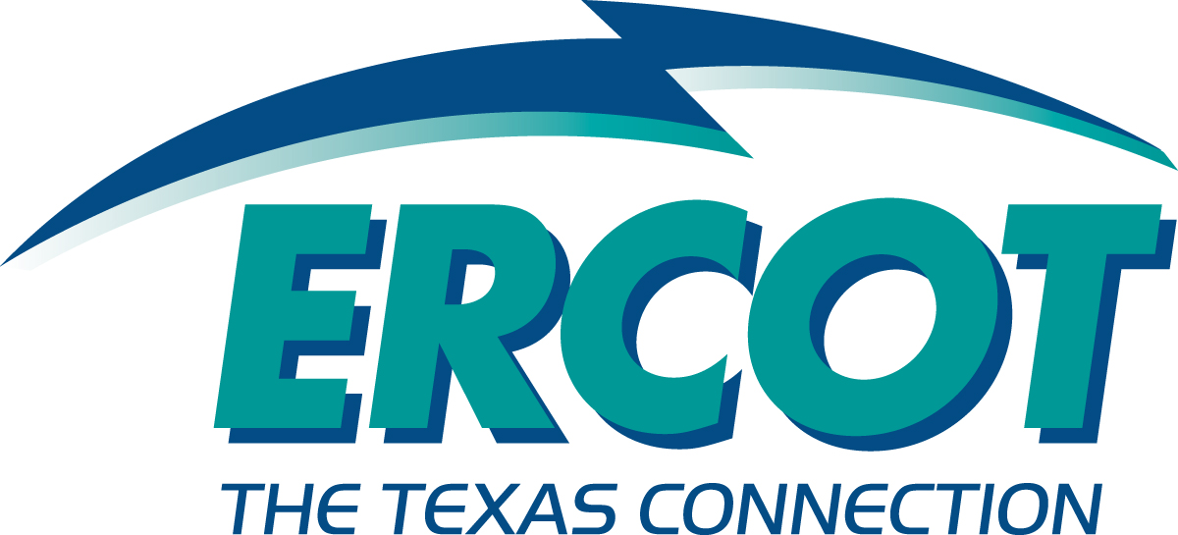
Demand Side Working Group Meeting
December 3, 2004
ERCOT METCENTER

Attendees:
Name | Company
Ed Echols (Chair) | TXU Energy
Mark Patterson | ERCOT
Steve Krein | ERCOT
Jeff Gilbertson | ERCOT
Michelle D’Antuono | Occidental
MaryAnne Brelinsky | Reliant
Robert King | Good Company Associates
Jay Zarnikau | Frontier Associates
Rick Keetch | Reliant
Rick Starr | Stellar Energy Solutions
Mike Walker | Exxon Mobil Production
Malcolm Smith | Energy Data Source
Billy G. Berny (phone) | American Electric Power
Dan Delurey (phone) | US Demand Response Coordinating Committee
Steve Karina (phone) | Nucor Steel
Bernie Neenan (phone) | Neenan Associates
Peter Cappers (phone) | Neenan Associates

Meeting Agenda:
- Antitrust Admonition
- The NY ISO Emergency program and summary of 3 year performance (Mr. Bernard F. Neenan—invited by Jay Zarnikau)
- Review and Approve Minutes from previous meeting
- Description of the IEA Project and US Demand Response
- Updates from the ERCOT staff:
  - LaaR deployment, sign-up count
  - DSWG Charter
- PRRs impacting LaaRs (PRR 558 and PRR560)
- Open Discussion

Meeting Minutes DSWG—12/3/2004:

- Antitrust Admonition—Ed Echols read the antitrust admonition and reminded everyone of their responsibilities as they participate in the meeting.
- Presentation on NYISO Demand Response Programs
  - Bernie Neenan and Peter Cappers gave a presentation on the NYISO sponsored ICAP, EDRP and Ancillary Services Programs (see the PowerPoint slides for additional detail)
  - Presentation slides posted to the ERCOT Website Notice for this Meeting
- Minutes from the Previous Meeting
  - Draft minutes were approved as corrected (added Jay Zarnikau to the list of attendees). Minutes are posted for that meeting on the ERCOT website notice for that meeting (10/29/2004).
- Description of the IEA Demand Response Program and the US DR Project
  - Dan Delurey, the Executive Director of the US Demand Response Coordinating Committee led a discussion of the International Energy Agency’s Demand Response Program and a new project that is being done in the US.
  - Eleven countries are currently participating in the overall program
  - The US Demand Response Project is currently in the development phase and funding is being secured thru utility, ISO and private company members.
  - The goals of the project are to characterize the demand response market in each of the member countries focusing on market potential, market valuation methodology, a demand response technology assessment, and identifying barriers to demand response implementation.
  - Members in the US phase of the project include AEP, Areva, PJM, NYISO, NEISO, National Grid, Southern Company, PG&E, SCE, SDG&E, Midwest ISO and the California Demand Response Research Center.
  - The project team is looking at the possibility of doing a workshop in TX covering the south central part of the US.
- Updates from ERCOT staff:
  - Latest stats on LaaR Registrations, LaaR Operations and Market Financial Summary—Mark Patterson presented the latest data on LaaR Registrations, Operations and a Market Summary to the team. (For details see the presentation materials posted to the ERCOT website notice for this meeting).
  - DSWG Charter—Additional changes have been suggested for the DSWG Charter and a discussion ensued over proposed language.
    - Several members requested that additional notice be given for distribution of meeting materials (agenda’s and presentation materials) and that a requirement be added to the DSWG Charter that if materials are not sent out far enough in advance that limitations be added on what action could be taken during the meetings. Group consensus was that agenda’s and other presentation materials should be sent out at least 48 hours prior to the meeting and that no actions be taken on issues that did not meet the 48 hour rule. All change requests to the meeting agenda’s need to be submitted to the Chairman in writing via email.
    - Several group members expressed concern that if decisions are not unanimous, that both majority and minority opinions be presented to WMS on issues.
    - Members want language added to indicate that the DSWG is responsible for reviewing PRR’s and OGRR’s that are initiated by the group and by entities outside the group.
- Discussion of PRR’s affecting LaaR’s
  - PRR 558—Market Notice of LaaR Proration. This PRR was scheduled to go to PRS in December, back to ERCOT for an impact analysis, then back to PRS again in January, then to TAC in February and then to the March Board meeting.
  - PRR 560—QSE Qualification Using LaaR’s. This PRR was scheduled to go to PRS in December, back to ERCOT for an impact analysis, then back to PRS again in January, then to TAC in February and then to the March Board meeting.
- Open Discussion
  - The group requested that an agenda item be added for a discussion on under-frequency relay settings for LaaR’s providing Responsive Reserve Service, including a discussion on a proposed recommended practice for the combined relay and disconnecting device operating times.
  - Jay Zarnikau recommended that the DSWG consider a new PRR addressing Demand Side Alternatives to Reliability Must Run (RMR) units and as solution to chronic OOM situations. Two PRR’s were previously endorsed by the DSWG to address this topic, consistent with a directive from the PUCT. The PRS and an RMR task force failed to act on the first one. The scope of the second PRR was later narrowed to supply-side “Must Run Alternatives” or “MRA’s”, so that demand side solutions to chronic OOM problems could not be addressed. Jay Zarnikau has drafted another (third) PRR to (hopefully) resolve this issue, and this has been provided to Mark Patterson for his review. Mark Patterson and Jay to investigate and report back to the group.
  - ERCOT to prepare a summary of Emergency Response Programs being implemented by ISO’s around the country and report back to the group.

Material in italics was not included in the Open Discussion during the meeting but was added afterward to provide some additional background material.

