PRR Number | 567 | PRR Title | Block Bidding of Ancillary Services
Date |  | 3/16/05
Submitter’s Information
Name |  | Clayton Greer
E-mail Address |  | Clayton.greer@constellation.com
Company |  | Constellation Energy Commodities Group
Company Address |  | 1005 Congress Ave.
Phone Number |  | 512-921-7013
Fax Number

ERCOT/Market Segment Impacts and Benefits
Instructions: To allow for comprehensive PRR consideration, please fill out each block below completely, even if your response is “none,” “not known,” or “not applicable.” Wherever possible, please include reasons, explanations, and cost/benefit analyses pertaining to the PRR.
 | Impact |  | Benefit
 | Business | Computer Systems | Benefit
ERCOT
MARKET SEGMENT
Consumer
LSE:
General, Including NOIE
LSE:
CR & REP
QSE
Resource
TDSP

Comments

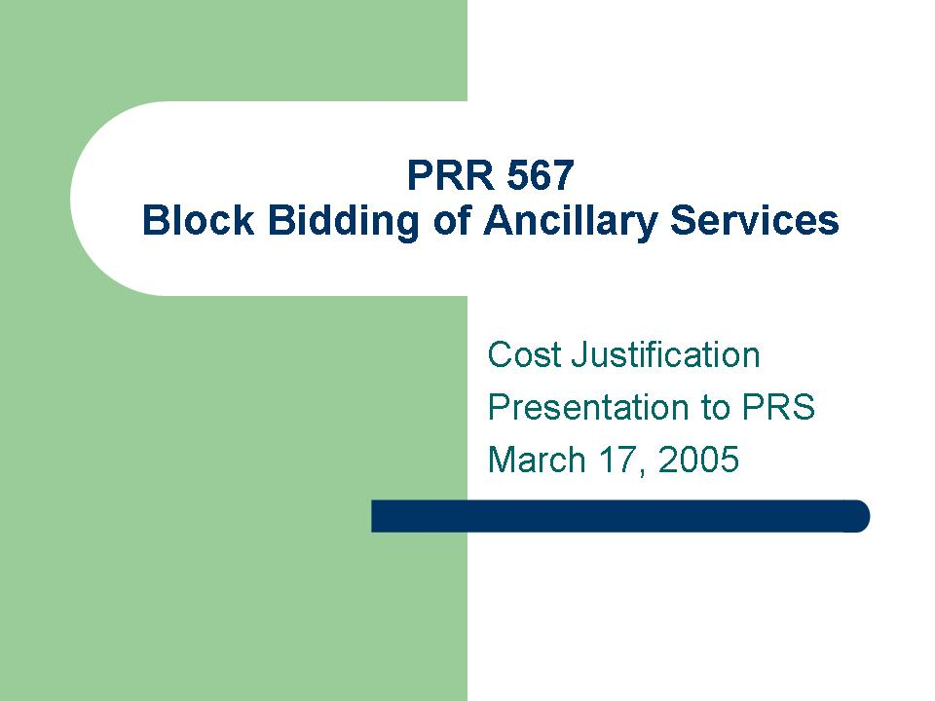

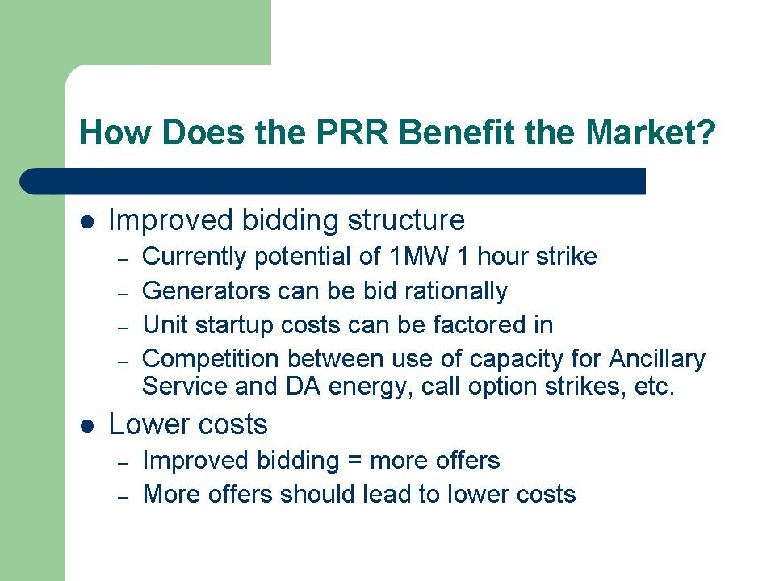

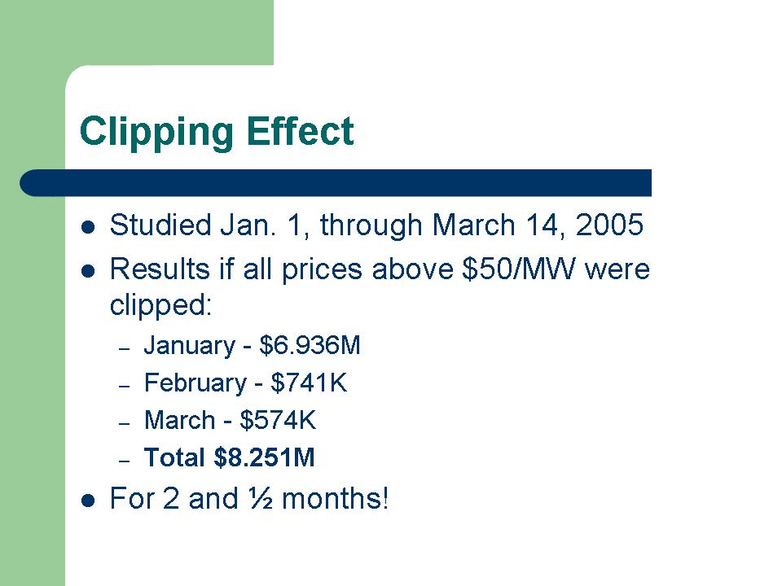
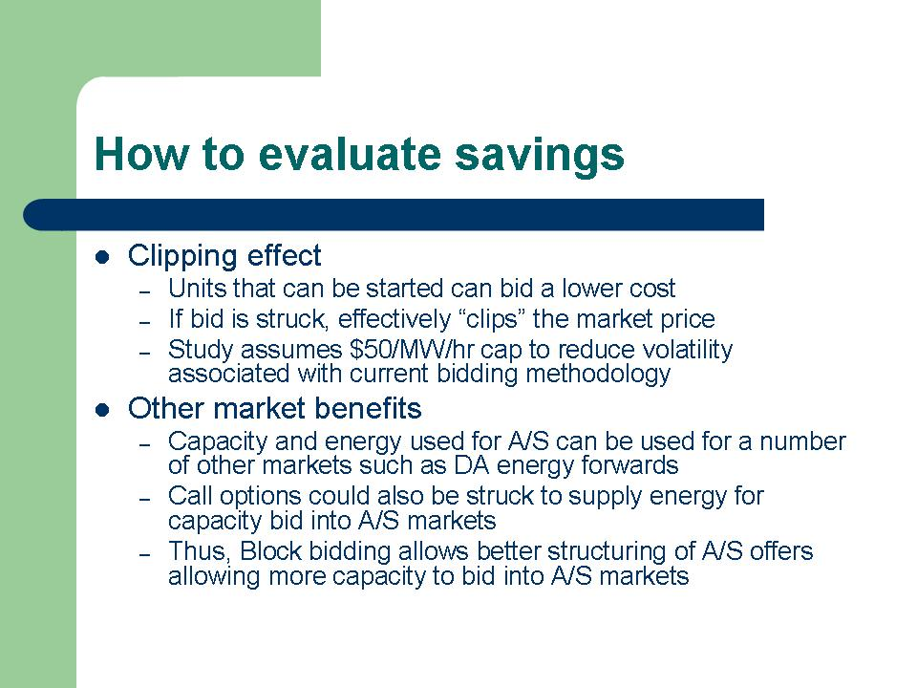
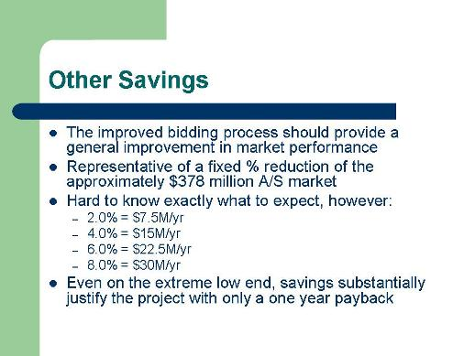

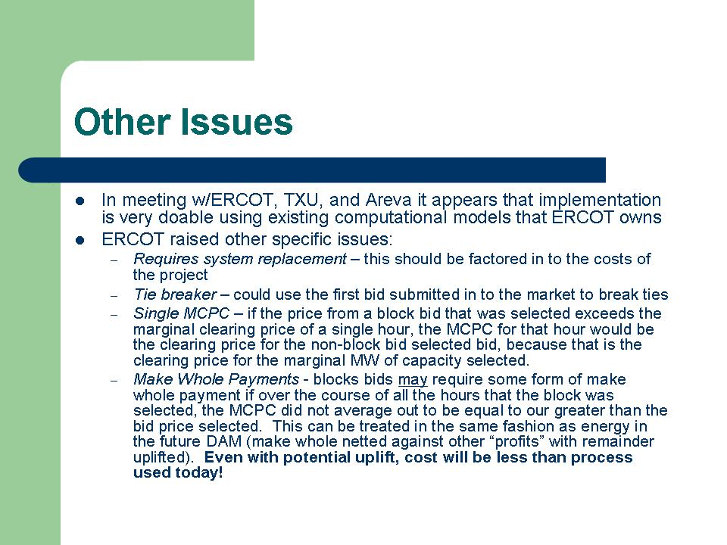
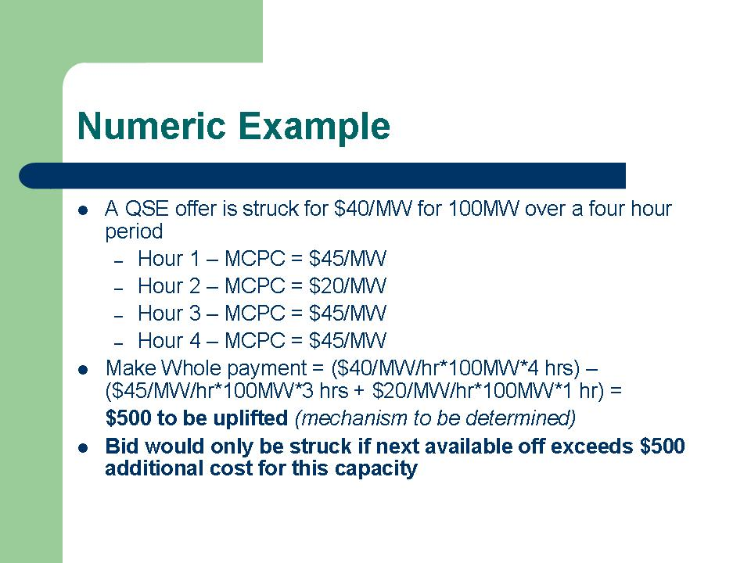

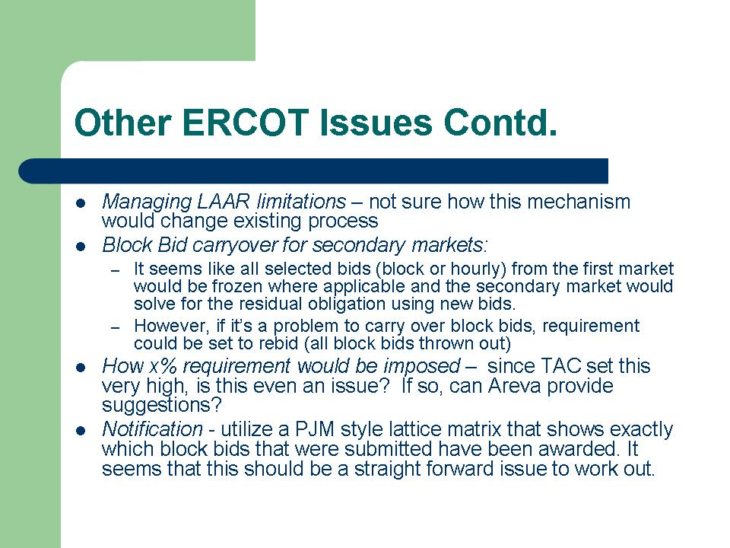
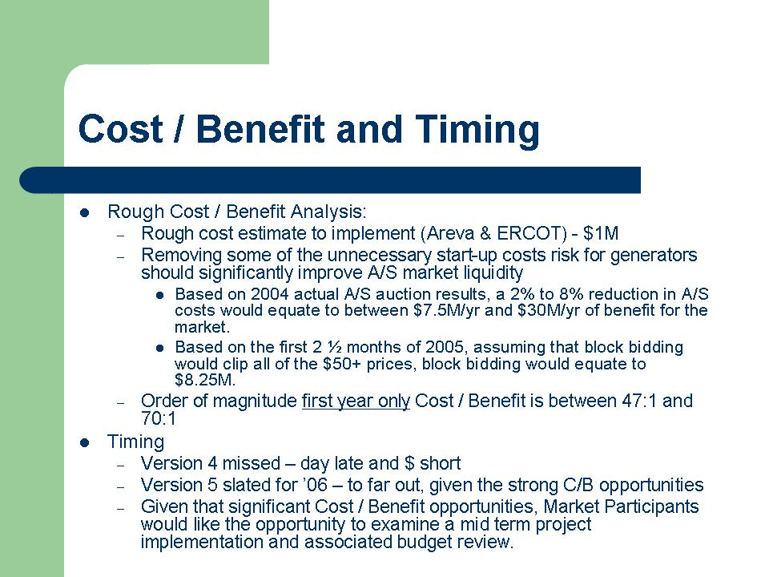

Revised Proposed Protocol Language

