8. Transient Voltage Stability Study Procedure:

Since Transient Voltage Stability (TVS) study procedure is not yet well-established, the DWG is including this section in the procedural manual as an interim guide for such studies.

Although the industry has made great strides in understanding the related phenomena there is still a great deal of work to be done in the areas of load modeling and development of a robust and uniform approach for assessing transient voltage security. This section intends to describe the present level of knowledge and techniques used in transient voltage analysis using time-domain transient stability utilizing PTI’s PSS/E software. It is possible that other robust and uniform methodologies may emerge that may be more suitable for transient voltage security assessment. However, utilizing the methodology described in this section will shed light on and provide a better understanding of the problem. As mentioned the load model is a major uncertainty factor.

The main factors affecting transient voltage stability of a bus are the induction motor load magnitudes and their characteristics, the Thevenin impedance of the system at that bus, and the reactive sources for the bus. For proper dynamic simulation using PSS/E, the load should be decomposed into similar load types, such as small motor, large motor, discharge lighting, resistive load, constant power, transformer saturation, and “remaining load” using PSS/E CLODXX and CIM5XX and /or CIMWXX. CIM6XX is a new induction motor model available in PSS/E Rev. 30, which may be used as well. It combines the CIM5XX and CIMWXX models. To use CIM5XX, CIMWXX, or CIM6XX models effectively, knowledge of the motor load speed-torque characteristic is required. Furthermore, the distribution power transformers, feeders, and capacitors should also be included as appropriate.

When using PSS/E for short-term voltage stability simulations, appropriate portion of the ERCOT load surrounding the study area should be represented with dynamic load model. To observe that the system is transient voltage stable the equivalent motor load terminal voltage (i.e. load voltage) and the motor slip should be plotted. If the slip is increasing after the voltage has passed its maximum then the load is unstable. On the other hand if the slip is not increasing after the voltage has passed its minimum then the load is stable.

Margin to voltage instability is a function of the degree of uncertainty in the models, data, and actual operating conditions and the sensitivity of the stability limits to these uncertainties. Each TDSP should consider the above and other factors such as cost of adding compensation to improve voltage stability in conjunction with the effects of voltage instability on the customers being served when establishing a margin to voltage instability.

8.1 ERCOT TVS criteria

Proposing a transient voltage stability criterion based on solid data and analysis is problematic in ERCOT. A survey conducted by the DWG suggested few if any regional reliability councils have such a criterion. There are no known standards that apply. An effective criterion may differ from one bus to another bus within ERCOT. The analysis tools used by most TDSPs will not guarantee voltage stability is maintained. One of the most critical components for any simulation, the load composition and dynamic characteristics, is generally unknown. Each TDSP should use judgment when evaluating voltage stability. With the above in mind, the following may be used as transient voltage stability criteria when no other guidance is available:

Considering realistic power transfers between zones,

- Allow a 5% margin load increase to a zone for ERCOT category B contingencies and
- Allow a 2.5% margin load increase to a zone for ERCOT category C contingencies.

The application of these criteria are not mandatory, and they are proposed as guidelines. Individual TDSPs should adjust these values based on local knowledge and conditions.

For additional information on this subject refer to DWG’s “ERCOT Transient Voltage Security Criteria Development” paper that was originally reported to the Reliability & Operation Subcommittee in 2003.

8.2 Sample System Transient Voltage Stability Analysis

In this section we will present an example using conventional time-domain dynamic stability to conduct transient voltage stability analysis. Transient voltage dip acceptability (TVD) analysis is conducted in the same fashion.

Fig.1 shows a sample system one-line diagram used in this illustration. Fig 2, and Fig 3 show the load flow and dynamics data associated with this system in PSS/E Version 28 format. Induction motor model parameters for several load types are given in the literature, gathered through research conducted by EPRI.

Note that Fig. 1 includes the models of the distribution power transformer, line, and the capacitor banks. These are recommended to conduct an accurate transient voltage stability analysis.

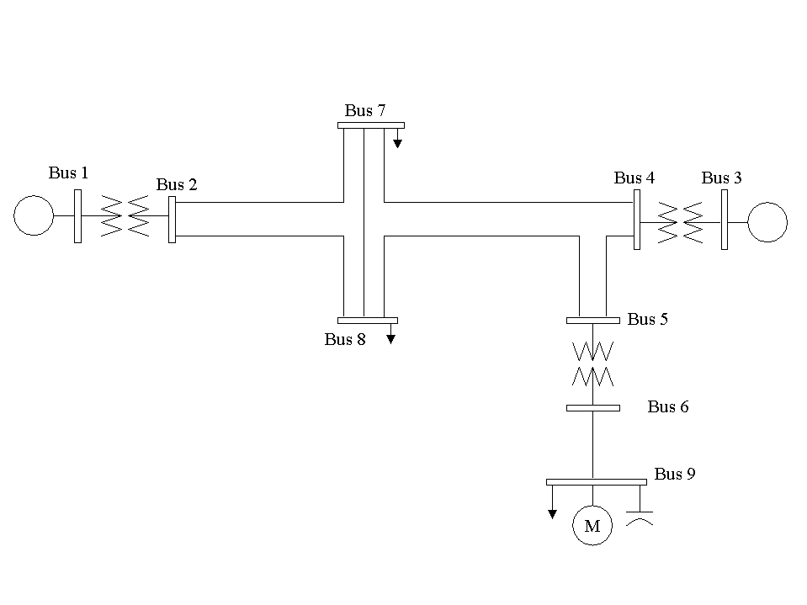
Fig 1. Study System One-line Diagram

0, 100.00 / PSS/E-28.1 TUE, SEP 02 2003 15:31
9 BUS POWER FLOW TEST CASE
BASE
1,'REMOTGEN', 20.0000,3, 0.000, 0.000, 1, 1,1.00000, 0.0000, 1
2,'REMOTGEN', 138.0000,1, 0.000, 0.000, 1, 1,1.02824, -4.9475, 1
3,'LOCALGEN', 20.0000,2, 0.000, 0.000, 1, 1,1.02577, -1.7904, 1
4,'LOCALGEN', 138.0000,1, 0.000, 0.000, 1, 1,1.02000, -6.6012, 1
5,'138TRANS', 138.0000,1, 0.000, 0.000, 1, 1,1.01246, -7.5153, 1
6,'DISTLINE', 13.8000,1, 0.000, 0.000, 1, 1,1.01966, -10.1919, 1
7,' LOAD1 ', 138.0000,1, 0.000, 0.000, 1, 1,1.01013, -7.9893, 1
8,' LOAD2 ', 138.0000,1, 0.000, 0.000, 1, 1,1.00912, -8.1124, 1
9,'DISTLOAD', 13.8000,1, 0.000, 0.000, 1, 1,0.99050, -13.7715, 1
0 / END OF BUS DATA, BEGIN LOAD DATA
7,'1 ',1, 1, 1, 0.000, 0.000, 0.000, 0.000, 100.000, -25.000, 1
8,'1 ',1, 1, 1, 0.000, 0.000, 0.000, 0.000, 100.000, -25.000, 1
9,'1 ',1, 1, 1, 0.000, 0.000, 0.000, 0.000, 50.000, -20.000, 1
9,'M ',1, 1, 1, 50.000, 20.000, 0.000, 0.000, 0.000, 0.000, 1
0 / END OF LOAD DATA, BEGIN GENERATOR DATA
1,'1 ', 155.576, 49.519, 100.000, -50.000,1.00000, 0, 300.000, 0.00000, 0.20000, 0.00000, 0.00000,1.00000,1, 100.0, 300.000, 50.000, 1,1.0000
3,'1 ', 150.000, 62.532, 75.000, -50.000,1.02000, 4, 250.000, 0.00000, 0.20000, 0.00000, 0.00000,1.00000,1, 100.0, 200.000, 50.000, 1,1.0000
0 / END OF GENERATOR DATA, BEGIN BRANCH DATA
2, 7,'1 ', 0.00800, 0.07425, 0.03600, 400.00, 500.00, 500.00, 0.00000, 0.00000, 0.00000, 0.00000,1, 25.00, 1,1.0000
2, 8,'1 ', 0.00800, 0.07425, 0.03600, 400.00, 500.00, 500.00, 0.00000, 0.00000, 0.00000, 0.00000,1, 25.00, 1,1.0000
4, 5,'1 ', 0.00160, 0.01485, 0.00720, 400.00, 500.00, 500.00, 0.00000, 0.00000, 0.00000, 0.00000,1, 5.00, 1,1.0000
4, -7,'1 ', 0.00800, 0.07425, 0.03600, 400.00, 500.00, 500.00, 0.00000, 0.00000, 0.00000, 0.00000,1, 25.00, 1,1.0000
5, -8,'1 ', 0.00800, 0.07425, 0.03600, 400.00, 500.00, 500.00, 0.00000, 0.00000, 0.00000, 0.00000,1, 25.00, 1,1.0000
6, 9,'1 ', 0.01050, 0.06630, 0.00001, 108.00, 108.00, 108.00, 0.00000, 0.00000, 0.00000, 0.00000,1, 1.00, 1,1.0000
7, -8,'1 ', 0.00320, 0.02720, 0.01580, 400.00, 500.00, 500.00, 0.00000, 0.00000, 0.00000, 0.00000,1, 10.00, 1,1.0000
0 / END OF BRANCH DATA, BEGIN TRANSFORMER DATA
1, 2, 0,'G1',1,1,1, 0.00000, 0.00000,1,' ',1, 1,1.0000
0.00000, 0.06000, 100.00
0.95000, 0.000, 0.000, 250.00, 250.00, 250.00, 0, 0, 1.10000, 0.90000, 1.10000, 0.90000, 33, 0, 0.00000, 0.00000
1.00000, 0.000
3, 4, 0,'G1',1,1,1, 0.00000, 0.00000,1,' ',1, 1,1.0000
0.00000, 0.06000, 100.00
0.97500, 0.000, 0.000, 250.00, 250.00, 250.00, 0, 0, 1.10000, 0.90000, 1.10000, 0.90000, 33, 0, 0.00000, 0.00000
1.00000, 0.000
5, 6, 0,'D1',1,1,1, 0.00000, 0.00000,1,' ',1, 1,1.0000
0.00200, 0.05000, 100.00
0.97500, 0.000, 0.000, 250.00, 250.00, 250.00, 0, 0, 1.10000, 0.90000, 1.10000, 0.90000, 33, 0, 0.00000, 0.00000
1.00000, 0.000
0 / END OF TRANSFORMER DATA, BEGIN AREA DATA
0 / END OF AREA DATA, BEGIN TWO-TERMINAL DC DATA
0 / END OF TWO-TERMINAL DC DATA, BEGIN SWITCHED SHUNT DATA
9,0,1.50000,0.50000, 0, 15.00, 1, 15.00
0 / END OF SWITCHED SHUNT DATA, BEGIN IMPEDANCE CORRECTION DATA
0 / END OF IMPEDANCE CORRECTION DATA, BEGIN MULTI-TERMINAL DC DATA
0 / END OF MULTI-TERMINAL DC DATA, BEGIN MULTI-SECTION LINE DATA
0 / END OF MULTI-SECTION LINE DATA, BEGIN ZONE DATA
0 / END OF ZONE DATA, BEGIN INTER-AREA TRANSFER DATA
0 / END OF INTER-AREA TRANSFER DATA, BEGIN OWNER DATA
0 / END OF OWNER DATA, BEGIN FACTS DEVICE DATA
0 / END OF FACTS DEVICE DATA

Fig 2. Study System Load Flow Data in PTI PSS/E Rev 28 RAWD Format

1 'GENROU' 1 6.0000 0.25000E-01 0.75000 0.50000E-01
5.0000 0.0000 2.1000 2.0000 0.22000
0.50000 0.20000 0.18000 0.10000 0.40000 /
1 'ESST4B' 1 0.0000 3.5000 3.7700 1.0000
-0.87000 0.10000E-01 1.0000 0.0000 1.0000
-0.87000 0.0000 6.0000 0.0000 7.0000
0.80000E-01 0.0000 0.0000 /
3 'GENROU' 1 6.0000 0.25000E-01 0.75000 0.50000E-01
5.0000 0.0000 2.1000 2.0000 0.22000
0.50000 0.20000 0.18000 0.10000 0.40000 /
3 'ESST4B' 1 0.0000 3.5000 3.7700 1.0000
-0.87000 0.10000E-01 1.0000 0.0000 1.0000
-0.87000 0.0000 6.0000 0.0000 7.0000
0.80000E-01 0.0000 0.0000 /

9 'CIM5BL' M 2 0.25000E-01 0.80000E-01 5.0000
0.28000E-01 0.40000E-01 0.0700 0.0300 0.0000
0.00000 0.0000 0.00000 29.300 0.0000
0.28000 0.0000 0.0000 0.0000 0.0000
0.0000 / Shaffer model C ;MBASE=29.3

Fig 3. Study System Dynamics Data in PTI PSS/E Rev 28 DYDA Format

Figs 4, and 5 show the results of a simulation for duration of 2 seconds. They show Voltage at bus 9, and the motor’s Telec, Tload, Slip, P, and Q. Fig. 4 shows the voltage at bus 9 and the slip of aggregate induction motor model highlighted in red and blue, respectively. Fig 5 shows Telec, and Tload highlighted in red and blue, respectively. The fault duration is 4 cycles, and the fault admittance is 1000 MVA. Note that the voltage at bus 9 recovers in less than one second, and the motor slip increases during the fault. However, after the fault clears the motor slip reduces and stabilizes to a constant value. Since the slip has reduced to a small constant value and voltage has recovered, the induction motor is stable; hence, bus 9 maintains transient voltage stability.

From Fig 5 we can see that the Telec is larger than Tload after the fault clears. Since the Telec is larger than Tload, the motor remains stable. Note that the reactive power is increasing during the fault and reduces and becomes constant after the fault has cleared. Similarly the real power consumption P during the fault increases, and returns to a constant value after the fault has cleared.

In summary, since Telec is larger than Tload throughout the disturbance and slip returns to a small constant value, we can conclude that this bus maintains voltage stability when subjected to the described disturbance.

Now, let us consider applying a 7-cycle fault with fault admittance of 1000 MVA. Similarly, Figs 6, and 7 show the results of a simulation for duration of 2 seconds. They show Voltage at bus 9, and the motor’s Telec, Tload, Slip, P, and Q. Fig 6 shows the voltage at bus 9 and the slip of aggregate induction motor model highlighted in red and blue, respectively. Fig 7 shows Telec, and Tload highlighted in red and blue, respectively. Since the slip is monotonically increasing while the motor terminal voltage has passed its maximum, the motor is unstable. Furthermore it shows that indeed the motor stalls, if it remains connected. Note that this example is intended to demonstrate instability. However, it is possible that the motor contactor may disconnect the motor from the system, which would yield different results. Note that during the fault the motor Q increases, that is the motor begins to absorb a large amount of reactive power. Telec is less than Tload, which indicates that the motor is unstable. Hence there are two indications of the motor instability 1) the slip is increasing while the terminal voltage has passed its maximum, and 2) Telec is less than Tload even after the fault has cleared.

In summary, since Telec is less than Tload and the slip increases monotonically after the voltage has passed its maximum, we can conclude that this bus does not maintain voltage stability when subjected to the described disturbance.

Fig 4. Stable Scenario, Voltage is in red and Slip is in blue

Fig. 5. Stable Scenario, Telect is in red and Tload is in blue

Fig 6. Unstable Scenario, Voltage is in red and Slip is in blue

Fig 7. Unstable Scenario, Telect is in red and Tload is in blue

