PRR Number | 562 | PRR Title | Permanent Elimination of Market Solution for Local Congestion
Date |  | 12/21/2004
Submitter’s Information
Name |  | Lori Johnson, Marguerite Wagner
E-mail Address |  | ljohnson@ercot.com
Company |  | ERCOT
Company Address |  | 2705 West Lake Drive Taylor, Texas 76574
Phone Number |  | 512-248-3956
Fax Number |  | 512-248-6560

ERCOT/Market Segment Impacts and Benefits
Instructions: To allow for comprehensive PRR consideration, please fill out each block below completely, even if your response is “none,” “not known,” or “not applicable.” Wherever possible, please include reasons, explanations, and cost/benefit analyses pertaining to the PRR.

ERCOT concurs with ERCOT/Market Segment Impacts and Benefits presented in the original PRR.

Comments

Earlier this year, the stakeholders agreed to replace the current Market Solution mechanism with Resource-Specific bid limits (PRR 485, Revision to Unit-Specific Deployment Based on Generic Cost). PRR 485 will resume payments for Resource-specific deployments based on bid and will be implemented as part of EMMS Release 4. The December 2004 version of the Protocols contains the PRR 485 language as “boxed language” --- pending implementation of EMMS Release 4 in 2005.

PRR 562, as submitted, would permanently maintain the payment for Balancing Energy for Local Congestion based on generic cost. In commenting on this PRR, ERCOT suggests a change to PRR 562 to make the language consistent with an earlier market decision (PRR 485) which compensates Balancing Energy for Local Congestion on the basis of mitigated bids. Upon implementation of Release 4, the proposed change would replace Section 7.4.3 with the boxed language presented below.

If this PRR is approved by the market, ERCOT will, in coordination with market participants, submit a separate PRR to address the use of the term “Market Solution” within the ERCOT Protocols. The term “Market Solution” is used inconsistently throughout Sections 2, 6 and 7 in reference to out-of-merit operations and determination of CSCs. These references occur in the following Protocol Sections:

- 2.1, Definition of Out of Merit Capacity
- 2.1, Definition of Out of Merit Energy
- 2.1, Definition of Reliability Must Run (RMR) Unit
- 2.1, Definition of Synchronous Condenser Unit
- 6.1.9, Reliability Must-Run Service
- 6.1.10, Out of Merit Capacity Service
- 6.1.11, Out of Merit Energy Service
- 6.3.1, ERCOT Responsibilities
- 6.7.8, Deployment of RMR Service
- 6.8.1.11, Local Congestion Replacement Reserve Payment to QSE when a Market Solution Exists
- 7.2.1.1(3), Process for Determining CSCs
- 7.6, Incorporation of Reliability Must-Run and Out of Merit Order Resources

To aid in understanding the relationship of this PRR to the current state of the market as well as Release 4, ERCOT provides the following graphic:

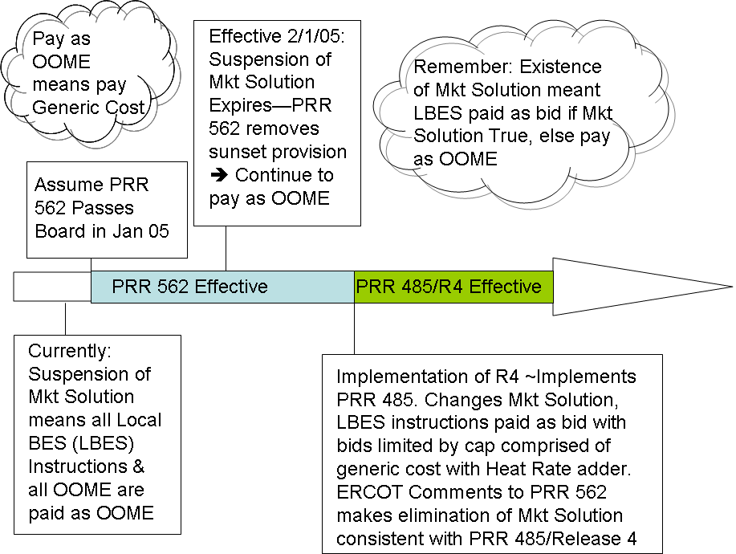

Revised Proposed Protocol Language

7.4.3 Settlement of Local Congestion Costs
Net Local Congestion costs will be settled in the Balancing Energy settlement process.
Notwithstanding the provisions of any other section of these Protocols, no Market Solution shall be determined to exist for the payment of Resources being deployed in resolving Local Congestion under any circumstances.
Balancing Energy for Local Congestion shall be paid in accordance with Section 6.8.2.3, Energy Payments of Out of Merit Energy Service.
PRR562: Upon system implementation of PRR 485, replace Section 7.4.3 with the following:
Net Local Congestion costs will be settled in the Balancing Energy settlement process.

