Attachment A

History

The Clear Springs to Salado 345-kV project (CSS) was chosen from a list of potential projects compiled at a joint North and South Regional Planning Group (RPG) meeting held April 4, 2002, as the most effective way to address local load growth in Travis, Bell, and Williamson counties, relieve existing transmission constraints in Central Texas and reduce south to north Commercially Significant Congestion (CSC). Stakeholder comments on the results of the April 4, 2002, meeting were compiled and distributed to stakeholders by ERCOT staff.

Preliminary work on the CSS project continued throughout 2003. On December 19, 2003, a formal meeting was held in which a project team was formed, a project scope was developed, and a timeline for completion of the project was determined. The Lower Colorado River Authority (LCRA), Austin Energy (AE), and Texas Utilities Electric Delivery (TXU ED) formed the team that began the evaluation of the project.

The initial findings of the project team were presented to both the North and South RPGs on January 21, 2004. Stakeholder comments on the information presented at the meeting were accepted with the overall response being in favor of the continued study of the project as defined by the project team.

On September 21, 2004, the project team presented their final study for North and South RPG review. The final RPG comment period was completed on October 14, 2004. Once again, stakeholder response to the project was favorable. This was the third comment period held on the project. The study mode for the project was completed on November 11, 2004.

ERCOT’s independent review has been completed, and ERCOT staff endorses the construction of the project.

Justification

Several factors support the construction of the CSS project with an estimated cost of $141 Million. The project should not be viewed solely as a reliability driven or an economically driven project, but rather as a combination of both. The major factors contributing to the justification of this project are listed below:

- The CSS project eliminates or delays the need for approximately $47.5 million dollars of reliability-driven transmission projects.
- The CSS project results in approximately $49 million of production cost savings annually. With a 7% discount rate this is estimated to be $368 million over ten years.
- The project eliminates transmission congestion that has limited production from relatively inexpensive generation in the Central Texas Area including the mothballed Hayes plant.
- The project includes 2 new 345/138-kV injection points in high load growth areas and includes the potential for several more.
- The project mitigates over $13 million (2500 incidents) of Balancing Energy costs that have occurred from June 1, 2002, to May 31, 2004.
- The project dramatically reduces the cost of taking regular transmission maintenance outages along the 345-kV corridor between Dallas and San Antonio. These costs are listed in ERCOT’s Independent Review.

Proposed Transmission Upgrades Included in the Project

The scope of the Project includes the construction of a new 345-kV corridor (approximately 100 miles in length) from the Guadalupe County area (existing Clear Springs and Zorn switching stations) to a new 345-kV switching station near the town of Salado in Bell County. The transmission line is proposed as a double-circuit 345-kV line constructed with bundled 1590 ACSR conductor rated for a total capacity of 3260 MVA. New 345-kV switching stations with 345/138-kV autotransformers will be located at Hutto switching station and Harris switching station. Figure 1 illustrates the location of the line and new stations. Tables 1 and 2 further describe the line section lengths and what company will be responsible for construction of the each section.
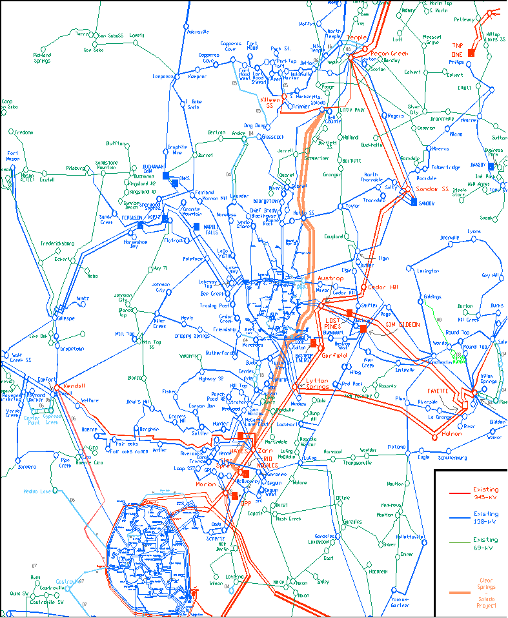
Salado Switch
Harris Branch
Hutto Switch
Zorn
Clear Springs
San Antonio
Austin
Temple
Figure 1: Project Location

Table 1: Line Lengths and Responsible Transmission Owner for Each Segment

Table 2: Stations and Terminals Included in Project and Responsible Transmission Owner

Based upon reassessments of the Project and a review of all engineering cost estimates, the total projected capital cost of the Project is $140,932,000 (2004 cost figures).

ERCOT Staff Independent Analysis

Details of the assumptions and data used in ERCOT’s independent analysis are included in ERCOT’s Independent Review of the CSS project.

The completion of the CSS project would result in production cost savings of approximately $46.8 million when compared to just building projects that are needed solely for reliability reasons (mitigated project listed in Table 6 of detailed report). In 2010, this number increases to $51.2 million. Over a ten-year period, this equates to approximately $368 million in production cost savings. The production cost savings in 2009 and 2010 (discounted at 7%), together with the capital cost of the mitigated projects, exceed the total capital cost of the CSS project. The CSS project pays for itself in 2 years.

ERCOT also examined the sensitivity of these savings to several factors, including the Houston Import Constraint Project, gas prices, new generation, and mothballed generation. Details for these sensitivities can be found in ERCOT’s Independent Review. Table 3 summarizes the results.

Table 3: Summary of Sensitivity Analysis

Other Alternatives Considered

The set of mitigated projects was the primary alternative to the CSS project. However, there were several other potential projects considered as alternatives to the CSS project. No fewer than 12 different ideas were examined at the meeting on April 4, 2002. These alternatives were evaluated by the regional transmission owners and the CSS project was chosen.

ERCOT Staff Recommendation

Due to the overall production cost benefit, the increase in reliability, and the added flexibility it allows for maintenance outages and future load growth, ERCOT staff supports the need for the Clear Springs to Salado 345-kV double-circuit line and associated switching stations with autotransformer capacity as set forth in the “Clear Springs – Salado 345-kV Project” proposal submitted to the South RPG for review.
ERCOT recommends the CSS be completed as soon as feasible. If the in-service date for the CSS project is moved from 2010 to 2009 approximately $50 million in production cost savings is realized.

