Elm Creek 345 kV Switching Station Project

Local Congestion Management Alternative:
Elm Creek 345-kV Switching Station

Produced through efforts of:
ERCOT Transmission Services System Planning Staff
City Public Service Staff
ERCOT South Regional Planning Group

September 15, 2004
Purpose

Transfers into San Antonio from other regions of ERCOT are currently limited under contingency. In particular, the northeast region of the transmission network in San Antonio is congested because of the vast amount of power being imported into that area from Central Texas and Houston. The purpose of this study is to evaluate the benefits of adding a 345-kV switching station at Elm Creek, which is the intersection of the 345-kV lines from South Texas Project (STP) – Skyline and South Texas Project – Hill Country with the double circuit lines from Marion – San Miguel. Potential benefits include increased reliability and outage flexibility, increased transfer capability into San Antonio, and the removal of an existing remedial action plan. Figure 1 shows an overview of the area being studied.

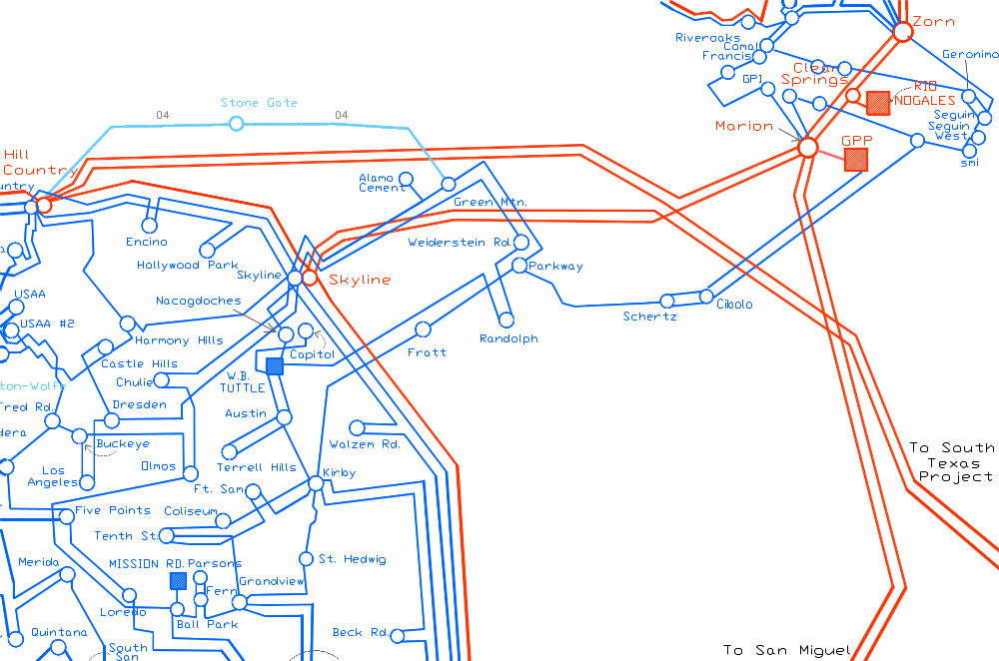

Figure 1: Northeast San Antonio Transmission Network

This study will also identify and compare other technically feasible options that produce similar benefits. Economic cost benefit analyses of these options using UPLAN will be done by ERCOT and reported at a later date. Finally, this report will give additional project details including the total CPS-estimated project cost, station design, expected fault currents, and review of the required voltage profile at STP.

Assumptions

The 2009 CSC summer base case was the used in this study. The San Antonio area was designated as the import region and the export regions were North Texas, Central Texas, Houston, and All of ERCOT. Transfers were made from each of the export regions into San Antonio using MUST. For MUST transfer analysis, the load and generation in the base case was scaled down by 10% to provide the generation capacity needed to make transfers. Tools used for load flow and transfer analysis include PowerWorld, PSS/E, and MUST.

Background

During August 2003 (summer peak), the Marion/Zorn area saw a total of 35 days of congestion management. The Zorn AT1, Clear Springs – Marion – Zorn 345-kV lines, and Marion – Hill Country/Skyline 345-kV lines were constrained for this time period to protect other elements. Protected elements were not published in the August 2003 Monthly Operations Report. Off-peak conditions also show constraints in the area. During April 2004, the Marion – Hill Country/Skyline 345-kV lines saw 8 days of congestion management to protect the Cibolo Creek – Schertz 138-kV line from overloads. Figures 2 & 3 show the amount of local congestion management that occurred during August 2003 and April 2004, respectively.

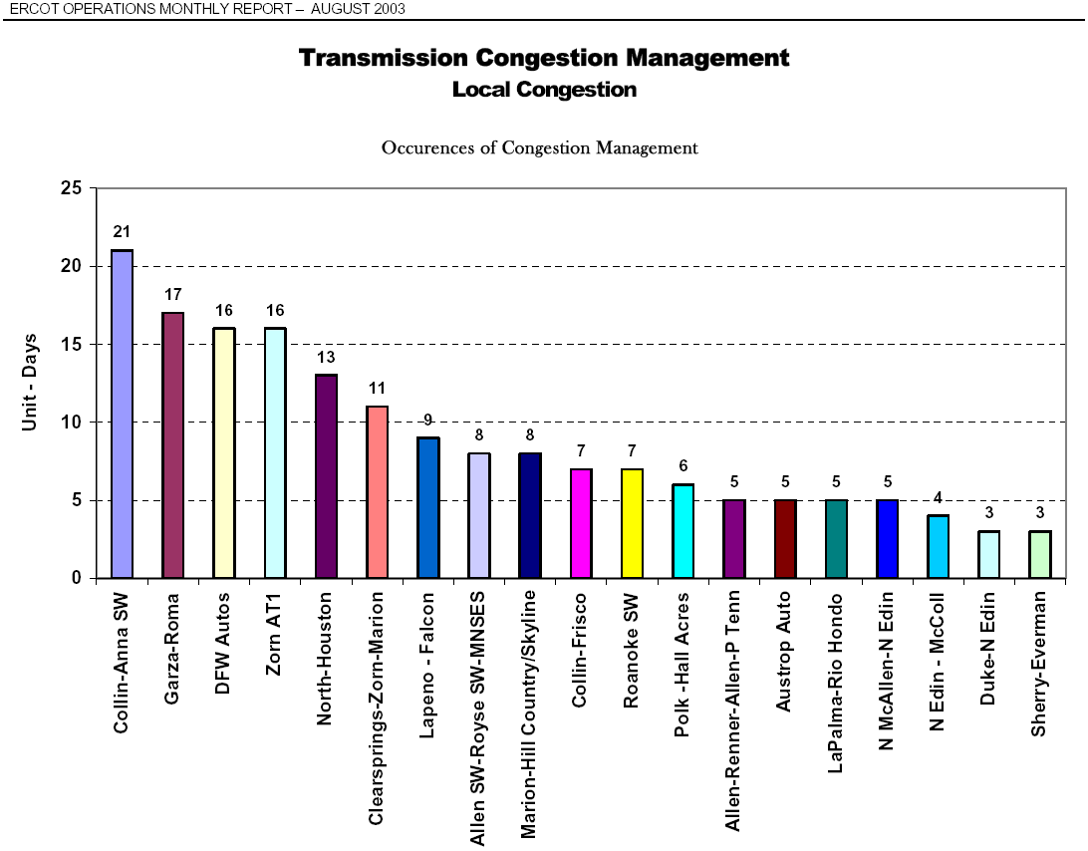
Figure 2: Local Congestion Management in August 2003

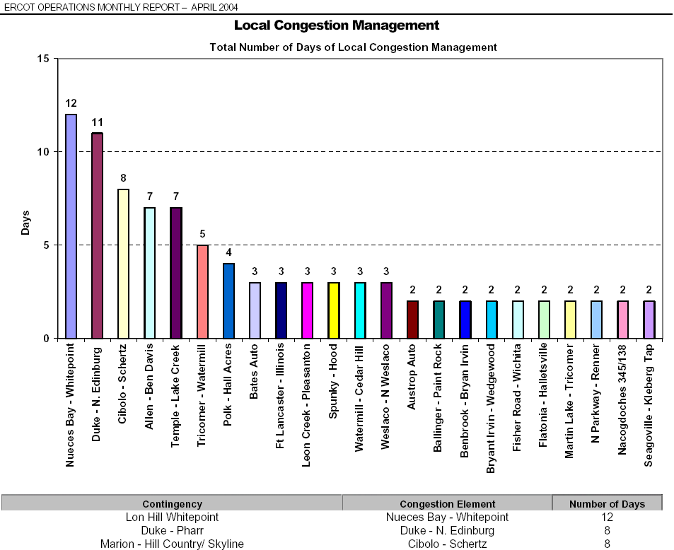

Figure 3: Local Congestion Management in April 2004

To expand upon the example above, the following table was created that summarizes the past 6-months as reported by ERCOT Operations. The table shows the number of days per month the contingency outage of Marion-Hill Country/Skyline resulted in the potential overload of the Cibolo-Schertz 138 kV line.

Contingency | Overload | ERCOT Op Report | Occurrences (days)
Marion - Hill Country/Skyline | Cibolo - Schertz | March 04 | 0
Marion - Hill Country/Skyline | Cibolo - Schertz | April 04 | 8
Marion - Hill Country/Skyline | Cibolo - Schertz | May 04 | 8
Marion - Hill Country/Skyline | Cibolo - Schertz | June 04 | 21
Marion - Hill Country/Skyline | Cibolo - Schertz | July 04 | 16
Marion - Hill Country/Skyline | Cibolo - Schertz | August 04 | 14

As the table above shows, the possibility of the Marion – Hill Country/Skyline double circuit contingency outage results in numerous occurrences of congestions and thus causes frequent OOME Down instructions to the generation in the area. This also results in inefficient wholesale markets. Note the 21 instances in June, which happened to be the “worst” offender in June.

This congestion is due to the large amount of generation in the area trying to get out to the load in Central Texas, North Texas, and San Antonio. With the topology present, the easiest path out is north, but there is also a large amount of power that flows to San Antonio from the Marion substation. As shown in April 2004, congestion management is required to protect the underlying 138-kV systems. Daily outage reports show limit violations for the Cibolo Creek – Schertz – Parkway 138-kV corridor for the loss of the Marion – Skyline/Hill Country 345-kV double circuit. Violations also show up on the 138-kV system near Seguin for the loss of the Marion – Clear Springs and Marion – Zorn 345-kV lines.

As a result of such congestion in this area, the Congestion Management Working Group (CMWG) evaluated the costs associated with two Marion Constraints. In August of 2004, the CMWG produced the following results with data from January 1, 2004 to August 10, 2004. The first chart lists the number of 15-minute intervals the associated contingency constraint occurred during the month listed. As the chart shows, the possibility of the Marion-Hill Country/Skyline double circuit contingency and the possible Zorn-Clear Springs/Marion double circuit contingency both led to numerous congestion over the past 7-months.

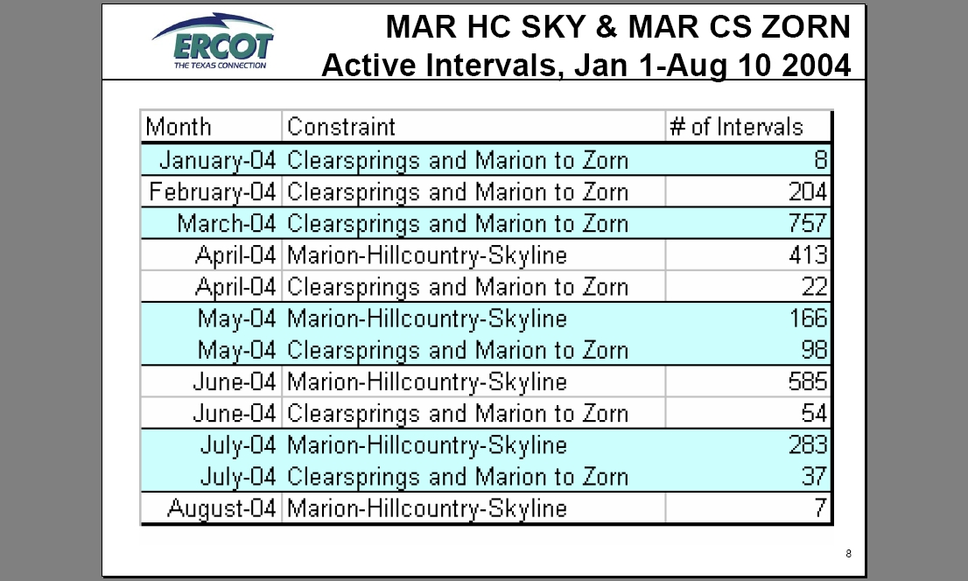

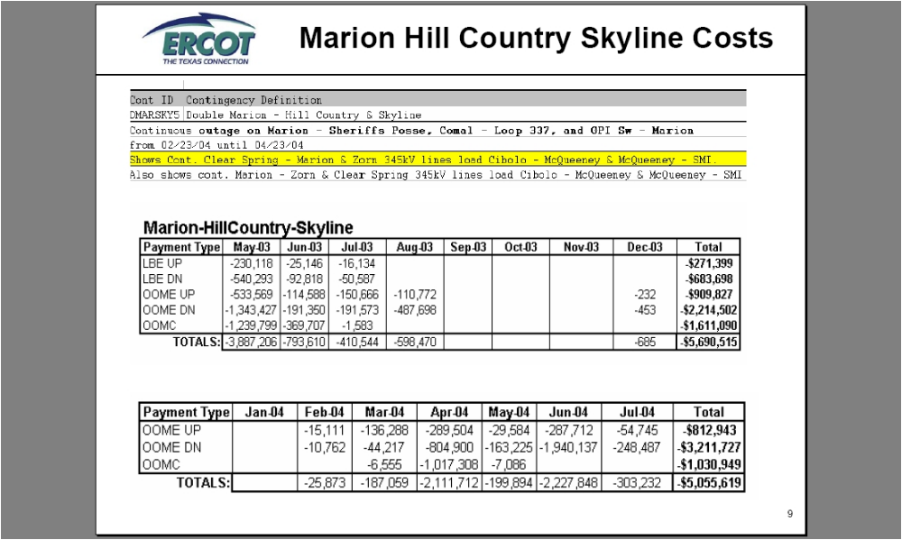

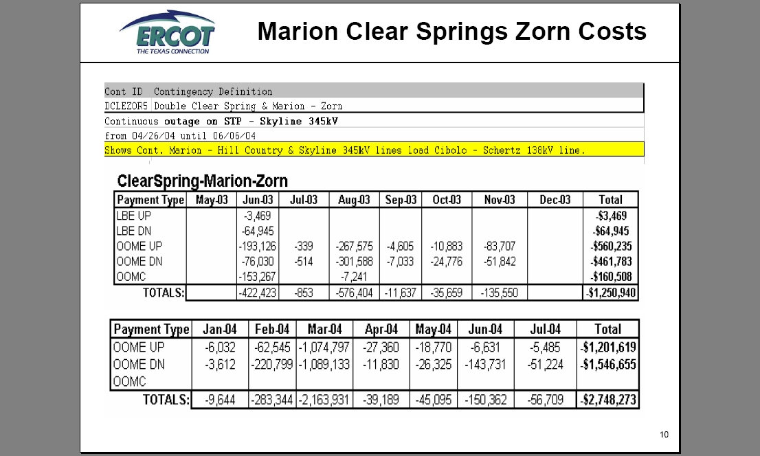

As can be seen from the past 15-month period listed above, the period resulted in over $14.7 million dollars in congestion costs that could be avoided if the proposed Elm Creek Switching station were built.

The addition of a 345-kV switching station at Elm Creek creates an additional 345-kV path into San Antonio, by tying the two San Antonio lines from STP into the Central Texas area before they reach the San Antonio Skyline and Hill Country substations. This will allow more flow out of the Central Texas area under normal and contingency conditions. Figure 4 shows the proposed location of the Elm Creek switching station.

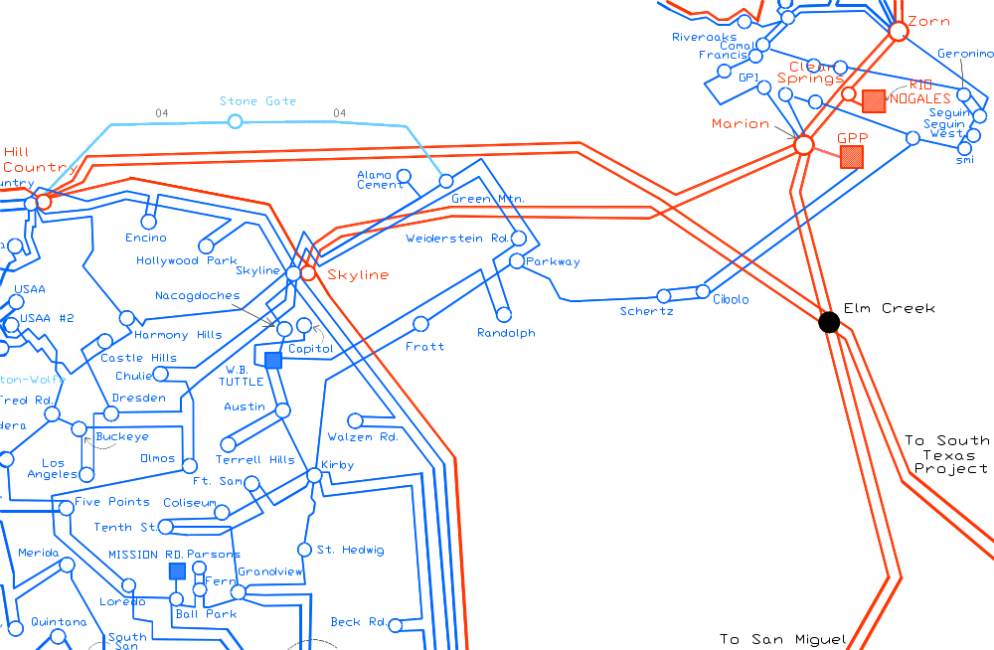
Figure 4: Proposed Elm Creek 345-kV Switching Station

Transfer Analysis

During peak conditions, power often flows into San Antonio from Central Texas and Houston. The Marion – Skyline 345-kV and Marion – Hill Country 345-kV lines bring in power from Central Texas. Also, the South Texas Project – Skyline 345-kV and South Texas Project – Hill Country 345-kV lines bring in power from the Houston area. Figure 5 below shows actual daily averaged loadings for these lines from January 2004 to May 2004. Figure 6 illustrates the line loadings in the study area for the 2009 base case.

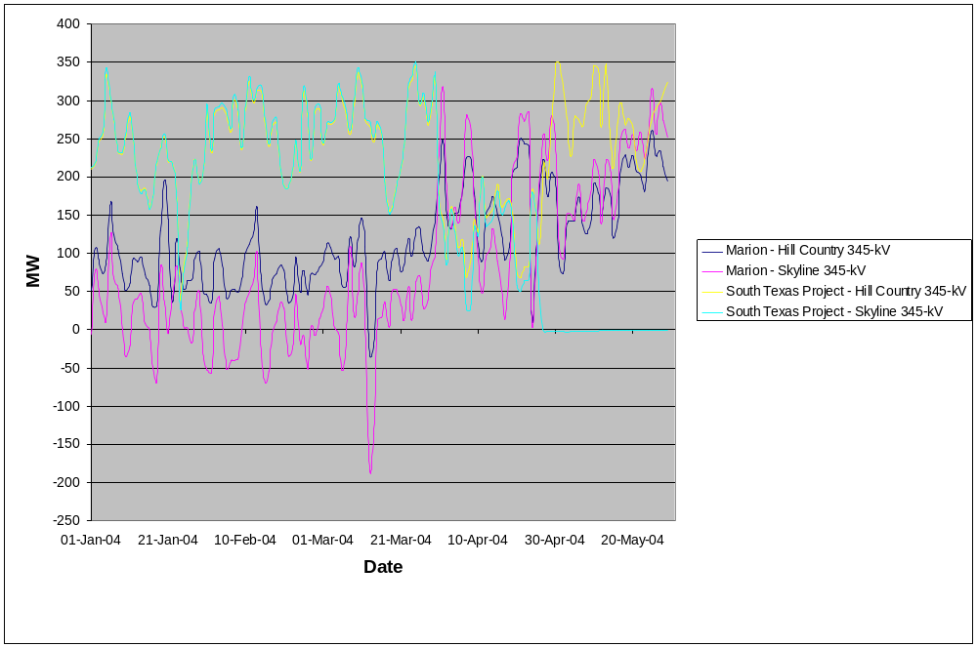
Figure 5: Daily Average Loading from 01/01/04 to 05/31/04

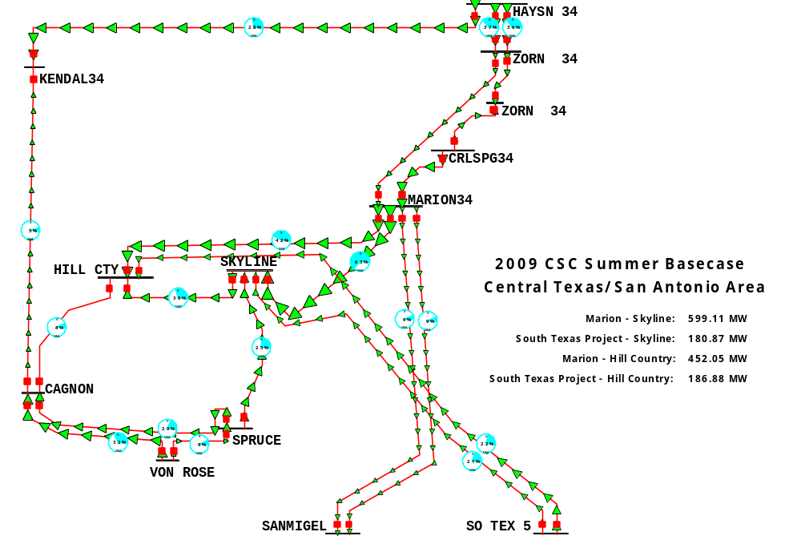

Figure 6: Central Texas/San Antonio Area in the 2009 Base Case

Table 1 shows the contingencies that most limit the bulk transfer capability into San Antonio for the 2009 base case being studied. The base case transfer amounts are also shown and the contingencies are labeled for future reference.

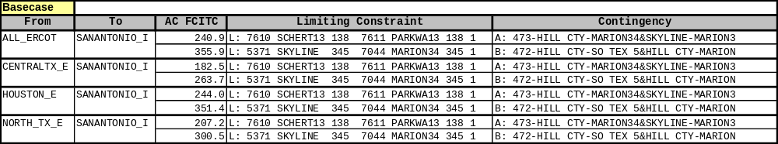

Table 1: Base Case Transfer Limits

Transfers into the San Antonio area are most limited by the Cibolo Creek – Schertz – Parkway 138-kV corridor under Contingency A and by the Marion – Skyline 345-kV line under Contingency B. These constraints in the 2009 base case are the same constraints that are frequently seen in operations on a daily basis (see Figures 2 & 3 and the examples above). When analyzed per contingency, Contingency B is the worst contingency outage, overloading the Marion – Skyline 345-kV line to 100% of its emergency rating. For Contingency A, there is a remedial action plan available to protect the 138-kV system. See Appendix A for base case transfer details.

The addition of the Elm Creek switching station at the intersection of the double circuit 345 kV lines from San Miguel to Marion and the double circuit 345 kV lines from STP to Skyline/Hill Country splits the four lines into eight circuits and creates a less severe contingency condition in the area. The worst contingency outage in the base case now becomes a loss of double circuit 345 kV lines from Hill Country to Marion/Elm Creek. For this outage, power is now permitted to flow south to Elm Creek and then to Skyline to serve San Antonio load. With the Elm Creek switching station, the loading on Marion – Skyline decreases from 100% in the base case to 89% under contingency. See Figures 7 & 8 for post-contingency loading on the Marion – Skyline 345-kV line both with and without the Elm Creek switching station.

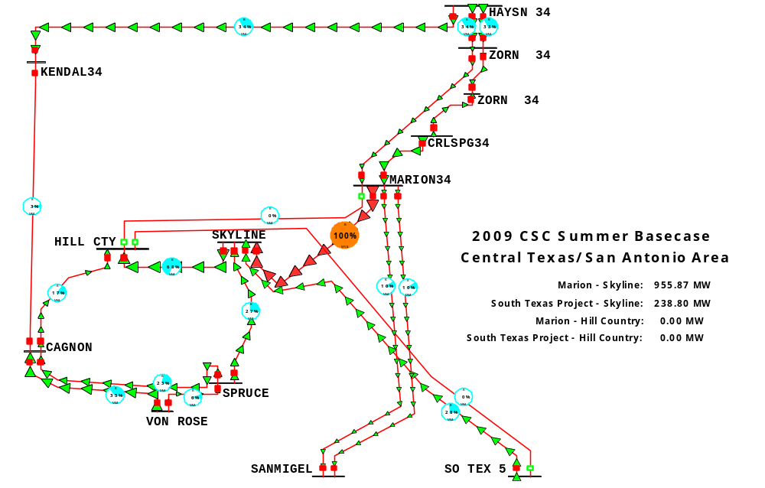

Figure 7: Contingency Loss of Hill Country – Marion/South Texas Project

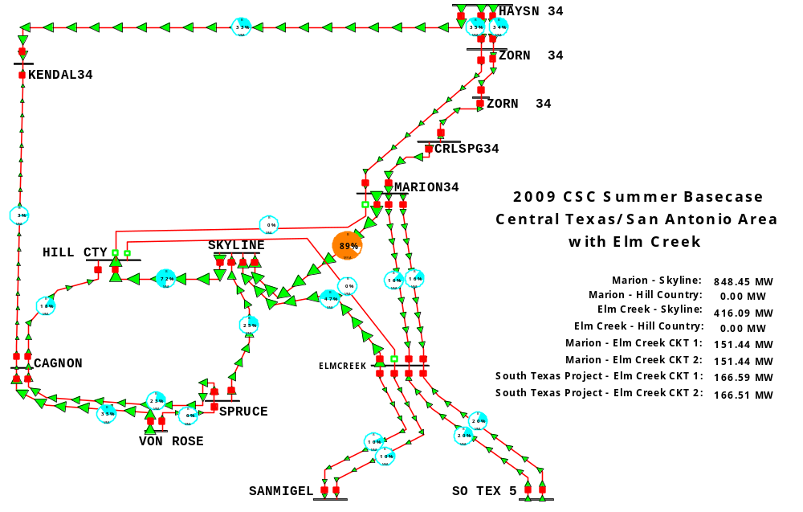
Figure 8: Contingency Loss of Hill Country – Marion / Elm Creek

Transfer limits also increased with the addition of the switching station. From the base case transfer results, an approximate 400 MVA increase was seen from all regions. Table 2 below shows these increases in transfer limits. See Appendix B for transfer details with Elm Creek in service.

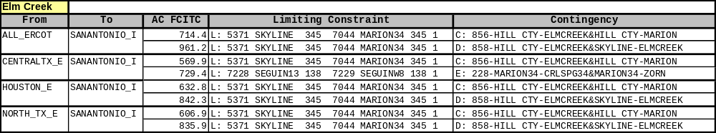

Table 2: Transfer Limits with Elm Creek

In conjunction with the Elm Creek switching station, adding a series reactor to the Marion – Skyline 345-kV line may increase import capability into San Antonio. The reactor would decrease flow on this line and divert it to the Marion – Elm Creek double circuit. Transfer analysis, with the addition of a 0.04 p.u. reactor to the Marion – Skyline 345-kV line, shows significant benefit over just building Elm Creek. Table 3 below has transfer results with the reactor in place. See Appendix C for transfer details.
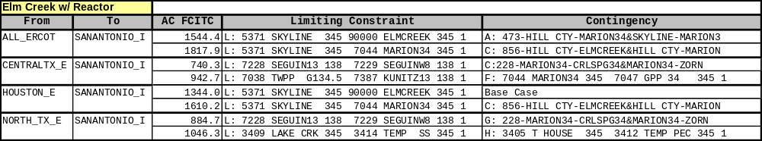

Table 3: Transfer Limits with Elm Creek and Series Reactor

Alternative Solutions

Several other solutions were evaluated to provide a comparison to the switching station alternative. Feasibility of these solutions is not known, so these alternatives should be used only to evaluate the amount of work necessary to achieve results similar to the addition of the switching station.

Alternative A: Upgrade Cibolo Creek 138-kV Corridor to 351 MVA

For base case conditions, the Cibolo Creek – Schertz – Parkway 138-kV corridor limits transfers into San Antonio for the loss of Marion – Hill Country/Skyline. In the 2009 base case, the Schertz – Parkway line loads to 97.5% under this contingency. The current rating of these lines in the 2009 base case is 220 MVA for Schertz – Parkway and 279 MVA from Cibolo Creek – Schertz. As seen in Table 4 below, upgrading these lines to 351 MVA doesn’t improve transfer capability as well as the Elm Creek substation. Depending on the cost to upgrade these lines, this alternative still has value, as it increases the transfer capability over base case levels. See Appendix D for transfer details.

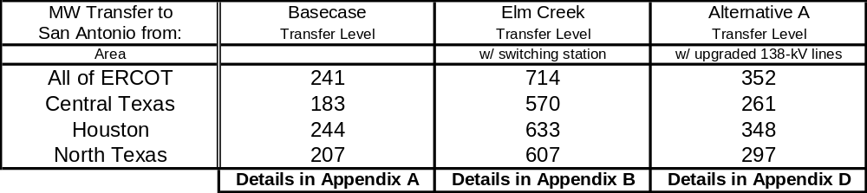

Table 4: Transfer Capabilities Determined By Most Limited Element

Alternative B: New Marion – Skyline 345-kV Circuit

Building a new single circuit 345-kV line from Marion to Skyline provides significant improvement over the base case transfer limits, but this may not be a viable alternative due to ROW considerations. For this alternative, the new line becomes the limiting element for the loss of Contingency A. Table 5 shows that the Elm Creek switching station is still a better solution since it provides more capacity and is probably cheaper than building a new 16-mile 345-kV line. See Appendix E for transfer details.

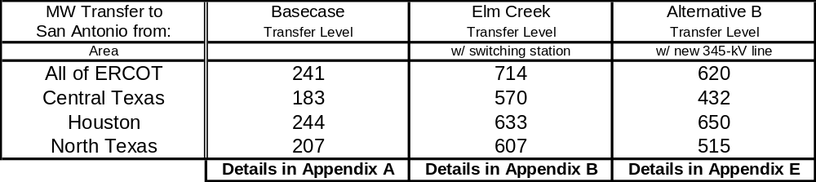

Table 5: Transfer Capabilities Determined By Most Limited Element

Alternative C: New Marion – Skyline/Hill Country 345-kV Double Circuit

The result of adding a new 345-kV double circuit line from Marion – Skyline/Hill Country outperforms all previous solutions, including the Elm Creek switching station, in terms of transfer capability. As with Alternative B, building these lines may not be possible due to ROW considerations. This alternative is just meant to show the amount of work it would take to provide a better solution than the Elm Creek switching station. The Elm Creek station with the reactor on Marion – Skyline comes closest to this alternative in transfer capability and is most definitely cheaper than building 44 miles of 345-kV lines. Table 6 shows a comparison of transfer capabilities determined by the most limiting contingency and monitored element in each analysis. See Appendix F for transfer details.

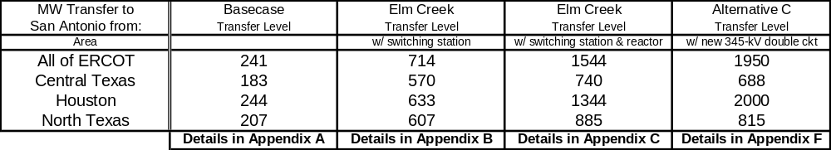

Table 6: Transfer Capabilities Determined By Most Limited Element

Station Design

The proposed Elm Creek switching station will have eight (8) 345 kV circuits from inception. Of course, future additions such as the addition of an autotransformer and/or additional circuits should be explored further. With at least 8-circuits, the Elm Creek switching station should be designed with a “Breaker and a Half” station arrangement. (See figure below) “Breaker and a Half" bus arrangement will result in twelve (12) 345 kV breakers as opposed to eight (8) breakers for the cheaper/less reliable “ring bus” configuration. Advantages of a “breaker and a half” configuration include greater flexibility for maintenance outages, increased reliability of circuits remaining in service following faults and/or breaker failure, and overall improved reliability due to the very nature of multiple paths for power to flow following any contingency at the station. In general, the breaker and a half scheme is generally preferred because it offers a high degree of reliability, operability, and maintainability for the Transmission System. Also, normal industry practice is to limit ring bus configurations to about six (6) circuits.

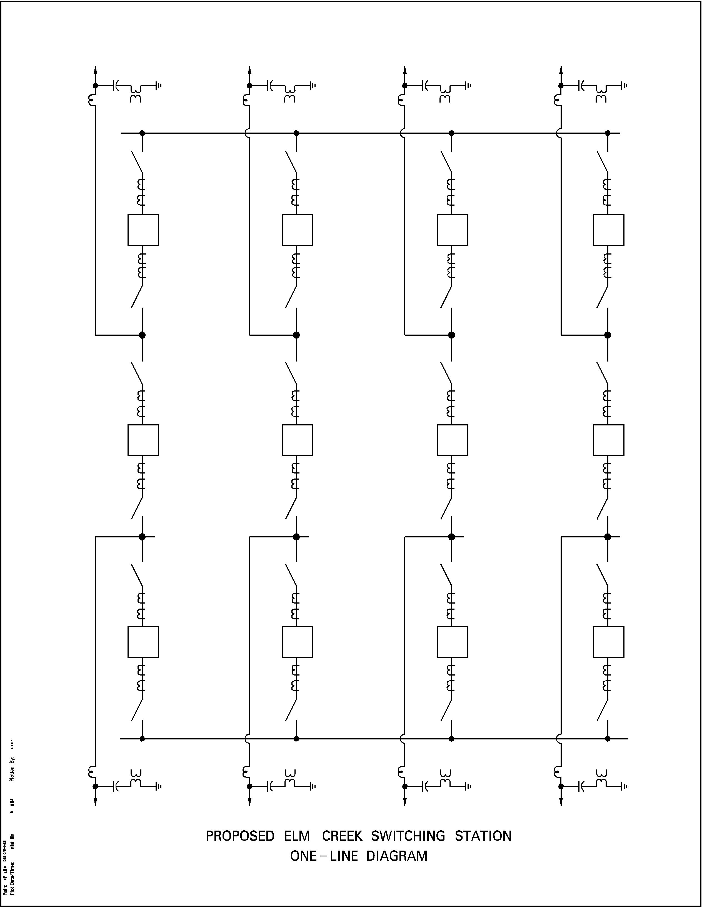

Fault Current Analysis

The Elm Creek switching station shall have at least a 50 kA fault current rating to allow for system growth. Using the current 2007 ERCOT short circuit case, with expected system additions, the 3-phase fault current at Elm Creek will be at least 35,829 Amps (see below). At current growth rates, fault current could easily be over 40 kA within a few years. Therefore, 50 kA, being the next design level, shall be chosen for the design standard. To illustrate potential growth of fault current, the following example lists the available fault current levels at the Skyline 345kV station from 1998 to 2002.

1998 - 23,000 Amps
1999 - 23,822 Amps
2000 - 25,735 Amps
2001 - 30,000 Amps
2002 - 31,500 Amps

As you can see, the fault currents increased by over 8,000 amps within 5 years. The biggest jump from 2000 to 2001 is attributed to the addition of an IPP (GPP, bus 7047) near Marion.

The fault current values were determined from the short circuit cases by tapping Elm Creek 14-miles from Marion on the Marion to San Miguel Lines, 40-miles from Hill Country, and 29-miles from Skyline. The following lines were tapped at the following percentages:

Skyline (5370) to STP (5915) ckt #1 17.5%
Hill Country (5211) to STP (5915) ckt #1 22.5%
Marion (7044) to San Miguel (5901) ckt #1 18.0%
Marion (7044) to San Miguel (5901) ckt #2 18.0%

The fault current values determined are listed below:

3-PH LG
Case #1: 2007 Future Year Case 34,000 A 22,000 A

Case #2: 2007 Future Year Case 35,388 A 22,382 A
with second 345 kV Loop Added
and JKS2 added

Case #3: 2007 Future Year Case 35,829 A 22,516 A
with second 345 kV Loop Added
and JKS2 added
and AVR2 added

Fault Current at STP
The fault currents at STP, with and without Elm Creek follow. Note that Elm Creek adds about 600 amps of fault current to an STP bus fault.

Without Elm Creek With Elm Creek
3PH LG 3PH LG
2007 Case with 345 Loop 2 35,895 A 42,474 A 36,520 A 43,061 A
& J.K. Spruce #2

2007 Case 35,840 A 42,423 A 36,483 A 43,027 A

Voltage Level Considerations

The Voltage levels at STP 345 kV substation must be maintained in a range of +2% and –4% of 362.25 kV when both units at STP are off-line, in order to comply with NRC safety requirements. The proposed Elm Creek substation will result in the Guadalupe, Rio Nogales, and San Miguel power plants having a larger effect on the STP voltages than without the Elm Creek station. As a result, these plants need to ensure that they can properly coordinate scheduled voltages. (See following e-mail for reference). The ERCOT 2004 Summer Voltage profile (revised 7/8/04) indicates that these plants have voltage set points significantly lower than the STP set point. Coordination must be obtained between these plants to eliminate the large variation between them and to ensure that STP complies with NRC requirements. In addition, the STP Interconnection agreement states that “The TDSPs will review ERCOT five year planning studies and provide input or comments as necessary to determine…”

-----Original Message-----
From: Paul X Rocha [mailto:paul.rocha@CenterPointEnergy.com]

Sent: Friday, August 06, 2004 10:54 AM
To: dadarnell@cps-ems.com; GAPressler@cps-satx.com
Subject: Elm Creek follow-up: STPNOC review

Just to follow-up on Elm Creek, to change STP - Skyline to STP - Elm Creek
requires STPNOC review and approval to ensure that the project does not
require NRC review or otherwise affect STP's NRC license. As it stands,
just to highlight our earlier comment on the project, we believe the
project WOULD require NRC review and would negatively affect STP's nuclear
operating license unless the voltage coordination issue is addressed as
part of the submittal (see comments provided by Wes Woitt).

Just wanted to make sure you are aware of this issue so you don't get
blind-sided. We provided the previous STP upgrade and line swap for such
STPNOC review - please call Don Sevcik (713-207-6638) if you have questions
about that process. If you have questions about the voltage coordination
issue, Wes Woitt (713-207-2760) can help you. I believe the issue can be
resolved, but there is some coordination and a review process involved.

Costs

CPS has estimated the total Elm Creek turnkey project cost to be approximately $11.8 million. The details of this estimate are not included in this report but the estimate includes a comprehensive detailed analysis of all expected costs to complete the project. As it turns out, this estimate is approximately $1 million per breaker. With this analogy, it can be deduced that a “ring bus” configuration option would be approximately $8 million. Incidentally, several industry experts and consulting firms have stated that in general, such a 345 kV switching station is generally about $1 million per breaker.

Conclusion

The addition of Elm Creek effectively adds, under normal and certain contingency conditions, another 345-kV double circuit into San Antonio by tying the lines from South Texas Project to the Marion bus. This allows for additional generation to flow out of Central Texas to serve load in San Antonio and could also provide a platform for future transmission upgrades.

From a reliability and outage coordination standpoint, the Elm Creek switching station creates a less severe contingency condition by allowing another path for power to flow on the 345-kV system. Currently, 345-kV lines are constrained in the area to protect the underlying 138-kV system in case of a 345-kV Category B double circuit contingency. An example of this occurs when the Cibolo Creek – Schertz – Parkway 138-kV corridor becomes heavily loaded for the loss of the Marion – Skyline/Hill Country 345-kV double circuit. There is a remedial action plan in effect that allows for the Cibolo Creek – Schertz 138-kV line to be opened if the lines in this corridor exceed their emergency ratings.

The Elm Creek switching station may eliminate the need for this RAP since it would allow for more post-contingency flow through the 345-kV system to the load in San Antonio. This can also be seen in the transfer results in Appendix A and B. The Schertz – Parkway 138-kV line is shown as a limiting element in the base case transfer results in Appendix A, but not in the transfer results with Elm Creek in-service in Appendix B.

Based on the results of this study, ERCOT staff, CPS staff, and ERCOT South Regional Planning view the addition of the Elm Creek switching station as a viable solution to relieve local congestion in and around the Marion area. ROW costs, construction costs, and economic cost/benefit analysis for this project indicates a payback to the ERCOT market in less than 2 years. With such a short payback, it is recommended to proceed with this project.

Appendix A

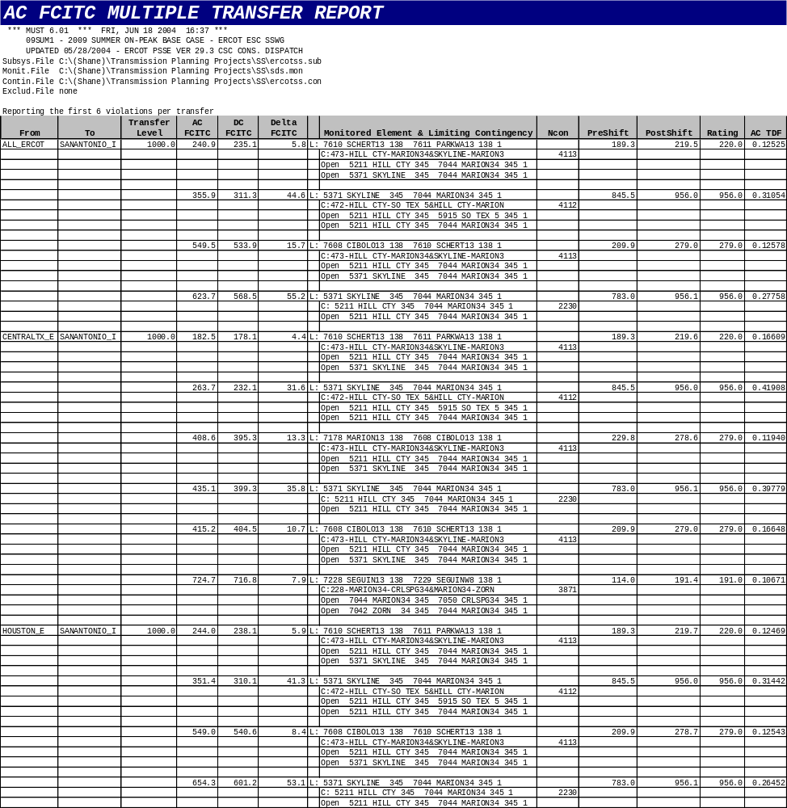
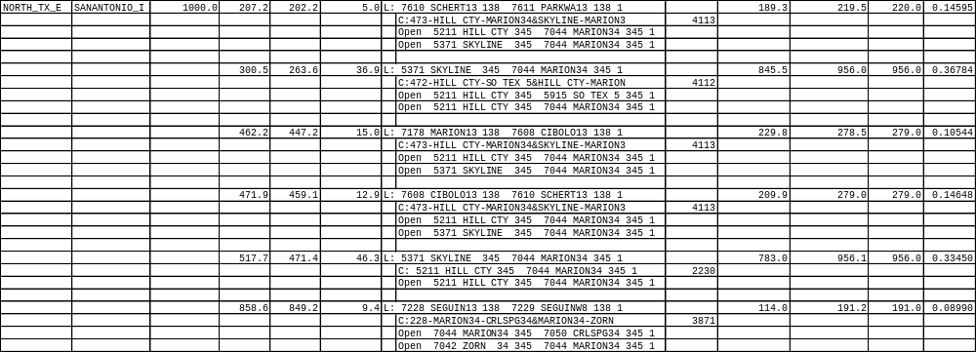
Appendix B

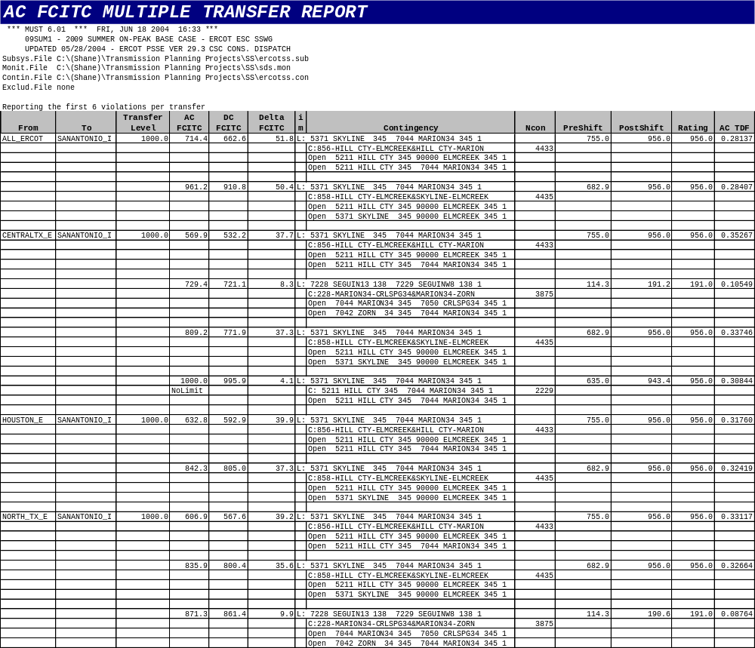
Appendix C

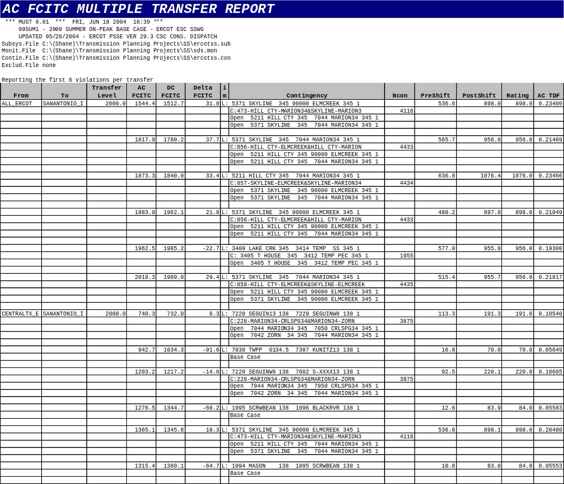
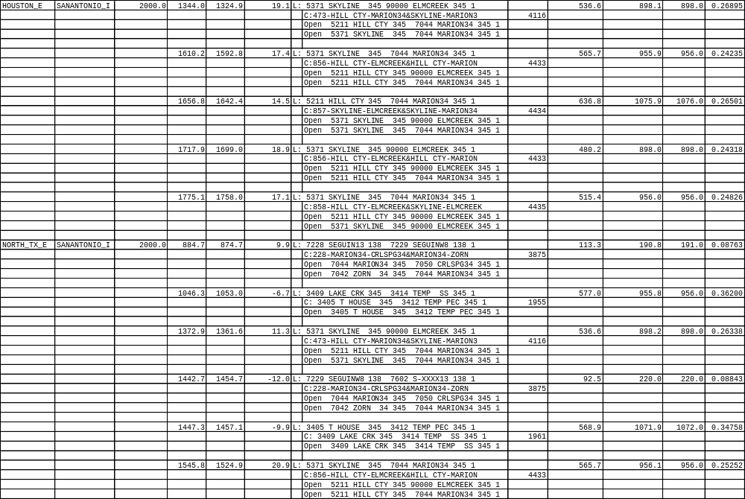
Appendix D

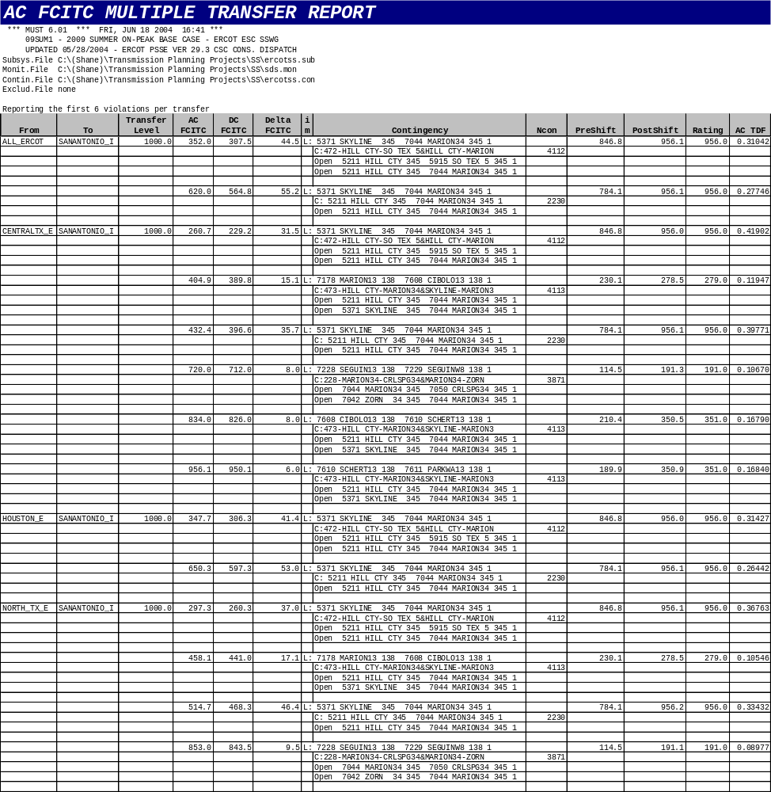
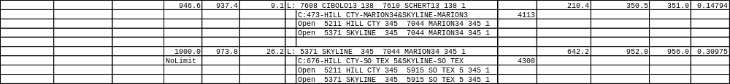
Appendix E

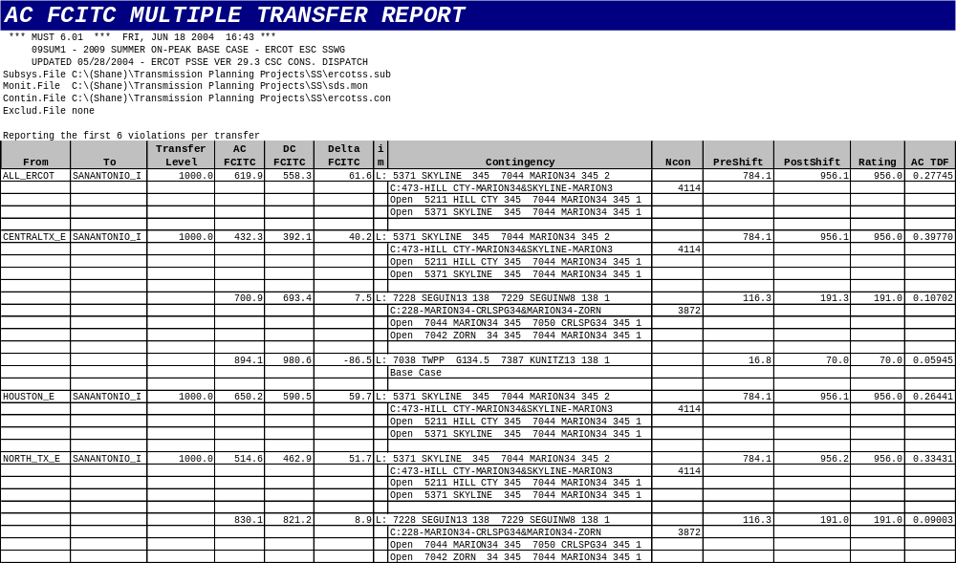
Appendix F



