

AUGUST 7th 2003 RIO GRANDE VALLEY
EVENT REPORT
Mark R. Henry, P.E.
ERCOT Compliance
April 9, 2004

Summary:

A failed surge arrestor on 138 kV line, accompanied by undesired protection system operations, resulted in loss of load and generation in the Rio Grande Valley. Prompt restoration led to recovery of most load loss within 30 minutes. Both AEP and Calpine facilities involved have been investigated by the owners and corrective actions taken to prevent recurrence. The event did not appear to impact overall ERCOT system operations.

Description of Event

At 15:23 on August 7, 2003, an initiating equipment failure followed by a sequence of line, generator and substation protection system operations resulted in the brief loss of roughly 375 MW of load throughout the Rio Grande Valley and 450 MW of generation at two facilities. The event began with a surge arrestor failure on a 138kV circuit leaving the North Edinburg substation and connecting to the Hidalgo generating facility’s switching station (HEC). This phase-ground fault was initially cleared at both ends without further problems; however, when the North Edinburg breaker 5000 reclosed, the fault recurred. Breaker 5000 tripped again, but numerous other protective device operations followed in short order, involving the Hidalgo unit STG3, the North Edinburg-Bates 69 kV line, the S. McAllen-N. McAllen 138 kV line, and a total of 22, 12kV feeders at 6 substations. Both transmission lines reclosed successfully, although the 69kV line went through 2 operation cycles. Finally, North Edinburg breaker 5000 closed a third time into the failed surge arrestor, restarting the fault. This led to operation of the transformer protection scheme for the MVEC plant CTG1, which is directly connected to the North Edinburg 138 substation. The other two plants at MVEC tripped offline in short order. AEP personnel found the failed surge arrestor roughly 8 minutes later and restoration activity commenced, with most load restored within 30 minutes.

A map of the area, primarily in Hidalgo County, Texas, is shown below:

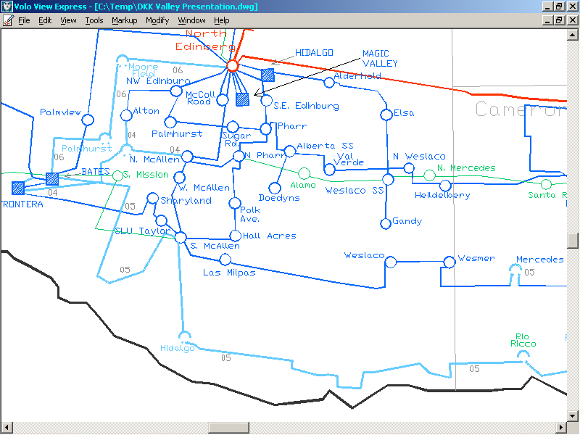

The general sequence of events was as follows, with times from AEP’s SCADA supplemented by fault recorder information:

15:23:16 North Edinburg to HEC 138 kV Fault
North Edinburg to HEC 138 KV Tripped (1)

15:23:18 North Edinburg To HEC 138 KV Closed (1st reclose)
North Edinburg To HEC 138 KV Tripped (2)
HEC STG #3 Tripped
Santa Rosa, Pharr, N. McAllen, Polk Ave 12KV Load Tripped
North Edinburg to Bates 69KV Tripped

15:23:20 Hall Acres 12KV Load Tripped
North Edinburg to Bates 69KV Closed (1st reclose)

15:23:22 North Edinburg to Bates 69KV Tripped (2)

15:23:24 Pharr 12KV Load Tripped & Closed

15:23:26 North Edinburg to Bates 69KV Closed (2nd reclose)
S. McAllen To N. McAllen 138 kV Tripped
S McAllen 12KV Load Tripped
N McAllen 12KV Load Tripped & Closed

15:23:28 Hall Acres 12KV Load Tripped
S. McAllen to N. McAllen 138 kV Closed (reclose)

15:23:30 North Edinburg to HEC 138 kV Closed (2nd reclose)
North Edinburg to HEC 138 kV Tripped (3) and Locked Out
North Edinburg to MVEC 138kV Tripped (CTG1 Transformer)

15:23:38 various 12KV Feeders Tripped & Closed over 15 minute period

15:37:30 MVEC CTG2 Tripped
MVEC STG3 Tripped

15:45 Found blown Surge Arrester at North Edinburg

The 138 kV one-line of North Edinburg and the affected generator plants, with fault and breaker operations indicated by a lightning bolt and shaded squares respectively, is below:

ERCOT System Impact:

This event was localized to the Valley, and did not involve 345 kV circuits. The amount of transmission removed from service was limited to a few circuits, and two of these successfully reclosed. Simultaneous loss of generation and load somewhat mitigated the impact on ERCOT frequency. There were issues during the same day with ERCOT frequency control; however, these were not specifically tied to this event and are not part of this report. Coordination with ERCOT Operations appeared to be adequate for the situation.

Generation Protection and Operations Issues:

Plants at two facilities directly connected to the North Edinburg station tripped. At Hidalgo, the steam unit of the combined cycle train tripped on the first recluse. At Magic Valley, all three units tripped starting with CT1. Total MW lost was roughly 450.

Calpine identified misoperations of its transformer differential relays for both the Magic Valley CT1 and Hidalgo ST. Further review of the Magic Valley relaying led to discovery of a loose connection in wiring, possibly aggravated by successive re-strikes of the fault current as this operation did not occur until the 3rd re-strike of the fault at the failed surge arrestor. Loss of the CT1 also resulted in loss of station service for CT2, which led to its trip as well. Once both CT’s had tripped, the steam unit at MVEC followed shortly.

Calpine has not fully determined the cause of the Hidalgo STG unit’s relay misoperation after the second re-strike of the fault at the failed surge arrestor. Its technicians did complete a review of wiring, settings, and relay functions, with assistance from the original relay coordination consultant and the relay manufacturer. At the time of this report, a test of the current transformers for saturation is planned.

The plant manager indicated that relay maintenance was current at both facilities.

The plant manager also indicated that all units are operated with automatic voltage regulators in the voltage control mode. Unfortunately, ERCOT’s data collection system uses telemetry with an approximate 10 second update, so it does not confirm the dynamic response of the units to the change in voltage during the fault. AEP fault recording devices do not record var flows, but they were able to calculate vars from voltage and current waveforms with additional effort. There was also a field current recording on one of the units and it clearly indicates changes in unit output to support voltage during the fault.

Transmission and Distribution Issues:

AEP is the “wires” company who owns and operates the transmission and distribution equipment affected by the event, and serves the loads.

The failure of the arrestor was unusual, in that these devices usually fail catastrophically and end up as open circuits. The particular model of arrestor was a recent addition to the AEP system. These devices had several recent failures and a decision was made to remove them prior to this event. The work had already started but this station had not been replaced. There was no apparent indication of imminent failure. After the event, AEP continued its efforts to remove all arresters of this type, and the last was removed in November 2004.

As noted, the fault was initially cleared, and problems began after the reclosing sequence. The loss of load at various stations was due mostly to ground relay operations on the distribution side of the system, typically at individual 12 kV distribution feeders but in two instances involving the “totalizer” that protects the entire low voltage bus on a step-down transformer. (AEP did indicate some distribution feeders had undervoltage protection operation.) Voltage sag following an event may prove sufficient to cause motors to stall, and the voltage problem tends to be worse at substations and distribution feeders further away from generation and other sources of voltage support. This is why load at Santa Rosa substation tripped but load closer to the fault at North Edinburg did not. AEP personnel cited difficulties in maintaining coordination for ground fault conditions between events such as this and the more typical events that occur on the distribution system itself. Other challenges affecting this effort include seasonal changes in load use (August afternoons with heavy air conditioning use compared to light loading at other times); uneven loading of feeders; and long-term change in the area from rural to more suburban characteristics along the same distribution circuits. AEP did adjust and reduce ground sensitivities on the relays following this event at the Polk and North Alamo substations, where totalizers sensed the conditions and tripped all load at the station.

The relay for North Edinburg breaker 5000 reclosed twice instead of AEP’s typical design approach of a single reclose. This has been set to single reclose.

Undesired operation on the 138 KV N. McAllen to S. McAllen line was a result of a relaying carrier’s ground switch in a closed position, which effectively kept the carrier from blocking a trip signal. This was likely an error following routine maintenance work and has been restored to proper position. The line automatically reclosed and interruption was minimal.

Another undesired operation occurred on the 69KV North Edinburg to Bates line, in this case due to a blown potential transformer fuse. This may have occurred during the event or before it happened; AEP did not have an indication of the condition. Loss of potential to relays, particularly older electromechanical relays, frequently leads to misoperation during fault conditions that are sensed from outside the immediate zone of protection. This line also automatically reclosed; in fact, it went through a second operational cycle.

AEP indicated that maintenance was current on these devices. It is a concern that device settings or switches are not in their intended arrangement; however the distribution to transmission coordination is most responsible for the loss of load event. AEP has acted to address these where its analysis suggests a better balance can be achieved.

Conclusions and Observations:

This event was local in scope and did not have immediate, significant system-wide impact to ERCOT. Recovery of the system occurred rapidly for both the grid and the plants. Misoperation and equipment failure were causative factors and led to a multiple contingency situation.

The failure of an arrestor with known problems and the various undesired operations of protection systems raise questions regarding maintenance and testing practices. AEP and Calpine both indicated they were current with maintenance in this area, and it is clear that AEP was removing equipment with a poor performance history prior to the event. Decisions about depth of maintenance procedures and quality control are the responsibility of individual companies. ERCOT and NERC standards do not specify anything about protection system maintenance, other than companies need a plan and need to follow it. Both companies have performed extensive misoperations analysis and taken corrective actions to correct the specifically identified problems.

ERCOT lacks adequate high-speed data collection to verify dynamic performance and must depend on disturbance monitor installations. ERCOT Operating Guides requirements for data recording equipment (Section 7.1.2.3) do not mandate recording of enough data to record or calculate VAR output. AEP did have traces sufficient to calculate VAR output of machines and in one instance had field current monitored. ERCOT should review locations to ensure that high speed plant VAR output data can be obtained to validate dynamic reactive requirements.

