

REQUEST FOR PROPOSAL:

Market Restructuring – Cost benefit analysis

January 2004

Key Dates:
1/8/2004 | RFP released
1/13/2004 | Notice of Intent to Bid due
1/13/2004 | Questions for clarification must be submitted by email
1/15/2004 | Answers to questions will addressed in a Bidder’s Conference
1/27/2004 | Proposals must be submitted and received
2/9 – 2/10/2004 | Meeting and presentation by possible bidders in Austin (tentative)
3/1/2004 | Bidder selected
Table of Contents

I. Introduction 4
A. General 4
B. About ERCOT 4
C. About the Texas Nodal Team (TNT) 5
II. Scope of Cost Benefit Analysis 6
A. General 6
B. Cost and Benefit Specifications 6
C. Model Specifications 8
D. Cost and Benefit Study Assumptions 9
E. Cost and Benefit Elements 9
F. Base Case 10
G. Change Cases 10
H. Development Schedule 10
I. Deliverables 11
III. Outline of Key Elements Required in Bidder’s Proposal 12
A. General 12
B. Capability 12
C. Project Management 12
D. Pricing 12
E. References 12
F. Exceptions 13
G. Conflicts of Interest 13
IV. RFP Process 13
A. Evaluation Schedule 13
B. Submission of Questions 14
C. Notice of Intent to Bid 14
D. Pre-Bid Conference 14
E. Bidder Presentations 15
F. General 15
G. Selection Process 15
H. Selection Criteria 16
I. Communications 16
V. Appendices 17
A. Substantive §25.501 17
B. Cost Benefit Charter 22
C. Current Market Design 23
D. Data Provisions 23
E. Assumptions 23
F. Cost and Benefit Elements 23
G. Cost Benefit Project Timeline 1
H. Standard Consulting Agreement 2
I. Consultant Travel Policy 2

Introduction

General

P.U.C. Subst. R. 25.501 was adopted on August 21, 2003, as developed under Project No. 26376 of the Public Utility Commission of Texas (PUCT). The rule requires the Electric Reliability Council of Texas (ERCOT) to modify its existing wholesale market structure to implement direct assignment of local congestion. The “Texas Nodal” rule additionally requires resource-specific bidding for energy and ancillary services, implementation of a voluntary day-ahead market, nodal prices for resources, zonal prices for loads, and other design and implementation requirements as further described in Appendix A. The rule also provides for an unbiased, in-depth cost-benefit study to be performed by an independent third-party.

An independent, third-party consultant shall perform an overall cost/benefit analysis of options that will consider all costs and benefits of implementing a nodal market design in the ERCOT control area in comparison to maintaining the current ERCOT market design, as defined in Appendix B. The analysis shall include an estimate of the economic effects of moving to a nodal system on a region-by-region and market segment-by-market segment basis.

The purpose of this Request for Proposal (RFP) is to identify and retain a qualified consultant or consortium of consultants (Bidder) to analyze the costs and benefits associated with moving ERCOT to a nodal market design. The selected Bidder will perform an unbiased assessment of these costs and benefits and produce a report that will present these findings to the ERCOT Board of Directors, which will in turn submit its findings to the PUCT. The market design options to be evaluated will be determined through the stakeholder process and provided to the Bidder for use in the analysis. There has been an extensive effort by the ERCOT stakeholders to develop the nodal market design and associated options; therefore, the Bidder will not be required to assist with designing the market or make recommendations as to market design. Instead, the Bidder shall focus on quantifying the costs and benefits of the nodal market design as compared to the existing ERCOT zonal market design.

Proposals are invited from suitably qualified Bidders, which can be either an individual firm or a consortium of firms represented by a primary contractor, who can demonstrate a successful record of practical experience in completing a quantitative and qualitative cost benefit analysis, in particular relating to the electric industry and market restructuring.

Proposals are due to ERCOT by 5:00 PM CST, January 27, 2004. The winning Bidder (Consultant) will be selected pursuant to the Selection Process described in this RFP. Short-listed Bidders may be invited to present their proposals directly to the Selection Committee on February 9 or 10, 2004.

About ERCOT

ERCOT is an independent, not-for-profit organization responsible for the reliable transmission of electricity across Texas' interconnected 37,000-mile power grid. Several times since its origin in 1970, ERCOT's duties have expanded to accommodate the changing needs of Texas' electric industry. In addition to ensuring transmission reliability and open access for wholesale electric market participants, ERCOT is also charged with overseeing the transactions related to the January 1, 2002, restructuring of the electric industry - including the development and effective operation of the competitive retail market in its region. Additionally, ERCOT has recently been charged to work with stakeholders to develop a nodal market design as a replacement to its existing zonal market design, in accordance with the P.U.C. Subst. R. 25.501.

The ERCOT reliability region serves about 85% of the electrical load in Texas and has an overall generating capacity of approximately 70,000 Megawatts (MW). It is one of 10 regional reliability councils in the North American Electric Reliability Council (NERC). As a NERC member, the primary responsibility of ERCOT is to facilitate reliable power grid operations in the ERCOT region by working with the region's electric energy industry organizations. ERCOT is the only reliability region in North America that is located completely within the borders of a single state with only limited DC interconnections with other reliability areas.

The PUCT is ERCOT's principal regulatory authority. The Texas legislature enacts the laws related to the electric utility industry. A balanced Board of Directors, made up of members from each of ERCOT's electric market groups, as well as unaffiliated directors, governs ERCOT. A Technical Advisory Committee (TAC), consisting of members from each market group, makes policy recommendations to the Board of Directors. Four subcommittees assist TAC: Protocol Revisions, Reliability and Operations, Retail Market, and Wholesale Market. The subcommittees are assisted by numerous workgroups and task forces. The Board of Directors hires the CEO and also appoints ERCOT's officers. These executives direct and manage ERCOT's day-to-day operations.

ERCOT's members include retail consumers, investor and municipally owned electric utilities, rural electric co-operatives, river authorities, independent power producers, competitive retailers, and power marketers.

About the Texas Nodal Team (TNT)

ERCOT is required to use a stakeholder process in the development and implementation of Texas nodal market design. ERCOT formed a Texas Nodal Team (TNT) to support the stakeholder process.

The TNT is a stakeholder group that uses three individuals to facilitate the stakeholder process of submitting a conceptual design and rules language. The TNT is made up of an independent facilitator, independent coordinator and an ERCOT staff coordinator.

Five Concept Groups have been formed to develop detailed conceptual design of the new market. These Concept Groups address subject matter related to Market Operations, Congestion Management, Commercial Operations, Cost Benefit, and Market Mitigation.

In performing the cost-benefit analysis, the Consultant will coordinate its work with the Cost-Benefit Concept Group (CBCG). The charter for the Concept Group is attached as Appendix C. The activities of the CBCG include:

Develop the cost-benefit assumptions to be examined by the Consultant. These assumptions, as well as any suggested by the Consultant and approved by the CBCG, will be quantified in the analysis; or if not quantifiable, will be discussed in a qualitative manner in the final report.

Meet with the PUCT staff, ERCOT staff and the Consultant to discuss the appropriate assumptions to be included in the cost-benefit study.

Organize and communicate to the Consultant the market design options to be evaluated in the cost-benefit study based on the work products of the other TNT Concept Groups.

Act as the liaison to the Consultant to address issues and questions from the Consultant and to communicate the results to stakeholders.

Coordinate monthly, or as needed, updates on progress of the study and preliminary results.

ERCOT will appoint a liaison to support the Consultant in the day-to-day performance of its analysis.

Scope of Cost Benefit Analysis

General

The RFP seeks responses from experts to complete a quantitative and qualitative economic cost-benefit analysis of the market restructuring options in comparison to the current market design including the impact on a region-by-region and market segment-by-market segment basis.

Subsection (m) of P.U.C. Subst. R. 25.501states:

“(m) Development and implementation. ERCOT shall use a stakeholder process to develop a wholesale market design that complies with this section. ERCOT shall file with the commission an application for approval of protocols that comply with this section and for approval of energy load zones that comply with subsection (h) of this section. As part of this application, ERCOT shall include an independent cost-benefit analysis of options that would comply with this section. These options may include an option, or options, that would involve modification of the existing ERCOT wholesale market design. However, all options that are evaluated in the cost-benefit analysis shall comply with this section. For each of the options, the cost-benefit analysis shall include the estimated net benefits of the option in comparison to the current market design. If the independent cost-benefit analysis produces a negative result, the stakeholder process shall continue until a wholesale market design is produced that yields a positive result upon application of the cost-benefit analysis. The protocols and all cost-benefit analyses shall be filed by ERCOT by November 1, 2004. The cost-benefit analysis shall be prepared with sufficient detail to provide the stakeholders and the commission with the necessary information to modify or delete specific items or categories of expenses in the event the costs exceed the benefits. ERCOT shall fully implement the requirements of this section by October 1, 2006.”

There have been concerns expressed by some market participants as to how a change in market design would affect different groups of ratepayers in the ERCOT control area. In adopting P.U.C. Subst. R. 25.501, the Commission recognized these concerns by specifying in the Preamble to the rule that the cost benefit study will include an analysis of the impacts of the new market design on ERCOT regions and market segments. In its Preamble to the rule, the Commission stated:

“Although the commission has determined that the net benefit of implementing this rule is positive and significant, the commission agrees that the benefits and costs of Texas Nodal will vary among regions and market segments. Consequently, the commission expects ERCOT to include in its cost-benefit analysis required by subsection (m) of the final rule, an analysis of benefits and costs on a region by region and market segment by segment basis.”

Therefore, the Consultant will not only need to quantify the costs and benefits associated with the change in the market design, but will also need to quantify how the new market design will affect the regions and the market segments within the ERCOT control area.

Cost and Benefit Analysis Specifications

This section outlines a number of the elements that will be involved in developing the cost benefit study. Many of these elements are interrelated. This itemization is not necessarily comprehensive. Questions regarding these elements should be provided in writing to the designated CBCG contact prior to the Pre-Bid Conference scheduled to be held on January 15, 2004.

Understanding of ERCOT Protocols: The Consultant must demonstrate a working knowledge of the current ERCOT Protocols. The operation of the ERCOT market is unlike market designs in other parts of the country. Thus, the current ERCOT market design, which will form the Base Case for the cost benefit study, may be significantly different than market designs previously encountered by the Consultant.

Data Collection: The data to be provided by ERCOT, and the associated periods for which they are available, are identified in Appendix C. The Consultant will have access to the data provided by ERCOT and will be expected to acquire any other necessary economic, operational, and technical data not provided by ERCOT for the analysis. The Consultant will coordinate the collection and verification of data used in models with ERCOT staff. All data provided by ERCOT or the Consultant will be subject to the confidentiality provisions set forth in the Standard Consulting Agreement, incorporated as Appendix H. From the receipt of the RFP until completion of the study, the Consultant may not obtain data from market participants in ERCOT except as provided through the TNT stakeholder process.

Production Costing: The production costing should be a security-constrained unit commitment and security-constrained economic dispatch of ERCOT resources to meet load. ERCOT staff will review the production costing data to be used for the study and will suggest relevant corrections. ERCOT staff will review Consultant’s production costing results and discuss with Consultant any adjustments that should be considered to accurately represent operation of the ERCOT market. ERCOT staff will also assist the Consultant in making decisions regarding generating plant additions, reliability must run units, and retirements. All production costing information provided to the Consultant is considered to be highly confidential and not subject to public release.

System Modeling: Where additional operating data are needed outside that described in Appendix D, ERCOT will assist the Consultant in quantifying such additional data to model the generation and transmission system. ERCOT’s assistance will be limited to providing data that is available.

Environmental Regulations: Several areas within the ERCOT region are classified as non-attainment areas by the Environmental Protection Agency (EPA). As such, these areas are subject to strict air quality controls that affect the operation (and thus the cost) of energy in those areas. The Consultant shall take into account EPA and Texas Commission on Environmental Quality (TCEQ) regulations in the production costing model and the cost-benefit study as appropriate.

Development of Costs and Benefits Associated with Changing Market Design: Consultant will develop and compare the costs and benefits of the Base Case and all market design options provided to the Consultant by the CBCG (Change Cases). The Base Case will be based on the current ERCOT market design adjusted for currently approved changes to the ERCOT Protocols, as defined in Appendix C. The CBCG will be available to discuss the implications of any proposed changes to the Protocols or any of the market design options with the Consultant as necessary.

Hardware and Software System Costs: The Bidder will be expected to evaluate the extent to which existing systems can be modified to meet the requirements of the rule, compared to replacing existing systems with new ones.

Market Segment Analysis: As indicated by section (m) of P.U.C. Subst. R.25.501, the cost-benefit study shall determine costs and benefits for each region in the ERCOT control area and for each market segment in ERCOT. The regions will be defined as the zones identified by the Congestion Management Concept Group (CMCG), and will be at least four zones. Subsets of the zones may be identified for further evaluation. The market segments are:

Investor-Owned Utilities

Municipal Utilities

Electric Cooperatives

Independent Power Generators

Independent Power Marketers

Independent Retail Electric Providers

Consumers

Market Mitigation: The ERCOT Market Mitigation Concept Group (MMCG) will develop any necessary market mitigation measures to be incorporated into the cost-benefit study. If necessary, the Consultant will discuss these market mitigation measures with the CBCG and if possible, incorporate these measures into the cost-benefit study.

Resource Distribution: For optional evaluation, the Consultant shall describe his recommended approach to reviewing the distribution of generation ownership in the regions and make recommendations to the CBCG as to whether the models should include any adjustments, particularly in congested areas.

Model Specifications

In order to perform the analysis of the impact of locational prices, the Consultant will need to be able to produce projected nodal and zonal prices for every year of the study period on an hourly basis and aggregated to a level of granularity to be specified before the study commences. Because of the potential for various configurations of load zones, the Consultant’s model should have the flexibility to aggregate nodal prices for loads under a variety of zones. Load zones will be developed by the ERCOT Congestion Management Concept Group (CMCG), approved by the TNT, and provided to the Consultant for use in the cost-benefit study.

The quantitative portion of the study should cover a ten-year period, starting in 2005 and continuing through 2014. Forecasts load flows for the first five years of the study will be provided by ERCOT. In the proposal response, the Bidder should describe his approach to developing the additional five years of load flows and load forecasts necessary to complete a ten-year quantitative study.

The following is a list of criteria which the model must generally support. The criteria listed below are not necessarily mandatory but are meant to be indicative of ERCOT’s requirements. Some of these criteria may be met by the vendor’s model as it currently exists. Other criteria may require customization. Each item should be individually addressed in the Bidder’s proposal and those items requiring customization from the vendor’s current model, as well as the items which the vendor’s model cannot meet, should be clearly identified as such. The criteria are:

The model should be capable of performing security-constrained unit commitment and security-constrained economic dispatch, based on fundamental costs and/or bidding behavior, of all generating units in the ERCOT control area to meet load;

Dispatch must be at least hourly, for at least a typical week of each month for a multi-year period;

Capable of modeling all generating units in the ERCOT control area, in terms of number and technology types (e.g steam, CT, combined cycle (CC), cogeneration, hydro, and wind);

Capable of modeling detailed ERCOT transmission network (60kV and above) and load distributed on busses;

In performing security-constrained dispatch, must be capable of simulating base case, N-1 and N-2 conditions on system elements and monitoring other elements for compliance with ERCOT planning criteria to the level anticipated in the nodal market design;

Capable of using load as a resource.

Cost and Benefit Study Assumptions

Assumptions used in the cost-benefit study are a key factor in achieving an unbiased analysis. The assumptions regarding the costs and benefits of moving to a nodal market design will be provided by the CBCG. In the Bidder’s response, the Bidder is welcome to comment on any additions or modifications to the assumptions that the Bidder’s believes is necessary to complete a thorough cost benefit study. Throughout the study, the Consultant will be expected to comment on the assumptions and make suggestions regarding additional assumptions of costs and benefits for the CBCG to review.

The CBCG will take the full list of assumptions regarding costs and benefits to the TNT General Session for approval. A preliminary list of assumptions is included as Appendix E.

Cost and Benefit Elements

This section outlines some of the potential cost and benefits that need to be addressed in the report and the quantitative and qualitative cost-benefit analyses to be prepared by the Bidder. Many issues are interrelated. The itemization of costs and benefits here is not necessarily comprehensive. The Bidder is asked to highlight and separately itemize for ERCOT any additional costs or benefits considered relevant. A more comprehensive list of costs and benefits is included as Appendix F.

Quantitative Factors: For the Base Case and each Change Case, the Bidder should describe his approach to quantifying, at a minimum, each of the following:

Implementation cost: Assess system set-up costs, implementation, and training costs to ERCOT and to the Market Participants.

Ongoing cost: Assess the ongoing market and infrastructure operational costs over the duration of the study.

Congestion cost: Evaluate costs of congestion in all models and quantify any avoidance or increase of congestion cost realized in any Change Case relative to the Base Case. [John Rainey] Break into more detail: Uplift, retail choice, market penetration, price excursions and 2) effect on economic dispatch in the model

Consumer cost: Estimate the total change in energy costs to consumers relative to the Base Case for each option by region.

Qualitative Measurements: Qualitative factors include those non-quantifiable factors affecting the costs and benefits of any Change Case as compared to the Base Case. Qualitative factors may include externalities to the extent they are not quantifiable. In the Bidder’s response, the Bidder should describe his approach to measuring each qualitative factor, including those further described in Appendix F.

Ease of Competition: Are there options which present a potential for increased competition at the wholesale or retail level? The benefits associated with wholesale and retail competition may be multidimensional, or even contradictory, and could include promotion of entry and the roll out of new wholesale or retail services, and possibly reduced time to market of new services.

Discriminatory Settings: Does any one model or option encourage or present options for a 1) segment or 2) a region to unduly benefit or face undue discrimination in operating in the ERCOT market?

Administrative Burden: Does one market design increase or decrease the cost to ERCOT to administer the market?

Market Mitigation: Does one market design increase of decrease the need for market mitigation?

Facility Investment: Does one market design encourage investment in generation or transmission that will improve reliability compared to the Base Case?

Base Case

The Bidder must be able to 1) perform simulations of the ERCOT market; and, 2) project the costs of congestion, balancing energy, ancillary services, losses and other factors that are relevant to quantifying the costs and benefits of proposed changes to the ERCOT market rules.

ERCOT staff has indicated that the development of congestion costs under the current ERCOT market design may need to be included in a model outside of a normal production-costing model. ERCOT staff will assist the Consultant in determining the most appropriate approach to use in modeling congestion costs under the various market design options provided by the CBCG.

Bidders should reference the rules by which the ERCOT market operates, the Protocols, which are available at http://www.ercot.com/AboutERCOT/PublicDisclosure/ProtocolRev.htm. These Protocols are made a part of this RFP by reference. Particular attention should be given to Sections 4 (Scheduling), 5 (Dispatch), 6 (Ancillary Services), and 7 (Congestion Management). Additional information on the current market design is included in Appendix C.

Change Cases

Change Cases continue to be developed from the output of other Concept Groups. Some of the more prominent characteristics of the Change Cases being discussed include:

Day Ahead Market – the type of Day Ahead Market; whether Congestion Revenue Rights (CRRs) are settled in the Day Ahead Market or in the Real-Time Market is still under discussion.

Reliability Unit Commitment (RUC) – that process as it relates to the Day Ahead Market and how it relates to real-time operations is being refined.

Real-Time – Details regarding all parameters of real-time operations continue to be discussed in the Market Operations Concept Group.

Congestion Rights – the type of right to be provided, whether options or obligation; flowgate or point-to-point continue to be evaluated by the Congestion Management Concept Group.

The Market Operations, Congestion Management and Commercial Operations Concepts Groups are all scheduled to complete their conceptual design between mid-February and late March. Detailed Protocols reflecting concepts of the new Market Design captured in Concept Group white papers will be drafted and reviewed in parallel to the cost benefit study being conducted. All available white papers from stakeholder groups will be provided to the Consultant. Any interested bidder can retrieve draft white papers in their current state from the Texas Nodal website at www.ercot.com/tnt.

While details continue to be refined, the Cost Benefit Concept Group believes reasonable detail will be available for all Change Case to conduct comprehensive modeling. Based on current progress of the Concept Groups, the Bidder may expect four or fewer comprehensive Change Cases to be modeled and evaluated.

Development Schedule

A development schedule identifying key activities and milestones is attached as Appendix G. The Bidder should identify any exceptions to the development schedule in his response.

Key activities in the schedule include:

Monthly status reports to the CBCG beginning in April 6, 2004

Draft findings and progress report for stakeholder review by July 22, 2004

Final Study published submitted to the PUCT by November 1, 2004 **

** I’m confused – shouldn’t ERCOT be the party to submit the final study (prepared by consultant) to the PUC, not the consultant?? (Carrie Morgan, Legal)

Deliverables

The key output required is a quantitative cost-benefit analysis and report and underlying spreadsheets that describe, and attribute a value to, a full range of costs and benefits for the options for implementing a Texas nodal market that would comply with P.U.C. Subst. R.25.501.

The associated cost-benefit models shall be flexible so as to show sensitivities to changes in inputs. ERCOT must be able to view and have access to the spreadsheets comprising the models (i.e. be able to adjust assumptions in the models). The Cost Benefit Concept Group will determine the assumptions used in the cost-benefit analysis models for the final conclusions.

The results of the cost-benefit study should also include the estimated change in the wholesale electric prices in each region, resulting from the new market design (and any options), as well as estimated changes in the wholesale electric prices to each of the seven market segments listed above. The Consultant will work with the CBCG to further define the market impact analysis.

The report shall also list qualitative factors that should be considered in evaluating the costs and benefits of moving to a nodal market design. The qualitative factors to be included in the report shall be reviewed by the CBCG and approved by the TNT General Session. The report should include a discussion of qualitative factors over the same ten-year period as the quantitative study. The report should also address longer range qualitative factors that may impact the market beyond the ten-year horizon to the extent practical.

The Consultant will provide a project status report on a monthly basis, or as requested by the CBCG during the duration of the project. The Consultant will also attend CBCG meetings as necessary to discuss assumptions and other issues identified by the Consultant or the CBCG. The Consultant will also attend certain TNT, ERCOT Technical Advisory Committee (TAC), PUCT, and ERCOT Board of Directors meetings to discuss the results of the cost-benefit study (both the draft study and the final report) as directed by the CBCG Chairperson. A preliminary schedule of CBCG, TAC and ERCOT Board meetings is provided in Appendix G.

As applicable to either the Base Case or any Change Case, the model should include, at a minimum, the following items in its calculation of costs

Typical production costs (fuel, start-up, minimum load operating costs, and variable O&M)

Ancillary services, exclusive of balancing energy sales

Environmental limitations

Losses (amount and cost)

Zonal and Nodal balancing energy prices, local balancing energy prices and other market and non-market solutions as defined in the Protocols

Contractual rates, proxy unit costs and bid premiums for RMR and OOM based on protocol or contract prices rather than fundamental costs

As applicable to either the Base Case or any Change Case, the model should calculate and produce at least the following items:

Hourly marginal prices for each bus and load-weighted prices by predefined zone

Total costs paid by load and paid to generators for study period and predefined subperiod by bus (or generator), predefined zone and system

Zonal MCPEs, OOMC, and OOME costs, relevant ancillary service prices and costs

Any other prices and costs which are necessary to meet the requirements of this cost benefit study

Outline of Key Elements Required in Bidder’s Proposal

General

Provide contact information for a person responsible for Bidder’s proposal who will coordinate any requests for information or to whom ERCOT may distribute addenda. Contact information shall include mailing address, phone number, fax number and email address.

Provide a company overview including years in business, number of employees and annual revenue for the period 1998-2002. Provide the same information for any and all major partners or subcontractors.

Capability

Describe organization-wide experience with cost benefit analysis, particularly in relation to the electric industry, and market restructuring;

Provide details on the additional information not identified in Appendix ?? that the consultant would require to complete the cost benefit analysis;

Provide information on the framework the organization would use in the cost-benefit analysis;

Describe the approach to quantifying costs, benefits, and externalities for the study period of time; and flexibility to model a number of scenarios and change inputs.

Project Management

Provide a project plan including a breakdown of timing, tasks and resources; details on time and input by individual members of the team; and description of the bidder’s internal quality assurance process, and policy for timely deliverables.

Provide a listing of the principal personnel who will be assigned to the project, subject to the CBCG’s approval for changes once the contract is awarded.

Pricing

The Bidder must provide the total costs for performing the study and terms of payment, including a not to exceed amount and the duration of any contract.

If submitting a time and materials bid, provide a breakdown of cost and payment details, including labor cost for each team member, travel, etc.

Provide hourly rates should supplemental consulting services be requested, including performance of additional sensitivity runs, provision of expert testimony, or changes in scope.

All required pricing material provided along with proposals is to be separately submitted and sealed.

References

Provide at least two (2) relevant client references who have used Bidder’s services in a similar capacity as those described in this RFP. With each reference, the Bidder must include the reference company’s name, address, phone number and the name and position of a person ERCOT can contact.

ERCOT reserves the right to contact any current or previous user of the Bidder’s service, whether or not listed, and by submitting a bid, Bidder consents to ERCOT contacting any such person or entity.

Exceptions

Identify any exceptions to the Standards Consulting Agreement or Consultant Travel Policy, included as Appendix H and Appendix I, respectively.

Provide any additional terms and conditions that the Bidder requires for completion of the project.

Conflicts of Interest

Bidders must make full disclosure in writing of any of the following:

Any interest, direct or indirect, in an entity dealing with ERCOT, if the interest is of such an extent or nature that Bidder’s services might be unduly influenced by such relationship;

Any services provided, presently or within the last 24 months, to any ERCOT market participant, including subsidiaries or affiliates, whether in the ERCOT market or another market. The Bidder’s response must include the market participant and general services rendered;

Any directorships or other governance relationship of any ERCOT personnel or family members of any ERCOT personnel and/or Board of Directors;

Information regarding any relationships between the Bidder’s organization (or any of its clients) and ERCOT that would impair the Bidder’s objectivity or independence, in fact or by appearance;

Any lawsuits or other legal disputes involving services provided by the Bidder’s organization.

RFP Process

Evaluation Schedule

1/08/04 | RFP released
 | All parties who may provide a proposal to this RFP should send a Notice of Intent to Bid (as described below) via email to Michelle Duncan (mduncan@ercot.com) by 5:00PM CST on this date
1/13/04 | Questions for clarification must be submitted and Notice of Intent to Bid by email to Michelle Duncan (mduncan@ercot.com) and Vikki Cuddy (vikki.cuddy@scgo.com) no later than this date
1/15/04 | Answers to submitted questions will be provided at Pre-Bid Conference and will be sent via email to those that have submitted a Notice of Intent to Bid.
1/27/04 | Proposals must be received at ERCOT no later than 5:00 PM CST on this date
2/9 & 2/10/04 | Tentative meeting and presentation by possible bidders in Austin
3/01/04 | Bidder selected by this date

Submission of Questions

After receiving this RFP, Bidders can submit written questions concerning the RFP to Michelle Duncan (mduncan@ercot.com) no later than 5 p.m. (CST) on January 13, 2004. All participating vendors will then receive a consolidated list of questions and answers sent electronically to the primary contact provided. All available answers will additionally be distributed at the Pre-Bid Conference.

Notice of Intent to Bid

Parties who may provide a proposal to this RFP should send an email stating such to Michelle Duncan (mduncan@ercot.com) by 5:00PM CST on January 13, 2004. The subject line of the email should be “Notice of Intent to Bid” and the email should contain at least the following information:

Name of company or consortium

Contact person at company or consortium

Contact person’s email address

Contact person’s phone number

Contact person’s mailing address

Pre-Bid Conference

A pre-bid conference will be held January 15th, 2004 at the ERCOT headquarters in Austin, Texas. The purpose of the conference will be to provide information on how ERCOT is currently operating as the ISO, discuss the goals of the cost-benefit study, and answer questions from Bidders.

Bidder Presentations

Selected Bidders may be requested to meet with and make presentations to the Selection Committee. These meetings are tentatively planned for February 9 and 10, 2004 in Austin. The Selection Committee will select bidders for this meeting. Not all Bidders may be selected for this meeting and presentation.

General

No work shall commence, no data will be provided nor shall any invoices be paid until the contractor has signed a consulting agreement with ERCOT. This agreement will require the confidentiality of ERCOT information. ERCOT has provided a copy of its standard consulting agreement for all Bidders as an attachment to this RFP.

ERCOT requests the Bidder to provide as much information as possible when responding to each point in this RFP. The Bidder must identify any specific requirements with which the Bidder is unwilling or unable to comply.

ERCOT reserves the right to amend this RFP at any time before the specified due date for proposals. After the proposal due date, amendments to the RFP shall be sent only to Bidders who submitted a proposal.

All those submitting proposals shall keep their proposals open for acceptance by ERCOT for a period of 90 days.

Any cost incurred by the Bidder in the preparation of the proposal will be borne by the Bidder and the proposal will become the property of ERCOT.

No oral or written statements made by ERCOT personnel shall be considered addenda to this RFP, unless the statement is confirmed in writing and identified as a written addendum to this RFP. During the evaluation process, it will be assumed that respondents received all amendments and addenda for this RFP.

ERCOT reserves the right to seek proposal clarification from any Bidder to assist in making decisions. A meeting and presentation by selected Bidders may be called by ERCOT and held in Austin to assist in final decisions. Any cost incurred by the Bidder for the meeting and presentation to ERCOT will be borne by the Bidder and the presentation will become the property of ERCOT.

Twelve (12) copies of the proposal are required. No electronic or fax copies will be accepted.

No data, results, reports, technical papers or documentation of any kind will be released by the selected Bidder outside of ERCOT staff without written authorization of ERCOT.

All information submitted in response to this RFP is public after the Notice of Award has been issued. The Bidder should not include as part of the response to the RFP any information, which the Bidder believes to be a trade secret or other privileged or confidential data. Any information submitted by Bidders may be shared with any ERCOT stakeholders (i.e, market participants in the ERCOT electric market) involved in the study.

Selection Process

A Selection Committee with nine members has been formed for evaluation of all RFP responses. The nine members include one (1) representative from each market segment, one (1) representative from ERCOT, and one (1) representative from the PUCT.

The Selection Committee will evaluate all proposals against the Selection Criteria in the selection of the Bidder it believes will provide the best overall value to ERCOT. It is understood that ERCOT reserves the right to reject any and/or all bids and to waive irregularities and informalities as deemed necessary. ERCOT also reserves the right to negotiate further with Bidders.

Selection Criteria

The weighting of the Selection Criteria will be determined by the CBCG. The criteria may or not be equally weighted, but no single criterion will be overriding or controlling in the final score of the Bidder.

Methodology: Bidder will be evaluated on its approach to completing the study, including its underlying infrastructure and modeling tools.

Market Communication: Bidder will be evaluated on its demonstration of ability to satisfy communication requirements of the market participants, including status reporting, issue resolution, presentation of findings, and experience providing expert testimony.

Project Management: Bidder will be evaluated against the appropriateness and feasibility of the project plan, including the organizational structure, complexity of firms and independent contractor relationships, core activities, deliverables, and total work days.

Personnel: Bidder will be evaluated on the background and experience of the specific individual(s) proposed to perform the study.

Commitment: Bidder will be evaluated for overall corporate stability and the ability to offset project risk through its corporate stability, project organization, and executive leadership.

Relevant Experience: Bidder will be evaluated on experience completing studies of similar scope and relevant industry experience with regulated and deregulated utility markets.

Price: Bidder’s pricing will be evaluated.

Communications

All communications regarding this RFP should be written and should be addressed to:

Michelle Duncan
Development Analyst
Program Management Office
7620 Metro Center Drive
Austin, Texas 78744
Email: mduncan@ercot.com

Appendices

P.U.C. Subst. R. §25.501

P.U.C. Subst. R. §25.501. Wholesale Market Design for the Electric Reliability Council of Texas

(a) General. The protocols and other rules and requirements of the Electric Reliability Council of Texas (ERCOT) that implement this section shall be developed with consideration of microeconomic principles and shall promote economic efficiency in the production and consumption of electricity; support wholesale and retail competition; support the reliability of electric service; and reflect the physical realities of the ERCOT electric system. Except as otherwise directed by the commission, ERCOT shall determine the market clearing prices of energy and other ancillary services that it procures through auctions and the congestion rents that it charges or credits, using economic concepts and principles such as: shadow price of a constraint, marginal cost pricing, and maximizing the sum of consumer and producer surplus.

(b) Bilateral markets and default provision of energy and ancillary capacity services. ERCOT shall permit market participants to self-arrange (self-schedule or bilaterally contract for) energy and ancillary capacity services, except to the extent that doing so would adversely impact ERCOT's ability to maintain reliability. To the extent that a market participant does not self-arrange the energy and ancillary capacity services necessary to meet its obligations or to the extent that ERCOT determines that the market participant's self-arranged ancillary services will not be delivered, ERCOT shall procure energy and ancillary capacity services on behalf of the market participant to cover the shortfall and charge the market participant for the services provided.

(c) Day-ahead energy market. ERCOT shall operate a voluntary day-ahead energy market, either directly or through contract.

(d) Adequacy of operational information. ERCOT shall require resource-specific bid curves for energy and ancillary capacity services that it competitively procures in the day-ahead or operating day, and ERCOT shall use these bid curves or ex-ante mitigated bid curves to address market failure, as appropriate, in its operational decisions and financial settlements.

(e) Congestion pricing.
(1) ERCOT shall directly assign all congestion rents to those resources that caused the congestion.
(2) ERCOT shall be considered to have complied with paragraph (1) of this subsection if it complies with this paragraph. ERCOT shall settle each resource imbalance at its nodal locational marginal price (LMP) calculated pursuant to subsection (f) of this section; each load imbalance at its zonal price calculated pursuant to subsection (h) of this section; and congestion rents on each scheduled transaction for a resource and load pair at the difference between the nodal LMP at the resource injection location calculated pursuant to subsection (f) of this section and the zonal price at the load withdrawal location calculated pursuant to subsection (h) of this section.

(f) Nodal energy prices for resources. ERCOT shall use nodal energy prices for resources. Nodal energy prices for resources shall be the locational marginal prices, consistent with subsection (e) of this section, resulting from security-constrained, economic dispatch.

(g) Energy trading hubs. ERCOT shall provide information for energy trading hubs by aggregating nodes and calculating an average price for each aggregation, for each financial settlement interval.

(h) Zonal energy prices for loads. ERCOT shall use zonal energy prices for loads that consist of an aggregation of either the individual load node energy prices within each zone or the individual resource node energy prices within each zone. Individual load node or resource node energy prices shall be the locational marginal prices, consistent with subsection (e) of this section, resulting from security-constrained, economic dispatch. ERCOT shall maintain stable zones and shall notify market participants in advance of zonal boundary changes in order that the market participants will have an appropriate amount of time to adjust to the changes.

(i) Congestion rights. ERCOT shall provide congestion revenue rights (CRRs), but shall not provide physical transmission rights. ERCOT shall auction all CRRs, using a simultaneous combinatorial auction, except as otherwise ordered by the commission for any preassigned CRRs approved by the commission. CRRs shall not be subject to "use-it-or-lose-it" or "schedule-it-or-lose-it" restrictions and shall be tradable.

(j) Pricing safeguards. ERCOT shall apply pricing safeguards to protect against market failure, including market power abuse, consistent with direction provided by the commission.

(k) Simultaneous optimization of ancillary capacity services. For ancillary capacity services that it competitively procures in the day-ahead or operating day, ERCOT shall use simultaneous optimization and shall set prices for each service to the corresponding shadow price.

(l) Multi-settlement system for procuring energy and ancillary capacity services. For any energy and ancillary capacity services that it competitively procures in the day-ahead or operating day, ERCOT shall set a separate market clearing price for each procurement of a particular service.

(m) Development and implementation. ERCOT shall use a stakeholder process to develop a wholesale market design that complies with this section. ERCOT shall file with the commission an application for approval of protocols that comply with this section and for approval of energy load zones that comply with subsection (h) of this section. As part of this application, ERCOT shall include an independent cost-benefit analysis of options that would comply with this section. These options may include an option, or options, that would involve modification of the existing ERCOT wholesale market design. However, all options that are evaluated in the cost-benefit analysis shall comply with this section. For each of the options, the cost-benefit analysis shall include the estimated net benefits of the option in comparison to the current market design. If the independent cost-benefit analysis produces a negative result, the stakeholder process shall continue until a wholesale market design is produced that yields a positive result upon application of the cost-benefit analysis. The protocols and all cost-benefit analyses shall be filed by ERCOT by November 1, 2004. The cost-benefit analysis shall be prepared with sufficient detail to provide the stakeholders and the commission with the necessary information to modify or delete specific items or categories of expenses in the event the costs exceed the benefits. ERCOT shall fully implement the requirements of this section by October 1, 2006.

Cost Benefit Charter

Cost-Benefit Concept Group Charter

Objective
Select, provide assistance to, and coordinate with an independent third party consultant in development of a cost – benefit analysis of options that will attempt to consider all costs and benefits of implementing a nodal market design in Texas in comparison to the current ERCOT market design. The analysis shall estimate the economic effects of moving to a nodal system on a region by region and market segment by market segment basis.

Scope
The Cost-Benefit Concept Group (CBCG) will complete the following tasks:

- Meet with ERCOT staff and the PUCT staff to develop a list of consultants who should receive the RFP and outline the general scope of the study for the cost benefit analysis.
- Assist ERCOT staff in the development of the RFP and statement of tasks to be performed by the Consultant.
- Work with ERCOT and the PUCT to coordinate the timeline for the study and the schedule of deliverables.
- Provide input to ERCOT in development of selection criteria, evaluation of proposals, and final recommendation on the choice of a Consultant to TNT.
- Develop cost and benefit categories to be examined and quantified by the Consultant.
- Meet with PUCT and ERCOT representatives and Consultant to discuss the appropriate analysis process and assumptions to use in study.
- Organize options for evaluation in the cost-benefit study based on the work products of other Concept Groups.
- Act as liaison between the Consultant and TNT or TNT Concept Groups to respond to questions regarding market design options for consideration in performing study.
- Act as liaison to the Consultant to respond to questions regarding analysis of market segment and market region impact evaluations for consideration in performing study.
- Communicate evaluation, selection, and study progress to TNT.
- Support TNT in issue resolution related to cost-benefit subject matter.
- Review and comment on draft report from Consultant for presentation to TNT.
- Review and comment on Final report for Consultant’s presentation to TNT.

Membership
The membership of the Cost-Benefit Concept Group will include ERCOT market participants, ERCOT staff and PUCT staff. The Cost-Benefit Concept Group will engage additional market experts as necessary. Meetings are open to any interested party.

Duration
The Cost-Benefit Group will meet as necessary until the Cost-Benefit Study is filed with the PUCT.

Procedural Guidelines
The CBCG will apply the following guidelines to reach the concept group’s objective:

- A calendar of meetings through 4th quarter 2004 will be developed and maintained taking into consideration the work effort required.
- The CBCG will report to TNT the agreed concepts, meeting notes, straw-dogs, protocol language and any contentious issues within the CBCG.
- The CBCG will respond in a timely manner to work assigned by the TNT team.
- The CBCG will report all positions directly to the TNT, whether a single agreed upon issue, or issues with multiple views.

Current Market Design

Data Provisions

Assumptions

Cost and Benefit Elements

Cost Benefit Project Timeline
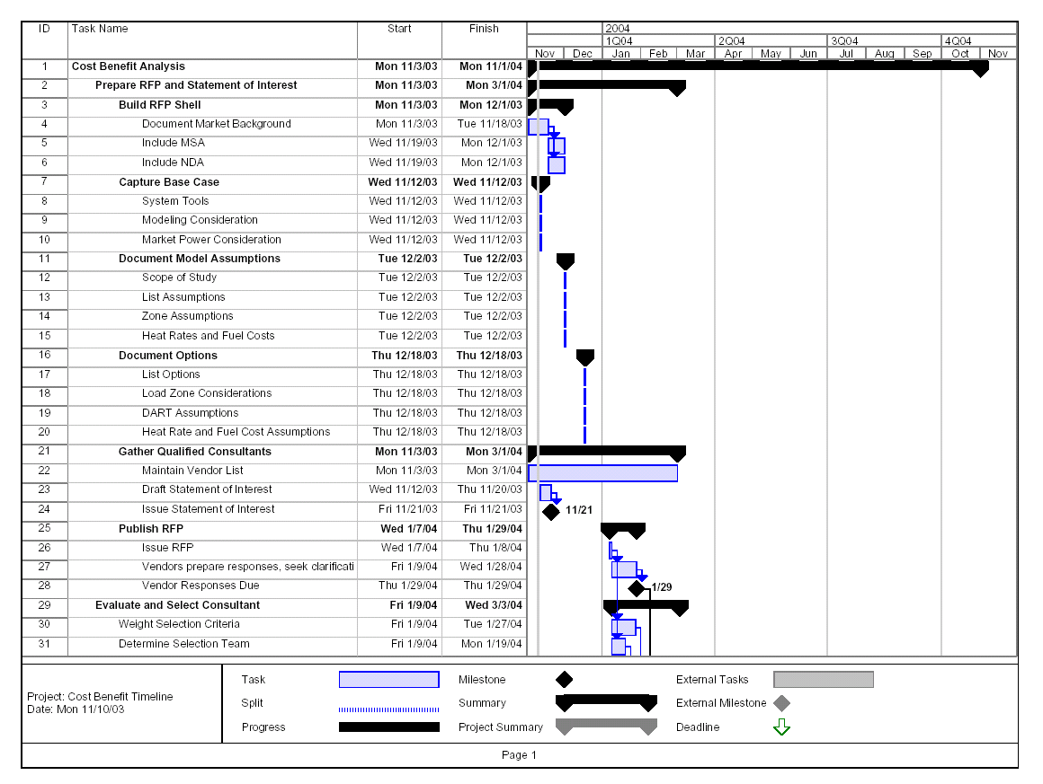
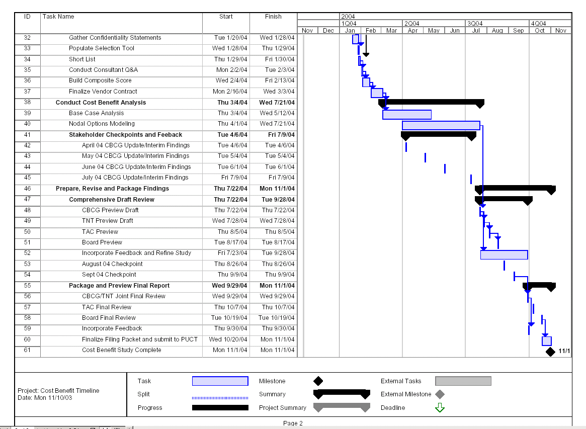

Standard Consulting Agreement

Consultant Travel Policy

